

ASSESSMENT OF METALS IN SEDIMENT OF A MONSOON-DOMINATED REGION IN THE NORTHERN MALACCA STRAIT

(Penilaian Logam dalam Sedimen di Wilayah yang Didominasi Monsun di Utara Selat Melaka)

Mohamad Arif Che Abd Rahim¹, Shengfa Liu^{2,3}, Xuefa Shi^{2,3}, Che Abd Rahim Mohamed^{1*}

¹Faculty of Science and Technology,

Universiti Kebangsaan Malaysia, 43600 UKM Bangi, Selangor, Malaysia

²Key Laboratory of Marine Geology and Metallogeny,

First Institute of Oceanography, Ministry of Natural Resources, Qingdao, China

³Laboratory for Marine Geology,

Qingdao National Laboratory for Marine Science and Technology, Qingdao, China

*Corresponding author: carmohd@ukm.edu.my

Received: 23 March 2022; Accepted: 18 May 2022; Published:

Abstract

Fluctuation levels of geochemical elements, sediment texture and nutrients were analysed from five surface sediments taken from the northern Malacca Straits. These samples were obtained during the RV Discovery Scientific cruises in September 2017 and April 2018, to assess pollution sources during monsoonal events. The results show a high output of clay and silt, revealing that the monsoonal season and cross-shelf inputs affect textural sediment. On the other hand, fluctuations in geochemical concentrations are due to industrialisation and urbanisation along the Malacca Straits, contributed by the local drainage basin. The presence of the monsoon also affects the diffusivity and absorption between the water-sediment interfaces, leading to constant fluctuation along the straits. Principal Component Analysis (PCA) of the association between the geochemical elements, sediment texture and nutrients reveal hydrological factors, mobility and accumulation through the sediment interface.

Keywords: weathering, pollution, monsoon, sediment, Malacca Strait

Abstrak

Tahap kepekatan unsur geokimia, tekstur sedimen dan nutrien telah dianalisis daripada lima sedimen permukaan yang diambil dari kawasan utara Selat Melaka. Sampel ini diperoleh semasa pelayaran RV Discovery Scientific pada September 2017 dan April 2018 untuk menilai sumber pencemaran semasa peristiwa monsun. Keputusan menunjukkan keluaran lempung dan kelodak yang lebih tinggi, menunjukkan bahawa musim monsun dan input rentas pelantar mempengaruhi sedimen tekstur. Sebaliknya, fluktuasi kepekatan geokimia adalah disebabkan oleh kawasan perindustrian dan pembandaran di sepanjang Selat Melaka, disumbangkan oleh lembangan saliran tempatan. Kehadiran monsun juga menjejaskan resapan dan penyerapan antara antara muka air-mendapan, yang membawa kepada fluktuasi yang berterusan di sepanjang selat. Analisis Komponen Utama (PCA) perkaitan antara unsur geokimia tekstur sedimen dan nutrien mendedahkan faktor hidrologi, mobiliti dan pengumpulan melalui antara muka sedimen.

Kata kunci: luluhawa, pencemaran, monsun, sedimen, Selat Melaka

Introduction

The Malacca Strait is located between the west coast of the Malaysian Peninsular and the east coast of Sumatra Island, and is connected with the Strait of Singapore at its south-eastern end. There are also smaller straits, such as the Johor Strait, Bengkali Strait and Rupat Strait. Together, these straits play an important role in international shipping routes linking the Indian Ocean to the Pacific Ocean [1]. The tropical climate in the Malacca Strait results in an annual precipitation of 3000 mm yr⁻¹ [2], leading to severe weathering on the adjacent peninsular. The tides and currents present in the Malacca Straits are mainly semi-diurnal, following the monsoonal current as the main force around the surrounding coast [3]. Low to medium high turbidity has been recorded, with transparency ranging from 10 to 30 m. Primary productivity is influenced geographically but is constant throughout the whole year. Shallower water along the coastlines leads to vertical mixing and nutrient inputs from drainage basins adjacent to the Malacca Straits [4].

A high volume of annual precipitation (3000 mm yr⁻¹) also leads to severe terrestrial weathering towards the straits, resulting in elevated sediment discharge [5]. On the west coast of the Malaysian Peninsular, a number of discharged sediment sources are the result of physical and chemical weathering [6], with most of the weathered material originating from igneous rock. The granitic rock present in the Malaysian Peninsular originates from the Central and Western Belts, for which the primary source are the Titiwangsa Ranges [7, 8]. According to Shoieb et al. [9], the Sibumasu Terrane, which comprises the Malaysian Peninsula’s Western Belt, was derived from the North West Australian Gondwana margin within the late Cambrian-Early Permian period. Therefore, the discharged weathered sedimentary rock material is Palaeozoic shale. An earlier study by Zakariah et al. [10] on the sustainability of the Kuala Muda basin located in the Kedah River, revealed a large quantity of granitic-bearing rocks, most of it originating from the Bintang Range granites. In Penang and Langkawi Island, the formation of the bedrock surrounding both islands originated from the Quaternary deposits, where most of the discharge was feldspar and plagioclase [11, 12]. This has resulted in the constant supply of igneous rock towards the Malacca Straits. In term of temporal influences, the Malacca Strait is affected by monsoonal seasons, where the northeast monsoon prevails from November to March and the southwest monsoon runs from May to September. In essence, the energy generated by the monsoonal season leads to corresponding changes in sea currents through eddies and cyclonic and anti-cyclonic events, thus altering the sinking processes in the Malacca Strait [13]. These monsoonal seasons also affect hydrological processes in the straits, leading to the distribution of weathered material around the coast.

The Malacca Strait is abundant in natural resources and many socio-economic activities related to metal processes and consumption, such as industrial and residential activities which are concentrated in this area, resulting in an increased contaminants load, due to rapid urbanisation and increased population density [14]. Urban development and industrialisation over the previous decade have raised major environmental issues. Pollutants in rivers are a severe problem in many rapidly growing cities, owing to the fact that water quality and sanitary infrastructure do not keep up with population and city expansion, particularly in developing countries. Human activities such as sand mining, land reclamation, deforestation, landfill leachate and urban water runoff are common anthropogenic problems of environmental concern [15]. Contaminants are deposited in aquatic environments as a result of physical erosion, chemical weathering and soil leaching [16]. Furthermore, monsoon-induced events (i.e., storms, flash floods and landslides) can be devastating in mountainous tropical environments, causing severe soil erosion with both on-site and downstream repercussions. When combined with anthropogenic inputs, these result in severe damage to the local population. These hazards also elevate geochemical concentrations and sedimentation.

Sediment is a major source of concern when it comes to environmental quality because of its importance in monitoring the health of both humans and the ecosystem. The importance of sediment is evidenced by its constant deposition of many sources of contamination, leading to bioaccumulation and bioassimilation in aquatic life, through source and sink processes. In theory, the high level of pollution surrounding the Malacca Straits is the result of natural and anthropogenic inputs, backed with monsoonal seasons, enhancing its concentration under physical and hydrological processes. The objective of this study is to identify the source of geochemical elements within the Malacca Straits, while assessing several factors influencing these geochemical elements. This paper examines pollution concentrations in the Malacca Strait and the prominent factors affecting geochemical elements along the straits.

Materials and Methods

During the UKM-FIO Scientific cruise in August 2017 and May 2018, five surface sediment samples were collected using a Veen Van Grab, at locations on the western coast of the Malaysia Peninsular (Figure 1 and Figure 2). Water depth in the study area ranged from 15.5 m to 67.8 m (Table 1). The sediment samples in this study were taken using a plastic scoop, rather than a metal scoop, to prevent cross contamination. They were stored in zipped polyethylene bags and frozen below 15°C on-board, before being shipped back to National University of Malaysia (UKM).

Sediment textural analysis was carried out, according to the method by Miller and Miller [17, 18]. Calgon solution was used, as proposed by Kaur and Fanourakis [19]. The 4 g bulk sample was mixed in a 50 ml centrifuge tube with 4.2% Calgon solution for better separation into clay, sand and silt layers. The sample was then mixed and sonicated for 15 to 30 minutes, for dispersion. The sample was centrifuged at 770 rpm for 3.3 minutes, for the clay to settle. The clay was then removed at 2.5 cm below the centrifuge tube meniscus level. Silt was obtained via wet sieving at 45 μm and the total amount of sand was calculated via the subtraction of total clay and silt [20].

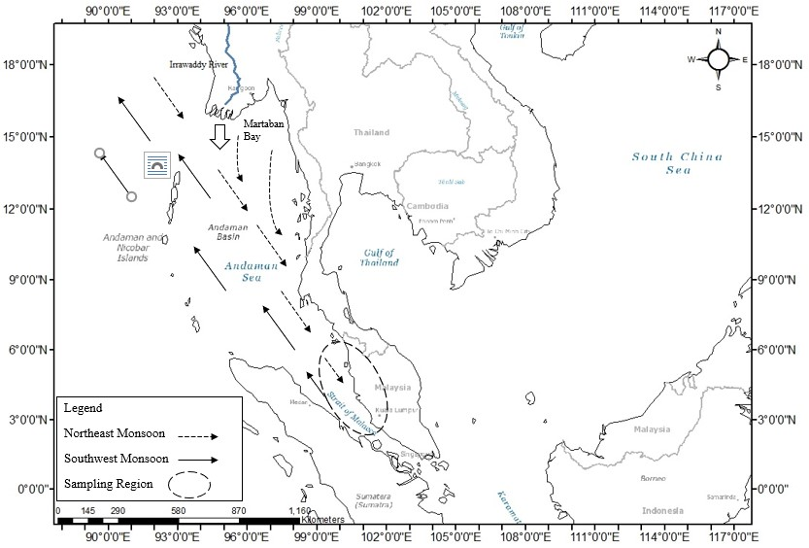

Figure 1. The area of sampling in Northern Malacca Straits affected by monsoonal season (Data source: [23])

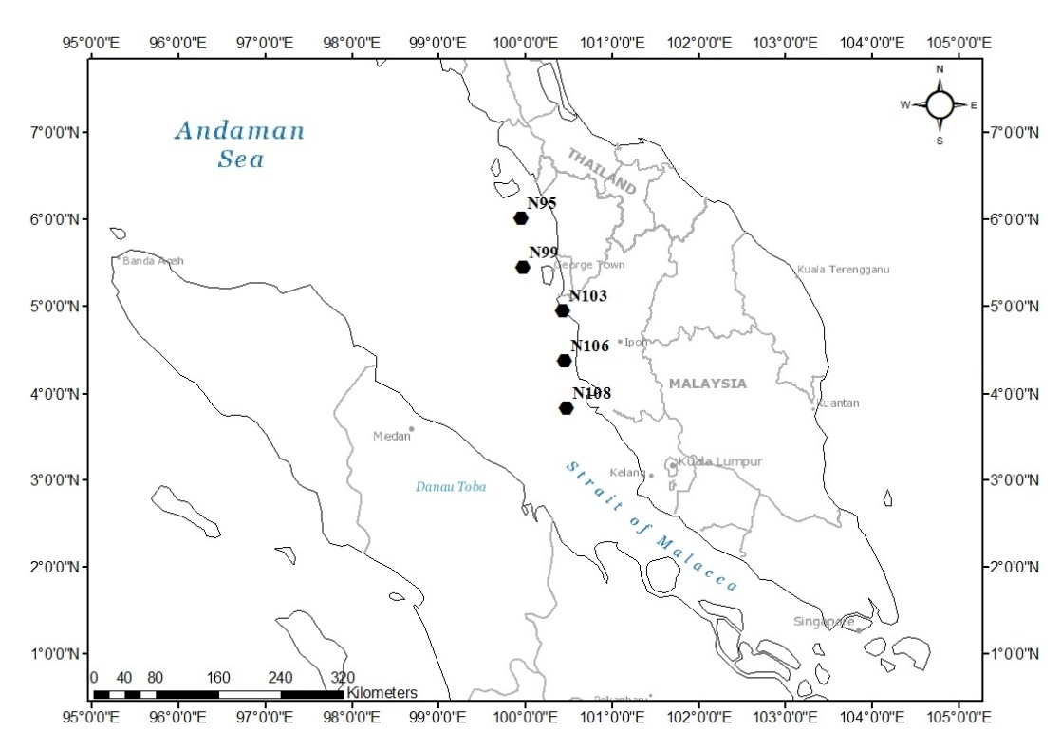

Figure 2. Sampling station in the Malacca Straits

Table 1. Sampling stations along the Malacca Straits

Station | Longitude | Latitude | Sampling Date | Depth (m)
N95 | 99.9606 | 6.0069 | 1/5/2018 | 39.5
N99 | 99.9811 | 5.4428 | 2/5/2018 | 40.8
N103 | 100.44 | 4.9433 | 2/5/2018 | 15.5
N106 | 100.4561 | 4.3733 | 2/5/2018 | 22.0
N108 | 100.4828 | 3.8247 | 2/5/2018 | 67.8

Geochemical element analysis was conducted, following the methods in Rahim et al. [16]. In summary, the dry and homogenised sediment was used and mixed with a mixture of 10 mL nitric acid (HNO₃), 5 mL perchloric acid (HClO₄) and 1 mL hydrofluoric acid (HF) for 2 h in a Teflon beaker at 120°C. With the acquisition of three replicates for each sample, the concentration of Al, Fe, Ti, Mn, Mg and Cr were determined using Inductively Coupled Plasma Mass Spectrometry (ICP-MS). Standard reference material (NIST 1633b) was used for the five replicates, to assess the yield and effectiveness of the established methods. The yield obtained was between 88% and 92%, with an average result of 13.54 ± 0.1% for Al, 7.00 ± 0.03% for Fe, 0.71 ± 0.02% for Ti, 0.43 ± 0.04% for Mg,118.55 ± 1.1 µg/g for Mn and 174.41 ± 1.3 µg/g for Cr.

For organic matter (OM) and calcium carbonate (CaCO₃) content, the loss of ignition (LOI) method was used, as suggested by Santisteban et al. [21]. The dried, finely ground and homogenised sediment was weighed accordingly and treated with high combustion heat for 4 hours at 550°C in a furnace. After heating, the sample was cooled down in the desiccator and weighed again. The same sample was then treated for 2 hours at 950°C, for CaCO₃ determination.

Results and Discussion

The data in Table 2 shows that the average percentage was 10.93% for clay, 37.99% for silt and 51.08% for sand, while OM and CaCO₃ averaged 5.87% and 9.51%, respectively, along the Malacca Strait. There was an average difference of OM (5.41%) and CaCO₃ (9.51%) between stations N95 and N108, where station N95 dominated with a higher value for OM and CaCO₃. In the meantime, the difference between N95 and N108 was apparent in the sediment, where a higher value of silt was present in N95, while N108 secured a higher value for clay and sand content in its sediment. This suggests that constant remobilisation acts on surface sediments and that this occurred at station N108. The constant discharge of particulates due to anthropogenic inputs and frequent precipitation from the nearby drainage basin, lead to the dominance of clay and sand at station N108 [22]. According to Ramaswamy et al. [23], sediment discharge from the Irrawaddy River, due to the continuous weathering of igneous rock, leads to accumulation within the Irrawaddy Delta. In addition, the severity of the monsoonal seasons has an effect on the Andaman Sea, extending to the Gulf of Martaban. Hence, the tides, waves and the Ekman transport generates a net motion via the monsoonal season, causing mass migration of suspended particulates towards station N95, before sinking to the bottom.

In nutrient distribution along the Malacca Strait, the average OM and CaCO₃ acquired was 5.87 ± 0.12% and 9.51 ± 0.28%, respectively. There is a difference in OM (5.41%) and CaCO₃ (8.24%) content between stations N95 and N108, due to the exposure of the neighbouring shelf, where hydrological changes affect the total distribution along the Malacca Strait. There are higher OM and CaCO₃ contents at N95, compared to N108, due to hydrological factors taking place within the Malacca Straits. According to [24], the general circulation of the Malacca Strait was affected by monsoonal seasons, producing ebb tides which, in turn, affected the sediment composition present in the Malacca Straits. The presence of the monsoonal season affects seabed sediment as the major sink, where the rate of removal is higher, in accordance with diffusion rates in the seabed sediment [25]. Similar to composition differences in textural sediments, the monsoonal season affects the coast where the reworking process on the seabed sediment is present, leading to the constant production of nutrients along the station.

Table 2. Physio-chemical characteristics of sediment in the Malacca Straits

Station | Clay (%) | Silt (%) | Sand (%) | OM (%) | CaCO₃ (%)
N95 | 7.23 | 21.98 | 70.79 | 8.53 ± 0.11 | 14.42 ± 0.34
N99 | 11.30 | 15.09 | 73.61 | 6.73 ± 0.02 | 10.02 ± 0.19
N103 | 13.24 | 65.70 | 21.06 | 4.24 ± 0.2 | 3.9 ± 0.47
N106 | 11.44 | 83.43 | 5.12 | 7.63 ± 0.2 | 6.68 ± 0.13
N108 | 11.41 | 3.77 | 84.81 | 3.12 ± 0.19 | 6.18 ± 0.45

The geochemical elements shown in Table 3 reveal that the average concentration for each element is 5.00 ± 0.5 % (Al), 2.88 ± 0.34 %(Fe), 0.23 ± 0.03 % (Ti), 51.41 ± 0.9 µg/g (Zn), 94.56 ± 6.4 µg/g (Cr), 526.08 ± 41.95 µg/g (Mn), and 1.92 ± 0.18 % (Mg). Following the acquired concentrations above, several elements show a difference in concentration compared to the paper by Shaari et al. [26], where higher levels of Fe and Zn were apparent, with respective differences of 44% and 10% on the east coast, compared to the west coast of the Malaysian Peninsular. This suggests continuous inputs from several sources, i.e., the Gulf of Thailand, the Western Pacific and the Natuna Straits. The weathering rate is more apparent as the monsoonal season elevates the precipitation rate, leading to a higher discharge rate. Furthermore, the industrialisation occurring along both river channels also contributes to the increase in geochemical elements. Low geochemical element concentrations, compared to Shaari et al. [26], are due to the bathymetry of the Malacca Straits, which promotes the diurnal prevailing tides within its semi-enclosed straits, which, in turn, contributes to the mobilisation and dilution of geochemical elements [24,27]. Cross-shelf inputs towards the semi-enclosed coast also affects the total geochemical elements being supplied to the east coast of the Malaysian Peninsular [28]. The cross-shelf input via the Western Pacific, which mobilises via the longshore currents of the Vietnamese coast through the Luzon Strait and through the southern South China Sea (sSCS), coupled with periodic monsoonal seasons, lead to the fluctuations of geochemical elements on the east coast of the Malaysian Peninsular [29].

Table 3. Concentration of geochemical elements in the Malacca Straits

Station | Al (%) | Fe (%) | Ti (%) | Zn (µg/g) | Cr (µg/g) | Mn (µg/g) | Mg (%)
N95 | 6.09 ± 0.29 | 3.01 ± 0.31 | 0.19 ± 0.02 | 55.09 ± 1.09 | 121.46 ± 6.25 | 371.62 ± 20.18 | 3.01 ± 0.12
N99 | 5.51 ± 0.24 | 2.68 ± 0.19 | 0.23 ± 0.02 | 46.05 ± 0.6 | 85.08 ± 5.07 | 319.86 ± 26.62 | 2.10 ± 0.10
N103 | 6.40 ± 0.96 | 3.00 ± 0.58 | 0.28 ± 0.05 | 59.78 ± 1.05 | 91.78 ± 9.77 | 564.96 ± 89.81 | 1.81 ± 0.32
N106 | 8.11 ± 1.56 | 3.75 ± 0.95 | 0.27 ± 0.06 | 73.09 ± 1.11 | 128.35 ± 5.97 | 598.15 ± 91.47 | 2.44 ± 0.46
N108 | 3.31 ± 0.09 | 1.48 ± 0.03 | 0.13 ± 0.01 | 52.57 ± 1.26 | 39.42 ± 2.07 | 505.40 ± 2.52 | 1.59 ± 0.06

On the west coast, the prominent contributor is the Andaman Sea, with its origins in the Bay of Bengal and Martaban Bay. Martaban Bay is the drainage basin for the Irrawaddy River and the Bay of Bengal is the drainage basin for the Ganges River, contributing most of the geochemical elements into the sea. Depth differences on the west coast may affect the bottom current trajectory, leading to a difference in the up-welling and down-welling dynamics. This results in less transport in deeper water, leading to a lower rate of remobilisation of seabed sediment. According to Väli et al. [30], the difference in dynamic uplift due to water depth suggests a larger difference in nutrient transport, leading to lower nutrient content in shallower coastal waters due to constant remobilisation. Furthermore, the difference in topography may lead to a lower current output, due to convergence at the northern Malacca Strait. Haditiar et al. [31] stated that the Malacca Strait facilitates a small water mass exchange between the Andaman Sea and the Malacca Strait, compared to the east coast of the Malaysian Peninsular, under the influence of monsoon, resulting in a smaller transport dynamic between the coasts.

To assess environment quality at the sampling stations, principal component analysis (PCA) was used to assess the significance of sediment contamination levels to aquatic ecosystem and environmental management. It also provides more quantification of dataset regarding geochemical elements in sediments and its controlling factors. The results of the PCA are presented in Table 4 for two principal components. The analysis shows that about 54 % of the total variation is explained by the first principal component, followed by 38% for the second principal component.

The first PCA is defined by the hydrological process that results in the accumulation preserved in silts, which, in turn, becomes a depository for Al, Fe, Ti, Cr, Mn and Zn (Table 4). Constant remobilisation of surficial sediment in the Malacca Strait may occur due to difference in the depths of the straits, leading to severe fluctuations in coastal transport dynamics, thus affecting the silt fraction and geochemical content in the sediment [30]. The absorbent nature of Fe-Mn oxyhydroxides combined with silt, would lead to sorption of most of the geochemical elements into the silt, leading to higher affinity, as well as through oxidation and reduction [32]. Fe-Mn acts as a scavenger in coastal environments where the co-precipitation process occurs, leading to the strong enrichment of geochemical elements [33]. On the other hand, the presence of Al, with respect to the silt fraction in seabed sediment, suggests the presence of feldspar and plagioclase, since both of the minerals are the main constituents in the sediment surrounding the Malaysian Peninsular due to weathering [34,35]. Furthermore, weathering effects in the natural environment lead to the conversion of common zinc species into a soluble form, which is then discharged into the aquatic environment and supplies the sediment in the Malacca Straits [36].

Table 4. Principal component loadings against variables in the Malacca Straits

 | Component
 | 1 | 2
Clay | 0.265 | -0.893
Silt | 0.985 | -0.166
Sand | -0.976 | 0.218
Al | 0.941 | 0.316
Fe | 0.897 | 0.412
Ti | 0.868 | -0.063
Mg | 0.285 | 0.943
Cr | 0.759 | 0.649
Mn | 0.619 | -0.635
Zn | 0.873 | -0.101
OM | 0.374 | 0.91
CaCO₃ | -0.307 | 0.952
Extraction Method: Principal Component Analysis
Rotation Method: Varimax with Kaiser Normalisation

The second PCA is defined by mobility, where clay acts as a carrier for geochemical elements and OM. A high negative value for clay represents the removal of the clay as the main carrier for nutrients and geochemical elements. This can be seen in Table 4, where a lower clay gradient is apparent with respect to nutrients (i.e., OM and CaCO₃). According to Pitt et al. [37], lower clay content represents the elevated infiltration of nutrients in the sediments, hence increasing the availability of nutrients within the sediments. Furthermore, Bobrowsky and Marker [38] also suggest that the association of Mg, Cr and Zn (Table 4) forms a dispersive clay, rather than ordinary clay; dispersive clay is easily flocculated in water and very erodible [39]. This characteristic explains why there is elevated Mg and Cr but less Mn, as the dispersity process prohibits clay from forming into fine-sized clumps. Furthermore, Mg and Cr are known pollutants within the marine ecosystem, where higher levels of water hardness are contributed by Mg, while toxicity and persistent Cr could bioaccumulate in aquatic environments. According to Ismail et al. [40], a medium to high level of chromium was detected due to various industrialisation and shipping activities adjacent to the coast. Similar connections were present when Idriss [41] stated that the Juru River contributed to elevated Cr levels, due to frequent land reclamation surrounding its deltaic region and deforestation within Penang Island, leading to mobilisation along the Juru River.

Conclusion

Sediment in the Malacca Strait faces elevated geochemical elements from natural and anthropogenic inputs. Cross-shelf inputs contribute towards the distribution and differences in concentrations along the Malacca Strait. Furthermore, the Malacca Strait is subject to physical and hydrological factors which lead to fluctuations in geochemical element distribution. In addition, local drainage basins channel pollutants from natural sources (via weathering) and through anthropogenic sources (via deforestation and land reclamation).

Acknowledgements

The authors would like to thank the First Institute of Oceanography (FIO) and the People's Republic of China, for providing the research grant (ST-2016-005) through the Universiti Kebangsaan Malaysia (UKM). We also thank the Ministry of Science Technology & Innovation (MOSTI) of Malaysia and the Universiti Malaysia Terengganu and Universiti Kebangsaan Malaysia, for their support during sampling. Lastly, we thank the laboratory members, for being an excellent research group, and the staff of the Department of Earth Sciences & Environment, Faculty of Science and Technology, Universiti Kebangsaan Malaysia, for their help during sampling.

References

1. Thia-Eng, A., Gorre, I. R. L., Ross, S. A., Bernad, S. R., Gervacio, B. and Ebarvia, C. (2000). The Malacca straits. Marine Pollution Bulletin, 41: 160-178.

2. Liu, Z., Wang, H., Hantoro, W.S., Sathiamurthy, E., Colin, C., Zhao, Y. and Li, J. (2012). Climatic and tectonic controls on chemical weathering in tropical Southeast Asia (Malay Peninsula, Borneo, and Sumatra). Chemical Geology, 291: 1-12.

3. Haditiar, Y., Putri, M.R., Ismail, N., Muchlisin, Z.A., Ikhwan, M. and Rizal, S. (2020). Numerical study of tides in the Malacca Strait with a 3-D model. Heliyon, 6(9): e04828.

4. Tan, C.K., Ishizaka, J., Matsumura, S., Yusoff, F.M., and Mohamed, M.I.H. (2006). Seasonal variability of SeaWiFS chlorophyll a in the Malacca Straits in relation to Asian monsoon. Continental Shelf Research, 26(2): 168-178.

5. Fujita, M., Kimura, F. and Yoshizaki, M. (2010). Morning precipitation peak over the strait of Malacca under a calm condition. Monthly Weather Review, 138(4): 1474-1486.

6. Amin, M. Z. M., Shaaban, A. J., Ercan, A., Ishida, K., Kavvas, M. L., Chen, Z. Q. and Jang, S. (2017). Future climate change impact assessment of watershed scale hydrologic processes in Peninsular Malaysia by a regional climate model coupled with a physically-based hydrology modelo. Science of the Total Environment, 575: 12-22.

7. Yusoff, A. H., and Mohamed, C. A. R. (2016). Mini review uranium-thorium decay series in the marine environment of the Southern South China Sea. Journal of Geology & Geophysics, 5(03): 1-9.

8. Schwartz, M. O., Rajah, S. S., Askury, A. K., Putthapiban, P. and Djaswadi, S. (1995). The Southeast Asian tin belt. Earth Science Reviews, 38(2–4): 95-293.

9. Shoieb, M. A., Sum, C. W., Ismail, M. S., and Tsegab, H. (2019). Geological characteristic of the Kroh formation in the upper Perak shales, western Peninsula Malaysia. International Journal of Advanced and Applied Sciences, 6(2): 102-106.

10. Zakariah, M. N. A., Roslan, N., Sulaiman, N., Lee, S. C. H., Hamzah, U., Noh, K. A. M. and Lestari, W. (2021). Gravity analysis for subsurface characterization and depth estimation of Muda River basin, Kedah, Peninsular Malaysia. Applied Sciences, 11(14): 6363.

11. Abdul Hamid, F. A. Z., Abu Bakar, A. F., Ng, T. F., Ghani, A. A. and Mohamad Zulkifley, M. T. (2019). Distribution and contamination assessment of potentially harmful elements (As, Pb, Ni, Cd) in top soil of Penang Island, Malaysia. Environmental Earth Sciences, 78(21): 1-13.

12. Khandaker, M. U., Asaduzzaman, K., Sulaiman, A. F. Bin, Bradley, D. A. and Isinkaye, M.O. (2018). Elevated concentrations of naturally occurring radionuclides in heavy mineral-rich beach sands of Langkawi Island, Malaysia. Marine Pollution Bulletin, 127 (12): 654-663.

13. Aboobacker, V. M. (2017). Wave energy resource assessment for eastern Bay of Bengal and Malacca Strait. Renewable Energy, 114 (3): 72-84.

14. Redzwan, G., Halim, H. A., Alias, S. A. and Rahman, M. M. (2014). Assessment of heavy metal contamination at west and east coastal area of Peninsular Malaysia. Malaysian Journal of Science, 33 (1): 23-31.

15. Saili, N. A. B. and Mohamed, C. A. R. (2021). Natural radioactivity of ²¹⁰Pb in mussels at the semi-enclosed water of the johor strait, malaysia through statistical approach. Malaysian Journal of Analytical Sciences, 25(1): 166-183.

16. Rahim, M. A. C. A., Aproi, A. A., Shi, X., Liu, S., Ali, M. M., Yaacob, W. Z. W. and Mohamed, C. A. R. (2019). Distribution of chromium and gallium in the total suspended solid and surface sediments of sungai kelantan, kelantan, Malaysia. Sains Malaysiana, 48(11): 2343-2353.

17. Miller, W. P. and Miller, D. M. (1987). A micro‐pipette method for soil mechanical analysis. Communications in Soil Science and Plant Analysis, 18(1): 1-15.

18. Miller, W. P. (1993). A micro-pipette method for water dispersible clay. Communications in Soil Science and Plant Analysis, 24 (19–20): 2531-2544.

19. Kaur, A. and Fanourakis, G. C. (2018). Effect of sodium carbonate concentration in calgon on hydrometer analysis results. Periodica Polytechnica Civil Engineering, 62(4): 866-872.

20. Gray, J. E. and Riehle, J. R. (1998). Geologic Studies in Alaska by the US Geological Survey 1998: 200.

21. Santisteban, J. I., Mediavilla, R., López-Pamo, E., Dabrio, C.J., Blanca Ruiz Zapata, M., José Gil García, M., Castaño, S. and Martínez-Alfaro, P. E. (2004). Loss on ignition: a qualitative or quantitative method for organic matter and carbonate mineral content in sediments? Journal of Paleolimnology, 32(3): 287-299.

22. Othman, S. Z., Adlan, M. N., and Selamat, M. R. (2015). A study on the potential of riverbank filtration for the removal of color, iron, turbidity and E. Coli in Sungai Perak, Kota Lama Kiri, Kuala Kangsar, Perak, Malaysia. Jurnal Teknologi, 74(11): 83-91.

23. Ramaswamy, V., Rao, P. S., Rao, K. H., Thwin, S., Rao, N. S. and Raiker, V. (2004). Tidal influence on suspended sediment distribution and dispersal in the northern Andaman Sea and Gulf of Martaban. Marine Geology, 208(1): 33-42.

24. Rizal, S., Damm, P., Wahid, M. A., Sündermann, J., Ilhamsyah, Y., Iskandar, T. and Muhammad (2012). General circulation in the Malacca Strait and Andaman Sea: A numerical model study. American Journal of Environmental Sciences, 8(5): 479-488.

25. Mohamed, K. N., Godon, E., Adnan, N. A., Rahim, Q. A., Liew, C., Abidin, A. I. Z. and Zainuddin, M. F. (2019). Study of dissolved nutrient condition at pulau perhentian, Terengganu. Pertanika Journal of Science and Technology, 27(2): 601-617.

26. Shaari, H., Mohamad Azmi, S. N. H., Sultan, K., Bidai, J. and Mohamad, Y. (2015). Spatial distribution of selected heavy metals in surface sediments of the EEZ of the East Coast of Peninsular Malaysia. International Journal of Oceanography, 2015(5): 1-10.

27. Rezai, H., Yusoff, F. M., Kawamura, A., Arshad, A. and Othman, B. H. R. (2003). Zooplankton biomass in the Straits of Malacca. Indian Journal of Marine Sciences, 32(3): 222-225.

28. Kok, P. H., Mohd Akhir, M. F., Tangang, F. and Husain, M. L. (2017). Spatiotemporal trends in the southwest monsoon wind-driven upwelling in the southwestern part of the South China Sea. PLOS ONE, 12(2): e0171979.

29. Schroeder, A., Wiesner, M. G. and Liu, Z. (2015). Fluxes of clay minerals in the South China Sea. Earth and Planetary Science Letters, 430: 30-42.

30. Väli, G., Zhurbas, V., Laanemets, J. and Elken, J. (2011). Simulation of nutrient transport from different depths during an upwelling event in the Gulf of Finland. Oceanologia, 53(1-TI): 431-448.

31. Haditiar, Y., Putri, M. R., Ismail, N., Muchlisin, Z. A. and Rizal, S. (2019). Numerical simulation of currents and volume transport in the Malacca Strait and part of South China Sea. Engineering Journal, 23(6): 129-143.

32. Batista, A. H., Melo, V. F., Gilkes, R. and Roberts, M. (2018). Identification of heavy metals in crystals of sand and silt fractions of soils by scanning electron microscopy (SEM EDS/WD-EPMA). Revista Brasileira de Ciencia do Solo, 42: 1-16.

33. Singh, S.K. and Subramanian, V. (1984). Hydrous fe and mn oxides — scavengers of heavy metals in the aquatic environment. Critical Reviews in Environmental Control, 14(1): 33-90.

34. Taylor, K. G. and Macquaker, J. H. S. (2014). Diagenetic alterations in a silt- and clay-rich mudstone succession: an example from the Upper Cretaceous Mancos Shale of Utah, USA. Clay Minerals, 49(2): 213-227.

35. Raj, J. K. (2021). Soil moisture retention characteristics of saprock from the weathering profile over a biotite-muscovite granite in Peninsular Malaysia. Warta Geologi, 47(3): 217-225.

36. Yap, C. K. and Pang, B. H. (2011). Assessment of Cu, Pb, and Zn contamination in sediment of north western Peninsular Malaysia by using sediment quality values and different geochemical indices. Environmental Monitoring and Assessment, 183(1–4): 23-39.

37. Pitt, R., Lantrip, J. and O’Connor, T. P. (2004). Infiltration through disturbed urban soils. Joint Conference on Water Resource Engineering and Water Resources Planning and Management 2000: Building Partnerships: p. 104.

38. Bobrowsky, P. T. and Marker, B. (2018). Encyclopedia of Engineering Geology, Springer International Publishing AG, Cham, Switzerland.

39. Zorluer, I., Icaga, Y., Yurtcu, S. and Tosun, H. (2010). Application of a fuzzy rule-based method for the determination of clay dispersibility. Geoderma, 160(2): 189-196.

40. Ismail, A., Toriman, M. E., Juahir, H., Zain, S. M., Habir, N. L. A., Retnam, A., Kamaruddin, M. K. A., Umar, R., and Azid, A. (2016). Spatial assessment and source identification of heavy metals pollution in surface water using several chemometric techniques. Marine Pollution Bulletin, 106(1–2): 292-300.

41. Idriss, A. A. (2012). Concentration of selected heavy metals in water of the Juru River, Penang, Malaysia. African Journal of Biotechnology, 11(33): 8234-8240.

