

A SIMPLE REAGENT-FREE METHOD FOR ANALYSIS OF THE ETHANOL CONTENT IN GASOHOL

(Kaedah Mudah Tanpa Reagen bagi Analisis Kandungan Etanol di dalam Gasohol)

Jutharut Pansombut, Phetlada Sunchayanukun, Sasithorn Muncharoen*

Department of Chemistry,

Faculty of Science,

Burapha University, Chonburi 20130, Thailand

*Corresponding author: Muncharoen@go.buu.ac.th

Received: 29 December 2021; Accepted: 27 April 2022; Published: xx August 2022

Abstract

A simple, convenient, economical and especially environmentally friendly method for ethanol analysis in gasohol was developed. The ethanol was extracted from gasohol by water based on ‘like dissolved like’ principle and then determined by simply weighing the water ethanol mixture using an analytical balance as a detector. The parameters that effect on the extraction such as extraction device, extraction ratio and sample volume were investigated. The results showed the correlation coefficient was 0.9976 for linear ranges 3-100% (v/v). Since this correlation coefficient was nearly 1 the relationship between ethanol content in gasohol and weigh of extracted water was linear. The limit of detection (LOD) and the limit of quantitation (LOQ) were 1.4% (v/v) and 4.6% (v/v), respectively. The percentage recovery (%Recovery) was 88-111%. The proposed method was successfully applied for determination of ethanol content in some gasohol products produced in Thailand and validated by gas chromatographic method (GC). The results obtained from the developed method was not significantly different from the GC at 95% confidence level (t_{stat} = 2.41, t_{crit} = 2.78).

Keywords: a reagent-less method, ethanol analysis, gasohol, analytical balance, green analytical method

Abstrak

Kaedah mudah, meyakinkan, ekonomik dan mesra alam bagi analisis etanol di dalam gasohol telah dibangunkan. Etanol yang diekstrak dari gasohol oleh pelarut air berasaskan prinsip larutan suka pelarut dan kemudian ditentukan melalui timbangan campuran air dan methanol menggunakan penimbang analitikal sebagai pengesan. Parameter yang memberi kesan terhadap pengekstrakan seperti alat pengesktrakan, nisbah pengekstrakan dan isipadu sampel telah dikaji. Keputusan menunjukkan pekali korelasi ialah 0.9976 untuk julat kelinearan 3-100% (v/v). Nilai pekali korelasi yang menghampiri 1 menjelaskan hubungan linear antara kandungan etanol dalam gasohol dan berat pelarut air yang diekstrak. Had pengesanan (LOD) dan had pengkuantitian (LOQ) masing -masing ialah 1.4% (v/v) dan 4.6% (v/v). Peratus perolehan semula ialah 88-111%. Kaedah yang dicadang telah Berjaya digunapakai bagi penentuan kandungan etanol di dalam beberapa produk gasohol di Thailand dan ditentusahkan melalui kaedah gas kromatografi (GC). Keputusan yang diperolehi tidak menghasilkan perbezaan secara signifikan pada aras keyakinan (t_{stat} = 2.41, t_{crit} = 2.78).

Kata kunci: kaedah tanpa reagen, analisis etanol, gasohol, penimbang analitikal, kaedah analisis hijau

Introduction
Today gasohol is used as an alternative energy source and is very popular in many countries around the world, for example America, Canada, Brazil, Kenya, Paraguay, Spain, Sweden, Australia and China. In Thailand there are attempts bring to use gasohol as a supplement or replacement fuel instead of crude oil because of several advantages including being more environmentally friendly [1-3]. Gasohol usually consists of a mixture of gasoline (fossil fuel) and purified ethanol (99.0-99.5% purity) in various proportions. Generally, ethanol or ethyl alcohol can be produced from natural raw materials such as sugar cane and cassava. Inferences can supply and growing up in a short time [4-7]. Then the gasohol is not only used as a green fuel for people around the world, but it can help agriculturalists’ revenue around the world also. Especially Thailand, it is an agricultural land. Due to foreseeing of the Royal Majesty the King Rama 9, the gasohol was occurred in 1985 by the Royal Development project. Then, the gasohol in Thailand has started at that time and has developed continuously to this day [8-10]

The different percentages of ethanol which are added into gasoline, are by the E-number, for instance E10 contains 10% (v/v) purified ethanol and 90% (v/v) gasoline. The advantages of ethanol blending with gasoline base-fuel include decreasing toxic combustion products, reduced price, increasing agriculture and boosting the octane number of the fuel. It is important that the ethanol content be monitored to control the quality of the fuel [11, 12].

Since, the quality of gasohol depends on the amount of ethanol added to the gasoline, the determination of ethanol in fuel ethanol is important to the oil and petroleum industry. There are many methods available to investigate the ethanol content in fuel including those based on chromatography, spectroscopy and electrochemistry. For example, chromatographic methods; gas chromatography (GC) is used as a standard method for determination of ether and alcohols in gasoline (ASTMD 4815-03) [13] and a liquid chromatography method was reported by Zinbo in 1984 [14] for the determination of C1-C3 alcohols in gasoline and alcohol blends using a mixed mode of size-exclusion and adsorption liquid chromatography (LC). In 2018, Morine et al., described the determination of ethanol in gasoline by high performance liquid chromatography (HPLC) [15]. In addition, GC was also used for determination of alcohols in other samples such as groundwater and surface water [16]. Spectroscopic methods; one of spectroscopy for ethanol analysis in fuel gas was infra-red spectroscopy (IR) [17, 18]. In 1981, Battiste et al. presented the measurement of ethanol concentration in a series of gasohol using IR-reflectance detection [17]. In 2003, Mendes et al. exhibited Fourier Transforms (FT)-near infra-red and FT-Raman spectrometry to analyze the ethanol content in fuels and beverages [18]. Flow based methods have also been used for analysis of ethanol in fuel [1, 19, 20]. Electrochemical method such as voltammetry [21, 22] and amperometry [23, 24] are often chosen for ethanol analysis. However, all the above methods require chemical reagents, sophisticated instruments and operators with special expertise. At the present time “green analytical methods” have become widely popular.

The main objectives of these methods are reduction of environmentally harmful chemicals and the harm caused using chemicals. The reagent-less method is one of the green analytical method. It is widely popular in various fields. The ultimate aim is to develop reagentless analytical strategies in this case for determination of the ethanol content in gasohol. The method is based on ethanol extraction from gasohol into distilled water and simply weighting the extract using an analytical balance.

Materials and Methods
Reagents and chemicals
An analytical balance Model RC 250 S (Scientific Promotion CO., LTD) and 10 mL syringe with metal lure lock (Mira) were used in the “reagent-free” analytical method. A UV-Visible Spectrophotometer model HP 8453 (Hewlett Packard CO., LTD) was used for the extraction efficiency study. A gas chromatograph (GC) model HP 6890 (Hewlett Packard CO., LTD) was used as the standard calibration method for ethanol.

Analytical procedure
The “reagent-free” method for analysis of ethanol in gasohol fuels was as follows: 3 mL of distilled water and then 1 mL of gasohol or based fuel was withdrawn into a 10 mL graduated syringe. The needle of syringe was inverted with the needle up and the solution was mixed well by pulling the plunger in and out for 2 min. The syringe was placed with the needle down and left united the water and oil layers separated. The extracted bottom water/ethanol layer was transferred into a vial for weighing using an analytical balance. Finally, the weight was analyzed to determine the amount of ethanol in gasohol. The schematic diagram of this extraction is shown in Figure 1 Additionally, the ethanol content analyzed by the proposed method were compared to that obtained by the standard GC method [25], [26].

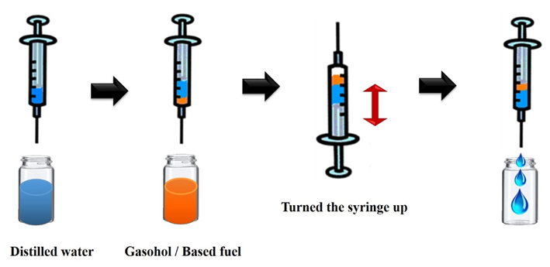
Figure 1. The schematic diagram of the 1st method that proposed for ethanol extraction from gasohol.

Optimization of the extraction device
The devices for extraction of the ethanol from gasohol studied here were burette, glass vial, modified burette and syringe with metal lure lock as shown in the Figure 2. These were used for extraction of standard gasohol fuel with various concentrations of ethanol content of 0, 10, 20, 40 and 60%v/v. The extraction procedure using these various devices was done according to topic 2.3. The extraction ratio used in this study was 1:2 (gasohol: distilled water) for plotting the calibration. The calibrations were plotted between the extracted water weight (y-axis) and concentrations of standard gasohol (x-axis) using different extraction devices.

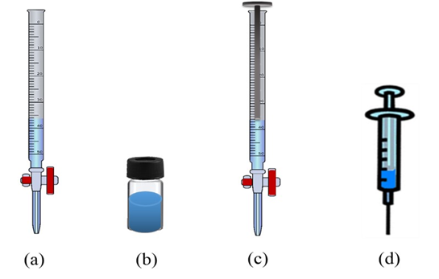
Figure 2. The devices used for the study of ethanol extraction from gasohol (a) commercial burette (b) glass vial (c) modified burette and (d) syringe.

Extraction ratio and sample volume
According to the experiment procedure (Analytical procedure), the ratio of gasohol fuel and distilled water was varied among 1:1, 1:2 and 1:3. In this study, the sample volume of 1 mL was used for varying these ratios. For sample volume study, the optimum ratio was used in this investigation varying the sample volumes of 0.6, 1.0 and 2.0 mL, respectively. Both studies, the comparisons of absorbance between the extracted ethanol and standard ethanol in water were studied using the regression line method as criterion.

Results and Discussion
Extraction device
These devices: burette, glass vial, modified burette and syringe with metal lure lock were used for the optimized extraction device study. The linearity, sensitivity and correlation coefficient (r²) were considered as criterion for the suitability of the extraction device. As shown in the Table 1, the sensitivities, which were slopes of the linear equations, were almost identical (0.0143-0.0149). However, the correlation coefficient (r²) created from the syringe was the closet to 1 (0.9896), while r² for the glass vial was slightly lower (0.9619) probably because of the many transfers step involved. Thus, the vial method was found to be less suitable as an ethanol extraction device. Considering the relative standard deviation (%RSD), the results illustrated that the highest value and subordinate values were burette, vial, modified burette and syringe, respectively (Table 1). This indicated that both the modified burette and syringe exhibited good precision. Nevertheless, considering convenience, controlling the volume of distilled water or gasohol using the modified burette was more difficult than the syringe. Consequently, the syringe with a metal lure lock was chosen as the most appropriate extraction device for extraction of ethanol.

Table 1. Linear equation, correlation coefficient, relative standard deviation (%RSD) of all studied extraction devices: burette, glass vial, modified burette and syringe

Extraction device | Linear equation | Correlation coefficient (r²) | %RSD  (n= 3)
Burette | y = 0.0145x - 0.0144 | 0.9778 | 1.8
Glass vial | y = 0.0149x - 0.0285 | 0.9619 | 0.9
Modified burette | y = 0.0147x + 0.0650 | 0.9823 | 0.7
Syringe | y = 0.0143x + 0.1336 | 0.9896 | 0.6

Optimization of the extraction condition: Extraction sequence
The extraction sequence was studied by different series of gasohol and distilled water. Here, the sequence of extraction was divided to 3 sets: (i) suction of 4.0 mL distilled water and then 2.0 mL standard gasohol (ii) suction of 2.0 mL standard gasohol and then 4.0 mL distilled water (iii) the series of 2.0 distilled water, 1.0 mL standard gasohol, 2.0 distilled water and finally 1.0 mL standard. The criteria sensitivity and relative standard deviation (%RSD) were used to compare the methods. The results shown in Table 2, found that the 3rd method gave the highest sensitivity due to the higher surface contact between the gasohol and water. However, it was found that this method also gave a poor method precision (the highest %RSD). It may because of difficult control of the capacitance of these solutions. The 2nd method gave the lowest slope of linearity range (sensitivity) compared to other methods, perhaps due to the easier evaporation of ethanol in gasohol. In the 1st method, the distilled water was pulled first and the gasohol was sucked later. Ethanol in the gasohol could be more easily trapped in the distilled water than in the 2nd set. It may be reason of the sensitivity of the 2nd one showed the higher value (slope of linearity). In addition, the precision in the 1st set was greater than the 2nd method (%RSD = 0.7467 and 1.0237 for the 1st and the 2nd sets, respectively). Consequently, the 1st method was selected for the extraction of ethanol content in gasohol for further work.

The ratio of gasohol and distilled water

In this study, the ratio of gasohol fuel and distilled water was varied among 1:1, 1:2 and 1:3. The absorbance of extracted ethanol results was compared to these of standard ethanol in water using the regression line method is shown in Figure 3 As a compromise between the correlation coefficient (r²) and extraction percentage for these ratios (Table 3), a ratio of 1:3 was chosen for further work (Figure 3).

Table 3. Linear equations, correlation coefficient (r²) and extraction percentage of standard ethanol for the extraction at various ratios of samples (gasohol) and distilled water

Ratio of extraction | Linear equation | Correlation coefficient (r²) | Percentage extraction of extracted ethanol at various concentrations (%v/v)
Ratio of extraction | Linear equation | Correlation coefficient (r²) | 10 | 20 | 40 | 60 | 80 | 100
1 : 1 | y = 0.0177x + 0.0264 | 0.9964 | 71 | 72 | 62 | 53 | 52 | 50
1 : 2 | y = 0.0178x - 0.0612 | 0.9976 | 85 | 86 | 60 | 76 | 76 | 72
1 : 3 | y = 0.0175x - 0.0273 | 0.9958 | 94 | 82 | 89 | 90 | 84 | 82

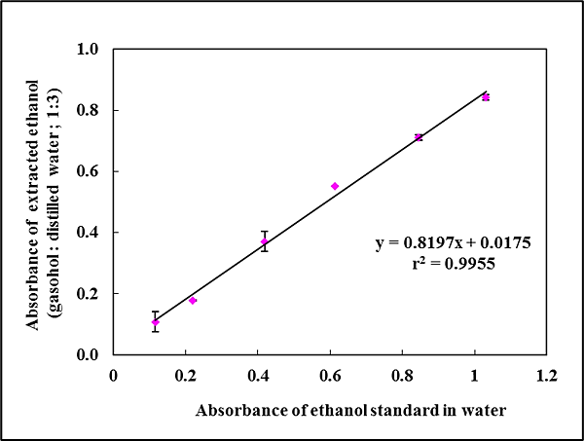

Figure 3. The plot of absorbance of extracted ethanol in water (from gasohol) and standard ethanol (the regression line method)

Volume of gasohol and distilled water for 1:3 ratio extraction
The volume of standard gasohol and extractant (distilled water) at 1:3 extraction ratio was studied. The volume (mL) of gasohol : distilled water was 0.6: 1.8; 1.0: 3.0; 2.0: 6.0 mL, respectively. The standard gasohol concentrations of ethanol content of 0, 10, 20, 40, 60 and 100 %v/v were studied for construction of calibration plots. The results (Figure 4) showed that the ratio of 2.0 mL gasohol : 6.0 mL distilled water gave the highest sensitivity and r². Thus, the volume of standard gasohol fuel and distilled water of 2.0 : 6.0 mL was selected for all subsequent experiments. Finally, the optimized extraction conditions for the ‘reagent-free’ method were listed in Table 4.

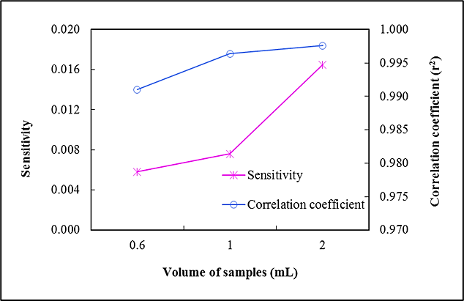

Figure 4. The relation plots of sensitivities (pink line) and correlation coefficient (r²) (blue line) of the extraction method with ratio of sample or gasohol : distilled water of 1:3 with sample volumes

Table 4. Optimization of experimental parameters for extraction of ethanol in gasohol

Parameter | Studied Condition | Selected Condition
Extraction sequence | 1st method (the distilled water was pulled first, and the gasohol was sucked later).  2nd method (the gasohol was pulled first, and the distilled water was sucked later).  3rd method ( switching the distilled water and gasohol). | 1st method
The ratio of gasohol and distilled water | 1 : 1  1 : 2  1 : 3 | 1 : 3
Volume of gasohol and distilled water for 1:3 ratio extraction (mL) | 0.6 : 1.8  1.0 : 3.0  2.0 : 6.0 | 2.0 : 6.0

Analytical performance: Linearity range
The capability of the proposed method for ethanol analysis was investigated using ‘reagent-free’ method. This method showed the two linearity ranges of 3-100 %v/v with r² of 0.9976 as shown in Figure 5.

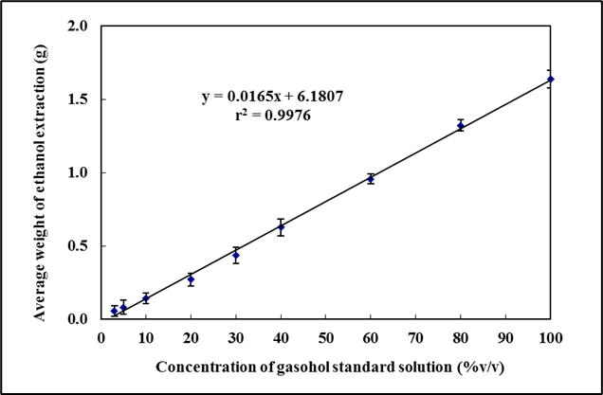

Figure 5. The calibration plots from the ‘reagent-free’ method corresponding to different concentrations of ethanol in the range of 3 to 100 %v/v

Limit of detection (LOD) and limit of quantitation (LOQ)
The LOD was 1.4 %v/v while the LOQ was 4.6 %v/v (Table 5), these were calculated by 3SD/slope and 10SD/slope, respectively. SD is the standard deviation of a series of replicate analyses and the slope is the gradient of the calibration curve.

Table 5. Analytical parameters for determination of ethanol in gasohol using ‘reagent-free’ method

Parameter | Optimized Value
Linearity range (%v/v) | 3 - 100
Linear equations: | y = 0.0165x + 6.1807 (r²= 0.9976)
LOD (%v/v) | 1.4
LOQ (%v/v) | 4.6
% RSD (n=10) | <1
% Recovery | 88.0 -111

Repeatability
The precision of the method or repeatability is represented by the relative standard deviation (%RSD). For concentrations of standard gasohol were 10 and 20%v/v, the %RSD of the weight were less than 1% for 10 replicate analyses (Table 6). This indicated that the proposed ‘reagent-free’ method provided a good precision for determination of ethanol in gasohol fuel.

Table 6. Relative standard deviation (%RSD) for precision study of the proposed method

Ethanol Concentration  (%v/v) | Average Weight of Extracted Ethanol  (g)* | Relative Standard Deviation  (%RSD)
10 | 6.3688 ± 0.0466 | 0.73
20 | 6.4977 ± 0.0610 | 0.94
^{Note * n = 10}

Recovery percentage
To test the accuracy of the ethanol analysis in gasohol fuel the standard addition method with the reagent-free method was used to evaluate as the recovery percentage. Normally gasohol fuel (10% v/v) called E10, is found at fuel service stations in Thailand. Thus, different brands of E10 were used in this study. The recoveries achieved for the samples spiked with various concentrations of ethanol were in the range of 88 -111% as shown in Table 7. This indicated that the proposed method was reliable for determination of ethanol in real samples.

Table 7. Recovery percentage for determination of ethanol in gasohol samples using the developed method

Sample | Concentration of Ethanol (%v/v) |  |  |  | Recovery  (%)
Sample | Added | Found  (mean ± SD; n = 3) |  |  | Recovery  (%)
A | - | 9.1 | ± | 0.0106
 | 5 | 13.6 | ± | 0.0173 | 89.8
B | - | 9.8 | ± | 0.0091
 | 5 | 15.3 | ± | 0.0116 | 111
C | - | 8.9 | ± | 0.0093
 | 5 | 14.3 | ± | 0.0076 | 108
D | - | 9.3 | ± | 0.0214
 | 5 | 13.7 | ± | 0.0138 | 87.6
E | - | 19.8 | ± | 0.0084
 | 5 | 25.7 | ± | 0.0168 | 117

Sample analysis
The determination of the ethanol content in gasohol fuel (real samples) was achieved using the external standard method. The results obtained using this method agreed with the data from gas-chromatography (GC) for all samples as shown in Table 8. The paired t-test [27] showed that the ethanol contents in real samples determined by the reagent-free methods were not significantly different from the contents given by gas-chromatography the at the 95% confidence level (t_{stat} = 2.41, t_{crit} = 2.78). This showed that the developed method was accurate and reliable for determination of ethanol in gasohol.

Table 8. Validation of the ‘reagent-free method’ by comparison the results with the standard gas chromatography

Sample | Type Of Gasohol | The Proposed Method | Standard Method  (Gas-Chromatography: GC)
A | E10 | 9.3 $\text{±}$ 0.1 | 10.7 $\text{±}$ 0.1
B | E10 | 10.7 $\text{±}$ 0.6 | 10.2 $\text{±}$ 0.1
C | E10 | 10.0 $\text{±}$ 0.6 | 11.3 $\text{±}$ 0.2
D | E10 | 9.2 $\text{±}$ 1.5 | 10.0$\text{±}$ 0.1
E | E20 | 19.5 $\text{±}$ 0.6 | 20.8 $\text{±}$ 0.3
Note E10 is 10% v/v and E20 is 10% v/v of ethanol added in based fuel. Sample A-E were purchased from the gas stations in Chonburi province of Thailand.

Conclusion

A reagent-free method was developed and applied to the analysis of ethanol content in gasohol fuel. The proposed experimental process uses no chemicals including using syringes in the experimental procedure that are commonly available is easy. Especially, other experimental devices are simple and economical. The responses of the method were found to be linear in the range of 3-100 %v/v of ethanol, Additionally, a comparison of the accurate values given by the gas chromatographic method and the proposed method revealed that there is no significant difference between the two methods. This suggests that the proposed method is valid alternative for determination of ethanol in fuel. Additionally, another application of the proposed method is in education especially quantitative analysis. Due to simple equipment non-toxicity and easy to operation.

Acknowledgement

This work was financially supported by the Research Grants from Burapha University and Government Budget Grant (B.E. 2562) through the National Research Council of Thailand (Grant no. 57.2/2562). We would like to enunciate thank to Miss Chinanan Sauguanboonyapong for undertaking the GC experiments. Additionally, we would like to thank the Faculty of Science, Burapha University for providing in English proofreading service for academic manuscripts. We express thanks to Dr. Ronald Beckett for useful suggestions on the manuscript.

References
1. Muncharoen, S., Sitanurak, J., Tiyapongpattana, W., Choengchan, N., Ratanawimarnwong, N., Motomizu, S., Wilairat, P. and Nacapricha, D. (2009). Quality control of gasohol using a micro-unit for membraneless gas diffusion. Microchimica Acta, 164(1): 203-210.
2. Alhadeff, E. M., Salgado, A. M., Pekeira, N. and Valdman, B. (2004). Development and application of an integrated system for monitoring ethanol content of fuels. Applied Biochemistry and Biotechnology - Part A Enzyme Engineering and Biotechnology, 113(1-3): 125-136.
3. Zinbo, M. (1984). Determination of one-carbon to three-carbon alcohols and water in gasoline/alcohol blends by liquid chromatography. Analytical Chemistry, 56(2): 244-247.
4. Silalertruksa, T., Gheewala, S. H. and Pongpat, P. (2015). Sustainability assessment of sugarcane biorefinery and molasses ethanol production in Thailand using eco-efficiency indicator. Applied Energy, 160(1): 603-609.
5. Gani, M. (2018). Production of bioethanol from sugarcane bagasse using saccharomyces production of bioethanol from sugarcane bagasse using Saccharomyces cerevisiae. Journal of Basic & Applied Mycology (Egypt), 22(1): 1-8.
6. Ajibola, F. O., Edema, M. O. and Oyewole, O. B. (2012). Enzymatic production of ethanol from cassava starch using two strains of Saccharomyces cerevisiae. Nigerian Food Journal, 30(2): 114-121. 7. Adeleye, T. M., Kareem, S. O., Mobolaji, O., Atanda, O. and Adeogun, A. I. (2020). Ethanol production from cassava starch by protoplast fusants of Wickerhamomyces anomalus and Galactomyces candidum. Egyptian Journal of Basic and Applied Sciences, 7(1): 67-81.
8. Yoosin, S. and Sorapipatana, C. (2007). A study of ethanol production cost for gasoline substitution in thailand and its competitiveness. Science and Technology Asia, 12(l): 69-80.
9. Mungkalasiri, W. and Pan-in, B. (2018). Optimization of bioethanol production from raw sugar in Thailand. Science and Technology Asia, 23(1): 57-66.
10. Thailand industry outlook (2021-2023). Ethanol Industry. https://www.krungsri.com/en/research/industry /industry-outlook/Energy-Utilities/Ethanol/IO/io-ethanol-21. [Access Online 10 September 2021].
11. Journal, B., Belincanta, J. and Alchorne, J. A. (2016). The brazilian experience with ethanol fuel: aspects of production, use, quality and distribution logistics. Brazilian Journal of Chemical Engineering, 33(4): 1091-1102.
12. Santos, A. P. F.d., Silva, K. K. D., Borges, G. A., and d’Avila, L. A. (2020). Fuel quality monitoring by color detection. In L.-W. Zeng and S.-L. Cao (Eds.), Color Detection. IntechOpen: pp. 1-22.
13. Drews, A. W. (1998). In manual on hydrocarbon analysis, 6th edition, standard test method for determination of MTBE, ETBE, TAME, DIPE, tertiary-amyl alcohol and C1 to C4 Alcohols in gasoline by gas chromatography. Blatimore: pp. 73-738.
14. Zinbo, M. (2020). Determination of methanol in gasoline and ethanol fuels by high-performance liquid chromatography. Journal of the Brazilian Chemical Society, 31(5): 1055-1063.
15. Morine, L., Pereira, A., Ignácio, D., Mattos, M. De, Gimenes, C., Souza, D., França, D., Andrade, D. and Antonio, L. (2018). Determination of ethanol in gasoline by high-performance liquid chromatography. Fuel, 212: 236-239.
16. Cassada, D. A., Zhang, Y., Snow, D. D. and Spalding, R. F. (2000). Trace analysis of ethanol, MTBE, and related oxygenate compounds in water using solid-phase microextraction and gas chromatography/mass spectrometry. Analytical Chemistry, 72(19): 4654-4658.
17. Battiste, D. R., Fry, E., Ted, B., and Perkin-elmer, T. (1981). Determination of ethanol in gasohol by infrared spectrometry. Analytical Chemistry, 53(1): 1096-1099.
18. Mendes, L. S., Oliveira, F. C. C., Suarez, P. A. Z. and Rubim, J. C. (2003). Determination of ethanol in fuel ethanol and beverages by Fourier transform (FT) -near infrared and FT-Raman spectrometries. Analtica Chimica Acta, 493(2): 219-231.
19. Alhadeff, E. M., Salgado, A. M., Pereira, N. and Valdman, B. (2005). A sequential enzymatic microreactor system for ethanol detection of gasohol mixtures. In Twenty-Sixth Symposium on Biotechnology for Fuels and Chemicals, pp. 361-371.
20. Alhadeff, E. M., Salgado, A. M., Cos, O., Pereira, N. and Valero, F. (2007). Enzymatic microreactors for the determination of ethanol by an automatic sequential injection analysis system. Applied Biochemistry And Biotechnology, 137(1): 17-25.
21. Pereira, P. F., Sousa, R. M. F., Munoz, R. A. A. and Richter, E. M. (2013). Simultaneous determination of ethanol and methanol in fuel ethanol using cyclic voltammetry. Fuel, 103: 725-729.
22. Cardoso, J. L., and Bertotti, M. (2007). The use of a copper microelectrode to measure the ethanol content in gasohol samples. Fuel, 86(7-8): 1185-1191.
23. Tomassetti, M., Capesciotti, G. S., Angeloni, R. and Martini, E. (2016). Bioethanol in biofuels checked by an amperometric organic phase enzyme electrode (OPEE) working in “ substrate antagonism ” format. Sensors, 16(9): 1-10.
24. Campanella, L., Capesciotti, G. S., Gatta, T., and Tomassetti, M. (2010). An innovative organic phase enzyme electrode (OPEE) for the determination of ethanol in leadless petrols. Sensors and Actuators: B. Chemical, 147(1): 78-86.25. Leary, J. J. (1983). A quantitative gas chromatographic ethanol determination: a contemporary analytical experiment. Journal of Chemical Education, 60(8): 675.

26. Hönig, V., Táborský, J., Orsák, M. and Ilves, R. (2015). Using gas chromatography to determine the amount of alcohols in diesel fuels. Agronomy Research, 13(5): 1234-1240.
27. Miller, J. N., and Miller, J. (2010). Statistics and chemometrics for analytical chemistry, 6th edition. Ashford Colour Press Ltd., Gosport: pp. 43-45.

