

DETERMINATION OF RESIDUAL XYLAZINE BY GAS CHROMATOGRAPHY IN DRUG-SPIKED BEVERAGES FOR FORENSIC INVESTIGATION

(Penentuan Sisa Xilazin dengan Kromatografi Gas dalam Minuman Ditambah

dengan Dadah bagi Penyiasatan Forensik)

Nabeesathul Sumayya Mohamed Sadiq¹, Way Koon Teoh¹, Kasrin Saisahas¹, Apichai Phoncai²,

Vanitha Kunalan³, Noor Zuhartini Md Muslim¹, Warakorn Limbut^{1,4,5}, Kah Haw Chang¹,

Ahmad Fahmi Lim Abdullah^{1*}

¹Forensic Science Programme,

School of Health Sciences,

Universiti Sains Malaysia, 16150 Kubang Kerian, Kelantan, Malaysia

²Division of Health and Applied Sciences,

Faculty of Science,

Prince of Songkla University, Hat Yai, Songkhla, 90112, Thailand

³Narcotics Division,

Forensic Science Analysis Centre,

Department of Chemistry, Jalan Sultan, 46661 Petaling Jaya, Selangor, Malaysia

⁴Center of Excellence for Trace Analysis and Biosensors (TAB-CoE),

Prince of Songkla University, Hat Yai, Songkhla, 90112, Thailand

⁵Center of Excellence for Innovation in Chemistry,

Faculty of Science, Prince of Songkla University, Hat Yai, Songkhla, 90112, Thailand

*Corresponding author: fahmilim@usm.my

Received: 16 February 2022; Accepted: 15 June 2022; Published:

Abstract

The utilization of xylazine, a veterinary drug, had recently been reported in drug facilitated crimes (DFC). Victims are incapacitated after consumption of drug-spiked beverages and subsequently exposed to the risk of robbery and sexual assault. In many instances, the suspected drug-spiked beverage samples are available at the scene but the concentration level of xylazine could be very low or restricted by its recoverable amount for forensic testing. To address challenges linked to samples with low or limited recoverable amounts, this study was aimed to establish a laboratory-based gas chromatography method by detecting and quantifying xylazine in drug-spiked beverage samples appearing in liquid, droplet, and dry forms. In this study, a gas chromatography-mass spectroscopy (GC-MS) method was optimized to detect the presence of xylazine, and a gas chromatography-flame ionization detector (GC-FID) method was validated for quantification of the substance. Subsequently, xylazine from four different beverage samples in three different physical forms, simulating the possible forensic settings; were recovered and determined. A validated GC method for the determination and quantification of xylazine within 15 minutes was reported. Limit of detection (LOD) and limit of quantitation (LOQ) were reported at 0.08 µg/mL and 0.26 µg/mL, respectively. Higher recoveries of xylazine were achieved from beverage samples in liquid form (77.2-97.3%) compared to droplet (50.8% – 80.0%) and dry samples (39.8% – 66.9%). This study evidenced that limited volume of leftover beverage samples, and even the dried samples; did not hinder the recovery of the targeted drug. To conclude, a gas chromatographic technique was successfully established for the determination of residual xylazine in drug-spiked beverages that can then provide valuable investigative technique to laboratory analysts and crime scene officers in DFC investigations.

Keywords: forensic science, drug-facilitated crime, xylazine, gas chromatography, drug spiked beverage

Abstrak

Baru-baru ini, penggunaan xilazin, sejenis ubat haiwan, telah dilaporkan dalam jenayah disebabkan dadah (DFC). Mangsa menjadi lemah selepas meminum minuman yang ditambah dengan dadah dan seterusnya terdedah kepada risiko rompakan dan gangguan seksual. Dalam kebanyakan situasi, sampel minuman yang disyaki telah dimasukkan dadah boleh dijumpai di tempat kejadian tetapi tahap kepekatan xilazin berkemungkinan amat rendah atau dibatasi oleh jumlah yang boleh diperolehi semula untuk pengujian forensik. Untuk mengatasi cabaran dalam mengaitkan sampel yang berisipadu rendah atau mempunyai kebolehpulihan yang terhad, kajian ini bertujuan untuk membangunkan satu kaedah kromatografi gas yang berasaskan makmal dengan mengesan dan menentukan kuantiti xilazin dalam sampel minuman yang dimasukkan dadah yang wujud dalam keadaan cecair, titisan dan kering. Dalam kajian ini, satu kaedah kromatografi gas-spektrometri jisim (GC-MS) telah dioptimumkan untuk mengesan kehadiran xilazin dan satu kromatografi gas-pengesanan pengionan nyalaan (GC-FID) telah ditentu-sahkan untuk pengkuantitian sebatian tersebut. Seterusnya, xilazin daripada empat sampel minuman dalam tiga keadaan fizikal berlainan, menyerupai tetapan forensik yang berkemungkinan, telah diperolehi semula dan ditentukan. Satu kaedah GC yang sah bagi penentuan dan penentuan kuantiti xilazin dalam 15 minit telah dilaporkan. Had pengesanan (LOD) dan had pengkuantitian (LOQ) telah dilaporkan masing-masing pada 0.08 μg/mL and 0.26 μg/mL. Xilazin dapat diperoleh semula daripada sampel minuman dalam keadaan cecair dengan peratusan yang lebih tinggi (77.2-97.3%) berbanding dengan sampel titisan (50.8 – 80.0%) dan sampel kering (39.8 – 66.9%). Kajian ini membuktikan bahawa isipadu sampel minuman tertinggal yang terhad dan dalam keadaan kering tidak menghalang perolehan semula dadah yang disasarkan. Kesimpulannya, satu kaedah kromatografi gas telah berjaya dibangunkan untuk menentukan sisa-sisa xilazin dalam minuman yang dimasukkan dadah. Hal ini dapat membantu teknik penyiasatan kepada juruanalisis makmal dan pegawai tempat kejadian dalam penyiasatan DFC.

Kata kunci: sains forensik, jenayah disebabkan dadah, xilazin, kromatografi gas, minuman yang dimasukkan dadah

Introduction

Xylazine serves as relaxant, sedative, analgesic, and anti-hypertensive agent [1–3]. It is widely used in veterinary practice but is not approved by the Food and Drug Administration (FDA) for human use [3] due to its deleterious side effects such as bradycardia, hypotension, and possibly death [4, 5]. The substance is not scheduled as a controlled substance by the Drug Enforcement Administration (DEA) [6]. In South-East Asian countries, for instance, xylazine is accessible to certain groups of people, such as veterinary personnel and animal trainers under the Poison Act 1952 in Malaysia [7] whereas it is scheduled as a controlled substance in Thailand [8]. According to the FDA, the use of xylazine in “food-producing animals” is specifically not allowable in the United States of America; however, in Canada, United Kingdom, France, Germany, and Switzerland, xylazine can legally be used in food-producing animals [3, 9]. In fact, this substance is still accessible in the market, commonly in injectable solutions, such as Rompun®, Sedazine®, and Anased® [5].

Drug-facilitated crime (DFC) is a serious issue worldwide. It refers to crimes committed whenever victims of the crime are placed under the influence of drugs [10]. More specifically, drug-facilitated sexual assault (DFSA) occurs whenever sexual assault has been committed with a victim has been drugged by the rapist beforehand [11]. The victim had previously unknowingly consumed either a beverage or food that was spiked with drugs and sexual assault occurred without the knowledge, understanding, or consent of the victim due to the drug’s affect. In other words, drugs originally designed for medicinal or veterinary use have been illegally used to incapacitate victims by exploiting the pharmacological effects of such drugs [12, 13]. Common examples include benzodiazepine [14-17], ketamine [14, 18] and gamma hydroxybutyrate (GHB) [19-20]. Recently, xylazine was also found in the list [21-25].

One way of DFC modus operandi is via drug-spiked beverages, whereby the beverages are allegedly produced by the unsolicited addition of drugs into them in drug-facilitated crimes, especially in robbery and rape cases [26]. Recent cases reported drug-spiking incidents through the addition of xylazine into a victim’s drink which alleged of sexual assault and robbery utilizing the sedative effects of xylazine [21]. Upon consumption of the spiked drinks, the victims would suffer intoxication with blurred vision, shortness of breath and vomiting before passing out shortly after [3,21]. In view of its potential abuse in DFC and DFSA, the searching of forensic evidence and successful detection of illicit drug contained in drug-spiked beverages is crucial for obtaining justice for victims.

Previous studies have suggested various instrumental techniques in detecting xylazine, for instance gas chromatography (GC) [27, 28], liquid chromatography [21, 28], thin layer chromatography [4] and electrochemical technique [29, 30]. These published articles and technical reports have undoubtedly provided significant contributions, mainly on the toxicology studies in human through the analysis of biological samples. Nonetheless, limited information could be retrieved from published works, particularly from the perspective of forensic related evidence, including the seizure of xylazine as an illicit drug or as an adulterant. The mass spectrometry detector was frequently employed in GC analysis of xylazine as a screening approach [21, 31]. In comparison to gas-chromatography-mass spectrometry (GC-MS), gas chromatography equipped with flame ionization detector (GC-FID) analysis can also serve as a reliable, sensitive, and reproducible method for trace analyses, depending on the structure and behavior of the analyte of interest [32]. When dealing with spiked drink samples, liquid-liquid extraction (LLE) was found to be the most common method applied in forensic drug analyses due to its low cost, comparably rapid and the procedures are easy to implement [33]. A portable electrochemical sensor was recently developed to provide quick, on-scene screening of xylazine in spiked drinks [34]. However, a laboratory-based technique would be crucial in supporting the forensic analysis for drug confirmation.

Additionally, the misuse of xylazine in DFC through the spiking of drug into beverages of victims is particularly serious that needs urgent actions from law enforcement agencies and testing laboratories. In certain cases, a victim claimed that his/her drink has been spiked with drugs, but the obtained sample had tested negative [35]. When dealing with biological samples, a false negative result could be reported due to delayed sample collection and detection [35]. Literature has reported the calculated plasma half-life of xylazine in human plasma was 4.9 hours [36]. As a victim suffers from an altered state of mind or other psychoactive effect upon intoxication, it would further increase the time elapsed between the occurrence of a crime and eventual forensic analysis, as well as pose challenges to rely solely on a witness’s statement for legal recourse [37]. In such situation, alternative sample i.e., consumed drinks, could be proposed as evidence to be collected from the glass left at crimes scenes.

Therefore, a study was designed to detect and quantify xylazine from beverages collected directly from drinking containers where the drug residues present might be at trace level. A GC technique was optimized and validated, taking into consideration that such an instrument is routinely used and available in most forensic laboratories. GC-MS was utilized to confirm the presence of xylazine, followed by GC-FID, used to quantitate xylazine that are found in spiked sample. Subsequently, the detection and quantification of xylazine in spiked beverages were investigated with the aid of LLE techniques. Other than appearing in liquid form, a glass or a cup suspected to have contained xylazine could be left with a few residual drops or even have dried off traces. As such, samples present in such states ought to be simulated and explored to maximize potential forms of evidence tracing in alleged DFC. It is hoped that this analytical method would aid in detecting the target drug in suspected spiked beverages to assist forensic investigation and to facilitate the tracing of suspects, while providing some insights to decide crime scene sampling decision by the crime scene officers.

Materials and Methods

Materials and chemicals

Dichloromethane (DCM) of GC grade was obtained from Merck (Whitehouse Station, NJ). Xylazine hydrochloride standard was purchased from U.S. Pharmacopeia (Rockville, MD). 2,2,2-triphenylacetophenone was used as an internal standard (IS), and certified reference material (CRM) standards of heroin, paracetamol, caffeine, codeine, morphine, 6-monoacetylmorphine and ketamine (≥99%); were obtained from the Department of Chemistry Malaysia. Analytical grade sodium hydroxide and anhydrous sodium sulphate were sourced from Merck (Whitehouse Station, NJ).

Ultrapure water (18.2 MΩ) was prepared in-house from a Millipore water purification system (Bedford, NY). Sample beverages (mineral water, carbonated drink, energy drink, and commercial fruit juice) were purchased from the local supermarket. The drinking glasses used in this study were obtained from a nearby kitchenware store.

Instrumentation

An Agilent 7890B GC system equipped with split/splitless injector and a 5977B Mass Spectrometer (MS) (Santa Clara, CA) was utilized to confirm the presence of xylazine. Chromatographic separation was achieved using a (5%-phenyl)-methylpolysiloxane (HP-5) capillary column (30 m × 0.32 μm i.d., 0.25 µm film thickness) purchased from Agilent Technologies (Santa Clara, CA). Purified helium gas (99.9% purity) was used as the carrier gas with a constant flow rate of 1 mL/min. The front inlet was set at 280°C. The oven temperature program began with an initial temperature of 170°C and held for 2 mins. The temperature was gradually increased to reach a temperature of 210°C at 20°C/min and subsequently ramped to 220°C at 3°C/min. It was further increased to 280°C at 50°C/min, and the final temperature was held for 6 mins. Data acquisition rate was set at 1.0 scan/sec and mass spectra were collected in scan mode from m/z 41 to m/z 500. The target compounds were studied, and the resultant peaks were identified using the NIST mass spectral library (Version 2.0) (National Institute of Standards and Technology, Gaithersbury, MD) and literature search.

An Agilent 7890A Gas Chromatographic system equipped with a split/splitless injector and a Flame Ionization Detector (FID) (Agilent Technologies, Santa Clara, CA) was used for quantification of xylazine. HP-5 capillary column with a splitless injection mode was used, and the purified nitrogen gas (99.9% purity) was utilized as the carrier gas at a constant flow rate of 1 mL/min. Liquid injection mode was performed at a constant inlet temperature (280°C). The initial oven temperature was set at 170°C with an equilibration time of 2 min. A temperature ramp of 20°C/min was selected to reach the maximum of 210°C and ramped to 220°C at 3°C/min. It was further increased to 280°C at 50°C/min and held for 6 mins. Hydrogen flow, air flow, and the make-up flow (purified nitrogen gas) were supplied to the detector at 30, 300, and 15 mL/min, respectively. A volume of 1 µL of standard solution or the extract from beverage samples were introduced into the injector port. Chemstation software (Rev. B.04.02, Agilent, Santa Clara, CA) was used for GC automation and data analysis. All standards and IS were identified by comparing the retention time.

Method validation

The xylazine stock solution with a concentration of 1 mg/mL was prepared in DCM. A 5 µg/mL internal standard was also prepared in DCM. Calibration standard solutions ranging from 5 µg/mL to 100 μg/mL were prepared independently by adding in a pre-determined volume of stock solution into volumetric flasks and diluting with DCM. Quality control (QC) solutions at three concentration levels, namely QC_{low}, QC_{medium}, and QC_{high}, were prepared at respective concentration levels of 15, 45, and 75 μg/mL using a separately prepared stock solution.

In this study, GC parameters were adjusted accordingly to establish chromatographic conditions with optimum results and good peak separation. Subsequently, the GC method was validated according to the criteria set by United Nations Office on Drugs and Crime (UNODC) [38]. Selectivity, linearity range, limit of detection and limit of quantitation, repeatability and reproducibility, and the accuracy of the analytical method were evaluated.

Selectivity was investigated by analyzing substances that potentially occur together with xylazine according to previous literatures [39-41], including paracetamol, caffeine, ketamine, codeine, morphine, 6-monoacetylmorphine, and heroin with a concentration 10 µg/mL of mix standard. Linearity assessment was performed by analyzing eight levels of xylazine calibration standards ranging between 5 µg/mL and 100 µg/mL for six times. The detection limit (LOD) was determined as concentration that produced 3:1 signal-to-noise ratio, and the limit of quantification (LOQ) of the developed method was calculated by 10:1 signal-to-noise ratio, as equivalent to 3.3 times LOD. The repeatability was assessed through the determination of relative standard deviation (RSD) upon ten times injection of three QC solutions consecutively on the same day (intra-day), while the reproducibility was evaluated by the measurements taken on three consecutive days (inter-day). The accuracy of the method was also measured by analyzing the three QC solutions and was expressed as percentage recovery.

Sample extraction

Liquid-liquid extraction (LLE) procedure was performed prior to GC analysis. Briefly, a volume of 1 mL of beverage sample aliquot spiked with xylazine of definite concentration level was carefully transferred into a vial and adjusted to alkaline pH (pH ≈11) using 13% sodium hydroxide solution. The pH of liquid sample was pre-verified using pH litmus paper. Subsequently, the aliquot was extracted with 0.5 mL of DCM twice. Upon extraction, the extracted solution was combined, passed through anhydrous sodium sulphate, and evaporated carefully under a gentle stream of nitrogen gas. Lastly, the residue was reconstituted with 100 µL of 10 µg/mL internal standard solution.

Analysis of xylazine-spiked beverage samples

The recoveries of extraction from the four beverage samples were determined by assaying spiked samples in five replications at concentration levels of 15, 45, and 75 μg/mL. Beverages were chosen based on the range of possible household beverages that would commonly be encountered in drink spiking cases. The selected beverages represented a plain water, an energy drink, a carbonated drink, and a fruit-based drink. To simulate the real case scenario, three different settings of xylazine-spiked beverage samples were prepared.

Firstly, a beverage with remaining at least 2 mL in its volume can be encountered at a scene (spiked liquid samples). To simulate such a setting, the definite amount of xylazine standard was spiked into the respective beverage samples. Following, 1 mL of the spiked liquid beverages were subjected to LLE procedure.

Secondly, leftover of any beverages priorly spiked with xylazine can appear as droplets (spiked droplet samples). To simulate this case, 1 mL of each sample beverage carrying the respective concentration levels was separately sprayed into drinking glass and left for a three-hour duration. Note that such duration did not dry the residues but remained as droplet samples. Then 1 mL of the distilled water was used to rinse the inner surface of the drinking glasses. The rinsates were collected and subjected to LLE procedure.

Thirdly, a beverage sample suspected to have been spiked with drug can exist in completely dry form, either due to the complete consumption by an individual or because of the extended duration of exposure to room conditions (spiked dry samples). To simulate the third scenario, 1 mL of sample beverages with definite concentration of xylazine was sprayed into drinking glass and left overnight to dry undisturbed. Then, 1 mL of distilled water was used to rinse the inner side of the drinking glasses and the rinsate was subjected to LLE procedure.

All prepared samples were analyzed by the validated GC method. Recovery percentages of xylazine from each beverage appearing at three different scenarios were calculated, evaluated, and compared.

Results and Discussion

Through the analysis, it was found that the GC-FID method was selective toward paracetamol, PCM (5.61 min), caffeine, CF (7.02 min), ketamine, KET (7.32 min), xylazine, XYZ (8.23 min), codeine, CD (10.70 min), morphine, MP (11.11 min), 6-monoacetylmorphine, MM (11.74 min), heroin, HR (12.65 min) and 2,2,2-triphenylacetophenone, IS (13.48 min), as shown in Figure 1. The presence of xylazine was also confirmed using the GC-MS, and a mass spectrum which most abundant molecular peak of m/z appeared at 205.1 and 220.1 is demonstrated in Figure 2. Calibration curve of peak area ratio against concentration was plotted with an equation of y = 0.205x - 0.0583 with a correlation coefficient of 0.997, suggesting the direct proportional relationship with the concentration of the analyte. For the established method, LOD and LOQ were determined as 0.08 μg/mL and 0.26 μg/mL, respectively, allowing detection and quantification at low microgram levels. This analytical ability of achieving very low LOD and LOQ is important in forensic cases, especially in scenarios where the amount of xylazine available for detection might appear at trace level such as in spiked beverages.

Figure 1. Chromatograms on the selectivity test of the developed method using GC-FID method.

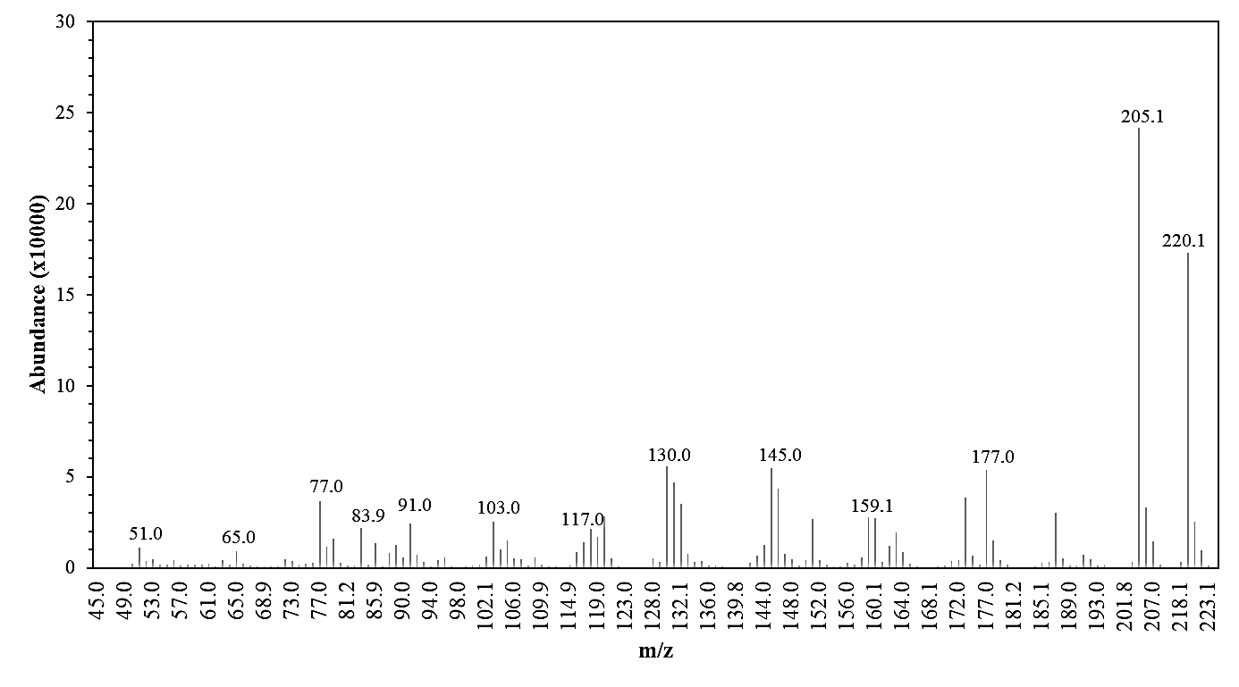

Figure 2. Mass spectrum of xylazine

This study showed good precision, where the intra-day precision reported RSD ranged from 0.5% to 0.7%, while the inter-day precision demonstrated a range of RSD between 1.6% and 3.9%. Repeatable and reproducible data were generated from multiple analyses of the same samples. For accuracy test, recoveries of xylazine from three different QC concentration levels were ranged between 97.3% to 100.7%, i.e., ± 5.0% of the pre-determined concentrations. The GC method proposed here met the intended scope of xylazine analysis, subsequently applied to test the recoveries of the targeted drug from various beverage samples.

Prior to sample analyses, beverage-negative controls, i.e., the extract of beverage-negative without addition of any drug; were run to determine possible matrix interference originating from the beverages. Figure 3 shows the representative chromatograms of beverages-negative controls and xylazine-spiked beverage samples. With the exception of mineral water, it was found that certain substances had been co-extracted, indicated by the presence of extraneous peaks in the chromatograms. Compounds extractable by the LLE procedure were detected, and the presence of caffeine peak was especially evident in both the chromatograms generated from the analyses of beverage-negative carbonated and energy drinks tested in this study. The composition contained in the fruit-based beverage also contributed to extraneous peaks in the chromatogram of beverage-negative control, thus, deserving further identification, perhaps through mass spectrometry, if the identities of these chemical substances are of concern, and they are beyond the scope of this current study.

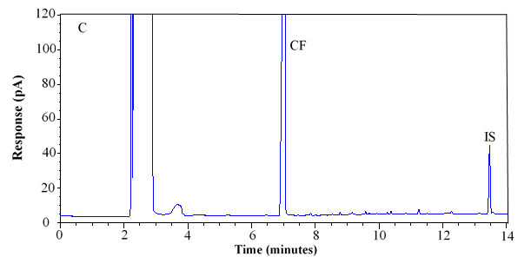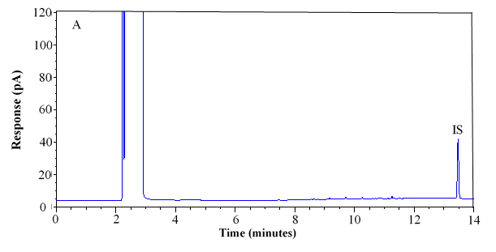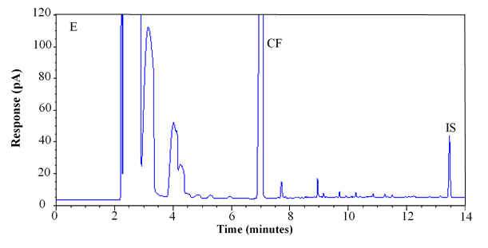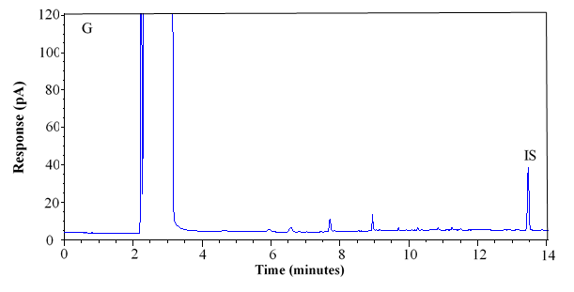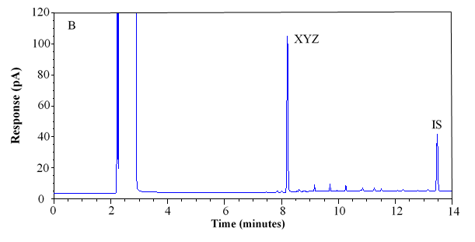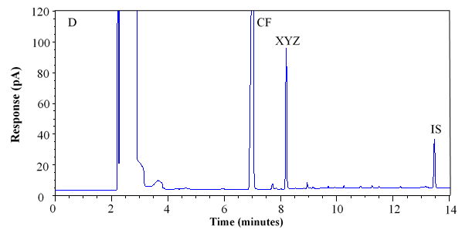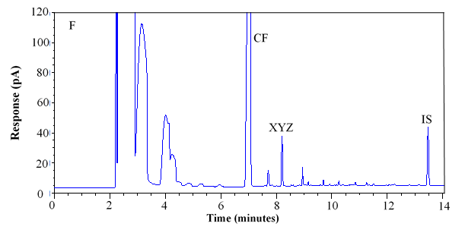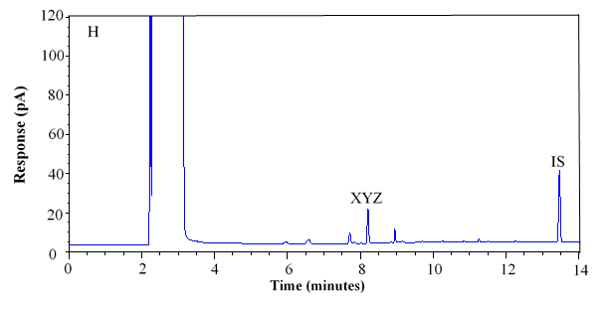
CF

Figure 3. Representative chromatograms of negative control and spiked samples; (A-B) mineral water; (C-D) carbonated drink; (E-F) energy drink; (G-H) fruit-based drink

Although extraneous peaks originated from the beverages were noticed in their respective chromatographic outputs, all these peaks did not interfere the determination and quantification of xylazine as its peak was well-separated from the potential interferences. As a good laboratory practice, it is recommended that a beverage-negative control run is performed in every instance whenever the recovery of a target drug from any beverage is to be determined. This is to avoid obtaining a false positive result, especially in drug-spiked beverage samples.

Under the optimized LLE procedure, DCM was chosen as the extracting solvent due to its relatively good polarity that could increase the recovery efficiency [42]. Apart from that, multiple extraction could potentially increase the distribution coefficient of xylazine [43], while the xylazine was extracted upon basifying the aqueous sample to pH 11 in this study. As a basic drug, alkaline aqueous sample, in this case the beverage sample, allowed greater extraction of the analyte to the DCM layer [43]. It is noted that all drinks except mineral water were appeared acidic in their respective original forms. Therefore, all the solution were made basic for better recovery efficiencies.

Recoveries of xylazine were determined through the evaluation of the extraction efficiency from beverage samples appearing in liquid, droplet, and dry forms. Spiked levels of xylazine with respective mass of 1.5 µg, 4.5 µg and 7.5 µg were utilized, and Table 1 demonstrates the recovery percentages of the drug for each beverage samples.

Table 1. Recoveries (± RSD) of xylazine from the four different beverages

Beverage Sample | 1.5 µg | 4.5 µg | 7.5 µg
Liquid form beverage sample
Mineral Water | 97.3 + 0.9% | 92.1 + 1.7% | 90.1 + 2.8%
Carbonated drink | 90.7 + 5.7% | 90.0 + 3.2% | 85.5 + 2.1%
Fruit-based drink | 87.8 + 7.0% | 82.0 + 8.6% | 77.2 + 5.3%
Energy drink | 89.8 + 5.3% | 84.1 + 3.5% | 82.2 + 6.4%
Droplet beverage sample
Mineral Water | 71.9 + 9.0% | 80.0 + 7.9% | 75.5 + 4.4%
Carbonated drink | 69.8 + 14.3% | 72.0 + 7.9% | 75.9 + 3.9%
Fruit-based drink | 50.8 + 5.3% | 59.3 + 9.9% | 54.6 + 11.6%
Energy drink | 59.2 + 16.7% | 54.3 + 15.9% | 56.5 + 12.1%
Dry beverage sample
Mineral Water | 60.8 ± 14.5% | 56.1 ± 8.4% | 60.5 ± 8.5%
Carbonated drink | 57.7 ± 4.3% | 58.3 ± 7.7% | 66.9 ± 5.3%
Fruit-based drink | 51.3 ± 16.2% | 49.7 ± 11.6% | 45.1 ± 11.3%
Energy drink | 50.3 ± 10.2% | 42.7 ± 8.9% | 39.8 ± 12.4%

In this study, the percentages of xylazine successfully recovered from the liquid beverage samples ranged between 77.2% and 97.3%, depending on the beverages used as the substrates. Meanwhile, percentage recoveries were reported relatively lower in both droplet (50.8-80.0%) and dry samples (39.8-66.9%). In other words, the extraction procedure implemented in this study appeared to be more effective in recovering the target drug from a liquid beverage sample. Unlike liquid sample, both droplet and dry form of samples were highly subjected to variation as they were exposed to the surrounding environment. Perhaps, the variations might be greater in real case scenarios when samples have to be recovered from non-laboratory settings.

Through GC analysis, the amount of xylazine contained in a liquid beverage sample could be quantified with recoveries greater than 82%. It is noted that the recovery and detection of sedative-hypnotics from beverage samples using gas chromatographic method is not a new practice implemented by the forensic communities, especially for the determination of DFC. Research had also been carried out for the detection of various drugs in beverages, including benzodiazepines [14-17], ketamine [14, 18] and GHB [19, 20]. However, to the authors’ knowledge, the current study was the first to investigate the determination of xylazine from spiked beverages, with the substance having similar effects as in the above-mentioned drugs on the victim after consumption.

Through the analyses, the composition of beverages could have interfered the extraction efficiencies in recovering the target drug [44, 45], in this case the xylazine. In this study, mineral water with the least matrix interference was found to allow better recoveries of the target drug from liquid samples, reporting at percentages greater than 90%. By comparison, substrates carrying greater matrix within their composition were reported with relatively lower recoveries but remained greater than 82%.

Literatures had suggested a wide range of recovery percentages from 70% and 110% based on the target illicit drugs and beverages used under different experimental conditions [14, 15, 18, 20]. Whenever beverage samples with complex matrices were used, lower recoveries of the target were achieved as reported by Famiglini et al. [17] with only 47% – 59% of benzodiazepines were successfully recovered from milk-based alcoholic beverages. It is therefore important that a sample of unspiked beverage must be obtained by the crime scene officer and made available for the analyst to use as a control to determine the degree of matrix effect, and extractable percentage.

In real case scenarios, forensic evidence in liquid form might not be always available. There were instances where a few drops of the residual beverages were discovered within a glass or cup, particularly after a victim consumed a drink or after a beverage content was dispensed but has not completely dried up. Additionally, the drinking glass might have totally dried up with no leftover residue being evident due to time elapse, probably due to beyond-control delayed discovery of such forensic evidence. It is mentioned here that the previous published studies mainly focused on the recovery of target drug from liquid beverage samples [14-20]. Droplet and dry evidence should not be overlooked by the forensic investigator as advances in technology which enables the detection of drug traces, as evidenced in this current study, subsequently aiding in DFC investigation.

Nonetheless, the presence of xylazine could still be detected from the droplets and dry form of each beverage. As reported in Table 1, using trace residues of the analyte available for testing, at least 40% of the xylazine can be recovered and detected. It is important to emphasize that the recoveries from droplet and dry beverage samples could vary due to the existence of uncontrolled factors and physical loss in this study, perhaps the variations might be greater in real case scenarios. However, our experimental procedure had successfully allowed for the recovery of xylazine from the drinking glass, at least for positive detection regardless of the volume of its content.

Rinsing is a recommended technique for sampling of traces from a surface [46]. It is useful, particularly in the sampling of large surface area, hollowed area or any area that is hard to access. It was also noted that a sampling method must be comprehensive enough to quantify both soluble and insoluble residuals [46]. A previous study reported the applicability of rinsing procedure to recover illicit ketamine from spiked drinks [47]. Swabbing has also been proposed for sampling of trace surface residues; however, it might yield limited qualitative determination [48-51]. The FDA recommended swabbing procedure to recover the targeted compound from a surface [46] and this shall be further explored in future studies to maximize the recovery and increase the chance for detection, as well as to evidence comparison of suitable sampling strategies in real case scenarios.

This study demonstrated the possibility to detect and quantify trace xylazine from spiked-beverage samples, regardless of its physical forms. Apart from the intention in conducting DFC by criminals, smuggling activities of illicit drugs in adulterated beverages were also reported, deserving screening and testing for the presence of controlled or illegal substances [52]. Therefore, it is important to maximize the likelihood of positive detection, and the method established in this study had allowed the trace detection of 0.08 μg/mL xylazine under experimental parameters. Note that such detection limit was adequately good for the detection of xylazine in real case scenario as the amount of the drug in causing toxicity was reported to be in the range between 40 mg and 2400 mg [3,53]. The outcome of this study provided useful detection technology information and could be beneficial for forensic investigation, sample collection and forensic testing, even in cases with very limited residual samples.

Conclusion

In this study, a gas chromatographic technique was successfully established to determine xylazine in drug-spiked beverages. More than 40% of xylazine can be detected at trace concentration. With the requirement of small amount of beverage samples, the GC method offers valuable investigation clues. As DFC is a serious threat to vulnerable groups, the detection of targeted drug should be performed through an accurate and validated analytical technique. Herein, an appropriate extraction protocol to maximize the recovery of targeted drugs is presented. The information provided in this study is also beneficial for crime scene investigation and scene sampling practices in cases involving DFC.

Acknowledgement

The authors thank the financial support from the Ministry of Science, Technology and Innovation, Malaysia via International Collaboration Fund (IF0618F1022) and Universiti Sains Malaysia via the USM RUI grant (1001/PPSK/8012322). Special thanks to Department of Chemistry Malaysia for providing logistics and technical assistance. Appreciation is also extended to Associate Professor Dr Geshina Ayu Mat Saat for her editorial assistance.

References
- Spoerke, D. G., Hall, A. H., Grimes, M. J., Honea, B. N. and Rumack, B. H. (1986). Human overdose with the veterinary tranquilizer xylazine. The American Journal of Emergency Medicine, 4(3): 222-224.
- Elejalde, J. I., Louis, C. J., Elcuaz, R. and Pinillos, M. A. (2003). Drug abuse with inhaled xylazine. European Journal of Emergency Medicine, 10(3): 252-253.
- Ruiz-Colón, K., Chavez-Arias, C., Díaz-Alcalá, J. E. and Martínez, M. A. (2014). Xylazine intoxication in humans and its importance as an emerging adulterant in abused drugs: A comprehensive review of the literature. Forensic Science International, 240: 1-8.
- Hoffmann, U., Meister, C. M., Golle, K. and Zschiesche, M. (2001). Severe intoxication with the veterinary tranquilizer xylazine in humans. Journal of Analytical Toxicology, 25(4): 245-249.
- Zheng, X., Mi, X., Li, S. and Chen, G. (2013). Determination of xylazine and 2,6-xylidine in animal tissues by liquid chromatography-tandem mass spectrometry. Journal of Food Science, 78(6): T955-T959.
- Drug Enforcement Administration (2020). List of scheduling actions, controlled substances and regulated chemicals – 2020. Access from https://www.gpo.gov/fdsys/. [Access online 29 September 2021].
- Poison Act 1952 (2021). Accessed from https://www.pharmacy.gov.my/v2/en/documents/poisons-act-1952-and-regulations.html. [Access online 29 September 2021].
- Asean Now (2013). Xylazine enlisted as controlled medicine in Thailand. Access from https://forum.thaivisa.com/topic/674890-xylazine-enlisted-as-controlled-medicine-in-thailand/. [Access online 29 September 2021].
- Arthur, L. C., Martha, R-L., Paul, D. and Jim, E. R. (1997). Extra label uses of tranquilizer and general anesthetics. Journal of the American Veterinary Medical Association, 211(3): 302-304.
- Pépin, G. (2014). The history of drug-facilitated crimes in France. Toxicological aspects of drug-facilitated crimes. Academic Press, New York: pp. 1-8.
- Anderson, L. J., Flynn, A. and Pilgrim, J. L. (2017). A global epidemiological perspective on the toxicology of drug-facilitated sexual assault: a systematic review. Journal of Forensic and Legal Medicine, 47: 46-54.
- Gharedaghi, F., Hassanian-Moghaddam, H., Akhgari, M., Zamani, N. and Taghadosinejad, F. (2018). Drug-facilitated crime caused by drinks or foods. Egyptian Journal of Forensic Sciences, 8(1): 4-10.

- Tiemensma, M. and Davies, B. (2018). Investigating drug-facilitated sexual assault at a dedicated forensic centre in Cape Town, South Africa. Forensic Science International, 288: 115-122.
- Acikkol, M., Mercan, S. and Karadayi, S. (2009). Simultaneous determination of benzodiazepines and ketamine from alcoholic and nonalcoholic beverages by GC-MS in drug facilitated crimes. Chromatographia, 70(7-8): 1295-1298.
- Gautam, L., Sharratt, S. D. and Cole, M. D. (2014). Drug facilitated sexual assault: Detection and stability of benzodiazepines in spiked drinks using gas chromatography-mass spectrometry. PLoS One, 9(2): e89031.
- Ghobadi, M., Yamini, Y. and Ebrahimpour, B. (2014). SPE coupled with dispersive liquid–liquid microextraction followed by GC with flame ionization detection for the determination of ultra-trace amounts of benzodiazepines. Journal of Separation Science, 37: 287-294.
- Famiglini, G., Capriotti, F., Palma, P., Termopoli, V. and Cappiello, A. (2015). The rapid measurement of benzodiazepines in a milk-based alcoholic beverage using QuEChERS extraction and GC-MS analysis. Journal of Analytical Toxicology, 39(4): 306 – 312.
- Lee, K., Awang, Z., Kunalan, V., Chang, K. H. and Abdullah, A. F. L. (2016). Recovery of ketamine from ribena using liquid-liquid extraction followed by gas chromatography techniques recovery of ketamine from ribena using liquid-liquid extraction followed by gas chromatography techniques. Malaysian Journal of Forensic Sciences, 7(1): 32-37.
- Meyers, J. E. and Almirall, J. R. (2005). Analysis of gamma-hydroxybutyric acid (GHB) in spiked water and beverage samples using solid phase microextraction (SPME) on fiber derivatization/gas chromatography-mass spectrometry (GC/MS). Journal of Forensic Sciences, 50(1): 1-6.
- Meng, L., Chen, S., Zhu, B., Zhang, J., Mei, Y. Cao, J. and Zheng, K. (2020). Application of dispersive liquid-liquid microextraction and GC–MS/MS for the determination of GHB in beverages and hair. Journal of Chromatography B, 1144: 122058.
- Krongvorakul, J., Auparakkitanon, S., Trakulsrichai, S., Sanguanwit, P., Sueajai, J., Noumjad, N. and Wananukul, W. (2018). Use of xylazine in drug-facilitated crimes. Journal of Forensic Sciences, 63(4): 1325-1330.
- Andresen-Streichert, H., Iwersen-Bergmann, S., Mueller, A. and Anders, S. (2017). Attempted drug-facilitated sexual assault—xylazine intoxication in a child. Journal of Forensic Sciences, 62(1): 270-273.
- Elena, C. (2016). Tech officer spiked poly lecturer’s water with “love potion”. https://www.straitstimes.com/singapore/courts-crime/tech-officer-spiked-poly-lecturers-water-with-love-potion. [Access online 15 October 2021].
- Jeanous, J. (2019). Teen spiked stepfather’s energy drinks with cow tranquilizers to be funny”. https://metro.co.uk/2019/03/05/teen-spiked-stepfathers-energy-drinks-cow-tranquilizers-funny-8825490/. [Access online 15 October 2021].
- The Star (2020). Thailand: Nonthaburi water-bottle spiking cases likely aimed at sexual assault, says police. https://www.thestar.com.my/aseanplus/aseanplus-news/2020/07/12/thailand-nonthaburi-water-bottle-spiking-cases-likely-aimed-at-sexual-assault-says-police. [Access online 15 October 2021].
- Chan, K. W. and Ramli, S. H. (2018). Development of an in-house HPLC method for the analysis of ecstasy-laced beverages. Egyptian Journal of Forensic Sciences, 8(1): 18.
- Barroso, M., Gallardo, E., Margalho, C., Devesa, N., Pimentel, J. and Vieira, D. N. (2007). Solid-phase extraction and gas chromatographic-mass spectrometric determination of the veterinary drug xylazine in human blood. Journal of Analytical Toxicology, 31(3): 165-169.
- Meyer, G. M. J., Meyer, M. R., Mischo, B., Schofer, O. and Maurer, H. H. (2013). Case report of accidental poisoning with the tranquilizer xylazine and the anesthetic ketamine confirmed by qualitative and quantitative toxicological analysis using GC-MS and LC-MS. Drug Testing and Analysis, 5(9-10): 785-789.

- Mendes, L. F., Souza e Silva, Â. R., Bacil, R. P., Serrano, S. H. P., Angnes, L. and Paixão, T. R. L. C. and de Araujo, W. R. (2019). Forensic electrochemistry: Electrochemical study and quantification of xylazine in pharmaceutical and urine samples. Electrochimica Acta, 295: 726-734.
- El-Shal, M. A. and Hendawy, H. A. M. (2019). Highly sensitive voltammetric sensor using carbon nanotube and an ionic liquid composite electrode for xylazine hydrochloride. Analytical Sciences. 35 (2): 189–194.
- Fiorentin, T. R., Logan, B. K., Martin, D. M., Browne, T. and Rieders, E. F. (2020). Assessment of a portable quadrupole-based gas chromatography mass spectrometry for seized drug analysis. Forensic Science International, 313: 110342.
- Misra, B. B., Bassey, E. and Olivier, M. (2019). Comparison of a GC-orbitrap-MS with parallel GC-FID capabilities for metabolomics of human serum. BioRxiv, 2019: 740795.
- Kim, J., Choi, K., & Chung, D. (2012). Sample Preparation for Capillary Electrophoretic Applications. Electrophoresis, 30(16):2905-2911
- Saisahas, K., Soleh, A., Promsuwan, K., Phonchai, A., Mohamed Sadiq, N. S., Teoh, W. K. Chang, K. H., Abdullah, A. F. L. and Limbut, W. (2021). A portable electrochemical sensor for detection of the veterinary drug xylazine in beverage samples. Journal of Pharmaceutical and Biomedical Analysis, 198: 113958.
- Hughes, H., Peters, R., Davies, G. and Griffiths, K. (2007). A study of patients presenting to an emergency department having had a “spiked drink”. Emergency Medicine Journal, 24(2): 89-91.
- Hoffmann, U., Meister, C., Golle, K. and Zschiesche, M. (2001). Severe intoxication with the veterinary tranquilizer xylazine in humans. Journal of Analytical Toxicology, 25(4): 245-249.
- Birkler, R. I., Telving, R., Ingemann-Hansen, O., Charles, A. V., Johannsen, M. and Andreasen, M. F. (2012). Screening analysis for medicinal drugs and drugs of abuse in whole blood using ultra-performance liquid chromatography time-of-flight mass spectrometry (UPLC-TOF-MS)-toxicological findings in cases of alleged sexual assault. Forensic Science International, 222(1-3): 154-161.
- United Nations Office on Drugs and Crime (2009). Guidance for the validation of analytical methodology and calibration of equipment used for testing of illicit drugs in seized materials and biological specimens a commitment to quality and continuous improvement. Vienna: United Nations Office on Drugs and Crime.
- Wong, S. C., Curtis, J. A. and Wingert, W. E. (2008). Concurrent detection of heroin, fentanyl, and xylazine in seven drug-related deaths reported from the Philadelphia medical examiner’s office. Journal of Forensic Sciences, 53(2): 495-498.
- Forrester, M. B. (2016). Xylazine exposures reported to Texas poison centers. Journal of Emergency Medicine, 51(4): 389-393.
- Tobias, S., Shapiro, A. M., Wu, H. and Ti, L. (2020). Xylazine identified in the unregulated drug supply in British Columbia, Canada. Canadian Journal of Addiction, 11(3): 28-32.
- Mashayekhi, H. A., Rezaee, M. and Khalilian, F. (2014). Solid-phase extraction followed by dispersive liquid-liquid microextraction for the sensitive determination of ecstasy compounds and amphetamines in biological samples. Bulletin of the Chemical Society of Ethiopia, 28(3): 339-348.
- Cairns, D. (2012). Essentials of pharmaceutical chemistry. Pharmaceutical Press
- Sarin, R. K., Sharma, G. P., Varshney, K. M. and Rasool, S. N. (1998). Determination of diazepam in cold drinks by high-performance thin-layer chromatography. Journal of Chromatography A, 822(2): 332-335.
- Webb, R., Doble, P. and Dawson, M. (2007). A rapid CZE method for the analysis of benzodiazepines in spiked beverages. Electrophoresis, 28(19): 3553-3565.
- United State Food and Drug Administration (2021). Validation of cleaning processes (7/93). https://www.fda.gov/validation-cleaning-processes-793. [Access online 15 October 2021].
- Albright, J. A., Stevens, S. A. and Beussman, D. J. (2012). Detecting ketamine in beverage residues: Application in date rape detection. Drug Testing and Analysis, 4(5): 337-341.

- D’Aloise, P. and Chen, H. (2012). Rapid determination of flunitrazepam in alcoholic beverages by desorption electrospray ionization-mass spectrometry. Science and Justice, 52(1): 2-8.
- Lygrisse, J., Lapp, M., Witherspoon, K., Van Stipdonk, M. J. (2009). Detection and quantification of ketamine HCl in alcohol/water matrices using ESI-MS and LC-ESI-MS. In Proceedings: 5th Annual Symposium: Graduate Research and Scholarly Projects: p. 48-49.
- Norma Esmeraldo, G. I. (2011). Qualitative analysis of sodium gamma-hydroxybutyric acid (GHB) residue from plastic and glass containers using FTIR-ATR. Thesis of Master Degree, University of California, Darvis.
- Øiestad, E. L., Karinen, R., Christophersen, A. S., Vindenes, V. and Bachs, L. (2014). Analyses of beverage remains in drug rape cases revealing drug residues - the possibility of contamination from drug concentrated oral fluid or oral cavity contained tablets. Journal of Forensic Sciences, 59(1): 208-210.
- Xie, R. F., Lu, Z. Q., Chai, Y. F., Wang, X. H., Li, H. F. and Gu, J. Y. (2018). Rapid determination of heroin in adulterated commercial beverage in drug transportation cases. Chinese Journal of Analytical Chemistry, 46(10): e1880-e1886.
- Mittleman, R. E., Hearn, W. L. and Hime, G. W. (1998). Xylazine toxicity—literature review and report of two cases. Journal of Forensic Sciences, 43(2): 400-402.

