

PHYTOCHEMICAL ANALYSIS OF Muntingia calabura Linn. AND ITS ANTIBACTERIAL PROPERTIES VIA IN VITRO EVALUATION

(Analisis Fitokimia Muntingia calabura Linn. dan Sifat-sifat Antibakteria
Melalui Penilaian In Vitro)

Suhaidi Ariffin*, Juita Zulkefli, Aqilah Muhammad Saleh
Faculty of Applied Sciences,
Universiti Teknologi MARA Cawangan Negeri Sembilan,
Kampus Kuala Pilah, 72000 Kuala Pilah, Negeri Sembilan, Malaysia

*Corresponding author: suhaidi@uitm.edu.my

Received: 14 March 2022; Accepted: 27 April 2022; Published:

Abstract
Muntingia calabura Linn. is one of the roadside trees that can easily be found in Malaysia. The calabura is the only species found in the genus Muntingia. The valuable bioactive compounds from this species had been documented, however, those originating from local are still considered scanty. This study was conducted to screen the phytochemicals presented, to identify the total phenolic content (TPC) and total flavonoid content (TFC), and to determine the antibacterial properties of both extracted ripe and unripe fruits. The extraction process was achieved by the successive maceration technique using three different solvents namely n-hexane, ethyl acetate, and methanol. The analysis of TPC and TFC was successfully done by Folin-Ciocalteu method and aluminium chloride colorimetric method respectively. A disc diffusion method had been employed to test the antibacterial effect. It was found that the percentage yield of methanol crude extract was the highest with 5.92% for unripe fruit and 8.66% for ripe fruit. Phytochemical screening of M. calabura L. extracts indicated the presence of flavonoids, phlobatannins, tannins, and glycosides for unripe fruit, and the ripe fruit extracts show the presence of alkaloids, flavonoids, tannins, and glycosides. The greatest TPC and TFC were observed in the methanol extract with 47.96 mg GAE/g (unripe), 94.43 mg GAE/g (ripe), and 99.74 mg QE/g (unripe), 35.38 mg QE/g (ripe) respectively. The in vitro antibacterial study of methanol and ethyl acetate extracts of the unripe fruit were active against all tested bacteria (B. subtilis, S. aureus, E. coli, and K. pneumonia). However, the ripe fruit extracts demonstrated no antibacterial activity. Thus, the findings remark the potential of these extracts especially the crude from methanol to obtain unique chemical compounds for drug discovery.
Keywords: fruit extracts, phytochemical, total phenolic content, total flavonoid content, antibacterial

Abstrak
Muntingia calabura Linn. merupakan antara pokok tepi jalan yang mudah didapati di Malaysia. Calabura adalah satu-satunya spesies yang terdapat dalam genus Muntingia. Sebatian bioaktif yang berharga daripada spesies ini telah didokumenkan, bagaimanapun, yang berasal dari tempatan masih dianggap sedikit. Kajian ini dijalankan untuk menyaring fitokimia yang dibentangkan, untuk mengenal pasti jumlah kandungan fenolik (TPC) dan jumlah kandungan flavonoid (TFC), dan untuk menentukan sifat antibakteria kedua-dua buah masak dan tidak masak yang diekstrak. Proses pengekstrakan dilakukan dengan teknik pemekatan berturut-turut menggunakan tiga pelarut berbeza iaitu n-heksana, etil asetat, dan metanol. Analisis TPC dan TFC telah berjaya dilakukan dengan kaedah Folin-Ciocalteu dan kaedah kolorimetrik aluminium klorida. Kaedah penyebaran cakera telah digunakan untuk menguji kesan antibakteria. Didapati peratusan hasil ekstrak mentah metanol adalah yang tertinggi iaitu 5.92% bagi buah yang belum masak dan 8.66% bagi buah masak. Pemeriksaan fitokimia bagi ekstrak M. calabura L. menunjukkan kehadiran flavonoid, phlobatannin, tanin, dan glikosida untuk buah yang belum masak, dan ekstrak buah masak menunjukkan kehadiran alkaloid, flavonoid, tanin, dan glikosida. Nilai TPC dan TFC terbesar telah diperolehi daripada ekstrak metanol dengan 47.96 mg GAE/g (belum masak), 94.43 mg GAE/g (matang), dan 99.74 mg QE/g (belum masak), 35.38 mg QE/g (matang). Kajian antibakteria in vitro bagi ekstrak metanol dan etil asetat buah yang belum masak adalah aktif terhadap semua bakteria yang diuji (B. subtilis, S. aureus, E. coli, dan K. pneumonia). Walau bagaimanapun, ekstrak buah masak tidak menunjukkan aktiviti antibakteria. Oleh itu, hasil kajian menunjukkan ekstrak methanol terutamanya, mempunyai potensi yang besar untuk mendapatkan sebatian kimia yang unik bagi hasilan ubat.

Kata kunci: ekstrak buah-buahan, fitokimia, jumlah kandungan fenolik, jumlah kandungan flavonoid, antibakteria

Introduction
Nature gives everything to the prosperity of humankind since the ancient times and this includes the keys for the principal endeavour at the therapeutic intervention. In old-fashioned times, humans depend on the natural resources such as plants for the treatment of numerous diseases. Even in the modernized days, plant materials remain a crucial resource to treat illnesses, including infectious diseases [1]. Plant-derived natural products have consistently been an essential source of medicines for the treatment of numerous illnesses and have received extensive attention in the recent years [2]. Therefore, the plant is one of the most important sources for isolating active chemical compounds that contribute to many uses in combating diseases [3]. However, some medicinal plants are still concealed inside the plant and must be carefully analysed.
Muntingia calabura Linn. (M. calabura L.) locally known as “buah ceri” or “kerukup siam” is belongs to the family of Muntingiaceae. M. calabura L. is native to Central America but has been widely cultivated in many tropical climate countries, such as Brazil, China, India, the Philippines, as well as Malaysia due to its strong tolerance to soil and climate [4, 5]. Extensive literature search shows that calabura is the only species found in the genus Muntingia. Calabura’s fruits (Figure 1) are very sweet and juicy if they are fully ripen. The sweetness of these ripe cherries is due to their high soluble solid content and low total titratable acidity [5]. Traditionally, the fruits of calabura are eaten fresh and sometimes cooked in tarts or made into jam [6]. However, this plant was reported to have many health benefits in curing illnesses [7] but the exploration of the fruit’s part is very little.

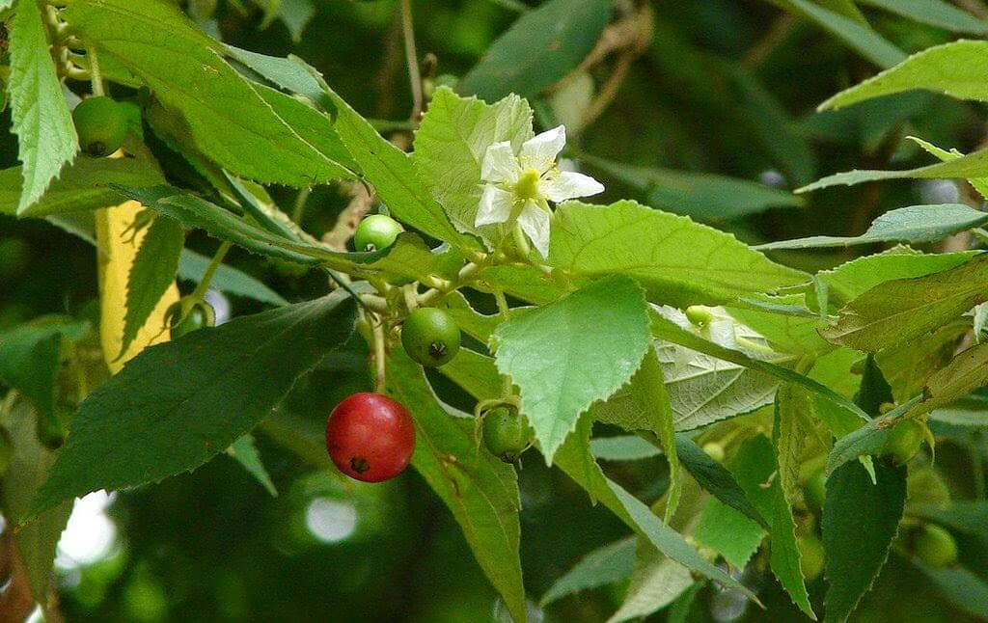
Figure 1: The fruits of M. calabura L. [8]

From many reported studies, several compounds were successfully elucidated from each part of this plant including the leaf, root, bark, and fruit [7]. In addition, a few of the reported compounds were found active as antibacterial [9, 10, 11], antitumor [12], anti-inflammatory [13], antipyretic [14], antinociception [15], antiproliferative [16], and also antioxidant [4, 17]. It indicates that calabura is one of the potential plants to screen valuable active compounds for drug discovery. However, the study on this species from Malaysia is still limited due to the less reported data from local publications that can be obtained. Thus, this study will present the qualitative phytochemical screening on alkaloids, flavonoids, glycosides, phlobatannins, and tannins, reported the quantitative phytochemical analysis of total phenolic content (TPC), and total flavonoid content (TFC), as well as documented the antibacterial properties from both ripe and unripe of M. calabura L. fruit extracts.

Materials and Methods
Fruit samples
The ripe fruits of M. calabura L. were collected from Seremban, Negeri Sembilan, and the unripe fruits were collected from Kampung Jembatan Duyong, Melaka, Malaysia in October 2021.

Preparation of fruit extracts
Fresh fruits (ripe and unripe) of M. calabura L. were washed with tap water and were directly dried under the sun for one week. The dried fruits were ground into powder form by using a grinder. The extraction process proceeded successively by mixing 100 g of powdered fruits with n-hexane, followed by ethyl acetate and methanol (500 mL of each) for 72 hours at room temperature. The extract was filtered by using Whatman no. 1 filter paper and the filtrate was concentrated by using a rotary evaporator. Crude extracts were stored at 4 ℃ prior to phytochemical and in vitro antibacterial analyses [18].

Qualitative phytochemical screening
Phytochemical tests were carried out on each extract using the standard procedure [19, 20] to identify the presence of alkaloids [21], flavonoids, glycosides, phlobatannins [22], and tannins [23].

Determination of total phenolic content
Total phenolic content (TPC) in the fruit extracts was determined by using the Folin-Ciocalteu method as described by [24] with minor modifications. An amount of 10 mg of the extract was dissolved in 10 mL of methanol to yield a concentration of 1 mg/mL. To each extract, 0.5 mL of sample was added to 2.5 mL of 10% Folin-Ciocalteu’s reagent. After 5 minutes, 2.5 mL of 7.5% Na₂CO₃ was added. The mixture was placed in the dark for 2 hours and the absorbance was measured at 725 nm by using UV-Vis Spectrophotometer. A similar procedure as described was repeated for the standard solution of gallic acid with different concentrations (6.25, 12.5, 25, 50, and 100 µg/mL), and the calibration curve was constructed. The concentration of phenolics (µg/mL) was obtained based on the calibration curve and the content of phenolic in the extract was expressed in terms of gallic acid equivalent (mg of gallic acid/g of extract), and methanol was used as blank.

Determination of total flavonoid content
Total flavonoid content (TFC) in the fruit extracts was determined by using the modified aluminium chloride colorimetric method [25]. An amount of 10 mg of the extract was dissolved in 10 mL of 80% ethanol (1 mg/mL). To each extract, 0.5 mL of sample was mixed with 1.5 mL of 95% ethanol, 0.1 mL of 10% aluminium chloride, 0.1 mL of 1 M potassium acetate, and 2.8 mL of distilled water. The mixture was incubated at room temperature for 30 minutes and the absorbance was measured at 425 nm by using UV-Vis Spectrophotometer. A similar step as described was repeated for the standard solution of quercetin with various concentrations (6.25, 12.5, 25, 50, and 100 µg/mL), and the calibration curve was constructed. The concentration of flavonoids (µg/mL) was obtained based on the calibration curve and the content of flavonoids in the extract was expressed in terms of quercetin equivalent (mg of quercetin/g of extract), and ethanol was used as blank.

Determination of antibacterial properties
Antibacterial assay of M. calabura L. fruit extracts was carried out based on the Clinical and Laboratory Standards Institute (CLSI) [26], and the disc diffusion method was used. The overnight bacterial culture (Escherichia coli, Klebsiella pneumonia, Staphylococcus aureus, and Bacillus subtilis) from nutrient broth (NB) was adjusted to the turbidity of 0.5 McFarland standard (1.5 X 10⁸ CFU/mL). Afterward, 0.1 mL of bacterial culture was pipetted out onto the Muller-Hinton agar (MHA) and spread in a direction and evenly distributed. The dried-loaded extracts (20 µL with a concentration of 10 mg/mL) of disc paper (5.5 mm diameter) were transferred onto the seeded MHA medium and incubated at 37°C for 24 hours. Streptomycin (10 µg) and 10% DMSO were used as positive and negative control. The diameter of zone inhibition was measured and recorded.
Results and Discussion
Qualitative phytochemical screening
M. calabura L. extracts (n-hexane, ethyl acetate, and methanol) for both ripe and unripe fruits were first tested for a qualitative phytochemical screening to check the presence and absence of alkaloids, flavonoids, glycosides, tannins, and phlobatannins in which these constituents might be responsible for the antibacterial properties. The data displayed in Table 1 shows that calabura’s fruit contained various phytochemicals. Flavonoids were detected in all extracts from both ripe and unripe fruits. Meanwhile, alkaloids and phlobatannins were found absent in all extracts from unripe and ripe fruits respectively. However, [21] reported the presence of alkaloids in both ripe and unripe M. calabura L. fruit extracts, but the study conducted and the sample collected was from India. For a local sample studied by [4], alkaloids were also reported absent but the sample was from M. calabura L. leaf extracts. Thus, abiotic factors such as soil, temperature, air, humidity, light, pH, salinity, minerals, and water may influence the accumulations of secondary metabolites [27, 28, 29].

Table 1. Detected phytochemical constituents in M.calabura L. fruit extracts
 |  |  | Fruit Extracts
 | Ripe |  |  |  | Unripe
Constituents | n-hexane | Ethyl Acetate |  | Methanol | n-hexane | Ethyl Acetate | Methanol
Alkaloids | - | + |  | + | - | - | -
Flavonoids | + | + |  | + | + | + | +
Glycosides | - | - |  | + | - | - | +
Tannins | - | + |  | + | - | + | +
Phlobatannins | - | - |  | - | - | + | +
‘-‘ indicates absence; ‘+’ indicates presence

Quantitative phytochemical analysis
The results of total phenolic content (TPC) and total flavonoid content (TFC) were summarized in Table 2. Among all extracts, methanol extract from both ripe and unripe fruits exhibited the highest TPC with 94.43 and 47.96 mg GAE/g respectively. In general, the more polar solvent influences the amount of TPC which gives a higher value. The 5-hydroxy-3,7,8-trimethoxyflavone compound is reported to contribute as a major phenolic compound [30] and [31, 32] revealed that this compound was elucidated from the fruits of M. calabura L. that have polar sites interaction (hydrogen bonds) with the solvent, which increased the solvation of compounds in the solvent.

Similarly, TFC was found highest in methanol extract with 35.38 and 99.74 mg QE/g in ripe and unripe fruits respectively. The TFC content is correlated with the preliminary phytochemical screening to prove that flavonoids are an important constituent in the calabura fruits and it is essential for future antioxidant study.

Table 2. The total phenolic and total flavonoid contents of different fruit extracts from M. calabura L.
Assay | Solvents Extraction
Assay |  | n-hexane | Ethyl Acetate | Methanol
TPC (mg GAE/g extract) | Ripe | 24.11 | 45.06 | 94.43
TPC (mg GAE/g extract) | Unripe | 15.43 | 27.96 | 47.96
TFC (mg QE/g extract) | Ripe | 4.08 | 22.97 | 35.38
TFC (mg QE/g extract) | Unripe | 42.70 | 61.59 | 99.74

This study proves that M. calabura L. fruit contains phytochemicals as an antibacterial agent. As shown in Table 3, methanolic fruit extract from the unripe sample gave the highest antibacterial effect against all tested bacteria compared to ethyl acetate extract and this is similar to the study reported by [21]. Moreover, the fruit extracts were more active against Gram-positive bacteria with zone inhibition of 14 mm and 12 mm for S. aureus and B. subtilis respectively. The Gram-negative cell wall is a multilayered structure and quite complex. It consists of an additional lipopolysaccharide layer called the outer membrane to make it more difficult for antibiotics to invade the cell wall [33]. However, none of the ripe sample extracts and extract from n-hexane exhibited antibacterial properties. Thus, the active compounds of this extract might have consisted of semi-polar to polar functional groups. Figure 2 displays the disc diffusion assay of M. calabura L. fruit extracts against tested bacteria.

Table 3. The inhibition zone value (mm) of M. calabura L. fruit extracts against tested bacteria
Extracts |  | Zone Inhibition Value (mm)
 |  | Tested Bacteria
 |  | Gram-negative |  | Gram-positive
 |  | E. coli | K. pneumonia | S. aureus | B. subtilis
n-hexane | Ripe | - | - | - | -
n-hexane | Unripe
Ethyl acetate | Ripe | - | - | - | -
Ethyl acetate | Unripe | 6.17 ± 0.15 | 6.10 ± 0.10 | 7.13 ± 0.15 | 6.23 ± 0.21
Methanol | Ripe | - | - | - | -
Methanol | Unripe | 10.10 ± 0.10 | 9.17 ± 0.15 | 14.17 ± 0.15 | 12.10 ± 0.10
Streptomycin | Ripe | 17.00 ± 0.00 | 15.00 ± 0.00 | 19.00 ± 0.00 | 18.00 ± 0.00
Streptomycin | Unripe
10% DMSO | Ripe | - | - | - | -
10% DMSO | Unripe
The values are represented as mean ± SD

Mahmood et al. [7] in their reviewed article had mentioned that various parts of the M. calabura L. plant were traditionally used to cure many illnesses. Several reported the antibacterial properties from the local sample used leave part [34, 35, 36]. The fruit part was only mentioned to be used as eaten fresh and cooked to make into jam. Therefore, the antibacterial result from this study can be used as a reference to support that calabura fruit also has potential active compounds to combat diseases.

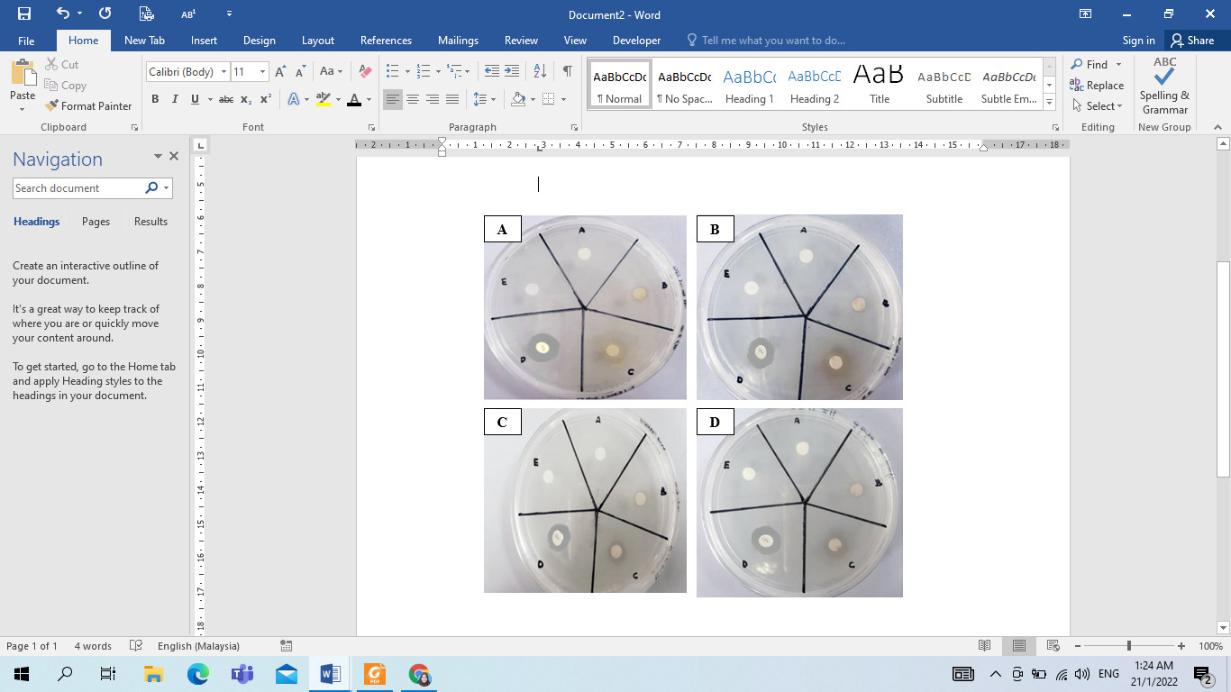
Figure 2. The zone inhibition observation of M. calabura L. extracts against S. aureus (A), B. subtilis (B), K. pneumonia (C), and E. coli (D) by disc diffusion method

Conclusion
M. calabura L. fruit extracts contain different phytochemical constituents including alkaloids, flavonoids, phlobatannins, tannins, and glycosides. The methanolic fruit extracts showed the highest TPC and TFC values from both ripe and unripe samples, and also exhibited the greatest antibacterial properties against all tested bacteria from the unripe sample. An antioxidant study is required to be performed since antibacterial and antioxidant studies serve as a basis for drug discovery.
Acknowledgment
The authors would like to thank UiTM Cawangan Negeri Sembilan, Kampus Kuala Pilah for providing facilities for this study.
References
- Durai, M. V., Balamuniappan, G., Anandalakshmi, R., Geetha, S. and Senthil, N. (2016). Qualitative and quantitative analysis of phytochemicals in crude extract of big-leaf mahogany (Swietenia macrophylla King.). International Journal of Herbal Medicine, 4(6): 88-91.
- Majumder, J. and Roy, S. (2017). Identification of quinones and coumarins in Swietenia macrophylla leaf. Pharmaceutical Biology, 7(6): 1-5.
- Boy, H. I. A., Rutilla, A. J. H., Santos, K. A., Ty, A. M. T., Yu, A. I., Mahboob, T., Tangpoong, J. and Nissapatorn, V. (2019). Recommended medicinal plants as source of natural products: A review. Digital Chinese Medicine, 1(2): 131-142.
- Pungot, N. H., Zainal Abidin, N. A. and Nazaharuddin, N. S. A. (2020). Potential of malaysian cherry leaves (Muntingia calabura) as an antioxidant agent. Science Letters, 14(2): 103-109.
- Pereira, G. A., Arruda, H. S., de Morais, D. R., Eberlin, M. N. and Pastore, G. M. (2018). Carbohydrates, volatile and phenolic compounds composition, and antioxidant activity of calabura (Muntingia calabura L.) fruit. Food Research International, 10(8): 264-273.
- Zakaria, Z. A., Mohd Nor Hazalin, N. A., Ghani, M. A., Hassan, M. H., Gopalan, H. K. and Sulaiman, M. R. (2007). Antinociceptive, anti-inflammatory and antipyretic effects of Muntingia calabura aqueous extract in animal models. Journal of Natural Medicines, 10(6): 443-448.

- Mahmood, N. D., Nasir, N. L. M., Rofiee, M. S., Tohid, S. F. M., Ching, S. M., Teh, L. K., Salleh, M. Z., and Zakaria, Z. A. (2014). Muntingia calabura: A review of its traditional uses, chemical properties, and pharmacological observations. Pharmaceutical Biology, 52(12): 1598-1623.
- Planting Man (2018). Muntingia calabura - fruit garden. Planting Man. Accessed from https://plantingman.com/muntingia-calabura-fruit-garden/. [Retrieved March 9, 2022].
- Buhian, W. P. C., Rubio, R. O., Valle, D. L., and Martin-Puzon, J. J. (2016). Bioactive metabolite profiles and antimicrobial activity of ethanolic extracts from Muntingia calabura L. leaves and stems. Asian Pacific Journal of Tropical Biomedicine, 6(8): 682-685.
- Fitri, G. D., Tistiana, H. and Radiati, L. E. (2017). Review study on antibacterial activity of cherry leaf (Muntingia calabura) against Staphylococcus spp. and Salmonella spp. The most causing disease in livestock. Jurnal Ilmu-Ilmu Peternakan, 27(2): 63-73.
- Paramesha, M., Tg, T., Ck, R. and S, N. (2017). Bioprospecting of Muntingia calabura: Bioactive compounds and its antioxidant, antimicrobial and anthelmentic activity. Innovare Journal of Sciences, 5(5): 7-11.
- Ragasa, C. Y., Tan, M. C. S., Chiong, I. D. and Shen, C. C. (2015). Chemical constituents of Muntingia calabura L. Der Pharma Chemica, 7(5): 136-141.
- Ansori, A. N. M., Kharisma, V. D. and Solikhah, T. I. (2021). Medicinal properties of Muntingia calabura L.: A review. Research Journal of Pharmacy and Technology, 14(8): 4509-4512.
- Sarojini, S., and Mounika, B. (2018). Muntingia calabura (Jamaica cherry): An overview. PharmaTutor, 6(11): 1-9.
- Zakaria, Z. A., Mohd Sani, M. H., Abdul Kadir, A., Kek, T. L. and Salleh, M. Z. (2016). Antinociceptive effect of semi-purified petroleum ether partition of Muntingia calabura leaves. Revista Brasileira de Farmacognosia, 26: 408-419.
- Rahmawati, A. N., Astirin, O. P. and Pangastuti, A. (2018). Intracellular antioxidant activity of Muntingia calabura leaves methanolic extract. Nusantara Bioscience, 10(4): 210-214.
- Zakaria, Z. A., Mahmood, N. D., Omar, M. H., Taher, M. and Basir, R. (2019). Methanol extract of Muntingia calabura leaves attenuates CCl4-induced liver injury: Possible synergistic action of flavonoids and volatile bioactive compounds on endogenous defence system. Pharmaceutical Biology, 57(1): 335-344.
- Mogollón, O. F. C., Gonzalez-Cuello, R. E. and López, J. S. G. (2018). In vitro antibacterial and antioxidant activity of Muntingia calabura fruits extract. Contemporary Engineering Sciences, 11(18): 881-890.
- Rao, U. S. M., Mohd, K. S. and Abdurrazak, M. (2016). Phytochemical screening, total flavonoid and phenolic content assays of various solvent extracts of tepal of Musa paradisiaca. Malaysian Journal of Analytical Science, 20(5): 1181-1190.
- Gul, R., Jan, S. U., Faridullah, S., Sherani, S. and Jahan, N. (2017). Preliminary phytochemical screening, quantitative analysis of alkaloids, and antioxidant activity of crude plant extracts from Ephedra intermedia indigenous to Balochistan. The Scientific World Journal, 2017: 5873648.
- Singh, R., Iye, S., Prasad, S., DeshmukH, N., Gupta, U., Zanje, A., Patil, S. and Joshi, S. (2017). Phytochemical analysis of Muntingia calabura extracts possessing anti-microbial and anti-fouling activities. International Journal of Pharmacognosy and Phytochemical Research, 9(6): 826-832.
- Shaikh, J. R., and Patil, M. (2020). Qualitative tests for preliminary phytochemical screening: An overview. International Journal of Chemical Studies, 8(2), 603–608.
- Iswantini, D., Tuwalaid, B. and Trivadila. (2021). The potency of legetan warak (Adenostemma lavenia) and Kersen leaf (Muntingia calabura) extract as a candidate for chronic obstructive pulmonary disease (COPD) herbal medicine. Proceedings of the 2nd International Conference on Science, Technology, and Modern Society, 2020: 447-452.

- Kabra, S. and Patel, S. (2018). Total phenolics and flavonoid content of the leaves of Carica papaya and Syzygium cumini. World Journal of Pharmaceutical Research, 7(14): 734-741.
- Pertiwi, R. D., Suwaldi, Martien, R. and Setyowati, E. P. (2020). Radical scavenging activity and quercetin content of Muntingia calabura L. leaves extracted by various ethanol concentration. Journal of Food and Pharmaceutical Sciences, 8(1): 173-183.
- CLSI GP02-A5. (2006). Laboratory documents: development and control; approved guideline-fifth edition. Accessed from https://webstoe.ansi.org/Standards/CLSI/CLSIGP02A5. [Retrieved December 24, 2020]
- Ma, Z., Li, S., Zhang, M., Jiang, S. and Xiao, Y. (2010). Light intensity affects growth, photosynthetic capability, and total flavonoid accumulation of anoectochilus plants. HortScience, 45(6): 863-867.
- Waqas, M. A., Kaya, C., Riaz, A., Farooq, M., Nawaz, I., Wilkes, A. and Li, Y. (2019). Potential mechanisms of abiotic stress tolerance in crop plants induced by thiourea. Frontiers in Plant Science, 10: 1336.
- Li, Y., Kong, D., Fu, Y., Sussman, M. R. and Wu, H. (2020). The effect of developmental and environmental factors on secondary metabolites in medicinal plants. Plant Physiology and Biochemistry, 148: 80-89.
- Yusof, M. M., Teh, L. K., Zakaria, Z. A. and Ahmat, N. (2011). Antinociceptive activity of the fractionated extracts of Muntingia calabura. Planta Medicine, 77: 21.
- Babbar, N., Oberoi, H. S., Sandhu, S. K., and Bhargav, V. K. (2014). Influence of different solvents in extraction of phenolic compounds from vegetable residues and their evaluation as natural sources of antioxidants. Journal of Food Science and Technology, 51(10): 2568-2575.
- Boeing, J. S., Barizão, É. O., e Silva, B. C., Montanher, P. F., de Cinque Almeida, V. and Visentainer, J. V. (2014). Evaluation of solvent effect on the extraction of phenolic compounds and antioxidant capacities from the berries: Application of principal component analysis. Chemistry Central Journal, 8(1): 1-9.
- Miller, S. I. (2016). Antibiotic resistance and regulation of the gram-negative bacterial outer membrane barrier by host innate immune molecules. MBio, 7(5): 5-7.
- Sufian, A. S., Ramasamy, K., Ahmat, N., Zakaria, Z. A. and Yusof, M. I. M. (2013). Isolation and identification of antibacterial and cytotoxic compounds from the leaves of Muntingia calabura L. Journal of Ethnopharmacology, 146: 198-204.
- Zakaria, Z. A., Mat Jais, A. M., Mastura, M., Mat Jusoh, S. H., Mohamed, A. M., Mohd, N. S., ... and Sulaiman, M. R. (2007). In vitro antistaphylococcal activity of the extracts of several neglected plants in Malaysia. International Journal of Pharmacology, 3(5): 428-431.
- Zakaria, Z. A. (2006). The in vitro antibacterial activity of Muntingia calabura extracts. International Journal of Pharmacology, 2(3): 290-293.

