THE COMPATIBILITY OF JACKFRUIT SEED STARCH AND POLYVINYL ALCOHOL BLEND AS BIOPOLYMER ELECTROLYTE HOST

(Keserasian Kanji Biji Nangka dan Campuran Polivinil Alkohol sebagai Hos Elektrolit Biopolimer)

Raihan Ramli¹, Fairuzdzah Ahmad Lothfy^{1*}, Asiah Mohd Nor², Ab Malik Marwan Ali²

¹Faculty of Applied Science,

Universiti Teknologi MARA Pahang,

26400 Bandar Tun Abdul Razak Jengka, Pahang, Malaysia

²Faculty of Applied Science,

Universiti Teknologi MARA Shah Alam, 40450 Shah Alam, Selangor, Malaysia

*Corresponding author: fairuzdzah@uitm.edu.my

Abstract

Biopolymer electrolytes have a lot of potential for future electrochemical device developments because of their environmentally-friendly features. In general, the structural characteristics of the biopolymer host play the most crucial impact in determining electrolyte conductivity. However, the semi crystallinity structure of biopolymer hosts caused the reduction of electrolyte conductivity. As a result, in this study, the structural characteristics of the biomaterial have been modified by blending jackfruit seed starch (JSS) and polyvinyl alcohol (PVA) to obtain the optimal composition of the blend that is compatible to be employed as a biopolymer electrolyte host. The jackfruit seed starch and polyvinyl alcohol were blended with various compositions using the solution casting technique. The purpose of this study is to look into the amorphousness, functional groups, and morphology of JSS with PVA blend and determine the compatibility of JSS with PVA blend as a polymer electrolyte host. The best compatible blend composition is JSS-PVA with a 1:1 ratio, which has the highest degree of amorphosity and the highest percentage of hydrogen bonding contact, C=O stretching, and C-O vibrations. Scanning electron microscopy investigation confirms the results, indicating that the blend is evenly dispersed.

Keywords: Jackfruit seed starch, polyvinyl alcohol, biopolymer electrolyte host, amorphous

Abstrak
Elektrolit biopolimer mempunyai banyak potensi untuk perkembangan peranti elektrokimia masa depan kerana ciri-ciri mesra alamnya. Secara umumnya, ciri-ciri struktur hos biopolimer memainkan peranan yang paling penting dalam menentukan kekonduksian elektrolit. Walau bagaimanapun, struktur separa kristal perumah biopolimer menyebabkan pengurangan dalam kekonduksian elektrolit. Hasilnya, dalam kajian ini, ciri-ciri struktur biomaterial telah diubahsuai dengan mencampurkan kanji biji nangka (JSS) dan polivinil alkohol (PVA) untuk mendapatkan komposisi optimum campuran yang serasi untuk digunakan sebagai hos elektrolit biopolimer. Kanji biji nangka dan polivinil alkohol diadun dengan pelbagai komposisi menggunakan teknik ‘solution casting’. Ia bertujuan untuk melihat sifat amorfousness, kumpulan berfungsi, dan morfologi JSS dengan campuran PVA dan menentukan keserasian JSS dengan campuran PVA sebagai hos elektrolit polimer. Komposisi campuran serasi terbaik ialah JSS-PVA dengan nisbah 1:1, yang mempunyai tahap amorphositi tertinggi dan peratusan tertinggi hubungan ikatan hidrogen, regangan C=O, dan getaran C-O. Mengimbas penyiasatan mikroskopi elektron mengesahkan hasilnya, menunjukkan bahawa campuran itu tersebar sama rata.

Kata kunci: Kanji biji nangka, polivinil alkohol, perumah elektrolit biopolimer, amorphous

Introduction
Polymer electrolytes (PEs) are generally described as linear macromolecular chains containing a large charge. It is also utilized in solar cells, batteries, and supercapacitors, among other electrochemical devices [1, 2]. PE has recently piqued researchers’ interest because of its promising features, which can be employed as a powerful platform for achieving high efficiency in the energy storage device. Recently, most of commercialized PE was prepared with non-biodegradable materials that are harmful to the environment and humans. This is due to most of the PE using petroleum-based polymers in the production of PEs. Petroleum-based polymer have limitations such as being expensive, depleting petroleum supplies, and causing environmental issues.

Biopolymer is a polymer host that has advantages since it eliminates the need for petroleum as a material source. In general, the choice of polymer host is an essential issue in the development of PEs [2]. Based on the previous studies, the choice of polymer host depends on two factors. Firstly, the presence of polar (functional) groups with adequate electron donor power to establish coordination with cations. For example, by having high concentration of polar groups (containing electron donors: O, NH, CN, F). Secondly, a low impediment to bond rotation [2]. Aside from that, the polymer host must be highly amorphous. It may occur due to increase in ionic diffusivity, as ions can move freely due to the low energy barrier. Furthermore, an amorphous polymer has a flexible backbone, which can increase local chain mobility. As a result, the segmental motion of a polymer can improve the electrolyte’s transportation property [2]. Other researchers also found that selection of a polymer host is determined by factors such as the presence of atoms or groups of atoms with sufficient electron donor capacity to form coordination bonds with cations, a low barrier to bond rotations, allowing for easy segmental motion of the polymer chain, and a suitable distance between coordinating centers, which allows for the formation of multiple intra-polymer ion bonds [3].

To replace the petroleum-based material, the structural properties of jackfruit seed starch were investigated to determine its compatibility as a polymer electrolyte host. In Malaysia, the average weight of a jackfruit ranges from 3.5 kg to 10 kg, with the largest edible fruit weighing up to 35 kg, and the source is abundant [4]. Seeds can account for up to 10% to 15% of the total weight of the fruit [5]. Jackfruit seed starch has a high amylose content (24-32%) and a high polar group [6]. Previous studies indicate that the functional properties of jackfruit seed starch, which have C=O and C-O-C bonding which suggest that they can be used as a polymer electrolyte host [7, 8, 9]. It demonstrates that jackfruit seed starch contained an electron donor and met one of the requirements of the polymer host. However, no research has been conducted on the percentage of C=O and C-O-C bonding functional groups. As a result, the percentage of these functional groups was measured in this study.

Semi-crystalline properties are found in some of the native starch polymers. The previous researchers discovered that the sample's ionic conductivity is low due to its crystalline structure after synthesizing PEs by reacting poly(ethylene oxide) (PEO) with a salt such as lithium iodide (LiI) [10]. PVA also has semi-crystallinity structure, by blending PVA with another polymer, it might reduce the crystallinity properties. The previous researchers found that blending PVA with pure cornstarch and chitosan can reduce the crystallinity peak [11, 12]. The chain structure promotes the formation of interchain "tunnels" through which the desired ion can bounce between coordination sites while the counterion travels down the polymer chain [13]. These tunnels constrain the movement of anion and cation in crystalline PEs due to their highly ordered crystalline domains that are selective for an ion and exclude its counterion, allowing for separation [10]. The conductivity of amorphous polymers is higher due to their amorphous properties, which allow for significant chain movement because ion coordination is transitory, enhancing ion mobility [14]. Ion transport is triggered in the amorphous phase by local mobility of polymer chain segments, which creates new coordination sites into which the ions can then travel [10]. While the crystallinity can restrict the movement of ions. It has been well reported that the ion transport occurs mainly in the amorphous region rather than the crystalline region, but the polymers host materials that used in PEs are often semi-crystalline. To summarize, the movements of ions in the amorphous phase allow ionic conductivity.

Thus, in this research, synthetic polymers such as PVA were blended with jackfruit seed starch to modify the polymer's structural properties and achieve the optimal state of amorphosity [15]. According to previous study, PVA is used because it has excellent charge storage properties, optical properties, and high dielectric strength. Fahmy et al. stated that PVA has a carbon chain backbone that is connected with hydroxyl groups [16]. Due to hydroxyl groups, or OH groups, are a source of hydrogen bonding, they aid in the formation of polymer blends or polymer complexes. Chen et al. investigated varied features of PVA/chitosan blends at different ratios and discovered that chitosan, as a natural polymer which can reduce the PVA crystallinity [17].

As a result, the primary goal of this study is to investigate the amorphousness, functional groups, and morphology of JSS with PVA blend to ensure that these properties are compatible as potential polymer electrolyte hosts.

Materials and Methods

Materials

JSS used in this experiment was purchased from the jackfruit merchant in Bandar Pusat Jengka, Pahang. The chemicals used were PVA and glycerol from R & M Chemicals, UK. 0.1 M sodium hydroxide (NaOH) and 0.1 M hydrochloric acid (HCl) were also used and were purchased from Sigma-Aldrich, USA.

Preparation of jackfruit seed starch and polyvinyl alcohol blend
The samples were prepared by using solution casting method. Different compositions of JSS and PVA were used as represented in Table 1. Firstly, the PVA solution was prepared by dissolving PVA into distilled water. The solution was heated at 100 ℃ for 30 minutes. While the PVA was being diluted, the JSS mixture were prepared by using double boiled method. JSS was mixed with distilled water before adding 1.5 mL of glycerol, HCl and NaOH. The mixture was stirred at 90 ℃ for 20 minutes. Then, the PVA solution was added into the mixture and it was stirred continuously for 30 minutes at 100 ℃ until the homogenous gel-like mixture was formed. After being homogenous, it was poured into a petri dish and dried for 48 hours at room temperature. Next, the dried films were peeled from the petri dish and was cut according to the characterization method used.

Table 1. Composition of JSS and PVA

Sample | JSS (%) | PVA (%)
S1 | 0 | 100
S2 | 30 | 70
S3 | 50 | 50
S4 | 70 | 30
S5 | 100 | 0

Characterization
The Fourier-transform infrared spectral analysis of functional groups for the bioplastic films was carried out by Perkin Elmer FTIR Model 2000 spectrometer in a range of 500-4000 cm⁻¹ at a resolution of 4 cm⁻¹. The surface analysis of the bioplastic films was carried out by using Scanning Electron Microscopy (SEM, Vega 3, Tescan Analytics, France). The morphological structure of the bioplastic films was obtained at a voltage of 20 kV (magnification of 1000x). The X-ray diffraction patterns of the films was characterized by X’Pert PRO MPD diffractometer (PANalytical, UK). It operated at 36 kV (20 mA) and the scanning range was 5°-90° in the scale of the angle 2θ.

Results and Discussion

Fourier-transform infrared spectral analysis
The FTIR spectra for JSS and PVA blend are shown in Figure 1. The strong and wide absorption band at 3300 cm⁻¹ indicates that the blend has the stretching vibration of OH groups [18]. The possible functional groups for this peak are the hydroxyl group and H-bonded OH stretch. The available hydroxyl groups on the starch chains cause the formation of the peak at 3300 cm⁻¹ [19]. The absorption band is also present in the PVA film, indicating that there are many water hydroxyl groups in the film, which are the same as those studied by El-Sawy and his colleagues [20]. The major OH groups that appear in all samples at 3300 cm⁻¹, indicate that there is an interaction between different –OH groups in the JSS and PVA blends for the other four samples. The intensity of S1 becomes lower with additional JSS into the blend due to the intensity of pure JSS, which is S5 that is the lowest. In other words, the FTIR spectra pattern for JSS and PVA blends seems to overlap compared to a single polymer component.

The peaks that occurred at 2900 to 2950 cm⁻¹ were attributed to C=H asymmetric stretching vibration [21]. Then, the peak at 1650 cm⁻¹ was caused by C=O stretch [22]. This peak belongs to PVA. Next, the peak at 1040 cm⁻¹ was attributed to C-O vibration of C-O-C groups [18]. The bands at 1000–1200 cm⁻¹ were ascribed to the C-O stretching vibration. The changes occurred of the peak intensity of C-O in C-O-C groups by blending JSS and PVA. The highest intensity was obtained at S3. It shows that the S3 has the highest C-O in C-O-C groups. Then, the peak for S3 slightly shifted to the left, from 1040 cm⁻¹ to 1029 cm⁻¹, indicating that strong hydrogen bonding interactions occurred between starch and PVA components. Both JSS and PVA have a lot of OH and C-O groups, which might help them establish hydrogen bonds and increase their compatibility [18]. The absorption peaks have also changed and shifted at 1400 cm⁻¹ to 1450 cm⁻¹. The peak for PVA appeared at 1400 cm⁻¹, but when there was the presence of JSS, the peak shifted to 1450 cm⁻¹. The shift indicates that there is a weak interaction caused by C-O bonds that occurred during the solution blending and casting process [8]. The FTIR spectra for the JSS and PVA blend films showed the same pattern with the FTIR spectra for PVA film which is S1. From Figure 1, there is no major change that occurred in the functional group due to the JSS and PVA that is homogenously blended. Changes in the characteristic spectra peaks alter the physical blends versus chemical interactions when two components are blended [23]. Based on the previous studies, if the shape and location of the characteristic peak for the blend films is similar to PVA, the interaction among the PVA molecules is dominant and stronger compared to the JSS-PVA molecules and JSS-JSS molecules [20].

The percentage area under the graph for each stretch was summarized in Table 2. The peak at 1040 cm⁻¹ for S3 has the highest percentage area under the graph. Having a higher percentage area under the graph for the C=O and C-O-C region is important in PEs because it is related to the conductivity of the PEs. Having a higher percentage area in those regions means that it has higher conductivity compared to the other blend films [24].

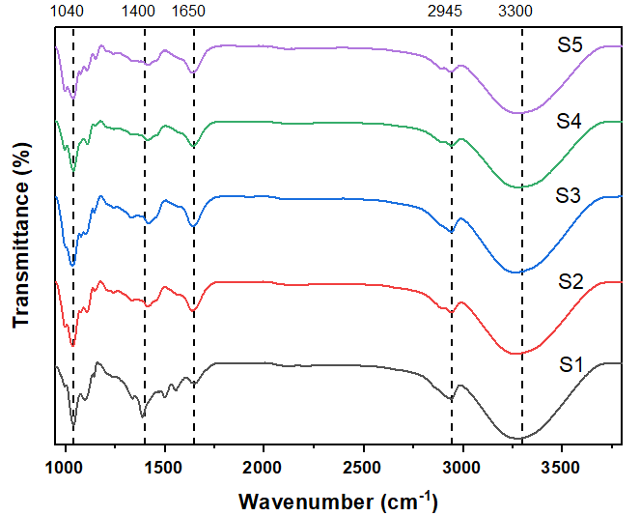

Figure 1. FTIR spectra of polymer blend with different composition of JSS and PVA blend
Table 2. Percentage area under the graph for each stretch
Sample | Percentage Area Under the Graph (%)
Sample | 1040 (cm⁻¹) | 1400 (cm⁻¹) | 1650 (cm⁻¹) | 2945 (cm⁻¹) | 3300 (cm⁻¹)
S1 | 9.99 | 14.27 | 6.30 | 6.98 | 62.45
S2 | 10.55 | 16.52 | 5.44 | 5.96 | 61.52
S3 | 14.26 | 8.00 | 4.47 | 7.09 | 66.18
S4 | 9.66 | 6.05 | 4.99 | 5.69 | 73.61
S5 | 12.25 | 6.05 | 5.25 | 5.90 | 70.60

Scanning electron microscope testing
The morphological structure of JSS and PVA blend films was analysed by SEM at magnification of 1000x (Figure 2). A homogenous structure was analysed for all of the samples. The surface of S1, which is an unfilled PVA film, had a smooth and clear surface as shown in Figure 2a. JSS is present in semi-round shaped granules and PVA is completely dissolved in the blend. The previous researchers also observed the semi-round shaped granules at a magnification of 1000x [25]. Then, a few other researchers also found that the presence of granules belong to the starch which is JSS [6, 11, 26]. Figure 2b, 2c, and 2d show that the JSS and PVA is evenly distributed and there is no formation of voids. The interface between those two materials in the blend was indistinct, which indicates the strong interaction between starch and PVA components. As indicated in the FTIR section, there is a strong hydrogen bonding formed between JSS and PVA, and it could improve the compatibility effectively [18]. The surface of S2 in Figure 2b shows a clear, semi-round shaped granules of JSS due to the fact that the amount of JSS in the blend is less than PVA. The JSS is evenly blended in the PVA matrix. As the amount of JSS added into the blend increases, the shape of the JSS in the blend can barely be seen as the JSS becomes more compact and the blend films become smoother and homogenous.

The smoothness of the blend films represents the amorphous phase of the electrolyte films [27]. As the amorphous surface in PEs increases, the conductivity will also increase. This is because the ions can move freely when a smooth surface PE is formed [28]. As a result, the conductivity is improved. For S5 with only JSS in the blend film, the surface of the blend film looks a little rough without the presence of PVA. Based on the previous research, blend films with the presence of PVA will appear a lot smoother compared to those without it [29]. The previous research also indicates that a rough surface morphology in the electrolyte film reflects a semi-crystalline phase, which reduces the film’s ionic conductivity [28]. From the morphological structure obtained, S3 with 50:50 of JSS and PVA demonstrated the optimum interaction between JSS and PVA compared to the other films with different compositions of JSS and PVA. Figure 2c reveals that the starch granules are well dispersed, homogenous, and have a smoother surface compared to other blend films. It can be concluded that S3 has the best conductivity based on the smoothness of the blend film.

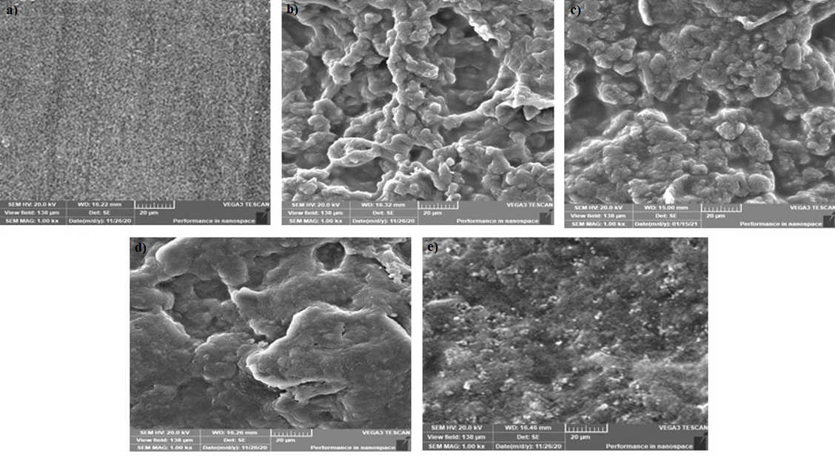

Figure 2. Surface morphology of different composition of JSS: (a) S1; (b) S2; (c) S3; (d) S4; (e) S5

X-ray powder diffraction testing
The XRD pattern for five samples with different compositions of JSS and PVA was presented in Figure 3 in the range 13° to 30°. Based on the figure, broad peak has been observed at 19.7° for all samples. This peak is related to the PVA phase where it is in a partially crystalline structure. The broad diffraction peak indicates that the crystallite is very small [4]. The position of the broad peaks for amorphous is normally within the range of 15° to 30°, implying that the broad peaks at 19.7° exhibit amorphous properties [30]. In Figure 3, the broadness for S2 and S3 increased while the intensity decreased. However, the intensity for S4 increased as the broadness increased. The increase in the broadness of the peak portrays the amorphous nature in the samples [31]. The previous researchers reported that the amorphousness in the system is related to the height of the peak and the degree of crystallinity of the system [31]. Thus, S3 is the sample that has the highest amorphous nature compared to the other samples as it has a broad diffraction peak with low intensity. It can be proven based on the value of percent crystallinity in Table 3, where S3 has the lowest percent crystallinity compared to other samples. This is compatible with the SEM analysis where S3 has the optimum interaction between JSS and PVA compared to other films.

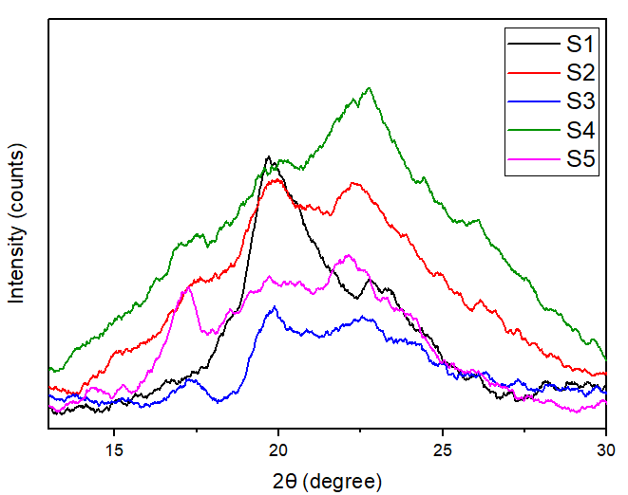

Figure 3. XRD analysis at 20° for polymer blend with different composition of JSS
Table 3. Percent crystallinity for each sample
Sample | Percent Crystallinity (%)
S1 | 84.04
S2 | 88.35
S3 | 41.82
S4 | 81.87
S5 | 74.55

Conclusion
The blend of JSS and PVA with different compositions was prepared via the solution casting method and their properties were investigated. From this study, it shows that the JSS and PVA have good compatibility and can be effectively reinforced together. Based on the FTIR analysis, the blend has a hydrogen bonding interaction and also have C=O stretching and C-O vibrations. Then, from SEM and XRD analysis, S3 has the most amorphous structure which then leads to high ionic conductivity. Thus, this study suggests that JSS and PVA are suitable to be used as PEs.

Acknowledgement
The authors acknowledge Universiti Teknologi MARA (UiTM) for a research grant FRGS (Grant No. 600-IRMI/FRGS 5/3 (267/2019)) and Faculty of Applied Science UiTM Jengka, Pahang for providing research facilities.

References
- Hallinan, D. T. and Balsara, N. P. (2013). Polymer electrolytes. Annual Review of Materials Research, 43: 503-525.
- Aziz, S. B., Woo, T. J., Kadir, M. F. Z. and Ahmed, H. M. (2018). A conceptual review on polymer electrolytes and ion transport models. Journal of Science: Advanced Materials and Devices, 3(1): 1-17.
- Gurusiddappa, J., Madhuri, W., Padma Suvarna, R. and Priya Dasan, K. (2016). Studies on the morphology and conductivity of PEO/LiClO₄. Materials Today: Proceedings, 3(6): 1451-1459.
- Theivasanthi, T. and Alagar, M. (2013). An insight analysis of nano sized powder of jackfruit seed. Nano Biomedicine and Engineering, 3(3): 2-3.
- Tulyathan, V., Tananuwong, K., Songjinda, P. and Jaiboon, N. (2002). Some physicochemical properties of jackfruit (Artocarpus heterophyllus Lam) seed flour and starch. ScienceAsia, 28: 37-41.
- Santana, R. F., Bonomo, R. C. F., Gandolfi, O. R. R., Rodrigues, L. B., Santos, L. S., dos Santos Pires, A. C., de Oliveira, C. P., da Costa Ilhéu Fontan, R. and Veloso, C. M. (2018). Characterization of starch-based bioplastics from jackfruit seed plasticized with glycerol. Journal of Food Science and Technology, 55(1): 278-286.
- Lothfy, F. A., Haron, M. F. and Rafaie, H. A. (2018). Fabrication and characterization of jackfruit seed powder and polyvinyl alcohol blend as biodegradable plastic. Journal of Polymer Science and Technology, 3(2): 1-5.
- Lestari, R. A. S., Kasmiyatun, M., Dermawan, K., Aini, A. N., Riyati, N. and Putri, F. R. (2020). Bioplastic from jackfruit seeds and rice. IOP Conference Series: Materials Science and Engineering, 835(1).
- Lin, Z., Guo, X., Wang, Z., Wang, B., He, S., Dell, L. A. O., Huang, J., Li, H., Yu, H. and Chen, L. (2020). Nano energy a wide-temperature superior ionic conductive polymer electrolyte for lithium metal battery. Nano Energy, 73(3): 104786.
- Gadjourova, Z., Andreev, Y. G., Tunstall, D. P. and Bruce, P. G. (2001). Ionic conductivity in crystalline polymer electrolytes. Nature, 412(6846): 520-523.
- Zou, G. X., Jin, P. Q. and Xin, L. Z. (2008). Extruded starch/PVA composites: Water resistance, thermal properties, and morphology. Journal of Elastomers and Plastics, 40(4): 303-316.
- Aziz, S. B., Marf, A. S., Dannoun, E. M. A., Brza, M. A. and Abdullah, R. M. (2020). The study of the degree of crystallinity, electrical equivalent circuit, and dielectric properties of polyvinyl alcohol (PVA)-based biopolymer electrolytes. Polymers, 12(10): 1-17.
- Long, L., Wang, S., Xiao, M. and Meng, Y. (2016). Polymer electrolytes for lithium polymer batteries. Journal of Materials Chemistry A, 4(26): 10038-10039.
- Hagfeldt, A., Boschloo, G., Sun, L., Kloo, L. and Pettersson, H. (2010). Dye-Sensitized Solar Cells. 6595–6663.
- Aslam, M., Kalyar, M. A. and Raza, Z. A. (2018). Polyvinyl alcohol: A review of research status and use of polyvinyl alcohol based nanocomposites. Polymer Engineering and Science, 58(12): 2119-2132.
- Fahmy, T., Sarhan, A. and Elqahtani, Z. M. (2020). Structural and optical characterization of thiourea-poly (vinyl alcohol) composites. International Journal of Engineering Research and Technology, 13(3): 454-461.
- Chen, S. H., Tsao, C. T., Chang, C. H., Lai, Y. T., Wu, M. F., Liu, Z. W., ... and Hsieh, K. H. (2013). Synthesis and characterization of reinforced poly (ethylene glycol)/chitosan hydrogel as wound dressing materials. Macromolecular Materials and Engineering, 298(4): 429-438.
- Tian, H., Yan, J., Rajulu, A. V., Xiang, A. and Luo, X. (2017). Fabrication and properties of polyvinyl alcohol/starch blend films: Effect of composition and humidity. International Journal of Biological Macromolecules, 96: 518-523.
- Retnowati, D. S., Ratnawati, R. and Purbasari, A. (2015). A biodegradable film from jackfruit (Artocarpus heterophyllus) and durian (Durio zibethinus) seed flours. Scientific Study and Research: Chemistry and Chemical Engineering, Biotechnology, Food Industry, 16(4): 395-404.
- Ooi, Z. X., Ismail, H. and Teoh, Y. P. (2018). Characterization and properties of biodegradable polymer film composites based on polyvinyl alcohol and tropical fruit waste flour. In Natural Fibre Reinforced Vinyl Ester and Vinyl Polymer Composites. Elsevier Ltd.
- Jayakumar, A., Heera, K. V., Sumi, T. S., Joseph, M., Mathew, S., Praveen, G., ... and Radhakrishnan, E. K. (2019). Starch-PVA composite films with zinc-oxide nanoparticles and phytochemicals as intelligent pH sensing wraps for food packaging application. International Journal of Biological Macromolecules, 136: 395-403.
- Nandiyanto, A. B. D., Oktiani, R. and Ragadhita, R. (2019). How to read and interpret FTIR spectroscope of organic material. Indonesian Journal of Science and Technology, 4(1): 97-118.
- Sarebanha, S., & Farhan, A. (2018). Eco-friendly composite films based on polyvinyl alcohol and jackfruit waste flour. Journal of Packaging Technology and Research, 2(3): 181-190.
- Arof, A. K., Amirudin, S., Yusof, S. Z. and Noor, I. M. (2014). A method based on impedance spectroscopy to determine transport properties of polymer electrolytes. Physical Chemistry Chemical Physics, 16(5): 1856-1867.
- Kane, S. N., Mishra, A. and Dutta, A. K. (2016). Preface: International Conference on Recent Trends in Physics (ICRTP 2016). Journal of Physics: Conference Series, 755(1): 6.
- Sarifuddin, N., Shahrim, N. A., Rani, N. N. S. A., Zaki, H. H. M. and Azhar, A. Z. A. (2018). Preparation and characterization of jackfruit seed starch/poly (vinyl alcohol) (PVA) blend film. IOP Conference Series: Materials Science and Engineering, 290(1): 012065.
- Hamsan, M. H., Nofal, M. M., Aziz, S. B., Brza, M. A., & Dannoun, E. M. A. (2021). Plasticized polymer blend electrolyte based on chitosan for energy storage application: structural, circuit modeling, morphological and electrochemical properties. Polymers, 13(8): 1233.
- Yap, Y. L., You, A. H., Teo, L. L. and Hanapei, H. (2013). Inorganic filler sizes effect on ionic conductivity in polyethylene oxide (PEO) composite polymer electrolyte. International Journal of Electrochemical Science, 8(2): 2154-2163.
- Janik, W., Wojtala, A., Pietruszka, A., Dudek, G. and Sabura, E. (2021). Environmentally friendly melt-processed chitosan/starch composites modified with pva and lignin. Polymers, 13(16): 2685.
- Liew, C. W. and Ramesh, S. (2015). Electrical, structural, thermal and electrochemical properties of corn starch-based biopolymer electrolytes. Carbohydrate Polymers, 124: 222-228.
- Hema, M., Selvasekarapandian, S., Arunkumar, D., Sakunthala, A. and Nithya, H. (2009). FTIR, XRD and ac impedance spectroscopic study on PVA based polymer electrolyte doped with NH₄X (X = Cl, Br, I). Journal of Non-Crystalline Solids, 355(2): 84-90.

