PRELIMINARY STUDIES ON SUNLIGHT ASSISTED DEGRADATION OF 2-CHLOROPHENOL USING MoS₂/GO AS PHOTOCATALYST
(Kajian Awal Mengenai Cahaya Tampak Dituruti Penyusutan Sinaran 2-klorofenol Menggunakan MoS₂/GO Sebagai Pemangkin Cahaya)
Kavirajaa Pandian Sambasevam, Syara Syazliana Muhammad Rajab, Izyan Najwa Mohd Norsham,
Siti Nor Atika Baharin^{1*}

Advanced Material for Environmental Remediation (AMER) Research Group,
Faculty of Applied Sciences,
University Teknologi MARA, Cawangan Negeri Sembilan, Kampus Kuala Pilah,
72000, Kuala Pilah, Negeri Sembilan, Malaysia

*Corresponding author: atikabaharin@uitm.edu.my
Abstract
This study highlighted preliminary studies on photodegradation of 2-chlorophenol using MoS₂/rGO photocatalyst with different weight ratios under sunlight irradiation. The 2-chlorophenol is known as one of the most dangerous pollutant due to its hazardous properties of mutagenicity, carcinogenicity and eco-pollutant. The MoS₂/rGO photocatalysts were synthesized using the hydrothermal method and used for the degradation of 2-chlorophenol under solar light irradiation. Three different compositions of MoS₂/rGO (1%, 5% and 15%) were synthesized with different weight ratio of MoS₂. The composites material of MoS₂, GO and MoS₂/rGO was characterized by FTIR and XRD indicating successful formation of MoS₂/rGO composites. The photodegradation of the 10 ppm of 2-chlorophenol were observed under the exposure of sunlight for 180 minutes and analyzed using UV-VIS to measure percent degradation of 2-chlorophenol. 1% MoS₂/rGO has been chosen as the composite to degrade 2-chlorophenol due to having the highest percent degradation of 51.41% among other photocatalysts.

Keywords: graphene oxide, molybdenum disulfide, photocatalytic degradation, semiconductor photocatalyst, solar irradiation
Abstrak
Kajian in menekankan kajian awal mengenai fotodegradasi 2-klorofenol dengan menggunakan berat ratio pemangkin cahaya MoS₂/rGO yang berlainan dibawah radiasi matahari. 2-klorofenol dikenali sebagai salah satu bahan pencemar yang mempunyai ciri-ciri merbahaya seperti mutagenisiti, karsinogenik dan eko-pencemar. Komposit MoS2/rGO telah disintesis menggunakan kaedah hidroterma. Kaedah fotokatalisis yang menggunakan MoS₂/rGO sebagai pemangkin cahaya untuk merosotkan 2-klorofenol dibawah sinaran matahari. Tiga komposisi MoS₂/rGO yang berlainan (1%, 5% and 15%) telah disintesis menggunakan nisbah berat MoS₂ yang berbeza. Bahan komposit MoS₂, GO dan MoS₂/rGO yang dicirikan menggunakan FTIR dan XRD telah menunjukkan hasil jaya pembentukan komposit MoS₂/rGO dengan jayanya. Penyusutan sinaran oleh 10 ppm 2-klorofenol telah diperhatikan dibawah sinaran matahari selama 180 minit telah dianalisiskan dengan UV-VIS untuk mengukur peratus penyusutan sinaran 2-klorofenol. 1% MoS2/rGO telah dipilih untuk merosotkan 2-klorofenol kerana mempunyai peratusan penyosotan yang tinggi iaitu 51.41%.

Kata kunci: grafena oksida, molibdenum disulfida, degradasi fotokatalitik, pemangkin cahaya semikonduktor, penyinaran suria
Introduction
2-chlorophenol is one of the chemical groups derives from chlorophenol that were made by electrophilic halogenation of phenol with chlorine. It is widely known as one of the most priority pollutants by the US Environmental Protection Agency and World Health Organization (WHO) based on its properties of strong odor, mutagenicity, carcinogenicity and eco-persistent [1]. It is highly toxic and difficult to degrade due to its high thermal and chemical stability [2]. Even with its hazardous characteristics, it is largely used in industrial and commercial scales such as plastic, pesticide, textile, steel, pharmaceutical, iron, paper and wood preserving that were reported to be a major source of chlorophenol compound found in the wastewater [3]. It can affect organisms when it released to the environment. Thus, many studies have been made to eliminate it such as biodegradation, adsorption and Fenton-like advanced oxidation processes. However, due to utilization of extra oxidants, vigorous conditions and intensive energy input, studies are made to search for sustainable technology to degrade 2-chlorophenol. Hence, to overcome the environment issues, solar-driven photocatalysis method is being used to eliminate the contaminant in the wastewater, ground water and rivers.
Photocatalysis is known as one of the advanced oxidation processes which is a method of removing contaminants concerning wastewater effluents. Photocatalysis is a technique to degrade pollutant by using photocatalyst to utilize photogenerated carriers such as electrons and holes in order to start the redox reaction for the conversion of solar to chemical energy [4]. Photocatalysis is one of the advanced treatment technologies to degrade contaminant by using radicals produced from transition-metal oxide photocatalysts involving UV irradiation. To promote indirect hole oxidation, the electron-hole pairs are generated on the photocatalyst surface and the valence band edge of photocatalysts must be better of the oxidation potential of hydroxyl radical, •OH [5]. Table 1 examines the different types of photocatalyst materials for degradation of 2-chlorophenol.
Table 1. Degradation of 2-chlorophenol using photocatalytic degradation
Photocatalyst | Source of Light | Degradation Time | Percentage Degradation | References
Ru/TiO₂ | UV light | 180 minutes | 50% | [6]
Cu doped BiFeO₃ and Ba-Cu co-doped BiFeO₃ | Visible light | 70 minutes | 98% and 100% | [7]
C₃N₄/TiO₂-NTs in pH of 9 and 12 | UV/ Visible light | 180 minutes | 25.02% and 70.25% | [8]
ZnO-ZnS@PANI | Visible light | 240 minutes | 89% | [9]
5% Ag-TiO₂ | UV light | 150 minutes | 74% | [10]

Meanwhile, photocatalyst is material that absorbs light energy to facilitate chemical reaction. Semiconductor photocatalyst uses light energy to get desirable chemical transformation through reduction-oxidation (redox) reaction. The photocatalytic semiconductors are commonly used for wastewater treatment, surfaces with self-cleaning and antifogging properties, purification of outdoor air, indoor air deodorization and cancer therapy [11]. It uses suitable band gap to produce strong visible light response with a high photocatalytic presentation, non-toxicity, good thermal, inexpensive and have chemical stability [12].

Graphene is a 2-D structure of hexagonal carbon atom in the sp² hybrid orbital that is widely used in electrochemical energy storage, optical and optoelectronics bioengineering due to its outstanding electrical, optical, thermal and mechanical properties. Graphene and its derivatives consist of large surface area, thermal conductivity and carrier mobility. Thus, it has the high potential in energy sensors and microelectronic devices. Integration of GO with other semiconductor can effectively improve the structural stability of the composites and enhance the photocatalytic activity by hindering the recombination of photo-generated carrier. Moreover, GO-based composite can alleviate the serious agglomeration of nanoparticles to a certain extent [13, 14] . Graphene is also known as electron cocatalyst that can improve hydrogen performance of photocatalysts due to its excellent of conductivity [15]. It also has capacity for adsorption of organic pollutants and potential mechanical strength and electrical conductivity [16]. GO can give productive route for highly dispersive, band tunable and few-layer structured of graphene-based materials thus it acts as supportive material for photocatalyst semiconductor [17].

MoS₂ is a 2-D layered n-type semiconductor and has narrow bandgap of 1.20 eV for its few layers where each layers have gap value of 1.90 eV. Thus, it has large specific surface area complex edge structure and abundant unsaturated active sites. It has high thermal stability and strong absorption in visible spectrum region. MoS₂ have limitations as it has limit in energy storage and photocatalytic properties due to high recombination rate of photo-generated electron hole pairs, low energy density and poor electronic conductivity. Combining with other metal oxide nanostructures, it can improve the disadvantages of MoS₂ such as GO can enhance its photocatalytic performances [18, 19]. This can be explained by transfer of photo-generated electrons from MoS₂ conduction band to the graphene [20]. When the band gap of MoS₂ increases due to quantum confinement effects of MoS₂, it will change the redox potential of MoS₂ thus photo-generated electron can be easily migrate [21]. Therefore, this research focusses on preliminary studies on the ability of MoS₂-GO photocatalyst to degrade 2-chlorophenol from aqueous solution under sunlight.

Materials and Methods
Materials
2-chlorophenol, sulphuric acid (H₂SO₄), sodium nitrate (NaNO₃), graphite powder, hydrogen peroxide (H₂O₂), hydrochloric acid (HCl), sodium molybdate dihydrate (Na₂MoO₄.2H₂O), thiourea (H₂NCSNH₂) were purchased from Merck Sdn. Bhd. Finally, deionized water was supplied from Purite machine model Fusion system (United Kingdom) that has ultrapure water 18.2 M Ω at a flow rate of 48 L/hr.

Synthesis of GO
Graphene oxide was prepared by using modified Hummers method from pure graphite powder. Solution of 23 mL sulphuric acid, H₂SO₄, 0.5 g of sodium nitrate, NaNO₃ and 1.0 g of graphite powder were mixed. The solution was stirred for an hour in ice bath until it becomes dark green solution. The solution was stirred for another 4 hours after being removed from the ice bath where the solution turned into dark grey solution. The solution was transferred into a water bath and the temperature was raised to 35˚C and stirred for 30 minutes. The solution was added 250 mL of deionized water and was stirred for another 15 minutes while heated up to 70˚C then added dropwise of 10 mL of hydrogen peroxide, H₂O₂. Cool the solution as there will be exothermic reaction occurs. The solution was centrifuged three times at 3000rpm for 10 minutes and the supernatant drained, and the residual was washed HCl to obtain GO solution. The GO solution was dried the using the oven at ˚C for 24 hours to gain powdered form of GO [22].

Synthesis of MoS₂
Molybdenum disulfide, MoS₂ was synthesized by using hydrothermal method. Firstly, 3.0 g sodium molybdate dihydrate, Na₂MoO₄.2H₂O, 3.8 g of thiourea, H₂NCSNH₂, 80 mL of deionized water were mixed and stirred for 30 minutes. 10 mL of 1M HCl was added to the solution and transferred into 100 mL Teflon stainless steel autoclave and heated in the oven at 120˚C for 24 hours. The solution was kept in the room temperature to let it cooled before centrifuged three times and washed with deionized water. The solution was dried in the oven at 70˚C for 24 hours [23].

Synthesis of MoS₂/GO
The solution was prepared by using ex-situ and hydrothermal method by adding 0.001 g of molybdenum disulfide, MoS₂ and 20 mL of deionized water were mixed and sonicated for 30 minutes. Another solution was prepared of 0.1 g of graphene oxide, GO and added with 20 mL of deionized water before sonicated for 30 minutes. Both solutions were added together and sonicate for another 30 minutes before transferred into the Teflon stainless steel and dry in the oven overnight at 120˚C. Centrifuged and washed the solution with deionized water three times after cooling at room temperature and dried the product at 80˚C for 24 hours [24].

Characterisations
Perkin Elmer Fourier Transform model 100 was used to identify the functional group of the sample by producing infrared absorption spectrum in the range 600-4000 cm⁻¹. Ultraviolet-visible spectroscopy solid Perkin Elmer model was used to measure light absorbance of the sample at the wavelength range of 200 to 500 nm. The model Oxford Instruments of X-ray Diffractometer (XRD) was used to determine the crystallographic structure of composites.

Degradation of 2-Chlorophenol by using MoS₂/ GO
The composites undergo screening process to determine the optimum sorbent for the extraction of 2-chlorophenol by exposing under the sunlight for 3 hours. 20 mL of 10 ppm of 2-chlorophenol was added to 10 mg photocatalyst. The degradation of 2-chlorophenol was measured using UV-visible in wavelength between 230 nm to 500 nm. Degradation percentage of 2-chlorophenol was determined by using the formula:

$Degradation of 2-Chlorophenol\left(\%\right)=\frac{Ao-A}{Ao} ×100$ (1)

where Ao is an initial absorption of 2-chlorophenol and A is an absorption of 2-chlorophenol at sampling time after the degradation process [25]. The natural sunlight photocatalysis was measured from April to May 2021 (Wednesday to Friday) at (2° 47' 20.3892" N, 102° 13' 4.6992" E) in Kuala Pilah, Negeri Sembilan Malaysia, (10AM- 1PM). The daily solar irradiance could reach 4.21–5.56 kWhm⁻² [26].

Results and Discussion
Figure 1 below show IR spectra of the representative composites within the range of 650 to 4000 cm⁻¹. The broad peak at 3353.94 cm⁻¹ in Figure 1 represented the hydroxyl group stretching vibration of graphene oxide composite. Besides, there is also C=O stretch of carboxylic acid at 1737.46 cm⁻¹. The peak at 1163.52 cm⁻¹ and 1042.35 cm⁻¹ assigned to C-O-C, epoxy and C-O stretch. Next, the peak at 1588.21 cm⁻¹ were corresponding to the C=C aromatic stretch group. The peaks at 862.28 cm⁻¹ that were observed at the MoS2 composite corresponds to the Mo-O bond. [24]. FTIR spectroscopy in Figure 1 confirms the presence of MoS₂ and GO which indicates successful preparation of MoS₂/GO in the experiment. Moreover, there are band shifts and intensified of the spectra for different concentration of the 1%, 5% and 15% MoS₂/GO composites.

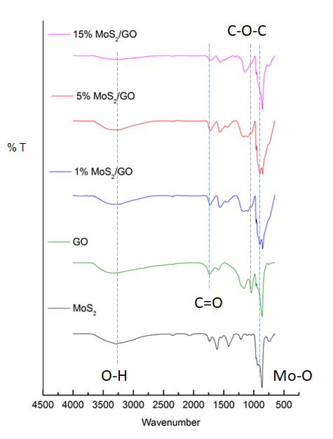
Figure 1. FTIR spectrum of MoS₂, GO and MoS₂/GO composites (1%, 5% and 15%)
Figure 2 shows diffractogram of MoS₂, GO and MoS₂/GO composites (1%, 5% and 15%). Based on the figure, the diffraction peak of GO can be seen at 2ᶿ = 24.92˚ indicating interplanar space of the GO sheet (001) [25]. MoS₂ also showed peak corresponding to (100) plane at 2ᶿ = 32.65˚ which successfully appeared at all of the mass ratio of MoS₂/GO (1%, 5% and 15%)[27][28]. Thus, it confirmed that GO and MoS₂ composites were successfully integrated.

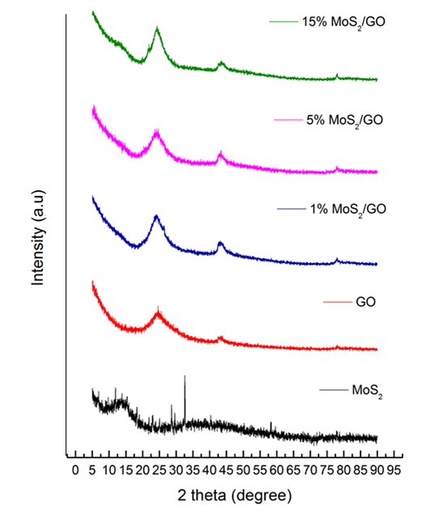
Figure 2. XRD patterns of MoS₂, GO, MoS₂/GO composite (1%, 5% and 15%)

Figure 3 reveals the photodegradation of 2-chlorophenol under sunlight using MoS₂, GO, MoS₂/GO composite (1%, 5% and 15%) photocatalyst. Successful photodegradation was monitored by decreasing in the intensity of absorbance with time irradiation. Hence, 1% MoS₂/GO proved for having lowest absorbance of 0.086 Abs. Based on the Figure 3, the MoS₂ showed an increase in absorption at 0.198 Abs of the visible light in the range of ~275 nm due to the absorption of MoS₂ in the 2-chlorophenol pollutant as it hinders complete usage of sunlight for charge carrier generation due to having wider band gap and have low mobility preventing charge transfer [29]. Moreover, rapid recombination of photogenerated electron hole pairs can decline its photocatalytic activities and poor dispersion happened when the nanomaterials are accumulated [30]. Meanwhile, Figure 4 presents the degradation percentage of all composites where the highest percent degradation is 51.41% for 1% MoS₂/GO composite due to the compatibility between graphene and MoS₂ as it enhanced the catalytic activities of amorphous producing highly efficient hydrogen production under visible light irradiation [31].

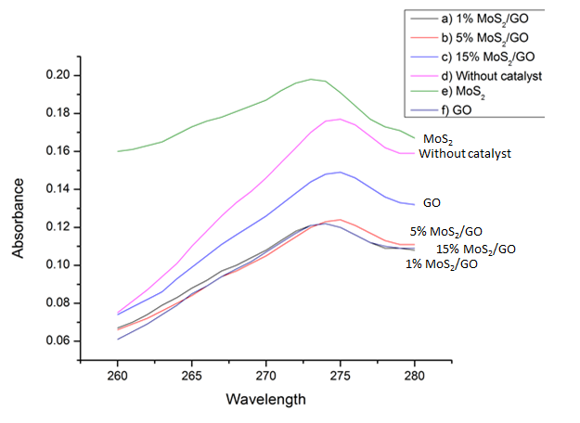
Figure 3. Different absorbance for different catalyst for 3 hours
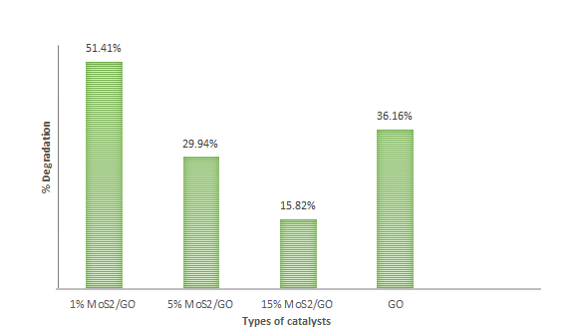
Figure 4. Degradation percentage of 2-chlorophenol for different catalysts under sunlight
Conclusion
MoS₂/GO composites were successfully prepared using ex-situ and hydrothermal method. This can be seen from the analyses of the FTIR, UV-Vis and XRD which confirmed the functional group and incorporated of MoS₂ and GO composites. From the findings, all of the composites prepared have the potential in degrading 2-chlorophenol under sunlight assisted degradation. 1% MoS₂/GO was revealed as the best composite to degrade 2-chlorophenol with the percentage degradation of 51.41%. Further optimization and controlled experiments can be done to tackle the most prominent condition for 2-chlorophenol to degrade with sunlight as the main source of light to achieve highest degradation percentage within a short time.
Acknowledgement
We acknowledge the financial support of the Ministry of Higher Education for Fundamental Research Grant (FRGS/1/2018/STG01/UITM/02/1). We also acknowledge School of Chemistry and Environment in the Faculty of Applied Science at UiTM Negeri Sembilan, Kuala Pilah Campus for the facilities that have been provided for the research.

References
- Li, K., Fang, X., Fu, Z., Yang, Y., Nabi, I., Feng, Y., Bacha, A. U. R. and Zhang, L. (2020). Boosting photocatalytic chlorophenols remediation with addition of sulfite and mechanism investigation by in-situ DRIFTs. Journal of Hazardous Materials, 398: 123007.
- Lei, M., Gao, Q., Zhou, K., Gogoi, P., Liu, J., Wang, J., Song, H., Wang, S. and Liu, X. (2021). Catalytic degradation and mineralization mechanism of 4-chlorophenol oxidized by phosphomolybdic acid/H₂O₂. Separation and Purification Technology, 257: 117933.
- Garba, Z. N., Zhou, W., Lawan, I., Xiao, W., Zhang, M., Wang, L., Chen, L. and Yuan, Z. (2019). An overview of chlorophenols as contaminants and their removal from wastewater by adsorption: A review. Journal of Environmental Management, 241: 59-75.
- Han, Z., Fei, J., Li, J., Deng, Y., Lv, M., Zhao, J., Wang, C. and Zhao, X. (2020). Enhanced dye-sensitized photocatalysis for water purification by an alveoli-like bilayer Janus membrane. Chemical Engineering Journal, 407: 127214.
- Abada, B., Alivio, T. E. G., Shao, Y., O’Loughlin, T. E., Klemashevich, C., Banerjee, S., Jayaraman, A., and Chu, K. H. (2018). Photodegradation of fluorotelomer carboxylic 5:3 acid and perfluorooctanoic acid using zinc oxide. Environmental Pollution, 243: 637-644.
- Elsalamony, R. A. and Mahmoud, S. A. (2017). Preparation of nanostructured ruthenium doped titania for the photocatalytic degradation of 2-chlorophenol under visible light. Arabian Journal of Chemistry, 10(2): 194-205.
- Soltani, T. and Lee, B. K. (2017). Enhanced formation of sulfate radicals by metal-doped BiFeO₃ under visible light for improving photo-Fenton catalytic degradation of 2-chlorophenol. Chemical Engineering Journal, 313: 1258-1268.
- Barakat, M. A., Kumar, R. and Eniola, J. O. (2021). Adsorption and photocatalytic scavenging of 2-chlorophenol using carbon nitride-titania nanotubes based nanocomposite: Experimental data, kinetics and mechanism. Data in Brief, 34: 106664.
- Anjum, M., Oves, M., Kumar, R. and Barakat, M. A. (2017). Fabrication of ZnO-ZnS@polyaniline nanohybrid for enhanced photocatalytic degradation of 2-chlorophenol and microbial contaminants in wastewater. International Biodeterioration and Biodegradation, 119: 66-77.
- Onkani, S. P., Diagboya, P. N., Mtunzi, F. M., Klink, M. J., Olu-Owolabi, B. I. and Pakade, V. (2020). Comparative study of the photocatalytic degradation of 2–chlorophenol under UV irradiation using pristine and Ag-doped species of TiO₂, ZnO and ZnS photocatalysts. Journal of Environmental Management, 260: 110145.
- Rueda-Marquez, J. J., Levchuk, I., Fernández Ibañez, P. and Sillanpää, M. (2020). A critical review on application of photocatalysis for toxicity reduction of real wastewaters. Journal of Cleaner Production, 258: 120694
- Prasad, C., Liu, Q., Tang, H., Yuvaraja, G., Long, J., Rammohan, A. and Zyryanov, G. V. (2020). An overview of graphene oxide supported semiconductors based photocatalysts: Properties, synthesis and photocatalytic applications. Journal of Molecular Liquids, 297: 111826.
- Chen, Y., Zhai, B. and Liang, Y. (2019). Enhanced degradation performance of organic dyes removal by semiconductor/MOF/graphene oxide composites under visible light irradiation. Diamond and Related Materials, 98: 107508.
- Kamalam, M. B. R., Inbanathan, S. S. R. and Sethuraman, K. (2018). Enhanced photo catalytic activity of graphene oxide /MoO₃ nanocomposites in the degradation of Victoria Blue Dye under visible light irradiation. Applied Surface Science, 449: 685-696.
- Cao, Y., Wang, P., Fan, J. and Yu, H. (2021). Covalently functionalized graphene by thiourea for enhancing H₂-evolution performance of TiO₂ photocatalyst. Ceramics International, 47(1): 654-661.
- El-Fawal, E. M., Younis, S. A. and Zaki, T. (2020). Designing AgFeO₂-graphene/Cu₂(BTC)₃ MOF heterojunction photocatalysts for enhanced treatment of pharmaceutical wastewater under sunlight. Journal of Photochemistry and Photobiology A: Chemistry, 401: 112746.
- Long, D., Peng, J., Liu, H., Feng, Z., Chen, L., Chen, X. and Lu, M. (2020). Graphene oxide discarded solution for high surface area photocatalyst. Solar Energy Materials and Solar Cells, 209: 110446.
- Asaithambi, S., Sakthivel, P., Karuppaiah, M., Balamurugan, K., Yuvakkumar, R., Thambidurai, M. and Ravi, G. (2021). Synthesis and characterization of various transition metals doped SnO₂@MoS₂ composites for supercapacitor and photocatalytic applications. Journal of Alloys and Compounds, 853: 157060.
- Yu-Cheng, C. and Yu-Wen, L. (2020). MoS₂@SnO₂ core-shell sub-microspheres for high efficient visible-light photodegradation and photocatalytic hydrogen production. Materials Research Bulletin, 129: 110902.
- Zhao, Y., Zhang, X., Wang, C., Zhao, Y., Zhou, H., Li, J. and Jin, H. B. (2017). The synthesis of hierarchical nanostructured MoS₂ /Graphene composites with enhanced visible-light photo-degradation property. Applied Surface Science, 412: 207-213.
- Rani, A., Singh, K., Patel, A. S., Chakraborti, A., Kumar, S., Ghosh, K. and Sharma, P. (2020). Visible light driven photocatalysis of organic dyes using SnO₂ decorated MoS₂ nanocomposites. Chemical Physics Letters, 738: 136874.
- Zaaba, N. I., Foo, K. L., Hashim, U., Tan, S. J., Liu, W. W. and Voon, C. H. (2017). Synthesis of graphene oxide using modified hummers method: solvent influence. Procedia Engineering, 184: 469-477.
- Gopalakrishnan, K., Sultan, S., Govindaraj, A. and Rao, C. N. R. (2015). Supercapacitors based on composites of PANI with nanosheets of nitrogen-doped RGO, BC_{1.5}N, MoS₂ and WS₂. Nano Energy, 12: 52-58.
- Song, Y., Cao, K., Li, W., Ma, C., Qiao, X., Li, H. and Hong, C. (2020). Optimal film thickness of rGO/MoS₂ @ polyaniline nanosheets of 3D arrays for carcinoembryonic antigen high sensitivity detection. Microchemical Journal, 155: 104694.
- Hanafi, N. N., Sambasevam, K. P., Arifutzzaman, A., Rahman, S. and Baharin, S. N. A. (2020). Solar-driven degradation of 2-chlorophenol using PANI/GO as photocatalyst. Orbital, 12(4): 205-212.
- Pawson, S. (n.d.). Weatherspark.com. Average Weather in April in Kuala Pilah, Malaysia - Weather Spark. https://weatherspark.com/m/114181/4/Average-Weather-in-April-in-Kuala-Pilah-Malaysia.
- Phung, H. N. T., Truong, N. D., Duong, P. A. and Tuan Hung, L. V. (2018). Influence of MoS₂ deposition time on the photocatalytic activity of MoS₂/ V, N co-doped TiO₂ heterostructure thin film in the visible light region. Current Applied Physics, 18(6): 737-743.
- Chao, J., Yang, L., Zhang, H., Liu, J., Hu, R. and Zhu, M. (2020). Engineering layer structure of MoS₂/polyaniline/graphene nanocomposites to achieve fast and reversible lithium storage for high energy density aqueous lithium-ion capacitors. Journal of Power Sources, 450: 227680.
- Beura, R., Pachaiappan, R. and Paramasivam, T. (2021). Photocatalytic degradation studies of organic dyes over novel Ag-loaded ZnO-graphene hybrid nanocomposites. Journal of Physics and Chemistry of Solids, 148: 109689.
- Saha, S., Chaudhary, N., Mittal, H., Gupta, G. and Khanuja, M. (2019). Inorganic–organic nanohybrid of MoS₂-PANI for advanced photocatalytic application. International Nano Letters, 9(2): 127-139.
- Sha, C., Lu, B., Mao, H., Cheng, J., Pan, X., Lu, J. and Ye, Z. (2016). 3D ternary nanocomposites of molybdenum disulfide/polyaniline/reduced graphene oxide aerogel for high performance supercapacitors. Carbon, 99: 26-34.

