EVALUATION OF THE TOTAL FLAVONOID, PHENOLIC CONTENT, AND ANTIOXIDANT ACTIVITY IN SABAH SNAKE GRASS EXTRACTS (Clinacanthus nutans Lindau)

(Penilaian Jumlah Kandungan Flavonoid, Fenolik dan Aktiviti Antioksida

bagi Ekstrak Belalai Gajah Clinacanthus nutans Lindau)

Idham Zaharudie and Chong Shu Xian*

Faculty of Pharmacy,
SEGi University,
No. 9, Jalan Teknologi, Taman Sains Selangor, Kota Damansara, PJU 5,
47810 Petaling Jaya, Selangor, Malaysia

*Corresponding author: chongshuxian@segi.edu.my

Abstract
Clinacanthus nutans Lindau (C. nutans) or locally known in Malaysia as the Sabah Snake Grass (SSG) contains phytochemicals such as flavonoids and phenolic acids. The leaves of the plant exhibit antioxidant, anti-inflammatory, and antiviral properties, thus, it was traditionally used to treat venomous injuries, rheumatism, and sprains throughout Asia. Previous studies of the antioxidative activity in C. nutans extracts have been carried out under different conditions or using different extraction methods, which may have resulted in a varied yield of antioxidative constituents. Thus, this study aimed to compare the total phenolic content (TPC), total flavonoid content (TFC), and antioxidative activity of C. nutans methanol, water, and hexane extracts using the traditional solvent extraction method. Results showed that the water extract contains the highest TPC value (3.66 ± 0.11 mg GAE/g) followed by methanol (2.84 ± 0.36 mg GAE/g) and hexane (0.13 ± 0.03 mg GAE/g). The TPC values of methanol and water extracts were significantly higher than hexane (p < 0.05). For TFC value, the methanol extract was the highest (1.91 ± 0.05 mg QE/g), followed by water extract (1.50 ± 0.01 mg QE/g) and hexane was not detected. The radical scavenging activity (RSA) decreased in the order of methanol > water > hexane extract. In conclusion, the study suggests that high phenolic and flavonoid contents in C. nutans extracts may be the key factor for it to act as an excellent source of natural antioxidants.

Keywords: Sabah snake grass, total phenolic content, total flavonoid content, radical scavenging activity

Abstrak
Clinacanthus nutans Lindau (C. nutans) atau lebih dikenali oleh penduduk tempatan di Malaysia sebagai belalai gajah mengandungi fitokimia seperti flavonoid dan asid fenolik. Dedaun tumbuhan berikut mempamerkan sifat-sifat seperti antioksida, anti radang, dan antivirus. Oleh itu, ia secara tradisionalnya digunakan di seluruh asia untuk merawat kecederaan berbisa, sakit sendi, dan seliuh. Kajian terdahulu mengenai aktiviti antioksida dalam ekstrak C. nutans menggunakan kaedah ekstrak yang berbeza atau dalam keadaan yang berbeza. Justeru, ini boleh menjana hasil kandungan antioksidan yang berbeza. Kajian ini betujuan membuat penilaian jumlah kandungan fenolik (TPC), flavonoid (TFC), dan aktiviti antioksida bagi ekstrak metanol, air, dan heksana daripada C. nutans dengan kaedah pengekstrakan pelarut tradisional. Keputusan menunjukkan bahawa ekstrak air mengandungi kandungi TPC tertinggi (3.66 ± 0.11 mg GAE/g) diikuti metanol (2.84 ± 0.36 mg GAE/g) and heksana (0.13 ± 0.03 mg GAE/g). Bagi nilai TFC, ekstrak methanol adalah tertinggi (1.91 ± 0.05 mg QE/g), mingikuti ekstrak air (1.50 ± 0.01 mg QE/g) dan heksana (tidak dikesan). Nilai TPC ekstrak metanol dan air adalah jauh lebih tinggi daripada heksana (p < 0.05). Perencatan radikal bebas (RSA) bagi ekstrak dalam tertib menurun adalah seperti berikut; metanol > heksana > air. Konklusinya, kajian ini mencadangkan bahawa kandungan fenolik dan flavonoid yang tinggi dalam ekstrak C. nutans mungkin menjadi faktor utama untuk ia bertindak sebagai sumber antioksida semula jadi yang hebat.

Kata kunci: belalai gajah, jumlah kandungan flavonoid, jumlah kandungan fenolik, perencatan radikal bebas

Introduction
C. nutans, or commonly known as Belalai Gajah in Malaysia, is a small plant native to tropical Asian countries [1]. The leaves of the plant can be described as flat, opposite, and narrowly elliptic-oblong in shape and the mature part of the plant exhibits lower levels of phytochemicals, chlorophyll, ascorbic acid, and phenolic content in comparison to its younger counterparts [2]. The slightly curved stem that supports the leaves resembles the curvature of an elephant's trunk where the name Belalai Gajah was derived [3].

C. nutans is used in Thailand as a traditional antivenom therapy for venomous creatures like snakes, jellyfish, and scorpions [4], while native Singaporeans utilise the plant for detoxification purposes [5]. The plants' anti-inflammatory characteristics allow locals in China to utilise it as a treatment for rheumatism and sprains from injuries [6]. The extract of C. nutans has demonstrated antioxidant activity and protection against free radical-induced haemolysis [7], which allows the plant to be further developed as a natural antioxidant for human consumption [8]. The leaf of the plant also exhibits antiviral properties against the herpes simplex virus type-2 (HSV-2) [9]. Yet, more studies are needed to establish and comprehend the bioactive components and therapeutic characteristics of this plant due to its multiple and beneficial attributes [10].

An antioxidant is an agent that has the ability to greatly delay or prevent the oxidation of an oxidisable substance when it is introduced at low concentrations compared to the substance [11]. The antioxidant effect mainly results from phenolic compounds such phenolic acid, flavonoids, and phenolic diterpenes. These compounds have the capability to undergo redox reaction, which absorbs and neutralises free radicals through the suppression of singlet and triplet oxygen [12]. Studies have isolated various bioactive compounds in C. nutans which exhibit antioxidant activity such as polyphenols [13], ferulic acid, caffeic acid, protocatechuic acid, chlorogenic acid [14], phthalic acid [15] and gendarucin A [16]. Studies have reported that the ethanolic extract of the leaf exhibited higher antioxidative activity than the stem extract [16], yet the extract exhibited remarkably lower antioxidative activity than green tea extract [13]. A study demonstrated that crude chloroform extract possessed the highest antioxidant activity compared to crude methanol and aqueous extracts [15]. However, other have reported that the crude 80% aqueous methanol extract had the highest antioxidant activity compared to fractionation extracts [17]. In addition, the activity of a younger plant extract was found to be higher than the older plant, and the buds extract showed significant higher activity than the leaf extract [18].

Most of the previous literatures had employed the basic liquid extraction method to study the antioxidative properties of methanolic extract in C. nutans [19-22]. Nevertheless, the investigation of antioxidative properties for other extracts, such as water and hexane extracts, had either used liquid extraction at higher temperatures (70°C) [21] or fractionation extraction from the crude methanolic extract [20]. Antioxidants are heat sensitive and are prone to degradation after prolonged heating [23], which results in a lower yield of its constituents. In addition, different extraction methods may result in varied yields of antioxidative constituents [24]. Previous studies have no comparable data on the antioxidative activity of C. nutans crude extract using methanol, water, and hexane. This study was thus conducted to compare the TPC, TFC and antioxidant activity of C. nutans using the basic liquid extraction method under room temperature.

Materials and Methods
Plant material
1 kg of C. nutans leaf was purchased from a herbal shop in Cheras, Kuala Lumpur. The authentication of the plant was confirmed by the Forest Research Institute Malaysia.

Extraction of C. nutans
The dried leaf of C. nutans was grinded into a fine powder with a blender. 100 g of fine plant powder was agitated in three different solvents (hexane, methanol, and distilled water) for 48 hours at room temperature. Each sample was filtered and concentrated by evaporation using a rotary evaporator at 60°C. The dried extracts were weighted and dissolved in methanol with the concentration of 0.1 g/mL and were stored at -20°C for further analysis.

Determination of TPC of C. nutans extracts
The Folin-Ciocalteu colorimetric method was used to quantify TPC. Gallic acid (GA) was used as the standard. The GA stock solution (50 µg/mL) was prepared in water and further dilution was made to achieve the calibration curve in the range of 1-40 µg/mL. 0.1 mL of each extract were placed into a volumetric flask and mixed with 0.2 mL of Folin-Ciocalteu phenol reagent and 1.5 mL of 6% Na₂CO₃ solution. The volume of the mixture was adjusted to 10 mL before incubation for 30 min in the dark. The absorbance of the mixture was then monitored and quantified against blank at 725 nm using a UV-visible spectrometer (Beckman Coulter DU730). The concentration of phenolic compounds was represented in microgram GA equivalent per gram of extract (mg GAE/g) [25], with the equation shown below:

TPC = [Concentration of GA from calibration curve (µg/mL) x Volume of extract (mL)] (1)
Mass of plant extract (g)

Determination of TFC of C. nutans extracts
The aluminium colorimetric method was used to analyse the TFC [25]. Quercetin was used as the standard. The quercetin stock solution (50 µg/mL) was prepared in ethanol and further dilution was made to achieve the calibration curve in the range of 6.25-40 µg/mL. 50 µL of each three extracts were placed into a volumetric flask and mixed with 5 mL water, 0.6 mL NaNO₃, 0.5 mL AlCl₃, and 4 mL NaOH. The mixture was then incubated for 20 min in the dark. The absorbance of the mixture was then quantified at 415 nm using a UV-visible spectrometer. The concentration of flavonoid was represented in microgram quercetin equivalent per gram of extract (mg QE/g) [25], with the equation shown below:

TFC = [Concentration of quercetin from calibration curve (µg/mL) x Volume of extract (mL)] (2)
Mass of plant extract (g)

Radical scavenging activity of C. nutans extracts: 2,2-diphenyl-1-picrylhydrazyl (DPPH) assay
An amount 60 µg/mL DPPH (Alfa Aesar, Lancashire, UK) stock was freshly prepared with ethanol. 10 µL of plant extracts were individually mixed with 3 mL of DPPH and incubated for 30 min. The absorbance values were recorded using a UV-vis spectrometer at 517 nm [25].

2,2’-azino-bis-(3-ethyl)benzothiazoline)-6-sulfonic acid diammonium salt (ABTS) radical cation scavenging assay
The ABTS assay was carried out as described by Rakholiya et al. [26]. 10 µL of plant extracts were individually mixed with 3 mL of ABTS radical cation solution and incubated for 40 min. The absorbance values were recorded using a UV-vis spectrometer at 734 nm.

The %RSA of DPPH and ABTS cation radical were quantified according to the equation shown below:

%RSA = (Absorbance of blank – Absorbance of sample) x 100% (3)
Absorbance of blank

Statistical analysis
The two-tailed t-test was used to analyse the differences between methanol, hexane, and water extracts of C. nutans, where p < 0.05 is considered statistically significant. Statistical calculation was performed using Microsoft Excel (Microsoft Office Professional Plus 2019, Washington, United States).

Results and Discussion
Extraction of C. nutans
The percentage yield for methanolic, hexane, and water extracts were obtained from 100 g of dried plant powder as shown in Table 1. Water extract had the highest percentage yield (8.09%) when compared to the methanolic extract (4.92%) and hexane extract (4.80%), which had the lowest percentage yield. The high yield in methanol was most likely due to the solubility of important components of SSG in methanol, such as the phenolic groups [27]. The polarity of the solvents used for extraction impacted the phenolic solubility [28]. Furthermore, water can enhance extraction efficiency [29] and this may result in the high recovery of phenolic compounds due to the high polarity in water.

Table 1. The net weight and percentage yield of C. nutans for methanol, hexane, and water extract
Solvent for Plant Extraction | Net Weight (g) | Yield (%)
Methanol | 2.191 | 4.92
Hexane | 2.400 | 4.80
Water | 4.050 | 8.09

Total phenolic content
Phenolic acids, flavonoids, and tannins are considered the most important dietary phenolic components among several types of phenolic compounds [30]. Phenolic compounds especially phenols act as antioxidants, immunological boosters, anti-clotting agents, and hormone modulators by modifying the prostaglandin pathways which prevent platelets from clumping and have the capacity to inhibit particular enzymes that induce inflammation [31]. The Folin–Ciocalteu test is the current standardised technique to determine TPC in food or biological samples, which is based on the interaction of phenolic compounds with a colorimetric reagent that permits detection in a visible spectrum [32-33]. Gallic acid (GA) was used as the positive control in the quantification of TPC. The TPC of three extracts (methanol, water, and hexane) were yielded from the calibration curve [y = 0.0389x - 0.0079); R² = 0.9901] obtained from the GA concentrations in µg GAE/g expression (Figure 1), where y is sample absorbance at 750 nm while x is the concentration of TPC.

Figure 2 shows that the methanolic extract has the highest content of TPC (3.66 ± 0.11 mg GAE/g), followed by methanol extract (2.84 ± 0.04 mg GAE/g), while hexane extract had the lowest content of TPC (0.13 ± 0.03 mg GAE/g). The two-tailed t-test showed significant differences between the TPCs among the three extracts (p < 0.05). All TPC values obtained were lower than reported in literature. Fadhlin Baharuddin et al. [34] reported that the TPC of methanolic extract was 11.05-13.87 GAE/g when the temperature ranged from 30-55°C. Ismail et al. [17] reported that the TPC of aqueous and hexane extracts fractionated from the crude methanolic extract possessed 415.76 and 50.24 mg GAE/g, respectively. These inconsistent findings resulted from differences in method of extraction, parts of plant, maturity of plant and storage of plant [35]. Nevertheless, our results agreed with previous study which showed that the water extract had the highest TPC and hexane extract had the lowest TPC [17].

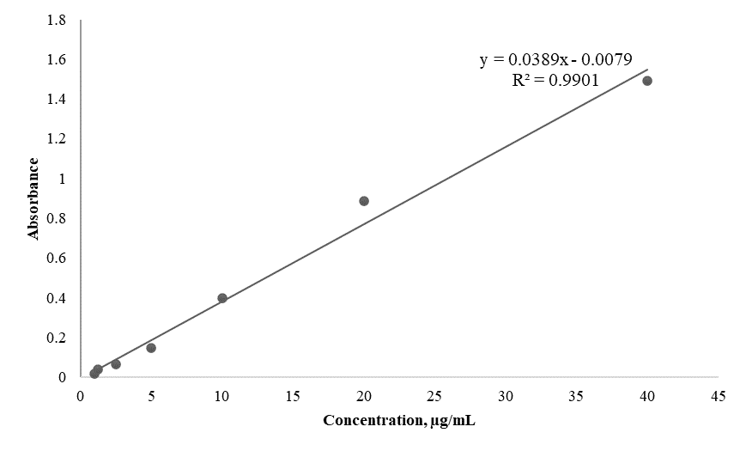

Figure 1. The calibration curve of the gallic acid standard solutions
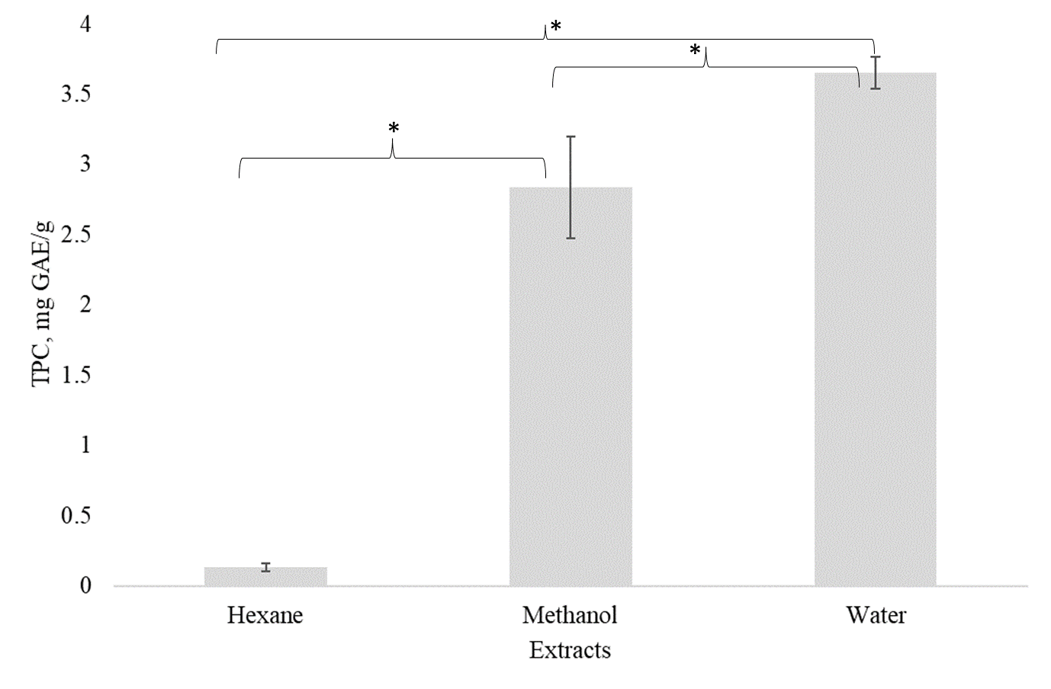
Figure 2. Mean total phenolic content for C. nutans hexane, methanol, and water extracts which were expressed as gallic acid equivalent (GAE). All experiments were performed in triplicates. Asterisk (*) indicates statistically significant at the level of p < 0.05 between the extracts
Total flavonoid content
Flavonoids are classified into different subclasses based on their composition, including flavanones, flavones, flavanols, and flavonols, with myricetin, kaempferol, and quercetin being the most common [36]. It is a water-soluble phytochemical compound which is obtained from essential plant phenolic with beneficial antimicrobial, anti-inflammatory, and antioxidant properties as well as the ability to inhibit oxidative cell damage and carcinogenesis [30]. Quercetin was used as the positive control in determining TFC. The TFC of three different extracts were yielded from the calibration curve [y = 0.0824x - 0.2444; R² = 0.957] obtained from the quercetin concentrations in µg QE/g as shown in Figure 3, where y is sample absorbance at 415 nm and x is the concentration of TFC. Figure 4 shows that the methanolic extract has the highest content of TFC (1.91 ± 0.05 mg QE/g), followed by the water extract (1.50 ± 0.01 mg QE/g); meanwhile, the hexane extract cannot be determined as the absorbance is below the limit of detection from the calibration curve. The two-tailed t-test showed significant differences in TFCs between the water and methanol extract (p < 0.05). Previous literature reported that the TFC of 80% methanolic extract of C. nutans was 4.31-7.32 mg QE/g, where the phenolics content of the plant was higher as the plant grew [19]. The variation in results may be due to many factors such as plant age [19] or different geographical distribution of the plant which affects the plant’s metabolism [35]. Our findings showed that the TPC in methanolic and aqueous extract was remarkably higher than hexane extract, and this trend is also observed in previous literature where the water extract has the highest TPC and hexane extract has the lowest TFC [17].

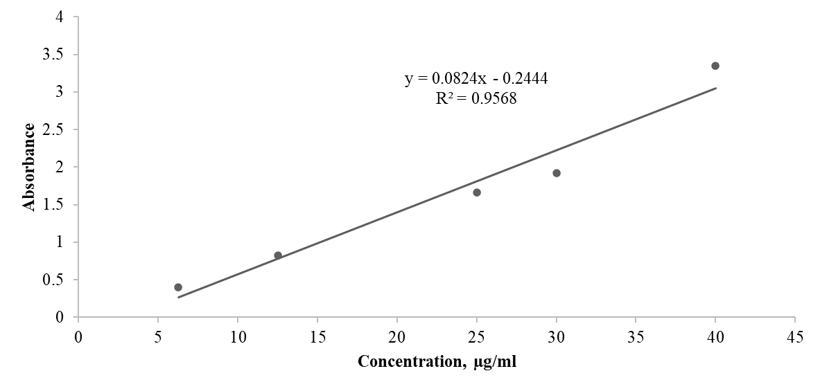

Figure 3. The calibration curve of the quercetin standard solution

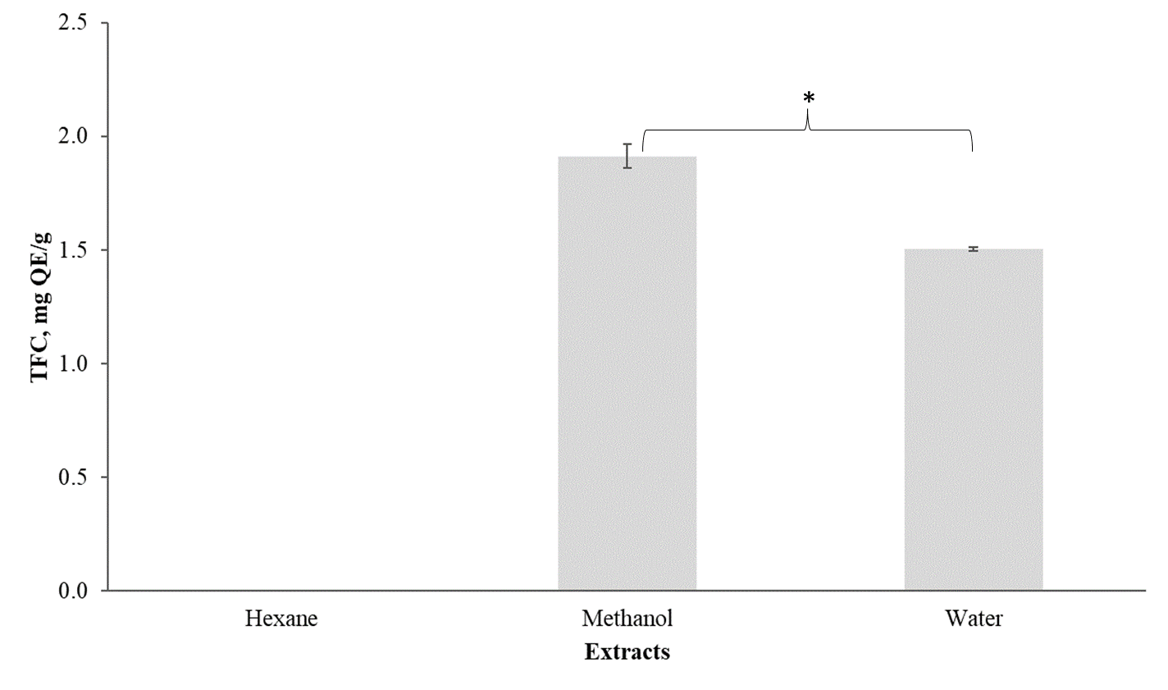
Figure 4. Mean total flavonoid content for C. nutans hexane, methanol and water extracts which were expressed as quercetin equivalent (QE). All experiments were performed in triplicates. Asterisk (*) indicates statistically significant at the level of p < 0.05 between the extracts
Radical scavenging activity - DPPH and ABTS assay
DPPH and ABTS assays are prominent surrogate markers to detect antioxidant capacity and evaluate potential substances behaving as free radical scavengers [37]. Table 2 shows that the DPPH and ABTS scavenging activity have the same trend, where the %RSA decreases in the order of methanolic > water > hexane extract. Our findings agree well with Ismail et al. [34] who reported that the methanolic crude extract exhibited the highest antioxidative activity and hexane fraction extract exhibited the lowest antioxidative activity.

Table 2. The %RSA of DPPH and ABTS cation radical for hexane, methanol and water extracts of C. Nutans
Plant Extract | %RSA
Plant Extract | DPPH | ABTS
Hexane | 16.04 ± 1.46 | 3.64 ± 0.48
Methanol | 59.27 ± 0.86 | 99.94 ± 0.22
Water | 53.40 ± 3.72 | 74.94 ± 2.04

Conclusion
C. Nutans was extracted using liquid extraction method under room temperature. The three types of solvents used for extraction are hexane, methanol and water. The TPC, TFC, and antioxidative activity were quantified using Folin-Ciocalteu assay, aluminium colorimetric method, DPPH, or ABTS assay, respectively. The value of TPC decreased in the following order: water > methanol > hexane, where the water extract (3.66 ± 0.11 mg GAE/g) was 1.3- and 28-folds higher than the methanol (2.84 ± 0.04 mg GAE/g) and hexane (0.13 ± 0.03 mg GAE/g) extracts, respectively. Meanwhile, the TFC value of methanol extract (1.91 ± 0.05 mg QE/g) was 1.3-fold higher than water extract (1.50 ± 0.01 mg QE/g), however, the hexane extract was too low to be detected. Lastly, the DPPH and ABTS radical scavenging capability of the three extracts decreased in the following order: methanol > water > hexane. Methanol and water extracts displayed supreme antioxidative scavenging activity compared to hexane extract and this might be due to the high phenolic and flavonoid content. These results suggest that C. nutans extracts are a good source of natural antioxidants.

Acknowledgement

This research is supported by SEGi University, SEGiIRF/2014-15/FoP-4/29 research fund.

References
- Intan, S., Mahiran, B., Kim, W., Siti, E., Hamid, R. and Maznah, I. (2015). In vitro antioxidant, cytotoxic and phytochemical studies of Clinacanthus nutans Lindau leaf extracts. African Journal of Pharmacy and Pharmacology, 9(34): 861-874.
- Zulkipli, I., Rajabalaya, R., Idris, A., Sulaiman, N. and David, S. (2017). Clinacanthus nutans: A review on ethnomedicinal uses, chemical constituents and pharmacological properties. Pharmaceutical Biology, 55(1): 1093-1113.
- Yahaya, R., Dash, G. K., Abdullah, M. S. and Mathews, A. (2015). Clinacanthus nutans (burm. F.) Lindau: An useful medicinal plant of south-east Asia, International Journal of Pharmacognosy and Phytochemical Research, 7(6): 1244-1250.
- P'ng, X., Akowuah, G. and Chin, J. (2013). Evaluation of the sub–acute oral toxic effect
of methanol extract of Clinacanthus nutans leaves in rats. Journal of Acute Disease, 2(1): 29-32.
- Siew, Y., Zareisedehizadeh, S., Seetoh, W., Neo, S., Tan, C. and Koh, H. (2014). Ethnobotanical survey of usage of fresh medicinal plants in Singapore. Journal of Ethnopharmacology, 155(3): 1450-1466.
- Globinmed.com (2021). GlobinMed – a unique interactive e-database with validated,
up-to-date and comprehensive information on integrated medicine. http://www.globinmed.com/index.php?option=com_content&view=article&id=79320:clinacanthus-nutans-burmf-lindau&catid=199:safety-of-herbal&Itemid=139 [Accessed online 22 August 2021].
- Pannangpetch, P., Laupattarakasem, P., Kukongviriyapan, V., Kukongviriyapan, U., Kongyingyoes, B. and Aromdee, C. (2007). Antioxidant activity and protective effect against oxidative hemolysis of Clinacanthus nutans (Burm.f) Lindau. Songklanakarin Journal of Science and Technology, 29: 1-9.
- Kong, H., Musa, K. and Abdullah Sani, N. (2016). Clinacanthus nutans (Belalai Gajah/Sabah Snake Grass): Antioxidant optimization on leaves and stems. AIP Conference Proceedings, 1784: 0300301-0300305.
- Jayavasu, C., Dechatiwongse, T. and Balachandra, K. (1992). Virucidal activity of Clinacanthus nutans Lindau extracts against herpes simplex virus type-2: In vitro study. Warasan Krom Witthayasat Kanphaet, 34 (4): 153-158.
- Ghasemzadeh, A., Nasiri, A., Jaafar, H., Baghdadi, A. and Ahmad, I. (2014) Changes in phytochemical synthesis, chalcone synthase activity and pharmaceutical qualities of Sabah snake grass (Clinacanthus nutans L.) in relation to plant age. Molecules, 19(11): 17632-17648.
- Halliwell, B. (1990) How to characterize a biological antioxidant. Free Radical
Research Communications, 9(1): 1-32.
- Krauss, R., Eckel, R., Howard, B., Appel, L., Daniels, S., Deckelbaum, R. (2000). The american heart association dietary guidelines. Circulation, 102(18): 2284-2299.
- Yuann, J. M. P., Wang, J. S., Jian, H. L., Lin, C. C. and Liang, J. Y. (2012). Effects of Clinacanthus nutans (Burm. f) Lindau leaf extracts on protection of plasmid DNA from riboflavin photoreaction. MC-Transaction on Biotechnology, 4: 45-58.
- Sarega, N., Imam, M. U., Md Esa, N., Zawawi, N. and Ismail, M. (2016). Effects of phenolic-rich extracts of Clinacanthus nutans on high fat and high cholesterol diet-induced insulin resistance. BMC Complementary and Alternative Medicine, 16(1): 1-11.
- Yong, Y. K., Tan, J. J., The, S. S., Mah, S. H., Ee, G. C. L., Chiong, H. S. and Ahmad, Z. (2013). Clinacanthus nutans extracts are antioxidant with antiproliferative effect on cultured human cancer cell lines. Evidence-Based Complementary and Alternative Medicine, 2013: 462751.
- Khoo, L.W., Mediani, A., Zolkeflee, N. K. Z., Leong, S. W., Ismail, I. S., Khatib, A., Shaari, K. and Abas, F. (2015). Phytochemical diversity of Clinacanthus nutans extracts and their bioactivity correlations elucidated by NMR based metabolomics. Phytochemistry Letters, 14:123-133.
- Ismail, N. Z., Md Toha, Z., Muhamad, M., Nik Mohamed Kamal, N. N. S., Mohamad Zain, N. N. and Arsad, H. (2020). Antioxidant effects, antiproliferative effects, and molecular docking of Clinacanthus nutans leaf extracts. Molecules, 25: 2067.
- Ghasemzadeh, A., Nasiri, A., Jaafar, H. Z. E., Baghdadi, A. and Ahmad, I. (2014). Changes in phytochemical synthesis, chalcone synthase activity and pharmaceutical qualities of Sabah snake grass (Clinacanthus nutans L.) in relation to plant age. Molecules, 19: 17632-17648.
- Abd Samat, N. M.A., Ahmad, S., Awang, Y., Bakar, R. A. H. and Hakiman, M. (2020). Alterations in herbage yield, antioxidant activities, phytochemical contents, and bioactive compounds of Sabah snake grass (Clinacanthus Nutans L.) with regards to harvesting age and harvesting frequency. Molecules, 25 (12): 2833.
- Alam, M. A, Zaidul, I. S., Ghafoor, K., Sahena, F., Hakim, M. A., Rafii, M.Y., Abir, H.M., Bostanudin, M. F., Perumal, V. and Khatib, A. (2017). In vitro antioxidant and, α-glucosidase inhibitory activities and comprehensive metabolite profiling of methanol extract and its fractions from Clinacanthus nutans. BMC Complementary and Alternative Medicine, 17(1): 181.
- Haron, N. H., Md Toha, Z., Abas, R., Hamdan, M. R., Azman, N., Khairuddean, M. and Arsad, H. (2019). In vitro cytotoxic activity of Clinacanthus nutans leaf extracts against HeLa cells. Asian Pacific Journal of Cancer Prevention, 20(2): 601-609.
- Sarega, N., Imam, M. U., Ooi, D. J., Chan, K. W., Md Esa, N., Zawawi, N. and Ismail, M. (2016). Phenolic rich extract from Clinacanthus nutans attenuates hyperlipidemia-associated oxidative stress in rats. Oxidative Medicine and Cellular Longevity, 2016: 4137908.
- Ioannou, I., Chekir, L. and Ghoul, M. (2020). Effect of heat treatment and light exposure on the antioxidant activity of flavonoids. Processes, 8: 1078.
- Tushar, D., Sonal, S., Gajbhiye, N. A. and Satyanshu, K. (2017). Effect of extraction methods on yield, phytochemical constituents and antioxidant activity of Withania somnifera. Arabian Journal of Chemistry, 10(1): S1193-S1199.
- Iqbal, E., Salim, K. and Lim, L. (2015). Phytochemical screening, total phenolics and antioxidant activities of bark and leaf extracts of Goniothalamus velutinus (airy shaw) from Brunei Darussalam, Journal of King Saud University - Science, 27(3): 224-232.
- Rakholiya, K., Kaneria, M., Nagani, K., Patel, A. and Chanda, S. (2015). Comparative analysis and simultaneous quantification of antioxidant capacity of four terminalia species using various photometric assays. World Journal of Pharmaceutical Research, 4 (4): 1280-1296.
- Ismail, H., Chan, K., Mariod, A. and Ismail, M. (2010). Phenolic content and antioxidant
activity of cantaloupe (Cucumis melo) methanolic extracts. Food Chemistry, 119(2): 643-647.
- Naczk, M. and Shahidi, F. (2006). Phenolics in cereals, fruits and vegetables: Occurrence, extraction and analysis. Journal of Pharmaceutical and Biomedical Analysis, 41(5): 1523-1542.
- Hemwimon, S., Pavasant, P. and Shotipruk, A. (2007). Microwave-assisted extraction of antioxidative anthraquinones from roots of Morinda citrifolia. Separation and Purification Technology, 54(1): 44-50.
- King, A. and Young, G. (1999). Characteristics and occurrence of phenolic phytochemicals. Journal of the American Dietetic Association, 99(2): 213-218.
- Hussain, I., Ullah, R., Ullah, R., Khurram, M., Ullah, N., Abdul, B., Khan, F., Khattak, M., Zahoor, M., Khan, J. and Khan, D. N. (2011). Phytochemical analysis of selected medicinal plants. African Journal of Biotechnology, 10(38): 7487-7492.
- Folin, O. and Ciocalteu, V. (1927). On tyrosine and tryptophane determinations in proteins. Journal of Biological Chemistry, 73(2): 627-650.
- Robards, K. and Antolovich, M. (1997). Analytical chemistry of fruit bioflavonoids: a review. The Analyst, 122(2): 11R-34R.
- Fadhlin Baharuddin, N. A., Mad Nordin, M. F., Morad, N. A., Aris, N. I. A. and Che Yunus, M. A. (2018). Total phenolic, flavonoid content and antioxidant activity of Clinacanthus nutans leaves by water-based ultrasonic assisted extraction. Malaysian Journal of Analytical Sciences, 22(4): 659-666.
- Ho, S. Y., Cheong, B. E. and How, S. E. (2017). Evaluation of antioxidant activity of Clinacanthus nutans (Acanthaceae). Short Communications in Biotechnology, 4: 63-74.
- Serafini, M., Peluso, I. and Raguzzini, A. (2010). Flavonoids as anti-inflammatory agents. Proceedings of the Nutrition Society, 69(3): 273-278.
- Ilyasov, I. R., Beloborodov, V. L., Selivanova, I. A. and Terekhov, R. P. (2020). ABTS/PP decolorization assay of antioxidant capacity reaction pathways. International Journal of Molecular Sciences, 2020(21): 1131.

