

STRUCTURAL AND ELECTROCHEMICAL CHARACTERIZATIONS OF LANTHANUM-BASED COBALT FERRITE AND BARIUM CERATE-ZIRCONATE OXIDES AS COMPOSITE CATHODE FOR PROTON CERAMIC FUEL CELL APPLICATION

(Pencirian Struktur dan Elektrokimia Lantanum Berasaskan Kobalt Ferum Oksida dan Barium Serat-Zirkonat Oksida Sebagai Komposit Katod untuk Aplikasi Sel Fuel Seramik Proton)

Nurul Izzati Abd Malek¹, Ismariza Ismail², Abdul Mutalib Md Jani³, Mohd Hafiz Dzarfan Othman⁴,

Nafisah Osman^{1,5}*

¹Proton Conducting Fuel Cell Research Group, Faculty of Applied Sciences,

Universiti Teknologi MARA, 40450 Shah Alam, Selangor, Malaysia

²Faculty of Engineering Technology,

Universiti Malaysia Perlis, 02100 Padang Besar, Perlis, Malaysia

³Faculty of Applied Sciences,

Universiti Teknologi MARA, 35400 Tapah Road, Tapah, Perak, Malaysia

⁴Advanced Membrane Technology Research Centre (AMTEC),

School of Chemical & Energy Engineering, Faculty of Engineering,

Universiti Teknologi Malaysia, 81310 UTM Skudai, Johor, Malaysia

⁵Faculty of Applied Sciences,

Universiti Teknologi MARA Perlis, 02600 Arau, Perlis, Malaysia

*Corresponding author: fisha@uitm.edu.my

Received: 12 September 2021; Accepted: 12 July 2022; Published: xx August 2022

Abstract

The increased of cathode polarization resistance (R_{p}) in Proton Ceramic Fuel Cells (PCFCs) system is a major challenge in lowering their operating temperature. Therefore, selecting superior cathode materials is important to enhance the electrocatalytic activity of the electrode component. In this study, a composite cathode of LaSrCoFeO₃-BaCeZrYO₃ (LSCF-BCZY) with a ratio of 70:30 is chosen due to its advantages compared to pure LSCF. Dry pressing and spin coating techniques have been used to fabricate a 13-mm symmetrical half-cell with configuration of LSCF-BCZY|BCZY|LSCF-BCZY. The phase of sample is verified by an X-Ray Diffractometer (XRD). The electrochemical and microstructure of the half-cell is characterized using an Electrochemical Impedance Spectroscopy (EIS) and a Scanning Electron Microscope (SEM), respectively. At calcination temperature of 900 ºC, the LSCF and BCZY components still preserved their single-phase structure as proven by XRD analysis. The half-cell demonstrated a thermally activated trend in a humidified atmosphere with area specific resistance (ASR) of 0.25 Ω.cm², 0.33 Ω.cm², 1.02 Ω.cm², 1.64 Ω.cm², and 5.75 Ω.cm² at temperature of 800 ºC, 750 ºC, 700 ºC, 650 ºC and 600 ºC, respectively. An image of SEM reveals that the 10 μm LSCF-BCZY layer is well-adhered on the dense BCZY electrolyte surface. Therefore, the prepared LSCF-BCZY with the ratio of 70:30 demonstrated excellent characteristics as composite cathode for PCFCs application.

Keywords: composite cathode, single phase, spin coating, proton ceramic fuel cells

Abstrak

Peningkatan pada katod rintangan pengutuban (R_{p}) dalam sistem sel fuel seramik proton (PCFC) adalah cabaran terbesar untuk menurunkan suhu operasi. Oleh itu, pemilihan bahan katod yang terbaik adalah penting kepada meningkatkan aktiviti elektro-mangkin pada komponen elektrod tersebut. Dalam kajian ini, komposit katod daripada LaSrCoFeO₃-BaCeZrYO₃ (LSCF-BCZY) dengan nisbah 70:30 dipilih disebabkan kelebihanya berbanding dengan LSCF tulen. Teknik penekanan kering dan saduran berpusing telah digunakan untuk menghasilkan 13-mm sel separa simetri dengan konfigurasi iaitu LSCF-BCZY|BCZY|LSCF-BCZY. Pembentukan fasa sampel telah disahkan oleh pembelauan sinar-X (XRD). Sifat elektrokimia dan struktur mikro daripada sel separa simetri masing-masing telah diciri menggunakan spektroskopi impedans elektrokimia (EIS) dan pengimbasan mikroskop elektron (SEM). Pada suhu kalsin 900 ºC, komponen LSCF dan BCZY tidak menunjukkan sebarang perubahan dan berfasa tunggal dibuktikan melalui analisis XRD. Sel ini menunjukkan kecenderungan aktif secara terma, yang disahkan melalui pengukuran EIS dalam atmosfera lembap dengan kawasan rintangan khusus (ASR) masing-masing iaitu 0.25 Ω.cm², 0.33 Ω.cm², 1.02 Ω.cm², 1.64 Ω.cm², dan 5.75 Ω.cm² pada suhu 800 ºC, 750 ºC, 700 ºC, 650 ºC dan 600 ºC. Gambar SEM mendedahkan bahawa lapisan 10 μm LSCF-BCZY dipegang dengan baik pada permukaan elektrolit padat BCZY. Maka, penghasilan LSCF-BCZY dengan nisbah 70:30 menunjukkan ciri-ciri yang terbaik sebagai katod komposit bagi aplikasi PCFC.

Kata kunci: katod komposit, fasa tunggal, saduran berpusing, sistem sel fuel seramik proton

Introduction

A Proton Ceramic Fuel Cell (PCFC) has been categorized as a green energy device that converts reactant chemical energy to electrical energy with heat and water as a by-product for a high-power generation system. Nonetheless, a high cathode polarization resistance (R_{p}) significantly reduces overall cell system performance, particularly at intermediate temperature ranges [1]. The rising trend in R_{p} is related to the lack of a surface-active site for the oxygen reduction process (ORR) at the triple-phase boundary (TPB), which connects the electrolyte, cathode and gas phase. The selection of the best materials for the cathode component is crucial for the PCFC system because materials will exhibit different characteristics as they are couple with other materials and/or operates at elevated temperatures. Pure LaSrCoFeO₃ (LSCF) is a well-known cathode material for PCFCs because it contains excellent ionic and electronic charge carrier species than traditional cathodes [2]. However, due to the limitation of TPB sites formed in this pure LSCF then various methods and/or materials have been suggested to increase the TPB length [3,4] where one of them is by using a composite cathode [5].

Recently, the addition of some protonic species, for example Y³⁺-doped Ba(Ce,Zr)O₃ (BCZY) into the LSCF cathode is reported to lengthen the TPB using chemical approaches with the best composition at 70:30 for LSCF to BCZY [6]. The symmetrical half-cell was built up for electrochemical studies to evaluate the behavior of materials. PCFC requires the optimum electrolyte substrate and cathode thin film design. The samples were dry pressed at the desired pressure and sintered at high temperatures to obtain the thick pellet. The study aims to characterize the structural of BCZY composite cathode powder after calcination and obtain electrochemical and microstructural data for composite LSCF coated on BCZY substrate. A button cell is used in EIS measurement to monitor material behavior and processing procedure for high system performance. A suitable equivalence circuit for EIS spectra is introduced to fit the electrochemical modelling procedure. The information from the fitting procedure is used to calculate capacitance, arc summit frequency, and ASR at intermediate temperatures. The Adler Lane Steel (ALS) model is used to explains the detailed mechanisms occur in each spectrum.

Materials and Methods

A modified sol-gel process was employed to produce LaSrCoFeO₃ cathode powder by dissolving all the metal nitrate salts in the universal solvent, followed by the addition of citric acid and ethylenediaminetetraacetic acid (EDTA). After alkalinizing the solution with ammonium hydroxide solution to pH 9, ethylene glycol was added to complete the reaction and the obtained brownish gel was calcined for 5 hours at 900 ºC. The BaCe_{0.54}Zr_{0.36}Y_{0.1}O_{2.95} (BCZY) single-phase powder and high relative density pellet (97.1%) were prepared as previously described [6]. To form the LSCF-BCZY composite cathode, the respective LSCF and BCZY powders was mixed at the ratio of 70:30 weight percent. The composite powder was transformed into cathode slurry and spin-coated both sites on BCZY pellet under optimized condition (2000 rpm for 30 seconds). The half-cell with configuration of LSCF-BCZY|BCZY|LSCF-BCZY was sintered at 600ºC for 1 hours and 900ºC for 3 hours.

An X-ray diffractometer (XRD), electrochemical impedance spectroscopy (EIS) and a scanning electron microscope (SEM) were used to characterize the prepared powder and half-cell, respectively. For XRD measurement, the LSCF-BCZY powder was radiated by Cu-K_{α} at ambient temperature with 1.5406 Å wavelengths using 8.04 keV energy (PANalytical X'Pert PRO MRD PW 3040). The scanning rate was set at 0.02 s⁻¹ to collect the 2θ from 20º to 80º. The XRD data was analysed with X'Pert HighScore Plus software and compared to the Joint Committee on Powder Diffraction Standard (JCPDS) card number 089-1268 for LCSF and 01-089-2485 for BCZY. For electrochemical measurement, the symmetrical half-cell was subjected to the wet air with a flow rate of 90 mL/min. The measurement was made between 1 MHz and 10 mHz with amplitude voltage ranging from 3 to 5 mV at 600-800ºC using the ZIVE SP2 Electrochemical Workstation (ZIVE LAB WonATech). An equivalence circuit of L_{s}-R_{s}(R1Q1)-(R2Q2) was applied for impedance spectrum analysis using ZIVE ZMANTM 2.4 tool. The value of capacitance, arc summit frequency and polarization resistance for each temperature was calculated using the equation as reported by Malek et al. [7]. The raw and fitted data were both re-plotted using Origin 2019b. Scanning Electron Microscopy with Energy Dispersive X-ray (SEM/EDX) was used to evaluate the pellet's morphology after electrochemical testing. ImageJ software was used to measure the porosity of the SEM image.

Results and Discussion

Figure 1 depicts the XRD pattern of LSCF-BCZY composite cathode powder after calcined at 900 ºC. All diffraction peaks were corresponded to JCPDS-card no. (LSCF ID: 01-089-1268) and (BCZY ID: 01-089-2485) with orthorhombic and cubic structures, respectively. The percentage formation of single perovskite phase was more than 90% for both LSCF and BCZY as calculated using Swarts and Shrout equation indicates that the calcination temperature of 900 °C was sufficient to produce single-phase of samples. The prominent peaks were indexed using their Miller Indices (hkl) reflected plane as follows: (110), (020), (202), (220), (132), (224), and (332) for LSCF, and (110), (200), (211), (220), and (222) for BCZY. The lattice constants of LSCF and BCZY were also calculated using the Mathcad 14.0 software, and they are agreed with the reference data shown in Table 1. The obtained values were also close to that reported by Ismariza et. al. [8] for the LSCF-BCZY which calcined at T=1000 ºC.

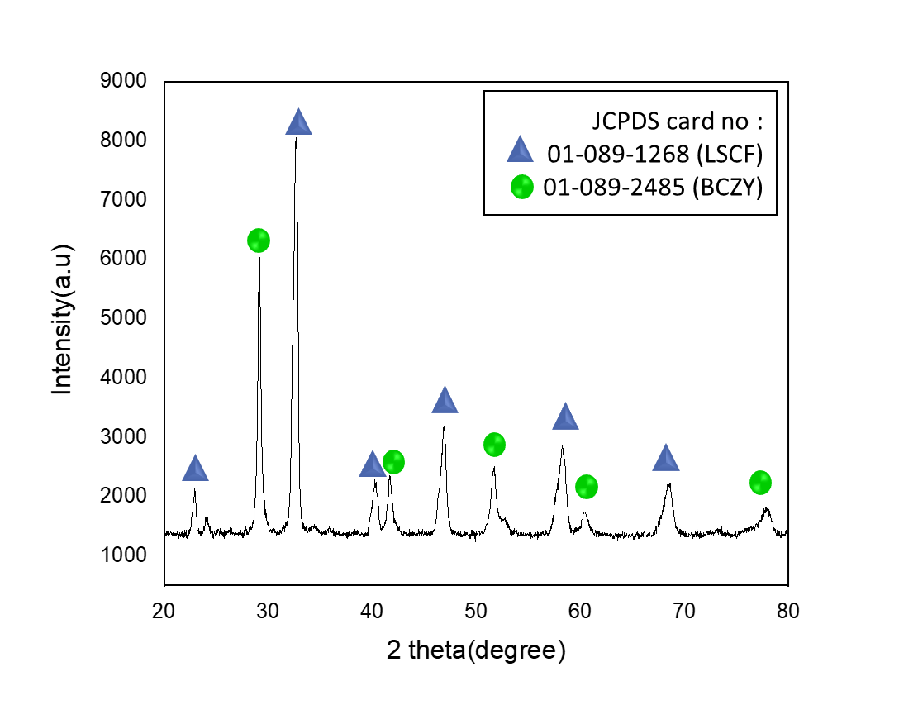

Figure 1. XRD pattern of the LSCF-BCZY composite cathode after calcined at T = 900ºC.

Table 1. Lattice parameter of the LSCF and BCZY taken from JCPDS-card and calculated ones using

Mathcad 14 software
Sample ID | Lattice Parameter/Å  (JCPDS-card) | Lattice Parameter/Å  (Mathcad 14 software)
LSCF (Orthorombic) | a = 5.475  b = 5.536  c = 7.848 | a = 5.471  b = 5.482  c = 7.900
BCZY (Cubic) | a = 4.3436 | a = 4.335

Figure 2 shows the Nyquist impedance plot of the fabricated half-cell in humidified air at temperatures ranging from 600 ºC to 800 ºC. As the temperature increased, the size of the impedance spectrum became smaller which obeying the thermally activated behavior, as expected by Arrhenius's Law [9]. The arcs were resolved using an equivalent circuit as shown in the inset Figure 2. The first arc as represented by R₁Q₁ was referred to electronic charge transfer that occur at the cathode surface and the second arc, R₂Q₂ was associated to the ionic charge transfer reaction at the cathode/electrolyte interphase. The calculated capacitance which lies in the ranges of 4x10⁻²-10⁻⁴ for R₁Q₁ circuit and 4x10⁻⁵-10⁻⁷ for R₂Q₂ circuit [10] signifies to the respective cathode process. Furthermore, the arc summit frequency confirmed the present of these two arcs at the middle and low frequency regions. The ASR values of 0.25 Ω.cm², 0.33 Ω.cm², 1.02 Ω.cm², 1.64 Ω.cm², and 5.75 Ω.cm² were obtained at the temperature of 800ºC to 600ºC with the 50ºC interval. The ASR values for pure LSCF increased by about one times higher than modified samples (800-600ºC : 1.06 Ω.cm², 1.13 Ω.cm², 3.13 Ω.cm², 6.50 Ω.cm². The reduction of ASR values for LSCF-BCZY compared to pure LSCF indicates that the used of composite cathode has potential to enhance the performance of PCFC.

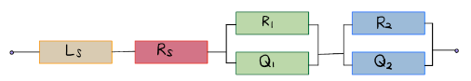
Ls
Ls

Figure 2. The EIS spectrum of LSCF-BCZY|BCZY|LSCF-BCZY under humidified air at the temperature in the range of 600 ºC to 800 ºC (Inset is the used equivalent circuit to resolve the associated responses)

Table 2. The calculated values of capacitance, arc summit frequencies and R_{p} and ASR for the

LSCF-BCZY|BCZY|LSCF-BCZY
Temperature (ºC) | Capacitance, C (Fcm²) | Arc summit frequency, f˚ (Hz) | Polarization Resistance, R_{p}  (Ωcm²) | Area specific resistance, ASR (Ωcm²)
800 | C₁: 3.08x10⁻⁵ C₂: 2.58x10⁻² | f˚₁: 1.09x10⁴ f˚₂: 2.67x10³ | R₁: 0.080  R₂: 0.420  R_{p}: 0.500 | 0.250
750 | C₁: 2.39x10⁻⁵  C₂: 7.86x10⁻¹ | f˚₁: 5.35x10⁶  f˚₂: 4.89x10³ | R₁: 0.075  R₂: 0.589  R_{p}: 0.664 | 0.332
700 | C₁: 1.02x10⁻⁵  C₂: 2.40x10⁻¹ | f˚₁: 3.37x10⁵  f˚₂: 1.67x10² | R₁: 0.750  R₂: 1.290  R_{p}: 2.040 | 1.020
650 | C₁: 3.11x10⁻⁶  C₂: 1.79x10⁻² | f˚₁: 2.81x10⁴  f˚₂: 3.16x10² | R₁: 0.800  R₂: 2.478  R_{p}: 3.278 | 1.639
600 | C₁: 8.46x10⁻⁵  C₂: 1.79x10⁻² | f˚₁: 2.14x10⁴  f˚₂: 5.35x10² | R₁: 2.100  R₂: 9.400  R_{p}: 11.500 | 5.750

Figure 3 shows the SEM images of fractured cross-section and cathode surface of the LSCF-BCZY|BCZY|LSCF-BCZY symmetrical half-cell after electrochemical measurement. There was no sign of crack and delamination occurring for the cell indicating a good adhesion between 10μm LSCF layer and dense electrolyte which promotes a low contact resistance [11]. The cathode surface shows well dispersed and homogenized microstructure with porosity about 32%. This percentage is sufficient to allow better oxygen diffusion through the cathode material as the required porosity is in the range of 20% to 40% [12]. A good adhesion between LSCF-BCZY cathode and BCZY electrolyte as well as the homogenized microstructure of the LSCF layer reduces the resistance of cathode bulk and leads to the fast surface oxygen ion diffusion [5, 13].

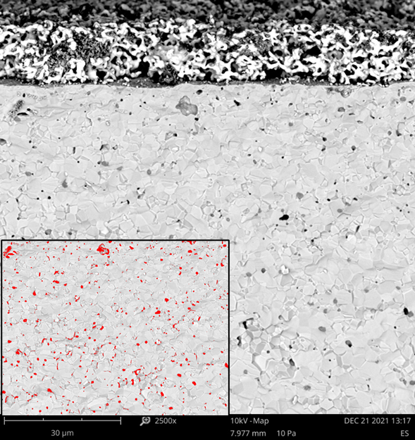
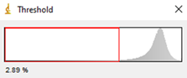
(b)
(a)
(b)
LSCF-BCZY (cathode)
Top-view (LSCF-BCZY)
BCZY(electrolyte)
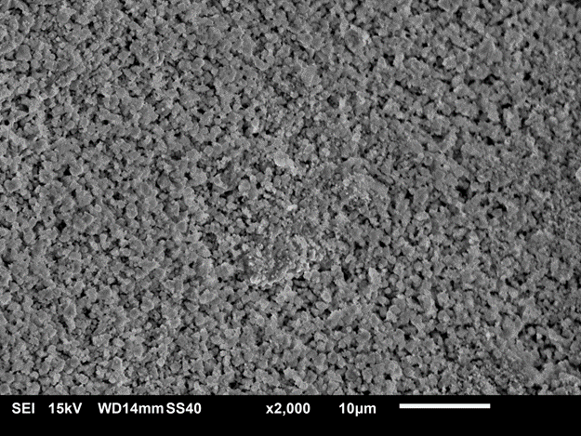
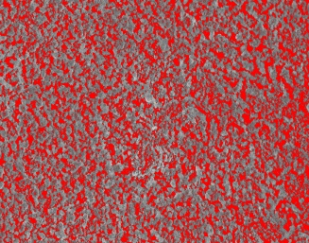
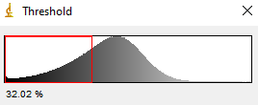

Figure 3. SEM images of the LSCF-BCZY|BCZY|LSCF-BCZY after electrochemical measurement (a) cross section and (b) top view of the cell

Conclusion

The LSCF and BCZY powders were successfully prepared by a sol-gel method using metals nitrate salts. Both compounds still maintained their respectively phase even after they were simultaneously calcined at 900 ºC. The ASR value of 0.25 Ω.cm², 0.33 Ω.cm², 1.02 Ω.cm², 1.64 Ω.cm², and 5.75 Ω.cm² were reported at the intermediate temperature of 800ºC to 600ºC with the use of composite cathode half-cell. The well distributed and delamination-free cell morphology with optimized porosity is still preserved after electrochemical cell testing. The utilization of LSCF-BCZY composite cathode significantly reduce the polarization resistance of the fabricated cell signifying that it has a great potential and reliable for PCFC application.

Acknowledgement

We acknowledged Strategic Research Partnership Grant UiTM-UTM (100-RMC 5/3/SRP GOV(002/2021)) for the sponsorship and UiTM for the facilities.

References
- He, W., Yuan, R. H., Dong, F. F., Wu, X. L. and Ni, M. (2017). High performance of protonic solid oxide fuel cell with BaCo_{0. 7}Fe_{0. 22}Sc_{0. 08}O_{3− δ} electrode. International Journal of Hydrogen Energy, 42(39): 25021-25025.
- Chen, J., Li, J., Jia, L., Moussa, I., Chi, B., Pu, J. and Li, J. (2019). A novel layered perovskite Nd (Ba_{0.} ₄Sr_{0.} ₄Ca_{0. 2}) Co_{1. 6}Fe_{0. 4}O5_{+ δ} as cathode for proton-conducting solid oxide fuel cells. Journal of Power Sources, 428: 13-19.
- Fang, X., Zhu, J. and Lin, Z. (2018). Effects of electrode composition and thickness on the mechanical performance of a solid oxide fuel cell. Energies, 11(7): 1735.
- Osman, N., Ismail, I., Samat, A. A. and Md Jani, A. M. (2016). Reactivity study of LaSrCoFeO₃-Ba (Ce, Zr) O₃ composite cathode material. In Materials Science Forum, 846: pp. 58-62.
- Ismail, I., Osman, N. and Jani, A. M. M. (2018). Evaluation of La_{0. 6}Sr_{0. 4}Co_{0. 2}Fe_{0. 8}O_{3-δ} as a potential cathode for proton-conducting solid oxide fuel cell. Sains Malaysiana, 47(2): 387-391.
- Zhu, H., Ricote, S., Duan, C., O’Hayre, R. P., Tsvetkov, D. S. and Kee, R. J. (2018). Defect incorporation and transport within dense BaZr_{0. 8}Y_{0. 2}O_{3− δ} (BZY20) proton-conducting membranes. Journal of The Electrochemical Society, 165(9): F581.
- Osman, N., Senari, S. M. and Md Jani, A. M. (2020). Characterization of NiO-BCZY as composite anode prepared by a one-step sol-gel method. Malaysian Journal of Fundamental and Applied Sciences, 16(4): 450–452.
- Miao, L., Hou, J., Gong, Z., Jin, Z. and Liu, W. (2019). A high-performance cobalt-free Ruddlesden-Popper phase cathode La_{1· 2}Sr_{0· 8}Ni_{0· 6}Fe_{0· 4}O_{4+ δ} for low temperature proton-conducting solid oxide fuel cells. International Journal of Hydrogen Energy, 44(14): 7531-7537.
- Mohsin, M., Yousaf, A., Raza, R. and Zia, R. (2019). Highly conducting perovskite structured (M-SrCoFe-O_{3-δ}, M= Ce, Ba) cathode for solid oxide fuel cell. Journal of Alloys and Compounds, 791: 248-254.
- Lee, S., Park, S., Wee, S., woo Baek, H. and Shin, D. (2018). One-dimensional structured La_{0. 6}Sr_{0. 4}Co_{0.} ₂Fe_{0. 8}O_{3− δ}-BaCe_{0. 5}Zr_{0. 35}Y_{0. 15}O_{3− δ} composite cathode for protonic ceramic fuel cells. Solid State Ionics, 320: 347-352.
- Osman, N., Ismail, I., Samat, A. A. and Md Jani, A. M. (2016). Reactivity study of LaSrCoFeO3-Ba (Ce, Zr) O3 composite cathode material. In Materials Science Forum, 486: 58-62.
- Kuroha, T., Yamauchi, K., Mikami, Y., Tsuji, Y., Niina, Y., Shudo, M., ... and Okuyama, Y. (2020). Effect of added Ni on defect structure and proton transport properties of indium-doped barium zirconate. International Journal of Hydrogen Energy, 45(4): 3123-3131.
- Baek, S.-W., J. Bae, and Y.-S. Yoo, Cathode reaction mechanism of porous-structured Sm0.5Sr0.5CoO₃− δ and Sm0.5Sr0.5CoO3−δ/Sm0.2Ce0.8O1.9 for solid oxide fuel cells. Journal of Power Sources,193(2): 431-440.

