
THE ANTIBACTERIAL, ANTIFUNGAL, ANTIOXIDANT POTENTIAL AND TOTAL PHENOLIC CONTENT OF MALAYSIAN ENDANGERED SPECIES Coscinium fenestratum FROM PAYA BUNGOR PAHANG

(Potensi Sifat Antibakteria, Antikulat, Antioksida dan Jumlah Kandungan Fenolik Cosinium fenestratum Spesies Terancam Malaysia dari Paya Bungor Pahang)

Aiza Harun¹*, Noorshilawati Abdul Aziz², Shaari Daud¹

¹Faculty of Applied Sciences

²Faculty of Plantation and Agrotechnology

Universiti Teknologi MARA Cawangan Pahang, 26400 Bandar Jengka, Pahang, Malaysia

*Corresponding author: aizaharun@uitm.edu.my

Received: 21 January 2022; Accepted: 2 April 2022; Published: xx August 2022

Abstract
Coscinium fenestratum (family: Menispermaceae), which is locally known as akar sekunyit, is one of the endangered species in Malaysia. C. fenestratum is wildly grown in the forest reserve, Paya Bungor, Pahang. This study aims to investigate the potential of C. fenestratum as an antibacterial, antifungal, and antioxidant agent as well as its total phenolic content. Four types of extracts were prepared from the consecutive soaking using hexane, dichloromethane (DCM), ethyl acetate (EA), and methanol. All types of extracts were assessed for their antibacterial and antifungal activities using the disc diffusion method against Salmonella thypi ATCC 10708, Staphylococcus aureus ATCC 43300, Escherichia coli UPMC 25922, Candida albicans ATCC 90028, and Aspergillus brasiliensis ATCC 16404. The potency of this species as an antioxidant agent was evaluated using semiquantitative staining dot blot assay against DPPH (2,2-diphenyl-1-picrylhydrazyl). The total phenolic content was assessed using the Folin-Ciocalteu method. The phytochemical screening for all types of extracts revealed the presence of alkaloid, terpenoid, phenolic, and saponin. All extracts with the concentration of 1,000 ppm demonstrated antibacterial and antifungal activities against S. aureus ATCC 43300 and C. albicans ATCC 90028 but none for the rest of the bacteria and fungi. The methanol extract was more active with a moderate inhibition zone. The semiquantitative staining dot blot assay against DPPH revealed that the lowest concentration of methanol extract for DPPH inhibition was at the concentration of 0.012 mg/ml, and the DCM extract showed that the DPPH inhibition was at 0.006 mg/ml. However, the methanol extract of C. fenestratum had a higher total phenolic content (TPC) with the value of 12.722 mg GAE/g sample compared to the DCM extract at 8.627 mg GAE/g sample. Hence, both methanol extract and DCM extract of C. fenestratum exhibited stimulating antimicrobial and antioxidant properties with potent phenolic content.

Keywords: Coscinium fenestratum, antibacterial, antifungal, akar sekunyit, antioxidant

Abstrak
Coscinium fenestratum (keluarga: Menispermaceae) yang dikenali sebagai akar sekunyit adalah salah satu spesies terancam di Malaysia iaitu Pahang dan ia tumbuh secara liar di hutan simpan Paya Bungor Pahang. Kajian ini bertujuan untuk menyiasat potensi C. fenestratum sebagai agen antibakteria, antikulat dan antioksidan serta jumlah kandungan fenolik. Empat jenis ekstrak telah disediakan daripada rendaman berturut-turut menggunakan heksana, diklorometana (DCM), etil asetat dan metanol. Semua jenis ekstrak telah dinilai untuk aktiviti antibakteria dan antikulat menggunakan kaedah penyebaran cakera terhadap Salmonella thypi ATCC 10708, Staphylococcus aureus ATCC 43300, Escherichia coli UPMC 25922, Candida albicans ATCC 90028 dan Aspergillus brasiliensis ATCC 90028. Keupayaan spesies ini sebagai agen antioksida dinilai daripada ujian bintik-bintik pewarnaan semikuantitatif terhadap DPPH (2,2-difenil-1-pikrilhidrazil). Jumlah kandungan fenolik dinilai menggunakan kaedah Folin-Ciocalteu. Pemeriksaan fitokimia untuk semua jenis ekstrak mendedahkan kehadiran alkaloid, terpenoid, fenolik dan saponin. Semua ekstrak dengan kepekatan 1,000 ppm menunjukkan aktiviti antibakteria dan antikulat terhadap S. aureus ATCC 43300 dan C. albicans ATCC 90028, tetapi aktiviti itu tidak dapat dilihat untuk bakteria dan kulat yang lain. Ekstrak metanol didapati sebagai ekstrak yang lebih aktif dengan zon perencatan sederhana berbanding dengan ekstrak yang lain. Ujian bintik-bintik pewarnaan separa kuantitatif terhadap DPPH mendedahkan bahawa kepekatan terendah ekstrak metanol untuk perencatan DPPH adalah pada kepekatan 0.012 mg/ml dan ekstrak DCM menunjukkan perencatan DPPH pada 0.006 mg/ml. Walau bagaimanapun, ekstrak metanol C. fenestratum mempunyai jumlah kandungan fenolik yang lebih tinggi dengan nilai 12.722 mg sampel GAE/g berbanding ekstrak DCM pada 8.627 mg sampel GAE/g. Oleh itu, adalah disahkan bahawa kedua-dua ekstrak metanol dan ekstrak DCM C. fenestratum mempamerkan sifat antimikrob dan antioksida yang baik dan sederhana dengan kandungan fenolik yang memberangsangkan.

Kata kunci: Coscinium fenestratum, antibakteria, antikulat, akar sekunyit, antioksida

Introduction
Many medicinal plants have a high content of antioxidants such as vitamin C, vitamin E, polyphenols, and phytochemical substances of antimicrobial agents. Most antimicrobial plant compounds are identified as secondary metabolites that mainly originated from the family of terpenoid or phenolic. To date, herbal extracts are well-known for defeating various infectious diseases. Many plant species have been investigated for their effectiveness to combat microbes that cause disease but the investigation is still insufficient. Some medicinal plants are rich in natural antioxidants and have fewer side effects compared to synthetic antioxidants which can reduce the risk of certain diseases such as heart disease and cancer. It has been discovered that plant species with polyphenolic compounds enhance antioxidant activities [1]. The polyphenolic compounds react as a hydrogen donor or an electron donor to stabilise the toxic radical that causes harmful diseases.

Coscinium fenestratum belonged to the family Menispermaceae, is known as akar sekunyit in Malaysia, and has been vastly used as a traditional medicine to treat snake bites, lower blood sugar and blood cholesterol, and stabilise blood pressure [2]. It is reported that the stem of C. fenestratum is anti-inflammatory and antiseptic, has a bitter taste, and has a potential in pharmacological studies to exhibit antifungal, antibacterial, antifungal, and antiproliferative activities [3]. C. fenestratum is considered a critically endangered medicinal species as a result of its high demands in traditional practice. It is reported that the function of C. fenestratum ethanolic extract irradiated with a gamma ray acts as an antimicrobial agent and is outstanding against Staphylococcus aureus with the inhibition zone of 16.3-17.5 mm as well as the antioxidant activity [4]. However, the effect of gamma irradiation was insignificant to enhance the TPC of the crude extract. This study aims to evaluate the antimicrobial, antioxidant, and TPC of four crude extracts of C. fenestratum stem from Paya Bungor, Pahang, Malaysia.

Material and Methods
Plant material
The stems of C. fenestratum (Menispermaceae) were collected from Paya Bungor forest, Kuantan, Pahang. Fresh samples were cut into small pieces and air dried at room temperature. The small pieces of dry samples were grounded into powder using a grinder before proceeding to the extraction process.

Preparation of extracts from the stem of C. fenestratum
About 1kg of C. fenestratum stem was subjected to consecutive soaking with hexane, dichloromethane, ethyl acetate, and methanol to obtain four different types of crude extracts. After three times of soaking in each solvent, the extracts were filtered and evaporated until they are dried using a rotary evaporator. The crude extracts were kept in the refrigerator before use.

Antibacterial and antifungal activity assay
The assay was conducted to evaluate the potency of C. fenestratum’s crude extracts against selected fungi and bacteria such as Salmonella thypi ATCC 10708, Staphylococcus aureus ATCC 43300, Escherichia coli UPMC 25922, Candida albicans ATCC 90028, and Aspergillus brasiliensis ATCC 16404. The sterile discs of all crude extracts with the concentration of 1,000 ppm were prepared for antibacterial and antifungal works and were used in the disc diffusion method. The antibacterial work of all crude extracts against S. thypi, S. aureus, and E. coli and the antifungal work against C. albicans and A. brasiliensis were slightly modified according to our previous study [5,6]. The positive standard discs were streptomycin and nystatin.

Thin layer chromatography analysis
The TLC method was conducted to screen phytochemicals such as alkaloid, phenolic compounds, and terpenoid. Spraying reagents such as the Dragendorff’s solution, ferric chloride solution, and vanillin/H₂SO₄ were used to screen the presence of alkaloid, phenolic, and terpenoid, respectively [6].

Antioxidant activity
Semiquantitative DPPH staining dot blot assay
This method was modified from our previous work [7] and was conducted to measure the lowest concentration of C. fenestratum’s extracts to scavenge the free radical of DPPH by observing the formation of yellow spots against the purple background of the marked TLC plate. The extracts were two-fold serially diluted ranging from 100 mg/mL to 0.003 mg/mL. Then, 10µL of each prepared extract was dripped into the marked TLC plate and was allowed to dry for about 30 min under the fume hood. After completing the drying process, the TLC plate was carefully sprayed with 0.05% DPPH solution in methanol. The results were determined by observing the formation of yellow spots around the applied extracts. The yellow spot indicates the amount and nature of radical scavengers in the extracts. The experiment was also conducted for isolated compound alkaloid and ascorbic acid as the positive standard.

Total phenolic content (TPC)
About 5 mg of each extract or standard ascorbic acid was measured and diluted with 5 mL of suitable solvent to produce the final concentration of 1 mg/mL (1,000 ppm). Then, 0.5 mL of each extract was mixed with 2.5 mL Folin-Ciocalteu reagent (10 times dilution) and left for 2 min. Then, 2 mL of 7.5% w/v Na₂CO₃ solution was added to the mixture and incubated for 30 min. After reaching the incubation time, the absorbance of all samples was determined using UV-VIS Spectrometer (Secomam, France) at 765 nm [8]. The method was repeated for the standard solution of gallic acid (1000, 500, 250, 125, 62.5, 31.25 ppm). The blank was made with the same procedure without any extract or standard. The standard curve was plotted using the value absorbance of standard gallic acid solution.

Results and Discussion
Phytochemical analysis
The present study of the TLC phytochemicals screening test was conducted on four different types of extracts namely hexane, DCM, EA, and methanol extracts of the stem of C. fenestratum. The test revealed the presence of some medicinally active constituents in a TLC fingerprint of extracts. The common phytochemical constituents found were alkaloid, phenolic, terpenoid, and saponin in each extract of the stem of C. fenestratum as summarised in Table 1. DCM, EA, and methanol extracts were screened and contained the most phytochemicals. The hexane extract only showed the positive appearance of terpenoid compounds. The screening of these important phytochemicals is important as they are attributed to antimicrobial action and antioxidant activity. It was reported that the phenolic compounds of white cabbage have retarded lipid oxidation and microbial growth of foodborne pathogenic bacteria and fungi [9].

Figure 1 depicts some TLC fingerprints that screen the presence of alkaloid and phenolic in methanol extract and DCM extract. TLC A shows the obvious presence of alkaloid from the methanol extract compared to the alkaloid in the DCM extract in TLC D, which is consistent with the previous finding [10, 11]. TLC B and TLC C of methanol extract show that alkaloid behaves as an antioxidant agent as the placement of alkaloid on TLC B is similar to the yellow spot of antioxidant on TLC C. TLC E and TLC F of DCM extract reveal the presence of antioxidative phenolic compounds. The observations of TLC D, TLC E, and TLC F of DCM extract show that alkaloid and phenolic compounds were also antioxidative.

Table 1. Phytochemicals in the stem of C. fenestratum
Types of extracts | Phytochemicals
 | Alkaloid | Phenolic | Terpenoid | Saponin
Hexane | x | x | √ | x
DCM*  Ethyl acetate* (EA) | √  x | √  √ | √  √ | x  x
Methanol* | √ | √ | √ | √
√ = present; x = not present; * = antioxidative; DCM: dichloromethane

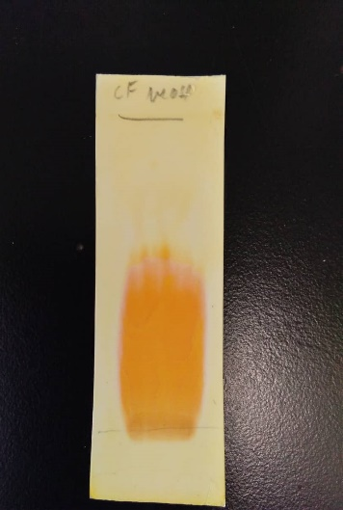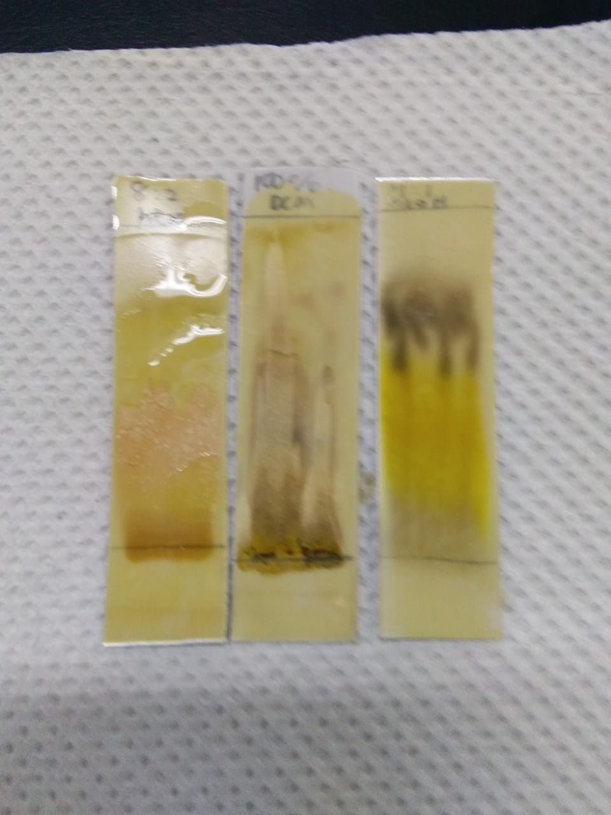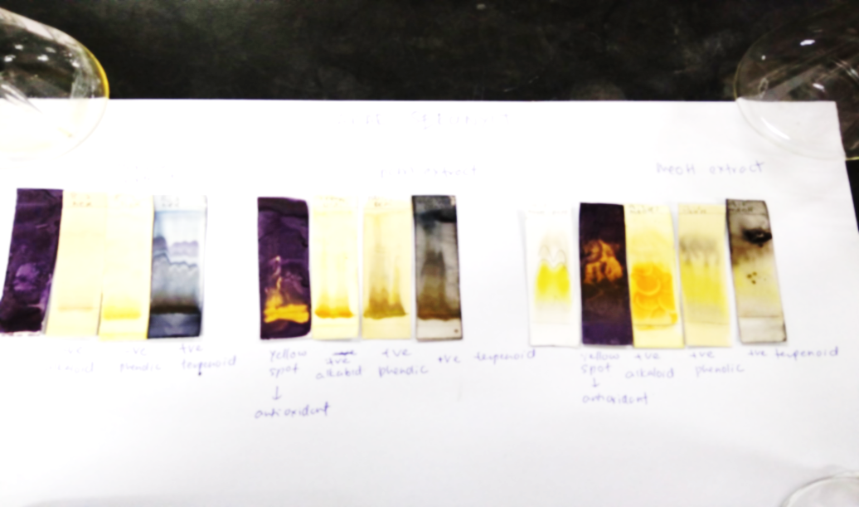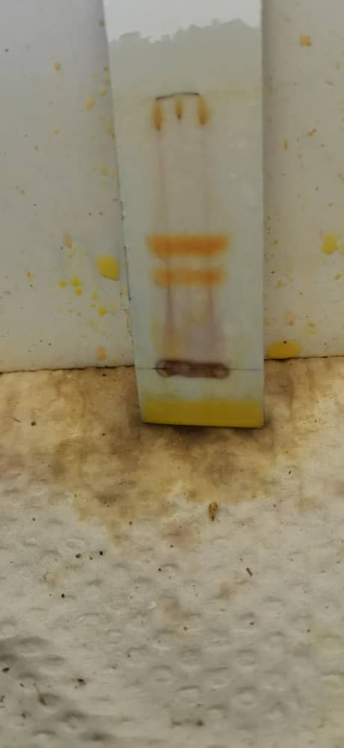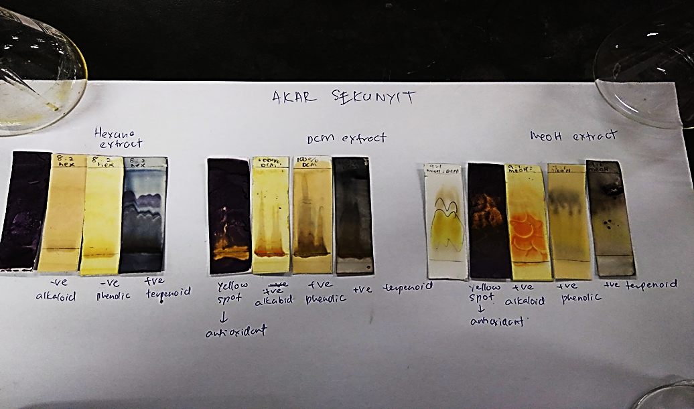
F
E
D
C
B
A
Figure 1. TLC fingerprint of alkaloid, phenolic, and antioxidant

- The orange spot against the yellow background indicates the presence of alkaloid in the methanol extract after spraying with Dragendorff’s reagent.
- The black area indicates the presence of phenolic compounds in the methanol extract after spraying ferric chloride solution; The yellow area indicates the presence of alkaloid.
- The yellow spot against the purple background indicates the presence of antioxidant in the methanol extract.
- The orange spot against the yellow background indicates the presence of alkaloid in the DCM extract after spraying with Dragendorff’s reagent.
- The black spots indicate the presence of phenolic compounds in the DCM extract after spraying with ferric chloride solution
- The yellow spot against the purple background indicates the presence of antioxidant in the DCM extract.

Antimicrobial activity of C. fenestratum stem
The results of antifungal and antibacterial activities in Table 2 indicate no inhibition zone towards S. thypi, E. coli, and A. brasiliensis for all crude extracts. All extracts were susceptible to S. aureus and C. albicans due to the use of a low concentration (1,000 ppm) of extracts which causes no visible inhibition zone against S. thypi, E. coli, and A. brasiliensis. However, a previous study [12] revealed that the methanol extract attempted to inhibit the growth of E. coli moderately at the concentration of 150 mg/ml with the zone inhibition of 17 mm. This finding confirms that the extracts may have the capability to block the growth of all tested microbes at a higher concentration of more than 1,000 ppm. Among the extracts, the methanol extract was moderately inhibiting the growth of C. albicans and weakly inhibits S. aureus compared to other extracts. The richness of secondary metabolites mainly alkaloid in the methanol extract could be the main reason for the antimicrobial action. This scientific finding is also in line with other previous reports where alkaloid berberine from the stem of C. fenestratum was responsible for the antibacterial activity against several human pathogenic bacteria [10]. Alkaloid berberine also displayed remarkable antimicrobial activities against phytopathogenic fungi [12]. The current investigation [13] revealed that the methanol extract of C. fenestratum has promising antibacterial activity against the plant pathogen Erwinia chrysanthemi with an inhibition zone of about 19 mm. Thus, the result of C. fenestratum methanol extract which behaves as a potent antimicrobial agent is in the line with the previous research.

Table 2. Antibacterial and antifungal activities of C. fenestratum
Types of Extracts  (1,000 ppm)/Standard | Diameter of Inhibition Zone (mm)
Types of Extracts  (1,000 ppm)/Standard | S. thypi | S. aureus | E. coli | C. albicans | - brasiliensis
Hexane | - | + | - | + | -
DCM | - | + | - | + | -
EA | - | + | - | + | -
MeOH | - | + | - | ++ | -
Streptomycin | +++ | +++ | +++ | - | -
Nystatin | - | - | - | +++ | +++
+++: strongly inhibited; ++: moderately inhibited; +: weakly inhibited; -: no inhibition zone; DCM: dichloromethane; MeOH: methanol; EA: ethyl acetate

Antioxidant activity and total phenolic content
DPPH dot blot assay is a semiquantitative antioxidant activity method that has been used on C. fenestratum by referring to its ability to reduce the DPPH – a stable free radical. The antioxidant activities of different concentrations (two-fold serially diluted) of methanol extract, DCM extract, EA, alkaloid, and ascorbic acid were evaluated through the observation of the appearance of yellow colour against the purple background on the marked TLC as illustrated in Figure 2. The hexane extract was not further evaluated for its antioxidant activity since it had been previously screened and did not display any trace of yellow colour indicating the presence of antioxidants. Table 3 shows the dot blot assay where both DCM extract and methanol extract have comparable values of their lowest concentration to scavenge DPPH radical at 0.006 mg/mL and 0.012 mg/mL, respectively. EA extract started to scavenge DPPH radical at the concentration of 0.089 mg/mL as the yellow spot first appeared at this concentration. The concentration where the yellow colour was firstly observed on the marked TLC is considered the lowest concentration of extracts that scavenged the DPPH radical as illustrated in Figure 2. The isolated compound alkaloid scavenged the DPPH radical at a slightly higher concentration of 0.625 mg/mL. In this case, any compounds or extracts that can scavenge DPPH radical at a lower concentration are said to function as a good scavenger. This result explains that the methanol extract and DCM extract were more antioxidative as they scavenged DPPH radical at a lower concentration compared to the EA extract and isolated compound alkaloid.

The antioxidant activities of DCM and methanol extract might be attributable to the presence of phenolic compounds in both extracts. The presence of phenolic compounds was authenticated from the determination of TPC values using the Folin-Ciocalteu method. Table 3 shows the methanol extract of C. fenestratum that contained a larger TPC value of 12.722 mg GAE/g sample compared to the DCM with a TPC value of 8.627 mg GAE/g sample. The result is parallel with a previous study [9] that determined the TPC value of methanol extract of C. fenestratum in Western Ghats, India at 18.35 mg GAE/g sample. It was reported that the phytochemical phenolic compounds were the main cause of methanol extract of Coscinium blumeanum for having a moderate antioxidant activity with an EC₅₀ value of 50.1 µg/mL [14]. However, the scavenging of DPPH radical by the EA extract at 0.089 mg/ml was not responsible for the presence of phenolic content as it had a negative value of TPC. The activity might be due to the presence of terpenoid as depicted in Table 1. The synergistic action between alkaloid, terpenoid, and phenolic in the DCM extract could cause the DCM extract to scavenge DPPH radical at a lower concentration compared to the methanol extract although it contains a lower TPC value compared to the methanol extract.

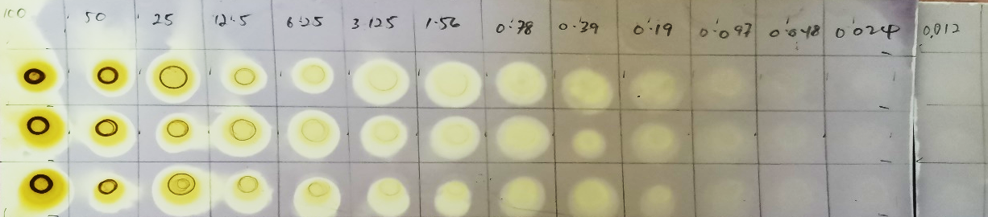
A
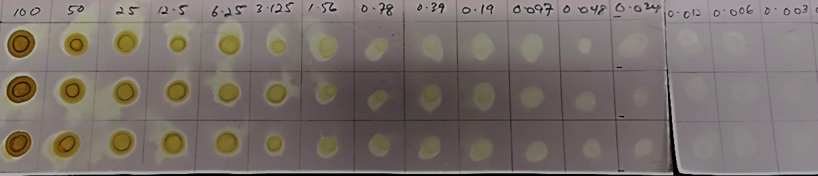
B
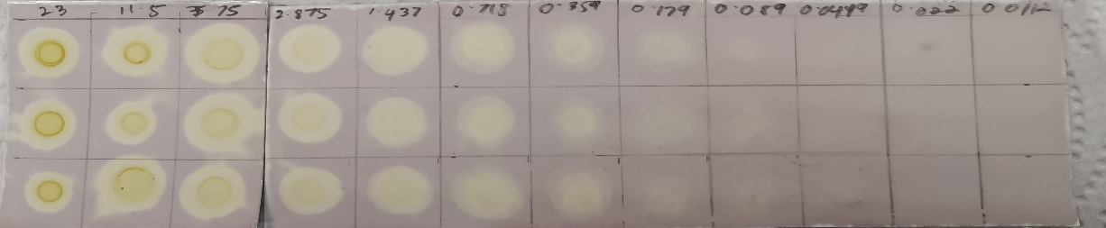
C

20 10 5.0 2.5 1.25 0.625 0.312 0.156 0.078 0.039 0.019 0.0097
0.0048
D
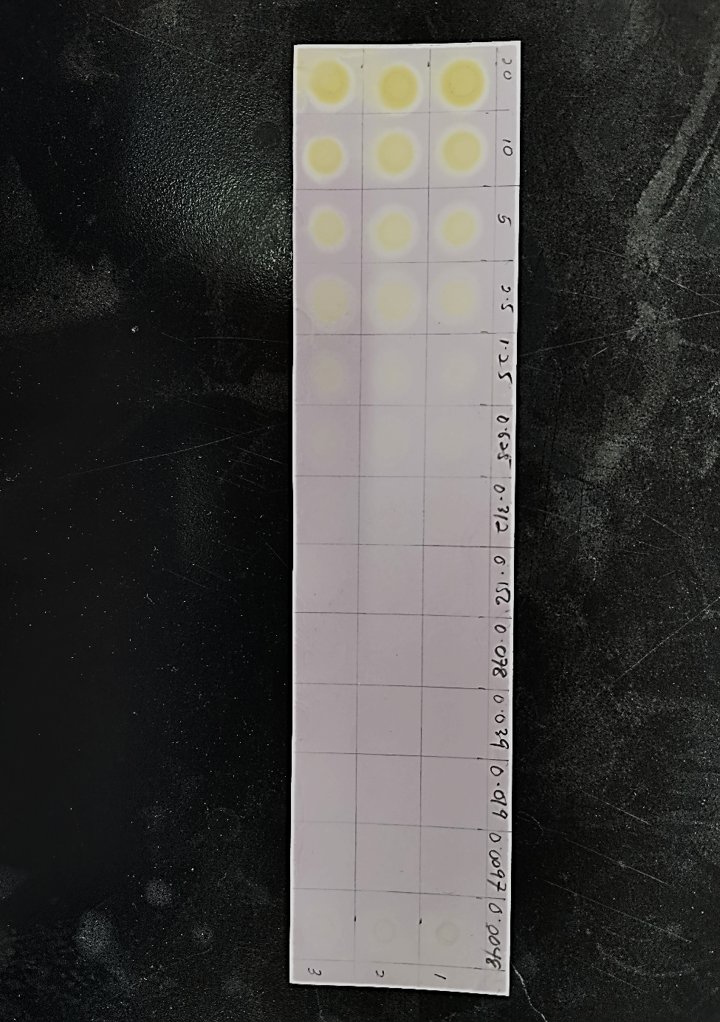
E
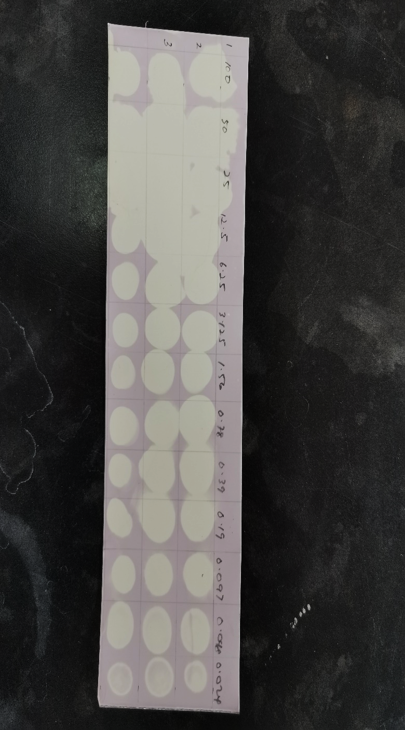
Figure 2. DPPH staining dot blot assay of C. fenestratum extracts, alkaloid, and standard ascorbic acid
- DPPH staining of two-fold serial dilution of methanol extract
- DPPH staining of two-fold serial dilution of DCM extract
- DPPH staining of two-fold serial dilution of EA extract
- DPPH staining of two-fold serial dilution of alkaloid from methanol extract
- DPPH staining of two-fold serial dilution of standard ascorbic acid

Table 3. Semiquantitative antioxidant activity from DPPH staining dot blot assay and total phenolic content
Extract/Standard | Lowest Concentration for DPPH Inhibition  (mg/mL) | Total Phenolic Content,  mg GAE/g sample
Dichloromethane (DCM) | 0.006 | 8.627
Ethyl acetate (EA) | 0.089 | negative
Methanol | 0.012 | 12.722
Alkaloid  (isolate from methanol extract) | 0.625 | negative
Standard ascorbic acid | < 0.006 | 693.416

Conclusion
We concluded that the methanol extract of C. fenestratum acts as a potent antibacterial and antifungal agent. The dichloromethane and methanol extracts scavenged the DPPH radical at the concentration of 0.006 mg/ml and 0.012 mg/ml, respectively. The highest TPC value among the extracts belonged to the methanol extract with a TPC value of 12.722 mg GAE/g sample. It is recommended that future work uses different concentrations of extracts tested on fungi that cause superficial skin disease and other bioactivity assays such cytotoxicity and anti-inflammatory and antiviral activities.

Acknowledgement
The author would like to express her warmest gratitude to Puan Nor Habibah Mohd Rosli, En. Mohd Zahir Ismail, and En. Mohd Rosdi Mat Tahir who were involved directly or indirectly in the completion of this research work.

References
- Cook, N. C. and Samman, S. (1996). Flavonoids-chemistry, metabolism, cardioprotective effects, and dietary sources. Nutritional Biochemistry, 7: 66-76.
- Rojsanga, P. and Gritsanapan, W.(2005). Variation of berberine content in Coscinium fenestratum stem in thailand market. Mahidol University Journal of Pharmaceutical Sciences, 32(3-4): 66-70.
- Danapur, V., Haleshi, C. and Sringeswara A. N. (2020). Endangered medicinal plant Coscinium fenestratum (Gaertn.) Colebr. - A review. Pharmacognosy Journal, 12(5): 1077-1085
- Eamsiri, J., Chookaew, S., Pewlong, W., Sajjabut, S. and Orpong, P. (2019). Effects of irradiation on antioxidant and antimicrobial activities of Coscinium fenestratum (Goetgh.) Colebr. IOP Conf. Series: Journal of Physics: Conf. Series 1285 (2019) 012006.
- Harun, A., Mat So’ad, S.Z., Mohd Hassan, N. and Che Mohd Ramli, N.K. (2014). In-vitro antidermatophytic activity of methanolic fractions from Entada spiralis Ridl. stem bark and its bioautographic profile. Pertanika Journal Science & Technology 22(1): 113-121.
- Daud, A. D., Azman, N. S., Alias, N. I. A., Syaifudin, N., Harun, A. and Abdul Aziz, N. (2021). Phytochemical and antibacterial properties on three medicinal plants for potent anti-soft rot agents. Malaysian Journal of Analytical Sciences, 25(1): 119-128.
- Harun, A., Abdul Aziz, N., Mohd Azenan, N. S., Muhammad Kamarazzaman, N. F and Mat So’ad., S. Z. (2020). Antimicrobial efficacy, antioxidant profile and nine alternative active constituents from petroleum ether and ethyl acetate extract of Entada spiralis. Malaysian Journal of Analytical Sciences, 25(5): 707-718.
- Siddiqui, N., Rauf, A., Latif, A. and Mahmood, Z.(2017). Spectrophotometric determination of the totalphenolic content, spectral and fluorescence study of the herbal Unani drug Gul-e Zoofa (Nepeta bracteata Benth). Journal of Taibah University Medical Sciences, 12(4): 360-363.
- Rubab, M., Chelliah, R., Saravanakumar, K., Kim, J. R., Yoo, D., Wang, M. H. and Oh, D. H. (2020). Phytochemical characterization, and antioxidant and antimicrobial activities of white cabbage extract on the quality and shelf life of raw beef during refrigerated storage. Royal Society of Chemistry,10: 41430-41442.
- Nair, G. M., Narasimhan, S., Shiburaj, S. and Abraham, T. K.(2005). Antibacterial effects of Coscinium fenestratum. Fitoterapia,76: 585-587.
- Singburaudom, N. (2015). The alkaloid berberine isolated from Coscinium fenestratum is an inhibitor of phytopathogenic fungi. Journal of Biopesticides, 8(1):28-36.
- Goveas, S.W. and Abraham, A. (2013). Evaluation of antimicrobial and antioxidant activity of stem and leaf extracts of Coscinium fenestratum. Asian Journal of Pharmaceutical Clinical Research, 6(3): 218-221.
- Mohd Azli, N. A. N., Harun, A., Abdul Aziz, N. and Daud, S. (2021). Anti soft rot and antioxidant behaviour of nine medicinal plants from Paya Bungor, Pahang. GADING Journal of Science and Technology, 4(2): 20-26.
- Keawpradub, N., Dej-adisai, S. and Yuenyongsawad., S. (2005). Antioxidant and cytotoxic activities of Thai medicinal plants named Khaminkhruea: Arcangelisia flava, Coscinium blumeanum and Fibraurea tinctoria. Songklanakarin Journal of Science Technology, 27(2): 455-467.

