A REVIEW ON PREPARATION, MODIFICATION AND FUNDAMENTAL PROPERTIES OF SPEEK NANOCOMPOSITE PEM FOR DIRECT METHANOL FUEL CELL APPLICATIONS

(Satu Ulasan tentang Penyediaan, Pengubahsuaian dan Ciri Asas Komposit Nano Membran Elektrolit Polimer SPEEK untuk Aplikasi Sel Bahan Api)

Nor Fatina Raduwan and Norazuwana Shaari*

Fuel Cell Institute,
Universiti Kebangsaan Malaysia, Bangi, 43600 Selangor, Malaysia

*Corresponding author: norazuwanashaari@ukm.edu.my

Abstract
Various types of promising proton exchange membrane (PEM) are based on thermoplastics due to their excellent conductivity, good thermal and chemical stability, high durability as well as low fabrication and material cost. Sulfonated poly (ether ether ketone) or SPEEK is one of the examples of thermoplastic polymer that has been sulfonated to enhance its fundamental properties. These properties can be altered and improved through the fabrication process and modifications of the membranes. Thus, current researches on combining SPEEK with other polymers and inorganic particles through various fabrication methods are discussed in this review. The characterization of SPEEK-based membrane in terms of its water uptake, methanol permeability, proton conductivity, thermal and mechanical stability are also included in the discussion. The impact of membrane modifications on the fundamental properties and comparison of different membrane preparation methods are addressed. In addition, the advantages and drawbacks of modified membranes are summarized.

Keywords: SPEEK; polymer electrolyte membrane; fuel cell

Abstrak
Pelbagai jenis polimer elektrolit membran yang diyakini adalah daripada termoplastik disebabkan oleh kekonduksian yang cemerlang, kestabilan terma dan kimia yang baik, ketahanan yang tinggi dan kos bahan dan pembuatan yang rendah. Poli (eter eter keton) tersulfonat atau SPEEK adalah satu contoh polimer termoplastik yang telah disulfonasi untuk mempertingkatkan ciri asas seperti pengambilan air dan ketertelapan metanol yang rendah, meningkatkan kekonduksian proton dan mempunyai ketahanan dan kestabilan yang tinggi. Ciri-ciri ini boleh diubahsuai dan dipertingkat melalui proses fabrikasi dan pengubahsuaian ke atas membran. Oleh yang demikian, para penyelidik menggabungkan SPEEK dengan polimer jenis lain dan bahan tak organik melalui pelbagai cara fabrikasi telah dibincangkan dalam ulasan ini. Kesan daripada pengubahsuaian membrane k etas ciri-ciri asanya dan perbandingan cara penyediaan membrane turut dibincangkan. Seterusnya, kelebihan dan kekurangan membran terubahsuai turut diringkaskan.

Kata kunci: SPEEK, membran elektrolit polimer, sel fuel

Introduction
As of September 2021, the current world population is 7.9 billion, according to the most recent United Nations estimates as elaborated by Worldometer. It is estimated that the population will reach up to 10 billion in another 30 years [1]. In line with the increase in the world population, the demand for energy also increases. Conventional fossil fuels are the primary sources of power to meet the world's energy demands. However, the depletion of fossil fuel sources and the rise of environmental issues, i.e., global warming due to the excessive releases of greenhouse gases have shifted the interest into the environmentally sustainable energy research [2]. One of the alternative energies that can solve this issue is through the utilization of natural sources such as hydrogen.

Hydrogen is one of the most abundant elements in the universe. For instance, the sun consists mainly of hydrogen. While on earth, hydrogen combines with other elements either in liquid, gas, or solid form as it does not exist freely in nature. As it only exists in a compound form, specific processes are required to split and obtain hydrogen, such as reforming, hydrolysis, and electrolysis [3]. Hydrogen can be utilized in many applications such as petroleum refining and fertilizer production, and for the past decades it has been widely used in fuel cell to generate electricity.

Fuel cell technology
Fuel cell is an electrochemical device that converts fuel and oxidant into electricity [4]. Basically, hydrogen is supplied as fuel at the anode and oxygen (oxidant) at the cathode. At the cathode, oxygen is reduced, and oxygen ions are produced. These oxygen ions will pass through the electrolyte and move towards the anode. When reaching the anode, they react with the protons that are broken down from hydrogen [5]. Electrons that are obtained from hydrogen molecules travel at the outer circuit and generate electricity. The half-reactions of this process at both sides are shown by the following equation:

Cathode : ½ O₂ + 2H⁺ + 2e⁻ H₂O (1)
Anode : H₂ 2H⁺ + 2e⁻ (2)
Overall reaction : H₂ + ½ O₂ H₂O (3)

As it generates electricity through an electrochemical reaction, the by-products from the reaction are basically water and heat, which do not contribute to the environmental pollution. In fact, the water can be reused in the system, and the heat that is generated can be recycled into another system, such as a water heater system. These reused and recycled processes eliminate energy wastes and yield high energy efficiency of fuel cells up to 90% [6]. Correspondingly, there are various types of fuel cells depending on the types of electrolytes that are used. They are further sub-categorized by the types of fuel (hydrogen, reforming hydrogen-rich fuels, i.e., methanol, ethanol, and hydrocarbon), and operating temperature- low temperature (LT), intermediate temperature (IT), high temperature (HT). For example, direct methanol fuel cell (DMFC) and direct ethanol fuel cell (DEFC), also known as direct liquid fuel cell (DLFC), are the extension study to the proton exchange membrane fuel cell (PEMFC). While for microbial fuel cell (MFC), some improvements are being made where glucose is employed on-non enzymatic noble metal electrode to overcome certain drawbacks of the conventional MFC, which is known as direct glucose fuel cell (DGFC). Whereas a direct borohydride fuel cell (DBFC) is a sub-category of an alkaline fuel cell (AFC), and the latest research has reported that the anionic exchange membrane fuel cell (AEMFC) possesses great potential in replacing the traditional liquid electrolyte AFC [7]. In SOFC, there are three sub-categories, which are differentiated by the range of operating temperature, i.e., LT-SOFC, IT-SOFC and HT-SOFC. Each temperature range requires different types of material to be used as electrolytes. All existing fuel cells and their characteristics, including the efficiency, are summarized in Table 1.

Table 1. Types of fuel cells and their characteristics

Electrolyte | Types Of Fuel Cells | Sub-Category | Operating Temperature (°C) | Fuel/Oxidant | Efficiency (%)
Phosphate buffer | MFC | DGFC | 25-30 | Organic load/Oxygen | -
Alkaline solution | AFC | DBFC | 50-90 | Sodium or potassium borohydride/Oxygen or hydrogen peroxide | 50-70
Alkaline solution | AFC | AEMFC | 50-90 | Hydrogen/Oxygen | 50-70
Solid polymer membrane | PEMFC | DMFC | 50-120 | Methanol/Oxygen | 40-50
Solid polymer membrane | PEMFC | DEFC | 50-120 | Ethanol/Oxygen | 40-50
Acidic solution | PAFC |  | 175-220 | Hydrogen/Oxygen | 40-45
Molten mixture | MCFC |  | 600-650 | Hydrogen/Oxygen | 50-60
Ceramic oxides | SOFC | LT-SOFC | 400-600 | Hydrogen or hydrocarbon/Oxygen | 60-90
Ceramic oxides | SOFC | IT-SOFC | 600-800 | Hydrogen or hydrocarbon/Oxygen | 60-90
Ceramic oxides | SOFC | HT-SOFC | 800-1000 | Hydrogen or hydrocarbon/Oxygen | 60-90

Among the types of fuel cells, DMFC which is the sub-category of PEMFC has been widely used in various applications- covering small-scale appliances to mobile usage such as transportation. These broad applications are due to the advantages of low operating temperature, which lead to rapid start-up and a long-life span. Besides that, the DMFC system yields high power density and through its compact design, provides superior transportation facilities compared to other existing fuel cells. Although it has a compact design, complex heat and water management are unavoidable. Also, it uses expensive materials as a catalyst, such as Platinum, Pt, and Palladium, Pd to speed up the chemical reaction, and Nafion® for membrane materials. However, owing to its vast advantages, DMFC has generated an interest among researchers to find a way to overcome the drawbacks.

Development of proton exchange membrane (PEM) for DMFC
DMFC is a type of fuel cell that uses methanol as fuel to replace hydrogen in a typical fuel cell. As methanol is a non-volatile liquid fuel, it does not easily evaporate into gas at room temperature. In fact, this type of fuel cell does not require any fuel processing equipment as the mixture of methanol and water are directly fed into the cell. Therefore, it is easy to store and handle compared to the volatile hydrogen gas. Other advantages of using methanol in fuel cell systems are the high energy density that is obtained; due to its abundant resources, the price of methanol is relatively cheap and affordable. The reactions that take place in both electrodes are as follows:

Anode : CH₃OH + H₂O CO₂ + 6H⁺ + 6e⁻ (4)
Cathode : 3/2 O₂ + 6H⁺ + 6e⁻ 3H₂O (5)

Accordingly, the overall cell reaction is

Overall : 3/2 O₂ + CH₃OH CO₂ + 2H₂O (6)
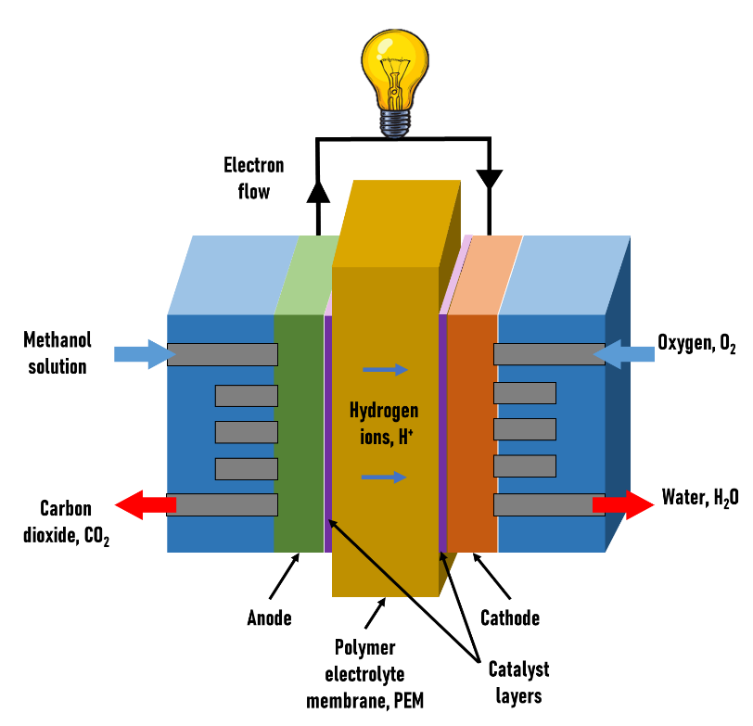
Figure 1. Working principle of DMFC
One of the key components in fuel cells, especially for DMFC, is the proton exchange membrane (PEM). PEM is needed to complete the electrochemical reaction to fulfill the energy requirement in which it serves to transfer H⁺ within itself from anode to cathode [8]. The high and outstanding PEM must meet specific criteria such as having good oxidative and hydrolytic stability, possessing high mechanical and thermal stability, and yield a high proton conductivity as well as being cost effective in the fabrication of membrane electrode assembly (MEA). As it is located between the electrodes, the PEM must also have good barrier properties to avoid the mixing of fuel (methanol) from the anode and oxidant (oxygen) coming from the cathode. The permeability of the membrane is an unresolved issue that is still under ongoing research. The high permeability membrane or leakage of the MEA (consisting of PEM) can contribute to a serious methanol crossover issue, which eventually will deteriorate the performance of fuel cell. Therefore, a high durability membrane is needed to overcome this issue.

Table 2. Target requirement for an ideal PEM [9]
Criteria | Target Requirement
Proton conductivity | 0.1 – 1 S cm⁻¹
Oxygen crossover | 2 mA cm⁻²
Fuel crossover | 2 mA cm⁻²
Electrical resistance | 1000 Ω cm⁻²
Durability | 20,000 cycles
Chemical stability | More than 500 h

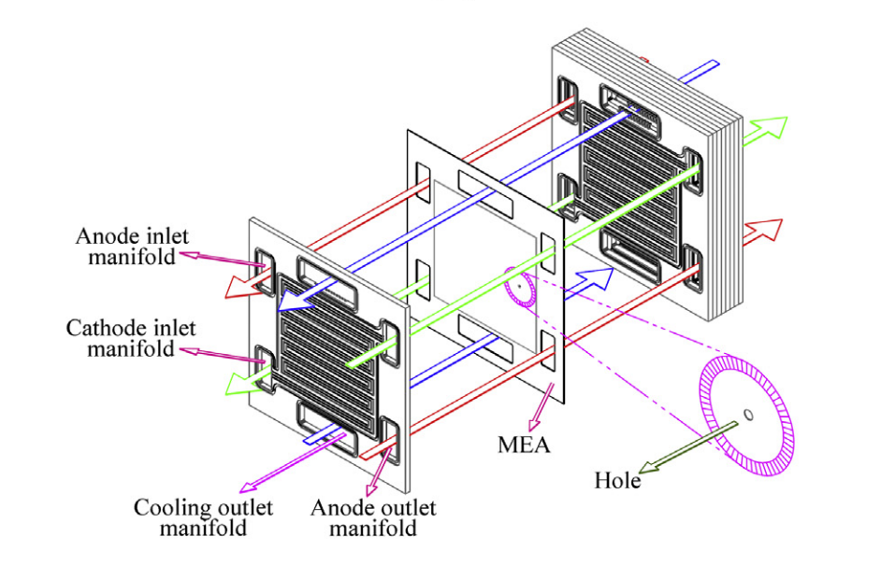

Figure 2. The leakage passing through the PEM [10]

Classification of polymeric membranes
Polymeric membranes can be classified into fluorinated and non-fluorinated polymers. Fluorocarbon-based ion-exchange membrane or Nafion® is the most common and readily available membrane in the market. Nafion® possesses unique structures that contribute to stability in terms of mechanical and chemical aspects as well as imparts high proton conductivity [11]. However, the presence of (approximately 4 nm) ionic clusters which are considerably large in size compared to methanol molecules, make them penetrate easily from anode to cathode. The methanol crossover is also being contributed by the separated nanophase of hydrophobic and hydrophilic domains of Nafion®. This methanol crossover will create a mixed potential that includes methanol and performance loss at cathode and anode, respectively. It will simultaneously affect the oxygen reduction reaction (ORR) and methanol oxidation reaction (MOR), which lead to a lower cathode potential and decrease in the cell voltage (as much as 0.15-0.2V)[12]. Besides that, electrocatalyst poisoning might occur at the cathode due to methanol oxidation from the crossover [13].

The ways to overcome these problems are a) synthesizing new polymeric membranes (non-fluorinated polymers) such as poly ether sulfone (PES), polyphenyl sulfone (PPSU), poly benzimidazole (PBI)[14, 15], poly ether ether ketone (PEEK), polyvinyl alcohol (PVA)[16] and polyimide (PI), b) sulfonation of aromatic polymers and c) incorporating the existing polymer membrane with other materials which are also known as filler. Filler can consist of inorganic particles such as titanium dioxide, iron titanate, zirconium phosphate, silica, heteropolyacid, and zeolites. The incorporation of this filler into the polymer produces a composite or hybrid membrane. This composite or hybrid membrane with control structure and outstanding properties for DMFC is attracting significant attention among researchers. This is proven by the number of papers that have been published in high-impact journals for the past ten years. Using the keywords search of ‘composite membrane’ or ‘hybrid membrane’ and ‘direct methanol fuel cell’ in the ScienceDirect website, the increasing trend of published papers that are related to the keywords is observed in Figure 4.

Figure 4. The trend of publication of composite membrane in high impact journals for the past 10 years
Due to the shortcomings and drawbacks of the perfluorosulfonic acid membrane as stated, non-fluorinated polymers, specifically poly arylene ether ether type-polymers such as PEEK, PES, PS, PI, PBI, and their derivatives have the potential to replace it. Besides having good thermal and mechanical stability, these alternative polymers also possess good cost-effective properties as well as high proton conductivity.

Sulfonated and modified PEEK as PEM
Polyether ether ketone or PEEK is a semi-crystalline thermoplastic polymer that belongs to the polyketone family of polymers (PEK, PEEK, PEEKK, PEKK, PEKEKK). Amongst them, PEEK is the most commonly used and produced in bulk production. The key properties of PEEK that make it widely used in various fields such as aerospace, automotive, electrical, and biomedical application are its good solvent resistance, dimensional stability, biocompatible, long life, and it exhibits exceptional mechanical properties [17, 18].

In order to improve the hydrophilicity and transportation of ions in PEEK material, sulfonation is carried out. Sulfonation is the process of either introducing sulfonic acid groups using sulfuric acid directly into the polymer chains as shown in Figure 5, by polymerizing functionalized sulfonated monomers or by grafting the sulfonic acid onto the aromatic backbone to produce random copolymers [9, 19]. However, the last method does not seem to be suggested as it leads to chemical degradation of the polymer chain [20].

The charged groups are important as they separate the protons from each other by water molecules and provide proton transport. Their addition depends on the substituents present in the ring [18]; substitution occurs on the aromatic ring between two ether (-O-) links. Many other polymers have also been sulfonated to enhance their properties in terms of wettability, water flux, perm selectivity, and solubility in solvents for processing. The solubility of PEEK enables it to be easily cast from organic solution and to eliminate complicated processes rather than when to fabricate perfluorosulfonic acid membranes. Other polymers, sulfonated polyarylene ether ketones (SPAEKs) with 60% of sulfonation degree, showed the best performance in terms of conductivity and methanol permeability [19].

At the same time, sulfonation also increased the proton conductivity of the polymer due to the improved hydrophilicity [21]. The proton conductivity is increased by increasing the degree of sulfonation. However, a higher sulfonation degree will increase the water uptake and raise another swelling issue. Swelling can make the membrane fragile, and changes of dimensions that lead to mechanical failures. Therefore, an optimum and moderate degree of sulfonation is crucial when undergoing the SPEEK sulfonation process. Based on the research by Li et al., it is advisable that for DMFC application, the degree of sulfonation for SPEEK is in the range of 30% to 60%. This is because too low a sulfonation degree will give poor conductivity. Otherwise, the polymers are highly swollen in methanol water solution (1 M) when the degree of sulfonation is above 60% [22].

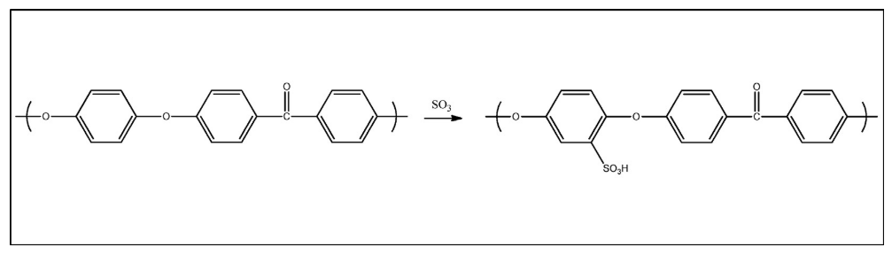
Figure 5. Process of PEEK sulfonation [23]
In the recent past, researchers have incorporated SPEEK with fillers to further enhance its properties, in addition to overcoming some limitations of having SPEEK alone as the membrane. This is due to the presence of significant numbers of dead-end channels in SPEEK limits, the conductivity thus affecting the overall performance [24]. Therefore, in order to not sacrifice the mechanical strength in the higher degree of sulfonation, fillers are added into an organic polymeric matrix.

Preparation methods of composite PEM
As polymer SPEEK owns many of the dead channels, it limits the flow of effective ionic conductivity. These ionic conductive channels can be built by incorporating organic polymers with inorganic backbones. Different ways of incorporating them are illustrated in Figure 6. Organic-inorganic composite membrane can benefit in mechanical and thermal stability from inorganic backbone, while the organic polymer gives advantages in terms of chemical reactivity, ductility and flexibility of processing.

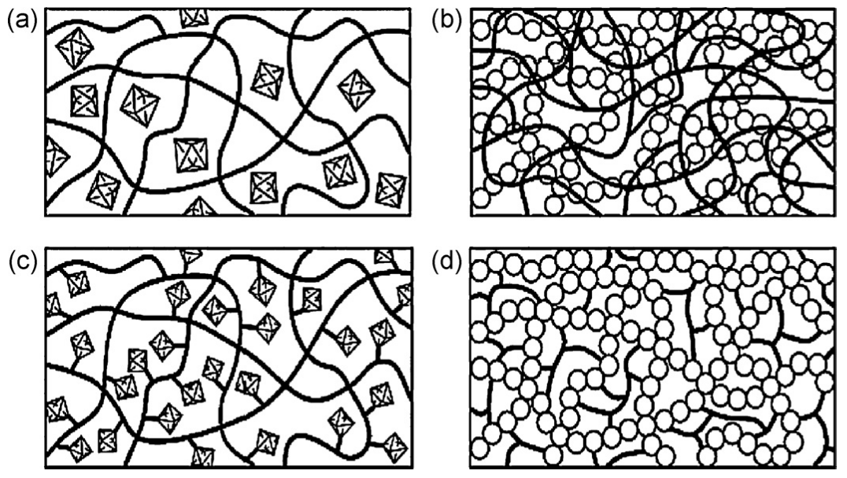

Figure 6. Different ways of incorporating the inorganic system in organic polymers: (a) inorganic moiety embedded into an organic polymer (b) interpenetrating networks with chemical bonds (c) inorganic groups incorporated by bonding to the backbone and (d) dual organic-inorganic hybrid polymer [25]

The composite of ionically conductive polymer and inorganic material can be varied, as shown in Figure 7. Usually, an inorganic precursor such as a monomer or oligomer is blended with a linear or network polymer matrix.

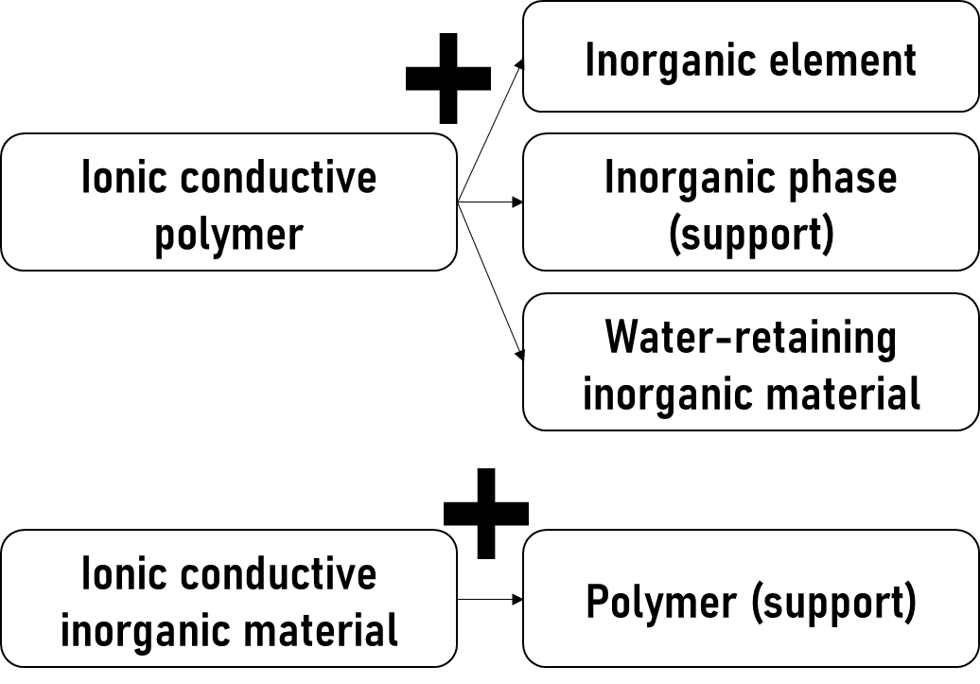
Figure 7. Different ways of organic-inorganic composite membranes arrangements [26]
The preparation methods of the nanocomposite materials include mixing or blending, in-situ polymerization or infiltration, and sol-gel.

Mixing or blending method.
The simplest method to prepare composite PEM is by direct mixing or blending of inorganic materials into the organic polymer matrix. There are two ways of blending the composite, which are melt blending and liquid-state blending. In both ways, it is important to ensure the desired composite components can be dispersed in a common solvent or melt at a high temperature.

Salarizadeh et al. [27] prepared blend nanocomposite SPEEK/perfluorosulfonic acid (PFSA)/barium strontium titanate (BST) membranes by dissolving SPEEK in N,N‐dimethylacetamide (DMAC) followed by mixing with the BST dispersion and PFSA solution. The experimental procedure is shown in Figure 7.

Although melt blending is more common due to its efficiency and prevention from the dispersing of hazardous material into the environment, the filler agglomeration tends to occur when the inorganic nanoparticles are dispersed in polymer matrix. In order to overcome the limitation, the surface of the nanoparticles is being modified to produce nanostructural composites.

Composite of nanosilica and polymer is the common example of membrane that is prepared by solution blending due to its simplicity in preparation. This membrane is widely being researched for gas separation, pervaporation and PEM in fuel cell application [28].

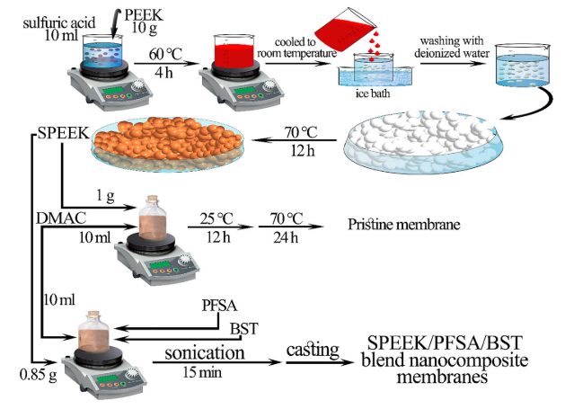

Figure 8. The steps involved in preparing the blend nanocomposite membrane SPEEK/PFSA/BST [29]

In-situ polymerization or infiltration method
In this method, inorganic nanoparticles are introduced in the polymer membrane to modify the transport properties. Firstly, the preformed membrane will be immersed in a solvent, allowing it to swell in order to increase the pore or void volume before the inorganic particle is doped or infiltrated. After the inorganic particle is infiltrated, the composite is cured by heat, radiation, or chemical grafting to gain covalent bonding inside the matrix. The drawback of this method is the leaching of inorganic materials from the membrane matrix [30].

Sol-gel method
This method is favorable as it is an environmentally friendly way and is conducted in low temperature. Briefly, sols are dispersions of colloidal particles in a liquid, while gels may be classified into four categories: (i) well-ordered lamellar structures of inorganics with organics (i.e., organopolysilsesquioxanes; (ii) covalent disordered polymeric networks; (iii) polymer networks formed through physical aggregation; (iv) disordered structures of inorganic and organic networks. There are two consecutive steps in sol–gel reactions, which are hydrolysis of metal alkoxides to produce hydroxyl groups and polycondensation of the hydroxyl groups to form a three-dimensional network. The process is started with solvents (low molecular weight) with alkoxide precursors M(OR)_{n}, (M is a network-forming element: Si, Ti, Zr, Al, B, etcetera, and R is an alkyl group (C_{x}H_{2x+1})) and water. Later, low molecular weight byproducts (alcohol or water) are produced during hydrolysis and condensation. They must be removed, resulting in shrinkage during the sol-gel process.

Modification of SPEEK membrane
Sulfonated PEEK is an organic thermoplastic polymer that possesses outstanding thermal and mechanical properties. As mentioned in the previous section, fillers are needed to overcome some of the drawbacks of SPEEK that can limit its potential to emerge as high-performance membrane. The introduction of nanostructures fillers can overcome the thermal and mechanical instability of SPEEK polymer. The inorganic materials as additives such as hygroscopic oxides (silicon oxide, zirconium oxide, titanium dioxide, iron-titanates, zeolites, and boron phosphate), solid acids and heteropolyacids (HPAs), clay, graphene oxide (GO), carbon nanotubes (CNTs), fullerene and perovskite oxides have shown improved performance for SPEEK membrane [31–33]. Besides overcoming the instability in thermal and mechanical properties, the modifications to SPEEK membrane through inorganic filler also improve methanol permeability in DMFC.

Zhang et al. [34] synthesized nanocomposite membrane by incorporating sulfonated hallyosite nanotubes (SHNTs) into the SPEEK matrix. The well-dispersed SHNTs in the SPEEK matrix bring advantages in terms of the thermal and mechanical stabilities of the membrane. Besides that, the water uptake, ionic exchange capacity, and proton conductivity have been improved tremendously due to the construction of ionic channels that are interconnected by the SHNTs in the SPEEK matrix. Figure 9 shows the improved proton pathways that will allow efficient proton transfer and lead to the enhancement of proton conductivity.

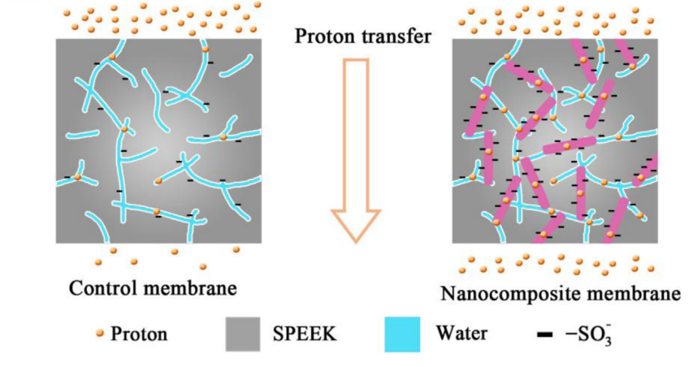

Figure 9. SHNTs interconnect the ionic channels within SPEEK matrix via -SO₃H groups [34]
Bagheri et al. [35] prepared SPEEK, sulfonated poly (vinilidinfluoride-co-hexaflourpropylen) (SPVDF-co-HFP), and lanthanum chromite (LaCrO₃) as nanocomposite blend membrane using solvent casting method. The increasing in proton conductivity is observed at the nanoparticle content of 1.5 wt.%, and the addition of 1.5 wt.% LaCrO₃ nanoparticles managed to make this membrane as effective barrier against methanol permeation. Figure 10 shows the performance of the composite membrane with different content.

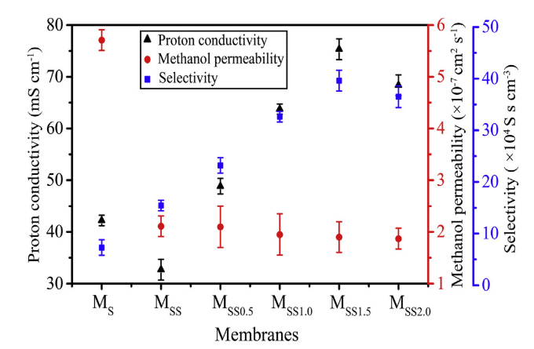

Figure 10. Comparison of different content with the performance of prepared membrane [35]
Later, Salarizadeh et al. [29] prepared another blend nanocomposite membrane of SPEEK with two different types of additives, namely perfluorosulfonic acid (PFSA) and Ba_{0.9}Sr_{0.1}TiO₃ (BST) doped‐perovskite nanoparticles. The addition of both additives has indicated that proton conductivity is improved while methanol permeability is decreased compared to pristine SPEEK membrane. The increase in proton conductivity is contributed by the high specific surface area of perovskite nanoparticles.

Table 3. Influence on membrane performances during the SPEEK modification
Composite | Improvement | Ref.
SPEEK/SnO₂/sBH | Water retention properties increase, which consequently enhance the ionic conductivity of the composite membrane. Methanol diffusion channels decrease and demonstrate the high power density as well as excellent durability | [36]
SPEEK/QDs/CS | Enhanced through-plane conductivity and decreased transfer anisotropy | [37]
sPEEK/sGNR-sGQD | Improved physico-chemical properties resulting in enhanced electrochemical selectivity. Significant enhancement in DMFC performance and better durability can be observed | [38]
SPEEK/CNFs | Improved mechanical strength and water uptake of the composite membranes and low methanol permeability | [39]
SPEEK/PVA/TEOS | The proton transport and fuel cells performance increased | [40]
SPEEK/PFSA/BST | Improved proton conductivity and methanol barrier. Enhanced mechanical stability | [29]

Properties of SPEEK composite membrane
Water uptake, swelling ratio, ion-exchange capacity, mechanical properties
The water uptake (WU) and membrane swelling (SW) are essential parameters in DMFC application as they directly affect the proton conductivity and mechanical stability of the membrane. Controlling the WU of the membrane is quite necessary for high WU can lead to mechanical and dimensional stability while low WU decreases the proton transferring rate within the membrane. They are calculated from the following equations:

$WU \left(\%\right)= \frac{m_{wet}-m_{dry}}{m_{dry}}×100$ (7)
$SW \left(\%\right)= \frac{L_{wet}-L_{dry}}{L_{dry}}×100$ (8)

To determine the water uptake (WU) and membrane swelling (SW), the membranes are dried and then their weights (M_{dry}) and the thickness (L_{dry}) are measured. After that, they are soaked in deionized water. Finally, the surface water of membranes is blotted with a clean paper, and immediately weights (M_{wet}) and thickness (L_{wet}) of membranes are measured.

The ion-exchange capacity (IEC) value is defined as the molar number of fixed sulfonate sites per gram polymer. It is decided by the concentration of exchangeable ions in membranes and determined by an acid-base titration method[41]. It is very closely related to water uptake as increasing the water uptake will increase the value of IEC. The value of IEC was calculated based on the following formula:

$IEC=\frac{{(N}_{NaOH}×V_{NaOH})}{{mass}_{dry}} ×100 \%$ (9)

The dried membrane is soaked in a saturated NaCl solution for a certain time and later is titrated with a NaOH solution using phenolphthalein as an indicator. The N_{NaOH} is the concentration of NaOH solution, while V_{NaOH} is the volume of NaOH solution consumed. The mechanical properties of the membrane are investigated using a universal tensile testing machine. It is evaluated with tensile stress-strain tests. Typically, the value of Young’s modulus is calculated from the slope of the initial linear part of the stress-strain curve. The maximum stress value of the entire curve was taken as the tensile strength [42].

Thermal and chemical stability
The thermal stability of the membrane is measured by its degradation of decomposition at a specific temperature. The membrane that has a good thermal stability should withstand a required temperature for a longer time before it degrades or decomposes [43]. It is usually investigated by a thermogravimetric analyzer (TGA) where the weight loss of the samples is determined.

The thermal stability study of the composite membrane SPEEK with inorganic additive, clay and electrospun fibers is carried out by Awang et al. [43]. The thermogravimetric analysis indicated that SPEEK with added inorganic filler (i.e., Cloisite) gives a higher degradation temperature compared to pristine SPEEK. It shows that the composite organic-inorganic membrane is thermally stable, especially when the amounts of Cloisite is increased as shown in Figure 11. The Cloisite acts as a mass transport barrier and insulator against the colatile compound when the heat is applied [44].

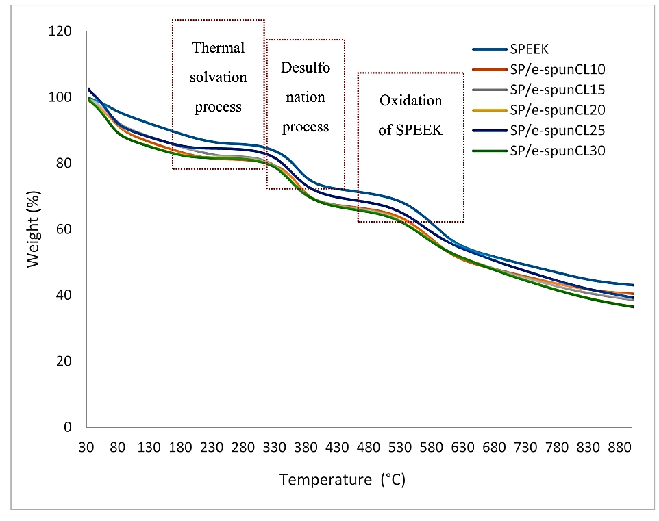

Figure 11. TGA of the SPEEK and composite SPEEK membrane with different amounts of Cloisite [43]
The chemical stability of the membrane is usually being tested by Fenton’s reagent. The experiment subjects the membrane to a very large excess of hydroxyl radicals between 60 and 80 °C to assess chemical durability. The reagent is made when ferrous sulfate is dissolved in hydrogen peroxide (H₂O₂) aqueous solution. This is to mimic the real situation during DMFC operation where H₂O₂ is formed at the cathode side due to the partial reduction of O₂ and the iron ion (Fe²⁺) that is formed from the corrosion of the iron back plate. The migration of Fe²⁺ to the cathode side will react with H₂O₂ and produces a free radical similar to the Fenton reagent. Then the prepared membrane is immersed in the reagent under stirring at a specific temperature. Carbon dioxide (CO₂) will be produced as a by-product when free radicals react with organic polymer. As CO₂ gas forms bubbles, the membrane structures tend to break if they cannot withstand the bubbles’ pressure. Oxidative stability of the membrane is recorded by the time the membrane begins to break [35].

From the chemical stability test conducted by Salleh et al. [45] on composite membrane SPEEK/Cloisite/triaminopyrimidine (SP/CL/TAP), it is proven that the presence of inorganic particles in nanocomposite membrane increased its resistance towards radical attack. The nanocomposite membrane can maintain its weight up to 48 hours. From the FESEM image, as shown in Figure 11, the surface deformation of SP/CL/TAP membrane started to occur after being exposed to Fenton reagent solution for 24h (Figure 11(h)).

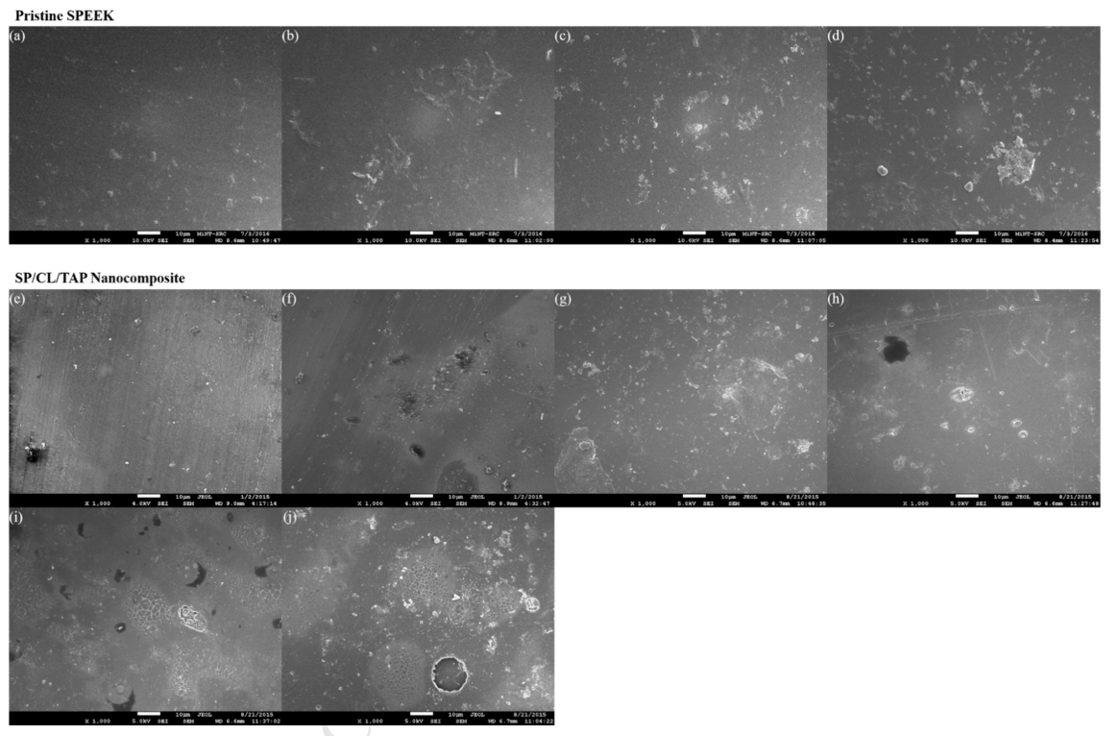

Figure 12. FESEM micrographs of pristine SPEEK and nanocomposite membrane SP/CL/TAP surface before (a,e) and after exposed to Fenton reagent solution for 6h (b,f), 12h (c,g) and 24h (d,h), 48h (i) and 96h (j) [45]
Methanol permeability
The methanol permeability (P, cm² s⁻¹) can be determined by different techniques such as potentiometry, gas chromatography technique (GC), and densimetry method. Each and every technique have its respective advantages and drawbacks, as summarized in Table 4. These three different experimental methods, however, provided very comparable results.

Table 4 Summary of different techniques used to measure methanol permeability

Techniques | Advantages | Drawbacks
Potentiometry | - Simplest method  - Cheapest | - Limited for certain parameters  - Absolute values of concentration at a given time cannot be measured  - Time-consuming
Gas chromatography technique | - Highly precise | - Very expensive
Densimetry | - Most efficient in terms of accuracy, simplicity, experimental time, and cost | -

The cell was separated into two equal-sized compartments by a membrane. The compartment in the left side was filled with methanol solution while the compartment in the right was filled with deionized water and both part had equal volume. The prepared membranes with certain areas are located vertically between the two compartments after keeping them in deionized water. The schematic experimental set-up is illustrated in Figure 13 [46]. As there is a methanol concentration gradient between these two parts, methanol can diffuse from the left to the right compartment, and methanol permeability was measured as a function of time. It is calculated from the following equation:

$C_{R}\left(t\right)= \frac{A P}{L V_{R}}C_{L}(t-t_{0})$ (10)

Where, C_{L} and C_{R} are the concentration of methanol in methanol and water compartment (mol L⁻¹) respectively; L is the thickness of the membranes (cm), A is the diffusion area (cm²), and V_{R} is the volume of deionized water in water compartment (mL). Methanol concentration in the water compartment was examined with time using a density meter.

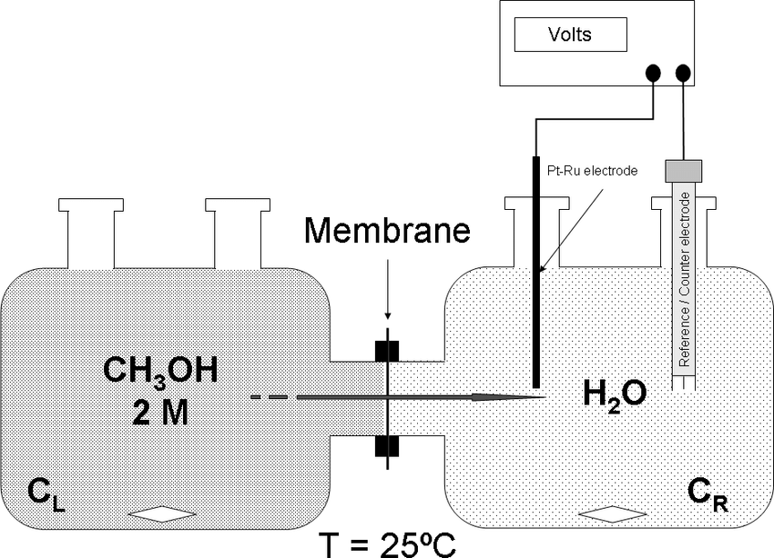

Figure 13. Schematic diagram of experimental set up to determine methanol permeability across the membrane [46]
Proton conductivity
The electrochemical performance of the composite membrane is often indicated by the value of proton conductivity. The proton conductivity heavily relied on the degree of sulfonation, water uptake, and methanol permeation. A summary of fundamental properties that contributed to proton conductivity of SPEEK based membrane is tabulated in Table 4. The proton conductivity is determined from the following equation:

$σ=L/RA$ (11)

Where, σ is the proton conductivity of the membrane (S cm⁻¹), L is the thickness of the membrane (cm), R is the resistance of the membrane (Ω), and A is the surface area of the two electrodes (cm²).

Gong et al. [42] illustrated proton conduction in composite membrane SPEEK/BPO₄@CNT in Figure 14. The composite membrane has higher proton conductivity compared to the pure SPEEK membrane. It could be primarily attributed to the dissociation of the absorbed water molecules on the BPO₄. The fundamental properties that contribute to the performance of composite SPEEK-based membranes that have been discussed in the earlier section are summarized in Table 5.

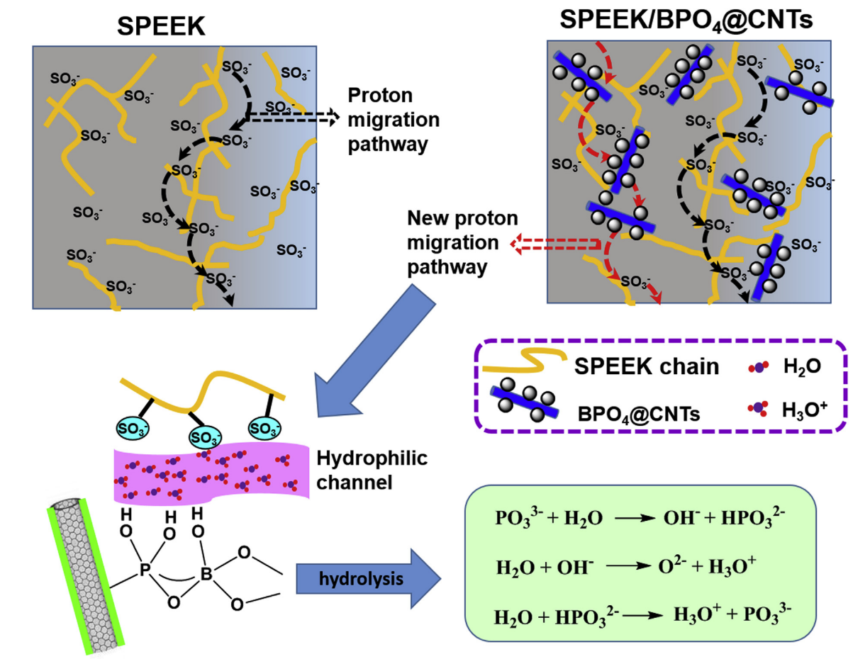

Figure 14. Schematic illustration of proton conduction in SPEEK and composite membrane SPEEK [42]

Table 5. Summary of fundamental properties of composite membrane SPEEK

Composite SPEEK-Based Membrane | Water Uptake (%) | Methanol Permeability  ($×$10⁻⁷ cm²s⁻¹) | Proton Conductivity @RT  (Scm⁻¹) | Ref
SPEEK/SPVDF-co-HFP  SPEEK/SPVDF-co-HFP (0.5 wt.%)  SPEEK/SPVDF-co-HFP (1.0 wt.%)  SPEEK/SPVDF-co-HFP (1.5 wt.%)  SPEEK/SPVDF-co-HFP (2.0 wt.%) | ⁓25  ⁓30  ⁓35  41.23  ⁓35 | 2.11  2.10  1.95  1.90  1.87 | 0.0327  0.0488  0.0638  0.0753  0.0684 | [35]
sPEEK  sPEEK/¹sGNR (1.5 wt.%)  sPEEK/sGNR-²sGQD (1.0 wt.%)  sPEEK/sGNR-sGQD (1.5 wt.%)  sPEEK/sGNR-sGQD (2.0 wt.%) | 29.3  30.4  33.9  37.1  33.6 | 9.24 ± 0.02  6.25 ± 0.28  6.76 ± 0.20  4.35 ± 0.17  5.24 ± 0.17 | 0.0102  0.0150  0.0135  0.0195  0.0147 | [38]
³CS/⁴SP  CS/SP/⁵PQD-10%  CS/SP/PQD-20%  CS/SP/PQD-30%  CS/SP/⁶GQD-20% | 52  -  -  85  - | -  -  -  -  - | 0.158*  0.327*  0.375*  0.456*  0.309* | [37]
SPEEK/⁷BH  SPEEK/sBH (1 wt.%)  SPEEK/sBH(3 wt.%)  SPEEK/sBH (5 wt.%)  SPEEK/SBH/SnO₂ (3 wt.%) | 25.05  38.62  45.01  44.73  50.34 | 1.58  2.52  2.90  2.87  1.28 | 0.0570**  0.0586**  0.0728**  0.0618**  0.0920** | [36]
SPEEK/⁸rGONR@TiO₂ |  | - | 1.78 | [47]

Future perspective and conclusions
The potential of composite SPEEK membrane as high-performance PEM is undeniable based on the past research. The properties such as water uptake and methanol permeation are closely linked to the performance of the membrane in terms of mechanical, thermal, chemical stability, and proton conductivity. With the results that have been obtained in literatures, the composite SPEEK membrane will be a strong competitor that has a big chance to replace the Nafion membrane. However, further investigations are needed i) to find optimum parameters and cost-effective methods in preparing the membrane , ii) to improve the distribution and proportion of inorganic particles in the polymer matrix , iii) to optimize the water uptake and methanol permeation in the membrane, iv) to produce a membrane that is suitable for higher temperature, humidity, and pressure.

In conclusion, the role of filler in improving the performance and properties of the SPEEK membrane is significant in comparison to the properties of either component in isolation.

References
1. Worldometer. (2021). Current World Population. Access from https://www.worldometers.info/world-population/ [Retrieved September 8, 2021]
2. Haiges, R., Wang, Y. D., Ghoshray, A. and Roskilly, A. P. (2017). Optimization of Malaysia’s Power generation mix to meet the electricity demand by 2050. Energy Procedia, 142: 2844-2851.
3. Laguna-Bercero, M. A. (2012). Recent advances in high temperature electrolysis using solid oxide fuel cells: a review. Journal of Power Sources, 203: 4-16.
4. Dai, H., Jiang, B., Hu, X., Lin, X., Wei, X. and Pecht, M. (2020). Advanced battery management strategies for a sustainable energy future: multilayer design concepts and research trends. Renewable and Sustainable Energy Reviews, 8: 110480.
5. Bahru, R., Shaari, N. and Mohamed, M. A. (2020). Allotrope carbon materials in thermal interface materials and fuel cell applications: A review. International Journal of Energy Research, 44(4): 2471-2498.
6. Raduwan, N. F., Muchtar, A., Somalu, M. R., Baharuddin, N. A. and Muhammed Ali, S. A. (2018). Challenges in fabricating solid oxide fuel cell stacks for portable applications: A short review. International Journal of Integrated Engineering, 10(5): 80-86.
7. Ferriday, T. B. and Middleton, P. H. (2021). Alkaline fuel cell technology - a review. International Journal of Hydrogen Energy, 46(35): 18489-18510.
8. Junoh, H., Jaafar, J., Mohd Norddin, M. N. A., Ismail, A. F., Othman, M. H. D., Rahman, M. A., … and Ilbeygi, H. (2015). A review on the fabrication of electrospun polymer electrolyte membrane for direct methanol fuel cell. Journal of Nanomaterials, 4: 4.
9. Esmaeili, N., Gray, E. M. A. and Webb, C. J. (2019). Non-fluorinated polymer composite proton exchange membranes for fuel cell applications – a review. ChemPhysChem, 20(16): 2016-2053.
10. Asghari, S., Fouladi, B., Masaeli, N. and Imani, B. F. (2014). Leak diagnosis of polymer electrolyte membrane fuel cell stacks. International Journal of Hydrogen Energy, 39(27): 14980-14992.
11. Wu, H., Hou, W., Wang, J., Xiao, L. and Jiang, Z. (2010). Preparation and properties of hybrid direct methanol fuel cell membranes by embedding organophosphorylated titania submicrospheres into a chitosan polymer matrix. Journal of Power Sources, 195(13): 4104-4113.
12. Jiang, S. P., Liu, Z. and Tian, Z. Q. (2006). Layer-by-layer self-assembly of composite polyelectrolyte-nafion membranes for direct methanol fuel cells. Advanced Materials, 18(8): 1068-1072.
13. Kim, H. J., Kim, D. Y., Han, H. and Shul, Y. G. (2006). PtRu/C-Au/TiO₂ Electrocatalyst for a direct methanol fuel cell. Journal of Power Sources, 159: 484-490.
14. Taherkhani, Z., Abdollahi, M., Sharif, A. and Barati, S. (2021). Poly(benzimidazole)/poly(vinylphosphonic acid) blend membranes with enhanced performance for high temperature polymer electrolyte membrane fuel cells. Solid State Ionics, 364: 115635.
15. Zarrin, H., Jiang, G., Lam, G. Y. Y., Fowler, M. and Chen, Z. (2014). High performance porous polybenzimidazole membrane for alkaline fuel cells. International Journal of Hydrogen Energy, 39(32): 18405-18415.
16. Herranz, D., Escudero-Cid, R., Montiel, M., Palacio, C., Fatás, E. and Ocón, P. (2018). Poly (vinyl alcohol) and poly (benzimidazole) blend membranes for high performance alkaline direct ethanol fuel cells. Renewable Energy, 127: 883-895.
17. Gao, X., Liu, Y. and Li, J. (2015). Review on modification of sulfonated poly (-ether-ether-ketone) membranes used as proton exchange membranes. Medziagotyra, 21(4): 574-582.
18. Yee, R. S. L., Zhang, K. and Ladewig, B. P. (2013). The effects of sulfonated poly(ether ether ketone) ion exchange preparation conditions on membrane properties. Membranes, 3(3): 182-195.
19. Xiang, Z., Zhao, X., Ge, J., Ma, S., Zhang, Y. and Na, H. (2016). Effect of sulfonation degree on performance of proton exchange membranes for direct methanol fuel cells. Chemical Research in Chinese Universities, 32(2): 291-295.
20. Hasani-Sadrabadi, M. M., Dashtimoghadam, E., Sarikhani, K., Majedi, F. S. and Khanbabaei, G. (2010). Electrochemical investigation of sulfonated poly(ether ether ketone)/clay nanocomposite membranes for moderate temperature fuel cell applications. Journal of Power Sources, 195(9): 2450-2456.
21. Chang, J. H., Park, J. H., Park, G. G., Kim, C. S. and Park, O. O. (2003). Proton-conducting composite membranes derived from sulfonated hydrocarbon and inorganic materials. Journal of Power Sources, 124(1): 18-25.
22. Li, L., Zhang, J. and Wang, Y. (2003). Sulfonated Poly(ether ether ketone) membranes for direct methanol fuel cell. Journal of Membrane Science, 226(1–2): 159-167.
23. Ata, K. C., Kadıoğlu, T., Türkmen, A. C., Çelik, C. and Akay, R. G. (2020). Investigation of the effects of SPEEK and its clay composite membranes on the performance of direct borohydride fuel cell. International Journal of Hydrogen Energy, 45(8): 5430-5437.
24. Rambabu, G. and Bhat, S. D. (2015). Sulfonated fullerene in SPEEK matrix and its impact on the membrane electrolyte properties in direct methanol fuel cells. Electrochimica Acta, 176: 657-669.
25. Kickelbick, G. (2003). Concepts for the incorporation of inorganic building blocks into organic polymers on a nanoscale. Progress in Polymer Science, 28(1): 83-114.
26. Peighambardoust, S. J., Rowshanzamir, S. and Amjadi, M. (2010). Review of the proton exchange membranes for fuel cell applications. International Journal of Hydrogen Energy, 35(17): 9349-9384.
27. Balazs, A. C., Emrick, T. and Russell, T. P. (2006). Nanoparticle polymer composites: Where two small worlds meet. Science, 314(5802): 1107-1110.
28. Zou, H., Wu, S. and Shen, J. (2008). Polymer/silica nanocomposites: Preparation, characterization, propertles, and applications. Chemical Reviews, 108(9): 3893-3957.
29. Salarizadeh, P., Bagheri, A., Beydaghi, H. and Hooshyari, K. (2019). Enhanced properties of SPEEK with incorporating of PFSA and barium strontium titanate nanoparticles for application in DMFCs. International Journal of Energy Research, 43(9): 4840-4853.
30. Tripathi, B. P. and Shahi, V. K. (2011). Organic-inorganic nanocomposite polymer electrolyte membranes for fuel cell applications. Progress in Polymer Science (Oxford), 36(7): 945-979.
31. Wong, C. Y., Wong, W. Y., Ramya, K., Khalid, M., Loh, K. S., Daud, W. R. W., … and Kadhum, A. A. H. (2019). Additives in proton exchange membranes for low- and high-temperature fuel cell applications: A review. International Journal of Hydrogen Energy, 44(12): 6116-6135.
32. Rambabu, G., Bhat, S. D. and Figueiredo, F. M. L. (2019). Carbon nanocomposite membrane electrolytes for direct methanol fuel cells—a concise review. Nanomaterials, 9(9): 1292.
33. Taufiq Musa, M., Shaari, N. and Kamarudin, S. K. (2020). Carbon nanotube, graphene oxide and montmorillonite as conductive fillers in polymer electrolyte membrane for fuel cell: An overview. International Journal of Energy Research, 45(2): 1309-1346.
34. Zhang, H., Ma, C., Wang, J., Wang, X., Bai, H. and Liu, J. (2014). Enhancement of proton conductivity of polymer electrolyte membrane enabled by sulfonated nanotubes. International Journal of Hydrogen Energy, 39(2): 974-986.
35. Bagheri, A., Javanbakht, M., Hosseinabadi, P., Beydaghi, H. and Shabanikia, A. (2018). Preparation and characterization of SPEEK/SPVDF-Co-HFP/LaCrO₃ nanocomposite blend membranes for direct methanol fuel cells. Polymer, 138: 275-287.
36. Ranjani, M., Al-Sehemi, A. G., Pannipara, M., Aziz, M. A., Phang, S. M., Ng, F. L. and Kumar, G. G. (2020). SnO₂ nanocubes/bentonite modified SPEEK nanocomposite composite membrane for high performance and durable direct methanol fuel cells. Solid State Ionics, 353(3): 115318.
37. Li, P., Dang, J., Wu, W., Lin, J., Zhou, Z., Zhang, J. and Wang, J. (2020). Nanofiber composite membrane using quantum dot hybridized SPEEK nanofiber for efficient through-plane proton conduction. Journal of Membrane Science, 609(5): 118198.
38. Shukla, A., Dhanasekaran, P., Nagaraju, N., Bhat, S. D. and Pillai, V. K. (2019). A facile synthesis of graphene nanoribbon-quantum dot hybrids and their application for composite electrolyte membrane in direct methanol fuel cells. Electrochimica Acta, 297: 267-280.
39. Liu, X., Yang, Z., Zhang, Y., Li, C., Dong, J., Liu, Y. and Cheng, H. (2017). Electrospun multifunctional sulfonated carbon nanofibers for design and fabrication of SPEEK composite proton exchange membranes for direct methanol fuel cell application. International Journal of Hydrogen Energy, 42(15): 10275-10284.
40. Sahin, A. (2018). The development of SPEEK/PVA/TEOS blend membrane for proton exchange membrane fuel cells. Electrochimica Acta, 271, 127–136.
41. Jiang, Z., Zhao, X. and Manthiram, A. (2013). Sulfonated poly(ether ether ketone) membranes with sulfonated graphene oxide fillers for direct methanol fuel cells. International Journal of Hydrogen Energy, 38(14): 5875-5884.
42. Gong, C., Zheng, X., Liu, H., Wang, G., Cheng, F., Zheng, G., … and Tang, C. Y. (2016). A new strategy for designing high-performance sulfonated poly(ether ether ketone) polymer electrolyte membranes using inorganic proton conductor-functionalized carbon nanotubes. Journal of Power Sources, 325: 453-464.
43. Awang, N., Jaafar, J. and Ismail, A. F. (2018). Thermal stability and water content study of void-free electrospun SPEEK/cloisite membrane for direct methanol fuel cell application. Polymers, 10(2): 1-15.
44. Yamaguchi, T., Miyata, F. and Nakao, S. I. (2003). Pore-filling type polymer electrolyte membranes for a direct methanol fuel cell. Journal of Membrane Science, 214(2): 283-292.
45. Salleh, M. T., Jaafar, J., Mohamed, M. A., Norddin, M. N. A. M., Ismail, A. F., Othman, M. H. D., … and Salleh, W. N. W. (2017). Stability of SPEEK/Cloisite®/TAP nanocomposite membrane under fenton reagent condition for direct methanol fuel cell application. Polymer Degradation and Stability, 137: 83-99.
46. Mollá, S., Compañ, V., Lafuente, S. L. and Prats, J. (2011). On the methanol permeability through pristine Nafion® and /PVA membranes measured by different techniques. A comparison of methodologies. Fuel Cells, 11(6): 897-906.
47. Roy, T., Wanchoo, S. K. and Pal, K. (2020). Novel sulfonated poly (ether ether ketone)/rGNOR@TiO₂ nanohybrid membrane for proton exchange membrane fuel cells. Solid State Ionics, 349: 115296.

