PtRu SUPPORTED ON POROUS 3D TITANIUM DIOXIDE-GRAPHENE AEROGEL AS A POTENTIAL ELECTROCATALYST FOR DIRECT METHANOL FUEL CELLS

(PtRu disokong pada 3D Titanium Dioksida-Grafin Aerogel Berliang Sebagai Potensi Elektromangkin untuk Sel Bahan Bakar Metanol Langsung)

Siti Hasanah Osman^{1*}, Siti Kartom Kamarudin^{1,2}, Sahriah Basri¹, Nabila A.Karim¹

¹Fuel Cell Institute,
Universiti Kebangsaan Malaysia, 43600 UKM Bangi, Selangor, Malaysia
²Department of Chemical and Process Engineering,
Faculty of Engineering and Built Environment
Universiti Kebangsaan Malaysia, 43600 UKM Bangi, Selangor, Malaysia

*Corresponding author: ctie@ukm.edu.my

Abstract

The catalyst support is typically implemented to improve the catalytic activity in direct methanol fuel cells (DMFCs). Thus, this study focused on the novel support of 3D hierarchical porous TiO₂-graphene aerogel which was established via a combination of hydrothermal method and freezing drying method. XRD, Raman spectra, and FESEM were used to study the PtRu/TiO₂-GA. The estimated particle size of PtRu/TiO₂-GA determined from the XRD analysis was less than composite TiO₂-GA. The existence of the carbon support material was confirmed by the Raman spectra in all generated samples. Within the electrocatalyst and TiO₂-GA, the ratio value of the D band to the G band (I_{D}/I_{G}) was not significantly different. The computed I_{D}/I_{G} values for TiO₂-GA and PtRu/TiO₂-GA electrocatalysts were 0.99 and 1.02, respectively. The best TiO₂-GA was doped with PtRu catalyst for the electrochemical test and DMFC performance based on FESEM characterization. PtRu/ TiO₂-GA exhibited better electrocatalytic activity, as well as improved PtRu usage efficiency stability and methanol oxidation reaction. Notably, the ECSA value was around 76.01 m²g⁻¹, and the mass activity (957.15 mAmg⁻¹) was higher than commercial with the same loading (20%) PtRu/C (110.79 mAmg⁻¹). Interestingly after the 2000s, the current density of PtRu/TiO₂-GA was consistently higher than that of PtRu/C. The superior electrocatalytic performance of PtRu/TiO₂-GA towards methanol oxidation demonstrates its use in practical application as a promising anode material for DMFCs

Keywords: 3D titanium dioxide-graphene aerogel, platinum-ruthenium nanoparticles, electrocatalysis, methanol electro-oxidation

Abstrak

Sokongan mangkin biasanya dilaksanakan untuk meningkatkan aktiviti pemangkin dalam sel bahan api metanol langsung (SFML). Oleh itu, kajian ini memberi tumpuan kepada novel sokongan pada TiO₂-grafin aerogel berliang hierarki 3D telah ditubuhkan dengan gabungan kaedah hidroterma dan kaedah pengeringan beku. XRD, spektrum Raman dan FESEM digunakan untuk mengkaji PtRu/TiO₂-GA. Anggaran saiz zarah PtRu/TiO₂-GA yang ditentukan daripada analisis XRD adalah kurang daripada komposit TiO₂-GA. Kewujudan bahan sokongan karbon telah disahkan oleh spektrum Raman dalam semua sampel yang dihasilkan. Dalam elektromangkin dan TiO₂-GA, nilai nisbah jalur D kepada jalur G (I_{D}/I_{G}) tidak berbeza dengan ketara. Nilai I_{D}/I_{G} yang dikira untuk elektromangkin TiO₂-GA dan PtRu/TiO₂-GA ialah 0.99 dan 1.02, masing-masing. TiO₂-GA terbaik akan didop dengan mangkin PtRu untuk ujian elektrokimia dan prestasi SFML berdasarkan pencirian FESEM. PtRu/ TiO₂-GA mempamerkan aktiviti elektrokatalitik yang lebih baik, serta peningkatan kestabilan kecekapan penggunaan PtRu dan tindak balas pengoksidaan metanol. Terutama, nilai ECSA adalah sekitar 76.01 m²g⁻¹, aktiviti jisim (957.15 mAmg⁻¹) adalah lebih tinggi daripada komersial dengan pemuatan yang sama (20%) PtRu/C (110.79 mAmg⁻¹). Menariknya selepas minit ke-2000 saat, ketumpatan semasa PtRu/TiO₂-GA sentiasa lebih tinggi daripada PtRu/C. Prestasi elektrokatalitik unggul PtRu/TiO₂-GA terhadap pengoksidaan metanol boleh digunakan dalam aplikasi praktikal sebagai bahan anod yang menjanjikan untuk DMFC.

Kata kunci: 3D titanium dioksida-grafin aerogel, nanopartikel platinum-ruthenium, elektromangkin, elektro-pengoksidaan metanol

Introduction
Direct methanol fuel cells (DMFCs) have gained traction recently due to their technological advances through a variety of characteristics: low emissions, excellent energy conversion efficiency, liquid fuel handling convenience, and low operating temperature. These are the results of the increasing use of mobile devices and the prerequisite of affording sufficient energy and power for the application [1, 2]. The electrochemical reaction in a direct methanol fuel cell is represented as follows:

CH₃OH + H₂O → CO₂ + 6H⁺ + 6e⁻ E° =0:016V (vs: SHE) (Anode reaction)
3/2O₂ + 6H⁺ + 6e⁻ → 3H₂O E° =1:229V (vs: SHE) (Cathode reaction)
CH₃OH + H₂O → CO₂ + 6H⁺ + 6e⁻ E° =1:245V (vs: SHE) (Overall reaction)

The need for highly active catalysts for the oxidation process of hydrogen-rich liquid fuels is one of the major driving forces behind the development of DMFC technology. The electrocatalyst selection is critical for DMFC because the quality of the reaction kinetics of catalyst influences current density and cell lifespan. Improved catalyst activity and durability can be achieved through the development of novel support materials or the use of innovative catalytic metals [3]. Due to their increased catalytic activity in the electrooxidation of methanol, platinum group metals (PGMs) are the most used anode catalysts in DMFCs [4-8]. Platinum is costly, thus finding a replacement catalyst will necessitate further research. The best catalyst for DMFCs right now is bimetallic platinum-ruthenium (PtRu). Pt loading can be lowered by reducing the electrocatalyst costs in DMFC using only the corresponding ratio of 1:1. Additionally, bimetallic Ru catalyst works in catalytic operations by eliminating carbon monoxide (CO) from the active site for HOR, where this catalyst can reduce CO poisoning [11, 12]. PtRu demonstrated a higher catalytic activity in the DMFC according to research by Bock et al. [4], and it was evident that the catalytic performance was significantly dependent on the distribution of Pt and Ru sites at the atomic level. However, the PtRu catalyst cannot solve the problem of low methanol oxidation. Further catalyst modifications are required to help the fuel cell sector.

The DMFC has been in progress for a decade with the creation of several catalyst-based solutions. Alternative support materials are stable and cost-effective, and they have been identified and developed with great effort [28–30]. Novel carbon supports, for example carbon nanotubes [5], mesoporous carbon [6], graphene [7], noncarbon materials, and nonconductive whiskers, due to their strong corrosion-resistance, have been explored as carbon alternatives. Graphene is the best candidate for catalyst support in fuel cells because of its chemical resistance, large and sufficient porosity, high conductivity, and diversity of topologies (network, aerogel, foam, etc.) [8, 9]. In general, the graphene aerogel (GA), which has a three-dimensional (3D) structure, has received a lot of attention due to its extensive macroporosity and multidimensional electron transport pathways, making it ideal for catalysis and energy storage devices [10, 11]. In the advancement of DMFCs, applying additional materials to the catalyst, including the formation of new hybrid catalysts, has become a trend [4–6]. However, issues such as electronic and protonic functioning, poor catalytic activity, stability, and conductivity are still persistent.

The most used materials to improve the electrocatalysis of DMFCs are metal oxides. Titanium dioxide (TiO₂) is a type of inorganic substance, non-flammable, corrosion-resistant, and fundamentally stable. Furthermore, TiO₂ crystal structures are thermodynamically stable, contributing to the production of a composite material that is thermally and electrochemically stable [12]. Anatase stimulates charge carriers deeper within the bulk material, leading more in surface reactions and rising catalytic activity with time [13]. Additionally, when the TiO₂ metal oxide interacts with another component, the electrical behaviour of the materials improves as well. Instead of lowering CO oxidation potentials, this material can also support to increase oxidation activity [14]. The metal catalyst is supported by TiO₂, which impacts the reaction kinetics and mechanism [15]. TiO₂ has all the advantages recorded above and it can be used in a variety of industries. Despite these benefits, the low conductivity of material prevents it from being widely used in fuel cell applications.

Significant loading of a Pt catalyst on TiO₂ made from an electrically conductive substance like N-doped carbon, as well as the use of sub-stoichiometric TiO₂, is necessary to overcome this obstacle [16]. In 2018, Abdullah et al. [16] developed PtRu alloys on a nanofiber catalyst structure with metal oxide as the catalyst support; PtRu/TiO₂-embedded carbon nanofiber (CNF) (PtRu/TECNF) was designed by Ito et al. [17], and Ercelik et al. [18] demonstrated PtRu/ C-TiO₂ as an electrocatalyst in DMFC technology; the result indicated that the performance of this new composite electrocatalyst was superior to PtRu catalyst. The above-mentioned performance is due to the homogeneous dispersion of PtRu nanoparticles on the support material. Consequently, combining a powerful PtRu catalyst with a rational TiO₂ and graphene aerogel structure has unique properties and high surface area, it has developed as the latest support material, with the possibility to increase electrocatalytic activity in MOR.

Materials and Methods

Preparation of TiO₂-GA and electrocatalyst

TiO₂-GA was produced hydrothermally, then freeze-dried in a typical experiment. Firstly, 20 mg of TiO₂ were homogeneously disseminated into 10 mL of GO solution (2 mg/mL) using moderate ultrasonication for 2 hours. After that, the solution was placed in a 50mL of Teflon-lined autoclave and kept at 200°C for 12 hours. To make a TiO₂-GA composite, the produced TiO₂-graphene hydrogel was thoroughly rinsed with deionized water before being freeze-dried for 24 hours. The steps of TiO₂-GA production are depicted schematically in Figure 1.

For electrocatalyst synthesis, a microwave-assisted alcohol reduction approach was used. The optimal TiO₂-GA support doped with PtRu catalyst was chosen specifically for this study. On TiO₂-GA support, 20 wt.% Pt-Ru with an atomic ratio of 1:1 was loaded. To begin, Ethylene Glycol (EG) solutions were combined with ruthenium chloride precursors and chloroplatinic acid precursors, and were homogenized for 15 minutes. After that, the TiO₂-GA powder that had been produced was mixed into the cooperation precursor solutions and agitated for 30 minutes to ensure that everything was well mixed. After that, the pH of the solution was adjusted to 10 using a 1 M NaOH solution. In addition, the mixture was microwaved for 1 minute, and was left to accomplish the reduction process for 1 minute twice. Finally, before being dried in a 120 °C oven for 3 hours, the sample was filtered and rinsed a few times with ethanol and DI water to remove the impurities.

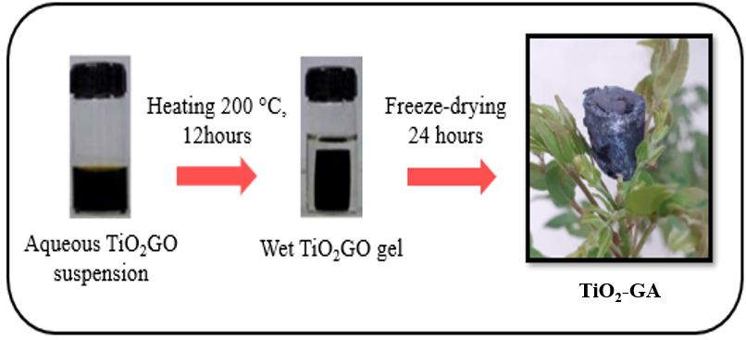

Figure 1. Design of the preparation of TiO₂-GA composite

Characterizations
To prove crystallinity in the manufactured tests for characterization uses, X-ray Diffraction (XRD) is a powerful physical description method. Using a D8 Advance/Bruker, AXS Germany model, all fabricated tests were examined at 2θ from 5° to 100°. Moreover, the degree of graphitization was described using Raman spectrum analysis. The surface morphology and forms of the samples were explored using a Field Emission Scanning Electron Microscope (FESEM).

Electrochemical characterization and performance test
In a 0.5 M H₂SO₄ the electrocatalyst performance was estimated by determining the electrochemical surface area, ECSA, cyclic voltammetry (CV), and catalyst stability measured with a chronoamperometry (CA) test. Three-electrode cell systems were used at room temperature: a working electrode with a glassy carbon electrode (3 mm Ø), reference electrodes noted as Ag/AgCl electrodes, and counter platinum-based electrode. Furthermore, 3 mg of electrocatalyst of PtRu/TiO₂-GA and commercial catalyst were dispersed in 150 mL DI water, 150 mL IPA, and 50 mL Nafion (5 wt.%) solution to make the electrocatalyst ink for the working electrode. On the glassy electrode, there was a catalyst loading of 0.0503 mg cm⁻². The CV was measured at a 50 mVs⁻¹ scan rate with potentials ranging from -0.2 to 1.0 V vs. Ag/AgCl. Note that in this analysis, the potentials ranged from -0.2 to 1.0 V vs. Ag/AgCl, while CV was recorded at a 50 mVs⁻¹ scan rate. The long- term performance of all electrocatalysts was assessed using chronoamperometry (CA) in the electrolyte solution at a potential of 0.6 V for 2000 s.

Results and Discussion
The crystal structure and pattern of the built catalyst support and electrocatalyst were investigated using XRD analysis. As a result, the TiO₂-GA support was synthesized by hydrothermal at 200 °C. The microwave-assisted alcohol reduction approach was used to make the PtRu/TiO₂-GA and PtRu/C marketable. The analysis of the diffraction peak for the associated sample and comparative samples of XRD pattern for PtRu/TiO₂-GA electrocatalyst is shown in Figure 2(a). Peaks at 25.3°, 37.8°, 48.0°, 53.9°, 55.1°, 62.7°, 68.8°, 70.3°, and 75.0° are indexed to (101), (004), (200), (105), (211), (204), (116), (220), and (215) crystal planes of TiO₂ anatase, respectively based on XRD examination for TiO₂-GA support sample [19, 20]. The TiO₂-GA hydrothermal at 200 °C was chosen as the best-produced TiO₂-GA and was doped with PtRu catalyst. The XRD results for the synthesized PtRu/TiO₂-GA showed the presence of all particles, PtRu, and C support. The Pt particles peaked at 39.7° (111), 46.2° (200), 67. 5° (220), and 81.3° (311). The diffraction peaks for Ru were 40.7° (111), 47° (200), 69° (220), and 83.7° (311). The structure of both metals was cubic, and in the electrocatalyst sample, high Bragg angles were detected in the range of 25°–60°, indicating that the catalyst possessed bimetallic or alloy interaction [21]. Additionally, the estimated crystallite size of PtRu was computed using Scherrer's equation, which revealed that PtRu/TiO₂-GA particles were smaller than PtRu/C particles [22]. As shown in Table 1, the particle size of Pt and Ru can also be predicted using the crystallite size. In general, smaller particles perform better in MOR electrocatalysis reactions than larger particles, since smaller catalyst particles contribute to a higher particle surface area. Furthermore, the smaller catalyst particle size may allow for a reduction in the use of Pt in electrocatalyst, as well as a reduction in the overall cost of DMFC production. The decreased size of PtRu particles found in the electrocatalyst sample could potentially be due to the lower crystalline structure.

Table 1. Estimated crystallite size of TiO₂-GA and PtRu/TiO₂-GA on XRD analysis
Samples | XRD/Crystallite Size (nm)
TiO₂-GA | 7.9
PtRu/TiO₂-GA | 3.8
PtRu/C | 3.9

In terms of the chemical and structural information offered by the shift in wavelength of inelastically scattered radiation, the D and G bands were 1350 and 1590 cm⁻¹. The two separate peaks in the Raman spectra for the samples in Figure 2(b) indicated that the D band was linked to crystal boundary vibrations and the G band reflected perfect sp2 vibrations of graphitic crystals. From the Raman spectrum analysis, the intensity ratio of the D to G band (I_{D}/I_{G}) had a descending order: TiO₂-GA (1.02), PtRu/ TiO₂-GA (0.99) and PtRu/C (0.98). The band fluctuated depending on the relative intensity of the D and G bands on the type of graphite material, and it could be used to estimate the degree of graphitization. The I_{D}/I_{G} ratio observed in this work showed that the aerogel was successfully achieved after the catalyst was disseminated at TiO₂-GA [23], [24]. Ultimately, in the disintegrated region and structure of TiO₂-GA, the carbon layer in these electrocatalysis samples was not significantly different. The weak Raman shift bands at 152 cm⁻¹ and 154 cm⁻¹ were identified in TiO₂-GA and PtRu/TiO₂-GA, respectively, and were linked to unique characteristics of TiO₂ anatase [25].

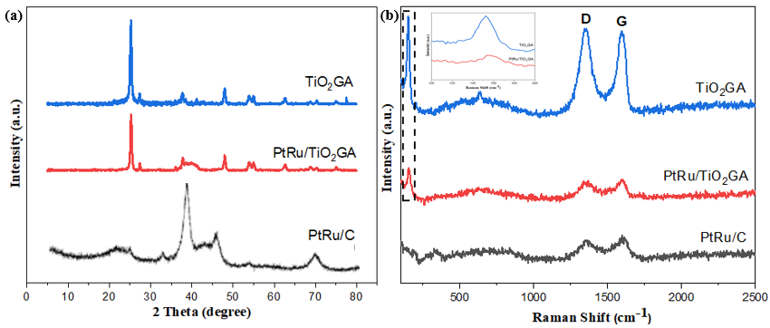

Figure 2. (a) XRD patterns of TiO₂-GA composite and PtRu/TiO₂-GA electrocatalyst (b) Raman spectra of TiO₂-GA composite and PtRu/TiO₂-GA electrocatalyst
FESEM was used to analyze the dispersion surface, morphologies, and sizes of PtRu/TiO₂-GA and PtRu/C produced using a microwave-assisted alcohol-reduction technique. PtRu/TiO₂-GA had a 3D-porous cellular structure, exhibiting constant porosity of sizes ranging from micrometres to sub micrometres as seen in Figure 3. Furthermore, the tight inspection revealed an evenly adorned PtRu nanoparticles in a 3D porous cellular structure, demonstrating a strong interaction among the PtRu-carbon building block. Interestingly, the PtRu/C images revealed that these carbon-supporting materials were spherical. [26]. The findings indicated that the samples were agglomerated with a diameter of 120-150 nm, which was available in the nanoscale range. The Van der Waals interaction surrounded by the particles could be causing the aggregation [27].
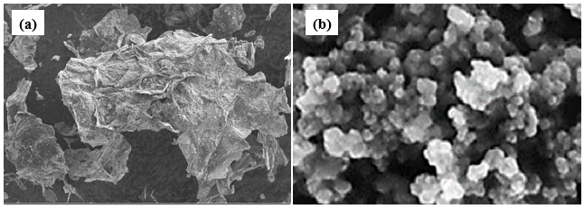

Figure 3. FESEM image of the prepared (a) PtRu/TiO₂-GA and (b) PtRu/C

Electrocatalytic performance
In recent decades, DMFCs have been intensively explored and gained increasing attention in the electrooxidation by methanol. For the methanol oxidation in acid media, the electrochemical efficiency of the PtRu/TiO₂-GA catalyst has been explored. The PtRu/TiO₂-GA CV curves and PtRu/C catalysts in N₂ with 0.5M H₂SO₄ saturated solutions are displayed in Figure 4(a). In the area from -0.2 V to 1.0 V vs Ag/AgCl, both electrics demonstrated the characteristics of hydrogen adsorption-desorption. The ECSAs computed for PtRu/TiO₂-GA and PtRu/C amount was about 68.44 m² g⁻¹ and 20.44 m² g⁻¹, respectively. The ECSA for PtRu/TiO₂-GA was 3 times that of PtRu/C and 30 % greater than that for commercial PtRu/C. This finding demonstrates that retaining a bimetallic 3D structure in TiO₂-GA helps to increase the ECSA of PtRu nanoparticles and improve catalyst utilization. This is owing to the differences in crystallite size between PtRu/TiO₂-GA and PtRu/C as shown in Table 1 from the XRD analysis: the PtRu/TiO₂-GA crystallite size for TiO₂-GA was the lowest and it had a superior ECSA value. Hence, the catalyst and reaction surface area can be increased by using the smallest crystallite size.

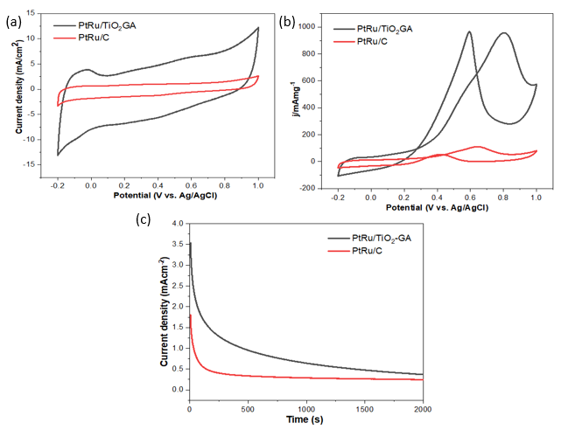

Figure 4. (a) CVs of PtRu/TiO₂-GA and PtRu/C in N₂ saturated 0.5 M H₂SO₄ solution at scan rate 50 mVs⁻¹, (b) CVs of PtRu/TiO₂-GA and PtRu/C in N₂ saturated 0.5 M H₂SO₄ solution containing 1 M CH₃OH at scan rate 50 mVs⁻¹, and (c) Chronoamperometric curves of H₂SO₄ in N₂ saturated containing 1 M CH₃OH

Figure 4(b) illustrates that the peak mass activity PtRu/TiO₂-GA is greater than PtRu/C. The CV values are indicated in Table 2 for the PtRu/TiO₂-GA and PtRu/C electrocatalyst. For PtRu/TiO₂-GA catalyst, the value for mass activity was 957.15 mA mg⁻¹ PtRu, 12 times greater than that of the commercial PtRu/C catalyst. This reveals that the support for TiO₂-GA is a superior replacement for carbon catalyst support. Throughout the carbonization process, the aerogel mixture can boost the electrical and thermal leads of the catalyst [28].

In a composite electrocatalyst, using an aerogel structure can increase the overall surface area as well as the active reaction site on the surface of the electrocatalyst. An additional benefit is the high anatase TiO₂ composition, as determined by the XRD measurements. Anatase has a higher electrocatalytic activity than rutile TiO₂. Besides increasing peak current density, the metal-support interaction also shows a favourable effect, and the material combination of PtRu and TiO₂-GA is an effective electrocatalyst in DMFCs. The performance of PtRu/C is significantly poorer than that of PtRu agglomeration, where the ECSA value as well as the crystallite size as determined by XRD are emphasized. Such state reduces the possibility of the electrocatalyst surface to be an active site and lowers the performance of the electrocatalysts.

Table 2. Assessment of the performance outcomes with the previous research
Research | Type of Catalyst | ECSA (m²/g_{PtRu}) | Mass ativity  (mA/mg_{PtRu})
This study | PtRu/TiO₂-GA | 68.44 | 957.15
This study | PtRu/C | 20.44 | 79.11
Abdullah et al. [16] | PtRu/TiO₂-CNF | 10.4 | 345.64
Basri et al. [29] | PtRuNiFe/MWCNT | - | 151.47
Ramli et al. [30] | PtRu/CNC | 16.23 | 427.00

CA tests were carried out to verify the stability of electrocatalyst and endurance for long-term MOR performance in a 1M methanol solution containing 0.5 M H₂SO₄ for 2000 seconds. At 0.6 V, the potential was kept constant. The CA curves electrocatalysts for the PtRu/TiO₂-GA and PtRu/C are shown in Figure 4(c). The current density of electrocatalysts indicates a dramatic decline at the beginning of the experiment probably due to methanol oxidation mediation poisoning. The limiting current PtRu/TiO₂-GA was higher than PtRu/C across the entire duration, indicating better stability. The result demonstrated that the PtRu/TiO₂-GA catalyst showed higher stability than PtRu/C. Consequently, it is assumed that the synergistic effects of combining Pt and Ru help to reduce poisoning rates [16]. Hence, the 3D hierarchical porous TiO₂-graphene aerogel encapsulation structure is important in enhancing the durability. This unique structure can be extensively applicable to commercial catalytic products. It was also shown that TiO₂-GA as support was a better alternative to bimetallic support since the mesoporous structure of TiO₂-GA could improve the total surface area on the electrocatalyst surface area.

Conclusion

The novel 3D hierarchical porous TiO₂-graphene aerogel (TiO₂-GA) was synthesized using hydrothermal technique and then freeze-dried before being used as a catalytic support for an anodic catalyst in the DMFC. Therefore, the catalytic activity of electrocatalyst was determined by comparing it to that of commercial PtRu/C. The maximal mass activity of the manufactured electrocatalyst PtRu/TiO₂-GA was 12 times that of the PtRu/C commercial electrocatalyst. The catalyst support of TiO₂ and the graphene aerogel catalyst structure resulted in the maximum catalytic activity. The reaction between the PtRu and TiO₂-GA catalysts at the metal-support interface serves to advance the characteristics of catalyst layers. Therefore, PtRu/TiO₂-GA is a viable choice for anode catalyst support in DMFCs.

Acknowledgement
The authors gratefully acknowledge the financial support for this work by The Ministry of Higher Education (MOHE) MALAYSIA and Universiti Kebangsaan Malaysia under Grant No: KKP/2020/UKM-UKM/3/1.

References
- Rashidi, R., Dincer, I., Naterer, G. F. and Berg, P. (2009). Performance evaluation of direct methanol fuel cells for portable applications. Journal of Power Sources, 187(2): 509-516.
- Achmad, F., Kamarudin, S. K., Daud, W. R. W. and Majlan, E. H. (2011). Passive direct methanol fuel cells for portable electronic devices. Applied Energy, 88(5): 1681-1689.
- Zhao, L., Wang, Z. B., Li, J. L., Zhang, J. J., Sui, X. L. and Zhang, L. M. (2016). Hybrid of carbon-supported Pt nanoparticles and three dimensional graphene aerogel as high stable electrocatalyst for methanol electrooxidation. Electrochimica Acta, 189: 175-183.
- Bock, C., Paquet, C., Couillard, M., Botton, G. A. and MacDougall, B. R. (2004). Size-selected synthesis of PtRu nano-catalysts: reaction and size control mechanism. Journal of the American Chemical Society, 126(25): 8028-8037.
- Zhang, X., Ma, J., Yan, R., Cheng, W., Zheng, J. and Jin, B. (2021). Pt-Ru/polyaniline/carbon nanotube composites with three-layer tubular structure for efficient methanol oxidation. Journal of Alloys and Compounds, 867: 159017.
- Li, W., Wang, Q., Wang, L., Fu, X. Z. and Luo, J. L. (2021). Mesoporous CeO₂–C hybrid spheres as efficient support for platinum nanoparticles towards methanol electrocatalytic oxidation. Journal of Rare Earths, 39(6): 674-681.
- Yang, Y., Guo, Y. F., Fu, C., Zhang, R. H., Zhan, W., Wang, P., ... & Zhou, X. W. (2021). In-situ loading synthesis of graphene supported PtCu nanocube and its high activity and stability for methanol oxidation reaction. Journal of Colloid and Interface Science, 595: 107-117.
- Ren, X., Lv, Q., Liu, L., Liu, B., Wang, Y., Liu, A. and Wu, G. (2020). Current progress of Pt and Pt-based electrocatalysts used for fuel cells. Sustainable Energy & Fuels, 4(1): 15-30.
- Karuppanan, K. K., Raghu, A. V., Panthalingal, M. K., Thiruvenkatam, V., Karthikeyan, P. and Pullithadathil, B. (2019). 3D-porous electrocatalytic foam based on Pt@ N-doped graphene for high performance and durable polymer electrolyte membrane fuel cells. Sustainable Energy & Fuels, 3(4): 996-1011.
- Gorgolis, G. and Galiotis, C. (2017). Graphene aerogels: a review. 2D Materials, 4(3): 032001.
- Mao, J., Iocozzia, J., Huang, J., Meng, K., Lai, Y. and Lin, Z. (2018). Graphene aerogels for efficient energy storage and conversion. Energy & Environmental Science, 11(4): 772-799.
- Siwińska-Stefańska, K. and Jesionowski, T. (2017). Advanced hybrid materials based on titanium dioxide for environmental and electrochemical applications. In Titanium Dioxide. IntechOpen.
- Odling, G. and Robertson, N. (2015). Why is anatase a better photocatalyst than rutile? The importance of free hydroxyl radicals. ChemSusChem, 8(11): 1838-1840.
- Dey, S. and Mehta, N. S. (2020). Synthesis and applications of titanium oxide catalysts for lower temperature CO oxidation. Current Research in Green and Sustainable Chemistry, 3: 100022.
- Bagheri, S., Muhd Julkapli, N. and Bee Abd Hamid, S. (2014). Titanium dioxide as a catalyst support in heterogeneous catalysis. The Scientific World Journal, 2014: 727496.
- Abdullah, N., Kamarudin, S. K. and Shyuan, L. K. (2018). Novel anodic catalyst support for direct methanol fuel cell: characterizations and single-cell performances. Nanoscale Research Letters, 13(1): 1-13.
- Ito, Y., Takeuchi, T., Tsujiguchi, T., Abdelkareem, M. A. and Nakagawa, N. (2013). Ultrahigh methanol electro-oxidation activity of PtRu nanoparticles prepared on TiO₂-embedded carbon nanofiber support. Journal of Power Sources, 242: 280-288.
- Ercelik, M., Ozden, A., Seker, E. and Colpan, C. O. (2017). Characterization and performance evaluation of PtRu/CTiO₂ anode electrocatalyst for DMFC applications. International Journal of Hydrogen Energy, 42(33): 21518-21529.
- Liu, R., Guo, W., Sun, B., Pang, J., Pei, M. and Zhou, G. (2015). Composites of rutile TiO₂ nanorods loaded on graphene oxide nanosheet with enhanced electrochemical performance. Electrochimica Acta, 156: 274-282.
- Xiang, C., Guo, R., Lan, J., Jiang, S., Wang, C., Du, Z. and Cheng, C. (2018). Self-assembling porous 3D titanium dioxide-reduced graphene oxide aerogel for the tunable absorption of oleic acid and RhodamineB dye. Journal of Alloys and Compounds, 735: 246-252.
- Cordero-Borboa, A. E., Sterling-Black, E., Gómez-Cortés, A. and Vázquez-Zavala, A. (2003). X-ray diffraction evidence of the single solid solution character of bi-metallic Pt-Pd catalyst particles on an amorphous SiO₂ substrate. Applied Surface Science, 220(1-4): 169-174.
- Vorokh, A. S. (2018). Scherrer formula: estimation of error in determining small nanoparticle size. Nanosystem Physics Chemistry Mathematics, pp. 364-369.
- Stankovich, S., Dikin, D. A., Piner, R. D., Kohlhaas, K. A., Kleinhammes, A., Jia, Y., ... and Ruoff, R. S. (2007). Synthesis of graphene-based nanosheets via chemical reduction of exfoliated graphite oxide. carbon, 45(7): 1558-1565.
- Zhu, Y., Murali, S., Cai, W., Li, X., Suk, J. W., Potts, J. R. and Ruoff, R. S. (2010). Graphene and graphene oxide: synthesis, properties, and applications. Advanced Materials, 22(35): 3906-3924.
- Li, Y., Cai, Q., Wang, L., Li, Q., Peng, X., Gao, B., … and Chu, P. K. (2016). Mesoporous TiO₂ nanocrystals/graphene as an efficient sulfur host material for high-performance lithium–sulfur batteries. ACS Applied Materials & Interfaces, 8(36): 23784-23792.
- Norilhamiah, Y., Kamaruddin, S. K., Karim, N. A., Masdar, M. S. and Loh, K. S. (2017). Gliserol, P. E. (2017). Preliminary study on pd-based binary catalysts supported with carbon nanofiber for the electrooxidation of glycerol. Malaysian Journal of Analytical Sciences, 21(3): 700-708.
- Ibrahim, S. A., Anwar, M. K., Ainuddin, A. R., Hariri, A., Rus, A. Z. M., Kamdi, Z., ... and Harun, Z. (2019). Synthesis and characterization of visible light active Fe-TiO₂ using hydrothermal method. International Journal of Integrated Engineering, 11(5): 80-85.
- Shaari, N. and Kamarudin, S. K. (2019). Current status, opportunities, and challenges in fuel cell catalytic application of aerogels. International Journal of Energy Research, 43(7): 2447-2467.
- Basri, S., Kamarudin, S. K., Daud, W. R. W., Yaakob, Z. and Kadhum, A. A. H. (2014). Novel anode catalyst for direct methanol fuel cells. The Scientific World Journal, 2014: 547604.
- Ramli, Z. A., Kamarudin, S. K., Basri, S. and Zainoodin, A. M. (2020). The potential of novel carbon nanocages as a carbon support for an enhanced methanol electro - oxidation reaction in a direct methanol fuel cell. International Journal of Energy Research, 44(13): 10071-10086.

