THE REMOVAL OF BISPHENOL-A FROM SYNTHETIC WASTEWATER USING THIN-FILM COMPOSITE MEMBRANE

(Penyingkiran Bisfenol A daripada Sisa Air Sintetik Mengunakan Membran Lapisan Komposit Nipis)

Taofiq Damilare Aiyelabegan , Siti Nur Alwani Shafie, Shafiq Mohd Hizam, Nik Abdul Hadi Nordin*

Department of Chemical Engineering,

Universiti Teknologi PETRONAS, 32610 Seri Iskandar, Perak, Malaysia

*Corresponding author: nahadi.sapiaa@utp.edu.my

Abstract

In this study, the removal performance of bisphenol A (BPA) from synthetic wastewater using the forward osmosis method was compared between polyamide thin film composite membrane (PA -TFC) and polysulfone (PSf) membrane substrate. The thin-film composite membrane was prepared by using flat polysulfone (PSf) sheets as membrane substrate through in-situ interfacial polymerization technique. To generate the thin film surface on the PSf substrate, M-phenylenediamine (MPD) and 1,3,5-benzene trichloride (TMC) were utilized as monomers in aqueous and organic solutions, respectively. The BPA retention efficiency of the PSf and TFC membranes was examined and compared accordingly. The membranes were characterized by using atomic force microscopy (AFM), field emission scanning electron microscope (FESEM), Fourier transform infrared spectroscopy (FTIR), and contact angle analysis. The fabricated thin film on the PSf substrate membrane has enhanced its hydrophilicity which aids in wastewater treatment by increasing the membrane’s water flow rate. A synthetic BPA wastewater solution of 100 mgL⁻¹ was prepared to evaluate the performance of the membrane. Based on the finding of this study, the PSf substrate and PA -TFC membrane yielded 25% and 91% of BPA removal from the feed solution, respectively.

Keywords: bisphenol-a, polyamide, thin-film composite membrane, forward osmosis

Abstrak

Dalam kajian ini, penyingkiran bisfenol A (BPA) dari air sisa sintetik disiasat menggunakan membran filem komposit nipis poliamida (PA -TFC) dan dibandingkan dengan substrat membran polisulfon (PSf) menggunakan proses osmosis hadapan. Membran TFC diperbuat melalui teknik pempolimeran dengan menggunakan permukaan PSf sebagai substrat membran. M-fenildiamina (MPD) dan 1,3,5-benzena triklorida (TMC) digunakan sebagai monomer dalam larutan berair dan organik untuk menghasilkan permukaan filem nipis pada substrat PSf. Penyingkiran BPA melalui membran PSf dan TFC disiasat dan dibandingkan. Setiap membran dicirikan dengan mikroskopi tekanan atom (AFM), mikroskopi imbasan elektron pancaran medan (FESEM), spektroskopi inframerah transformasi Fourier (FTIR) dan analisa sudut sentuhan. Lapisan filem nipis yang dihasilkan pada membran substrat PSf meningkatkan daya hidrofiliknya, yang membantu dalam rawatan air sisa dengan meningkatkan kadar pengeluaran air. 100 ppm larutan sisa air BPA sintetik disediakan untuk menguji prestasi membran. Dari data yang diperoleh dari kajian ini, substrat PSf dan membran PA -TFC menghasilkan 25% dan 91% penurasan BPA dari sisa tersebut.

Kata kunci: bisfenol a, poliamida, membran filem komposit nipis, osmosis hadapan

Introduction

The rapid growth and development of modern industries have led to serious environmental issues nowadays. The threats posed by organic micropollutants especially pharmaceutically active and endocrine-disrupting compounds have been of great concern over the previous years. Numerous studies have been performed on investigating their removal mechanism from the wastewater [1]. These compounds are highly related to the effluents of industrial sectors such as pharmaceutical, plastic, dye and textiles, oil refineries, and petrochemical industries [2]. Industrial wastewater treatment plant (WWTP) effluent is an important source of these compounds, as these micropollutants are hardly removed by the conventional treatment processes [3, 4]. Thus, advanced membrane treatment of WWTP effluents to remove these pollutants could be an effective approach to reduce their presence in the ecosystem and thus contribute to mitigating the environmental risk.

Bisphenol-A (BPA) is an endocrine disruptor that is commonly utilized in the manufacturing of polycarbonate, epoxy resins, dental composites, and medical equipment [5]. This organic pollutant has huge potential to cause serious health hazards to humans, wildlife, and the ecosystem even at low concentrations [6, 7]. Structurally, BPA consists of phenolic and hydroxyl groups in combination with an aromatic ring. BPA has a molecular weight of 228 g/mol and shows relatively low solubility in water with the range of 120-300mg/L at 25 ºC [8]. However, its solubility increases if dissolved in polar organic solvents or aqueous solutions with alkaline concentrations. The total daily intake (TDI) of BPA has been regulated at 50µg/kg/day, while the oral reference dosage for BPA has been set at 100 µg/L as the maximum allowable concentration in drinking water according to the United States Environmental Protection Agency [9].

BPA can cause adverse health effects because it is an endocrine disruptor that binds to receptors in living organisms [38]. BPA acts as a hormone receptor blocker for various hormones and interferes with their activity which leads to damage to the human body. For instance, it acts as an antiestrogen by competing with endogenous E and inhibiting its estrogenic response [10]. Previous laboratory studies reported that this compound may also bind directly to the sex hormone receptors (androgen receptors) and inhibit the activity of endogenous androgen [11]. These hormone-inhibiting effects may lead to fertility problems such as decreased sperm quality, polycystic ovary syndrome, and sex hormone concentrations. Increases in chronic diseases such as type 2 diabetes, obesity, cardiovascular disease, prostate, and breast cancer have been linked to early exposure to BPA [12]. In addition, there is a high probability that maternal exposure to BPA can cause postnatal abnormalities in DNA methylation status, disrupting the expression of some particular genes and the epigenetic programming of gene expression during child development [13]. Due to their widespread dispersion in the environment and continuous usage in industry, it is critical to develop new treatment techniques for their degradation, detoxification, and removal in wastewater effluents.

Concentrative processes such as absorption, ozonation, and Fenton have effectively removed the major microbial contaminants and chemicals from wastewater treatment facilities. However, the application of these techniques for the removal of endocrine disruptors is restricted [14, 15, 16]. In addition, due to stringent water quality requirements, it is becoming increasingly important to remove BPA from water sources, even if it presents in extremely low concentrations. Pressure-driven membrane separation methods such as reverse osmosis (RO), nanofiltration (NF), ultrafiltration (UF), and microfiltration (MF) in pore sizes ascending order, have been demonstrated to be effective in removing BPA from wastewater and producing high-quality water from WWTP secondary effluent [17]. According to Schrotter et al., membrane technology has been utilized to treat approximately 60 million m³ of water per day, with RO being the most widely used membrane process for wastewater treatment. Meanwhile, microfiltration and ultrafiltration have a combined average capacity of 20 million m³ per day, accounting for 60% of total drinking water production [17].

Unlike chemical oxidation and biodegradation, membrane filtration does not utilize chemicals or generate by-products/new metabolites, making it more suitable for treating drinking water due to its environmentally friendly’s characteristic [17]. The membrane process uses a variety of mechanisms to remove micropollutants from wastewater. For example, BPA removal in NF and RO is performed by sieving and electrostatic interactions, while the removal mechanism in MF and UF is generally based on the adsorption process [18, 19]. When compared to traditional techniques, the employment of membrane separation processes has numerous advantages: low energy cost, easy operational control, no use of chemicals, and compact structure with possible material recovery [20].

Zhao et al. examined the removal of BPA using a commercial UF hollow fibre membrane at a dosage of 1000 µg/L. Due to the large pore size of the UF membrane (0.04 microns), the BPA removal efficiency was found to be < 5%. The removal approach applied the adsorption mechanism of the membrane rather than the size exclusion technique [21]. The UF-Koch membrane was tested for the removal performance of BPA at the concentration of 1µM. This membrane showed significant retention efficiency of BPA (> 40%), which was attributed to the adsorption process on the membrane surface [22]. Bing-Zhi et al. [2010] investigated the removal of BPA from wastewater using a commercial MF membrane. They found that this membrane showed poor BPA retention performance, with the removal rate decreasing from 95% to 20% at the end of the filtration process as the membrane got saturated with BPA [23].

Yuskel et al. observed that the RO and NF membranes performed well when tested for removing BPA from synthetic wastewater at a concentration of 50 mg/L with an operating pressure of 10 bar. The NF membranes made of compressed and loose polyamide were used in the experiment. A polyamide and cellulose acetate RO membrane was also tested. The dense RO and NF membranes demonstrated excellent BPA removal (> 98%), while the loose NF membrane demonstrated much lower rejection (80%), and the cellulose acetate RO membrane demonstrated low rejection of BPA of 10-40%, which was attributed to BPA adsorption on the membrane surface [24]. These technologies, however, fall short because they are particularly susceptible to membrane fouling, have large pore sizes (MF and UF), and rely on high pressure to work [17].

Forward osmosis (FO) is an alternative membrane filtration process that has been utilized in recent decades for desalination, wastewater treatment, and production of high-quality water. The FO method uses the osmotic differential pressure between the draw and feed solutions to reject the trace organic pollutants. [25]. This process has a great advantage over the conventional membrane filtration process as it does not require the application of hydraulic pressure to operate, and fouling propensity is minimal due to the generation of osmotic pressure from the concentrated draw solution [26]. Even when fouling occurs, it can easily be reversed and controlled via chemical, physical, or physiochemical cleanings unlike the RO and NF methods [27, 28].

Presently, there have been advancements in the type of membranes fabricated using interfacial polymerization (IP) that can be used with the forward osmosis process, such as the thin film composite and thin film nano-composite membranes. these membranes are controlled by the osmotic pressure of water and are usually utilized in the wastewater separation and desalination processes in pharmaceuticals and chemical industries [29]. TFC membranes are believed to be a viable method for eliminating tiny organic contaminants such as BPA from industrial and pharmaceutical effluents since they are modified to have smaller pore sizes as compared to RO, NF, and UF membranes. Nowadays, TFC membranes made from modifying a thin-film layer of aromatic polyamide on a porous membrane substrate are employed in wastewater treatment operations [30, 31]. The greater retention of feed solution components, along with an increase in permeate flow has led to their widespread adoption. TFC membranes can remove heavy metals, organic micropollutants such as pharmaceuticals, endocrine disruptors, and pesticides from wastewater [17]. In general, polyamide membranes have been reported in the literature that they performed better than cellulose acetate-based membranes in rejecting organic micropollutants. This is because they have lower pressure requirements and operate under more flexible settings [32].

Thus, the goal of this study is to determine if employing a thin-film composite membrane to remove BPA from pharmaceutical effluent is more feasible and efficient than using conventional polysulfone substrates. The interfacial polymerization method was used to fabricate the TFC membrane on the polysulfone membrane substrate layer. Both membranes’ efficiency in removing BPA from the synthetic wastewater was compared in this study.

Materials and Methods

Materials and reagents

Bisphenol A (BPA), polysulfone (PSf), polyvinylpyrrolidone (PVP), N-methyl-2-pyrrolidinone (NMP), M-phenylenediamine (MPD), 1,3,5-benzenecarbon trichloride (TMC) were procured from Sigma Aldrich Chemicals Company. These materials were all of the analytical grades and were used exactly as they were received. All of the experiments were conducted using distilled water.

Forward osmosis membrane fabrication: Membrane substrate preparation (Psf substrate)

The wet phase inversion method was used to prepare the PSf membrane substrate. Firstly, a dope solution with the composition of PSf/NMP/PVP (wt.%) = (15/82/3) was prepared. The NMP was then dissolved in PSf pellets, and PVP was added as an additive to increase the porosity of the membrane substrate. The casting solution was continuously stirred until the polysulfone pellets were completely dissolved in the solution. The dock solution was then poured on the glass surface with a 200µm casting rod. The casted membrane on the glass surface was instantly submerged in a water bath for the wet phase inversion. The generated PSf support membrane was kept in distilled water before use.

Thin-film composite membrane fabrication

The thin-film polyamide layer was fabricated by using the interfacial polymerization method as shown in Figure 1. Two solutions were prepared: an aqueous solution comprising of 2 wt.% MPD in distilled water and an organic solution comprising of 0.05 wt.% TMC dissolved in heptane. The PSf membrane substrate was immersed in the MPD solution for 3 minutes. After that, a thin-film polyamide layer was formed by carefully pouring the TMC solution on top of the membrane for 3 minutes. The generated Polyamide Thin-Film Composite (PA-TFC) membranes were stored in distilled water and kept at room temperature before use.

Characterization of the PA-TFC FO membrane: Morphological Analysis
The morphological structures including top surface and cross-section of the PSf substrate and PA -TFC membrane were examined using field emission scanning electron microscopy (FESEM, Zeiss, supra 55VP, 12-2,000,000x). The samples were then further examined using a Zeiss Supra V55 microscope.

Contact angle analysis
The contact angle of the membranes was measured at room temperature with a GSPJ-360 goniometer and distilled water was used as the measuring liquid. When water was dropped onto the membrane's surface, the CA was instantaneously calculated and recorded. To reduce experimental errors, 10 measurements were conducted at random points on the membrane surface, and the average CA was calculated.

Fourier-transform infrared spectroscopy
An infrared spectroscope (Perkin Elmer, Frontier 01) with a range of 550-4000 cm⁻¹ was used to investigate the chemical changes on the membrane surface before and after the TFC treatment. FTIR spectroscopy was used to detect the active polyamide layer as well as other functional groups.

Atomic force microscopy analysis
The surface roughness of the membrane was measured using an AFM (Hitachi AFM500II). The membrane samples were cut into sections of 5 cm × 5 cm. The samples were then mounted on the device for AFM investigation using a metal block.

Preparation of the Synthetic Wastewater and Determination of the PA-TFC Performance
Due to BPA’s insolubility in water, a working feed solution with a concentration of 100 mgL⁻¹ was prepared by dissolving the prescribed amount of BPA in a small amount of methanol before it was introduced to the experimental feed solution. The solution was then stirred at 120 ºC with a magnetic stirrer until the BPA particles were completed dissolved. The draw solution consisted of 4M NaCl. The active layer of the membrane was positioned toward the feed solution.

The forward osmosis experiment was conducted according to the setup as shown in Figure 2. The initial quantities of the feed and draw solutions were 500 and 800 mL, respectively. The draw and feed solutions were interacting directly with each other through the membrane module. The temperature of both solutions was maintained at room temperature. Membrane orientation was kept on AL-FS mode to mitigate the fouling effect [14]. The feed and draw solutions were recirculated in co-current mode to the membrane module at 200 mL/min using a BT600M dual-channel pump. The feed solution was placed on a precision balance (Huazhi Scientific Instrument HZK-3102) to record the weight variations associated with the water flux calculation. The precision weight balance was linked to a computer for data logging via the Serial-Port-to-Keyboard software provided by Huazhi Scientific Instrument. The samples were taken at predetermined intervals, and the concentrations of the feed and draw solutions were measured using a UV-Vis spectrophotometer. Each of the experiments was conducted twice in order to ascertain the accuracy and precision of the results.

Water permeation flux, J_{w} in L/m²h was calculated using the change in weight of the feed solution over time and the membrane area, $A_{m}$(m²) as shown in equation (1):

J_{w} = $\frac{Δw}{A_{m}Δt}$ (1)

Δw = The recorded weight change of the feed solution, and Δt(h) = Experimental test time

Equation (2) is used to calculate BPA rejection in the FO process

R (%) = $\frac{(C_{i} – C_{f})}{C_{f}}$ x 100% (2)

where, R = The rejection percentage of BPA, C_{i} = Concentration of BPA in the feed solution at the start of the experiment (mg/L), and C_{f} = Final concentration of BPA in the draw solution after the experiment (mg/L)

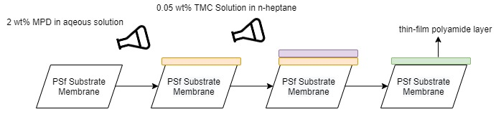

Figure 1. Preparation of polyamide TFC layer via interfacial polymerization method

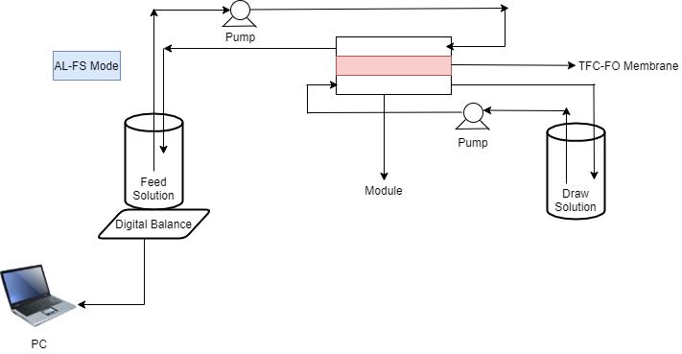

Figure 2. Illustration diagram of the forward osmosis setup (AL-FS mode)

Results and Discussion
Morphological analysis (FESEM)
The morphological structures of the surface and cross-section of the PA-TFC membrane were examined using FESEM (Zeiss, supra 55VP). In addition, the FESEM images were used to confirm the presence of the selective layer (PA layer) on top of the PSF membrane substrate. As depicted in Figure 3a, the thin polyamide layer can be seen on top of the PSf membrane substrate, which contains dense and porous layers. The denser layer of the membrane was found on top of the porous support layer, and it was believed to be a polyamide thin-film layer formed via interfacial polymerization. This morphological evidence indicates that the membrane's rejection capability is improving while its permeability is decreasing [33]. According to Khorshidi et al., one disadvantage of the denser layer of the membrane is the low water flow, and the only option to address this issue is for the dense layer to be extremely thin. The PA selective layer as depicted in Figure 3a was estimated to be roughly 4.4µm thick, which is sufficient because the typical thickness of PA thin film is around 200nm. The thickness of the PA layer is proportional to the concentration of TMC, which best explains the formation of the PA layer because low TMC concentrations were used in the preparation of the membrane (0.05%) [30].

There is a difference in the membrane surface appearance between the PSf and PA-TFC membranes, as shown by the FESEM surface images in Figures 3(b) and 3(c). The PSf substrate has a smooth and porous surface, but the PA-TFC membrane has a ridge-and-valley structure that results in a rough surface texture, as shown in Figure 3(b). The PSf membrane substrate has a porous structure with long finger-like pores formed under a thin sponge-like layer, making it excellent for FO membranes to minimize the structural parameters. The polyamide layer produced in this study has a ridge-valley structure, which is typical of TFC polyamide membranes prepared with the monomers MPD and TMC [34]. Miao et al. found that the ridge-and-valley structure is a significant indicator of the formation of the polyamide layer on the PSf membrane [35].

Fourier-transform infrared spectroscopy studies
The top surface of the modified PA-TFC membrane and Polysulfone substrate layer was analyzed using FTIR to examine the chemical compositions. Figure 4 shows the IR spectra of the Polysulfone and PA-TFC membrane. The transmittance peak at wavelengths of 1150 cm⁻¹ (O-S-O stretching), 1243 cm⁻¹ (C-O-C stretching) and 1106 cm⁻¹ (S=O stretching) are the characteristics of sulfone group. Also, the absorption at 1013 and 833 cm⁻¹ are assigned to the C-H stretching of the polysulfone aromatic rings. The peaks at 1605, 1538, 1486, 1247, 997 and 750 cm⁻¹ are attributed to C=O of the amide linkage, O-H bending of the carboxylic acid, C-H bending, C-N stretching, C=O stretching and C-Cl stretching, respectively. These observations indicate the formation of polyamide layer on the polysulfone substrate. The absorbance at 3320 cm⁻¹ suggests the N-H stretching of the amine functional group, indicating that the polyamide structure was formed through the interfacial polymerization of MPD and TMC [36].

Atomic force microscopy
The AFM was utilized to examine the surface morphology of polyamide layer. The three-dimensional images show the PSf substrate and the coated TFC-PA membrane via interfacial polymerization with different top surface roughness. The PSf membrane has a smooth surface with a root mean square (RMS) value of 4.5nm while the TFC-PA membrane has a higher root mean square value of 20.76nm with increased surface roughness. This is because the polyamide layer was effectively polymerized over the porous PSf substrate layer [37]. The polymerization of the PA layer results in increased ridge-and-valley microstructure, raising the surface roughness value to 20.76nm. The increased surface roughness of the TFC membrane was also attributable to nodules generated on its surface as a result of MPD and TMC interaction. The advantage of having a higher surface roughness on the TFC membrane is that it will have a larger surface area for water to interact, resulting in a higher water flux performance for the membrane [38]. Morgan's theory states that the membrane roughness is related to the heterogeneity of different reactions between the amide and diacid chloride reactions following the initial formation of the Polyamide film [39].

Contact angle test
The contact angle of a membrane is one of its most important physical characteristics since it reveals its hydrophilicity and fouling susceptibility. An ideal membrane should be hydrophilic with high water flow rate and low fouling properties. The contact angle of the PSf substrate and the TFC membrane was assessed using a goniometer to determine their hydrophilicity. Figure 6 shows that the average contact angle for both membranes was less than 90º, which indicates its hydrophilicity. The hydrophilicity of the TFC membrane (36.04º) is higher than that of the PSf membrane (65.57º), indicating that more amide groups are generated on the TFC membrane surface. TFC membranes have lower contact angle values because the polyamide layer structure contains strong polar amide functional groups that are hydrophilic in nature [40]. The presence of the pendant carboxylic acid groups inside the main chain has contributed to the increased hydrophilicity of the TFC membrane [33]. The TFC membrane thickened as the interfacial polymerization reaction time increased, contributing to its dense structure. This also explains why the contact angle of TFC membrane is decreasing [34].

Water permeability flux
The water flux change between TFC and PSf membrane was examined. Permeate flow is known to be highly related to membrane pore size, hence the increase in water flux in PSf substrate was expected. TFC membranes have a low water flux because of their dense structure, which obstructs water flow and hence reduces the water flux value across the membrane [29]. In addition, it is worth noting that a denser active layer offers better rejection and lower fouling propensity [41].

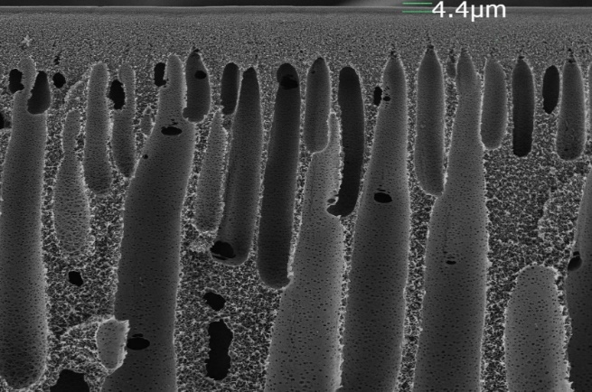
(a)

(b)

(c)

Figure 3. FESEM top surface morphologies of (a) cross section images of the PA-TFC membrane, surface images of (b) Polysulfone substrate and (c) Polyamide-TFC membrane

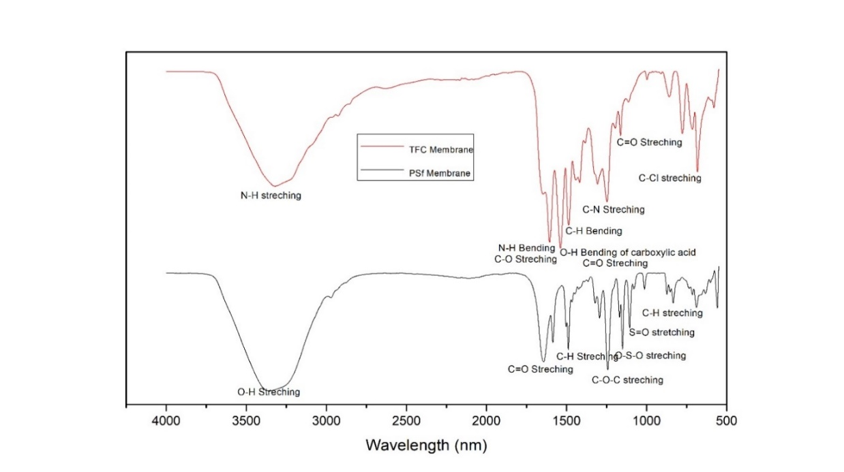

Figure 4. FTIR Spectra of PA-TFC and PSf membranes

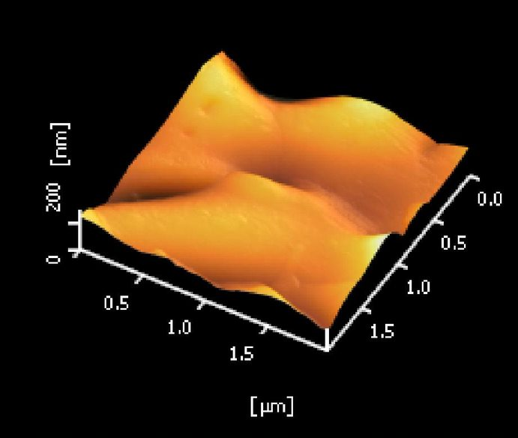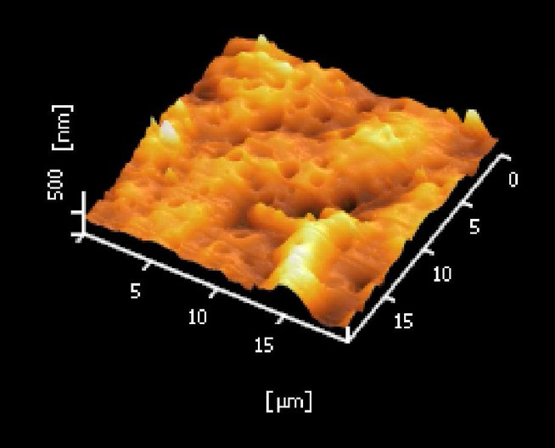
(b)
(a)

Figure 5. AFM surface morphology of (a) Polysulfone membrane substrate and (b) the thin-film composite membrane
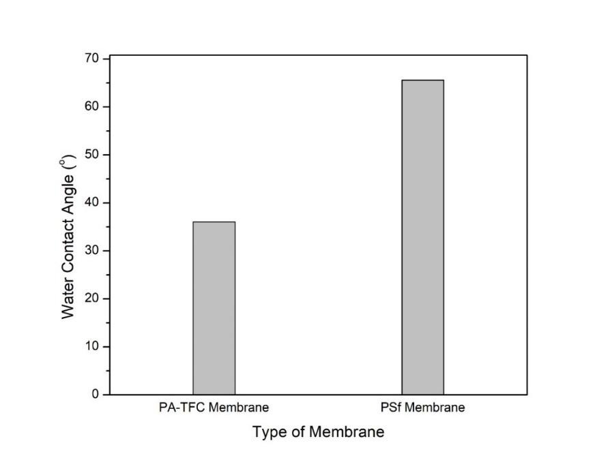
Figure 6. Comparison of contact angle values between PA-TFC and PSf membranes

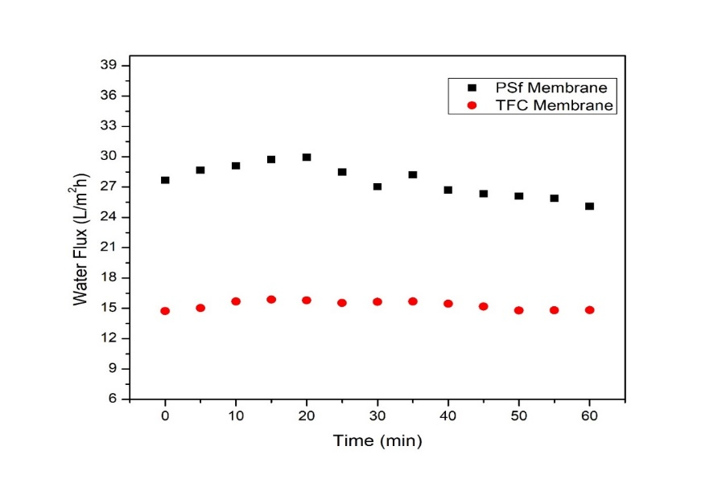

Figure 7. Water flux of FO with the model solution and pure water as feed (experimental conditions: AL-FS, 4M NaCl as DS

BPA removal
The retention of BPA was investigated utilizing both the PA-TFC and PSf membranes, and the results were compared accordingly. Figure 8 demonstrates that the overall rejection of BPA was within the range of 91% with the membrane orientation mode at AL-FS, whereas the PSf membrane yielded a rejection of 25%. The thin-film active layer produced on the membrane substrate was predicted to increase the retention capacity of TFC forward osmosis membrane. The thin-film layer which has a higher ridge-and-valley microstructure, entraps the BPA at the active layer. BPA rejection of more than 90% suggested that its pore size is substantially smaller than BPA particle size, which explains the high removal from the feed solution. The dense top coating of the TFC membrane was believed to have contributed to the significant BPA rejection due to its excellent substance retention properties [29, 34]. The result shows that the thin-film composite membrane fabricated through the IPIS method can be used to remove BPA from industrial and pharmaceutical wastewaters.

In terms of the forward osmosis rejection efficiency of BPA, the result from this study is slightly higher than the values reported by Zhu et al. (approx. 80%) [42], Hancock et al. (approx. 70%) [43] and Linares et al. (approx. 49%) [44]. These above-mentioned studies were basically carried out using the cellulose triacetate forward osmosis membranes. The interfacial polymerization of the polyamide layer on the polysulfone substrate could improve the BPA rejection by FO according to the findings of this study and comparisons with earlier research. This modification will enhance hydrophilicity, increase substance rejection from feed solution, and maintain the highest possible flow rates [29].

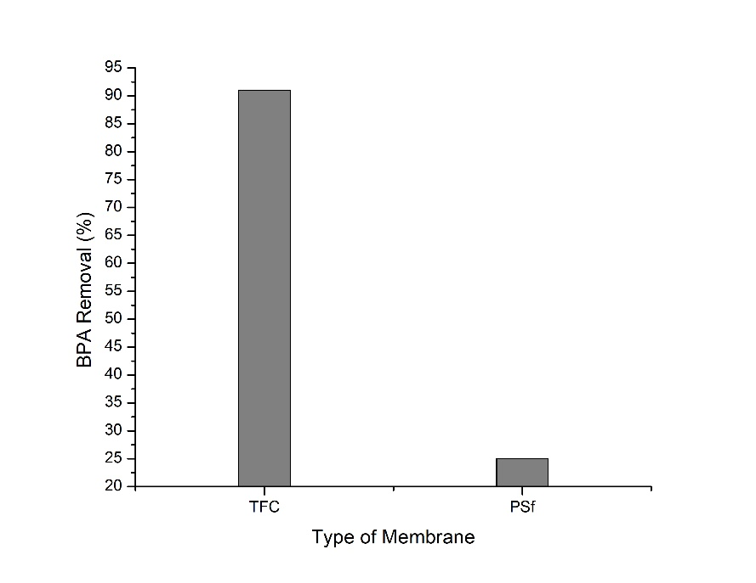
Figure 8. Rejection of BPA by PA-TFC and PSf membrane

Conclusion

This study assessed the effectiveness of a successfully fabricated PA-TFC membrane on a polysulfone membrane substrate using the interfacial polymerization method. Both membranes were examined and compared for their retention performance of bisphenol-A from a synthetic wastewater solution of 100mg/L using the forward osmosis process. The polyamide-based membrane performed well with a retention efficiency of 91%, whereas the polysulfone membrane retained just approximately 25%. The performance results of both membranes indicate that the fabricated membrane appears to be more promising and provides greater BPA retention than the polysulfone membrane substrate using the forward osmosis technique. It can be used to treat pharmaceutical and industrial wastewaters, which primarily contain small organic pollutants like phenols that are difficult to remove using other conventional or membrane treatment processes.

Acknowledgement

This research work was supported by the Yayasan Universiti Teknologi PETRONAS (Grant No: 015MD0-056) research grant. In addition, the authors thankfully acknowledge the support from the Centralized Analytical Lab (CAL) and the technical assistance offered by the Chemical Engineering Department throughout the experimental work.

References
- Li, J., Liu, Q., Liu, Y. and Xie, J. (2017). Development of electro-active forward osmosis membranes to remove phenolic compounds and reject salts. Environmental Science: Water Research & Technology, 3(1): 139-146.
- Silva, C. P., Otero, M. and Esteves, V. (2012). Processes for the elimination of estrogenic steroid hormones from water: A review. Environmental Pollution, 165: 38-58.
- Xiao, M., Zhou, J., Tan, Y., Zhang, A., Xia, Y. and Ji, L. (2006). Treatment of highly-concentrated phenol wastewater with an extractive membrane reactor using silicone rubber. Desalination, 195(1-3): 281-293.
- Mohammadi, S., Kargari, A., Sanaeepur, H., Abbassian, K., Najafi, A. and Mofarrah, E. (2015). Phenol removal from industrial wastewaters: a short review. Desalination and Water Treatment, 53(8): 2215-2234.
- Huang, Y. Q., Wong, C. K. C., Zheng, J. S., Bouwman, H., Barra, R., Wahlström, B., Neretin, L., & Wong, M. H. (2012). Bisphenol A (BPA) in China: A review of sources, environmental levels, and potential human health impacts. Environment International, 42: 91-99.
- Kumar, A., Gupta, K., Tomer, V., Kaur, A., & Kumar, V. (2018). Bisphenols as human health hazard: A systematic review on potent sources, route of exposure, harmful effects and safe alternatives. Toxicology International, 25(1): 78–-92.
- Katibi, K. K., Yunos, K. F., Man, H. C., Aris, A. Z., Mohd Nor, M. Z. and Azis, R. S. (2021). Recent advances in the rejection of endocrine-disrupting compounds from water using membrane and membrane bioreactor technologies: A review. Polymers, 13(3): 392.
- Tsai, W. T. (2006). Human health risk on environmental exposure to bisphenol-A: A review. Journal of Environmental Science and Health - Part C Environmental Carcinogenesis and Ecotoxicology Reviews, 24(2), 225-255.
- Rubin, B. S. (2011). Bisphenol A: An endocrine disruptor with widespread exposure and multiple effects. Journal of Steroid Biochemistry and Molecular Biology, 127(1–2): 27-34.
- Viñas, R., Jeng, Y. J. and Watson, C. S. (2012). Non-genomic effects of xenoestrogen mixtures. International Journal of Environmental Research and Public Health, 9(8): 2694-2714.
- Zoeller, R. T., & Belcher, S. M. (2007). In vitro molecular mechanisms of bisphenol A action. Reproductive Toxicology, 24(2): 178-198.
- Rochester, J. R. (2013). Bisphenol A and human health: A review of the literature. Reproductive Toxicology, 42: 132-155.
- Kundakovic, M. and Champagne, F. A. (2011). Epigenetic perspective on the developmental effects of bisphenol A. Brain, Behavior, and Immunity, 25(6): 1084-1093.
- Chen, H. W., Liang, C. H., Wu, Z. M., Chang, E. E., Lin, T. F., Chiang, P. C. and Wang, G. S. (2013). Occurrence and assessment of treatment efficiency of nonylphenol, octylphenol and bisphenol-A in drinking water in Taiwan. Science of the Total Environment, 449: 20-28.
- Kleywegt, S., Pileggi, V., Yang, P., Hao, C., Zhao, X., Rocks, C., Thach, S., Cheung, P. and Whitehead, B. (2011). Pharmaceuticals, hormones and bisphenol A in untreated source and finished drinking water in Ontario, Canada - Occurrence and treatment efficiency. Science of the Total Environment, 409(8): 1481-1488.
- Sodré, F. F., Locatelli, M. A. F. and Jardim, W. F. (2010). Occurrence of emerging contaminants in Brazilian drinking waters: A sewage-to-tap issue. Water, Air, and Soil Pollution, 206(1–4): 57-67.
- Muhamad, M. S., Salim, M. R., Lau, W. J. and Yusop, Z. (2016). A review on bisphenol A occurrences, health effects and treatment process via membrane technology for drinking water. Environmental Science and Pollution Research, 23(12): 11549-11567.
- Yüksel, S., Kabay, N. and Yüksel, M. (2013). Removal of bisphenol A (BPA) from water by various nanofiltration (NF) and reverse osmosis (RO) membranes. Journal of Hazardous Materials, 263: 307-310.
- Mehwish, N., Kausar, A. and Siddiq, M. (2014). Advances in Polymer-based Nanostructured Membranes for Water Treatment. Polymer - Plastics Technology and Engineering, 53(12): 1290-1316.
- Kim, I. C. And Lee, K. H. (2003). Effect of various additives on pore size of polysulfone membrane by phase-inversion process. Journal of Applied Polymer Science, 89(9): 2562-2566.
- Zhao, F. B., Tang, C. C., Liu, X. Y., Shi, F. J., Song, X. R., Tian, Y. and Li, Z. S. (2015). Transportation characteristics of bisphenol A on ultrafiltration membrane with low molecule weight cut-off. Desalination, 362: 18-25.
- Heo, J., Flora, J. R. V., Her, N., Park, Y. G., Cho, J., Son, A. and Yoon, Y. (2012). Removal of bisphenol A and 17β-estradiol in single walled carbon nanotubes-ultrafiltration (SWNTs-UF) membrane systems. Separation and Purification Technology, 90: 39-52.
- Bing-zhi, D., Hua-qiang, C., Lin, W., Sheng-ji, X. and Nai-yun, G. (2010). The removal of bisphenol A by hollow fiber microfiltration membrane. Desalination, 250(2): 693-697.
- Yüksel, S., Kabay, N. and Yüksel, M. (2013). Removal of bisphenol A (BPA) from water by various nanofiltration (NF) and reverse osmosis (RO) membranes. Journal of Hazardous Materials, 263: 307-310.
- Lutchmiah, K., Verliefde, A. R. D., Roest, K., Rietveld, L. C. and Cornelissen, E. R. (2014). Forward osmosis for application in wastewater treatment: A review. Water Research, 58: 179-197.
- Cartinella, J. L., Cath, T. Y., Flynn, M. T., Miller, G. C., Hunter, K. W. and Childress, A. E. (2006). Removal of natural steroid hormones from wastewater using membrane contactor processes. Environmental Science and Technology, 40(23): 7381-7386.
- Lee, S., Boo, C., Elimelech, M. and Hong, S. (2010). Comparison of fouling behavior in forward osmosis (FO) and reverse osmosis (RO). Journal of Membrane Science, 365(1-2): 34-39.
- Mi, B. and Elimelech, M. (2010). Organic fouling of forward osmosis membranes: Fouling reversibility and cleaning without chemical reagents. Journal of Membrane Science, 348(1-2): 337-345.
- Adamczak, M., Kamińska, G. and Bohdziewicz, J. (2019). Preparation of polymer membranes by in situ interfacial polymerization. International Journal of Polymer Science, 2019: 6217924.
- Khorshidi, B., Thundat, T., Fleck, B. A. and Sadrzadeh, M. (2016). A novel approach toward fabrication of high performance thin film composite polyamide membranes. Scientific Reports, 6(1): 1-10.
- Al-Hobaib, A. S., El Ghoul, J., Ghiloufi, I. and El Mir, L. (2016). Synthesis and characterization of polyamide thin-film nanocomposite membrane reached by aluminum doped ZnO nanoparticles. Materials Science in Semiconductor Processing, 42: 111-114.
- Mehwish, N., Kausar, A. and Siddiq, M. (2014). Advances in polymer-based nanostructured membranes for water treatment. Polymer - Plastics Technology and Engineering, 53(12): 1290-1316.
- Wei, J., Qiu, C., Tang, C. Y., Wang, R. and Fane, A. G. (2011). Synthesis and characterization of flat-sheet thin film composite forward osmosis membranes. Journal of Membrane Science, 372(1–2): 292–302.
- Syahida Mat Anan, N., Jaafar, J., Sato, S. and Mohamud, R. (2021). Titanium dioxide incorporated polyamide thin film composite photocatalytic membrane for bisphenol a removal. IOP Conference Series: Materials Science and Engineering, 1142(1): 012015.
- Miao, L., Jiang, T., Lin, S., Jin, T., Hu, J., Zhang, M. and Liu, G. (2020). Asymmetric forward osmosis membranes from p-aramid nanofibers. Materials & Design, 191: 108591.
- El-Arnaouty, M. B., Abdel Ghaffar, A. M., Eid, M., Aboulfotouh, M. E., Taher, N. H. and Soliman, E.-S. (2018). Nano-modification of polyamide thin film composite reverse osmosis membranes by radiation grafting. Journal of Radiation Research and Applied Sciences, 11(3): 204-216.
- Park, H. M., Takaba, H., & Lee, Y. T. (2020). Preparation and characterization of TFC NF membrane with improved acid resistance behavior. Journal of Membrane Science, 616: 118620.
- Song, X., Qi, S., Tang, C. Y. and Gao, C. (2017). Ultra-thin, multi-layered polyamide membranes: Synthesis and characterization. Journal of Membrane Science, 540: 10-18.
- Morgan, P. W. and Kwolek, S. L. (1996). Interfacial polycondensation. II. Fundamentals of polymer formation at liquid interfaces. Journal of Polymer Science Part A: Polymer Chemistry, 40(137): 299-327.
- Rajaeian, B., Rahimpour, A., Tade, M. O. and Liu, S. (2013). Fabrication and characterization of polyamide thin film nanocomposite (TFN) nanofiltration membrane impregnated with TiO₂ nanoparticles. Desalination, 313: 176-188.
- McGinnis, R. L., Hancock, N. T., Nowosielski-Slepowron, M. S. and McGurgan, G. D. (2013). Pilot demonstration of the NH₃/CO₂ forward osmosis desalination process on high salinity brines. Desalination, 312: 67-74.
- Zhu, H. and Li, W. (2013). Bisphenol A removal from synthetic municipal wastewater by a bioreactor coupled with either a forward osmotic membrane or a microfiltration membrane unit. Frontiers of Environmental Science and Engineering, 7(2): 294-300.
- Hancock, N. T., Xu, P., Heil, D. M., Bellona, C. and Cath, T. Y. (2011). Comprehensive bench- and pilot-scale investigation of trace organic compounds rejection by forward osmosis. Environmental Science and Technology, 45(19): 8483-8490.
- Valladares Linares, R., Yangali-Quintanilla, V., Li, Z. and Amy, G. (2011). Rejection of micropollutants by clean and fouled forward osmosis membrane. Water Research, 45(20): 6737-6744.

