PHOTOCATALYTIC HYDROGEN GENERATION FROM WATER BY TiO₂/Co₃O₄ COMPOSITE PHOTOCATALYSIS

(Penjanaan Hidrogen Fotokatalitik dari Molekul Air Mengunakan Komposit Fotomangkin TiO₂/Co₃O₄)

Siti Nurul Falaein Moridon¹, Dian Anggraini², Khuzaimah Arifin^{1*}, Lorna Jeffery Minggu¹,
Mohammad B. Kassim^{1,3}

¹Fuel Cell Institute,
Universiti Kebangsaan Malaysia, 43600 UKM Bangi, Selangor, Malaysia
²Department of Chemistry,
Faculty of Mathematic and Natural Science,
Universitas Riau,
Kampus Binawidya, Km 12.5 Simpang Baru, Pekan baru, Riau, Indonesia,
³Faculty of Science and Technology,
Universiti Kebangsaan Malaysia, 43600 UKM Bangi, Selangor, Malaysia

*Corresponding author: khuzaim@ukm.edu.my

Abstract
Titanium dioxide (TiO₂) is one of the most studied materials as photocatalyst of water splitting for hydrogen generation. However, TiO₂ has a large band gap of around 3.2 eV, limits its absorption energy to visible light, and the photoexcitation products, such as electron and hole, are recombined rapidly. One method to overcome this problem is by creating a composite heterojunction with other semiconductor materials. In this study, the photocatalytic hydrogen generation of water splitting by TiO₂/Co₃O₄ composite photocatalyst was evaluated. The composite was prepared through hydrothermal synthesis assisted by ball mill crushing, and the powder was annealed at 550 °C. The percentage of Co₃O₄ loading on the TiO₂ varied at 0.5% w/w (TC-05), 1% w/w (TC-1), and 2% w/w (TC-2) to study the suitable amount of Co₃O_{4.} The surface morphology of the composites was investigated through field emission scanning electron microscopy (FESEM) analyses. Results showed that nanosphere and cubic–shaped morphologies were obtained. For the hydrogen performance analysis, two different conditions of photocatalytic hydrogen generation, which are in pure water and water with addition of 10 vol% of methanol solution as the sacrificial reagent, were measured by using a hydrogen sensor (UNISENSE). TC-1 showed the highest hydrogen production in the pure water, which is 6.75 µmol h^{­1} g^{­1} compared with others. The addition of 10% methanol enhanced the hydrogen production by three times compared with pure water (20.22 µmol h⁻¹ g⁻¹. The superior heterojunction of TiO₂ and Co₃O₄ performance can be used in practical applications to enhance the photocatalytic properties of TiO_{2.}

Keywords: cobalt oxide, hydrogen production, PEC, titanium dioxide

Abstrak
Titanium dioksida (TiO₂) adalah salah satu bahan yang paling banyak dikaji sebagai fotomangkin pembelahan molekul air untuk penjanaan hidrogen. Walau bagaimanapun, TiO₂ mempunyai jurang jalur yang besar sekitar 3.2 eV, yang mengehadkan tenaga penyerapannya kepada cahaya nampak, dan hasil fotopengujaan, iaitu, elektron dan lubang mengakibatkan bergabung semula dengan cepat. Salah satu cara untuk mengatasi masalah tersebut ialah dengan mencipta gabungan komposit dengan bahan semikonduktor lain. Dalam kajian ini, untuk penjanaan hidrogen bagi pembelahan molekul air fotomangkin gabungan komposit TiO₂/Co₃O₄ telah dinilai. Kaedah sintesis hidroterma dibantu oleh proses penghancuran penggilingan bebola yang digunakan untuk menyediakan komposit berikutan penyepuhlindapan serbuk pada 550 °C. Peratusan pengabungan Co₃O₄ pada TiO₂ telah divariasi pada 0.5% w/w (TC-05), 1% w/w (TC-1), dan 2% w/w (TC-2) untuk mengkaji kadar Co₃O₄ yang sesuai. Morfologi permukaan komposit telah disiasat menggunakan analisis FESEM. Berdasarkan FESEM menunjukkan nanosfera dan berbentuk kubik. Untuk analisis prestasi hidrogen, dua keadaan berbeza penjanaan hidrogen fotokatalitik iaitu dalam air tulen dan air ditambah 10 vol % larutan metanol sebagai reagen, dan telah diukur menggunakan sensor hidrogen (UNISENSE). Hasilnya, TC-1 menunjukkan pengeluaran hidrogen tertinggi dalam air tulen iaitu 6.75µmol h⁻¹ g⁻¹ berbanding yang lain. Penambahan 10% metanol meningkatkan pengeluaran hidrogen 3 kali lebih tinggi berbanding dengan air tulen 20.22µmol h⁻¹ g⁻¹. Gabungan komposit TiO₂ dan Co₃O₄ boleh digunakan dalam aplikasi praktikal meningkatkan sifat fotomangkin TiO₂.

Kata kunci: kobalt oksida, pengeluaran hidrogen, PEC, titanium dioksida

Introduction
The growth in global population and quality of life has caused a remarkably increase in energy consumption, where fossil-based fuels are the primary energy contributors to date. Given the nonrenewable nature of fossil fuels, they will be depleted if humans do not undertake steps to safeguard these resources. Alternative fuels are necessary to fulfil future energy demands if fossil fuels are no longer available, particularly for the transportation sector, which consumes around 60% of global energy [1, 2]. Hydrogen was identified four decades ago as a fundamental element of a feasible future energy framework for giving safe, savvy, and ecologically harmless energy. The Energy Policy Act of 1992 classifies hydrogen as an alternative fuel. The ability to power fuel cells in zero-emission cars and the fuel cell’s rapid filling time and high efficiency have sparked interest in hydrogen as an alternative transportation fuel. A fuel cell with an electric motor is two to three times more efficient than a gasoline-powered internal combustion engine. Internal combustion engines may use hydrogen as a fuel [3, 4].

The availability of H₂ has become a new barrier because it is not naturally accessible on earth. Hydrogen may be found in a variety of forms, including hydrocarbons, water molecules, and acid and base molecules. Thus, H₂ must be eliminated from all of the abovementioned sources [5]. Coal gasification, steam reforming of natural gas, cryogenic distillation, and water splitting are the methods used for producing commercial hydrogen [6]. Coal gasification and steam reforming of natural gas processes can produce significant quantities of hydrogen. However, these approaches need a strong and safe system due to the tremendous energy consumption (temperatures > 1000 °C) necessary to perform reactions [7]. Electricity generated from renewable energy sources, such as hydropower, wind power, and solar power, might be used to electrolyze water molecules. However, these procedures are inefficient and costly [8]. Photocatalytic water splitting technologies have gained considerable interest for producing green and sustainable hydrogen energy from water. The intrinsic features and architectures of semiconductor-based photocatalysts and photoelectrodes have a large influence on the efficiency of solar-to-hydrogen conversion in photocatalytic and/or PEC catalysis [9].

Titanium dioxide (TiO₂) became the most widely used photocatalyst in the 1970s when water splitting drew the attention of researchers. This condition is due to the low cost, chemical stability, Earth abundance, and nontoxicity of TiO₂. Unfortunately, the potential of TiO₂ is limited because of its high band gap width, poor conductivity, and problematic excited dissociation and electron transport. Thus, many studies have focused on improving the TiO₂’s photocatalytic efficacy by changing its surface and microstructure, adding cocatalysts, and creating heterojunctions with metals or other semiconductors [10]. Engineered heterojunctions in photocatalysts were revealed to be a viable approach for increasing catalyst activity by allowing photogenerated electron–hole pairs to be separated spatially. Co₃O₄ is a good choice for fabricating TiO₂-based hybrids for water splitting because Co₃O₄ is one of the most well-known p-type semiconductors, with incredible substance dependability, low solvency, and solid electrical, attractive, and reactant attributes. The cost-effectiveness and availability of Co-based chemicals may simplify large-scale applications [11-13]. Compared with the typical hydrogen electrode, Co₃O₄ has conduction band (CB) and valence band (VB) areas of 0.97 and 1.23 eV, respectively, thereby resulting in a p–n heterointersection with TiO2. The performance of a combination of varying weight percent of TiO₂/Co₃O₄ thin films in PEC and photocatalytic water splitting was investigated in this work. TiO₂ P25 was used to make a heterojunction with Co₃O₄ by using a hydrothermal technique.

Materials and Methods
Materials
Cobalt nitrate hexahydrate Co (NO₃)₂.6H₂O and TiO₂ P25 were obtained from Sigma-Aldrich. Urea (analytical grade), polyethylene glycol, and ethanol were purchased from Chem-Supply. All chemicals were used without further purification.

Preparation of TiO₂
Ethanol (1 mL) was mixed with 0.2 g of TiO₂ P25 and 0.05 g of polyethylene glycol, and the mixture was crushed. Blade coating was used to coat the slurry on the fluorine-doped tin oxide (FTO) surface at 0.5 mm thickness, which was then annealed at 500 °C for 2 h.

Synthesis of cobalt oxide
In accordance with prior research, cobalt oxide was produced by using a hydrothermal technique [11]. Cobalt nitrate hexahydrate (1.74 g) and urea (0.72 g) were dissolved in 50 mL deionized water. A stainless-steel autoclave was used to transfer the homogenous solution. The autoclave was placed in a furnace for 6 h at 100 °C. The autoclave was turned off and allowed to cool to ambient temperature. The sample was washed with deionized water before being dried in an oven. Cobalt oxide produced by hydrothermal technique was ball milled for 2 h before being mixed with TiO₂.

Synthesis of the composite heterojunction of TiO₂ and Co₃O₄ as a sample
TiO₂, Co₃O₄, polyethylene glycol, and ethanol were ball milled for 20 min, coated over the FTO surface, and annealed for 2 h at 550 °C. TC-05 (0.5% Co₃O₄.TiO₂), TC-1 (1% Co₃O₄.TiO₂), and TC-2 (2% Co₃O₄.TiO₂) were the three weight variants of TiO₂:Co₃O₄. The sample was characterized and used as a working electrode.

Characterization
A field emission scanning electron microscopy (FESEM) model of ZEISS MERLIN was used to examine the surface morphology with 10k magnification and signal A intense duo.

Electrochemical study
In a three-electrode setup with 0.5 M Na₂SO₄ electrolyte solution, linear sweep voltammetry (LSV) analysis was performed by using an Ametek Versastat 4 under a 100 mW/cm² xenon light. The working electrodes were TiO₂/Co₃O₄ thin films, the counter electrodes were platinum wires, and the reference electrodes were Ag/AgCl electrodes.

Photocatalytic H₂ generation measurements
The sample (100 mg) was weighed and placed in a reactor to conduct the photocatalytic H₂ generation measurements. The sample was added with 100 mL of sodium sulfate and placed under solar AM 1.3 illumination (100 mW cm⁻²) using 75 W Xenon light at 500 nm bandwidth for 2 h, and hydrogen readings were taken every 20 min. The steps were repeated by adding methanol as scavenger, and the readings were taken. In this study, a hydrogen sensor was used to measure the hydrogen produced through a photochemical process.

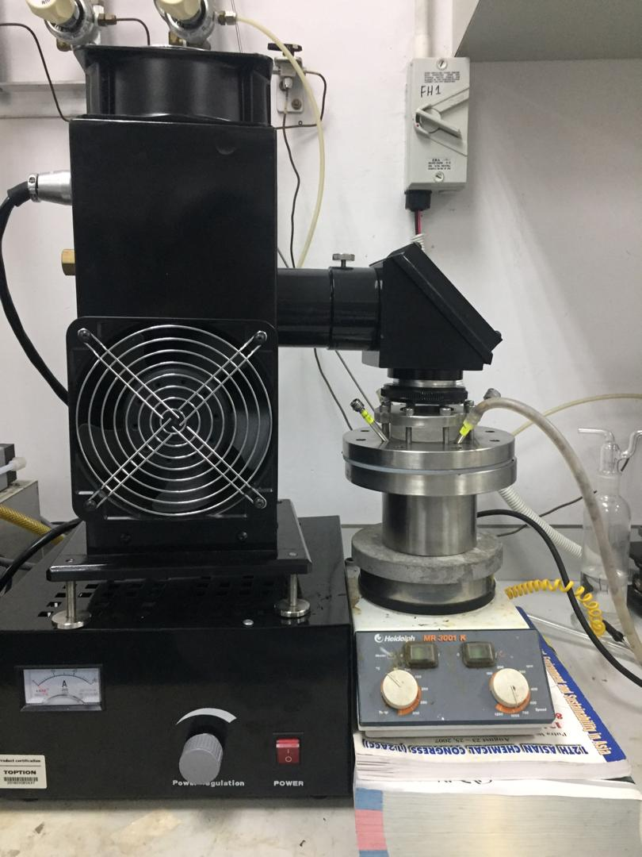
Figure 1. Photoreactor set up for the photocatalytic H₂ generation measurements
Results and Discussion
Characterizations of catalysts
Figure 2 displays the FESEM images of the as-prepared (a) TiO₂ (b) TC-05, (c) TC-1, and (d) TC-2 samples. From Figure 2a, the TiO₂ shows well-defined nanocubic morphology, with the width of 1.011 µm. Figures 2b–c shows that the loaded Co₃O₄ is finely dispersed on the TiO₂ surface with a diameter of approximately 7.14 nm. Figure 2d shows that an obvious agglomeration occurs during the introduction of Co₃O₄ species. The result is mostly similar to a previous study [12]. However, the different weight percentages of composite heterojunction show different sizes of loaded Co₃O₄ [12].
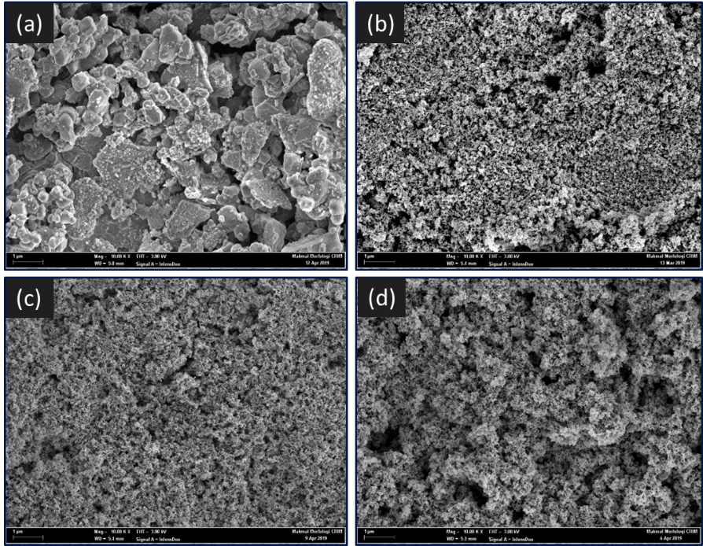
Figure 2. FESEM image of (a) TiO₂ (b) TC-05, (c) TC-1, and (d) TC-2
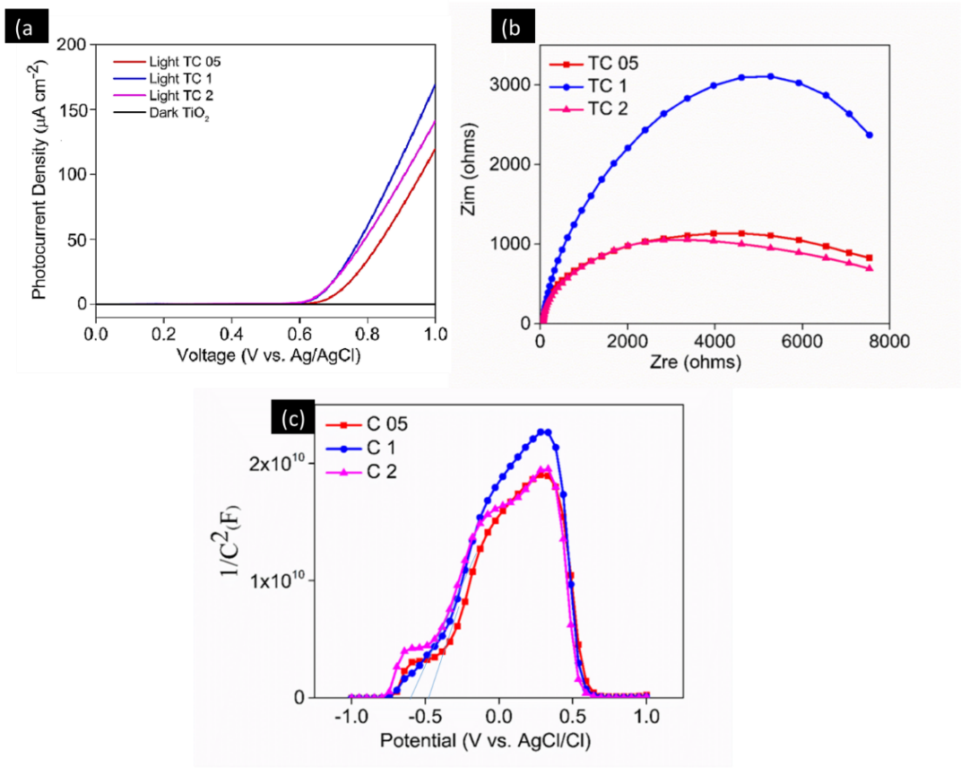
Figure 3. (a) Photocurrent density (b) Electrochemical impedance spectroscopy (EIS), and (c) Mott–Schottky plot of TC-05, TC-1 and TC-2

LSV analysis was used to study the potential of the photocatalyst, and the overpotentials of TC-05, TC-1, and TC-2 were calculated. Figure 3a shows the photocurrent responses of (a) TiO₂, (b) TC-05, (c) TC-1, and (d) TC-2 samples. TC-1 had the highest photocurrent density (70 µA cm⁻²) among the composites, implying that coating TiO₂ with Co₃O₄ nanoparticles (NPs) improved the photogeneration performance. However, the photocurrent decreased when the Co₃O₄ composites increased to 2 wt.%. This condition occurred because of the agglomeration of the photocatalyst, as shown in the FESEM image (Figure 2d). The agglomeration of the photocatalyst decreased the active site and surface area. EIS analysis was used to test the charge carrier transport capabilities of the composites (Figure 3b), The Nyquist plot of TC-1 was less than that of TC-05 and TC-2. This finding revealed that the TC-1 sample had the lowest electron migration resistance among the samples, indicating that it had a high photocatalytic hydrogen evolution reaction (HER) performance. These findings suggested that the TC-1 sample had the best charge detachment behavior of photogenerated carriers among the photocatalyst samples. The amount of active free radicals available for photocatalytic H₂ creation will rise if charge carrier separation was effective [14].
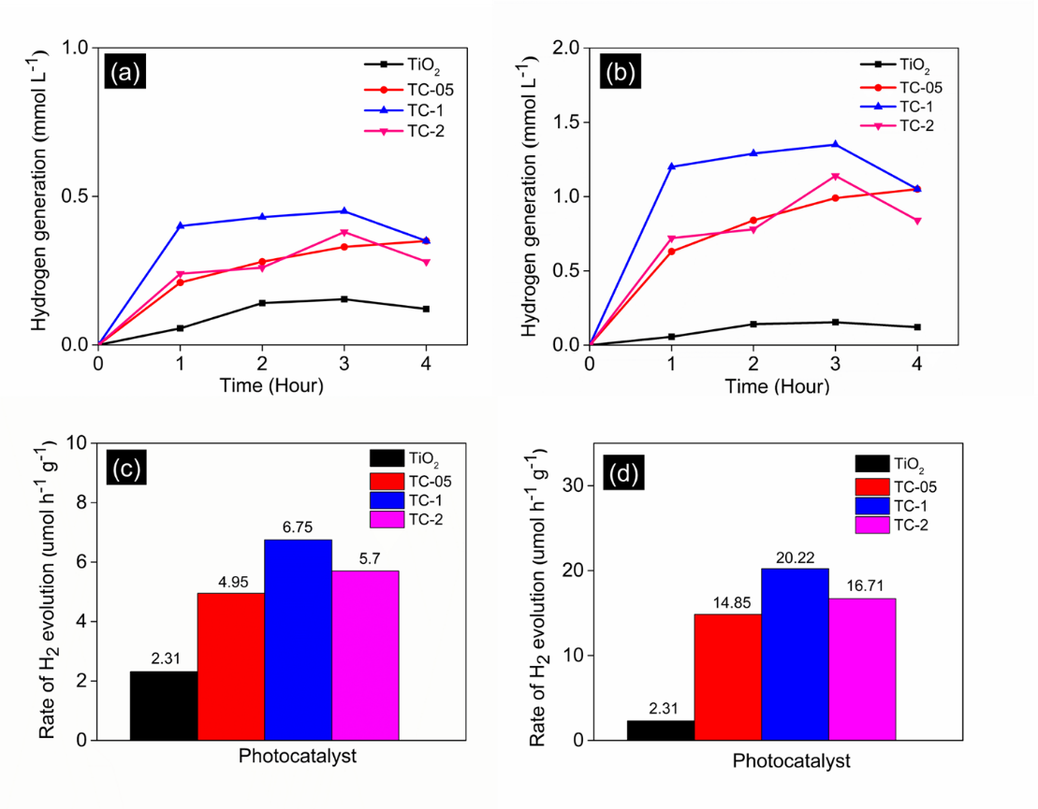
Figure 4. Photocatalytic hydrogen evolution of sample with (a) pure water (b) pure water and methanol, and hydrogen evolution rate of sample with (c) pure water and (d) pure water and methanol.

Photocatalytic hydrogen generation
The photocatalytic hydrogen evolution of the prepared samples was evaluated under artificial sunlight irradiation by using a hydrogen sensor. The photocatalytic hydrogen evolution was tested in two different solutions, and the results were compared. The first analysis (Figure 3a) was tested by using only pure water, and the second analysis (Figure 4b) was tested by using pure water with the addition of 10 vol% of methanol solution as the sacrificial reagent. The comparison of Figures 4a and b showed that the sample with methanol exhibited three times excellent photocatalytic hydrogen evolution as compared without methanol. As shown in Figures 4a and b, the TC-1 sample exhibited the highest H₂ advancement rate (6.75 µmol g⁻¹h⁻¹) in pure water and (20.22 µmol g⁻¹h⁻¹) in methanol among all the prearranged Co₃O₄/TiO₂ tests. The H₂ production in methanol is higher compared with pure water because methanol effectively separates the hole charges, and the hole–electron pair recombination is reduced [15]. The H₂ advancement rate of TC-2 diminished to 5.70 µmol g⁻¹h⁻¹ in pure water and 16.71 µmol g⁻¹h⁻¹ in methanol.

The photocatalytic HER of the proposed TiO₂/Co₃O₄ heterojunctions is shown in Figure 5 to analyze the composite heterojunction of TiO₂/Co₃O₄. A previous study [11] provided the specifics of the Co₃O₄ band structure. TiO₂ has a higher Fermi level than Co₃O₄ before they come into contact in the heterojunction. Negative charges migrated from TiO₂ to Co₃O₄ after the heterojunction because p-type Co₃O₄ NPs developed on the surface of n-type TiO₂. This condition caused the Fermi level alignment between TiO₂ and Co₃O₄, resulting in a p–n Co₃O₄/TiO₂ junction. According to Wang et al. (2022), a space charge region with a strong built-in electric field in the TiO₂ to Co₃O₄ direction occurs at the TiO₂/Co₃O₄ interface when the energy bands of TiO₂ and Co₃O₄ are bent up and down, resulting in a drift of the photogenerated charge carrier for heat transfer until a balance thermal equilibrium is reached [16]. The charge transfer mechanism is shown in Figure 5. Under solar AM 1.3 illumination, photogenerated electrons migrated from TiO₂ and Co₃O₄ VBs to the corresponding CBs. The photogenerated electrons were guided from the p-type Co₃O₄ CB to the n-type TiO₂ CB by the induced built-in electric field, resulting in the spatial detachment of photogenerated electron–hole sets. Similarly, Co₃O₄ NPs filled in as a cocatalyst in this p–n Co₃O₄/TiO₂ intersection, assisting in expanding the charge partition. Therefore, more photogenerated electrons might focus on TiO₂, which can then be used in the water reduction cycle to produce H₂.
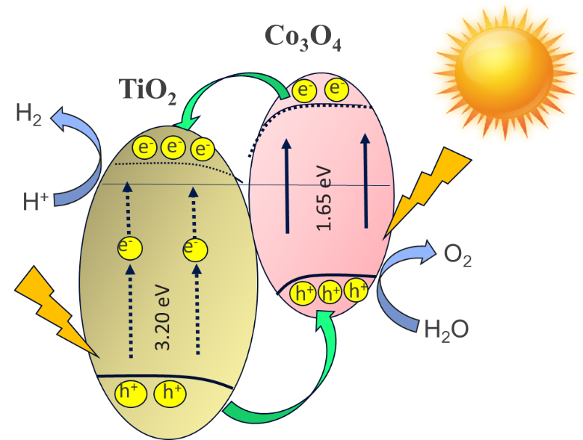
Figure 5. Schematic of the photocatalytic HER mechanism and photogenerated electron–hole separation route of Co₃O₄/TiO₂ p–n junction.

Conclusion
In this study, hydrothermal synthesis was used to efficiently construct a Co₃O₄/TiO₂ p–n heterojunction. With a photocatalytic H₂ development pace of 20.22 mol g⁻¹h⁻¹, the enhanced Co₃O₄/TiO₂ heterojunction had the best photocatalytic H₂ advancement rate. This study used the catalytic effect of Co₃O₄ to distinguish photogenerated electron–hole pairs. A unique Co₃O_{4/}TiO₂ contact interface and a p–n heterojunction was utilized for fast charge carrier transport pathways to enhance the photocatalytic performance. This study may help in the future development and production of p–n heterojunction photocatalyst with high visible light-driven energy conversion efficiency.

Acknowledgment
This work was supported by the Malaysia’s Ministry of Education through the FRGS/1/2019/STG01/UKM/03/2 research grant.
References
- Acar, C. and Dincer, I. (2020). The potential role of hydrogen as a sustainable transportation fuel to combat global warming. International Journal of Hydrogen Energy, 45(5): 3396-3406.
- Rath, B. N., Akram, V., Bal, D. P. and Mahalik, M. K. (2019). Do fossil fuel and renewable energy consumption affect total factor productivity growth? Evidence from cross-country data with policy insights. Energy Policy, 127: 186-199.
- Griffiths, S., Sovacool, B. K., Kim, J., Bazilian, M. and Uratani, J. M. (2021). Industrial decarbonization via hydrogen: A critical and systematic review of developments, socio-technical systems and policy options. Energy Research & Social Science, 80: 102208.
- Zhao, F., Mu, Z., Hao, H., Liu, Z., He, X., Victor Przesmitzki, S. and Ahmad Amer, A. (2020). Hydrogen fuel cell vehicle development in China: An industry chain perspective. Energy Technology, 8(11): 2000179.
- Hosseini, S. E. and Wahid, M. A. (2020). Hydrogen from solar energy, a clean energy carrier from a sustainable source of energy. International Journal of Energy Research, 44(6): 4110-4131.
- Mah, A. X. Y., Ho, W. S., Bong, C. P. C., Hassim, M. H., Liew, P. Y., Asli, U. A., ... and Chemmangattuvalappil, N. G. (2019). Review of hydrogen economy in Malaysia and its way forward. International Journal of Hydrogen Energy, 44(12): 5661-5675.
- Ahmad, H., Kamarudin, S. K., Minggu, L. J. and Kassim, M. (2015). Hydrogen from photo-catalytic water splitting process: A review. Renewable and Sustainable Energy Reviews, 43: 99-610.
- Acar, C. and Dincer, I. (2019). Review and evaluation of hydrogen production options for better environment. Journal of Cleaner Production, 218: 835-849.
- Qureshy, A. M., Ahmed, M. and Dincer, I. (2019). Performance assessment study of photo-electro-chemical water-splitting reactor designs for hydrogen production. International Journal of Hydrogen Energy, 44(18): 9237-9247.
- Arifin, K., Yunus, R. M., Minggu, L. J. and Kassim, M. B. (2021). Improvement of TiO₂ nanotubes for photoelectrochemical water splitting. International Journal of Hydrogen Energy, 46(7): 4998-5024.
- Moridon, S. N. F., Salehmin, M. I., Mohamed, M. A., Arifin, K., Minggu, L. J. and Kassim, M. B. (2019). Cobalt oxide as photocatalyst for water splitting: Temperature-dependent phase structures. International Journal of Hydrogen Energy, 44(47): 25495-25504.
- Anggraini, D., Wardani, P. K., Agustina, M., Awaluddin, A.and Arifin, K. (2019). TiO₂/Co₃O₄ Composite as photoanode of photoelectrochemical water splitting. In Journal of Physics: Conference Series, 1351: 012032.
- Moridon, S. N. F., Salehmin, M. N. I., Arifin, K., Minggu, L. J. and Kassim, M. B. (2021). Synthesis of cobalt oxide on FTO by hydrothermal method for photoelectrochemical water splitting application. Applied Sciences, 11(7): 3031.
- Kumar, S.G. and Rao, K. K. (2017). Comparison of modification strategies towards enhanced charge carrier separation and photocatalytic degradation activity of metal oxide semiconductors (TiO₂, WO₃ and ZnO), Applied Surface Science, 2017: 391124-148.
- Alenzi, N., Liao, W. S., Cremer, P. S., Sanchez-Torres, V., Wood, T. K., Ehlig-Economides, C. and Cheng, Z. (2010). Photoelectrochemical hydrogen production from water/methanol decomposition using Ag/TiO₂ nanocomposite thin films. International Journal of Hydrogen Energy, 35(21): 11768-11775.
- Wang, L., Tang, G., Liu, S., Dong, H., Liu, Q., Sun, J. and Tang, H. (2022). Interfacial active-site-rich 0D Co₃O₄/1D TiO₂ pn heterojunction for enhanced photocatalytic hydrogen evolution. Chemical Engineering Journal, 428: 131338.

