THE THERMAL STABILITY AND PRELIMINARY PERFORMANCE OF SODIUM ALGINATE AND POLYVINYL ALCOHOL-BASED MEMBRANE IN DMFC: MONTMORILLONITE AS A FILLER

(Kestabilan Haba dan Prestasi Awal Membran Berasaskan Natrium Alginat dan Polivinil Alkohol untuk DMFC: Montmorillonit sebagai Pengisi)

Maryam Taufiq Musa¹, Norazuwana Shaari^{1*}

¹Fuel Cell Institute, Universiti Kebangsaan Malaysia, Bangi,43600, Selangor, Malaysia;

*Corresponding author: norazuwanashaari@ukm.edu.my

Graphical abstract
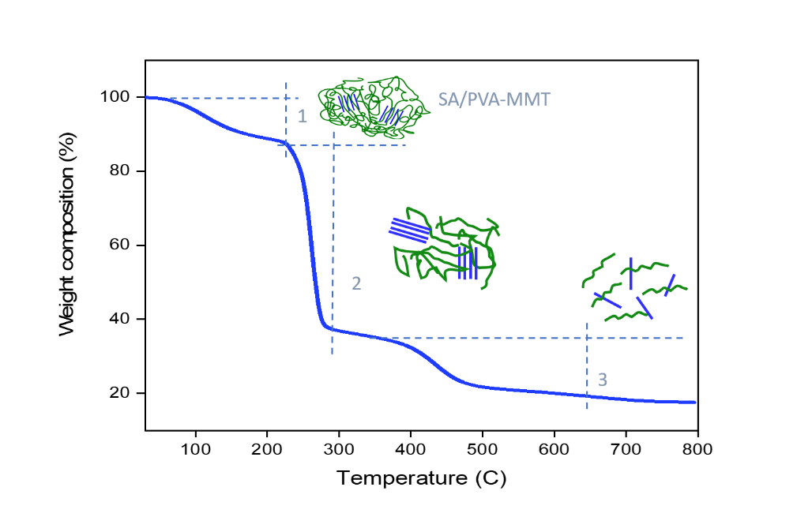

Abstract

Biopolymer-based membranes have emerged vastly in recent years for fuel cell applications. Polymer electrolyte membranes (PEM) have become a major component in DMFC stacks that have gone through many studies beforehand. An improvement has been made to PEM, especially using biopolymers like alginate based. Sodium alginate (SA) has significant characteristics such as being too hydrophilic, which is its biggest weakness as a PEM. Blending it with another polymer of polyvinyl alcohol (PVA) and adding a clay filler of montmorillonite (MMT) would be a great solution, in this work. From TGA-DSC analysis, SA/PVA-MMT achieved different thermal stability as the filler content differed. The glass transition temperature of the membrane had increased as the MMT content increased, at a maximum range of 240-260 °C at 15 wt% of MMT content. The membrane’s thermal stability ranking was then followed by 10 wt% (250 °C) and 2 wt% (240 °C) of filler content. The higher the glass transition temperature, the greater the thermal stability due to the greater mass loss after being exposed to a later heating. Meanwhile, for the proton conductivity test, a hybrid membrane of SA/PVA-MMT with SVM 20 (20 wt% MMT) obtained the highest value of 8.0510 mS/cm, followed by SVM 10, SVM 2, SVM 15 and SVM 5 with values of 6.5025, 2.6429, 2.0332 and 1.6083 mS/cm respectively. Higher proton conductivity enables the potential of the hybrid to conduct electricity in DMFC. The lowest methanol uptake was shown by the membrane with 20 wt% MMT content, with a value of 53.00 %, followed by 15 wt% (97.46 %), 10 wt% (121.59 %), 5 wt% (132.23 %) and 2 wt% (203.30 %), respectively. Low methanol uptake of the membrane indicated that the DMFC stack could operate with high efficiency. This study showed that SA/PVA-MMT could be a promising choice of PEM with an optimum MMT content of 10 wt% for a better performance produced by a cheaper hybridized membrane.

Keywords: alginate, polyvinyl alcohol, montmorillonite, copolymer membrane, thermal stability

Abstrak

Membran berasaskan biopolimer telah muncul secara meluas sejak kebelakangan tahun ini, dalam aplikasi sel fuel. Membran polimer elektrolit (PEM) telah menjadi komponen utama dalam tindanan DMFC, yang mana telah menjadi objek kajian berkali ganda sebelumnya. Satu penambahbaikan PEM telah dibuat khususnya menggunakan biopolimer alginat. Natrium Alginat (SA) mempunyai sifat signifikan iaitu terlalu hidrofili, yang mana ianya merupakan kelemahan terbesar sebagai PEM. Di dalam kajian ini, Natrium alginat (SA) akan dicampur bersama polivinil alkohol (PVA) dan montmorillonit (MMT), sejenis pengisi berasaskan tanah liat. Campuran ini telah menghasilkan prestasi yang amat baik. Daripada analisis TGA-DSC, SA/PVA-MMT telah mencapai kestabilan haba yang berbeza apabila kandungan pengisi turut berbeza. Suhu peralihan kaca membran tersebut bertambah apabila kandungan MMT dalam sampel juga bertambah, pada 15 wt% MMT, maksima julat suhu dicapai ialah 240-260 ℃. Kestabilan haba membran ini kemudiannya diikuti dengan 10 wt% (250 ℃) dan 2 wt% (240 ℃) konten pengisi. Semakin tinggi suhu peralihan kaca, semakin tinggi kestabilan haba membran disebabkan jisim mula berkurang banyak pada suhu pemanasan yang tinggi (lebih lewat). Manakala untuk kekonduksian proton, SVM 20 (20 wt% MMT) mendapat nilai tertinggi iaitu, 8.0510 mS/cm, diikuti dengan SVM 10, SVM 2, SVM 15 dan SVM 5 dengan nilaian 6.5025, 2.6429, 2.0332 dan 1.6083 mS/cm masing-masing. Tingginya nilai kekonduksian proton, semakin besarlah potensi membran hibrid tersebut untuk mengalirkan elektrik dalam DMFC. Ambilan metanol terendah dibuktikan oleh SVM 20 (20 wt% MMT) dengan nilaian 53.00 %, diikuti dengan 15 wt% (97.46 %), 10 wt% (121.59 %), 5 wt% (132.23 %) dan 2 wt% (203.30 %) masing-masing. Hasil ambilan metanol yang rendah menunjukkan tindanan DMFC boleh beroperasi pada tahap keberkesanan yang tinggi. Kajian ini menyimpulkan bahawa SA/PVA-MMT boleh menjadi pilihan PEM yang terbaik, dengan kandungan MMT optimum pada 10 wt% beserta kos yang rendah untuk prestasi yang lebih baik.

Kata kunci: alginat, polivinil alkohol, montmorillonit, membran dwipolimer, kestabilan haba

Introduction

A polymer electrolyte membrane (PEM) that contains additives is normally able to enhance performance when operating in a fuel cell system. There are many polymers, such as sulfonated poly(ether ether) ketone [1], polybenzimidazole [2], polyvinyl alcohol [3], sulfonated polyimide [4] and polyether sulfone [5], that have been utilized in previous studies to develop non-Nafion based membranes. These polymers are claimed to be capable of replacing Nafion owing to their polysaccharide backbone, which is able to act as both hydrophilic and hydrophobic domains. However, with the high production costs needed for polymer materials, an alternative innovation has been constructed, using biopolymers that are PEM-based.

Recent studies have discovered that chitosan [6], carrageenan [7] and alginate [8] are PEM-based. These biopolymers have the potential to conduct protons as they are mostly in an amorphous state. The highly amorphous condition of the materials resulted in high proton conductivity as there are more proton pathways in amorphous mediums [9]. Charradi et al. (2019) worked on SiO₂-montmorillonite filled membranes (9% content) for PEMFC and obtained 0.158 S/cm proton conductivity, which was higher than the pristine polymer at 120 ℃ and 100% relative humidity [10]. Sainul Abidin et al. (2017) achieved the highest proton conductivity of 0.0706 S/cm by using modified montmorillonite at 10 wt% loading, under 70 ℃ conditions, using a polyimide based PEM [11]. Wang et al. (2018) synthesized chitosan-based PEM that was filled with solvent-free carbon nanotube fluids and was able to perform maximum proton conductivity at a value of 0.044 S/cm at 80 ℃ [12]. Since biopolymers are highly amorphous, by blending them with other semi-crystalline polymers such as PVA, the resulting membrane could have better flexibility and a firmer structure. Zakaria et al. (2018) and Yang et al. (2009) worked on PVA-based membranes, each achieving the highest proton conductivity of 0.0095 S/cm and 0.0368 S/cm respectively, both at 30 ℃ [13], [14]. Nevertheless, these works were unable to figure out the hidden potential of blending membrane composites of sodium alginate and polyvinyl alcohol together with an inorganic filler – montmorillonite. Montmorillonite is a clay-type filler, that contains silica tetrahedral, an octahedral layer of aluminum, and exchangeable cations like magnesium and potassium.

Montmorillonite (MMT) has been studied previously, modified with additional protons like H⁺, Na⁺, Mg²⁺ Ca²⁺ and K⁺. Wu et al (2016) achieved high proton conductivities at 38.5 mS/cm with balanced water uptake, 24.26% when developed cloisite sodium montmorillonite [15] Wang, Wang and Zhu (2018) reported 5wt% of MMT-PBI-O exhibited 0.5 mS/cm proton conductivities at 80 ℃ and losing weight easily (under TGA analysis) compared to pure PBI-O membrane [16]. This was because the insertion of MMT facilitates water absorption thus allowing proton channel formation; 5wt% was better than 3wt% MMT. When blending MMT with SPEEK polymer, the water uptake reached 35% which was lower than pure SPEEK, contributing to 0.057 S/cm of ionic conductivity at ambient condition, which was a good finding from Ata et al (2020) [17].

These reports potentially bring up this study to show how MMT involvements can improve proton conductivity of polymer matrix besides its thermal stability could be maintained as well. To distinguish, additional polymer – PVA was included together with biopolymer sodium alginate for developing a novel hybrid membrane electrolyte for direct methanol fuel cell application. This work highlighted on membrane performance tests relating to the thermal degradation analysis.

Materials and Methods

The membranes comprising of sodium alginate, polyvinyl alcohol and montmorillonite as the hybridized membrane of SA/PVA-MMT, were simply named as SVM in this work. The variation of MMT loadings in each sample were differentiated as follows, in Table 1:

Table 1. The notation for each sample
MMT loadings (wt%) | Notation
0 | SV0
2 | SVM2
5 | SVM5
10 | SVM10
15 | SVM15
20 | SVM20

Membrane preparation

The SVM blended solution was prepared using the solution casting method. Sodium alginate (SA, Acros Belgium) and polyvinyl alcohol (PVA, R & M Chemicals) were mixed together at a concentration ratio of 40:60. The SA and PVA solutions were prepared separately, then dispersed in deionized (DI) water, at 70 ℃ and 90 ℃ respectively. Both polymer solutions were mixed in a beaker and stirred for 1 hour, adding 1mL of 10% glutaraldehyde (GA, Nacalai Tesque Japan) for internal crosslinking, dropwise, until homogenized. Then solutions of 2 wt%, 5 wt%, 10 wt%, 15 wt% and 20 wt% Montmorillonite (MMT, Acros Belgium) were prepared in 5 mL DI water each, which were dispersed overnight at ambient temperature. The SA/PVA solutions and MMT solutions were blended altogether, stirring for 5 hours, to create a homogenized mixture. The mixture was then cast in a petri dish and dried for 12 hours at 60 ℃, followed by 1 hour at 80 ℃ using a box furnace (Carbolite chamber) to become a membrane film. The membrane film was externally crosslinked with 1.5 wt% CaCl₂ and 10% GA by soaking it for 30 minutes under ambient conditions, before further testing.

Thermal analysis

The film samples were characterized using the Simultaneous Thermal Analyzer-Differential Scanning Calorimetry (STA-DSC), NETZSCH Proteos Software, to determine their thermal stability based on the glass transition temperature (T_{g}). The analysis was run under a nitrogen atmosphere, within the temperature range of 30-800 ℃, with a heating rate of 10 ℃/min.

Membrane performance tests

The membrane film was proceeded to the liquid uptake performance test and proton conductivity test. The membrane film was cut according to a 2 cm x 2 cm dimension for both water and methanol uptake. The film was weighed after 24 hours of being soaked in DI water and 10 % methanol for respective tests, which is denoted as W_{wet} (g). The films were weighed again after drying for 24 hours at room temperature, denoted as W_{dry} (g). The weights recorded were calculated using the liquid uptake equation formula (1),

$$\frac{W_{wet}-W_{dry}}{W_{dry}}×100$$

--------- (1)

to obtain the percentage of water uptake and methanol uptake.

For proton conductivity testing, the membrane film (4 cm x 1 cm dimension) must be in a fully hydrated state; it was immersed in DI water for an hour before being placed in a four-electrode conductivity cell that was connected to a potentiostat/galvanostat (WonATech) for 60 seconds, over a frequency range of 1 MHz–50 Hz. This potentiostat would produce a linear trend of voltage versus the current graph, producing a membrane resistance from the slope. The in-plane proton conductivity value (σ) can be calculated by using the in-plane proton conductivity equation formula (2) [5]:

$$σ=\frac{L}{RWT}$$

--------- (2)

where L is the length of the film in cm, R is the average resistance (Ω), W is the film width (cm) and T is the thickness of the film (cm).

Result and Discussion

FESEM

For micrographs images, only four samples were observed, because the morphology analysis demand was required just to emphasized on the homogeneity of the surfaces as clay loadings increased – SV0, SVM5, SVM10, SVM20. These desired membranes were proven having carbon, oxygen and sodium elements as observed in EDX in Figure 1(c), (f), (i), (l). Figure 1 (a), (d), (g), (j) were the surface morphology of the membranes while Figure 1 (b), (e), (h), (k) were showing the cross sectional of the membranes. based on Figure 1 (a), which resembling SV0, the present surface image seemed to have pores, as well as could be seen in the cross-section image (Figure 1(b)). Too many porosities were undesirable because it creates channel for water absorption which then leading to excessive membrane swelling. When introduce a little amount of MMT, the surface image for SVM5 looked rougher than SV0, as illustrated in Figure 1(d). The cross-sectional image for SVM2 looked rougher as well, implying the successful intercalation of MMT, with proven EDX elemental peak based on the rising of Mg, Al, Si, K peaks. However, the declining peak of Na, was due to the well-blend of MMT with the polymer chain, interrupting the structure of polymer consisting Na.

As MMT increased higher, SVM10 membrane surface looked much rougher and compact cross-sectional area as shown in Figure 1(g,h). This indicating that water molecules had fully evaporated from the polysaccharide matrix [18], as white tiny particle were visible in Figure 1(h) depicting the successful intercalation of MMT into the SA/PVA copolymer matrix. Nevertheless, the agglomeration presented in SVM20 because of excessive MMT addition resulting it to concentrate at one point, that further discussed in liquid uptake part.

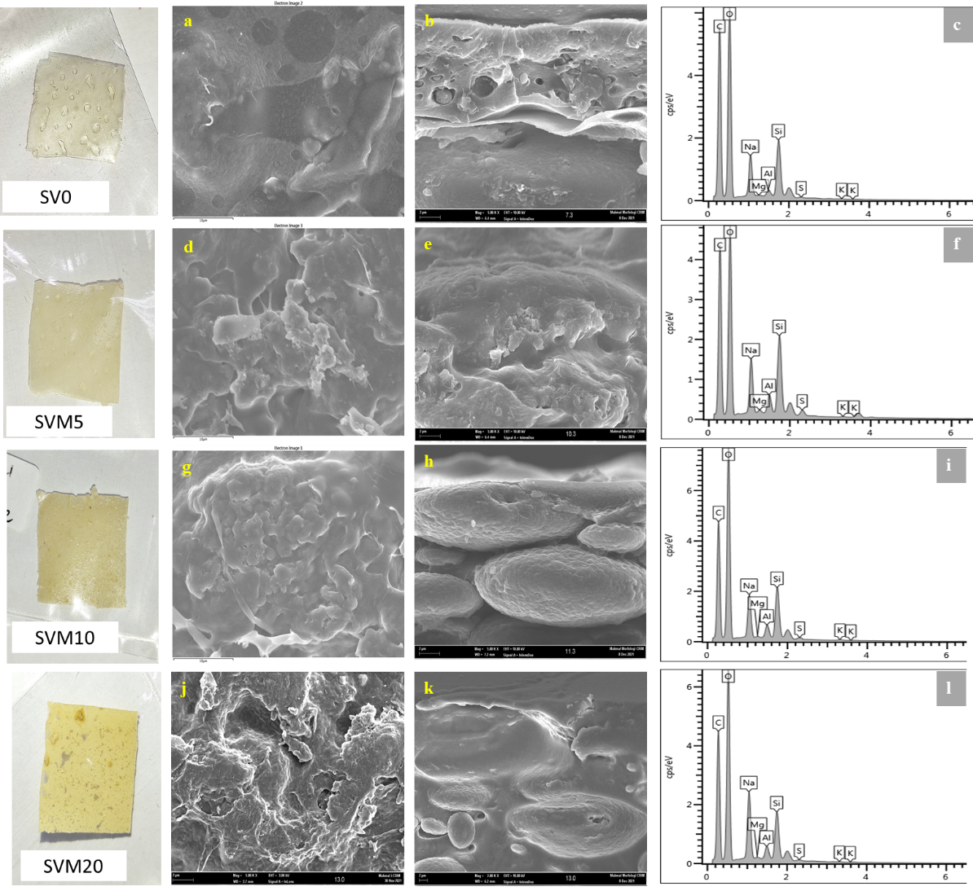

Figure 1. FESEM images of membrane samples, followed by the physical sample on the left-handside, surface images, cross-sectional images and elemental peaks EDX on the right-handside. SV0 (a,b,c), SVM5 (d,e,f), SVM10 (g,h,i) and SVM20 (j,k,l).

TGA-DSC

For thermal stability analysis, only four samples were involved since we just insisted to compare the obvious trend among the expected significant MMT loadings in the membranes – SV0, SVM2, SVM10, SVM15. The membrane film obtained good thermal stability, with an increased temperature phase of degradation as MMT loadings increased. Referring to Figure 2, the polymer blend started to degrade at 220–240 ℃ and proved to be better than previous studies, which indicated that the first stage began at 80 ℃ [19] and 198 ℃ [20] with only PVA and SA. This first degradation phase was attributed to solvent evaporation [21]. By adding MMT, the membrane has a combination of amorphous and crystalline phases, making the degradation phases a bit slower. The polymer must have a semi-crystalline phase since high amorphous properties might result in a low strength structure of the film. The presence of semi-crystalline properties of the PVA could strengthen the interaction bond between the polymer chain and the filler bond. The interaction bond involved was a strong hydrogen bond, which is difficult to break apart. The weight loss of the membranes was around 50.4–55.2%, which began at a range of 259.8–263.5 ℃, which was dominated by SVM 15. In comparison, the second degradation phase of these MMT-filled membranes had slightly lower thermal stability than the SP/PVA membrane at 307 ℃ [19]. This was due to the presence of MMT, which has hydrophilic properties that cause it to easily degrade. The hydrophilicity enables the membrane to retain water molecules in the matrix, thus degrading at lower temperatures [20], [22]. However, the presence of PVA and MMT in a sodium alginate-based membrane was much better as this blended membrane took higher ranges of the third degradation phase (470–800 ℃) to fully depolymerize the polysaccharide backbone owing to the interfacial connections and improvised crystallinity.

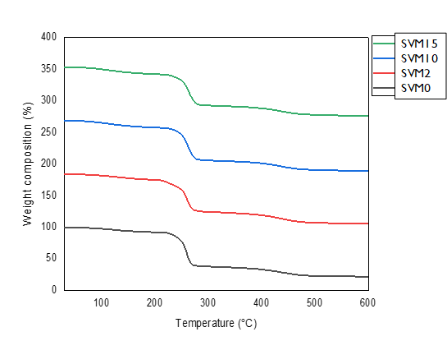

Figure 2. The thermogram of the membranes.

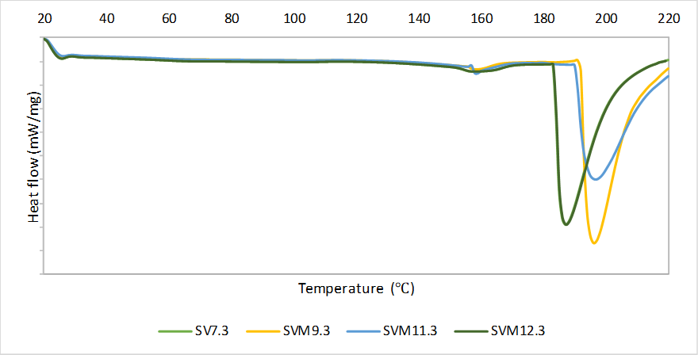
SV0
SVM2
SVM10
SVM15

Figure 3. DSC thermogram of the membranes

The thermograms of DSC shown in Figure 3 above, indicating that the glass transition phase changed as MMT loading increased. The glass transition temperature increased from SV0 to SVM10 which was owing to the dipole interaction declining that happened within the homopolymers [23]. This is simultaneous phase to the TGA thermogram whereby the hybridized membranes facing phase changes to rubbery state at a later temperature as the clay fillers added. However, when reaching 15 wt% of MMT in the hybridized membrane, the glass transition temperature decreased to complex peak value of 123.6 ℃, which could be seen overlapping peak with the control membrane, SV0 in the thermogram. This indicating that backbone polymers became soften at certain higher loading point. In relation to the water uptake performance, SVM15 absorb more water molecules than SVM10 by 10.84%, deducing it has voids for water binding. The voids presence turned up SVM15 membrane to be easily degraded and change phase. Therefore, SVM10 was much preferable type of membrane in this case because it possessed the greater thermal stability with peak value glass transition temperature at 196.7 ℃

Membrane Performance Tests

From Figure 4, the graph trend fluctuated as the MMT content increased. The maximum value of proton conductivity was achieved at 8.0510 mS/cm by using SVM20 (at 20 wt% MMT loadings). During the conductivity testing, the prominent functional groups involved were H⁺, H₃O⁺ and ⁻OH ions, where H⁺ dissociated from the water molecules, hopping from one molecule to another. The insufficiency of single electrons causes the H⁺ to react actively with the ⁻OH free ions from the MMT, which also contributes to transporting the protons throughout the medium. The hydration state of the membrane was crucial as it would produce more H⁺ to actively bind with lone pairs of electrons in H₂O, thus forming a highly reactive ion, H₃O⁺. The cycle of transporting protons through negatively charged ions was repeated simultaneously with the protons hopping. In this study, both mechanisms could potentially occur - the proton hopping mechanism, namely, the Grotthuss mechanism, and the proton being transported, namely the Vehicular mechanism [24]. As shown by SVM15, the existence of free volumes in the membrane decreased when a higher MMT filling was introduced, which resulted in difficulties for the protons to be transferred. The tendency of the proton conductivity to increase at 20 wt% MMT was due to the presence of active sites at the MMT, which enabled the transport of the proton to pass through. The values were lower at SVM5 and SVM15, most probably caused by the activation of the inhibition properties of MMT when extra loading produced an aggregated effect on the membrane [25], [26].

Figure 4. Proton conductivity for SVM2 (2wt%), SVM5 (5wt%), SVM10 (10wt%), SVM15 (15wt%) and SVM20 (20wt%).

For water uptake performance, according to Figure 5, the membrane began to reduce absorbing water at 2 wt% MMT. Then, the trend started to decline again at 15 wt% MMT after a slight increase at 10 wt% MMT. The increment of water absorption was due to the introduction of MMT to the pure SAPVA membrane, slightly induced by the hydrophilicity of MMT, which provides a high water content to the membrane [22].

This hydrophilic property, owing to its oxygenated functional group (-OH) [27], through the abundance of water, creates a continuous transferring channel and facilitates ion movement [22]. These functional groups interact with each other (polymer and fillers) via strong hydrogen bonding or polar-polar interaction [27]. The lowest water uptake point was at 20 wt% (SVM20), after 10 wt% (SVM10) of MMT. The water uptake level dropped from 162.46 % to a value of 129.65 % at 10 wt%, before it decreased even further to 74.89 %, with the addition of SVM20.

The additional MMT filler had partially reduced the size of the ion channels because of agglomeration, hence blocking the absorption of water. Figure 6 and Figure 7 illustrate the plausible figures of how MMT filled up the polymers’ matrix. The matrix inside the membranes was homogenously distributed, thus decreasing the free voids of the resultant matrix [27]. The mobility of the SA/PVA chains was reduced then, thus leading to a decrement of water content. Based on the experimental results as shown in Table 3 and Figure 5, the methanol uptake value dropped after reaching its peak at 2 wt% MMT, from 203.30 %, to 53 % at 20 wt% MMT. The explanation for methanol uptake was similar, since the graph trend also decreased as MMT loading increased. The same trend showed that there was good networking and bonding between the alginate polymer and MMT, which prevented fuel crossing [22].

Table 2. The comparison of previous membrane hybridized studies
Membrane composite | Filler loadings (wt%) | Proton conductivity (mS/cm) | References
Pure SA | 0 | 0.48 | [18]
PVA/SA(6/4) | 0 | 91.0 | [19]
PVA/TiO₂ | 15 | 48.0 | [28]
SA/TiO₂ | 25 | 17.3 | [8]
SA/Alumina | 15 | 13.0 | [20]
PVA/MMT | 10 | 36.8 | [14]

Table 3. Proton conductivity and liquids uptake of the membranes according to the MMT loadings
Sample | MMT loadings (wt%) | Proton conductivity (mS/cm) | Water uptake (%) | Methanol uptake (%)
SV 0 | 0.0 | 1.4828 | 162.46 | 98.55
SVM 2 | 2.0 | 2.6429 | 177.50 | 203.30
SVM 5 | 5.0 | 1.6083 | 147.10 | 132.23
SVM 10 | 10.0 | 6.5025 | 129.65 | 121.59
SVM 15 | 15.0 | 2.0332 | 143.70 | 97.46
SVM 20 | 20.0 | 8.0510 | 74.89 | 53.00

Figure 5. Water uptake and methanol uptake performances for SVM2-20

Figure 6. The plausible figures for blended SVM membranes [29]

Figure 7. The another version of plausible figures [3]

Conclusion

To conclude, sodium alginate-based membranes are biopolymers that have a high potential to be used in conducting protons. By blending it with semi-crystalline PVA, the membrane is more thermally stable when the depolymerization phase occurs at a higher temperature. The addition of the inorganic filler, MMT, to the PEM could have a more powerful impact in terms of the liquid uptake. The study proves that 10 wt% of MMT is the most preferable to obtain a balanced water uptake and reduce methanol uptake, hence suggesting SVM10 as the best composite PEM with improved proton conductivity. Overall, further research might require functionalizing MMT or PVA to enhance the conductivity value in order to be the most promising alternative PEM.

Acknowledgement

The authors would like to give their heartiest gratitude to Universiti Kebangsaan Malaysia for the research funding received through GGPM-2019-002 that has financially supported this work.

References

- Gosalawit, R., Chirachanchai, S., Shishatskiy, S., & Nunes, S. P. (2008). Sulfonated montmorillonite/sulfonated poly(ether ether ketone) (SMMT/SPEEK) nanocomposite membrane for direct methanol fuel cells (DMFCs). Journal of Membrane Science, 323(2), 337–346. https://doi.org/10.1016/j.memsci.2008.06.038
- Singha, S., Koyilapu, R., Dana, K., & Jana, T. (2019). Polybenzimidazole-Clay Nanocomposite Membrane for PEM Fuel cell: Effect of Organomodifier Structure. Polymer. https://doi.org/10.1016/j.polymer.2019.01.066
- Yang, C. C. (2011). Fabrication and characterization of poly(vinyl alcohol)/montmorillonite/ poly(styrene sulfonic acid) proton-conducting composite membranes for direct methanol fuel cells. International Journal of Hydrogen Energy, 36(7), 4419–4431. https://doi.org/10.1016/j.ijhydene.2011.01.011
- You, P. Y., Kamarudin, S. K., & Masdar, M. S. (2019). Improved performance of sulfonated polyimide composite membranes with rice husk ash as a bio-filler for application in direct methanol fuel cells. International Journal of Hydrogen Energy, 44(3), 1857–1866. https://doi.org/10.1016/j.ijhydene.2018.11.166
- Xing, D., He, G., Hou, Z., Ming, P., & Song, S. (2011). Preparation and characterization of a modified montmorillonite/sulfonated polyphenylether sulfone/PTFE composite membrane. International Journal of Hydrogen Energy, 36(3), 2177–2183. https://doi.org/10.1016/j.ijhydene.2010.11.022
- Rosli, N. A. H., Loh, K. S., Wong, W. Y., Mohamad Yunus, R., Lee, T. K., Ahmad, A., & Chong, S. T. (2020). Review of Chitosan-Based Polymers as Proton Exchange Membranes and Roles of Chitosan-Supported Ionic Liquids. International Journal of Molecular Sciences, 21(632), 1–52.
- Mohy Eldin, M. S., Farag, H. A., Tamer, T. M., Konsowa, A. H., & Gouda, M. H. (2020). Development of novel iota carrageenan-g-polyvinyl alcohol polyelectrolyte membranes for direct methanol fuel cell application. Polymer Bulletin, 77(9), 4895–4916. https://doi.org/10.1007/s00289-019-02995-6
- Shaari, Norazuwana, Kamarudin, S. K., & Zakaria, Z. (2019). Potential of sodium alginate/titanium oxide biomembrane nanocomposite in DMFC application. International Journal of Energy Research, 43(14), 8057–8069. https://doi.org/10.1002/er.4801
- Yang, C. C., & Lin, S. J. (2002). Preparation of composite alkaline polymer electrolyte. Materials Letters, 57(4), 873–881. https://doi.org/10.1016/S0167-577X(02)00888-1
- Charradi, K., Ahmed, Z., Aranda, P., & Chtourou, R. (2019). Silica / montmorillonite nanoarchitectures and layered double hydroxide- SPEEK based composite membranes for fuel cells applications. Applied Clay Science, 174(March), 77–85. https://doi.org/10.1016/j.clay.2019.03.027
- Sainul Abidin, K., Kannan, R., Bahavan Palani, P., & Rajashabala, S. (2017). Role of structural modifications of montmorillonite , electrical properties effect , physical behavior of nanocomposite proton conducting membranes for direct methanol fuel cell applications. Materials Science-Poland, 35(4), 707–716. https://doi.org/10.1515/msp-2017-0112
- Wang, J., Gong, C., Wen, S., Liu, H., Qin, C., Xiong, C., & Dong, L. (2018). Proton exchange membrane based on chitosan and solvent-free carbon nanotube fluids for fuel cells applications. Carbohydrate Polymers. https://doi.org/10.1016/j.carbpol.2018.01.032
- Zakaria, Z., Kamarudin, S. K., Timmiati, S. N., & Masdar, M. S. (2019). New composite membrane poly(vinyl alcohol)/graphene oxide for direct ethanol–proton exchange membrane fuel cell. Journal of Applied Polymer Science, 136(2), 1–13. https://doi.org/10.1002/app.46928
- Yang, C. C., & Lee, Y. J. (2009). Preparation of the acidic PVA/MMT nanocomposite polymer membrane for the direct methanol fuel cell (DMFC). Thin Solid Films, 517(17), 4735–4740. https://doi.org/10.1016/j.tsf.2009.03.138
- Wu, X.-W., Wu, N., Shi, C.-Q., Zheng, Z.-Y., Qi, H.-B. & Wang, Y.-F. (2016). Proton conductive montmorillonite-Nafion composite membranes for direct ethanol fuel cells. Journal of Applied Surface Science, 1-6. http://dx.doi.org/10.1016/j.apsusc.2016.01.171
- Wang, F., Wang, D. & Zhu, H. (2018). Montmorillonite – Polybenzimidazole Inorganic- Organic Composite Membrane with Electric Field-Aligned Proton Transport Channel for High Temperature Proton Exchange Membranes. Polymer-Plastics Technology & Engineering, 1-8. https://doi.org/10.1080/03602559.2017.1422267
- Ata, K. C., Kadioglu, T., Turkmen, A. C., Celik, C. & Akay, R. G. (2020). Investigation of the effects of SPEEK and its clay composite membranes on the performance of Direct Borohydride Fuel Cell. International Journal of Hydrogen Energy, 45(8), 5430-5437. https://doi.org/10.1016/j.ijhydene.2019.09.203
- Shaari, N., Kamarudin, S. K., Basri, S., Shyuan, L. K., Masdar, M. S. & Nordin, D. (2018). Enhanced mechanical flexibility and performance of sodium alginate polymer electrolyte bio-membrane for application in direct methanol fuel cell. Journal of Applied Polymer Science, 46666(M), 1-13. https://doi.org/10.1002/app.46666
- Yang, J. M., Wang, N. C. & Chiu, H. C. (2014). Preparation and characterization of poly(vinyl alcohol)/sodium alginate blended membrane for alkaline solid polymer electrolytes membrane. Journal of Membrane Science, 457, 139-148. https://doi.org/10.1016/j.memsci.2014.01.034
- Shaari, N., & Kamarudin, S. K. (2020). Sodium alginate/alumina composite biomembrane preparation and performance in DMFC application. Polymer Testing, 81, 106183. https://doi.org/10.1016/j.polymertesting.2019.106183
- Yang, C. C., Lee, Y. J., & Yang, J. M. (2009). Direct methanol fuel cell (DMFC) based on PVA/MMT composite polymer membranes. Journal of Power Sources, 188(1), 30–37. https://doi.org/10.1016/j.jpowsour.2008.11.098
- Shaari, N., Kamarudin, S. K., Basri, S., Shyuan, L. K., Masdar, M. S., & Nordin, D. (2018). Enhanced Proton Conductivity and Methanol Permeability Reduction via Sodium Alginate Electrolyte-Sulfonated Graphene Oxide Bio-membrane. Nanoscale Research Letters.
- Hemalatha, R., Alagar, M., Selvasekarapandian, S., Sundaresan, B. & Moniha, V. (2019). Studies of proton conducting polymer electrolyte based on PVA, amino acid proline and NH₄SCN. Journal of Science: Advanced Materials and Devices, 4(1), 101-110.
- Kreuer, K. D. (2001). On the development of proton conducting polymer membranes for hydrogen and methanol fuel cells. Journal of Membrane Science, 185, 29–39.
- Radmanesh, F., Rijnaarts, T., Moheb, A., Sadeghi, M., & de Vos, W. M. (2019). Enhanced selectivity and performance of heterogeneous cation exchange membranes through addition of sulfonated and protonated Montmorillonite. In Journal of Colloid and Interface Science (Vol. 533). https://doi.org/10.1016/j.jcis.2018.08.100
- Uddin, F. (2018). Montmorillonite: An Introduction to Properties and Utilization. IntechOpen Web of Science, Pakistan: (pp. 1–23).
- Kakati, N., Maiti, J., Das, G., Lee, S. H., & Yoon, Y. S. (2015). An approach of balancing the ionic conductivity and mechanical properties of PVA based nanocomposite membrane for DMFC by various crosslinking agents with ionic liquid. International Journal of Hydrogen Energy, 40(22), 7114–7123. https://doi.org/10.1016/j.ijhydene.2015.04.004
- Yang, C.-C., Chiu, S. J., Lee, K.-T., Chien, W.-C., Lin, C.-T. & Huang, C.-A. (2008). Study of poly(vinyl alcohol)/titanium oxide composite polymer membranes and their application on alkaline direct alcohol fuel cell. Journal of Power Sources, 184(1), 44-51. https://doi.org/10.1016/j.jpowsour.2008.06.011
- Kamjornsupamitr, T., Sangthumchai, T., Saejueng, P., Sumranjit, J., Hunt, A. J., & Budsombat, S. (2021). Composite proton conducting membranes from chitosan, poly(vinyl alcohol) and sulfonic acid-functionalized silica nanoparticles. International Journal of Hydrogen Energy, 46(2), 2479–2490. https://doi.org/10.1016/j.ijhydene.2020.10.062

