Graphical abstract

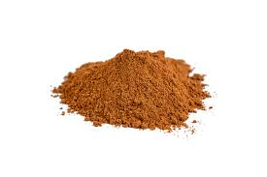
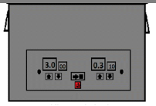
Avocado seed powder
- Phytochemicals
- Antioxidant activity

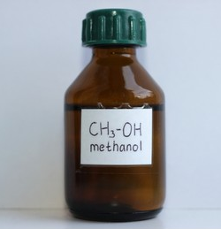
Ultrasonic bath
Methanol

