
SYNTHESIS OF GREEN-RENEWABLE BIOLUBRICANT BASE STOCK FROM MALAYSIAN PALM OIL

(Sintesis Stok Asas Biopelincir Hijau-Diperbaharui daripada Minyak Sawit Malaysia)

Nurazira Mohd Nor¹* and Jumat Salimon²

¹MaterOleo Research Group,
Faculty of Applied Sciences,
Universiti Teknologi MARA, Cawangan Negeri Sembilan, Kampus Kuala Pilah, 72000 Kuala Pilah, Negeri Sembilan, Malaysia
²Department of Chemical Sciences, Faculty of Science and Technology,
Universiti Kebangsaan Malaysia, 43600 UKM Bangi, Selangor, Malaysia
*Corresponding author: nurazira@uitm.edu.my

Received: 20 August 2021; Accepted: 3 February 2022; Published: xx June 2022

Abstract
Palm oil has become one of the potential renewable resources in biolubricant application. However, the direct application of palm oil as a biolubricant is restricted due to its low oxidative stability and poor low temperature properties. These drawbacks can be overcome by molecule structural redesign through chemical modification process. Palm oil (PO) was modified via epoxidation, ring opening and esterification process. The epoxidized palm oil (EPO) was prepared by using an in-situ performic acid catalyst. Then, EPO was ring-opened using oleic acid in the presence of p-toluenesulfonic acid (PTSA) as a catalyst and further esterification with oleic acid using sulfuric acid as catalyst. The molecular structure confirmation of modified palm oils was proven through the oxirane oxygen content (OOC) value, iodin value, hydroxyl value, Fourier transformation infra-red (FTIR), proton and carbon nuclear magnetic resonance (¹H-NMR and ¹³C-NMR) spectroscopy analysis. Results showed that the conversion of PO into EPO has improved its oxidative stability (190 °C). While, the esterification process has resulted in branching and bending in the molecule structure of the final product (palm oil dioleate, PODO), which improved its pour point (-10 °C), flash point (315 °C) and viscosity index (146). These make PODO suitable to be used in biolubricant application.

Keywords: biolubricant, epoxidation, esterification, ring opening, palm oil

Abstrak
Minyak sawit merupakan salah satu sumber yang boleh diperbaharui yang berpotensi dalam penghasilan biopelincir. Walaubagaimanapun, penggunaan secara terus minyak sawit sebagai biopelincir adalah terhad disebabkan oleh kestabilan oksidatif yang rendah dan sifat suhu rendah yang lemah. Kelemahan ini boleh diatasi dengan ubahsuai struktur molekul melalui proses pengubahsuaian kimia. Minyak sawit (PO) diubahsuai melalui proses pengepoksidaan, pembukaan gelang dan pengesteran. Minyak sawit terepoksida (EPO) dihasilkan menggunakan mangkin asid performik yang dijana secara in-situ. Seterusnya, EPO ditindakbalaskan melalui pembukaan gelang menggunakan asid oleik dengan kehadiran p-toluena asid sulfonik (PTSA) sebagai mangkin dan diikuti dengan pengesteran dengan asid oleik dengan menggunakan mangkin asid sulfurik. Pengecaman struktur molekul minyak sawit terubahsuai dibuktikan melalui nilai kandungan oksigen oksiran, nilai iodin, nilai hidroksil, spektroskopi infra-merah transformasi Fourier (FTIR), proton dan karbon nuklear magnetik resonans (¹H-NMR dan ¹³C-NMR). Keputusan menunjukkan penukaran PO kepada EPO telah memperbaiki nilai kestabilan oksidatifnya (190 °C). Manakala proses pengesteran telah menghasilkan struktur molekul yang bercabang dan bengkok bagi hasil akhir (dioleate minyak sawit, PODO) dan telah memperbaiki nilai takat tuang (-10 °C), takat kilat (315 °C) dan indeks kelikatan (146). Ini menjadikan PODO sesuai untuk digunakan dalam aplikasi biopelincir.

Kata kunci: biopelincir, pengepoksidaan, pengesteran, pembukaan gelang, minyak sawit

Introduction
Currently, there are wide ranges of base oils used in lubricant application, which include mineral oils, synthetic oils, re-refined oils and plant oils. Among these, mineral oils are the most commonly used [1]. However, mineral oils pose a constant threat to ecology and vast ground water reserves due to their inherent toxicity and non-biodegradable nature [1, 2]. The reduction of petroleum oil resources and increasing greenhouse gas emissions also provide a clear picture of the importance of the move towards sustainable development [3]. The use of renewable sources in the industry is vital to ensure sustainable development.

Plant oils are found to be the best alternative source to replace mineral oils in the production of biolubricant because they are renewable raw materials, biodegradable, non-toxic and environmentally friendly. Plant oil itself exhibits good lubrication properties with high viscosity index [4]. Biolubricants hold great potential for environmental conservation as an alternative lubricant. The global market size for biolubricants was USD 2.20 billion in 2019 and is projected to reach USD 2.46 billion by 2025, at a compound annual growth rate (CAGR) of 4.1% between 2020 and 2025 [5]. Stringent regulations and the growing acceptance among end-users are projected to drive the biolubricants market [5].

However, plant oils have several drawbacks that will restrict their direct application in the lubricant industries such as low oxidative stability [6, 7] and poor low temperature properties [3, 8]. The low oxidative stability is due to the presence of bis-allylic protons in plant oil’s structure which are highly susceptible to free radical attack and therefore undergo oxidative degradation to form polar oxy compounds [9-13]. The rate of the oxidation process can be attributed to the number of unsaturated fatty acids present in its composition [10,14]. Meanwhile, poor low temperature properties include cloudiness, precipitation, poor flowability and solidification at relatively high temperatures [8, 15]. The poor low temperature properties also will limit its use at a low operating temperature [6].

The oxidative stability and poor low temperature drawbacks that occur in the plant oils can be overcome by molecule structural redesign through chemical modifications. The presence of the double bonds and their reactivity have allowed the functional addition reactions into the unsaturated fatty acids. The epoxidation process is one of the most important functionalization reactions of the double bond to other stable functional groups to improve the plant oil’s oxidative stability [6, 16, 17]. The epoxidation of plant oil using peracids is one of the most important steps and a useful modification process toward the double bonds because the epoxides are reactive intermediates that can be converted to other functional groups through ring-opening reactions [18]. Plant oils with high content of unsaturated fatty acid are used to produce high epoxy functionality materials [19]. Epoxidized plant oils products from the epoxidation process can be used as high-temperature lubricants [20], plasticizers [21] and high temperature coating materials [22].

Meanwhile, the modification that can be used to improve poor low temperature properties of plant oil is ring opening and esterification reactions. The oxirane ring opening by acidic or alkaline catalyzed reaction with suitable reagent provides interesting polyfunctional compounds [15, 23], whereas reducing structural uniformity of the oil by attaching alkyl side chains would improve the low-temperature performance [15, 24]. The branching group which resulted from ring opening reaction will interfere with the formation of macro-crystalline structures during low-temperature applications and provide enhanced fluidity to plant oils. These modified plant oils with chain branching were reported to have the superior performance of the physicochemical properties and are promising as biolubricants [25]. Products obtained from ring opening can be used as low-temperature lubricants [20].

Palm oil which is abundantly available all over Malaysia become one of the potential plant oils that can be used as biolubricant base stock [26, 27]. In this paper, the modification of palm oil molecule structure to produce a base stock oil for lubricant application as shown in Figure 1 is reported. Palm oil contains a high percentage of unsaturated fatty acid (49.4%) [28], which serves as good starting material for the epoxidation process. Palm oil was converted into epoxidized palm oil followed by the ring opening and esterification reactions with oleic acid to enhance the lubrication properties. The structure of products was confirmed by FTIR and NMR spectroscopy. Physicochemical properties of products were examined by using several tests such as oxidative stability, pour point, flash point and viscosity index.

Figure 1. The schematic reaction for the modification of palm oil

Materials and Methods
Materials
Palm oil was obtained from Jomalina Refinery, Teluk Panglima Garang, Selangor, Malaysia. Formic acid (88%) was obtained from Fisher Scientific and hydrogen peroxide (30%) from Merck. Oleic acid (90%) was purchased from Sigma Aldrich. Ethyl acetate, toluene, sodium hydrogen carbonate and sodium chloride were purchased from Systerm.

Chemical modification processes
The epoxidation process was carried out based on the optimum conditions reported by Nurazira et al. [27]; mole ratio of PO: HCOOH: H₂O₂ (1:5.91:3.6), reaction temperature of 40 °C and reaction time of 2.55 hours. Next, the ring opening process was carried out based on the optimum conditions reported by Nurazira et al. [29]; mole ratio of EPO: oleic acid (1:3), reaction temperature of 119 °C, reaction time of 4.73 hours and 1.02% of p-toluenesulfonic acid (PTSA). The next esterification was carried out by using a mole ratio of POHO and oleic acid at 1:3, reaction temperature of 135 °C, reaction time of 4.96 hours and 1.86% of sulphuric acid.

Characterization of modified palm oils
The unsaturation of oil was determined by iodine value (IV) test using the Wijs method [30]. Oxirane oxygen content (OOC) value was determined by direct method using hydrobromic acid solution in glacial acetic acid (AOCS Cd 9-57) [31]. Hydroxyl value (HV) was performed according to analysis method (AOCS Tx 1a-66) [31]. The structure of modified oils was confirmed by using Fourier Transformation Infra-red (FTIR), proton and carbon Nuclear Magnetic Resonance (¹H-NMR and ¹³C-NMR). FTIR spectra were recorded on a Perkin Elmer Infrared Spectrophotometer in the range of 400-4000 cm⁻¹. ¹H and ¹³C NMR were recorded on JEOL-ECP 400 spectrometer (400 MHz ¹H/100.61 MHz ¹³C) using CDCl₃ as a solvent.

Physicochemical properties tests of modified palm oils
The American Society for Testing Materials standards such as ASTM D-6186, ASTM D-5853, ASTM D-92 and ASTM D-2270 were used to measure oxidative stability, pour point, flash point and viscosity index [32]. The oxidative stability test was conducted using Differential Scanning Calorimetry (DSC). 1.5 mg of sample was placed into an aluminum pan with a pinhole cover to allow interaction between ester product and oxygen gas which acts as reaction gas. Then, aluminum pan was put into DSC and heated for 20 minutes up to temperatures of 250 °C by using nitrogen gas. Onset temperature was recorded to determine the oxidative stability.

In the pour point test, the sample was filled into a U-shaped glass tube until it reached a height of 4 cm. The thermometer was placed at one end of the U-shaped tube and both ends of the U-shaped tube was covered with parafilm. The U-shaped tube containing the sample was placed in the refrigerator (minimum temperature -80 °C) for 24 hours to ensure that the sample froze completely. After being left overnight, the U tube was removed and flipped upside down. The lowest temperature at which movement of the sample was observed was recorded as the pour point.

For flash point testing, 2 mL of sample was placed in a crucible and heated on a heating plate. A thermometer with a maximum reading temperature of 360 °C was placed on the sample to measure the sample’s temperature. The temperature was rapidly increased at first and then at a slow constant rate as the flash point was approached. The lowest temperature at which the vapors above the surface of the liquid ignited was taken as the flash point.
For the viscosity index test, the Rheometer Anton Paar (Physica MCR 301 model) was used to measure the viscosity and viscosity index of the tested sample. The diameter used for both samples was 0.051 mm. Samples was tested at 40 °C and 100 °C [32]. The sample viscosity index was calculated based on the formula below:
Viscosity index= (L-U)/(L-H)×100
where: U= oil’s kinematic viscosity at 40 °C, L and H = values based on the oil’s kinematic viscosity at 100 °C.

Results and Discussion
Palm oil is golden yellow and exists in the semi-solid form at room temperature. The liquid fraction contains unsaturated triacylglycerol (TAG), whereas the solid fraction contains more saturated TAG. The epoxidation process is more likely to occur at unsaturated TAG.

In epoxidation reaction, hydrogen peroxide acts as an oxygen donor, while formic acid acts as an oxygen carrier and gets regenerated once the epoxidation reaction takes place [33]. Formic acid also takes part in the overall reaction as a catalyst in the formation of the oxirane ring and as a reactant in the hydrolysis of the oxirane ring. To attain the maximum oxirane oxygen content, the level of the formic acid should be such that these two effects are balanced [34,35]. Figure 2 shows the mechanism of the epoxidation reaction.

The results for the epoxidation of palm oil are shown in Table 1. The average percentage yield of epoxidation was 86% (w/w). The epoxi dation process can be monitored through the IV and OOC values. The IV should be as small as possible after epoxidation, while OOC should be as large as possible. There was a difference between the IV before and after epoxidation. The initial IV of palm oil before epoxidation was 57.8 m/g, while the IV obtained for EPO after epoxidation was low approaching zero (0.09 mg/g). EPO showed a high OOC value which was 3.46% with 99.43% of relative conversion oxirane (RCO). The theoretical value of OOC was 3.49%. It means almost all unsaturated fatty acids in PO were successfully epoxidized and converted to oxirane rings to produce EPO.

Many nucleophilic reagents are known to add to an oxirane ring, resulting in ring opening. The ester branching groups produced from oxirane ring opening based esterification reactions are effective for attaining the desired molecular spacing. Most of the oxirane ring groups were opened and converted into ester bonds in the molecule with the hydroxyl group [26, 36]. The modified plant oils with chain branching were reported to have superior performance properties and are promising as biodegradable lubricants [26,36,37]. Figure 3 shows the mechanism of ring opening reaction.

Figure 2. The mechanism of the epoxidation reaction

Table 1. Analysis results for modified palm oils
Compound | PO | EPO | POHO | PODO
Yield (%) | - | 86 | 84 | 80
Iodine value (mg/g) | 57.8 | 0.09 | 59.4 | 109.8
OOC value (%) | - | 3.46 | 0.041 | -
RCO (%)  Hydroxyl value (mgKOH/g) | -  19 | 99.43  23 | -  118.7 | -  25.4

Figure 3. The mechanism of the ring opening reaction

This study reports the oxirane ring opening reaction of epoxidized palm oil (EPO) by the nucleophilic addition of oleic acid (OA) in the presence of homogenous acid catalysts which was p-toluenesulfonic acid (PTSA). PTSA was preferred to be used in the reactions due to the maximum yield of epoxy ring opening and no evidence of any side reaction occurred during the reaction [38]. The nucleophilic attack by the fatty acid molecule which was oleic acid on the oxirane ring of epoxidized palm oil (EPO) in the presence of PTSA as catalyst resulted in the ring opened product: palm oil hydroxy oleate (POHO).

The results for the ring opening process are shown in Table 1. The average percentage yield of ring opening was 84% (w/w). The ring opening process can be monitored through IV, HV and OOC values. The OOC value should be as small as possible. This is because the reduction of OOC value is proportional to the number of epoxides opened. OOC value obtained after ring opening process was low approaching zero (0.041%). It showed that the entire epoxide ring was successfully opened during the ring opening reaction with the oleic acid to produce POHO. The entire epoxide ring had been successfully converted to hydroxyl oleate ester functional groups. This can be evidenced by the increase of IV and HV of the product. The addition of the olefin which exists from the oleate acyl group had increased the IV of POHO to 59.4 mg/g. There was also an increase in HV from 23 mg KOH/g to 118.7 mg KOH/g after the ring opening process. Further esterification of POHO with oleic acid produced the final product: palm oil dioleate (PODO). The average percentage yield of the final esterification process was 80% (w/w). There was a decrease in HV of PODO to 25.4 mgKOH/g and an increase of IV (109.8 mg/g) after esterification. It means that the hydroxyl group of POHO was reacted with oleic acid to produce the oleate acyl group.

FTIR spectra
The presence of functional groups in all modified oils was identified by using FTIR spectroscopy. Figure 4 shows the FTIR spectra of PO, EPO, POHO and PODO. The disappearance of the double bond functional group peak at 3005 cm⁻¹ which was initially present in the PO spectrum indicated the conversion of the double bond to the epoxy group. It can be proven by the presence of a C-O-C oxirane peak at 843 cm⁻¹ in the EPO spectrum. Pavia et al. [39] reported the presence of epoxy group can be monitored at wavenumber range of 815-950 cm⁻¹ which agrees well for this study.

The disappearance of the epoxide peak showed that the entire oxirane ring had been successfully converted to hydroxyl oleate ester functional groups during the ring opening reaction with oleic acid. This is evidenced by the increase of peaks intensity of the hydroxyl (OH) functional group at 3463 cm⁻¹ and C=O stretching at 1740 cm⁻¹ in the POHO spectrum. A significant change in the ring opening process also can be evidenced by the existence of the C=C olefin peak of the oleate acyl group at 3003 cm⁻¹ in the POHO spectrum. The final esterification product (PODO) was evidenced by the reduction of the peak intensity of the hydroxyl group in the PODO spectrum.

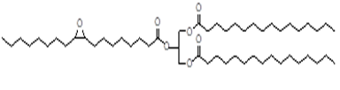
(a) Epoxidation product

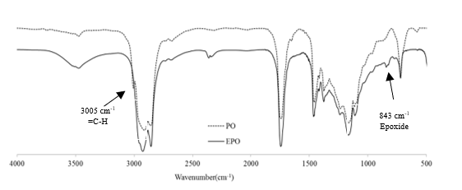
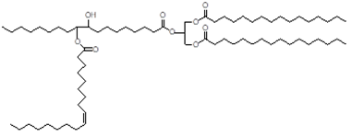
(b) Ring opening product

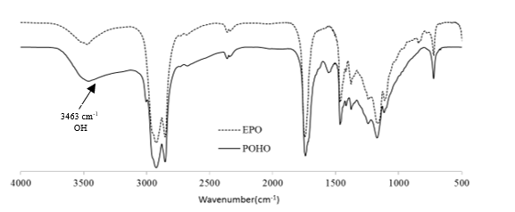
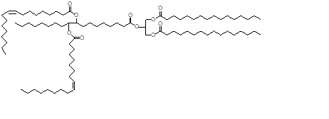
(c) Esterification product

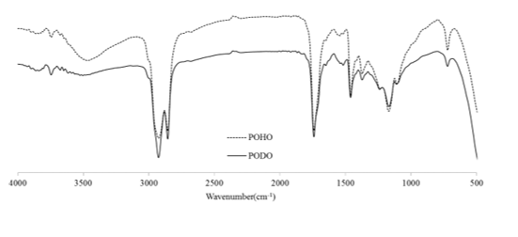
Figure 4. FTIR spectra of (a) epoxidation; (b) ring opening; (c) esterification products

NMR spectra
Figure 5 shows ¹H NMR spectra of PO, EPO, POHO and PODO and Table 2 shows the chemical shift for all products. The epoxidation process (EPO) can be proven by the disappearance of olefin proton at 5.34 ppm (C=C-H) and allylic proton at 2.0-2.05 ppm (C=C-C-H), which initially were present in the PO spectrum. They were replaced by the existence of a peak signal at 2.89 ppm, which corresponds to the proton of oxirane ring (CHOCH) and a peak signal at 1.49 ppm that represents epoxy proton (CH₂-CHOCH-CH₂) in the EPO spectrum. The result of ring opening reaction can be confirmed by the disappearance of peak signal of oxirane ring proton (CHOCH) in the POHO spectrum. Peak signal for olefin proton and allylic proton can be detected at 5.30-5.36 ppm (C=C-H) and 1.97-2.09 ppm (C=C-C-H) in the POHO spectrum. The final product showed that there was a disappearance of the C-O-H peak signal (C-O-H) in the PODO spectrum.

Figure 6 shows ¹³C NMR spectra of PO, EPO, POHO and PODO and Table 3 shows the chemical shift for all products. The peaks at 127.85- 130.17 ppm in the PO spectrum represented the double bond (C=C). Conversion of the double bond to oxirane ring can be proven by the disappearance of double bond peak and existence of carbon atom of epoxy (C-O) at 54.19-57.22 ppm in EPO spectrum. The results of ring opening reaction can be evidenced by the disappearance of epoxy carbon, the existence of carbon olefin (C=C) at 129.60-129.97 ppm and also the existence of peak signal at 73.50 ppm, which represents the carbon next to the hydroxyl group (HC-OH) in POHO spectrum. The final product showed that there was a disappearance of the HC-OH signal peak in the PODO spectrum.

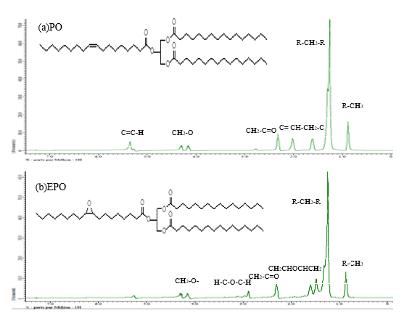

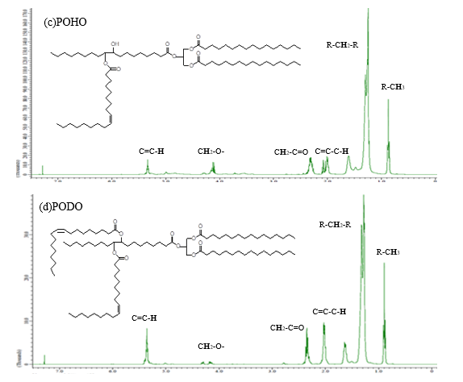
Figure 5. ¹H NMR spectra of (a) PO; (b) EPO; (c) POHO and (d) PODO

Table 2. The chemical shifts for ¹H NMR PO, EPO, POHO and PODO spectra
Compound | Chemical Shift, ppm | Chemical Shift, ppm  (Reference³⁶) | Remarks
PO | 5.34 | 4.5-6.5 | C=C-H
 | 2.00 - 2.05 | 1.6-2.6 | C=C-C-H
EPO | 2.89 | 2.5-3.5 | CHOCH
POHO | 5.30-5.36 | 4.5-6.5 | C=C-H
 | 1.97-2.09 | 1.6-2.6 | C=C-C-H
 | 4.99 | 0.5-5.0 | C-O-H
PODO | 5.34-5.37 | 4.5-6.5 | C=C-H
 | 2.00-2.07 | 1.6-2.6 | C=C-C-H

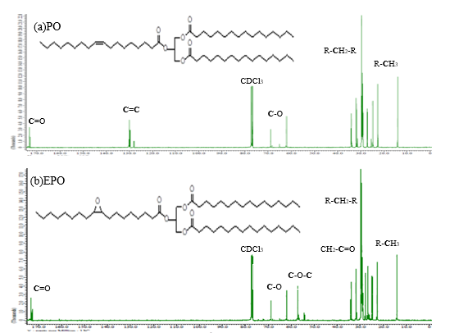
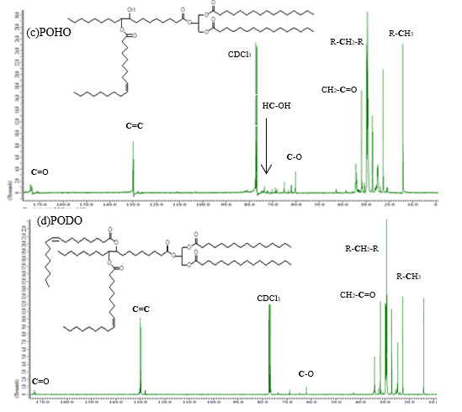
Figure 6. ¹³C NMR spectra of (a) PO; (b) EPO; (c) POHO and (d) PODO

Table 3. The chemical shifts for ¹³C NMR PO, EPO, POHO and PODO spectra

Compound | Chemical Shift, ppm | Chemical Shift, ppm  (Reference³⁶) | Remarks
PO | 127.85- 130.17 | 100-150 | C=C
EPO | 54.19-57.22 | 56.9-58.5 | C-O-C
POHO | 129.60-129.97 | 100-150 | C=C
 | 60.18-63.30 | 40-80 | C-O
PODO | 127.88-130.16 | 100-150 | C=C

Physicochemical properties
There were several tests conducted to determine the physicochemical properties of the modified oils. The physicochemical properties results obtained are shown in Table 4. The ability of a substance to resist oxidative degradation is an important property of biolubricant. Oxidative stability is determined by the onset temperature (OT) using Differential Scanning Calorimetry (DSC). OT is the temperature at which the occurrence of a sharp increase in the rate of oxidation of the sample. Higher onset temperature indicates that the lubricant has high oxidation stability [6]. Based on the DSC analysis, there was an improvement in oxidative stability for EPO (190 °C) compared to PO (181 °C). It was due to the conversion of the double bond group to the epoxy group which will reduce the active site of oxidation and make it less susceptible to radical attack. However, POHO and PODO showed low oxidative stability due to increasing double bond content and carbon chain, which will increase the potential active site for the oxidation process.

Table 4. Physicochemical properties of PO, EPO, POHO, PODO and commercial lubricants (100A and 100B)
Compound | PO | EPO | POHO | PODO | 100Aª | 100B^{b}
Oxidative stability (°C) | 181 | 190 | 170 | 157 | n/a | n/a
Pour point (°C) | 7 | 18 | -8 | -10 | -19 | -27
Kinematic viscosity (40 °C) | 56.97 | 97.72 | 616.46 | 83.45 | 96 | 96.7
Kinematic viscosity (100 °C) | 9.24 | 14.56 | 60.73 | 15.30 | 10.9 | 11
Viscosity index (VI) | 130 | 133 | 125 | 146 | 97 | 100
Flash point (°C) | 240 | 255 | 295 | 315 | 276 | 254
ISO viscosity grade | 46 | 100 | 680 | 100 | 100 | 100

a:100A: Denicol Compressor Oil ISO VG 100 [41],
b: SubsTech Hydraulic Oil ISO 100 [42]

Pour point is one of the important quality parameters to determine cold flow or low temperature properties of the lubricant. The cold flow properties of plant oils are extremely poor and these limit their use at low operating temperatures especially as automotive and industrial fluids. Plant oils tend to form macrocrystalline structures at low temperatures through uniform self-stacking of the linear triacylglycerol molecules. The macrocrystals restrict the easy flow of the system due to the loss of kinetic energy of individual molecules during self-stacking [6, 15, 40]. PODO has the lowest pour point (-10 °C) compared to other products due to the branched carbon chain and bent structure. It makes it more restricted to self-stacking and more hollows in the structure, thus easier for it to flow, which contributed to the lowest pour point. In general, the presence of a branching group at the end of the molecule will disrupt this stacking process and create a steric barrier around the individual molecules and inhibit crystallization [18]. This will result in the formation of microcrystalline structures rather than macro structures. At lower temperatures, the microcrystalline structures can easily tumble and glide over one another resulting in better fluidity of the total matrix [6], resulting in a lower pour point. Moreover, the disappearance of the hydroxyl group in PODO esters means that no hydrogen bonds exist in the molecule, which causes the molecules to be less sticky to each other and to move freely around.

Viscosity also becomes one of the important quality parameters for lubricating oils. The efficiency of the biolubricant in reducing friction and wear is greatly influenced by its viscosity. The viscosity of PO is lower than EPO due to the existence of a double bond, which provides the lubricating properties of liquids by degrees of unsaturation. POHO has a higher viscosity due to the presence of intermolecular hydrogen bonding from the hydroxyl group resulted from the ring opening reaction. The hydroxyl group gives a higher polarity that influences the viscosity of the oil, in which more polar molecule of oil, the higher the viscosity [40]. In general, the hydroxyl group will form a bond between molecules and cause lubricating oil to become more viscous. After the final esterification process, the viscosity of PODO decreased due to the disappearance of the hydroxyl group. The viscosity of PODO was in the medium range, which was 83.45 centistokes (cSt) at 40 °C and decreasing to 15.30 cSt at 100 °C. It shows the viscosity of biolubricant decreases as temperature increases. The least viscous biolubricant which still forces the two moving surfaces apart is desired. If the biolubricant is too viscous, it will require a large amount of energy to move and if is too thin, the surfaces will rub and friction will increase [6]. The viscosity index highlights how the viscosity of biolubricant changes with variations in temperature [6]. PODO showed the highest viscosity index (146) compared to other products. It shows the viscosity of PODO is less affected by temperature changes and does not drastically change when the temperature varies. This is a good indicator and it is suitable for use at a large temperature range.

The flash point is often used as a descriptive characteristic of fuel oil and it is also used to describe oils that are not used as fuels such as a lubricant. Flash point refers to both flammable oils and combustible oils. The oils with a flash point of less than 43 °C are flammable, while those having a flash point above this temperature are combustible. Biolubricant which has a low flash point value is considered to have been contaminated by volatile and usually requires special precautions when handling these biolubricant [6]. PODO showed the highest flash point (315 °C) compared to other products. It is due to the increasing carbon number which causes an increasing molecular weight that gives a higher flash point. In addition, PODO also has a big branched molecular structure which requires more energy to burn. This will increase the flash point of PODO. A high flash point is important to ensure that the lubricant is not burned in the engine during its operation.

Table 4 also shows a comparison of lubrication properties between the biolubricant base stock produced (PODO) with commercial lubricants in the market. The selected commercial lubricants are ISO VG 100 grade lubricants, namely Denicol Compressor Oil (100A) [41] and SubsTech Hydraulic Oil (100B) [42]. Based on the comparison made, PODO has a higher viscosity index compared to 100A and 100B lubricants. The pour point value of PODO is also lower than 100A and 100B lubricant. In addition, PODO also recorded much higher flash point value than 100A and 100B lubricants.

Conclusion
The chemically modified palm oils showed improvement in physicochemical properties. The epoxidized palm oil (EPO) has the highest oxidative stability due to the reduction of double bond content, while the final esterification product, palm oil dioleate (PODO) has the lowest pour point due to the greater ability of the branched chain esters to disrupt crystalline formation. A bigger, bending, branching and hollow structure makes the molecule less compact, thus improve the lubricity of the lubricant. PODO also showed the highest viscosity index and flash point due to the big branched molecular structure. This makes PODO as plausible to be used as a biolubricant with better lubrication properties.

Acknowledgement
The authors gratefully acknowledge Universiti Kebangsaan Malaysia for financial support under research grant GUP-2016-012 and GUP-2016-058. The authors also thank the Ministry of Education, Malaysia for providing scholarship support (MyPhD) for the author.

References
- Salimon, J. and Salih, N. (2009). Oleic acid diesters: Synthesis, characterization and low temperature properties. European Journal of Scientific Research, 32(2): 216-222.
- Farhoosh, R., Einafshar, S. and Sharayei, P. (2009). The effect of commercial refining steps on the rancidity measures of soybean and canola oils. Food Chemistry, 115: 933-938.
- Erhan, S. Z. and Asadauskas, S. (2000). Lubricant basestocks from vegetable oils. Industrial Crops and Products, 11: 277-282.
- Nirmal, V. P. and Dineshbabu, D. (2015). Performance and emission of Pongamia pinnata oil as a lubricant in diesel engine. International Journal of Innovative Research in Science, Engineering and Technology, 4(2): 75.
- Salih, N. and Salimon, J. (2021). A review on eco-friendly green biolubricants from renewable and sustainable plant oil sources. Biointerface Research in Applied Chemistry, 11(5): 13303-13327.
- Salimon, J., Salih, N. and Yousif, E. (2011). Chemically modified biolubricant basestocks from epoxidized oleic acid: Improved low temperature properties and oxidative stability. Journal of Saudi Chemical Society, 15: 195-201.
- Wu, X., Zhang, X., Yang, S., Chen, H. and Wang, D. (2000). The study of epoxidized rapeseed oil used as a potential biodegradable lubricant. Journal of the American Oil Chemist Society, 77: 561-563.
- Salimon, J. and Salih, N. (2010). Modification of epoxidized ricinoleic acid for biolubricant base oil with improved flash and pour points. Asian Journal of Chemistry, 22(7): 5468-5476.
- Adhvaryu, A., Liu, Z. and Erhan, S. Z. (2005). Synthesis of novel alkoxylated triacylglycerols and their lubricant base oil properties. Industrial Crops and Products, 21:113-119.
- Borugadda, V. B. and Goud, V. V. (2015). Response surface methodology for optimization of biolubricant basestock synthesis from high free fatty acids castor oil. Energy Science & Engineering, 3(4): 371-383.
- Erhan, S. Z., Sharma, B.K. and Perez, J. M. (2006). Oxidation and low temperature stability of vegetable oil-based lubricants. Industrial Crops and Products, 24: 292-299.
- Sharma, B. K., Perez, J. M. and Erhan, S. Z. (2007). Soybean oil-based lubricants: A search for synergistic antioxidants. Energy Fuels, 21: 2408-2414.
- Singh, C. P. and Chhibber, V. K. (2013). Chemical modification in karanja oil for biolubricant industrial applications. Journal Drug Delivery Therapeutics, 3:117-122.
- Borugadda, V. B. and Goud, V. V. (2013). Comparative studies of thermal, oxidative and low temperature properties of waste cooking oil and castor oil. Journal Renewable Sustainable Energy, 5: 063104.
- Salimon, J. and Salih, N. (2009). Substituted esters of octadecanoic acid as potential biolubricants. European Journal of Scientific Research, 31(2): 273 – 227.
- Moser, B. R. and Erhan, S. Z. (2007). Preparation and evaluation of a series of α-hydroxy ethers from 9, 10-epoxystreates. European Journal Lipid Science Technology, 109: 206-213
- Salimon, J., Ahmed, W. A., Salih, N., Yarmo, M. A. and Derawi, D. (2015). Lubricity and tribological properties of dicarboxylic acids and oleyl alcohol based esters. Sains Malaysiana, 44(3): 405-412.
- Wang, R. and Schuman, T. P. (2013). Vegetable oil-derived epoxy monomers and polymer blends: A comparative study with review. eXPRESS Polymer Letters, 7(3):272–292.
- Meyer, P. P., Techaphattana, N., Manundawee, S., Sangkeaw, S., Junlakan, W. and Tongurai, C. (2008). Epoxidation of soybean oil and jatropha oil. Thammasat International Journal Science Technology, 13: 1-5.
- Lathi, P. S. and Mattiasson, B. (2007). Green approach for the preparation of biodegradable lubricant base stock from epoxidised vegetable oil. Applied Catalysis B: Environmental, 69: 207-212.
- Joseph, R., Madhusoodhanan, K. N., Alex, R., Varghese, S., George, K. E. and Kuriakose, B. (2014). Studies on epoxidised rubber seed oil as secondary plasticiser/stabiliser for polyvinyl chloride. Plastics Rubber and Composites, 33(5): 217-222.
- Derawi, D. and Salimon, J. (2016). Sintesis sebatian hidroksi-eter minyak sawit olein. Sains Malaysiana, 45(5): 817-823.
- Yunus, R., Razi, A. F., Iyuke T. L. and Idris, A. (2003). Preparation and characterization of trimethylolpropane esters from palm kernel oil methyl esters. Journal of Oil Palm Research, 15(2):42-49.
- Sharma, B. K., Doll, K. M. and Erhan, S. Z. (2008). Ester hydroxy derivatives of methyl oleate: tribological, oxidation and low temperature properties. Bioresource Technology, 99: 7333-7340.
- Salimon, J., Abdullah, B. M., Yusop, R. M., Salih, N. and Yousif, E. (2013). Synthesis and optimization ring opening of monoepoxide linoleic acid using p-toluenesulfonic acid. SpringerPlus, 2: 429.
- Nor, M. N., Derawi, D. and Salimon, J. (2017). Chemical modification of epoxidized palm oil for biolubricant application. Malaysian Journal of Analytical Sciences, 21(6):1423-1431.
- Nor, M. N., Derawi, D. and Salimon, J. (2018). The optimization of RBD palm oil epoxidation process using D-optimal design. Sains Malaysiana, 47(7):1359-1367.
- Njoku, P. C., Egbukole, M. O. and Enenebeaku, C. K. (2010). Physio-chemical characteristics and dietary metal levels of oil from Elaeis guineensis species. Pakistan Journal of Nutrition, 9(2):137-140.
- Nor, M. N., Salih, N. and Salimon, J. (2021). Optimization of the ring opening of epoxidized palm oil using D-optimal design. Asian Journal of Chemistry, 33(1):67-75.
- Kuntom, A., Lin, S. W., Ai, T. Y., Idris, N. A., Yusof, M., Sue, T. T. and Ibrahim, N. A. (2004). MPOB test methods: A compendium of test on palm oil products, palm kernel products, fatty acids, food related products and others. MPOB, Bangi.
- A.O.C.S. (1998). Official Methods and Recommended Practices of AOCS, AOCS, Illionis.
- Nadkarni, R. A. (2007). Guide to ASTM test methods for the analysis of petroleum products and lubricants. ASTM International, West Conshohocken
- Mungroo, R., Pradhan, N. C, Goud, V. V. and Dalai, A. K. (2008). Epoxidation of canola oil with hydrogen peroxide catalyzed by acidic ion exchange resin. Journal of the American Oil Chemist Society, 85:887-896.
- Goud, V.V., Patwardhan, A.V. and Pradhan, N. C. (2006). Studies on the epoxidation of mahua oil (Madhumica indica) by hydrogen peroxide. Bioresource Technology, 97:1365-1371.
- Goud, V.V., Patwardhan, A.V., Dinda, S. and Pradhan, N. C. (2007) Kinetics of epoxidation of Jatropha oil with peroxyacetic and peroxyformic acid catalysed by acidic ion exchange resin. Chemical Engineering Science, 62: 4065-4076.
- Baumann, H., Buehler, M., Fochem, H., Hirsinger, F., Zoebelein, H. and Falbe, J. (1988). Natural fats and oils – renewable raw materials for the chemical industry. Angewandte Chemie, 27(1): 41-62.

- Hwang, H. S. and Erhan, S. Z. (2001). Modification of epoxidized soybean oil for lubricant formulation with improved oxidative stability and low pour point. Journal of the American Oil Chemist Society, 78(12): 1179-1184.
- Salimon, J., Abdullah, B. M., Yusop, R. M., Salih, N. and Yousif, E. (2013). Synthesis and optimization ring opening of monoepoxide linoleic acid using p-toluenesulfonic acid. SpringerPlus, 2: 429.
- Pavia, D. L., Lampman, G. M., Kriz, G. S. and Vyvyan, J. R. (2009). Introduction of spectroscopy, Fourth edition. Cengage Learning, United States: pp. 51-52
- Sharma, A., Adhvaryu, A., Liu, Z. and Erhan, S. Z. (2006). Chemical modification of vegetable oils for lubricant applications. Journal of the American Oil Chemist Society, 83:129-136.
- Denicol Motor Oils N.V (2020). Denicol compressor oil. Access from https://pdf4pro.com/view/compressor-oil-iso-vg-32-46-68-100-150-denicol-5786bc.html. [Access online 25 December 2020].
- SubsTech: Substances and Technologies (2012). SubsTech hydraulic oil. Access from http://www.substech. com /dokuwiki/doku.php? id=hydraulic_oil_iso_100 .[Access online 25 December 2020].

