

FORMULATION AND CHARACTERISATION OF LSCF/YSZ-SDC AND LSCF/YSZ-SDCC DUAL COMPOSITE CATHODES FOR INTERMEDIATE-TEMPERATURE SOLID OXIDE FUEL CELL

(Formulasi dan Ciri Dwi-Komposit Katod LSCF/YSZ-SDC dan LSCF/YSZ-SDC Karbonat untuk Sel Bahan Api Oksida Pepejal Bersuhu Pertengahan)

Nurul Farhana Abdul Rahman, Umira Asyikin Yusop, Yohannes Nyambong Lowrance,

Hamimah Abd. Rahman*, Mohd Azham Azmi, Shahruddin Mahzan, Azzura Ismail

Faculty of Mechanical and Manufacturing Engineering,

Universiti Tun Hussein Onn Malaysia, 86400 Parit Raja, Batu Pahat, Johor, Malaysia

*Corresponding author: hamimah@uthm.edu.my

Received: 28 November 2021; Accepted: 27 February 2022; Published: xx June 2022

Abstract

A cathode component solid oxide fuel cell (SOFC) is important in the manufacturing of the cells. This study evaluated two dual composite cathodes, namely, (La_{0.6}Sr_{0.4})_{0.97}Co_{0.2}Fe_{0.8}O₃ (LSCF)/Y_{0.8}Zr_{0.92}O_{1.96} (YSZ)-Sm_{0.2}Ce_{0.8}O_{1.9} (SDC) and LSCF/YSZ-SDC carbonate (SDCC). The dual composite cathodes with different compositions were developed through high-energy ball milling (HEBM) for the production of dual composite powder and screen-printing method for the fabrication of symmetrical cells. The properties of the dual composite cathodes were studied. Phase identification was carried out via X-ray diffractometry (XRD), and the electrochemical performance of the symmetrical cells was measured by impedance test. The physical morphologies of LSCF/YSZ-SDC and LSCF/YSZ-SDCC were slightly different. The XRD patterns of the LSCF/YSZ-SDC cathode powder showed no secondary peak, whereas the LSCF/YSZ-SDCC cathode powder had SrCO₃ as an impurity. Microstructure and powder homogeneity are considered essential in addition to the good formulation of the dual composite’s cathodes. The particle sizes of LSCF/YSZ-SDC and LSCF/YSZ-SDCC as analyzed by ImageJ software were in the range of 130–160 nm. The printed cathode was investigated under heat treatment from 700 °C to 500 °C. The electrochemical performance of LSCF/YSZ-SDCC was slightly better compared with that of LSCF/YSZ-SDC because of the addition of the carbonate; however, the polarization resistance obtained did not meet the standard range. The electrochemical performance obtained from this study was not favorable because of severe problems, such as the technique applied during cell fabrication and the presence of impurity after the HEBM process.

Keywords: dual composite cathodes, intermediate temperature, screen printing, solid oxide fuel cell

Abstrak

Komponen katod untuk sel bahan api oksida pepejal (SOFC) adalah penting dalam pembuatan sel. Dalam kajian ini, penilaian katod komposit dwi (LSCF)/(YSZ)-(SDC) and (LSCF)/(YSZ)-Karbonat (SDCC) dibentangkan. Komposisi yang berbeza bagi katod komposit dwi telah dibangunkan melalui teknik pengisaran bebola tenaga tinggi untuk penghasilan serbuk komposit dwi dan kaedah percetakan skrin telah digunakan untuk fabrikasi sel simetri. Pencirian sifat katod komposit dwi telah dikaji. Pengenalpastian fasa melalui kaedah pembelauan sinaran-X telah dijalankan dan prestasi electrokimia sel simetri diukur dengan menggunakan ujian impedans. Perbandingan antara morfologi fizikal LSCF/YSZ-SDC and LSCF/YSZ-SDCC menunjukkan sedikit perbezaan dengan penambahan karbonat. Corak sinar-X untuk komposit dwi campuran LSCF/YSZ-SDC katod serbuk tidak memaparkan puncak sekunder. Bagaimanapun, Komposit dwi campuran LSCF/YSZ-SDCC katod serbuk memaparkan kehadiran sebagai bendasing. Kehomogenan struktur mikro dan serbuk dianggap pentiing sebagai tambahan kepada perumusan katod dwi komposit yang baik. Purata saiz zarah purata bagi LSCF/YSZ-SDC and LSCF/YSZ-SDCC dwi komposit selepas dianalisis oleh perisian Image J didedahkan berada dalam julat antara 130-160. Filem bercetak katod telah disiasat di bawah suhu rawatan haba dari 700$℃$ hingga 500$℃$. Prestasi elektrokimia LSCF/YSZ-SDCC menunjukkan lebih baik sedikit berbanding LSCF/YSZ-SDC kerana penambahan karbonat namun keputusan yang diperoolehi tidak mencapai julat piawai rintangan polarisasi. Prestasi elektokimia yang diperoleh daripada kajian ini adalah tidak memberangsangkan kerana masalah yang teruk seperti teknik yang digunakan semasa fabrikasi sel dan kehadiran bendasing selepas proses HEBM.

Kata kunci: katod komposit dwi, suhu pertengahan, percetakan skrin, sel bahan api oksida pepejal

Introduction

Solid oxide fuel cells (SOFCs) are still highly investigated because they have the highest potential for future power-generating devices in fuel cell technology. The capability of SOFCs to convert chemical energy from hydrogen or versatile fuels, particularly hydrocarbon fuels, into electrical or thermal energy made SOFCs a potential renewable energy source. Recent developments in SOFCs have focused on limiting the operating temperature and selecting a stable material for SOFC components. Although many cathodes have been developed and studied in detail, dual composite cathodes are barely reported. Dual composite cathodes are introduced to create an ideal cathode microstructure that can help improve phase contiguity and interfacial coherence by selecting suitable materials as cathode components [1-4]. Several studies have development of dual composite cathode was investigated. According to Ko et al. [3], (La_{0.6}Sr_{0.4})_{0.97}Co_{0.2}Fe_{0.8}O₃ (LSM)-Y_{0.8}Zr_{0.92}O_{1.96} (YSZ) composite cathodes struggle to achieve a high electrochemical performance because their effective surface area is small for electrocatalytic reactions. As a solution, an LSM/YSZ-YSZ dual composite cathode was created with LSM and YSZ particles conjugated together on YSZ-based particles. Based on the reported analysis, the LSM/YSZ-YSZ dual composite cathode had improved cathodic performance and also improved the durability of the cell by enhancing the phase contiguity and interfacial coherence between cells. Several dual composite cathodes were created for the further investigation of dual composite cathode materials. For example, LSM/YSZ-gadolinium-doped ceria (GDC), LSCF/YSZ-GDC and LSCF/GDC-YSZ were developed. The cell performances of these dual composite cathodes were investigated by comparing with a single composite cathode (LSCF-GDC), and the results showed that LSCF/GDC-YSZ had a lower polarization resistance (0.075 Ωcm²) than LSCF-GDC (0.195 Ωcm²) [3-4]. However, the operating temperatures of previously developed dual composite cathodes for SOFCs are high.

In this study, two new dual composite cathodes, namely, LSCF/YSZ-Sm_{0.2}Ce_{0.8}O_{1.9} (SDC) and LSCF/YSZ-SDC carbonate (SDCC), were developed in an attempt to investigate their electrochemical performances in limited operating temperatures. Previous research developed and evaluated two different dual composite cathodes, namely, LSM/GDC-YSZ and LSCF/YSZ-GDC. The electrochemical performances of these cathodes were investigated at high operating temperatures [3-4]. In the present study, the operating temperature was limited to 700–500 °C. YSZ was added to the LSCF-SDC composite cathode as an electrolyte material because YSZ can help increase the performances of cell components [5]. Moreover, SDC was used instead of GDC in this research. Both doped ceria are good oxygen ion conductors [6], but SDC is preferred because of its excellent ionic conductivity, which is related to oxygen vacancy [6]. Samarium causes a remarkable increase in oxygen vacancies, which help increase ionic conductivity [6]. Additionally, incorporating carbonate salts (Li₂CO₃ and Na₂CO₃) can improve ionic conductivity [7]. For these reasons, two new dual composite cathodes were developed and examined in this study.

The present work aimed to investigate the electrochemical performances of dual composite cathodes in an operating temperature between 700 °C and 500 °C. The dual composite cathodes were prepared by mixing LSCF with YSZ-SDC and YSZ-SDCC with different weight percentages. The symmetrical cells were prepared by screen printing method using LSCF/YSZ-SDC and LSCF/YSZ-SDCC as the inks. Moreover, the phase microstructure and electrochemical performances of the dual composite cathode symmetrical cells were evaluated in depth in this study.

Materials and Methods

Preparation and characterization of dual composite powders

YSZ-SDC and YSZ-SDCC composite powders were prepared using high-speed ball milling technique. SDCC electrolyte was prepared using low-speed ball milling method with 80 wt.% raw SDC powder (Kceracell, South Korea) mixed with 20 wt.% binary carbonates, which comprise 67 mol.% Li₂CO₃ and 33 mol.% Na₂CO₃ (Sigma Aldrich, USA) [7]. YSZ-SDC and YSZ-SDCC composite powders were prepared by mixing commercial YSZ powder (Kceracell, South Korea) with commercial SDC and SDCC electrolyte powders, respectively, via high-energy ball milling (HEBM) (Fritsch Pulveristte, Germany) at 550 rpm for 2 h in zirconia jars. Three different weight ratios (50 wt.%:50 wt.%, 60 wt.%:40 wt.% and 70 wt.%:30 wt.%) for YSZ-SDC and YSZ-SDCC were selected as inspired from a previous research [8]. The resultant YSZ-SDC and YSZ-SDCC wet mixtures were dried and calcined.

In the second step, a commercial LSCF powder (Kceracell, South Korea) was added into the obtained YSZ-SDC and YSZ-SDCC composite powders with a 50:50 ratio to form dual composite cathode powders. HEBM was applied to produce homogenous mixtures of the dual composite cathode powders. Lastly, both dual composite cathode powders were dried overnight and heat treated at 750 °C for 1 h [8]. Table 1 shows the compositions of the prepared composite powders and dual composite powders.

All the fabricated powders were characterized by X-ray diffractometry (XRD; D8 Advanced Bruker, Germany) to identify the crystalline phases and the formation of any secondary phases. Then, the microstructure and element composition distribution were characterized using field-emission scanning electron microscopy (FESEM) with electron-dispersive spectroscopy (EDS; JSM 6380-Jeol, Japan). The particle sizes of all the resultant powders were estimated through the ImageJ software using the micrographs obtained by FESEM.

Table 1. Weight ratio compositions of composite and dual composite powders
Composite Powder | Weight Ratio Composition (wt.%) | Dual Composite Powder | Designated samples | Weight Ratio Composition  (wt.%)
YSZ-SDC | 50:50 | LSCF/YSZ-SDC | LYS1 | 50/50:40
YSZ-SDC | 60:40 | LSCF/YSZ-SDC | LYS2 | 50/60:40
YSZ-SDC | 70:30 | LSCF/YSZ-SDC | LYS3 | 50/70:30
YSZ-SDCC | 50:50 | LSCF/YSZ-SDCC | LYSC1 | 50/50:50
YSZ-SDCC | 60:40 | LSCF/YSZ-SDCC | LYSC2 | 50/60:40
YSZ-SDCC | 70:30 | LSCF/YSZ-SDCC | LYSC3 | 50/70:30

Electrical performance analysis of LSCF/YSZ-SDC and LSCF/YSZ-SDCC dual composite cathodes

The dual composite symmetrical cells (LSCF/YSZ-SDC//YSZ electrolyte//LSCF/YSZ-SDC and LSCF/YSZ-SDCC//YSZ electrolyte// SCF/YSZ-SDCC) were prepared for the evaluation of the electrical performances of the dual composite cathodes. YSZ electrolyte pellet was prepared using a uniaxial press (Bench Top 3851, Carver, USA). Commercial YSZ powder (0.5 g) was mixed with a drop of polyethylene glycol to produce 13 mm-thick YSZ pellets. LSCF/YSZ-SDC and LSCF/YSZ-SDCC were screen printed on both sides of the YSZ electrolyte pellet. The dual composite powder was merged with terpineol (solvent; Merck kGaA, Germany), ethyl cellulose (binder; Sigma Aldrich, USA) and oleic acid (dispersant; Sigma Aldrich, USA) to create the screen-printing ink [9]. All the chemicals were mixed and agitated for several hours in an agate mortar until the suitable ink viscosity was achieved. Samples of the dual composite cathode symmetrical cells were placed in alumina boats and sintered at 600 °C for 90 min at a heating rate of 5 °C/min using a furnace (PLF 130, Protherm, Turkey) [10]. The surface morphologies of the dual composite cathodes were examined by scanning electron microscopy (SEM; Jeol, Japan). The electrical performances of symmetrical cells were tested using AC impedance spectroscopy (Metroahm Autolab Potentiostat and Galvanostat) in the frequency range of 0.1–1 MHz and AC voltage amplitude of 500–700 °C. Figure 1 shows the schematic diagram for the dual composite cathode symmetrical cell with its characterization, which will be discussed later in this paper.

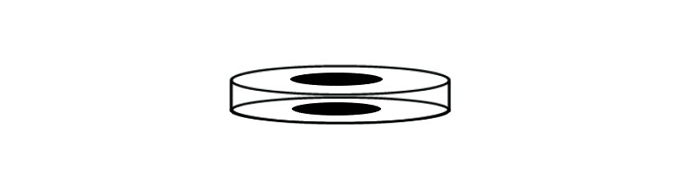
Dual composite cathode component film (bottom)

Dual composite cathode component film [top]

YSZ electrolyte pellet
Electrochemical Impedance Testing (EIS) at
700, 600 and 500 °C
Morphological properties (SEM):
Cross section (thickness)

Figure 1. Schematic diagram of the dual composite cathode symmetrical cell

Results and Discussion

Characterization of dual composite powders

The XRD patterns of LSCF/YSZ-SDC and LSCF/YSZ-SDCC powders with different electrolytes and electrolyte contents (YSZ-SDC and YSZ-SDCC) are shown in Figures 2(a) and (b), respectively. Both dual composites cathodes were compared with commercial LSCF, YSZ, SDC and SDCC. As shown in Figure 2, only three primary phases of the standard peaks of LCSF perovskite (JCPDS No 01-089-5720), SDC (JCPDS No 01-075-0157) and YSZ (JCPDS No 00-030-1468) were detected. The carbonate (Li/Na) peaks in the SDCC composite shown in Figure 2(b) yielded the crystallite peak of the pure fluorite structure of SDC, which is equivalent to the pure SDC structure. This result indicates that carbonates form an amorphous form, whereas SDC forms a well-defined fluorite crystal structure [8]. The SDCC peak was similar to the SDC pattern, as the addition of binary carbonates did not affect the shape and size of the original structures of the SDC particles. Li₂CO₃ and Na₂CO₃ were in molten amorphous states because the calcination temperature was over their melting temperatures [10]. Secondary phases were detected in the LSCF/YSZ-SDCC dual composite. Figure 2(c) shows the enlarged XRD pattern of the secondary phase identified as strontium carbonate (SrCO_{3,} JCPDS No. 00-005-0418). According to Rahman et al. (2020), this phenomenon is normally due to excessive power generated during the milling process of commercial LSCF powders, which caused the minor phase of SrCO₃ to form [11]. The formation of SrCO₃ impurity might be one of the reasons that caused the degradation of the electrochemical performances of the dual composite cathode cells owing to its incompatibility with the electrolyte material. A further analysis between the formation of impurities and the performances of dual composite cells need to be addressed more in the future.

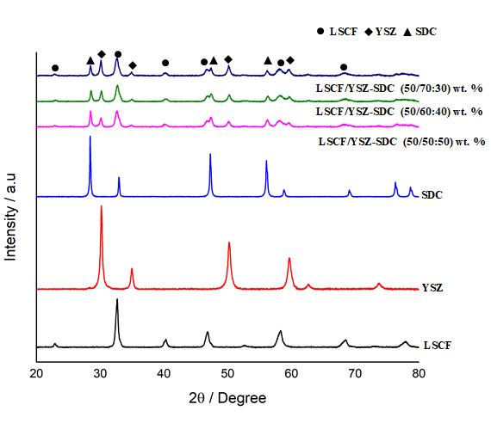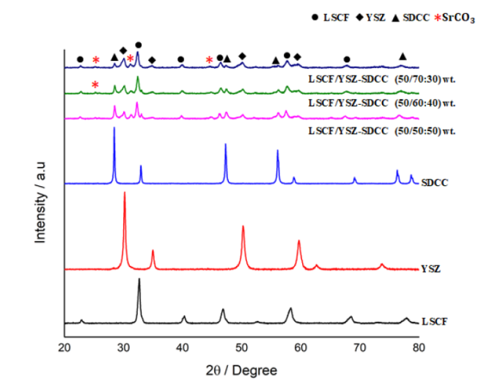
(b)
(a)

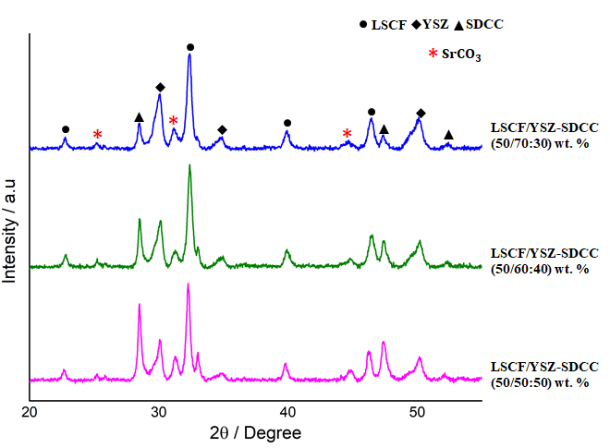
(c)

Figure 2. XRD patterns of (a) LSCF/YSZ-SDC and (b) LSCF/YSZ-SDCC dual composite cathode powders. (c) Peak enlargement for LSCF/YSZ-SDCC dual composite cathode powder

Microstructure analysis of dual composite cathode powders

The effect of various weight compositions (YSZ-SDC and YSZ-SDCC) on powder morphology after the incorporation with LSCF were further investigated via FESEM. Figures 3 and 4 show the FESEM micrographs of the LSCF/YSZ-SDC and LSCF/YSZ-SDCC dual composite cathodes. Well-distributed and fine particles were obtained in all dual composite cathode powders after HEBM. Fine particles in the range of 130–160 nm were observed. HEBM is a well-known technique used to synthesise nanocrystalline perovskites that exhibit an improvement in response ratios at low operating temperatures [12]. The particle sizes of the commercial powders of LSCF,YSZ and SDC, as well as those of the developed dual composite cathodes, are tabulated in Table 2. LYSC1 (159 nm) had the largest particle size, followed by LYSC2 (145 nm) and LYSC3 (135 nm). Similarly, amongst the LSCF/YSZ-SDC dual composites, LYS1 (147 nm) displayed a slightly larger particle size compared with LYS2 (138 nm) and LYS3 (126 nm). The prepared LSCF/YSZ-SDC and LSCF/YSZ-SDCC dual composite powders had smaller particles compared with commercial LSCF, YSZ and SDC powders. The decrease in size can be affected by the calcination process, as the calcination temperature directly influences the parameters [14]. The decrease in the average particle size of the dual composite powders was expected because the milling process creates mechanical energy to breakdown the particles into smaller size and creates a uniform mixture of solid contents [15]. However, a slight agglomeration was seen in the LYS3 dual composite powders. This finding indicates that the composition 70YSZ:30SDC is not suitable for the development of dual composite cathodes. As a result, the total polarisation resistance of LYS3 was the highest amongst the compounds. Parwaiz et al. reported that the improper selection of a sample parameter will induce unwanted phase transformation and undesirable material properties [16].

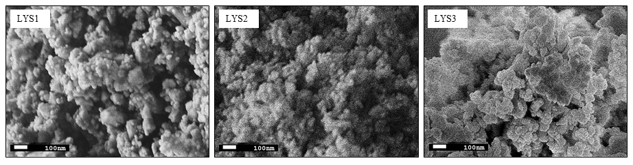

Figure 3. FESEM micrographs of the LSCF/YSZ-SDC dual composite cathode after HEBM and calcination at 50,000× magnification

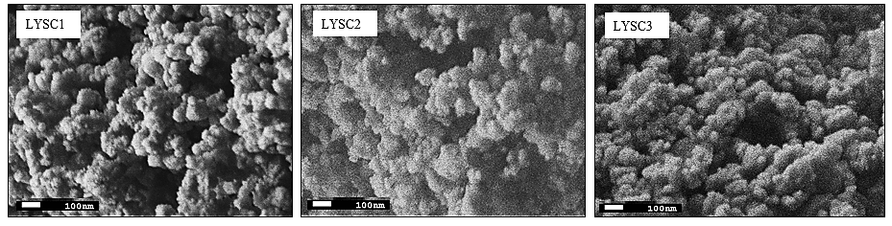

Figure 4. FESEM micrographs of the LSCF/YSZ-SDCC dual composite cathode after HEBM and calcination at 50,000× magnification

Table 2. Average particle sizes of the commercial and prepared dual composite powders
Powders | Average Particle Size (nm)
Commercial Powder LSCF | 567
Commercial Powder YSZ | 379
Commercial Powder SDC | 130
Prepared LSCF/YSZ-SDC (50/50:50 wt.%) | 147
Prepared LSCF/YSZ-SDC (50/60:40 wt.%) | 138
Prepared LSCF/YSZ-SDC (50/70:3 0wt.%) | 126
Prepared LSCF/YSZ-SDCC (50/50:50 wt.%) | 159
Prepared LSCF/YSZ-SDCC (50/60:40 wt.%) | 145
Prepared LSCF/YSZ-SDCC (50/70:30 wt.%) | 135

Microstructure analysis of dual composite cathode symmetrical cells

The printed surfaces and cross-sections of the LSCF/YSZ-SDC and LSCF/YSZ-SDCC pellets were observed through SEM and EDS as illustrated in Figure 5, Figure 6 and Figure 7. Figure 5 shows the secondary (SE) SEM images of the printed surfaces of the dual composite cathodes in the same magnification. Small pores were seen in all LSCF/YSZ-SDCs, whereas large pores were detected in the LSCF/YSZ-SDCCs. This outcome was probably because the binary carbonate reached the melting point as the sintering temperature (600 °C) during the preparation of the symmetrical cells was fixed. In addition, the porosity of the cathode should lie in the range of 20%–40% to achieve a better electrochemical performance [17]. The estimated average porosity for both dual composite cathodes was determined using SEM. The maximum porosity percentages of all LSCF/YSZ-SDC and LSCF/YSZ-SDCC dual composite cathodes were kept within the acceptable range. Table 3 shows the estimated averages porosity for the different compositions of the dual composite cathodes. The morphology of the pellets showed a regular distribution; however, the addition of carbonate as the solid content increased the roughness of the printed surface. The addition of a solid content helps increase the surface roughness by improving the elastic properties of the screen-printing ink [18]. As shown in Figure 5, a small crack was observed on the surface of the printed cathode films in the LYS3 and LYSC3 dual composite cathodes. Carbonate degradation might have led to the cracking phenomenon. Besides, a weak adhesion to the surface of the substrate during the deposition of the printed material is perhaps one of the reasons that caused the cracking surface [19].

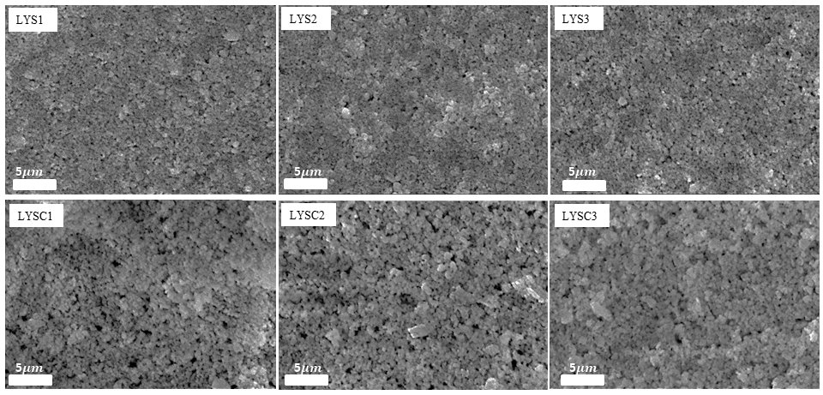
Crack
Crack
Pores
Pores
Small Pores
Small Pores

Figure 5. SEM micrographs for of the printed surfaces of (above) LSCF/YSZ-SDC and (below) LSCF/YSZ-SDCC at 10,000× magnification

Table 3. Average porosity of dual composite cathode symmetrical cells
Dual Composite Cathode | Average Porosity (%)
Dual Composite Cathode | 50/50:50 | 50/60:40 | 50/70:30
LSCF/YSZ-SDC | 20.22 | 25.91 | 25.07
LSCF/YSZ-SDCC | 23.85 | 26.29 | 25.86

Figure 6 and Figure 7 show the cross-section micrograph view and EDS spectra of LSCF/YSZ-SDC and LSCF/YSZ-SDCC dual composite cathode layer on YSZ electrolyte pellet by 10 times repetition using screen printing method. The EDS spectra presented all the elements consist of La, Sr, Co, Fe, Sm, Ce, Y, Zr, O and C from LSCF/YSZ-SDC dual composite cathode. Na element was detected from LSCF/YSZ-SDCC as the addition of the ${Na}_{2}{Co}_{3}$ carbonate existing in melting amorphous state however due to a very low energy characteristics radiation, element Li were not detected in EDS spectra analysis region

The screen-printing thickness of the dual composite cathode layer was uniform thickness for 10 times repetition for each layer. Table 4 shows the total thickness of each LSCF/YSZ-SDC and LSCF/YSZ-SDCC after the printing of 10 layers. The average thicknesses of the dual composite cathodes per printing are presented in Table 4. The thickest screen-printed layer was 45.6 μm for the LYSC3 composition. The thickness of the cathode layer using the LSCF/YSZ-SDCC ink seen wider compared with that of the LSCF/YSZ-SDC ink. The increase in thickness using the LSCF/YSZ-SDCC inks may be related to the improved elastic properties caused by the addition and increase in solid content [18]. The formulations for dual composite cathode ink are non-identical for each composition as the weight compositions (YSZ-SDC and YSZ-SDCC) are different. The powder volume of the final dual composite ink was <30 vol.% as suggested from a previous research to obtain good quality cathode inks [18]. Thus, the thickness of the screen-printing layer and the production of cathode inks are important as it can help improve cell performance [20].

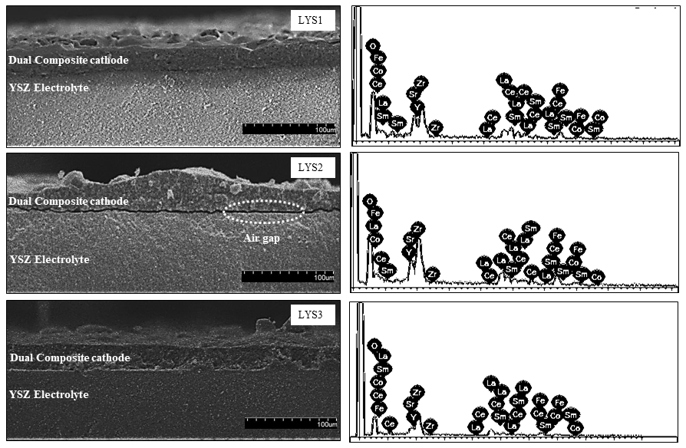
Figure 6. Cross-sectional micrographs and EDS spectra of screen-printed LSCF/YSZ-SDC cathode films

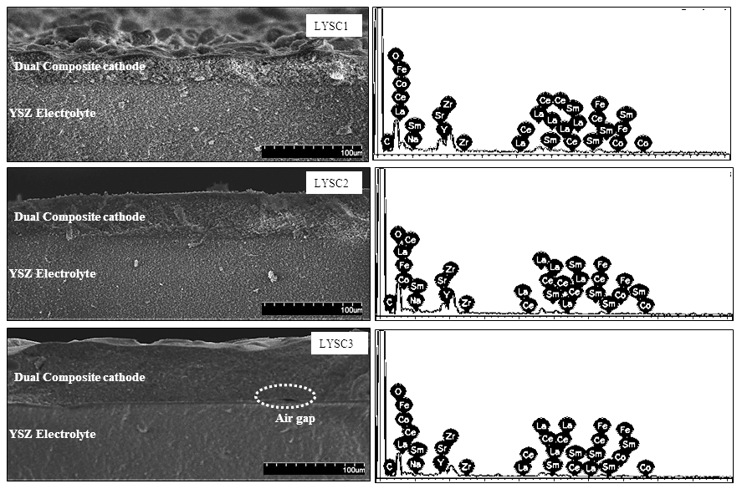
Figure 7. Cross-sectional micrographs and EDS spectra of screen-printed LSCF/YSZ-SDCC cathode films

Table 4. Screen printing thickness of the cathode layer
Dual Composite Cathode | Total Thickness  (μm) | Average Thickness per Printing  (μm)
LYS1 | 17.9 | 1.79
LYS2 | 16.3 | 1.63
LYS3 | 15.1 | 1.51
LYSC1 | 23.8 | 2.38
LYSC2 | 32.5 | 3.25
LYSC3 | 45.6 | 4.56

Electrochemical performance of the dual composite cathodes

The ionic conductivities of the symmetrical cells of LSCF/YSZ-SDC and LSCF/YSZ-SDCC were measured. Figures 8 and 9 show the impedance spectra of LSCF/YSZ-SDC and LSCF/YSZ-SDCC in an open circuit condition with a firing temperature from 700 °C to 500 °C in air. The impedance spectra were fitted, and the fitting results are shown in Table 5. The total polarization resistance of all cells showed a decrement with the increment in operating temperature (500–700 °C). In addition, the ionic conductivities of the dual composite cathodes were calculated using equation below.

Ionic conductivity formula:
$σ=\frac{1}{ρ}=\left( \frac{1}{R} \right)x ( \frac{A}{d} )$ (1)
where: $σ:$ Conductivity, d: Thickness of the sample (cm), R: Resistance (Ω), A: Effective area (cm²), and $ρ:$ Resistivity (Ωm).

LYS2 (0.080×10⁻⁵ S cm⁻¹) yielded the highest ionic conductivity for the LSCF/YSZ-SDC parameter, whereas LYSC1 (0.410×10⁻⁵ S cm⁻¹) attained the greatest ionic conductivity for the LSCF/YSZ-SDCC parameter. Both dual composite cathodes yielded the best ionic conductivity at 700 °C. LYSC1 (307 kΩ) showed the lowest polarization resistance, followed by LYSC2 (37.90 kΩ) and LYSC3 (39.20 kΩ), at 700 °C. Unfortunately, the recorded polarization resistance values were not favorable, as the resistance was too high, and the ionic conductivity was extremely low. Nonetheless, this finding proved that the conductivity and polarization resistance of LSCF/YSZ-SDCC was slightly better compared with those of the dual composite cathodes without the addition of binary carbonate. This finding was also coherent with the findings of previous research, which reported that binary carbonates are able to enhance the electrochemical performances. [11-12] .

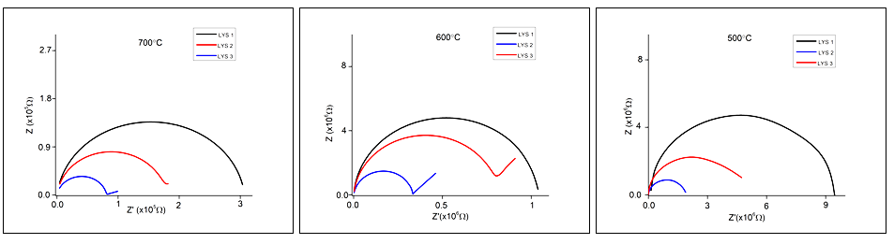

Figure 8. Impedance spectra of LSCF/YSZ-SDCC at 700, 600 and 500 °C

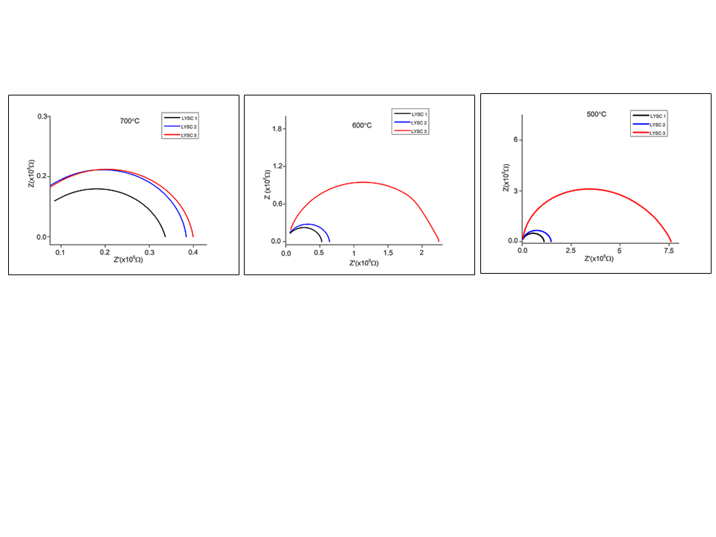

Figure 9. Impedance spectra of LSCF/YSZ-SDCCC at 700, 600 and 500 °C

Table 5. Polarization resistance and conductivity of the dual composite cathodes from 700 °C to 500 °C
Temperature | Samples | Total Resistance, (R_{total})  [kΩ] | Conductivity, (σ)  [×10⁻⁵ S cm⁻¹]
700 °C | LYS1 | 307.0 | 0.042
700 °C | LYS2 | 159.90 | 0.080
700 °C | LYS3 | 3.61×10³ | 0.004
700 °C | LYSC1 | 31.10 | 0.410
700 °C | LYSC2 | 37.90 | 0.336
700 °C | LYSC3 | 39.20 | 0.325
600 °C | LYS1 | 1.04×10³ | 0.012
600 °C | LYS2 | 666.0 | 0.019
600 °C | LYS3 | 8×10³ | 0.0016
600 °C | LYSC1 | 52.50 | 0.2426
600 °C | LYSC2 | 63.60 | 0.2003
600 °C | LYSC3 | 222.0 | 0.0574
500 °C | LYS1 | 9.31×10³ | 0.0014
500 °C | LYS2 | 6.39×10³ | 0.0020
500 °C | LYS3 | 16.1×10³ | 0.0008
500 °C | LYSC1 | 111.0 | 0.1148
500 °C | LYSC2 | 148.0 | 0.0861
500 °C | LYSC3 | 759.0 | 0.0168

The high ionic conductivity for excellent fuel cell performance at the intermediate- to low-temperature region is in the range of 0.01–1 S${cm}^{-1}$[21]. The data gathered in this study show that the obtained ionic conductivity is not within the acceptable range. Some factors possibility affected the performances of the LSCF/YSZ-SDC and LSCF/YSZ-SDCC cells. The first factor was the selection of sintering temperature during the preparation of the symmetrical cells. The sintering temperature for a YSZ material is 1300–1600 °C; therefore, 1400 °C was chosen as the sintering temperature for SOFC application [22]. In addition, selecting the appropriate temperature for a material is crucial, as high conductivity is achieved when the operating temperature is above the melting point of the material [23]. Besides the selection of sintering temperature, the development of symmetrical cells is considered one of the reasons for the low ionic conductivity. For example, during the cross-sectional analysis, the dual composite ink was not well screen printed on the surface of the YSZ pellet. This poor application may trap air between the cathode and electrolyte layers. During the printing process, parameters, including printing repetition layer, squeegee-related parameters, printing angle and forces exerted during the screen-printing process, influence the quality of the printed layer [20].

Conclusion

The current study presented the development of new dual composite cathodes, namely, LSCF/YSZ-SDC and LSCF/YSZ-SDC carbonate, for use in intermediate-temperature SOFC application. The main objective was to enhance the electrochemical performances of LSCF/YSZ-GDC and LSM/GDC-YSZ, which remains a challenge owing to the poor ionic conductivities of LSCF/YSZ-SDC and LSCF/YSZ-SDCC. However, this study proved that the addition of the Li/Na binary carbonate helped increase the ionic conductivity and showed a better electrochemical performance compare with LSCF/YSZ-SDC.

Acknowledgement

The research was supported by the Ministry of Higher Education of Malaysia through funding under the Fundamental Research Grant Scheme (FRGS/1/2020/TK0/UTHM/02/15) and partially funded by Universiti Tun Hussein Onn Malaysia under the Collaborative Research Grant (CRG K260) and Postgraduate Research Grant (GPPS H577).

References
- Udomsilp, D., Thaler, F., Menzler, N. H., Bischof, C., de Haart, L. G. J., Opitz, A. K. and Bram, M.(2019). Dual-phase cathodes for metal-supported solid oxide fuel cells: Processing performance, durability. Journal of the Electrochemical Society, 166(8): F506.
- Rahman, N. F. A., Rahman, H. A and Azmi, M. A. (2021). Perovskite-type oxide-based dual composite cathode for solid oxide fuel cells: A short review. Solid State Phenomena, 317: 417-425.
- Ko, H. J., Myung, J. H., Hyun, S. H. and Chung, J. S. (2012). Synthesis of LSM–YSZ–GDC dual composite SOFC cathodes for high-performance power-generation systems. Journal of Applied Electrochemistry, 42(4): 209-215.
- Ko, H. J., Myung, J. H., Lee, J. H., Hyun, S. H. and Chung, J. S. (2012). Synthesis and evaluation of (${La}_{0.6}{Sr}_{0.4})({Co}_{0.2}{Fe}_{0.8})O_{3}$ (LSCF)-$Y_{0.08}{Zr}_{0.92}O_{1.96}$ (YSZ)-${Gd }_{0.1}{Ce}_{0.9}O_{2-δ}$ (GDC) dual composite SOFC cathodes for high performance and durability. International Journal of Hydrogen Energy, 37(22): 17209-17216.
- Railsback, J., Choi, S. H. and Barnett, S. A. (2019). Effectiveness of dense Gd-doped ceria barrier layers for (La,Sr)(Co,Fe)$O_{3}$ cathodes on Yttria-stabilized zirconia electrolytes. Solid State Ionics, 335: 74-81.
- Fergus, J., Hui, R., Li, X., Wilkinson, D. P and Zhang, J. (2016). Solid oxide fuel cells: Materials properties and performance. CRC press.
- Rahman, H. A., Ng, K. H., Ahmad, S., Taib, H., Mahzan, S., Salleh, S. M. and Muchtar, A. (2019, March). Influence of microstructure on the electrochemical behaviour of LSCF-SDCC. In IOP Conference Series: Materials Science and Engineering, 494(1): 012062.
- Mohammad, S. F., Ahmad, S., Rahman, H. A. and Muchtar, A. (2019). Effect of SSC Loading on the microstructural stability SSC-SDCC composite cathode as new potential SOFC. International Journal of Integrated Engineering, 11(7): 162-168.
- Somalu, M. R., Muchtar, A., Daud, W. R. W. and Brandon, N. P. (2017). Screen-printing inks for the fabrication of solid oxide fuel cell films: a review. Renewable and Sustainable Energy Reviews, 75: 426-439.

- Huang, J., Gao, Z. and Mao, Z. (2010). Effects of salt composition on the electrical properties of samaria-doped ceria/carbonate composite electrolytes for low-temperature SOFCs. International Journal of Hydrogen Energy, 35(9): 4270-4275.
- Abd Rahman, H., Agun, L., Hoa, N. K., Ahmad, S. and Nordin, N. A. (2020). Effects of binary (lithium/natrium$)_{2}$ carbonates on the phase and microstructural stability of LSCF-SDC for low temperature solid oxide fuel cells. Sains Malaysiana, 49(12): 3155-3167.
- Mohammad, S. F., Ahmad, S., Rahman, H. A. and Muchtar, A. (2019). Effect of SSC loading on the microstructural stability SSC-SDCC composite cathode as new potential SOFC. International Journal of Integrated Engineering, 11(7): 162-168.
- Ghasdi, M. and Alamdari, H. (2010). CO sensitive nanocrystalline ${LaCoO}_{3}$ perovskite sensor prepared by high energy ball milling. Sensors and Actuators B: Chemical, 148(2): 478-485.
- Baharuddin, N. A., Abd Rahman, H., Muchtar, A., Sulong, A. B. and Abdullah, H. (2013). Development of lanthanum strontium cobalt ferrite composite cathodes for intermediate-to low-temperature solid oxide fuel cells. Journal of Zhejiang University Science A, 14(1): 11-24.
- Gao, D., Zhao, J., Zhou, W., Ran, R. and Shao, Z. (2011). Influence of high-energy ball milling of the starting powder on the sintering; microstructure and oxygen permeability of ${Ba}_{0.5}{Sr}_{0.5}{Fe}_{0.5}O_{3-δ}$ membranes. Journal of Membrane Science, 366(1-2): 203-211.
- Parwaiz, S., Khan, M. M. and Pradhan, D. (2019). ${CeO}_{2}$-based nanocomposites: An advanced alternative to TiO₂ and ZnO in sunscreens. Materials Express, 9(3): 185-202.
- Lu, X., Heenan, T. M., Bailey, J. J., Li, T., Li, K., Brett, D. J. and Shearing, P. R. (2017). Correlation between triple phase boundary and the microstructure of solid oxide fuel cell anodes: The role of composition, porosity and Ni densification. Journal of Power Sources, 365: 210-219.
- Somalu, M. R., Muchtar, A., Daud, W. R. W. and Brandon, N. P. (2017). Screen-printing inks for the fabrication of solid oxide fuel cell films: a review. Renewable and Sustainable Energy Reviews, 75: 426-439.
- Zhang, J. and Jung, Y. G. (2018). Advanced ceramic and metallic coating and thin film materials for energy and environmental applications Berlin: Springer: pp. 20.
- Baharuddin, N. A., Abdul Rahman, N. F., Abd. Rahman, H., Somalu, M. R., Azmi, M. A. and Raharjo, J. (2020). Fabrication of high‐quality electrode films for solid oxide fuel cell by screen printing: a review on important processing parameters. International Journal of Energy Research, 44(11): 8296-8313.
- Chen, Y., Lin, Y., Zhang, Y., Wang, S., Su, D., Yang, Z. and Chen, F. (2014). Low temperature solid oxide fuel cells with hierarchically porous cathode nano-network. Nano Energy, 8: 25-33.
- Talebi, T., Haji, M. and Raissi, B. (2010). Effect of sintering temperature on the microstructure, roughness and electrochemical impedance of electrophoretically deposited YSZ electrolyte for SOFCs. International Journal of Hydrogen Energy, 35(17): 9420-9426.
- Ali, S. M., Muchtar, A., Sulong, A. B., Muhamad, N. and Majlan, E. H. (2013). Influence of sintering temperature on the power density of samarium-doped-ceria carbonate electrolyte composites for low-temperature solid oxide fuel cells. Ceramics International, 39(5): 5813-5820.

