

SYNTHESIS OF ZnO ON 3D GRAPHENE/NICKEL FOAM FOR PHOTOELECTROCHEMICAL WATER SPLITTING

(Sintesis ZnO pada 3D Grafin/Busa Nikel untuk Pembelahan Molekul Air Secara Fotoelektrokimia)

Nur Rabiatul Adawiyah Mohd Shah, Rozan Mohamad Yunus*, Nurul Nabila Rosman, Wai Yin Wong,

Khuzaimah Arifin, Lorna Jeffery Minggu

Fuel Cell Institute,

Universiti Kebangsaan Malaysia, 43600 UKM Bangi, Selangor, Malaysia

*Corresponding author: rozanyunus@ukm.edu.my

Received: 13 December 2021; Accepted: 27 February 2022; Published: xx June 2022

Abstract

Photoelectrochemical (PEC) water splitting is a promising method that involves a direct route to produce green hydrogen (H₂). An efficient semiconductor photoelectrode that has a suitable band gap between the valence and conduction band is stable in an aqueous solution and cost-effective. Efficient charge transfer and outstanding light absorption are required to achieve enhanced PEC water splitting performance. However, the wide band gap of current photoelectrode such as zinc oxide (ZnO) limits their ability to transport electron, causing photogenerated electron–hole pair recombination and poor PEC performance. This study aims to design an efficient photoelectrode by incorporating a three-dimensional (3D) graphene with ZnO, where 3D graphene serves as a co-catalyst/support to enhance the photocatalytic activity of ZnO. The 3D graphene was first synthesized on nickel foam (Ni-foam) via chemical vapor deposition method with the flow of argon, H₂, and methane gas flow in a quartz tube, followed by the growth of ZnO via a hydrothermal method at 150 °C and 200 °C. FESEM, EDX and Raman confirmed the successful growth of ZnO on 3D graphene/Ni-foam. The flower-like ZnO was observed by FESEM after the hydrothermal method, and the highest photocurrent density was measured at 150 °C (108.2 mA cm⁻²). Therefore, flower-like ZnO flower-like on 3D graphene/Ni-foam can be used as an efficient semiconductor photoelectrode in PEC water splitting.

Keywords: 3D graphene, zinc oxide, photoelectrode, photoelectrochemical water splitting

Abstrak

Pembelahan molekul air secara fotoelektrokimia (PEC) merupakan kaedah yang menggunakan laluan yang mudah untuk menghasilkan hidrogen (H₂). Fotoelektrod semikonduktor yang cekap mempunyai jurang jalur yang sesuai antara jalur valensi dan konduksi, stabil dalam larutan berair dan kos yang rendah. Pemindahan cas yang cekap dan penyerapan cahaya yang baik diperlukan untuk mencapai prestasi pembelahan molekul air PEC yang tinggi. Walau bagaimanapun, jurang jalur fotoelektrod yang lebar seperti zink oksida (ZnO) menghadkan kebolehannya untuk pengangkutan elektron, menyebabkan penggabungan semula lubang–elektron terjana dan prestasi PEC yang rendah. Kajian ini bertujuan untuk merekacipta fotoelektrod yang cekap dengan menggabungkan tiga-dimensi (3D) grafin dengan ZnO, di mana 3D grafin bertindak sebagai pemangkin bersama/sokongan untuk meningkatkan aktiviti fotokatalitik ZnO. 3D grafin disintesis pada busa nikel (busa-Ni) melalui kaedah pemendapan wap kimia dengan aliran gas argon, H₂ dan metana dalam tiub kuarza, diikuti dengan pertumbuhan ZnO melalui kaedah hidrotherma pada 150 °C and 200 °C. FESEM, EDX dan Raman mengesahkan pertumbuhan ZnO pada 3D grafin/busa-Ni. Pertumbuhan ZnO seperti bunga dapat dilihat dengan alat FESEM selepas melalui kaedah hidrotherma dan ketumpatan foto arus yang tinggi diukur pada suhu 150 °C (108.2 mA cm⁻²). Oleh itu, ZnO berbentuk seperti bunga pada 3D grafin/busa-Ni boleh digunakan untuk fotoelektrod semikondutor yang cekap dalam pembelahan air secara PEC.

Kata kunci: 3D grafin, zink oksida, fotoelektrod, pembelahan molekul air secara fotoelektrokimia.

Introduction

Photoelectrochemical (PEC) water splitting is a potential technology that involves a direct route using sunlight and water to produce green hydrogen (H₂) for a variety of applications [1, 2]. Water is a primary source of H₂, and the consumption and cycle of H₂ are in a continuous loop. In addition, as compared to a photovoltaic-electrolysis system, the PEC system is simple and space saving with fewer components [3]. However, current solar-to-hydrogen (STH) efficiencies of the PEC system, 16.2% produced by a multijunction semiconductor, are insufficient compared with existing technologies. Thus, continuous, high-efficiency, and sustainable photocatalytic H₂ evolution from water without the assistance of electron donors with STH values greater than 10% is necessary [4–6].

In general, semiconductor materials with an appropriate band gap are often used as photoelectrode for light absorption in the PEC system. Nevertheless, not all semiconductors fulfill the band gap requirements for overall water splitting, which require the conduction band (CB) to be more negative than the reduction potential of water to produce H₂ and the valence band to be more positive than the oxidation potential of water to produce oxygen [7, 8]. The wide band gap of current photoelectrode, such as zinc oxide (ZnO), which is approximately 3.37 eV, inhibits the ability to transport electrons, resulting in the recombination of photogenerated electron–hole pairs [9–11]. Hence, three-dimensional (3D) graphene with a high surface area, high conductivity, and fast charge carrier transport as a co-catalyst/support can overcome the limitations of ZnO by extending the light absorption range and improving charge separation and transportation properties [12, 13].

In this work, 3D graphene was synthesized on nickel foam (Ni-foam) using chemical vapor deposition (CVD) method, followed by hydrothermal method to synthesize ZnO on 3D graphene/Ni-foam by using two different reaction temperature (150 °C and 200 °C) for 2 hours (Figure 1). The photocatalytic performance of 3D graphene/Ni-foam hierarchical flower-like ZnO exhibits a large surface area that can increase the charge separation efficiency, resulting in excellent photocatalytic performance.

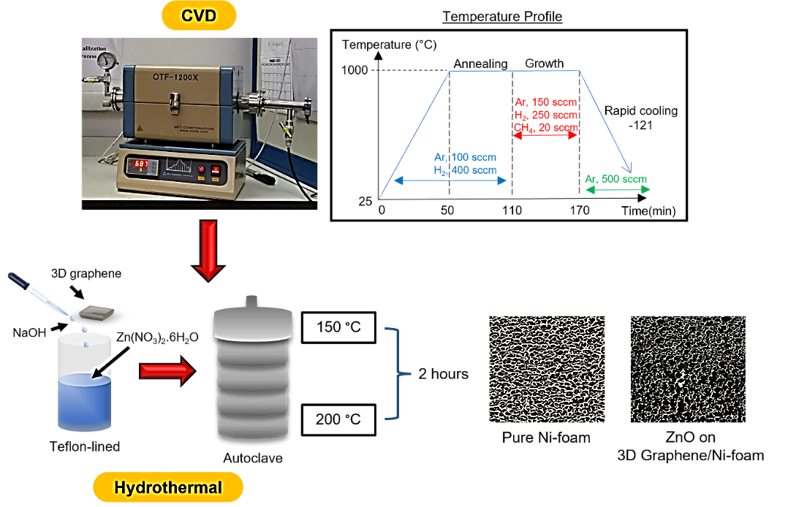
Figure 1. Schematic illustration for preparation of ZnO on 3D graphene/Ni-foam

Materials and Methods

Preparation of three-dimensional (3D) graphene

The nickel foam (Ni-foam; 1.5 cm x 1.5 cm x 0.16 cm, Brand TOB) was used as a template to grow graphene via chemical vapor deposition (CVD) method. Acetone, ethanol, and deionized water were used during ultrasonic cleaning and dried using nitrogen blow. Then, the Ni-foam was placed in the center of the quartz tube and heated up to 1000 °C for 50 min at 20 °C/min. The temperature was maintained for another 60 min with argon (Ar, 100 sccm) and H₂/Ar (400 sccm) gas flow. For 60 min of growth time, methane (CH₄) with 20 sccm gas flow was introduced as the carbon source. The sample is rapidly cooled to room temperature.

Synthesis of 3D Graphene/ZnO on nickel foam (Ni-foam)

Zinc nitrate hexahydrate (Zn(NO₃)₂.6H₂O), sodium hydroxide (NaOH) from Sigma-Aldrich, and deionized water were used throughout the experiment. 0.5 M Zn(NO₃)₂.6H₂O solutions were prepared in 30 mL deionized water under stirring for 30 min. Simultaneously, 5 M NaOH solutions were prepared in 30 mL deionized water under stirring for the same duration. Zn(NO₃)₂.6H₂O solution was transferred to a sealed Teflon-lined stainless-steel autoclave. Next, 3 drops of NaOH solution were added to the former solution to change the pH of the reactants, and the 3D graphene/Ni-foam was immersed into the reaction before being kept in a box furnace at 150 °C and 200 °C for 2 hours. Finally, the autoclave was taken outside, and the as-sample were dried for 2 hours at 80 °C.

Characterization techniques

Raman analysis was conducted using DXR2xi, Thermo Scientific, to confirm the presence of graphene on Ni foam. The morphology of the samples was examined by field emission scanning electron microscopy (FESEM) and energy dispersive X-ray (EDX) analysis to confirm the existence of graphene and ZnO (Carl Zeiss/GeminiSEM 500).

Photocatalytic measurements

UV-Vis Spectroscopy (Perkin Elmer/Lambda 35) was used to evaluate the band gap energy for ZnO on 3D graphene/Ni-foam at 150 °C and 200 °C for 2 hours. A three-electrode system was used to study the photocurrent of the as-samples, where the working electrode is ZnO on 3D graphene/Ni-foam, the counter electrode is Pt wire, and the reference electrode is Ag/AgCl (3.0 M KCl). A 0.5 M sulfuric acid (H₂SO₄) aqueous solution was used as the electrolyte, and it was purged with nitrogen before testing. 100 mW cm⁻² Xe lamp was used as the light source, and the area of the ZnO on 3D graphene/Ni-foam exposed to light was 1.5 cm².

Result and Discussion

Typically, 3D graphene can be synthesized by using CVD method based on the previous study [14]. FESEM was used to study the physical and structural characteristics of the resulting 3D graphene/Ni-foam, ZnO on 3D graphene/Ni-foam, and ZnO nanoparticles, as shown in Figure 2(a). Combining 3D graphene with metal oxide like ZnO can enhance the PEC performance through shifting the band gap energy, lowering electron–hole pair recombination, increasing charge separation efficiency, and producing smaller particle size with larger surface area [15]. Figure 2(b – c) shows the FESEM image of pristine graphene taken after the CVD growth. Two different color contrasts were observed on the image where the dark contrast corresponds to graphene, which will be validated through Raman and EDX analysis. The hydrothermal method was then performed to develop ZnO on 3D graphene/Ni-foam at 150 °C and 200 °C. The morphological images of flower-like ZnO on 3D graphene/Ni-foam in Figure 2(d – e) demonstrate a high coverage area of ZnO on 3D graphene/Ni-foam. During the hydrothermal process, ZnO nanoparticles were formed (Figure 2(f – g)), and the presence of graphene influenced the growth of hierarchical flower-like ZnO structures. The mechanism of flower-like ZnO was well explained in previous study [16].

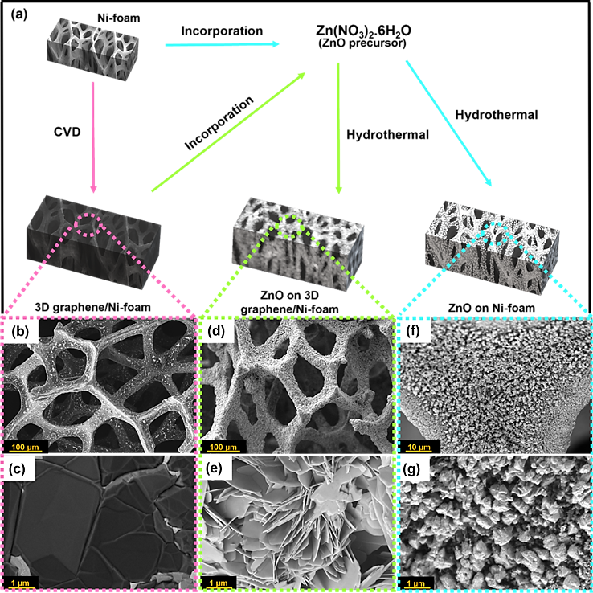
Figure 2. (a) Schematic illustration of the prepared sample. FESEM image of (b – c) 3D graphene/Ni-foam, (d – e) ZnO on 3D graphene/Ni-foam, and (f – g) ZnO on Ni-foam at the low and high magnification, respectively.

Raman spectra for 3D graphene/Ni-foam (Figure 3(a)) were determined. Two graphene fingerprint peaks, including G and 2D bands at ~1581 and ~2700 cm⁻¹, respectively, were observed (Figure 3(b)). The graphene is successfully growth with high quality as there is no D band (~1350 cm⁻¹) observed, in which the D band corresponds to the disorder and defect in graphene [17]. Thus, a sample at low temperature (150 °C) was selected to confirm the successful growth of ZnO using EDX mapping due to the good coverage and flower-like structure of ZnO. As shown in Figure 3(c – d), the existence of carbon (C), zinc (Zn), oxygen (O) and nickel (Ni) indicates the successful growth of ZnO using the hydrothermal method.

Photocatalysts with a narrow band gap can harvest visible light and generate excellent efficiency in photocatalytic applications. The reflectance spectra and Kubelka-Munk plot were used to determine the band gap energy for pure Ni-foam, 3D graphene/Ni-foam and ZnO on 3D graphene/Ni-foam at 150 °C and 200 °C at 2 hours, respectively. Figure 4(a) shows a significance decrease around 380 nm. This decrease is related to the electron transitions occurring the optical band gap. The Kubelka-Munk function was used to convert the UV-Vis reflectance spectrum to measure the precise value of the band gap. As a result, the band gap energy of pure Ni-foam and 3D graphene/Ni-foam are E_{g}= 3.217 eV and ZnO on 3D graphene/Ni-foam at 150 °C and 200 °C for 2 hours are E_{g}= 3.218 eV, respectively (Figure 4(b)). There are no significance changes of band gap energy with the introduction of ZnO. However, the presence of ZnO enhances the photocatalytic performance, where the highest photocurrent density is achieved with ZnO on 3D graphene/Ni-foam at 150 °C, approximately 108.2 mA cm⁻² (Figure 4(c)). Considering that the coverage of ZnO for 150 °C is larger than that for 200 °C, the structure of ZnO starts to agglomerate with the increase of temperature to 200 °C, thereby decreasing the surface area and resulting in a low photocurrent density [18]. In addition, the electron transfer rate of reaction for all samples is evaluated. Electrochemical impedance spectroscopic (EIS) analysis (Figure 4(d)) demonstrates that ZnO on 3D graphene/Ni-foam at 150 °C has the smallest arc radius of a semicircle, implying that the sample experienced faster interfacial electron charge transfer. This finding could be explained by the porous structure of 3D graphene, which has a large surface area, excellent mechanical and electrical properties, good electron transport, and electron–hole separation, making them suitable for PEC applications [7,8,14]. As shown in Table 1, ZnO on 3D graphene/Ni foam shows higher photocurrent density as compared with other conventional methods and materials for PEC water splitting.

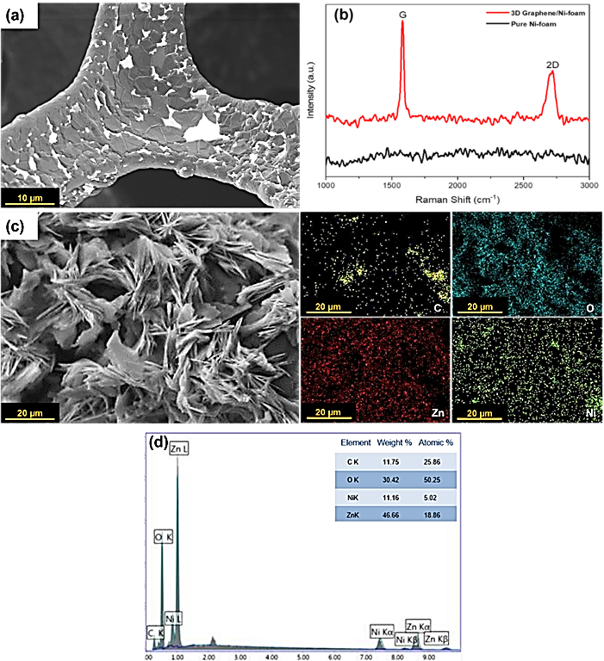

Figure 3. (a) FESEM image and (b) Raman spectra of 3D graphene/Ni-foam. EDX (c) mapping and (d) analysis of ZnO on 3D graphene/Ni-foam at 150 °C for 2 hours
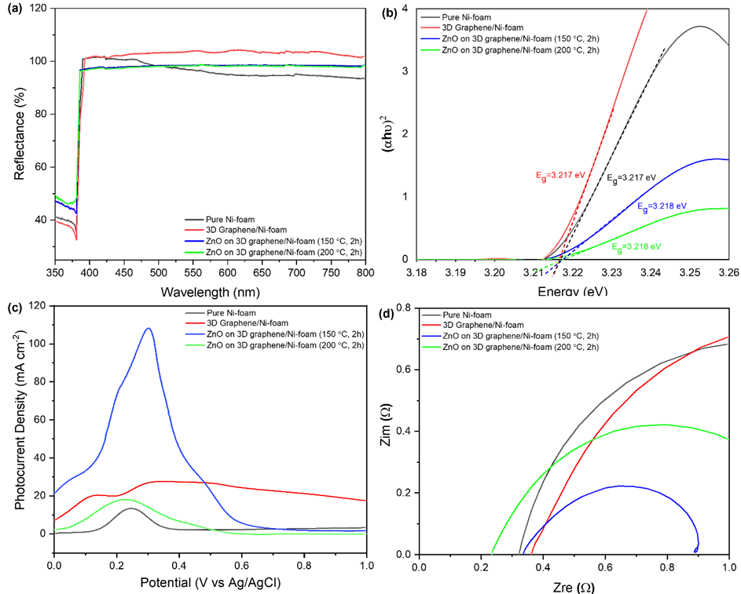

Figure 4. (a) Diffuse reflectance spectra, (b) Kubelka-Munk plot, (c) Photocurrent density at 0.0 – 1.0 V vs Ag/AgCl and (d) EIS analysis using Nyquist plot for pure Ni-foam, 3D graphene/Ni-foam, ZnO on 3D graphene/Ni-foam at 150 °C and 200 °C for 2 hours

Table 1. PEC performance of modified ZnO using various methods
Materials | Methods | Structures of ZnO | Photocurrent Densities (mA cm⁻²) | Reference
ZnO on 3D graphene/Ni-foam | CVD and hydrothermal | Flower-like | 108.2 at 0 – 1.0 V vs Ag/AgCl | This work
ZnO-C@Ni-foam | Hydrothermal | Mixed of nanorods and flower-like | 100 at 0 – 0.9 V vs Ag/AgCl | [19]
ZnO@Ni-foam | Hydrothermal | Mixed of nanorods and flower-like | 30 at 0 – 0.9 V vs Ag/AgCl | [19]
ZnO/rGO foam | One-step hydrothermal | Nanorods | 0.27 at 1.0 V vs Ag/AgCl | [20]

Figure 5 illustrates a possible mechanism for efficient electron transport in ZnO on 3D graphene/Ni-foam based on the results of the PEC test. When sunlight illuminates ZnO on 3D graphene/Ni-foam, electrons in the VB of ZnO are excited to jump to the CB using 3D graphene/Ni-foam as a co-catalyst/support. Hydrogen was produced on the surface of ZnO and 3D graphene/Ni-foam. The incorporation of 3D graphene/Ni-foam provides a good electron transport channel in the ZnO on 3D graphene/Ni-foam structure.

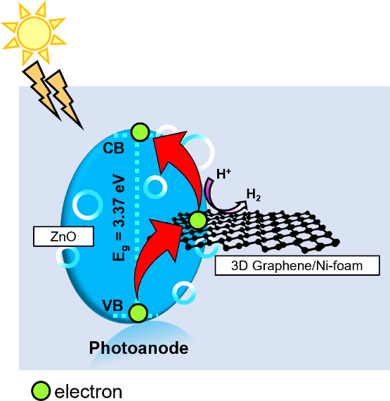
Figure 5. Schematic illustration of PEC water splitting using ZnO on 3D graphene/Ni-foam.

Conclusion

ZnO on 3D graphene/Ni-foam was successfully synthesized by a two-step approach, CVD and hydrothermal methods. The highest photocurrent density was achieved at 150 °C for 2 hours (108.2 mA cm⁻²). Therefore, a photoelectrode with a high surface area, which provides more active sites, can enhance the photocatalytic performance by increasing charge separation efficiency. Thus, ZnO on 3D graphene/Ni-foam could be a potential photoelectrode for PEC water splitting.

Acknowledgement

This work is funded by Ministry of Higher Education (MOHE) and Universiti Kebangsaan Malaysia (UKM) through FRGS/1/2019/STG07/UKM/02/2 and DIP-2019-020, respectively. The authors would also like to express their gratitude to all UKM staff and technicians who contributed to this study, especially from the Fuel Cell Institute and Faculty of Science and Technology.

References
- Li, Y. and Tsang, S. C. E. (2020). Recent progress and strategies for enhancing photocatalytic water splitting. Mater. Today Sustain., 9: 100032.
- Li, X., Zhao, L., Yu, J., Liu, X., Zhang, X., Liu, H. and Zhou, W. (2020). Water splitting: From electrode to green energy system. Nano-Micro Letters, Springer Singapore 12.
- Dias, P. and Mendes, A. (2018). Hydrogen production from photoelectrochemical water splitting. In encyclopedia of sustainability science and technology (Meyers, R. A., ed.). Springer New York, New York: pp 1-52.

- Cao, S., Piao, L. and Chen, X. (2020). Emerging photocatalysts for hydrogen evolution. Trends Chemistry, Elsevier Inc. 2: pp. 57-70.
- Hisatomi, T. and Domen, K. (2019). Reaction systems for solar hydrogen production via water splitting with particulate semiconductor photocatalysts. Nature Catalyst, 2: 387-399.
- Young, J. L., Steiner, M. A., Döscher, H., France, R. M., Turner, J. A. and Deutsch, T. G. (2017). Direct solar-to-hydrogen conversion via inverted metamorphic multi-junction semiconductor architectures. Nature Energy, 2: 1-8.
- Kuang, P., Sayed, M., Fan, J., Cheng, B. and Yu, J. (2020). 3D graphene-based H₂-production photocatalyst and electrocatalyst. Advance Energy Materials, 10: 1-53.
- Mohd Shah, N. R. A., Mohamad Yunus, R., Rosman, N. N., Wong, W. Y., Arifin, K. and Jeffery Minggu, L. (2021). Current progress on 3D graphene-based photocatalysts: From synthesis to photocatalytic hydrogen production. International Journal Hydrogen Energy, 46: 9324-9340.
- Gowtham, M., Chandrasekar, S., Mohanraj, C. and Senthil Kumar, N. (2020). Morphology dependent photocatalytic activity of ZnO nanostructures-A short review. NanoNEXT, 1: 30-38.
- Baruah, S. and Dutta, J. (2009). Hydrothermal growth of ZnO nanostructures. Science Technology Advance Materials, 10: 013001.
- Vaseem, M., Umar, A. and Hahn, Y. (2010). ZnO nanoparticles: Growth, properties, and applications. Metal Oxide Nanostructures Their Applications, 5: 1-36.
- Singh, P., Shandilya, P., Raizada, P., Sudhaik, A., Rahmani-Sani, A. and Hosseini-Bandegharaei, A. (2020). Review on various strategies for enhancing photocatalytic activity of graphene based nanocomposites for water purification. Arabian Journal Chemistry, 13: 3498-3520.
- Gao, C., Zhong, K., Fang, X., Fang, D., Zhao, H., Wang, D., Li, B., Zhai, Y., Chu, X. and Li, J. (2021). Brief review of photocatalysis and photoresponse properties of ZnO–graphene nanocomposites. Energies, 14: 6403.
- Mohd Shah, N. R. A., Rosman, N. N., Wong, W. Y., Arifin, K., Jeffery Minggu, L. and Mohamad Yunus, R. (2021). Effect of annealing time on chemical vapor deposition growth of 3D graphene for photoelectrochemical water splitting. Material Today Proceeding, 57(3): 1215-1219.
- Ong, C. B., Ng, L. Y. and Mohammad, A. W. (2018). A review of ZnO nanoparticles as solar photocatalysts: Synthesis, mechanisms and applications. Renewable Sustainable Energy Review, 81: 536–551.
- Mohamed, M. A., M. Zain, M. F., Jeffery Minggu, L., Kassim, M. B., Jaafar, J., Saidina Amin, N. A., Mastuli, M. S., Wu, H., Wong, R. J. and Ng, Y. H. (2019). Bio-inspired hierarchical hetero-architectures of in-situ C-doped g-C3N4 grafted on C, N co-doped ZnO micro-flowers with booming solar photocatalytic activity. Journal Industry Engineering Chemistry, 77: 393-407.
- Wang, W. X., Zhang, S. C., Xing, Y. L., Wang, S. B. and Ren, Y. B. (2016). The closed-environment CVD method for preparing three-dimensional defect controllable graphene foam with a conductive interconnected network for lithium-ion battery applications. RSC Advance, 6: 75414-75419.
- Ghorbani, M., Abdizadeh, H., Taheri, M. and Golobostanfard, M. R. (2018). Enhanced photoelectrochemical water splitting in hierarchical porous ZnO/Reduced graphene oxide nanocomposite synthesized by sol-gel method. Int. J. Hydrogen Energy, 43, 7754–7763.
- Gadisa, B. T., Baye, A. F., Appiah-Ntiamoah, R. and Kim, H. (2021). ZnO@Ni foam photoelectrode modified with heteroatom doped graphitic carbon for enhanced photoelectrochemical water splitting under solar light. International Journal Hydrogen Energy, 46: 2075-2085.
- Men, X., Chen, H., Chang, K., Fang, X., Wu, C., Qin, W. and Yin, S. (2016). Three-dimensional free-standing ZnO/graphene composite foam for photocurrent generation and photocatalytic activity. Applied Catalyst B Environment, 187: 367-374.

