

THE CHEMICAL PROPERTIES AND ANTI-ACNE ACTIVITY DETERMINATION of Swietenia macrophylla SEED EXTRACTS

(Penentuan Ciri Kimia dan Aktiviti Anti-Jerawat Ekstrak Biji Swietenia Macrophylla)

Non Daina Masdar¹, Noor Hafizah Uyup¹, Zamzila Erdawati Zainol², Muhammad Akmal Roslani²,
Siti Nur Syarifa Anuar¹, Muhamad Azhar Zulkafle³*

¹Department of Chemistry
²Department of Marine
³Department of Biology
Faculty of Applied Sciences,
Universiti Teknologi MARA, Perlis Branch, Arau Campus, 02600 Arau, Perlis, Malaysia

*Corresponding author: azharz@uitm.edu.my

Received: 7 October 2021; Accepted: 18 December 2021; Published: 28 April 2022

Abstract

Acne is a common skin disorder usually treated using antibiotics and drugs. However, until today, dermatologists struggle to treat acne resistance towards topical treatment over a long period. One of the solutions is using natural bioactive compounds from plant extracts. In this work, Swietenia macrophylla seeds oil, rich in active compounds, was used to inhibit acne-causing bacteria, i.e., Propionibacterium acnes, Staphylococcus aureus, and Staphylococcus epidermidis. The seed powder sample was extracted using the Soxhlet extraction method in three different solvents for six hours and ten cycles. The seed extracts were analysed using a gas chromatography-mass spectrophotometer (GC-MS), and a disc diffusion assay was performed to analyse the antibacterial activities. The heavy metal analysis was determined by inductively coupled plasma atomic emission spectroscopy (ICP-OES). The results show that bioactive compound yields are 37-72%. Eugenol and isoeugenol compounds are the main constituents in the oil extracts with 98% and 97% quality. The compounds also demonstrated inhibitory activities towards all tested bacteria, with inhibition zones between 11 and 22 mm on 30 µg tetracycline discs. These compounds without isolation work also showed inhibitory activity against all bacteria tested with inhibition zones ranging from 11 to 21 mm.

Keywords: Swietenia macrophylla, acne, natural treatment, Propionibacterium acne, Staphylococcus epidermidis

Abstrak
Jerawat adalah penyakit kulit biasa dan selalunya dirawat menggunakan antibiotik dan ubat-ubatan. Namun, sehingga hari ini, pakar dermatologi masih belum dapat merawat ketahanan jerawat terhadap rawatan permukaan dalam jangka masa panjang. Salah satu penyelesaiannya adalah menggunakan sebatian bioaktif semula jadi dari ekstrak tumbuhan. Dalam kajian ini, minyak biji Swietenia macrophylla yang kaya dengan sebatian aktif, digunakan untuk merencat bakteria penyebab jerawat iaitu Propionibacterium acnes, Staphylococcus aureus, dan Staphylococcus epidermidis. Sampel serbuk biji diekstrak menggunakan kaedah pengekstrakan Soxhlet dalam tiga jenis pelarut berbeza selama enam jam dan sepuluh kitaran. Analisis hasil ekstrak dijalankan menggunakan kromatografi gas-spektrofotometer jisim (GC-MS) dan asai cakera resapan dilakukan untuk menganalisis aktiviti antibakteria. Analisis logam berat pula ditentukan melalui spektrometri pancaran optikal-plasma gandingan aruhan (ICP-OES). Hasil kajian menunjukkan bahawa hasil sebatian bioaktif ialah 37-72%. Sebatian eugenol dan isoeugenol merupakan sebatian utama dalam sampel ekstrak minyak dengan kualiti 98% dan 97%. Sebatian tanpa kerja pengasingan ini juga menunjukkan aktiviti perencatan terhadap semua bakteria yang diuji dengan zon perencatan berjulat antara 11 hingga 21 mm.

Kata kunci: Swietenia macrophylla, jerawat, rawatan semula jadi, Propionibacterium acne, Staphylococcus epidermidis

Introduction
IntroductionAcne is a specific skin disease in dermatology. The skin problem occurs in pre-pubertal individuals, teenagers, and adults. It usually occurs in 14 to 17 years old girls and 16 to 19 years old boys. Those affected would experience distressing self-esteem and social relationships due to the inﬂammatory lesions and scarring effects [1]. Several factors that trigger acne include genetics, gender, youth, stress, and smoking habit [2]. The proliferation of bacteria such as Propionibacterium acnes in clogged pores causes the problem to worsen, especially when the body releases enzymes to break down the sebum, causing inflamed pores [3]. The main goal of acne treatment is to control the existing acne lesions, prevent permanent scarring, and reduce the disorder. According to Vora et al. [4], acne may be treated by topical and systemic therapies, such as antibiotics, comedolytic agents, and anti-inflammatory drugs such as clindamycin, salicylic acid, and isotretinoin.

The use of natural products or non-drug treatments is preferable and acceptable due to organic awareness of remedial solutions. Moreover, natural products, especially skincare, are safer than synthetic products [5]. Even though various herbal products such as orange peel, neem, jojoba oil, and turmeric are used for acne treatment, the research on natural medication continues due to the tolerance resistance of P. acnes towards the commercially available antibiotics [6-7]. Swietenia macrophylla is a common plant species that grows wildly in Malaysia. It is known as the “sky fruit” or tunjuk langit, as the fruits seem to point upwards to the sky (Figure 1). Swietenia macrophylla is abundant in more than 40 countries, including Brazil, Bolivia, Mexico, Guatemala, Peru, and other central American countries [8]. In Malaysia, the locals usually consume the S. macrophylla seeds to treat high blood pressure, diabetes, increase blood circulation, and relieve body pain [9]. The S. macrophylla seeds are also widely used in healthcare and skincare products [10]. Due to the numerous pharmacological activities of S. macrophylla extract, including antimicrobial, anti-inflammatory, antioxidant, antidiabetic, antifungal, and antimalaria [11], the S. macrophylla extract is suitable to be explored and utilised in an acne treatment regime.

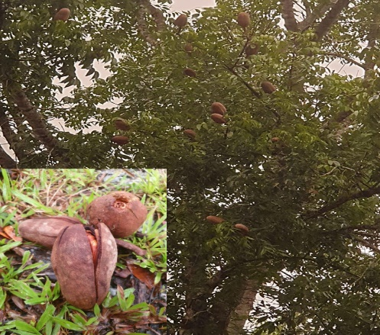
Figure 1. Photo image of Swietenia macrophylla tree and seeds (insert)

Hence, this study explored the properties of seed extract as the novel ingredient for acne treatment. The Soxhlet extraction method was performed to investigate the extraction yield in three different extraction solvent systems (methanol, ethyl acetate, and methanol: ethyl acetate mixture). The bioactivities of the extracts were analysed using a gas chromatography-mass spectrophotometer (GC-MS), and the heavy metals elements were determined using the inductive coupled plasma optical emission spectrometry (ICP-OES). A biochemical test and the disc diffusion assay method were conducted to determine the antibacterial activity against P. acnes, Staphylococcus aureus, and Staphylococcus epidermidis.
Materials and Methods
Material and reagents

Tetracycline (30 µg) was purchased from Sigma Chemicals (St. Louis, MO, USA), Mueller Hinton agar (MHA), Mueller Hinton broth, nutrient agar (NA) and nutrient broth used for the determination of antibacterial activity were purchased from Merck (M) Sdn. Bhd. and Thermo Fisher Scientific (M) Sdn. Bhd. All chemicals and solvents used in the experiment were analytical grades with above 98% purity. The reagents were supplied by the Chemistry Laboratory 2 and 4, UiTM Perlis Branch. The methanol, ethyl acetate, and 1:1 ratio of methanol: ethyl acetate mixtures were prepared and used to extract the S. macrophylla seeds sample. P. acnes, S. aureus, and S. epidermidis were obtained from the Biology Laboratory, UiTM Perlis Branch.

Preparation of Swietenia macrophylla samples extract
The S. macrophylla seeds were collected from the trees in Jitra, Kedah. The seeds were washed with tap water to remove dust and other inert materials. The cleaned samples were air-dried for two days. Then, the samples were ground into powder using an electrical blender. About 5.0 g of powdered seed sample was mixed with 150 mL of extraction solvent (methanol, ethyl acetate, and methanol-ethyl acetate mixture) and extracted using the Soxhlet apparatus for 6 h. The filtrate was then concentrated using a rotary evaporator to remove the solvent, and the yield percentage was expressed in w/w% and stored in a vacuum desiccator for further analysis. The yield percentage was calculated using the following equation:
% yield = [M₁ – M_{o}] × 100 (1)
where M₁ = mass of sample (g) and M_{o} = mass of the extract (g)

The chemical properties of SME
The chemical properties of SME were analysed using a GC-MS (Model Agilent 6890 equipped with 5MS, 30 m × 0.25 mm i.d. capillary column coated with 0.25 μm film and coupled with Agilent Chemstation software of NIST/Wiley Library). A volume of 0.1 mL samples extracts was derivatised with 100 µL N, O-Bis(trimethylsilyl)trifluoroacetamide (BSTFA) for 30 min in a sealed 2 mL vial. Then 0.1 µL of derivatised samples were analysed by the GC-MS, and the data was recorded, according to Hashim et al. [11].

The elemental analysis was determined using the ICP-OES (Model Thermo Scientific ICAP6000 Series). The multi-element of the standard solution was prepared from a 10-ppm stock solution in different concentrations at 0.01 ppm, 0.1 ppm, 1.0 ppm, and 10 ppm. Approximately 0.5 g of sample was digested with 8 mL of 65% nitric acid and 2 mL of concentrated hydrogen peroxide in microwave digestion. The sample was treated in the microwave digester for 15 min at 180 °C of 500 W. The treated sample mixture was cooled and diluted to 10 times concentration with distilled water prior to ICP-OES analysis.

The antibacterial analysis
The MHA and NA media were prepared according to the manufacturer’s instructions. Approximately 38.0 and 28.0 g of the MHA and NA powders were weighed to prepare 1000 mL agar and poured into conical flasks. The powder was dissolved in distilled water and continuously stirred until homogenised. The agar solution was sterilised using an automatic autoclave at 121 °C for 15 min. The agar was cooled to 45 to 50 °C before being poured into sterile Petri dishes. These agars were stored upside down in a chiller of 4 to 8 °C before being used.

The bacteria were subcultured by the streaking method. The inoculation loop was sterilised and cooled for a few seconds before dipping into the bacterial solution and streaked in a zigzag motion on the agar. This method was repeated three times for each bacterium. The inoculating loop was sterilised each time before subculturing the bacteria. The agar plates of S. aureus and S. epidermidis were incubated at 37 °C for 18 to 24 h in an inverted position [12].

The P. acnes was subcultured using a different method since it is a facultative anaerobic. It grows best under limited oxygen (0-20%), and the growth rate was reduced at high oxygen concentration [14]. The cultured plate was incubated under anaerobic conditions [13], i.e., inside a candle jar to provide a suitable condition for the P. acnes to grow at 37 °C for 72 h [15]. The biochemical tests involved were the catalase, the methyl red/Voges-Proskauer (MR-VP), and Gram staining to identify the desired bacterial interaction activities.

The catalase test was performed according to Habib et al. [16], whereby S. aureus and S. epidermidis were streaked onto MHA, and P. acnes was streaked onto NA to obtain bacterial colonies. The plates were incubated for 24 h and 72 h, respectively. Each bacterial colony was mixed with 2 to 3 drops of 3% hydrogen peroxide, where the formation of bubbles indicated positive results.

The methyl red (MR) and Voges-Proskauer (VP) test utilised the MR-VP broth. The MR-VP broth was prepared according to the manufacturer’s recommendation. About 17g of broth powder was weighed to prepare 1000 mL MR-VP broth and sterilised at 121 °C for 15 min. The MR-VP broth was then incubated at 37 °C for 24 h and 48 h, respectively, for the VP and MR tests. The VP and MR test method. Approximately 1 mL of MR-VP broth was poured into test tubes. The VP test involved the addition of each bacterial colony, 0.6 mL of 5% α naphthol, and 0.2 mL of 40% of potassium hydroxide to test tubes. Meanwhile, the MR test involved the addition of five drops of methyl red to test tubes containing bacterial colonies. Then, the test tubes were shaken gently and left undisturbed for 10 to 15 min. The colour changes from yellow to red of the sample showed a positive result.

The Gram staining test method was performed according to Shinkafi and Ndanusa [17]. A loopful of bacteria was heat-fixed onto a slide. A drop of crystal violet, followed by the decolouriser, iodine, and safranin, was added onto the bacteria on the slide for 1 min and was washed off with distilled water. The slide was blotted to dry before being observed under the light microscope at 100× magnifications and recorded.

The disc diffusion assay method to test antibacterial activities was performed according to Park et al. [14]. Approximately 100 µL of each bacterial suspension was used and spread on MHA using a sterile cotton swab (for S. aureus and S. epidermidis) and NA (for P. acnes). Each disc impregnated with antibiotics was gently pressed down to ensure that the disc was completely in contact with the agar surface and did not fall when inverted. The streptomycin antibiotic disc was used as a positive control, while the extraction solvent, i.e., methanol, ethyl acetate, and 1:1 ratio of methanol: ethyl acetate mixture, was used as the negative control. The experiment was done in triplicate for each bacterium. The plates were incubated at 37 °C for 24 h (S. aureus and S. epidermidis) and 37 °C for 72 h in a candle jar to retain the anaerobic condition for P. acnes. The antibacterial activity was measured based on the diameter of the inhibition growth zone.

Results and Discussion

The S. macrophylla seed was extracted using the Soxhlet extraction method in three different solvent systems; methanol aqueous, ethyl acetate, and 1:1 methanol-ethyl acetate mixture. Table 1 shows that the 1:1 ratio of methanol-ethyl acetate solvent mixture produces the highest percentage of crude oil extract (72.68%), followed by ethyl acetate (67.55%) and aqueous methanol (37.65%). All solvents used can extract the crude oil in 6 h extraction time. Do et al. mentioned that methanol solvent is generally more efficient in extracting lower molecular weight polyphenols [18]. In this experiment, the combination of methanol-ethyl acetate organic solvent facilitates a suitable extraction of all soluble compounds in both solvents. According to Nawaz et al., using a combination of polar and nonpolar solvents can increase the excellent quality of extraction yield from the bean and other legume seeds [19]. Furthermore, Che Sulaiman et al. reported that the extraction yield of organic samples is also dependent on the extraction times, extraction temperatures, and solvent ratios [20].

Table 1. Percentage Yield of Swietenia macrophylla Seed’s Extract in a different solvent
Solvent Types | Mass of Dried Powder  (g) | Mass of Oil Crude Extract  (g) | % Yield
Methanol | 5.07 ± 0.02 | 1.90 ± 0.45 | 37.65
Ethyl Acetate | 5.04 ± 0.02 | 3.40 ± 0.18 | 67.55
Methanol: Ethyl Acetate | 5.04 ± 0.03 | 3.67 ± 0.49 | 72.68

The phytochemical compounds in the S. macrophylla seed extract were analysed using GC-MS analysis. About 13 compounds were successfully identified in the methanol extract, 20 in the ethyl acetate extract, and 12 in the 1:1 methanol-ethyl acetate mixture as terpenoids, flavonoids, and limonoids. The compounds obtained strongly depended on the nature of extracting solvent due to different antioxidant compounds that vary their chemical characteristics and polarities. The most extracted compounds were reported in ethyl acetate, methanol, and 1:1 methanol-ethyl mixture due to the semipolar-polar compounds [21]. The number of extracted compounds in the 1:1 methanol-ethyl acetate extract is less than ethyl acetate alone because the elution strength of ethyl acetate decreased due to the polarisation effect of methanol. The extraction process yielded seven compounds in methanol extract, five compounds in ethyl acetate extract, and two compounds in the 1:1 methanol-ethyl acetate mixture, with more than 80% quality compared to the GC-MS reference library software (Table 2). In Table 2 show that silane methoxytrimethyl-, disiloxane hexamethyl, and 2,2,2-trifluoro-N-(trimethylsilyl)- are the major bioactive compound present in S. macrophylla seed extract, with the under peak percentage area of more than 23.57%. A previous study by Azhari et al. [22] stated that several compounds of limonoids such as phenol, 2-methoxy-4-(1-propenyl)-, and eugenol were also found in S. macrophylla seed extract using the maceration method. In this work, compounds such as phenol, 2-methoxy-4-(1-propenyl)-, (E)-(isoeugenol), silane, [2-methoxy-4-(1-propenyl) phenoxy] trimethyl- (isoeugenol), and eugenol are present in the sample. As reported in previous works, these compounds possess effective antifungal and antibacterial activities [23-25]. According to Sharma et al. [26], phytocompounds present in chloroform and methanol seed extracts are responsible for the varied antioxidant and antimicrobial activities.

The concentration of arsenic (As), lead (Pb), cadmium (Cd), nickel (Ni), mercury (Hg), and copper (Cu) in S. macrophylla seed powder was analysed using ICP-OES. Table 3 shows the result of heavy metal concentration in the crude oil extract sample. Only low concentrations of mercury are detected in the sample, i.e., 0.080 ppm. The result revealed that the S. macrophylla seed powder is low in heavy metal content. Hence, it is considered a safe ingredient in medication or cosmetic products. According to the U.S. Food and Drug Administration (USFDA) limits regulation, the accepted concentration of mercury must be less than 1 ppm (1 mg/kg), i.e., safe to be used as new constituents in products [31].

The images of catalase test (CT), Voges Proskauer (VP), and Gram staining test (GST) of Gram-positive bacteria (S. aureus, S. epidermidis, and P. acnes [facultative anaerobic bacteria]), are shown in Figures 2 - 4. Figure 2 shows a positive CT result, whereby bubbles are observed at 10 min observation. The finding is similar to the study by Mustafa [30], Kallstrom et al. [31], and Cauich-Sanchez et al. [32]. The catalase acts as a catalyst in breaking down the hydrogen peroxide into water and oxygen to form an oxygen bubble produced by the bacteria. The VP test was conducted to measure the production of acetyl methyl carbinol, as shown in Figure 3. S. aureus and P. acnes show positive results, where the color of the solution change to red. In contrast, the colour of the S. epidermidis solution remains unchanged. This result is similar to Shinkafi and Ndanusa [17], whereby the colour change from light yellow to slightly red in the S. aureus and P. acnes tests indicated positive results. Whereas the colour of the solution in the S. epidermidis tube did not change, indicating a negative result. Further validation analysis for S. aureus, S. epidermidis, and P. acnes were carried out using the methyl red (MR) test (Figure 4). The unchanged colour of the MR solution of S. aureus and P. acnes indicates positive results. On the contrary, the colour of the S. epidermidis solution changed from light yellow to red. The researcher also stated that S. aureus and P. acnes showed negative results when the colour of the MR solution remained unchanged. This is contradictory to S. epidermidis, which showed positive results when the light-yellow solution slightly changed to red. The purpose of the MR test is to determine the ability of the bacteria to oxidise glucose and produce a high concentration of acidic products.

Table 2. Phytocompounds in SME in different extraction solvents by using GC-MS
Retention Time (min) | Area (%) | Name of Compound | Bioactivity | Solvent
1.300 | 45.76 | Silane, methoxytrimethyl- | NR | Methanol
1.545 | 23.57 | Disiloxane, hexamethyl- | NR | Methanol
4.409 | 0.34 | Benzene-1-ethyl-3-methyl- | NR | Methanol
4.540 | 0.16 | Benzene-1,3,5-trimethyl- | NR | Methanol
4.723 | 0.12 | Benzene, 1-ethyl-2-methyl- | NR | Methanol
4.997 | 0.57 | Benzene, 1,2,3-trimethyl- | NR | Methanol
5.535 | 0.18 | Benzene, 1,2,3-trimethyl- | NR | Methanol
1.923 | 25.84 | Disiloxane, hexamethyl- | NR
2.414 | 34.13 | Acetamide, 2,2,2-trifluoro-N-(trimethylsilyl)- | NR | Ethyl acetate
13.205 | 0.11 | Phenol, 2-methoxy-4-(1-propenyl)-, (E)- | Antifungal [21], | Ethyl acetate
13.239 | 0.15 | Eugenol | Antibacterial, Anti-inflammatory [22], Antioxidant [23] | Ethyl acetate
14.988 | 0.12 | Silane, [2-methoxy-4-(1-propenyl) phenoxy] trimethyl- | Antifungal [20] | Ethyl acetate
1.631 | 2.77 | Silane, methoxytrimethyl- | NR | Methanol: ethyl acetate (1:1)
5.660 | 0.15 | Benzene, 1,2,4-trimethyl- | NR | Methanol: ethyl acetate (1:1)

NR – Activity of compound is not reported

Table 3. Heavy metal concentration in Swietenia macrophylla seed’s powdered sample using ICP-OES
Heavy Metal | Concentration  (ppm)
As | 0
Pb | 0
Cd | 0
Ni | 0
Hg | 0.080
Cu | 0

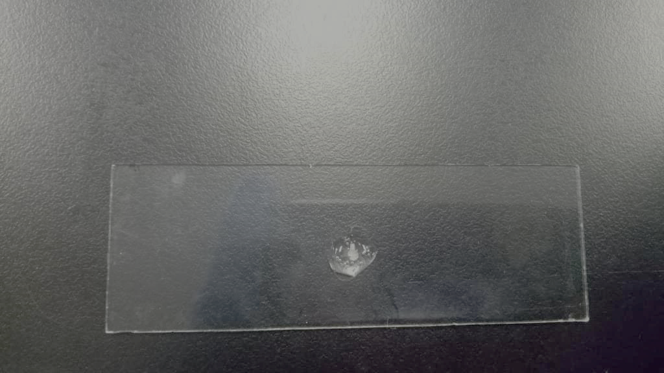  (a) | 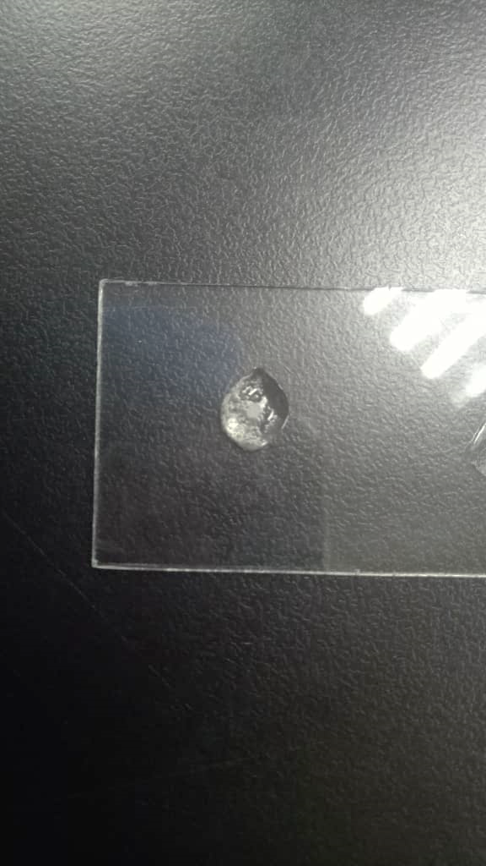  (b) | 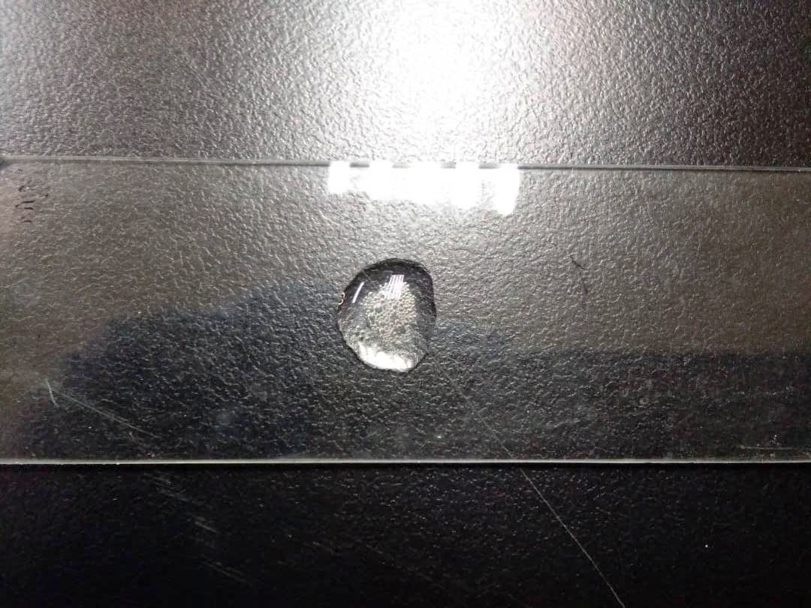  (c)
Figure 2. The photo images of catalase test of (a) S. aureus, (b) S. epidermidis, and (c) P. acnes

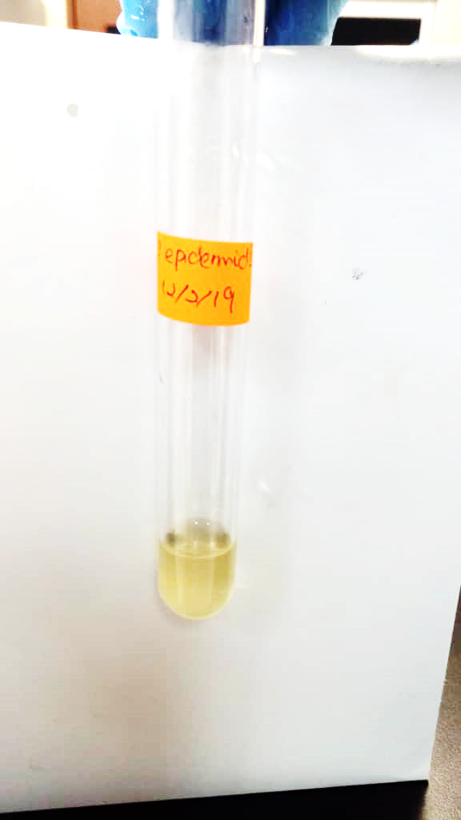  (a) | 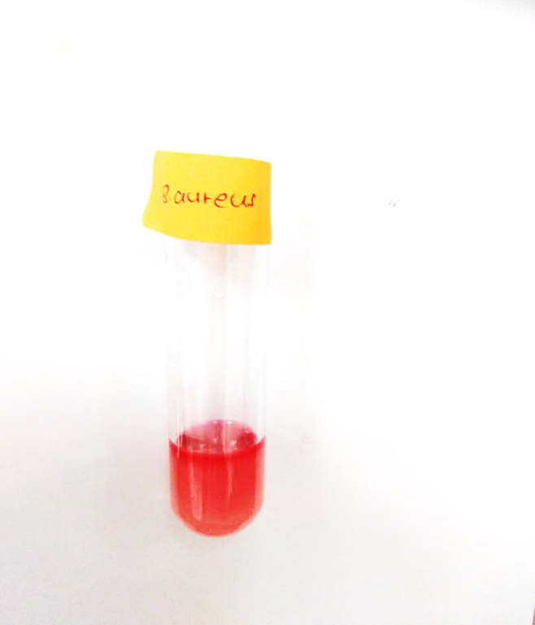 | (b) |  | 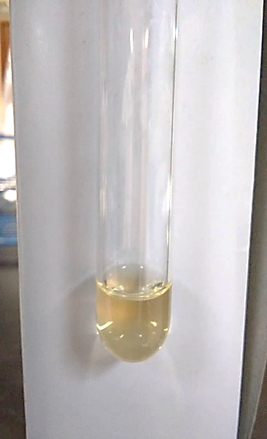  (c) | 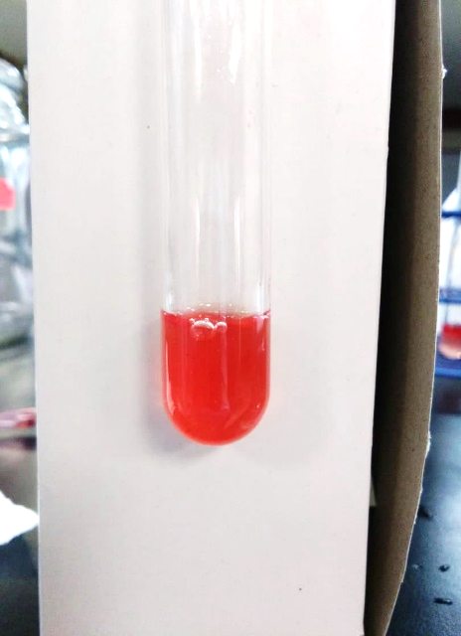
Before | After | Before | After | Before | After
Figure 3. The photo images of Voges Proskauer (VP) test of (a) S. aureus (b) S. epidermidis (c) P. acnes

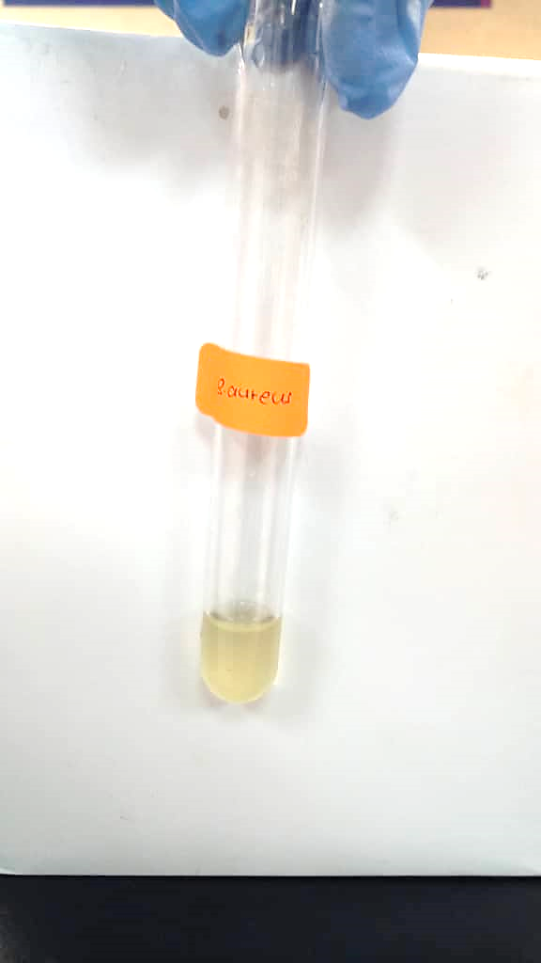  (a) | 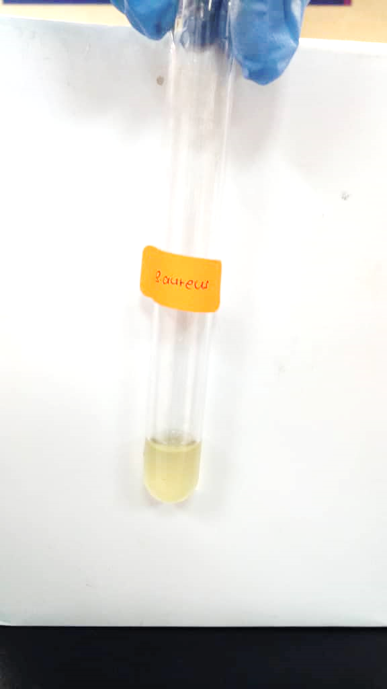 | (b) | 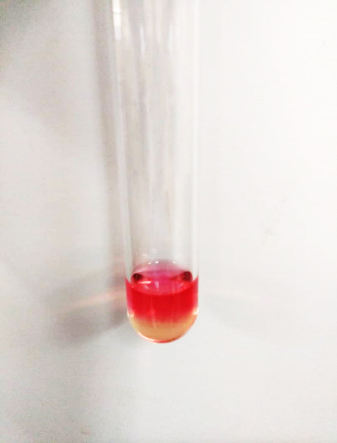 | 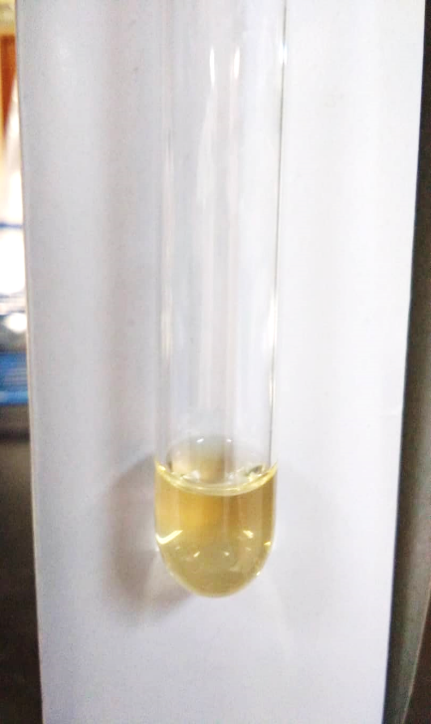  (c) | 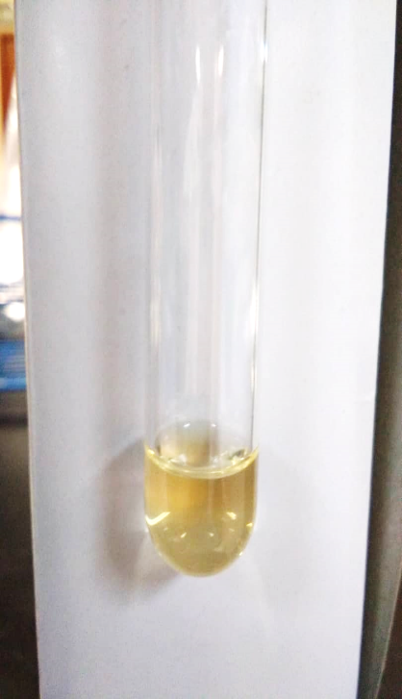
Before | After | Before | After | Before | After
Figure 4. Photo images of methyl red (MR) test of (a) S. aureus, (b) S. epidermidis, and (c) P. acnes

The Gram-staining analysis was performed to determine the Gram-positive and Gram-negative bacteria based on the bacterial cell wall colour using an Olympus CKX53 inverted microscope (Figure 5). The Gram-positive bacteria, i.e., S. aureus, S. epidermidis, and P. acnes, were observed in this analysis. The results showed that the bacteria appear violet with aggregated grape-like clusters under 100× magnification [16]. In contrast, the P. acnes is visualised as violet with a rod-like bacillus structure [33], as shown in Figure 5(c). According to Panawala [34], the bacteria appear violet under the microscope due to the thick peptidoglycan cell wall and teichoic acid composition.

The inhibition zones of the three bacteria species were determined using the disc diffusion assay method, as shown in Figure 6 and Table 4. The disc assay method is a rapid determination of antibacterial activity by measuring the diameter of the inhibition zone that resulted from the diffusion of the phytochemical compound into the medium surrounding the disc [35]. Table 4 shows the inhibition zone category and bacterial inhibition zone in 30-disc tetracycline concentration (µg/disc).

The inhibition of bacteria towards the sample extract was expressed as susceptible, intermediate, and resistant according to international standards (ISO 20776-1). Susceptible is when the bacteria are inhibited in vitro by a drug concentration with high therapeutic properties. Meanwhile, intermediate is when the bacteria are inhibited in vitro by a drug with uncertain therapeutic effects. For resistance, the bacteria are inhibited in vitro by a drug with a high chance of therapeutic failure [36].

Figure 6 shows P. acnes is minimally inhibited in the methanol and 1:1methanol-ethyl acetate extracts. In comparison, the inhibition zone of the S. aureus is more prominent than in tetracycline (antibiotic control). Table 4 shows the results of the inhibition zone of the bacteria tested. S. aureus is susceptible in methanol and 1:1 methanol-ethyl acetate extracts, as the zone of inhibition more than 19.00 ± 0.00 mm, while S. epidermidis is resistant towards ethyl acetate and 1:1 methanol-ethyl acetate extracts at 13.00 ± 1.00 mm and 13.00 ± 2.31, respectively.

Meanwhile, P. acnes exhibits resistant, intermediate, and susceptible properties in 1:1 methanol-ethyl acetate, methanol, and ethyl acetate extract respectively. Aditi and Hossain [37] reported that S. aureus acquired resistance easily, a good bio-indicator model for surveillance studies of antimicrobial resistance [38]. S. aureus and P. acnes in ethyl acetate extraction solvent showed a more significant inhibition zone but slightly lower inhibition of S. epidermidis. In a nutshell, for antibacterial activity, all extracts showed a high therapeutic capability towards S. aureus and P. acnes but are less effective against S. epidermidis.

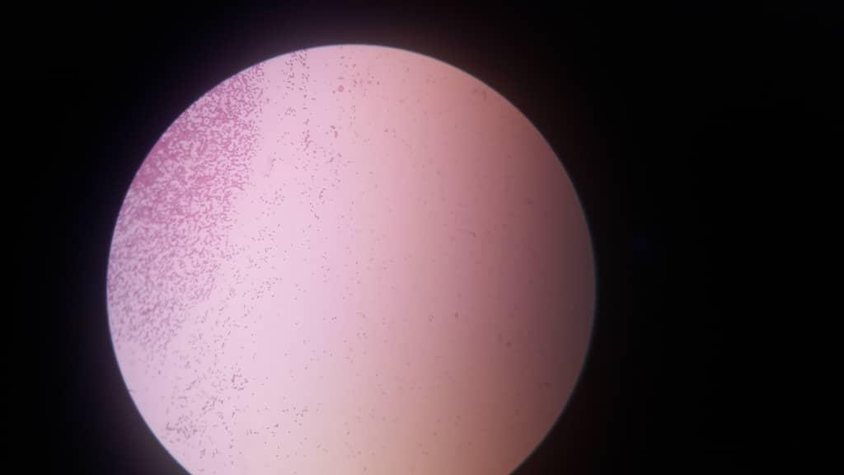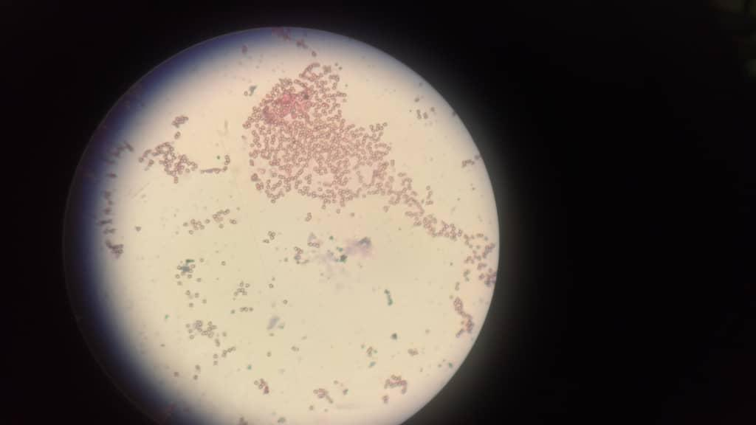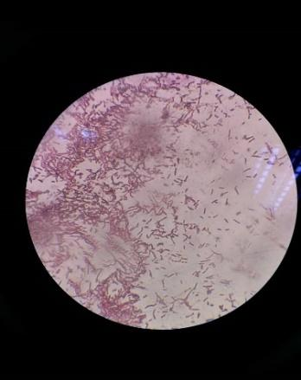
(b)
Figure 5. Photo images of Gram Staining Test in 100X Magnifications of (a) S. aureus (b) S. epidermidis, and (c) P. acnes
(c)
(b)
(a)
(a)
(c)
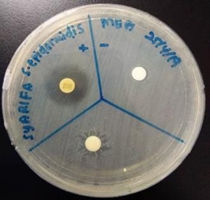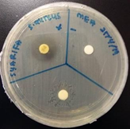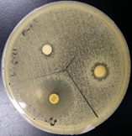
Figure 6. Inhibition zone photo images of the test discs (a) S. epidermidis, (b) S. aureus, and (c) P. acnes of SME in 1:1 methanol-ethyl acetate mixture

Table 4. Inhibition zone category in tetracycline and inhibition zone on bacterial growth activities in different extraction solvent
Antibiotic | Inhibition zone (Category)
Tetracycline (control) in  30-disc (µg/disc) | S. aureus (± n)  18.33 ± 0.58 | S. epidermidis (± n)  18.67 ± 0.58 | P. acnes (± n)  21.33 ± 1.53
Sample in the different extraction solvent | Inhibition zone (Bacterial Growth)
Methanol | 20.67 ± 6.03 | 18.67 ± 14.15 | 16.33 ± 5.69
Ethyl acetate | 16.67 ± 6.66 | 13.00 ± 1.00 | 19.00 ± 4.36
Methanol: Ethyl acetate (1:1) | 21.67 ± 11.72 | 13.00 ± 2.31 | 11.00 ± 1.73
*R- resistant (≤14 mm), I- intermediate (15-18 mm), S-susceptible (≥19 mm) [9]
*The values were presented in mean ± SD, where n=3

Conclusion

The properties of S. macrophylla seeds in three different extraction solvents were successfully determined. Three new compounds, phenol, 2-methoxy-4-(1-propenyl)-, (E)-Eugenol; and silane, [2-methoxy-4-(1-propenyl) phenoxy] trimethyl, were successfully extracted from S. macrophylla seeds using ethyl acetate solvent. The highest extraction yield is obtained in the 1:1 methanol-ethyl acetate mixture (72.68%), followed by ethyl acetate (67.55%) and methanol (37.65%). From the disc diffusion assay, S. epidermidis and P. aureus are susceptible towards methanol and 1:1 methanol-ethyl acetate extracts. In contrast, P. acnes is susceptible towards ethyl acetate extract. The result showed that S. macrophylla seeds extract is an effective ingredient for treating acne due to positive inhibition towards three acne-causing bacteria and is considerably low in heavy metal contents.

Acknowledgement

The authors are sincerely grateful to UiTM Perlis Branch, Arau Campus, to provide the research facilities. High appreciation also goes to the Frontier Applied Science and Technology research group (FAST) for completing this work.

References
- Zaghloul, S. S., Cunliffe, W. J. and Goodfield, M. J. D. (2005). Objective assessment of compliance with treatments in acne. British Journal of Dermatology, 152(5): 1015-1021.
- Fox, L., Csongradi, C., Aucamp, M., Du Plessis, J. and Gerber, M. (2016). Treatment modalities for acne. Molecules, 21(8): 1-20.
- Savage, A. E. O. (1985). United States Patent, 19(54): pp. 19.
- Vora, J., Srivastava, A. and Modi, H. (2018). Antibacterial and antioxidant strategies for acne treatment through plant extracts. Informatics in Medicine Unlocked, 13: 128-132.
- Afsar, Z. and Khanama, S. (2016). Formulation and evaluation of polyherbal soap and sanitiser. International Research Journal of Pharmacy, 7(8): 54-46.
- Platsidaki E. and Dessinioti C. (2018). Recent advances in understanding Propionibacterium acnes (Cutibacterium acnes) in acne. F1000Research, 7(F1000 Faculty Rev:1953).
- Tan, A. U., Schlosser B. J. and Paller, A.S. (2017). A review of diagnosis and treatment of acne in adult female patients. International Journal of Women's Dermatology, 4(2): 56-71.
- Eid, A. M. M., Elmarzugi, N. A. and El-Enshasy, H. A. (2013). A review on the phytopharmacological effect of Swietenia macrophylla. International Journal of Pharmacy and Pharmaceutical Sciences, 5(3): 47-53.
- Suliman, M. B. (2018). Preliminary phytochemical screening and thin layer chromatography analysis of Swietenia Macrophylla King methanol extracts. Chemistry of Advanced Materials, 3(1): 1-7.
- Durai, M., Balamuniappan, G. and Geetha, S. (2016). Phytochemical screening and antimicrobial activity of leaf, seed and central-fruit-axis crude extract of Swietenia macrophylla King. Journal of Pharmacognosy and Phytochemistry, 181(53): 181-186.
- Hashim, M. A., Yam, M. F., Hor, S. Y., Lim, C. P., Asmawi, M. Z. and Sadikun, A. (2013). Anti-hyperglycaemic activity of Swietenia macrophylla king (meliaceae) seed extracts in normoglycemic rats undergoing glucose tolerance tests. Chinese Medicine (United Kingdom), 8(1): 1-8.
- Wu, Q., Li, Y., Hu, H., Wang, M., Wu, Z. and Xu, W. (2012). Rapid identification of Staphylococcus aureus: FISH versus PCR methods. Laboratory Medicine, 43(6): 276-280.
- Naghdi, N. and Ghane, M. (2017). A comparison of culture and PCR methods for identifying Propionibacterium acnes in lesions isolated from patients with acne. Turkish Journal of Medical Sciences, 47(3): 967-972.
- Park, J., Lee, J., Jung, E., Park, Y., Kim, K., Park, B., Jung, K., Park, E., Kim, J. and Park, D. (2004). In vitro antibacterial and anti-inflammatory effects of honokiol and magnolol against Propionibacterium sp. European Journal of Pharmacology, 496(1): 189-195.
- Nirmal, N. P. and Panichayupakaranant, P. (2014). Anti-propionibacterium acnes assay-guided purification of brazilin and preparation of brazilin rich extract from Caesalpinia sappan heartwood. Pharmaceutical Biology, 52(9): 1204-1207.
- Habib, F., Rind, R., Durani, N., Latif Bhutto, A., Buriro, R. S., Tunio, A., Aijaz, N., Lakho, S., Ghulam, B. and Shoaib, M. (2015). Morphological and cultural characterization of Staphylococcus aureus isolated from different animal species. Journal of Applied, Environmental and Biological Sciences, 5(2): 15-26.

- Shinkafi, S., and Ndanusa, H. (2013). Antibacterial activity of citrus lemon on acne vulgaris (pimples). International Journal of Science Inventions Today, 2(5): 397-409.
- Do, Q. D., Angkawijaya, A. E., Tran-Nguyen, P. L., Huynh, L. H., Soetaredjo, F. E., Ismadji, S. and Ju, Y. H. (2014). Effect of extraction solvent on total phenol content, total flavonoid content, and antioxidant activity of Limnophila aromatica. Journal of Food and Drug Analysis, 22(3): 296-302.
- Nawaz, H., Shad M. A., Rehman, A. N., Andaleeb, H. and Ullah, N. (2020). Effect of solvent polarity on extraction yield and antioxidant properties of phytochemicals from bean (Phaseolus vulgaris) seeds. Brazilian Journal of Pharmaceutical Sciences, 56: 17129.
- Che Sulaiman I. S. and Basri, M. (2017). Effects of temperature, time, and solvent ratio on the extraction of phenolic compounds and the anti-radical activity of Clinacanthus nutans Lindau leaves by response surface methodology. Chemistry Central Journal, 11(1): 54.
- Akbar A., Soekamto N. H., Firdaus and Bahrun (2021) Antioxidant of n-hexane, ethyl acetate and methanol extracts of Padina sp. with DPPH method. Earth and Environmental Science 800: 012019.
- Azhari, Nour, H., Mohammed, Sulieman, B., Mashitah, Yousf, M. and Adam, M. M. (2016). Bioassay-guided isolation and identification of antifungal compounds from seeds of Swietenia macrophylla King. Australian Journal of Basic and Applied Sciences, 10(17): 55-62.
- Aquirre-Becerra H., Pineda-Noeto S. A., Garcia-trejo J.F., Guevara-Gonzalez R. G., Feregrino-Perez A. A., Alerez-Mayorga B. L. and Rivera-Pastrana D. M. (2020). Jacaranda flower (Jacarand mimosifolia) as alternaive for antioxidant and antimicrobial use. Heliyon, 6(12): e05802.
- Eid A., Elmarzugi N. and El-Enshasy H. (2013). A review on the phytopharmacological effect of Swietenia macrophylla. International Journal of Pharmacy and Pharmaceutical Sciences, 5: 47-53.
- Moghadamtousi S. Z., Goh B. H., Chan C. K., Shabab T. and Kadir, H. A. (2013). Biological activities and phytochemicals of Swietenia macrophylla King. Molecules, 18: 10465-10483.
- Sharma S., Kumari A., Dhatwalia J., Guleria I., Lal S., Upadhyay N., Kumar V. and Kumar A., (2021), Effect of solvents extraction on phytochemical profile and biological activities of two Ocimum species: A comparative study. Journal of Applied Research on Medicinal and Aromatic Plants, 25(2021): 100348.
- Koeduka, T. (2014). The phenylpropene synthase pathway and its applications in the engineering of volatile phenylpropanoids in plants. Plant Biotechnology, 2014: 14-0801.
- Nejad, S. M., Özgüneş, H. and Başaran, N. (2017). Pharmacological and toxicological properties of eugenol. Turkish Journal of Pharmaceutical Sciences, 14(2): 201.
- Bendre, R. S., Rajput, J. D., Bagul, S. D. and Karandikar, P. S. (2016). Outlooks on medicinal properties of eugenol and its synthetic derivatives. Natural Product Chemistry Research, 4(3): 1-6.
- Mustafa, H. S. I. (2014). Staphylococcus aureus can produce catalase enzyme when adding to human WBCs as a source of productions in human plasma or serum in the laboratory. Open Journal of Medical Microbiology, 04: 249251.
- Kallstrom, G., Chang, T., Albertson, M., Morilla, D., Fisher, M. A. and Eberly, B. (2011). Recovery of a catalase-negative Staphylococcus epidermidis strain in blood and urine cultures from a patient with pyelonephritis. Journal of Clinical Microbiology, 49(11): 4018-4019.
- Cauich-Sanchez, P., Alatriste-Mondragon, F., Garcia-Cano, E. and Aquino-Santiago, C. (2001). Identification of anaerobic nonsporeforming gram-positive bacilli by biochemical tests and gas-liquid chromatography. Revista Latinoamericana de Microbiologia, 43(1): 27-35.
- Rolf, L. (2011). Propionibacterium acnes and its phages department of clinical sciences. Department of Clinical Sciences, Lund University: pp. 1-85.

- Kuntom, A. and Kifli, (1998). Properties of soaps derived from distilled palm stearin and palm kernel fatty acids. Journal of Surfactants and Detergents, 1(3): 329-334.
- Panawala, L. (2017). Difference between gram positive and gram-negative bacteria. Epedıaa, 3: 1-13.
- Tenover F. C. (2019). Antimicrobial susceptibility testing. Encyclopedia of Microbiology (Fourth Edition): pp. 166-175.
- Rodloff, A., Bauer, T., Ewig, S., Kujath, P. and Müller, E. (2008). Susceptible, intermediate, and resistant – the intensity of antibiotic action. Deutsches Aerzteblatt Online, 105(39): 657-662.
- Aditi, F. Y., Rahman, S. S. and Hossain, M. M. (2017). A study on the microbiological status of mineral drinking water. The Open Microbiology Journal, 11: 31.
- Hepp, N. M., Mindak, W. R., Gasper, J. W., Thompson, C. B. and Barrows, J. N. (2014). Survey of cosmetics for arsenic, cadmium, chromium, cobalt, lead, mercury, and nickel content. Journal Cosmetic Sciences, 65(3): 125.

