
OPTIMIZATION PARAMETERS FOR ELECTROPOLYMERIZATION OF MELAMINE IN DEEP EUTECTIC SOLVENT

(Pengoptimuman Parameter Elektropempolimeran Melamin Dalam Pelarut Eutektik Dalam)

Yeet Hoong Chang¹, Pei Meng Woi^{1,2}*, Yatimah Alias^{1,2}

¹Department of Chemistry, Faculty of Science
²University Malaya Centre for Ionic Liquids (UMCiL)
University of Malaya, 50603 Kuala Lumpur, Malaysia

*Corresponding author: pmwoi@um.edu.my

Received: 15 September 2021; Accepted: 10 December 2021; Published: xx April 2022

Abstract

Polymelamine is a new class of polymer that possess electrocatalytic behavior in dopamine (DA) detection. Our previous studies have successfully replaced the conventional acidic electrolyte to deep eutectic solvent (DES) has open the opportunity for a greener solvent in used. Herein we report the optimization process of melamine electropolymerize in DES- reline. Various electrochemical techniques have been employed to studies the ideal parameters. The optimum potential window, scan rate, and number of scan cycles were recorded as -0.20 V – 1.60 V, 50 mV s⁻¹ and five scan cycles, respectively. Cyclic voltammetry (CV) was employed in the electropolymerization of melamine to optimize the redox behavior of polymelamine film on electrode surface. The growing of polymer film which indicated by the increased of reduction current can be well-controlled by the slow scan rate and optimum scan cycles which leads to strong adhesion and uniform morphology. Amperometry sensing on DA was performed to study and compare the sensitivity and limit of detection for the polymers synthesized in varied parameters. A brief discussion on the principal polymerization factors that would affecting the electrocatalytic behavior of melamine is included.

Keywords: deep eutectic solvent, electropolymerization, melamine, optimization

Abstrak
Polimelamin adalah kelas polimer baharu yang mempunyai tingkah laku elektromangkin dalam pengesanan dopamin (DA). Kajian yang dilaporkan terdahulu menujukkan kerjayaan penggantian elektrolit berasid konvensional kepada pelarut eutektik (DES). Kerjayaan ini membuka peluang untuk pelarut yang lebih mesra alam digunakan. Dengan ini, kami melaporkan proses pengoptimum elektropolimerisasi melamin dalam DES-relin. Pelbagai teknik elektrokimia telah digunakan untuk mengkaji parameter yang terbaik. Julat keupayaan, kadar imbasan dan bilangan kitaran imbasan yang terbaik dicatat pada -0.20 V – 1.60 V, 50 mVs⁻¹ dan lima kitaran imbasan. Siklik voltametri (CV) telah digunakan dalam elektropolimerisasi melamin untuk mengoptimumkan tingkah laku elektropemangkinan lapisan polimelamin pada permukaan elektrod. Pertumbuhan lapisan polimer yang ditunjukkan dalam penainkkan arus penurunan boleh dikawal baik dengan kadar imbasan yang perlahan dan kitaran imbasan optimum untuk mencapai lekatan yang kuat dan morfologi yang seragam. Penderiaan amperometri pada DA telah dijalankan untuk mengkaji dan membandingkan kepekaan dan had pengesanan rendah untuk polimer yang disintesis dalam parameter yang berbeza-beza. Perbincangan ringkas tentang faktor-faktor elektropolimerisasi yang mempengaruhi tingkah laku elektromangkin melamin telah disertakan.

Kata Kunci: pelarut eutektik dalam, elektropempolimeran, melamin, pengoptimuman

Introduction
Heretofore, the polymers such as polyisoprene, polystyrene, polythiophene, polyaniline, polypyrrole, formaldehyde resin and their by-products have been examined extensively as promising candidates in sensor development. A novel class of conducting polymer - polymelamine (PME) was proposed. PME is made from the nitrogen-rich melamine (1,3,5-Triazine-2,4,6-triamine) which is a heterocyclic organic compound. The synthesis methods of PME included chemical, electrochemical, photo-initiating, biocatalytic, and plasma polymerization. Among all, electropolymerization is commonly employed due to its advantages in facile engineer the morphology, thickness, density, and growing rate of the polymer. PME can be synthesized easily using electropolymerization technique by oxidize the amino groups found in melamine. In the discipline of electrochemistry, PME has been employed as a stable matrix to enhance the effective immobilization of nanomaterials on it. It is also employed as electrochemical sensor owing to the existence of numerous active groups such as nitrogen and amine. PME and its offshoots were soon utilized extensively in sensing of different neurotransmitters, pharmaceutic particles, and toxic heavy metals [1-3]. Moreover, PME composited with nanocarbon demonstrated high specificity and exhibited exceptional catalytic reaction over broad extent of molarity [4].

Deep eutectic solvent (DES) draws great attention lately owing to their solvation potential, conductivity, simple synthesis method, cost effective and many are biodegradable [5]. DES are commonly applied in two principal fields: metal processing (metal electropolishing, metal dissolution, metal deposition) and as synthesis solvent [6-8]. Reline (a Type III DES) was employed as stimulant and reducing mediator for polymerization of hydrophilic monomer at temperature close to ambient [9]. Reline and glyceline (a Type III DES) were proposed to substitute typical aqueous solution in free-radical polymerization of acrylamide [10]. The outcome shows the polymer synthesized has similar molecular mass compared to the polymer synthesized in aqueous solution. Moreover, polyaniline synthesized in DES demonstrated exceptional conductivity reported at 50 S cm⁻¹ [11]. The polyaniline shows excellent reversibility to doping/dedoping mechanisms which indicated rapid charge transfer. Furthermore, Type I DES has effectively utilized as a cationic catalyst for epoxy resin curing [12].

Despite that, DES being the synthesis solvent particularly in the formation of polymers are rarely examined in terms of polymerization parameters. Conventionally, electropolymerization of melamine was conducted in acidic electrolyte [1]. Acidic electrolyte with pH less than two is the key for the growth and establishment of radical cations that required in rate-limiting step during the electropolymerization of melamine. In accordance with our published work, we have successfully superseded the conventional acidic electrolyte with DES. PME synthesized in DES manifests excellent sensitivity, specificity, and stability [13]. In this work, we focus on the optimization of polymerization parameters, and discuss the effect of these parameters in polymerization of melamine. Reline is selected as study target due to the enlightenment of the novel perception asserted that chloride ion (Cl⁻) is the vital factor for PME formation [14]. Reline is a mixture of choline chloride and urea in 1:2 ratio, urea molecules offer plentiful positive hydrogen bonding spot to adopt the Cl⁻ negative ion into their polar matrix [15]. PME synthesized in reline is then applied in electrochemical qualification and quantification of dopamine (DA).

Materials and Methods
Materials
Melamine monomer, choline chloride, ethylene glycol, urea, glycerol, dopamine (DA), potassium dihydrogen phosphate (KH₂PO₄) and potassium hydrogen phosphate (K₂HPO₄) were purchased from Sigma Aldrich. Ultra-pure deionized (DI) water with a resistance of 18.3 MΩcm (Merck Synergy) was used in all sample preparations. All the chemical reagents were of analytical grade and were used without further purification.

Instrumentation
The surface morphology of the bare and modiﬁed sensor was studied by using Horizontal Attenuated Total Reﬂectance-infrared spectroscopy (HATR-IR, PerkinElmer, Inc). All electrochemical experiments were carried out by Autolab potentiostat/galvanostat PGSTAT-302N with an ordinary three electrodes system, containing glassy carbon electrode (GCE) (ALS-Japan, diameter = 3.0 mm, surface area = 0.071 cm² ) as working electrode, a platinum braid wire (BASi, diameter = 1.0 mm, surface area = 0.008 cm²) as counter electrode and sodium chloride (KCl) saturated Ag/AgCl (BASi) as the reference electrode. All the potential readings were referred to Ag/AgCl unless stated elsewhere. A pseudo reference electrode (Ag wire, BASi, diameter = 1.0 mm, surface area = 0.008 cm²) was employed for electrochemical polymerization of polymer in DES or mixtures. The referred reading of the pseudo wire with respect to the Ag/AgCl electrode was at + 90 mV. Amperometry analysis of DA was conducted at constant potential (0.20 V) in PBS (0.10 M, pH 7.0).

Preparation of deep eutectic solvent
Type III DES - reline was prepared by mixing choline chloride into urea, in 1:2 molar ratio. The mixture was heat under oil bath with control temperature from 55ºC to 60ºC until a clear solution was obtained. Reline was then set aside to cool down to ambient temperature prior served as supporting electrolyte for the electropolymerization of melamine.

Preparation of 0.10 mM melamine(reline) solution
A 10.0 mM of melamine was prepared by mixing 5.0 mg of melamine into 4.0 mL reline followed by ultrasonication for 30 minutes until a homogeneous solution is achieved. The as-prepared melamine solution was named as melamine(reline).

Synthesis of PME(reline)/GCE
GCE was gently polished with 0.05 μM alumina slurry and then rinsed with DI water and ethanol a few times until a clean mirror-like surface was obtained. A clean GCE was then immersed into melamine(reline) solution and CV was scanned from the studied potential window at various scan rates for different number of cycles as part of the optimization studies. The fabricated PME(reline)/GCE was gently rinsed with DI to wash off the monomer residue and then set to dry in ambient condition before used.

Preparation of phosphate buffer solution
Phosphate buffer solution (PBS) was used as supporting electrolyte in amperometry sensing of DA. 27.2 g of KH₂PO₄ and 34.8 g of K₂HPO₄ were individually poured into 1.0 L volumetric flask and added with DI until meniscus line forming solution A (0.20 M) and B (0.20 M), respectively. PBS (0.10 M, pH 7.0) was prepared by mixing 39.0 mL solution A and 61.0 mL solution B follow diluted with DI to 200 mL. The pH value of the buffer solution was confirmed with pH meter (model pH 700, Eutech Instruments).

Preparation of DA stock solution
1000 μM of DA stock solution was prepared by adding 0.015 g DA into 100 mL volumetric flask and added DI until meniscus. DA solution was freshly prepared daily and kept in refrigerator at 4ºC before used for not more than 12 hours. A layer of aluminum foil was used to cover the stock solution to avoid contact with light.

Results and Discussion
Optimization of potential window for melamine electropolymerization
To understand the effect of applied potential window on the melamine electropolymerization process, repeated CV cycling tests were carried out on melamine dissolved in reline. To begin with the potential window investigation, parameters of melamine concentration, scan rate, scan cycles, and temperature were fixed at 10.0 mM, 50 mV s⁻¹, five scan cycles and 25°C, respectively. Figure 1 shows the electropolymerization of melamine at fixed starting potential (-0.20 V) and ended with varied potentials: 1.20 V, 1.40 V, 1.60 V, and 1.80 V. The electropolymerization behavior of melamine in reline was different from the conventional electrolyte - H₂SO₄ as in previous literature [14]. In conventional electrolyte, a cathodic peak at around + 0.85 V was noticed owing to the coupling among the melamine molecules and carbonyl groups (C=O and/or C-O) from the DES instead of head-to-head linking of amine groups betwixt the melamine molecules [13]. Figure 1(c) illustrated an anodic peak at 1.20 V was observed for the electropolymerization of melamine from -0.20 to 1.60 V. The anodic peak was due to functionalization of melamine monomers with carbonyl groups (C=O) attributed from the reline and forming an electroactive PME functionalized DES. Likewise, an anodic peak at about 1.20 V was observed in Figure 1(b) for applied potential window -0.20 - 1.40 V, indicating the formation of PME. However, it noticed that the peak current was lower as compared to the electropolymerization of melamine at -0.20 to 1.60 V, indicating the limit of charge depository of polymer formed at -0.20 - 1.40 V. Noted that in Figure 1(a) and Figure 1(d), no anodic peak was observed with the applied potential. This is probably due to a narrow potential window restricts the charge depository ability of monomer during polymerization, while a wide potential window will lead to overoxidation of polymer, causing breakage of polymer chain [16]. From these, it was concluded that potential range from -0.20 V to 1.60 V is well suited to carry out the melamine electropolymerization for the PME formation.

To further verify how the tuning of potential window affecting the performance of PME in dopamine (DA) sensing, all the PME/GCE electrodes synthesized in varied potential window were further tested in two aspects: sensitivity and limit of detection (LOD). In amperometry setting, DA is oxidised at potential 0.20 V [13]. Therefore, amperometry was scanning at fixed potential (0.20 V) with additional of DA with concentration ranging from 100 - 1200 μM in PBS (0.10 M, pH 7.0) as shown in Figure 2. Sensitivity and LOD were then calculated based on the amperometric results and summarized in Figure 3 and Table 1. Naming of PME was based on the maximum applied potential e.g., PME synthesized in reline with potential window applied at -0.20 - 1.20 V is named as PME(reline +1.20 V). Based on Figure 2, it was noticed that the amperometry result of PME(reline +1.60 V) recorded the highest current response as compared to the other PME. Figure 3(A) and (B) illustrated the calculated sensing sensitivity and LOD of DA at PME(reline), respectively. Noted that the sensing of DA at PME(reline +1.60 V) recorded the highest sensitivity and lowest LOD recorded at 0.044 μA μM⁻¹ cm⁻² and 0.198 $μ$M, respectively which are in line with amperometry result shown in Figure 2. The sensitivity line graph of over-potential showed increment from +1.20 V and reached maximum at +1.60 V. At the same time, LOD obey the opposite relationship and reaching the minimum LOD at +1.60 V. In case, further widen the potential window of PME(reline) to +1.80 V, the electrode sensing capability has reduced drastically where the LOD did not showed any improvement and has been increased 10-fold recorded at 2.070 $μ$M compared to +1.60 V. The result justified the optimized potential window for electropolymerization of melamine is -0.20 V to +1.60 V.

Figure 1. Electropolymerization of melamine (10.0 mM) in reline scanning with varied potential window a) -0.20 to 1.20 V, b) -0.20 to 1.40 V, c) -0.20 to 1.60 V, and d) -0.20 to 1.80 V at 50 mV s⁻¹ with five scan cycles

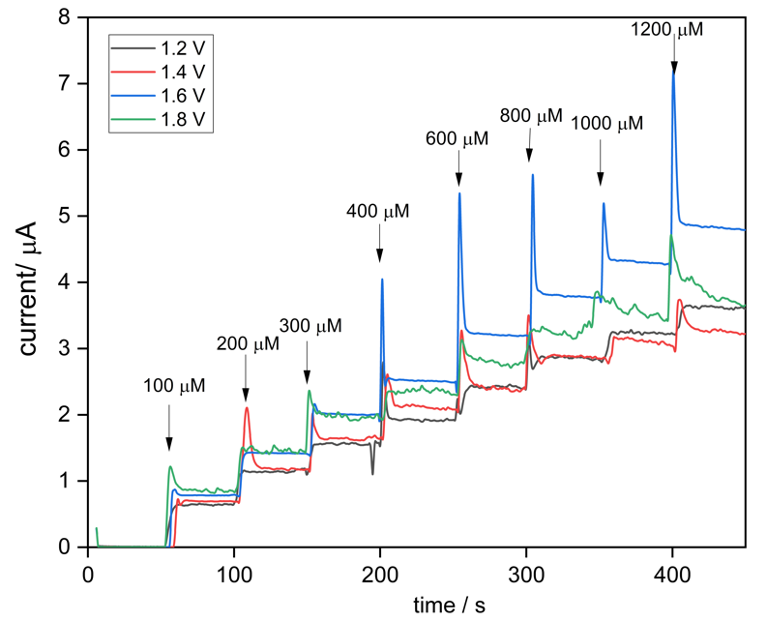
Figure 2. Amperometry results of PME synthesized in different potential window. All the amperometry test were scanned at a fixed potential (0.20 V) with additional of DA with concentration ranging from 100 - 1200 μM in PBS (0.10 M, pH 7.0)
Figure 3. Graphs of (a) sensitivity and (b) LOD results versus varied potential window applied for electropolymerization of melamine in reline.

Table 1. Optimization studies for electropolymerization of melamine in reline, DA as model analyte; sensing with amperometry at 0.20 V vs Ag/AgCl: Effect of electropolymerization potential window, effect of scan rate and effect of scan cycles
Parameter Varied |  | Eutectic  Solvent | Sensitivity /  μA μM⁻¹ cm⁻² | LOD / $μ$M
Potential (V) | 1.2 | reline | 0.032 | 4.8640
Potential (V) | 1.4 | reline | 0.034 | 0.4110
Potential (V) | 1.6 | reline | 0.044 | 0.1980
Potential (V) | 1.8 | reline | 0.038 | 2.0700
Scan rate (mV s⁻¹) | 10 | reline | 0.035 | 0.4450
Scan rate (mV s⁻¹) | 25 | reline | 0.044 | 0.3260
Scan rate (mV s⁻¹) | 50 | reline | 0.044 | 0.1980
Scan rate (mV s⁻¹) | 75 | reline | 0.046 | 1.0770
Scan rate (mV s⁻¹) | 100 | reline | 0.045 | 0.7860
Scan cycles | 3 | reline | 0.038 | 0.6800
Scan cycles | 5 | reline | 0.044 | 0.1980
Scan cycles | 10 | reline | 0.039 | 1.1800
Scan cycles | 15 | reline | 0.044 | 0.5680

Optimization of scan rate for melamine electropolymerization
Figure 4 illustrates the electropolymerization behavior of melamine in different scan rates. Scan rate determine the time taken to complete one polymerization cycle. In this study, the recorded voltammogram was not able to distinct any significant observation to relate the effect of scan rate on polymerization of melamine. Thus, these electrodes prepared at 10, 25, 50, 75, and 100 mV s⁻¹ scan rates were analyzed using the amperometry technique to investigate the performance in DA sensing. Figure 5 displays the amperometry plot of PME whereas Figure 6 displays the calculated sensitivity and LOD based on the amperometry results obtained.

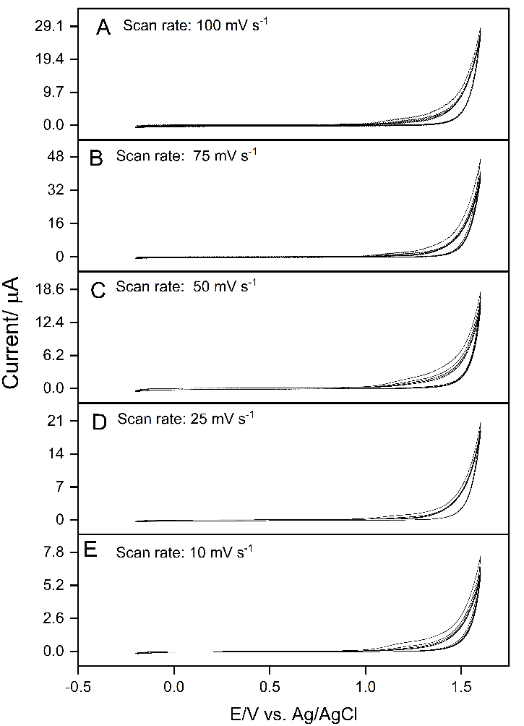
Figure 4. Electropolymerization of melamine (10.0 mM, -0.20- 1.60 V, five cycles) in reline scanning with varied scan rate (10, 25, 50, 75, and 100 mV s⁻¹)

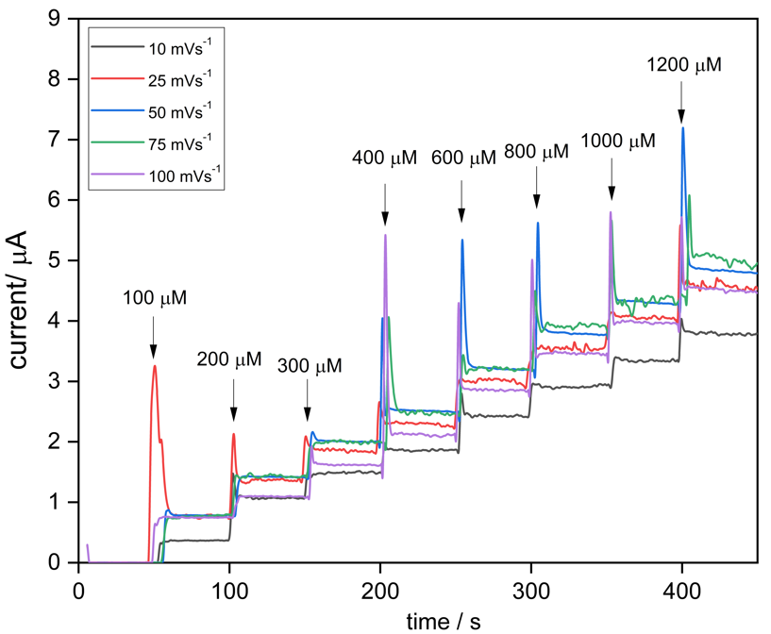
Figure 5. Amperometry results of PME synthesized in different scan rates. All the amperometry test were scanned at a fixed potential (0.20 V) with additional of DA with concentration ranging from 100 - 1200 μM in PBS (0.10 M, pH 7.0)

Figure 6. Graphs of (a) sensitivity and (b) LOD results versus varied scan rates applied for electropolymerization of melamine in reline

The result of amperometry sensing of DA at PME/GCE synthesized with varied scan rates are display in Figure 5. Based on Figure 5, the amperometry plots of PME(reline 75 mV s⁻¹) and PME(reline 50 mV s⁻¹) were very close to each other, unable to differentiate which scan rate gives the best outcome. Figure 6(a) and (b) show the fluttered of sensitivity and LOD of varied scan rates applied in electropolymerization of melamine (10.0 mM) in reline. The scan rate applied was varied from 10 to 100 mV s⁻¹. PME(reline) synthesized with 10 mV s⁻¹ is named as PME(reline 10 mV s⁻¹) in accordance to the scan rate applied. As shown, the PME(reline 50 mV s⁻¹) was selected as the ideal scan rate where the sensitivity and LOD reported at 0.044 $μ$A $μ$M⁻¹ cm⁻² and 0.198 $μ$M, respectively. In this case, PME(reline 75 mV s⁻¹) and PME(reline 25 mV s⁻¹) demonstrated the excellent sensitivity at 0.046 $μ$A $μ$M⁻¹ cm⁻² and 0.044 $μ$A $μ$M⁻¹ cm⁻², respectively. However, both PME(reline 75 mV s⁻¹) and PME(reline 25 mV s⁻¹) showing much poorer sensing capability with LOD recorded at 1.077 $μ$M and 0.326 $μ$M, respectively as indicate in Table 1. It is noted that the change of polymerization scan rate affecting the LOD significantly. This is due to the low signal strength and high signal noise. Higher scan rate will result in branched polymer that have side chains growing out from the main chain. Branched polymer exhibits lower density and less packing where the analyte would be easily to move into the polymer cavity during the electrocatalytic activity, thus inducing flux of analyte molecules or ions at the electrode-electrolyte interface which result in a great fluctuation (noise) [17]. Whereas lower scan rate develops linear polymer which are very dense and compact, resulting there would be almost no channel for analyte to approach the electrode and hence reduced the signal strength and increased the LOD.

Optimization of scan cycles on melamine electropolymerization
Scan cycles influences the polymer film thickness and sensing characteristics. The optimum scan cycle was investigated using constant conditions i.e., 10.0 mM melamine in reline electrolyte at room temperature with CV scanned from -0.20 V - 1.60 V. The growing of polymer film was indicated from the increase of the reduction current. Figure 7 illustrates the electropolymerization behavior of melamine in different scan cycle. Different scan cycles lead to different thickness of polymer on the surface of GCE. Unfortunately, the voltammogram could not show any significant result to relate the effect of scan cycle on polymerization behaviour of melamine as scan cycle are served to control the thickness the polymer film. Therefore, amperometry was employed to study the effect of polymer thickness on its sensing properties. Figure 8 shows the electrocatalytic performance of PME synthesized in different scan cycles. Scan cycles of five shows the steady increase of current with the increase of DA concentration, it also demonstrates the highest current response among all. Based on Figure 9(a) and (b), the optimum polymeric film can be obtained in five scan cycles, due to the sharp enhancement of sensitivity that has been recorded. When the scan cycles are increased to ten, it caused a minor decreased on LOD, further increasing of scan cycles to 15 attributed to a steeply decrease in sensitivity and raising of LOD. Such phenomenon was presumably due to excess polymer deposited on the GCE surface which blocking the electron transfer that needed for the DA oxidation process. As deduced from the higher charge transferred during polymerization, thin polymer films are usually superior in sensing studies due to better conductivity and easier in accessing analyte. Hence, five scan cycles were used for film formation.

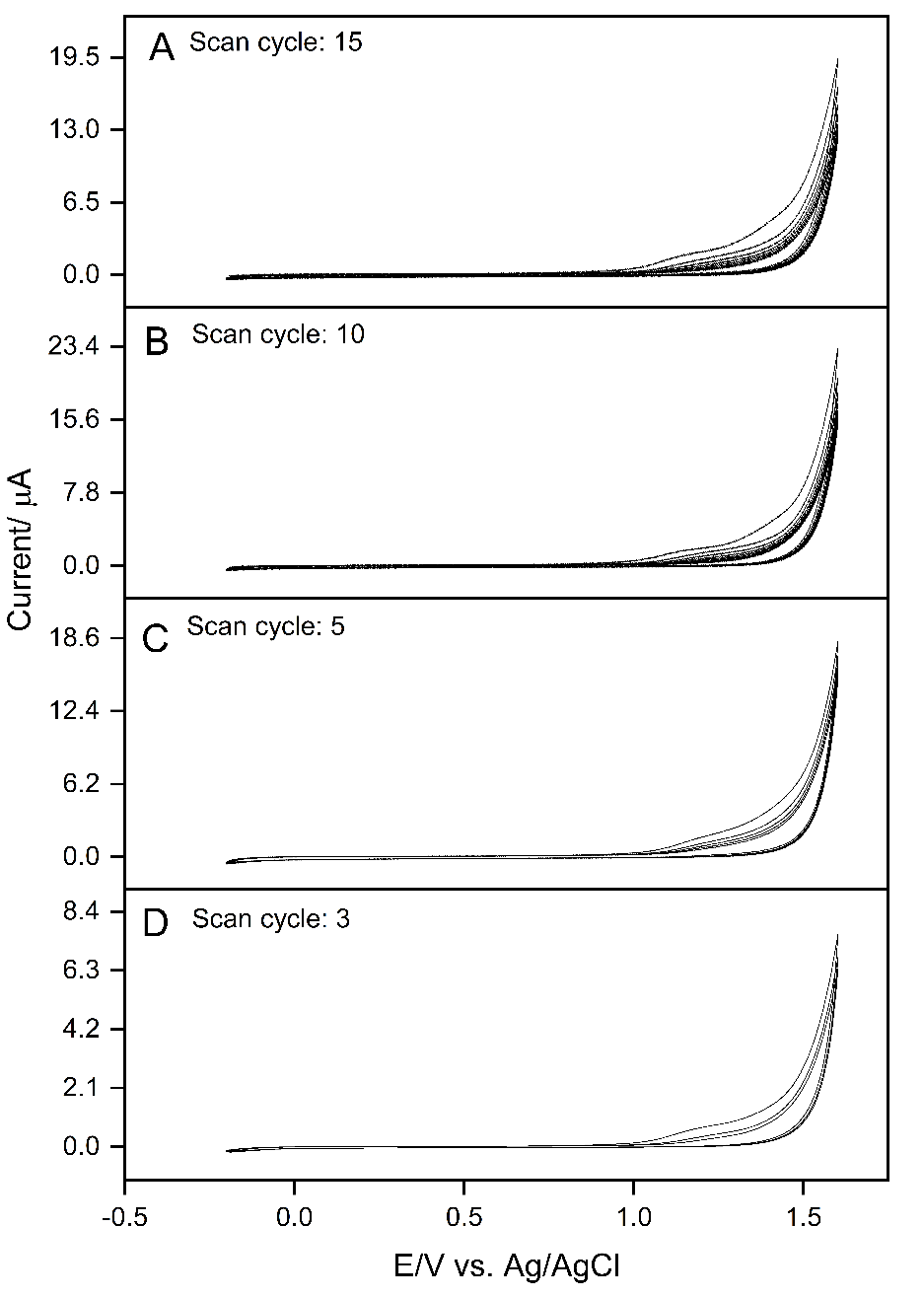
Figure 7. Electropolymerization of melamine (10.0 mM, -0.20- 1.60 V, 50 mV s⁻¹) in reline scanning with varied scan cycle (3, 5, 10 and 15)

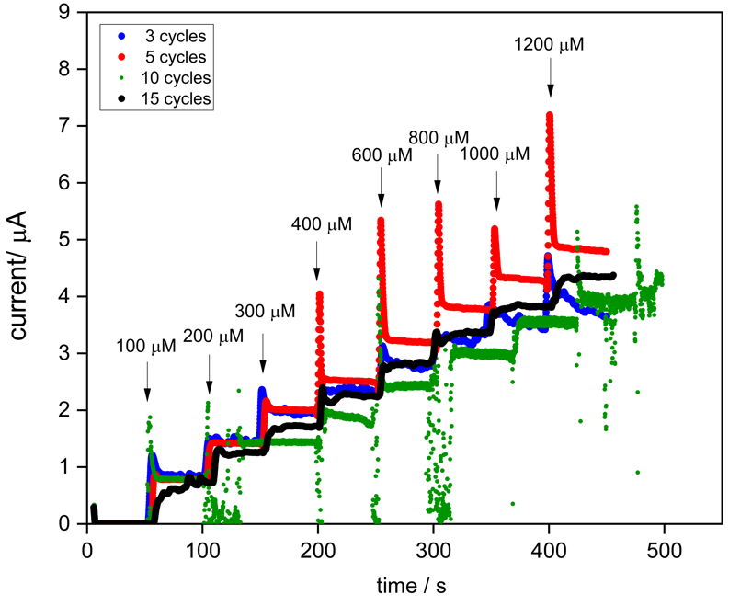
Figure 8. Amperometry results of PME synthesized in different scan cycles. All the amperometry test were scanned at a fixed potential (0.20 V) with additional of DA with concentration ranging from 100 - 1200 μM in PBS (0.10 M, pH 7.0)

Figure 9. Graphs of (a) sensitivity and (b) LOD results versus varied scan cycles applied for electropolymerization of melamine in relin

Conclusion
Hereby reports the novel studies of optimization parameters for melamine electropolymerizes in DES, reline. Different parameters including potential window, scan rate, and number of scan cycles were manipulated in preparing PME in DES. Amperometry sensing on DA was conducted to compare the sensitivity and limit of detection for the PME prepared in different parameters. The optimum polymerization parameters for melamine were discovered as -0.20 V – 1.6 V, 50 mVs⁻¹, and five scan cycles, respectively. The effect of each parameter on the electrocatalytic behavior of PME has been clarified. With the successful optimization, PME(reline)/GCE with high sensitivity and low limit of detection recorded at 0.044 μA μM⁻¹ cm⁻² and 0.198 $μ$M has achieved. Proportionally, contemporary potential polymers can be construct by manipulating the parameters accordingly.

Acknowledgement
This work is financially supported by Impact Oriented Interdisciplinary Research Grant IIRG013B-2019 and Frontier Research Grant FG030-17AFR by the Universiti Malaya.

References
  - Gupta, P. and Goyal, R. N. (2014). Polymelamine modified edge plane pyrolytic graphite sensor for the electrochemical assay of serotonin. Talanta, 120: 17-22.
  - Kesavan, S., Kumar, D. R., Lee, Y. R. and Shim, J. J. (2017). Determination of tetracycline in the presence of major interference in human urine samples using polymelamine/electrochemically reduced graphene oxide modified electrode. Sensors and Actuators B: Chem, 241: 455-465.
  - Khosropour, H., Rezaei, B., Alinajafi, H. A. and Ensafi, A. A. (2021). Electrochemical sensor based on glassy carbon electrode modified by polymelamine formaldehyde/graphene oxide nanocomposite for ultrasensitive detection of oxycodone. Microchimica Acta, 188(1): 1.
  - Farida, A. N., Fitriany, E., Baktir, A., Kurniawan, F. and Harsini, M. (2019). Voltammetric study of ascorbic acid using polymelamine/gold nanoparticle modified carbon paste electrode. IOP Conference Series: Earth Environmental Science, 217: 012004.
  - Qin, H., Hu, X., Wang, J., Cheng, H., Chen, L. and Qi, Z. (2020). Overview of acidic deep eutectic solvents on synthesis, properties and applications. Green Energy and Environment, 5(1): 8-21.
  - Zante, G. and Boltoeva, M. (2020). Review on hydrometallurgical recovery of metals with deep eutectic solvents. Sustainable Chemistry, 1(3): 238-255.
  - Cen, P., Spahiu, K., Tyumentsev, M. S. and Foreman, M. R. S. J. (2020). Metal extraction from a deep eutectic solvent, an insight into activities. Physical Chemistry Chemical Physics, 22(19): 11012-11024.
  - Paiva, A., Craveiro, R., Aroso, I., Martins, M., Reis, R. L. and Duarte, A. R. C. (2014). Natural deep eutectic solvents – solvents for the 21st century. ACS Sustainable Chemistry & Engineering, 2(5): 1063- 1071.
  - Mendonça, P. V., Lima, M. S., Guliashvili, T., Serra, A. C. and Coelho, J. F. (2017). Deep eutectic solvents (DES): Excellent green solvents for rapid SARA ATRP of biorelevant hydrophilic monomers at ambient temperature. Polymer, 132: 114-121.
  - Sánchez-Leija, R. J., Torres-Lubián, J. R., Reséndiz-Rubio, A., Luna-Bárcenas, G. and Mota-Morales, J. D. (2016). Enzyme-mediated free radical polymerization of acrylamide in deep eutectic solvents. RSC Advances, 6(16): 13072-13079.
  - Fernandes, P. M. V., Campiña, J. M., Pereira, N. M., Pereira, C. M. and Silva, F. (2012). Biodegradable deep-eutectic mixtures as electrolytes for the electrochemical synthesis of conducting polymers. Journal of Applied Electrochemistry, 42(12): 997-1003.
  - Mąka, H., Spychaj, T. and Adamus, J. (2015). Lewis acid type deep eutectic solvents as catalysts for epoxy resin crosslinking. RSC Advances, 5(101): 82813-82821.

  - Chang, Y. H., Woi, P. M. and Alias, Y. B. (2021). Electrochemical characterization of melamine electropolymerized in deep eutectic solvents for selective detection of dopamine. Electrocatalysis, 12(3): 238-250.
  - Chen, S., Liu, S., Wen, A., Zhang, J., Nie, H., Chen, J., Zeng, R., Long, Y., Jin, Y. and Mai, R. (2018). New insight into electropolymerization of melamine. I: Chloride promoted growth of polymelamine in different pH medium. Electrochimica Acta, 271: 312-318.
  - Migliorati, V., Sessa, F. and D’Angelo, P. (2019). Deep eutectic solvents: A structural point of view on the role of the cation. Chemical Physics Letters, 2: 100001.
  - Li, R., Lin, C. W., Shao, Y., Chang, C., Yao, F. K., Kowal, M., Wang, H., Yeung, M., Huang, S. C. and Kaner, R. (2016). Characterization of aniline tetramer by MALDI TOF mass spectrometry upon oxidative and reductive cycling. Polymers, 8(11): 401.
  - Gabrielli, C., Huet, F. and Keddam, M. (1993). Fluctuations in electrochemical systems. I. General theory on diffusion limited electrochemical reactions. The Journal of Chemical Physics, 99: 7232.

