

ESTIMATION OF METHANE PRODUCTION VIA ANAEROBIC CO-DIGESTION OF FOOD WASTE AND SLUDGE BY BIOCHEMICAL METHANE TEST

(Anggaran Pengeluaran Metana Melalui Pencernaan Bersama Anaerobik Sisa Makanan dan Enap Cemar oleh Ujian Potensi Metana Biokimia)

Nur Anisah Abdul Latif¹, Zuhaida Mohd Zaki², Khor Bee Chin³, Faeiza Buyong¹*

¹Faculty of Applied Sciences,
Universiti Teknologi MARA, 40450 Shah Alam, Selangor, Malaysia
²Faculty of Civil Engineering,
Universiti Teknologi MARA, 13500 Permatang Pauh, Pulau Pinang, Malaysia
³Indah Water Konsortium Sdn. Bhd., Damansara Height, 50490 Kuala Lumpur, Malaysia

*Corresponding author: faeiza@uitm.edu.my

Received: 28 December 2021; Accepted: 27 February 2022; Published: 28 April 2022

Abstract
Biochemical methane potential (BMP) tests are extensively used in many studies related to anaerobic co-digestion (AcoD) to evaluate biogas production and determine the potential methane yield between various substrates at specific retention times and parameters. AcoD is a process of mixing two or more substrates in a digester that could help to improve the methane yield as compared to mono-digestion with the same substrates. This study evaluates the methane production efficiency via AcoD of food waste and thickened sludge by using the BMP tests. The substrates used for this study were wastes from non-dairy creamer, coffee, and mixed food waste with sludge. Additionally, thickened sludge as an inoculum was used for the BMP test. The samples characterisation was analysed according to standard and HACH methods. The thickened sludge was set up at a ratio of 1:1 as a control, while the food wastes sample with sludge was set up at a ratio of 1:2. The initial pH was adjusted in a range of 6.5-7. The BMP test setup was done using a 125mL serum bottle in triplicates for 31 days in an incubator at 37ºC. The results showed that the highest methane production of the BMP was from thickened sludge itself which is 18.275 ± 3.3 mL CH₄/gVS, followed by non-dairy creamer waste with thickened sludge, mixed food waste with sludge and coffee waste with thickened sludge which are 17.865 ± 6.2 mL CH₄/gVS, 17.825 ± 0.05 mL CH₄/gVS and 14.797 ± 0.01 mL CH₄/gVS respectively. In conclusion, the pre-treatments process is highly recommended in order to improve biogas production.

Keywords: anaerobic co-digestion, biochemical methane potential, experimental methods, food wastes, methane production

Abstrak
Ujian potensi metana biokimia (BMP) digunakan secara meluas dalam banyak kajian berkaitan penghadaman bersama anaerobik (AcoD) untuk menilai pengeluaran biogas dan menentukan potensi hasil metana antara pelbagai substrat pada masa dan parameter pengekalan tertentu. AcoD merupakan suatu proses mencampurkan dua atau lebih substrat dalam pencerna yang boleh meningkatkan hasil metana berbanding mono-pencernaan dengan substrat yang sama. Kajian ini bertujuan menilai kecekapan pengeluaran metana oleh AcoD bagi sisa makanan dan enap cemar pekat menggunakan ujian BMP. Substrat yang digunakan untuk kajian ini ialah sisa daripada krimer bukan tenusu, kopi, dan sisa makanan yang bercampur dengan enap cemar. Enap cemar pekat digunakan untuk ujian BMP sebagai inokulum. Pencirian sampel dianalisis mengikut kaedah standard dan HACH. Enap cemar yang menebal telah disediakan dalam nisbah 1:1 sebagai kawalan, manakala sampel sisa makanan dengan enap cemar disediakan dalam nisbah 1:2. Nilai pH awal diselaraskan dalam julat 6.5–7. Persediaan ujian BMP dilakukan menggunakan botol serum 125mL sebanyak tiga kali ganda selama 31 hari dalam inkubator pada suhu 37ºC. Hasil kajian menunjukkan bahawa pengeluaran metana BMP tertinggi adalah daripada enap cemar pekat itu sendiri, iaitu 18.275 ± 3.3 mL CH₄/gVS, diikuti sisa krimer bukan tenusu dengan enap cemar pekat, sisa makanan bercampur dengan enap cemar, dan sisa kopi dengan enap cemar pekat, masing-masing 17.865 ± 6.2 mL CH₄/gVS, 17.825 ± 0.05 mL CH₄/gVS, dan 14.797 ± 0.01 mL CH₄/gVS. Kesimpulannya, proses pra-rawatan amat disyorkan untuk meningkatkan pengeluaran biogas.

Kata kunci: pencernaan bersama anaerob, potensi metana biokimia, kaedah eksperimen, sisa makanan, penghasilan metana

Introduction
The amount of sewage sludge is continuously increasing as a surplus of the wastewater treatment process due to increased population. The higher percentage of households connected to the main wastewater treatment plants (WWTPs) also contributes to the higher production of sewage sludge [1, 2]. Nevertheless, improper handling and untreated sewage sludge may lead to environmental impacts and public health problems. This is because sewage sludge is characterised by its high concentrations of solids and organic matter, with the presence of nutrients, organic and inorganic pollutants and pathogens that create odour problems. Nowadays, there are several alternative techniques which are applied for sewage sludge disposal, such as incineration, landfills, compost, recycling, and anaerobic digestion (AD). AD is a proven technology and one of the most feasible techniques applied for the treatment of sewage sludge in many countries due to its lower operational cost, reduced chemical oxygen demand (COD), decreased pollutants discharged into the environment, and production of energy-rich biogas [3, 4, 5].

Besides that, anaerobic digestion (AD) is also known as the most efficient process for the treatment of municipal solid waste and wastewater sludge [6, 7]. In general, anaerobic digestion (AD) is the process in which organic waste such as bio-waste, animal manure, sludge, crops, and other biomasses are biologically degraded in the absence of oxygen and converted into a form of biogas and other organic compounds as end products [6, 7]. The food waste also can be characterised by its high percentage of biodegradability, moisture content around (˃ 70%), volatile solids (˃ 95%), with numerous amounts of lipids [8] that will enhance the AD performance. Other than that, the methane gas obtained from the AD process can be used to generate electricity and for heating purposes. Sewage sludge is characterised by its high concentration of solids and organic matter, with the presence of nutrients, organic and inorganic pollutants, and pathogens. According to Appels et al., [6], fuels can be produced by using sewage sludge. It can also be used as an inoculum in the anaerobic digestion process by considering its characteristics. Thus, anaerobic co-digestion (AcoD) is the process of mixing two or more substrates in a digester that could improve methane production from 25% to 400% as compared to the mono-digestion [9-13] of the same substrates [14,15].

Non-dairy creamer (NDC) and coffee are from the food and beverages industry. However, the NDC contains no lactose. It is a substitute product for milk or cream in the form of a liquid or powder which produces high water dissolved fat emulsion that is made up from vegetable oil (30% hydrogenated coconut or palm oil) for the purpose of reducing the amount of milk or replacing the milk powder in oatmeal, baked goods, coffee and others [16]. Huang et al.,[17] stated that NDC is made up of 60-65% glucose or corn syrup, 2-5% sodium caseinate, stabilisers, and emulsifiers [18], and it contains about 1.2% of minerals, 8.5% of protein, 32.5% of fat, and the highest percentage is carbohydrate at 58%. The liquid waste and sewage sludge are the by-products of the NDC industry. The improper processing of the NDC wastewater will affect the environment. The sewage sludge and wastewater from NDC contain high organic matter such as proteins, lipids, and carbohydrates [19-21] While the coffee processing effluent is highly acidic, has high chemical oxygen demand (COD), and also contains a high amount of organic matter and suspended solids [22-23], the foul odour and eutrophication occurs due to the dark brown colour of the effluent which was produced from the coffee processing plants due to the decomposition of lignin (humic acid, tannin) with different macromolecules such as caffeine and polyphenols (melanoidins). Cardenas et al., [24] cited that melanoidins consist of ligands (polysaccharides, tannins), which hardly degrade biologically [25]. Thus, AD is considered as an alternative method to treat both NDC and coffee waste.

In addition to that, AD can be applied experimentally via the biochemical methane potential (BMP) test by determining the biodegradability of waste biomass and wastewater and also the methane potentiality [26]. The BMP experimental test is usually suitable for small-scale (batch) analysis (lab-work) which is costly, and time-consuming, with analysis within 20 to ˃100 days [27] compared to the BMP theoretical test. Several parameters influence the determination of BMP experimental tests such as the inoculum-substrate ratio, pH, temperature, retention time, chemical oxygen demand (COD), total solids (TS), moisture content, volatile solids (VS), and others [28]. The objective of this study is to evaluate the methane production via anaerobic co-digestion of food waste and sludge by using the BMP experimental method.

Material and Methods
Sample collection
Substrate and inoculum
Food waste samples as substrates (coffee, non-dairy creamer waste and mixed food waste) were obtained from the food manufacturing industry and the IWK sludge (thickened) was used as inoculum. All food wastes and thickened sludge were supplied by Indah Water Konsortium Sdn. Bhd (IWK), whose WWTP plant is located at IWK Sewage Treatment Plant, Kuala Lumpur. Then, the collected samples were degassed or pre-incubated to deplete the residual biodegradable organic material present in them [29]. Table 1 presents the setup of substrates used for this study.

Table 1. Substrates for BMP, and S/I ratio
Inoculum & Substrates | Label | Substrate/inoculum Ratio, S/I
Thickened sludge (inoculum) | IWK Sludge | 1:1
Non-dairy creamer waste + inoculum | Co-digestion 1 | 1:2
Coffee waste + inoculum | Co-digestion 2 | 1:2
Mixed food wastes + inoculum | Co-digestion 3 | 1:2

Analytical method
Sample characterization
The characterisations of the substrate (food waste) and inoculum (thickened sludge) conducted for this study are the moisture content, Volatile Matter, pH, temperature, Total Solid (TS) and Volatile Solid (VS), chemical oxygen demand (COD), alkalinity and volatile fatty acid (VFA). Thus, all these parameters were measured according to the Standard Methods [30] except for the alkalinity and VFA, which used the HACH method. About 200mL of the sample was placed in a 500 mL beaker. The pH meter was calibrated first at pH 4, 7 and 10, and then the pH of the samples was measured by using the pH meter (Orion Star A111 pH meter). In order to do that, moisture and TS were determined by drying the samples at 105 °C overnight and for 4 hours at a constant weight [30]. While the previous sample from the moisture content and TS was heated by furnace at 550 °C for 2 hours and 15 minutes to measure the volatile matter and VS. Chemical oxygen demand (COD) was performed by using and preparing the high range COD standard reagents (200-15000 mg/L), blank, and samples. Each sample was diluted by 1:10 time’s dilution, and about 2.0 mL of the sample was filled into the high range COD reagent vial. Thus, the samples were placed into the COD reactor within 2 hours at 150 °C. Then, the readings of the COD were analysed by using the spectrophotometer.

However, for alkalinity, the digital titration cartridge, sulfuric acid 1.600±0.008 N was used (based on the HACH method procedure). About 10mL of the sample volume was titrated with a digital titration cartridge, and the titration was stopped at a pH 4.5. Then, the counter (at the digital titrator) showed the digits for the first endpoint, and the digits were multiplied with the digit multiplier (x10) for samples in the range of 1000-4000 (mg/L as CaCO₃). Thus, the exact volume (mg CaCO₃/L) total alkalinity was recorded. Lastly, for the VFA test method, about 0.5 mL of deionized water and samples (the filtrate or supernatant) were placed separately on a sample cell. An amount 1.5 mL of ethylene glycol was added to each sample cell, and then it was swirled, followed by adding 0.2 mL of 19.2N sulfuric acid. Then, the sample cell was boiled for 3 minutes. The sample cell was immersed into cool water at 25 °C (until the cells feel cold). 0.5 mL of Hydroxylamine hydrochloride solution, 2.0 mL of 4.5N sodium hydroxide standard solution, 10 mL of ferric chloride sulfuric acid solution, and 10 mL of deionized water was added to each sample cell and the cell was inverted to mix. 10 mL of the blank solution and prepared sample were transferred to a clean sample cell. The sample cell was inserted into the cell holder and the results were shown in mg/L HOAC.

Sample preparation
BMP experimental test
The BMP experimental test was performed in 125 mL serum bottles for the AD process [31] with a working volume of 70% and 30% remaining for the gas production as shown in Figure 1 [32]. Food waste samples such as coffee and non-dairy creamer were used as a substrate, while the IWK sludge (thickened sludge) was an inoculum. The initial pH was adjusted at a range of 6.5-7. After mixing and adding the samples into the serum bottle, the nitrogen gas was purged immediately in the headspace of the bottles for 3 minutes to remove the presence of air, which creates an anaerobic condition in the system [33], prior to sealing the serum bottles. All serum bottles were placed into an incubator at 37 °C, which is the optimum temperature for microbial activities [34] within the retention period of 31 days [35]. Every batch of AD was set up according to a 1:1 ratio for control and a 1:2 ratio of food waste to sludge. The serum bottles were placed into a rotary shaker once a day for 15 minutes to ensure the mixtures were well shaken. All experiments were performed in triplicate. An inoculum filled with water, with no substrate added, was used as a blank assay for the background of the methane yield. The gas sample produced was abstracted from the serum bottle and was then analysed by Gas Chromatography (GC) Agilent 7890A (30m x 32 μm x 0.25 μm).

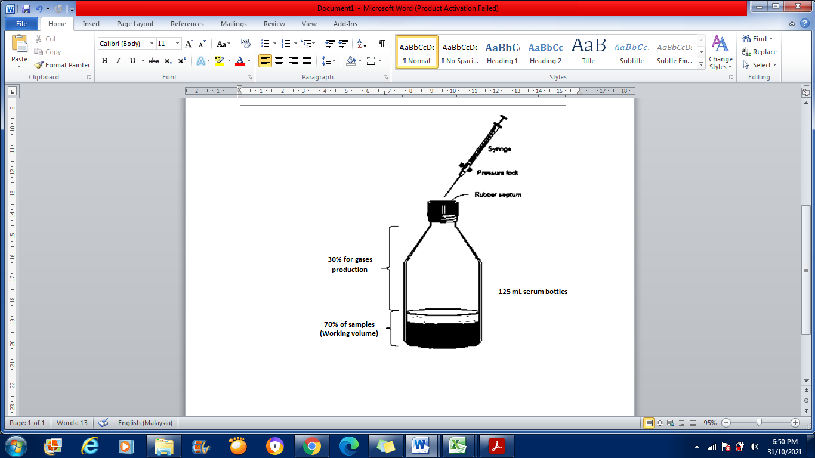

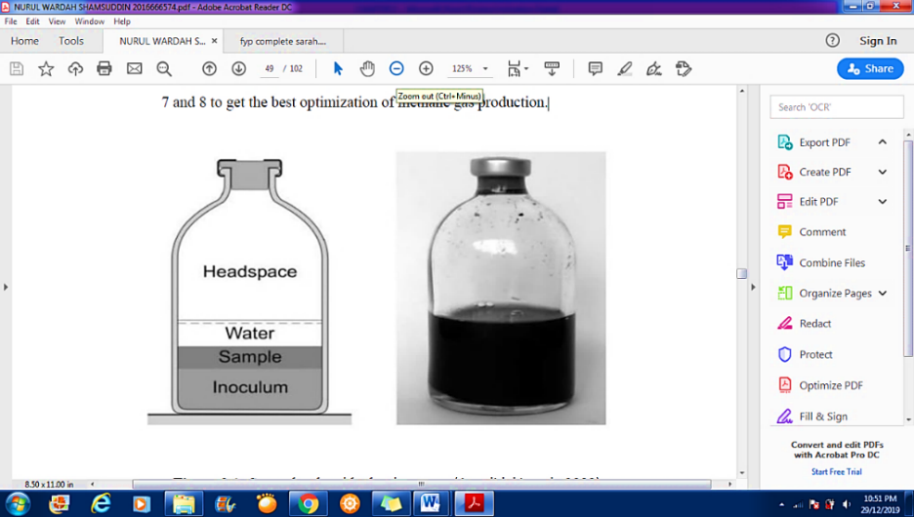

Figure 1. 125 mL of serum bottles set up [31]

Results and Discussion
Sample characterization
The results of the characterization of all samples are summarized in Table 2. The pH for non-dairy creamer waste (NDC), coffee waste, thickened sludge, and mixed food waste with sludge was in the range of slightly neutral to alkaline. The highest pH observed was in coffee waste. During the methanogenesis stages of AD, the methanogenic bacteria are highly sensitive to pH, so the optimum pH for methanogenic bacteria activities is within a range of 6.8-7.2 [36-37], as supported by Lusk [38]. The digester should be maintained at a pH near 7.0 to enhance biogas production, while a low pH would create the accumulation of volatile fatty acids (VFA) which results in the inhibition of the digestion process [39-40]. For a proximate analysis, the information on the moisture content (MC), volatile matter (VM) and others were obtained, which is important to determine the potentiality and suitability of the biomass [41]. From the results in Table 2, the MC for all raw samples is more than 90%, which shows that the water content of each sample was high, which means the raw materials have sufficient MC for anaerobic digestion, as the moisture content of the food waste in the substrate is between 95 - 97% from his study [42]. The volatile matter (VM) for all the samples was in the range of 66-80%. Thus, the fraction of VM for all the samples showed its potential to produce higher biogas production [43-44]. The thickened sludge and mixed food waste produced the higher chemical oxygen demands (COD) with 18790 ± 96.44, and 12,516 ± 92.38 mg/L respectively. According to Treagust [45], the COD of coffee wastewater reaches up to 50,000 mg/L. Toxic chemicals such as tannis, alkaloids (caffeine) and polyphenolics can be found in coffee wastewater in small amounts. The COD values measured the oxygen needed to oxidize all organic material present within substances [46]. The higher the COD values, the higher the potential of substances to produce methane.

The total solids (TS) of the substrates mainly started from ˂ 7%. TS measures the suspended and dissolved solids in water. Coffee waste has the greater TS value, with 7.32%, compared to others. Volatile solids (VS), are described as the organic matter present in the wastewater which is important for AD performances that would enhance the higher production of methane. The VS value for food waste and sludge is at a range of 40-70%. Alkalinity is a very important parameter in the AD process. Alkalinity helps to avoid the failure of the digester and causes the inhibition of methanogenic bacteria activities by preventing the pH drop. The alkalinity of NDC, coffee waste, thickened sludge, and mixed food waste with sludge was 900 ± 1.48, 794.83 ± 1.56, 3012.5 ± 1.75 and 3337.5 ± 0.89 mg CaCO₃/L. Volatile fatty acid (VFA) is another option to justify the availability of the raw materials used in AD for the production of methane. Like other common factors of AD such as pH, alkalinity, and COD, the VFA gives information on the process status [47]. The hydraulic loading, temperature, and organic loading might affect the concentration of VFA. According to Yu et al. [48], the accumulation of VFA will interrupt the digester buffer capacity, leading to acidification and the failure of system performance by inhibiting the methanogenic bacteria activities. Thus, the VFA readings for all the samples were 6510 ± 25.39, 2410.33 ± 27.94, 211 ± 23.81, and 707.33 ± 57.66 mg/L which represents the NDC, coffee waste, thickened sludge, and mixed food waste with sludge. There are many studies on the effects of VFA content that might affect AD efficiency.

Table 2. The results of the characterization of samples
Parameters | Non-Dairy Creamer waste (NDC) | Coffee waste | Mixed Food waste with sludge | Thickened sludge
pH | 7.46 ± 0.01 | 11.55 ± 0.08 | 7.07 ± 0.03 | 7.09 ± 0.03
Moisture Content (%) | 99.34 ± 0.02 | 90.05 ± 0.03 | 95.53 ± 0.02 | 96.21 ± 0.01
Volatile Matter (%) | 80.03 ± 1.82 | 73.59 ± 1.18 | 66.07 ± 2.08 | 68.97 ± 0.002
Chemical Oxygen Demands (mg/L) | 8400 ± 52.92 | 7843.33 ± 32.15 | 12516.67 ± 92.38 | 18790 ± 96.44
Total Solid (%) | 0.68 ± 0.18 | 7.32 ± 0.02 | 4.49 ± 0.03 | 4.11 ± 0.06
Volatile Solid (%) | 70.84 ± 0.08 | 44.68 ± 0.002 | 67.11 ± 0.06 | 69.18 ± 0.001
Alkalinity (mg CaCO₃/L) | 900 ± 1.48 | 794.83 ± 1.56 | 3337.5 ± 0.89 | 3012.5 ± 1.75
Volatile Fatty Acids, VFA (mg/L) | 6510 ± 25.39 | 2410.33 ± 27.94 | 707.33 ± 57.66 | 211 ± 23.81

BMP experimental test
The BMP experimental test was performed in 125 mL serum bottles for the AD process [31] with a working volume of 70% and 30% remaining for the gas production as shown in Figure 1. Constant BMP experimental results were achieved for all samples after the retention time of 31 days for the anaerobic digestion process took place. The BMP assays are assumed to be finished when the daily production is less than 1% or when the cumulative graph shows a constant trend of methane production which indicates the organic substances are fully degraded. The microorganisms no longer have enough nutrients for digestion purposes. Figure 2 shows the methane production of co-digestion 1, co-digestion 2, co-digestion 3, and thickened sludge. The lag phase, which is the time of adaptation for inoculum to a new environment or medium, stopped around 7 days, in this study. According to the curves in Figure 2, it can be observed that the methane production was initially slow, but continuously increased at around 20 days. There was a constant production of methane from day 20 until day 31. Thus, it took almost 20 days for all the methane to be produced from the substrates. It can be seen that the highest methane production was from the thickened sludge which is 18.275 ± 3.3 mL CH₄/gVS, followed by the non-dairy creamer waste with sludge (co-digestion 1) that is 17.865 ± 6.2 mL CH₄/gVS and mixed food waste with sludge (co-digestion 3) at 17.825 ± 0.05 mL CH₄/gVS. While, the lowest methane production is from coffee waste with sludge (co-digestion 2) which is 14.797 ± 0.01 mL CH₄/gVS.

Co-digestion 2 shows the lowest production of methane compared to co-digestions 1 and 3. The coffee waste itself is characterized as lipids, cellulose, lignin-rich biomasses. Lignin (humic acid, tannin) has different macromolecules such as caffeine and polyphenols (melanoidins). Cardenas et al.,2009 [24] cited that, melanoidins consist of ligands (polysaccharides, tannins), which hardly degrade biologically [24]. The cellulose and lignin make the lignocellulosic biomass a great prospect for biogas production through AD. However, it is still considered difficult for it to be degraded and digested. Somehow, the study also highlighted that lower methane potentials of about 0.16 - 0.35 CH₄ m3/kg VS of food waste are rich-lignocellulosic fractions and have low lipids content, such as fruit and vegetable residues and brewery waste. Moreover, the coffee waste shows that the highest pH, which is 11.55 ± 0.08, is very alkaline. It will affect biogas productivity. As mentioned before, it has been proved that the optimum pH for methanogenic bacteria activities is within a range of 6.8-7.2, which will give a significant effect on biogas yield [36-37]. Co-digestion 1 shows that the second-highest methane yield is 17.865 ± 6.2 mL CH₄/gVS. This is because NDC contains high organic matter with about 1.2% minerals, 8.5% protein, 32.5% fat, and the highest percentage is carbohydrates (58%) [18-21]. Protein and carbohydrate-rich substrates are considered to be easily degradable, and lipids have less of a hydrolysis rate [48]. Thus [42, 49], higher methane yields can be achieved from food wastes rich in lipids, such as easily degradable carbohydrates.

The reading of the methane yields for co-digestion 3 (mixed food waste with sludge) is slightly similar to co-digestion 1 which is 17.825 ± 0.05 mL CH₄/gVS. The COD of co-digestion 3, which is 12516.67 ± 92.38 mg/L, is higher compared to co-digestion 1 and co-digestion 2. However, the COD for the thickened sludge, which is 18790 ± 96.44 mg/L, shows the highest yield compared to the others. This shows that most of the organic matter is contained in both co-digestion 3 and the thickened sludge. It can be summarised from Figure 2, that the solely thickened sludge has the potential to produce a higher methane yield without adding any substrate. As we informed, the mixed food waste with sludge consists of coffee and non-dairy creamer waste. Thus, there is the mixing of protein, carbohydrates, and lipids with lignin groups of waste within it. These can act as a reason for the lower methane yield of co-digestion 3 compared to the inoculum which is solely thickened sludge. Therefore, the pre-treatment to the substrate is suggested either by biological, chemical, or thermal treatments to improve the substrate’s potential in producing methane. This study has proven different substrates have different characteristics, as can be seen in the proximate analysis of the raw materials. Thus, pre-treatment approaches can be taken to enhance the efficiency of methane generation.

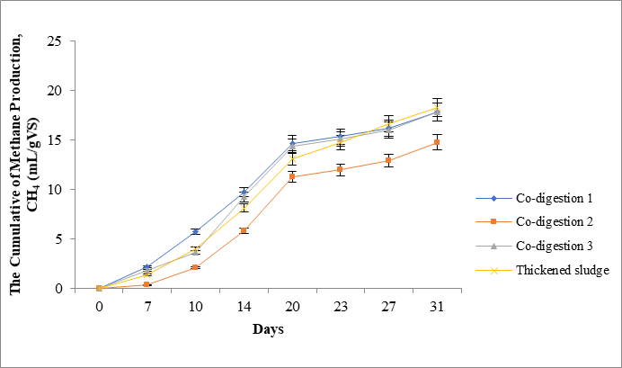
Figure 2. The cumulative BMP experimental test of methane production for co-digestions and inoculum

Conclusion
The NDC and coffee industry play an important role by providing good handling and processing wastewater management in order to achieve and maintain environmental stability. Nevertheless, the BMP experimental test results indicate that there is a potential for a single inoculum (thickened sludge), and the co-digestion of different wastes such as coffee waste, non-diary creamer waste, and the sample of mixed food waste with sludge would produce a methane yield within the 31 days of the AD process. However, it is also possible to inhibit the AD process if the nutrients are imbalanced. For further observation, an effective and environmentally friendly pre-treatments process is highly recommended to improve biogas production.

Acknowledgements
The authors would like to thank Universiti Teknologi MARA and IWK for awarding the grant ((100-RMC 5/3/SRP PRI (026/2020)). Special appreciation to the Faculty of Applied Sciences, UiTM, and IWK for providing the facilities to conduct this study.

References
- Werther, J. and Ogada, T. (1999). Sewage sludge combustion. Progress Energy Combustion, 25: 55-116.
- Appels, l., Baeyens, J., Degrève, J. and Dewil, R. (2008). Principles and potential of the anaerobic digestion of waste-activated sludge. Progress Energy Combustion, 34: 755-781.
- Appels, L., Degrève J., Van der Bruggen, B., Van Impe, J., and Dewil, R. (2010). Influence of low temperature thermal pre-treatment on sludge solubilisation, heavy metal release and anaerobic digestion. Bioresource Technology, 101: 5743-5748.
- Angelidaki, D., Karakashev, D.J. Batstone, C.M, Plugge, A.J.M. (2011). Stams, biomethanation and its potential. Methods in Enzymology, 494: 327-351.
- Ward, A. J., Hobbs, P. J., Holliman, P. J. and Jones, D. L. (2008). Optimization of the anaerobic digestion of agricultural resources. Bioresource Technology, 99: 7928-7940.
- Appels, L., Joost, L., Degrève, J., Helsen, L., Lievens, B. and Willems, K. (2011). Anaerobic digestion in global bio-energy production: potential and research challenges. Renewable Sustainable Energy Reviews, 15: 4295-4301.
- Nasir, I. M., Tinia, I. M. G. and Rozita, O. (2012). Production of biogas from solid organic wastes through anaerobic digestion: a review. Applied Microbiology Biotechnology, 95: 321-329.
- Zhang, J., Wang, Q., Zheng, P. and Wang, Y. (2014). Anaerobic digestion of food waste stabilized by lime mud from paper-making process. Bioresource Technology, 170: 270-277.
- Astals, S., Nolla-Ardevol, V. and Mata-Alvarez, J. (2013). Thermophilic co-digestion of pig manure and crude glycerol: process performance and digestate stability. Journal of Biotechnology, 166: 97-104.
- Chen, J. H., Lin, C. C. and Wang, K. S. (2013). Potential of methane production by thermophilic anaerobic co digestion of pulp and paper sludge with pig manure. Journal Biobased Material Bioenergy, 7: 300-304.
- Giuliano, A., Bolzonella, D., Pavan, P., Cavinato, C. and Cecchi, F. (2013). Co-digestion of livestock effluents, energy crops and agro-waste: Feeding and process optimization in mesophilic and thermophilic conditions. Bioresource Technology, 128: 612-618.
- Astals, S., Ariso, M., Galí, A. and Mata-Alvarez, J. (2011). Co-digestion of pig manure and glycerine: experimental and modelling study. Journal Environmental Management, 92: 1091-1096.
- Fraizer, R. S., Hamilton, D. and Ndegwa, P. M. (2011). Anaerobic digestion: biogas utilization and cleanup. Oklahoma Cooperative Extension Service.
- Cavinato, C., Fatone, F., Bolzonella, D., Pavan, P. (2010). Thermophilic anaerobic co-digestion of cattle manure with agro-wastes and energy crops: comparison of pilot and full scale experiences. Bioresource Technology, 101:545-50.
- Shah, F. A., Mahmood, Q., Rashid, N., Pervez, A., Raja, I. A and Shah, M. M. (2015). Co-digestion, pretreatment and digester design for enhanced methanogenesis. Renewable Sustainable Energy Reviews, 42: 627-642.
- Dedin, F., Rosida, Mulyani, T. and Reshita Septalia, L. (2016). A comparative study of non-dairy cream based on the type of leguminosae protein source in terms of physico chemical properties and organoleptic. Agriculture and Agricultural Science Procedia, 9: 431-439.

- Huang, X., Lee, E. J. and Ahn, D.U. (2019). Development of non-dairy creamer analogs/mimics for an alternative of infant formula using egg white, yolk, and soy proteins. Asian-Australasian Journal of Animal Sciences, 32(6): 881-890.
- Ramesh, C.C, Kilara, A. and Shah, N. P. (2008). Dairy processing and quality assurance. 1st Edition., Wiley Blackwell Publishing, A. John Wiley and Sons Inc., New York.
- Dewi, E. R. S., Legowo, A. M. and Izzati, M. (2016). Absorption of organic compounds by Saccharomyces cerevisiae on industrial waste media. International Journal of Applied Environmental Science, 11(1): 27-36.
- Dewi, E. R. S., Legowo, A. M., Izzati, M. and Purwanto (2016). Kinetic growth of Saccharomyces cerevisiae in non dairy creamer wastewater medium. Journal of Environmental Studies, 2(1): 1-5.
- Triyaswati, D. and Ilmi, M. (2020). Lipase-producing filamentous fungi from non-dairy creamer industrial waste. Microbiology and Biotechnology Letters, 48(2): 167–17.
- Navitha, K. and Kousar, H. (2018). A comparative study on the potential of Aspergillus niger and Aspergillus favus for the treatment of coffee processing effluent. International Journal Environmental Ecology Family and Urban Studies, 8(4):17-22.
- Sahana, M., Srikantha, H., Mahesh, S. and Swamy, M.M. (2018). Coffee processing industrial wastewater treatment using batch electrochemical coagulation with SS and Fe electrodes and its combinations recovery and reuse of sludge. Water Science Technology, 78: 279-289.
- Cardenas, A., Zayas, T., Morales, U. and Salgado, L. (2009). Electrochemical oxidation of wastewaters from the instant coffee industry using a dimensionally stable RuIrCoOx anode. ECS Transactions, 20(1): 291-299.
- Péerez, T.Z., Geissler, G. and Hernandez, F. (2007). Chemical oxygen demand reduction in coffee wastewater through chemical flocculation and advanced oxidation processes. Journal Environmental Sciences, 19: 300-305.
- Remigi, E.U., Buckley, C.A. (2006). Co-digestion of high strength/toxic organic effluents in anaerobic digesters at wastewater treatment works; water research commission: Pretoria, South Africa.
- Da Silva, C., Astals, S., Peces, M., Campos, J. L. and Guerrero, L. (2018). Biochemical methane potential (BMP) tests: Reducing test time by early parameter estimation. Waste Management, 71: 19-24.
- Raposo, M. M. M., Castro, M. C., Belsley, M. and Fonseca, A. M. C. (2011). Push pull bithiophene azo-chromophores bearing thiazole and benzothiazole acceptor moieties: Synthesis and evaluation of their redox and nonlinear optical properties. Dyes Pigments, 91:454-465.
- Yan (2014). Romania to develop national strategy to reduce food waste: Minister. Access from http://news.xinhuanet.com/english/world/2014-04/01/c_133230744.htm [Accessed date 03.09.14]
- APHA (1998). Standard methods of examination of water and wastewater. 20th ed. American Water Works Association, Water Pollution Control Federation, American Public Health Association, Washington DC.
- Angelidaki, I., Alves, M., Bolzonella, D., Borzacconi, L., Campos, J. L., Guwy, A. J. and van Lier, J. B. (2009). Defining the biomethane potential (BMP) of solid organic wastes and energy crops: a proposed protocol for batch assays. Water Science and Technology, 59(5): 927-934.
- Ramatsa, I., Sibiya, N. and Huberts, R. (2014). Effect of nutrients addition during anaerobic digestion of potato peels and maize husk. International Conference on Chemical, Environmental & Metallurgical Engineering, 2014: pp. 15-16.
- Ebner, J. H., Labatut, R. A., Lodge, J. S., Williamson, A. A. and Trabold, T. A. (2016). Anaerobic co-digestion of commercial food waste and dairy manure: Characterizing biochemical parameters and synergistic effects. Waste Management, 52: 286-294.

- Sibiya, N. T., Edison, M. and Habtom, B. T. (2014). Effect of temperature and pH on the anaerobic digestion of grass silage. International Conference on Chemical Engineering & Advanced Computational Technologies, 2014: 198-201.
- Nielfa, A., Cano, R. and Fdz-Polanco, M. (2015). Theoretical methane production generated by the co-digestion of organic fraction municipal solid waste and biological sludge. Biotechnology Reports, 5, 14-21.
- Turovskiy, I. S. and Mathai, P.K. (2006). Wastewater sludge processing. New York: Wiley
- Cioabla, A. E., Ionel, I., Dumitrel, G.-A. and Popescu, F. (2012). Comparative study on factors affecting anaerobic digestion of agricultural vegetal residues. Biotechnology for Biofuels, 5(1): 39.
- Lusk, P. (1999). Methane recovery from animal manures the current opportunities casebook. National Renewable Energy Laboratory, NREL/SR-580-25145.
- Parkin, G. F. and Owen, W. F. (1986). Fundamentals of anaerobic digestion of wastewater sludges. Journal of Environmental Engineering, 112: 867-920.
- Pearse, L.F., Heittiaratchi, J.P. and Kumar, S. (2018). Towards developing a representative biochemical methane potential (BMP) assay for landfilled municipal solid waste-a review. Bioresource Technology, 254: 312-324.
- Brito, J. O., Barrichello, L. E. G. and Trevisan, J. F. (1978). Condicoes climaticas e suas influencias sobre a producao de resinas de pinheiros tropicais, Piracicaba, 16: 37-44
- Labatut, R., Angenent, L.T. and Scott, N., (2011). Biochemical methane potential and biodegradability of complex organic substrates. Bioresource Technology, 102(3): 2255-2264.
- Vassilev, S., Baxter, D., Andersen, L. and Vassileva, C. (2010). An overview of the chemical composition of biomass. Fuel, 89: 913-933.
- Demiral, I. and Ayan, E.A. (2011). Pyrolysis of grape bagasse: Effect of pyrolysis conditions on the product yields and characterization of the liquid product. Bioresource Technology, 102: 3946-3951.
- Treagust, J. (1994). Coffee waste water treatment. B.Sc. (Hons.) dissertation. Cranfield, United Kingdom: Cranfield University.
- Watershed Protection Plan Development Guidebook (2015). Description of commonly considered water quality constituents [Access date 10 October 2015].
- Boe, K., Batstone, D. J. and Angelidaki, I. (2007). An innovative online VFA monitoring system for the anerobic process, based on headspace gas chromatography. Biotechnology and Bioengineering, 96(4): 712-721.
- Mata-Alvarez, J., Dosta, J., Romero-Güiza, M., Fonoll, X., Pecesa, M. and Astals, S., (2014). A critical review on anaerobic co-digestion achievements between 2010 and 2013. Renewable Sustainable Energy Review, 36: 412-427.
- Meng, Y., Li, S., Yuan, H., Zou, D., Liu, Y., Zhu, B., Chufo, A., Jaffar, M. and Li, X., (2015). Evaluating biomethane production from anaerobic mono- and co-digestion of food waste and floatable oil (FO) skimmed from food waste. Bioresource Technology, 185: 7-13.

