Initiatives in utilizing natural reagents and natural materials for chemical analysis:
Talent and challenge for ASEAN in new normal
chemical analysis

(Inisiatif dalam Penggunaan Reagen Semulajadi dan Bahan Semulajadi bagi Analisis Kimia: Bakat dan Cabaran untuk ASEAN dalam Analisis Kimia di Norma Baru)

Kanokwan Kiwfo^{1,2}, Pei Meng Woi^{3*}, Chalermpong Saenjum^{1.2.4}, Treethip Sukkho^{1,2,4}, Kate Grudpan^{1,2,5}

¹Center of Excellence for Innovation in Analytical Science and Technology,
Chiang Mai University, Chiang Mai 50200, Thailand
²Cluster of Excellence on Biodiversity-based Economic and Society (B.BES-CMU),
Chiang Mai University, Chiang Mai 50200, Thailand
³Chemistry Department,
Faculty of Science, Universiti Malaya, 50603 Kuala Lumpur, Malaysia
⁴Pharmaceutical Sciences,
Faculty of Pharmacy, Chiang Mai University, Chiang Mai 50200, Thailand
⁵Department of Chemistry,
Faculty of Science, Chiang Mai University, Chiang Mai 50200, Thailand

*Corresponding author: pmwoi@um.edu.my
Abstract
This review explores the contributions of natural resources with diverse disciplines which offers the insights into the design of greener chemical analysis. The discussion was focused on the published works in our group where a diverse range of natural reagents used in the determination of various environmental analytes has been highlighted, aiming to discuss the initiatives and applicability of the usage of alternative natural reagents and substitute synthetic methods in optimizing analytical processes, which in turn would lead to cost-effective and time-efficient in handling analytes assay. By exploring the potential of natural reagents, the sustainability in green chemical analysis could be promised in coming near future, especially in convincing for the talent and challenge for ASEAN in this new normal chemical analysis.

Keywords: green analytical chemistry, natural reagent, natural material, local wisdom, sustainable chemistry

Abstrak
Ulasan ini membincangkan sumbangan reagen semula jadi dalam pelbagai disiplin ilmu yang dapat memberikan gambaran mengenai analisis kimia hijau. Perbincangan in fokus kepada penerbitan yang telah diterbitkan oleh kumpulan kami di mana beberapa jenis reagen semula jadi yang digunakan dalam penentuan pelbagai analit persekitaran akan diutamakan, bagi membincangkan inisiatif dan penerapan penggunaan reagen semulajadi alternatif dan kaedah sintetik gantian dalam mengoptimumkan proses analisis, supaya analisis dapat dikendalikan secara kos efektif dan cekap masa. Dengan menerokai potensi reagen semula jadi, kesinambungan dalam analisis kimia hijau akan dapat dijanjikan dalam masa terdekat terutamanya dapat memberikan keyakinan dalam bakat dan cabaran di ASEAN dari segi analisis kimia di norma baru ini.

Kata kunci: kimia analisis hijau, reagen semula jadi, bahan semula jadi, kebijaksaan tempatan, kimia kelestarian

Introduction
Green chemistry concept was first devised in the early of 1990s, which is practically about 30 years ago [1, 2]. This concept is laid on the foundation of twelve principles for green chemistry which can be described as ecological approaches in molecules and materials making, reactions, and processes that are meant to provide a safer human health with the effort in minimizing or removing the use and production of harmful constituents. Evolving from here, green analytical chemistry has adopted the green chemistry’s twelve principles to focus on the development of analytical methodologies and techniques with greater commitment in preservation of the environment and safety of operators. These two concepts, the green chemistry, and the green analytical chemistry, are closely associated with sustainable chemistry, which is the scientific notion that strive for efficiency improvement in natural resources utilization as to fulfill the human needs and requirement for chemical products and services. Sustainable chemistry encompasses the design, manufacture and use of efficient, effective, and more environmentally benign and friendly on chemical products and processes. This also serves the United Nations Sustainable Development Goals (UN SDGs) on the universal call to act in protecting the planet by integrating balance in between development involving social, economic, and environmental sustainability [3].

Having said that, a global consensus on how to assess and appraise the greenness of an analytical method has not yet been achieved, but several green metric tools have been proposed towards this goal [4]. Apart from the development in experimental techniques and instrumentation designs, which both are crucial for quality improvements in chemical analyses; efforts and attempts are being made to reduce or minimizing the undesirable impact of chemical analyses on the environment, and to enable sustainable development principles being embedded and implemented within analytical laboratories. As shown in Figure 1, the current trend in analytical practices is depending on high-performance instruments which emphasize on sensitivity, selectivity, and precision. Such laboratory design and set-up always required skillful human resource, and utilize enormous amounts of chemicals, solvents, as well as energy [5]. The similar practice was applied in almost all academia institutions in developed countries as well as for the laboratories setting in industry, where most of them rely on high-end instruments to generate most of the analytical information which applicable for process control, or environmental conditions assessment and evaluation [6]. Nevertheless, despite the capability of such designed-laboratories, there is an urgent need for simple indicator-type sensors in market that able to offer adequate precision and specificity, easy to handle thus do not require trained personnel, and while during operation, little or no waste generation thanks to volume minimization, which in return consume negligible amounts of energy or none, and still capable to obtain chemical information from the point-of-care, including on-site process analysis for the widest use. Such sensor characteristics would also link to cost-effective operation.

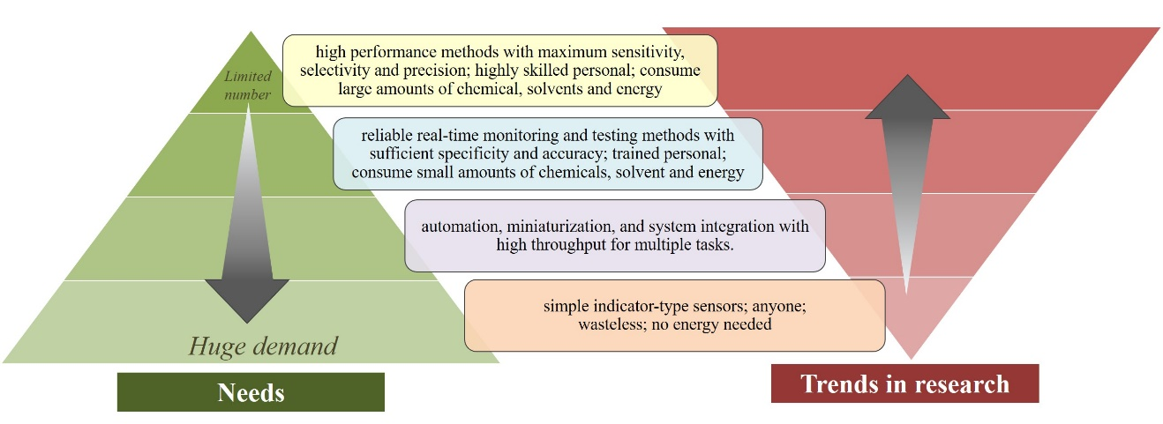

Figure 1. Comparison of the needs and trends in analytical chemistry. Reproduced with adaptation from [5]

Thus, one of the purposes of green analytical chemistry is to discover alternative reagents or substitutive synthetic methods which can reduce or minimize the usage of hazardous or poisonous chemicals. This suggestion may at first seem to be counteract to one of the best adhered principles of analytical chemistry, in which typically reagents of the highest purity grade are accounted for minimization of reagent blanks and impurities interferences. Nevertheless, in some cases there may be the possibility in replacing or substituting this highly purified reagents (which contributing to the costing in analysis) without compromising or bargaining the success of the assay determination. Under the typical condition of analytical experiments, a reagent is normally required in a small amount, or a crude extract which contains the essential active reagent are sufficient to get the analysis done. This is where the use of such natural reagents is highly desirable attributed to its simplicity in their preparation as well as the inherent or zero energy and chemical waste prevention. The ASEAN countries including Thailand and Malaysia are rich in natural resources. Utilizing a variety of natural resources existing in this region for health, chemicals, nutrient tests, and as natural dyes have been exercised as one of local wisdoms. Such wisdoms have long been employed in local peoples for improvement of life quality, for example using the fermented tea leaf like Miang as health supplement and snacks [7], which in return becomes the major source of income and tourism activities for one of the village in northern Thailand. Natural dyeing craftsmanship in textile industry has been kept alive thanks to discovery of various extracts from local plant such as mangosteen tree (Garcinia dulcis) [8] which offers bright yellow color, indigo leaves (Indigofera tinctoria) which contributes the blue color and coconut barks which attributed to pinkish brown color [9]. A team of chemists, focusing on the development of green chemical analysis techniques, has adapted the wisdoms in modern chemical analyses. In many parts of Thailand alone, there has been some regional handling of guava leaves as the sign or as an indicator towards the presence of iron in ground water. The appearance of darker color of water upon contacts with the guava leaves helps local villagers in making some decisions (or “screening test”, as for today term), such as whether the water is suitable for cloth washing, due to the strain that tends to deposited on the cloth, attributed to the iron presence in the water source; or it can lead to pre-treatment decisions such as applying alum into the ground water prior consumed for drinking or cooking use. This example of local wisdom has never been published nor any scientific explanation is available until Settheeworrarit et al. reported the investigation of natural guava (Psidium guajava L., Myrtaceae family) leaf extract as an alternative natural indicator for quantification of iron using the flow injection technique [10]. This is just one of the many examples which showcase on how the natural resources can work perfectly in applying chemical analysis in such green analytical approach.

From the Scopus database, trends in research works based on keywords “natural reagent” in “chemistry” have shown an increasing pattern as displays in Figure 2. This indicates an encouraging direction among analytical chemist in effort towards green analytical chemistry which adopted natural reagents as the active materials in performing assay testing. It is worth to notice that scientific articles contribution from our group are sharing the similar development. Different examples of the use of natural reagents for derivatization have been published as indicated by the used database. Natural reagents are consisted of extracts from various sources including the vegetables, plant-based, bacteria, or animals that required minimal treatment (extraction process) and among them, natural compounds contained in plants were able to distinguish themselves as the imperative key to green analytical chemistry initiatives.

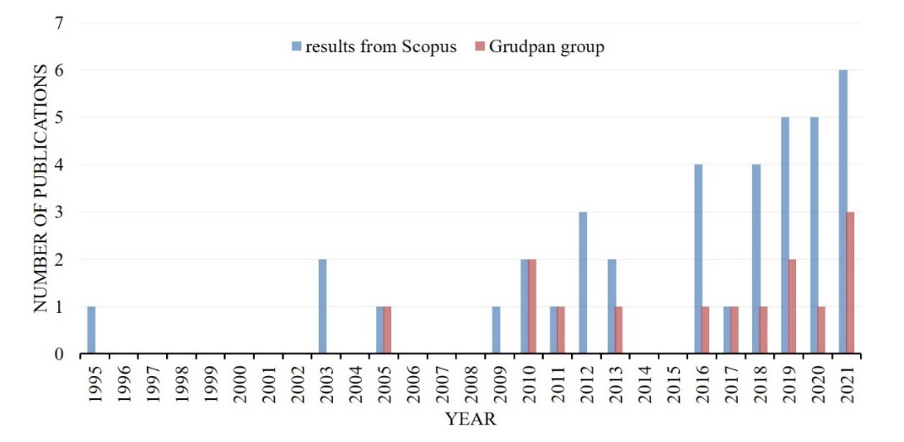

Figure 2. Number of publications obtained from Scopus database using the keywords of “natural reagent” () in chemistry and with “grudpan” () (searched on 31 August 2021

Herein in this review, we have pin-pointed the published works done on natural reagents and materials, particularly in green analytical chemistry by our group to discuss its scientific potential as part of the ASEAN consortium efforts. The scope of discussion was designed to fortify the geographical advantages in this southern Asia region where each country is sharing the similar bioresources that could be explored further in various scientific exploration as well as collaboration and networking. One of the advantages of the reported works here is that it could help in shorten the needs of screening a vast range of natural compounds, hence open the opportunity to adopt the similar plant species for further exploration. A diverse range of natural reagents used for the determination of various environmental analytes has been highlighted, aiming to critically discussed the initiatives and applicability of the use of such alternative reagents and alternative synthetic methods in optimizing analytical processes, as a way to provide the required information in a manner that is environmentally friendly, prioritize sustainability with the least possible consumption of materials, energy, and generating less or zero waste along the way.

Natural reagents used in chemical analysis
Table 1 represents some natural reagents extracts which can be found in plants that grew in ASEAN countries. The tropical forests in this region offer a unique natural heritage which has been evolved for over a hundred million years, resulting in rich flora and fauna with spectacular biodiversity. Currently, these are in much demand due to their efficacy, safety, and minimal side effects. Sample treatment which involves both the extraction of the analytes and the purification of the sample extract obtained, is still considered the bottleneck of the entire analytical procedure, despite much progress on automation and miniaturization has been accomplished. It is still the most labor-intensive and time-consuming analytical step, accounting for 60–80% of the total analysis time. These steps can affect both, the accuracy and precision, and green analytical features of analytical methods. Extraction of plant materials can be done by various conventional and nonconventional extraction procedures including maceration, infusion, percolation, digestion, decoction, Soxhlet extraction, ultrasound-assisted extraction, turbo-extraction, countercurrent extraction, microwave-assisted extraction, ultrasound extraction, supercritical fluid extraction, solid-phase extraction, and column chromatography. Considering the aforementioned information, it is easy to imagine that substantial efforts have been made in recent years to simplify the overall sample preparation steps and to tailor it to the green analytical chemistry principles. Major efforts of scientists have been devoted to miniaturization of the extraction device; development of new sorbent materials with advanced properties; reduction and replacement or elimination of toxic and hazardous organic solvents; reduction of sample volume and extraction time, and maximizing extraction efficiency and selectivity, among others. The natural reagents reported here can be obtained in a greener approach of extraction which only involving the use of water and ethanol as the organic solvent. The extracted chemical species have shelf-life of up for weeks provided with proper storage in fridge, thus allowing repeatability of experiments easily without restriction in chemical stocks.

Based on previous reported works, the chemical species which are active to certain analytes are listed. These active compounds are operating on the principle of colorimetric, where upon interacts with target analyte, the color changes will provide information on types of analytes as well as its concentration range, by performing the image analyzing via open source (free) color applications such as ImageJ and Color Grab. It should be noticed that for an analyte detection, the coloration visualization may be attributed to presence of different ligands from the reagents active compounds that forming chelation or binding with the analyte itself. This explains the versatility of various active compounds as they may obtain from different plants as of same species or family, yet capable to provide the equal analyte quantification. For instance, the anthocyanins species that active towards acidity measurement, can be obtained from butterfly pea, orchid and beetroot [11, 12]; iron can be quantified using phenolic compounds from green tea and guava leave [13, 14]. It is then of interest to explore which local plants would be use of in each analyte detection. By combining the efforts and intellectual of analytical chemists, natural products expertise, biologist, computational modeling, along with the advantages of ASEAN geographical, many plant species as natural reagents could be explored further. Such strategy one day may offer benefits in the possibility where we would be on self-reliance in using the reagents from the bioresources in our region, and with less dependent from the big chemical companies, thus affording the cost-effective in handling analytes assay; and time-efficiency where chemical delays arise from delivery would no longer be an issue.

Despite the detection limits and linear ranges are probably constrained by higher blank values originating from the reagents themselves, and the limitation of the detection systems used, yet the assay determination in analytical chemistry does not restrict to maximum sensitivity, rather to the applicability towards the targeted detection range. The trend of having high precision and sensitivity which restricted to advance instrument and highly trained personnel is not able to support the demand in analytical testing especially in those resources-limited countries. While most of these examples focus on agricultural, clinical or wastewater samples, which have higher analyte concentrations, the use of natural reagents for trace analytical purposes, e.g., in environmental waters, are possible to accomplish when the enhanced analytical control of flow injection-based or sequential injection analysis is utilized in combination with intrinsically sensitive detection methods such as chemiluminescence. Thus, when applied with recognition of their limitations, natural reagents, especially when used in combination with flow-based systems, can offer an alternative approach to sustainable and greener analytical measurement.

Table 1. Natural regents obtained from plants used in chemical analysis

Analyte | Active Species | Common Name | Scientific Name | Ref. | Photo of the Plant | Availability
Acidity and iron | Anthocyanins | Butterfly pea flower | Clitoria ternatea L. | [11] | 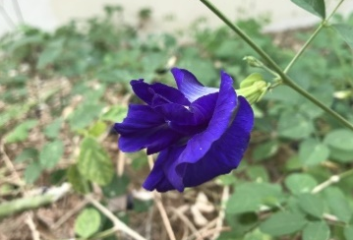 | Introduced into: Cambodia, Laos, Myanmar, Thailand, Vietnam, Brunei Darussalam, Philippines, Singapore, Indonesia,  commercial hybrid
 | Anthocyanins | Orchid flower | Dendrobium Sonia |  | 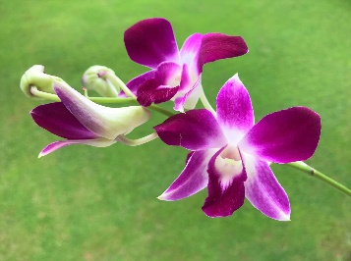 | Commercial hybrid
 | Anthocyanins | Beet root | Beta vulgaris subsp. Vulgaris |  | 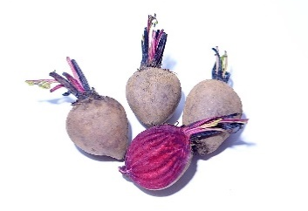 | Introduced into: Vietnam, Thailand
 | Phenolic compounds | Tea | Camellia sinensis (L.) Kuntze |  | 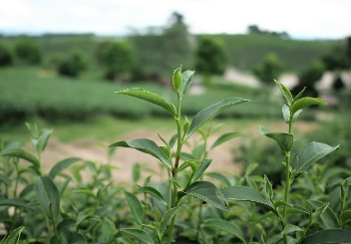 | Native to: Laos, Myanmar, Thailand, Vietnam  Introduced into: Cambodia
Acidity | Anthocyanins | Butterfly pea flower | Clitoria ternatea L. | [12] | 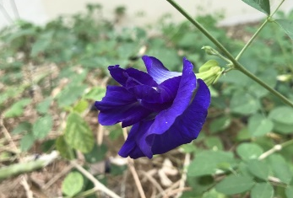 | Introduced into: Cambodia, Laos, Myanmar, Thailand, Vietnam, Brunei Darussalam, Philippines, Singapore, Indonesia,  commercial hybrid
Benzoyl peroxide | β-carotene compound | Pumpkin | Cucurbita moschata Duchesne | [15] | 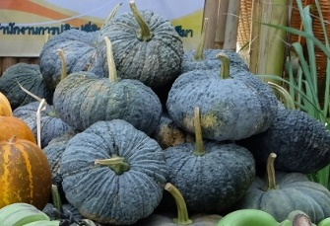 | Introduced into: Thailand, Myanmar, Vietnam, Indonesia
Aluminum | Polyphenolic compounds | Indian almond leaf | Terminalia catappa L. | [16] | 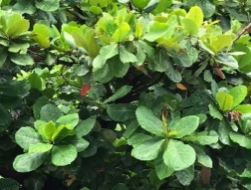 | Native to: Cambodia, Myanmar, Philippines, Thailand, Vietnam, Brunei Darussalam, Indonesia, Malaysia, Singapore
Aluminum | Homo-isoflavonoid compounds | Heartwood of Indian radwwod/ Sappan tree | Caesalpinia sappan L. | [17] | 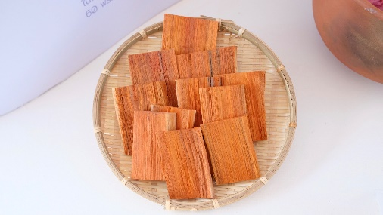 | Native to: Cambodia, Laos, Myanmar, Thailand, Vietnam  Introduced into: Brunei Darussalam, Indonesia, Malaysia, Philippines, Singapore
Copper and acidity | Starch  Anthocyanins | Rice  Butterfly pea flower | Oryza sativa L.  Clitoria ternatea L. | [18] | 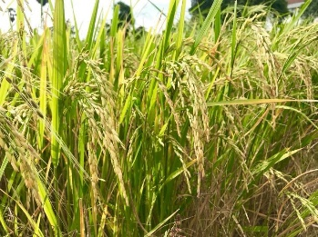 | Introduced into: Brunei Darussalam, Cambodia, Indonesia, Laos, Myanmar, Malaysia, Philippines, Singapore, Vietnam, Thailand
Introduced into: Cambodia, Laos, Myanmar, Thailand, Vietnam, Brunei Darussalam, Philippines, Singapore, Indonesia,
commercial hybrid

Iron | Polyphenolic compounds | Guava leaf | Psidium guajava L. | [10] | 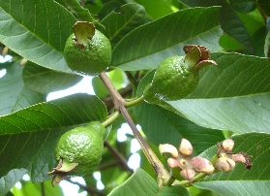 | Introduced into: Brunei Darussalam, Malaysia, Thailand, Singapore, Indonesia
Iron | Polyphenolic compounds | Green tea | Camellia sinensis (L.) Kuntze | [13] | 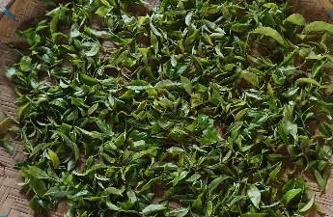 | Native to: Laos, Myanmar, Thailand, Vietnam  Introduced into: Cambodia
Iron | Phenolic compounds | Guava leaves | Psidium guajava L. | [14] |  | Introduced into: Brunei Darussalam, Malaysia, Thailand, Singapore, Indonesia,
Iron | Phenolic compounds | Pomegranate Peels | Punica granatum L. | [19] | 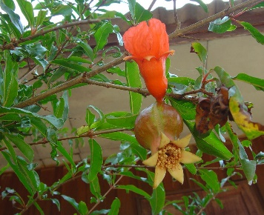 | Introduced into: Laos, Thailand, Vietnam
Iron | Mimosine | Leucaena leaf | Leucaena leucocephala (Lam.) de Wit | [20] | 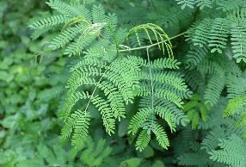 | Introduced into: Cambodia, Indonesia, Laos, Philippines, Thailand, Vietnam
Iron | Phenolic compounds | Betel nut | Areca catechu L. | [21] | 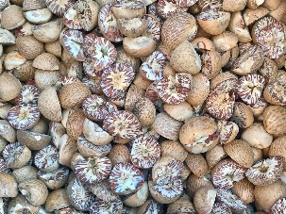 | Native to: Philippines  Introduced into: Cambodia, Laos, Thailand, Vietnam, Malaysia, Brunei Darussalam, Indonesia
Nitrite | Phenolic compounds | Miang | Camellia sinensis var. assamica (J.W.Mast.) Kitam. | [22] | 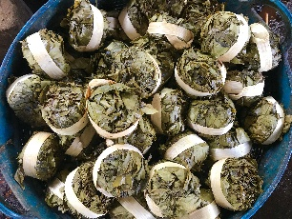 | Native to: Laos, Myanmar, Thailand, Vietnam

Natural reagents for green analytical procedures
Pertaining to the effective experimental measurement stage, greener analytical procedures and experimental setup are inherent to automated flow-based instrument setup, owing to their capability in reducing the consumption and needs of reagent and solvent and to the possibility of incorporating decontamination of wastes on-line. The development of flow-analysis-based techniques best suited in realizing such ideology. The flow analysis approach offers a feasible means of employing natural reagents for green chemical analysis.

Guava leaf extract is one of the widely studied natural reagent where its chemical compounds may serve as whitening essence, anti-bacterial, anti-pigmentation, and in diabetes prevention. Besides, guava leaf extract is an alternative natural compound used to identify ferrous (Fe²⁺) metal through flow injection method. In one of the reported works by Hartwell and her co-workers, by using a simple flow injection system, the scientific explanation behind the use of guava leaf extract as an alternative reagent to quantify iron(II) in water samples has been revealed. Chemical and physical properties of the extract, including its stability and ability to form chelation complexes with iron(II) and (III), respectively, spectroscopic characteristics, the appropriate solvent medium used for extraction, and its potential to be used for quantification of iron in water samples were tabulated in detail. Minimization on guava leaf extract consumption was achieved via using the modified reverse flow injection manifold with two lines, where the reagent was injected into the buffer solution which was later mixed with the flow of sample solution. Such in-situ design displayed a better sensitivity and detection limit as compared to the conventional flow system. This is presumably attributed to higher amount and a concentrated iron solution are being introduced via pumping as compared to injection along the line. [10]

Some of the works discussed as follows, although were not registered in the above search (Table 1), they engaged with the deployment of natural reagent. A simple simultaneous quantification of two metals-iron and manganese in ground water via sequential injection spectrophotometry was reported by utilizing the astilbin crude which extracted from Smilax china L. root. This natural reagent can be found easily in one of those common plants that grown in many tropics and subtropics worldwide. The extraction was done with methanol solvent at room temperature and the solid astilbin was obtained after evaporation and recrystallization steps. By dissolving the natural reagent with buffer solution, the mixtures were sequentially aspirated into the holding coil and the reactions with iron(III), manganese(II) and astilbin which took place in the flow cell was monitored by measuring absorbance change at the visible light wavelength. The applicability and simplicity setup which demonstrated in this work indicates that the proposed system and the easily obtained reagent are useful for ground water analysis. [23].

A simple and cost-effective analytical device for determination of ammonia which based on gas pervaporation and diffusion method is proposed [24]. This user-friendly device is consisted of a well microplate as a donor chamber and the butterfly pea flower extract was applied as natural indicator. The butterfly pea flower which having an intense blue color flower is easily grown in the ASEAN region. In this reported work, the flower extract was immobilized on the paper as the acceptor sensor. The anthocyanin color pigments from this flower extract are strongly influenced by the degree of acidity upon contact which changed the structure of the pigment and displaying color changes accordingly to different pH values. Using the reagent immobilization method on paper allows the microliter-scale solution handling. Such principle can reduce the consumption of reagent and the analyte itself. On the reported work, the sample preparation started by converting the ammonium ion into ammonia by using the solution in alkalinity range. The next procedure is allowing the ammonia gas pervaporation and diffusion across the PTFE membrane into the natural indicator which has been pre-immobilized on the filter paper. The colorimetric change (color appearance) on the paper was then detected by either a smartphone camera or naked eye which offer the quantitative or semi-quantitative analysis, respectively. Such simple paper sensor was successfully applied for real samples in ammonia detection that are widely found in the swine farming wastewater and chemical fertilizer samples. On top of that, the developed ammonia sensor could concurrently perform triplicate runs of 18 samples in just 15 minutes, which in return can generate 72 samples in one-hour timeframe. This proposed device with pervaporation and diffusion method offers on-site assay and green chemical analysis with relatively high throughput while at the same time display the example of cost-efficiency.

Several extracts from natural sources- vegetables and plant-based, namely carrots, leaves and flowers of peacock plants (Caesalpinia pulcherrima) were acquired through maceration and boiling procedures by using ethanol and water as solvents. Such extracts are being tested to detect lead(II), the poison heavy metal which mainly found in agriculture or industrial ecosystem. After performing the screening using the reagents which have been prepared, the researchers from Indonesia discovered those which can form complexes between ligand compounds of plant extract with lead(II), via the observation of color change, were only the flowers of the peacock plant (Caesalpinia pulcherrima). As such, the sequential injection analysis (SIA) system for determination of lead(II) in this work by employing the peacock flower extract as the natural reagent was developed. The discovery of using such natural reagent offers the advantages, once again, cost-effective and feasibility due to the easily available plant itself, inexpensive experimental setup, environmentally friendly, and the reagent can form the stable complex with the target lead ion [25].

In the recent published work, phenolic species of the guava leaf extract was used as natural reagent which responsible for chelation with the ferrous metal ions and leads to color formation. Such observation serves as a detection tool for the small and portable paper-based analytical devices (PADs) which can operate without any complicate supporting equipment, thus it is well-suited for point of care applications in places especially where budget is limited. The novel PAD reported here has been fabricated using a home-based printer with the design that able to complete replication test of iron analysis via a single run which in turn offers the versatility of having standards for calibration and duplicate or triplicate of sample analysis; concurrently under one analysis. Calibration plot in the concentration range from 0 to 20 ppm iron(III) was plotted based on the gray color intensity against iron concentration [26].

Natural materials used in chemical analysis
Various natural materials have been proposed for the use in chemical analysis, as represented in Table 2. They serve as platforms in colorimetric assays, in combining with the use of information technology (IT) devices including smartphone, webcam camera, and scanner, or via naked eyes, to perform the images analysis as the mode of detection. Such arrangements offer the benefits, such as easily accessible to local available materials, biodegradable, portable in terms of smartphones, and with simple fabrication (using home-based printer to complete the process). All the listed pros eventually will lead to cost-effective and user-friendly analytical applications.

Table 2. Natural materials used in chemical analysis

Material | Analyte | Reagent | Detection Principle | Detection Device | Advantages | Ref.
Paper | Ammonium | Alkaline solution and butterfly pea flower extract | Gas pervaporation, diffusion method and acid –base equilibrium | Smartphone | High sample through put, local available materials, biodegradable materials, portable | [24]
Paper and cotton cloth | Acidity | Red maple leaf extract | Acid-base equilibrium | Smartphone | Local available materials, biodegradable materials, portable | [27]
Paper | Iron, phosphate, water hardness | Iron: 1,10-phenanthroline/guava leaf extract  phosphate: molybdenum blue  water hardness: Eriochrome black T and EDTA | Iron: complex formation reaction  phosphate: complex formation reaction  water hardness: complexometric titration | Smartphone | Replication analysis of a sample within a single run, local available materials, biodegradable materials, portable | [26]
Cotton thread | Anionic surfactant | Methylene blue | Ion association | Smartphone | Local available materials, biodegradable materials, portable | [28]
Cotton thread | Total phenolic content and antioxidant capacity | Total phenolic content: Folin-ciocalteu  antioxidant capacity  : 2, 2-diphenyl-1-picryhydrazyl (DPPH) | Redox reaction | Smartphone | Local available materials, biodegradable materials, portable | [29]
Noodle | Acidity and copper | Acidity: bromothymol blue/ butterfly pea flower extract  copper: starch and potassium iodide | Acidity: acid-base equilibrium  copper: redox reaction and complex formation | Webcam camera/ scanner | Local available materials, biodegradable materials, self- indicating platform | [18]
Kaolin clay | Acidity | Phenolphthalein/ thymol blue/ butterfly pea flower extract | Acid-base titration | Naked eye | Reusable, local available, materials, biodegradable materials | [12]

Natural reagents with synthetic materials
From the green analytical perspective, new analytical tools can be obtained via modification or combination of conventional molecules with synthetic materials and forming a kind of hybrid system. Such tactics set off a promising strategic way in getting synergistic and additive effect achieved from either the natural reagents or the synthetic materials. In the work reported by Rujiwatra et al., [22] miang (Camellia sinensis var. assamica) leaves from northern Thailand are being fermented and blended with silver (Ag) nanoparticles (NPs) which can be applied as colorimetric agents for nitrite determination. The working principle behind this work is depends on employing p-aminobenzoic acid as aiding reagent, and a camera phone as a detector to capture the color changes upon interaction of Ag-miang NPs with the target analyte. As an effort to design the synthesis route become more environmentally benign, crude water extracts of miang leaves, which are abundantly available locally throughout the year in two forms, i.e., non-fermented and fermented miang, were used as natural reagents. Unique color of AgNPs can be obtained via controlling the morphology and sizes of AgNPs itself. Thus, the Ag-miang nanocomposites in turn providing the rapid, simple, and selective tool for the determination of nitrite.

On another reported work by Rujiwatra et al., [30], the team has demonstrated a sustainable way of reducing the waste generation, which in turn offers the potential in minimizing the impact on the environment. Such approach is achieved via the consumption of crude water extract from the ground longan (Dimocarpus longan Lour) seeds industry in northern Thailand, which annually discarded in large amount. This untreated wastewater was being used as the natural reagent, serving as the starting material for the green synthesis of ZnO photocatalyst. By using the simple and rapid microwave synthesis, phytochemicals from longan seeds such as flavonoids, catechins, vitamins, proteins, and sugars can be employed as either the capping or reducing agents, or both at same time which driven the ZnO nanoparticles synthesis. Such green synthesis of ZnO nanoparticles can be employed further for wastewater treatment of the local textile dyeing industry and contributing to the circular economy in the region.

Natural reagents in new normal chemistry education
Covid-19 has deeply affected the education sector globally as it forced many schools and colleges to remain closed temporarily. For most science students, their hands-on experience working as a real scientist in school and university laboratory are limited during this lockdown period, whereas in some region, certain students are inaccessible to fully stocked and supported teaching lab owing to limited funding. Despite such scenarios have created many problems; one can harness it as an opportunity for profound changes in our practical education approach that will align our teaching laboratories with those where we conduct our research, by adopting green chemistry principles to the practice of science education lab work. We live in a golden age of easy-to-access instrumentation thanks to smartphones which can be used as detector in chemical analysis. The difficulties of having to set up a measurement almost from scratch, without technicians to prepare equipment and solutions, could help inculcate a spirit of improvisation. By combining these factors, lab-at-home teaching is ready in action. Some of the examples using natural reagents extracted from plants as alternative low-cost tools in teaching chemical analysis, especially in school laboratories that ought to operate within a stiff budget. In some of the universities in Thailand, the ready-to-use natural reagents were introduced in the academic year of 2019 in science and pharmaceutical science courses. They were also employed in lab-at-home sessions and E-workshops. One of the examples was using the natural reagent kit for iron assay in water quality testing which adapted from Thai local wisdom using guava leaves. The kit was equipped with dry guava leaf powder that served as natural reagent in the assay, iron(III) standard and buffer solutions, sample vials, 96-wells microplate as reaction platform and a manual. The camera from smartphone was used as the detector to monitor the difference in color intensity of the reaction product which attributed by the reaction in between iron(III) and phenolic compounds in the natural reagent. Students from six different universities have received the kit via postage during the pandemic lock-down period and had benefits from this lab-at-home practice [31]. The initiative of using modern green chemical analysis in the online classroom setting received great feedback from teachers and learners as the chemicals involved utilized locally available bioresource as the natural reagent for green analysis in chemistry education which supports the sustainable education in Thailand. The method is now being employed by an increasing number of institutions. The team has demonstrated that their experience in conducting this green analytical research can be incorporated into the new normal style of teaching [32].

Challenges in natural reagents application
Natural reagents hold great promise for addressing global humanitarian needs including the goals of sustainable development. The sources of natural reagents and their applications are numerous, yet they are still largely an untapped resource. Use of natural reagents as a source of greener and cheaper reagents for a range of analytical tasks should not be seen as an option just for the developing world, but as something that is equally applicable worldwide. Opportunity should be valued when a natural reagent can be legitimately substituted for a purified or synthetic material, without compromising the viability or quality of the analytical process. Despite not explored here, there is also great potential to utilize food grade or domestic chemicals in a range of analytical procedures, again without prejudice to analytical quality. However, most current developments are not immediately translatable to outside-the-lab scenarios which differ in terms of resource-accessible and resource-limited aspects. Resource-accessible settings include scenarios whereby technology is deployed with essentially unlimited access to resources and experienced personnel. Resource-limited settings refer to situations marked by limited or no access to resources and expertise, which unfortunately most part of ASEAN fall in this category. Such challenges necessitate the time constraints in accessing commercially available chemicals especially when dealing with the long duration of waiting period for procurement. The increasing prices of reagent grade chemicals may restrict the accessibility as well. For instance, when students extract an indicator from plant tissue, and applied in an acid base titration or extracting the acid phosphatase from potatoes and used in the study of enzyme behavior and kinetics, costing of such experiments can be varied by 30 times as compared to procuring of 50 units acid phosphatase from a major US supplier which costs about $60 dollar with ca. $2 for a sack of potatoes. Students studying such fundamental analytical and biochemical behavior would gain an appreciation for the important role of natural product chemistry.

Conclusion
This mini review discusses the simple natural reagents and natural materials which were developed from a century-old local knowledge in the rural area, and through the combining with today technology, such phenomenon contributes to green chemistry, principally in green analytical chemistry aspect, leading to sustainable chemistry which could serves many goals of the United Nation Sustainable Development Goals (UN SDGs). Research of such direction has gained of interest as indicated by the increasing trends in publications. ASEAN is rich in bioresources, there are talent and challenges in development of utilizing natural reagents and natural materials for chemical analysis in new normal chemical analysis. To meet the talent and challenge, works across disciplines with networking would enhance the targets. Apart from analytical scientists, researchers in the other fields including, natural product, computational chemistry, chemometrics, other fields of chemistry, computer scientists etc. should work together. The work would reflect: Local issue- Global impact- Sustainable world.

Acknowledgement
The authors would like to thank the Thailand Research Fund (TRF) Distinguished Research Professor Award Grant (DPG6080002) and indirect support by Alexander von Humboldt Foundation (K. Grupdan); Universiti Malaya for RU SATU Grant ST022-2020 (P.M. Woi); Chiang Mai University (through Center of Excellence on Innovation in Analytical Science and Technology (I-ANALY-S-T), Cluster of Excellence on Biodiversity-based Economics and Society (B.BES-CMU) and postdoctoral fellowship grant (K. Kiwfo).

References

1. Anastas, P. and Eghbali, N. (2010). Green chemistry: principles and practice. Chemical Society Reviews, 39(1): 301-312.
2. Abdussalam-Mohammed, W., Qasem Ali, A. and Errayes, A. O. (2020). Green Chemistry: principles, applications, and disadvantages. Chemical Methodologies, 4(4): 408-423.
3. OECD (2021). Sustainable chemistry. Access from https://www.oecd.org/chemicalsafety/risk-management/sustainablechemistry.htm [Retrieved 13 September 2021].
4. Gamal, M., Naguib, I. A., Panda, D. S. and Abdallah, F. F. (2021). Comparative study of four greenness assessment tools for selection of greenest analytical method for assay of hyoscine N-butyl bromide. Analytical Methods, 13(3): 369-380.
5. Koel, M. (2016). Do we need green analytical chemistry?. Green Chemistry, 18(4): 923-931.
6. Chang, F., Zhang, X., Zhan, G., Duan, Y. and Zhang, S. (2021). Review of methods for sustainability assessment of chemical engineering processes. Industrial & Engineering Chemistry Research, 60(1): 52-66.
7. Chinwong, D., Charaj, P., Panitsupakamol, P., Chankaew, T., Chinwong, S. and Saenjum, C. (2021). Local wisdom of miang lifestyle and community for sustainable development in Northern Thailand. Sustainability, 13: 7381.
8. Lim, T. K. (2012). Garcinia dulcis. In edible medicinal and non-medicinal plants: fruits. Springer Netherlands: pp. 35-40.
9. Purnama, H., Hidayati, N., Safitri, D. S. and Rahmawati, S. (2017). Effect of initial treatment in the preparation of natural indigo dye from Indigofera tinctoria. AIP Conference Proceedings, 1855(1): 020022.
10. Settheeworrarit, T., Hartwell, S. K., Lapanatnoppakhun, S., Jakmunee, J., Christian, G. D. and Grudpan, K. (2005). Exploiting guava leaf extract as an alternative natural reagent for flow injection determination of iron. Talanta, 68(2): 262-267.
11. Grudpan, K., Hartwell, S. K., Wongwilai, W., Grudpan, S. and Lapanantnoppakhun, S. (2011). Exploiting green analytical procedures for acidity and iron assays employing flow analysis with simple natural reagent extracts. Talanta, 84(5): 1396-1400.
12. Kanna, M., Somnam, S., Wongwilai, W. and Grudpan, K. (2019). Towards green titration: Batchwise titration with reusable solid sorbed indicators. Analytical Sciences, 35(3): 347-350.
13. Pinyou, P., Kradtap Hartwell, S., Jakmunee, J., Lapanantnoppakhun, S. and Grudpan, K. (2010). Flow Injection determination of iron ions with green tea extracts as a natural chromogenic reagent. Analytical Sciences, 26(5): 619-623.
14. Siriangkhawut, W., Ponhong, K. and Grudpan, K. (2019). A green colorimetric method using guava leaves extract for quality control of iron content in pharmaceutical formulations. Malaysian Journal of Analytical Sciences, 23(4): 595-603.
15. Supharoek, S.-A., Ponhong, K. and Grudpan, K. (2017). A green analytical method for benzoyl peroxide determination by a sequential injection spectrophotometry using natural reagent extracts from pumpkin. Talanta, 171, 236-241.
16. Insain, P., Khonyoung, S., Sooksamiti, P., Lapanantnoppakhun, S., Jakmunee, J., Grudpan, K., Zajicek, K. and Kradtap Hartwell, S. (2013). Green analytical methodology using indian almond (Terminalia Catappa L.) leaf extract for determination of aluminum ion in waste water from ceramic factories. Analytical Sciences, 29(6): 655-659.
17. Siriangkhawut, W., Khanhuathon, Y., Chantiratikul, P., Ponhong, K. and Grudpan, K. (2016). A green sequential injection spectrophotometric approach using natural reagent extracts from heartwood of Ceasalpinia sappan Linn. for Determination of Aluminium. Analytical Sciences, 32(3): 329-336.
18. Kiwfo, K., Wongwilai, W., Paengnakorn, P., Boonmapa, S., Sateanchok, S. and Grudpan, K. (2018). Noodle based analytical devices for cost effective green chemical analysis. Talanta, 181: 1-5.
19. Siriangkhawut, W., Didpinrum, P., Khanhuathon, Y., Ponhong, K. and Grudpan, K. (2020). Small-scale ultrasound-assisted extraction of phenolics from pomegranate peels and their application as a natural reagent for the colorimetric assay of iron. Analytical Letters, 53(6): 887-904.
20. Kotchabhakdi, N., Seanjum, C., Kiwfo, K. and Grudpan, K. (2021). A simple extract of Leucaena leucocephala (Lam.) de Wit leaf containing mimosine as a natural color reagent for iron determination. Microchemical Journal, 162: 105860.
21. Weerasuk, B., Supharoek, S.-a., Grudpan, K. and Ponhong, K. (2021). Exploiting crude betel nut (Areca catechu Linn.) extracted solution as a natural reagent with sequential injection spectrophotometry for iron analysis in rice samples. Journal of the Iranian Chemical Society, 19: 741-751.
22. Tapala, W., Chankaew, C., Grudpan, K. and Rujiwatra, A. (2021). Silver-miang nanocomposites: A green, rapid and simple approach for selective determination of nitrite in water and meat samples. Microchemical Journal, 162: 105879.
23. Ganranoo, L., Chokchaisiri, R. and Grudpan, K. (2019). Simple simultaneous determination of iron and manganese by sequential injection spectrophotometry using astilbin extracted from Smilax china L. root. Talanta, 191: 307-312.
24. Jaikang, P., Paengnakorn, P. and Grudpan, K. (2020). Simple colorimetric ammonium assay employing well microplate with gas pervaporation and diffusion for natural indicator immobilized paper sensor via smartphone detection. Microchemical Journal, 152: 104283.
25. Sabarudin, A. and Indrayani, D. O. (2019). Sequential Injection analysis for determination of lead(II) using extract of Caesalpinia pulcherrima as a natural reagent. IOP Conference Series. Materials Science and Engineering, 546(3): 032027.
26. Kiwfo, K., Woi, P. M., Saenjum, C. and Grudpan, K. (2022). New designs of paper based analytical devices (PADs) for completing replication analysis of a sample within a single run by employing smartphone. Talanta, 236: 122848.
27. Kiwfo, K., Wongwilai, W., Sakai, T. N. T., Murakami, H.P. P., Phojuang, K., Kotchabhakdi, N. and Grudpan, K. (2020). Simple natural material based microfluidic platforms with a smartphone detection employing natural reagent for acidity assay. Journal Flow Injection Analysis, 37(1): 9-12.
28. Sateanchok, S., Wongwilai, W., Kiwfo, K. and Grudpan, K. (2016). The assay of anionic surfactant employing thread based analytical device with mobile phone. Journal Flow Injection Analysis, 33(1): 5-7.
29. Sateanchok, S., Wangkarn, S., Saenjum, C. and Grudpan, K. (2018). A cost-effective assay for antioxidant using simple cotton thread combining paper based device with mobile phone detection. Talanta, 177: 171-175.
30. Chankaew, C., Tapala, W., Grudpan, K. and Rujiwatra, A. (2019). Microwave synthesis of ZnO nanoparticles using longan seeds biowaste and their efficiencies in photocatalytic decolorization of organic dyes. Environmental Sciene Pollution Research International, 26(17): 17548-17554.
31. Kiwfo, K., Yeerum, C., Issarangkura Na Ayutthaya, P., Kesonkan, K., Suteerapataranon, S., Panitsupakamol, P., Chinwong, D., Paengnakorn, P., Chinwong, S., Kotchabhakdi, N., Saenjum, C., Vongboot, M. and Grudpan, K. (2021). Sustainable Education with local-wisdom based natural reagent for green chemical analysis with a smart device: experiences in Thailand. Sustainability, 13(20): 11147.
32. Center, C. C. A. R. (2021). CMU researcher creates green innovation in chemical analysis from century-old wisdom of the Fang people. Access from https://www.cmu.ac.th/en/article/7b2719e8-86bc-4d0c-9205-9b4a40647597.

