CHEMICAL CHARACTERISATION OF BIOCHAR FROM OIL PALM FROND FOR PALM OIL MILL SECONDARY EFFLUENT TREATMENT

Analisis Sifat Kimia Biochar Daripada Pelepah Kelapa Sawit Untuk Rawatan Air Sisa Sekunder Kilang Pemprosesan Kelapa Sawit

Nadia Razali and Nurhanim Zulaikha Kamarulzaman*

Section of Environmental and Polymer Engineering Technology

Malaysian Institute of Chemical and Bioengineering Technology (MICET)

Universiti Kuala Limpur, 78000 Alor Gajah, Melaka

*nurhanim.kamarulzaman@s.unikl.edu.my

Abstract

The oil palm frond (OPF) biomass contains chemical characteristics, which makes it a potential alternative adsorbent in wastewater treatment applications. In this study, the OPF sample was produced as biochar by using a top-lit updraft (TLUD) gasifier. The maximum temperature of this process was 750ºC and it yielded 20% w/w of biochar. The Brunauer–Emmett–Teller (BET) surface area for the OPF biochar was 248.08 m²/g with an average pore size of 4.3 nm and categorised as mesoporous adsorbent. The OPF biochar had a high carbon content of more than 70%, which was desirable for the alternative adsorbent. It was discovered that the aromatic ring and aliphatic functional group was detected in the biochar based on the Fourier Transform Infrared (FTIR) analysis which was commonly found in biochar produced at temperatures above 500°C. Based on the result obtained from the adsorption test, the OPT biochar could provide a maximum removal of 64.65% of COD, with an initial COD of 3960 mg/L. This study has found that the OPF biochar is suitable to be used as an alternative adsorbent for wastewater applications.

Keywords: biochar, oil palm frond, adsorption, palm oil mill effluent

Abstrak

Pelepah kelapa sawit (OPF) mempunyai sifat kimia yang berpotensi sebagai bahan penjerap alternatif dalam aplikasi rawatan air sisa. Dalam kajian ini, sampel OPF digunakan sebagai bahan mentah untuk menghasilkan biochar dengan menggunakan gasifier top-lit updraft (TLUD). Suhu maksimum process ini adalah 750ºC dan 20% w/w biochar telah dihasilkan. Luas permukaan Brunauer–Emmett–Teller (BET) untuk biochar OPF adalah 248.08 m²/g dengan ukuran purata saiz pori 4.3 nm dan diketagorikan sebagai penjerap mesoporos. Biochar OPF mempunyai kandungan karbon yang tinggi melebihi daripada 70%, yang merupakan ciri-ciri yang dikehendaki untuk penjerap alternatif. Berdasarkan analisis spektroskopi inframerah transformasi Fourier (FTIR), kumpulan organik alifatik dan cincin aromatik dikesan didalam bahan ini. Kumpulan organik ini biasanya ditemui dalam biochar yang dihasilkan pada suhu melebihi 500°C. Berdasarkan hasil kajian yang diperolehi daripada ujian penjerapan, biochar OPT mampu memberikan menyingkirkan 64.65% COD daripada air sisa kilang kelapa sawit yang mempunyai COD awal sebanyak 3650 mg/L. Kajian ini mendapati bahawa biochar OPF wajar digunakan sebagai penjerap altenatif untuk rawatan sisa pepejal.

Kata kunci: biochar, pelepah kelapa sawit, penjerapan, sisa efluen kilang kelapa sawit

Introduction

Crude palm oil (CPO), palm kernel oil (PKO), and palm kernel cake (PKC) are the primary interests in palm oil industry. In 2020, there were 5.87 million hectares of palm oil plantations in Malaysia. The production of crude palm oil (CPO) in the same year was 19.14 million tonnes [1]. A total of 80 million tonnes of biomass are generated annually in Malaysia, with the majority from the palm oil industry [2, 3]. Biomass generated by the palm oil industry are mainly produced from the harvesting of fresh fruit bunch (FFB) at the plantation, and the processing of FFB in mills. These biomasses include mesocarp fibre (MF), empty fruit bunch (EFB), palm shell (PS), oil palm fronds (OPF), oil palm leaflet (OPL), oil palm trunk (OPT), and palm mill effluent (POME). The presence of wastes creates a disposal problem, which requires the implementation of a robust management strategy.

POME is one of the wastes generated from the palm oil industry. POME is brownish wastewater generated from the processing of FFB; it has a high amount of organic contaminants and requires proper treatment before it can be discharged into any water body. Anaerobic and aerobic digestion treatments are the common treatments used to remove the organic contaminants in the wastewater, but both treatments are not sufficient to comply with the standard set by the Department of Environment (DOE) Malaysia, as shown in Table 1 [4]. The final discharge of POME from the biological treatment or palm oil secondary effluent (POMSE) usually remains high in chemical oxygen demand (COD) and biochemical oxygen demand (BOD), with an average of 800 mg/L and 200 mg/L respectively. Furthermore, it is also dark in colour, which is higher than the standard set by the DOE [5]. This is due to the presence of lignin, carotene, humic acids and other organic compounds that are recalcitrant to biological treatments [6]. Another treatment that should be implemented to polish the biologically treated POME, ensuring that it complies with environmental legislation, is the adsorption technique, a technology that can be applied to biologically treat POME as a polishing method. The key benefits of this technology are that it is easy to design, and it has a minimal initial investment. Natural resources such as biomass, silica, and zeolite can be used to make the adsorbent [7, 8].
Table 1. Environmental Quality (Industrial Effluent) Regulation 2009
Parameter | Unit | Standard
Parameter | Unit | A | B
COD | mg/L | 80 | 200
BOD₅ | mg/L | 20 | 50
Colour | ADMI | 100 | 200
TSS | mg/L | 50 | 100

The biomass from this industry has the potentials to be converted into valuable products. The potentials include using OPT as building materials, OPF as the precursor for ethanol production, OPS as an aggregate in lightweight cement, MF as a growing media for tissue culture, POME as a substrate for methane generation, and OPL and EFB as mulch in plantation [3, 9]. Some biomass, such as PKS and EFB, have critical functions as fuel sources for mills and to maintain soil conditions [10, 11]. However, there is still a significant amount of biomass that are unutilised, and measures should be taken to improve its functionalities. In recent years, there is an increasing amount of literature on the conversion of palm oil biomass into biochar. Biochar is a carbon-rich material produced from the thermochemical process. The pyrolysis process is the common thermochemical process utilised to produce biochar. However, scarce attention has been paid to gasification as a thermochemical process to produce biochar.

Gasification is defined as a thermochemical process to convert carbonaceous feedstock into syngas (a mixture of hydrogen, carbon dioxide, and methane), tar, and biochar at high temperatures (≥ 500°C) in oxygen-deficit conditions [12, 13]. So far, this method has only been applied for the generation of energy [14]. Most of the literature on the gasification process only focus on the optimisation of process parameters and the quality of gas produced from this process [15, 16]. The solid product of gasification, i.e., biochar, receives less attention. In general, biochar is known as an effective carbon sequestration strategy due to its recalcitrant properties. Therefore, biochar produced from the gasification process might have the same potentials as biochar produced from other thermochemical processes, i.e., fast pyrolysis, and hydrothermal process. The characteristics of biochar are dependent on the properties of biomass, the conditions of the process, and the type of reactor used for the thermochemical process.

Most literature on biochar are more focused on carbon sequestration and soil conditioner. The potential of biochar is not only limited to carbon sequestration and soil application, but it also has the potential to be used in other applications especially in water application. However, there are limited studies done on the application of biochar in water and wastewater treatment. In a study on the application of biochar as an alternative adsorbent, Huggins et al. [17] found that biochar from the gasification process could reduce phosphate, COD, and nitrogen ammonia in brewery wastewater. Kearn et al. [18] proved that biochar produced from the gasification process could remove trace organic contaminants from drinking water. Similarly, Kaetzl et al. [19] found that biochar was found to reduce both organic and inorganic contaminants from a municipal wastewater. Overall, many studies highlighted that biochar was effective in eliminating organic and inorganic pollutants from water and wastewater [16-23] This could be due to the high porosity of biochar or the presence of other chemical species that aids the adsorption process [12, 25].

The utilisation of biochar produced from the gasification process in wastewater application is an interesting topic to be studied. This paper will focus on biochar produced from gasification by using top-lit updraft (TLUD) gasifier and oil palm frond (OPF), which were used as the raw materials in this study. The characteristics of the biochar and its performance to treat biologically treated POME will be evaluated.

Materials and Methods

Source and preparation of biomass
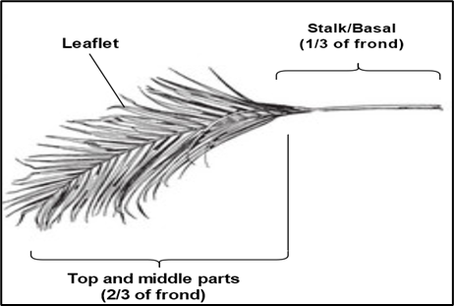
The raw material used in this study was oil palm frond (OPF). The OPF was obtained from a local plantation located in Tampin, Negeri Sembilan. Figure 1 shows the structure of OPF. The structure of the OPF consists of the top section, middle section, and basal. Only the basal part of the frond was used in this study as it was easier for real-life application. The OPF was chopped using a mechanical chopper with the particle size ranging from 1–4 mm and rinsed with tap water to remove any impurities. The OPF was then dried in a vacuum oven for 24 hours to avoid rotting.

Figure 1. Structure of OPF

Gasification of oil palm frond
The top-lit updraft gasifier (TLUD) was used to produce OPF biochar, as illustrated in Figure 2. Before the gasification process, the raw OPF was sieved to ensure that the particle of the OPF was uniformed. The uniformity of the size of feedstock was vital to ensure that the feedstock was fully charred, and to achieve a good airflow through the reactor body. The dried OPF was weighed before it was filled into the gasifier. The dried OPF was then placed into the gasifier about ¾ of the reactor body (approximately 600 g of dried OPF). A small piece of paper or wood was used as rekindling. The kindling was lighted, and it would burn strongly. The fan of the gasifier was turned on to provide air to assist the gasification process. The temperature of the process was monitored for quality control and assurance. The dried OPF was burnt from top to bottom until a bluish flame was formed. The blue flame was an indicator that the OPF was fully gasifier. The fan was then turned off and the gasifier was allowed to cool. The OPF biochar was then sprayed with some water to remove any ash and fine. The biochar was cooled until it was cool enough for handling.

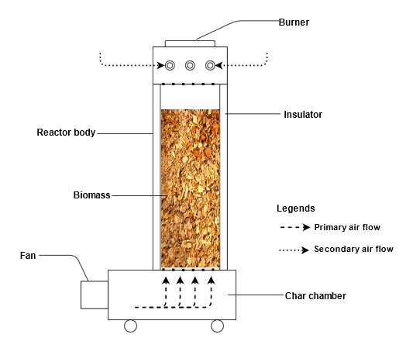
Figure 2. TLUD gasifier

The OPF biochar produced was weighted and the percentage of yield of the biochar was calculated using Equation 1.

$\text{\%Yield= }\frac{{\text{W}}_{\text{1}}\text{- }{\text{W}}_{\text{2}}}{{\text{W}}_{\text{1}}}\text{×100}$ (1)

where, W₁ is a weight of biomass and W₂ is a weight of biochar

Characterisation of OPF: pH of biochar
pH is an indicator of the acidity and basicity of the biochar. The pH of biochar can be a good indicator to understand the oxygen complexes and functional groups on the surface of biochar. The OPF biochar was soaked in the deionised water (ratio of 1:25% wt./v solid to water ratio) for one hour with agitation [26]. The pH of the slurry was then tested with a pH meter (Mettler Toledo).

Proximate analysis and ultimate analysis of raw material and biochar
There were three components of proximate analysis which were moisture content, ash content, and volatile matter. The proximate analysis of raw OPF was done using National Renewable Energy Laboratory (NREL) method for all three analyses. On the other hand, the proximate analysis of biochar was done using the ASTM method (ASTM D2867-09, ASTM D5832-98, and ASTM D2866-04).

The ultimate analysis of both raw OPF and OPF biochar was carried out using a CHNS analyser. This analysis was done to quantify the content of carbon, hydrogen, nitrogen, and sulphur in both samples. All four elements were analysed simultaneously.

Scanning electron microscopy analysis and Brunauer–Emmett–Teller surface area analysis
Scanning electron microscopy (SEM) analysis of raw OPF and OPF biochar was carried out using Scanning Electron Microscope SEM (FEI Quanta 450). BET analysis was used to determine the surface area of biochar in this study. The BET analysis was conducted using a BET Surface analyser (Micromeritic) with N₂ gas adsorption at 77 K in relative pressure from 0.05 to 0.2. The samples were degassed for 2 hours at 200ºC.

Fourier transform infrared analysis
FTIR analysis was done to determine the functional groups of the biochar. This analysis is vital to gain an understanding of the chemical characteristic of biochar and the adsorption mechanism of biochar. Before conducting the FTIR analysis, the OPF biochar was ground into powder and dried in an oven overnight to remove any residual moisture in the biochar. The sample was then mixed with potassium bromide (KBr) with a ratio of 1:2000 (1 part sample: 2000-part KBr). The mixture was then pressed into a pellet form by using a hydraulic presser. The pellet was finally analysed using the FTIR analyser (Nicolet 5700, FTIR, Thermo Fisher Scientific, and Waltham, MA, USA).

Adsorption test
The batch adsorption test was conducted to determine the applicability of OPF biochar as an adsorbent for wastewater treatment. The adsorbate used in this study was palm oil mill secondary effluent (POMSE). POMSE is the effluent generated after the biological treatment of POME. It is high in chemical oxygen demand. (COD). Method No.8006 was used to measure the COD of POMSE before and after treatment. The measurement of COD was conducted using the APHA potassium dichromate method. The measurement was carried out in HACH COD high range vials by using DR900 spectrophotometer and HACH COD reactor (Model: 45600).
Next, the batch adsorption test was conducted using 100 ml of POMSE. The OPF biochar was added to the conical flask containing 100 ml of POMSE. The mixture of the OPF biochar and POMSE was then shaken for 24 hours at 150 rpm using an incubator shaker. The samples were withdrawn at a fixed time interval. The adsorbent was separated from samples by filtration. The filtrates were then analysed for COD. The number of COD adsorbed per unit mass of the adsorbent (qe) was calculated according to the following Equation (2) and the adsorption yield was calculated by using Equation (3).

${\text{q}}_{\text{e}}\text{=}\left({\text{C}}_{\text{0}}\text{-C}\right)\text{×}\frac{\text{V}}{\text{m}}$ (2)

$\text{\%COD removal = }\frac{{\text{C}}_{\text{0}}\text{- C}}{{\text{C}}_{\text{0}}}\text{×100}$ (3)

where, q_{e} is the number of COD adsorbed per gram of adsorbent (mg/g); C₀ and C are the initial and final COD concentrations (mg/L), respectively; V is the volume of POMSE (L); and m is the mass of biochar (g).

Results and Discussion

Gasification of OPF
The main products of the gasification process usually consist of syngas, bio-oil, and biochar. The quantity biochar product derived from the gasification process is usually lower compared to other types of thermochemical processes such as pyrolysis, hydrothermal and torrefaction. For this study, the yield of OPF biochar was 20%. The same yield of biochar was obtained by Nsamba et al.[26] using the same gasification system. The biochar obtained from the gasification process is usually lower than other thermochemical processes i.e., fast pyrolysis because of the partial oxidation of carbon into carbon monoxide and other flue gasses [27, 28]. Other than partial oxidation of carbon in the biomass, the release of volatile matter from the polymeric backbone of carbonaceous feedstock also contributed to the yield of the biochar. Apart from that, the temperature of the gasification that is usually ≥ 500°C is good to produce high porosity biochar [29, 30]. In this study, the range of maximum temperature of the gasification process for OPF biochar was 750°C by controlling the speed of the fan that improved the air supply. Studies on the effect of temperature on the properties of biochar in past studies found that the surface area of the biochar was increased as the temperature of the thermochemical increased [31, 32]. Increasing the surface area of the biochar contributed to better performance of biochar as an adsorbent as it can remove more pollutants from wastewater. This trend can be seen in earlier studies using orange peel biochar for removal of cadmium from aqueous solution; maximum removal of cadmium was obtained when the orange peel biochar was produced at a temperature of 700°C, which was then used as an adsorbent [33]. Other studies showed a similar trend in the removal of chromium from aqueous solution [34, 35]. These findings suggest that gasification biochar has the potential to be used as an adsorbent.

Characterisation of OPF biochar: pH of biochar
The pH for OPF biochar in this study is alkaline (pH=8) which is similar to the literature where most biochar is best produced at temperatures higher than 400°C [29, 30, 36, 37]. The alkaline pH of OPT biochar is correlated to the presence of basic functional groups on the surface of biochar, as shown in Figure 4. Generally, raw biomass has a high number of acidic functional groups. Figure 4 illustrates the presence of acidic functional group in the raw OPF that corresponded to the carboxylic acid functional group. However, the band of the functional group diminished after the gasification process. The reduction of the acidic functional groups was aligned to the reduction of volatile matter of biomass as the temperature of the process increased.

Apart from the reduction of acidic functional groups, the alkalinity of OPF biochar was contributed by the formation of the aromatic and aliphatic functional group. The peak of the functional groups can be seen at the band of 1200–1600 cm^{–1}. The same findings can be seen in a study conducted by Usman et al. [38] on the production of biochar from the date palm waste. Other studies had established that the pH of biochar increased when the temperature of thermochemical increased [38-40]. The presence of alkaline metal contributed to the alkalinity of biochar [12, 42].

Proximate analysis and ultimate analysis
Table 2 shows the proximate analysis and ultimate analysis for both raw material and biochar. Generally, the value of each component changed after the gasification process. Table 2 shows that the volatile matter decreased sharply from 86.49% in raw OPF to 15.57%. This was due to the conversion of volatile matter into more condensed aromatic structures and/or may burn out which might help in the development of the porous structure of biochar [43]. The raw OPF had high volatile matter (86.49%), which was a good indicator that the biomass is suitable to be used as a feedstock for the thermochemical process. The percentage of volatile matter obtained in this study is closed to those obtained from other studies [11, 31, 11, 31].

Table 2. Proximate analysis and ultimate analysis
Proximate Analysis (%w/w) | Raw OPF | OPF Biochar
Moisture content | 9.95 | 3.71
Ash content | 0.92 | 12.38
Volatile matter | 86.49 | 15.57
Fixed carbon | 12.59 | 68.34
Ultimate analysis (%w/w)
Carbon (C) | 41.87 | 76.97
Hydrogen (H) | 6.00 | 2.50
Nitrogen (N) | 0.33 | 0.76
Sulphur (S) | 0.70 | 0.39
Oxygen (O) | 51.10 | 19.38
O/C ratio | 0.92 | 0.19
H/C ratio | 1.72 | 0.39
pH | - | 8
Porous characteristics
BET surface area, m²/g | - | 248.08
Pore Volume, cm²/g | - | 0.23
Average pore size, nm | - | 4.3

Ash content is a vital indicator to determine the suitability of the biomass as feedstock for the thermochemical process. The ash content of the raw OPF in this study is 0.92%, which aligned with previous studies [11, 31, 44]. The ash content of the biochar is higher than the raw OPF due to the accumulation of inorganic material in the biomass after the volatilisation of carbon, oxygen, and hydrogen [45]. The fixed carbon content is significantly increased from 12.59% in raw OPF to 68.34% in OPF biochar. The ash content of OPF biochar is 13 times greater than raw OPF; similar trend can be observed in other studies [28, 36, 38, 46].

Table 2 provides the Carbon (C), Hydrogen (H), Nitrogen (N), Sulphur (S) and Oxygen (O) content of both raw OPF and OPF biochar. The C and N content of the OPF biochar was significantly higher compared to its original biomass. On the other hand, the O and H content of the biochar is lower than its original biomass. This may be due to the breakdown of carbon and functional groups of the biomass during the gasification which led to the formation of aromatic functional groups [47]. The O/C and H/C ratio of the biochar is found to be lower than the biomass, which indicated the formation of aromatic functional and reduction of hydrophilicity of the biochar [47], [48].

Scanning electron microscopy analysis and Brunauer–Emmett–Teller surface area analysis
SEM analysis was performed to analyse the morphology of raw biomass and biochar. Figure 3 shows the morphology of raw material and biochar. Figure 3 demonstrates a significant change in the surface of OPF and OPL before and after the gasification process. In Figure 3 (a), the surface of OPF is very rough and less pore is visible whereas in Figure 3 (b) the surface of the OPF biochar is smoother than raw OPF. More pores were visible for OPF biochar. The formation of pores in the biochar are caused by the release of volatile matter, decomposition of cellulose and hemicellulose, which resulted in the complex structure of biochar with multiple diameters of pore [47, 49].
BET and BJH analysis were done on the OPF biochar to analyse its surface area and characteristics of pores. Table 2 provides the BET surface area, pore volume and average pore size of OPF biochar. The BET surface area of OPT biochar was 248.08 m²/g with an average pore size of 4.3 nm. The OPF biochar can be classified in the mesopore category as the average pore size of OPF biochar fell within the range of 2–50 nm. When compared to other studies, the surface area and pore volume of OPF biochar found to be higher than other studies which, on average pores, are lower than 150 m²/g [44, 50, 51]. Compared to commercial activated carbon (AC), the AC has a larger surface area and smaller average pore size which leads to high affinity to low molecular weight compound but is less efficient in the removal of high molecular weight compound. The high molecular weight compounds are commonly present in wastewater after biological treatments as refractory pollutants. A study conducted by An et al. [52] proved that a mesoporous lignite adsorbent was effective in removing refractory pollutants from biologically treated coal gasification wastewater. The result of this study is aligned to the findings from other studies using the same type of wastewater, similar to the research by Gai et al. [53] and Xu et al. [54]. The OPF biochar appears to have the potential to be used as alternative adsorbent to improve the characteristics of biologically treated wastewater.
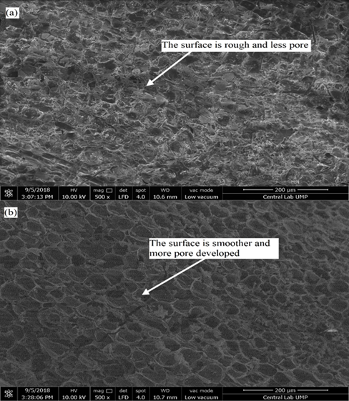
(b)
(a)

Figure 3. (a) raw OPF (b) OPF biochar

Fourier transform infrared analysis
FTIR analysis was done to determine the functional group of the biochar’s. Figure 4 compares the FTIR spectra of both raw materials and biochar produced in the gasification process. Overall, the spectra between raw OPF and OPF biochar is different. In Figure 4, the peak between 3200-3600 cm^{–1} corresponded to the –OH group with stretch vibration and carboxylic acid functional group. The presence of broad –OH in the raw OPF which attributed to the moisture content and hydroxyl functional group found in lignin, hemicellulose, and cellulose [54], [55]. The intensity of the peak decreased after the gasification process. The reduction of the intensity of the peak indicated that the removal of moisture and volatile matter contributed to the porous structure of the biochar [39], [56].
There is a peak within the band of 2800-3000 cm^{–1} which corresponded to the saturated aliphatic C–H functional group. This functional group is associated with the methylene functional group in cellulose [54, 56]. The peak within the band of 1700-1800 cm^{–1} represents the C=O acetyl group associated with the ester functional group in hemicellulose [55, 57]. This band diminished after the gasification process due to the integration of cellulose and hemicellulose. There are some peaks within the band of 1600-1700 cm^{–1} in both biomass and biochar. These bands correlated with the carboxylic acid functional group. However, the peaks diminished after the gasification process is aligned with the alkaline pH of the biochar.
The intensity of the peak within the band of 1500-1600 cm^{–1} is abated. The peaks within this band correlated to the aromatic hydrocarbon functional group of lignin C­C stretching vibration in the aromatic ring [55, 56]. The peaks within the band of 1000-1500 cm^{–1} corresponded to the aliphatic and aromatic functional groups. The intensity of the peaks was reduced in the OPF biochar. This might be due to the partial decomposition of lignin in the raw biomass. The presence of aromatic aliphatic functional groups in the biochar will provide the active sites to assist the adsorption process and contributes to the hydrophobicity of the biochar. This can be seen in the study conducted by Liu et al. [57] on the role of functional groups in the adsorption of bisphenol A (BPA) on activated carbon. The study revealed that the modified AC provided 10% higher removal of BPA compared to commercial AC. This was due to the decrease of acidic functional groups in the modified AC and stronger hydrophobicity than commercial AC which leads to better BPA adsorption and more water molecule exchange, which aligns with the findings by Sidik et al. [58] on the OPL adsorbent with enhanced hydrophobicity.

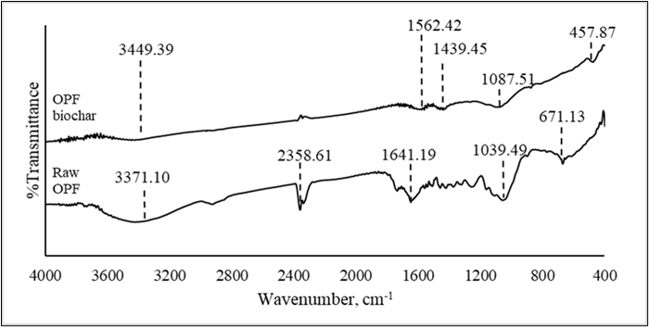
Figure 4. FTIR spectra of raw OPF and OPF biochar

Adsorption test
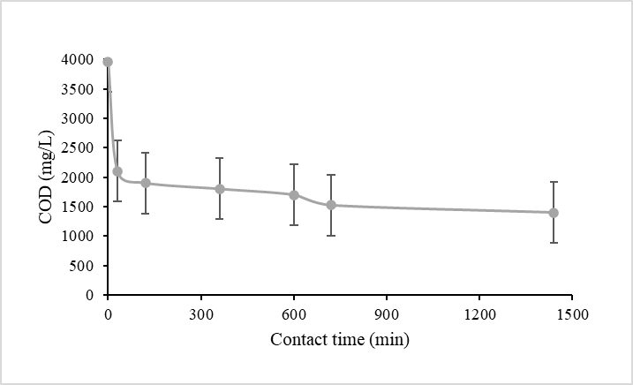
The wastewater used in this study was palm oil secondary effluent (POMSE) obtained from a local palm mill in Selangor. The POMSE is the effluent generated from the biological treatment of raw POME and it was still high in COD. This is a common problem faced by palm oil mill operators [59]. The high COD in the POMSE was contributed by the presence of macromolecules, such as fulvic acid and humic acid [60]. The initial concentration of COD is 3960 mg/L and the experiment was conducted in batch modes. Figure 5 and Figure 6 show the reduction of COD from POMSE by using OPF biochar as an adsorbent. As shown in Figure 5, there is a significant reduction of COD from POMSE. After 30 minutes of contact time with OPF biochar, the COD of POMSE is reduced from 3960 mg/L to 2100 mg/L. The COD of POMSE continuously reduced as the contact time with the OPF biochar increased.

Figure 5. COD removal POMSE
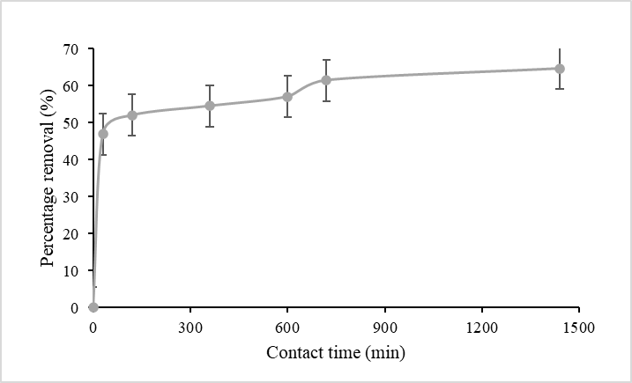
From Figure 6, the maximum removal of COD is 64%, in which it is achieved after 24 hours of contact time. When compared to other studies, the biochar produced in this study can provide better removal of pollutants than other alternative adsorbent which on average can only provide 55% removal of pollutants [44]. Other than that, the performance of the OPF biochar in this study was comparable to the coconut-based activated carbon produced in the study conducted by Parveen et al. [61]. After 24 hours of contact time, the removal of COD from POMSE is constant. This is due to the unavailability of active adsorption sites on the OPF biochar [62], [63]. By comparing to the research conducted by Razali et al. [64] using oil palm trunk (OPT) biochar, the OPF biochar provided better removal of COD than OPT biochar. This might be due to the differences in characteristics of the biochar. In comparison, the surface area of the OPF biochar is higher than the OPT biochar. Other than the surface area, the OPF biochar has a higher pore volume compared to OPT biochar which is in line with the surface area of the biochar.

Figure 6. Percentage removal of COD from POMSE

Conclusion

The gasification process proves that other valuable and functional products (biochar) can be produced by using OPF, which is currently used as mulching and fertiliser. This study discovered that gasification biochar that was specifically produced from raw OPF has the potential to be used as adsorbents in wastewater application treatment. The biochar from the gasification process can be used as soil conditioning and in wastewater treatment as an adsorbent due to its unique characteristic, low moisture content, low ash content and high fixed carbon content. The OPF biochar produced from this study has a large surface area and high total pore volume which can be potentially used as alternative adsorbent in the adsorption process. The high carbon content and the presence of carbonyl compound and aromatic rings in the biochar provide active sites that aid the adsorption process. It was proven that OPF biochar can provide more than 50% removal of pollutants from the wastewater tested in this study compared to other biochar produced in other studies.

A further study should be done on the application of biochar as an adsorbent for wastewater application. Further research on the factors and the kinetic of adsorption using this gasification biochar should be conducted to gain more understanding on the mechanism involved in the adsorption process by using gasification biochar.

Acknowledgement
This research is supported by Short Term Grant - STRG (Grant no. STRG/NBR/STR16034) from Universiti Kuala Lumpur.

- References
1. Ghulam Kadir, A. P. (2020). Overview of the malaysian oil palm industry 2020. In Malaysian Palm Oil Board website. Access from https://www.mpob.gov. [Accessed Jun. 14, 2021].
2. Tan, Z. Y. (2020). Green technology: Time to Tap Biomass. The Edge Markets. https://www.theedgemarkets.com/article/green-technology-time-tap-biomass [Accessed Jun. 14, 2021].
3. Zwart, R. (2013). Sustainability in the cultivation of oil palm –issues and prospects for the industry. Journal of Oil Palm and the Environment, 4(5): 41-62.
4. Malaysian Department of Environment (2009). Environmental quality (industrial effluent) regulations 2009. In Environmental Quality Act 1974 (pp. 4010–4059). Access from https://www.doe.gov.my/portalv1/wpcontent/uploads/2015/01/Environmental_Quality_Industrial_Effluent_Regulations_2009_-_P.U.A_434-2009.pdf.
5. Zainuri, N. Z., Hairom, N. H. H., Sidik, D. A. B., Desa, A. L., Misdan, N., Yusof, N. and Mohammad, A. W. (2018). Palm oil mill secondary effluent (POMSE) treatment via photocatalysis process in presence of ZnO-PEG nanoparticles. Journal of Water Process Engineering, 26:10-16.
6. Zahrim, A. Y., Nasimah, A. and Hilal, N. (2014). Pollutants analysis during conventional palm oil mill effluent (POME) ponding system and decolourisation of anaerobically treated POME via calcium lactate-polyacrylamide. Journal of Water Process Engineering, 2014: 159-165.
7. Ngeno, E. C., Orata, F., Baraza, L. D., Shikuku, V. O. and Kimosop, S. J. (2016). Adsorption of caffeine and ciprofloxacin onto pyrolitically derived water hyacinth biochar: isothermal, kinetic and thermodynamic studies. Journal of Chemistry and Chemical Engineering, 10(4): 185-194.
8. Sia, Y. Y., Tan, I. A. W. and Abdullah, M. O. (2017). Adsorption of colour, TSS and COD from palm oil mill effluent (POME) using acid-washed coconut shell activated carbon: Kinetic and mechanism studies. MATEC Web of Conferences, 87:1-7.
9. Chin, M. J., Poh, P. E., Tey, B. T., Chan, E. S. and Chin, K. L. (2013). Biogas from palm oil mill effluent (POME): Opportunities and challenges from Malaysia’s perspective. Renewable and Sustainable Energy Reviews, 26: 717-726.
10. Mukherjee, I. and Sovacool, B. K. (2014). Palm oil-based biofuels and sustainability in Southeast Asia: A review of Indonesia, Malaysia, And Thailand. Renewable and Sustainable Energy Reviews, 37: 1-12.
11. Umar, M. S., Jennings, P. and Urmee, T. (2013). Strengthening the palm oil biomass renewable energy industry in Malaysia. Renewable Energy, 60; 107-115.
12. Hansen, V., Müller-Stöver, D., Ahrenfeldt, J., Holm, J. K., Henriksen, U. B. and Hauggaard-Nielsen, H. (2015). Gasification biochar as a valuable by-product for carbon sequestration and soil amendment. Biomass and Bioenergy, 72: 300-308.
13. Shen, Y. (2015). Chars as carbonaceous adsorbents/catalysts for tar elimination during biomass pyrolysis or gasification. Renewable and Sustainable Energy Reviews, 43: 281-295.
14. Hosseini, S. E., Wahid, M. A. and Ganjehkaviri, A. (2015). An overview of renewable hydrogen production from thermochemical process of oil palm solid waste in Malaysia. Energy Conversion and Management, 94: 415-429.
15. Anukam, A., Mamphweli, S., Reddy, P., Meyer, E. and Okoh, O. (2016). Pre-processing of sugarcane bagasse for gasification in a downdraft biomass gasifier system: A comprehensive review. Renewable and Sustainable Energy Reviews, 66: 775-801.
16. Couto, N., Rouboa, A., Silva, V., Monteiro, E. and Bouziane, K. (2013). Influence of the biomass gasification processes on the final composition of syngas. Energy Procedia, 36:596-606.
17. Huggins, T. M., Haeger, A., Biffinger, J. C. and Ren, Z. J. (2016). Granular biochar compared with activated carbon for wastewater treatment and resource recovery. Water Research, 94: 225-232
18. Kearns, J., Anh, M. T. L., Reents, N. W., Shimabuku, K. K., Mahoney, R. B., Summers, R. S. and Knappe, D. R. U. (2014). Trace organic contaminant removal from drinking water using local char. 37th WEDC International Conference, 2014: pp. 1-6.
19. Kaetzl, K., Lübken, M., Uzun, G., Gehring, T., Nettmann, E., Stenchly, K. and Wichern, M. (2019). On-farm wastewater treatment using biochar from local agro residues reduces pathogens from irrigation water for safer food production in developing countries. Science of the Total Environment, 682: 601-610.
20. Thompson, K. A., Shimabuku, K. K., Kearns, J. P., Knappe, D. R. U., Summers, R. S. and Cook, S. M. (2016). Environmental comparison of biochar and activated carbon for tertiary wastewater treatment. Environmental Science & Technology, 50(20): 11253-11262.
21. Zhang, F., Wang, X., Yin, D., Peng, B., Tan, C., Liu, Y., Tan, X. and Wu, S. (2015). Efficiency and mechanisms of Cd removal from aqueous solution by biochar derived from water hyacinth (Eichornia crassipes). Journal of Environmental Management, 153: 68-73.
22. Han, R., Wang, Y., Zhoa, X., Wang, Y., Xie, F., Cheng, J. and Tang, Mi. (2009). Adsorption of methylene blue by phoenix tree leaf powder in a fixed-bed column: Experiments and prediction of breakthrough curves. Desalination, 245(1–3): 284-297.
23. Enaime, G., Baçaoui, A., Yaacoubi, A. and Lübken, M. (2020). Biochar for wastewater treatment—conversion technologies and applications. Applied Sciences, 10: 1-29.
24. Wang, X., Guo, Z., Hu, Z. and Zhang, J. (2020). Recent advances in biochar application for water and wastewater treatment: A review. PeerJ, 8: 1-34.
25. Oliveira, F. R., Patel, A. K., Jaisi, D. P., Adhikari, S., Lu, H. and Khanal, S. K. (2017). Environmental application of biochar: Current status and perspectives. Bioresource Technology, 246: 110-122.
26. Nsamba, H. K., Hale, S. E., Cornelissen, G. and Bachmann, R. T. (2014). Improved gasification of rice husks for optimized biochar production in a top lit updraft gasifier. Journal of Sustainable Bioenergy Systems, 4: 225-242.
27. James, R. A. M., Yuan, W. and Boyette, M. D. (2016). The effect of biomass physical properties on top-lit updraft gasification of woodchips. Energies, 9(4): 1-13.
28. You, S., Ok, Y. S., Chen, S. S., Tsang, D. C. W., Kwon, E. E., Lee, J. and Wang, C. H. (2017). A critical review on sustainable biochar system through gasification: energy and environmental applications. Bioresource Technology, 246: 242-253.
29. Mohan, D., Sarswat, A., Sik, Y. and Pittman, C. U. (2014). Organic and inorganic contaminants removal from water with biochar, a renewable, low cost and sustainable adsorbent – a critical review. Bioresource Technology, 160: 191-202.
30. Ahmad, M., Rajapaksha, A. U., Lim, J. E., Zhang, M., Bolan, N., Mohan, D., Vithanage, M., Lee, S. S. and Sik Ok, Y. (2014). Biochar as a sorbent for contaminant management in soil and water: A review. Chemosphere, 99: 19-33.
31. Rahman, A. A., Abdullah, N. and Sulaiman, F. (2014). Temperature effect on the characterization of pyrolysis products from oil palm fronds. Advances in Energy Engineering, 2: 14-21.
32. Sun, Y., Gao, B., Yao, Y., Fang, J., Zhang, M., Zhou, Y., Chen, H. and Yang, L. (2014). Effects of feedstock type, production method, and pyrolysis temperature on biochar and hydrochar properties. Chemical Engineering Journal, 240: 574-578.
33. Tran, H. and Yuan, C. (2016). Effect of pyrolyisis temperatures and times in adsorption of cadmium onto orange peel derived biochar. Waste Management & Research, 34(2): 129-138.
34. Tan, X., Liu, Y., Zeng, G., Wang, X., Hu, X. and Gu, Y. (2015). Application of biochar for the removal of pollutants from aqueous solutions. Chemosphere, 125: 70-85.
35. Mojiri, A., Ziyang, L., Tajuddin, R. M., Farraji, H. and Alifar, N. (2016). Co-treatment of landfill leachate and municipal wastewater using the ZELIAC/Zeolite constructed wetland system. Journal of Environmental Management, 166: 124-130.
36. Lam, S. S., Liew, R. K., Cheng, C. K., Rasit, N., Ooi, C. K., Ma, N. L., Ng, J. H., Lam, W. H., Chong, C. T. and Chase, H. A. (2018). Pyrolysis production of fruit peel biochar for potential use in treatment of palm oil mill effluent. Journal of Environmental Management, 213: 400-408.
37. Angın, D. (2012). Effect of pyrolysis temperature and heating rate on biochar obtained from pyrolysis of safflower seed press cake. Bioresource Technology, 128: 593–597.
38. Usman, A. R. A., Abduljabbar, A., Vithanage, M., Ok, Y. S., Ahmad, M., Ahmad, M., Elfaki, J., Abdulazeem, S. S., & Al-Wabel, M. I. (2015). Biochar Production from Date Palm Waste: Charring Temperature Induced Changes in Composition and Surface Chemistry. Journal of Analytical and Applied Pyrolysis, 115: 392-400.
39. Mahmood, W. M. F. W., Ariffin, M. A., Harun, Z., Ishak, N. A. I., Ghani, J. A. and Rahman, M. N. A. (2014). Characterisation and potential use of biochar from gasified oil palm wastes. Journal of Engineering Science and Technology, 45-54.
40. Suárez-Hernández, L., Ardila-A, A. N. and Barrera-Zapata, R. (2017). Morphological And physicochemical characterization of biochar produced by gasification of selected forestry species. Revista Facultad de Ingeniería, 26(46): 123-130.
41. Feng, D., Zhao, Y., Zhang, Y., Sun, S. and Gao, J. (2018). Steam gasification of sawdust biochar influenced by chemical speciation of alkali and alkaline earth metallic species. Energies, 11(1): 205.
42. Shen, Y. (2015). Chars as carbonaceous adsorbents/catalysts for tar elimination during biomass pyrolysis or gasification. Renewable and Sustainable Energy Reviews, 43: 281-295.
43. Park, J., Hung, I., Gan, Z., Rojas, O. J., Lim, K. H. and Park, S. (2013). Activated carbon from biochar: influence of its physicochemical properties on the sorption characteristics of phenanthrene. Bioresource Technology, 149: 383-389.
44. Liew, R. K., Nam, W. L., Chong, M. Y., Phang, X. Y., Su, M. H., Yek, P. N. Y., Ma, N. L., Cheng, C. K., Chong, C. T. and Lam, S. S. (2017). Oil palm waste: An abundant and promising feedstock for microwave pyrolysis conversion into good quality biochar with potential multi-applications. Process Safety and Environmental Protection, 2017: 1-13.
45. Domingues, R. R., Trugilho, P. F., Silva, C. A., de Melo, I. C. N. A., Melo, L. C. A., Magriotis, Z. M. and Sánchez-Monedero, M. A. (2017). Properties of biochar derived from wood and high-nutrient biomasses with the aim of agronomic and environmental benefits. PLoS ONE, 12(5): 1-19.
46. Klasson, K. T. (2017). Biochar characterization and a method for estimating biochar quality from proximate analysis results. Biomass and Bioenergy, 96: 50-58.
47. Wijitkosum, S. and Jiwnok, P. (2019). Elemental composition of biochar obtained from agricultural waste for soil amendment and carbon sequestration. Applied Sciences, 9(19): 3980.
48. Wei, L., Huang, Y., Huang, L., Li, Y., Huang, Q., Xu, G., Müller, K., Wang, H., Ok, Y. S. and Liu, Z. (2020). The ratio of H/C is a useful parameter to predict adsorption of the herbicide metolachlor to biochars. Environmental Research, 184: 109324.
49. Griffith, S. M., Banowetz, G. M. and Gady, D. (2013). Chemical characterization of chars developed from thermochemical treatment of Kentucky bluegrass seed screenings. Chemosphere, 92(10): 1275-1279.
50. Ibrahim, I., Hassan, M. A., Abd-Aziz, S., Shirai, Y., Andou, Y., Othman, M. R., Ali, A. A. M. and Zakaria, M. R. (2017). Reduction of residual pollutants from biologically treated palm oil mill effluent final discharge by steam activated bioadsorbent from oil palm biomass. Journal of Cleaner Production, 141: 122-127.
51. Cibati, A., Foereid, B., Bissessur, A. and Hapca, S. (2017). Assessment of miscanthus × giganteus derived biochar as copper and zinc adsorbent: study of the effect of pyrolysis temperature, pH and hydrogen peroxide modification. Journal of Cleaner Production, 162: 1285-1296.
52. An, H., Liu, Z., Cao, X., Teng, J., Miao, W., Liu, J., Li, R. and Li, P. (2017). Mesoporous lignite-coke as an effective adsorbent for coal gasification wastewater treatment. Environmental Science: Water Research & Technology, 3(1): 169-174.
53. Gai, H., Guo, K., Xiao, M., Zhang, N., Li, Z., Lv, Z. and Song, H. (2018). Ordered mesoporous carbons as highly efficient absorbent for coal gasification wastewater – a real case study based on the inner Mongolia autonomous coal gasification wastewater. Chemical Engineering Journal, 341: 471-482.
54. Xu, L., Wang, J., Zhang, X., Hou, D. and Yu, Y. (2015). Development of a novel integrated membrane system incorporated with an activated coke adsorption unit for advanced coal gasification wastewater treatment. Colloids and Surfaces A: Physicochemical and Engineering Aspects, 484: 99-107.
55. Lamaming, J., Hashim, R., Sulaiman, O., Peng Leh, C., Sugimoto, T. and Nordin, A. (2015). Cellulose nanocrystals isolated from oil palm trunk. Carbohydrate Polymers, 127: 202-208.
56. Jahi, N., Ling, S., Othaman, R. and Ramli, S. (2015). Modification of oil palm plantation wastes as oil adsorbent for palm oil mill effluent (POME). Malaysian Journal of Analytical Sciences, 19: 31-40.
57. Liu, G., Li, X. and Campos, L. C. (2017). Role of the functional groups in the adsorption of bisphenol a onto activated carbon: Thermal modification and mechanism. Journal of Water Supply: Research and Technology-Aqua, 66(2): 105-115.
58. Sidik, S. M., Jalil, A. A., Triwahyono, S., Adam, S. H., Satar, M. A. H. and Hameed, B. H. (2012). Modified oil palm leaves adsorbent with enhanced hydrophobicity for crude oil removal. Chemical Engineering Journal, 203: 9-18.
59. Zainal, N. Ha., Jalani, N. F., Mamat, R. and Astimar, A. A. (2017). A review on the development of palm oil mill effluent (POME) final discharge polishing treatments. Journal of Oil Palm Research, 29(4): 528-540.
60. Bhalla, B., Saini, M. S. and Jha, M. K. (2013). Effect of Age and Seasonal Variations on Leachate Characteristics of Municipal Solid Waste Landfill. International Journal of Research in Engineering and Technology, 2(8): 223-232.
61. Parveen, S., Kaman, D., Ai, I., Tan, W., Lik, L. and Lim, P. (2016). Palm oil mill effluent treatment using coconut shell – based activated carbon: adsorption equilibrium and isotherm. MATEC Conference ENCON, 2016: 1-6.
62. Majedi, Y., Alhilali, E., al Nehayan, M., Rashed, A., Ali, S. S., Al Rawashdeh, N., Thiemann, T. and Soliman, A. (2014). Treatment of dye-loaded wastewater with activated carbon from date palm leaf wastes. World Sustainability Forum, 2014: 1-12.
63. Abdulsalam, M., Man, H. C., Yunos, K. F., Abidin, Z. Z., Idris, A. I. and Hamzah, M. H. (2020). Augmented yeast-extract and diary-waste for enhancing bio-decolourization of palm oil mill effluent using activated sludge. Journal of Water Process Engineering, 36: 1-12.
64. Razali, N. and Kamarulzaman, N. Z. (2020). Chemical characterizations of biochar from palm oil trunk for palm oil mill effluent (POME) treatment. Materials Today: Proceedings, 31(1): 191-197.

