THE PREPARATION AND APPLICATION OF ZINC SULFIDE AS PHOTOCATALYST FOR WATER REMEDIATION: A MINI REVIEW

(Penyediaan dan Aplikasi Zink Sulfida sebagai Pemangkin Cahaya
untuk Rawatan Air: Ulasan Ringkas)

Kavirajaa Pandian Sambasevam, Jamilin Rashida Adnan, Izyan Najwa Mohd Norsham,
Siti Nor Atika Baharin*

Advanced Material for Environmental Remediation (AMER) Research Group,
Faculty of Applied Sciences,
Universiti Teknologi MARA, Cawangan Negeri Sembilan, Kampus Kuala Pilah,
72000, Kuala Pilah, Negeri Sembilan, Malaysia

*Corresponding author: atikabaharin@uitm.edu.my
Abstract
ZnS has gained attention as an effective photocatalyst for the photocatalytic degradation method in wastewater treatment. Photocatalysis is believed to be a promising solution to solve the problem of water pollution and remove organic pollutants. Apart from other photocatalysts such as ZnO, TiO₂ and MoS₂, ZnS is a developing photocatalyst in this degradation method due to its large bandgap energy. This review paper comprehensively considered the preparation (hydrothermal, solvothermal, low temperature, green synthesis, solid-state reaction, and microwave-assisted synthesis) of ZnS, application, and some challenges that have been faced by photocatalytic degradation methods. The adsorption and photocatalytic properties of ZnS depend on the different morphology and size formed by different methods. ZnS modification presents higher decomposition efficiency in removing organic pollutants.

Keywords: metal disulfide, organic pollutants, photocatalytic degradation, sustainable water management

Abstrak
ZnS mendapat perhatian sebagai pemangkin cahaya yang terbaik untuk melakukan rawatan terhadap air yang tercemar. Fotokatalisis dipercayai sebagai penyelesaian dalam menyelesaikan masalah air yang tercemar dan menyingkirkan pencemaran semulajadi yang terdapat di dalam air. Selain daripada pemangkin cahaya seperti ZnO, TiO₂ dan MoS₂, ZnS dijadikan sebagai pemangkin cahaya dalam kaedah pemulihan air kerana ZnS mempunyai tenaga jurang pita yang tinggi. Kertas kajian ini merangkumi cara penyediaan (hidroterma, solvoterma, teknik suhu rendah, sintesis hijau, tindak balas keadaan pepejal, dan sintesis berteraskan gelombang mikro) ZnS, aplikasi dan beberapa cabaran yang perlu di hadapi dalam proses rawatan air. Ciri-ciri penyerapan dan fotokatalitik ZnS bergantung kepada perbezaan struktur permukaan dan saiz yang terbentuk dari perbezaan penyediaan. Pengubahsuaian ZnS menunjukkan kecekapan penguraian yang tinggi kepada pencemaran semulajadi.

Kata kunci: logam disulfida, pencemar organik, penyingkiran fotokatalitik, pengurusan lestari air

Introduction
Filtration, chemical precipitation, ion exchange adsorption, electro deposition and membrane system are several conventional methods of water treatment. However, they exhibit slow and non-destructive effects on some organic contaminants [1]. Application of advanced oxidation methods such as photodegradation is significant due to their complete degradation without leaving any by-product behind. Photocatalysis has been widely studied because it requires an exceptionally simple procedure to generate free radicals that can degrade organic pollutants [2]. Photocatalytic study can be defined as the ability of some materials to speed up a certain reaction as a catalyst in combination with light including sunlight, UV and visible light. The term ‘photocatalytic’ designated reactions accelerated by light but maintaining the same course as the thermal reactions [3]. Photocatalytic activity is influenced by the crystal structure, particle size, band gap, dispersibility and hydroxyl of the catalyst. Photocatalytic degradation is a study that is still currently developing. Semiconductor photocatalysts play an important role in photocatalytic activities. Various studies were widely carried out by many researchers around the globe. Among all semiconductors, titanium dioxide (TiO₂) is the most frequently used photocatalyst in study and research regarding oxidation of organic pollutants. However, its high potential for charge recombination has become a limiting factor of TiO₂ for sunlight photocatalytic applications [4].

Meanwhile, the single semiconductor which is the photocatalyst only consists of one medium of photocatalyst to degrade organic pollutant that shows ineffective degradation rates, such as bismuth vanadate (BiVO₄), zinc oxide (ZnO) and cadmium selenide (CdSe) [5]. ZnS is a II-VI semiconductor material that exhibits a high excitation energy which is approximately 40 meV. ZnS also has a band gap energy of 3.7 eV and ZnS can be used as semiconductor photocatalyst to degrade pollutants due to its non-toxic nature, highly negative reduction potential of excited electrons and high rate of formation of electron-hole pairs that leads to higher conduction band position in aqueous media [6,7]. A study reported that ZnS is an important inorganic material for various applications such as solar cell, field effect transistor, photoconductors, sensors, light-emitting materials and optical coating [8]. Moreover, ZnS is chosen to be a photocatalyst because of its direct wide band gap (e.g., = 3.7 eV), good mechanical stability, highly efficient conductivity, and high electron transfer ability, aside from the ZnS nanoparticle having a high rate of success when doped with the polyaniline matrix [6,5]. Thus, this mini review aimed to examine the recent preparation technique of ZnS and its application as a photocatalyst in water remediation.

Fundamental of photocatalytic degradation
Photocatalytic degradation technology is one of the advanced oxidation processes (AOP) that involves semiconductor photocatalyst and oxygen to produce radicals in which the activity is influenced by the crystal structure, particle size, band gap, dispersibility and hydroxyl of the catalyst. The basic principle of photocatalyst activation mechanism can be seen in Figure 1. During this reaction, these photons contribute to the excitation of electrons (e⁻) on the surface of photocatalyst in the valence band when the energy of the photons is higher than the band gap which makes the e⁻ rise up into the conduction band and causes the production of a hole (h⁺) in the valence band. These separated holes and electrons can recombine and release the absorbed energy to form heat. The excited electrons that are now in the conduction band (e⁻_{CB}) will react with oxygen (O₂) to form superoxide radicals (O₂⁻) or hydroperoxide radicals (HO₂). Next, these reactive oxygen species will be used for the degradation of pollutants into water (H₂O) and carbon dioxide (CO₂). O₂⁻ can be further used again in secondary degradation steps where these reactions could result in the oxidation of water molecules at the positive hole in the valence band (h⁺_{VB}) that produces hydroxyl radicals (OH) and hydrogen ions (H⁺). Lastly, the OH would react with pollutants and result in H₂O and CO₂ [9,10].
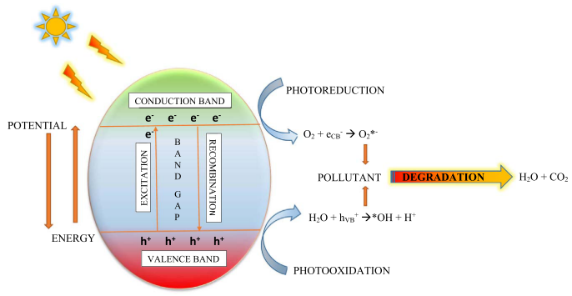
Figure 1. Basic principle of photocatalysis [9]

Many studies have been carried out to test a variety of light sources and mostly focused on the implementation of UV light because this light provides enough photons to generate electron hole pairs within the catalyst. Thus, it could perform efficiently in the production of radicals and the oxidative degradation of the toxic and dangerous pollutants [11]. Photocatalytic processes can use artificial UV lamps and sunlight as the radiation source in photocatalysis. Mostly used artificial UV lamps that were mercury lamps that can be divided into low pressure, medium pressure and high pressure. Moreover, sunlight also has been used in this reaction as nearly 4 to 5% of the sunlight that reaches the surface of earth is in the range of 300 to 400 nm. ZnS is powerful as a photocatalyst in UV range compared to visible range [12]. Furthermore, sunlight has its own limitation because of its graphical variation when compared with artificial UV lamps [13]. Munawaroh and co-author stated that zinc oxide/graphene oxide (ZnO/GO) had high adsorption capacity and GO addition made the band gap narrower, which prevented the recombination of electron and led to high electron transfer on the ZnO [14]. The photocatalytic activity of ZnO/GO is performed in different irradiation times which are 15, 30, 45 and 60 minutes and the maximum wavelength is 665 nm. Figure 3 shows that UV light is involved to activate the photocatalytic properties of the material to form radical species that lead to degradation of the methylene blue dye into green compounds. From Figure 2, it is proven that the longer the contact time, the more electrons would be excited which contribute to production of more h⁺. Mechanisms (1) to (6) show the formation of h⁺ which contributes to formation of hydroxyl radicals in the photocatalytic degradation. More production of h⁺ would increase the photocatalytic degradation. The percent efficiency of degradation based on formula (7) in methylene blue with ZnO/GO 1:2 is 94.05% [14].

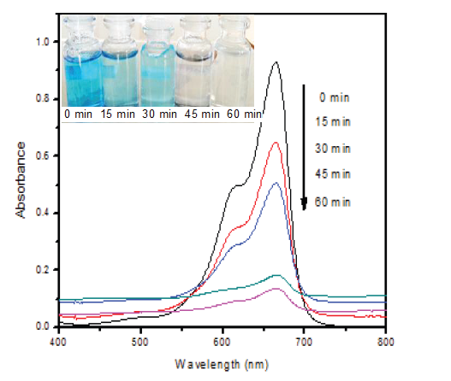
Figure 2. UV-vis spectra of methylene blue with ZnO/GO (1:2) and under UV illumination [14]

Excitation: Photon (hv) + Semiconductor $→$ e⁻ _{CB} + h⁺ _{VB} | (1)
Recombination: e⁻ + h⁺ $→$ energy | (2)
Oxidation of H₂O: H₂O + h⁺ _{VB} $→$ ●OH + H⁺ | (3)
Reduction of adsorbed O₂: O₂ + e⁻ $→$ O₂●⁻ | (4)
Reaction with H⁺: O₂●⁻ + H⁺ $→$ ●OOH | (5)
Electrochemical reduction: ●OOH + ●OOH $→$ H₂O₂ + O₂ | (6)

Preparation of zinc sulfide
In general, ZnS can be synthesised via various methods such as solution-phase reaction, hydrothermal, solvothermal, exfoliation, high pressure autoclave processes, physical vapour deposition (PVD) and chemical vapour deposition (CVD). ZnS can be easily synthesised with the aid of autoclave at high pressure and low temperature without the need of a catalyst [15]. At ambient conditions, ZnS possess two crystal structures which are zinc blend (cubic) and wurtzite (hexagonal), meanwhile at high pressure “rock salt” crystalline shape can be achieved but only in case of nanostructures of ZnS [15].

Hydrothermal method
Hydrothermal method refers to the heterogeneous reactions for synthesising inorganic materials in an aqueous media above ambient temperature and pressure which is used to obtain nanoparticles, generally at relatively high temperature which is around 200°C by using an autoclave reactor and high pressure. In order to get the desired size and shape of ZnS, a capping agent is applied to control the size and shape of ZnS such as surfactants, ligands, dendrimers and polymers [16]. In hydrothermal synthesis, this capping agent is used to control the nanometre size of ZnS. Thioglycolic acid (TGA) is a common capping agent that has been studied for synthesising ZnS. It is proven that ZnO/ZnS nanocable, ZnS/organic composite nanoribbons and ZnS nanotube arrays have been successfully synthesised by using TGA. In the previous study, TGA was used to prevent the chalcogenide nanocrystal accumulation which is known as stability agents. Thus, TGA is a perfect choice during the hydrothermal process as a capping agent for self-assembly and crystal growth of ZnS crystal to cluster. In this process, the temperature of 105°C is maintained during the autoclave for 7 hours. Based on the transmission electron microscopy (TEM) and selected area electron diffraction (SAED) in the range of 50 to 150 nm as shown in Figure 3, the morphology of ZnS crystal forms some loose spheres by accumulation of small particles. Most of the organic molecules are degraded because of the temperature that took place during the process. The ZnS nanocluster is formed at the final process due to only a part of the TGA molecule which is diffused into the ZnS nanoparticle. The SAED pattern also shows sharp rings of (1 1 1), (2 2 0) and (3 1 1) planes of cubic zinc blended ZnS that corresponded to the XRD study Figure. 4. The size of the nanocrystals based on the Scherrer formula (D= 0.89λ/β cos θ), estimated from the full width at half maxima (FWHM) of the (1 1 1) diffraction peak is about 4 nm for synthesised nanoparticles which are much smaller than the spherical diameters. This indicates that the clusters are formed from nanocrystal mass assembly. It is fair to assume that the TGA-assisted hydrothermal process provides a great opportunity to scale-up other chalcogenides morphology preparation [17]. Based on a previous study, a composite of SnO₂/ZnS prepared by hydrothermal method at 180°C showed the highest photocatalytic activity to degrade RhB [18]. The photocatalytic degradation of 95% is reached at the 1 g/L SnO₂/ZnS dosage with 10 mg/L initial RhB concentration, 4.59 initial solution pH and 23°C. The photocatalytic degradation of the RhB really fitted to the first-order kinetic model and it is also showing the decrease of initial RhB concentration with the increase of SnO₂/ZnS dosage. The composited SnO₂/ZnS that are prepared by hydrothermal method also showed a stable performance during 5 runs of reuse [18].

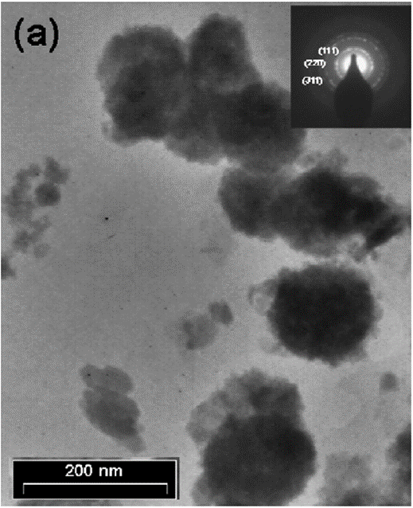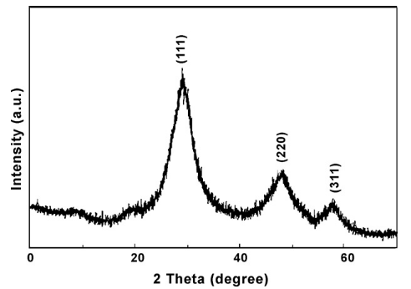
(b)
(a)
Figure 3. (a) TEM image of ZnS nanocluster; (b) Figure 4 XRD pattern of as-prepared ZnS nanocluster [17]

Solvothermal method
Solvothermal process refers to a heterogeneous reaction involving the thermal decomposition of metal complexes using the solvent mineraliser either by boiling the contents in an inert atmosphere or in a sealed vessel (autoclave). Solvothermal method possesses advantages including less energy consumption and simple and also some disadvantages including need for expensive autoclaves and Teflon liners in stainless steel, which can lead to safety problems during reaction processes and the impossibility of studying in-situ reactions due to their closed system [19]. Unlike hydrothermal route which needs a surfactant, toxic template or capping agent to control the size of ZnS morphology, solvothermal method is without surfactant and needs propylene glycol solvent at 140°C for 12 hours to produce the ZnS nanoplates. The SEM image in Figure 4 (a) of ZnS exhibits flower-like morphology and a large amount of quasi hexagonal plates which were produced via solvothermal method.

However, in the solvothermal method, the right choice of temperature is crucial. As can be seen in Figure 4 (b), higher temperature at 160°C yielded non-uniform and amorphous nature of ZnS. Obviously, this condition via solvothermal technique did not favour the synthesis of ZnS. This is due to the decreasing crystallisation temperature WHICH can be attributed to a slight increase in photocatalytic activity, hence temperatures higher than 140°C mostly do not support this method [20]. Song and co-worker carried out the preparation of a ternary photocatalyst of zinc cadmium sulphide by this method which was synthesised at a maintained temperature of 120-140°C for 3 hours [21]. The methylene blue (MB) was degraded by the photocatalytic activity of zinc cadmium sulphide. 0.4 g zinc cadmium sulphide photocatalyst was dispersed in 250 mL of MB solution. In this study, after a 1-hour reaction time, at 120°C the photocatalytic activity showed the best photocatalytic activity compared to 140 and 130°C as shown in Figure 5 below due to 120°C being the lowest temperature so it is suitable for the solvothermal method.

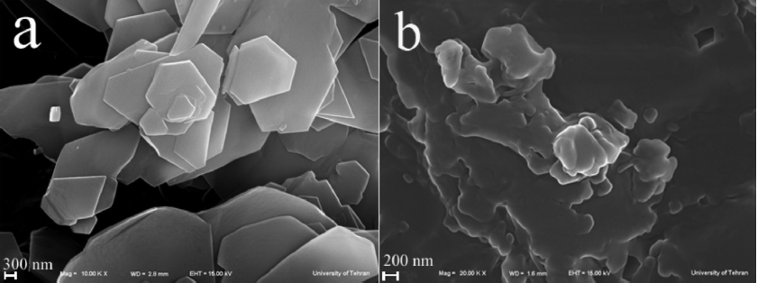
(b)
(a)

Figure 4. SEM image of as-synthesized product in propylene glycol for 12 hours: (a) 140°C and (b) 160°C [20]

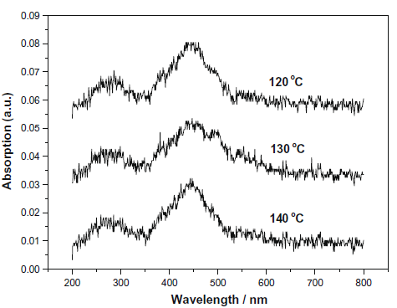

Figure 5. UV-vis absorbance spectra of sample treated at 120-140°C [20]

Low temperature method
This method basically involves low temperature (below 100°C) by a chemical reaction that occurs between zinc ions and reduces sulphide ions in ethanol as a reaction medium. This method requires a strong reducing agent to have a better control reaction such as hydrazine hydrate to have better control to convert elemental sulphur (S₈) to reactive sulphide ions (S²⁻) by in-situ reduction. The sulphide ions then react on impulse with zinc ions, since zinc chloride and elemental sulphur were used separately as sources of zinc and sulphur [22]. Low temperature method exhibited preferable characteristics as it is less toxic, less time consuming, low cost and needs low temperature without any solvent release, low waste and environmentally friendly [22]. The less time consumption can be observed when the reduction of S₈ into S²⁻ took place in a very short time. The reaction can be represented in equation (7) [20].

${ZnCl}_{2}+\frac{1}{8S}+ N_{2}H_{2}.H_{2}O \frac{C_{2}H_{5}OH, 60 °C}{C_{3}H_{8}O_{2}S}>ZnS+2HCl+ N_{2(g)}H_{2\left(g\right)}+ H_{2}O$ | (7)
Equation (7) showed a rapid process as it only takes a few seconds (30-40 seconds) of the elemental sulphur reduction to happen. The concentration of zinc before and after reaction was calculated to know the yield of the reaction by using an ICP-OES spectrometer. The reading of the ICP-OES spectrometer showed 99% consumption of zinc precursor in the reaction which means a very high conversion yield of the precursor to the final product was obtained. Study of the reaction time impact showed that longer reaction times lead to agglomeration of less particles to bigger ones. Hence, the reaction time should be adjusted to form the particles as soon as hydrazine hydrate has been added. Figure 6 (a) shows UV-Vis absorption spectra of ZnS quantum dots at 60°C with different reaction times of 2, 3, 5, 7 and 12 minutes which displayed that the size of ZnS quantum dots were almost the same and that longer time which was up to 60 minutes at 60°C did not influenced the particle size with absorption peak at ~257 nm. Meanwhile, Figure 6 (b) shows UV-Vis absorption spectrum of ZnS quantum dots at 120°C for 60 minutes. An absorption peak at 277 nm was observed which is red shifted as compared to the absorption peak at 60ºC, displaying an increase in size [22]. The photocatalytic activity of ZnS synthesised by this method can be observed on the removal of MB with a photocatalyst of ZnS under UV irradiation. This study showed that ZnS succeeded in achieving removal efficiency of 75% during photocatalytic degradation of MB [23].
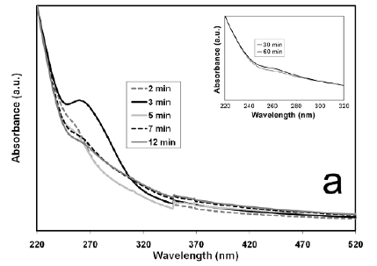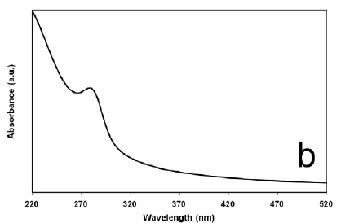
(b)
(a)

Figure 6. (a) UV-Vis absorption spectrum of ZnS quantum dots at 60°C for reaction time 2, 3, 5, 7, 12 minutes (a) at 60°C for reaction time 30 and 60 minutes (b) at 120°C for 60 minutes [22]

Green synthesis method
Green synthesis method is a biological synthesis of nanoparticles that basically uses plants or plant extract which is low cost, nontoxic and environmental friendly method. A study on glucose was used as both stabilizer and capping agent while latex solution prepared from Jatropha curcas L. In the Jatropha curcas L there were curcacycline A (an octapeptide), curcain (an enzyme) and curcacyline B (a nanopeptide) equipped inside as a potential stabilizing and reducing agent [24,25]. Glucose is a monosaccharide that present in the plants with five hydroxyl groups are arranged in its own manners along its six-carbon backbone and it is renewable, natural, large quantity and biodegradable. Glucose is used in this method while zinc nitrate and sodium sulfide as zinc and sulphur source respectively. In this method, the resulting solution was heated at 70°C up to 6 hours. The final product of this synthesis, can be observed in the equation (8). The ZnS that obtained via this method, exhibited crystallinity peak at 28.38°, 47.73° and 56.50° as shown in Figure. 7. The peaks were assigned to the cubic plane of ZnS as (1 1 1), (2 2 0) and (3 1 1). The broad peaks in XRD indicated the formation of nanoparticles. Thus, it proved that ZnS nanoparticles succesfully synthesized by green method by using glucose as capping agent [24].
$${Zn\left({NO}_{3}\right)}_{2}+ {Na}_{2}S \underset{→}{Glucose} ZnS+2NaNO_{3}$$ | (8)
This method can be observed in its photocatalytic activity in a study by Kannan et al. (2020) involving ZnS that had been synthesised using plant extract of Tridax procumbens (T:ZnS). Biosynthesised T:ZnS (40 mL) nanoparticles displayed high surface area which was 131.84 m²/g and also exhibited larger pore size which was 12.15 nm. This high surface area was able to promote more active sites, hence increasing the photocatalytic ability to degrade MB achieved 98% of degradation efficiency under visible light irradiation.

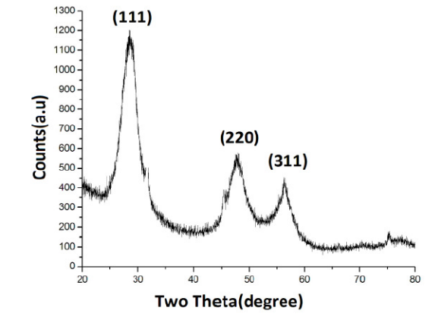

Figure 7. XRD spectra of ZnS nanoparticles [23]

Solid-state reaction method
Solid state reaction method is a simple reaction for the preparation of ZnS nanorods. This method utilises simple techniques such as melting or grinding together the starting materials or simply applying heat to a mixture of starting materials and also without any metal catalyst, solvent or templates. The nanoparticles were prepared by one-step, typically solid-state reaction of zinc chloride and sodium sulphide as zinc and sulphide sources, respectively which will be ground with mortar and pestle at ambient temperature in sodium chloride flux. This method, however, needs high temperatures because it involves precursors to synthesise nanotubes by using a furnace at 800 °C for 2 hours for the heat treatment sample. Figure 8 shows XRD spectra of final nanoparticle ZnS nanorods fabricated by annealing precursor ZnS nanoparticle in sodium chloride flux. The synthesised ZnS nanorods have changed from cubic to hexagonal structure via solid state reaction method [27].

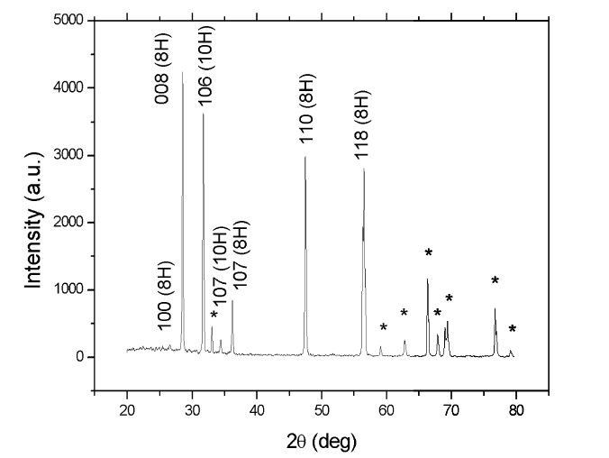

Figure 8. XRD spectra of final nanoparticle ZnS nanorods fabricated by annealing precursor ZnS nanoparticle in sodium chloride flux

The photocatalytic performance is known to be dependent on the crystallinity, morphology and surface area that are able to enhance the recombination of photogenerated electron-hole pairs. Jothibas et al. (2018) showed the photocatalytic activity of ZnS doped with nickel (Ni) that was synthesised by this method. The ZnS doped Ni was used to degrade the MB. It proved the MB concentration decreases in the presence of ZnS doped Ni due to destruction of the homo and hetero-poly aromatic ring present in the MB or the fast degradation of the dye [27].

Microwave assisted synthesis method
Microwave (MW) assisted synthesis is a heating method that uses ionic liquids (ILs) as MW absorbing medium to synthesise the highly crystalline ZnS quantum dots (QDs). Imidazolium or phosphonium cations together with many types of anions ranging from simple anions including halides to more complex ones included bis(trifluoromethanesulphonyl) amide based, are two types of ionic liquids that were used in this method. The QDs that were synthesised as the final product were less than 5 nm in size and of wurtzite ZnS type. MW irradiation basically is a heating method where the dielectric heating mechanism involves bipolar polarisation and ionic conduction that allows for faster reactions with higher yields and higher purities without high vacuum requirements [22]. ILs are considered as friendly environmental media that can be replaced with other volatile and toxic organic solvent. It is also exhibiting some properties of high polarity, high thermal stability, high ionic conductivity and a good solvent for both electrolyte and organic compounds. Hence MW assisted with IL method that produced via ‘green’ synthesis route to produce the nanoparticles [23]. The microwave-assisted synthesis method to produce ZnS nanoballs with an average diameter of 41.9 nm was composited with graphene nanosheets (GNS) [29]. These ZnS nanoballs are made up of many small self-assembled ZnS crystals with an average size of 3 nm. 0.20 g of ZnS-GNS composite was used to degrade the MB, resulting in the intensity of the adsorption peaks of MB which gradually diminished with increasing exposure time and finally disappeared after about 32 minutes. This showed a complete degradation of MB as no new absorption peaks appeared in the visible and UV region.

Zinc sulfide as photocatalyst in photodegradation of organic pollutant
Overall, from the syntheses listed above, they show that photocatalytic performance of photocatalysts can be influenced by their crystallinity, morphology, size and surface area. Morphology-controlled synthesis are increasing in popularity because of the structure that decides the characteristics. Different sizes, morphology and structure of materials exhibited different properties. Scale quantisation of particles with semiconductors resulted in dramatic shifts of other essential properties of the materials. Firstly, the quantisation of the scale affects the electronics characteristics of the semiconductor particle, with ultra-small crystallites made up of a few molecular units maintaining their subtle HOMOs (Highest Occupied Molecular Orbitals) and LUMOs (Lowest Unoccupied Orbital Molecular Orbitals). Next, chemical and physical properties which are dedicated to electronic properties of the semiconductor really depend on the size of the nanoparticles. The band gap of the semiconductor becomes larger as the particle size decreases and is related to an absorption shift at shorter wavelengths hence, the level of valence band is shifted to lower energy while conduction band are strongly shifted to higher energies. To summarise, Table 1 represents comparable methods of ZnS preparation, properties and their degradation efficiency towards degradation of pollutants.

Table 1. Methods of preparation, properties, and their degradation efficiency

Methods of Preparation | Particle Size  and Shape | Pollutants | Source  of Light | Degradation Efficiency | References
Hydrothermal | Clearly observed lattice fringes indicate that the particles are crystalline. | Methyl Orange (MO) | UV lamp | 70% in 120 min | [30]
Solvothermal | The shape and size are uniform and it is observed that all the nanorods are well dispersed. | Rhodamine B | UV lamp | 98% in 90 minutes | [31]
Solid-state reaction | The orbital composition of well-defined particles, which has spherical shapes | MO | Visible | 88% in 75 minutes | [32]
Green synthesis | Revealed the crystal structures and obvious atomic planes for single particles . | Phenanthrene | Visible | 82% in 90 minutes | [33]
Microwave assisted | Looked like agglomerated spherical clusters with particle size | 4-chlorophenol | UV lamp | 100% | [34]

On the other hand, many methods have been developed to remove organic pollutants including photodegradation with usage of ZnS as semiconductor/photocatalyst. Among the semiconductors/photocatalysts mentioned above, degradation efficiency of ZnS also can be enhanced as in binary and ternary photocatalysts.

Binary photocatalyst
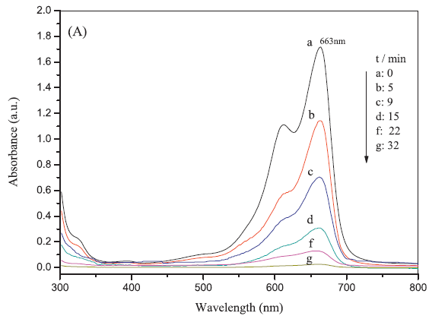
Binary photocatalyst of ZnS is when ZnS is composited with another filler for example graphene. This composite (ZnS-graphene) can result in new properties of photocatalysts. The photocatalytic activity of ZnS-graphene was observed by degrading methylene blue (MB) in water [29]. This study used a graphene nanosheet and the UV-Vis spectrum in the range of 300 to 800 nm is given in Figure 9. The characteristic absorption peak of methylene blue solution at 663 nm was selected as the parameter monitored to detect the methylene blue concentration. Figure 13 shows the evolution of absorption spectra of MB in the presence of 0.20 g ZnS-graphene composites. It was found that the intensity of the absorption peaks aligned directly to MB which gradually declined with increasing exposure time and finally vanished after about 32 minutes. There were no new absorption peaks pop up in the visible and ultraviolet region, showing the complete degradation of MB. In addition, the photocatalytic activity of ZnS-graphene can be observed to degrade 4-nitrophenol (4-NP) [34]. The declining of absorption peak intensity of nitrophenolate ion with ZnS-graphene was recorded over time under simulated light to observe the photocatalytic activity of the composite toward reduction of 4-NP.

Figure 9. Absorption spectra of a solution of MB with ZnS-graphene [29]

The reduction efficiency of ZnS-graphene and ZnS was compared under simulated solar light illumination as indicated in Figure 10 (a) and (b) respectively. The time used for illumination was 70 minutes to achieve 87% of reduction efficiency with the composite while it was only 34% with single ZnS under similar experimental conditions. Hence, based on formula (10) of reduction rate constant, k shows the results of pseudo-first order reduction kinetics of 4-NP where the k of ZnS is 6 × 10⁻³ min⁻¹ while ZnS-graphene composite is 30 × 10⁻³ min⁻¹. This shows that ZnS-graphene composite results in better efficiency compared to ZnS and 5 times higher k than ZnS because of its synergistic effect between reduced graphene oxide and ZnS where graphene is responsible for an efficient photo-induced charge separation and transportation [35]. Then, the photo-induced electrons generated in the ZnS nanorod high-band gap pass from its conduction bands to the 4-NP LUMO level through the graphene sheets and reduce the 4-NP to 4-aminophenol [35].

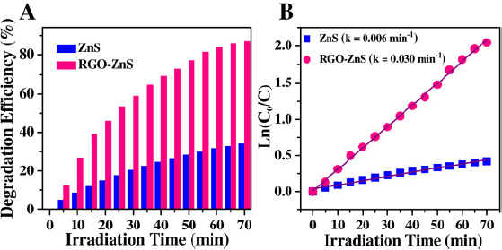
(b)
(a)

Figure 10. (a) The comparison of the reduction efficiency versus irradiation time over ZnS and ZnS-graphene (b) Plot of In (C₀/C) for the photocatalysis of 4-NP solution with ZnS and ZnS-graphene composite [34]

Ternary photocatalyst
Ternary photocatalyst is a photocatalyst that has a three-system photocatalysis; for example, reduced graphene oxide-ZnS-TiO₂ (rGO-ZnS-TiO₂). The photocatalytic activity of ternary photocatalysts of rGO-ZnS-TiO₂ nanocomposite can be observed on its application for crystal violet dye (CV) removal [36]. This combination is proven to be an effective photocatalyst for the treatment of wastewater. Through this study, the result showed that almost 97% CV dye was removed by adsorption and photodegradation at temperature of 35°C with initial dye concentration of 50 ppm and nanocomposite amount of 0.4 g/L. The study was carried out with varied loadings of catalyst to decide the optimal amount of rGO-ZnS-TiO₂ nanocomposite prepared with the aid of ultrasonic irradiation. Based on Figure 11, the overall photocatalytic degradations are 94.83%, 97.02% and 96.30% obtained for 0.3 g/L, 0.4 g/L and 0.5 g/L of rGO-ZnS-TiO₂ nanocomposite respectively. The results also showed that the quantity of nanocomposite increased from 0.3 g/L to 0.4 g/L. The degradation of CV was also increased from 94.83% to 97.02% independently and continuous increase in the loading of rGO-ZnS-TiO₂ nanocomposite at 0.5 g/L exhibited a marginal decline in the degradation, which was meant to be at 96.30%. rGO-ZnS-TiO₂ nanoparticles displayed strong adsorption abilities and the excessive adsorption reduced the photocatalytic activity. Hence, the distribution of impudent loaded nanocomposite will hinder the UV light irradiation and the restriction can result in an efficient usage of light resulting in declining photocatalytic degradation of CV dye. So, the result concluded that the optimal dose of rGO-ZnS-TiO₂ is 0.4 g/L with the aid of ultrasonic illumination to obtain effective degradation of CV dye [36].

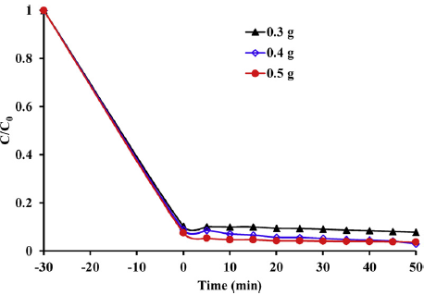
Figure 11. The effect of catalyst loading on degradation of CV dye [35]

Table 2. Comparison between binary and ternary ZnS composites in photocatalytic degradation

Types of ZnS Photocatalyst | Pollutants | Source of Light | Degradation Efficiency | References
Binary
ZnS-graphene | methylene blue (MB) | UV light | 98% | [29]
RGO-ZnS | 4-nitrophenol | Solar Light | 87% | [35]
Cadmium-ZnS | Methyl Orange | Visible light | 90% | [32]
ZnS layers of ZnS(en)x complex | Chromium IV | Hg lamp | 99% | [37]
Ternary
rGO-ZnS-TiO₂ | crystal violet dye | UV light | 97% | [36]
ZnS–TiO₂/RGO | Methylene blue | Visible light | 90% | [38]
ZnO/reduced graphene oxide (rGO)/polyaniline (PANI) | Methyl Orange | Visible Light | 100% | [39]
ZnO-ZnS@Pani | 2-chlorophenol | Visible Light | 87% | [40]
Ag₂S–ZnS loaded on cellulose | Rhodamine  B | Visible light | 95% | [41]

Conclusion
Based on the overall review towards the application of ZnS, it can be concluded that ZnS can be successfully composited with conducting polymers and other photocatalysts. ZnS was able to be prepared through various preparations and methods resulting in different sizes and morphologies based on their SEM and TEM images. It is also proven that different sizes and morphologies of ZnS would result in different reactions of ZnS towards photocatalytic studies. The smaller the size of ZnS, the better the photocatalytic degradation of organic pollutants. Moreover, ZnS can also act as a photocatalyst in different forms including single semiconductor, binary photocatalyst and ternary photocatalyst. Ternary photocatalysts proved to be the better photocatalytic as three media compositions increased the photocatalytic behaviour of ZnS. This is because ternary photocatalysts improved the electric properties of the photocatalyst, hence improving the photocatalytic degradation of organic pollutants. Last but not least, it can be proven on the basis of the analysis that ZnS exhibited a strong photocatalytic activity to degrade organic contaminants such as organic dye and nitrophenols. Future studies can explore whether ZnS is able to act as a photocatalyst which is a composite with conducting polymer. Conducting polymer is widely used in applications such as sensors because of its characteristics including ease of synthesis, low density and conducting properties. Conducting polymers show potential as it can greatly increase conductivity has the advantages of conventional organic polymers including strength, plasticity, toughness and flexibility. It is believed that composited photocatalysts with conducting polymer increase the effectiveness of degradation because of the increasing appropriate surface of the photocatalyst.

References
- Dehghanifard, E., Jafari, A. J., Kalantary, R. R., Mahvi, A. H., Faramarzi, M. A. and Esrafili, A. (2013). Biodegradation of 2, 4-dinitrophenol with laccase immobilized on nano-porous silica beads. Iranian Journal of Environmental Health Science and Engineering, 10(1): 25.
- Anjum, M., Oves, M., Kumar, R. and Barakat, M. A. (2017). Fabrication of ZnO-ZnS@ polyaniline nanohybrid for enhanced photocatalytic degradation of 2-chlorophenol and microbial contaminants in wastewater. International Biodeterioration and Biodegradation, 119: 66-77.
- Ayodhya, D. and Veerabhadram, G. (2018). A review on recent advances in photodegradation of dyes using doped and heterojunction based semiconductor metal sulfide nanostructures for environmental protection. Materials Today Energy, 9: 83-113.
- Salah, N., Hameed, A., Aslam, M., Babkair, S. S., and Bahabri, F. S. (2016). Photocatalytic activity of V doped ZnO nanoparticles thin films for the removal of 2-chlorophenol from the aquatic environment under natural sunlight exposure. Journal of Environmental Management, 177: 53-64.
- Das, M. and Sarkar, D. (2017). One-pot synthesis of zinc oxide-polyaniline nanocomposite for fabrication of efficient room temperature ammonia gas sensor. Ceramics International, 43(14): 11123-11131.
- Allahyeran and Mehrizad (2017). Comparison between different d-dimer cutoff values to assess the individual risk of recurrent venous thromboembolism: Analysis of results obtained in the DULCIS study. International Journal of Laboratory Hematology 38(1): 42-49.
- Lai, K., Wei, W., Yingtao, Z., Meng, G., Ying, D. and Baibiao, H. (2012). Effects of oxygen vacancy and n-doping on the electronic and photocatalytic properties of Bi₂MO₆ (M=Mo, W). Journal of Solid State Chemistry 187:103-108.
- Goswami, M., Sahoo, S., Meikap, A. K. and Ghosh, R. (2011). Characterization, optical and dc electrical properties of polyaniline-zinc sulphide nanocomposite. In International Conference on Nanoscience, Engineering and Technology, 2011: 314-318.
- Bora, L. V. and Mewada, R. K. (2017). Visible/solar light active photocatalysts for organic effluent treatment: Fundamentals, mechanisms and parametric review. Renewable and Sustainable Energy Reviews, 76: 1393-1421.
- Byrne, C., Subramanian, G. and Pillai, S. C. (2018). Recent advances in photocatalysis for environmental applications. Journal of Environmental Chemical Engineering, 6(3): 3531-3555.
- Al-Hamdi, Abdullah, M., Uwe, R. and Mika, S. (2017). Tin dioxide as a photocatalyst for water treatment: A review. Process Safety and Environmental Protection 107:190-205.
- Mahvelati-Shamsabadi, T. and E. K. Goharshadi. (2017). Photostability and visible-light-driven photoactivity enhancement of hierarchical ZnS nanoparticles: The role of embedment of stable defect sites on the catalyst surface with the assistant of ultrasonic waves. Ultrasonics Sonochemistry, 34: 78-89.
- Umar, M. and Aziz, H. A. (2013). Photocatalytic degradation of organic pollutants in water. Organic Pollutants-Monitoring, Risk and Treatment, 8: 196-197.
- Munawaroh, H., Sari, P. L., Wahyuningsih, S. and Ramelan, A. H. (2018) The photocatalytic degradation of methylene blue using graphene oxide (GO)/ZnO nanodrums. In AIP Conference Proceedings, 2014: p. 020119.
- Majhi, M., Choudhary, R. B., and Maji, P. (2017). HCl protonated polymeric PANI-ZnS nanocomposites and measurement of their robust dielectric, optical and thermal performance. Optik, 136: 181-191.
- Varanda, L. C., de Souza, C. G. S., Perecin, C. J., de Moraes, D. A., de Queiróz, D. F., Neves, H. R. and da Silva, T. L. (2019). Inorganic and organic–inorganic composite nanoparticles with potential biomedical applications: Synthesis challenges for enhanced performance. In Materials for Biomedical Engineering: pp. 47-99.
- Salavati-Niasari, M., Fatemeh, D. and Mehdi, M. (2009). Synthesis and characterization of ZnS nanoclusters via hydrothermal processing from [Bis(Salicylidene)Zinc(II)]. Journal of Alloys and Compounds 470(1–2): 502-506.
- Hu, L., Feiyan, C., Pengfei, H., Lianpei, Z. and Xing, H. (2016). Hydrothermal synthesis of SnO2/ZnS nanocomposite as a photocatalyst for degradation of rhodamine b under simulated and natural sunlight. Journal of Molecular Catalysis A: Chemical, 411: 203-213.
- Lee, G. J. and Wu, J. J. (2017). Recent developments in ZnS photocatalysts from synthesis to photocatalytic applications -A review. Powder Technology, 318: 8-22.
- Shakouri-Arani, M. and Salavati-Niasari, M. (2014). Synthesis and characterization of wurtzite ZnS nanoplates through simple solvothermal method with a novel approach. Journal of Industrial and Engineering Chemistry, 20(5): 3179-3185.
- Song, L., Zhang, S., Chen, B., Ge, J. and Jia, X. (2010). Fabrication of ternary zinc cadmium sulfide photocatalysts with highly visible-light photocatalytic activity. Catalysis Communications, 11(5): 387-390.
- Shahid, R., Toprak, M., Soliman, H. and Muhammed, M. (2012). Low temperature synthesis of cubic phase zinc sulfide quantum dots. Open Chemistry, 10(1): 54-58.
- Guo, J., Khan, S., Cho, S. H., and Kim, J. (2019). Preparation and immobilization of zinc sulfide (ZnS) nanoparticles on polyvinylidene fluoride pellets for photocatalytic degradation of methylene blue in wastewater. Applied Surface Science, 473: 425-432.
- Senapati, U. S., Jha, D. K. and Sarkar D. (2013). Green synthesis and characterization of ZnS nanoparticles. Research Journal of Physical Sciences,1(7): 2320-4796.
- Hudlikar, M., Shreeram, J., Mayur, D. and Kisan, K. (2012). Latex-mediated synthesis of ZnS nanoparticles: Green synthesis approach. Journal of Nanoparticle Research, 14(5): 865.
- Kannan, S., Subiramaniyam, N. P. and Sathishkumar, M. (2020). A novel green synthesis approach for improved photocatalytic activity and antibacterial properties of zinc sulfide nanoparticles using plant extract of Acalypha indica and Tridax procumbens. Journal of Materials Science: Materials in Electronics, 31(12): 9846-9859.
- Lan, C., Kunquan, H., Wenzhong, W. and Guanghou, W. (2003). Synthesis of ZnS nanorods by annealing precursor ZnS nanoparticles in NaCl flux. Solid State Communications, 125(9): 455-58.
- Jothibas, M., Manoharan, C., Jeyakumar, S. J., Praveen, P., Punithavathy, I. K. and Richard, J. P. (2018). Synthesis and enhanced photocatalytic property of Ni doped ZnS nanoparticles. Solar Energy, 159: 434-443.
- Hu, H., Wang, X., Liu, F., Wang, J. and Xu, C. (2011). Rapid microwave-assisted synthesis of graphene nanosheets–zinc sulfide nanocomposites: Optical and photocatalytic properties. Synthetic Metals, 161(5-6): 404-410.
- Boulkroune, R., Sebais, M., Messai, Y., Bourzami, R., Schmutz, M., Blanck, C., ... and Boudine, B. (2019). Hydrothermal synthesis of strontium-doped ZnS nanoparticles: structural, electronic and photocatalytic investigations. Bulletin of Materials Science, 42(5): 1-8.
- Chen, Y., Yin, R. H. and Wu, Q. S. (2012). Solvothermal synthesis of well-disperse ZnS nanorods with efficient photocatalytic properties. Journal of Nanomaterials, 2012: 560310.
- Suganya, S., Jothibas, M. and Jeyakumar, S. J. (2019). Solid state synthesis of cadmium doped ZnS with excellent photocatalytic activity and enhanced visible light emission. Journal of Materials Science: Materials in Electronics, 30(8): 7916-7927.
- Abbasi, M., Rafique, U., Murtaza, G. and Ashraf, M. A. (2018). Synthesis, characterisation and photocatalytic performance of ZnS coupled Ag2S nanoparticles: A remediation model for environmental pollutants. Arabian Journal of Chemistry, 11(6): 827-837.
- Wang, W., Lee, G. J., Wang, P., Qiao, Z., Liu, N. and Wu, J. J. (2020). Microwave synthesis of metal-doped ZnS photocatalysts and applications on degrading 4-chlorophenol using heterogeneous photocatalytic ozonation process. Separation and Purification Technology, 237: 116469.
- Ibrahim, S. K., Chakrabarty, S., Ghosh, S. and Pal, T. (2017). Reduced graphene oxide–zinc sulfide composite for solar light responsive photo current generation and photocatalytic 4‐nitrophenol reduction. ChemistrySelect, 2(1): 537-545.
- Kale, D. P., Deshmukh, S. P., Shirsath, S. R. and Bhanvase, B. A. (2020). Sonochemical preparation of multifunctional rGO-ZnS-TiO₂ ternary nanocomposite and its application for CV dye removal. Optik, 208: 164532.
- Hernández-Gordillo, A., García-Mendoza, C., Alvarez-Lemus, M. A. and Gómez, R. (2015). Photocatalytic reduction of Cr(VI) by using stacked ZnS layers of ZnS (en) x complex. Journal of Environmental Chemical Engineering, 3(4): 3048-3054.
- Qin, Y. L., Zhao, W. W., Sun, Z., Liu, X. Y., Shi, G. L., Liu, Z. Y., ... and Ma, Z. Y. (2019). Photocatalytic and adsorption property of ZnS–TiO₂/RGO ternary composites for methylene blue degradation. Adsorption Science & Technology, 37(9-10): 764-776.
- Wu, H., Lin, S., Chen, C., Liang, W., Liu, X. and Yang, H. (2016). A new ZnO/rGO/polyaniline ternary nanocomposite as photocatalyst with improved photocatalytic activity. Materials Research Bulletin, 83: 434-441.
- Anjum, M., Oves, M., Kumar, R. and Barakat, M. A. (2017). Fabrication of ZnO-ZnS@ polyaniline nanohybrid for enhanced photocatalytic degradation of 2-chlorophenol and microbial contaminants in wastewater. International Biodeterioration & Biodegradation, 119: 66-77.
- Kumar, T. K. M. and Kumar, S. K. (2019). Visible-light-induced degradation of rhodamine B by nanosized Ag₂S-ZnS loaded on cellulose. Photochemical & Photobiological Sciences, 18(1): 148-154.

