DEVELOPMENT AND OPTIMIZATION OF A RAPID RESOLUTION LIQUID CHROMATOGRAPHY METHOD FOR CYANIDIN-3-O-GLUCOSIDE IN RAT PLASMA

(Pembangunan dan Pengoptimuman Kaedah Kromatografi Cecair Resolusi Pantas untuk Sianidin-3-O-Glukosida Klorida di dalam Plasma Tikus

Nadiratul Asyikin Sauji¹, Wan Amir Nizam Wan Ahmad^{1,*}, Liza Nordin²

and Ruzilawati Abu Bakar^{3,*}

¹Biomedicine Program, School of Health Sciences
²Department of Physiology, School of Medical Sciences
³Department of Pharmacology, School of Medical Sciences
Universiti Sains Malaysia, 16150, Kubang Kerian, Kelantan, Malaysia

*Corresponding authors: ruzila@usm.my; wanamir@usm.my

Abstract

The growing interest in anthocyanins in plants has brought about the importance of investigating their pharmacological properties. Sensitive and specific analytical methods are required to accurately analyze the anthocyanins present in samples. One of the anthocyanins found in plants is cyanidin-3-O-glucoside. The objective of this study was to develop and optimize a rapid resolution liquid chromatography (RRLC) method for cyanidin-3-O-glucoside determination in rat plasma. Spectrophotometric analysis was performed to determine the best ultraviolet (UV) absorbance wavelength. Liquid-liquid extraction (LLE) and solid-phase extraction (SPE) methods were compared to determine the best extraction method for cyanidin-3-O-glucoside in rat plasma samples. The effects of varying the type and proportion of organic solvents, the type and concentration of buffer solutions, flow rates, column temperatures, and UV wavelengths were examined. The optimized chromatographic method for RRLC analysis of cyanidin-3-O-glucoside was a mobile phase composition of 0.1% trifluoroacetic acid aqueous solution and acetonitrile in a ratio of 81:19, respectively, with a 0.5 mL/min flow rate, at 30°C column temperature and 525 nm detection wavelength. SPE was our choice of final extraction method. Our findings revealed that the optimized RRLC method can be used to determine cyanidin-3-O-glucoside in rat plasma.

Keywords: Rapid resolution liquid chromatography; method development; cyanidin-3-O-glucoside; rat plasma

Abstrak

Kajian antosianin dalam rosel yang semakin meluas mengetengahkan kepentingan analisis sebatian tersebut untuk mengkaji ciri-ciri farmakologinya. Kaedah analisis yang sensitif dan spesifik diperlukan untuk menganalisis antosianin yang terdapat dalam sampel dengan tepat. Salah satu antosianin yang terdapat dalam tumbuhan ialah sianidin-3-O-glukosida. Objektif kajian ini adalah untuk membangunkan dan mengoptimumkan kaedah kromatografi cecair resolusi pantas (RRLC) untuk sianidin-3-O-glukosida di dalam plasma tikus. Analisis spektrofotometri dilakukan untuk memilih penyerapan ultraungu yang terbaik. Kaedah pengekstrakan cecair-cecair (LLE) dan pengekstrakan fasa pepejal (SPE) juga dijalankan untuk menilai kaedah pengekstrakan terbaik bagi antosianin daripada sampel plasma tikus. Kesan mempelbagaikan jenis dan peratusan pelarut organik, jenis dan kepekatan larutan penimbal, kadar aliran fasa bergerak, suhu turus dan panjang gelombang pengesan ultraungu telah diuji. Kaedah pengoptimuman kromatografi menunjukkan komposisi fasa bergerak bagi larutan akueus asid trifluoroasettik 0.1% dan asetonitril dalam nisbah 81:19, dengan kadar aliran 0.5 mL/min, pada suhu turus 30°C dan panjang gelombang pengesanan 525 nm adalah sesuai untuk analisis sianidin-3-O-glukosida. Kaedah SPE dipilih sebagai kaedah pengekstrakan terbaik kerana ia menghasilkan puncak kromatogram yang lebih baik berbanding kaedah LLE. Kesimpulannya, kaedah RRLC yang dibangunkan dalam kajian ini boleh digunakan untuk menentukan sianidin-3-O-glukosida dalam plasma tikus.

Kata kunci: kromatografi cecair resolusi pantas; pembangunan kaedah; cyanidin-3-O-glucoside chloride; plasma tikus

Introduction

Anthocyanins are polyphenolic pigments that belong to the flavonoid group and are present in the vacuolar sap of the epidermal tissues of flowers and fruits [1,2]. These compounds are responsible for various colors of plant organs, such as fruits, flowers, and leaves, and they are also present in vegetables [1]. One of the anthocyanins found in plants is cyanidin-3-O-glucoside [3]. The ever-increasing evidence about anthocyanins has drawn many researchers to investigate more about these plant flavonoids. The increasing importance of elucidating their health -promoting properties has raised the need for specifictasks for their determination methods.

The development of a combined extraction method—spectrophotometric and chromatographic methods—is regarded as having the most significant impact on the analysis of anthocyanins [3,4]. Although liquid chromatography has been the most employed technique to identify or quantify anthocyanins [5], an advanced and improved method of high-performance liquid chromatography (HPLC), such as rapid resolution liquid chromatography (RRLC), is currently applied in anthocyanin research, as it offers better separation and identification of specific components of anthocyanins. Therefore, the objective of this study was to develop and optimize an RRLC method for cyanidin-3-O-glucoside in rat plasma. Spectrophotometric analysis was performed to determine the appropriate UV absorbance. Both liquid-liquid extraction (LLE) and solid-phase extraction (SPE) methods were performed to determine the best extraction method for cyanidin-3-O-glucoside chloride in the rat plasma sample. We tested the effects of varying the type and percentage of organic solvents, the type and concentration of buffer solutions, flow rates, and column temperatures.

Materials and Methods

Chromatographic equipment

The chromatographic system and machine consisted of the Agilent Technologies 1200 Series system consisted of a binary pump, an autosampler, thermostat column compartment, variable wavelength detector and a vacuum degasser (Agilent Technologies, Santa Clara, California, USA). The analytical column was Agilent Reverse Phase EC-C18 (4.6 x 150 mm I. D, particle size 2.7 µm) (Agilent Technologies, Santa Clara, California, USA). The guard column was Agilent Reverse Phase EC-C18 2.7 µm (4.6 x 5 mm) (Agilent Technologies, Santa Clara, California, USA).

Chemicals and reagents

All chemicals were HPLC grade. Acetonitrile (ACN), 5-sulfosalicylic acid dihydrate, ethyl acetate, methyl tert-butyl ether (MTBE), methanol (MeOH), formic acid (CH₂O₂), phosphoric acid (H₃PO₄), hydrochloric acid (HCL) and trifluoroacetic acid (TFA) were from Merck® (Darmstadt, Germany). Diethyl ether was from Fisher Chemical (Massachusetts, USA).

Drug standard and internal standard

The drug standard, cyanidin-3-O-glucoside chloride was purchased from ChemFaces (catalogue no. CFN99740) (CAS no. 7084-24-4). The internal standard, cyanidin-3,5-O-diglucoside chloride was also purchased from ChemFaces (catalogue no. CFN92138) (CAS no. 2611-67-8).

Standard stock solutions of cyanidin-3-O-glucoside chloride (100 µg/ml) and internal standard, cyanidin-3,5-O-diglucoside chloride (100 µg/ml) were prepared by dissolving 1 mg of each compound in 10 ml MeOH, respectively. The solutions were then stored at -20°C in clear vials and were protected from light with aluminium foils.

The working cyanidin-3-O-glucoside chloride and internal standard solutions were prepared fresh daily by diluting the stock solutions with the mobile phase. The concentration of working solution for internal standard and cyanidin-3-O-glucoside chloride used for the optimization of chromatographic conditions were 250 ng/ml and 500 ng/ml, respectively.

Preparation of plasma standard and samples

The rats used in this study were approved by the USM Institutional Animal Care and Use Committee (USM IACUC) [USM/IACUC/2019/(118)(1000)] and supplied by the Animal Research and Service Centre (ARASC), Health Campus, USM Kelantan, Malaysia. Rats' blood was collected and stored in heparin blood tubes before being centrifuged to separate the plasma. Then, the rat plasma was stored at -80°C within 8 hours of collection.

The fresh-frozen rat plasma was allowed to thaw naturally on the bench at room temperature for approximately 45-60 minutes. It was then vortexed for a few seconds to ensure uniform distribution. The plasma standard was prepared in the same ratio with different volumes for each extraction method.

Spectrophotometry analysis

The spectrophotometric analysis of cyanidin-3-O-glucoside chloride and the internal standard were performed on a Cary 100 UV-visible spectrophotometer. Dilutions of aliquots of standard stock solution (100 ug/mL) of both cyanidin-3-O-glucoside chloride and internal standard were carried out with 0.1% HCL in 75% MeOH to reach the concentration range 10 ug/mL and 50 ug/mL. The wavelength of range 300 to 700 nm was selected for the quantitation of cyanidin-3-O-glucoside chloride and internal standard.

Optimization of chromatographic conditions

We followed the RRLC optimisation guideline provided by Agilent Technologies to equilibrate the column and detector with 10 column volumes of the mobile phase prior to use (1 ml – 5 ml) depending on column size [6]. The approximate time to equilibrate the instrument was 20 minutes to 45 minutes or until the pressure pump reading was stabilized. The column of RRLC should be equilibrated each time before use and need to be performed when run for the new solvent of different mobile phases. The pressure pump was maintained at 147 bar during the equilibration process. The effect of varying the type and percentage of organic solvents, type and concentration of buffer solutions, flow rates, column temperatures and ultraviolet wavelengths were tested.

Optimization of extraction methods

Liquid-liquid extraction (LLE) and solid-phase extraction (SPE) methods were carried out to decide which extraction method is more suitable to be used in extracting the cyanidin-3-O-glucoside chloride from rat plasma. The method which demonstrated the best extraction results of cyanidin-3-O-glucoside chloride and internal standard would be chosen for further testing.

Liquid-liquid extraction (LLE)

The LLE method was performed by referring to a study conducted by Banaszewski et al.[7]. In this method, 50 µL of working cyanidin-3-O-glucoside chloride and internal standard solutions were added to the 500 µL of rat plasma. The freshly prepared plasma standard was then acidified to pH 2 with CH₂O₂ because anthocyanin is more stable at low pH and then extracted with 1.5 mL of ACN. The sample was then centrifuged at 10,000 rpm for 15 minutes at a temperature of 4 °C. After that, they were re-extracted with 1.5 mL MeOH. The extracts were then pooled and the supernatants were collected. Then, the supernatants underwent an evaporation process in the pre-heated water bath at 35°C, in vacuo using a vacuum pump. Next, they were reconstituted in 250 µL of mobile phase and centrifuged at 10,000 rpm for 30 minutes at 4°C. Lastly, the samples were transferred to the amber vials and immediately analyzed by RRLC. We also compared different extraction solvents to extract the anthocyanin from plasma such as diethyl ether, ethyl acetate and MTBE using the same procedure.

Solid-phase extraction (SPE)

The SPE method was carried out by referring to a study conducted by Harada et al. [8]. The cartridge was firstly conditioned, by washing with 1 to 2 mL of MeOH and then equilibrated with the same volume of 0.1 % TFA aqueous solution. The plasma standards were prepared by mixing 200 µL of cyanidin and internal standard working solutions of selected concentrations into 2 mL of the thawed plasma, followed by vortexing the solution for 5 seconds. Then, the plasma standard was subsequently mixed with 2 mL of 0.1% TFA aqueous solution and 100 µL of 20% sulfosalicylic acid aqueous solution. After that, it was vortex-mixed and centrifuged at 4000 x g for 20 minutes at 4°C. The supernatant then was further treated in the conditioned and equilibrated Sep-Pak tC18 cartridge. Next, the cartridge was rinsed with 2 mL of 0.1% TFA solution and subsequently purged with air. The dried cartridge was then eluted with 2 mL of MeOH and evaporated to dryness using a vacuum pump at a temperature below 40°C (35 - 37°C). The resultant dry residue then was dissolved in 50 µL of 0.1% TFA aqueous solution. Afterwards, it was centrifuged at 6000 rpm for 15 minutes at 10°C using an Ultrafree®-MC centrifugal filter (Merck, Germany). Lastly, the solution was subjected to RRLC for analysis.

Result and Discussion

Spectrophotometry analysis

The UV absorbances of cyanidin-3-O-glucoside chloride and cyanidin-3,5-O-diglucoside chloride were measured using a Cary 100 UV-visible spectrophotometer (Varian, California, USA). Spectrophotometry analysis of both cyanidin-3-O-glucoside chloride and cyanidin-3,5-O-diglucoside chloride showed that the maximum absorption was 524 nm, as shown in Fig. 1. Thus, UV absorbance was used throughout the study.

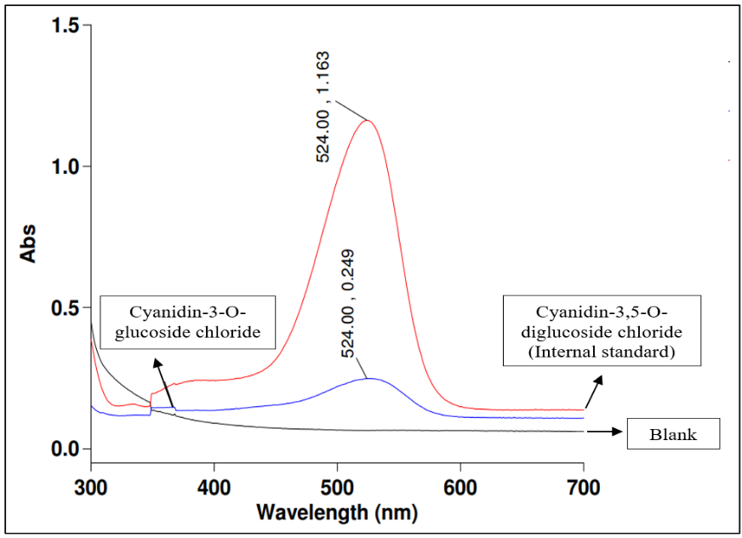

Figure 1. Spectrophotometry of the blank sample, cyanidin-3-O-glucoside chloride and cyanidin-3,5-O-diglucoside chloride (internal standard)

Absorption spectroscopy, especially UV-Vis spectroscopy, has been extensively utilized to identify anthocyanins and has revealed a lot about the structural properties and identification of these molecules [9]. From the results, the absorption peak of both cyanidin-O-glucoside chloride and the internal standard emerged at a wavelength of 524 nm. Using UV-Vis spectroscopy, absorption peaks emerged at wavelengths of 266 nm and 530 nm, indicating that the extract contains anthocyanin compounds [10]. UV-Vis spectrophotometer demonstrated that absorption at an absorption maxima (λmax) 536 nm was the specification of anthocyanins [11]. A typical UV-Vis spectrum of anthocyanin exhibits two basic absorbance clusters [9]. The first one is at 260–280 nm (UV area) and the second at 490–550 nm (VIS region) (visible region), in which the λmax in the visible range is typically measured at 510–520 nm. The typical absorption bands of anthocyanins are in the 490 to 550 nm region of the visible spectra [12].

Optimization of chromatographic conditions

Optimization of type and concentration buffer solutions

Three different buffer solutions were investigated: 5% CH2O2 aqueous solution, 1% H3PO4 aqueous solution, and 0.1% TFA aqueous solution with acetonitrile (ACN) as the organic solvent. Each of the solvents was prepared with different concentrations according to the manufacturer’s datasheet, as well as based on respective previous studies [8,13]. The column temperature, mobile phase flow rate, and wavelength signal were kept constant. Among the three buffer solutions, the mobile phase of 0.1% TFA aqueous solution and ACN showed faster retention time and good peak shapes, with the least peak tailing. Thus, this combination of solvents was selected.

One of the factors that affects the retention of substances in RRLC is the mobile phase composition [14]. Buffers are usually used in mobile phases to hold and adjust the pH constant. The pH of the mobile phase is kept constant because it is always freshly prepared before RRLC analysis. The acid is used to improve the chromatographic peak shape and to provide a source of protons in reversed-phase LC/MS [15]. In this method, we also utilized isocratic elution, as it offers greater simplicity, lower cost, simpler instrumentation, and no need for column re-equilibration between consecutive injections [16].

Optimization of the percentage of organic solvents

We investigated three ratios of TFA:ACN: 90%:10%, 85%:15%, and 81%:19%. The column temperature, wavelength signal, and mobile phase flow rate were kept constant. The ratio combination was determined based on the previous literature on anthocyanins [8]. Among the three ratios tested, only the 81%:19% composition showed the presence of peaks. The chromatograms of the other two ratios did not generate any peaks, possibly due to differences in the percentage of ACN used. The higher the percentage of acetonitrile, the faster the retention time for anthocyanins. Hence, the 81%:19% TFA:CAN combination was chosen because it also exhibited a faster retention time and good peak shapes.

Optimization of type of organic solvents

The selection of proper organic solvents is also important for retaining substances in RRLC. The two organic solvents tested, ACN and MeOH, are the most commonly used solvents in RRLC. We tested ACN and MeOH in combination with a 0.1% TFA aqueous solution. The column temperature, mobile phase flow rate, wavelength signal, and percentage of organic solvent in the mobile phase were kept constant.

The results showed that using ACN as an organic solvent generated peaks in the chromatogram, while there was no peak when MeOH was used. This could be due to the elution strength of the organic solvents. ACN has a higher elution strength than MeOH [17]. Thus, at the same percentage of organic solvent in the mobile phase, which was 19% for ACN and MeOH, we observed shorter retention times for the analytes with ACN than with MeOH. ACN has a lower viscosity than MeOH [18]. Hence, with increasing column temperature, the pressure also tends to decrease as the viscosity of the solvent decreases. ACN is also often used because of its low UV cut-off wavelength, which is lower than that of MeOH (190 nm and 205 nm for ACN and MeOH, respectively) [19]. Thus, ACN was chosen for further investigation, as the chromatogram showed peaks of cyanidin-3-O-glucoside chloride and an internal standard .

Optimization of flow rates

Another chromatographic parameter that affects chromatographic separation is the flow rate. Three different mobile phase flow rates—0.5, 0.8, and 1.0 ml/min—were investigated. The percentage of organic solvent in the mobile phase, column temperature, and injection volume were kept constant. An increase in the flow rate will decrease the retention factor, thereby resulting in rapid analysis [20]. A flow rate of 0.5 mL/min was chosen, as it displayed a good retention time of about 4 min, good area counts, and good peak shape. Although the peaks at other flow rates were generated at a shorter retention time, they were not chosen, as the increase in the flow rate caused a reduction in the peak area. Increased flow rates may shorten retention time, but they may contribute to band broadening and a decrease in the column’s efficiency [20].

Optimization of column temperatures

One of the important chromatographic conditions is column temperature, as it is an important variable in LC separation [21]. The column temperature was optimized at three different temperatures: 30, 35, and 40°C. The percentage of organic solvent in the mobile phase, wavelength signal, and mobile phase flow rate were kept constant. The column temperature of 30°C was chosen because it gave the best peak area ratio, as recommended by the manufacturer.

Higher column temperatures can affect column pressure due to their effect on lowering mobile phase viscosities. Thus, a desirable lower systemic pressure will be produced. This, in return, allows a lower linear velocity for the chromatographic system and thus produces a sharper peak [22]. In this study, although column temperatures of 35 and 40°C generated shorter retention times, the column temperature of 30°C was selected because it also gave fast retention time and better peak shape without compromising the peak area. Further, a lower column temperature is preferable to sustaining the stability of cyanidin, as a higher temperature would result in a faster degradation rate of anthocyanins [23]. High temperatures could also be detrimental to the column’s packing when used over a prolonged time [22].

Final chromatographic conditions

We performed the detection of cyanidin-3-O-glucoside chloride and internal standard cyanidin-3,5-O-diglucoside chloride at 525 nm with the ratio of mobile phase at 81:19 (0.1% TFA:ACN) (v/v). The mobile phase flow rate was set at 0.5 ml/min. The column temperature was set at 30°C. Using the column chromatographic conditions described above, the average retention times for cyanidin-3-O-glucoside chloride and cyanidin-3,5-O-diglucoside chloride were 4.4 min and 3.2 min, respectively , with a total run time of 10 min and a stop time of 5 min (Figure 2).

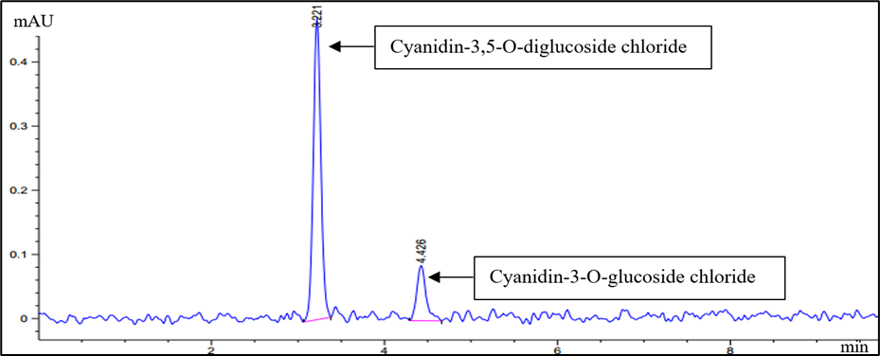

Figure 2. Chromatograms of standard solutions of cyanidin-3-O-glucoside chloride (3.221 min) and the internal standard, cyanidin-3,5-O-diglucoside chloride (4.426 min)

Optimization of liquid-liquid extraction (LLE) method
The optimized chromatographic condition was applied for the analysis of plasma samples using the LLE method.

Effect of using different extracting solvents
The percentage recoveries of compounds extracted using different solvents were calculated (Table 1). The acetonitrile was chosen as the extracting solvent because both the percentage recoveries of analyte and internal standard were higher than those of the other solvents.

The internal standard was used in this test to aid in quantification of analytes (anthocyanin) and improve the accuracy and precision of the method. Internal standard is used to compare the peak area of target analytes to the peak area of internal standard to obtain the peak area ratio.

Table 1. Percentage recoveries of cyanidin-3-O-glucoside chloride and cyanidin-3,5-O-diglucoside chloride by liquid-liquid extraction method when different extracting solvents were used

Solvent | Recovery for cyanidin-3-O-glucoside chloride (%) | Recovery for cyanidin-3,5-O-diglucoside chloride (%)
Acetonitrile (ACN) | 72.85 | 119.05
Diethyl ether (Et2O) | No peak seen | No peak seen
Ethyl acetate (EtAc) | 66.72 | 38.85
Methyl tert-butyl ether (MTBE) | 110.46 | 44.85

Optimization of solid-phase extraction (SPE) method
The optimized chromatographic conditions were also applied for the analysis of the plasma samples using SPE.

Selection of final extraction method
The chromatograms of cyanidin-3-O-glucoside chloride for both the LLE and SPE methods were analyzed at concentrations of 500 ng/ml and 1000 ng/ml, respectively. The recovery percentage of cyanidin-3-O-glucoside chloride from LLE was slightly better than that of SPE (72.85% and 68.36%, respectively). However, the chromatogram generated from the SPE method demonstrated better peak shapes for cyanidin-3-O-glucoside chloride and
the internal standard compared to the chromatogram of the LLE method. In addition, the chromatogram of the SPE method showed less peak tailing compared to the LLE method. The chromatogram of the SPE method also exhibited similar retention times for cyanidin-O-glucoside chloride and internal standard prior to extraction. Hence, we chose SPE as the final extraction method, as it yielded more favorable results than LLE in the extraction cyanidin-O-glucoside chloride in rat plasma based on the results of RRLC analysis (Figure 3).

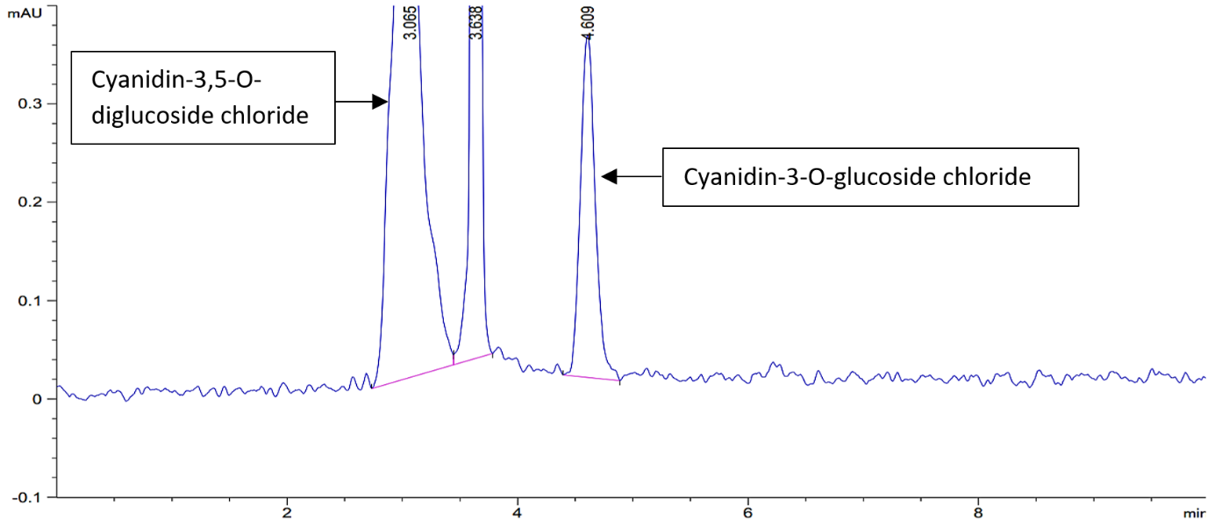

Figure 3. Chromatogram of cyanidin-3-O-glucoside chloride (4.609 min) and internal standard, cyanidin-3,5-O-diglucoside chloride (3.065 min) at concentration 1000 ng/mL following SPE method.

Extraction is a critical step in sample preparation, as the presence of endogenous impurities in biological fluids might cause interference in anthocyanin analysis. SPE and LLE are among the extraction methods used for anthocyanins, with increasing selectivity or specificity and improved recoveries and reproducibility [24]. In this experiment, we performed both methods to determine the most suitable extraction method for cyanidin-3-O-glucoside chloride.

LLE offers an advantage as an extraction method, in that the technique is relatively cheaper than SPE. However, this method requires costly and hazardous organic solvents, which are undesirable for health and disposal reasons [25]. LLE also requires a lengthy analysis period, which can give rise to the possible degradation of anthocyanins. By contrast, SPE techniques can overcome many of the problems associated with LLE, such as incomplete phase separations, less-than-quantitative recoveries, and the use and disposal of large and expensive quantities of organic solvents [25]. The only drawback of the SPE compared to the LLE technique is that the cost of the equipment required for SPE is higher than for LLE. Another advantage of SPE is that this technique can be used not only in preparing liquid samples and extracting semi-volatile or non-volatile analytes but also for solids that are pre-extracted into solvents [25].

From our results, although the percentage recoveries of anthocyanin from the LLE method were slightly better than those from the SPE method, we also considered other factors. The chromatographic peak shapes obtained with the SPE method were better than those obtained with LLE. An optimum chromatographic peak shape is important to ensure more accurate quantitation of analytes. Abnormal peak shapes, such as peak tailing, generate imprecise results. The chromatograms of SPE displayed lesser peak tailing than those of LLE. Peak tailing is one of the common chromatographic peak shape distortions [26], which can occur for several reasons, including the purity of the packing material, a quality that can influence the peak shape [27]. Contaminants in the material can enhance secondary interactions, which lead to peak tailing. Thus, using an extraction method that employs a sample cleanup procedure will offer better results [26]. Here, the SPE method involved a filtration step that used an Ultrafree-MC 0.45 µm filter unit before RRLC analysis. Therefore, given its chromatogram results and advantages compared to LLE, the SPE method was adopted as the extraction method in this study.

Conclusion

We successfully determined cyanidin-3-O-glucoside chloride in rat plasma using RRLC analysis. The spectrophotometry analysis showed that the maximal absorbance of the compound was in the absorption range reported in the previous literature. The optimization of chromatographic conditions demonstrated that the mobile phase composition of 0.1% TFA aqueous solution and ACN in the ratio of 81:19%, respectively, with a flow rate of 0.5 ml/min, at 30°C column temperature and detection wavelength of 525 nm, were suitable for RRLC analysis of cyanidin-3-O-glucoside chloride. SPE was selected as the final extraction method for cyanidin-3-O-glucoside chloride and its internal standard.

Acknowledgement

The research was financially supported by the Ministry of Agriculture’s Herbal Research Grant Scheme (HRGS) (project: NH1015S020; 304.PPSK.6150169.K123)

References

1. Wallace, T. C., & Giusti, M. M. (2015). Anthocyanins. Advances in Nutrition, 6 (5): 619 – 622.
2. Passeri, V., Koes, R., & Quattrocchio, F. (2016). New Challenges for the Design of High Value Plant Products: Stabilization of Anthocyanins in Plant Vacuoles. Front Plant Science, 7 (Feb 2016): 1 – 9 .
3. Riaz, G., & Chopra, R. (2018). A Review on Phytochemistry and Therapeutic Uses of Hibiscus sabdariffa L. Biomedicine & Pharmacotherapy, 102 (June 2018): 575 – 586.
4. Rubinskiene, M., Jasutiene, I., Venskutonis, P. R., & Viskelis, P. (2005). HPLC Determination of the Composition and Stability of Blackcurrant Anthocyanins. Journal of Chromatographic Science, 43 (9): 478 – 482.
5. Hapsari, B. W., Manikharda, & Setyaningsih, W. (2021). Methodologies in the Analysis of Phenolic Compounds in Roselle (Hibiscus sabdariffa L.): Composition, Biological Activity, and Beneficial Effects on Human Health. Horticulturae, 7 (2): 1 – 36.
6. Angelika, G.-H., Frank, M., & Gotenfels, C. (2009). Agilent 1200 Series Rapid Resolution LC and Rapid Resolution LC/MS Optimization Guide. https://www.agilent.com/cs/library/usermanuals/public/1200SeriesRRLC-OptimizeGuide_ebook.pdf. [Access online 11 July 2021].
7. Banaszewski, K., Park, E., Edirisinghe, I., Cappozzo, J. C., & Burton-Freeman, B. M. (2013). A Pilot Study to Investigate Bioavailability of Strawberry Anthocyanins and Characterize Postprandial Plasma Polyphenols Absorption Patterns by Q-TOF LC/MS in Humans. Journal of Berry Research, 3 (2): 113 – 126.
8. Harada, K., Kano, M., Takayanagi, T., Yamakawa, O., & Ishikawa, F. (2004). Absorption of Acylated Anthocyanins in Rats and Humans After Ingesting an Extract of Ipomoea Batatas Purple Sweet Potato Tuber. Bioscience, Biotechnology and Biochemistry, 68 (7): 1500 – 1507.
9. Saha, S., Singh, J., Paul, A., Sarkar, R., Khan, Z., & Banerjee, K. (2021). Anthocyanin Profiling Using UV-Vis Spectroscopy and Liquid Chromatography Mass Spectrometry. Journal of AOAC International, 103 (1): 23 – 39.
10. Dwilistiani, D., Darwis, D., & Santoni, A. (2015). Characterization of Cyanidin 3-(6-acetylglucoside)-5-(3”-coumaryl-6”- malonylglucoside) Compound from Cinnamon Bud Leaves (Cinnamomum burmanni (Ness & T. Ness) Blume) by HPLC-DAD-ESI-MS. Journal of Chemical and Pharmaceutical Research, 7 (47): 519 – 523.
11. Nuryanti, S., Matsjeh, S., Anwar, C., & Raharjo, T. J. (2012). Isolation Anthocyanin from Roselle Petals (Hibiscus sabdariffa L) and the Effect of Light on the Stability. Indonesian Journal of Chemistry, 12 (2): 167 – 171.
12. Prior, R. L., & Wu, X. (2012). Analysis Methods of Anthocyanins. In Z. Xu & L. R. Howard (Eds.), Analysis of Antioxidant-Rich Phytochemicals, John Wiley & Sons, New Jersey: pp. 149 – 180.
13. Durst, R. W., & Wrolstad, R. E. (2005). Separation and Characterization of Anthocyanins by HPLC. In Current Protocols in Food Analytical Chemistry, John Wiley & Sons, New Jersey: pp. 33 – 45.
14. Deineka, V. I., Deineka, L. A., & Saenko, I. I. (2015). Regularities of Anthocyanins Retention in RP HPLC for “Water–Acetonitrile–Phosphoric Acid” Mobile Phases. Journal of Analytical Methods in Chemistry, 2015 (2015): 1 – 6.
15. Guzzetta, A. (2001). Reverse Phase HPLC Basics for LC/MS. http://www.ionsource.com/tutorial/chromatography/rphplc.htm. [Access online 18 July 2021].
16. Ukić, Š., Rogošić, M., Novak, M., Šimović, E., Tišler, V., & Bolanča, T. (2013). Optimization of IC Separation Based on Isocratic-to-Gradient Retention Modeling in Combination with Sequential Searching or Evolutionary Algorithm. Journal of Analytical Methods in Chemistry, 2013 (1): 1 – 11.
17. Gilar, M., Jaworski, A., & McDonald, T. S. (2014). Solvent Selectivity and Strength in Reversed-Phase Liquid Chromatography Separation of Peptides. Journal of Chromatography A, 1337(1): 140 – 146.
18. Chua, Y. A., Abdullah, W. Z., Yusof, Z., & Gan, S. H. (2019). Validation of HPLC and Liquid-Liquid Extraction Methods for Warfarin Detection in Human Plasma and Its Application to a Pharmacokinetics Study. ASM Science Journal, 12 (2019): 1 – 10.
19. Yabré, M., Ferey, L., Somé, I. T., & Gaudin, K. (2018). Greening Reversed-Phase Liquid Chromatography Methods Using Alternative Solvents for Pharmaceutical Analysis. Molecules : A Journal of Synthetic Chemistry and Natural Product Chemistry, 23 (5): 1065 – 1089.
20. Afsah-Hejri, L., Jinap, S., Arzandeh, S., & Mirhosseini, H. (2011). Optimization of HPLC Conditions for Quantitative Analysis of Aflatoxins in Contaminated Peanut. Food Control, 22 (3–4): 381 – 388.
21. Dolan, J. W. (2002). The Importance of Temperature. LC GC Europe, 20 (6): 524 – 530.
22. Chua, Y. A., Abdullah, W. Z., & Gan, S. H. (2012). Development of a High-Performance Liquid Chromatography Method for Warfarin Detection in Human Plasma. Turkish Journal of Medical Sciences, 42 (5): 930 – 941.
23. Liu, Y., Liu, Y., Tao, C., Liu, M., Pan, Y., & Lv, Z. (2018). Effect of Temperature and pH on Stability of Anthocyanin Obtained from Blueberry. Journal of Food Measurement and Characterization, 12 (3): 1744 – 1753.
24. Martín, J., Navas, M. J., Jiménez-Moreno, A. M., & Asuero, A. G. (2017). Anthocyanin Pigments: Importance, Sample Preparation and Extraction. In M. Soto-Hernandez, M. Palma-Tenango and M. R. Garcia-Mateos (Eds.), Phenolic Compounds - Natural Sources, Importance and Applications, Intech Open, London: pp. 117 – 152.
25. Garcia-Salas, P., Morales-Soto, A., Segura-Carretero, A., & Fernández-Gutiérrez, A. (2010). Phenolic-Compound-Extraction Systems for Fruit and Vegetable Samples. Molecules, 15 (12): 8813 – 8826.
26. Crawford Scientific. (2017, September 18). Peak Tailing in HPLC. https://www.crawfordscientific.com/chromatography-blog/post/peak-tailing-in-hplc. [Access online 19 July 2021].
27. Denoulet, B. (2020). The Perfect Peak Shape: Five Solutions to Peak Tailing Problems. https://www.barts-blog.net/the-perfect-peak-shape-five-solutions-to-peak-tailing-problems/. [Access online 19 July 2021].

