

THERMAL DECOMPOSITION OF CALCIUM CARBONATE IN CHICKEN EGGSHELLS: STUDY ON TEMPERATURE AND CONTACT TIME

Penguraian Kalsium Karbonat dalam Kulit Telur Ayam: Kajian Mengenai Suhu dan Masa)

Nadia Razali¹, Nurriswin Jumadi^{1,2}*, Adlin Yasmin Jalani¹, Nurhanim Zulaikha Kamarulzaman¹,

Khairul Faizal Pa’ee³

¹Section of Environmental Engineering Technology

²Section of Process Engineering Technology

³Section of Food Engineering Technology

Universiti Kuala Lumpur – MICET, 78000 Alor Gajah, Melaka, Malaysia

⁴Kolej Komuniti Jelebu,

71600 Kuala Klawang, Negeri Sembilan, Malaysia

*Corresponding author: nurriswin@s.unikl.edu.my

Received: 13 September 2021; Accepted: 3 February 2022; Published: xx April 2022

Abstract

Within the context of a circular economy, the recycling or valorisation of eggshells, which are typically discarded in landfills, represents an opportunity. The primary compound in eggshells is calcium carbonate (CaCO₃), which can be decomposed into calcium oxide (CaO) by calcination. This study examined the calcination conditions (temperature and contact time) for the optimum CaCO₃ decomposition rate. The eggshell samples were pre-treated to eliminate dirt and unnecessary biological substance, ground into powder and sieved. The primary physical and chemical characteristics of eggshell powder were studied, including colour changes, mass loss, bulk density, moisture content, pH, thermal properties, and identification of chemical bonds and compounds in a molecule. This study evaluated the physical and chemical properties of the synthesised CaCO₃ from eggshells, moisture content, bulk density, pH, FTIR, and XRD. The results showed significant differences in the samples' colour transition at various temperatures and contact times based on the physical observation. The TGA analysis showed that eggshell powder decomposed at a temperature range of 600–900 °C. The FTIR results reported that for the calcine samples, the grey powder consists of CaCO₃, while the solid white powder consists of metal oxide content. Similar seven diffraction peaks were observed in the XRD analysis for calcination at 900 °C and industrial CaO (32.25, 37.41, 53.92, 64.18, 67.41, 79.70, and 88.58). The eggshell powder calcined at the temperature of 900 °C and contact time of 3 h was identified as an ideal condition for the decomposition of raw eggshell powder based on FTIR and XRD analyses. Both results showed that CaO corresponded to the wavelength spectrum and diffraction analysis of the sample.

Keywords: calcium carbonate, calcium oxide, eggshell, calcination

Abstrak

Dalam konteks ekonomi kitaran, terdapat peluang untuk mengitar semula kulit telur yang biasanya dibuang di tempat pembuangan sampah. Sebatian utama dalam kulit telur ialah kalsium karbonat dan ia boleh diuraikan kepada kalsium oksida melalui proses pengkalsinan. Kajian ini dilakukan untuk mengkaji keadaan kalsinasi (suhu dan masa pembakaran) yang sesuai bagi kadar penguraian kalsium karbonat yang optimum. Sampel kulit telur diproses terlebih dahulu untuk membuang kotoran dan sisa biologi yang tidak diperlukan dan seterusnya dikisar menjadi serbuk serta diayak. Ciri-ciri fizikal dan kimia utama serbuk kulit telur seperti perubahan warna, kehilangan jisim, ketumpatan, kandungan lembapan, pH, sifat terma, dan mengenal pasti ikatan kimia dan sebatian dalam molekul telah dikaji. Untuk mengkaji ciri-ciri fizikal dan kimia sintesis kalsium karbonat daripada kulit telur, ujian kandungan lembapan, ketumpatan pukal, pH, FTIR, and XRD dilaksanakan. Daripada pemerhatian fizikal, hasil menunjukkan terdapat perbezaan dalam perubahan warna sampel pada pelbagai suhu dan masa pembakaran. Analisis TGA menunjukkan serbuk kulit telur terurai pada julat suhu 600°C hingga 900°C. Hasil FTIR melaporkan bahawa warna kelabu sampel terkalsin terdiri daripada kalsium karbonat sementara serbuk putih terdiri daripada kandungan oksida logam. Terdapat tujuh puncak difraksi yang serupa yang dilaporkan dalam analisis XRD untuk kalsinasi pada suhu 900 °C dan kalsium oksida (32.25, 37.41, 53.92, 64.18, 67.41, 79.70, dan 88.58). Pengkalsinan serbuk kulit telur pada suhu 900 °C selama 3 jam dikenal pasti sebagai keadaan yang sesuai untuk penguraian serbuk kulit telur mentah berdasarkan analisis FTIR dan XRD. Kedua-dua hasil menunjukkan terdapat kalsium oksida berdasarkan spektrum gelombang dan analisis difraksi sampel.

Kata kunci: kalsium karbonat, kalsium oksida, kulit telur, kalsinasi

Introduction

Poultry egg is a cost-effective food source due to its high protein and nutritional content [1]. The egg from a chicken or hen (Gallus gallus domesticus, Linnaeus, 1758) is now a global mass-production industry. Quail, duck, goose, turkey, and ostrich eggs are popular choices. Both white and yellow yolks contain aqua, protein, glucose, fat, and ash, but the proportions of these components differ in every egg breed [2]. Essential lipids, proteins, minerals, and low-calorie sources are also found in eggs. Egg products are utilised in various food industrial applications, including thickening, binding, leavening, glazing, and garnishing [3]. A three-layered structure makes up an eggshell: cuticle, spongeous, and lamellar layers. The cuticle layer is the outermost layer, mainly made up of proteins. Protein fibres coupled to calcium carbonate (CaCO₃) crystals form a matrix made up of spongey and lamellar layers. CaCO₃ accounts for 94% of the eggshell, followed by calcium phosphate (1%), magnesium carbonate (1%), and organic matter (4%) [4]. The eggshell and albumen are two thin eggshell membranes primarily of collagen, alkynes, alkanes, amines, protein amides, and carboxylic acids [5].

Approximately 8 million tons of eggshell wastes are produced annually worldwide [6]. Meanwhile, in Malaysia, 70,686 tons of eggshell waste are produced by various industries [7]. Eggshell waste is listed in the European Union regulation as hazardous waste, and this regulation leads to elevated costs of disposal management [8-11]. In America, companies spend millions of dollars annually to dispose of eggshells in landfills, and the capacity is reached by the fillings [12]. The majority of eggshells are usually disposed to landfills without being treated as eggshells are considered unusable and have no commercial value [13]. However, there have been many studies utilising eggshells in various applications, such as agricultural green chemicals [13, 14, 15], a low-cost catalyst for biodiesel production [16], biofilter in wastewater treatment [17], construction materials [18, 19, 20], biomedical [21], health supplements [22], and craft [23, 24]. [25] studied the effects of eggshell powder as a supplementary material to produce recycled paper.

Various researchers have studied calcined eggshell powder (CESP) waste as a source of calcium oxide (CaO). [26] studied calcined eggshells as a catalyst in biodiesel production, [27] reported the characterisation of nano-CaO based on eggshell waste, [28] studied the CaO sorbents from chicken eggshells for enhanced carbon dioxide (CO₂) capture, [29] utilised calcined eggshells to formulate mortar for building restoration, [30] studied the effects of calcined eggshells as biomaterials for the preparation of linear low-density polyethene, [31] examined the effects of calcined eggshell catalyst in the transesterification of waste cooking oil, and [32] identified the thermoluminescence properties of CaO powder obtained from chicken eggshells.

The calcination process can decompose CaCO₃ to CaO. Calcination is a technique for extracting volatile chemicals from solids by heating them to a high temperature, oxidising a portion of the mass, or making them brittle [33]. Calcination is frequently thought of as a purifying method. CaCO₃ is calcined using two methods: combustion with CO₂/oxygen gas (O₂) or steam [34]. The process produces a completely decomposed substance depending on the temperature selected. CaCO₃ completely decomposed at the temperature range of 500–900 °C [35]. Research by [36] identified that seashell calcination at the temperature of 800 °C produced a higher amount of CaO based on Fourier transform infrared (FTIR) spectroscopy, scanning electron microscopy (SEM), energy-dispersive X-ray spectroscopy (EDX), and thermal gravimetric analysis (TGA) tests. Although seashells and eggshells are made of CaCO₃, their structure is different. It can be seen through their surface morphology. According to [37], the SEM image for seashell (cockle) is platy-shaped. On the other hand, the eggshell is porous and fibril [38]. Furthermore, based on the TGA result, the thermal decomposition of ESP and seashell varied. [39] established that the decomposition of raw eggshell powder (RESP) was in the range of 600–850 °C, while according to [40], the decomposition of cockle was in the range of 500–700 °C. [41] indicated that calcination was highly dependent on temperature, heating rate, and particle size. [39] identified no significant differences in the weight variation of eggshell powder samples during calcination. It was observed that the optimum operating conditions for the decomposition of CaCO₃ samples were 900 °C with a heating rate of 20 °C/min and particle size of 0.3 mm. Therefore, it is established that the best temperature for CaCO₃ calcination is 800 °C and above.

Researchers have recently studied CaO derived from eggshells for new green chemistry and catalyst by reducing dependence on limestone. However, variations in calcination temperatures and contact hours have been reported. Therefore, this study aimed at finding the ideal conditions in the calcination process for converting CaCO₃ from chicken eggshells to CaO. The experiments were conducted based on two parameters: contact time (h) and temperature (°C). The primary physical and chemical characteristics of eggshell powder were studied, including colour changes, mass loss, bulk density, moisture content, pH value, thermal properties, and identification of chemical bonds and compounds in a molecule.

Materials and Methods

Raw materials

Chicken eggshells were collected from local food truck vendors. The eggshells were instantly washed with gentle soap and tap water after being collected as preparation for cleaning treatment. The eggshells were boiled for 30 min [42]. This process is vital to avoid biological contamination and decaying of the eggshells. Next, the eggshells were cleaned by running tap water, air-dried for 24 h at room temperature, and stored in a dark-coloured container [43, 44]. The chicken eggshell samples were ground using an electrical powder grinder (SY-25) 2,000 W to obtain RESP. Then, the RESP was sieved with a 500-µm mesh to eliminate granular sizes. Figure 1 shows the pre-treated eggshells and ground eggshell powder.

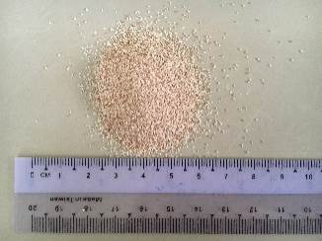
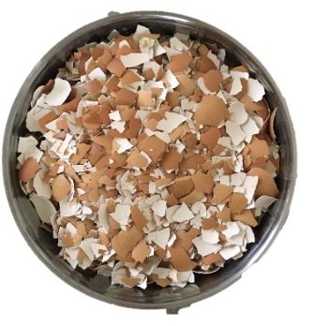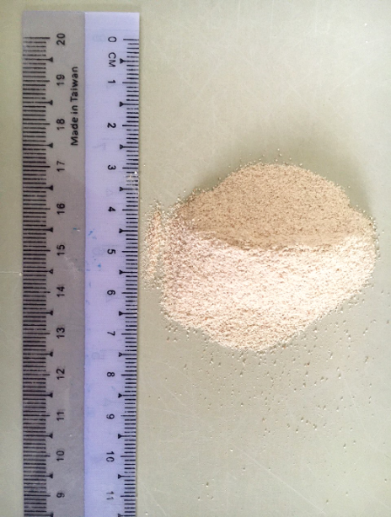

Pre-treated eggshells Raw eggshell powder

Figure 1. Preparation of chicken eggshells samples

Material's thermal stability and the fraction of volatile components - Thermogravimetric analysis

TGA was performed using a Shimadzu TGA-50 thermobalance. In this study, approximately 8 g of eggshell powder was heated at 50–950 °C in a nitrogen atmosphere with a flow rate of 20 mL/min and a heating rate of 25 °C/min [45].

Calcination of chicken eggshell

The eggshell powder samples were placed in closed porcelain crucibles and calcined in a chamber furnace (Carbolite ELF 11/14B) according to the eight experiment sets as shown in Table 1. Two parameters were varied to examine the calcination process (i.e., temperature (°C) and contact time (h)) with a constant weight RESP (i.e., 20 g). Each calcination protocol was done in triplicates. To avoid a reaction with moisture and atmospheric air, the CESP was stored in flasks and placed atop a desiccator after calcination [46].

Table 1. Calcination parameters
No. | Sample Code | Parameter
No. | Sample Code | Temperature  (ºC) | Contact Time  (hour)
1 | CESP T₆₀₀₋₃ | 600 | 3
2 | CESP T₆₀₀₋₄ | 600 | 4
3 | CESP T₇₀₀₋₃ | 700 | 3
4 | CESP T₇₀₀₋₄ | 700 | 4
5 | CESP T₈₀₀₋₃ | 800 | 3
6 | CESP T₈₀₀₋₄ | 800 | 4
7 | CESP T₉₀₀₋₃ | 900 | 3
8 | CESP T₉₀₀₋₄ | 900 | 4

Results and Discussion

Thermogravimetric analysis

TGA is carried out to determine the thermal stability of a material and its fraction of volatile components by monitoring the weight change that occurs as a sample is heated at a constant rate. Based on Figure 2, four reaction steps occurred in this experiment.

The first step showed that 1.13% mass decreased at midpoint 84.23 °C. The temperature range at step 1 can be considered as eliminating moisture of the sample. [48] supported this statement, stating that biomass drying is conducted in the range of 40–200 °C. Referring to [49], the slight decrease of mass in the second step was due to the decomposition of organic matter in the range of 200 - 600 °C. The RESP started to decompose from CaCO₃ to CaO and released CO₂ at 600 °C and ended at 850 °C in step 3. A slight mass loss in step 4 at 950 °C can be referred to as the end of the reaction.

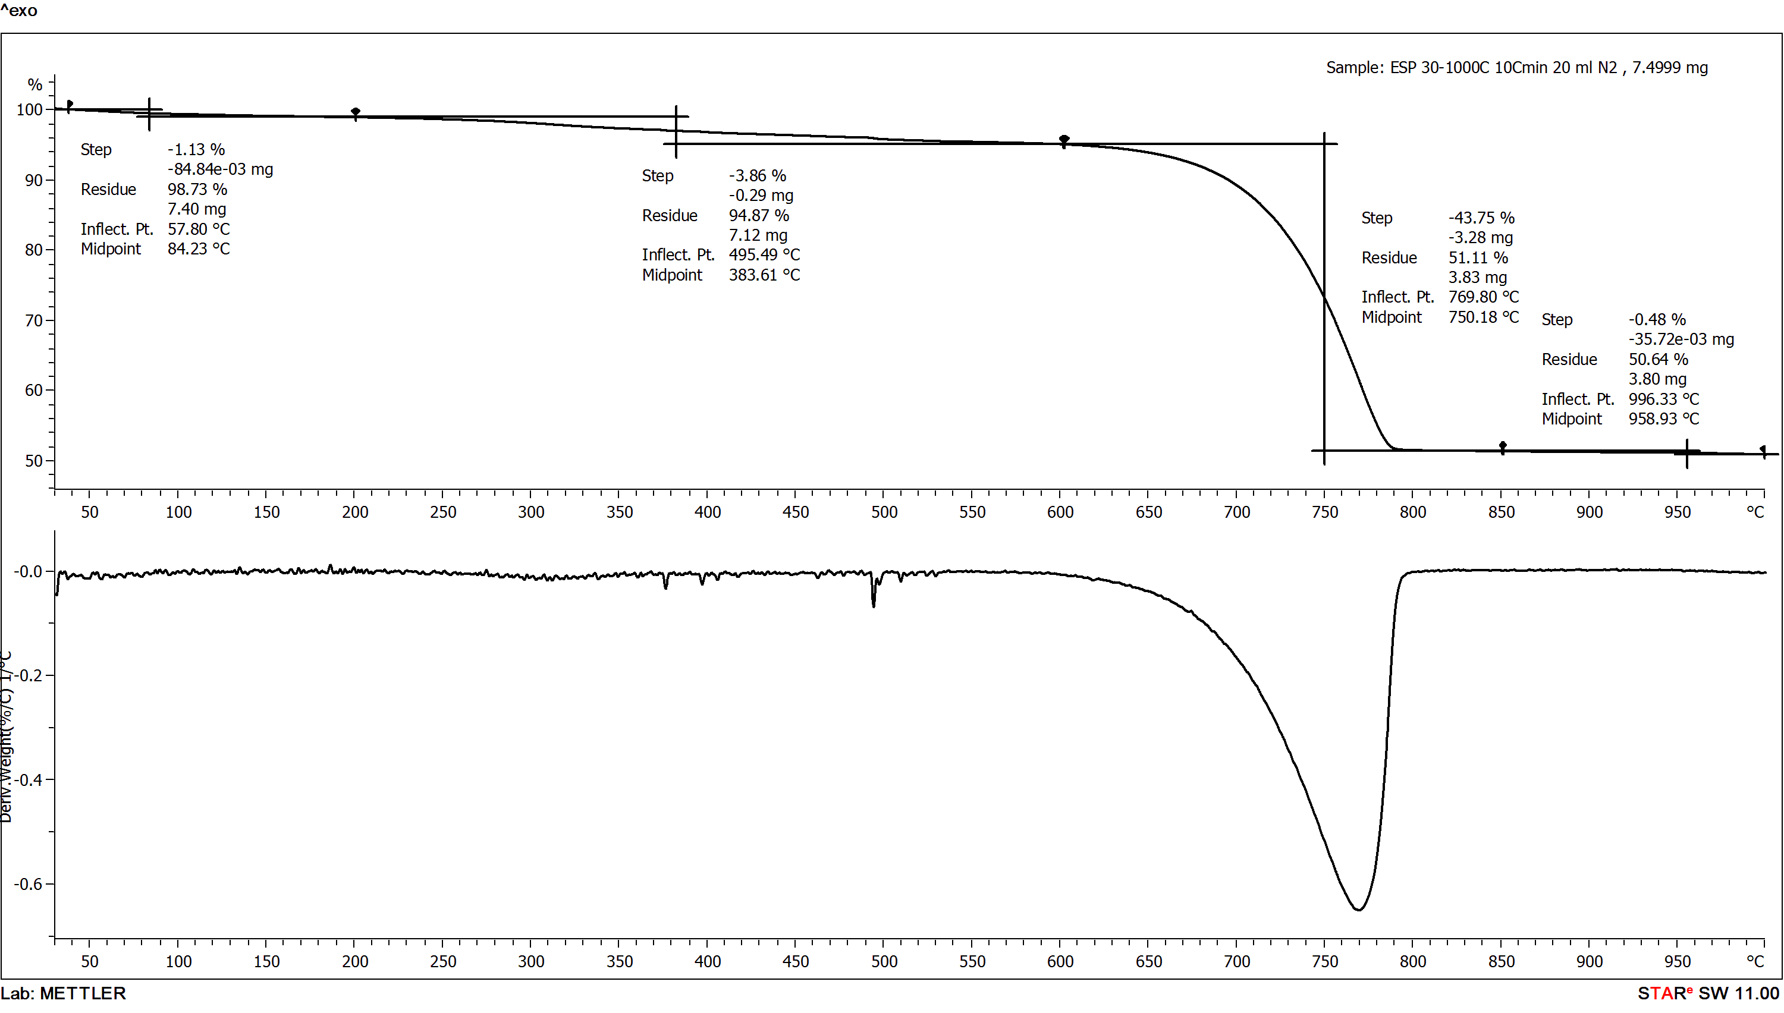

Figure 2. Thermogravimetric analysis of RESP

Calcination process

Calcination is the process of decomposing CaCO₃ by burning the compound at high temperatures. The catalysts were completely decomposed at the temperature range of 500–900 °C [39]. The optimum temperature for the calcination of CaCO₃ from cockle shell was 900 °C for 2 h with a particle size of 0.3 mm under inert conditions [41]. [13] supported this statement and reported that the suitable temperature and time for complete decomposition in the calcination of CaCO₃ from duck eggshells were 900 °C and 1 h, respectively. [50] and [40] argued that calcite fully decomposed to form CaO at 800 °C. Based on these studies, three conditions may affect the calcination process. In this study, CaO is derived from eggshell powder, as shown in Equation 3.

CaCO_{3(s)} → CaO_{(s)} + CO_{2(g)} (3)

The primary characteristics of CESP were studied and recorded, including physical observation (colour changes), moisture content, bulk density, and average mass loss. Based on the TGA result in Figure 2, the RESP decomposed in the temperature range of 600–850 °C. Therefore, the range of calcination temperature in this study was chosen from 600 °C to 900 °C. By referring to Table 2, as the temperature increases, the bulk density value decreases, and consequently, the mass loss increases. From the result, it shows that calcination temperature affected the reduction in mass for eggshell powder. Different colour changes were observed between uncalcined and calcined samples. The colour of the uncalcined eggshell is light brown based on its original colour. In comparison, a perfect CESP should be solid white. Based on the result, low calcination temperatures produced dark or grey colour, whereas at high calcination temperatures, solid white colour was obtained. More metal oxide (solid white powder) was produced for higher calcination temperatures. [51] stated that the higher temperature would produce a higher amount of metal oxide and the colour would become whiter. [41] established the optimum temperature of 900 °C for CaCO₃ decomposition. High temperatures are required for CESP to produce perfect CaO. The dark powder obtained at low temperatures indicates that eggshell powder has not completely decomposed.

Compared to other manipulated variables, the samples calcined at different contact times showed a massive percentage of mass loss. This could be explained by the longer calcination duration, which resulted in greater mass loss [52]. The colour transition for different contact times is presented in Table 2. Even though the samples of eggshell powder were calcined at the same temperature and weight, the calcination result was affected by the contact time. The formation of dark grey powder at low contact time was due to a lack of heat distribution. The grey powder at the inner part of the sample showed that the heat was not well distributed to the whole part of the sample. Therefore, increasing the calcination period is one of the significant ways to improve the formation of metal oxide. [13] stated that higher temperature and longer calcination time produced better CaO quality.

Moisture loss occurred during calcination, which corresponds to the loss of water and/or gas of the eggshell powder. In this study, the moisture loss percentages of CESP in all conditions were too insignificant, and therefore, could be ignored. [54] stated that the decomposition of volatile materials (e.g., water and organic matter) occurred in the temperature range of 30–400 °C. There were no changes in the acidity of RESP and dark powder. Meanwhile, the acidity for solid white powder changed to alkali. Therefore, if the amount of dark powder is more significant than solid white powder, the sample can be considered as CaCO₃.

The bulk density values of eggshell powder calcined with different parameters are tabulated in Table 2. The solid white powder of CESP T₉₀₀₋₃ and CESP T₉₀₀₋₄ showed a softer and more refined texture. [13] reported that calcination at 900 °C for 1 h reduced the particle size of the samples. According to Equation 2, density is inversely proportional to volume. The bulk density decreased as the particle size increased [53]. The volume depends on the particle size of the samples.

The pH of RESP changed to alkali when it was calcined at high temperatures. The alkalinity value increased as the temperature and contact time increased. The samples of CESP₇₀₀₋₄ to CESP₉₀₀₋₄ showed an alkaline pH value of 12.70–13.26, indicating the presence of CaO. The result is correlated with previous findings, where the calcination temperature of 700 °C produced sufficient CaO and achieved the critical value of an alkaline solution [54].

Table 2. Calcination of ESP with different parameters
Sample | Physical Observation | Mass Loss  (%) | Moisture Content (%) | Bulk Density  (g/ml) | pH
Uncalcined | 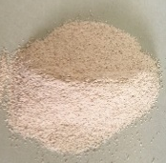 | N/A | 0.451 | 2.47 | 7.00
CESP T₆₀₀₋₃ | 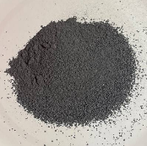 | 0.84 | N/A | 1.38 | 9.36
CESP T₆₀₀₋₄ | 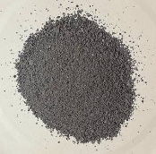 | 0.83 | N/A | 1.41 | 10.84
CESP T₇₀₀₋₃ | 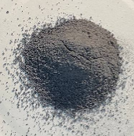 | 1.13 | N/A | 1.36 | 11.64

Table 2 (cont’d). Calcination of ESP with different parameters
Sample | Physical Observation | Mass Loss  (%) | Moisture Content (%) | Bulk Density  (g/ml) | pH
CESP T₇₀₀₋₄ | 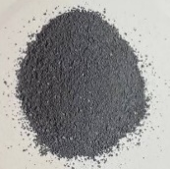 | 0.98 | N/A | 1.33 | 12.70
CESP T₈₀₀₋₃ | 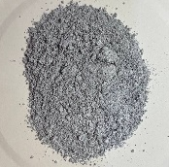 | 2.19 | N/A | 1.38 | 12.67
CESP T₈₀₀₋₄ | 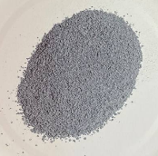 | 2.99 | N/A | 1.33 | 12.85
CESP T₉₀₀₋₃ | 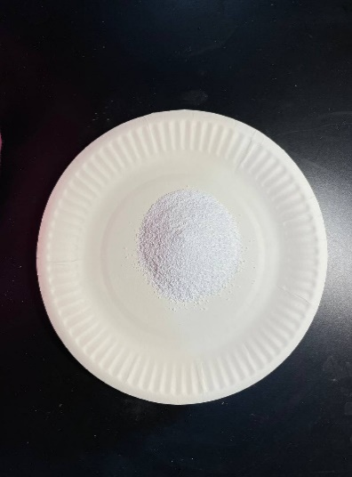 | 11.00 | N/A | 3.00 | 12.96
CESP T₉₀₀₋₄ | 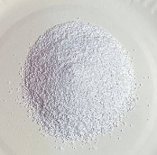 | 11.43 | N/A | 3.33 | 13.26

Compounds identification

The FTIR analysis can be divided into three broad regions. The first region is from 4000 cm⁻¹ to 3000${\text{ cm}}^{\text{-1}}$, which represents hydrogen bonding. The second region, which is from 3000 cm⁻¹ to 1500 cm⁻¹, shows functional groups. Meanwhile, the third region reveals the existence of biominerals. Based on physical observation and pH values in Table 2, chemical characterisation was conducted for the selected samples of CESP T₇₀₀₋₄, CESP T₈₀₀₋₃, CESP T₈₀₀₋₄, CESP T₉₀₀₋₃, and CESP T₉₀₀₋₄. Sufficient CaO content produced from the calcination of eggshells will make the pH value reach the critical value of 12.7 [56]. Therefore, the FTIR analysis identifies the functional groups present in the eggshells calcined at 900 °C with different contact times.

Figure 3 below presents the FTIR spectra for CESP at various temperatures and contact times. Small sharp peaks were detected at 874 cm⁻¹ and 1417 cm⁻¹ for CESP T₇₀₀₋₃, CESP T₇₀₀₋₄, CESP T₈₀₀₋₃, and CESP T₈₀₀₋₄. The bands at both wavelength indicated CaCO₃ in the tested samples [55,56]. Another strong peak was observed at 2516 cm⁻¹ due to the presence of CaCO₃ [57]. According to [7], the observable peaks in the range of 713–875 cm⁻¹ can be associated with the presence of CaCO₃. The observation by [58] for the band at 1430 cm⁻¹ was attributed to the stretching vibration of CaCO₃. Meanwhile, the bands at 875 cm⁻¹ and 715 cm⁻¹ strongly corresponded to CaCO₃ [59]. The lowest band represents the weak band to indicate CaCO₃.

Sharp peaks were observed at 707 cm⁻¹ and 709 cm⁻¹. The wavenumber increased as the transmittance increased intensely at the peak of 874 cm⁻¹. Both peaks are associated with in-plane deformation and out-plane deformation modes of eggshell powder in the presence of CaCO₃, as described by [7]. The sharp, strong band detected at 1560 cm⁻¹ is attributed to the oxidation process [60].

An amine group was present at the band of 1055 cm⁻¹. According to [61], the presence of the functional groups of amines and amides was observed due to the chemical composition of fibrous proteins. As referred to [62], CESP T₉₀₀₋₃ showed a medium-sized peak at 1052 cm⁻¹ corresponding to the stretching of both C-O in the C-OH bond. The peaks at 1424 cm⁻¹ and 1422 cm⁻¹ indicated the presence of OH bonding. The existence of hydroxide might be due to exposure to the atmosphere during calcination [63]. Another significant peak was detected at 2361 cm⁻¹ in regard to the presence of O=C=O bonds. The presence of O=C=O bonds indicated the carbonation of CaO, as shown in Equation 4 [64].

${Ca\left(OH\right)}^{2}+ {CO}_{2}→ {CaCO}_{3}+ H_{2}O$ (4)

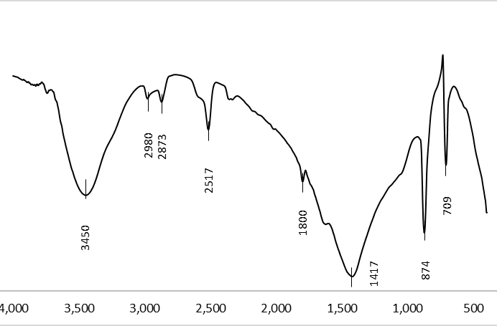  (a) CESP T₇₀₀₋₃ | 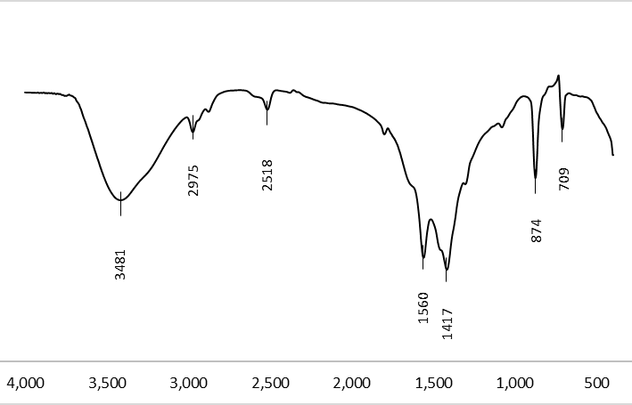  (b) CESP T₇₀₀₋₄
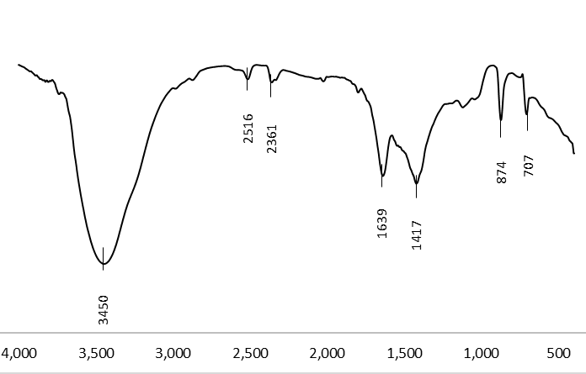  (c) CESP T₈₀₀₋₃ | 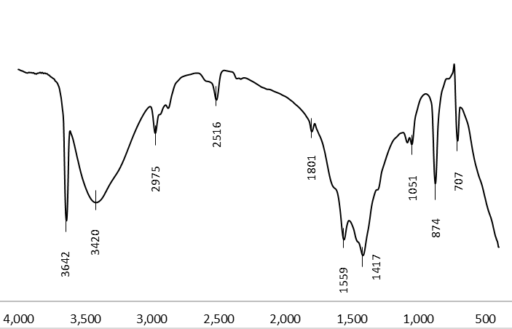  (d) CESP T₈₀₀₋₄
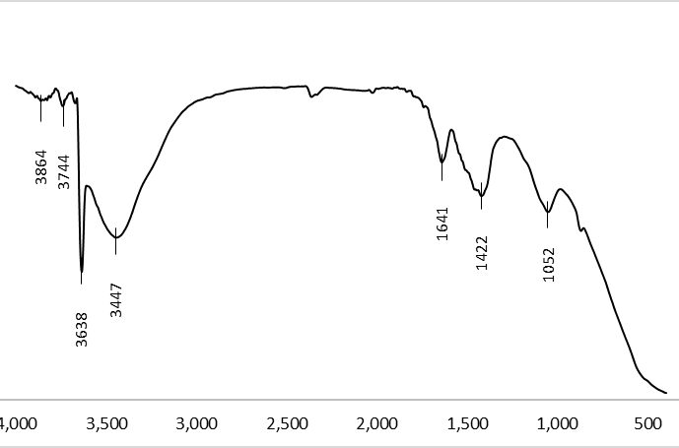  (e) CESP T₉₀₀₋₃ | 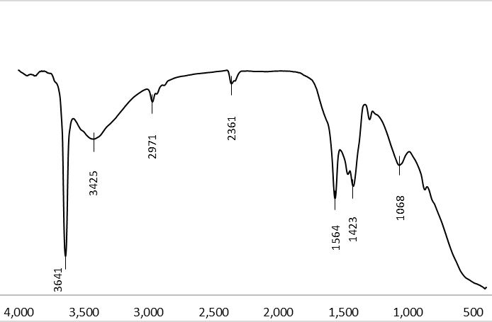  (f) CESP T₉₀₀₋₄

Figure 3. The FTIR spectra for CESP at different contact times and temperatures

The XRD analysis was carried out to identify CaO in CESP at different temperatures. Figure 4 illustrates the results of XRD analysis for RESP and CESP at 900 °C (CESP T₉₀₀₋₃), 700 °C (CESP T₇₀₀₋₃), and industrial CaO as a reference. The intensity of CaCO₃ showed the primary compound of RESP. The diffraction showed both distinct components of CaO and CaCO₃ for CESP T₇₀₀₋₃. Thus, the intensity of CaCO₃ decreased compared to RESP. At 700 °C, incomplete decomposition of CaCO₃ occurred, based on the diffraction pattern (c). A similar study by [53] claimed that CaO was absent at 700 °C. CESP T₇₀₀₋₃ showed a different peak pattern of CaO than CESP T₉₀₀₋₃ and industrial CaO. Meanwhile, CESP T₉₀₀₋₃ showed seven diffraction peaks similar to the diffraction peaks of industrial CaO. The simplified XRD analysis is shown in Table 3.

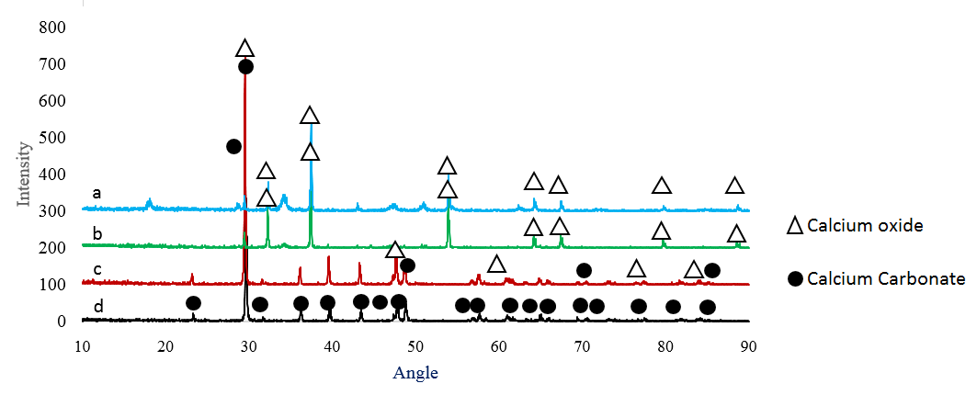

Figure 4. XRD patterns of a) industrial CaO, b) ESP T₉₀₀₋₃, c) ESP T₇₀₀₋₃, and d) RESP

Table 3. X-ray diffraction results for CaO and CaCO₃ from synthesised eggshell powder
Sample | Compound | Angle (2θ)
CESP T₇₀₀₋₃ | CaCO₃ | 28.78 | 47.25 | 62.73 | 71.79 | 84.88 | - | -
CESP T₇₀₀₋₃ | CaO | 29.52 | 47.67 | 60.84 | 77.45 | 84.02 | - | -
CESP T₉₀₀₋₃ | CaO | 32.25 | 37.41 | 53.92 | 64.18 | 67.41 | 79.70 | 88.58
Industrial CaO | CaO | 32.33 | 37.45 | 56.97 | 64.24 | 67.47 | 79.78 | 88.66

Conclusion
Different calcination temperatures and contact times were applied in the calcination of eggshell waste to decompose CaCO₃ into CaO. Based on physical inspection, higher temperature and increased contact time produced white powder, which was later identified as CaO. Among the studied calcination conditions, the best conditions were the temperature of 900 °C and the contact time of 3 h. The CaO synthesized from eggshells can be used in various applications, such as in the laboratory (gas absorber), construction (lime putty and cement production), soil stabiliser, medicinal purposes, and others. Hence, it is believed that calcined chicken eggshells can be an alternative source of CaO to reduce the dependency on limestone resources.

Acknowledgement
An industrial research fund partially supported this research under the MRT-SSP-V208-Second Tier ICP Agreement 2019 (Grant Number: ICP/MTDC/2019). We would like to thank our colleagues from Universiti Kuala Lumpur – MICET and Universiti Teknikal Melaka Malaysia, who provided insight and expertise that greatly assisted the research.

References
- Miranda, J.M., Anton, X., Redondo-Valbuena, C., Roca-Saavedra, P., Rodriguez, J.A. and Lamas, A. (2015). Egg and egg-derived foods: Effects on human health and use as functional foods. Nutrients, 7: 706-729.
- Godbert, S.R., Guyot, N. and Nys, Y. (2019). The golden egg: Nutritional value, bioactivities, and emerging benefits for human health. Nutrients, 11(684): 1-26.
- Laca, A., Paredes, B., Rendueles, M. and Díaz, M. (2014). Egg yolk granules: Separation, Characteristics, and Applications in The Food Industry. LWT - Food Science and Technology, 59(1): 1-5.
- Rivera, E.M., Araiza, M., Brostow, W., Castano, V.M., Diaz-Estrada, J.R., Hernandez, R. and Rodriguez, J.R. (1999). Synthesis of hydroxyapatite from eggshells. Materials Letter, 41: 128-134.
- Park, S., Choi, K.S., Lee, D., Kim, D., Lim, K.T., Lee, K.H., Seonwoo, H. and Kim. J. (2016). Eggshell membrane: Review and impact on engineering. Biosystem Engineering, 151: 446-463.
- De Angelis, G., Medeghini, L., Conte, A.M. and Mignardi, S. (2017). Recycling of eggshell waste into low-cost adsorbents for Ni removal from wastewater. Journal of Cleaner Production, 164: 1497-1506.
- Carvalho, J., Araujo, J. and Castro, F. (2011). Alternative low-cost adsorbent for water and wastewater decontamination derived from eggshell waste: an overview. Waste Biomass Valor, 2: 157-167.
- Laca, A., Laca, A. and Díaz, M. (2017). Eggshell waste as catalyst: A review. Journal of Environmental Management, 197: 351-359.
- Quina, M., Soares, M.A. and Quinta, F.R. (2017). Applications of industrial eggshells as a valuable anthropogenic resource. Resources Conservation and Recycling, 123: 176-186.
- Ummartyotin S. and Manuspiya, H. (2018). A critical review of eggshell waste: An effective source of hydroxyapatite as photocatalyst. Journal of Metals, Materials, and Minerals, 28(1): 124-135.

- Sonenklar, C. (1999). Famous for Egg Waste. The PennState news. The Pennsylvania State University. https://news.psu.edu/story/140891/

1999/09/01/research/famous-egg-waste. [Access online 1 September 1999]
- Arabhosseini, A. and Faridi, H. (2018). Application of eggshell wastes as valuable and utilizable products: A review. Resource Agriculture Engineering, 64: 104-114.
- Tangboriboon, N., Kunanuruksapong, R. and Sirivat, A. (2012). Preparation and properties of calcium oxide from eggshells via calcination. Materials Science-Poland, 30(4): 313-322.
- Ok, Y.S., Lee, S.S., Jeon, WT., Oh, S.E., Usman, A.R.A. and Moon, D.H. (2011). Application of eggshell waste for the immobilization of cadmium and lead in contaminated soil. Environ Geochem Health 33: 31-39.
- Yasar, F. (2019). Biodiesel production via waste eggshell as a low-cost heterogeneous catalyst: Its effects on some critical fuel properties and comparison with CaO. Fuel, 255(1): 115828 .
- Bashir, A.S.M. and Manusamy, Y. (2015). Characterization of raw eggshell powder (ESP) as a good bio filler. Journal of Engineering Research and Technology, 2(1): 56-60.
- Ahmad, R., Rohim, R. and Ibrahim, N. (2015). Properties of waste eggshell as calcium oxide catalyst Applied Mechanics and Materials, 754: 171-175.
- Karthick, J., Jeyanthi, R. and Petchiyammal, M. (2014). Experimental study on usage of egg shell as partial replacement for sand in concrete. International Journal of Advanced Research in Education Technology, 1(1): 7-10.
- Gabol, N.A., Memon, F.A., Jawaduddin, M. and Zardari, Z.H. (2019). Analysis of eggshell powder as a partial replacing material in concrete. International Journal of Modern Research in Engineering & Management, 2(9): 22-31.
- Razali, N., Azizan, M.A., Pa'ee, K.F., Razali, N. and Jumadi, N. (2020). Preliminary studies on calcinated chicken eggshells as fine aggregates replacement in conventional concrete. Materials Today: Proceedings, 31(1): 354-359.
- Abdulrahman, I., Tijani, H.I., Mohammed, B.A., Saidu, H., Yusuf, H., Jibrin, M.N. and Mohammed, S. (2014). From garbage to biomaterials: An overview on eggshell-based hydroxyapatite. Journal of Materials, 2014: 1-6.
- Bartter, J., Diffey, H., Yeung, Y.H., O'Leary, F., Häsler, B., Maulaga, W. and Alders, R. (2018). Use of chicken eggshell to improve dietary calcium intake in rural sub-saharan Africa. Maternal & Child Nutrition, 14(3): 1-10.
- Hitchcock, R.K. (2012). Ostrich eggshell jewelry manufacturing and use of ostrich products among San and Bakgalagadi in the Kalahari. Botswana Notes and Records, 44: 93-105.
- Zoran. A. (2018). The ostrich eggshell beads craft of the Ju/’hoansi: A reflection on modern craft theories. Craft Research, 9(2): 229-253.
- Abdullah, M., Soo, K. Y., Raofuddin, D.N.A, Sukor, M.Z., Roslan, A., Ilyas, S.M.M. and Yasin, M.H. (2018). An evaluation of eggshell waste/waste paper mechanical properties as composite paper. International Journal of Engineering & Technology, 7: 239-241.
- Sulaiman S., and Talha N.S. (2018) Technique to produce catalyst from egg shell and coconut waste for biodiesel production. In: Amid A., Sulaiman S., Jimat D., Azmin N. (eds) Multifaceted Protocol in Biotechnology.
- Mosaddegh, E. and Hassankhani, A. (2014). Preparation and characterization of nano-cao based on eggshell waste: Novel and green catalytic approach to a highly efficient synthesis of pyrano[4,3-b] pyrans. Chinese Journal Catalyst, 35: 351-356.
- Sacia, E.R., Ramkumar, S., Phalak, N. and Fan, L.S. (2013). Synthesis and regeneration of sustainable CaO sorbents from chicken eggshells for enhanced carbon dioxide capture. ACS Sustainable Chemical Engineering, 1: 903-909.
- Beck, K., Brunetaud, X., Mertz, J.D. and Al-Mukhtar, M. (2010). The use of eggshell lime and tuffeau powder to formulate an appropriate mortar for restoration purposes. Geological Society London Special Publications, 331(1): 137-145.
- Jirimali, H.D., Chaudhari, B.C., Khanderay, J.C., Joshi, S.A., Singh, V., Patil, A.M. and Gite, V.V. (2018). Waste eggshell-derived calcium oxide and nanohydroxyapatite biomaterials for the preparation of LLDPE polymer nanocomposite and their thermomechanical study. Polym-Plast Technology Engineering, 57: 804-811.
- Tan, Y.H., Abdullah, M.O., Nolasco-Hipolito, C. and Zauzi, N.S.A. (2017). Application of RSM and Taguchi methods for optimizing the transesterification of waste cooking oil catalyzed by a solid ostrich and chicken-eggshell derived CaO. Renew Energy, 114(Part B): 437-447.

- Nagabhushana, K.R., Lokesha, H.S., Reddy, S.S., Prakash, D., Veerabhadraswamy, M., Bhagyalakshmi, H. and Jayaramaiah, J.R. (2017). Thermoluminescence properties of CaO powder obtained from chicken eggshells. Radiation Physics Chemistry, 138: 54-59.
- Britannica, T. Editors of Encyclopedia. Calcination. Encyclopedia Britannica. Retrieved Oct 04, 2016, from https://www.britannica.com/technology/calcination. [Access online 4 October 2016].
- Lin. S., Kiga. T., Wang. Y. and Nakayama. K. (2011). Energy analysis of CaCO₃ calcination with CO₂ capture. Energy Procedia, 4: 356-361.
- Al-Fatesh, A.S.A. and Fakeeha, A.H. (2012). Effects of calcination and activation temperature on dry reforming catalysts. Journal of Saudi Chemical Society, 16: 55-61.
- Nordin, N., Hamzah, Z., Hashim, O., Kasim, F.H., and Abdullah, R. (2015). Effect of temperature in calcination process of seashells. Malaysian Journal of Analytical Sciences, 19(1): 65-70.
- Dampang, S., Purwanti, E., Destyorini, F., Kurniawan, S. B. K., Abdullah, S. R. S. and Imron, M. (2021). Analysis of optimum temperature and calcination time in the production of CaO using seashells waste as CaCO₃ source. Journal of Ecological Engineering, 22(5): 221–228.
- Aina, S., Plessis, B. D., Mjimba, V. and Brink, H. (2021). Eggshell valorization: Membrane removal, calcium oxide synthesis, and biochemical compound recovery towards cleaner productions. Biointerface Research in Applied Chemistry, 12(5): 5870-5883.
- Razali, N., Musa, F. A. M., Jumadi, N. and Jalani, A. Y. (2021). Production of calcium oxide from eggshell: Study on calcination temperature, raw weight and contact time. RSU International Research Conference, 2021: 624-637.
- Hussein, A. I., Ab-Ghani, Z., Mat, A. N. C., Ab-Ghani, N. A., Husein, A. and Rahman, I. A. (2021). Synthesis and characterization of spherical calcium carbonate nanoparticles derived from cockle shells. Applied Science, 10: 7170.
- Mohamad, S.F.S, Mohamad, S. and Jemaat, Z. (2016). Study of calcination condition on decomposition of calcium carbonate in waste cockle shell to calcium oxide using thermal gravimetric analysis. ARPN Journal of Engineering and Applied Sciences, 11(16): 9917-9921.
- Islam, K.N., Bakar, M.Z.B.A., Ali, M.E., Hussein, M.Z.B., Noordin, M.M., Loqman, M.Y., Miah, G., Wahid, H. and Hashim, U. (2013). A novel method for the synthesis of calcium carbonate (aragonite) nanoparticles from cockle shells. Powder Technology, 235: 70-75.
- Ali, M. and Badawy W. Z. (2017). Utilization of eggshells by-product as a mineral source for fortification of bread strips. Journal of Food and Dairy Sciences, 8(11): 455-459.
- Oulego, P., Laca, A., Calvo, S. and Díaz, M. (2019). Eggshell-supported catalysts for the advanced oxidation treatment of humic acid polluted wastewaters. Water, 12(100): 1-18.
- Yahya, N., Tahir, S.M. and Rosli, N.H.M. (2019). Green eggshell/polypropylene biocomposite. International Journal of Recent Technology and Engineering, 8: 2277-3878.
- Castro, L.D.S., Barañano, A.G., Pinheiro, C.J.G.L, Menini, L. and Pinheiro, P.F. (2019). Biodiesel production from cotton oil using heterogeneous CaO catalysts from eggshells prepared at different calcination temperatures. Green Process Synthesis, 8: 235-244.
- Gatea, A.A., Kouzani, A.Z., Kaynak, A., Khoo, S.Y., Norton, M. and Gates, W. (2018). Soil bulk density estimation methods: A review. Pedosphere, 28(4): 581-596.
- Jewiarz, M., Wrobel, M., Mudryk, K. and Szufa, S. (2020). Impact of the drying temperature and grinding technique on biomass grindability. Energies, 13(3392): 1-22.
- Queirós, M.V.A., Bezerra, M.N. and Feitosa, J.P.A. (2017). Composite superabsorbent hydrogel of acrylic copolymer and eggshell: Effect of biofiller addition. Journal Brazillian Chemical Society, 2017: 1-9.
- Loy, C.W., Matori, K.A., Way F.L., Schmid, S., Zainuddin, N., Wahab, Z.A., Alassan, Z.N. and Zaid, M.H.M. (2016). Effects of calcination on the crystallography and nonbiogenic aragonite formation of ark clamshells under ambient conditions. Advances in Materials Science and Engineering. 2016: 1-8.
- Mohadi, R., Anggraini, K., Riyanti F. and Lesbani, A. (2016). Preparation of calcium oxide (CaO) from chicken eggshells. Sriwijaya Journal of Environment, 1(2): 32-35.
- Krähenbühl, M., Etter, B. and Udert, K.M. (2015). Pre-treated magnesite as a source of low-cost magnesium for producing. Science of The Total Environment, 542: 1155-1161.

- Zhang, S. (2015). Relationship between particle size distribution and porosity in dump leaching. Thesis of Doctor of Philosophy. The University of British Columbia.
- Shao, W.C., and Dong, Y.W. (2020). A study on physicochemical properties and formaldehyde adsorption and degradation of purifying air quality by modified biocalcium. International Journal of Environmental Science and Development, 7(11): 327-335.
- Rujitanapanich, S., Kumpapan, P. and Wanjanoi, P. (2014). Synthesis of hydroxyapatite from oyster shell via precipitation. Energy Procedia, 56: 112-117.
- Yao, C., Xie, A., Shen, Y., Zhu, J. and Li, T. (2013). Green synthesis of calcium carbonate with unusual morphologies in the presence of fruit extracts. Journal Chilean Chemical Society, 58(4): 2235-2238.
- Daskalakis, M.I., Magoulas, A., Kotoulas, G., Catsikis, I., Bakolas, A., Karageorgis, A.P., Mavridou, A., Doulia, D., Rigas, F. (2013). Pseudomonas, pantoea and cupriavidus isolates induce calcium carbonate precipitation for biorestoration of ornamental stone. Journal of Applied Microbiology, 115: 409-423.
- Veerasingam, S. and Venkatachalapathy, R. (2014). Estimation of carbonate concentration and characterization of marine sediment by fourier transmission infrared spectroscopy. Infrared Physics and Technology, 66: 136-140.
- Reyes, J., Gutiérrez, R., Centeno, G., Treviño, D., Bartolo, P., Quintana, P., Azamar, J.A., and Pérez, T. (2008). Chemical characterization of Crusts Formed in Mortars of Historical Buildings in San Francisco de Campeche City, Mexico. Historical Mortars Conference, 2008: pp. 1-11.
- Pardo, F.N., Barrera, G.M., Hernández, A.L.M., Castaño, V.M., Armenta, J.L.R., Rodríguez, F.M. and Santos C.V. (2013). Effects on the thermo-mechanical and crystallinity properties of nylon 6,6 electrospun fibres reinforced with one dimensional (1d) and two-dimensional (2d) carbon. Materials, 8: 3494-3513.
- Tsai, T.Y., Coumar, M.S., Hsu, T., Hsieh, H.P., Chien, C.H., Chen, C.T., Chang, C.N., Lo, Y.K., Wu, S.H., Huang, C.Y., Huang, Y.W., Wang, M.H., Wu, H.Y., Lee, H.J., Chen, X., Chao, Y.S., and Jiaang, W. (2006). Substituted pyrrolidine-2,4-dicarboxylic acid amides as potent dipeptidyl peptidase IV inhibitors. Bioorganic & Medicinal Chemistry Letters. 16(12): 3268-3272.
- Nandiyanto, A.B.D., Oktiani, R. and Ragadhita, R. (2019). How to read and Interpret FTIR spectroscope of organic material. Indonesian Journal of Science & Technology, 4(1): 97-118.
- Zaman, T., Mostari, M. S., Mahmood, M. A. and Rahman, M. S. (2018). Evolution and characterization of eggshell as a potential candidate of raw material. CerâMica, 64(370): 236-241.
- Habte, L., Khan, M.D., Shiferaw, N., Farooq, A., Lee, M.H., Jung, S.H. and Ahn, J.W. (2020). Synthesis, characterization, and mechanism study of green aragonite crystals from waste biomaterials as a calcium supplement. Sustainability, 12(5062): 1-10.

