

A SHORT REVIEW ON THE INFLUENCE OF THE PREPARATION METHOD ON THE PHYSICOCHEMICAL PROPERTIES OF Mg/Al HYDROTALCITE FOR GLUCOSE ISOMERIZATION

(Ulasan Ringkas Mengenai Pengaruh Kaedah Penyediaan Terhadap Sifat-Sifat Fizikokimia Mg/Al Hidrotalsit untuk Pengisomerisasi Glukosa)

Munirah Zulkifli^{1,2}, Noor Hidayah Pungot^{1,2}*, Nazrizawati Ahmad Tajuddin¹, Mohd Fadhlizil Fasihi Mohd Aluwi³, Nor Saliyana Jumali⁴, Zurina Shaameri^{1,2}

¹School of Chemistry and Environment, Faculty of Applied Sciences,
Universiti Teknologi MARA, 40450 Shah Alam, Selangor, Malaysia
²Organic Synthesis Laboratory, Institute of Science,
Universiti Teknologi MARA Puncak Alam Campus, 42300 Bandar Puncak Alam, Selangor, Malaysia
³Faculty of Industrial Sciences and Technology,
Universiti Malaysia Pahang, Lebuhraya Tun Razak, 26300 Gambang, Kuantan, Pahang, Malaysia
⁴ Department Chemistry, Kulliyyah of Science,
International Islam University Malaysia, 25200 Bandar Indera Mahkota, Kuantan, Pahang, Malaysia

*Corresponding author: noorhidayah977@uitm.edu.my

Received: 15 September 2021; Accepted: 3 February 2022; Published: xx April 2022

Abstract

Hydrotalcite (Mg₆Al₂(OH)₁₆CO₃4H₂O) is a naturally occurring anionic clay with a layered crystal structure. Hydrotalcites is classified as heterogeneous catalysts that exhibit an excellent separation post-reaction. Furthermore, commercial hydrotalcites are environmentally friendly. Organically synthesised hydrotalcites have attracted numerous researchers. The compounds are crucial solid base materials for several organic reactions, such as the Aldol condensation, Knoevenagel, Claisen-Schmidt, and Michael addition reactions. The present review covers the synthesis of magnesium aluminide (MgAl) hydrotalcites with varying magnesium to aluminium (Mg/Al) molar ratios employed to prepare the catalyst. Additionally, the characterisation of MgAl hydrotalcites with X-ray diffraction (XRD), Brunauer-Emmett-Teller (BET), and scanning electron microscopy (SEM) are highlighted. The instruments were utilised to identify the physicochemical properties of the catalyst, including crystallinity, surface area, and morphology. The catalytic activity of MgAl hydrotalcite was explored in the isomerisation of glucose into fructose as a model reaction for the catalytic performance.

Keywords: MgAl hydrotalcite, Mg/Al molar ratio, physicochemical properties, catalytic activity

Abstrak

Hidrotalsit (Mg₆Al₂(OH)₁₆CO₃4H₂O) ialah tanah liat anionik yang wujud secara semula jadi dengan struktur kristal berlapis. Hidrotalsit dikelaskan sebagai pemangkin heterogen yang mempamerkan pemisahan selepas tindak balas yang sangat baik. Tambahan pula, hidrotalsit komersial adalah mesra alam. Hidrotalsit yang disintesis secara organik telah menarik ramai penyelidik. Sebatian tersebut merupakan bahan asas pepejal yang penting untuk beberapa tindak balas organik, seperti tindak balas kondensasi Aldol, Knoevenagel, Claisen-Schmidt, dan penambahan Michael. Ulasan semula ini meliputi sintesis magnesium aluminida (MgAl) hidrotalsit dengan pelbagai nisbah molar magnesium kepada aluminium (Mg/Al) digunakan untuk menyediakan mangkin. Selain itu, pencirian hidrotalsit MgAl dengan pembelauan sinar-X (XRD), Brunauer-Emmett-Teller (BET), dan mikroskop elektron pengimbasan (SEM) diserlahkan. Instrumen ini telah digunakan untuk mengenal pasti sifat fizikokimia mangkin, termasuk kehabluran, luas permukaan, dan morfologi. Aktiviti pemangkin hidrotalsit MgAl telah diterokai dalam pengisomeran glukosa kepada fruktosa sebagai tindak balas model untuk prestasi pemangkin.

Kata kunci: MgAl hidrotalsit, nisbah molar Mg/Al, sifat-sifat fizikokimia, aktiviti pemangkin

Introduction

Hydrotalcite is a magnesium-aluminium hydroxy-carbonate, a naturally occurring mineral with the chemical composition Mg₆Al₂(OH)₁₆CO₃4H₂O that exhibits a layered crystal structure [1]. The layers consist of positively charged hydroxide layers, while the interlayers contain carbonate anions and water molecules, as displayed in Figure 1. The general formula of hydrotalcites is [M²⁺_{(1−x)}M³⁺_{x}(OH)₂]_{x+}(A_{x/n})^{n−}.yH₂O, where M²⁺ and M³⁺ are the metal components with divalent and trivalent cations, respectively, and A^{n−} is an interlayer anion [2]. Aluminium (Al) is partially substituted in magnesium hydroxide (Mg(OH)₂) and is a brucite structure in magnesium aluminide (MgAl) hydrotalcite, the typical representation of hydrotalcites [3]. The charge imbalance when a trivalent cation replaces the divalent is counterbalanced by the placement of available anions, such as CO₃^{2–}, NO₃–, Cl–, SO₄^{2–}, and OH–, in the interlayers along with water molecules [4].

The MgAl hydrotalcites are solid bases that exhibit potential catalytic activity and good stability under required reaction conditions [6]. Moreover, hydrotalcites possess two representative and prominent properties, the ability to capture and exchange organic and inorganic anions and the memory effect due to their unique structures [7]. The unique characteristics resulted in the wide range of applications of the compounds as anion exchangers, absorbing agents, stabilisers for polymers, catalysts, electroactive materials, and pharmaceuticals. Hydrotalcite is classified as a heterogeneous catalyst with numerous advantages over homogeneous catalysts, including catalyst reusability, high purity by-products, and good separation and purification [8]. The wide applications of hydrotalcite catalysts have brought more functionality to the industry. Researchers in the scientific field generally employ hydrotalcite catalysts in organic synthesis reactions [9]. The catalysts are regarded as crucial solid base materials for various organic reactions, including Aldol condensation [10], Knoevenagel [11], Claisen-Schmidt [12], and Michael addition [13] reactions.

Numerous methods, such as co-precipitation, urea, sol-gel, and hydrothermal synthesis, could be utilised to prepare MgAl hydrotalcite [14, 15]. In this review, the preparation of MgAl hydrotalcite via co-precipitation, urea, and simple methods are discussed in detail. Furthermore, the current review highlights the characterisation of MgAl hydrotalcites with X-ray diffraction (XRD), Brunauer-Emmett-Teller (BET), and scanning electron microscopy (SEM). The instruments identified the physicochemical properties of the catalyst, including crystallinity, surface area, and morphology. The catalytic properties of MgAl hydrotalcite as base catalysts were confirmed by the isomerisation of glucose to fructose. The influence of the preparation method on the physicochemical properties and activity of MgAl hydrotalcites as solid base catalysts based on the characterisation results and the catalytic activities observed are discussed and compared.

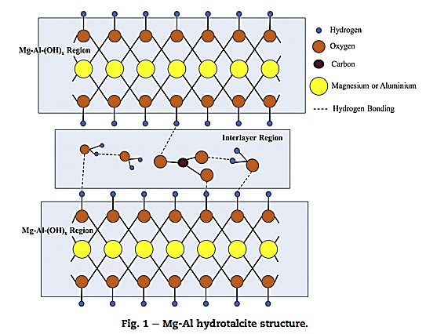

Figure 1. MgAl Hydrotalcite Structure [5]

Preparation of MgAl hydrotalcite catalyst

Researchers have employed numerous methods to synthesise MgAl hydrotalcite catalysts, such as co-precipitation, urea, and simple methods. The techniques are applicable in the isomerisation of glucose into fructose. The most common method to prepare hydrotalcite catalyst is the co-precipitation method. The pH of the solution plays a vital role in the technique. If the pH of the solution utilised is low, not all ions would precipitate, while a high pH would result in the dissolution of the metallic ions present [5]. Consequently, it is essential to control the pH of the solution to obtain the hydrotalcite catalyst successfully. Park et al. [14] performed the preparation of MgAl hydrotalcite catalyst via the co-precipitation method by adding aqueous solution B, sodium hydroxide and sodium carbonate in distilled water dropwise into solution A that consisted Mg(NO₃)₂.6H₂O and Al(NO₃)₃.9H₂O dissolved in distilled water. During the addition of solution B into solution A, the pH of the solution need to be maintained at approximately 9.5. The resulting solution was vigorously stirred at room temperature for 18 h before proceeding with the filtration process by washing it with distilled water several times. Subsequently, the solid product was dried overnight at 100 ℃. The molar magnesium to aluminium (Mg/Al) ratio utilised in the study was three. The report found that the ratio resulted in a promising catalyst for various base-catalysed reactions due to its excellent base catalytic properties.

The utilisation of varying Mg/Al molar ratios affected the catalytic performance of the MgAl hydrotalcites catalyst obtained [16]. Kang et al. prepared MgAl hydrotalcite via the co-precipitation method with different Mg/Al atomic ratios of from 0.5 to 3.5, which was dissimilar to the investigation by Park et al., where the only Mg/Al molar ratio employed was three. In a similar investigation to [14], Yu et al. reported synthesising fresh, calcined, and rehydrated MgAl hydrotalcite catalysts with the Mg/Al ratio of three [17]. The calcined MgAl hydrotalcite was prepared by calcining the synthesised MgAl hydrotalcite at 450 ℃ for 10 h in an airstream. In contrast, the rehydrated MgAl hydrotalcite was obtained by hydrating the calcined MgAl hydrotalcite in decarbonated water with vigorous stirring in an inert atmosphere at 60℃ for a day followed by filtration and drying overnight at 80 °C.

Urea hydrolysis is one of the techniques employed to acquire MgAl hydrotalcite. The alternative precipitating agent utilised in the method is urea, while the co-precipitating technique employs Na₂CO₃ as the precipitating agent [5]. The MgAl hydrotalcite with Mg/Al = 3 was prepared by Park et al. [16] according to this procedure. A solution of Mg(NO₃)₂.6H₂O, Al(NO₃)₃.9H₂O, urea, and distilled water was added into a three-neck flask equipped with a condenser . The reaction was conducted at 95℃ for two days, while the pH of the solution was measured every 15 min during the hydrolysis. After the reaction was completed, the resulting mixture was cooled in an ice bath for 30 minutes, filtrated, washed, and dried at 80 ℃. Another method employed by the same researchers was the simple method. The technique was based on the hydration of metal oxides obtained by calcination of metal nitrates in the air at 450 ℃ for 10 h. Subsequently, suitable amounts of MgO and Al₂O₃ were dissolved in distilled water, and the resulting solution was aged at 60 ℃ for a week. A white precipitate was obtained after the solution was filtered and dried overnight at 80 ℃. The method was simpler than the other two techniques as no particular controlled variables were involved with metal oxides [7].

Characterization of MgAl hydrotalcite catalyst

The formation of MgAl hydrotalcite was confirmed with various characterisation tools such as XRD, SEM, and BET. The XRD is one of the most common characterisation tools employed to confirm the layered structure of hydrotalcite. Park et al. [16] reported that the typical XRD pattern of MgAl hydrotalcite exhibits definite crystalline phases observable in fresh catalyst obtained from every method, attributing to the reflections of 2θ = 11.6° (003), 23.3° (006), 34.8° (009), 60.7° (110), and 62.0° (113), as shown in Figure 2. The results indicated that the MgAl hydrotalcite with Mg/Al = 3 retained the layered double hydroxide structures even though they are prepared differently. The XRD patterns in Figure 2(b) demonstrated a slight shift of the peaks at the (003) plane, depending on the preparation method employed. The observation was due to the different anions located in the interlayer spaces of the hydrotalcite procured from the three preparation techniques.

Figure 3 displays the XRD pattern of the MgAl hydrotalcite synthesised by Yu et al. [17]. Only the synthesised and rehydrated MgAl hydrotalcites exhibited the characteristic hydrotalcite XRD peaks similar to the planes reported by Park et al. [16]. No XRD peaks corresponded to the layered structure of hydrotalcite in the calcined MgAl hydrotalcite due to the destruction of the structure by the calcination process. Conversely, the calcined MgAl hydrotalcite maintained the spinel structure of MgAl mixed oxide. Surprisingly, the rehydrated MgAl hydrotalcite preserved the layered structure of hydrotalcite, proving the memory effect of hydrotalcite.

Figure 3 exhibits the XRD peaks for (003) planes in the rehydrated MgAl hydrotalcite, which was much broader compared to the synthesised MgAl hydrotalcite. The observation was due to the exfoliation and vertical breaking of layers in the structure of hydrotalcite, resulting in a smaller crystallite size of the rehydrated MgAl hydrotalcite. A report demonstrated the XRD patterns of MgAl hydrotalcites synthesised with different Mg/Al atomic ratios between 0.5 and 3.5 (Figure 4). The catalysts with the Mg/Al atomic ratios of 0.5 and 1.5 were the least developed. The lower the Mg/Al atomic ratio, the more the peaks shifted towards higher values, attributing to a decreased d-spacing between the hydroxide layers, resulting in reduced distance between layers of MgAl hydrotalcite as the Al content was elevated [16].

The XRD peaks on the (003) plane were applied in the Scherrer equation to calculate the crystallite size of the MgAl hydrotalcites. Specific surface areas (S_{BET}) of the MgAl hydrotalcites were determined via the BET plot. Park et al. found that different preparation methods of MgAl hydrotalcite significantly impacted the crystallite size and S_{BET}. The MgAl hydrotalcite prepared via co-precipitation (HT_P) demonstrated the smallest crystallite size and the highest S_{BET} compared to the urea (HT_U) and simple (HT_S) techniques (Table 1). Yu et al. [17] reported that the crystallite size of the synthesised (HT_A) and rehydrated MgAl (HT_R) hydrotalcites could be calculated as the catalysts prepared through the co-precipitation method but under different conditions retained their LDH structure. Nonetheless, the calcined MgAl (HT_C) hydrotalcite did not produce results for crystallite as the structure of the catalyst was destroyed during the calcination process.

Kang et al. [16] concluded that as the Mg/Al atomic ratio decreased, the S_{BET} increased even at the Mg/Al ratio of 1.0 (Figure 4). Nonetheless, based on the XRD characterisation, the 1.0 sample exhibited lower S_{BET} due to the unsuccessful formation of layered structures. Additionally, the catalyst produced with the Mg/Al ratio of 1.5 demonstrated the most significant S_{BET} and the smallest crystallite size. Consequently, the crystallite size was strongly affected by the preparation method as the growth of the hydrotalcite layers and the degree of layer stacking differed greatly depending on the preparation method. Resultantly, the surfaces of the active sites had different exposures to reactants, resulting in varying catalytic activities of the MgAl hydrotalcites [14].

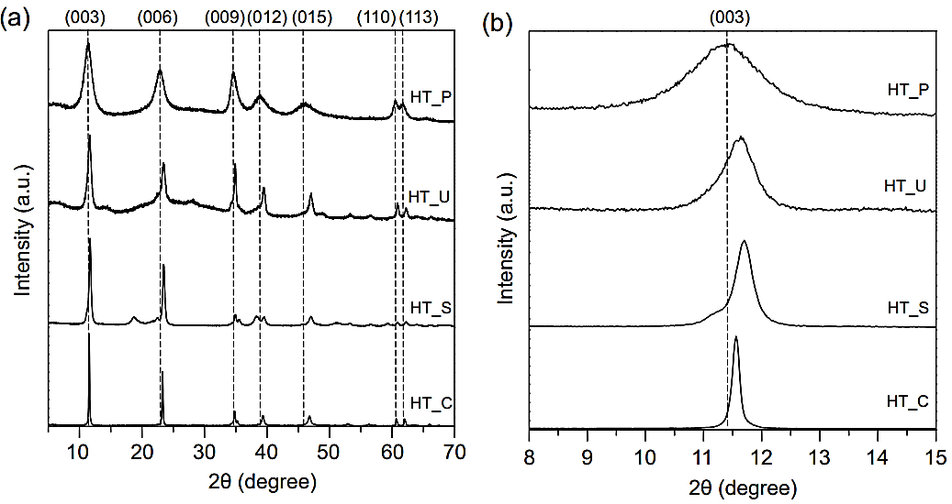

Figure 2. XRD patterns of MgAl hydrotalcite catalyst (HT_P = Co-precipitation, HT_U = Urea, HT_S = Simple & HT_C = Purchased from Sigma-Aldrich) [14]

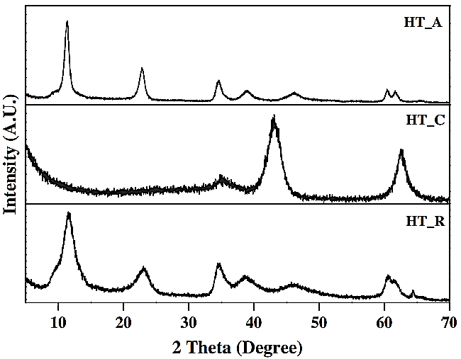

Figure 3. XRD patterns of MgAl hydrotalcite catalyst (HT_A = Synthesized MgAl hydrotalcite, HT_C = Calcined MgAl hydrotalcite & HT_R = Rehydrated MgAl hydrotalcite) [17]

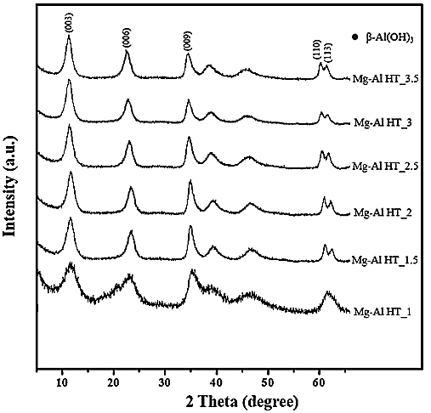

Figure 4. XRD patterns of MgAl hydrotalcite catalyst with different Mg/Al atomic ratio (1.0 – 3.5) [16]

Table 1. Crystallite size and specific surface areas of the Mg-Al hydrotalcite catalyst
Catalyst Used | Synthesis Method | Mg/Al Atomic Ratio | Crystallite Size (nm)  (At (003) plane) | S_{BET} (m²g^{–1} ) | Ref
Mg-Al | Co-precipitation (HT_P)  Urea (HT_U)  Simple (HT_S) | 3.0  3.0  3.0 | 5.80  12.6  21.3 | 141.0  36.6  1.3 | [14]
Mg-Al | Co-precipitation (HT_A)  Co-precipitation (HT_C)  Co-precipitation (HT_R) | 3.0  3.0  3.0 | 9.9  -  4.1 | 68.9  158.5  88.8 | [17]
Mg-Al | Co-precipitation (HT_1.0)  Co-precipitation (HT_1.5)  Co-precipitation (HT_2.0)  Co-precipitation (HT_2.5)  Co-precipitation (HT_3.0)  Co-precipitation (HT_3.5) | 1.0  1.5  2.0  2.5  3.0  3.5 | -  3.9  4.7  4.6  4.7  5.2 | 86.3  204.5  110.7  130.1  109.0  89.1 | [16]
Mg-Al | Co-precipitation (HT_1.0)  Co-precipitation (HT_1.5)  Co-precipitation (HT_2.0)  Co-precipitation (HT_3.0)  Co-precipitation (HT_5.0) | 1.0  1.5  2.0  3.0  5.0 | 7.9  8.4  10.3  8.1  6.8 | 147  131  110  37  23 | [18]

Upare et al. [18] reported XRD patterns for all the samples with rehydrated Mg/Al ratios from 1.0 to 5.0 (Figure 5). Based on the XRD characterisation, an increase of Mg/Al ratio was slightly shifted to a lower angle on the (003) plane at 2θ of 11.4° corresponding to the interlayer anion. This observation indicating that the interlayer spacing and unit cell parameter increased with Mg/Al ratio of the rehydrated hydrotalcite [18]. Additionally, the crystallite size increases from 7.9 to 10.3 nm as the rehydrated hydrotalcite with Mg/Al ratio increases from 1.0 to 3.0. Conversely, the crystallite size decreases from 10.3 to 6.8 nm as Mg/Al ratio decreases from 3.0 to 5.0.

Apart from XRD and BET analysis, SEM analysis also can be employed to confirm the structure of MgAl hydrotalcites and to prove the crystallite size calculated from the XRD analysis. The characteristic layered structures of the synthesised MgAl hydrotalcites were composed of platelet-like particles that agglomerated in different ways depending on the preparation method, as shown in Figure 6. In particular, the HT_P MgAl hydrotalcite with the smallest crystallite size exhibited a sand-rose morphology (Figure 6(a)) [14]. Kang et al. [16] observed a similar sand-rose morphology, indicating that the co-precipitation method successfully produced the layered MgAl hydrotalcite structure (Figure 7). The findings might be due to the surfaces being easily exposed to reactants, which strongly affected the catalytic activity of the catalysts [14]. Consequently, Park et al. reported that MgAl hydrotalcites prepared according to the co-precipitation procedure could be expected to exhibit superior activity over other hydrotalcite catalysts in base-catalysed reactions [14].

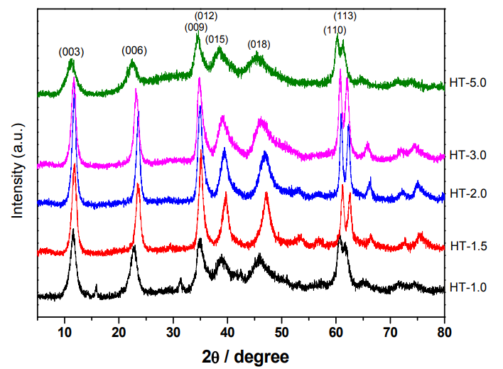

Figure 5. The XRD patterns of the rehydrated MgAl hydrotalcite catalyst synthesised with different Mg/Al atomic ratios (1.0–3.5) [18]

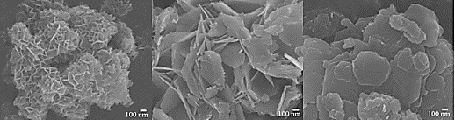

Figure 6. SEM images of (a) HT_P (b) HT_U (c) HT_S [14]

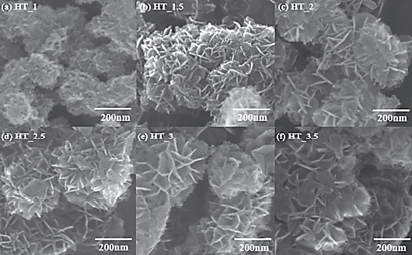

Figure 7. SEM images of MgAl hydrotalcite with different Mg/Al atomic ratio [16]

Catalytic reaction in the isomerization of glucose to fructose

Glucose isomerisation was employed as a model reaction to explore the catalytic activity of the synthesised MgAl hydrotalcites. The isomerisation of glucose into fructose is a critical step in biomass conversion technologies [19]. Generally, the isomerisation of glucose into fructose was conducted in a batch-type glass reactor with glucose as the reactant, MgAl hydrotalcite as the catalyst, and dimethylformamide. The reaction was conducted at 100°C for 3 h. After the reaction was completed, the reactor was cooled in an ice bath, followed by filtrating the resultant solution to separate the catalyst. Lastly, the filtrate was analysed with HPLC equipped with a UV-Vis detector. Table 2 tabulates the catalytic activity of the synthesised MgAl hydrotalcite as a solid base catalyst in the isomerisation of glucose into fructose, as reported by Park et al., Yu et al., and Kang et al. [14, 16, 17]. According to Park et al. [14], the MgAl hydrotalcite prepared by co-precipitation produced the highest fructose yield at 25% compared to the other methods. Moreover, since the method fabricated the smallest crystallite size with abundant surface base sites, numerous researchers utilised MgAl hydrotalcite catalyst prepared with the co-precipitation technique to convert glucose into fructose [14].

Yu et al. [17] found that the highest fructose yield (30%) was obtained when the rehydrated MgAl hydrotalcite catalyst was employed. The results were due to the abundant and selective surface base sites for glucose isomerisation were produced during the rehydration process. Meanwhile, Kang et al. [16] studied the effects of Mg/Al with different ratios on the catalytic activity of MgAl hydrotalcite. They reported that the MgAl hydrotalcite with an Mg/Al ratio of 1.5 produced the highest fructose yield (42%). The increased catalytic activity of the MgAl hydrotalcite during the isomerisation of glucose into fructose was assumed to be due to the small crystallite size obtained by co-precipitation of Mg/Al with the molar ratio of 1.5. Theoretically, the larger the surfaces of the MgAl hydrotalcite exposed to the reactants, the catalyst would exhibit a better catalytic activity.

A report demonstrated by Upare et al. on glucose isomerization, 1-butanol was used as the solvent. It is noted to be very effective in preventing the formation of humin based on their previous study [18]. The uniqueness of 1-butanol as a solvent for glucose isomerization showed that there is no leaching of Mg ions from the hydrotalcite catalyst compared to other solvents such as water, ethanol and dimethylformamide [18]. Notably, the rehydrated MgAl hydrotalcite catalyst with Mg/Al ratio of 2.0 is the excellent catalyst for the isomerization of glucose into fructose with the highest percent yield (51%). The fructose yield increased from Mg/Al ratio of 1.0 to 2.0, however, it decreased from Mg/Al ration of 2.0 to 5.0. These results showed that the high rehydrated Mg/Al ratio were not favourable in the formation of fructose [18].

Apart from using the combination of 1-butanol and hydrotalcite catalyst in glucose isomerisation, ethanol is one of the solvent used in this reaction. Yabuhita et al. found that the use of ethanol enhance the fructose yield and thus, obtained 50% yield which is quite higher compared to other results (Table 2). Furthermore, the removal of ethanol after the reaction is much simpler as its boiling point is quite low than water [20]. By having Mg/Al molar ratio of 3, Yabushita et al. [20] successfully acquired the formation of fructose within a short time.

Table 2. Recent studies on MgAl hydrotalcite for Isomerization of Glucose into Fructose
Synthesis Method | Mg/Al atomic ratio | Conditions | Conversion of glucose (%) | Selectivity of fructose (%) | Yield for fructose (%) | Ref
Co-precipitation  Urea  Simple | 3.0 | At 100°C for 3 h | 38  22  21 | 65  69  71 | 25  14  13 | [14]
Co-precipitation  Synthesized HT  Calcined HT  Rehydrated HT | 3.0 | At 100°C for 5 h | 48  75  63 | 53  32  47 | 25  23  30 | [17]
Co-precipitation  HT | 1.0  1.5  2.0  2.5  3.0  3.5 | At 100°C for 5 h | 25  62  58  55  48  47 | 98  71  73  70  81  79 | 24  42  41  39  40  38 | [16]

Table 2 (cont’d). Recent studies on MgAl hydrotalcite for Isomerization of Glucose into Fructose
Synthesis Method | Mg/Al atomic ratio | Conditions | Conversion of glucose (%) | Selectivity of fructose (%) | Yield for fructose (%) | Ref
Co-precipitation  Rehydrated (HT/1-Butanol) | 1.0  1.5  2.0  3.0  5.0 | At 120°C for 5 h | 46  59  62  66  72 | 65  83  82  70  58 | 30  49  51  46  42 | [18]
Co-precipitation  (HT/Ethanol) | 3.0 | At 90°C for  2 h | 61 | 83 | 50 | [20]

Conclusion

Based on the comprehensive literature review, it could be concluded that the preparation method of MgAl hydrotalcite strongly influenced the growth and stacking of its layers and the type of anions intercalated during the formation of the layered structure. The unique characteristics of the MgAl hydrotalcites led to varied crystallite sizes and morphologies. The co-precipitation method was more favourable than the urea and simple methods to fabricate MgAl hydrotalcites with surfaces that consist of numerous basic sites. Furthermore, different Mg/Al molar ratios also affected the formation and catalytic activity of the synthesised MgAl hydrotalcite. The catalytic activity of the synthesised MgAl hydrotalcite was observed in the isomerisation of glucose into fructose. The MgAl hydrotalcite prepared via co-precipitation produced the highest fructose yield as its small crystallite size and sand-rose morphology result in significant exposure of its surface active sites to the reactants.

Acknowledgement

The authors acknowledge the generous support of Organic Synthesis Research Laboratory, Institute of Science (IOS), Universiti Teknologi MARA, Puncak Alam Campus and Faculty of Applied Sciences, Universiti Teknologi MARA (UiTM), Shah Alam as well as the financial support of the Ministry of Higher Education, Malaysia FRGS Grant [600-RMC/SRC/5/3 (024/2020)].
References
- Dębek, R., Motak, M., Grzybek, T., Galvez, M. E. and Da Costa, P. (2017). A short review on the catalytic activity of hydrotalcite-derived materials for dry reforming of methane. Catalysts, 7(1): 32.
- Gomes, J. F. P., Puna, J. F. B., Gonçalves, L. M. and Bordado, J. C. M. (2011). Study on the use of MgAl hydrotalcites as solid heterogeneous catalysts for biodiesel production. Energy, 36(12): 6770-6778.
- Baskaran, T., Christopher, J. and Sakthivel, A. (2015). Progress on layered hydrotalcite (HT) materials as potential support and catalytic materials. RSC Advances, 5: 98853-98875.
- Tsujimura, A., Uchida, M. and Okuwaki, A. (2007). Synthesis and sulfate ion-exchange properties of a hydrotalcite-like compound intercalated by chloride ions. Journal of Hazardous Materials, 143(1–2): 582-586.
- Sikander, U., Sufian, S. and Salam, M. A. (2017). A review of hydrotalcite based catalysts for hydrogen production systems. International Journal of Hydrogen Energy, 42: 19851-19868.
- Delidovich, I. and Palkovits, R. (2015). Structure-performance correlations of Mg-Al hydrotalcite catalysts for the isomerization of glucose into fructose. Journal of Catalysis, 327: 1-9.

- Lee, G., Kang, J. Y., Yan, N., Suh, Y. W. and Jung, J. C. (2016). Simple preparation method for Mg–Al hydrotalcites as base catalysts. Journal of Molecular Catalysis A: Chemical, 423: 347-355.
- Nur Fazira Edlina, I., Nazrizawati, A. T., Erma Hafiza, I. A. Z. and Noraini, H. (2020). MgAl mixed oxide derived alkali-free hydrotalcite for transesterification of waste cooking oil to biodiesel. ASM Science Journal, 13: 1-7.
- Nope, E., Sathicq, G., Martinez, J., Rojas, H., Luque, R. and Romanelli, G. (2018). Hydrotalcites in Organic Synthesis: Multicomponent Reactions. Current Organic Synthesis, 15(8): 1073-1090.
- Kikhtyanin, O., Kadlec, D., Velvarská, R. and Kubička, D. (2018). Using Mg-Al mixed oxide and reconstructed hydrotalcite as basic catalysts for aldol condensation of furfural and cyclohexanone. ChemCatChem, 10(6): 1464-1475.
- Jadhav, A. L. and Yadav, G. D. (2019). Clean synthesis of benzylidenemalononitrile by Knoevenagel condensation of benzaldehyde and malononitrile: Effect of combustion fuel on activity and selectivity of Ti-hydrotalcite and Zn-hydrotalcite catalysts. Journal of Chemical Sciences, 131(8): 79.
- Arias, K. S., Climent, M. J., Corma, A. and Iborra, S. (2016). Chemicals from biomass: Synthesis of biologically active furanochalcones by claisen–schmidt condensation of biomass-derived 5-hydroxymethylfurfural (HMF) with acetophenones. Topics in Catalysis, 59(13–14): 1257-1265.
- Mokhtar, M., Saleh, T. S. and Basahel, S. N. (2012). Mg-Al hydrotalcites as efficient catalysts for aza-Michael addition reaction: A green protocol. Journal of Molecular Catalysis A: Chemical, 353-354: 122-131.
- Park, S., Kwon, D., Kang, J. Y. and Jung, J. C. (2019). Influence of the preparation method on the catalytic activity of Mg-Al hydrotalcites as solid base catalysts. Green Energy and Environment, 4(3): 287-292.
- Labuschagné, F. J. W. J., Wiid, A., Venter, H. P., Gevers, B. R. and Leuteritz, A. (2018). Green synthesis of hydrotalcite from untreated magnesium oxide and aluminum hydroxide. Green Chemistry Letters and Reviews, 11: 18-28.
- Kang, J. Y., Lee, G., Suh, Y. W. and Jung, J. C. (2017). Effect of Mg/Al atomic ratio of Mg–Al hydrotalcites on their catalytic properties for the isomerization of glucose to fructose. Journal of Nanoscience and Nanotechnology, 17(11): 8242-8247.
- Yu, S., Kim, E., Park, S., Song, I. K. and Jung, J. C. (2012). Isomerization of glucose into fructose over Mg-Al hydrotalcite catalysts. Catalysis Communications, 29: 63-67.
- Upare, P. P., Chamas, A., Lee, J. H., Kim, J. C., Kwak, S. K., Hwang, Y. K., and Hwang, D. W. (2020). Highly efficient hydrotalcite/1-butanol catalytic system for the production of the high-yield fructose crystal from glucose. ACS Catalysis, 10(2): 1388-1396.
- Huang, H., Meng, X. G., Yu, W. W., Chen, L. Y. and Wu, Y. Y. (2021). High selective isomerization of glucose to fructose catalyzed by amidoximed polyacrylonitrile. ACS Omega, 6(30): 19860-19866.
- Yabushita, M., Shibayama, N., Nakajima, K. and Fukuoka, A. (2019). Selective glucose-to-fructose isomerization in ethanol catalyzed by hydrotalcites. ACS Catalysis, 9(3): 2101-2109.

(a) HT_P
(b) HT_U
(c) HT_S

