THE CONJUGATION AND CHARACTERISATION OF THERMORESONSIVE POLY (N-ISOPROPYLACRYLAMIDE)
WITH TERNATIN BIOMOLECULE

(Konjugasi dan Pencirian Poli (N-Isopropilakrilamida)
dengan Biomolekul Ternatin)

Adrina Zulkifli, Farahiyah Najah Ab Samad, Nukman Ameen Rosli, Nurul Aina Jamaluddin,
Nor Nadiah Mohamad Yusof, Noor Faizah Che Harun*

Green Chemistry and Sustainable Engineering Technology, Polymer Technology Section,
Universiti Kuala Lumpur (UniKL) MICET,
Lot 1988, Kawasan Perindustrian Bandar Vendor, Taboh Naning, 78000 Alor Gajah, Melaka, Malaysia

*Corresponding author: noorfaizah@unikl.edu.my

Abstract
Poly (N-isopropylacrylamide) (PNIPAAm) is a well-known thermoresponsive polymer that shows a reversible coil-to-globule transition at the lower critical solution temperature (LCST) (32°C) in aqueous solution. Chemically modified PNIPAAm with hydrophilic/hydrophobic compound will tune its LCST. Below the LCST, PNIPAAm and its conjugate behave as an extended coil form in an aqueous solution, whereas it shrinks into a globule form above the LCST. In this study, a direct conjugate of PNIPAAm with a ternatin biomolecule and their physicochemical characterizations were investigated. Ternatin biomolecule is an anti-adipogenic cyclic peptide that has a potential as a new treatment approach for obesity and metabolic disorders. Poly (N-isopropylacrylamide)-chain transfer agent (PNIPAAm-CTA) was synthesized through reversible addition fragmentation chain transfer (RAFT) polymerization using 2-(Dodecylthiocarbonothioyltho)-2-methylpropanoic acid (DDMAT) as chain transfer reagent. One end-group of PNIPAAm-CTA was subsequently modified with maleimide to form PNIPAAm-Maleimide through aminolysis reaction. Thereafter, a carboxylic end-group of PNIPAAm-Maleimide was directly conjugated with a hydroxyl group of ternatin biomolecule (PNIPAAm-Ternatin) through esterification method. The chemical structure, molecular weight (Mw) and molecular weight distribution (Mw/Mn) of PNIPAAm were determined through the proton nuclear magnetic resonance (¹H-NMR), Fourier transform infrared (FTIR) and size exclusion chromatography (SEC) measurements. Moreover, the LCST of PNIPAAm and its conjugate were determined through light scattering intensity analysis. The results indicated that upon heating the solutions of PNIPAAm and its conjugates in 10 mM HEPES solution pH 7.4 at 25°C-40 °C, PNIPAAm-CTA, PNIPAAm-Maleimide and PNIPAAm-Ternatin solutions started to increase their light intensities at 32 °C, 34 °C and 35 °C, respectively. In conclusion, chemical structure modification of PNIPAAm could tune their LCST.

Keywords: poly (n-isopropylacrylamide), raft polymerization, ternatin biomolecule, conjugation, lower critical solution temperature

Abstrak
Poli (N-isopropilakrilamida) (PNIPAAm) adalah polimer termoresponsif terkenal yang menunjukkan peralihan gegelung-ke-globule yang boleh berbalik pada suhu larutan kritikal rendah (LCST) (32°C) dalam larutan akueus. PNIPAAm yang diubahsuai secara kimia dengan sebatian hidrofilik/hidrofobik akan mengubahkan LCSTnya. Pada suhu di bawah LCST, PNIPAAm dan konjugatnya berbentuk gegelung di dalam larutan akueus, manakala ia akan mengecut menjadi bentuk globul pada suhu di atas LCST Dalam kajian ini, konjugasi secara langsung PNIPAAm dengan biomolekul ternatin dan sifat fizikokimianya dikaji. Biomolekul ternatin adalah peptida siklik anti-adipogenik. Ia berpotensi sebagai rawatan baharu untuk obesiti dan gangguan metabolik. Poli (N-isopropilakrilamida)-agen pemindahan rantai (PNIPAAm-CTA) disintesis melalui polimerisasi radikal hidup menggunakan asid 2-(dodekilthiokarbonothioiltho)-2-metilpropanoik(DDMAT) sebagai reagen pemindahan rantai. Selepas itu, satu kumpulan akhir pada PNIPAAm-CTA diubahsuai dengan maleimida untuk membentuk PNIPAAm-Maleimida melalui tindak balas aminolisis. Kemudian, kumpulan akhir karboksilik PNIPAAm-Maleimida dihubungkan secara langsung dengan kumpulan hidroksil pada biomolekul ternatin (PNIPAAm-Ternatin) melalui kaedah esterifikasi. Struktur kimia, berat molekul (Mw) dan taburan berat molekul (Mw/ Mn) bagi PNIPAAm dikaji melalui analisis proton resonans magnetik nuklear (¹H-NMR), spektroskopi inframerah Fourier transformasi (FTIR) dan kromatografi ekslusi saiz (SEC). Seterusnya, sifat LCST bagi PNIPAAm dan konjugatnya dikaji melalui analisis intensiti penyerakan cahaya. Hasilnya, setelah larutan PNIPAAm dan konjugat dalam larutan HEPES 10 mM pH 7.4 dipanaskan pada suhu 25-40 °C, intensiti cahaya bagi PNIPAAm-CTA, PNIPAAm-Maleimida dan PNIPAAm-Ternatin mula meningkat pada 32 °C, 34 °C dan 35 °C. Kesimpulannya, pengubahsuaian struktur kimia PNIPAAm dapat mengubah sifat LCST polimer.

Kata kunci: poli (n-isopropilakrilamida), pempolimeran raft, biomolekul ternatin, konjugasi, suhu larutan kritikal rendah

Introduction
Over the years, a great deal of effort has been devoted to the development of stimuli-responsive smart polymers that can provide a variety of applications for cosmetic, agriculture, biomedical and biotechnology [1-4]. Smart polymers are polymeric materials, in which the structure, function, and stability drastically change by slight changes in external stimuli. These stimuli could be temperature, pH, light, redox and/or photo [5-9]. In the case, whereby the external stimulus is the temperature change, the polymers are often referred as thermoresponsive polymers. Poly(N-isopropylacrylamide (PNIPAAm) is one of the well-known thermoresponsive polymer. PNIPAAm displays a lower critical solution temperature (LCST) of 33 °C [10-12]. PNIPAAm remains in coil conformation in water below LCST, meanwhile, it collapses into globule conformation above LCST [13, 14]. The LCST of PNIPAAm chain could be tuned by several approaches, such as modification of end-group with hydrophilic or hydrophobic compound, adding comonomers and/or changing its tacticity [15-17]. The introduction of hydrophilic compound into PNIPAAm chain leads to an increase of LCST, meanwhile, PNIPAAm incorporated with hydrophobic compound tends to decrease LCST. Moreover, a reported study demonstrated that PNIPAAm conjugated with a small interfering of ribonucleic acid (RNA) (siRNA) biomolecule using click chemistry tools tuned the LCST of PNIPAAm conjugates [18].

In the present study, a facile synthetic route for the conjugation of PNIPAAm with ternatin biomolecule was prepared to investigate the thermoresponsive behaviour. Ternatin biomolecule is a natural compound that is extracted from a plant, known as butterfly pea, or its scientific name Clitoria ternatea [19]. Ternatin is an anti-adipogenic cyclic peptide containing one or more N-methyl (or N-alkyl) amino acids [20, 21]. Furthermore, this study hypothesised that the modification of PNIPAAm chain with hydrophilic compound end-group and ternatin biomolecule would tune the thermoresponsive behaviour of PNIPAAm. Concisely, this study prepared PNIPAAm and its conjugate through controlled living radical polymerisation and esterification techniques (Figure 1). It is expected that the prepared facile synthetic route for the conjugation of thermoresponsive polymer with biomolecule and the resulted thermoresponsive behaviour in this study would be useful for further related field studies.
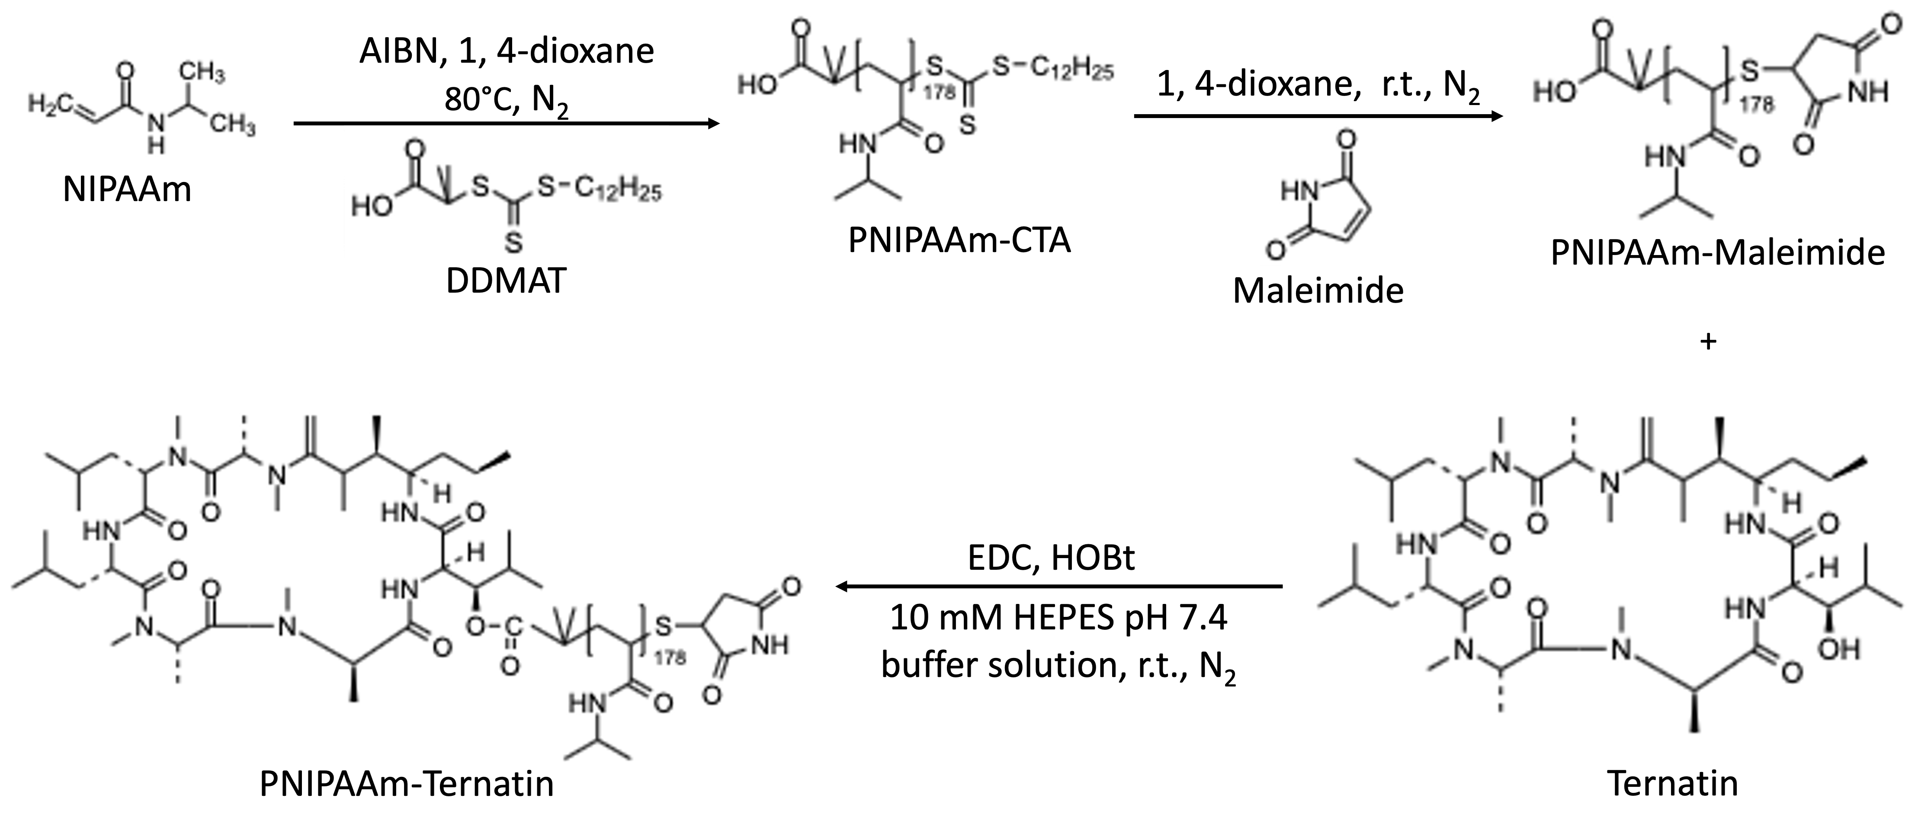

Figure 1. Synthetic route of PNIPAAm-Ternatin conjugation

Materials and Methods
Materials
N-Isopropylacrylamide (NIPAAm), 2-(Dodecylthiocarbonothioyltho)-2-methylpropanoic acid (DDMAT), 2,2’-Azobis(2-methylpropionitrile) (AIBN), 1,4-dioxane, diethyl ether, ethanolamine, maleimide, tributylphosphine (TBP), HEPES solution, N-ethyl-N’-(3-dimethylaminopropyl) carbodiimide (EDC), 1-Hydroxybenzotriazole (HOBt), tetrahydrofuran (THF) and acetonitrile were purchased from Sigma-Aldrich, Malaysia. NIPAAm was purified by recrystallisation from n-hexane and dried in a vacuum. AIBN purification was performed by recrystallisation from cold methanol. Prior to the usage, 1,4-dioxane was purified using reflux condenser. Ternatin was purchased from Cayman Chemical (Ann Arbor, Michigan, USA). Deuterated methanol (MeOD) was purchased from Merck and it was used without further purification.

Synthesis of PNIPAAm–CTA
PNIPAAm-CTA was synthesised by dissolving NIPAAm (3.0 g, 30.0 mmol), DDMAT (110 mg, 0.3 mmol), AIBN (2.5 mg, 0.015 mmol) in 1,4-dioxane (10 mL) ([NIPAAm]: [DDMAT]: [AIBN] = 100: 1: 0.05, respectively). The solution was stirred at room temperature until a homogeneous mixture was formed. Next, the nitrogen gas was purged into the reaction for 15 minutes. The mixture was stirred and heated in an 80 °C oil bath for 12 hours. After 12 hours, the reaction solution was precipitated into cold diethyl ether to remove the unreacted monomer. The produced polymer was filtered using vacuum pump and dried in a desiccator for a day. Finally, the polymer was collected, weighted and stored in the refrigerator.

Synthesis of PNIPAAm–maleimide
PNIPAAm–Maleimide was synthesised by dissolving PNIPAAm-CTA (1.5 g, 0.27 mmol), ethanolamine (1.6 g, 27.20 mmol) and maleimide (0.26 g, 2.72 mmol) into the 1,4-dioxane (5 mL). The solution was stirred at room temperature until a homogeneous mixture was formed. Next, the nitrogen gas was purged into the reaction for five minutes. After five minutes, TBP (0.10 mL, 0.54 mmol) was added to the mixture ([PNIPAAm–CTA]: [maleimide]: [TBP]: [ethanolamine] = 1: 10: 2: 100, respectively). The mixture was stirred at room temperature for six hours. After six hours, the reaction solution was precipitated into cold diethyl ether to remove the unreacted monomer. The produced polymer was filtered using a vacuum pump and dried in a desiccator for a day. The polymer was collected, weighted and stored in the refrigerator.

Synthesis of PNIPAAm–ternatin
PNIPAAm–Maleimide solution was prepared by dissolving PNIPAAm-Maleimide (33.33 mg, 0.02 mmol) into 4 mL of 10 mM HEPES pH 7.4 buffer solution. The mixture was stirred for 20 hours at room temperature. After 20 hours, EDC (3 mg, 0.02 mmol) and HOBt (1 mg, 0.01 mmol) were added to the mixture and stirred continuously for three hours at room temperature to activate the carboxylate group. Next, the nitrogen gas was purged into the reaction for 15 minutes and 0.5 mL of 10 ppm ternatin was slowly added to the mixture. After 15 minutes, the mixture was stirred for 20 hours at room temperature. Thereafter, 4 mL of 10 mM HEPES pH 7.4 buffer solution was added to the mixture and cooled at room temperature. After two days, it was purified by centrifugation using ultra centrifugal filter (MWCO 3kDa, Millipore) to remove the unreacted molecules. Finally, the produced PNIPAAm-Ternatin was collected and stored in the refrigerator.

Molecular weight and molecular weight distribution
The polymer molecular weight and molecular weight distribution (Mw/Mn) was measured by using Waters® ACQUITY® Advanced Polymer Chromatography™ (APC) with THF, which was used as an eluent at a flow rate of 1.0 mL/min at 40°C using the standard polystyrene. The ACQUITY UPLC Refractive Index Detector ACQUITY APC Column were used.

Chemical structure characterisations
Fourier transform infrared (FTIR) spectra of the PNIPAAm-CTA and PNIPAAm-Maleimide were recorded with FTIR Nicolet 510 spectrometer in the 4,000 cm⁻¹ – 400 cm⁻¹ range. The samples were prepared by grinding the polymer with KBr pellets and compressing the mixture to form disks. For PNIPAAm-Ternatin, FTIR spectra was recorded with Shimadzu FTIR-8300 instrument in the 4,000 cm⁻¹ - 600 cm⁻¹ range. The polymer chemical structure and the conjugated polymers were also characterised using ¹H NMR spectra. It was conducted on a Bruker Spectrospin 400 MHz UltraShield Spectrometer. Chloroform-d (CDCl₃) and methanol-d (MeOD) were used as solvents.

Reversed-phase high-performance liquid chromatography analysis
Reversed-phase high-performance liquid chromatography (RP-HPLC) analysis was used to separate, identify and quantify each component in the produced polymer conjugated with ternatin. For polymer-peptide conjugate, the HPLC gradients consisted of eluent A with 0.1% formic acid in water and eluent B with 0.1% formic acid in acetonitrile. The flow rate was maintained at 0.5 mL/min, detected at 200 nm and the column temperature was at room temperature.

Light scattering intensity analysis
Light scattering intensity analysis was performed to determine the LCST of polymer by using Zetasizer Nano (Malvern Instrument Ltd.) at a detection angle of 173°. The sample solutions were prepared by dissolving the polymer, ternatin and its polymer conjugates in 10 mM HEPES solution (pH 7.4) (sample solution concentration at 0.5 mg mL⁻¹). It was measured at various temperatures from 25°C to 40°C. The results were presented as mean value of count rate in kilo counts per second (kcps) and the standard deviation was obtained from three times repetitions.

Results and Discussion
Chemical structure characterisation of PNIPAAm-CTA and PNIPAAm-Maleimide
The synthesised PNIPAAm-CTA possessed molecular weight, Mw at 20140 g/mol and had a narrow molecular weight distribution (Mw/Mn) of 1.26. The obtained molecular weight of PNIPAAm-CTA was purely theoretical. Furthermore, a quite narrow molecular weight distribution suggested that a successful controlled polymerization of PNIPAAm.
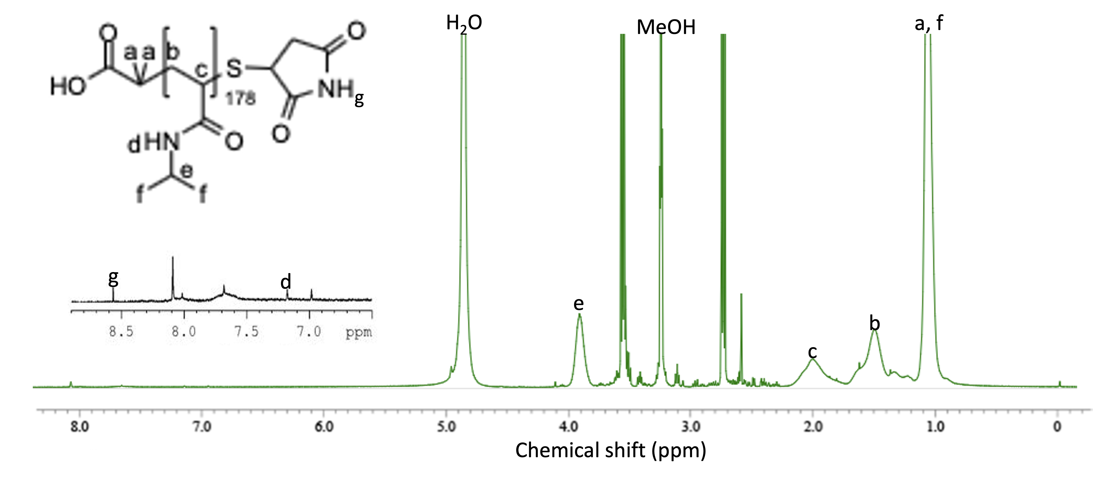

Figure 3. ¹H NMR spectrum of PNIPAAm-Maleimide
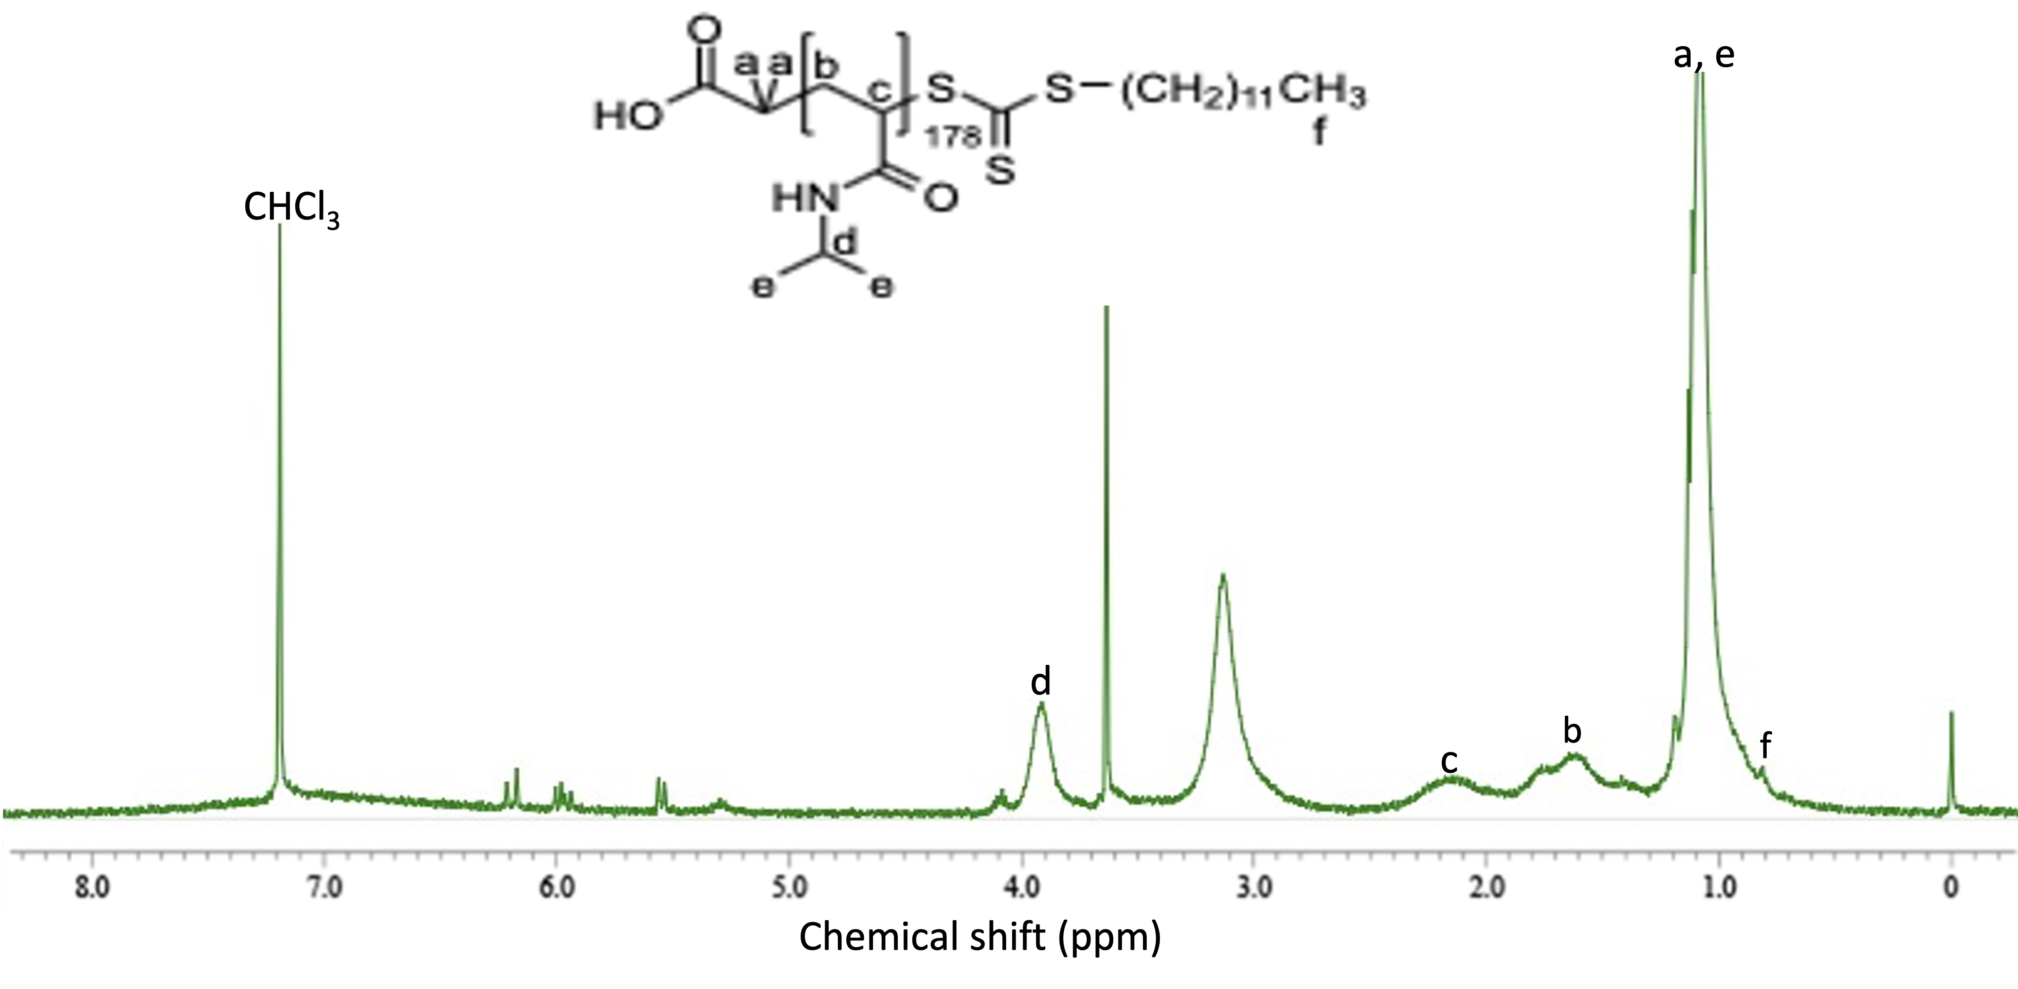

Figure 2. ¹H NMR spectrum of PNIPAAm-CTA

The chemical structure of PNIPAAm-CTA and PNIPAAm-Maleimide were characterised by ¹H NMR and FTIR analysis. The ¹H NMR spectrum of PNIPAAm-CTA in Figure 2 showed the presence of signal characteristic of PNIPAAm at δ = 3.9 ppm for CH connected to the NH, 1.15 ppm for CH₃, 1.61 ppm (-CH₂-) and 2.13 ppm (-CH-) [22, 23]. The formation of PNIPAAm-CTA was proven by the existence of trithiocarbonate functionality at the PNIPAAm-CTA end-group, which was demonstrated in the ¹H NMR spectrum through the peak at 0.88 ppm (CH₃–(CH₂)₁₀–CH₂–S–) [24]. Furthermore, the ¹H NMR spectrum of PNIPAAm-Maleimide confirmed the existence of maleimide at the peak of 8.55 ppm which belong to the -NH group in maleimide [25]. The disappearance of the peak at 0.88 ppm for trithiocarbonate group in the spectrum suggested the successful conversion into PNIPAAm-Maleimide through aminolysis reaction [26].
PNIPAAm-CTA and PNIPAAm-Maleimide chemical structures were further confirmed through FTIR analysis. In Figure 4, the FTIR spectrum for PNIPAAm-CTA showed that the formation was proven by the C=S stretching band of the chain at 1,065 cm⁻¹ [27]. The C=S group was belong to the trithiocarbonate end in PNIPAAm-CTA. The FTIR spectra for PNIPAAm-CTA also represented the N-H stretch at 3,414 cm⁻¹, carbonyl group (C=O) at 1,554 cm⁻¹ and 1,643 cm⁻¹, and C–N stretching at 1,462 cm⁻¹ [28]. The FTIR spectrum for PNIPAAm–Maleimide showed that the aminolysis reaction was succeeded because the C=S stretching band (1,050 cm⁻¹ – 1,080 cm⁻¹) of the trithiocarbonate end was no longer being observed after the aminolysis reaction [29]. Furthermore, there was a peak at 1,743 cm⁻¹ for maleimide C=O stretching. For symmetric C-N-C stretch, the peak was situated at 1,457 cm⁻¹, which affirmed the existence of maleimide [30]. The FTIR absorption band, which was around 3,300 cm⁻¹ – 3,500 cm⁻¹ covered N-H stretching group bands in PNIPAAm and maleimide [31]. These results confirmed the polymerisation of PNIPAAm-CTA and the modification of its end-group to produce PNIPAAm-Maleimide.
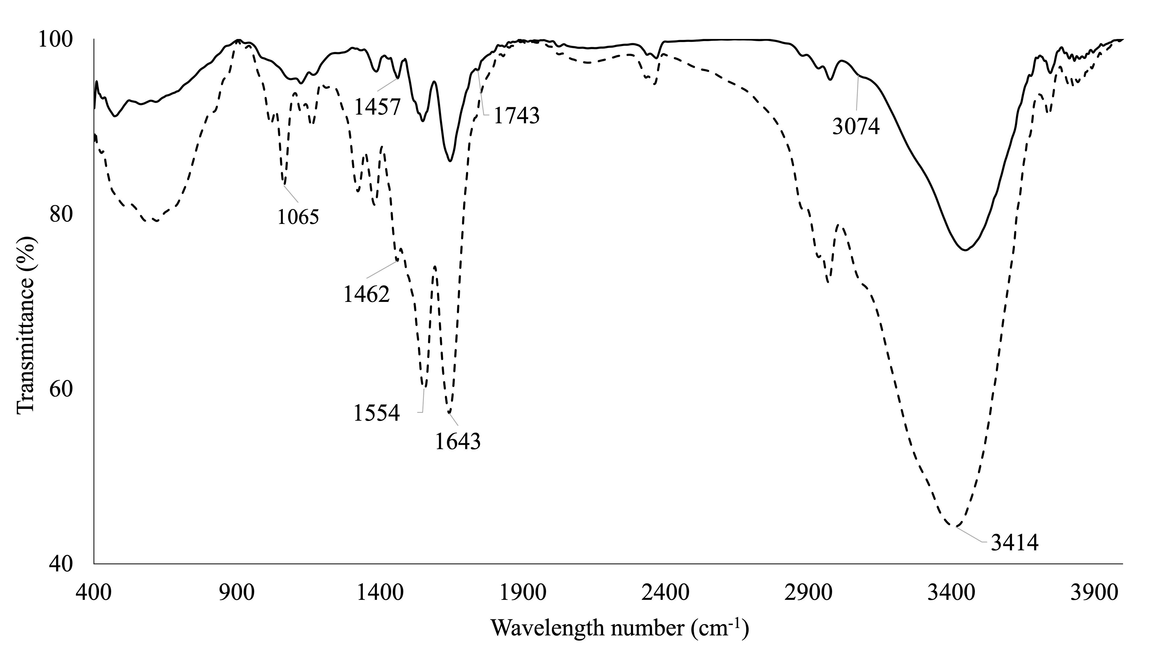

Figure 4. FTIR analysis for PNIPAAm-CTA (dash-line) and PNIPAAm-Maleimide (straight-line)

Characterisations of PNIPAAm-Ternatin conjugate
The esterification method was used to synthesise the PNIPAAm-Ternatin. The chemical structure of PNIPAAm-Ternatin was confirmed by the FTIR. In Figure 5 (a) showed the FTIR analysis for PNIPAAm-Ternatin, whereby the band at 1,635 cm⁻¹ and 1,185 cm⁻¹ were attributed to the C=O and C-O stretching frequencies of ester linkage, respectively [32]. Therefore, it was suggested that the PNIPAAm-Ternatin was successfully synthesised through esterification method. A broad stretch at 3,286 cm⁻¹ was indexed to the NH group in ternatin [33]. The NH stretching group in PNIPAAm and maleimide at 3,300 cm⁻¹ – 3,500 cm⁻¹ were overlapped by the broad stretch of OH group in the ternatin [34].

The HPLC chart for PNIPAAm-Ternatin is shown in Figure 5 (b). The purpose of this analysis was to identify the retention time of ternatin, PNIPAAm-Maleimide and PNIPAAm-Ternatin and also to calculate the concentration and conjugation percentages of ternatin biomolecule to PNIPAAm chain. As a result, it was confirmed that the peak at the retention time of 2.57 minutes and 3.06 minutes for ternatin and PNIPAAm-Ternatin, respectively, clearly appeared in the HPLC chart. The concentration and conjugation percentages of PNIPAAm-Ternatin were obtained at 8.75 ppm and 87.5%, respectively, which was calculated based on ternatin calibration. Consequently, the collected PNIPAAm-Ternatin through RP-HPLC was purified using centrifugation against 10 mM HEPES pH 7.4 buffer solution and conducted for further analysis.

Thermoresponsive behaviour of PNIPAAm and its conjugate
The LCST of PNIPAAm and its conjugate were determined by light scattering intensity analysis. The resulting light scattering intensity of PNIPAAm and its conjugate are shown in Figure 6(a) for PNIPAAm-CTA, Figure 6(b) for PNIPAAm-Maleimide and Figure 6(c) for PNIPAAm-Ternatin. Upon heating solutions of PNIPAAm-CTA, PNIPAAm-Maleimide and PNIPAAm-Ternatin in 10 mM HEPES pH 7.4 from 25 °C to 40 °C, it could be seen that light scattering intensity of PNIPAAm-CTA started to increase at a temperature of 32 °C, whereas the change was shifted to the temperature at 34 °C in the case of PNIPAAm-Maleimide and at 35 °C for PNIPAAm-Ternatin. The increased light scattering intensity of PNIPAAm and its conjugate were due to the aggregation of globule form of PNIPAAm chain above the LCST [35]. The modification of chemical structure of PNIPAAm with hydrophilic or hydrophobic compound tuned the LCST of PNIPAAm [36]. Based on this study, the LCST for PNIPAAm-Maleimide and PNIPAAm-Ternatin were higher when compared to the LCST of PNIPAAm-CTA. This was due to the addition of hydrophilic maleimide compound and ternatin biomolecule at end-group of PNIPAAm chain that improved the LCST of the polymer. Therefore, the results indicated that the addition of hydrophilic compound increased the LCST of PNIPAAm. The small changes of LCST for PNIPAAm-Ternatin solution upon heating suggested that the conjugation of PNIPAAm with ternatin biomolecule did not contribute any effect on the thermoresponsive behaviour of PNIPAAm chain.
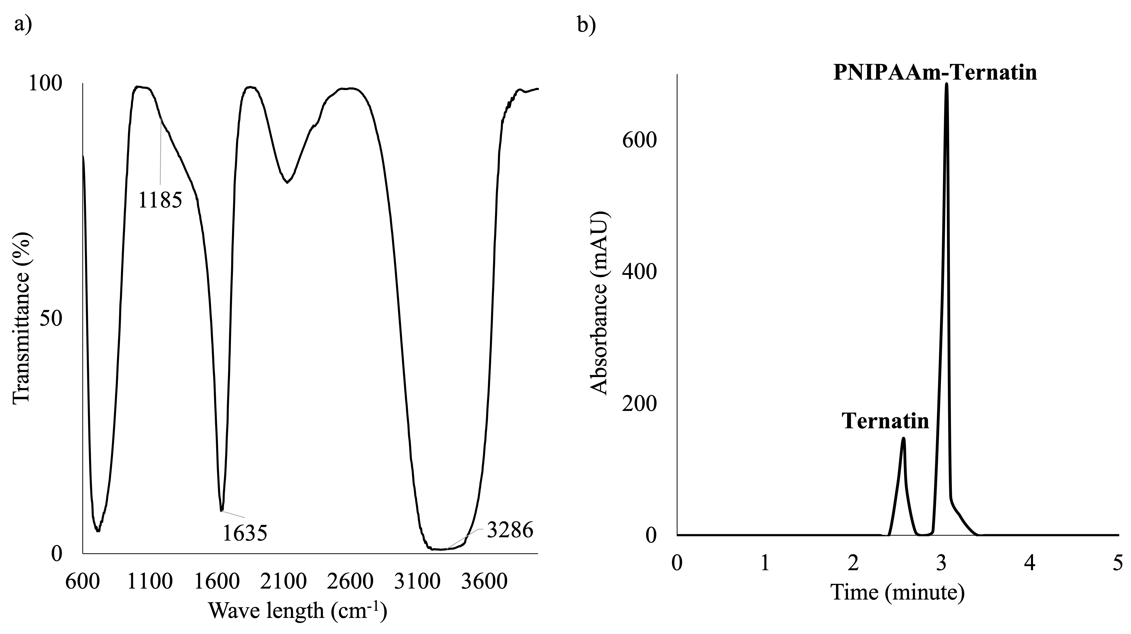

Figure 5. (a) FTIR analysis and (b) HPLC analysis for PNIPAAm-Ternatin

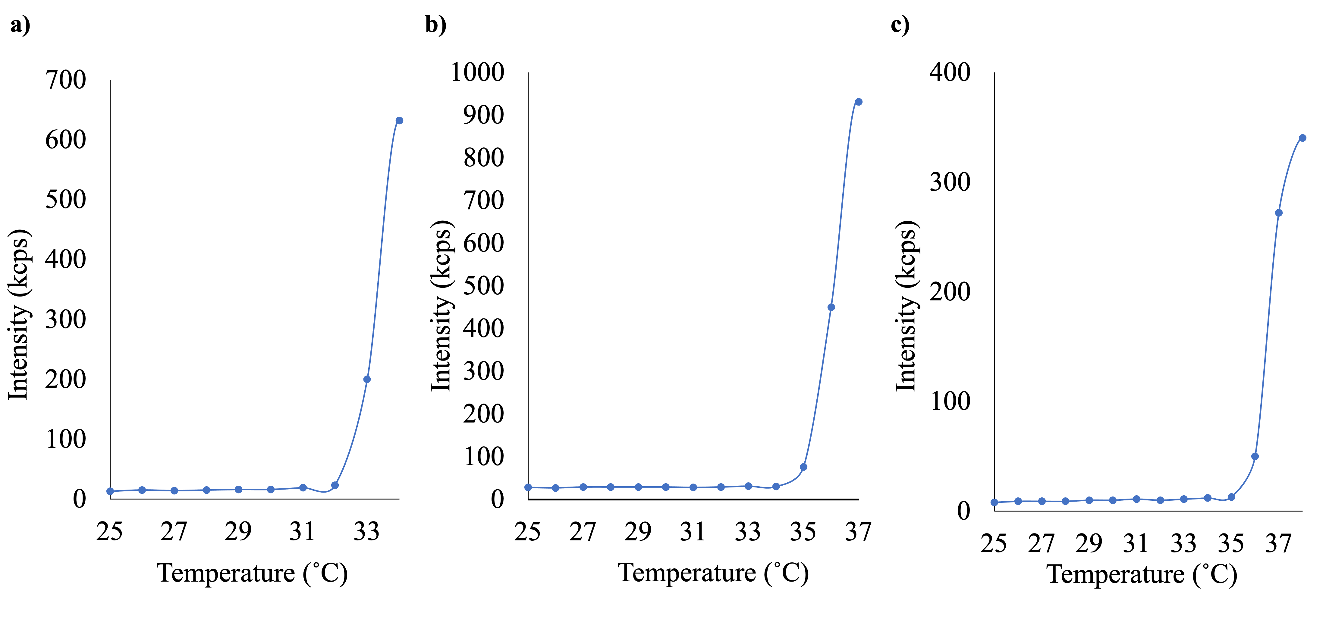

Figure 6. Light scattering intensities of (a) PNIPAAm-CTA, b) PNIPAAm-Maleimide and c) PNIPAAm-Ternatin solution at an indicated temperature in 10 mM HEPES pH 7.4 buffer solution

Conclusion
A thermoresponsive PNIPAAm conjugate was designed with ternatin biomolecule through controlled living radical polymerisation and esterification techniques. The synthesised PNIPAAm-CTA possessed molecular weight, Mw of 20140 g/mol and had quite a narrow molecular weight distribution (Mw/Mn) of 1.26, which revealed that the synthesised PNIPAAm through RAFT polymerisation was in a controlled structure. Moreover, PNIPAAm-Ternatin with conjugation percentage of 87.5% was successfully prepared through esterification technique. The synthesised PNIPAAm-CTA had a LCST at 32 °C. Meanwhile, the modification of PNIPAAm chain end-group by the addition of hydrophilic compound of maleimide (PNIPAAm-Maleimide) and the introduction of ternatin biomolecule (PNIPAAm-Ternatin) increased the LCST of PNIPAAm to 34 °C and 35 °C, respectively. Therefore, reported synthesised PNIPAAm and its chemical modifications are expected to provide a fundamental knowledge for further design and an excellent flexibility in tailoring for specific usage, particularly in the bioengineering and biomedical studies. Further studies on this topic are now in progress.

Acknowledgements
The authors thank the Ministry of Higher Education (MOHE) Malaysia for the financial support provided via the Fundamental Research Grant Scheme [ref no. FRGS/1/2018/STG05/UNIKL/02/5]. The authors also thank Universiti Kuala Lumpur Malaysian Institute of Chemical and Bioengineering Technology, Melaka, Malaysia for providing resources and necessary facilities for FTIR, HPLC and Light Scattering Intensity analyses. The authors also thank the Nuclear Magnetic Resonance Laboratory, University Industry Research Laboratory, Universiti Teknologi Malaysia, Johor, Malaysia for ¹H NMR analysis.

References

- Hoffman, A. S. and Stayton, P. S. (2007). Conjugates of stimuli-responsive polymers and proteins. Progress in Polymer Science, 32(8-9): 922-932.
- Martens, P. J., Bryant, S. J. and Anseth, K. S. (2003). Tailoring the degradation of hydrogels formed from multivinyl poly (ethylene glycol) and poly (vinyl alcohol) macromers for cartilage tissue engineering. Biomacromolecules, 4(2): 283-292.
- Tan, L., Liu, J., Zhou, W., Wei, J. and Peng, Z. (2014). A novel thermal and pH responsive drug delivery system based on ZnO@PNIPAM hybrid nanoparticles. Materials Science and Engineering: C, 45(1): 524-529.
- Tian, Y., Wei, X., Wang, Z. J., Pan, P., Li, F., Ling, D., Wu, Z. L. and Zheng, Q. (2017). A facile approach to prepare tough and responsive ultrathin physical hydrogel films as artificial muscles. ACS Applied Materials & Interfaces, 9(39): 34349-34355.
- Bajpai, A., Shukla, S. K., Bhanu, S. and Kankane, S. (2008). Responsive polymers in controlled drug delivery. Progress in Polymer Science, 33(11), 1088-1118.
- Xiong, X., Del Campo, A. and Cui, J. (2019). Photoresponsive polymers. Smart Polymers and Their Applications, 1: 87-153.
- Swift, T., Swanson, L., Geoghegan, M. and Rimmer, S. (2016). The pH-responsive behaviour of poly (acrylic acid) in aqueous solution is dependent on molar mass. Soft Matter, 12: 2542-2549.
- Elbert, J., Mersini, J., Vilbrandt, N., Lederle, C., Kraska, M., Gallei, M., Stuhn, B., Plenio, H. and Rehahn, M. (2013). Reversible activity modulation of surface-attached grubbs second generation type catalysts using redox-responsive polymers. Macromolecules, 46(11): 4255-4267.
- Lustig, S. R., Everlof, G. J. and Jaycox, G. D. (2001). Stimuli-responsive polymers. 5. Azobenzene modified polyaramides containing atropisomeric binaphthyl linkages: Tuning chiroptical behavior with light and heat. Macromolecules, 34(7): 2364-2372.
- Schild, H. (1992). Poly(n-isopropylacrylamide): Experiment, theory and application. Progress in Polymer Science, 17(2): 163-249.
- Abbott, L. J., Tucker, A. K. and Stevens, M. J. (2015). Single chain structure of a poly(n-isopropylacrylamide) surfactant in water. The Journal of Physical Chemistry B, 119 (9): 3837-3845.
- Hirokawa, Y. and Tanaka, T. (1984). Volume phase transition in a nonionic gel. The Journal of Chemical Physics, 81 (12): 6379-6380.
- Cook, M. T., Haddow, P., Kirton, S. B. and McAuley, W. J. (2020). Polymers exhibiting lower critical solution temperatures as a route to thermoreversible gelators for healthcare. Advanced Functional Materials, 31(8): 2008123.
- Irani, C. A. and Cozewith, C. (1986). Lower critical solution temperature behavior of ethylene propylene copolymers in multicomponent solvents. Journal of Applied Polymer Science, 31(6): 1879-1899.
- Maeda, Y., Higuchi, T. and Ikeda, I. (2000). Change in hydration state during the coil−globule transition of aqueous solutions of poly(n-isopropylacrylamide) as evidenced by FTIR spectroscopy. Langmuir, 16(19): 7503-7509.
- García-Peñas, A., Biswas, C. S., Liang, W., Wang, Y., Yang, P. and Stadler, F. J. (2019). Effect of hydrophobic interactions on lower critical solution temperature for poly (n-isopropylacrylamide-co-dopamine methacrylamide) copolymers. Polymers, 11 (6): 991.
- Ashbaugh, H. S. and Paulaitis, M. E. (2006). Monomer hydrophobicity as a mechanism for the LCST behavior of poly (ethylene oxide) in water. Industrial & Engineering Chemistry Research, 45(16): 5531-5537.
- Che Harun, N., Takemoto, H., Nomoto, T., Tomoda, K., Matsui, M. and Nishiyama, N. (2016). Artificial control of gene silencing activity based on siRNA conjugation with polymeric molecule having coil-globule transition behavior. Bioconjugate Chemistry, 27(9): 1961-1964.
- Nair, V., Bang, W. Y., Schreckinger, E., Andarwulan, N. and Cisneros-Zevallos, L. (2015). Protective role of ternatin anthocyanins and quercetin glycosides from butterfly pea (Clitoria ternatea Leguminosae) blue flower petals against lipopolysaccharide (LPS)-induced inflammation in macrophage cells. Journal of Agricultural and Food Chemistry, 63(28), 6355-6365.
- Carelli, J. D., Sethofer, S. G., Smith, G. A., Miller, H. R., Simard, J. L., Merrick, W. C., Jain, R. K., Ross, N. T. and Taunton, J. (2015). Ternatin and improved synthetic variants kill cancer cells by targeting the elongation factor-1a ternary complex. eLife, 4: e10222.
- Kobayashi, M., Kawashima, H., Takemori, K., Ito, H., Murai, A., Masuda, S., Yamada, K., Uemura, D. and Horio, F. (2012). Ternatin, a cyclic peptide isolated from mushroom, and its derivative suppress hyperglycemia and hepatic fatty acid synthesis in spontaneously diabetic KK-AY mice. Biochemical and Biophysical Research Communications, 427(2): 299-304.
- Kuo, S.-W., Hong, J.-L., Huang, Y.-C., Chen, J.-K., Fan, S.-K., Ko, F.-H. and Chang, F.-C. (2012). Star poly(n-isopropylacrylamide) tethered to polyhedral oligomeric silsesquioxane (POSS) nanoparticles by a combination of ATRP and click chemistry. Journal of Nanomaterials, 2012: 1-10.
- Coronado, R., Pekerar, S., Lorenzo, A. T. and Sabino, M. A. (2010). Characterization of thermo-sensitive hydrogels based on poly(n-isopropylacrylamide)/hyaluronic acid. Polymer Bulletin, 67(1): 101-124.
- Ma, Y.-M., Wei, D.-X., Yao, H., Wu, L.-P. and Chen, G.-Q. (2016). Synthesis, characterization and application of thermoresponsive polyhydroxyalkanoate-graft-poly(n-isopropylacrylamide) Biomacromolecules, 17(8): 2680-2690.
- Avila, A., Chinchilla, R. and Nájera, C. (2012). Enantioselective Michael addition of α,α-disubstituted aldehydes to maleimides organocatalyzed by chiral primary amine-guanidines. Tetrahedron: Asymmetry, 23(24): 1625-1627.
- Ho, T. H., Levere, M., Soutif, J.-C., Montembault, V., Pascual, S. and Fontaine, L. (2011). Synthesis of thermoresponsive oxazolone end-functional polymers for reactions with amines using Thiol-Michael addition “click” chemistry. Polymer Chemistry, 2(6): 1258.
- Lai, J. T., Filla, D. and Shea, R. (2002). Functional polymers from novel carboxyl-terminated trithiocarbonates as highly efficient RAFT agents. Macromolecules, 35(18): 6754-6756.
- Roach, P., McGarvey, D., Lees, M. and Hoskins, C. (2013). Remotely triggered scaffolds for controlled release of pharmaceuticals. International Journal of Molecular Sciences, 14(4): 8585-8602.
- Willcock, H. and O'Reilly, R. K. (2010). End group removal and modification of RAFT polymers. Polymer Chemistry, 1(2): 149-157.
- Shen, G. (2004). X-ray photoelectron spectroscopy and infrared spectroscopy study of maleimide-activated supports for immobilization of oligodeoxyribonucleotides. Nucleic Acids Research, 32(20): 5973-5980.
- Icriverzi, M., Rusen, L., Sima, L. E., Moldovan, A., Brajnicov, S., Bonciu, A., Mihailescu, N., Dinescu, M., Cimpean, A., Roseanu, A. and Dinca, V. (2018). In vitro behavior of human mesenchymal stem cells on poly (n-isopropylacrylamide) based biointerfaces obtained by matrix assisted pulsed laser evaporation. Applied Surface Science, 440: 712-724.
- Smith, B. (2020). The C=O bond, Part VI: Esters and the rule of three. Access from https://www.spectroscopyonline.com/view/co-bond-part-vi-esters-and-rule-three. [Access online on 12 August 2021].
- Ludin, N. (2018). Utilization of natural dyes from zingiber officinale leaves and Clitoria ternatea flowers to prepare new photosensitisers for dye-sensitised solar cells. International Journal of Electrochemical Science, (1): 7451-7465.
- Ramesh, S., Sivasamy, A. and Kim, J. (2012). Synthesis and characterization of maleimide-functionalized polystyrene-SiO₂/TiO₂ hybrid nanocomposites by sol–gel process. Nanoscale Research Letters, 7(1): 350.
- Chung, J., Yokoyama, M., Yamato, M., Aoyagi, T., Sakurai, Y. and Okano, T. (1999). Thermo-responsive drug delivery from polymeric micelles constructed using B lock copolymers of poly(n-isopropylacrylamide) and poly(butylmethacrylate). Journal of Controlled Release, 62(1-2), 115-127.
- Yang, L., Fan, X., Zhang, J. and Ju, J. (2020). Preparation and characterization of thermoresponsive poly (n-isopropylacrylamide) for cell culture applications. Polymers, 12(2): 389.

