BIOMIMETIC SYNTHESIS OF SILVER NANOPARTICLES USING
Eleusine indica EXTRACT AND ITS ANTIBACTERIAL PROPERTIES

(Sintesis Biomimetik Nanopartikel Perak Menggunakan Ekstrak

Eleusine indica dan Ciri Antibakteria)

Ropisah Me¹, Muhammad Hafiz Istamam¹, Noor Hidayah Pungot², Nazlina Ibrahim³, Alice Shanthi⁴

¹Universiti Teknologi MARA, Cawangan Negeri Sembilan, Kampus Kuala Pilah,
72000 Kuala Pilah, Negeri Sembilan, Malaysia.
²Universiti Teknologi MARA, 40450 Shah Alam, Selangor, Malaysia
³Universiti Kebangsaan Malaysia, 43600 Bangi, Selangor, Malaysia
⁴Universiti Teknologi MARA, Cawangan Negeri Sembilan, Kampus Seremban,
70300 Seremban, Negeri Sembilan, Malaysia.

*Corresponding author: ropisah@uitm.edu.my

Abstract

The biomimetic method, which relies on natural resources such as plant extracts, bacteria, and fungi, offers an alternative for synthesizing silver nanoparticles (AgNPs). The use of biomimetic method for synthesizing AgNPs have various benefits including cost effectiveness, low toxicity, and suitabiity for biomedical application. This study synthesizes plant mediated nanoparticle using Eleusine indica to determine its antibacterial activity. Eleusine indica methanol extract is treated with 1 mM of silver nitrate at room temperature (25-27 °C) for 24 hours. The resulting product is characterized using UV-Vis spectroscopy and transmission electron microscope (TEM). UV-Vis absorption spectroscopy displays a strong resonance centered on the surface of AgNPs at approximately 413 nm. Physical appearance of AgNPs as characterized by transmission electron microscopy (TEM) showed formation of AgNPs with average particle size of 20 nm. In the antibacterial activity of the synthesized AgNPs, minimum inhibitory concentration (MIC) and minimum bactericidal concentration (MBC) assays are performed. The plant mediated AgNPs has predicted bacteriocidal activity according to the ratio of MBC to MIC values against selected Gram-positive and Gram-negative bacteria. In this study, plant mediated AgNPs has been successfully synthesized by reduction of silver nitrate with Eleusine indica leaves methanol extract.

Keywords: Plant-mediated silver nanoparticles, Eleusine indica, UV-Vis analysis, transmission electron microscope, antibacterial activity

Abstrak
Kaedah biomimetik yang bergantung kepada sumber alam seperti ekstrak tumbuhan, bakteria dan kulat, menawarkan alternatif dalam sintesis nanopartikel perak (AgNPs). Penggunaan kaedah biomimetik dalam sintesis AgNPs mempunyai pelbagai kelebihan termasuk keberkesanan kos, ketoksikan yang rendah, dan kesesuaian dalam kegunaan biomedik. Objektif kajian ini adalah untuk mensintesis nanopartikel perak diperantara tumbuhan menggunakan Eleusine indica dan menentukan aktiviti antibakteria. Ekstrak metanol Eleusine indica telah dirawat dengan 1 mM larutan perak nitrat pada suhu bilik (25 – 27 °C) selama 24 jam. Sampel telah dicirikan menggunakan spektroskopi UV-Vis dan mikroskopi transmisi elektron (TEM). Spektroskopi penyerapan UV-Vis menunjukkan resonans berpusat yang kuat atas permukaan AgNPs pada kira-kira 413 nm. Rupabentuk fizikal AgNPs yang dicirikan melalui mikroskopi transmisi elektron (TEM) menunjukkan pembentukan AgNP dengan purata saiz partikel 20 nm. Aktiviti antibakteria nanopartikel perak perantaraan-tumbuhan yang disintesis telah diasai melalui penentuan kepekatan perencatan minimum (MIC) dan kepekatan bakterisidal minimum (MBC). Gabungan nanopartikel perak perantaraan-tumbuhan diramal mempunyai aktiviti bacteriosidal berdasarkan nisbah nilai MBC kepada MIC terhadap bakteria Gram positif dan Gram negatif bakteria. Dalam kajian ini, AgNPs perantaraan-tumbuhan telah berjaya disintesis melalui penurunan perak nitrat dengan ekstrak metanol daun Eleusine indica.

Kata kunci: nanopartikel perak perantaraan-tumbuhan, Eleusine indica, analisa UV-Vis, mikroskopi transmisi elektron, aktiviti antibakteria

Introduction

Nanotechnology is developing - rapidly in the growing field with the applications of science and technology for the purpose of making new nanoscale materials [1]. Communication, electronics, chemistry, physics, robotics, biology, and medicine can benefit from nanotechnology research [2]. Different forms of nanoparticles (NPs) such as copper, zinc, titanium, magnesium, gold, alginate and silver have emerged, but silver NPs have proven to be the most effective since they have strong antimicrobial efficiency against bacteria, viruses and other eukaryotic microorganisms [1]

Conventional methods for synthesizing AgNPs, such as physical and chemical procedures, involved the usage of heavy equipment, substantial amounts of energy consumption, highly toxic and hazardous chemical compounds that can cause biological hazards and therefore, they are not environmentally sustainable and they are unsafe [3]. As a result, biomimetic nanoparticle syntheses or plant-mediated silver nanoparticles are often used because they are simple, cost-effective, environmentally friendly, and they are easily reproduced [4]. AgNPs synthesized in a biomimetic method - useful in a variety of fields, including optoelectronic devices [5], catalytic activities [6], and the food packaging industry [7]. AgNPs is has also be regarded as the agent of wound-healing, antioxidant, antimicrobial, antiviral, and anticancer [8].

Synthesis methods using either plant extract or fruit extract have several advantages over other biological approaches. This includes no requirement in cell culture that can take more time to produce which can scale up the synthesis process [9]. Plant extracts contain a wide range of metabolites that can act as capping and stabilizing agents and thus avoids the need to add these agents from other sources [3]. There are other studies whereby plant-mediated AgNPs have been investigated for the antibacterial properties such as using Rhazya stricta [10] and Azhadirachta indica [11] to synthesis AgNPs. This study aims to add the possibility of Eleusine indica as a plant candidate to synthesize AgNPs. Eleusine indica or locally known as sambau has been known to possess antioxidant, antibacterial and antiviral activities among others [12,13]. Thus, it is a good potential for producing AgNPs against bacterial candidates known to be pathogenic. The strategy involves the reduction of silver nitrate and the methanol extract of Eleusine indica which can be used as a reductant as well as a stabilizer. The synthesized AgNPs is evaluated for its physical characteristics and antibacterial activity against four pathogenic microorganisms.

In this study, an extract of Eleusine Indica is used in the synthesis of plant-mediated AgNPs, and the relation between AgNPs and the extract's metabolites, and evaluate its antibacterial properties The characterization of synthesized AgNPs is analyzed with the use of UV-Vis spectroscopy and transmission electron microscopy (TEM).

Materials and Methods

Materials

All the reagents purchased were of laboratory grade and used as received. Silver nitrate (AgNO₃) were purchased from R&M Chemicals, US. Methanol was purchased from Sigma Aldrich, Germany. (3-[4,5-dimethylthiazol-2-yl]-2,5 diphenyl tetrazolium bromide) (MTT), Mueller Hinton agar and nutrient broth was obtained from Universiti Kebangsaan Malaysia. The fresh leaves of Eleusine indica were collected in Kuala Pilah, Negeri Sembilan. Authentication of this species was done by Forest Research Institute Malaysia (FRIM) where voucher specimen (FRI-51486) was deposited. Deionized water was used throughout the experiment.

Extractions of Eleusine indica
About 250 g of ground dried Eleusine indica leaves was soaked in 2500 mL of methanol for 72 hours at room temperature by using maceration technique [14]. The sample was filtered and concentrated by using rotary evaporator. The extract was placed in a fume hood until almost dried to obtain Eleusine indica methanol extract and kept in a vial for further analysis.

Biomimetic synthesis and characterization of silver nanoparticles

The biomimetic method was followed by Lee and Jun [15] with some modification. About 10 mL of Eleusine indica methanol extract was added drop by drop into 30 mL of 1 mM silver nitrate solution and was allowed to be reacted at room temperature for 24 hours at 25-27 ºC. The appearance of yellowish-brown color of the solution indicates the formation of silver nanoparticles [16]. The formation of plant-mediated AgNPs was analyzed using UV-Vis spectroscopy and TEM.

Characterization of plant-mediated silver nanoparticles

Physicochemical properties of the synthesized plant-mediated silver nanoparticles were characterized using UV-Vis spectra and TEM analysis. The UV-Vis spectra analysis was conducted using a UV 2450 Shimadzu double-beam spectrophotometer, operated at a resolution of 2 nm in the range from 300 to 500 nm. The formation of AgNPs was confirmed by transmission electron microscopy (TEM). TEM analysis of AgNPs was performed using a Philips CM12 instrument operated at an accelerating voltage at 80 kV. The size distribution of the AgNPs was calculated from the TEM images by measuring the diameter in nm of approximately 50 nanoparticles.

Evaluation of antibacterial activity

The antibacterial potential of the synthesized plant-mediated silver nanoparticles was determined using minimum inhibitory concentration (MIC) and Minimum Bactericidal Concentration (MBC) assays [17]. In the assay, four bacteria were tested with two Gram-positive bacteria (Staphylococcus aureus, Bacillus subtilis) and another two Gram-negative bacteria (Escherichia coli, Enterobacter aerogenes). MIC assay was performed in triplicate in a 96-well microtiter plate. Serial double dilutions of plant-mediated silver nanoparticles (AgNPs) varying from 100% to 1.562 % in nutrient broth were prepared in the MIC assay. Each dilution (100 μL) was dispensed into the wells and then 100 μL of the bacterial suspension in nutrient broth was incubated at 37ºC for 24 hours. After 24 hours, 10 μL of 0.2 mg/mL (MTT) solution was added into each well and incubated for another 2 hours. The solution color change from pale yellow to red/purple, which indicated biologically active bacteria [18]. MBC is the determination of the lowest concentration without colony growth on the agar plates. This was determined by plating 10 μL from each well that showed no growth on a Mueller Hinton agar plate. Plates was then incubated for further 24 hours at 37°C. Lowest concentration that shows no colony growth was determined as MBC.

Results and Discussion

Extractions of Eleusine indica

Dried ground Eleusine indica leaves was used in this study in order to enhance the surface area and optimize the extraction process (Figure 1). The percentage yield of the crude extract was calculated and presented in Table 1.

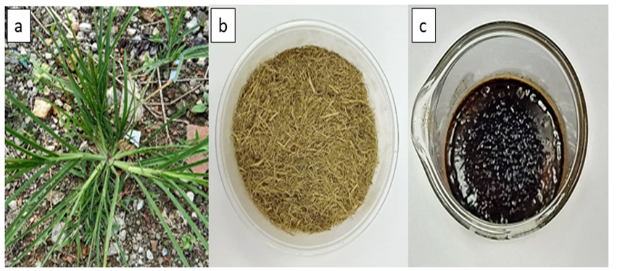

Figure 1. Eleusine indica plant (a), the dried ground leaves (b), Eleusine indica methanol extract (c)

Table 1. Percentage yield of Eleusine indica crude extract

Type of  Crude Extract | Weight of Sample  (g) | Weight of Crude  (g) | Percentage of Crude Extract  (%)
Methanol | 250 | 13.3 | 5.32

Methanol extraction resulted in moderate weight and percentage yield of Eleusine indica. Methanol is a polar solvent that can extract most of the key phytochemical compounds [19]. Compared with aqueous solvent, methanol solvent has less polarity which gives more efficiency in term of extraction because of its capability in degradation of cell wall. Thus, methanol provides excellent capability in extraction of secondary metabolites such as phenolics, glycosides, tannins, flavonoids, saponins, steroids and alkaloids [20, 21]. These secondary metabolites have polyhydroxy group that are suitable in reducing metal ions to nanoparticles [22]. According to Iberahim et al. [23], Eleusine indica methanol extract have several groups of metabolites including phenolics, glycosides, flavonoids and terpenoids. These metabolites substantiate the selection of Eleusine indica in this study to potentially act as reducing and stabilizing agent in the synthesis of AgNPs.

Biomimetic synthesis and characterization of silver nanoparticles

Formation of silver nanoparticles in this study is monitored by color change. Figure 2 shows the color changes when the Eleusine indica methanol extract was mixed with a 1 mM AgNO₃ solution and treated at room temperature for 24 hours. The appearance of a yellowish solution in the reaction vessel indicated the formation of AgNPs due to excitation of surface plasmon resonance in the AgNPs [24,25].

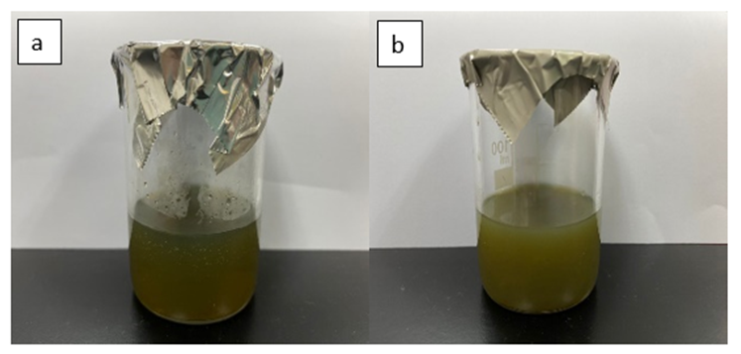

Figure 2. Eleusine indica extract (a), Eleusine indica extract mixed with silver nitrate after 24 hours (b)

Characterization of silver nanoparticles

Ultraviolet-visible spectroscopy (UV-Vis) and transmission electron microscopy (TEM) were used to characterize the synthesized AgNPs. As illustrated in Figure 3, the surface plasmon resonance of the AgNPs is centered at approximately 413 nm, indicating the presence of AgNPs in the solution. AgNPs are known to exhibit a UV-Visible absorption maximum in the range of 400-500 nm because of surface plasmon resonance [26]. The conduction band and valence band in AgNPs are relatively close to one other, allowing the electrons to travel freely. The collective oscillation of electrons of silver nano particles in resonance with the light wave produces a surface plasmon resonance (SPR) absorption band, which is caused by these free electrons [27]. According to Kerker [28], the absorbance of AgNPs depends mainly upon size and shape. thus, this will affect the absorbance of AgNPs that obtained.

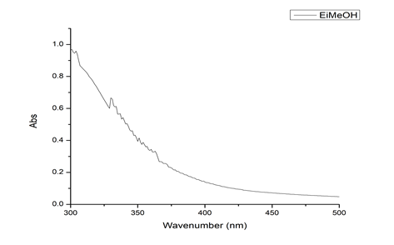
(a)

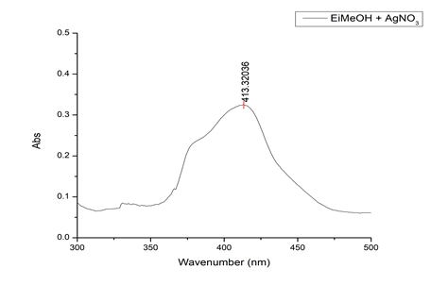
(b)

Figure 3. UV-Vis absorption spectrum of Eleusine indica extract (EI-MeOH) (a) and synthesized silver nanoparticles (EI-MeOH-AgNPs) (b)
The morphology and size distribution of plant-mediated AgNPs was analyzed using TEM micrograph. The TEM image in Figure 4 (left) shows that the particles are almost spherical. The particles size histograms of the plant-mediated AgNPs (Figure 4-right) suggest that the particles diameter is within the range of 10 nm to 55 nm with an average size of 20 nm. Silver nanoparticles, in particular, have varying scale sizes depending on the type of plant extracts used [16]. For example, the silver nanoparticles synthesized using Plumbago auriculata leaves has average size between 15 to 30 nm [29]. [30] found that AgNPs synthesized using Datura stramonium leaf extract has average size of 15 to 20 nm. Based on the theory of quantum restraint, a smaller wavelength leads to a higher energy of the wave and a smaller particle size [31].

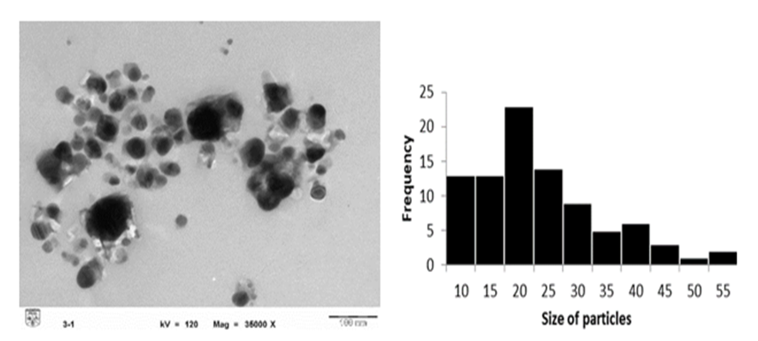

Figure 4. TEM micrograph and particle histogram

It has been reported that Eleusine indica extract contains 12 metabolites such as hydroxycinnamic acid, naringenin (flavanones), 2(3,4-dihydroxyphenyl)-7-hydroxy-5-benzenepropanoic acid, antraquinone, caffeic acid derivative, caffeoyl glucose, hydroxybenzoic acid derivatives methyl 2-[cyclohex-2-en-1-yl(hydroxy)methyl]-3-hydroxy-4-(2-hydroxyethyl)-3-methyl-5-oxoprolinate (aglycone) from the flavonoid and phenolic groups [12]. Active oxygen found in phenols, flavonoids, and triterpenoic acid can donate electrons into AgNPs to reduce silver precursors [32]. This reduction of silver ions to silver nanoparticles could be possibly due to -OH groups in flavonoids such as quercetin, which can be released during the tautomeric change of flavonoids from the enol to keto type that releases reactive hydrogen atoms that are responsible for the reduction of silver nanoparticles [33]. Figures 5 show the possible mechanism of reduction of silver ions to AgNPs by naringenin (flavonone) molecule.

Figure 5. The proposed mechanism for the formation of plant-mediated AgNPs

Antibacterial activity of silver nanoparticles

The efficacy of AgNPs as promising antimicrobial has been experimentally tested against a wide range of medically important planktonic and sessile pathogenic microorganisms including bacteria, viruses, champignons, lichens and yeasts [34, 35]. In this study, the plant-mediated silver nanoparticles were tested against Gram-positive bacteria and Gram-negative bacteria. Table 2 shows the MIC and MBC test of synthesized silver nanoparticles against Staphylococcus aureus, Bacillus subtilis, Escherichia coli and Enterobacter aerogenes.

Table 2. MIC and MBC test of silver nanoparticles synthesized by Eleusine indica against four bacteria

Bacteria | MIC  (μg/mL) | MBC  (μg/mL) | MBC to MIC Ratio
Staphylococcus aureus | 12.5 | 12.5 | 1
Bacillus subtilis | 1.56 | 1.56 | 1
Escherichia coli | 6.25 | 12.5 | 2
Enterobacter aerogenes | 3.13 | 6.25 | 2

Based on the MIC and MBC values, the synthesized nanoparticle suggest the display of bacteriocidal potentials. The formal definition of a bactericidal agent is the ratio of MBC to MIC is ≤ 4, while a bacteriostatic agent has an MBC to MIC ratio of > 4 (CLSI). AgNPs antibacterial effects may be determined by the characteristics of certain bacterial species and the type of metabolite present in the plant [36] as well as the size ranges and shapes of the AgNPs [27]. Theoretically, upon interaction with bacteria, nanoparticles bind with bacterial membrane which causes changes to both its physical and chemical nature. Nevertheless, the normal physiological process such as respiration and permeability of cells will be compromised [37]. Besides, the formation of various reactive nitrogen and oxygen species can be induced by nanoparticles that generates oxidative stress on DNA, and other important cell constituents which disrupt the overall functioning of bacterial cells.

Conclusion

In conclusion, the biomimetic method was demonstrated as a simple, safe, cost-effective, and ecofriendly preparation of AgNPs using Eleusine indica methanol extract. The synthesized plant-mediated AgNPs gave UV-Vis reading at 413 nm and have an average particle size of 20 nm. They showed potential antibacterial activity against Gram-positive and Gram-negative bacteria including Staphylococcus aureus, Bacillus subtilis, Escherichia coli and Enterobacter aerogenes. Thus, application of these synthesized AgNPs based on the findings may lead to valuable discoveries in various fields, including medical devices and in the pharmaceutical and biomedical industries. Toxicity studies of these AgNPs using human pathogens may open the door to a new range of antibacterial agents and the possibility to the use of AgNPs as antiviral agents.

Acknowledgement

The authors would like to acknowledge Ministry of Education for the financial support under Fundamental Research Grant Scheme (FRGS/1/2019/STG01/UITM/02/10) and Universiti Teknologi MARA (UiTM), Negeri Sembilan Branch, Kuala Pilah Campus, Negeri Sembilan; Faculty of Applied Sciences, Universiti Teknologi MARA, Shah Alam Selangor; Faculty of Science & Technology and CRIM, Universiti Kebangsaan Malaysia, Bangi Selangor for providing the research facilities. Thanks also to Mr Yip Chee Wai for the invaluable guidance in the antibacterial assays. Not to be missed is our profound acknowledgement to Forest Research Institute Malaysia (FRIM), Mrs Syahida Emiza binti Suhaimi and Mr Mohd Aidil bin Nordin for helping in plant identification.

References
- Logeswari, P., Silambarasan, S. and Abraham, J. (2015). Synthesis of silver nanoparticles using plants extract and analysis of their antimicrobial property. Journal of Saudi Chemical Society, 19(3): 311-317.
- Safari, J. and Zarnegar, Z. (2014). Advanced drug delivery systems: Nanotechnology of health design a review. Journal of Saudi Chemical Society, 18(2): 85-99.
- Rajeshkumar, S. and Bharath, L. V. (2017). Mechanism of plant-mediated synthesis of silver nanoparticles – A review on biomolecules involved, characterisation and antibacterial activity. Chemico-Biological Interactions, 273: 219-227.
- Ahmed, S., Saifullah, Ahmad, M., Swami, B. L. and Ikram, S. (2016). Green synthesis of silver nanoparticles using Azadirachta indica aqueous leaf extract. Journal of Radiation Research and Applied Sciences, 9(1): 1-7.
- Poulose, S., Panda, T., Nair, P. P. and Théodore, T. (2014). Biosynthesis of silver nanoparticles. Journal of Nanoscience and Nanotechnology, 14(2): 2038-2049
- Mosaviniya, M., Kikhavani, T., Tanzifi, M., Tavakkoli Yaraki, M., Tajbakhsh, P. and Lajevardi, A. (2019). Facile green synthesis of silver nanoparticles using Crocus Haussknechtii Bois bulb extract: Catalytic activity and antibacterial properties. Colloids and Interface Science Communications, 33(8): 100211.
- Zhao, X., Zhou, L., Riaz Rajoka, M. S., Yan, L., Jiang, C., Shao, D. and Jin, M. (2018). Fungal silver nanoparticles: Synthesis, application and challenges. Critical Reviews in Biotechnology, 38(6): 817-835.
- Larayetan, R., Ojemaye, M. O., Okoh, O. O. and Okoh, A. I. (2019). Silver nanoparticles mediated by Callistemon citrinus extracts and their antimalaria, antitrypanosoma and antibacterial efficacy. Journal of Molecular Liquids, 273: 615-625.
- Roy, K., Sarkar, C. K. and Ghosh, C. K. (2015). Plant-mediated synthesis of silver nanoparticles using parsley (Petroselinum crispum) leaf extract: spectral analysis of the particles and antibacterial study. Applied Nanoscience (Switzerland), 5(8): 945-951.
- Shehzad, A., Qureshi, M., Jabeen, S., Ahmad, R., Alabdalall, A. H., Aljafary, M. A. and Al-Suhaimi, E. (2018). Synthesis, characterization and antibacterial activity of silver nanoparticles using Rhazya stricta. PeerJ, 2018(12): 1-15.
- Lalitha, A., Subbaiya, R. and Ponmurugan, P. (2013). Green synthesis of silver nanoparticles from leaf extract Azhadirachta indica and to study its anti-bacterial and antioxidant property. International Journal of Current Microbiology and Applied Sciences, 2(6): 228-235.
- Abdul, A. B., Al-Zubairi, A. S., Abdelwahab, S. I., Peng, C. Y., Mohan, S. and Elhassan, M. M. (2011). Eleucine indica possesses antioxidant, antibacterial and cytotoxic properties. Evidence-Based Complementary and Alternative Medicine, 2011: 965370.
- Iberahim, R., Nor, N. S. M., Yaacob, W. A. and Ibrahim, N. (2018). Eleusine indica inhibits early and late phases of herpes simplex virus type 1 replication cycle and reduces progeny infectivity. Sains Malaysiana, 47(7): 1431-1438.
- Devi, M., Devi, S., Sharma, V., Rana, N., Bhatia, R. K. and Bhatt, A. K. (2020). Green synthesis of silver nanoparticles using methanolic fruit extract of Aegle marmelos and their antimicrobial potential against human bacterial pathogens. Journal of Traditional and Complementary Medicine, 10(2): 158-165.
- Lee, S. H. and Jun, B. H. (2019). Silver nanoparticles: Synthesis and application for nanomedicine. International Journal of Molecular Sciences, 20(4): 1-23.
- Din, L. B., Mie, R., Samsudin, M. W., Ahmad, A. and Ibrahim, N. (2015). Biomimetic synthesis of silver nanoparticles using the Lichen ramalina dumeticola and the antibacterial activity. Malaysian Journal of Analytical Sciences, 19(2): 369-376.
- Wang, W., Li, N., Luo, M., Zu, Y. and Efferth, T. (2012). Antibacterial activity and anticancer activity of Rosmarinus officinalis L. essential oil compared to that of its main components. Molecules, 17(3): 2704-2713.
- Zarai, Z., Kadri, A., Ben Chobba, I., Ben Mansour, R., Bekir, A., Mejdoub, H. and Gharsallah, N. (2011). The in-vitro evaluation of antibacterial, antifungal and cytotoxic properties of Marrubium vulgare L. essential oil grown in Tunisia. Lipids in Health and Disease, 10(1): 161.
- Ahmad, Aftab, Husain, A., Mujeeb, M., Khan, S. A., Alhadrami, H. A. A., & Bhandari, A. (2015). Quantification of total phenol, flavonoid content and pharmacognostical evaluation including HPTLC fingerprinting for the standardization of Piper nigrum Linn fruits. Asian Pacific Journal of Tropical Biomedicine, 5(2): 101-107.
- Truong, D. H., Nguyen, D. H., Ta, N. T. A., Bui, A. V., Do, T. H. and Nguyen, H. C. (2019). Evaluation of the use of different solvents for phytochemical constituents, antioxidants, and in vitro anti-inflammatory activities of Severinia buxifolia. Journal of Food Quality, 2019: 8178294.
- Gupta, M., Thakur, S., Sharma, A. and Gupta, S. (2013). Qualitative and quantitative analysis of phytochemicals and pharmacological value of some dye yielding medicinal plants. Oriental Journal of Chemistry, 29(2): 475-481.
- Sahu, N., Soni, D., Chandrashekhar, B., Satpute, D. B., Saravanadevi, S., Sarangi, B. K. and Pandey, R. A. (2016). Synthesis of silver nanoparticles using flavonoids: hesperidin, naringin and diosmin, and their antibacterial effects and cytotoxicity. International Nano Letters, 6(3): 173-181.
- Iberahim, R., Yaacob, W. A. and Ibrahim, N. (2015). Phytochemistry, cytotoxicity and antiviral activity of Eleusine indica (sambau). AIP Conference Proceedings, 1678: 1–5.
- Shankar, S. S., Rai, A., Ankamwar, B., Singh, A., Ahmad, A. and Sastry, M. (2004). Biological synthesis of triangular gold nanoprisms. Nature Materials, 3(7): 482-488.
- Kumar R, Ghoshal G, J. A. and G. M. (2017). Rapid green synthesis of silver nanoparticles (AgNPs) using (Prunus persica) plants extract: Exploring its antimicrobial and catalytic activities. Journal of Nanomedicine & Nanotechnology, 08(04): 2157-7439
- Ashraf, J. M., Ansari, M. A., Khan, H. M., Alzohairy, M. A. and Choi, I. (2016). Green synthesis of silver nanoparticles and characterization of their inhibitory effects on AGEs formation using biophysical techniques. Scientific Reports, 2015(6): 1-10.
- Zhang, X. F., Liu, Z. G., Shen, W. and Gurunathan, S. (2016). Silver nanoparticles: Synthesis, characterization, properties, applications, and therapeutic approaches. International Journal of Molecular Sciences, 17(9): 1534.
- Kerker, M. (1985). The optics of colloidal silver: something old and something new. Journal of Colloid and Interface Science, 105(2): 297-314.
- Singh, K., Naidoo, Y., Mocktar, C. and Baijnath, H. (2018). Biosynthesis of silver nanoparticles using Plumbago auriculata leaf and calyx extracts and evaluation of their antimicrobial activities. Advances in Natural Sciences: Nanoscience and Nanotechnology, 9(3): 035004.
- Gomathi, M., Rajkumar, P. V., Prakasam, A. and Ravichandran, K. (2017). Green synthesis of silver nanoparticles using Datura stramonium leaf extract and assessment of their antibacterial activity. Resource-Efficient Technologies, 3(3): 280-284.
- Narchin, F., Larijani, K., Rustaiyan, A., Ebrahimi, S. N. and Tafvizi, F. (2018). Phytochemical synthesis of silver nanoparticles by two techniques using Saturaja rechengri Jamzad extract: Identifying and comparing in vitro anti-proliferative activities. Advanced Pharmaceutical Bulletin, 8(2): 235-244.
- Ramesh, A. V., Devi, D. R., Battu, G. R. and Basavaiah, K. (2018). A Facile plant mediated synthesis of silver nanoparticles using an aqueous leaf extract of Ficus hispida Linn. f. for catalytic, antioxidant and antibacterial applications. South African Journal of Chemical Engineering, 26(7): 25-34.
- Jain, S. and Mehata, M. S. (2017). Medicinal plant leaf extract and pure flavonoid mediated green synthesis of silver nanoparticles and their enhanced antibacterial property. Scientific Reports, 7(1): 1-13.
- Burdușel, A. C., Gherasim, O., Grumezescu, A. M., Mogoantă, L., Ficai, A. and Andronescu, E. (2018). Biomedical applications of silver nanoparticles: An up-to-date overview. Nanomaterials, 8(9): 1-25.
- Mie, R., Samsudin, M. W., Din, L. B., Ahmad, A., Ibrahim, N. and Adnan, S. N. A. (2013). Synthesis of silver nanoparticles with antibacterial activity using the lichen Parmotrema praesorediosum. International Journal of Nanomedicine, 9(1): 121-127.
- Kim, J. S., Kuk, E., Yu, K. N., Kim, J. H., Park, S. J., Lee, H. J. and Cho, M. H. (2007). Antimicrobial effects of silver nanoparticles. Nanomedicine: Nanotechnology, Biology, and Medicine, 3(1): 95-101.
- Salomoni, R., Léo, P. and Rodrigues, M. F. A. (2015). Antibacterial activity of silver nanoparticles (agnps) in staphylococcus aureus and cytotoxicity effect in mammalian cells. The Battle Against Microbial Pathogens: Basic Science, Technological Advances and Educational Programs, 2015: 851-857.

