ENHANCING TRYPSIN RECOVERY USING POLYMER-BASED AFFINITY ULTRAFILTRATION MEMBRANE: EFFECTS OF ELUTION pH AND DISPLACING SALTS

(Meningkatkan Perolehan Tripsin menggunakan Membran Afiniti Ultrafiltrasi

berasaskan Polimer: Kesan pH Pengeluatan dan Penggantian Garam)

Norhafiza Ilyana Yatim¹, Sofiah Hamzah^{2*}, Maslinda Alias², Nora’aini Ali^{1,2}, Marinah Mohd Ariffin³,

Abdul Wahab Mohammad⁴

¹Higher Institution Centre of Excellence (HICoE), Institute of Tropical Aquaculture and Fisheries

²Faculty of Ocean Engineering Technology and Informatics

³Faculty of Science and Marine Environment

Universiti Malaysia Terengganu, 21030 Kuala Nerus, Terengganu, Malaysia

⁴Faculty of Engineering and Built Environment

Universiti Kebangsaan Malaysia, 43600 UKM Bangi, Selangor, Malaysia

*Corresponding author: sofiah@umt.edu.my

Abstract

Downstream processing of trypsin synthesis, which includes purification, is a major issue due to high complexity of the bio-suspension itself and the stress sensitivity of the desired target molecules. Therefore, an affinity membrane was fabricated in this study using polysulfone polymers and modified by chitosan to enhance biofouling resistance. To determine the optimum conditions for maximum trypsin adsorption and desorption during affinity ultrafiltration process, elution buffers and pH were investigated using various types of displacing salts (potassium chloride, KCl; sodium chloride, NaCl; magnesium chloride, MgCl₂; calcium chloride, CaCl₂) and elution pH (pH 4, 5, 6, 7, 8). The result showed that the buffer using KCl was identified as the best displacing salt as it recovered the highest trypsin of 78.84%, with a purification fold of 1.31. Trypsin recovery increased to 92% and 1.20 purification fold when the experiments were at pH 8. These buffers dissolved the interference chemical bonds comprising trypsin-trypsin inhibitor interactions and restore target trypsin to the permeate stream in an active state for maximum trypsin recovery. The information provided in this study represents a possible future avenue for developing an affinity membrane system.

Keywords: affinity, ultrafiltration, trypsin, elution pH, displacing salt creator

Abstrak

Pemprosesan hiliran sintesis tripsin, yang termasuk penulinan, adalah isu utama kerana kerumitan bio-pengampaian itu sendiri dan kepekaan tekanan molekul sasaran yang dikehendaki. Oleh itu, membran afiniti telah direka dalam kajian ini menggunakan polimer polisulfon dan diubahsuai oleh kitosan untuk meningkatkan rintangan bio-kotoran. Untuk menentukan keadaan optimum untuk penjerapan tripsin maksimum dan penyahjerapan semasa proses ultrafiltrasi perkaitan, penimbal pengeluat dan pH telah disiasat menggunakan pelbagai jenis garam pengganti (kalium klorida, KCl; natrium klorida, NaCl; magnesium klorida, MgCl₂; kalsium klorida, CaCl₂) dan pH pengeluatan (pH 4, 5, 6, 7, 8). Hasilnya menunjukkan bahawa penimbal menggunakan KCl dikenal pasti sebagai garam pengganti terbaik kerana ia perolehan tripsin tertinggi sebanyak 78.84%, dengan lipatan penulenan 1.31. Perolehan tripsin meningkat kepada 92% dan 1.20 lipatan penulenan apabila eksperimen berada di pH 8. Penimbal ini telah melarutkan ikatan kimia yang menganggu yang terdiri daripada interaksi perencat tripsin-tripsin dan memulihkan tripsin sasaran ke aliran menelap dalam keadaan aktif untuk perolehan maksimum tripsin. Maklumat yang disediakan dalam kajian ini mewakili jalan masa depan yang mungkin untuk membangunkan sistem membran afiniti.

Kata kunci: afiniti, ultrafiltrasi, tripsin, pH pengeluat, pencipta pengganti garam

Introduction

Affinity ultrafiltration membranes have unfolded a new avenue in membrane technology due to the ability of membranes to bind specifically to target molecules/proteins via a specific interaction. This type of membrane results from a combination of two separation processes, namely affinity adsorption and ultrafiltration. It comprises the use of affinity ligands attached to the crosslinked or activated membrane matrix covalently. Ligands are bound to the target enzyme with different adsorption mechanisms and degrees of specificity, depending on the type of ligand used. This system conducts affinity adsorption and ultrafiltration in stages in ultrafiltration modules or separate systems [1].

The recent literature on the development of affinity chromatographic membranes describes highly diversity for proteins and enzyme purification in particular [2]. In fact, several recent studies have reported the rapid development of affinity membranes for protein recovery which increased gradually due to the need of this protocol to obtain high protein quality [3-6]. To meet the growing market demand for this enzyme, commercial production should focus either on innovating alternative procedures or modifying existing methods with slight improvement [7]. Based on the studies described above, affinity membrane chromatography has great potential to isolate a single protein fraction from protein mixture.

The target enzymes can be dissociated from the enzyme-ligand complex and passed through the affinity membranes by applying a suitable elution buffer on the system at the same operating pressure. Various buffers and conditions can be utilised for these studies; affinity-bound enzyme elution and elution using high-concentration salt solution are widely used [8]. This elution buffer breaks the connections between the target enzyme and ligand, lowers its binding affinity and forces the desired enzyme into the permeate stream.

Trypsin is one of the most well-known proteases and consists of serine endopeptidases [9]. Trypsin has a wide range of applications due to its strong proteolytic function and specificity of action, including its use as a critical intermediary in the manufacture of insulin, cell culture applications, research and production of recombinant proteins for clinical use, debriding agent in the wound care market, and oral treatment for inflammatory edema, hematoma and pain associated with diabetes [10, 11, 12].

In most cases, elution buffers were selected at random, most likely due to convenience or prior experience, although the final aim was to achieve a functional eluate [13]. However, several investigations have shown that elution conditions can substantially impact both the yield and specific activity of eluted products [14, 15]. The selected displacing salts are ensured to be soluble, non-denaturated, stable, transparent, ionic at relevant pH, pH stable, non-hazourdous and available [16].

The main benefit of ultrafiltration techniques over conventional separation methods such as chromatography, electrophoresis and conventional affinity separation is the high product throughput. Furthermore, ultrafiltration technologies are considerably easier to scale up, simple to clean and run, and relatively compact in design [17]. Although the use of ultrafiltration is widespread, its potential in protein fractionation application has not been fully realised in the biotechnology industry due to lack of knowledge on the separation mechanism concepts and membrane fouling [18]. As a result, this study was conducted to determine the most efficient approach to increase the use of unltrafiltration in the biotechnology industry.

This study provides fundamental knowledge in designing a highly specific affinity ultrafiltration membrane for trypsin purification under proper pressure to selectively eliminate target enzyme-ligand complex as a retentate and simultaneously, other unbound impurities flow through membrane pores. Selectivity of polysulfone as a membrane material was due to its strong and thermally stable characteristics. The integration of chitosan with polysulfone was hypothesized to produce a hydrophilic segment on the membrane surface which can be an ideal method to combine both the advantages of hydrophilic and hydrophobic membranes. The use of ligands to support materials using activator (glutaraldehyde) can enhance the performance of affinity membranes. It is crucial to determine the best conditions for the trypsin recovery protocol; therefore, this study was conducted to identify the effects of displacing salt and pH of the buffer solution in separation process. In conclusion, with the integration of affinity chromatographic and high-performance ultrafiltration concept, it is believed that affinity ultrafiltration membrane will become common in the near future especially for protein and enzyme recovery.

Materials and Methods

Chemicals and raw materials

Membranes were produced using a ternary casting solution including polysulfone (PSf) as the polymer, N-methyl-2-pyrrolidone (NMP) as the solvent (provided by Merck), and water (H₂O) as the non-solvent. In this study, N-Methyl-2-Pyrrolidone (NMP) from MERCK Schuchard OHG, Germany, was used as a solvent for PES. As a coagulation medium, distilled water was employed. Fluka trypsin (Mw = 25 000 g/mol) was used as the target enzyme in this study. Trypsin inhibitor type III (ovomucoid) and trypsin (Mw = 25 000 Dalton) purchased from Sigma Aldrich were used for affinity ligand and adsorption study, respectively. Chitosan particle (Sigma Aldrich) was used for hydrophilic modification of asymmetric PSF membrane. Glutraraldehyde (Sigma Aldrich ) was used for membrane activation to develop the affinity membranes. N-α-benzoly-L-arginine p-nitroanilide (BAPNA) was used for enzyme activity. Sodium acetate acetic acid buffer (solution), acetic acid solution, potassium chloride (KCl), sodium chloride (NaCl), calcium chloride (CaCl₂), and magnesium chloride (MgCl₂) were purchased from Sigma Chemical Co. (St Louis, Missouri) for affinity ultrafiltration experiments. All materials utilised in this study were of analytical grade.

Preparation of affinity membrane
For PSf membrane preparation, the weight of the binary dope was determined at 70 g. Then, 85 (wt.%) NMP was heated at 60 ˚C in a reactor flask for 10 minutes. The solvent was then gently infused with 15 (wt.%) polymer (PSf) until all polymers were dissolved and stirred at 300 to 400 rpm for about 8 hours at a constant temperature of 600 ˚C using a WiseStirTM Digital Overhead Stirrer from DAIHAN Scientific, Co., Ltd. To eliminate trapped air bubbles, the resulting polymer solution was immersed in an ultrasonic bath for about 3 hours. The prepared binary dope was then titrated with water as a non-solvent to produce the ternary dope and the stirrer was set to stir at a moderate speed. The presence of a drop of water that changed the colour of the binary dope solution indicated that the cloud point was achieved, and the volume of water titrated was recorded. The polymer solvent mixture was mixed again until all the components utilised were completely dissolved. Finally, the finished dope solution was put into a Schott bottle.

The affinity membrane (CH/PSf-60) was prepared with simple dry/wet phase inversion technique using an electrically casting machine at shear rate of 200 s⁻¹ and then immersed directly into a coagulation bath for 24 hours. For surface modification, a native PSf membrane was immersed into the chitosan solution (0.1 wt.% in acetic acid with pH 5) for 60 minutes to deposit chitosan particles onto the membrane surface and dried in ambient air. The dried membrane was then neutralized with NaOH solution (0.1 M in 50% of water-ethanol mixture) for 30 minutes to ensure that all chitosan acetate was converted to chitosan. To prevent osmotic cracking and to remove the remaining NaOH, the membrane was rinsed with 50% v ethanol solution for 3 times, and followed by washing with distilled water and stored in distilled water before use.

The membrane support (CH/PSf-60) was cut to an area of 14.6 cm² and incubated in an incubation shaker for 150 min in a reacting solution containing different amounts of 25 vol% glutaraldehyde (GTA) aqueous solution in 0.1 M sodium chloride and 0.1 M sodium acetate-acetic acid buffer (pH 7.4). From the reaction, excess glutaraldehyde was removed from the membrane by washing three times with 2 M acetic acid. The trypsin inhibitor was immobilized onto the active membrane for 180 minutes, and the adsorption capacity was measured every 30 minutes. The CH/PSf-60 membrane was referred to as an affinity membrane.

Affinity ultrafiltration experiment
A dead-end cell with a processing volume of 300 mL, and an effective permeation membrane area of 14.6 cm² was used for affinity ultrafiltration. This solution was drawn across the membrane using compressed nitrogen at a pressure of 5 bar. A washing step with 0.1 M phosphate buffer was used to eliminate unbound trypsin and contaminants. For the elution step, the bound trypsin was subsequently desorbed from the affinity membrane using 0.01 M Tris-HCl buffer with various displacing salts, namely KCl, NaCl, CaCl₂ and MgCl₂, and pH (pH 4, 5, 6, 7, 8). When the enzymes were firmly attached to the affinity membrane, it may be beneficial to pause the flow for 15 min after adding the eluent before proceeding with the elution. This phase allows additional time for dissociation to occur, which assists in the recovery of bound trypsin. The total protein content of the eluate was determined using the Bradford assay and trypsin activity.

Determination of total protein and enzyme activity
Protein concentration was calculated using Bradford method with Bovine Serum Albumin (BSA) as the standard. Using a UV-Vis spectrophotometer, absorbance and concentrations were determined by dissolving each 100 µL sample in 5 mL of Bradford reagent. The experiment was repeated with trypsin as the sample. Trypsin activity was assessed with minor changes [19] [12]. As a chromogenic substrate, BAPNA was utilised. Analiquot of the enzyme solution of 200 μL was added to the pre-incubated reaction mixture containing 1000 μL of BAPNA solution (dimethyl sulfoxide) and 200 μL of 0.05 M Tris-HCl. The mixture was incubated at 40°C for 10 min. The enzymatic process was halted by adding 200 μL of 30% (v/v) acetic acid and then centrifuged at 8000x g for 3 min at room temperature. Due to the production of p-nitroaniline, absorbance was used to assess trypsin activity at 410 nm using Equation 1 (Bayramoglu et al., 2003):

(1)
where, q is the amount of trypsin adsorbed onto the membrane (mg.ml⁻¹); C₀ and C are the total protein in the initial solution and the aqueous phase after adsorption, respectively (mg.ml⁻¹); V is the volume of the aqueous solution (ml); and A is the area of the membranes in the adsorption medium (cm²).

Results and Discussion
Characteristics of affinity membrane
As seen in Figure 1(a), affinity membrane generally employs two separation concepts, namely affinity adsorption and ultrafiltration. It comprises the use of affinity ligands attached to the crosslinked or activated membrane matrix covalently. Depending on the ligand utilised, the ligands are attached to the target enzyme through different adsorption methods and specificity. Then, for ultrafiltration separation, a buffer media with sufficient pressure selectively excludes the target enzyme-ligand complex as a retentate while allowing other unbound contaminants to flow through the membrane pores. The target enzymes can be separated from the enzyme-ligand combination and processed through an amplification process. By introducing an appropriate elution buffer to the system at the same operating pressure, the target enzymes can be dissociated from the enzyme-ligand complex and passed through the affinity membranes. Figure 1(b) shows the schematic diagram of the developed affinity membrane consisting of 15% PSf membrane. The PSf membrane underwent surface modification with chitosan to produce membrane hydrophilicity followed by an activation process using glutaraldehyde and immobilised using trypsin inhibitor as ligand.
Trypsin
Chitosan
PSf membrane
Glutaraldehyde
Trypsin inhibitor
Operating pressure
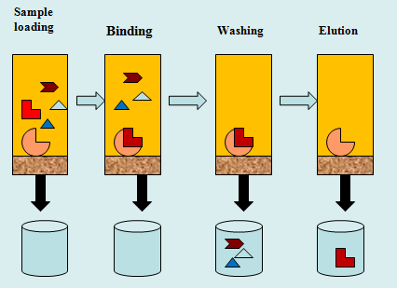
Affinity Membrane Protein
Affinity ligand Impurities

(a) (b)

Figure 1. Graphical image of (a) protein purification protocols using affinity chromatographic membrane developed, and (b) synthesis of affinity membrane

The separation method of the affinity membrane is based on the affinity characteristics of the desired solute molecules. The selection of suitable membrane is one of the important elements influencing the separation performance of affinity ultrafiltration membrane. Large pore sizes and high porosity membrane matrix are necessary to avoid fouling while also allowing larger pollutants to flow through the membrane during the washing phase. The hydrophilic properties of the CH/PSf membrane enhances its ability to immobilise ligands and transmit trypsin during affinity ultrafiltration. Figure 2 depicts the surface morphology of native PSf 15 and affinity membrane after trypsin inhibitor was effectively adsorbed onto the CH/PSf membrane by glutaraldehyde activation.
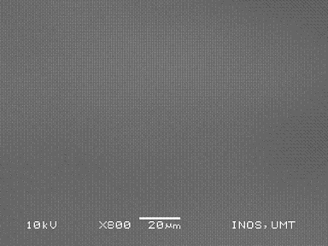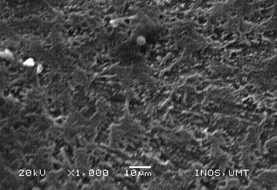
(b)
(a)

Figure 2. Surface morphology of (a) native membrane (PSf 15), and (b) affinity membrane (CH/PSf-60)

Membrane activation with glutaraldehyde results in crosslinking, stabilising the membrane structure during ligand immobilisation [20]. As a result, this affinity membrane has rough and porous surface structure which improves the surface area, minimises mass transfer resistance and facilitates enzyme molecule diffusion. This results in a low diffusional resistance situation in the membrane, which contradicts to the packed bed affinity column, in which significant pressure drops constantly occur [21].

Figure 3 depicts the native membrane (PSf 15) and the affinity membrane by ATR-FTIR. The spectra represented the group of main compounds associated with the native membrane (PSf 15). After incorporating with chitosan, the band stretching was less intense due to the thin layer formation on the PSf 15 membrane. This band revealed the presence of O-H and N-H₂ groups in chitosan in affinity membrane (CH/PSf-60) ranging between 3200 and 3600 cm⁻¹ [22,23]. The O–H stretching vibration peak (v=3200 to 3600 cm⁻¹) was reduced by crosslinking CH/PSf with glutaraldehyde (Figure 2 (b)). The wavelength at 2873 cm⁻¹ exhibited C-H stretching due to aldehyde as well as duplet adsorption with peaks ascribed to the alkyl chain [24]. The band at 1657 cm⁻¹ could be attributed to >C=O stretching (amide I) of the N-acetyl group in chitosan particles and a wavelength of 1722 cm⁻¹ may be attributed to the presence of ethylenic chain [7].

The appearance of aldehyde peaks in the affinity membrane spectrum was due to the incomplete reactivity of glutaraldehyde with the chitosan OH groups during crosslinking network formation. As a bifunctional crosslinking, one aldehyde group may form a hemiacetal structure with hydroxyl groups of CH/PSf polymer chain while the other is unreacted associated with a certain conformation. The addition of a small amount of GTA may increase crosslinking chain with the formation of intermolecular covalent bonds between ligands and membrane (CH/PSf-60) via the availability of free amine group in affinity membrane (CH/PSf-60) [25]. Moreover, as a bi-functional reactive agent capable of reacting with the surface –OH groups of membrane and the amines groups of enzyme inhibitor, GTA could efficiently alleviate strong interaction between ligand and matrix apart from its ability to sustain ligand immobilization to be more resistant to pH changes and ionic strength.
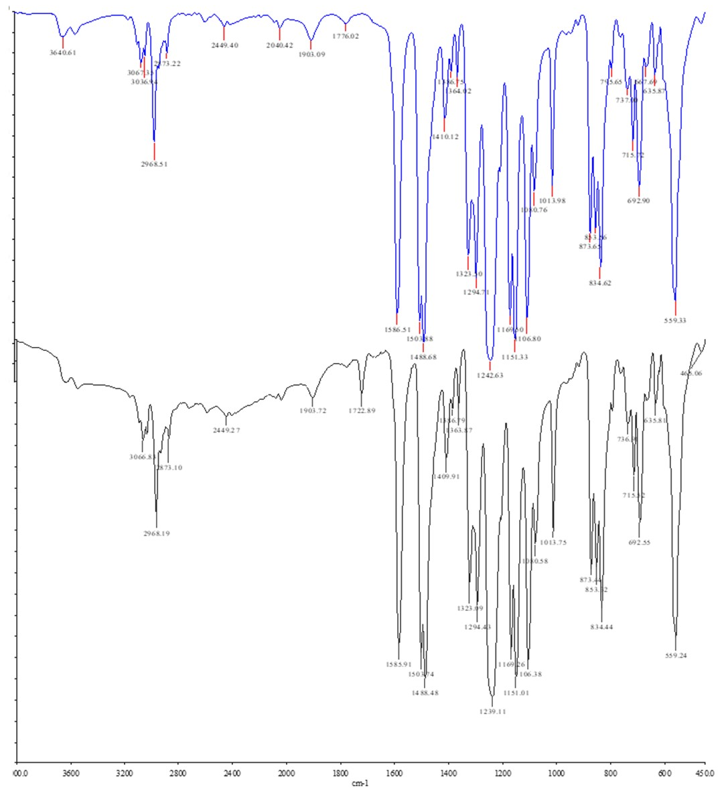
Wavelength (cm⁻¹)
(b)
Transmittance (% T)
(a)

Figure 3. ATR-FTIR spectra of (a) native PSf15 and (b) affinity membrane

Effect of displacing salt in elution buffer
Other impurities and unbound molecules of the desired enzyme were removed using appropriate buffer solution during the washing stage. Although affinity chromatography membrane aims to target enzymes from their affinity ligands, an equally important aspect of this purification technique is the ability to release and recover isolated targets in active form.

A list of buffers and conditions can be applied for this recovery process, or the elution of affinity-bound enzymes using high-concentration salt solution [8] is commonly used. This elution buffer disrupts the interactions between the target enzyme and the ligand to reduce the binding affinity between them and force the desired enzyme in the permeate stream. In most cases, elution buffer options are targeted to obtain a functional eluate [26]. However, a number of studies have demonstrated that elution conditions can significantly influence both the yield and specific activity of the eluted products [27].

In this study, four displacing salts (KCl, NaCl, MgCl₂ and CaCl₂) with 0.05 M ionic strength were added to the elution buffer to determine the ionic species that could enhance the dissociation of enzyme-ligand complex and trypsin transmission through affinity membrane. The results presented in Figures 4 and 5 exhibited a series of trypsin recovery in increasing order: CaCl₂ < NaCl < MgCl₂ < KCl. The main component in the adsorption mechanism is the affinity of positively charged trypsin and negatively charged sites on the membrane surface. The ionic bonding of this enzyme-ligand interaction can be affected by changing the physicochemical environment controlled by the displacing salts.

CaCl₂ MgCl₂

Figure 4. Effect of displacing salts of membrane parameters and data are presented as mean ± standard error (SE), n = 3

MgCl₂ CaCl₂

Figure 5. Effect of displacing salts on trypsin recovery activity and data are presented as mean ± standard error (SE), n = 3

The pH 7 condition provided a favorable environment for trypsin adsorption with the help of electrostatic interaction that has dominated the adsorption. Trypsin was best adsorbed onto the affinity membrane with low positive charge as the electrostatic interactions between enzyme molecules decreased as the membrane increased. Moreover, in this favourable physicochemical environment, the amine groups of the trypsin molecules can undergo protonation to NH₃⁺ [3], and these protonated amino groups on the surface of trypsin enhanced the electrostatic interaction between trypsin and affinity membrane. This observation is in agreement with the previous findings who found that the maximum adsorptive capacity of trypsin occureds around pH 7 [28].

The presence of displacing salts influenced the ionic strength of the elution buffer solution when KCl-HCl was added and then disrupted the electrostatic interaction of enzyme-affinity ligands, thus ionic exchange process occurred. K⁺ cation is more electropositive, then the enzyme-ligand complex was dissociated and permeated through the membrane. Therefore, the trypsin recovery by KCl-HCl was highest at 78.8% with 1.31 purification fold. The properties of high chaotropic effect and salting of K⁺ may destabilize the bonding between trypsin and trypsin inhibitor, leading to enhanced trypsin transmission [16].

The findings were attributed to different elution strengths of displacing ions during competition with trypsin in the affinity system. The trypsin recovery using the displacing salts such as NaCl-HCl, MgCl₂ and CaCl₂ were 65.0%, 69.3% and 40.6%, respectively. Compared to Ca²⁺, Mg²⁺ with higher charge density is a better charge acceptor, thus it is expected to bind more tightly to the protein binding sites [29]. From the experimental observations, the addition of CaCl₂ converted the buffer solution to a cloudy solution, resulting in lower total protein readings and trypsin activity. This finding may be explained due to the formation of metal-enzyme complexes interaction. Calcium is a cosmotropic ion that can promote hydrophobic interaction with trypsin and may retain this enzyme on the membrane surface after elution [30].. Moreover, trypsin was assumed to have two binding sites, and the primary site has high affinity for calcium ions. This interaction has considerably stabilized the enzyme against denaturation [31] and was achieved by a conformational shift in the trypsin molecule, resulting in a more compact structure [32]. This change broke the bonding between trypsin and its ligand, and reduced trypsin transmission during the elution process.

Effect of elution pH
The adsorption behaviour in this study occurred mostly due to electrostatic interaction, and it is important to consider electrostatic interaction between trypsin molecules as well as between trypsin and membranes. pH can induce alteration in spatial structure of the trypsin to affect the affinity of trypsin [33]. A small change in the pH of the solution can alter the electrical charge on proteins as well as membrane due to ionization or deionization of various acidic/basic groups on protein and membrane surface, which can cause either repulsive or attractive interactions [34]. The protein activity can be observed in Figures 6 and 7. The ionization of the charged groups on the ligand and/or the bound trypsin alters as the pH changes. This transition may directly influence the binding sites, reduce their affinity, or cause indirect changes in affinity through conformational changes.

Figure 6. Effect of different pH on total protein, total activity and purity of affinity membranes using KCl buffer and data are presented as mean ± standard error (SE), n = 3

Figure 7. Effect of pH on trypsin recovery of affinity membranes using KCl buffer and data are presented as mean ± standard error (SE), n = 3

Since the optimum adsorption of trypsin occurred at pH7, the trypsin recovery at this condition was 73.6%. This could be due to the fact that the electrostatic attraction of enzyme-ligand was strong and retained on the affinity membrane. Based on the optimum adsorption at pH 7, the pH of the elution buffer should be higher to break down the bonding of the enzyme and its ligand. Using an elution buffer at pH8, trypsin permeated into the membrane and resulted in about 92.0% recovery and 1.2 purification fold. An increase in the pH of elution buffer (pH 8) increased the dissociation of the sulfonic functional group of membranes and created a negative charge of the membrane. Therefore, electrostatic repulsion between enzyme-ligand was disrupted and thus trypsin dissociation occurred. An increase in the surrounding negative charge will cause the trypsin-ligand instability on the affinity membrane, increase the electrostatic repulsion and lead to high protein (trypsin) in eluent [35]. High OH⁻ anion will trigger enzyme aggregation as the net charge of the enzyme surface becomes zero. Therefore, there is no electrostatic repulsive force between trypsin-ligand [36]. The reduction of enzyme adsorption under alkaline pH could be attributed to the electrostatic repulsion between enzyme-membranes [37] and is responsible for lower adsorption, where thermodynamic entropy difference is the only force inducing the adsorption [38].

At lower pHs (6, 5 and 4), the decrease in protein activity due to trypsin recovery was 66.7%, 55.6%, and 50%, respectively. However, at extreme pH (acidic), the protein will be denatured [39]. Therefore, during the measurement of trypsin activity, the conformational changes of the trypsin molecules (denatured trypsin) at acidic pH affect the proper binding of the enzyme to the substrate, resulting in loss of the activity of the recovered trypsin in the permeate [40].

Conclusion
To conclude, this study suggests that the CH/PSf-60 membrane is the most appropriate membrane for trypsin separation. Furthermore, the modification of membrane with chitosan solution is a potential technique to mitigate fouling and improvemembrane lifespan as an excellent matrix material for developing an affinity membrane for trypsin separation and purification. Although the affinity membrane was well prepared, the physicochemical environment of the enzyme solution was also considered to obtain the greatest adsorption capacity. KCl as the displacing salt in the elution buffer solution was the optimum condition for trypsin recovery (78.8%). The recovery increased to 92% by setting the elution buffer pH at pH8. This study proved that the condition of elution buffer significantly influenced the degree of dissociation between the target enzyme and the affinity ligand, and enhanced the separation and purification performance. Thus, the fundamental chemical properties involved in the adsorption and desorption of proteins should be prioritized to develop affinity membrane protocols. The knowledge proposed in this study could be a good pathway for developing affinity membrane systems in the future.

Acknowledgement

The authors like to acknowledge Universiti Malaysia Terengganu for providing facilities and supporting this research.

References
- Fane, A. G. and Radovich, J. M. (2020). Membrane systems. Separation processes in biotechnology. CRC Press: pp 209-262.
- Kielkopf, C. L., Bauer, W. and Urbatsch, I. L. (2021). Considerations for membrane protein purification. Cold Spring Harbor Protocols, 2021(1): 102285.
- Bayramoglu, G., Ozalp, V. C., Altintas, B. and Arica, M. Y. (2014). Preparation and characterization of mixed-mode magnetic adsorbent with p-amino-benzamidine ligand: Operated in a magnetically stabilized fluidized bed reactor for purification of trypsin from bovine pancreas. Process Biochemistry, 49(3): 520-528.
- Ghosh, R. (2016). Bioseparations using integrated membrane processes. Integrated Membrane Systems and Processes: pp 23-34.
- Khangembam, B. K. and Chakrabarti, R. (2015). Trypsin from the digestive system of carp Cirrhinus mrigala: Purification, characterization and its potential application. Food Chemistry, 175: 386-394.
- Zamani, A. and Benjakul, S. (2016). Trypsin from unicorn leatherjacket (Aluterus monoceros) pyloric caeca: Purification and its use for preparation of fish protein hydrolysate with antioxidative activity. Journal of the Science of Food and Agriculture, 96(3): 962-969.
- Sun, J., Yang, L., Jiang, M. and Xu, B. (2017). Stability and activity of immobilized trypsin on carboxymethyl chitosan-functionalized magnetic nanoparticles cross-linked with carbodiimide and glutaraldehyde. Journal of Chromatography B, 1054: 57-63.
- Mondal, K. and Gupta, M. N. 2006. The affinity concept in bioseparation: Evolving paradigms and expanding range of applications. Biomolecular Engineering, 23: 59-76.
- Poonsin, T., Simpson, B. K., Benjakul, S., Visessanguan, W. and Klomklao, S. (2017). Albacore tuna (Thunnus alalunga) spleen trypsin partitioning in an aqueous two-phase system and its hydrolytic pattern on Pacific white shrimp (Litopenaeus vannamei) shells. International Journal of Food Properties, 20(10): 2409-2422.
- Mukherjee, S., Roy, D. and Bhattacharya, P. (2008). Comparative performance study of polyethersulfone and polysulfone membranes for trypsin isolation from goat pancreas using affinity ultrafiltration. Separation and Purification Technology, 60(3): 345-351.
- Braia, M., Loureiro, D., Tubio, G., Lienqueo, M. E. and Romanini, D. (2017). Interaction between trypsin and alginate: An ITC and DLS approach to the formation of insoluble complexes. Colloids and Surfaces B: Biointerfaces, 155: 507-511.
- Vatić, S., Mirković, N., Milošević, J. R., Jovčić, B. and Polović, N. Đ. (2021). Trypsin activity and freeze-thaw stability in the presence of ions and non-ionic surfactants. Journal of bioscience and bioengineering, 131(3): 234-240.
- Lemma, S. M., Boi, C. and Carbonell, R. G. (2021). Nonwoven Ion-Exchange Membranes with High Protein Binding Capacity for Bioseparations. Membranes, 11(3): 181.
- Soper, A. S. and Aird, S. D. (2007). Elution of tightly bound solutes from concanavalin A Sepharose: Factors affecting the desorption of cottonmouth venom glycoproteins. Journal of Chromatography A, 1154(1-2): 308-318.
- Wang, L., Shen, S., He, X., Yun, J., Yao, K. and Yao, S.-J. (2008). Adsorption and elution behaviors of bovine serum albumin in metal-chelated affinity cryogel beds. Biochemical Engineering Journal. 42: 237-242.
- Malmquist, G. and Lundell, N. 1992. Characterization of the influence of displacing salts on retention in gradient elution ion-exchange chromatography of proteins and peptides. Journal of Chromatography A, 627: 107-124.
- Ghosh, R., Wan, Y. H. and Cui, Z. F. (2003). Parameter scanning ultrafiltration: rapid optimization of protein separation. Biotechnology Bioengineering. 81: 673-682.
- Ghosh, R. and Cui, Z. F. (2000). Protein purification by ultrafiltration with pre-treated membrane. Journal of Membrane Science, 167: 47-53.
- Jellouli, K., Bougatef, A., Daassi, D., Balti, R., Barkia, A. and Nasri, M. (2009). New alkaline trypsin from the intestine of Grey triggerfish (Balistes capriscus) with high activity at low temperature: Purification and characterisation. Food Chemistry, 116: 644-650.
- Guo, W. and Ruckenstein, E. (2002). Crosslinked mercerized cellulose membranes for the affinity chromatography of papain inhibitors. Journal of Membrane Science, 197: 53-62.
- Chen, T. -X., Nie, H. -L., Li, S. -B., Branford-White, C., Su, S. -N. and Zhu, L. -M. (2009). Comparison: Adsorption of papain using immobilized dye ligands on affinity membranes. Colloids and Surfaces B: Biointerfaces, 72: 25-31.
- Boributh, S., Chanachai , A. and Jiraratananon, R. (2009). Modification of PVDF membrane by chitosan solution. Journal of Membrane Science, 342: 97–104.
- Varghese, J. G., Kittur, A. A., Rachipudi, P. S. and Kariduraganavar, M. Y. (2010). Synthesis, characterization and pervaporation performance of chitosan-g-polyaniline membranes for the dehydration of isopropanol. Journal of Membrane Science, 364: 111-121.
- Mansur, H. S., Sadahira, C. M., Souza, A. N. and Mansur, A. A. P. (2008). FTIR spectroscopy characterization of poly (vinyl alcohol) hydrogel with different hydrolysis degree and chemically crosslinked with glutaraldehyde. Materials Science and Engineering C, 28: 539-548.
- Geng, L., Li, N., Xiang, M., Wen, X., Xu, D., Zhao, F. and Li, K. (2003). The covalent immobilization of trypsin at the galleries of layered γ-zirconium phosphate. Colloids and Surfaces B: Biointerfaces, 30: 99-109.
- Firer, M. A. (2001). Efficient elution of functional proteins in affinity chromatography. Journal of Biochemical and Biophysical Methods, 49: 433-442.
- Lee, W. -C., Chen, C. -H. (2001). Predicting the elution behavior of proteins in affinity chromatography on non-porous particles. Journal of Biochemical and Biophysical Methods, 49: 63-82.
- Wu, J., Luan, M. and Zhao, J. (2006). Trypsin immobilization by direct adsorption on metal ion chelated macroporous chitosan-silica gel beads. International Journal of Biological Macromolecules, 39: 185-191.
- Dudev, T. and Lim, C. (2014). Competition among metal ions for protein binding sites: determinants of metal ion selectivity in proteins. Chemical reviews, 114(1): 538-556.
- de Gonzalo, G., and Lavandera, I. (Eds.). (2021). Biocatalysis for Practitioners: Techniques, reactions and applications. John Wiley & Sons.
- Kishimura, H. and Hayashi, K. (2002). Isolation and characteristics of trypsin from pyloric ceca of the starfish Asterina pectinifera. Comparative Biochemistry and Physiology Part B. Biochemistry and Molecular Biology, 132: 485-490.
- Klomklao, S., Benjakul, S., and Visessanguan, W. (2004) Comparative studies on proteolytic activity of spleen extracts from three tuna species commonly used in Thailand. Journal of Food Biochemistry, 28: 355–372.
- Li, C., Han, Y., Gao, L., Zhang, Y. and Simpson, B. K. (2021). Development of a novel trypsin affinity material using a recombinant buckwheat trypsin inhibitor mutant with enhanced activity. LWT, 146, 111382.
- Aravind, U. K., Mathew, J. and Aravindakumar, C. T. (2007). Transport studies of BSA, lysozyme and ovalbumin through chitosan/polystyrene sulfonate multilayer membrane. Journal of Membrane Science, 299: 146-155.
- Purkait, M. K., Sinha, M. K., Mondal, P. and Singh, R. (2018). Introduction to membranes. Interface science and technology, Elsevier, 25: 1-37.
- Gustafsson, H., Thörn, C. and Holmberg, K. (2011). A comparison of lipase and trypsin encapsulated in mesoporous materials with varying pore sizes and pH conditions. Colloids and Surfaces B: Biointerfaces, 87: 464-471.
- Chen, N., Zou, J., Wang, S., Ye, Y., Huang, Y., Gadda, G. and Yang, J. (2009). designing protease sensors for real-time imaging of trypsin activation in pancreatic cancer cells. Biochemistry, 48: 3519
- Li, X., Zhang, Y. and Fu, X. 2004. Adsorption of glutamicum onto polysulphone membrane. Separation and Purification Technology, 37: 187-198.
- Zhou, L., Liao, T., Liu, J., Zou, L., Liu, C. and Liu, W. (2019). Unfolding and inhibition of polyphenoloxidase induced by acidic pH and mild thermal treatment. Food and Bioprocess Technology, 12(11): 1907-1916.
- Kim, J. S. and Lee, S. (2019). Immobilization of trypsin from porcine pancreas onto chitosan nonwoven by covalent bonding. Polymers, 11: 1462.

