

SUPRAMOLECULAR ASSEMBLIES OF 1,2-DISUBSTITUTED CYCLOHEXANE AMIDE LIGANDS AND THEIR COORDINATION POLYMER: SYNTHESIS, CHARACTERISATION, AND

CRYSTAL STRUCTURE

(Himpunan Supramolekul Ligan Amida Sikloheksana 1,2-Tertukar Ganti dan Polimer
Koordinatannya: Sintesis, Pencirian, dan Struktur Hablur)

Nur Shuhaila Haryani Haris¹, Nafisah Mansor¹, Maisara Abdul Kadir^{1,2}*

¹Faculty of Science and Marine Environment,
²Advanced Nano Materials Research Group, Faculty of Science and Marine Environment,
Universiti Malaysia Terengganu, 21030 Kuala Nerus, Terengganu, Malaysia

*Corresponding author: maisara@umt.edu.my

Received: 13 September 2021; Accepted: 18 December 2021; Published: xx February 2022

Abstract
Supramolecular interactions such as hydrogen bonding, $π$-$π$ stacking, Van der Waals interactions, and metal-ligand are important in stabilising the structure of molecules. In order to determine the presence of supramolecular interactions in two novel compounds, 1,2-disubstituted cyclohexane amide ligands, namely 1,2-bis[N, N’-6-(3-pyridylmethylamido)pyridyl-2-carboxyamido]cyclohexane (L1) and 1,2-bis[N,N’-6-(4-pyridylmethylamido)pyridyl-2-carboxyamido]cyclohexane (L2) were successfully synthesised and fully characterised by FTIR, ¹H and ¹³C NMR and mass spectrometry, while the molecular formula was determined by elemental analysis. X-ray crystallography revealed that the folded conformations of both ligands were stabilised by intramolecular N-H···O=C and N-H···N hydrogen bonds at the pre-organised amide moieties. The crystal’s structure was stabilised by weak face-to-face π-stacking interaction or centroid-centroid π-stacking interaction involving the two pendant pyridine rings. In the crystal structure of one-dimensional coordination polymer, there are two intermolecular hydrogen bonding interactions (N-H···O=C, d = 2.094 Å, D = 2.946 Å and d = 2.090 Å, D = 2.938 Å, N-H···O angle = 161.52°) formed between the pre-organised NH amide donors of a molecule of L1 in one coordination polymer and the amide carbonyl group of a molecule of L1 in an adjacent polymer that leads to the formation of 2-D hydrogen-bonded sheets extend in the ac diagonal.

Keywords: supramolecular, coordination polymer, cyclohexane, hydrogen bonding, racemic

Abstrak
Interaksi supramolekul seperti ikatan hidrogen, susunan $π$-$π$, interaksi Van der Waals dan logam-ligan adalah penting dalam menstabilkan struktur molekul. Dalam usaha mengenalpasti kehadiran interaksi supramolekul dalam dua sebatian baharu, ligan amida sikloheksana 1,2-tertukar ganti, iaitu 1,2-bis[N,N’-6-(3-piridilmetilamino)piridil-2-karboksiamido]sikloheksana (L1) and 1,2-bis[N,N’-6-(4-piridilmetilamido)piridil-2-karboksiamido]sikloheksana (L2) telah disintesis dan dicirikan sepenuhnya dengan FTIR, ¹H dan ¹³C NMR serta spektrometri jisim, manakala formula molekul ditentukan melalui analisis unsur. Kristalografi sinar-X menunjukkan bahawa konformasi bagi kedua-dua ligan distabilkan oleh ikatan hidrogen intramolekul N-H···O=C dan N-H···N pada kawasan amida separa tersusun. Struktur hablur juga distabilkan oleh interaksi lemah susunan muka ke muka atau titik pusat ke titik pusat di antara gelang aromatik piridina. Dalam struktur hablur polimer koordinatan satu dimensi, terdapat dua ikatan hidrogen intermolekul (N-H···O=C, d = 2.094 Å, D = 2.946 Å dan d = 2.090 Å, D = 2.938 Å, N-H···O sudut = 161.52°) yang terbentuk di antara NH amida dari molekul L1 dalam polimer koordinatan dan karbonil amida dari molekul L1 dalam polimer bersebelahannya dan menghasilkan lapisan 2-D ikatan hidrogen yang bersambung ke diagonal ac.

Kata kunci: supramolekul, polimer koordinatan, sikloheksana, ikatan hidrogen, rasemik

Introduction
Supramolecular chemistry is often defined as ‘the chemistry beyond the molecule’ [1]. This term was introduced by Jean-Marie Lehn who won the Nobel Prize in Chemistry in 1987 together with Donald J. Cram and Charles J. Pedersen. They received the prize for their contributions to the synthesis of shape-selective and ion-selective receptors, in particular, the development of selective ‘host-guest’ complexes. In broader terms, supramolecular chemistry is defined as the self-assembly of small molecular subunits into large aggregates via weak intermolecular forces or reversible covalent bonding. The interactions commonly involved in the self-assembly process are hydrogen bonds, π-π interactions (stacking of aromatic rings), Van der Waals forces, cation-interactions, and metal-ligand (M-L) interactions [2]. The order of strength for the intermolecular interactions from very weak to very strong is broadly as follows: hydrophobic/hydrophilic interactions, Van der Waals forces, H-bonding interactions, electrostatic forces and metal coordination [3].

In general, the intermolecular interactions are individually weak, but by using multiple weak intermolecular forces within the assemblies, robust structures can be generated. Besides, the dynamic nature of noncovalent interactions endows supramolecular polymeric systems with many fascinating properties and functions, such as reversibility, adaptability, self-healing, and stimuli-responsiveness [4]. Hydrogen bonding interactions are commonly employed in supramolecular chemistry [5]. Hydrogen bonding occurs between a proton donor attached to an electronegative atom such as O, N, S, F or C (D-H) and an acceptor (A). The donor is partially positive hydrogen while the acceptor is a partially negative atom with unshared valence electrons or polarisable π electrons. The strength of hydrogen bonds is typically around 20 kJmol⁻¹, but can even be as strong as 163 kJmol⁻¹ as has been reported for the F···HF interaction [6,7]. Weak interactions involving π-systems such as π-stacking interactions (π···π) are observed in many supramolecular systems [8]. Other weak interactions involving π-systems are C-H···π, cation···π and anion···π interactions. The C-H···π interaction is classified as weak H-bonding and have similar properties to the weak hydrogen bonds. Cation···π interactions occur between metallic or organic cations and π-bonded systems of the molecule.

Open chain molecules such as amide, thiourea, and urea are of interest because intermolecular amide-amide hydrogen bonding can promote the fabrication of well-defined assemblies of supramolecular chemistry [9]. Furthermore, amide ligands with the presence of pyridyl as one of the outstanding N or O-donor organic linkers have been effectively selected because they can connect metal centres through their pyridyl groups or the amide groups [10]. Thus, in this research, two novel amide compounds containing 1,2-disubstituted cyclohexane spacer were prepared (Figure 1). Compounds 1,2-bis[N,N’-6-(3-pyridylmethyl amido)pyridyl-2-carboxyamido] cyclohexane (L1) and 1,2-bis[N,N’-6-(4-pyridylmethylamido)pyridyl-2-carboxyamido]cyclohexane (L2) were synthesised from a racemic mixture of trans-1,2-diamino cyclohexane in two steps. The incorporation of a cyclohexyl spacer was anticipated to limit the relative arrangements of the two 2,6-pyridine dicarboxamide moieties as compared to common approaches of using aliphatic alkyl chains spacer [11].

The advantages of the pyridyl-amide ligands are the amide groups with both N-H hydrogen donor and C=O hydrogen acceptor can enhance the formation of hydrogen bonds and supramolecular structures. The isomerism and flexibility of ligands play important roles in permitting guest molecules such as anions to interact with the host molecules by using weak hydrogen bonding. The presence of aromatic rings from 1,2-disubstituted cyclohexane amide moieties and pyridine pendant groups is important to achieve well-defined frameworks with higher stability contributed by the supramolecular interactions of π-π stackings. In a work by Yusof et al. [12] the conformation of cyclohexane derived compound was stabilised by intramolecular hydrogen bonds and intermolecular N-H···O and C-H···O hydrogen bonds, which led to centrosymmetric dimers arrangement [12].

Figure 1. The structure of 1,2-bis[N,N’-6-(3-pyridylmethylamido)pyridyl-2-carboxyamido]cyclohexane (L1) and 1,2-bis[N,N’-6-(4-pyridylmethylamido)pyridyl-2-carboxyamido]cyclohexane (L2)

Materials and Methods
Synthesis of 1,2-bis[N,N’-6-(3-pyridylmethyl amido)pyridyl-2-carboxyamido]cyclohexane (L1)
1,2-bis[6-methoxycarbonyl)pyridyl-2-carboxyamido] cyclohexane (0.50 g, 1.1 mmol) and 3-aminomethylpyridine (0.22 mL, 2.3 mmol) were suspended in toluene (20 mL). The reaction mixture was heated at reflux for 72 hours, during which time a white solid precipitated. After cooling to room temperature, the solvent was removed in vacuo, the residue re-dissolved in dichloromethane (40 mL), washed with saturated aqueous sodium bicarbonate solution (2 × 100 mL), and the chlorinated extract was dried over magnesium sulphate. The solvent was removed in vacuum to give a sticky off-white solid. The solid was washed with diethyl ether, dried, and recrystallised from ethanol to give L1 as a white solid (0.55 g, 82%). Mp 250-252 °C. Anal. found: C, 64.19; H, 5.52; N 18.70. (C₃₂H₃₂N₈O₄) requires C, 64.84; H, 5.45; N 18.90%. ¹H (300 MHz; CDCl₃; Me₄Si) δ = 1.32 (2H, m, CH₂), 1.65 (1H, m, CH₂), 2.17 (1H, m, CH₂), 3.87 (1H, s, CH), 4.15 (2H, d, J = 11.43 Hz, CH₂), 7.23 (1H, m, pyH5), 7.82 (2H, m, pyH3, pyH4’, pyH4), 8.28 (2H, m, pyH5’), 8.54 (2H, d, J = 4.81 Hz, pyH6’), 8.65 (2H, m, NH, pyH2’) and 9.07 (1H, d, J = 8.38 Hz, NH). ¹³C (75.1 MHz; CDCl₃; Me₄Si) δ = 23.1, 28.3, 45.1, 54.6, 123.9, 125.7, 125.9, 134.8, 136.7, 139.2, 148.1, 149.5, 149.9, 150.8, 161.1, 162.4. m/z (ES-MS) 592.2 (MH⁺, 100), 593.6 (MH⁺, 50%), 614.5 (MNa⁺, 65%), 1204.2 (M.H₂O+H)⁺, 30%). Selected IR bands (KBr disk, cm⁻¹): 3368 (m), 3267 (m), 2916 (s) 1627 (m), 1650 (s), 1527 (s), 1424 (m), 1306 (s). Crystals were obtained by slow evaporation of a methanol solution of L1 and copper nitrate.

Synthesis of 1,2-bis[N,N’-6-(4-pyridylmethyl amido)pyridyl-2-carboxyamido]cyclohexane hydrate L2·H₂O (L2)
1,2-bis[6-methoxycarbonyl)pyridyl-2-carboxyamido]cyclohexane (0.52 g, 1.2 mmol) and 4-aminomethylpyridine (0.24 mL, 2.4 mmol) were dissolved in hot toluene (20 mL) and heated at reflux for 72 hours. During the course of the reaction, a yellow solid precipitated. The solvent was removed in vacuum to give a yellow solid. The solid was re-dissolved in dichloromethane (40 mL), washed with saturated sodium bicarbonate solution (2 × 100 mL), and the chlorinated layer was dried over magnesium sulphate. The solvent was removed in vacuum to give a yellow oil which was triturated with hot ethyl acetate (5 mL) to give a brown solid. This solid was purified by column chromatography, eluting with 1:9 methanol–CH₂Cl₂ to give L2·H₂O as a brown solid (0.24 g, 33%). Mp 220 – 225 °C. Anal. found: C, 64.67; H, 5.89; N, 18.90. (C₃₂H₃₄N₈O₅) requires C, 64.84; H 5.45; N, 18.91%. ¹H (300 MHz; CDCl₃; Me₄Si) δ = 1.43 (2H, m, CH₂), 1.93 (2H, d, J = 6.73 Hz, CH₂), 2.14 (2H, d, J = 13.29 Hz, CH₂), 3.77 (1H, s, CH), 4.72 (2H, m, CH₂), 7.25 (2H, m, pyH3’, pyH5’), 7.74 (2H, m, pyH3, pyH5), 8.32 (1H, m, pyH4), 8.54 (2H, d, J =5.70 Hz, pyH2’, pyH6’), 9.15 (1H, d, J = 6.25 Hz, NH) and 9.75 (1H, t, J = 6.40 Hz, NH). ¹³C (75.1 MHz; CDCl₃; Me₄Si) δ = 22.5, 28.9, 45.6, 54.0, 124.3, 125.6, 125.9, 139.8, 147.3, 148.9, 149.2, 149.9, 160.5, 161.8. m/z ES-MS) 592.3 (MH⁺, 100%), 593.1 (MH⁺, 75%). Selected IR bands (KBR disk, cm⁻¹): 3282 (m), 2923 (s), 1652 (s), 1671 (s), 1529 (s), 1444 (m), 672 (s). Crystals were obtained by slow evaporation of a methanol solution of L2 and copper perchlorate.

Synthesis of {[CdBr₂(L1)₄]·4H₂O}_{n}
CdBr₂ (0.0026 g, 0.010 mmol) was dissolved in water (5 mL), heated for 5 minutes, before being added dropwise to a solution of L1 (0.0120 g, 0.020 mmol) dissolved in methanol (15 mL). The resulting slightly cloudy solution was heated for 45 minutes to re-dissolve the precipitate and was left to evaporate at room temperature. The solution afforded {[CdBr₂(L1)₄]·4H₂O}_{n} as colourless crystals in low yields (0.009 g, 24%). Mp 230-235ºC.

Results and Discussion
Compounds 1,2-bis[N,N’-6-(3-pyridylmethyl amido)pyridyl-2-carboxyamido]cyclohexane (L1) and 1,2-bis[N,N’-6-(4-pyridylmethylamido)pyridyl-2-carboxyamido]cyclohexane (L2) were synthesised from a racemic mixture of trans-1,2-diaminocyclohexane in two steps (Scheme 1). To synthesise the ligand, firstly, pyridine-2,6-dicarboxylic acid monomethyl ester (i) was reacted with thionyl chloride to produce 6-(methoxycarbonyl)pyridine-2-carboxylic acyl chloride (ii). Then, compound (ii) was reacted with 1,2-diamino cyclohexane (iii) with a 2:1 mol ratio to provide 1,2-bis[6-methoxy carbonyl)pyridyl-2-carboxyamido]cyclohexane (iv). At the second step, precursor (iv) and 3-aminomethylpyridine were suspended in toluene and heated at reflux for approximately 72 hours to give 1,2-bis[N, N’-6-(3-pyridylmethylamido)pyridyl-2-carboxy amido]cyclohexane (L1) (Scheme 1). The crude product of L1 was obtained as an off-white solid after being isolated after re-dissolved in hot ethanol. The insoluble solids were removed by filtration, and the filtrate was left to evaporate to afford L1 as a colourless powder in an 82% yield.

Ligand L2 was prepared with a similar procedure, but the 3-aminomethylpyridine was replaced with 4-aminomethylpyridine. The coordination chemistry of these ligands was investigated with a range of late transition metals, including cadmium(II), copper(II), cobalt(II), silver(I), and zinc(II). The focus of this synthesis was to produce coordination polymers that display anion coordinating pockets (Figure 2). Compounds L1 and L2•H₂O were found to preferentially crystallise from solutions containing metal salts. It showed that the ligands were insoluble in the metal salts solution and caused limitations to obtain metal complexes. Rectangular block-shaped colourless crystals of both compounds were obtained from several different reactions and were suitable for X-ray crystallography.

The FTIR spectra for the three compounds showed distinctive peaks for v(N-H), v(O-H), v(C=N), v(C=O), v(Cd-N), and v(N-O). As for compound L1, the v(N-H) stretching displayed a broad peak due to the water molecule and the weak hydrogen bond interactions interrupted the chemical changes. The low frequency (N-H) stretching appeared at 3267 cm⁻¹ showing that the steric effect occurred with the presence of methyl located near the amino group [13]. Meanwhile, the v(N-H) bending was interpreted at 1527 cm⁻¹ because of the hydrogen bond donor. The strong frequency band at 2916 cm⁻¹ referred to v(C-H) aromatics vibration respective to the formation of sp³ hybridisation. The carbonyl v(C=O) band shifted to the low frequency at 1650 cm⁻¹ suggested the involvement of hydrogen bonds formed between the amide moieties and pendant pyridyl group [14]. In the IR spectrum, the high frequency above 3000 cm⁻¹ regions is a signature area for recognition phenyl C-H stretching vibrations. The region below 2000 cm⁻¹ showed very sharp and strong peaks [15]. The spectrum of L2 showed a close resemblance of the absorbance pattern compared with L1. Compound L2 observed the appearance of amide stretching, ν_{str}(N-H) at 3282 cm⁻¹. A significant stretching vibration of v_{str}(C-H) aromatics band attributed at 2923 cm⁻¹. Nevertheless, the wavenumbers captured in both compounds for v(C=O) amide revealed a significant difference. Compound L2 recorded the appearance of the carbonyl stretching at wavenumbers 1647 cm⁻¹. The compounds showed bands at 1529 cm⁻¹ which was ascribed to the N-H bending.

Scheme 1. The synthesis of L1 and L2

Figure 2. Coordination polymers that display anion coordinating pockets, where A in the circle represents anion

The ¹H NMR spectra of L1 were recorded in deuterated chloroform (Table 1). A signal that appears as a triplet at 9.09 ppm corresponding to the N-H protons of the pyridine core amide [16,17]. The signals for the cyclohexyl amide and the pendant pyridyl H2’ are overlapped to give a broad singlet at 8.65 ppm. Another two signals (H6’ at 8.54 and H5’at 8.28 ppm) were assigned to the pendant pyridine protons H6’ and H5’, while the multiplet near 7.82 ppm corresponded to the overlap between one triplet and doublets from the pyridine carboxamide H4 proton and the H4’ of the pendant pyridine ring. The nearby doublet was assigned as the H3 and H5 hydrogen atoms from the pyridine core. The multiplets at 4.15 ppm arise from the CH₂ protons from the methylene linker adjacent to the pyridine rings. The cyclohexane protons are doublets that appear upfield at 3.87, 2.17, 1.65 and 1.32 ppm. The ESI-MS obtained on a methanol solution of L1 revealed peaks for the parent ion [L1+H]⁺ at m/z 591.2. Meanwhile, a peak at m/z 1204.2 corresponded to the hydrated dimeric species, [(L1)₂·H₂O+H]⁺, while a hydrated trimeric species [(L1)₃·H₂O+H]⁺ was observed at m/z 1793.2 in low relative abundance. There is also a peak observed for a sodium-containing ion, [L1+Na]⁺, at m/z 614.5 (25%).

Based on the conditions employed for the synthesis of L1, the reaction of 6-(methoxycarbonyl)pyridine-2-carboxylic acyl chloride with a greater than two-fold excess of 4-aminomethylpyridine gave L2. Similar to the synthesis of L1, the reaction was heated at reflux for approximately 72 hours, and the formation of the product was monitored by TLC and NMR spectroscopy. Compound L2 was isolated by flash column chromatography techniques using the mixture of dichloromethane-methanol (9:1) as the eluting solvent system. Unfortunately, L2 was isolated in a much lower yield (33%) compared to L1. This is a consequence of the reduced nucleophilicity of the amine nitrogen compared to the 3-substituted precursor, as reported by Ikawa et al., 2011 [18]. Elemental analysis of the product obtained supports the isolation of the hydrate, L2·H₂O. In the ¹H NMR spectrum of L2.H₂O, the amide protons were observed downfield compared to L1, with a doublet at 9.75 ppm and a doublet at 9.15 ppm. The remaining signals between 7.25-8.54 ppm corresponded to the protons from the pyridine ring and the pyridine core. The methylene linker had a resonance at 4.72 ppm, while the cyclohexane protons showed signals at 3.77, 2.14, 1.93, and 1.43 ppm. The mass spectrometry indicated the presence of a dominant molecular ion corresponding to [L2+H]⁺ at m/z 592.3 (100%).

Table 1. ¹H NMR data for L1 and L2
Proton signals | L1 | Proton signals | L2
2H, m, CH₂ | 1.32 |  | 1.43
1H, m, CH₂ | 1.65 | 2H, d, CH₂ | 1.93
1H, m, CH₂ | 2.17 | 2H, d, CH₂ | 2.14
1H, s, CH | 3.87 |  | 3.77
2H, d, CH₂ | 4.15 | 2H, m, CH₂ | 4.72
1H, m, pyH5 | 7.23 | 2H, m, pyH3’, pyH5’ | 7.25
2H, m, pyH3, pyH4’, pyH4 | 7.82 | 2H, m, pyH3, pyH5 | 7.74
2H, m, pyH5’ | 8.28 | 1H, m, pyH4 | 8.32
2H, d, pyH6’ | 8.54 | 2H, d, pyH2’, pyH6’ | 8.54
2H, m, NH, pyH2’ | 8.65 | 1H, d, NH | 9.15
1H, d, NH | 9.07 | 1H, t, NH | 9.75

X-ray crystallography
Crystal structure of L1
The particular crystals of L1 studied here were readily obtained from a methanol solution of copper nitrate and L1, consistent with the poor solubility of these compounds. Compound L1 crystallises in the triclinic space group P-1 with one molecule of L1 in the asymmetric unit. The structure reveals that this compound retained the two pre-organised amide hydrogen bond donor regions in the anticipated conformation (Figure 3), but as observed in molecule L1, these were arranged to form two separate pockets rather than one larger pocket. This arrangement is attributed to the planar arrangement of the substituents on the cyclohexane ring at the 1 and 2 positions.

In the conformation of L1 observed in the crystal structure, it appears there were intramolecular N-H···O=C and N-H···N hydrogen bonds that stabilised the folded conformation. Figure 3 shows these hydrogen bonds have the following distances, N15-H15···O14 (d = 2.201 Å, D = 2.953 Å), N49-H49···O14 (d = 2.333 Å, D = 3.157 Å), N49-H49···N41 (d =2.308 Å, D = 2.697 Å), and N15-H15···N41 (d = 2.251 Å, D = 2.663 Å). The N-H···N angles are 106.78° and 108.41°, respectively.
Figure 4 shows that several intermolecular interactions were responsible for the formation of a dimeric arrangement of L1 in the solid state. The dimer was stabilised by four N-H···O=C hydrogen bonds between each molecule of L1 (N12-H12···O17, d = 2.158 Å, D = 3.000 Å; and N29-H29···O17 d= 2.111 Å; D = 2.951 Å).
The structure was further stabilised by π-π stacking interactions between the pyridine rings [19]. In the dimer, the pendant pyridyl group and the central pyridine core interact in an edge-to face interaction, in which the C-H···π(centroid) distance is 2.912 Å. Adjacent dimers were then further involved in the π-stacking interactions involving one 2,6-pyridine dicarboxamide core of each molecule of L1 (Figure 5). The two pyridine cores formed a weak face-to-face π-stacking interaction (centroid-centroid distance 4.20 Å; angle 47.46°; centroid offset 1.32 Å). This ultimately resulted in a 1-D chain-like arrangement of the dimers.

Crystals of L2 were obtained from a methanol solution of copper perchlorate and compound L2. Like compound L1, compound L2 also crystallised in the triclinic space group P-1 but with two molecules of compound L2 in the asymmetric unit. The two molecules of L2 have similar conformations, with the major distinction between the two molecules being differences in bond lengths and angles. As observed in compound L1, intramolecular hydrogen bonding (d = 2.249-2.445 Å; N-H···N angles = 107.7 and 105.60°) pre-organised the NH functionalities of the compound to provide two anion pockets (Figure 6).
Like L1, one of these pockets was occupied by carbonyl oxygen of the other 2,6-pyridine dicarboxamide moiety (N-H···O, d = 2.380 Å ; D = 3.234 Å). Once again, intermolecular hydrogen bonding between the carbonyl oxygen (N-H···O) (d = 2.107 Å and D = 2.135 Å) and the pre-organised amide led to the formation of a dimer in the solid-state (Figure 7). Both molecules in the asymmetric unit demonstrated the same hydrogen bonding motifs with slightly different hydrogen bond distances (Table 2). One of the dimers had N-H···O hydrogen bond lengths of d = 2.109 - 2.137 Å, while the second dimer had hydrogen bond lengths of 2.106-2.153 Å. As observed in compound L1, the structures were also stabilised by intermolecular π-π stacking interactions. In the crystal packing, compound L2 was stabilised a centroid-centroid π-stacking interaction involving the two pendant pyridine rings (centroid-centroid distance 3.731 Å). The presence of excessive hydrogen-bonds networks in the compounds explains the huge range in the melting points for both compounds L1 and L2.

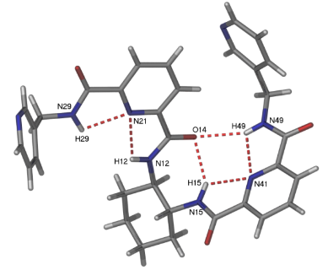

Figure 3. The asymmetric unit of compound L1, showing the presence of intramolecular N-H···O=C and N-H···N hydrogen bonds

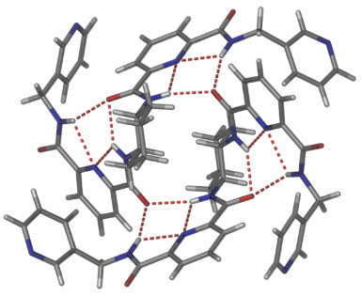
Intramolecular interaction
Intermolecular interaction
Figure 4. A perspective view of a dimer of L1 showing the weak intramolecular and intermolecular hydrogen bonds responsible for the conformation of L1 and the formation of the dimeric aggregate

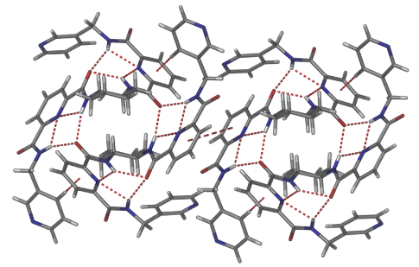
Edge to face $π-π$ stacking
Figure 5. A perspective view of the π-π stacking interactions observed between the two pyridine cores of molecules of L1 that are involved in forming dimers

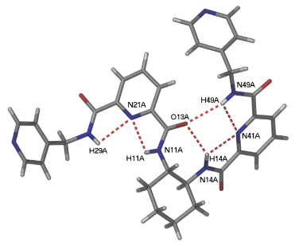
A
A
Figure 6. A perspective view of one of the molecules of L2 in the asymmetric unit, showing the pre-organizing intramolecular hydrogen bonding interactions that provided two potential anion pockets marked by A.

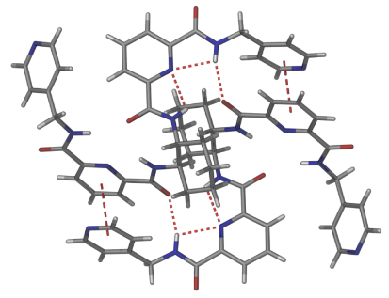
$π$-stacking
Figure 7. A perspective view of one of the dimers of compound L2, showing the intramolecular and intermolecular interactions, including the π-stacking interactions

Table 2. The asymmetric unit of hydrogen bond distances for L1 and L2
L1
N15-H15···O14 | d = 2.201 Å, D = 2.953 Å
N49-H49···O14 | d = 2.333 Å, D = 3.157 Å
N49-H49···N41 | d =2.308 Å, D = 2.697 Å
N15-H15···N41 | d = 2.251 Å, D = 2.663 Å
L2
N-H···O | d = 2.380 Å ; D = 3.234
N-H···O | d = 2.107 Å ; D = 2.135 Å
N-H···O | d = 2.109 - 2.137 Å
N15-H15···O14 | d = 2.249 -2.445 Å

Crystal structure of CP-L1
Crystals of {[CdBr₂(L1)₂]·4H₂O}_{n} were obtained from a methanol-water solution of L1 and cadmium bromide upon slow evaporation in 24% yield. Complex {[CdBr₂(L1)₂]·4H₂O}_{n} was crystallised in the triclinic space group P-1 with one ligand L1, one cadmium atom (on a centre of inversion), two water molecules, and one bromide in the asymmetric unit (Figure 8). The cadmium atom adopts an octahedral coordination environment, with two bromide atoms in the axial positions and the equatorial positions occupied by four pyridyl donors from four separate molecules of L1. The Cd-N bond length is 2.453(4) Å and the Cd-Br bond length is 2.6805(5) Å, which is typically observed [20]. The Cd-Br bond distance was approximately 0.08-0.1 Å longer than the Cd-Br distance in compound 4.27, while the Cd-Cd distance in this compound is 16.765 Å.

The extended structure of compound CP-L1 is shown in Figure 9. Within the ligand, the pendant 4-pyridyl rings twisted backwards and forward relative to the 1,2-cyclohexane core with an -N-CH₂-CH₂-N- torsion angle of 56.3(2)° (Figure 9). This enabled the ligand to coordinate with two different cadmium centres which are also linked by a second molecule of L1.

Each cadmium is coordinated by four molecules of the ligand to generate a necklace-type 1-D coordination polymer. This coordination polymer was also constructed from a dinuclear metallo-macrocylic repeating unit (Figure 9). Two types of ligand derived hydrogen bonding interactions are responsible for the internal conformation of the coordination polymers and the packing of adjacent 1-D coordination polymers in the solid-state. In the inter-polymer packing there are two intermolecular hydrogen bonding interactions in (N-H···O=C, d = 2.094 Å, D = 2.946 Å and d = 2.090 Å, D = 2.938 Å, N-H···O angle = 161.52°) formed between the pre-organized NH amide donors of a molecule of L1 in one coordination polymer and the amide carbonyl group of a molecule of L1 in an adjacent polymer (Figure 10(a)). The intermolecular hydrogen bonding led to the formation of 2-D hydrogen bonded sheets of the 1-D coordination polymers that extended in the ac diagonal (Figure 10(b)). Internally, each ligand within the coordination polymer adopts a conformation whereby the amide C=O forms a moderately strong N-H···O=C intramolecular hydrogen bonding interaction (d = 1.862 Å, D= 2.911 Å). This blocked one of the anion binding pockets of the ligand (Figure 10 (a)). In the 2-D crystal packing, the 1-D coordination polymers in each 2-D layer form C-H···π stacking interactions with 1-D coordination polymers in adjacent layers. These interactions occur between the pendant pyridyl rings of molecules of L1 in the adjacent layers (C-H-centroid distance 2.73 Å; angle 95.30°, centroid offset 1.39 Å Figure 10 (c). Weak intramolecular hydrogen bonding interactions of CP-L1 is shown in Table 3 while crystal data for CP-L1 is shown in Table 4.

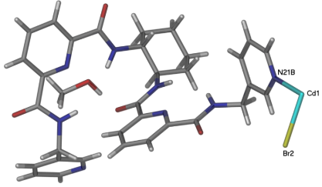
Figure 8. A perspective view of the asymmetric unit of compound CP-L1

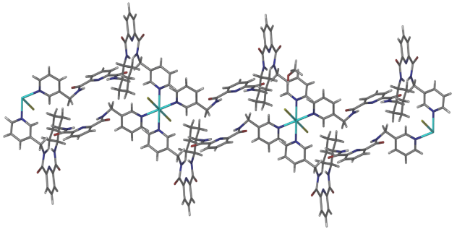
Figure 9. A perspective view of the extended structure of complex CP-L1

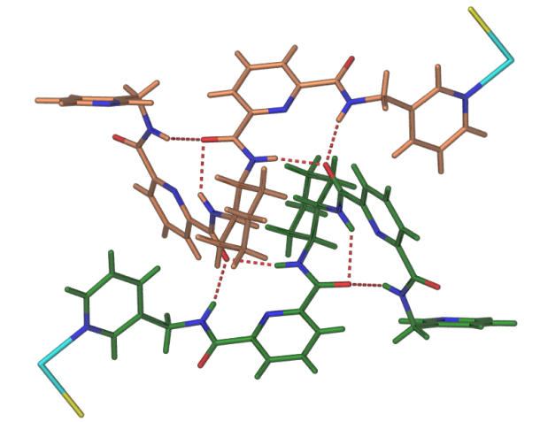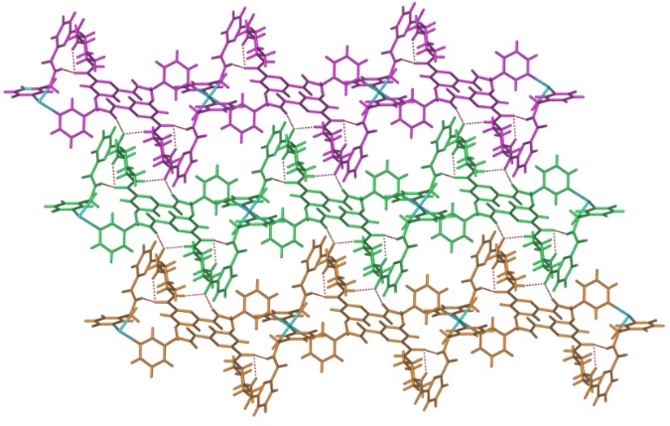
(a)
(b)

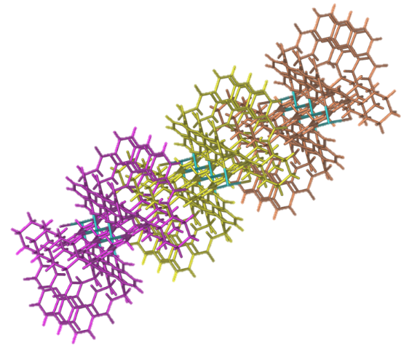
(c)
Figure 10. (a) A perspective view of intra- and the intermolecular hydrogen bonding in CP-L1 (b) The packing of 1-D coordination polymers into 2-D hydrogen bonded sheets (c) A perspective view of the crystal packing

Table 3. Weak hydrogen bonding of CP-L1
CP-L1
N15-H15···O14 | d = 2.201 Å, D = 2.953 Å
N49-H49···O14 | d = 2.333 Å, D = 3.157 Å
N49-H49···N41 | d =2.308 Å, D = 2.697 Å
N15-H15···N41 | d = 2.251 Å, D = 2.663 Å
N-H···O | d = 2.380 Å ; D = 3.234
N-H···O | d = 2.107 Å ; D = 2.135 Å
N-H···O | d = 2.109 - 2.137 Å
N15-H15···O14 | d = 2.249 - 2.445 Å

Table 4. Crystal data for L1, L2 and the CP-L1
Compound | L1 | L2 | CP-L1
Empirical formula | C₃₂H₃₂N₈O₄ | C₃₂H₃₂N₈O₄ | C₃₃H₃₆BrCd_{0.50}N₈O₅
Formula weight | 592.66 | 592.66 | 760.81
Crystal system | Triclinic | Triclinic | Triclinic
Space group | P-1 | P-1 | P-1
a (Å) | 9.0155(10) | 13.0319(15) | 9.4207(5)
b (Å) | 12.1413(9) | 15.1859(13) | 11.4609(7)
c (Å) | 13.7390(16) | 16.7954(16) | 16.1643(9)
α (º) | 81.057(8) | 111.971(8) | 103.151(5)
β (º) | 81.067(9) | 103.352(9) | 103.088(5)
γ (º) | 78.114(8) | 101.168(8) | 97.360(5)
Volume (Å³) | 1441.9(3) | 2965.8(5) | 1625.38(16)
Z | 2 | 4 | 2
Density (calculated) (Mg/m³) | 1.365 | 1.327 | 1.555
Absorption coefficient (mm⁻¹) | 0.094 | 0.091 | 1.638
F(000) | 624 | 1248 | 778
Crystal size (mm³) | 0.30x0.13x0.09 | 0.35x0.08x0.04 | 0.20x0.08x0.04
Theta range for data (º) | 2.91 – 29.86 | 2.47 – 28.24 | 2.57 – 29.94
Reflections collected | 27261 | 34643 | 8454
Observed reflections [I>2s(I)] | 7549 | 12267 | 5156
Data/restraints/parameters | 7549/0/397 | 12267/0/793 | 8454/0/432
Goodness-of-fit on F² | 0.819 | 1.044 | 1.33
R₁ [I>2s(I)] | 0.0604 | 0.0336 | 0.0485
wR₂ (all data) | 0.2629 | 0.2629 | 0.1369
Largest diff. peak and hole (e.Å⁻³) | 0.194 and -0.213 | 1.369 and -0.775 | 1.049 and -0.727

Conclusion
In conclusion, two new 1,2-disubstituted cyclohexane amide ligands and one-dimensional coordination polymer were successfully prepared. L1 and L2 still maintained the pre-organisation of the 2,6-pyridine dicarboxamide in the solid states. X-ray crystallography also revealed that these three compounds crystallised in a triclinic crystal system with space group P-1. Several supramolecular interactions such as intramolecular and intermolecular hydrogen bonding interactions, π-π stacking interactions, C-H···π stacking interactions, and metal to ligand interactions were observed in the crystal structure in order to form a stable molecular architecture.

Acknowledgement

The authors thank the Ministry of Education of Malaysia and the Universiti Malaysia Terengganu for financial support through FRGS (vote number 59579, FRGS/1/2019/STG01/UMT/02/3). The University of Adelaide is also acknowledged for the access to a single-crystal X-ray diffractometer for crystal-structure determination.

References
- Lehn, J. M. (1988). Supramolecular chemistry-scope and perspectives molecules, supermolecules, and molecular devices (nobel lecture). Angewandte Chemie International Edition in English, 27(1): 89-112.

- Lu, R., Zhang, X., Cheng, X., Zhang, Y., Zan, X. and Zhang, L. (2020). Medical applications based on supramolecular self-assembled materials from tannic acid. Frontiers in Chemistry, 8: 1-25.
- Shuturminska, K., O'Malley, C., Collis, D. W. P., Conde, J. and Azevedo H.S. (2018). Displaying biofunctionality on materials through template self-assembly. Self-Assembling Biomaterials, 341-370.
- Qin, B., Yin, Z., Tang, X., Zhang, S., Wu, Y., Xu, J. F. and Zhang, X. (2020). Supramolecular polymer chemistry: From structural control to functional assembly. Progress in Polymer Science, 100: 101167.
- Deng, J. H., Luo, J., Mao, Y. L., Lai, S., Gong, Y. N., Zhong, D. C. and Lu, T. B. (2020). $π$-$π$ Stacking interactions: Non-negligible forces for stabilizing porous supramolecular frameworks. Science Advances, 6(2): eaax9976.
- Frey, P. A. (2004). Low barrier hydrogen bonds. Encyclopedia of Biological Chemistry, 2004: 594-598.
- Wendler, K., Thar, J., Zahn, S. and Kirchner, B. (2010). Estimating the hydrogen bond energy. The Journal of Physical Chemistry A, 114: 9529-9536.
- Castiñeiras, A., Fernández-Hermida, N., García-Santos, I., Gómez-Rodríguez, L., Gil, D. M. and Frontera, A. (2021). Supramolecular, spectroscopic and computational analysis of weak interactions in some thiosemicarbazones derived from 5-acetylbarbituric acid. Journal of Molecular Structure, 5: 131031.
- Ghule, N. V., La, D. D., Bhosale, R. S., Kobaisi, M. A., Raynor, A. M., Bhosale, S. V. and Bhosale, S. V. (2016). Effect of amide hydrogen bonding interaction on supramolecular self-assembly of naphthalene diimideamphiphiles with aggregation induced emission. ChemistryOpen, 5(2): 157-163.
- Rong, X., Lin, H., Liu, D., Wang, X., Liu, G. and Wang X. (2016). Solvothermal synthesis, structures and properties of two new octamolybdate-based compounds with tetrazole- and pyridyl-containing asymmetric amide ligands. Inorganic Chemistry Communications, 71: 9-14.
- Haris, N. S. H., Mansor, N., Yusof, M. S. M., Sumby, C. J. and Kadir, M.A. (2021). Investigating the potential of flexible and pre-organized tetraamide ligands to encapsulate anions in one-dimensional coordination polymers: synthesis, spectroscopic studies and crystal structures. Crystals, 11: 77.
- Yusof, M. S. M., Ayob, N. A. C., Kadir, M. A. and Yamin, B. M. (2008). 1, 2-bis [N’-(2, 2-dimethylpropionyl) thioureido] cyclohexane. Acta Crystallographica Section E: Structure Reports Online, 64(5): o937.
- Shanmugharaj, A. M., Rhee, K. Y. and Ryu, S.H. (2006). Influence of dispersing medium on grafting of aminopropyltriethoxysilane in swelling clay materials. Journal of Colloid and Interface Science, 298(2): 854 -859.
- Oprea, S., Potolinca, V. O. and Varganici, C. D. (2016). Synthesis and properties of polyurethane urea with pyridine-2,6-dicarboxamide moieties in their structure. The Royal Society of Chemistry, 6(108): 106904–106913.
- Yalcin, S. P., Ceylan, U., Sarioglu, A. O. and Sonmez, M. (2015). Sythesis, structural, spectral (FT-IR, ¹H and ¹³C NMR and UV-Vis), NBO and first order hyperpolarizability analysis of N-(4-nitrophenyl)-2, 2-dibenzoylacetamide by density functional theory. Journal of Molecular Structure, 1098: 400-407.
- Basak, A., Ghosh, S. C., Das, A. K. and Bertolasi, V. (2005). A novel azetidinyl $γ$-lactam based peptide with a preference for $β$-turn conformation. Organic and Biomolecular Chemistry, 3: 4050-4052
- Kushwaha, N., Saini, R. K. and Kushwaha, S. K. S. (2011). Synthesis of some amide derivatives and their biological activity. International Journal of ChemTech Research, 3(1): 203-209.
- Ikawa, T., Nishiyama, T., Shigeta, T., Mohri, S., Morita, S., Takayanagi, S-I., Terauchi, Y., Morikawa, Y., Takagi, A., Ishikawa, Y., Fujii, S., Kita, Y. and Akai, S. (2011). Ortho-selective nucleophilic addition of primary aminesto silylbenzynes: synthesis of 2-silylanilines. Angewandte Chemie, 123: 5792-5795.

- Hadadzadeh, H., Rezvani, A. R., Abdolmaleki, M. K., Ghasemi, K., Esfandiari, H. and Daryanavard, M. (2009). Pyridine-2,6-dicarboxylic acid (dipic): crystal structure from co-crystal to a mixed ligand nickel(II) complex. Journal of Chemical Crystallography, 40(1): 48-57.
- Kadir, M. A., Yusof, M. S. M., Sumby, C. J (2018). Conjoint experimental and theoretical evaluation of zinc (II) coordination polymer as potential anion receptors for nitrate and chromate. ASM Journal of Science, 1: 136-146.

