

INSIGHT MECHANISTIC STUDY OF SAMARIUM OXIDE BASED
CATALYST IN METHANATION REACTION

(Kajian Mendalam Mekanistik Pemangkin Berasaskan Samarium Oksida dalam Tindak Balas Metanasi)

Salmiah Jamal Mat Rosid¹*, Susilawati Toemen², Wan Azelee Wan Abu Bakar², Ahmad Zamani Ab Halim³,
Sarina Mat Rosid⁴

¹Unisza Science and Medicine Foundation Centre,
Universiti Sultan Zainal Abidin, Gong Badak Campus, 21300 Kuala Nerus, Terengganu, Malaysia
²Department of Chemistry, Faculty of Science,
Universiti Teknologi Malaysia, 81310 UTM Skudai, Johor, Malaysia
³Faculty of Industrial Sciences & Technology,
Universiti Malaysia Pahang, 26300 Gambang, Kuantan, Pahang, Malaysia
⁴Advanced Membrane Technology Research Centre (AMTEC),
Universiti Teknologi Malaysia, 81310 UTM Skudai, Johor, Malaysia

*Corresponding author: salmiahjamal@unisza.edu.my

Received: 8 September 2021; Accepted: 1 January 2022; Published: xx February 2022

Abstract
An understanding of the mechanism of chemical reactions is needed to optimize the reaction process and improve performance. The adsorption of reactant molecules, formation of reaction intermediates, and finally the distribution of products depend on the composition and surface structure of the catalyst. This research work deployed Fourier transform infrared (FTIR), high performance liquid chromatography (HPLC), and gas chromatography (GC) to identify the mechanism of Sm/Mn/Ru (60:35:5)/Al₂O₃ catalyst. The envisioned methanation reaction initially follows the Langmuir Hinselwood mechanism with the adsorption of CO₂ and H₂ gases on the catalyst surface. From the gaseous product, only methane peak was observed. Meanwhile, from the liquid product, methanol peak is observed at retention time 20 mins which accordance with standard methanol. Therefore, the final products acquired from the methanation reaction of Sm/Mn/Ru (60:35:5)/Al₂O₃ catalyst are CH₄, CH₃OH and H₂O.

Keywords: methanation, hydrogenation, samarium oxide, catalyst, mechanism

Abstrak
Pemahaman kepada mekanisme tindak balas kimia adalah perlu untuk mengoptimumkan proses tindak balas dan meningkatkan prestasi. Penjerapan molekul reaktan, pembentukan perantaraan tindak balas, dan taburan produk pada asasnya bergantung kepada komposisi dan struktur permukaan pemangkin. Kerja penyelidikan ini menggunakan inframerah transformasi Fourier (FTIR), kromatografi cecair prestasi tinggi (HPLC), dan kromatografi gas (GC) untuk mengenal pasti mekanisma mangkin Sm/Mn/Ru (60:35:5)/Al₂O₃. Tindak balas metana yang dipostulatkan adalah mengikut mekanisma Langmuir Hinselwood yang pada mulanya melibatkan penjerapan gas CO₂ dan H₂ pada permukaan mangkin. Daripada produk gas, hanya puncak metana diperhatikan. Manakala, daripada produk cecair, puncak metanol diperhatikan pada minit ke 20 masa tahanan mengikut larutan piawai metanol. Oleh itu, produk akhir yang diperoleh daripada tindak balas metana mangkin Sm/Mn/Ru (60:35:5)/Al₂O₃ ialah CH₄, CH₃OH dan H₂O.

Kata kunci: metanasi, penghidrogenan, samarium oksida, pemangkin, mekanisma

Introduction
Nowadays, catalytic methanation reaction has been widely explored in order to convert CO₂ gas to CH₄ gas by reducing emission of greenhouse gases using metal oxide. The most conventional metal oxide catalyst used are nickel, cobalt, manganese, copper, iron and lanthanide element. The catalytic ability of metal oxide catalyst deteriorates after several hours of reaction time due to the carbon forming process. The formation of carbon can be avoided by adding a dopant to the metal oxide catalyst [1]. Rosid et al. revealed that dopants and metal-based oxides have varying functions in hydrogenation reactions [2]. The metal-based oxide incites the reaction via combining with CO₂ molecules to form carbonate species on the surface, while the dopant split the H₂ molecules and provides the H atoms required for further hydrogenation of the carbonate to form methane [3].

Carbon dioxide (CO₂) adsorption happens during carbonate species and carrier-related formate formation in H₂ presence [4, 5]. Many studies have proposed varying CO₂ methanation mechanisms. The first proposed mechanism refers to CO₂ reaction in a carrier, while H (ads) species generated in metals yield formate intermediate (COOH) at the interface of metal support. The CO (ads) species generated by formate are hydrogenated to methane [6]. Meanwhile, on second proposed mechanism, CO₂ (ads) and O (ads) dissociated directly on the metal surface. Subsequently, CO (ads) become hydrogenated to CH₄. The dissociation of CO (ads) denotes the rate determining step of the reaction [7].

Other than that, Marc. et al. also pointed out that the methanation process consists of three steps, of which the first step is to adsorb CO₂ on the catalyst chemically [8]. The second step is to separate CO₂ into surface-absorbed CO and O, and the final step is species reaction to separate it from H₂. The particular reaction process is known as Langmuir-Hinselwood mechanism [9]. However, most of the proposed mechanism involved alkaline earth metal dan transition metal which showed the formation of carbonate and formate species during reaction. Therefore, in this study the mechanistic study has been conducted over lanthanide element, which is samarium oxide catalyst in order to identify the mechanism pathway and product formed during the reaction occur. This study was conducted using FTIR, GC and HPLC for identification of product and by-product formed in methanation reaction.

Materials and Methods
Catalyst preparation
The catalyst was prepared by aqueous incipient wetness impregnation method. 5 g of samarium(III) nitrate was firstly weighed in a beaker and dissolved in a small amountof distilled water, then mixed together with a solution of RuCl₃.xH₂O and Mn(NO₃)₂.4H₂O salts according to the desired ratio. The catalyst solutions were stirred continuously for 30 minutes before 7 g of alumina was added to it. After that, the coated alumina was aging at 80 – 90 ºC for 24 hours followed by calcination at 1000 ºC for 5 hours using a ramp rate of 10 ºC/min to remove all the metal counter ions and water present in the catalyst. Lastly, the sample was labelled as Sm/Mn/Ru (60:35:5)/Al₂O₃. All chemicals used in this study were purchased from Sigma Aldrich.

Catalytic screening
A gas mixture consisting of CO₂ and H₂ with a molar ratio of 1: 4 was continuously passed through the catalyst at a flow rate of 50.00 cm³/min. Prior to starting the catalyst test, the reaction gas was introduced into the microreactor system without passing through the catalyst as a calibration. Then, the reaction gas was passed through a catalyst and the temperature is raised from room temperature (RT) to 400°C using FTIR Nicolet Avatar 370 DTGS spectrophotometer. The percentage of CO₂ conversion calculation is shown in Equation 1.

Peak Area of CO₂ calibration – Peak Area of CO₂ conversion
% of CO₂ conversion = × 100 (1)
Peak area of CO₂ calibration

Mechanistic study
First, the catalyst was ground and placed in a glass tube, while air pre-treatment was executed for 30 minutes at 100 °C for catalyst sample activation. When the sample cooled to ambient temperature, H₂/CO₂ gas was installed into the microreactor system with the temperature increased to 400 °C. The product stream was gathered in a sample cell equipped with a KBr window and scanned through an in-situ Nicolet Avatar FTIR 370 DTGS spectrophotometer. Then, FTIR was used to analyze the catalyst powder to identify adsorbed materials on the catalyst surface. The liquid product of the reaction and methanol standard were analyzed by HPLC (Rezex ROA-Organic Acid), and methanol was detected using a 300 mm × 7.8 mm ID column with a refractive index (RI) detector. Meanwhile, gas products were analyzed by Hewlett Packard 6890 series gas chromatograph with Flame Ionization Detector (FID) and methane production was determined using an Equation 2.

[CH₄] from GC
% Yield of CH₄ = × 100% (2)
% Conversion of CO₂

Results and Discussion
Marwood et al. and Sharma et al. confirmed the direct decomposition of CO₂ into CO and O [10, 11]. In this study, it seems that the direct decomposition of CO₂ is demonstrated. This proposal is very consistent with the fact that, as described by Solymosi et al. formate was not detected in excessive supports containing low concentrations of OH groups [12]. This was ascribed to hydrogen present in the reaction that hindered CO intermediates formation, thus yielding formate species.

Products analysis
Potential Sm/Mn/Ru (60:35:5)/Al₂O₃ catalyst reveal catalytic routes for methane as main product, methanol and water as a by-product. In this study, it seems that the direct decomposition of CO₂ is demonstrated. The FTIR spectrum of the gaseous product is presented in Figure 1. The spectrum shows that the peak is close to 2351 cm⁻¹ due to the CO₂ stretching mode. At the same time, the stretching mode of CH₄ band at the wavenumber of 3014 cm⁻¹ and C-H deformation mode at 1310 cm⁻¹ [13] can be clearly detected starting at 250 ºC reaction temperature. From the figure, it can be observed that no methane peak was appeared at room temperature (RT) and 100 ºC indicating the absence of methane gas produced during the reaction. When the reaction temperature was raised to 400 ºC, the highest CH₄ gas was formed with around 69% detected by GC-FID. This show that methane formation is advantageous at high reaction temperature [14]. No band of 3300-3600 cm⁻¹ of water was observed in the FTIR spectrum because the silica trap system used in the reactor functions as adsorbed water. Interestingly, no CO intermediate was formed as there is no CO peak around 2080 cm⁻¹ was detected. This shows that CO₂ gas is directly converted into CH₄ gas without producing CO gas as an intermediate.

As can be observed in Table 1, no methane gas was formed at room temperature (RT) and 100 ºC of reaction temperature which agreed with the absence of methane peak (~3000 cm⁻¹) in FTIR spectra in Figure 1. However, when increasing reaction temperature to 200 ºC, about 6% of CH₄ gas was formed from 65.52% of CO₂ conversion. This means that 59.09% of the reacted CO₂ was attained as a by-product. At a reaction temperature of 250 ºC, the catalyst formed 20% CH₄ gas. Upon raising the reaction temperature to 400 °C (maximum value), the best 69% CH₄ gas was formed as detected by GC-FID. Although CO₂ conversion is 100%, but the CH₄ gas formed only 69%. This might due to formation of methanol as side product for the catalysts (Refer Figure 2) as confirmed by HPLC analysis which showed the presence of peak at 20 minutes compatible with the retention time of standard methanol. As qualitatively, the presence of methanol was confirmed in the water product. This is because the peak area of 1.708 x 10⁶ at 20.038 minutes coincided with the peak of standard methanol (not shown) at 19.122 minutes.

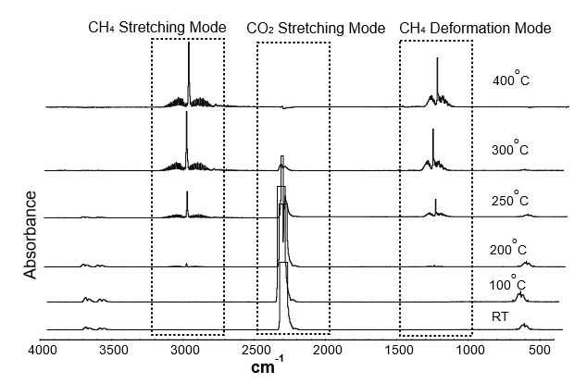
Figure 1. FTIR spectra of gaseous product at various reaction temperatures over calcined Sm/Mn/Ru (60:35:5)/Al₂O₃ catalyst

Table 1. Product analysis via in-situ reactions during methanation for Sm/Mn/Ru (60:35:5)/Al₂O₃ catalyst calcined on 1000 ºC for 5 hours using GC-FID
Reaction Temperature (ºC) | Converted CO₂ (%)* |  | Unreacted CO₂ (%)
Reaction Temperature (ºC) | % Formation of CH₄** | % Formation of H₂O + with/without CH₃OH*** | Unreacted CO₂ (%)
RT | - | 0.00 | 100.00
100 | - | 0.31 | 99.69
200 | 6.43 | 59.09 | 34.48
250 | 20.85 | 71.67 | 7.48
300 | 31.11 | 65.67 | 3.22
350 | 48.91 | 49.95 | 1.14
400 | 68.87 | 31.13 | -
*Converted CO₂ and Unreacted CO₂ was determined from FTIR as in Equation 1
**Formation of CH₄ was calculated from GC-FID as in Equation 2
***The presence of CH₃OH was confirmed with HPLC

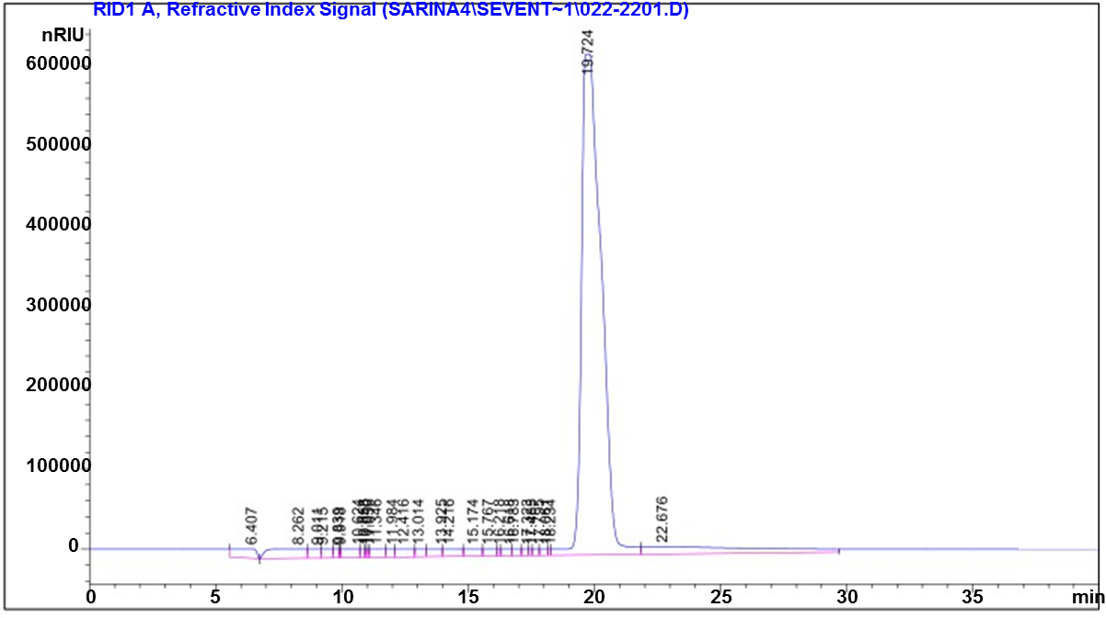
Figure 2. HPLC chromatogram of liquid product over calcined Sm /Mn/Ru (60:35:5)/Al₂O₃ catalyst

Methanation mechanism
The hydrogenation methanation adhered to the Langmuir-Hinshelwood mechanism, which reflected CO₂ and H₂ gases adsorption on the surface of catalyst. All CO₂ adsorption, dissociation, and reaction of the resolved species with H₂ had been established from in-situ FTIR experiments without any carbonate adsorption peak at 1760 and 1570 cm⁻¹. The FTIR spectra for catalyst during reaction is depicted in Figure 3. The spectra exhibited two broad O-H peak around 3443 and 1637 cm⁻¹ corresponded to stretching and bending of adsorbed water on Al₂O₃ support [15, 16]. According to Narain et al., a peak band was noted at 1639 cm⁻¹ for the similar temperature due to O-H bending derived from H₂O [17]. Initially, CO₂ and H₂ molecules were drawn to the catalyst surface (Step I) and directly coordinated the C atoms to generate inorganic carboxylate as proposed in Figure 4. The peak at 1116 cm⁻¹ assigned to the CO species observed during the attachment of CO₂ to the catalyst surface at reaction temperature, 100ºC [10]. This suggested the arrangement of C atoms attached to the catalyst surface (Step II). The adsorbed H₂ molecule was dissociated to active H atom species, and this was followed by CO₂ gas dissociation, as reported by Haldor [18] in Step III. The continuous flow of H₂ gas on the catalyst connects with oxygen atoms at the lone pair of electrons with higher electronegativity to form water (step IVa). This was supported with intense peak in the FTIR at reaction temperature, 200ºC. A little peak at 1397 cm⁻¹ was also observed at 200ºC that correspond to the methoxy group (H₃C-O) as suggested in step IVb. Solymosi et al. described the peak around 1397 cm⁻¹ on the catalyst surface foremost to the formation of methanol as a by-product [12]. When increased the reaction temperature to 250 – 300ºC, the peak at 2892-2926 cm⁻¹ was appeared which suggested free carbon from step III react directly with hydrogen to produce methane (step V). The intensity of C-H peak decreased at 350ºC indicating that almost all CHx was released as CH₄ gas. At a reaction temperature of 400ºC, all peak C-H groups disappeared which resulted higher CH₄ formation at this reaction temperature with 69% as stated in Table 1. This signifying the conversion of all species to CH₄, H₂O, and CH₃OH as the final yields.

Figure 3. FTIR spectra of Sm/Mn/Ru (60:35:5)/Al₂O₃ catalyst surface at (a) 100ºC, (b) 200ºC, (c) 250ºC, (d) 300ºC, (e) 350ºC, and (f) 400ºC reaction temperature

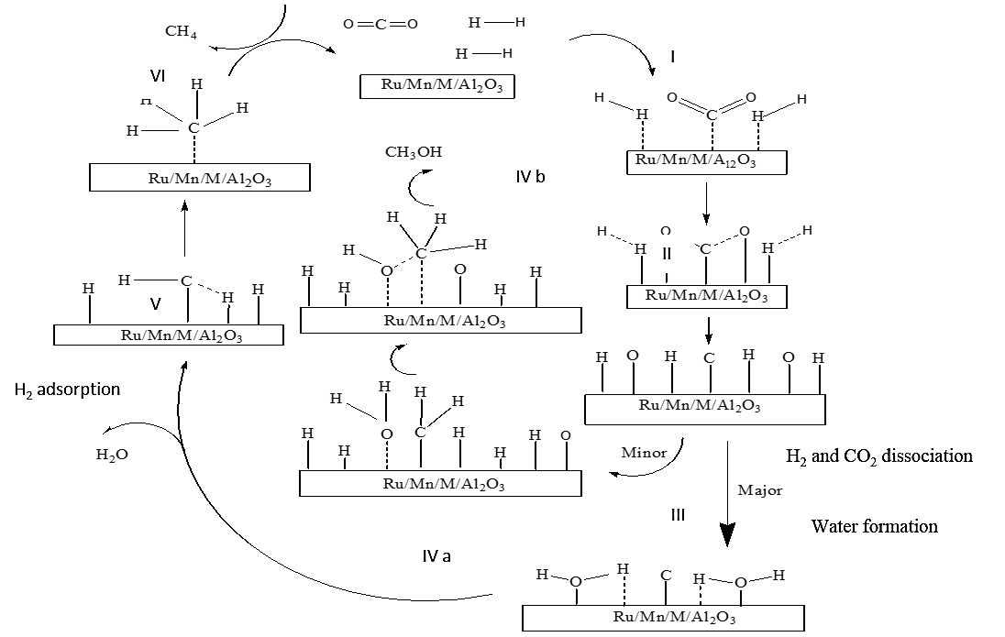
Figure 4. Proposed mechanism of M/Mn/Ru (60:35:5)/Al₂O₃, (M= Sm) calcined for 5 hours at 1000 ºC

Conclusion
This evaluation revealed compliance with the Langmuir Hinselwood mechanism, where CO₂ gas is first adsorbed, and then H₂-reactive gas is adsorbed on the catalyst surface. Based on the mechanistic approach, CH₄ was formed at temperature of 250 ºC and CO₂ peak was gradually decrease when the reaction temperature increased. The CO₂ conversion at 400ºC is 100%, with CH₄ formation of 69%. The others percent conversion was side products which are water and methanol, as detected by HPLC.

Acknowledgement
The authors gratefully acknowledge the Universiti Sultan Zainal Abidin and Universiti Teknologi Malaysia for financial support under GUP grant vote 13H34.

References
- Asif Iqbal, M. M., Toemen, S., Abu bakar, W. A. W., Razak, F. I. A., Rosid, S. J. M. and Azelee, N. I. W. (2020). Catalytic methanation over nanoparticle heterostructure of Ru/Fe/Ce/γ-Al₂O₃ catalyst: Performance and characterization, Renewable Energy, 162: 513-524,
- Rosid, S. J. M., Toemen, S., Iqbal, M. M. A., Bakar, W. A. W. A., Mokhtar, W. N. A. W. and Aziz, M. M. A. (2019). Overview performance of lanthanide oxide catalysts in methanation reaction for natural gas production. Environmental Science and Pollution Research, 26(36): 36124-36140.
- Hu, D., Gao, J., Ping, Y., Jia, L., Gunawan, P., Zhong, Z., Xu, G., Gu, F. and Su, F. (2012). Enhanced Investigation of CO methanation over Ni/Al₂O₃ catalysts for synthetic natural gas production. Industrial & Engineering Chemistry Research, 51: 4875-4886.
- Panagiotopoulou, P., Kondarides, D. I. and Verykios, X. E. (2008). Selective methanation of CO over supported noble metal catalysts: Effects of the nature of the metallic phase on catalytic performance. Applied Catalysis A: General, 344(1-2): 45-54.
- Erdohelyi, A. (2021). Catalytic reaction of carbon dioxide with methane on supported noble metal catalysts. Catalysts, 11: 159.
- Wang, X., Hong, Y., Shi, H., & Szanyi, J. (2016). Kinetic modeling and transient DRIFTS–MS studies of CO₂ methanation over Ru/Al₂O₃ catalysts. Journal of Catalysis, 343:185-195.
- Fisher I.A. and Bell A.T. (1996). A comparative study of Co and CO₂ hydrogenation over Rh/SiO₂. Journal of Catalysis, 162: 54-65.
- Marc J. Antoine Beuls, Patricio R. (2010). Catalytic production of methane from CO₂ and H₂ at low temperature: Insight on the reaction mechanism. Catalyst Today, 157: 462-466.
- Gabor A. S. and Yimin L. (2010). Major success of theory and experiment-combined studies in surface chemistry and heterogeneous catalysis. Top Catalyst, 53: 311-325.
- Marwood, M., Doepper, R. and Renken, A. (1997). In-situ surface and gas phase analysis for kinetic studies under transient conditions: The catalytic hydrogenation of CO₂. Applied Catalysis A: General. 151: 223-246.
- Sharma, S., Hu, Z., Zhang, P., McFarland, E. W. and Metiu, H. (2011). CO₂ methanation on Ru-doped ceria. Journal of Catalysis, 278: 297-309.
- Solymosi, F., Erdehelyi, A. and Bansagi, T. (1981). Methanation of CO₂ on supported rhodium catalyst. Journal of Catalysis, 68: 371-382.
- Zamani, A. H., Shohaimi, N. A. M., Rosid, S. J. M., Abdullah, N. H. and Shukri, N. M. (2019). Enhanced low temperature reaction for the CO₂ methanation over Ru promoted Cu/Mn on alumina support catalyst using double reactor system. Journal of the Taiwan Institute of Chemical Engineers, 96: 400-408.
- Rosid, S. J.M., Abu Bakar, W.A.W., Toemen, S., Yusoff, N. M., Azid, A. and Mokhtar, W. N. A.W. (2019). Investigation of active species in methanation reaction over cerium based loading. Malaysian Journal of Fundamental and Applied Sciences, 2018: 319-323.
- Li, C., Sakata, Y., Arai, T., Domen, K. and Maruya, K. (1989). Carbon monoxide and carbon dioxide adsorption on cerium oxide studied by Fourier- transform infrared spectroscopy. Journal of Chemical Society: Faraday Transaction. 85(4): 929-943.
- Stevens, R. W., Siriwardane, R. V and Logan, J. (2008). In situ Fourier transform infrared (FTIR) investigation of CO₂ adsorption onto zeolite materials. Energy & Fuels. 22(12): 3070-3079.

- Narain, K., Yazdani, T., Bhat, M. M. and Yunus M. (2012). Effect on physico-chemical and structural properties of soil emended with distillery effluent and ameliorated by cropping two cereal plant spp. Environmental Earth Sciences, 66: 977-984.
- Haldor Topsøe A/S, (2005). Methanation of CO over nickel mechanism and kinetics at high H₂/Co ratios. Journal Physical Chemistry B, 109(6): 2432-2438.

