

ELICITATION OF INDUCED POLYKETIDE COMPOUNDS FROM A CO-CULTURE BETWEEN Streptomyces sp. STRAIN SUK10 AND Fusarium sp. AND THEIR ANTIBACTERIAL ACTIVITIES

(Elisitasi Sebatian Poliketida Teraruh daripada Satu Kultur-bersama di antara

Streptomyces sp. Strain SUK10 dan Fusarium sp. dan Aktiviti Antibakteria)

Muhammad Asyraf Zawawi¹, Nurul Izzati Rosdi¹, Noor Wini Mazlan^{1,2}*, Mariam Taib¹, Kamariah Bakar², Noraziah Mohamad Zin³, Siti Nordahliawate M. Sidique⁴, Saif Aldeen Mohammad Fayiz Jaber⁵,
RuAngelie Edrada-Ebel⁵

¹Faculty of Science and Marine Environment
²Institute of Marine Biotechnology
Universiti Malaysia Terengganu, 21030 Kuala Nerus, Terengganu, Malaysia
³Center for Diagnostic, Therapeutic and Investigative Studies, Faculty of Health Sciences,
Universiti Kebangsaan Malaysia, Jalan Raja Muda Abd Aziz, 50300 Kuala Lumpur, Malaysia
⁴Faculty of Fisheries and Food Science,
Universiti Malaysia Terengganu, 21030 Kuala Nerus, Terengganu, Malaysia
⁵Strathclyde Institute of Pharmacy and Biomedical Sciences,
University of Strathclyde, The John Arbuthnott Building, 161 Cathedral Street, Glasgow G4 0RE, Scotland

*Corresponding author: noorwini@umt.edu.my

Received: 3 November 2021; Accepted: 30 December 2021; Published: xx February 2022

Abstract
Endophytes including bacteria and fungi produce an array of biologically active secondary metabolites. Different approaches have been applied in order to increase the probability production of new metabolites including mimicking the environment, media and the microbes. However, the use of single culture usually re-produces known compounds with known bioactivities. Therefore, co-culturing between Streptomyces sp. strain SUK10 and Fusarium sp. in the same media at different growth stages leads to direct interaction which may trigger the expression of “silent” biosynthetic pathway to produce novel secondary metabolites. In this study, we elicited the production of the unknown secondary metabolites from co-culture extracts by using high resolution liquid chromatography-mass spectrometry, while data was processed by utilizing the quantitative expression analysis software MZmine 2.40.1 and SIMCA P+ 15.0 coupled with macro analysis and supported with DNP database for dereplication studies. The results showed that only the extract from co-culture of F7S15 showed enhances antibacterial activity on the Gram-positive bacteria with minimum inhibition concentration (MIC) values of 5 mg/mL and 10 mg/mL against Micrococcus sp. and Staphylococcus aureus, respectively, compared with their independent and other co-culture extracts were non-active. However, all extracts were non-active on the Gram-negative bacteria. Our preliminary results showed that the potential of co-culture method leading the production of novel metabolites which could be explored for future antibacterial agents.

Keywords: co-culture, metabolomics, liquid chromatography-mass spectrometry, multivariate analysis, dereplication

Abstrak

Endofit termasuk bakteria dan fungus menghasilkan satu tatasusunan metabolit sekunder yang mempunyai keaktifan biologi. Pelbagai pendekatan telah digunakan bagi tujuan meningkatkan kebarangkalian penghasilan metabolit baru termasuk mengajuk persekitaran, media dan mikrob. Walaubagaimanapun, penggunaan kultur tunggal selalumya menghasilkan semula sebatian dengan bioaktiviti yang telah diketahui. Oleh itu, satu pengkulturan bersama di antara Streptomyces sp. strain SUK10 dan Fusarium sp. di dalam media yang sama di peringkat pertumbuhan yang berbeza, memacu kepada interaksi yang mungkin pencetus kepada ungkapan laluan biosintetik senyap untuk menghasilkan metabolit sekunder baru. Dalam kajian ini, kami telah memperolehi penghasilan metabolit sekunder yang belum diketahui daripada ekstrak kultur bersama dengan menggunakan kromatografi cecair-spektrometri jisim resolusi tinggi, sementara itu data telah dianalisis menggunakan perisian analisis ungkapan kuantitatif MZmine 2.40.1 dan SIMCA P+ 15.0 beserta analisis makro dan disokong oleh pengkalan data DNP bagi kajian dereplikasi. Keputusan telah menunjukkan bahawa hanya ekstrak daripada kultur bersama F7S15 telah menunjukkan peningkatan aktiviti antibakteria ke atas bakteria Gram-positif dengan nilai minimum kepekatan perencatan (MIC) 5 mg/mL dan 10 mg/mL melawan Micrococcus sp. dan Staphylococcus aureus, masing-masing, berbanding ekstrak kutur bebas dan kultur bersama yang lain adalah tidak aktif. Walaubagaimanapun, semua ekstrak tidak aktif ke atas bakteria Gram-negatif. Keputusan awal kajian kami telah menunjukkan potensi kaedah kultur bersama memacu penghasilan metabolit baru yang boleh diterokai bagi agen antibakteria masa hadapan.

Kata kunci: kultur bersama, metabolomik, kromatografi cecair-spektrometri jisim, analisis multivariat, dereplikasi

Introduction
Natural products have been rich sources of therapeutic agents as they inspire the advancement of synthetic methodologies to allow the possibility of making analogues of original lead compounds with improved pharmaceutical properties. For example, the secondary metabolites obtained from endophytic microbes are found to have antimicrobial, antiviral, anticancer, antioxidants, antidiabetic and immunosuppressant properties. The endophytic fungi and bacteria are known to produce these types of natural products that are potent for antibiotics [1]. They live inside the living plant tissues for at least a part of their life without causing any apparent disease symptoms in the host. Various bioactive metabolites are produced by endophytes that are proven to have potential to be anticancer, antioxidant, antifungal, antibacterial, antiviral and anti-insecticidal [2]. The induction of secondary metabolites is triggered by the interaction between the microorganisms, simulating the microbial competition for nutrition and space. Besides, the cultivation of the microbes is sustainable and reproducible in laboratory conditions. A well-known drugs-producer Streptomyces sp. belonging to actinobacteria varies in structures and has a great potential to be developed as therapeutic drugs for human use [3]. Streptomyces sp. is an aerobic, Gram-positive mycelial bacteria that disperse sporse as a method of reproduction and can develop branching vegetative hyphae in which the mycelium helps in scavenging nutrients from the surroundings [4]. Streptomyces sp. is able to synthesise potent secondary metabolites for medical applications such as antibiotics, herbicidal, antiparasitic, antitumor, antifungal and enzyme inhibiting agents as well as having the ability to inhibit various human pathogens including gancidin W [5], divergolides A-D [6], polycyclic anthraquinones [7], cyclic dipeptide [8-10] and xiamycin [11]. Meanwhile, a pathogenic fungus Fusarium sp. produces metabolites including naphthoquinones [12, 13], pyrones [14-16] and indole-acetic acids [17], naphthalenone derivatives [18] and aminobenzamide [19].

However, the discovery of new potential bioactive metabolites from independent cultures is challenging due to re-isolation of the known compounds with the same reported bioactivity. The re-occurrence of the known metabolites from an independent culture either of Streptomyces sp. SUK10 or Fusarium sp. may lead to similar bioactivities. Therefore, a co-culture method is introduced to challenge different strains instead of individual strains. A co-culture is a process of culturing of two or more different microorganisms that mimic the complex microbial habitat in nature where they co-exist, leading to competition among them due to limited source and antagonism. Microbial community is a complex and dynamically changing consortium in which metabolic interactions between microbial species take place. The interaction between microbial communities often involves exchange of molecules for nutritional purposes that may benefit one or both species, which is known as symbiosis [20]. The co-cultures of different microbes in comparison to mono-cultures are increasingly being used in microbial natural product research as the interaction of two different microbes can increase the availability of existing natural products or may induce the expression of silent biosynthetic pathways resulting in new metabolites that are useful in the medical field [21].

A co-cultivation between Streptomyces sp. SUK10 and Fusarium sp. at different growth stages was carried out. Present study, the metabolomics approach was used to predict and identify potential novel bioactive components from the crude extracts, leading to the rapid and high-throughput assessment of metabolites. Metabolite profiling of the active metabolites in crude extracts of natural sources was supported by dereplication in which the novel compounds from the active groups were differentiated from known compounds that have been studied previously [22]. The dereplication method is a process for screening the known metabolites from the crude extracts before further scale-up or isolation work is undertaken, in order to avoid repetitive work.

High-resolution electrospray ionisation-liquid chromatography-mass spectrometry (HRESI-LCMS) data from both positive and negative ionisation modes were subjected to multivariate statistical analysis including unsupervised principal component analysis (PCA) and orthogonal partial least squares- discriminant analysis (OPLS-DA) to establish the optimal position of the discriminating plane, which would best separate classes. The high-resolution mass spectral data generated predicted molecular formulas used for dereplication of the secondary metabolites found in the crude extracts. Later in the final step of the metabolomics approach, the selected unique biomarkers were interpreted to putatively identify the novel metabolite using databases like Dictionary of Natural Products (DNP). The ultimate aim of this study was to fast track the identification of the metabolites from the co-culture extracts, which can lead to the decision-making of the optimum parameter for up-scaling of targeted metabolites responsible for biological activities. In future, the targeted metabolites will be isolated and absolute elucidation and identification of the molecule structures will be achieved using one and two dimensional-nuclear magnetic resonance (NMR) and high-resolution mass spectrometry (MS).

Materials and Methods
Preparation of microbial samples
A stock culture of Streptomyces sp. strain SUK10 was obtained from the Novel Antibiotics Laboratory, Programme of Biomedical Sciences, Faculty of Health Sciences, Universiti Kebangsaan Malaysia (UKM), Kuala Lumpur, while Fusarium sp. was obtained from the culture collection of Fungus Laboratory, Central Laboratory, Universiti Malaysia Terengganu (UMT). Streptomyces sp. SUK10 was originally isolated from the barks of Shorea ovalis [5] and Fusarium sp. was isolated from the roots of Avicennia lanata collected from Setiu Wetlands, Terengganu [13]. A 5 mm x 5 mm diameter plug containing Fusarium sp. mycelium was cut from the edge of the colony and placed in the middle of a new malt agar plate to establish a fresh and pure colony. The plates were incubated at 27 ± 2 °C (Vindon Scientific Ltd., UK) for 7-15 days. Meanwhile, Streptomyces sp. SUK10 was streaked onto fresh ISP2 agar plates and incubated at room temperature for 7-15 days.

Independent cultures
The International Streptomyces Project (ISP) medium was prepared by adding 10.0 g of malt extract, 4.0 g of D-(+)-glucose monohydrate, 4.0 g of yeast extract and 1 L of distilled water, vigorously shaken until completely mixed and dissolved. The pH was adjusted ranging at 7.2-7.4 using 10% NaOH or 36.5% HCl, and autoclaved at 121 ℃ for 15 minutes. The independent cultures of Streptomyces sp. strain SUK10 and Fusarium sp. were achieved in which each active growing strain on the agar plate was cut into small cubes and transferred separately into seven 500 mL Erlenmeyer flasks containing 100 mL of ISP medium. The cultures were incubated in an orbital shaker and shaken at 150 rpm and 28 °C for 7 and 15 days (seven replicates). The metabolites were extracted twice with equal volumes of ethyl acetate, homogenised and filtered. The organic layer was discarded into a 500 mL round bottom flask using liquid-liquid extraction technique to obtain an organic solvent that was then concentrated under vacuum using a rotary evaporator (Büchi, Switzerland) to afford crude extracts ± 10.0 mg. The crude extracts were kept at 4 °C prior to analysis.

Co-cultivation between Streptomyces sp. strain SUK10 and Fusarium sp.
The co-cultivation between Streptomyces sp. strain SUK10 and Fusarium sp. was achieved including sets FS7, FS15, F7S15, and S7F15. The co-cultivation of sets FS7 and FS15 were obtained by mixing the agar cubes containing active growing Streptomyces sp. strain SUK10 and Fusarium sp. at initial incubation in the ISP broth. The incubation of co-cultivation of set FS7 was continued until day 7, while the co-cultivation of set FS15 was incubated until day 15. The co-cultivation of set F7S15 was obtained in which the agar plugs containing Streptomyces sp. strain SUK10 were introduced into the Fusarium sp. culture after 7 days of incubation, and the incubation was continued until day 15. The co-cultivation of set S7F15 was obtained in which the agar plugs containing Fusarium sp. mycelia were introduced into the Streptomyces sp. strain SUK10 culture after 7 days of incubation, and the incubation was also continued until day 15. A 100 mL of ISP broth was used for each culture and the incubation was done in an orbital shaker at 150 rpm and 28 °C (seven replicates). The metabolites were extracted twice with equal volumes of ethyl acetate, homogenised, and filtered. The organic layer was discarded into a 500 mL round bottom flask using liquid-liquid extraction technique to obtain an organic solvent that was then concentrated under vacuum using a rotary evaporator (Büchi, Switzerland) to afford crude extracts ± 15.0 mg. The crude extracts were kept at 4 °C prior to analysis.

Dereplication using HRESI-LCMS
The dereplication strategy on the crude extracts was performed using HRESI-LCMS and processed with the MZmine software 2.40.1, an in-house macro coupled with the Dictionary of Natural Products (DNP) 2015 and SIMCA P+ 15.0 (Umetrics AB, Umeå, Sweden). The procedure and programme for HRESI-LCMS was set up as described here [23]. 1 mg/mL of each extract was dissolved in methanol and analysed on an Accela HPLC (Thermo Scientific, UK) coupled with a UV detector at 280 and 360 nm and an Exactive-Orbitrap high-resolution mass spectrometer (Thermo Scientific, UK). A methanol blank was also analysed. The mass spectral data was processed using the procedure by MacIntyre et al. [23] which was established in the Natural Products Metabolomics Group Laboratory at Strathclyde Institute of Pharmacy and Biomedical Sciences (SIPBS) as described here [13, 23]. The LC-MS chromatograms and spectra were viewed using Thermo Xcalibur 2.1 or MZmine 2.40.1.

Antibacterial activity using agar disk-diffusion
An antibacterial activity of the extracts from independent and co-cultures was conducted using the agar disk-diffusion method as described here [24]. Each extract was diluted with 2-fold dilutions in dimethyl sulfoxide (DMSO) with concentration values of 0.156 mg/mL, 0.313 mg/mL, 0.625 mg/mL, 1.25 mg/mL, 2.50 mg/mL, 5.00 mg/mL and 10 mg/mL. The inhibition zone diameter (IZD) was measured to the nearest millimetres. Minimum inhibitory concentration (MIC) was taken as the lowest concentration of the extracts that shows the inhibition zone. MIC values of the extracts against the Gram-positive and Gram-negative bacteria were determined by averaging the results of three independent assays. Six strains of Gram-positive bacteria namely Staphylococcus aureus, Bacillus cereus and Micrococcus sp. and Gram-negative bacteria - Vibrio cholera, Salmonella sp. and Escherichia coli from glycerol stock were obtained from the Microbiology Laboratory, Institute of Marine Biotechnology, UMT.

Statistical analysis
All data were presented as mean + SD and statistically analysed with One-Way ANOVA in the comparison between selected fractions using statistical analyses software PRISM ver. 5. Data were significantly different at p < 0.05.

Results and Discussion

Dereplication study on crude extracts
Each extract was screened on antibacterial activity at different concentrations: 10 mg/mL to 0 mg/mL. The inhibition zone diameter (IZD) was measured to the nearest millimetres. The results showed that the minimum inhibition concentration (MIC) values of the extracts against the Gram-positive and Gram-negative bacteria were determined by averaging the results of three independent assays (Table 1). The co-culture extract F7S15 revealed marginal antibacterial activity on Micrococcus sp. and S. aureus with MIC values of 5 mg/mL and 10 mg/mL, respectively, as compared to the non-active independent and other co-culture extracts. Meanwhile, the antibacterial activity on the Gram-negative bacteria showed that all extracts were non-active in this screening test, thereby supporting further investigation of the biologically-active compounds from the co-cultivation extracts.

Total ion chromatogram for the extract of co-cultivation between Streptomyces sp. strain SUK10 and Fusarium sp. F7S15 (Figure 1) showed the distribution of known and unknown compounds present in the extract (Table 2). The dereplication studies revealed that the co-culture extract F7S15 possessed certain types of compounds including macrocylic aromatic compounds such as macrolide- oligomycin A and cyclic peptolides-icosalide A1 and A3, which have also been previously isolated from different Streptomyces and fungi species, respectively (Table 2). The values and predicted formulas of unknown compounds are also shown (highlighted rows). The extracts of co-cultivation between Streptomyces sp. strain SUK10 and Fusarium sp. as well as the independent cultures were preliminarily screened on antibacterial activity and subjected to HRESI-LCMS prior to multivariate analysis. A dereplication study was performed to obtain the metabolomic profile of each extract.

The relationship between the occurrence of the metabolites in the independent and co-cultivation extracts and their bioactivity on antibacterial activity were evaluated through multivariate analysis. The PCA scores plot showed strong separation of the extracts (Figure 2a). There was clear separation between the co-culture extract of F7S15 from other extracts. The PCA loadings plot (Figure 2b) predicted the metabolites in the extracts. Meanwhile, a supervised multivariate OPLS-DA score plot analysis (Figure 2c) exhibited a distinctive separation between the active extract F7S15, while other extracts were the non-active group. These predicted antibacterial active compounds by MVA were indicated with their MZmine IDs as listed in Table 2. Peak IDs used in this table corresponded to those designated for the chromatogram as shown in Figure 1.

Table 1. Antibacterial activity for independent and co-culture extracts (calculated as mean value percentage viability) at different concentrations ranging at 10 mg/mL to 0 mg/mL. Highlighted rows showed enhanced antibacterial activity
Extracts | Concentration of Crude Extract (mg/mL)
Extracts | Micrococcus sp.
Extracts | 0.156 | 0.313 | 0.625 | 1.25 | 2.50 | 5.00 | 10.00
Extracts | Diameter of inhibition (mm)
F7 | n.d | n.d | n.d | n.d | n.d | n.d | n.d
F15 | n.d | n.d | n.d | n.d | n.d | n.d | n.d
S7 | n.d | n.d | n.d | n.d | n.d | n.d | n.d
S15 | n.d | n.d | n.d | n.d | n.d | n.d | n.d
FS7 | n.d | n.d | n.d | n.d | n.d | n.d | n.d
FS15 | n.d | n.d | n.d | n.d | n.d | n.d | n.d
F7S15 | n.d | n.d | n.d | n.d | n.d | 7.5±0.6 | 8.7±0.5
S7F15 | n.d | n.d | n.d | n.d | n.d | n.d | 8.0±0
Oxytetracycline (30 µg) | 35.7±0.2
 | Staphylococcus aureus
F7 | n.d | n.d | n.d | n.d | n.d | n.d | n.d
F15 | n.d | n.d | n.d | n.d | n.d | n.d | n.d
S7 | n.d | n.d | n.d | n.d | n.d | n.d | n.d
S15 | n.d | n.d | n.d | n.d | n.d | n.d | n.d
FS7 | n.d | n.d | n.d | n.d | n.d | n.d | n.d
FS15 | n.d | n.d | n.d | n.d | n.d | n.d | n.d
F7S15 | n.d | n.d | n.d | n.d | n.d | n.d | n.d
S7F15 | n.d | n.d | n.d | n.d | n.d | n.d | 8.0±0
Oxytetracycline (30 µg) | 26.0±1.4

*Legend: extracts F7 = mono-culture Fusarium sp. incubation day 7; F15 = mono-culture Fusarium sp. incubation day 15; S7 = mono-culture Streptomyces sp. SUK10 incubation day 7; S15 = mono-culture Streptomyces sp. SUK10 incubation day 15; F7S15 = co-cultivation between Fusarium sp. and Streptomyces sp. SUK10 in which Streptomyces sp. SUK10 was added into Fusarium sp. culture after 7 days incubation and the incubation was continued until day 15; S7F15 = co-cultivation between Fusarium sp. and Streptomyces sp. SUK10 in which Fusarium sp. was added into Streptomyces sp. SUK10 culture after 7 days incubation and the incubation was continued until day 15; n.d: not detected; n=3.

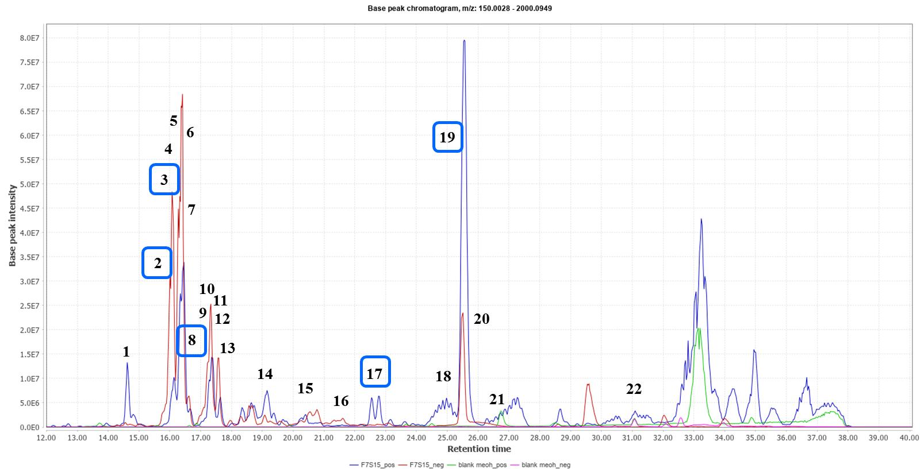
Figure 1. Total ion chromatogram for the extract of co-cultivation between Streptomyces sp. strain SUK10 and Fusarium sp. F7S15 (blue and red represent positive and negative ionization modes of F7S1 extract, respectively; green and pink represent positive and negative ionization modes of blank methanol, respectively). Dereplication of numbered peaks is shown on Table 1. Boxed in blue are the metabolites putatively identified using DNP database.

Table 2. List of compounds indicated on the total ion chromatogram for the extract of co-cultivation between Streptomyces sp. strain SUK10 and Fusarium sp. F7S15 that were putatively identified using DNP database. Peak IDs used in this table correspond to those designated for the chromatogram shown on Figure 1. Highlighted rows represent the unknown compounds as indicated with their MZmine IDs.
Peak  ID | ESI Modes/ MZmine ID | Rt  (min) | MS  (m/z) | Molecular  Weight | Chemical  Formula | Chemical  Name | Tolerance  (ppm) | Sources | Peak  Area
1 | P_22521 | 14.58 | 274.2015 | 273.1943 | C₁₄H₂₇NO₄ | No hits |  |  | 1.27E+08
2 | N_2411 | 16.03 | 795.5293 | 796.5361 | C₄₁H₈₀O₁₂S | bovine seminolipid | -1.1324 | bovine spermatozoa | 6.10E+08
3 | P_21220 | 16.04 | 779.5308 | 778.5235 | C₄₄H₇₄O₁₁ | narasin D | 0.5015 | Strep. aureofaciens | 2.75E+08
4 | N_2409 | 16.19 | 633.4391 | 634.4464 | C₃₀H₆₄N₆O₄P₂ | No hits |  |  | 3.81E+08
 | N_2441 | 16.33 | 777.5188 | 778.5258 | CH₅NO₁₅P₄S₁₂ | No hits |  |  | 8.40E+08
6 | P_21679 | 16.35 | 801.5129 | 800.5056 | C₁₀N₃O₆PS₁₆ | No hits |  |  | 3.80E+08
7 | N_2435 | 16.36 | 759.5081 | 760.5154 | C₆HN₅O₃P₆S₁₂ | No hits |  |  | 3.00E+08
8 | P_21649 | 16.45 | 761.5204 | 760.5135 | C₄₄H₇₂O₁₀ | oligomycin A; 26-Demethyl, 12-deoxy | 1.2529 | S. aureofaciens | 8.62E+08
9 | N_2422 | 17.26 | 659.4550 | 660.4622 | C₄₀H₇₀OP₂S | No hits |  |  | 1.89E+08
10 | P_21450 | 17.28 | 793.5469 | 792.5396 | C₂H₁₈NO₃P₁₅S₇ | No hits |  |  | 4.10E+08
11 | P_22522 | 17.32 | 833.5393 | 832.5320 | C₅H₉N₃O₈P₁₄S₅ | No hits |  |  | 3.36E+08
12 | N_2495 | 17.33 | 809.5449 | 810.5525 | C₂H₂N₃O₁₉P₉S₅ | No hits |  |  | 2.12E+08
13 | N_2496 | 17.58 | 777.5192 | 778.5264 | C₃₈H₇₂N₁₀O₃P₂ | No hits |  |  | 1.69E+08

Table 2 (cont’d). List of compounds indicated on the total ion chromatogram for the extract of co-cultivation between Streptomyces sp. strain SUK10 and Fusarium sp. F7S15 that were putatively identified using DNP database. Peak IDs used in this table correspond to those designated for the chromatogram shown on Figure 1. Highlighted rows represent the unknown compounds as indicated with their MZmine IDs.
Peak  ID | ESI Modes/ MZmine ID | Rt  (min) | MS  (m/z) | Molecular  Weight | Chemical  Formula | Chemical  Name | Tolerance  (ppm) | Sources | Peak  Area
14 | P_22523 | 19.10 | 783.5023 | 782.4957 | C₂H₄N₅O₅P₃S₁₆ | No hits |  |  | 1.90E+08
15 | N_2511 | 20.79 | 1556.0436 | 1557.0510 | C₄₆H₈₈N₉O₂P₉S₁₅ | No hits |  |  | 1.11E+08
16 | N_2549 | 21.62 | 1589.0730 | 1590.0803 | C₄₁H₇₄N₁₄O₂₀P₄S₁₂ | No hits |  |  | 4.41E+07
17 | P_22525 | 22.74 | 685.4392 | 684.4319 | C₃₄H₆₀N₄O₁₀ | icosalide A3 | 1.3669 | fungus OSI 74159 | 9.07E+07
18 | N_2408 | 25.38 | 711.4578 | 712.4649 | C₃₈H₅₆N₁₂O₂ | No hits |  |  | 4.31E+08
19 | P_21186 | 25.48 | 713.4698 | 712.4622 | C₃₆H₆₄N₄O₁₀ | icosalide A1 | -0.1214 | Aureobasidium sp. fungus OSI 59166 | 1.27E+09
20 | N_2410 | 25.46 | 681.4474 | 682.4547 | C₃₄H₆₃N₆O₆P | No hits |  |  | 2.87E+08
21 | P_21721 | 26.85 | 471.4048 | 470.3975 | C₂₃H₅₁N₈P | No hits |  |  | 8.99E+08
22 | P_23269 | 31.03 | 523.3828 | 522.3755 | C₂₇H₅₄O₉ | 1-Heptacosene-4,6,8,10,12,14,16,18,24-nonol | -2.3912 |  | 4.07E+05

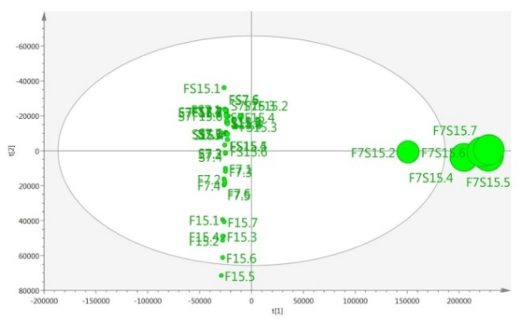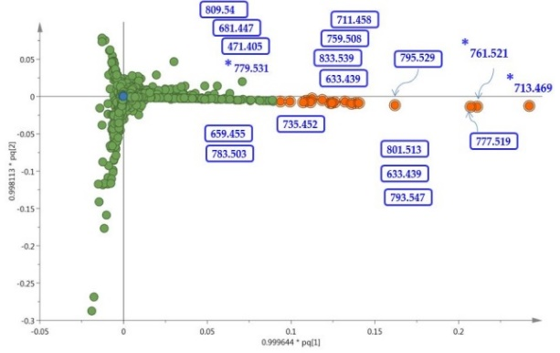
(a)
(b)

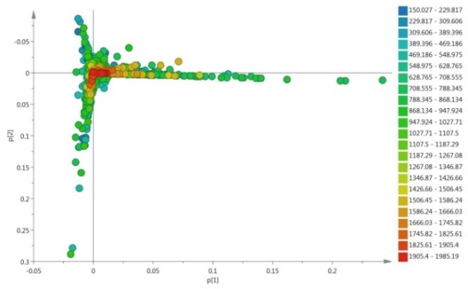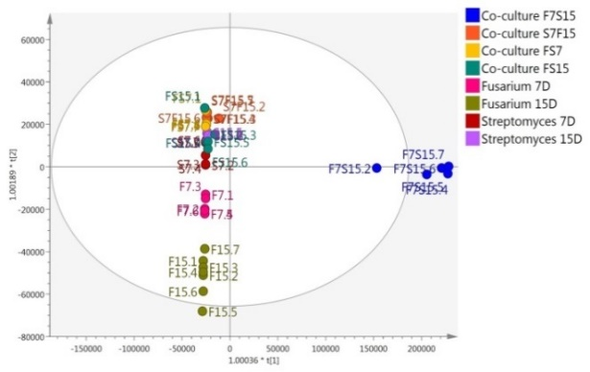
(c)
(d)

Figure 2. (a) Unsupervised PCA scores plot of mono- and co-cultivation extracts showed distinctive separation between the datasets. (b) PCA loadings plot showed the discriminating metabolites within the extracts. (c) OPLS-DA scores scatter plot of the extracts (R²(Y) = 1.00; Q² =0.998); Q²(Y intercept). (d) Supervised OPLS-DA loadings plot showed the discriminating metabolites of the active co-culture extract F7S15 within the extracts. Asterisk specifies the identified metabolites from where the respective active extract F7S15. Legend: set F7.1-F7.7 = mono-culture Fusarium sp. incubation day 7; set F15.1-F15.7 = mono-culture Fusarium sp. incubation day 15; set S7.1-S7.7 = mono-culture Streptomyces sp. SUK10 incubation day 7; S15.1-S15.7 = mono-culture Streptomyces sp. SUK10 incubation day 15; set F7S15.1-F7S15.7 = co-cultivation between Fusarium sp. and Streptomyces sp. SUK10 in which Streptomyces sp. SUK10 was added into Fusarium sp. culture after 7 days incubation and the incubation was continued until day 15; set S7F15.1-S7F15.7 = co-cultivation between Fusarium sp. and Streptomyces sp. SUK10 in which Fusarium sp. was added into Streptomyces sp. SUK10 culture after 7 days incubation and the incubation was continued until day 15, n=7.

The OPLS-DA loadings plot (Figure 2d) exhibited the discriminating metabolites in the active group F7S15 in which the ion peaks at m/z [M+H]⁺ 713.469, 761.521, and 801.513 as well as m/z [M-H]⁻ 777.519, 795.529, and 633.439 were outliers, indicating the presence of unique chemical profiles in the F7S15 extract. From the DNP database, it was putatively determined that the F7S15 extract contained polyketide and aromatic compounds [25-28] that perhaps contributed towards the antibacterial activity of F7S15. Some of the ion peaks in the F7S15 extract have been dereplicated as presented in Table 1. Characteristic metabolite for co-culture F7S15 extract observed at m/z [M+H]⁺ 713.469 were putatively identified as icosalide A1, which has been identified from an Aureobasidium sp. fungus OSI 59166 [26, 29]. The ion peaks at m/z [M+H]⁺ 761.521 and 779.531 were putatively identified as oligomycin A; 26-demethyl, 12-deoxy, and narasin D, respectively. Both compounds were isolated from Streptomyces aureofaciens [30, 31]. The m/z [M-H]⁻ 795.529 was putatively identified as bovine seminolipid, which has been isolated from bovine spermatozoa [32]. Meanwhile, the ion peaks at m/z [M+H]⁺ 801.513 and m/z [M-H]⁻ 777.519 and 633.439 were the unidentified metabolites that were only produced in the active co-culture extract F7S15. The relative occurrence of the targeted putatively identified and unknown metabolites in the bioactive extract F7S15 is shown in Figure 3. Based on the predicted chemical formula of the unknown compounds, they may consist of at least one nitrogen atom that contributes to the presence of macrocyclic polyketide-membered rings. Isolation of polyketide compounds from Streptomyces sp. under normal condition is widely known [5, 33-35], and perhaps the discovery of most antibiotics in the market are from this species. However, the world is facing a multidrug resistant against bacteria. Thus, dual cultivation of different strains used in our preliminary study may enlighten the opportunity to discover more potential new drug candidates that could be further explored. The optimization works in this study showed that the co-cultivation of F7S15 produced promising metabolites with enhanced antibacterial activity, which can be further scaled up to obtain larger volume extracts for isolation and identification of target metabolites that were absent in their parent culture. Our future study will focus on the identification of molecule structures of the unknown metabolites by using tandem mass spectrometry (MS/MS) analysis and one/two-dimensional nuclear magnetic resonance (1D/2D NMR) spectroscopy.

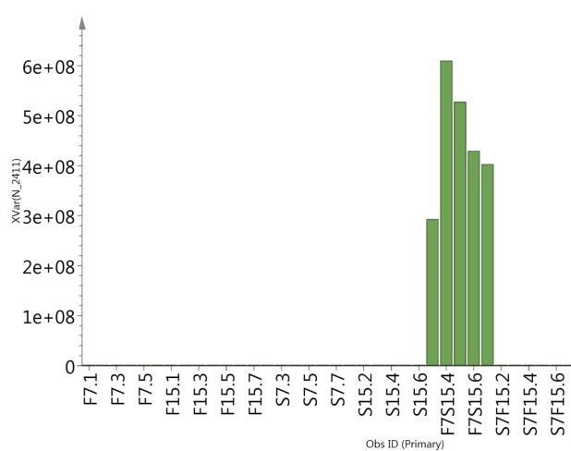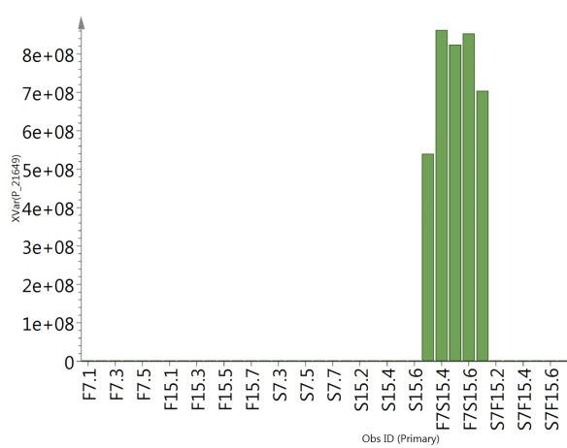
(a)
(b)

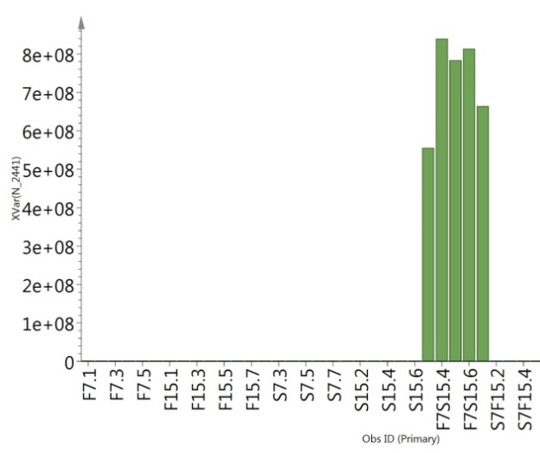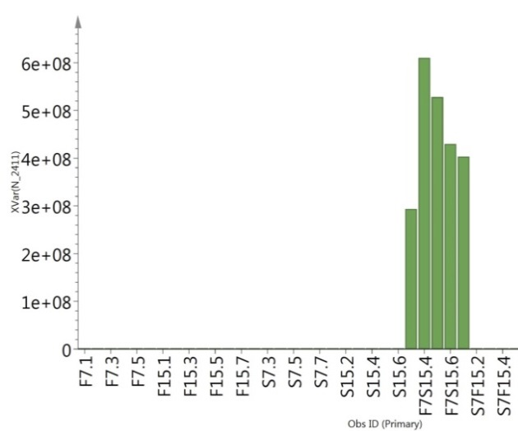
(c)
(d)
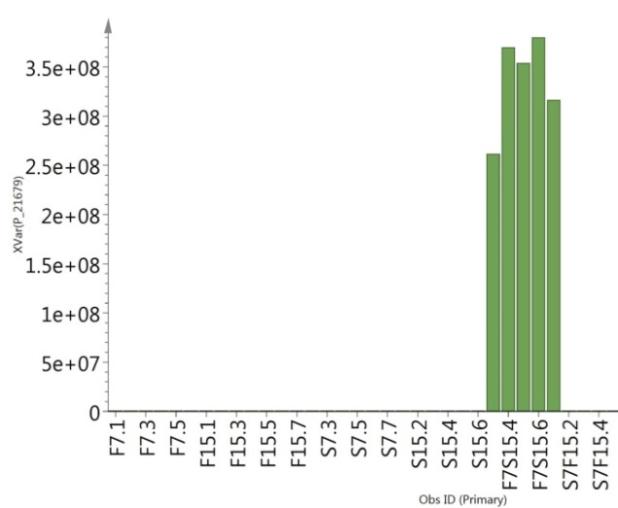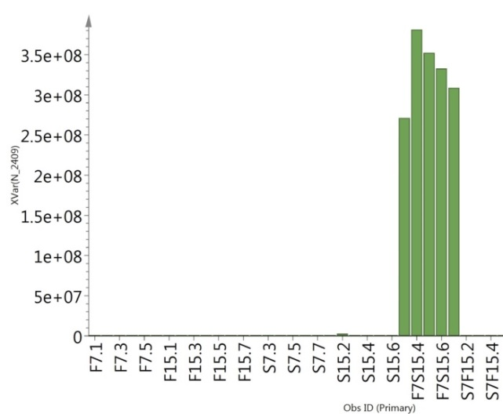
(e)
(f)
Figure 3. Relative abundance of target metabolites (a-f) which only present in the active co-culture extract of F7S15. Asterisk specifies the identified metabolites from where the respective active extract F7S15. (a) P_21186: m/z = 713.469, RT = 25.48 min; (b) P_21649: m/z = 761.521, RT = 16.45 min; (c) N_2496: m/z = 777.519, RT = 17.58 min; (d) N_2411: m/z = 795.529, RT = 16.03 min; (E) P_21679: m/z = 801.513, RT = 16.35 min; (F) N_2409: m/z = 633.439, RT = 16.19 min

Conclusion

The main aims in this study were to establish an optimum parameter to target and pinpoint the bioactive secondary metabolites directly from the extracts that were absent in the independent culture and subsequently imply the same parameter in the scale-up of the co-cultivation. By means of high-resolution liquid chromatography-mass spectrometry, the extracts obtained from mono- and co-cultivation were preliminarily screened for bioactive molecules and analyzed by multivariate analysis such as PCA and OPLS-DA. Dereplication study was used to screen the known metabolites and predict the novelty metabolites from the extracts which were not detected in single cultures, to avoid repetitive work on the same compounds with known bioactivity. Our future study will focus on the scale-up and isolation works of the targeted active metabolites from co-culture extract F7S15. In addition, identification of the molecule structures will be achieved using 1D and 2D-nuclear magnetic resonance (NMR) and high-resolution mass spectrometry (MS).

Acknowledgement

We wish to thank the Ministry of Higher Education Malaysia for the grant awarded to Noor Wini Mazlan FRGS/1/2018/STG05/UMT/03/2. The research described in this study has been done in IMB and Central Laboratory, UMT. The authors would like to thank Siti Aisha Mohd Radzi for assisting in the sample preparation.

References
1. Christina, A., Christapher, V. and Bhore, S. J. (2013). Endophytic bacteria as a source of novel antibiotics: an overview. Pharmacognosy Reviews, 7(13): 11.
2. Sarasan, M., Puthumana, J., Job, N., Han, J., Lee, J. S. and Philip, R. (2017). Marine algicolous endophytic fungi-a promising drug resource of the era. Journal of Microbiology and Biotechnology, 27(6): 1039-1052.
3. Berdy, J. (2005). Bioactive microbial metabolites. The Journal of Antibiotics, 58(1): 1-26.
4. Chater K. F., Losick, R. and Shapiro, L. (1984). Microbial development. Cold Spring Habor Laboratory, Cold Spring Habor, New York: pp. 89-116.
5. Zin, N. M., Baba, M. S., Zainal-Abidin, A. H., Latip, J., Mazlan, N. W. and Edrada-Ebel, R. (2017). Gancidin W, a potential low-toxicity antimalarial agent isolated from an endophytic Streptomyces SUK10. Drug Design, Development and Therapy, 11: 351.
6. Gao, H., Li, G. and Lou, H. X. (2018). Structural diversity and biological activities of novel secondary metabolites from endophytes. Molecules, 23(3): 646.
7. Liang, Y., Xie, X., Chen, L., Yan, S., Ye, X., Anjum, K., Huang, H. Lian, X. and Zhang, Z. (2016). Bioactive polycyclic quinones from marine Streptomyces sp. 182SMLY. Marine Drugs, 14(1): 10.
8. Cheng, C., Othman, E. M., Stopper, H., Edrada-Ebel, R., Hentschel, U. and Abdelmohsen, U. R. (2017). Isolation of petrocidin A, a new cytotoxic cyclic dipeptide from the marine sponge-derived bacterium Streptomyces sp. SBT348. Marine Drugs, 15(12): 383.
9. Gondry, M., Lautru, S., Fusai, G., Meunier, G., Ménez, A. and Genet, R. (2001). Cyclic dipeptide oxidase from Streptomyces noursei: Isolation, purification and partial characterization of a novel, amino acyl α, β‐dehydrogenase. European Journal of Biochemistry, 268(6): 1712-1721.
10. Saadouli, I., Zendah El Euch, I., Trabelsi, E., Mosbah, A., Redissi, A., Ferjani, R. and Ouzari, H. I. (2020). Isolation, characterization and chemical synthesis of large spectrum antimicrobial cyclic dipeptide (l-leu-l-pro) from Streptomyces misionensis V16R3Y1 bacteria extracts. A novel ¹H NMR metabolomic approach. Antibiotics, 9(5): 270.
11. Ding, L., Münch, J., Goerls, H., Maier, A., Fiebig, H. H., Lin, W. H. and Hertweck, C. (2010). Xiamycin, a pentacyclic indolosesquiterpene with selective anti-HIV activity from a bacterial mangrove endophyte. Bioorganic & Medicinal Chemistry Letters, 20(22): 6685-6687.
12. Khan, N., Afroz, F., Begum, M. N., Rony, S. R., Sharmin, S., Moni, F. and Sohrab, M. H. (2018). Endophytic Fusarium solani: A rich source of cytotoxic and antimicrobial napthaquinone and aza-anthraquinone derivatives. Toxicology Reports, 5: 970-976.
13. Mazlan, N. W., Tate, R., Yusoff, Y. M., Clements, C. and Edrada-Ebel, R. (2020). Metabolomics-guided isolation of anti-trypanosomal compounds from endophytic fungi of the mangrove plant Avicennia lanata. Current Medicinal Chemistry, 27(11): 1815-1835.
14. Zhen, X., Mao, M. J., Wang, R. Z., Chang, S. S., Xiao, T. M., Wu, Y. X., Yu, Y., Song, Y. L., Chen, M. H. and Si, S. Y. (2021). Fusapyrone A, a γ-pyrone derived from a desert Fusarium sp. Journal of Asian Natural Products Research, 23(5): 504-511.
15. Choi, H. G., Song, J. H., Park, M., Kim, S., Kim, C. E., Kang, K. S. and Shim, S. H. (2020). Neuroprotective γ-pyrones from Fusarium Solani JS-0169: Cell-based identification of active compounds and an informatics approach to predict the mechanism of action. Biomolecules, 10(1): 91.
16. Gao, H., Li, G., Peng, X. P. and Lou, H. X. (2020). Fupyrones A and B, two new α-pyrones from an endophytic fungus, Fusarium sp. F20. Natural Product Research, 34(3): 335-340.
17. Luo, K., Rocheleau, H., Qi, P. F., Zheng, Y. L., Zhao, H. Y. and Ouellet, T. (2016). Indole-3-acetic acid in Fusarium graminearum: Identification of biosynthetic pathways and characterization of physiological effects. Fungal Biology, 120(9): 1135-1145.
18. Xiao, W. J., Chen, H. Q., Wang, H., Cai, C. H., Mei, W. L. and Dai, H. F. (2018). New secondary metabolites from the endophytic fungus Fusarium sp. HP-2 isolated from “Qi-Nan” agarwood. Fitoterapia, 130: 180-183.
19. Ibrahim, S. R., Mohamed, G. A., Al Haidari, R. A., Zayed, M. F., El-Kholy, A. A., Elkhayat, E. S. and Ross, S. A. (2018). Fusarithioamide B, a new benzamide derivative from the endophytic fungus Fusarium chlamydosporium with potent cytotoxic and antimicrobial activities. Bioorganic & Medicinal Chemistry, 26(3): 786-790.
20. Rodrigues Reis, C. E., Ogero D’Otaviano, L., Rajendran, A. and Hu, B. (2018). Co-culture of filamentous feed-grade fungi and microalgae as an alternative to increase feeding value of ethanol coproducts. Fermentation, 4(4): 86.
21. Kamdem, R. S., Wang, H., Wafo, P., Ebrahim, W., Özkaya, F. C., Makhloufi, G. and Proksch, P. (2018). Induction of new metabolites from the endophytic fungus Bionectria sp. through bacterial co-culture. Fitoterapia, 124: 132-136.

22. Harvey A. L., Edrada-Ebel, R. and Quinn, R. J. (2015). The re-emergence of natural products for drug discovery in the genomics era. Nature Reviews Drug Discovery, 14(2): 111-129.
23. Macintyre, L., Zhang, T., Viegelmann, C., Martinez, I. J., Cheng, C., Dowdells, C. and Edrada-Ebel, R. (2014). Metabolomic tools for secondary metabolite discovery from marine microbial symbionts. Marine Drugs, 12(6): 3416-3448.
24. Assaw, S., Mohd Amir, M. I. H., Khaw, T. T., Bakar, K., Mohd Radzi, S. A. and Mazlan, N. W. (2020). Antibacterial and antioxidant activity of naphthofuranquinones from the twigs of tropical mangrove Avicennia officinalis. Natural Product Research, 34(16): 2403-2406.
25. Chan, W. Y., Hickey, E. E., Khazandi, M., Page, S. W., Trott, D. J. and Hill, P. B. (2020). In vitro antimicrobial activity of narasin and monensin in combination with adjuvants against pathogens associated with canine otitis externa. Veterinary Dermatology, 31(2): 138-e26.
26. Boros, C., Smith, C. J., Vasina, Y., Che, Y., Dix, A. B., Darveaux, B. and Pearce, C. (2006). Isolation and identification of the icosalides--cyclic peptolides with selective antibiotic and cytotoxic activities. Journal of Antibiotics, 59(8): 486-494.
27. Dose, B., Niehs, S. P., Scherlach, K., Flórez, L. V., Kaltenpoth, M. and Hertweck, C. (2018). Unexpected bacterial origin of the antibiotic icosalide: two-tailed depsipeptide assembly in multifarious Burkholderia symbionts. ACS Chemical Biology, 13(9): 2414-2420.
28. Lysenkova, L. N., Saveljev, O. Y., Omelchuk, O. A., Zatonsky, G. V., Korolev, A. M., Grammatikova, N. E. and Shchekotikhin, A. E. (2020). Synthesis, antimicrobial and antiproliferative properties of epi-oligomycin A, the (33 S)-diastereomer of oligomycin A. Natural Product Research, 34(21): 3073-3081.
29. Jenner, M., Jian, X., Dashti, Y., Masschelein, J., Hobson, C., Roberts, D. M. and Challis, G. L. (2019). An unusual Burkholderia gladioli double chain-initiating nonribosomal peptide synthetase assembles ‘fungal’icosalide antibiotics. Chemical science, 10(21): 5489-5494.
30. Khebizi, N., Boudjella, H., Bijani, C., Bouras, N., Klenk, H. P., Pont, F. and Sabaou, N. (2018). Oligomycins A and E, major bioactive secondary metabolites produced by Streptomyces sp. strain HG29 isolated from a Saharan soil. Journal de Mycologie Medicale, 28(1): 150-160.
31. Anadón, A. and Martínez-Larrañaga, M. R. (2014). Veterinary drugs residues: coccidiostats: 63-75.
32. Alvarez, J. G., Storey, B. T., Hemling, M. L., & Grob, R. L. (1990). High-resolution proton nuclear magnetic resonance characterization of seminolipid from bovine spermatozoa. Journal of Lipid Research, 31(6): 1073-1081.
33. Bekiesch, P., Oberhofer, M., Sykora, C., Urban, E. and Zotchev, S. B. (2019). Piperazic acid containing peptides produced by an endophytic Streptomyces sp. isolated from the medicinal plant Atropa belladonna. Natural Product Research, 35(7): 1090-1096.
34. Cho, E., Kwon, O. S., Chung, B., Lee, J., Sun, J., Shin, J. and Oh, K. B. (2020). Antibacterial activity of chromomycins from a marine-derived Streptomyces microflavus. Marine Drugs, 18(10): 522.
35. Qureshi, K. A., Bholay, A. D., Rai, P. K., Mohammed, H. A., Khan, R. A., Azam, F. and Prajapati, D. K. (2021). Isolation, characterization, anti-MRSA evaluation, and in-silico multi-target anti-microbial validations of actinomycin X2 and actinomycin D produced by novel Streptomyces smyrnaeus UKAQ_23. Scientific Reports, 11(1): 1-21.

