
SPECTROSCOPIC FINGERPRINTING COMBINED WITH CHEMOMETRICS FOR PESTICIDE RESIDUE SCREENING ON ORGANIC PRODUCE: A CASE STUDY OF CHILI

(Gabungan Cap Jari Spektroskopi dengan Kemometrik untuk Saringan Sisa Racun Perosak pada Hasil Organik: Kajian Kes ke atas Cili)

Intan Amirah Restu¹, Nur Fatin Zahra Mohamad Zhahir¹, Shum Mun-Hoe¹, Yong Chin Hong¹, Ng Jing Sheng¹, Syahidah Akmal Muhammad^{1,2}*

¹Environmental Technology Division, School of Industrial Technology,
Universiti Sains Malaysia, 11800 USM, Penang, Malaysia
²Analytical Biochemistry Research Centre (ABrC), Inkubator Inovasi Universiti (I²U), Kampus SAINS@USM,
Universiti Sains Malaysia, Lebuh Bukit Jambul, 11900 Bayan Lepas, Pulau Pinang

*Corresponding author: syahidah.muhammad@usm.my

Received: 15 September 2021; Accepted: 30 December 2021; Published: 25 February 2022

Abstract
Pesticide detection for organic produce authentication requires laboratory work involving sample testing, which is generally arduous and time-consuming. In this study, a simple and reliable technique to produce an instant result for the pesticide screening of organic chili was developed, using attenuated total reflection-Fourier transform infrared (ATR-FTIR) spectroscopy. The resultant spectra observed in the region between 600-1800 cm⁻¹ were further analyzed using principal component analysis (PCA) and orthogonal partial least square-discriminant analysis (OPLS-DA). Accordingly, the outcomes underline the potential for distinguishing chili samples sprayed with pesticides, such as cypermethrin, fenobucarb, and malathion, versus their organic counterparts. Furthermore, the models constructed by OPLS-DA were capable of classifying chili samples, yielding high-classification rates ranging between 91.67-100%. Thus, ATR-FTIR combined with chemometrics may be utilized as a potentially reliable screening tool for 'front-line' organic produce screening, where only flagged samples need to undergo further confirmation testing.

Keywords: chili, organic produce, pesticide screening, ATR-FTIR spectroscopy, principal component analysis

Abstrak
Pengesanan racun perosak untuk tujuan pengesahan hasil organik memerlukan kerja makmal yang melibatkan ujian sampel, yang biasanya sukar dan memakan banyak masa. Dalam kajian ini, satu teknik yang mudah dan berkesan dijalankan dengan menggunakan kaedah spektroskopi inframerah transformasi Fourier-pantulan keseluruhan dikecilkan (ATR-FTIR) bagi tujuan saringan racun perosak untuk sayuran cili organik. Spektrum yang dihasilkan dalam lingkungan antara 600-1800 cm⁻¹ dianalisis dengan lebih lanjut dengan analisis komponen prinsipal (PCA) dan analisis ortagonal kuasa dua terkecil separa-diskriminan (OPLS-DA). Hasil kajian menunjukkan potensi yang baik dalam membezakan sampel cili yang disembur dengan racun perosak seperti cypermethrin, fenobucarb, dan malathion daripada sampel organik. Model yang dibina oleh OPLS-DA dapat mengklasifikasikan sampel cili dengan kadar klasifikasi yang tinggi dalam lingkungan antara 91.67-100%. Oleh itu, penggabungan spektroskopi ATR-FTIR bersama aplikasi kimometrik dapat digunakan sebagai alat saringan yang berpotensi tinggi untuk pengesahan hasil organik, di mana hanya sampel yang dikenal pasti sahaja perlu menjalani ujian pengesahan dengan lebih lanjut.

Kata kunci: cili, hasil organik, saringan racun perosak, spektroskopi ATR-FTIR, analisis komponen prinsipal

Introduction

The demand for organic fruits and vegetables is growing in domestic and global markets alike, following consumers perceiving them as a healthier, safer, and more environmentally friendly option than non-organic types. Subsequently, there people have become increasingly apprehensive about the safety of the food that they consume on a daily basis. Accordingly, pesticide-free production is one of the most important factors influencing consumer preference for organic food options. Contrary to popular belief, however, some pesticides are permitted in organic farming as long as they have natural substances, such as hydrogen peroxide, lime sulfur, and copper sulfate, as ingredients [1]. Besides this, certain fairly low-risk synthetic pesticides are allowed in limited circumstances to manage pests and weeds, whereby their use markedly differs from the approach employed in non-organic farming.

It should be noted that organic fruits and vegetables may contain residues of synthetic pesticides, due to drift from neighboring non-organic farms or to irrigation contamination, originating at streams and groundwater polluted by synthetic fertilizers and pesticide runoff. According to the U.S. National Organic Program, the U.S. Environmental Protection Agency defines a level of tolerance in which organic claims are allowed for products containing synthetic pesticide residues as no more than 5% of said specified tolerance level [1]. In general, major manufactured pesticides are classified based on their chemical composition; examples include carbamates and dithiocarbamates, organophosphorus, and pyrethroids [2]. Malathion, an organophosphate insecticide, is especially prevalent as one of the oldest and widely-used active ingredients for pest control in fruits and vegetables [3]. Cypermethrin belongs to the class of pyrethroid insecticides, which are more effective and less toxic compared to organophosphates. Fenobucarb is a carbamate insecticide extensively implemented in controlling plant hopper, thrips, aphids, and whiteflies.

The increased utilization of pesticides has been associated with various health and environmental effects. Hence, maximum residue limits (MRLs) are defined by respective countries to monitor the level of pesticide chemical residues allowable in their food crops. The MRL represents the highest level of pesticide residue legally permitted in food crops [4]. In particular, the Malaysia Food Regulation 1985 in the 16th Schedule (Regulation 41) provides the MRLs for selected pesticides, as shown in Table 1. Standard techniques used for pesticide detection in fruits and vegetables, such as gas chromatography and high-performance liquid chromatography (HPLC), are often time-consuming and laborious. These methods necessitate sample destruction, lengthy test duration, controlled test conditions and expert lab skills, rendering them unsuitable for on-site analysis [5].

Therefore, a robust and quick technique capable of providing immediate results during organic produce screening for pesticides is currently necessary in the commercial world, particularly for the fast-moving consumer goods (FMCG) industry. As an alternative technique, attenuated total reflection-Fourier transform infrared (ATR-FTIR) spectroscopy represents an attractive option for pesticide detection in organic produce authentication, due to its non-destructive capability and portability, as well as its reliability in producing accurate results in a matter of minutes when combined with chemometrics [6]. Previous studies have shown that ATR-FTIR could be used to confirm the presence of organophosphate insecticides in vegetables [7]. Furthermore, data from several works also demonstrate the potential of ATR-FTIR, combined with chemometrics, to solve adulteration and authentication issues for various food products, such as green tea, rice, and fruits [8, 9, 10].

Principal component analysis (PCA) is the most widely-used statistical procedure for interpreting large spectral data. As an unsupervised technique, it provides an overview of any patterns and groupings observable in studied samples, via a graphical representation in the form of 2D or 3D scatter plots [10]. However, it is not always possible to obtain differentiating features and adequate information directly from PCA models. On the other hand, supervised techniques such as orthogonal partial least squares-discriminant analysis (OPLS-DA) are often utilized to build classification models for further exploration of the data generated [11]. The combination of PCA and OPLS-DA may offer remarkable information for the classification and discrimination of the considered samples.

Chili (Capsicum annuum L. var Kulai) is one of the most widely cultivated and consumed vegetables in Malaysia [12]. The chili plant is highly susceptible to many diseases caused by insects, such as mites and thrips, resulting in the routine use of chemical insecticides to combat the problem. Therefore, this study aims to develop a screening method for the detection of pesticide presence in chili samples by using ATR-FTIR combined with chemometrics (PCA and OPLS-DA). The developed procedure can, thus, be utilized as a ‘front-line’ detection tool by food regulators prior to advanced laboratory testing, reserved only for flagged samples, resulting in cost and time-saving opportunities.

Table 1. The maximum residue limit for selected pesticides used in chili plant
Pesticide | Molecular Formula | Classification | Maximum Residue Limit (mg/kg)
Malathion | C₁₀H₁₉O₆PS₂ | Organophosphate (OP) | 2
Cypermethrin | C₂₂H₁₉Cl₂NO₃ | Synthetic Pyrethroid (SP) | 2
Fenobucarb | C₁₂H₁₇NO₂ | Carbamate | 0.5

Materials and Methods
Sample preparation
Three types of pesticides that were selected contained different concentrations and were in liquid form. The commercial pesticides, namely Wesco Malathion 57 (malathion, 57% w/w), Wesco Cyperin 550 (cypermethrin, 5.5% w/w), and Hoppergone (Fenobucarb, 50% w/w), were purchased from Volcano Agribusiness Sdn. Bhd. These pesticides were selected as they are frequently quantified in fruit and vegetable samples, and can be easily obtained from pesticide distributors [13]. The pesticides were diluted using distilled water, according to commercial formulations under Pesticides Act 1974, to replicate actual field conditions (Table 2). The prepared solutions were kept at room temperature and used within one week.

A total of 120 samples of organic chili (Capsicum annuum L. var Kulai) were purchased directly from a local certified farmer in Pulau Pinang. The farmer was aware of the aim of this study; hence the chance of including any fraudulent or inauthentic organic products in the dataset is minimized. The chili samples were left unwashed and randomly divided into four groups. In the first group, the chili samples were not treated and marked as group O (Organic). In the second, third and fourth groups, the chili samples were evenly sprayed with different pesticide solutions and marked as group M (Malathion), C (Cypermethrin), and F (Fenobucarb), respectively. All samples were left to dry for 2 hours so that the pesticide solution was evenly distributed over the surface of the chili prior to analysis.

Infrared spectroscopy measurements
The chili samples were scanned using a Perkin-Elmer Spectrum ATR-FTIR spectrophotometer. The equipment was connected to computer software (Spectrum for Windows, Perkin-Elmer), and mid-infrared spectra were recorded in the wavenumber range of 4000-600 cm⁻¹, with a spectral resolution of 4 cm⁻¹ at 16 scans. To simulate the on-site pesticide screening analysis, the whole chili was placed on the sample stage for direct measurement with no sample preparation. As a reference, the background spectrum of air was collected. Prior to each analysis, the ATR crystal surface was thoroughly cleaned with ethanol and wiped with clean tissue paper. The spectra for each of the three pesticide samples (cypermethrin, fenobucarb, and malathion) were also measured in ATR mode. Spectrum acquisition of each sample was repeated in triplicate under the same conditions, and an average spectrum was obtained.

Data pre-processing and chemometrics
Experimental data were subjected to chemometrics using SIMCA software (version 14.1, Umetrics, Sweden), wherein both unsupervised PCA and supervised OPLS-DA were performed for sample classification. The usual spectral region for mid-IR (4000-600 cm⁻¹) was observed and taken into account for the analysis; however, the fingerprint region between 1800-600 cm⁻¹ was scrutinized further, due to this being the primary region where biomolecules absorb IR radiation [14]. Spectral pre-processing, such as first derivative transformation with third-degree polynomial, and standard normal variate (SNV) was applied to the IR data matrices to increase the predictive ability and accentuate any subtle features [15]. All variables were scaled and normalized using UV-scaling (unit variance) and log-10, respectively. The assessment of PCA's ability to detect and discriminate organic from pesticide-contaminated chili samples was made based on score plots observations, in which the principal component (PC) score plots were constructed using the first two resultant principal components. The OPLS-DA models were presented with several components based on the predictive performance from the internal sevenfold cross-validation by default, as suggested by the SIMCA software.

Table 2. Pesticide preparation according to commercial formulations
Pesticide | Amount Taken  (mL) | Total Volume (solvent, mL)
Wesco Cyperin 550 (cypermethrin 5.5% w/w) | 5 | 1000
Hoppergone (fenobucarb 50% w/w) | 1.5 | 1000
Wesco Malathion 57 (malathion 57% w/w) | 1.5 | 1000

Results and Discussion
ATR-FTIR spectral analysis of organic chili
The mid-FTIR spectrum of organic chili in the range of 4000-600 cm⁻¹ is shown in Figure 1. As expected, the spectrum showed absorption bands corresponding to the vibrations of functional groups belonging to carotenoids, phenolic compounds and ascorbic acid, which corresponded to previously reported studies [16, 17]. A strong absorption band was observed at 3342.05 cm⁻¹, corresponding to characteristic stretching vibrations of O-H from amino acids. The small sharp cluster of peaks at 2900-2800 cm⁻¹ was assigned to the C-H stretching band of methyl and methylene groups from the carboxylic acid structure. The medium-intensity peak at 1635 cm⁻¹ corresponded to the C=O stretching, indicating the characteristic amide I band, while a low-intensity band at 1454 cm⁻¹ was observed for the characteristic bending vibrations of C-H. The presence of polyphenols could be identified by the intense bands in the region of 1260-1180 cm⁻¹, caused by the stretching vibration of C-C-O and low-intensity C-H bending [16]. The functional groups associated with the absorption peaks identified from the spectra of the organic chili samples are summarized in Table 3.

ATR-FTIR spectral analysis of pesticides
The IR spectra of the three pesticides were also recorded to identify functional groups with unique absorption bands. As depicted in Figure 2, the green spectrum represents cypermethrin, the blue spectrum represents fenobucarb, and the red spectrum represents malathion. Each peak was contributed by a particular functional group present in the compound. In general, the pesticides revealed similar spectral patterns with a minimal shift of absorption band positions and intensity across the samples.

The C-H stretching in the two benzene rings of cypermethrin contributed to the stronger peaks within the wavenumber range of 3080–2820 cm⁻¹; thus, distinguishing this from the other two pesticides. The other, stronger peak which was more obvious for cypermethrin is the peak at 806 cm⁻¹, which is contributed by the C-Cl functional group, present in cypermethrin but not in fenobucarb or malathion. The peaks contributing to the fenobucarb cluster were mainly the N-H stretching at 3346 cm⁻¹, C=O stretching at 1718 cm⁻¹, C-O-C stretching at 1216 cm⁻¹, and C-N stretching at 1183 cm⁻¹. Malathion has a strong peak at 1013 cm⁻¹, mainly due to the presence of two P-O-C stretches. The P-O-C stretching was only observed in malathion as compared to cypermethrin and fenobucarb. Another prominent strong peak present only in malathion was observed at 654 cm⁻¹, mainly due to S=P-S-C stretching.

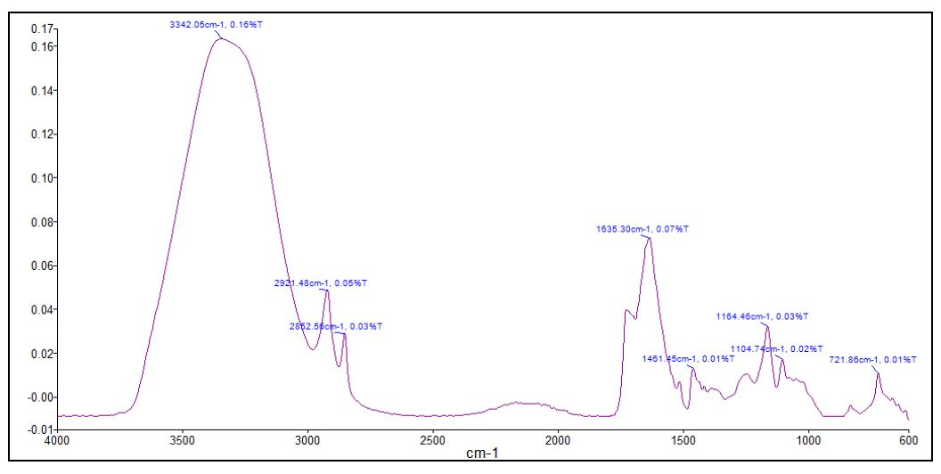
Figure 1. The FTIR spectrum of chili at wavenumber 4000-600 cm⁻¹

Table 3. The functional groups associated with absorption peaks identified in organic chili
Absorption Peak (cm⁻¹) | Possible Functional Group
3342.05 | O-H stretching from amino acids
2921.48 and 2852.56 | C-H stretching (from CH₃ and CH₂ groups)
1635.3 | C=O stretching of amide I band
1461.45 | C-H bending
1164.46 | C-C-O stretching  C-H bending
1104.74 | C-C-O stretching  C-H bending

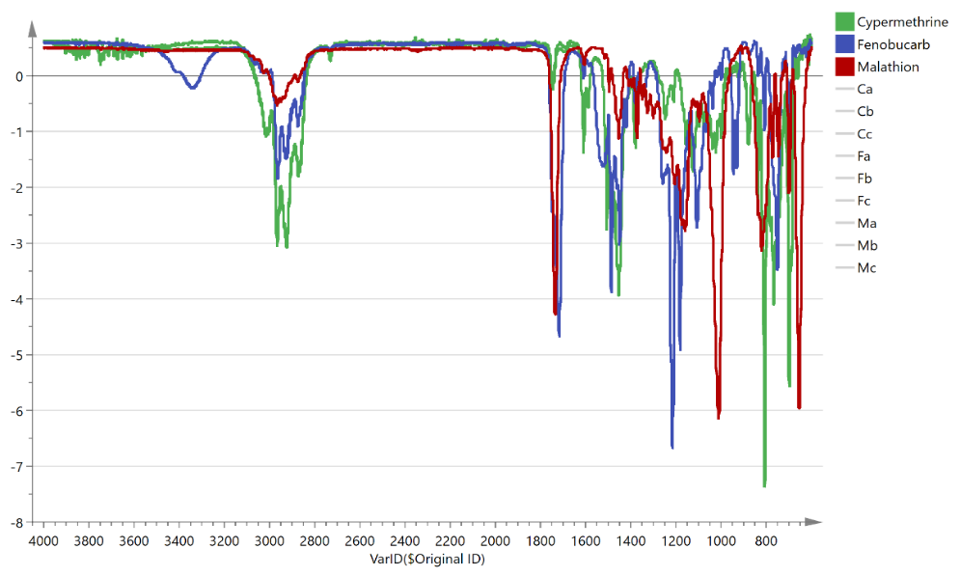
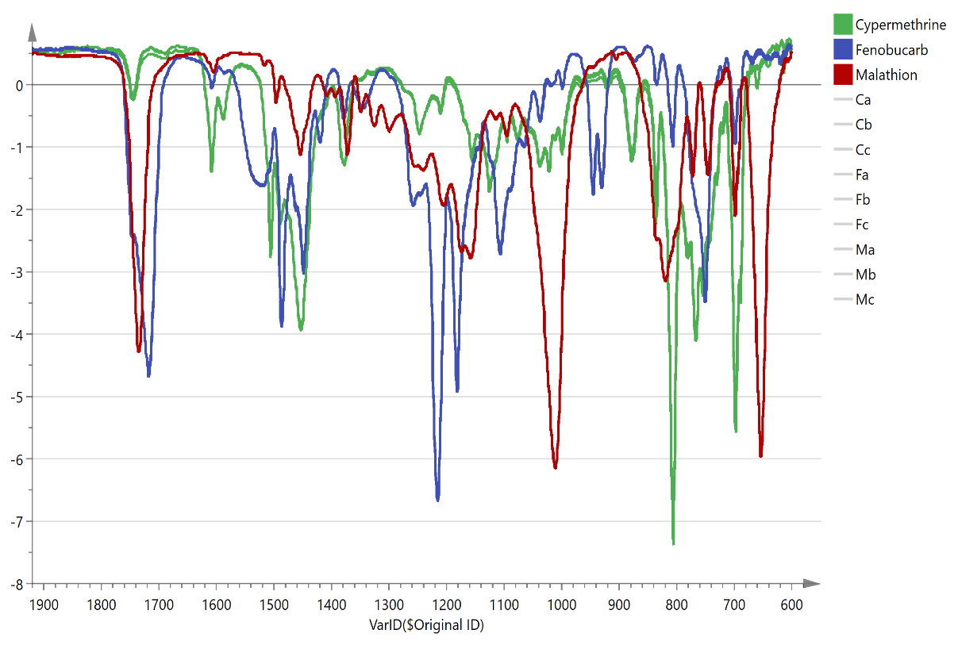

Figure 2. Full range FTIR spectra at wavenumber 4000–600 cm⁻¹ (top) and the FTIR spectra enlarged at wavenumber 1900-600 cm⁻¹ (bottom) for the three pesticides

Principal component analysis
Prior to analysis, the IR spectra of the chili samples were pre-processed to minimize data variation and overcome the dominating effect of strong peak absorbance over weaker absorbance intensity [18]. Selecting a proper spectral range may be beneficial in reducing the computational burden of the software in terms of variables. Hence, the spectral region 1800–600 cm⁻¹ was selected for further analysis, due to the high positive correlations between changes in the composition and spectral response observed, which may be due to biomolecules’ absorption of IR radiation occurring primarily in this region [14, 17].

As an unsupervised method, PCA was adopted for the initial exploratory data analysis, whereby the score plot reflected separation among the samples. PCA was applied to the dataset of 120 chili samples to detect outliers, as well as to predict possible patterns and trends of clustering. For a visual illustration and understanding, different classes of organic and pesticide samples were mapped and labeled with representative symbols. Figure 3(a) shows the score scatter plot for PCA overview using the first two principal components, PC1 (as in t1) and PC2 (as in t2). Most samples fell within Hotelling's T2 ellipse at 95% confidence intervals, with a few outliers. The combination of PC1 and PC2 explained 43.6% of the variation in the dataset. However, the organic and pesticide-contaminated samples could not be distinctly classified into two clusters, as some samples overlapped with each other. The presence of outliers may indicate experimental error due to sample preparation. Direct measurement of the samples without additional preparation may cause possible background noise, leading to inconsistencies.

PCA was performed further by plotting the individual score plots of each pesticide and organic sample, to allow better qualitative discrimination between sample groups. Results showed that a distinct separation into two clusters was observed in each of the scatter plots, meaning that PCA adequately captured relevant information within the dataset. As illustrated in Figure 3(b), the organic samples were well-segregated from cypermethrin-containing samples, with clearly defined clusters along PC2. When both PC1 and PC2 were combined, they contributed about 56.7% of the total variance, with some samples overlapping with each other. As for the outcome of PCA on organic samples and fenobucarb-containing samples (Figure 3(c), the result shows that the samples were well-distinguished, also mostly based on PC2. When both PC1 and PC2 were combined, these accounted for 57.5% of the total variance. Likewise, as shown in Figure 3(d), partially overlapping samples were observed in the score plot of organic and pesticide malathion-sprayed samples, with a total variance of 56.7%. This may be due to a low concentration of spiked malathion, making it difficult to differentiate between the IR spectra of both organic and pesticide-containing samples.

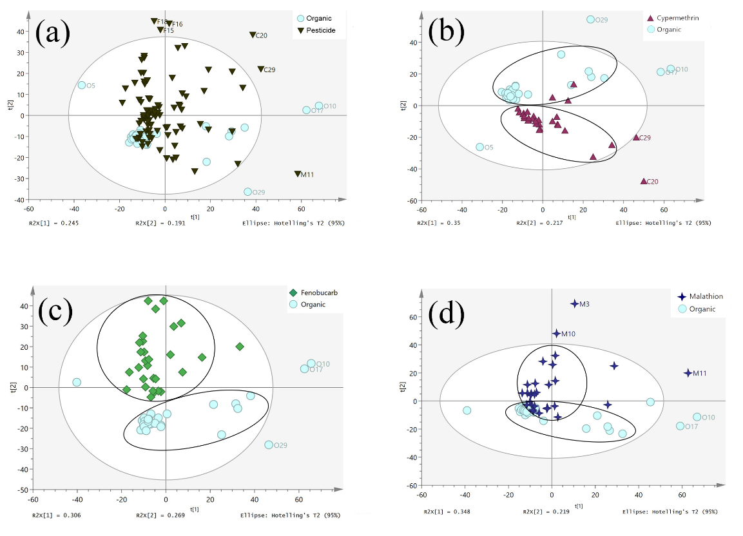
(c)))
(d)
(b)
(a)
Figure 3. PCA score scatter plot based on PC1 and PC2 (a) organic and pesticide-contaminated samples, (b) organic and cypermethrin-contaminated samples, (c) organic and fenobucarb-contaminated samples, and (d) organic and malathion-contaminated samples

PCA was also performed on the IR spectra of neat cypermethrin, fenobucarb and malathion samples, to investigate the main variance among the three pesticides used in this study (Figure 4). The first two principal components explained 90.6% of data variation and showed observable clustering of the samples, according to the main active compound for the three pesticides.

Predictive models
As PCA had successfully distinguished the dataset into the observable cluster, a supervised OPLS-DA method was later performed using each dataset separately: organic with cypermethrin, organic with fenobucarb, and organic with malathion. The original dataset was divided into a training set and testing set, using an 80:20 ratio. Initially, 80% of the samples from the original dataset (24 samples from each class) were randomly selected as a training dataset, to build the predictive models aimed at differentiating organic and pesticide-contaminated chili samples. Classification rates were obtained from the internal sevenfold cross-validation by default in the SIMCA software. The remaining 20% of the samples (6 samples from each class) were set aside as an external validation test set, to evaluate the robustness of the predictive models. The overall efficiency of the models was assessed by observing the numbers of correctly and incorrectly assigned members of different classes for training and test datasets.

The score scatter plots displayed the samples by specific color-coded classes are shown in Figure 5. The four classes in the training set were organic chili (denoted as Organic Training Set), and organic chili that had been sprayed with pesticides: cypermethrin (denoted as Cypermethrine Training Set), fenobucarb (denoted as Fenobucarb Training Set), and malathion (denoted as Malathion Training Set). The scatter plots in OPLS-DA showed better separation between classes compared to PCA. As depicted in Figure 5, the samples in each cluster were more tightly grouped in OPLS-DA than in PCA.

The predictive model for organic and cypermethrin has a fitness of data (R²) of 64.6%. The predictive ability (Q²) was above moderate at 79.6%, with a total sum of variation (R²(Y)) of 84.2%. The model for organic and fenobucarb has an R² of 62%, high predictive ability (Q²) of 80.3%, and R²(Y) of 85.8%. For organic and malathion-contaminated samples, the predictive model has an R² of 78.1%, moderate Q² of 70.6%, and R²(Y) of 88.9%. The cross-validated analysis of variation (CV-ANOVA) for cypermethrin, fenobucarb, and malathion models reported P-values of 1.10 × 10⁻¹², 5.70 × 10⁻¹³, and 3.15 × 10⁻⁷, respectively. The results showed that the discrimination between organic and pesticide-contaminated chili samples was significant (p <0.05).

The classification of the samples has been accurately performed (100% accuracy) for organic and cypermethrin models (Table 4), as well as organic and fenobucarb models (Table 5). In the case of organic and malathion models (Table 6), a single sample was misclassified into the organic class (91.67% accuracy), while all six organic chili samples fell accurately into their right cluster (100% accuracy). These results demonstrate the reliability of the models as a primary screening tool to detect the presence of pesticides in organic produce. It may help food regulators to ascertain whether the fruits or vegetables require further testing using more sophisticated instrumentation.

Figure 4. PCA score scatter plot according to the main active compound for the three pesticides

(a)
(b)

(d)
(c)

(f)
(e)

Figure 5. OPLS-DA scatter plots by the class of organic and pesticide-contaminated samples (a) training set for organic and cypermethrin, (b) predicted plot for organic and cypermethrin, (c) training set for organic and fenobucarb, (d) predicted plot for organic and fenobucarb, (e) training set for organic and malathion and (f) predicted plot for organic and malathion

Table 4. Misclassification table for organic and cypermethrin samples
 | Members | Correct  (%) | Organic Training Set | Cypermethrine Training Set
Organic Training Set | 24 | 100 | 24 | 0
Cypermethrine Training Set | 24 | 100 | 0 | 24
Test Set | 12 | 100 | 6 | 6
Total | 60 | 100 | 30 | 30

Table 5. Misclassification table for organic and fenobucarb samples
 | Members | Correct  (%) | Organic Training Set | Fenobucarb Training Set
Organic Training Set | 24 | 100 | 24 | 0
Fenobucarb Training Set | 24 | 100 | 0 | 24
Test Set | 12 | 100 | 6 | 6
Total | 60 | 100 | 30 | 30

Table 6. Misclassification table for organic and malathion samples
 | Members | Correct  (%) | Organic Training Set | Malathion Training Set
Organic Training Set | 24 | 100 | 24 | 0
Malathion Training Set | 24 | 100 | 0 | 24
Test Set | 12 | 91.67 | 7 | 5
Total | 60 | 100 | 31 | 29

Conclusion
The combination of ATR-FTIR and chemometrics can be utilized for preliminary screening of pesticides in organic produce, yielding benefits such as high speed, non-invasiveness, and simplicity of sample preparation. In general, distinguishing each pesticide was possible according to its functional groups, as analyzed by ATR-FTIR. Cypermethrin, for example, revealed stronger peaks contributed by C-H (from benzene rings) and C-Cl functional groups, whereas fenobucarb was identifiable by N-H stretching, C-O-C stretching, and C-N stretching. Malathion had strong peaks contributed by two P-O-C stretches and S=P-S-C stretching. The results also showed clear discrimination and classification between organic and pesticide-contaminated chili samples through PCA, and can be considered as a successful attempt, despite a few outliers observed in the process. With the use of OPLS-DA, it is possible to classify samples according to organic and pesticide-contaminated classes and predict the residues of unknown pesticides. This study serves as an approach for pesticide screening of organic produce, thereby suggesting further investigation, based on the detection limit of pesticide residues for various fruit and vegetables, in ensuring more robust classification models.
Acknowledgment
The authors greatly acknowledge the funding provided by Universiti Sains Malaysia Bridging Grant (Khas) with Project Code: USM 304/PTEKIND/6316224, which has enabled this work to be conducted.

References
- Winter, C. K. (2012). Pesticide residues in imported, organic, and “suspect” fruits and vegetables. Journal of Agricultural and Food Chemistry, 60(18): 4425-4429.
- Akashe, M. M., Pawade, U. V. and Nikam, A. V. (2018). Classification of pesticides: A review. International Journal of Research in Ayurveda and Pharmacy, 9(4): 144-150.
- Chatterjee, S., Das, S. K., Chakravarty, R., Chakrabarti, A., Ghosh, S. and Guha, A. K. (2010). Interaction of malathion, an organophosphorus pesticide with Rhizopus oryzae biomass. Journal of Hazardous Materials, 174(1–3): 47-53.
- Munawar, A. and Hameed, S. W. (2013). Quantification of pesticide residues in vegetables by different chromatographic techniques. Journal of Chromatography and Separation Techniques, 4(8): 8-11.
- Sadi, B. B., Vonderheide, A. P. and Caruso, J. A. (2004). Analysis of phosphorus herbicides by ion-pairing reversed-phase liquid chromatography coupled to inductively coupled plasma mass spectrometry with octapole reaction cell. Journal of Chromatography A, 1050(1): 95-101.
- Ellis, D. I., Brewster, V. L., Dunn, W. B., Allwood, J. W., Golovanov, A. P. and Goodacre, R. (2012). Fingerprinting food: Current technologies for the detection of food adulteration and contamination. Chemical Society Reviews, 41(17): 5706-5727.
- Xiao, G., Dong, D., Liao, T., Li, Y., Zheng, L., Zhang, D. and Zhao, C. (2015). Detection of pesticide (chlorpyrifos) residues on fruit peels through spectra of volatiles by FTIR. Food Analytical Methods, 8(5): 1341-1346.
- Cheajesadagul, P., Arnaudguilhem, C., Shiowatana, J., Siripinyanond, A. and Szpunar, J. (2013). Discrimination of geographical origin of rice based on multi-element fingerprinting by high resolution inductively coupled plasma mass spectrometry. Food Chemistry, 141(4): 3504-3509.
- Liu, Z., Yuan, Y., Zhang, Y., Shi, Y., Hu, G., Zhu, J. and Rogers, K. M. (2019). Geographical traceability of Chinese green tea using stable isotope and multi-element chemometrics. Rapid Communications in Mass Spectrometry, 33(8): 778-788.
- Sârbu, C., Nacu-Briciu, R. D., Kot-Wasik, A., Gorinstein, S., Wasik, A. and Namieśnik, J. (2012). Classification and fingerprinting of kiwi and pomelo fruits by multivariate analysis of chromatographic and spectroscopic data. Food Chemistry, 130(4): 994-1002.
- Cubero-Leon, E., De Rudder, O. and Maquet, A. (2018). Metabolomics for organic food authentication: Results from a long-term field study in carrots. Food Chemistry, 239(555): 760-770.
- Lob, S., Aris, M. N. M., Sidique, S. N. M., Ibrahim, N. F. and Jin, X. (2017). Growth development and natural infection incidence of tobacco mosaic virus (TMV) on silicon-treated chilli (Capsicum annuum L.) cultivated in commercial soil. Malaysian Applied Biology, 46(3): 221-226.
- Zaidon, S. Z., Hamsan, H. and Bin, H. Y. (2016). A review on pesticides occurrence in fruits and vegetables in Malaysia and their potential health risk among adults. Indian Journal of Environmental Protection, 36(10): 826-832.
- Skolik, P., McAinsh, M. R. and Martin, F. L. (2019). ATR-FTIR spectroscopy non-destructively detects damage-induced sour rot infection in whole tomato fruit. Planta, 249(3): 925-939.

- Devos, O., Downey, G. and Duponchel, L. (2014). Simultaneous data pre-processing and SVM classification model selection based on a parallel genetic algorithm applied to spectroscopic data of olive oils. Food Chemistry, 148: 124–130.
- Ciulu-Costinescu, F., Neamţu, J., Popescu, M., Chirigiu, L., Simionescu, A., Bubulică, M. V. and Belu, I. (2015). Preliminary analysis of Capsicum annuum L. extracts. Current Health Sciences Journal, 41(4): 311-316.
- Domínguez-Martínez, I., Meza-Márquez, O. G., Osorio-Revilla, G., Proal-Nájera, J. and Gallardo-Velázquez, T. (2014). Determination of capsaicin, ascorbic acid, total phenolic compounds and antioxidant activity of Capsicum annuum L. var. serrano by mid infrared spectroscopy (Mid-FTIR) and chemometric analysis. Journal of the Korean Society for Applied Biological Chemistry, 57(1): 133-142.
- Ismail, D., Rahimi, A., Wan Ishak, W. R., Mahat, N. A. and Mat Desa, W. N. S. (2021). Classification model for detection and discrimination of inedible plastic adulterated palm cooking oil using ATR-FTIR spectroscopy combined with principal component analysis. Malaysian Journal of Analytical Sciences, 25(3): 388-398.

