
CATALYTIC NEUTRALIZATION OF ACIDIC PETROLEUM CRUDE OIL UTILIZING 2-METHYLIMIDAZOLE WITH ADDITION OF Cu/Ce(10:90)/Al₂O₃ CATALYST

(Peneutralan Pemangkin Minyak Mentah Petroleum Berasid Menggunakan 2-Metilimidazol dengan Tambahan Mangkin Cu/Ce(10:90)/Al₂O₃)

Norshahidatul Akmar Mohd Shohaimi¹*, Noraini Safar Che Harun¹, Hisyam Saufi Tajudin¹,
Wan Azelee Wan Abu Bakar², Nurasmat Mohd Shukri³, Nor Hakimin Abdullah⁴, Ahmad Zamani Ab Halim⁵

¹Faculty of Applied Sciences,
Universiti Teknologi MARA Pahang, Bandar Tun Abdul Razak Jengka, Pahang, Malaysia
²Faculty of Sciences,
Universiti Teknologi Malaysia, Johor Bahru, Johor, Malaysia
³School of Health Sciences,
Universiti Sains Malaysia, Health Campus, 16150 Kubang Kerian, Kelantan
⁴Advanced Materials Research Centre (AMRC), Faculty of Bioengineering and Technology,
Universiti Malaysia Kelantan, Locked Bag 100, 17600 Jeli, Kelantan
⁵Faculty of Industrial Sciences & Technology,
Universiti Malaysia Pahang, 26300 Gambang, Kuantan, Pahang, Malaysia

*Corresponding author: akmarshohaimi@uitm.edu.my

Received: 22 December 2021; Accepted: 3 February 2022; Published: xx February 2022

Abstract
The presence of naphthenic acid (NA) in crude oil leads to corrosion problems within oil refineries which may increase the maintenance cost and produce lower quality of crude oil. The objective of this study is to reduce the total acid number (TAN) of Petronas Penapisan Melaka (PPM)’s crude oil (TAN = 2.43 mgKOH/g) using 2-methylimidazole with the aid of Cu/Ce (10:90)/Al₂O₃ catalyst through the catalytic neutralization technique. A 10% of 2-methylimidazole in ethanol solution was used as the acid removal agent. Cerium oxide based catalysts with copper as a dopant were supported onto alumina and calcined at different calcination temperatures of 800 ℃, 900 ℃ and 1000 ℃. The potential catalyst was characterized by using TGA-DTG, FTIR and XRD for its physicochemical properties. The results showed TAN was reduced to 0.53 mg KOH/g with 78.2% reduction at catalyst calcination temperature of 900 ℃, 0.5% catalyst loading, reaction temperature of 27 ℃ and 10 minutes reaction time. The small particle size of catalyst calcined at 900 ℃ which was 18.02 nm led to bigger surface areas that enhanced the neutralization process. These structural properties contributed to the excellent catalytic performance which removed the NAs in the PPM’s crude oil and concurrently reduced the TAN value below than one.

Keywords: catalyst, catalytic neutralization, crude oil, naphthenic acid

Abstrak
Kehadiran asid naftenik (NA) dalam minyak mentah membawa kepada masalah kakisan dalam kilang penapisan minyak yang boleh meningkatkan kos penyelenggaraan dan menghasilkan minyak mentah yang berkualiti rendah. Objektif kajian ini adalah untuk mengurangkan jumlah asid (TAN) minyak mentah Petronas Penapisan Melaka (PPM) (TAN = 2.43 mgKOH/g) menggunakan 2-metilimidazol dengan bantuan mangkin Cu/Ce (10:90)/ Al₂O₃ melalui teknik peneutralan pemangkin. 10% daripada 2-metilimidazol dalam larutan etanol digunakan sebagai agen penyingkiran asid. Pemangkin berasaskan serium oksida dengan kuprum sebagai dopan disokong pada alumina dan dikalsinkan pada suhu pengkalsinan berbeza 800 ℃, 900 ℃ dan 1000 ℃. Mangkin berpotensi dicirikan dengan menggunakan TGA-DTG, FTIR dan XRD untuk sifat fizikokimianya. Keputusan menunjukkan TAN dikurangkan kepada 0.53 mg KOH/g dengan pengurangan 78.2% pada suhu pengkalsinan mangkin 900 ℃, 0.5% pemuatan mangkin, suhu tindak balas 27 ℃ dan 10 minit masa tindak balas. Saiz zarah kecil pemangkin yang dikalsinkan pada 900 ℃ iaitu 18.02 nm membawa kepada kawasan permukaan yang lebih besar yang meningkatkan proses peneutralan. Ciri-ciri struktur ini menyumbang kepada prestasi pemangkin yang sangat baik yang mengeluarkan NA dalam minyak mentah PPM dan secara serentak mengurangkan nilai TAN di bawah satu.

Kata kunci: mangkin, peneutralan pemangkin, minyak mentah, asid naftenik

Introduction
Nowadays, crude oil had become one of the most important source of energy in the world. Since raw petroleum is an important source of energy, it is imperative to overcome the issue of acidic crude oil to have better oil production [1]. In recent years, acidic crude oil production has raised by 0.3% per year worldwide. The naphthenic acid (NA) compound present in crude oil leads to the high acidity of oil. The term “naphthenic acids” is used to account for all carboxylic acids present in crude oil including acyclic and aromatic acids, which is also referred to as complicated mixtures [2].

The acidity of petroleum crude oil is measured by its total acid number (TAN), which refers the number of milligrams of KOH required to reduce the corrosiveness in one gram of oil [3]. Currently, the treatment for acidic oil either relies upon weakening or caustic washing techniques to decrease the TAN number of overwhelming rough oils. Moreover, neither of these method is altogether attractive. For example, even though mixing high TAN unrefined petroleum with a low TAN unrefined petroleum might decrease the NAs content to a worthy level, the acidic mixes still remain [1]. Burning treatment can also considerably evacuate NAs, but the procedure creates critical measures of wastewater and emulsion that are problematic to treat. Specifically, once an emulsion is formed, it is exceptionally hard to evacuate [4, 5]. A series of homogeneous basic catalysts are widely used in the petroleum industry such as KOH and NaOH but these types of catalysts would induce an emulsion problem and no catalyst recovery. Solid acid catalysts have attracted a lot of attention in recent years in various industrial organic transformations, owing to their non-toxicity, non-corrosiveness, low cost, easy handling, recovery, and reusability. Among the several mesoporous materials, such as MCM-41 and SBA-16, the most important amphoteric substance is ɣ-alumina (ɣ-Al₂O₃), which is commercially accessible. It has been employed directly as a catalyst and as a catalyst support material in the automotive and petroleum industries due to its combination of textural features such as surface area, pore volume, and pore size dispersion.

Due to the fact that crude oil upgrading is important to ensure the crude oil produced is in a high quality with a good price, an extensive treatment will be carried out for the high acidic crude oil. In this study, the catalytic neutralization technique was introduced utilizing a 2-methylimidazole in ethanol solution with the aids of copper doped cerium based catalyst with alumina as a support.

Materials and Methods
Catalyst preparation and characterization
In this study, cerium oxides were used as catalysts of interest and supported onto alumina with copper as a dopant. Cerium nitrate and copper nitrate were chosen as the metal precursor as it is easily soluble in water. The ratio of based-dopant used was 10 (dopant) to 90 (base) according to the metal precursor molar ratio and then calcined at a temperatures of 800 ℃, 900 ℃, and 1000 ℃ [6]. An aqueous Incipient Wetness Impregnation (IWI) method was used to prepare the catalyst. According to the desired ratio, each of the metal salts was weighted in a beaker and it was dissolved in small amount of distilled water. To homogenize the mixture, the solutions were mixed together and the mixture solution was stirred continuously by magnetic bar for 30 minutes at 27 ℃. The alumina (Al₂O₃) beads as a support material were immersed into the catalysts solution for 1 hour and the supported catalysts were transferred onto an evaporating dish covered with glass wool [7, 8].

To remove water and allow good coating of catalyst solution on the surface of alumina, it was then aged inside an oven at 80-90 ℃ for 24 hour. To eliminate all the metals precursor, excess water and impurities, this steps were followed by calcination in the furnace at 800 ℃ for 5 hours using a ramp rate of 5℃/min [9]. The preparation of the best catalyst was further optimized at temperatures of 900 ℃ and 1000 ℃ [4]. To study its physicochemical properties, the potential catalyst was characterized by a several methods. The data obtained were exceedingly valuable to comprehend the relationship between catalyst properties and its catalytic performance towards the neutralization activity. The characterization techniques that were used are X-ray Diffraction Spectroscopy (XRD), Fourier Transform Infrared Spectroscopy (FTIR), and Thermal Gravimetry Analysis (TGA-DTG) [10].

Feedstock and basic chemical
The materials were purchased from QReCTM and used as supplied. Feedstock used in this study was obtained from Petronas Penapisan Melaka (PPM), Malaysia with TAN of 2.43 mg KOH/g. In this study, the 2-propanol and toluene was used as titration solvents. The indicator used in the neutralization reaction is a phenolphthalein solution, 1% (w/v) in ethanol. Potassium hydroxide pellets and barium hydroxide were utilized as titrants [11, 12].

Catalytic neutralization reaction
Crude oil and 2-methylimidazole solution in ethanol by a certain mass ratio was stirred. A total of 10% (w/w) of imidazole derivative solutions in ethanol and cerium oxide as catalyst were added to Petronas Penapisan Melaka (PPM)’s crude oil. Then the mixture solution was put into 2 neck round bottom flask equip with a magnetic stirrer and thermometer to control the constant temperature. Parafin oil was used to ease the maintaining of the constant temperature that was 27 ℃, 40 ℃, 50 ℃ and 60 ℃ [13]. The mixture then was stirred at the various temperatures for 5, 10 and 15 minutes to study the effect of reaction time [2]. After the extraction process, the mixture was put into a centrifuge container and was centrifuge with a speed of 50×106 rpm for 30 minutes. The mixture was centrifuged to achieve the gravity separation of the reagent with the acidic compounds extracted from the crude oil sample. The reagent with ionic liquid was on top of the centrifuge tube, while the neutralized crude oil was collected at the bottom of the tube [9].

Total acid number (TAN) determination
A 0.2 g Melaka crude oil sample after neutralization treatment was measured and placed in a titration beaker. The titration solvent, 40 mL with a mixture of 2-propanol: toluene: distilled water (50:49.5:0.5) was poured into the crude oil sample in the titration beaker. Then, the petroleum crude oil sample was titrated with potassium hydroxide and barium hydroxide solution (0.01 mol/L).

TAN value for Melaka’s crude oil (TAN = 2.43 mg KOH/g) was determined by semi-micro colour indicator titration method. The indicator used was phenolphthalein solution, 0.1 mL where the stable red colour was observed and indicated the end-point for the titration method. The titration method was performed on Melaka’s crude oil before and after the catalytic neutralization reaction. In order to express the results, the TAN of the sample was calculated in milligrams of potassium hydroxide per gram of sample (mg KOH/g) by using Equation 1.
( V_{KOH} – V_{B} )
TAN = 56.1 x c x (1)
m
where 56.1 is the molecular mass of KOH (g/mol), c is the concentration of the standard volumetric potassium hydroxide solution (mol/L), V_{KOH} is the volume of titrant used to reach the equilibrium point (mL), V_{B} is the volume of titrant required for the blank titration (mL), and m is the sample mass (g).

Results and Discussion
Thermogravimetry analysis-differential thermal gravimetry (TGA-DTG)
TGA-DTG analysis was studied to obtain thermal stability of potential catalyst after being aged overnight in an oven at 80-90 ℃ [1]. TGA profile exhibited some well-defined sections of weight loss accompanied by different slopes of thermogravimetric trace (weight loss rate). The thermogram of the Cu/Ce(10:90)/Al₂O₃ catalyst showed three phases of weight loss as depicted in Figure 1 while the Table 1 tabulated the type of species deduction corresponding to the heating temperature.

The weight loss in the range of 100-200 ℃ was due to the loss of physisorbed water molecules and was assigned to the evaporation of chemically adsorbed water molecules[14]. Between the temperature of 200–380℃, the weight loss was attributed to the loss of hydroxyl molecules and lastly the weight loss at the range of 380–650℃ was due to the decomposition of nitrate precursors as shown in equation

2Ce(NO₃)₃ → 2CeO₂ + 6NO₂ + O₂ (2)

The theoretical mass loss when the nitrates were decomposed can be calculated in terms of the final mixture form (CeO₂/Al₂O₃) from 650 ℃ to 1000 ℃ for being a stable form [15]. From the overall of TGA–DTG analysis, it can be concluded that thermal treatment had eliminated the impurities and water from the materials with 14.50% of total weight loss in 8.15 mg of catalyst and the pure metal oxide was obtained after heating at 650 ℃ [16].

This observation is in agreement with the result shown in Figure 5 where by using Cu/Ce (10:90)/Al₂O₃ catalyst calcined at 900 ℃, the TAN value of PPM’s crude oil can be reduced from the original TAN value as the catalyst calcined at this temperature show complete formation of metal oxide. The detailed weight loss and the deduction for each stages of weight loss is presented in Table 1.

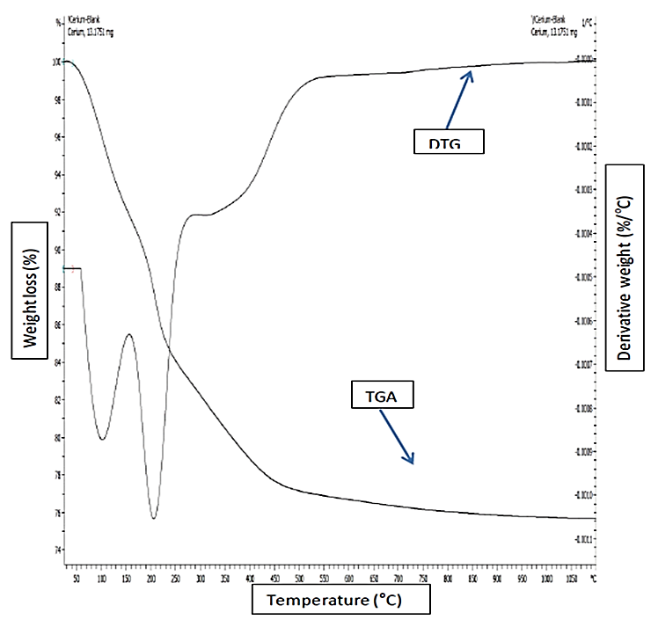
Figure 1. TGA-DTG thermogram of Cu/Ce (10:90)/Al₂O₃ catalyst after aging in an oven for 24 hours at 80-90 ℃
Table 1. TGA analysis results for Cu/Ce (10:90)/Al₂O₃ catalyst
Heating Temperature,  ºC | Weight Loss, % | Deduction
100-200 | 14.50 | Loss of crystal water and surface water molecule
200-380 | 8.20 | Complete removal of water and formation of pure metal oxide
380-650 | 1.30 | Loss of nitrate compound and surface hydroxyl molecule

X-ray diffraction
The XRD diffractogram for the bimetallic catalyst of Cu/Ce (10:90)/Al₂O₃ calcined at different temperatures of 800 ℃, 900 ℃, and 1000 ℃ were compiled in Figure 2. From the XRD diffractogram pattern, it can be seen that Cu/Ce(10:90)/Al₂O₃ catalyst calcined at 800 ℃ and 900 ℃ were less crystalline compared to the catalyst calcined at 1000 ℃. Typically, the calcination process of a catalyst involves the loss of chemically bound water or precursors, modification of the texture through sintering, modification of the structure, generation of an active phase and stabilization of mechanical properties which result in the development of an increased surface area of these catalysts [17].

The polycrystallinity phase of the catalyst calcined at 800 ºC and 900 ºC was dominated by the CeO₂ face-centered cubic (fcc) species and some of the alumina orthorhombic (o) phase. The broadening of CeO₂ peak calcined at 800 ℃ and polycrystalline of CeO₂ calcined 900 ℃ were attributed to the presence of a mixture of metal oxides and also due to loose arrangement of atom in the compound [18]. The high crystallinity of CeO₂ peak observed at 1000 ºC calcination temperature is in agreement with the finding from [19] who stated that the size of catalyst will increase as it was calcined at high temperature. Increasing in particle size of catalyst will lead to the smaller surface area. Therefore, 900 ℃ was an ideal calcination temperature for Cu/Ce (10:90)/Al₂O₃ catalyst in order to reduce the NAs content of PPM’s crude oils.

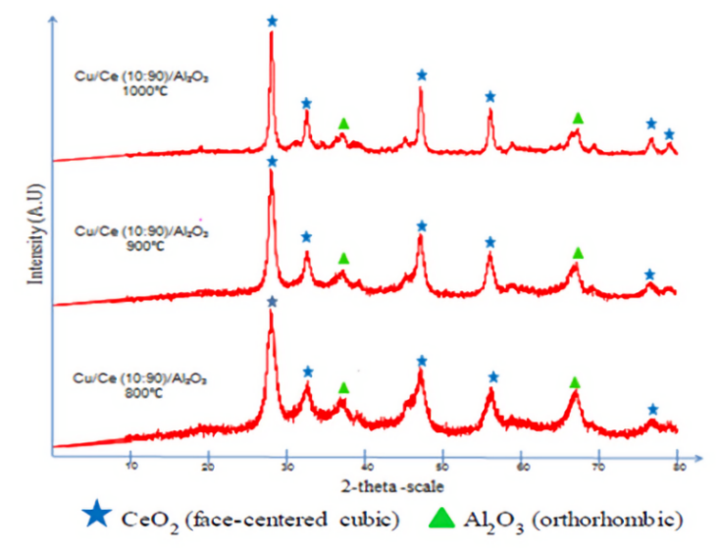
Figure 2. The XRD diffractograms of Cu/Ce(10:90)/Al₂O₃ catalyst calcined at temperatures of 800, 900 and 1000 ℃ for 5 hours

Fourier transform infrared spectroscopy
The FTIR spectra of Cu/Ce (10:90)/Al₂O₃ is shown in Figure 3. The peaks assignments for the catalyst is tabulated in Table 2. The results showed a group assignment for peak at 567.46 – 541.32 cm⁻¹ at calcination temperature of 900 ℃ before and after neutralization process was due to the stretching mode of metal oxide group which resulted from the complete formation of pure metal oxide catalyst as also reported by Roy and Bhattacharya [20]. Based on the figure, it can be observed that after deacidification process (b), the new peak appeared at stretching frequency of 1310.65, 1478.24, 2810.87, and 2987.87 due to the attachment of impurities on the surface of the catalyst. It could be suggested that the catalyst should be pre-treated before use in the next cycle of reaction.

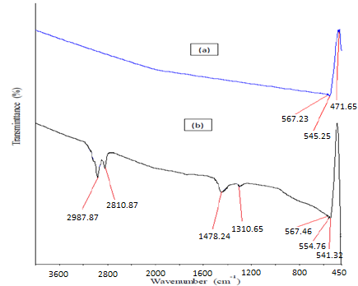
Figure 3. FTIR spectra of Cu/Ce (10:90)/Al₂O₃ catalyst at calcination temperatures of 900 ℃, (a) before neutralization reaction (b) after neutralization reaction

Wavenumber, cm⁻¹ | Peak Assignment
2987.87 and 2810.87 | sp³ C-H stretching
1478.24 | sp² C-H stretching
1310.65 | Stretching mode of free nitrate (NO₃⁻) group from metal precursors
567.46 – 541.32 | Stretching mode of Metal=Oxygen (M=O)
Table 2. FTIR peak assignment of Cu/Ce (10:90)/Al₂O₃ catalyst

Effect of reagent concentration towards crude oil TAN without catalyst
Shi et al. [13] had reported the effect of different imidazole derivatives on the reduction of TAN value of PPM’s crude oil. It could be seen that when ethanol was used to extract NA from crude oil, the acid removal rate reached up to 17.6%. The polar NAs could be partially dissolved in alcohol especially the smaller molecular weight ones with larger polarity were more easily dissolved in ethanol according to the similar dissolve mutually theory. Due to this theory, when imidazole derivatives were added into ethanol solution, the acid removal rate was significantly improved. The stronger the alkalinity of imidazole derivatives, the easier the reaction to occur because NA is a weak acid.

Figure 4 shows various amount of 2-methylimidazole concentration from 5% to 15% that were tested in order to reduce the TAN of untreated PPM’s crude oil sample. When higher percentages of 2-methylimidazole were used, the TAN value of PPM’s crude oils was further decreased. The best result showing the highest concentration of 2-methylimidazole (15%) reduced TAN value from 2.43 mg KOH/g to 1.10 mg KOH/g is when the percentage removal of NA was 55%.

Figure 4. Effect of different reagent concentration towards TAN value without presence of catalyst

Effect of catalyst calcination temperature
An investigation on this parameter was conducted to determine the effect of calcination temperature on the alumina supported catalyst by using 10% of 2-methylimidazole. Figure 5 showed the trends of TAN value based on different catalyst calcination temperature. The trend of TAN value of PPM’s crude oils decreased from calcination temperature of 800 ℃ to 900 ℃ and increased when the catalyst calcined at 1000 ℃. The catalysts which calcined at lower calcination temperatures (800 ℃) showed poor performance in this study while the catalyst functioned well in the removal of NAs process when calcined at a medium calcination temperature of 900 ℃. At 900 ℃ calcination temperature, it showed an improvement in reducing acidic content of crude oil due to the larger surface area of the catalyst from smaller particle size as supported from the BET results obtained by [4]. Thus, it provided sufficient surface sites for an excellent NAs removal process [21].

Lower performance was shown by this catalyst calcined at 1000 ℃, which gave TAN value of 1.87 mg KOH/g which is above than one. This is probably due to the fact that increasing calcination temperature will increase particle size of the catalyst which leads to a smaller surface area because of high crystallinity of the catalyst observed by the narrow peak as shown by diffractogram in XRD analysis. Therefore, 900℃ was selected as the ideal calcination temperature for removal of NA for PPM’s crude oil samples [6].

Figure 5. Effect of different calcination temperature towards TAN value

Effect of catalyst loading
Catalyst loading is the percentage of the catalyst used by calculating the weight of catalyst used over mass of crude oil. In this study, this parameter was observed to study the effectiveness and efficiency of various catalyst loading towards TAN value. Figure 6 showed the trend of TAN value for PPM’s crude oil based on different catalyst loading. The trend of TAN value for PPM’s crude oils was decreasing with an increase in the percentage of the catalyst loading. It could be seen that the highest catalyst loading of 0.5% successfully reduced TAN value to 0.53 mg KOH/g while the lowest loading percentages that was 0.1% only reduced the TAN value to 1.69 mg KOH/g. An increased in the catalyst loading made the catalytic reaction became faster and more efficient.

Figure 6. Effect of different percentage of catalyst loading towards TAN value (Catalyst calcination temperature: 900 ºC)

Effect of reaction temperature
In this study, different reaction temperatures were studied for catalytic neutralization process on PPM’s crude oils. The temperature can be used to determine the speed of the neutralization reaction and can also decrease the viscosity of the crude oil, making the crude oil more accessible to the 2-methylimidazole. The trend of TAN for PPM’s crude oils was increased when the reaction temperature increased as shown in Figure 7.

The percentage of catalytic neutralization activity decreased from 27 ℃ until 40 ℃ for PPM’s crude oil samples as the TAN value for 27 ℃ reduced from 2.43 to 0.53 mg KOH/g while at 40 ℃, TAN reduced from 2.43 to 0.74 mg KOH/g and at 50 ℃ it decreased to 1.24 mg KOH/g and lastly, for 60 ℃ the TAN decreased from 2.43 to 1.44 mg KOH/g. This was because the reaction occured at higher temperature was not profitable for the reaction between 2-methylimizadole and NAs in crude oil as the higher temperature can increase the viscosity of the crude oil. This occurrence probably stabilized the NA in crude oil and inhibited the reagent to react with NA effectively. In addition, this study offered an environmental friendly process because lower reaction temperature can lead to lower energy consumption and at the same time can reduce air pollution [3].

Figure 7. Effect of different reaction temperature towards TAN value (Catalyst calcination temperature: 900 ºC, catalyst loading: 0.5%)

Effect of reaction time
The effect of different reaction times on the neutralization process with Cu/Ce (10:90)/Al₂O₃ catalyst calcined at 900 ℃ with addition of 0.5% catalyst loading, 10% of 2-methyl imidazole concentration, and reaction temperature of 27 ℃ was performed on PPM’s crude oils shown in Figure 8. The results illustrated that the TAN values decreased when the reaction time was increased from 5 to 15 minutes. This substantial reduction of the TAN value was attributed to the elevated opportunity for a reaction between 2-methylimidazole aided by a catalyst and NA in the crude oil. The longer the reaction time, the longer the duration for which the solution was stirred, which consequently meant the more markedly the 2-methylimidazole aided by Cu/Ce (10:90)/Al₂O₃ catalyst in the solution reacted to remove NA in PPM’s crude oils.

According to Shi et al. [13] when the reaction time was increased above 15 minutes, the TAN values became constant for PPM’s crude oil samples. This is because after 15 minutes, reagent successfully reduced and removed all NAs in crude oils. As a longer reaction time will only consume more energy, the optimum reaction time recommended is 10 minutes for the basic chemical to remove NA effectively and the best TAN value reduced is to 0.53 mg KOH/g for PPM’s crude oils. It was observed that the acid-removal rate was increased by increasing the reaction time from 5 minutes to 10 minutes at 27 ℃, but showed very small improvement of TAN value when the reaction time is between 10 minutes and 15 minutes. TGA–DTG analysis concluded that thermal treatment had eliminated the impurities and water from the materials with 14.50% of total weight loss in 8.15 mg of catalyst and the pure metal oxide was obtained after heating at 650 ℃.

Figure 8. Effect of the different reaction times on the TAN values of PPM crude oils

Conclusion
The catalytic neutralization technique had successfully been applied in this study for the removal of NA and simultaneously solved the corrosion and emulsion problem by meeting the PETRONAS benchmark for TAN value less than 1 mg KOH/g. PPM’s crude oil which possessed an initial TAN value of 2.43 mg KOH/g was reduced to 0.53 mg KOH/g with addition of 10% of 2-methylimidazole, catalyst calcination temperature of 900 ℃, 0.5% of Cu/Ce (10:90)/Al₂O₃ catalyst loading (4 beads), reaction temperature of 27 ℃ and reaction time of 10 minutes. XRD results revealed the polycrystallinity phase of the catalyst which was dominated by the CeO₂ face-centered cubic (fcc) species and some of the alumina orthorhombic (o) phase. As a recommendation for further study, other instruments to characterize the physicochemical properties of catalyst such as Brunauer–Emmett–Teller (BET), and Transmission Electron Microscopy (TEM) could be implemented.

Acknowledgement
The authors acknowledged the funding from Research Grant, FRGS with Grant No.: 011000190001 (File no.: 600 IRMI/FRGS 5/3 (108/2019)).

References
- Shohaimi, N. A., Mohd Halim, N. S., Ab Halim, A. Z., Mohd Shukri, N. and Abdullah, N. H. (2020). Catalytic study of Ni/Ce/Al₂O₃ and Ni/Ca/Al₂O₃ on the removal of naphthenic acid from petroleum crude oil utilizing sodium thiocyanate in ethanol. Petroleum Science and Technology, 38(6): 602-608.
- Sun, Y. and Shi, L. (2012). Basic ionic liquids with imidazole anion: New reagents to remove naphthenic acids from crude oil with high total acid number. Fuel, 99: 83-87.
- Cho, K., Rana, B. S., Cho, D. W., Beum, H. T., Kim, C. H. and Kim, J. N. (2020). Catalytic removal of naphthenic acids over Co-Mo/γ-Al₂O₃ catalyst to reduce total acid number (TAN) of highly acidic crude oil. Applied Catalysis A: General, 606: 117835.
- Shukri, N. M., Bakar, W. A., Jaafar, J. and Majid, Z. A. (2015). Removal of naphthenic acids from high acidity Korean crude oil utilizing catalytic deacidification method. Journal of Industrial and Engineering Chemistry. 28: 110-116.
- Wu, C., De Visscher, A. and Gates, I. D. (2019). On naphthenic acids removal from crude oil and oil sands process-affected water. Fuel, 253: 1229-1246.
- Shukri, N. M., Bakar, W. A., Jaafar, J. and Majid, Z. A. (2015b) Optimization of basic catalyst with ammoniated polyethylene glycol for the removal of naphthenic acid from petroleum crude oil by Box–Behnken design. Clean Techn Environ Policy Clean Technologies and Environmental Policy, 17(8), 2387-2400.
- Zamani, A. H., Shohaimi, N. A. M., Rosid, S. J. M., Abdullah, N. H. and Shukri, N. M. (2019). Enhanced low temperature reaction for the CO₂ methanation over Ru promoted Cu/Mn on alumina support catalyst using double reactor system. Journal of the Taiwan Institute of Chemical Engineers, 96: 400-408.
- Shohaimi, N. A. M., and Marodzi, N. F. S. (2018). Transesterification of waste cooking oil in biodiesel production utilizing CaO/Al₂O₃ Heterogeneous Catalyst. Malaysian Journal of Analytical Sciences, 22(1): 157-165.
- Aziz, N. H., Shohaimi, N. A. M. and Che Harun, N. S. (2021). The effectiveness of Ni/Ce/Al₂O₃ catalyst in the extraction of naphthenic acids from acidic crude oil. Materials Science Forum, 1025: pp. 284-289.
- Shohaimi, N. A. M, Jelani, N., Ab Halim, A. Z., Abdullah, N. H. and Shukri, N. M. (2021). Catalytic neutralization of naphthenic acid from petroleum crude oil by using cerium oxide catalyst and 2-methylimidazole in polyethylene glycol. Recent Innovations in Chemical Engineering, 14(3): 219-227.
- Shohaimi, N. A. M., Jaafar, J. and Bakar, W. A. W. A. (2015). Catalytic deacidification optimization of Korean crude oil based on response surface methodology. Clean Technologies and Environmental Policy, 17(6), 1513-1522.
- Shohaimi N.A.M, Bakar, W. A. W. A. and Jaafar, J. (2014). Catalytic neutralization of acidic crude oil utilizing ammonia in ethylene glycol basic solution. Journal of Industrial and Engineering Chemistry, 20(4): 2086-2094 .
- Shi, L. J., Shen, B. X., Wang, G. Q. (2008). Removal of naphthenic acids from beijiang crude oil by forming ionic liquids. Energy & Fuels Energy Fuels. 22(6): 4177-4181.
- Shohaimi, N. A. M., Bakar, W. A. W. A. and Jaafar, J. (2014). Catalytic neutralization method for naphthenic acid removal in crude oil by alumina supported Ca and Ba catalysts. Petroleum Science and Technology, 32(19): 2365-2375.
- Dias, A. P. S., Bernardo, J., Felizardo, P. and Neiva Correi, M. J. (2012). Biodiesel production over thermal activated cerium modified Mg-Al hydrotalcites. Energy. 41: 344-353.
- Alouche, A. (2008). Preparation and characterization of copper and/or cerium catalysts supported on alumina or ceria. Jordan Journal of Mechanical and Industrial Engineering, 2: 111-116.
- Bakar, W. A. W. A., Ali, R., Sulaiman, N. and Rahim, H. A. (2010). Manganese oxide doped noble metals supported catalyst for carbon dioxide methanation reaction. Iranian Journal of Science and Technology Transactions. 17: 115-123.

- Lamonier, C., Bennani, A., D’Huysser, A., Aboukais, A. and Wrobel, G. (1996). Evidence for different copper species in precursors of copper-cerium oxide catalysts for hydrogenation reactions: An X-ray diffraction, EPR and X-ray photoelectron spectroscopy study. Journal of Chemical Society Faraday Transaction, 92(l): 131-136.
- Bueno-Ferrer, C., Parres-Esclapez, S., Lozano-Castello, D. and Bueno-Lopez, A., (2010). Relationship between surface area and crystal size of pure and doped cerium oxides. Journal of Rare Earths, 28: 647-656.
- Roy, A. and Bhattacharya, J., (2011). Microwave-assisted synthesis and characterization of CaO nanoparticles. International Journal Nanoscience, 10(41): 3-8.
- Li, X., Zhu, J., Liu, Q. and Wu, B., (2013). The removal of naphthenic acids from dewaxed VGO via esterification catalyzed by Mg–Al hydrotalcite. Fuel Processing Technology, 111: 68-77.

