
TEMPERATURE EFFECT ON THE ENCAPSULATION OF THE DRUG TETRACAINE HYDROCHLORIDE IN DIFFERENT CYCLODEXTRINS

(Kesan Suhu Terhadap Pengkapsulan Dadah Tetrakain Hidroklorida dalam Siklodekstrin yang Berbeza)

Houria Boudjoras, Teffaha Fergoug, Mansour Azayez*, Youcef Bouhadda, Noureddine Meddah-araibi,
Cherifa Zelmat

Laboratory of Physical Chemistry of Macromolecular and Biological Interfaces,
Faculty of Exact Sciences,
University of Mustapha Stambouli, Mascara, Algeria

*Corresponding author: m.azayez@univ-mascara.dz

Received: 25 September 2021; Accepted: 30 December 2021; Published: xx February 2022

Abstract
The encapsulation of tetrakain hydrochloride (TC-HCl) in α-cyclodextrin (α-CD), β -cyclodextrin (β-CD) and hydroxypropyl-β-cyclodextrin (HPβ-CD) has been studied by UV-Visible at different temsperatures. The appearance of isosbestic points as well as hyperchromic and bathochromic shifts on the different UV-Visible spectra confirm the complexes formation. From the complexation constants values the stability of the 1:1 type complexes is in the order of α-CD < HPβ-CD < β-CD and decreases with increasing temperature for each complex. All complexation processes are spontaneous, with a favorable enthalpic contribution and an unfavorable entropic term as deduced from Van’t Hoff plot analysis. The negative values obtained for ∆Cp ° indicate that the apolar part of TC-HCl is encapsulated in the cavities of the CDs.

Keywords: UV-Vis spectrophotometry, cyclodextrins, tetracaine drug, temperature effect, Van’t Hoff analysis

Abstrak
Pengkapsulan tetrakain hidroklorida (TC, HCl) dalam α-siklodekstrin (α-CD), β-sikloododekstrin (β-CD) dan hidroksipropil-β-siklodekstrin (HPβ-CD) telah dikaji mengunakan spektrofotometri UV-cahaya nampak pada suhu yang berbeza. Kemunculan titik isosbestik serta pergeseran hipokromik dan bathokromik pada spektrum UV-cahaya nampak yang berbeza mengesahkan pembentukan kompleks. Daripada nilai pemalar kompleks, kestabilan kompleks jenis 1: 1 berada dalam urutan α-CD <HPβ-CD <β-CD dan menurun dengan kenaikan suhu bagi setiap kompleks. Semua proses pengkompleksan adalah spontan, dengan sumbangan entalpik yang menggalakkan dan istilah entropik yang tidak menguntungkan seperti hasil analisis plot Van't Hoff. Nilai negatif yang diperoleh untuk ∆Cp ° menunjukkan bahawa bahagian tidak berkutub TC-HCl dikemas dalam rongga CD.

Kata kunci: spektrofotometri UV-cahaya nampak, siklodekstrin, dadah tetrakain, kesan suhu, analisis Van't Hoff

Introduction
The administration of local anesthetics such as tetracaine or procaine during ophthalmologic or dentistry surgeries often shows adverse side effects such as irritations and sometimes cardiac arrhythmias and neurological after effects [1-3]. To reduce these discomforting effects an alternative approach consisting in reformulating these anesthetics as molecular complexes with adapted complexing agents, has emerged. In this option, the complexing agent is generally a molecule with a peculiar structural conformation shaping a hydrophobic pocket-like site suited to fully encompass the anesthetic molecule or a part of it. Molecules such as cyclodextrin, crown-ether and calixarene are examples of these complexing agents and they operate based on the molecular recognition principle better known as host-guest interaction [4-6].

Cyclodextrins (CDs) represent the most used molecules in host-guest processes because of their biodegradability, non-toxicity and aqueous solubility. They are cyclic oligomers comprising many α(1,4) bound glucopyranose units. They are often schematized in the form of a torus-shaped molecule having a dual nature with hydrophilic external faces and a hydrophobic cavity making them able to form non-covalently bonded inclusion complexes with a variety of hydrophobic molecules in an aqueous solution. The size of each cyclodextrin (CD) varies according to the number of glucose units forming the structure (α-, β- and γ-CD contain respectively 6, 7 and 8 units of D-glucopyranosyl) [7-9] (Figure 1a). The stability of the formed complex is therefore depending partly on the size compatibility between the host and the guest molecule and in the other part on the nature of interacting forces. According to the chemical nature of the guest molecule different interactions may take place as Van der Waals interactions, hydrophobic effect, solvent reorganization, hydrogen bonding, charge transfer, etc. [10, 11]. So, structural information such as complex stoichiometry and geometry are important to know as well as thermodynamic parameters as the association constant, the variation of the free enthalpy (∆G⁰) and the entropy (∆S⁰) of binding. All these are necessary to achieve the best formulation of these complexes [12, 13].

In this present study, the formation of complexes made of tetracaine-hydrochloride (TC-HCl) and different CDs in an aqueous solution are investigated by UV-Visible spectrophotometry from a thermodynamic point of view. The guest molecule (Figure 1b) is a potent local anesthetic, primarily used for topical anesthesia and spinal block, but has a fairly toxic effect resulting in cauda equina syndrome among other compelling side effects [14]. Chemically, TC-HCl is an amino ester where the ester group links a hydrophilic ammonium group to an aromatic lipophilic ring. These peculiarities allow TC-HCl to behave both as a surfactant molecule and as a weak acid with a PKa of 8.5 [15].

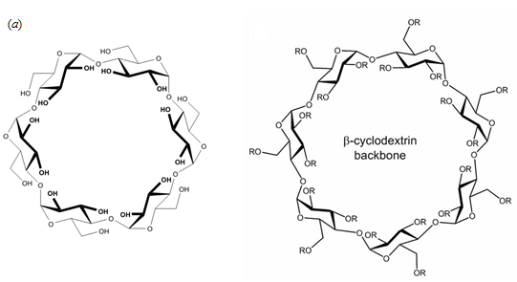
(a)
α-CD R=CH₂CHOHCH₃ for HPβ-CD

(b)

Figure 1. Chemical structures of: (a) CDs, (b) tetracaine hydrochloride

Materials and Methods

Materials
4-(Butylamino)benzoic acid 2-(dimethylamino)ethyl ester monohydrochloride, called tetracaine hydrochloride (TC-HCl) was obtained from Sigma in the crystalline form and was used without further purification. The β-cyclodextrin (β-CD), α-cyclodextrin (α-CD), and hydroxypropyl-β-cyclodextrin (HPβ-CD) were purchased from Sigma. 6-Hydroxypropyl-β-cyclodextrin (HPβ-CD), containing an average of 0.64 hydroxypropyl groups per glucopyranose unit. All of them, with 99% purity or greater, were used without further purification. All the solutions were freshly prepared with a distilled/deionized water of a conductivity value lower than 2 µS/cm. The homogeneity of the initial solutions was assured by sonicating them in an ultrasonic bath.

UV-Vis measurements
The UV-Vis spectra were recorded with a Specord 200plus double-beam UV-Vis spectrophotometer (Germany), from 190 to 400 nm with 1 nm intervals at 15, 20, 25 and 37 °C, which temperature was kept constant with thermostated cell. Data acquisition of UV-Vis spectra was performed with software (Winspec) supported by the manufacturer and converted to ASCII format for their analysis. On the experiments with the Drug/water binary systems, the (TC-HCl) concentration was varied from 0 to 0.1mM, while for the CD/Drug/water ternary systems, the drug concentration was kept constant at 10⁻⁵ mol.l⁻¹ and CD concentration was varied from 0 to 10 mmol.l⁻¹.

Modeling stoichiometry and association constants

Assuming that a 1:1 complex between any CD and the drug is formed, the following chemical equilibrium takes place.
CD + G CD- G (1)
If one takes that the activity coefficients of all species are equal to unity, the equilibrium constant K can be written as:

(2)

The laws of mass conservation for all species require that
(3)
(4)
with [CD]₀: initial (total) concentration of host molecule, [G]₀: initial (total) concentration of the guest molecule. [CD], [G], [CD-G]: equilibrium concentrations of host, guest and complex respectively. The combination of these equations gives the expression of K the equilibrium constant as a function of initial concentrations of the host and the guest molecules as well as one of the formed complexes:
(5)
So, to compute the equilibrium constant one has to determine the concentration of the formed complex since all other quantities are available. This quantity can be extracted from any technique for which intensity variation is proportional to the concentration of the complex. Amongst all available techniques, UV-Vis spectrophotometry represents the most used technique because of its simplicity and repeatability. For this technique, it is well known that the absorbance or optical
density
is proportional to the concentration of the absorbing chromophore so the observed absorbance for a system constituted of CD, guest and complex species is expressed as:
(6)
A_{CD}, A_{G} and A_{CD-G} represent respectively the absorbance of the host, the guest and the complex. Taking that the length of the optical path is fixed to 1 cm, the different absorbances can be expressed as a function of the molar extinction coefficients ε of each absorbing species in solution.
(7)
(8)
(9)
(10)
where A₀ represents the absorbance of the drug in absence of cyclodextrin and A_{CD}, A_{G} and A_{CD-G} are absorbances of CD, Guest and the complex in the solution. Assuming that CD doesn’t absorb light in the near-UV-Visible domain and combining equations 5 to 10 gives after a rearrangement the following equation (11) [16].

(11)

which relates the difference in absorbance ∆A=A_{abs}-A₀ to the equilibrium constant K. The use of a nonlinear regression permits to extract simultaneously the values of ∆ε and K from the experimental curve of the variation of ∆A versus [CD].

Results and Discussion
The UV-Visible spectra of the drug TC-HCl in an aqueous solution at different concentrations at 25 °C are reported on Figure 2(a).

It can be observed that the spectra show three peaks centered at wavelength 190, 227 and 312 nm, corresponding to π-π* and n-π* electronic transitions of the unsaturated C = C bonds of the aromatic ring and the non-binding doublets of the nitrogen and the oxygen atoms [17]. With increasing drug concentration no significant wavelength shift occurs but the absorbance (A) increases obeying to a typical Lambert-Beer law (2b). This means that in this concentration range the solutions are dilute and no important intermolecular interactions exist as well as any solvent effect. From the linear fitting of the absorbance data as a function of drug concentration, the molar absorption coefficient, ε=20604 is determined for λ_{max}=312nm. The extracted value is comparable to one published by Merino et al for procaine hydrochloride anesthetic which possesses an identical chromophore as tetracaine, they reported a value of ε=19825 for λ_{max}=311nm [18].

Figure 3 shows the UV spectra of aqueous solutions of TC-HCl at a constant concentration of 10⁻⁵M in the absence and the presence of β-CD, at three different temperatures. The analysis of the obtained three spectra shows the presence of isosbestic points which indicates the occurrence of chemical equilibrium between the free and the complexed TC-HCl. For the spectrum at 15°C both absorbance and wavelength variations (ΔA and Δλ) are obvious but for the spectra at 25 and 37°C the wavelength shift Δλ diminishes considerably with temperature increase. When the same sets of experiments are conducted with α-CD and HPβ-CD instead of β-CD different behaviors are noted as shown in Figure 4.

Figure 4 shows, as an example, the experiments performed at 25 °C. For α-CD only one isosbestic point is visible at λ=329 nm and only absorbance variation ΔA is observed. For HPβ-CD both ΔA and Δλ variation are noticeable and many isosbestic points close to ones observed for β-CD appear. All these observations underline that an inclusion complexation has occurred between these CDs and the drug [19]. These results agree with ones reported by García et al. using the fluorimetry method [20].

The analysis of the obtained three spectra shows the presence of isosbestic points which indicates the occurrence of chemical equilibrium between the free and the complexed TC-HCl. For the spectrum at 15°C both absorbance and wavelength variations (ΔA and Δλ) are obvious but for the spectra at 25 and 37°C the wavelength shift Δλ diminishes considerably with temperature increase. When the same sets of experiments are conducted with α-CD and HPβ-CD instead of β-CD different behaviors are noted as shown in Figure 4.

(b)
(a)
(b)
(a)

(a)
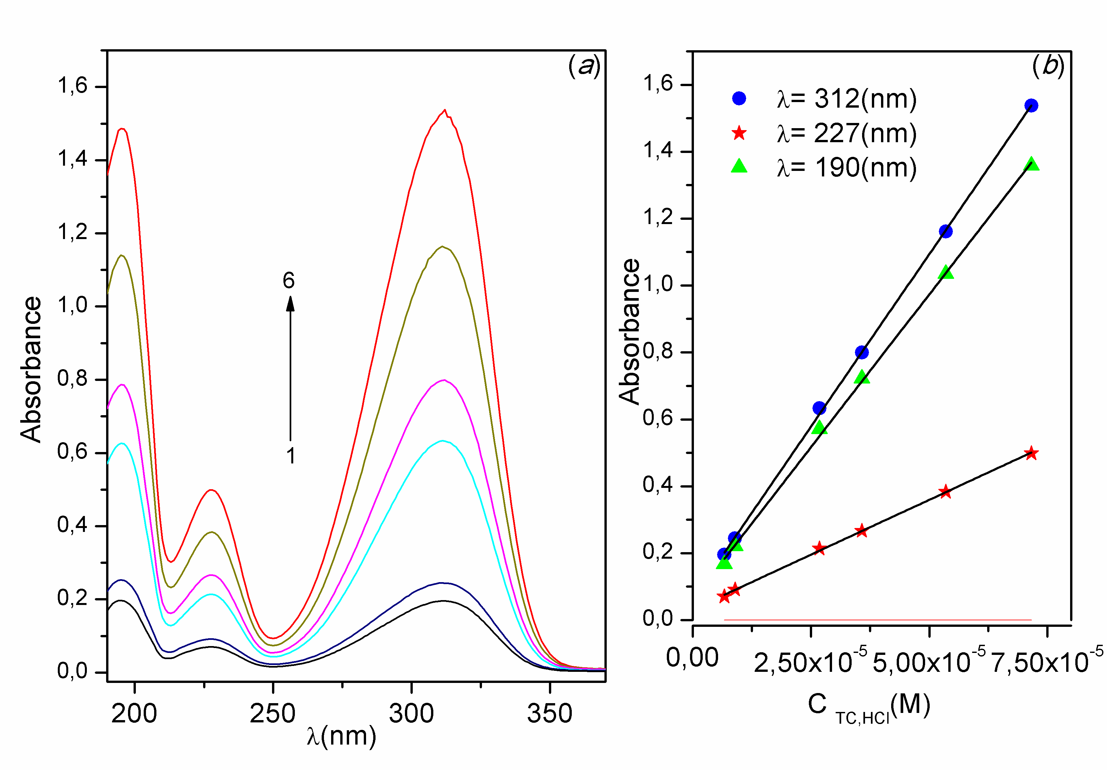
(a)

Figure 2. (a) UV-Visible spectra of aqueous solution of TC-HCl for different concentrations at 25°C. 1) 3.43x10⁻⁶M, 2) 5.52 x 10⁻⁶ M, 3) 9.2 x 10⁻⁶ M, 4) 1.48 x 10⁻⁵M, 5) 3.1 x 10⁻⁵ M, 6) 5 x 10⁻⁵M. (b) Absorbance as function of concentration for different wavelengths.

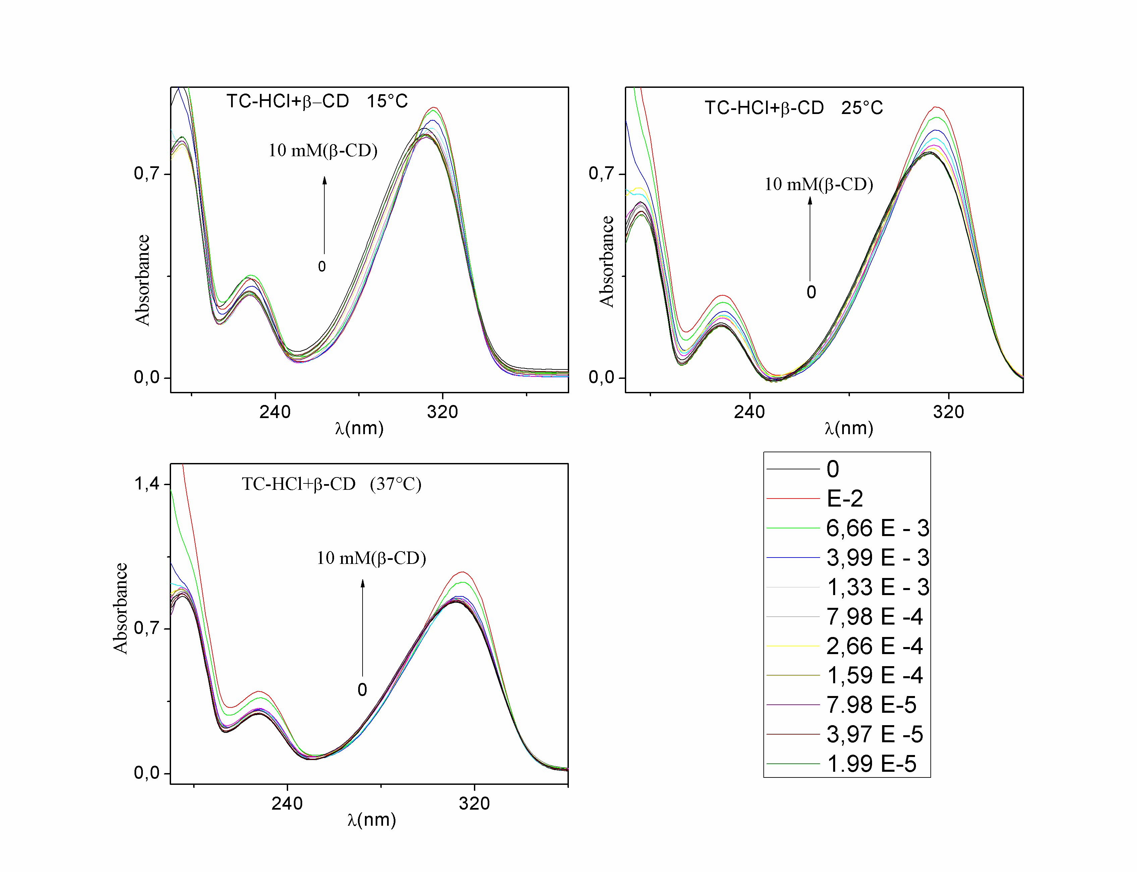
Figure 3. UV-Visible spectra of aqueous solutions of tetracaine hydrochloride (TC-HCl) 10⁻⁵M with different amounts of β-CD (0-10mM) at different temperatures

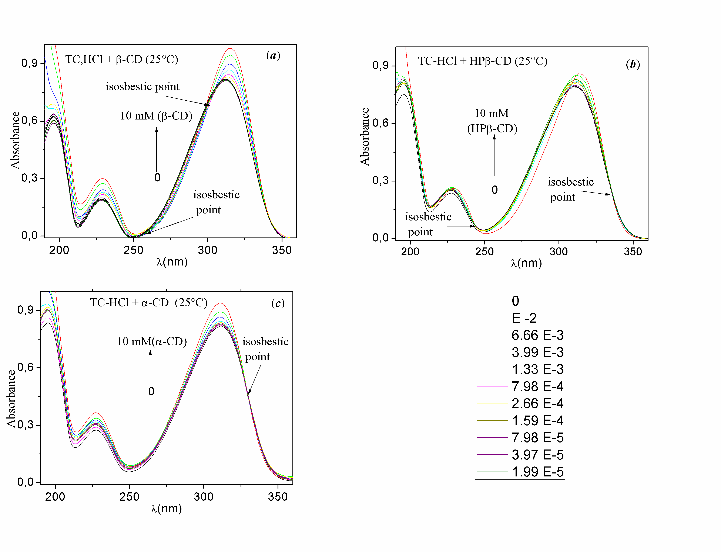
(b)

(a)

(c)

Figure 4. UV-Visible spectra of aqueous solutions (TC-HCl) 10⁻⁵M in the presence of different host molecules. (a) β-CD, (b) HPβ-CD and (c) α-CD at 25 °C

In order to confirm the formation of complexes the same set of experiments were carried out in the presence of d-(+)-glucose at amounts analogous to ones used for CD’s experiments at 25 °C. Because CDs are oligomers of glucose molecule units, they have mainly the same elemental composition but different spatial conformational characteristics. With this choice one tries to preserve the solvent-molecule interaction (water-CD interaction are supposed close to water-glucose one) and letting the geometry differences be the only influencing parameter. From Figure 5 it is easy to note that for d-(+)-glucose no isosbestic points exist, only a slight red shift of the order of 1 nm is obtained with a very weak effect on absorbance values.

From the variation of the curve of ΔA against CD concentration it is possible to extract the K values by a nonlinear regression method [19]. As an example, Figure 6 shows the variation of ΔA against CD’s concentration at T=25°C. The same method was applied for all the studied systems at different temperatures and the corresponding association constants are reported in Table 1.

The dependence of equilibrium constants with the temperature can be noticed in Table 1, where the affinity of all cyclodextrins for the drug decreases as long as the temperature increases. Our results at T=25 °C agree with the findings of Takisawa and al. [21] who studied the inclusion of TC-HCl into α-CD and β-CD using the potentiometric method using drug-sensitive electrodes. They reported that the (β-CD/TC-HCl) formed complex is more stable than (α-CD/TC-HCl) one. From the preceding results, it is possible to determine some thermodynamic parameters of complexation from the variation of RlnK against 1/T. Figure 7 shows the Van’t Hoff plots of all association processes using both linear (ΔC_{p}°=0) and non-linear (ΔC_{p}°≠0) fitting functions.

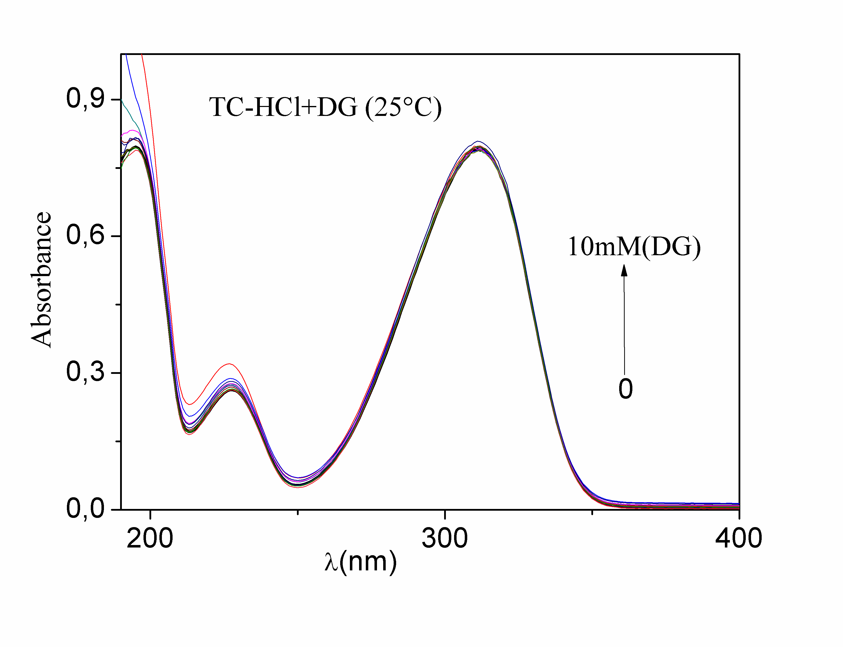
Figure 5. UV-Vis spectra of aqueous solutions of TC-HCl (10⁻⁵M) for different amounts of d-(+)-glucose

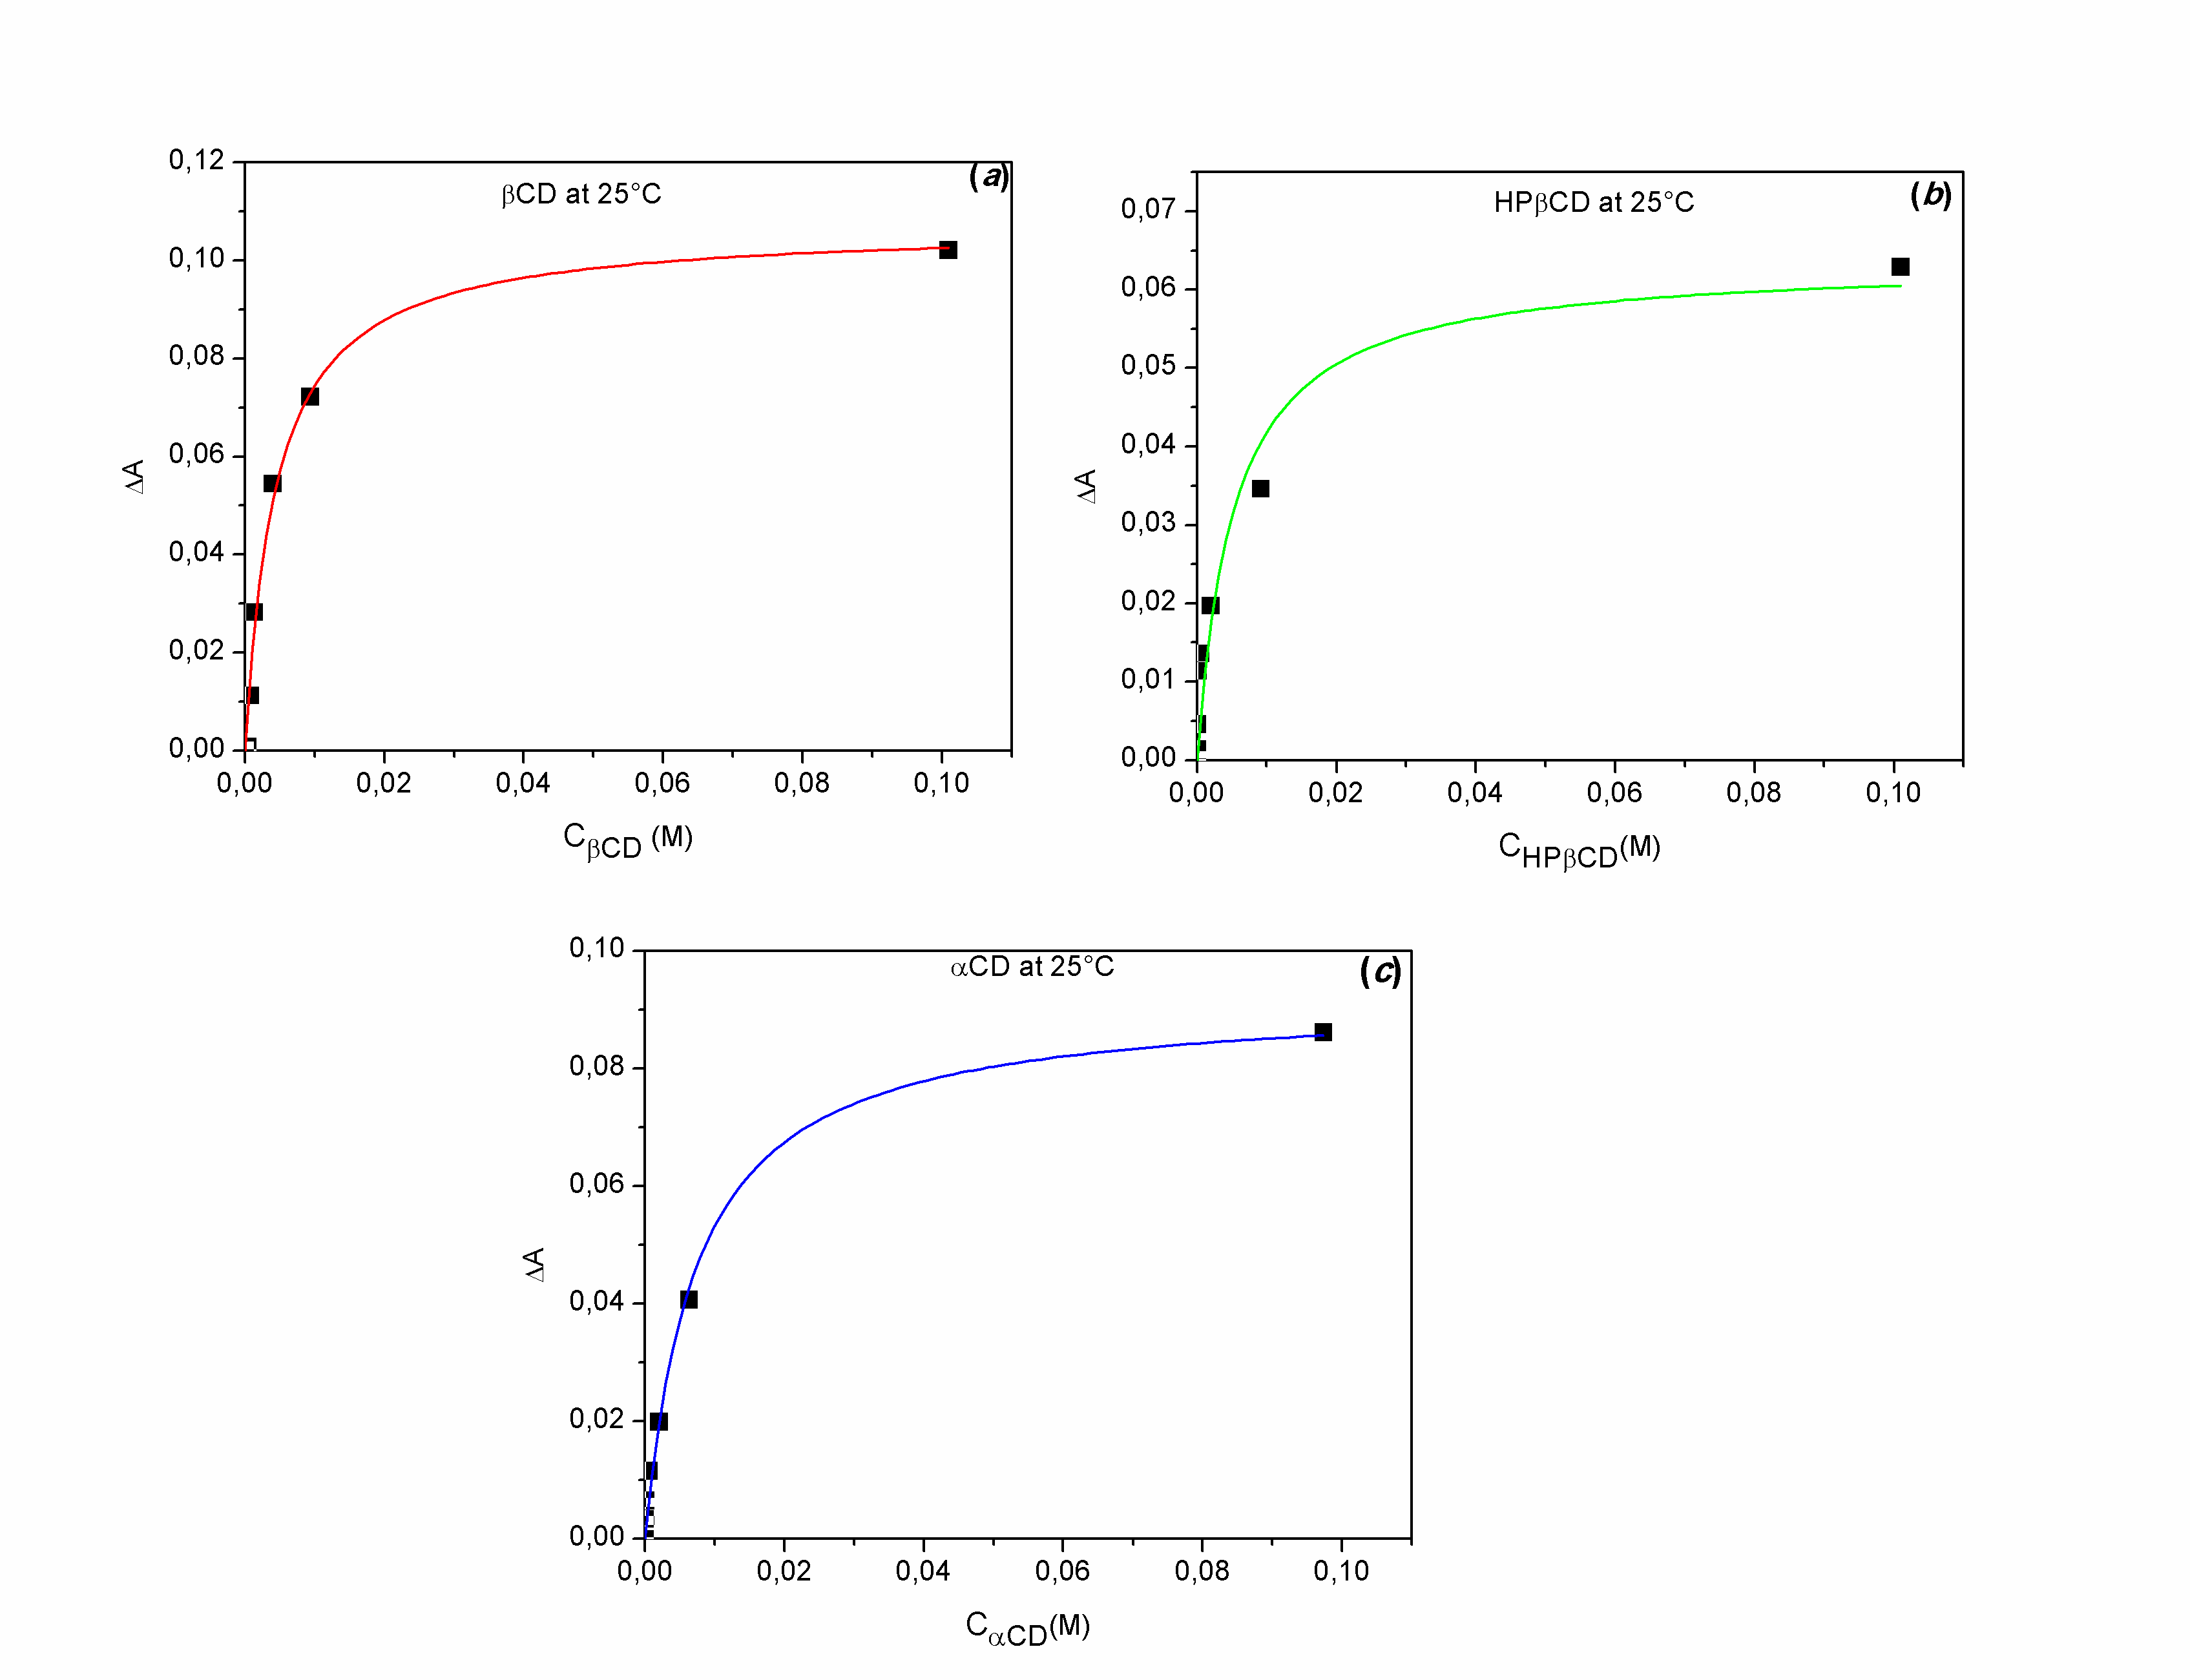

Figure 6. Non-Linear fitting of the variation of ΔA as a function of CD’s concentration at 25°C for λ=310 nm

Table 1. Values of the association constant (K_{CD}) at different temperatures, obtained from UV-Vis measurements for the complex β-CD/TC-HCl, HPβ-CD/TC-HCl and α-CD/TC-HCl
T  (°C) | K _{α-CD}  (l.mol⁻¹) | K _{β-CD}  (l.mol⁻¹) | K _{HPβ-CD}  (l.mol⁻¹)
15 | 155 ± 2 | 293 ± 26 | 285 ± 22
20 | 152 ± 14 | 263 ± 20 | 234 ± 12
25 | 137 ± 24 | 229 ± 36 | 193 ± 81
 | 252 ± 14^{(**)} | 1090 ± 40^{(**)}
37 | 76 ± 5.58 | 121 ± 9.6 | 91 ± 20
(**): reference [21]

Figure 7. Van’t Hoff plot for the association of TC-HCl with a) α-CD, b) β-CD and c) HPβ-CD

From the slopes of the linear fits of the data to the classical Van’t Hoff equation (RlnK= −ΔH°/T + ΔS°), values of ΔH° equal to -24.3, -30.06 and -38.08 Kj.mol⁻¹ are obtained respectively for α-CD, β-CD and HPβ-CD complexes (Table 2). Negative values of the binding enthalpy are the sign that the drug establishes favorable interactions with cyclodextrins. In such association, the enthalpy change is the result of two main conflicting contributions: the favorable enthalpy associated with van der Waals forces coupled to the host/guest hydrogen bonds formation and the unfavorable enthalpy associated with the desolvation of the guest polar groups [11-13]. Van der Waals interactions become maximal when a perfect size fitting between cyclodextrin and the drug takes place while the hydrogen bonds formation optimization is reached when drug polar groups prefer forming hydrogen bond with the cyclodextrin prior to the surrounding water molecules. Thus, an unfavorable binding enthalpy usually indicates that the desolvation is not enough to permit the inclusion of the guest molecule. However, the enthalpic contribution is not the sole provider of the stabilization of the complex and one has to consider the entropic contribution ΔS°. Two major terms contribute to the entropy of binding; the first one is the favorable desolvation entropy change which originates from the release of water molecules as the drug molecule and the binding cavity undergo desolvation upon binding [11-13].

The second term is related to the conformational entropy change which is almost always unfavorable since during the binding process both the drug and the cyclodextrin molecules induce the loss of conformational degrees of freedom. Thus, for our studied system, from the intercepts of Van’t Hoff plot, ΔS° values equal to −41.8, -56.63 and -84.73 J.K⁻¹.mol⁻¹ are extracted for α-CD, β-CD and HPβ-CD complexes respectively (Table 2). For all cases it can be observed that the drug bind to CDs with a favorable enthalpic term (ΔH° < 0) and an unfavorable entropic term (ΔS° < 0). All processes are exothermic and enthalpy driven (|ΔH°| > T|ΔS°|), as usually found for such associations [10, 22]. With its negative entropy ΔS° < 0 the complexation seems to be mainly driven by Van der Waals attractive forces (ΔH° < 0; ΔS° < 0) and solvent reorganization effects. The contribution coming from the hydrophobic effect seems to be negligible especially for HPβ-CD (ΔS° =-84 J.mol⁻¹.K⁻¹).

For HPβ-CD a linear relationship has been found in the Van Hoff plot, revealing independence of both the ΔH° and the ΔS° of the association processes with T. For β-CD and α-CD, Van Hoff plots are better described by nonlinear curves as usually reported for this kind of processes by different authors [10, 22]. With its hydroxypropyl hydrocarbon chains the HPβ-CD second rim is a relatively flexible structure compared to one belonging to native βCD which is more rigid since hydrogen bonds belt is thought to exist all around the rim. These hydrocarbon chains can hinder the complete inclusion of the guest molecule and decrease the desolvation process and thus diminish the strength of the desolvation positive entropy contribution. So, the contribution of solvent reorganization and hydrophobic effects couldn't be similar in both inclusion processes which make the binding of β-CD and TC-HCl energetically more favorable than that of HPβ-CD with TC-HCl. The proposed architecture of the complexes formed can then be illustrated in Figure 8.

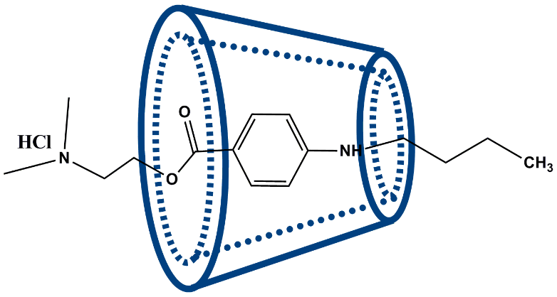
Figure 8. Architecture of inclusion complexes TC-HCl/CD

The negative value of all the ∆C_{p}° in table 2 obtained from the fitting of the experimental data with the non-linear Van Hoff equation (R.lnK= [−(ΔH°+(T-T_{o}) ∆C_{p}°)/T + ΔS°+(∆C_{p}°ln(T/T_{o}))]) are close to values generally found when apolar solutes are encapsulated in CD’s [23]. The difference found in the values of ∆C_{p}° for β-CD and HPβ-CD confirm the fact that the β-CD complex is more stable than the HPβ-CD one probably due to the diminution of the OH groups on the HPβ-CD molecule, which limit the formation of hydrogen bonds with the surrounding water.

The β-CD secondary face diameter is larger than the α-CD one and could better accommodate the inclusion of a guest molecule bearing a benzene structure. This hypothesis is confirmed by the appearance of shifts of the absorbance and wavelength λ and consequently the attractive Van der Walls interactions must be optimal for the TC-HCl/β-CD complex compared to the TC-HCl/α-CD one. The hyperchromic effect is usually attributed to the dissociation of the hydrogen bonds and the bathocromic is related to change of drug surrounding environment which become more apolar. According to Bernardi's theoretical DFT calculation in water the terminal nitrogen end of tetracaine possesses appreciable hydrophilicity which can reach the ester function close to the benzene cycle whereas the hydrocarbon butyl chain is completely hydrophobic [23, 24]. So, it can be proposed that the drug penetrates deeply in the β-CD cavity to an extent where both hydrophobic butyl chain and the benzene aromatic structure are influenced by the cavity walls which explain the simultaneous variation of ∆A and ∆λ. For α-CD because of its narrower rim diameter only hydrophobic chain is penetrated and hyperchromic signature is revealed by UV-Visible spectrophotometry.

Table 2. Values of ΔH°; ΔS°, and ∆C_{P}⁰ for the association of TC-HCl with different CDs obtained from the linear and nonlinear fitting of Van't Hoff equation
CD | Fitting | ΔH°  ( KJ.mol⁻¹) linear | ΔS°  ( J.mol⁻¹.K⁻¹) | ∆C_{P}⁰  (J.mol⁻¹.K⁻¹)
α-CD | Linear | -24.3 ± 7.74 | -41.8 ± 25.9 | -
α-CD | Nonlinear | -23.0 ± 0.077 | -39.29 | -2311 ± 464.4
β-CD | Linear | -30.06 ± 6.68 | -56.63 ± 22.4 | -
β-CD | Nonlinear | -29.23 ± 0.00 | -53.40 ± 4.81 | -1000 ± 4.85
HPβ-CD | Linear | -38.08 ± 6.06 | -84.73 ± 20 | -
HPβ-CD | Nonlinear | -37.78 ± 5.10 | -83.57 ± 17.08 | -300

Conclusion
Employing the spectrophotometry technique for the inclusion complexation of tetracaine hydrochloride in different type of CDs (α-CD, β-CD and HPβ-CD) was demonstrated. The occurrence of the complexation is confirmed by the appearance of isosbestic points, hyperchromic and bathochromic shift effects on the UV-Visible spectra. From the values of complexation constants, the strength of the complexation increases from α-CD to β-CD in accord with the majority of the studies earlier reported by different authors with other techniques. From the Van’t Hoff analysis, the studied complexation processes are spontaneous, with a favorable enthalpic contribution and an unfavorable entropic term. This means that the complexation seems to be driven by Van der Waals attractive forces (ΔH° < 0; ΔS° < 0) and to the solvent reorganization effects. Van’t Hoff plots well show that for the drug/HPβ-CD association process linear fitting function is sufficient to describe the phenomena. However, for the α-CD and β-CD a non-linear fitting is necessary (ΔCp°≠0) to characterize their association with the drug.

Acknowledgement
The authors would like to thank the general directorate of scientific research and technological development, Algeria for the financial support.

References
- Mary Ann Vann, M. D., Babatunde O. Ogunnaike, M. D. and Girish P. Joshi, M.B. (2007). Sedation and anesthesia care for ophthalmologic surgery during local/regional anesthesia. Anesthesiology, 107(3): 502-508.
- Glantz, L., Drenger, B. and Gozal, Y. (2007). Perioperative myocardial ischemia in cataract surgery patients: general versus local anesthesia. Anesthesia & Analgesia, 91(6): 1415-1419.
- Cherobin, A. C. F. P. and Tavares, G. T. (2020). Safety of local anesthetics. Anais Brasileiros de Dermatologia, 95 (1):82-90.
- Ariga, K. and Kunitake, T. (2006). Supramolecular chemistry-fundamentals and applications. Springer-Verlag Berlin, Heidelberg: pp. 207-238.
- Torchilin, V. P. (2006). Multifunctional nanocarriers. Advanced Drug Delivery Reviews, 58(14): 1532-1555.
- Loftsson, T. and Masson, M. (2001). Cyclodextrin in topical drug formulation: Theory and practice. International Journal of Pharmaceutics, 225(1-2): 15-30.
- Frömming, K. H. and Szejtli, J. (1994). Cyclodextrin in pharmacy. Klumer Academies Publishers, Dordrecht: pp. 1-18.
- Martin Del Valle, E. M. (2004). Cyclodextrins and their uses: A review. Process Biochemistry, 39: 1033-1046.
- Maheriya, P. M. (2017). Cyclodextrin: A promising candidate in enhancing oral bioavailability of poorly water soluble drugs. Bioequivalence &Bioavailability, 3(3): 60-63.

- Junquera, E. and Aicart, E. (1997). Potentiometric study of the encapsulation of ketoprophen by hydroxypropyl-β-cyclodextrin. Temperature, solvent, and salt effects. Journal Physical Chemistry. B, 101(36), 7163–7171.
- Astray, G., Mejuto, J. C., Morales, J., Rial-Otero, R. and Simal-Gándara, J. (2010). Factors controlling flavors binding constants to cyclodextrins and their applications in foods. Food Research International, 43 (4): 1212-1218.
- Rekharsky, M. V. and Inoue, Y. (1998). Complexation thermodynamics of cyclodextrins. Chemical Reviews, 98(5): 1875-1918.
- Santos, C. I. A. V., Ribeiro, A. C. F. and Esteso, M. A. (2019). Drug delivery systems: Study of inclusion complex formation between methylxanthines and cyclodextrins and their thermodynamic and transport properties. Biomolecules, 9(5): 196-216.
- Hugh, C., Hemmings, Jr. and Talmage D. E. (2019). Pharmacology and physiology for anesthesia: Foundations and clinical application, Elsevier, Philadelphia. pp: 20-43.
- Shibata, A., Ikawa, K. and Terada, H. (1995). Site of action of the local anesthetic tetracaine in a phosphatidylcholine bilayer with incorporated cardiolipin. Biophysical Journal, 69(2): 470-477.
- Schalley, C. (2007). Analytical methods in supramolecular chemistry. Wiley-VCH Verlag GmbH & Co. KGaA, Weinheim. pp: 419-471.
- Nouiri, M. A., Fergoug, T., Azayez, M., Boujores, H., Zelmat, C. and Bouhadda, Y. (2017). Experimental and theoretical study of tetracaine-hydrochloride β-cyclodextrin complexation. Journal of Materials Environmental Sciences, 8(5): 1589-1598.
- Merino, C., Junquera, E., Jiménez-Barbero, J. and Aicart, E. (2000). Effect of the presence of β-cyclodextrin on the solution behavior of procaine hydrochloride. spectroscopic and thermodynamic studies. Langmuir, 16(4): 1557-1565.
- Mura, P. (2014). Analytical techniques for characterization of cyclodextrin complexes in aqueous solution: A review. Journal of Pharmaceutical and Biomedical Analysis, 101: 238-250.
- García, I., Brandariz, I. and Iglesias, E. (2010). Fluorescence study of tetracaine- cyclodextrin inclusion complexes. Journal of Supramolecular Chemistry, 22(4): 228-236.
- Takisawa, N., Shirahama, K. and Tanaka, I. (1993). Interactions of amphiphilic drugs with α-, β-, and γ- cyclodextrins. Colloid and Polymer Science, 271: 499-506.
- Cano, J. Rodriguez, A. Aicart, E. and Junquera, E. (2007). Temperature effect on the complex formation between tricyclic antidepressant drugs (amitriptyline or imipramine) and hydroxypropyl-β-cyclodextrin in water. Journal of Inclusion Phenomena and Macrocyclic Chemistry, 59: 279-285.
- Bernardi, R. C., Gomes, D. E. B., Pascutti, P., Ito, A. S. and Ota, A. T. (2006). Theoretical studies on water–tetracaine interaction. International Journal Quantum Chemistry, 106: 1277-1282.
- Bernardi, R. C. Gomes, D. E. B. Ito, A. S. Ota, A. T. Pascutti, P. G. and Taft, C. (2007). Density functional and molecular dynamics simulations of local anesthetics in 0.9% NaCl solution. Molecular Simulation, 33(14): 1135-1141.

