

PHYSICAL AND CHEMICAL DISCRIMINATION OF METHAMPHETAMINE TABLETS FOR FORENSIC INTELLIGENCE

(Diskriminasi Fizikal dan Kimia bagi Pil Metamfetamin untuk Perisikan Forensik)

Noor Azlina Awang^{1,2}, Khai Lee¹, Way Koon Teoh¹, Vanitha Kunalan³, Ahmad Fahmi Lim Abdullah¹,

Kah Haw Chang¹*

¹Forensic Science Programme, School of Health Sciences,

Universiti Sains Malaysia, 16150 Kubang Kerian, Kelantan, Malaysia

²Department of Chemistry Malaysia (Kelantan Branch), 16100 Panji, Kota Bharu, Malaysia

³Narcotics Division, Forensic Science Analysis Centre,

Department of Chemistry, Jalan Sultan, 46661 Petaling Jaya, Selangor, Malaysia

*Corresponding author: changkh@usm.my

Received: 16 September 2021; Accepted: 10 November 2021; Published: xx February 2022

Abstract

Illicit methamphetamine seizures have risen significantly worldwide, and its widespread use threatens societal well-being. Thus, attention from various parties is required to stem methamphetamine trafficking; however, routine forensic analysis is generally limited to identifying and quantifying the controlled substances according to standard operating procedures. Although further analytical characterization and drug profiling via physical and chemical methods is not routinely conducted, it warrants further exploration for forensic comparison and intelligence. In this study, the physical and chemical profiles of seized illicit methamphetamine tablets were obtained employing various analytical techniques, including physical examination, attenuated total reflectance-Fourier transformed infrared (ATR-FTIR) spectroscopy, thin layer chromatography (TLC), and gas chromatography (GC). Physical characterization did not enable the identification of methamphetamine, but sample discrimination based on unique logos and dimensions was achieved. Based on ATR-FTIR and principal component analysis results, caffeine was found to be the most common adulterant, while the dyes used in the composition were identified via TLC analysis. GC analysis results confirmed the presence of methamphetamine and its quantity. Overall, a methamphetamine tablet profiling strategy was implemented to gather important information regarding the similarities and differences among illicit methamphetamine tablets, potentially beneficial for sample-to-sample, case-to-case, and seizure-to-seizure comparisons.

Keywords: forensic science, methamphetamine, drug profiling, physical examination, chemical analysis

Abstrak

Rampasan metamfetamin haram telah meningkat dengan ketara di seluruh dunia and penggunaannya secara meluas telah mengancam kesejahteraan masyarakat. Justeru, perhatian daripada pelbagai pihak adalah diperlukan untuk mengurangkan penjualan metamfetamin. Namun begitu, analisis forensik rutin secara umumnya dihadkan kepada pengenalpastian dan pengkuantitian bahan terkawal berdasarkan prosedur operasi standard. Sungguhpun pencirian analitikal dan pemprofilan dadah seterusnya melalui kaedah fizikal dan kaedah kimia tidak dilaksanakan secara rutin, hal ini membolehkan penerokaan selanjutnya untuk perbandingan dan perisikan forensik. Dalam kajian ini, profil fizikal and profil kimia pil metamfetamin haram yang dirampas telah diperoleh dengan menggunakan pelbagai teknik analitikal, termasuk pemeriksaan fizikal, spektroskopi transformasi inframerah Fourier dengan pantulan keseluruhan dikecilkan (ATR-FTIR), kromatografi lapisan nipis (TLC) dan kromatografi gas (GC). Pencirian fizikal tidak membolehkan pengenalpastian metamfetamin tetapi diskriminasi sampel berdasarkan logo dan dimensi unik telah dicapai. Berdasarkan keputusan ATR-FTIR dan analisis komponen utama, kafien dinampakkan sebagai bahan adukan yang paling lazim, manakala pewarna yang digunakan dalam kandungan telah dikenal pasti melalui analisis TLC. Keputusan analisis GC telah memastikan kehadiran metamfetamin and kuantitinya. Secara keseluruhannya, satu strategi pemprofilan pil metamfetamin telah dilaksanakan untuk mengumpulkan maklumat penting berkenaan dengan kesamaan dan perbezaan antara pil metamfetamin haram. Hal ini berpotensi dalam memanfaatkan perbandingan sampel kepada sampel, kes kepada kes, dan rampasan kepada rampasan.

Kata kunci: sains forensik, metamfetamin, pemprofilan dadah, pemeriksaan fizikal, analisis kimia

Introduction

Methamphetamine acts on the central nervous system by stimulating excessive dopamine secretion [1]; thus, it has become one of the most abused stimulants worldwide, as evidenced by a sevenfold increase in global seizures thereof over the past two decades [2]. Although methamphetamine possession, trafficking, and manufacture is strictly enforced and punishable by law worldwide, cases of its abuse are increasing globally, especially in the United States, Europe, Australia, and New Zealand [2]. Users in East and South-East Asia account for more than 30% of the total estimated worldwide users of amphetamine-type stimulant (ATS) [2]. The severe societal well-being deterioration associated with illicit methamphetamine use necessitates collective strategic action, both domestically and internationally.

In recent years, methamphetamine manufacture in the United States, China, and the Islamic Republic of Iran has reportedly decreased, but a significant expansion of illicit methamphetamine drug trafficking has been encountered in Mexico, as well as in East and South-East Asia [3,4], suggesting a gradual shift in this illicit black market from North America to East and South-East Asia. Malaysia, the country where the present study was based, has reported a sharp increase in seized methamphetamine since 2015, wherein approximately 5.8 tons of crystalline methamphetamine and more than 1.6 million illicit methamphetamine tablets had been seized law enforcement authorities in 2019 alone [2]. Recent statistics and trend analyses have indicated that the expansion of the methamphetamine black market in East and South-East Asia has been driven by supply, as the organized crime groups have adapted their trafficking routes in response to law enforcement operations [5,6]. In fact, the growing methamphetamine manufacture in the region has also been supported by an increase in the diversion and trafficking of precursors and related chemicals [6].

Methamphetamine can appear in various forms: as an oily paste consisting of methamphetamine free-base, as a solid, which is the methamphetamine salt form, whereby high-purity methamphetamine salt can appear in crystalline form, commonly termed as “crystal” or “ice”. Methamphetamine is also commonly processed into tablet form known as “Yaba” tablets in Asia, especially in the golden triangle region bounded by Thailand, Laos, and Myanmar. Countries such as Malaysia, Australia, and China are inundated by transnational drug trafficking [7]. Transnational efforts to identify and disrupt the supply chain are therefore crucial. In routine forensic analysis, testing is frequently limited to identifying and quantifying the controlled substance in the illicit drug sample. However, limited information is retrieved regarding the source of origin, supply, trafficking, and distribution network thereof without further post-seizure profiling studies. Studies focused on the profiling of methamphetamine have been conducted, generally employing gas chromatographic techniques [8-10]. However, analytical characterization via physical and chemical methods is less likely to be conducted in forensic laboratories, and therefore gathering further information is required for subsequent forensic comparisons and intelligence. In non-ideal clandestine laboratory production, the chemical composition of illicit drugs can vary significantly [11]. Illicit drug profiling involving the characterization of seized samples in a systematic manner should be conducted to elucidate the connection between suppliers, distributors, and users [11]. In this study, the physical and chemical profiles of illicit methamphetamine tablets were investigated employing various analytical techniques. Integrated approach for profiling illicit drugs could potentially support forensic intelligence [11-13] and be particularly useful for law enforcement authorities.

Materials and Methods

Standards and samples

Illicit methamphetamine tablets (164 samples) seized between January 2019 and December 2020 were used in this study. Methamphetamine, ephedrine, and caffeine standards were sourced from certified reference material suppliers, while various sugars, including glucose, lactose, dextrose, maltose, and mannitol were obtained from Merck (Whitehouse Station, NJ). For thin layer chromatography (TLC) analysis, various dye standards, including Amaranth, Rhodamine B, Erythrosine BS, Carmoisine, Red 2G, Ponceau 4R, Tartrazine, Sunset Yellow, Fast Green, Green S, and Brilliant Blue were sourced from Merck (Whitehouse Station, NJ). All solvents used, including glacial acetic acid, 25% w/w ammonia (S.G. 0.880), acetone, methanol, 2-propanol, n-butanol, and butanone, were of analytical grade. Nortriptyline HCl was used as the internal standard (IS) for gas chromatography (GC) analysis. Chloroform and methanol used to dissolve the standards and samples were of GC grade and were sourced from Merck (Whitehouse Station, NJ).

Physical examination

Physical examination was performed on the seized tablets by observation of the stamp or logo on each tablet, and that of their respective colors. The diameter and thickness of each sample (± 0.02 mm) were also measured using vernier calipers, while the weight (± 0.01 mg) was determined using an analytical balance. All physical characteristics were recorded and compared.

Attenuated total reflectance-fourier transform infrared spectroscopy

Various drug and adulterant standards, and the illicit methamphetamine samples in powdered form were analyzed directly using a Bruker Fourier transformed infrared (FTIR) Tensor 27 instrument (Bruker Corporation, Billerica, MA) equipped with a single-reflection zinc selenide attenuated total reflectance (ATR) sampling accessory, at a controlled ambient temperature (≈25˚C). Approximately 10 mg of the standard or sample was placed onto the ATR crystal to obtain their ATR-FTIR profiles. A background spectrum was recorded before each analysis run and absorbances were measured in the wavelength range between 4000 and 600 cm⁻¹. The resolution was set at 4 cm⁻¹ and 16 scans were performed. The built-in software, OPUS 7.0.122 (Bruker Corporation, Billerica, MA) was utilized for spectrum acquisition. All spectra were recorded in duplicate, compared, and the differences evaluated. A repeatability test was performed by analyzing a representative sample thrice. A reproducibility test was also performed by analyzing a representative sample on three consecutive days. All spectral data were reported as absorbance values at each data point for subsequent interpretation and comparison.

It is often the case that the illicit drugs seized in forensic cases are normally in the form of mixture, which not only contain the drug alone but also adulterants and/or diluents. The influence of mixture composition on the respective ATR-FTIR profiles was investigated. Mixture samples consisting of methamphetamine and different adulterants in varying quantities were prepared. Based on the literature search, caffeine, ephedrine, and various sugars are more common [14,15]. Caffeine is a legal substance, inexpensive and readily available. The stimulant properties of caffeine could also create milder but very similar effect of methamphetamine. Ephedrine is the precursor during manufacturing, usually through Nagai pathway. On the other hand, sugars do not contribute to any additional effects on the methamphetamine but used to dilute or add the bulk of the illicit drugs. Being legal and readily available, sugars give greater margin to the illicit drug manufacturers [14,15]. In this study, four commonly reported adulterants were used, namely caffeine, ephedrine, lactose, and mannitol. The mixtures (w/w) of methamphetamine and the respective adulterant were prepared at 100%, 90%, 75%, 50%, 25%, 10%, and 0%. All the prepared mixtures then underwent ATR-FTIR analysis.

For statistical analysis, data points of regions with noticeable variations, in the ranges of 3200-2550 cm⁻¹ and 1800-600 cm⁻¹, were used. Data points of all ATR-FTIR spectra were transferred into Microsoft Excel® (Redmond, WA) and normalized to remove any possible variation resulting from inconsistent sample quantity. This was done by dividing the absorbance value at each data point to the total absorbance under the spectrum of the standards and samples. The normalized data were then analyzed using Minitab 18 software (Minitab Inc., State College, PA). Principal component analysis (PCA) was implemented for the characterization of illicit methamphetamine samples, and any potential differences among the samples were evaluated.

Thin layer chromatography

Prior to TLC analysis, the dye was extracted from the tablets to remove any sugars, fats, or other substances contained in a tablet [16,17]. The presence of any sugar might cause blurring of the spots upon TLC analysis [18]. Therefore, acidification coupled with alkaline treatment on the samples was suggested for the extraction of dye from tablet-coating formulations [17-19].

Dyes present in the samples were extracted for TLC analysis according to the following procedure. Approximately 10 mg of powdered sample was transferred into a vial. Acetic acid (5% v/v) was added to the vial, followed by the introduction of a knotted piece of white knitting wool, 5 cm in length. Knitting wool was knotted to avoid disassembling of the thread. Note that the wool was firstly washed with dilute ammonium hydroxide and water to minimize the effect of possible interference and to enhance the absorption of dye onto the treated wool. Warming of the mixture in a temperature range of 70-80ºC allowed the transfer of dye onto the knitting wool, and the entire procedure was complete within approximately 15 min. Then, the wool was carefully removed using tweezers and washed thoroughly with distilled water. The treated wool, now visibly colored, was dried and then placed into another vial. Dye extraction was performed by adding 1 mL of a solution consisting of equal volumes of acetone and 3N ammonia and warming for 15 min between 70-80ºC, after which time the wool was removed from the vial. Finally, the resultant dye solution was gently warmed in a water bath to evaporate the solvent and concentrate the solution. All the targeted dye standards were prepared following the above-described procedure for comparison.

TLC separation was performed using silica gel 60 F254 (Merck, Darmstadt, Germany). Four solvent systems were evaluated to select the optimal system for the separation of dyes possibly contained in illicit methamphetamine tablets. The four solvent systems were as follows:

(1) Solvent system A- isopropanol: ammonia (4:1)

(2) Solvent system B- n-butanol: glacial acetic acid: water (10:5:6)

(3) Solvent system C- acetone: butanone: ammonia: water (60:140:1:60)

(4) Solvent system D- isopropanol: ammonia: water (7:2:1)

The various dye solutions obtained from the samples were analyzed using the optimal solvent system. All the visible bands were compared to those of the reference dye standards. The TLC plates were also visualized under UV light to detect the presence of fluorescent spots. Any potential differences among the illicit drugs samples were evaluated based on their TLC profile and the respective dyes contained in the tablets were identified.

Gas chromatography

A methamphetamine standard containing a precisely known concentration thereof was used in both qualitative and quantitative analyses using gas chromatography-mass spectrometry (GC-MS) and a gas chromatography-flame ionization detector (GC-

FID), respectively. Prior to sample analysis, a calibration curve was constructed using the data obtained from the GC-FID analysis of methamphetamine calibration standards in a concentration range of 0.10 – 1.40 mg/mL. Such calibration range had allowed the determination of concentration of the target substance within an illicit tablet. Note that the GC method was adapted from United Nations Office on Drugs and Crime [20] and is utilized in the country of study for routine forensic analysis.

A Perkin Elmer Clarus 600 Gas Chromatographic system coupled with Mass Spectroscopy (MS) (Perkin Elmer, Waltham, MA) was used to confirm the presence of methamphetamine using a HP-5 capillary column (30 m × 0.25 mm i.d., 0.25 µm film thickness) (Agilent Technologies, Santa Clara, CA). Purified helium gas (99.99%) was used as the carrier gas at a constant flow rate of 1.5 mL/min. The front injection temperature was set to 270°C. The initial temperature was 80°C, and it was held for 1 min. The temperature was then increased to 200°C at 30°C/min, followed by a further increase to 270°C at 50°C/min. The final temperature was held for 1.0 mins. The temperature of the transfer line of the MS detector was set to 280°C. The data acquisition rate was 1.0 sec/scan and mass fragments were collected in the 50–500 m/z range. Turbomass Ver 5.4.2 Properties (Perkin Elmer, Waltham, MA) was used for data analysis. The spectra of the target compounds were interpreted, evaluated, and the resultant peaks were identified using the mass spectral library (NIST MS 2014 version 2.2) (National Institute of Standards and Technology, Gaithersbury, MD).

An Agilent 7890B Gas Chromatography system equipped with a split/splitless injector, and an FID (Agilent Technologies, Santa Clara, CA) was used for methamphetamine quantification upon positive identification based on GC-MS results. Liquid injection was performed at a constant inlet temperature of 270°C. Chromatographic separation was achieved using a HP-5 capillary column (30 m × 0.32 μm i.d., 0.25 µm film thickness). Purified helium gas (99.99%) was used as the carrier gas at a constant flow rate of 0.6 mL/min. The initial oven temperature was set at 150°C and held for 1 min. A temperature ramp of 30°C/min was selected to reach the maximum of 270°C and held for 2.5 min. Hydrogen flow, air flow, and the make-up flow were supplied to the detector at 30, 400, and 29.4 mL/min, respectively. Standard solution (1 µL) was introduced into the injector port. Chemstation software (Rev. B.04.02, Agilent, Santa Clara, CA) was used for GC automation and data analysis. All standards and IS were identified by comparison of the retention times.

The drug samples were prepared by weighing an accurately weighed amount of the powdered sample into a 10 mL volumetric flask. The sample was then dissolved using the IS solution to the levelling of mark and ultrasonicated for five minutes to allow for complete dissolution. An IS solution with a concentration of 0.60 mg/mL nortriptyline HCl was used. The solution formed upon the sonication was transferred into GC vial and properly labelled. All prepared samples were then introduced into the GC systems.

Upon analysis by GC-FID, the area under the chromatogram of each peak was integrated and the peak area ratio of the target substance was determined. The percentage of methamphetamine was calculated using Equation 1.

% methamphetamine = [(Concentration × 10)/weight of sample taken] × 100% (1)

where concentration is in mg/mL; 10 is the volume of dissolved sample in a 10 mL volumetric flask, and weight of sample taken is measured in mg. The purity among all the samples tested in this study was then compared.

Drug profiling strategy

A drug profiling scheme involving the physical characterization and chemical analyses of illicit methamphetamine tablets was conducted in that order. A comparative study was performed on the samples and possible differences were determined on a case-by-case basis.
Results and Discussion

A total of 164 seized illicit methamphetamine tablets were analyzed in this study. Among them, six were green in color (3.7%), differing from the commonly encountered red tablets (96.3%). Therefore, the six green samples were labelled as G01-G06, while the remaining 158 samples were labelled as S001–S158.

Physical examination

Color

The samples analyzed in this study were predominantly red. However, the red color of each tablet differed slightly in terms of the hue, likely due to the use of different dyes. Some tablets appeared cherry-red, while some were maroon in color. Such variation in color could be due to the presence of different dyes or combinations of dyes that had been used in the manufacturing process, which can be determined by chemical analysis of the dye composition. In addition to the red tablets, six tablets were green in color. Generally, only one or two such green tablets are encountered in larger packages of seized samples containing 100 or 200 tablets.

Logo variant

All the methamphetamine tablets were round in shape with a deep convex center. A speciﬁc logo was observed on one of the sides, consisting of the letter’s “w” and “y”, as shown in Figure 1. However, different variations of the logo were noted, whereby “wY”, “WY,” or “wy” were present. In our case, the “wY” logo was dominant with 155 out of 164 samples (94.5%) being stamped with it [Figure 1(a)-(d)]. A slight variation in the size and positioning of the markings was also noted among the “wY”-labelled tablets, likely due to the use of different tableting machines. Some of the tablets exhibited deeply stamped logos, whereby the two letters could be seen clearly (Figure 1(a)-(b)), while most of the logos appeared very faint (Figure 1(c)-(d)).

Previous studies have indicated that such variations are a result of manufacture by different drug syndicates [21]. Tablets with the “wY” insignia were the most common in the sample set, and it is believed that they are produced by the United Wa State Army [21]. The other two variants, that is tablets bearing the “WY” and “wy” logos, were not common, being noted on only two (1.2%) [Figure 1(e)] and one sample (0.6%), respectively, [Figure 1(f)]. Reportedly, the former variant likely originated from the Myanmar National Defense Alliance Army, while the latter was produced by the Shah United Army 15. The “Wy” insignia was not observed among our seized samples; neither were other less common variants, such as “R”, “OK”, “888”, and “Ã/99” [21,22]. None of the tablets bore an imprint on the reverse side.

The presence of a logo indicated the unique physical characteristics of the methamphetamine tablets, as it appeared on most of our tested samples. However, drug syndicates and trafficking groups other than those mentioned above reportedly stamp the same logos on their tablets, essentially counterfeiting illicit methamphetamine tablets [21,23]. As the samples tested in this study had all been seized, they could have been exposed to unknown physical and environmental conditions; thus, the faintness of the markings and/ or the rough texture of some tablets possibly resulted from exposure to moisture or due to transport and handling practices. Tablets whereby the logo on the surface could not be clearly determined through visual observation accounted for 3.7% of the total samples, or six out of 164 samples.

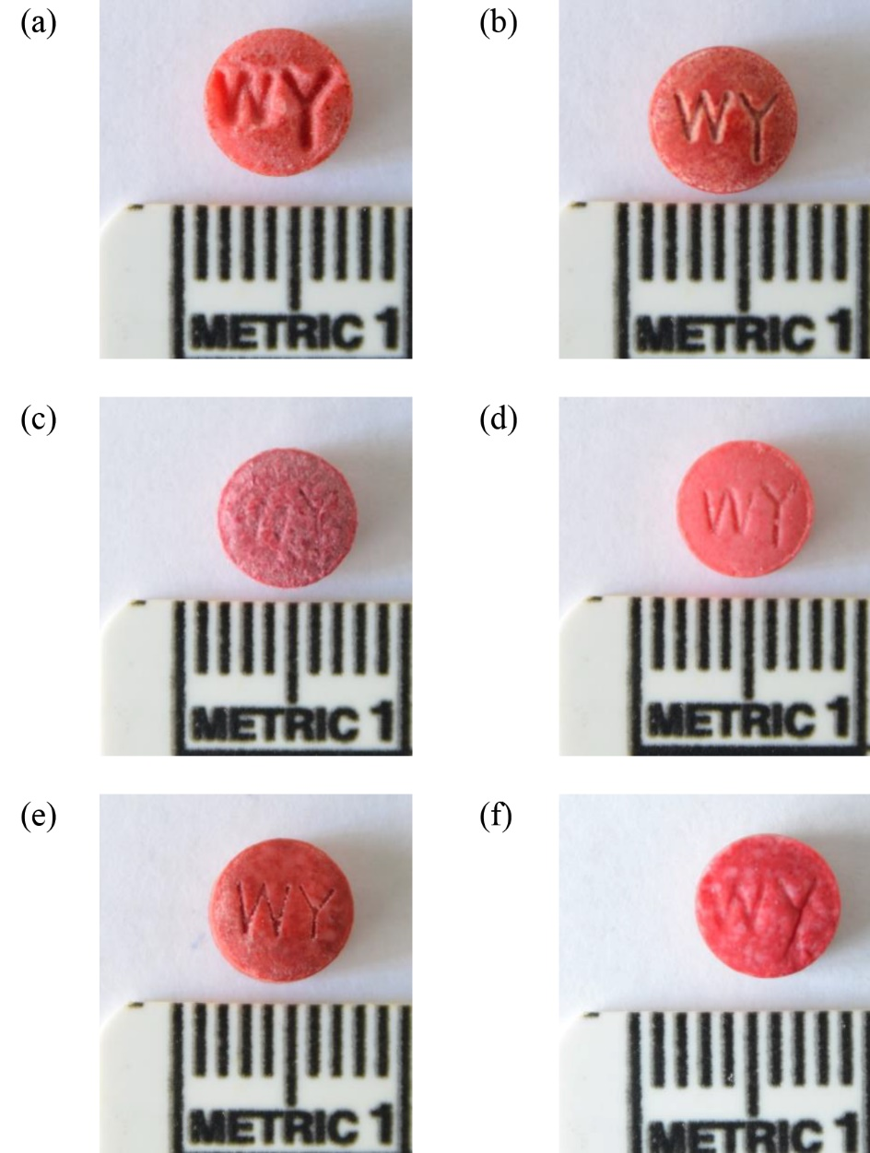

Figure 1. Physical observation of illicit drug tablets encountered in this study.

Dimensions

In terms of size, all of the tablets appeared very similar to each other, and the average diameter and thickness were 6.21 ± 0.21 mm and 3.06 ± 0.14 mm, respectively. Four of the samples were slightly larger in diameter, especially S077, measuring 8.16 mm in diameter. On the other hand, the diameter of S001 was relatively smaller at only 5.60 mm. The weight of each tablet was directly related to its dimensions. In this study, the average weight of the tablets was 97.63 ± 32.52 mg, but the range was from 26.50 mg to 474.95 mg, showing significant variation. The heaviest sample was S017, although its diameter and thickness were within the dimension range of the dominant group. Figure 2 illustrates the number and percentage of samples with a certain diameter, thickness, and weight.

In most instances, drug tablets produced using the same tableting machine present uniform dimensions and thickness [24]. A tableting machine compresses pharmaceutical powder with a specific formulation into tablet form, resulting in the production of tablets with uniform size, shape, and weight [24,25]. Thus, the variation in the physical characteristics could be as a result of the use of different tableting machines in the production step [21,23]. Any differences in terms of the punches and dies of a tableting machine could potentially produce tablets that differ in diameter [21]. Tablet thickness could be affected by the compressive force, even when a consistent ingredient fills of the die is practiced [21,26]. Tablet weight is governed by the volume of the ingredient filling the die cavity in a tableting machine, and the size of the granule and void space would influence the weight [21].

For forensic intelligence, our findings suggested that the majority of illicit drug samples were likely to have similar physical characteristics, but several samples that showed significant variation from the dominant group were identified. Taking note of such variation could be beneficial for differentiating between batches and manufacturers, at least for sample-to-sample, case-to-case, and seizure-to-seizure direct comparisons [27]. The physical examination would additionally be supported by the information obtained from the chemical analyses for forensic characterization.

Figure 2. The number and percentages of samples in term of their (a) diameters, (b) thicknesses and (c) weights

ATR-FTIR analysis

ATR-FTIR spectral comparison of illicit drug samples and standards

ATR-FTIR spectroscopy is a useful technique for analyzing and identifying samples, as well as for comparing various samples in numerous forensic applications [28,29]. All 164 illicit drug samples (158 red-colored and 6 green-colored samples) were analyzed using ATR-FTIR spectroscopy to determine their structure, compare their spectra with that of the methamphetamine standard, and to differentiate the seized samples. Prior to determination and comparative studies, repeatability and reproducibility tests were performed. A representative sample (S001) from the same seizure was used in the repeatability study, showing close agreement between three successive measurements under the same conditions [Figure 3(a)]. In the reproducibility study, no differences were observed in ATR-FTIR spectra when S100 was analyzed thrice on three consecutive days [Figure 3(b)], indicating that ATR-FTIR spectroscopy is capable of generating comparable results from multiple analyses and preparations of the same sample. For both repeatability and reproducibility tests, the intensity of three major peaks appearing at 1691, 1653 and 743 cm⁻¹ were respectively measured, and their relative standard deviations were determined to be less than 5%.

Complex interacting vibrations were evident in the ATR-FTIR spectra of both the standards and samples. Figure 4 depicts the ATR-FTIR spectra of the methamphetamine standard and common adulterants, including caffeine, ephedrine, and various sugars [14,15], added during the manufacture of illicit methamphetamine tablets.

With reference to (Figure 4(a)), the absorbance pattern of methamphetamine contained major peaks in regions ranging from 3200 to 2550 cm⁻¹ and 1800 to 650 cm⁻¹ [29-31]. Broad absorbance bands were observed at 2972, 2726, and 2457 cm⁻¹, and were attributed to C-H (C-CH₃), NH₂, and C-N-C stretching vibrations, respectively. Meanwhile, two sharp absorbance peaks were also observed at 699 cm⁻¹ and 747 cm⁻¹, likely arising from the aromatic C-H out-of-lane bending vibration. The existence of an aromatic ring stretching vibration (C=C-C) at 1602 cm⁻¹ could be unique to aromatic ring bonding, while the absorbances at 1454, 1386, and 1046 cm⁻¹ likely arose due to C-H bond deformation in the chemical structure. Absorbance peaks in the region of 1192 cm⁻¹ possibly represented C-N stretching in a secondary amine structure of methamphetamine.

The ATR-FTIR profile of ephedrine (Figure 4(c)) appeared very similar to that of methamphetamine due to their similar structure. However, the distinguishing feature of the ephedrine spectrum was the presence of additional absorbance bands at 3400 and 3200 cm⁻¹ ascribed to hydroxyl stretching. Additionally, the absorbance peaks of ephedrine appeared weaker than those of methamphetamine in the region of 2400-3100 cm⁻¹.

In the spectrum of caffeine (Figure 4(b)), prominent absorbance peaks were evident in the region of 1655-1705 cm⁻¹, attributed to C=O bond vibration, C=C bonds of cyclic hydrocarbons, and/or C=N bond stretching. The ketone group present in caffeine gave rise to peaks at 1025 and 1237 cm⁻¹. Additionally, C-N stretching gave rise to an absorbance peak at 1359 cm⁻¹, while C=C vibration contributed to the peak at 1486 cm⁻¹.

From the ATR-FTIR spectra of the five types of sugars tested in this study, glucose [Figure 4(d)] and dextrose (Figure 4(h)) had very similar profiles. As disaccharides, the spectra of lactose [Figure 4(e)] and maltose [Figure 4(f)] also appeared very similar to each other. Lastly, the spectrum of mannitol [Figure 4(g)], a type of sugar alcohol used as sweetener, was distinct, containing two intense absorbances at 1074 and 1015 cm⁻¹. Absorbance peaks in the ATR-FTIR profiles of sugars arise predominantly from skeletal C-C vibrations (1300-700 cm⁻¹), methyne C-H bending (1350-1330 cm⁻¹), and H-bonded OH stretching (3570-3200 cm⁻¹).

Visually, two unique ATR-FTIR spectral patterns were observed for the illicit drug samples tested in this study, as depicted in Figures 4(i) and 4(j). Careful analysis suggested that pattern A (Figure 4(i)) contained peaks similar to those of caffeine, while pattern B (Figure 4(j)) resembled the spectrum of mannitol. In this study, only one sample, namely S077, showed ATR-FTIR profile of pattern B. Experimental results can be used to determine the major adulterant added to the composition of illicit drug tablets during the manufacturing process. It was noted that the choice of adulterants can differ among the drug distributors and manufacturers, due to factors such as user preference, drug syndicate “trade-marks,” the availability of these substances, and differing strategies for increasing the profit margin [32,33]. The ATR-FTIR profiles of the six green tablets did not differ from those of the red tablets, suggesting that the tablets had a similar composition, with the exception of the dye.

Figure 3. (a) Repeatability test using sample S001 as representative sample, and (b) reproducibility test using sample S100 as representative sample

Figure 4. ATR-FTIR spectra of drug standards and seized illicit drug samples in the region of 4000 to 600 cm⁻¹

ATR-FTIR spectral comparison of adulterated methamphetamine at varying percentages

To further evaluate the inclusion of adulterants and their influence on the resultant ATR-FTIR profiles, varying ratios of methamphetamine and adulterants were prepared, and the spectra of the mixtures were examined. Figure 5 illustrates the comparison of the ATR-FTIR profiles of the methamphetamine standard containing varying adulterant amounts.

As evident in Figure 5, the ATR-FTIR profile of methamphetamine changed upon the addition of adulterants, regardless of the choice of adulterant. With increasing adulterant content, the prominent methamphetamine absorbance peaks gradually reduced in intensity or became concealed by the intense peaks originating from the adulterant. For instance, an increase in caffeine content in a mixture led to a gradual decrease in the intensity of the main absorbance peak at 699 cm⁻¹. When methamphetamine content reached 25% in the mixture, the peak was no longer detectable. Additionally, the broad absorbances within the wavenumber region of 3100-2400 cm⁻¹ also underwent significant changes. On the other hand, absorbance peaks arising from caffeine were evident in the range of 1655-1705 cm⁻¹ for a mixture containing 25% caffeine. Absorbance peaks in this region became more intense with increasing caffeine content. From Figure 5(a), the absorbance peaks attributed to methamphetamine were virtually absent for a mixture containing > 75% caffeine, and the spectrum resembled that of the pure caffeine standard. Based on the ATR-FTIR spectra of the methamphetamine and ephedrine standards, the spectrum of their mixture contained an additional

peak at 3340 cm⁻¹ due to the presence of a hydroxyl group in ephedrine (Figures 5(b)). When sugars were added to the composition, the dominant peaks from methamphetamine also decreased in intensity, gradually being replaced by the peaks arising from the sugars. In other words, the ATR-FTIR profile of the mixture started to resemble that of the sugars with increasing sugar concentration (Figures 5(c) and (d)).

Regardless of the adulterant added, the peaks ascribed to methamphetamine remained prominent in the ATR-FTIR spectrum when methamphetamine content was 75% and above. However, with the addition of 50% or more of any adulterant, the presence of methamphetamine was challenging to confirm using the ATR-FTIR profile of the mixture. A previous study has suggested the potential of using ATR-FTIR spectra to identify methamphetamine when the concentration thereof is >30% [34]; however, the presence of adulterants impeded the determination of methamphetamine in our study. In our case, at least 75% methamphetamine content was required for confident determination of its presence in a mixture. Thus, the ATR-FTIR technique has several limitations, particularly when the screening for the presence of methamphetamine as a controlled substance. However, the ATR-FTIR technique could be applied in clandestine laboratory settings where illicit drugs of very high purity have been synthesized prior to the packaging stage. In such cases, ATR-FTIR spectroscopic analysis would allow for rapid determination and portable on-site detection.

Figure 5. ATR-FTIR profiles of methamphetamine with varying percentage of adulterants

PCA decomposition of ATR-FTIR profiles

Our findings indicated that the determination of methamphetamine presence in illicit drug tablets using ATR-FTIR spectroscopy could be challenging. However, the identity of the adulterant in an illicit drug pill could be determined via this technique based on the obtained spectrum, and consequently, samples of differing composition can be differentiated. PCA was performed to decompose the large dataset into a smaller set that represented the variability of all the 164 samples tested in this study. Prior to the PCA, the ATR-FTIR spectra were pre-treated and normalized. From the ATR-FTIR spectra in Figure 4, the regions with noticeable variations among the standards and samples, namely those ranging from 3200 to 2550 cm⁻¹ and 1800 to 650 cm⁻¹, were subjected to PCA. Figure 6 illustrates the two-dimensional score plot upon PCA decomposition of data for the 164 illicit drug samples and related standards.

The majority of the illicit drug samples tended to locate closely, as seen for cluster P in the score plot (Figure 6). These samples were clustered together with the caffeine standard, suggesting the similarity in their ATR-FTIR profiles. This observation was supported by the visual comparison of their ATR-FTIR spectra, wherein they appeared very similar, as demonstrated in Figures 4(b) and 4(i). On the other hand, the S077 sample was located away from the cluster P, while being close to the sugar standards, denoted as cluster Q. S077 could have been adulterated with any sugar, most likely mannitol, based on the similarities of its ATR-FTIR profile with that of mannitol (Figure 4(g)). The PCA grouped the green samples into cluster P, as the color did not contribute to significant changes in the ATR-FTIR profile.

The PCA score plot indicated that all the illicit drug samples were located very far away from the methamphetamine standard data point, found in the right bottom corner. This observation implied that the absorbance peaks comprising the ATR-FTIR profile of the methamphetamine standard were not useful for determining its presence in the illicit drug tablets, as they were concealed by the peaks originating from the adulterants. It was noted that the ephedrine standard was located close to methamphetamine (cluster R), indicating significant similarities between their ATR-FTIR profiles. Generally, PC1 (52.8%) discriminated the majority of the samples from the standards and adulterants, including methamphetamine, ephedrine, and various sugars. PC2 (26.9%) further separated the methamphetamine and ephedrine standards from the data points consisting of various sugars. The presence of adulterant had modified the ATR-FTIR profiles of methamphetamine. As evident in Figure 7 demonstrating the score plot decomposing drug samples and the standard-adulterant mixtures, data points of the mixture carrying greater percentage of adulterant, in this case caffeine, had been dispersed away from cluster R to cluster P. Majority of the drug sample tested in this study could have contained less than 25% active compound and adulterated with caffeine. The sample S077 might have also contained a percentage of methamphetamine at a level of less than 10% and adulterated with sugar, probably mannitol based on the ATR-FTIR spectrum.

In this study, the discrimination of illicit drug samples was possible through the use of ATR-FTIR spectroscopy by recognizing the corresponding pattern and comparing it to that of the standards and adulterants. PCA allowed for more objective clustering and discrimination. The majority of the illicit drug samples tested in this study were adulterated with caffeine, except for one sample, namely S077, that likely contained mannitol. The literature has suggested the preference for utilizing caffeine as the adulterant during illicit drug production probably due to the similar stimulant effect of caffeine as in methamphetamine [15,23]. Perhaps more samples from different regions of the country should be included in future profiling activities to evaluate if the choice of caffeine was restricted to the east coast of the country, or generally, across the country and in nearby countries.

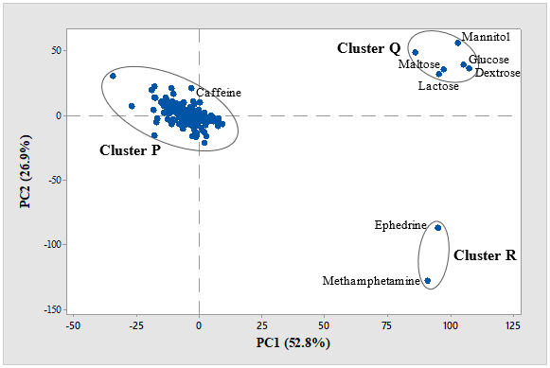

Figure 6. Decomposition of 164 samples and standards into two-dimensional score plot

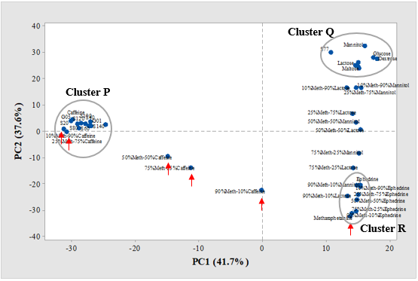

Figure 7. Decomposition of drug samples and standard-adulterant mixture into two-dimensional score plot

TLC analysis

Choice of Solvent System

Prior to TLC analysis, the dye was extracted from the tablets to remove any sugars, fats, or other substances contained therein [16,17] that could potentially cause blurring of the spots upon analysis [18]. Thus, the dye was transferred to a piece of wool via acidification and subsequently stripped from the wool by alkaline treatment [17-19,35]. All the dye standards used in this study underwent the same procedure as did the negative control. Upon TLC analysis, all the standards developed colored spot(s) on the plate when various solvent systems were applied, and their respective retention factor (R_{f}) values are given in Table 1.

Among the dye standards, the Rhodamine B dye standard exhibited strong fluorescence under long-wave UV light illumination; Erythrosine BS fluoresced weakly. Adequate separation of the dye standards could not be achieved using solvent systems B or C for TLC analysis. These solvent systems were excessively polar, and the dye components moved high up the plate due to insufficient interaction with the stationary phase. Solvent system A consisting of isopropanol and ammonia (4:1 v/v) reportedly achieves effective separation of synthetic food colorants with minimum tailing effects [17]. However, it was found that certain dye standards were not adequately separated using solvent system A, as evident from the very close R_{f} values of the color spots formed by Tartrazine and Brilliant Blue. The color spot generated from Brilliant blue dye was also very close to those formed by the two green-colored dye standards used in this study, namely Fast Green and Green S. These occurrences hamper interpretation, especially in the analysis of green tablets. In fact, the green color may be the result of a blue and yellow dye mixture.

Favorable separation among the dye standards was achieved with silica gel plates eluted with solvent system D consisting of isopropanol, ammonia, and water in a volume composition of 7:2:1, especially in the case of the red dyes. Furthermore, the greater separating distance between the spots formed by Tartrazine and Sunset Yellow dye standards resulting from the use of solvent system D would allow for more confident discrimination between these two dyes potentially found in the green tablets. Thus, solvent system D was used for the subsequent determination of dye components in the illicit drug samples.

Table 1. R_{f} values of the color dye standards upon TLC analysis
Standard | Solvent system A | Solvent system B | Solvent system C | Solvent system D
Amaranth | 0.81 | 0.81 | 1.00 | 0.64
Carmoisine | 0.88 | 0.91 | 1.00 | 0.70
Erythrosine BS | (0.93) | (0.94) | (1.00) | (0.82)
Ponceau 4R | 0.81 | 0.87 | 1.00 | 0.65
Rhodamine B | (0.90)  (0.74)  (0.71) | (0.90)  (0.87) | (1.00)  (0.88)  (0.80) | (0.82)  (0.76)  (0.65)
Red 2G | 0.84 | 0.90 | 1.00 | 0.73
Tartrazine | 0.78 | 0.87 | 1.00 | 0.64
Sunset Yellow | 0.83 | 0.88 | 1.00 | 0.73
Fast Green | 0.83  0.80 | 0.88  0.86 | 1.00 | 0.68  0.65
Green S | 0.78  0.72  0.64 | 0.81 | 1.00 | 0.64
Brilliant Blue | 0.77 | 0.87 | 0.95 | 0.73
( ) indicates fluoresced colored spot under UV illumination

Determination of dye components in illicit drug samples

In pharmaceutical products, the addition of color aids in enhancing drug acceptability, discrimination among different drugs, and prevents counterfeiting 18. In illicit drugs, dyes are used to improve their external appearance, and to render them readily identifiable on the drug scene [36]. Figure 8 illustrates the percentages of drug samples that contained specific dye components. Upon examination, a total of 151 samples (95.6%) contained Ponceau 4R as the only dye. In addition to Ponceau 4R, Erythrosine BS (0.6%), Sunset Yellow (1.9%), and Tartrazine (0.6%) were also concurrently detected in certain drug samples, suggesting that the dye used during the manufacturing of certain drug samples was not restricted to a single type. Only two samples were found to be unique and not to contain Ponceau 4R (1.3%), namely S001 and S002, which contained Rhodamine B and Erythrosine BS. The six green-colored illicit drug samples were classified into two separate groups, according to whether they contained Tartrazine and Brilliant Blue (66.7%), or Ponceau 4R as well (33.3%). However, the presence of Ponceau 4R in the two green-colored samples possibly originated from contamination by red-colored tablets as they were all placed in the same packaging.

TLC analysis contributed significantly to the identification of the various dyes contained in the illicit drug samples. Importantly, the dye must be carefully extracted from the samples to ensure satisfactory TLC separation. Ponceau 4R was the most commonly used dye in red-colored samples, but a mixture of dyes was also encountered. Based on TLC analysis results, at least seven different groups of illicit drug samples were determined.

Figure 8. Percentages of samples of varying dye composition in (a) red-colored and (b) green colored illicit drug samples tested in this study

Gas chromatographic analysis

Confirmation of methamphetamine presence

Due to the excellent sensitivity of GC-MS, it was chosen to confirm the presence of methamphetamine [8,11]. Figure 9 shows a representative chromatogram showing methamphetamine and IS peaks upon sample analysis. The methamphetamine and IS peaks appeared at 3.72 and 7.27 min, respectively. The presence of caffeine was also evident in the majority of samples, supporting the findings of ATR-FTIR analysis. The caffeine peak dominated the chromatogram, appearing at a retention time of 6.33 min. The mass spectrum of methamphetamine displayed an M-1 peak with an m/z ratio of 148. The base peak was found at m/z 58, followed by m/z 91 and 134.

Of the 164 samples tested in this study, 162 of them were found to contain methamphetamine; samples S077 and G02 did not. A probability index of greater than 80% was considered for a positive determination of methamphetamine. It was noted that physical examination alone could not confidently indicate the presence of methamphetamine. As evident in these two samples, the target substance was not detected using our analytical method, either because it was absent, or its content was too low for detection.

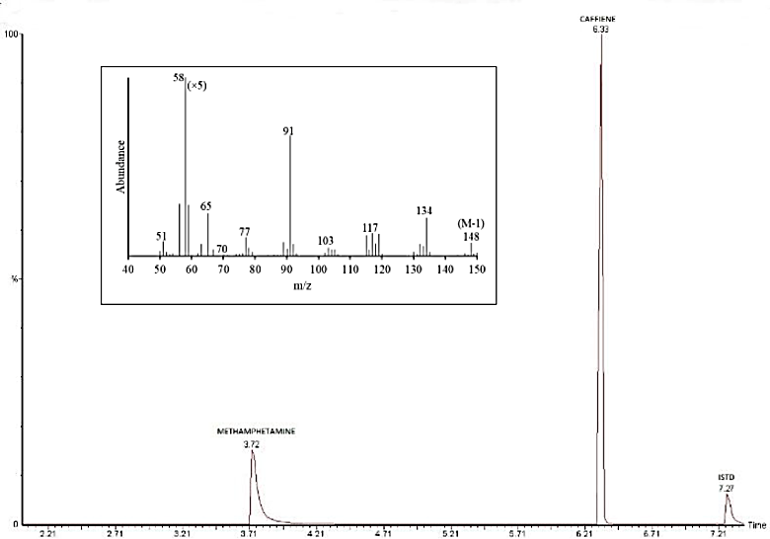

Figure 9. Representative chromatogram showing the peaks of methamphetamine, caffeine, and IS upon GC-MS analysis of sample S001 (Inset: mass spectrum of methamphetamine)

Quantification of methamphetamine in illicit drug tablets

A calibration curve was constructed using the GC-FID analysis results obtained for methamphetamine solutions of varying concentrations and linear least regression analysis, and the percentage of methamphetamine (w/w) in each illicit drug tablet was determined, as shown in Figure 10.

The mass of methamphetamine in individual samples was found to vary. Most of the samples contained 15.01% – 17.50% w/w of methamphetamine, accounting for 64.8% of the total samples. In fact, > 98% of the samples (159 samples) were found to contain < 20% methamphetamine. Our experimental data indicated that most of the tablets had been adulterated with caffeine to add bulk during the manufacturing and tableting processes; however, caffeine quantification was not pursued in this study. Considering the w/w ratios and the tablet weight, approximately 16 mg of methamphetamine was generally present in a single tablet.

Several samples were distinct in terms of their methamphetamine content, which was either significantly higher or lower than the average, allowing for their discrimination from the majority groups. The two samples with a relative higher percentage of methamphetamine were S082 (35.04% methamphetamine) and S094 (56.60% methamphetamine). In other words, they contained significantly lower amounts of adulterant. The empty space between the granules may have been larger, reducing their measured weights [21]. On the other hand, five samples (3.08%) were found to contain <10% methamphetamine. The lowest methamphetamine content was found in sample S002, wherein only 10 mg methamphetamine was detected for all 300 tablets encountered in a single packaging. The remaining w/w percentage of each tablet was principally made up of the adulterant. Samples with such low methamphetamine content are not commonly encountered as their effects upon consumption would be diminished. The other four samples within the same group contained approximately 7% methamphetamine.

Thus, the presence methamphetamine in seized drug samples was confirmed based on GC-MS analysis results and its quantity was determined through the GC-FID analysis. In this study, 98.7% of the samples contained methamphetamine, and only several tablets contained either very high or very low levels of methamphetamine.

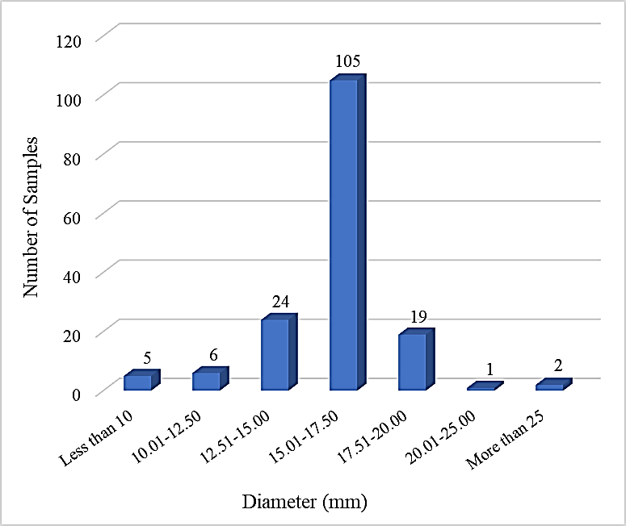

Figure 10. Percentages of methamphetamine (w/w) of 162 illicit drug tablets positively confirmed by GC-MS

General discussion

Based on physical characterization and chemical analyses results, valid information was retrieved regarding the composition of illicit drug samples [37]. In routine forensic analysis, the ultimate objective is to detect the presence of a controlled substance and quantify it. However, more in-depth analysis of illicit drug samples could contribute to a greater comparative study to gather information regarding sample-to-sample, case-to-case, seizure-to-seizure connections, especially when a large number of samples are encountered by the enforcement authorities [38-41]. To a certain extent, this approach could contribute to establishing the origins of illicit drug samples, the possible manufacturing pathway, as well as the potential trafficking and distribution network [42-43], enabling the tracking of drug syndicates or manufacturers.

In this study, illicit drug samples from various seizures were profiled for possible clustering or discrimination among them. Although physical characterization did not provide information on the identity of the substance in the illicit drugs, it allowed for the discrimination of a few samples from the major groups due to their unique physical appearance, especially in relation to their respective logos, diameter, thickness, and weight. ATR-FTIR analysis coupled with PCA indicated that the majority of the illicit drug samples were adulterated with caffeine. TLC analysis enabled the identification of the dyes that had been added to the tablets, whereby Ponceau 4R was found to be the most commonly used dye. Lastly, GC-MS analysis enabled the determination of the presence of methamphetamine as well as that of its content in each tablet through GC-FID. All the analytical results are summarized in Figure 11; the classification of samples into several groups was based on the drug profiling results. The proposed strategy can be used by law enforcement agencies and forensic laboratories to profile illicit drugs, in this case, methamphetamine tablets. Illicit methamphetamine samples tested in this study had demonstrated certain degree of physical and chemical differences. Differentiation among drug samples would be advantageous for sample-to-sample and seizure-to-seizure comparison. It was noted that this profiling study could have been restricted by the availability of methamphetamine samples, limited to the east coast region of Malaysia. A greater number of samples, perhaps from different regions of the country, would provide information of the current situation of illicit methamphetamine in the country. Nonetheless, data from such analytical endeavors should be further collated as it is necessary for wider forensic intelligence to provide information on the possible connection among seized samples to law enforcement authorities.

Figure 11. Drug profiling strategy and grouping of illicit drug samples

Conclusion

Forensic drug profiling was conducted with the aim of benefiting forensic investigation and intelligence. In this study, samples were differentiated based on several physical and chemical characteristics, allowing sample-to-sample comparison. With a greater number of illicit drug samples being processed, the linkages between seizures could be revealed, beneficial for tracking down the sources of these illicit drugs on the black market and their related distribution chain. Drug profiling strategies on a global level in accordance with comparative analyses of illicit drug samples would be advantageous for uncovering complex trafficking networks. This information could advance the body of knowledge useful to drug-related investigations and intelligence.

Acknowledgement

The authors thank the financial support via the USM RUI grant (1001/PPSK/8012236).

References
- National Institute on Drug Abuse (2021). Methamphetamine. Access from https://www.drugabuse.gov/publications/drugfacts/methamphetamine. [Access online 29 May 2021].
- United Nations Office on Drugs and Crime (2020). Drug use and health consequences. Vienna: United Nations Office on Drugs and Crime.
- United Nations Office on Drugs and Crime (2020). Synthetic drugs in east and southeast Asia: Trends and patterns of amphetamine-type stimulants and new psychoactive substances. Vienna: United Nations Office on Drugs and Crime.
- United Nations Office on Drugs and Crime (2020). Drug supply. Vienna: United Nations Office on Drugs and Crime.
- Hamdan, R., Nik Hassan, N. F., Mat Desa, W. N. S., Kunalan, V., Sulaiman, M. and Abdullah, A. F. L. (2015). Characterisation of seized clandestine methamphetamine in Malaysia. Malaysian Journal of Forensic Sciences, 6(1): 20-29.
- United Nations Office on Drugs and Crime (2020). Synthetic drugs in east and southeast Asia: Latest developments and challenges. Vienna: United Nations Office on Drugs and Crime.
- Libby H. (2018). Myanmar’s meth crisis reaches as far as Australia. ABC News. Access https://www.abc.net.au/news/2018-07-29/myanmars-meth-crisis-reaches-australia/10044502 [Access online 29 May 2021].
- Puthaviriyakorn, V., Siriviriyasomboon, N., Phorachata, J., Pan-ox, W., Sasaki, T. and Tanaka, K. (2002). Identification of impurities and statistical classification of methamphetamine tablets (Ya-Ba) seized in Thailand. Forensic Science International, 126(2): 105-113.
- Sennello, L. T. (1971). GLC determination of methamphetamine hydrochloride in methyl acrylate-methyl methacrylate sustained-release tablets. Journal of Pharmaceutical Sciences, 60 (4): 595-596.
- Mitrevski, B. and Zdravkovski, Z. (2005). Rapid and simple method for direct determination of several amphetamines in seized tablets by GC–FID. Forensic Science International, 152 (2-3): 199-203.
- United Nations Office on Drugs and Crime (2001). Drug characterization/impurity profiling – Background and concept. Vienna: United Nations Office on Drugs and Crime.
- Dufey, V., Dujourdy, L., Besacier, F. and Chaudron, H. (2007). A quick and automated method for profiling heroin samples for tactical intelligence purposes. Forensic Science International, 169:108-117.
- Esseiva, P., Dujourdy, L., Anglada, F., Taroni, F. and Margot, P. (2003). A methodology for illicit heroin seizures comparison in a drug intelligence perspective using large databases. Forensic Science International, 132(2): 139-152.
- European Monitoring Centre for Drugs and Drug Addiction (2009). Methamphetamine: A european union perspective in the global context. Portugal: European monitoring centre for drugs and drug addiction.
- Cole, C., Jones, L., Mcveigh, J., Kicman, A., Syed, Q. and Mark, A. B. (2010). A guide to adulterants, bulking agents and other contaminants found in illicit drugs. Faculty of Health and Applied Social Sciences, Liverpool John Moores University, Liverpool.
- De Andrade, F. I., Florindo Guedes, M. I., Pinto Vieira, Í. G., Pereira Mendes, F. N., Salmito Rodrigues, P. A., Costa Maia, C. S., Marques Ávila, M. M. and de Matos Ribeiro, L. (2014). Determination of Synthetic Food Dyes in Commercial Soft Drinks by TLC and Ion-pair HPLC. Food Chemistry, 157: 193-198.
- Dixon, E. A. and Renyk, G. (1982). Isolation, separation, and identification of synthetic food colors. Journal of Chemical Education, 59(1): 67-69.
- Kucharska, M. and Grabka, J. (2010). A review of chromatographic methods for determination of synthetic food dyes. Talanta, 80(3): 1045-1051.
- Fadil, F. A. and McSharry, W. O. (1979). Extraction and TLC separation of food, drug, and cosmetic dyes from tablet-coating formulations. Journal of Pharmaceutical Sciences, 68(1): 97-98.
- United Nations on Office Drugs and Crime (2006). Recommended methods for the identification and analysis of amphetamine, methamphetamine and their ring-substituted analogues in seized materials. Vienna: United Nations Office on Drugs and Crime.
- Adam, P., Natakankitkul, S., Sirithunyalug, J. and Aramrattana, A. (2005). Physio-chemical profiles of methamphetamine tablets. CMU Journal, 4(1): 65-70.
- Adam, P., Natakankitkul, S., Sirithunyalug, J. and Aramrattana, A. (2004). Drug characterization of methamphetamine tablets – a scientific tool to help identify drug production and trafficking networks. In: The third Australasian drug strategy conference – preventing and reducing substance abuse, 4-6 May 2004, Alice Springs, Australia.
- Li, T., Hua, Z., Meng, X. and Liu, C. (2018). A Simple and effective physical characteristic profiling method for methamphetamine tablet seized in China. Journal of Forensic Sciences, 63(2): 541-547.
- Haywood, A. and Glass, B. D. (2011). Pharmaceutical excipients - where do we begin? Australian Prescriber, 34(4): 112-114.
- Armstrong, N. (2006). Tablet manufacturer. In: Encyclopedia of pharmaceutical technology (3rd edition). Marcel Dekker, New York.
- Gordon, R. E., Rosanske, T. W. and Fonner, D. E. (1990). Granulation technology and tablet characterization. In: Pharmaceutical dosage forms. Marcel Dekker, New York.
- Cole, M. D. (2003). The analysis of controlled substances. John Wiley and Sons Ltd Wiley, New Jersey.
- Bunaciu, A. A. and Aboul-Enein, H. Y. (2021). Adulterated drug analysis using FTIR spectroscopy. Applied Spectroscopy Reviews, 56 (5): 423-437.
- Mail, R., Teoh, W. K., Kunalan, V., Chang, K. H. and Abdullah, A. F. L. (2021). Quick discrimination of seized erimin-5 tablets by attenuated total reflectance-Fourier transform infra-red spectroscopy. Australian Journal of Forensic Sciences, In Press.
- Liu, C-M., Han, Y., Min, S-G., Jia, W., Meng, X. and Liu, P-P. (2018). Rapid qualitative analysis of methamphetamine, ketamine, heroin, and cocaine by Fourier transform infrared spectroscopy (FTIR). Forensic Science International, 290: 162-168.
- He, X., Wang, J., You, X., Niu, F., Fan, L. and Lv, Y. (2020). Classification of heroin, methamphetamine, ketamine and their additives by attenuated total reflection-Fourier transform infrared spectroscopy and chemometrics. Spectrochimica Acta Part A: Molecular and Biomolecular, 241: 118665.
- Chan, K. W., Tan, G. H. and Wong, R. C. S. (2012). Gas chromatographic method validation for the analysis of major components in illicit heroin seized in Malaysia. Science and Justice, 52(1): 9-16.
- Broséus, J., Gentile, N. and Esseiva, P. (2016). The cutting of cocaine and heroin: A critical review. Forensic Science International, 262: 73-83.
- Hughes, J., Ayoko, G., Collett, S. and Golding, G. (2013). Rapid quantification of methamphetamine: Using attenuated total reflectance Fourier transform infrared spectroscopy (ATR-FTIR) and chemometrics. PLoS One 8(7): e69609.
- Abdullah, A. F. L., Abraham, A. A., Sulaiman, M. and Kunalan, V. (2012). Forensic drug profiling of erimin-5 using TLC and GC-MS. Malaysian Journal of Forensic Sciences, 3 (1): 11-15.
- Joyce, J. R. (1980). The identification of dyes in illicit tablets. Journal of Forensic Science Society, 20(4): 247-252.
- Chiarotti, M., Fucci, N. and Furnari, C. (1991). Comparative analysis of illicit heroin samples. Forensic Science International, 50(1): 47-56.
- Barnfield, C., Burns, S., Byrom, D. L. and Kemmenoe, A. V. (1988). The routine profiling of forensic heroin samples. Forensic Science International, 39(2): 107-117.
- Johnston, A. and King, L. A. (1988). Heroin profiling: Predicting the country of origin of seized heroin. Forensic Science International, 95(1): 47-55.
- Yusoff, M. Z., Chang, K. H. and Abdullah, A. F. L. (2017). Attenuated total reflectance – Fourier transform infra-red spectral profiling of illicit heroin for forensic intelligence. Australian Journal of Forensic Sciences, 50(5): 543-551.
- Collins, M., Huttunen, J., Evans, I. and Robertson, J. (2007). Illicit drug profiling: The Australian experience. Australian Journal of Forensic Sciences, 39(1): 25-32.
- Dams, R., Benijts, T., Lambert, W. E., Massart, D. L. and De Leenheer, A. P. (2001). Heroin impurity profiling: Trends throughout a decade of experimenting. Forensic Science International, 123(2-3): 81-88.
- United Nations on Office Drugs and Crime (2005). Methods for impurity profiling of heroin and cocaine - manual for use by national drug testing laboratories. Vienna: United Nations Office on Drugs and Crime.

