ESTIMATION OF CARBO DIOXIDE EMISSION IN THE TRANSPORTATION SECTOR ON PRIMARY ARTERIAL ROADS IN WONOKROMO DISTRICT, SURABAYA BEFORE AND AFTER
COVID-19

(Anggaran Pelepasan Gas Karbon Dioksida Bagi Sektor Pengangkutan di Jalan Utama Daerah Wonokromo Kota Surabaya Sebelum dan Selepas Covid-19)
Fatimah Zahra^{1*}, Agus Supriyanto², Nita Citrasari¹

¹Environmental Engineering Program,
²Biology Program, Biology Department,
Biology Department,
Faculty of Science and Technology, Universitas Airlangga, Indonesia

*Corresponding author: fatimah.zahra-2016@fst.unair.ac.id

Abstract
This research aims to determine the number of motorized vehicles of the road transportation sector at primary arterial roads in Wonokromo District before and after COVID-19, the estimated amount of emission produced by motorized vehicles before and after COVID-19 and the correlation between the distribution of the amount and the types of motorized vehicles and the estimated amount of carbon dioxide (CO2) emission. Data collection for determining the amount and type of motorized vehicles was conducted at Jalan Stasiun Wonokromo, Jalan Bung Tomo and Jalan Raya Ngagel. Data collection was conducted in the morning (06.00-08.00 a.m.), afternoon (11.00 a.m. – 01.00 p.m.) and evening (04.00-06.00 p.m.). This study utilizes the IPCC method to determine the concentration of CO2 while implementing the IPCC formula in travel distance approach and the idle emission formula in fuel consumption approach. The estimated amount of CO2 emission load is decreased due to COVID-19 by 44% at Jalan Stasiun Wonokromo, by 62% at Jalan Bung Tomo and by 34% at Jalan Raya Ngagel. The total number of motorized vehicles correlates to the estimated amount of CO2 emission load where there is an increase in number of motorized vehicles there will be an increase in the estimated amount of CO2 emission load as well.

Keywords: before and after COVID-19, carbon dioxide, idle emission, motorized vehicles, primary arterial roads

Abstrak
Kajian ini bertujuan untuk mengetahui jumlah kendaraan bermotor berdasarkan jenisnya di jalan utama daerah Wonokromo sebelum dan selepas COVID-19, anggaran beban pelepasan yang dihasilkan oleh kenderaan bermotor sebelum dan selepas COVID-19 dan mengetahui hubungan antara taburan jumlah dan jenis kendaraan bermotor dengan anggaran pelepasan gas karbon dioksida (CO2). Pengambilan data berupa jumlah dan jenis kendaraan bermotor dilakukan di Jalan Stasiun Wonokromo, Jalan Bung Tomo dan Jalan Raya Ngagel. Pengambilan data dilakukan pada pagi (06.00-08.00 WIB), tengahari (11.00-13.00 WIB) dan petang (16.00-18.00). Penelitian ini menggunakan kaedah pengiraan kepekatan CO2 dengan pendekatan jarak tempuh kenderaan menggunakan formula IPCC dan pengunaan bahan bakar menggunakan formula pelepasan terbiar. Pandemik COVID-19 menyebabkan terjadinya penurunan beban pelepasan CO2. Jalan Stasiun Wonokromo mengalami penurunan sehingga 44%, Jalan Bung Tomo pada 62% dan Jalan Raya Ngagel pada 34%. Korelasi antara jumlah kenderaan dengan anggaran pelepasan gas CO2 dipercayai semakin tinggi jumlah kenderaan maka semakin tinggi beban pelepasan CO2 berlaku.
Kata kunci: sebelum dan selepas COVID-19, karbon dioksida, pelepasan terbiar, kenderaan bermotor, jalan utama

Introduction
The increasing use of energy from fossil fuels for various human activities especially in industrial processes, transportation, and forest-clearing activities has led to increased greenhouse-gas emissions. The transportation sector plays a major role in air pollution through motorized-vehicle emissions. Motorized-vehicle emissions globally contribute 60% to air pollution, wherein 25% is made up of CO₂, 50% of NOx, and 25% of other gases [1]. CO₂ is also the main cause of the increase in the Earth's temperature, and the effect is bound to continue. The 2007 Global Climate Assessment showed that CO₂ has a radiative forcing (RF) value of 1.68 W/m². CO₂ has the largest positive RF value of all greenhouse gases produced by human activities, so CO₂ plays the largest role in global warming. A positive RF value represents an average increase in surface temperature caused by a gas, and a negative one indicates a decrease in temperature [2]. The increase in the number of motorized vehicles in the city of Surabaya has affected the amount of gas emissions produced, thereby contributing to climate change

and global warming. The consumption of fossil fuels in metropolitan cities tends to be high owing to high levels of population, mobility, and increased urban-transportation activities. The increase in urban-transportation activities in Indonesia is triggered by an increase in the ownership and use of private vehicles [3].

Materials and Methods
Based on the Technical Guidelines for Deconcentration of Mobile Source Air Pollution Control, the areas of study are three primary arterial roads in the city. The sampling was a one-time sampling. Sampling shall be conducted on working days and weekend; thus Monday, Tuesday, Saturday and Sunday were selected as representatives [4]. Accordingly, Jalan Stasiun Wonokromo, Jalan Bung Tomo, and Jalan Raya Ngagel were selected. Eleven sampling points on the three roads were chosen, as shown in Figures 2–4.
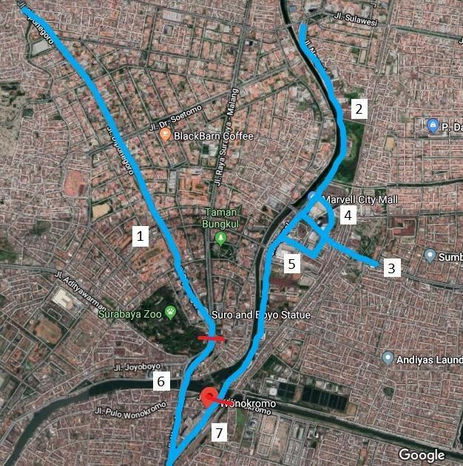

Figure 1. Primary arterial roads in Wonokromo District
Directory:

: Primary Arterial Roads in Wonokromo District
- : Jalan Diponegoro
- : Jalan Raya Ngagel
- : Jalan Bung Tomo
- : Jalan Upa Jiwa

- : Jalan Ratna
- : Jalan Wonokromo
- : Jalan Stasiun Wonokromo

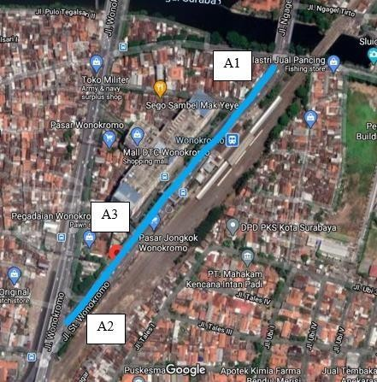

Figure 2. Sampling points in Jalan Stasiun Wonokromo

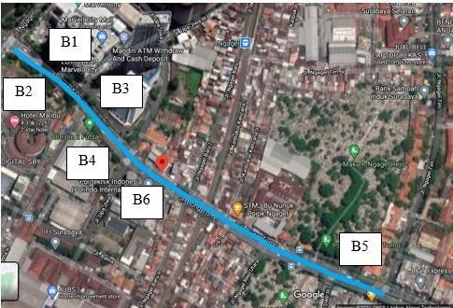
Figure 3. Sampling points in Jalan Bung Tomo
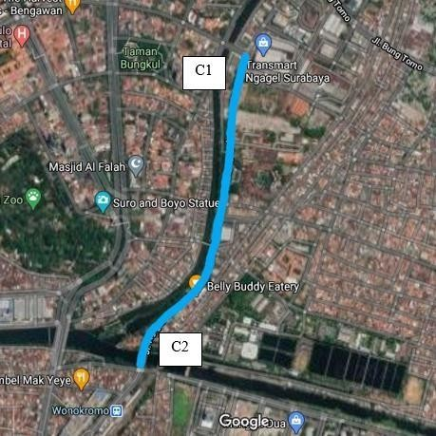

Figure 4. Sampling points in Jalan Raya Ngagel

Primary data collection
The primary data needed for this study were the number of vehicles, vehicle types, vehicle idling time, and travel distance. The number of vehicles was obtained by traffic counting at the predetermined sampling points before COVID-19 and by using CCTV footages after COVID-19. Traffic counting was conducted for a week after COVID-19 because traffic counting through CCTV footages did not need to consider volunteer to help on the road. Traffic counting was conducted at peak hours in the morning (06.00–08.00 a.m.), afternoon (11.00 a.m.–01.00 p.m.) and evening (04.00–06.00 p.m.). Traffic counting was performed using a manual hand counter. Vehicle idling time was the duration of vehicles stopping and in idle condition at a red light. Travel distance was the length of road segments which differs based on inlet and outlet points of vehicles on each road. The length of road segments and idling time at each sampling point are listed in Table 1.

Table 1. Length of road segments and idling time at each sampling point

Street Name | Sampling Point | Length of Road Segment  (km) | Idling Time  (h)
Stasiun Wonokromo | A1 | 0.352 | 0.0167
 | A2 | 0.517 | 0.0250
 | A3 | 0.169 | -
Bung Tomo | B1 | 0.083 | 0.0167
 | B2 | 0.083 | -
 | B3 | 0.226 | 0.0250
 | B4 | 0.226 | 0.0250
Bung Tomo | B5 | 0.408 | -
 | B6 | 0.408 | -
Raya Ngagel | C1 | 1.120 | 0.0167
 | C2 | 1.120 | 0.0200

Secondary data collection
The secondary data needed for this study were emission factor (Table 2) [5], fuel economy in running condition (Table 3) [5], fuel economy in idle condition (Table 3) [6], and fuel density. Fuel density in this study included gasoline (0.737 kg/m³⁾ and diesel (0.82 kg/m³).

Table 2. Emission factor of motorized vehicles in Indonesian cities

 | Type of Vehicle | CO | HC | NOx | PM10 | CO2 | SO2
 | Type of Vehicle | (g/km) | (g/km) | (g/km) | (g/km) | (g/kg fuel) | (g/km)
1. | Motorcycle | 14 | 5.9 | 0.29 | 0.24 | 3180 | 0.008
2. | Gasoline-fueled van/minibus | 40 | 4 | 2 | 0.01 | 3180 | 0.026
3. | Diesel-fueled van/minibus | 2.8 | 0.2 | 3.5 | 0.53 | 3172 | 0.44
4. | Bus | 11 | 1.3 | 11.9 | 1.4 | 3172 | 0.93
5. | Truck | 8.4 | 1.8 | 17.7 | 1.4 | 3172 | 0.82
6. | Angkutan kota (angkot) | 43.1 | 5.08 | 2.1 | 0.006 | 3180 | 0.029
7. | Taxi | 55.3 | 5.6 | 2.8 | 0.008 | 3180 | 0.025
8. | Pick-up truck | 31.8 | 3.5 | 2 | 0.026 | 3178 | 0.13
9. | Jeep | 36.7 | 3.86 | 2.36 | 0.039 | 3178 | 0.145
10. | Sedan | 33.8 | 3.7 | 1.9 | 0.004 | 3180 | 0.023

Table 3. Fuel economy in running condition

No. | Type of Vehicle | km/liter
1. | Sedan | 9.8
2. | Van/minibus | 8
3. | Taxi | 8.7
4. | Angkot | 7.5
5. | Micro and medium bus | 4
6. | Large bus | 3.5
7. | Pick-up truck | 8.5
8. | Truck with 2 sets of axles | 4.4
9. | Truck with 3 sets of axles | 4
10. | Jeep | 8
11. | Motorcycle | 28

Table 4. Fuel economy in idle condition

 | Type of Vehicle | mL/10 min | L/h
1. | Sedan | 88.0 | 0.528
2. | Van/minibus | 88.0 | 0.528
3. | Taxi | 88.0 | 0.528
4. | Angkot | 88.0 | 0.528
5. | Micro and medium bus | 153.1 | 0.919
6. | Large bus | 108.2 | 0.649
7. | Pick-up truck | 88.0 | 0.528
8. | Truck with 2 sets of axles | 167.0 | 1.002
9. | Truck with 3 sets of axles | 419.3 | 2.516
10. | Jeep | 100.0 | 0.600
11. | Motorcycle | 22.8 | 0.137

Emission load calculation
CO2 emissions for motorized vehicles while traveling was calculated using a modified equation from the Intergovernmental Panel on Climate Change [7], as shown in Equation 1.

Emission (tonnes/year) = EF × (1 / FE) × TD × AV × fuel density × 10⁻⁶ × 365 (day/year) (1)
EF is the emission factor of CO2 (g/kg-fuel), FE is fuel economy (km/l), TD travel distance or road length (km), AV is the number of vehicles per vehicle type (unit), and fuel density in this study included gasoline and diesel (kg/m³).
CO2 emissions produced by motorized vehicles in idle condition were calculated using Equations 2 and 3 [8]:
Idle-fuel use = (idle-fuel flow) × (idle time per day) (2)
Idle-fuel use is fuel consumption during waiting time (L/day), idle-fuel flow (L/h), and idle time per day is waiting time per day (hours).
Idle emissions = (idle-fuel use) × (GHG emission factor) × AV × fuel density (3)

Idle emissions are emissions in idle condition (g/day), idle-fuel use is fuel used in idle time (l/day), GHG emission factor (g/L), AV is the number of vehicles per vehicle type (unit), and fuel density in this study included gasoline and diesel (kg/m³).

Statistical analysis
The data obtained were tested statistically with the Kolmogorov-Smirnov test and the Spearman correlation test using the Statistical Package for the Social Sciences (SPSS) application. The Kolmogorov-Smirnov test was conducted to determine whether the research data were normally distributed or not. The data was then examined by the Spearman correlation test because it was not normally distributed.

Results and Discussion
Vehicle volume and composition
Vehicle volume on Jalan Stasiun Wonokromo, Jalan Bung Tomo, and Jalan Raya Ngagel before COVID- 19 is shown in Figures 5–7.
12000
10000
8000
6000
4000
2000
0
Monday
Tuesday
Saturday
Sunday
Time (day)

Morning Afternoon Evening
Number of Vehicles (units)

Figure 5. Vehicle volume on Jalan Stasiun Wonokromo before COVID-19

Figure 6. Vehicle volume on Jalan Bung Tomo before COVID-19
10000

8000

6000

4000

2000

0
Monday
Tuesday
Saturday
Sunday
Time (day)

Morning Afternoon Evening
Number of Vehicles (units)




12000
10000
8000
6000
4000
2000
0
Morning
Afternoon Evening
Time (day)

Number of Vehicles (units)

Figure 7. Vehicle volume on Jalan Raya Ngagel before COVID-19

Vehicle volume before COVID-19 was 296,292 units on Jalan Stasiun Wonokromo, 346,740 units on Jalan Bung Tomo, and 561,463 units on Jalan Raya Ngagel. Vehicle activity was higher during weekdays compared to weekend. High vehicle activity on weekdays was related to community activities, such as work and academic activities [9, 10]. Vehicle volume on Jalan Stasiun Wonokromo, Jalan Bung Tomo, and Jalan Raya Ngagel after COVID-19 is shown in Figures 8–10.



12000
10000
8000
6000
4000
2000
0
Morning
Afternoon
Evening
Time (day)

Figure 8. Vehicle volume on Jalan Raya Ngagel after COVID-19
Number of Vehicles (units)
Number of Vehicles (units)



8000
7000
6000
5000
4000
3000
2000
1000
0
Morning
Afternoon Evening
Time (day)




Figure 9. Vehicle volume on Jalan Bung Tomo after COVID-19
8000
7000
6000
5000
4000
3000
2000
1000
0
Morning
Afternoon Evening
Time (day)
Number of Vehicles (units)

Figure 10. Vehicle volume on Jalan Bung Tomo after COVID-19

Vehicle volume after COVID-19 was 551,716 units on Jalan Stasiun Wonokromo, 449,495 units on Jalan Bung Tomo, and 424,068 units on Jalan Raya Ngagel. The City Government of Surabaya began implementing large- scale social restrictions on April 28, 2020. This regulation was implemented as an effort to prevent the spread of COVID-19. Restrictions were made on activities outside the home and modes of transportation [11]. Vehicle composition on Jalan Stasiun Wonokromo, Jalan Bung Tomo, and Jalan Jalan Raya Ngagel after COVID-19 is shown in Figures 11–13.
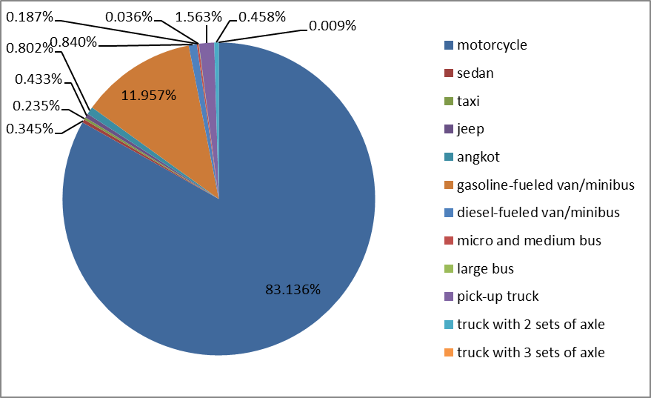

Figure 11. Vehicle composition on Jalan Stasiun Wonokromo

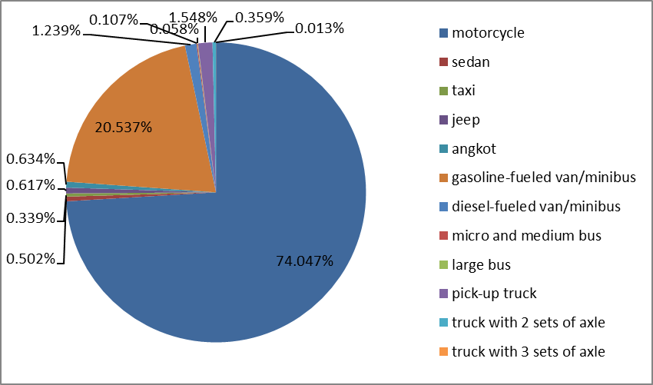
Figure 12. Vehicle composition on Jalan Bung Tomo

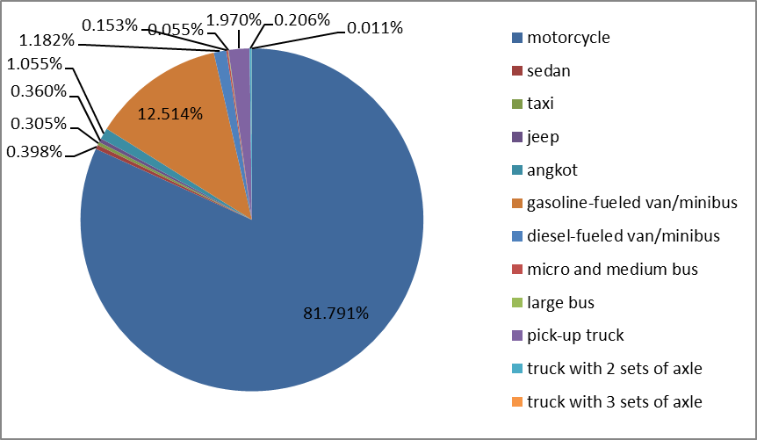
Figure 13. Vehicle composition on Jalan Raya Ngagel

The number of vehicles on the three roads was dominated by motorcycle, with percentages of 83%, 74%, and 82%, respectively. The vehicle with the second largest percentage was gasoline-fueled van/minibuse with a percentage of 12% on Jalan Wonokromo Station, 21% on Jalan Bung Tomo, and 13% Jalan Raya Ngagel. The lowest number of vehicles on the three roads was truck with three sets of axle.

Estimated CO2 emission
Estimated CO2 emission on Jalan Stasiun Wonokromo, Jalan Bung Tomo, and Jalan Raya Ngagel before and after COVID-19 is shown in Figures 14–16.

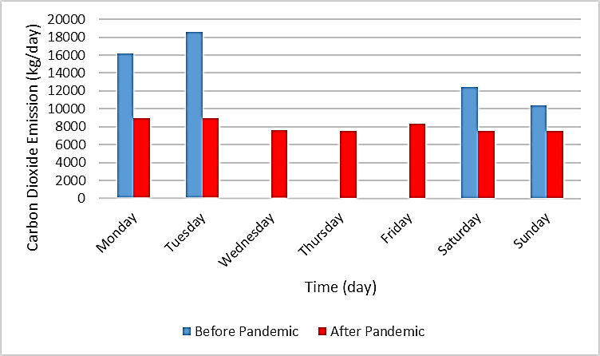

Figure 14. Estimated CO2 emission on Jalan Stasiun Wonokromo before and after COVID-19

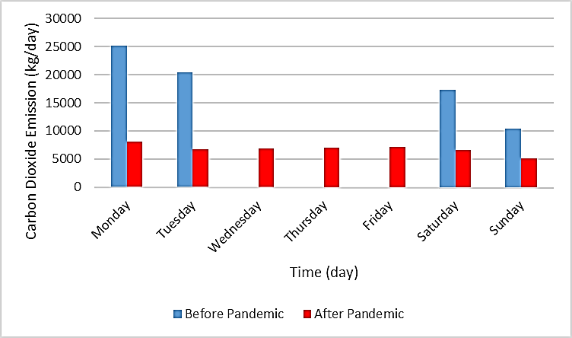
Figure 15. Estimated CO2 emission on Jalan Bung Tomo before and after COVID-19
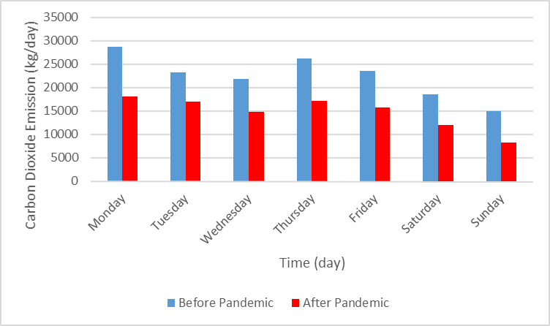
Figure 16. Estimated CO2 emission on Jalan Raya Ngagel before and after COVID-19

Estimated CO2 emission before COVID-19 was 5,259 kg/year on Jalan Stasiun Wonokromo, 6,668 kg/year on Jalan Bung Tomo, and 8,202 kg/year on Jalan Raya Ngagel. Figures 13–15 show decreased CO2 emission on the three roads owing to the COVID-19 COVID-19. Estimated CO2 emission decreased by 44% on Jalan Stasiun Wonokromo, by 62% on Jalan Bung Tomo, and by 34% on Jalan Raya Ngagel. The estimated CO2 emission after the COVID-19 was 2,945 kg/year on Jalan Stasiun Wonokromo, 2,478 kg/year on Jalan Bung Tomo, and 5,402 kg/year on Jalan Raya Ngagel.

Correlation between vehicle volume and type and estimated CO2 emission
Estimated CO2 emission based on vehicle type on Jalan Stasiun Wonokromo, Jalan Bung Tomo, and Jalan Raya Ngagel is shown in Figures 17–19.

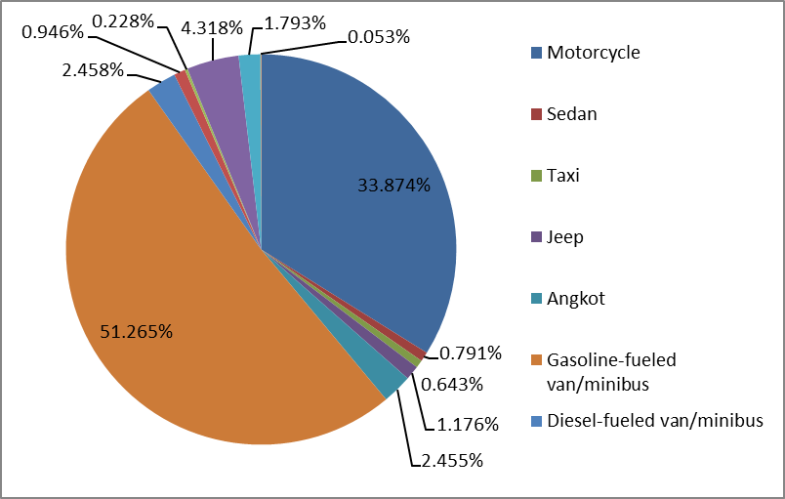

Figure 17. Estimated CO2 emission based on vehicle type on Jalan Stasiun Wonokromo
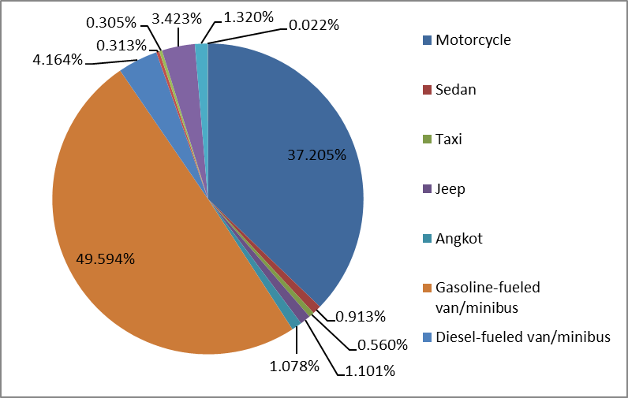
Figure 18. Estimated CO2 emission based on vehicle type on Jalan Bung Tomo

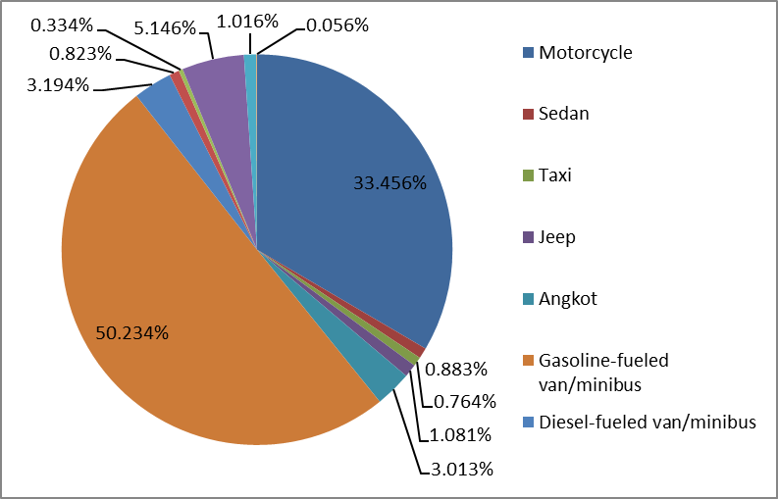
Figure 19. Estimated CO2 emission based on vehicle type on Jalan Raya Ngagel

Figures 17–19 show gasoline-fueled van/minibus as the largest contributor to CO2 emission. Gasoline-fueled van/minibus was the second largest number of vehicles after motorcycle, but it had a higher idle-fuel economy value and lower running-fuel economy value than motorcycle. This finding caused gasoline-fueled van/minibus to consume more fuel in engine operation [5, 7 ]. The lowest contributor to CO2 emission was truck with three sets of axle. Truck with three sets of axle had a high fuel-economy value, although it was extremely smaller than the other vehicle types, thereby resulting in considerably lower CO2 emission. The result of the Kolmogorov- Smirnov normality test shows that the data are not normally distributed because the number of vehicles has a sig value of 0.000 < (α) 5%. The Spearman correlation test shows that there is a correlation between the number of vehicles and the CO2 emission load as can be seen from a significance value of 0.000 < (α) 5% and has a correlation coefficient of 0.979 for Jalan Station Wonokromo, 0.937 for Jalan Bung Tomo and 0.944 for Jalan Raya Ngagel. The correlation coefficient > 0.9 indicates a strong positive correlation, namely the higher the number of vehicles, the higher the CO2 emission load will be.

Conclusion
CO2 emission on the primary arterial roads of Wonokromo District decreased owing to the COVID-19. It decreased by 55% on Jalan Stasiun Wonokromo, by 62% on Jalan Bung Tomo, and decreased by 37% on Jalan Raya Ngagel. The estimated CO2 emission before COVID-19 was 5,259 kg/year on Jalan Wonokromo Station, 6,668 kg/year on Jalan Bung Tomo, and 8,202 kg/year on Jalan Raya Ngagel. The estimated CO2 emission during COVID-19 was 2,945 kg/year on Jalan Stasiun Wonokromo, 2,478 kg/year on Jalan Bung Tomo, and 5,402 kg/year on Jalan Raya Ngagel. There is a correlation between the number of vehicles and estimated CO2 emission load namely the higher the number of vehicles, the higher the CO2 emission load will be.

Acknowledgement
We thank the Dinas Perhubungan Kota Surabaya and the Surabaya Intelligent Transportation System Kota Surabaya for providing the CCTV footages for traffic counting after COVID-19. We also thank Mirza Chalif Ardian, Farah Mutia, Harum Nuraliyah, and Puput Cahyono Wulandari for helping in on-site traffic counting before COVID-19. Finally, we thank the team of the Solid-Waste Program Study of Environmental Engineering Universitas Airlangga for the joint funding of this research.

References
- Kusuma, W. P., Boedisantoso, R. dan Wilujeng, S. A. (2010). Studi kontribusi kegiatan transportasi terhadapemisi karbon di Surabaya bagian barat. Undergraduate Study, Institut Teknologi Sepuluh Nopember.
- Intergovernmental Panel On Climate Change (2007). Climate change 2007: Impacts, adaptation and vulnerability. Cambridge, Cambridge University Press.

- Mudjiastuti, H. (2011). Analisis hubungan sistem transportasi kota terhadap konsumsi bbm (kota: metropolitan, besar dan sedang di Jawa). Prosiding Seminar Nasional Sains dan Teknologi Ke-2 Tahun 2011: 8-12.
- Kementerian Lingkungan Hidup dan Kehutanan. (2012). Petunjuk teknis dekonsentrasi pengendalian pencemaran udara sumber bergerak. Deputi Bidang Pengendalian Pencemaran Lingkungan Hidup, Jakarta: pp. 7.
- Kementerian Lingkungan Hidup dan Kehutanan. (2010). Peraturan menteri lingkungan hidup nomor 12 tahun 2010 tentang pelaksanaan pengendalian pencemaran udara di daerah, Indonesia.
- Kumar, P. V.P., Singh, A., Sharma, N., and Chalumuri, R. S. (2015). Evaluation of idling fuel consumption of vehicles across different cities. Government Study, New Delhi Central Road Research Institute.
- Amri, S. and Driejana. (2011). A simple approach to estimate gridded-value in high-resolution GHG emission map of road transport sector. Proceedings of the Eastern Asia Society for Transport Studies, 2011: 8.
- Taylor, G.W.R. (2003). Vehicle idling incidence and energy use data. Review of the incidence, energy use and costs of vehicle idling. Final report 13: pp. 2-13.
- Novianti, S. and Driejana. (2010). Pengaruh karakteristik faktor emisi terhadap estimasi beban oksida nitrogen (nox) dari sektor transportasi (studi kasus: wilayah Karees, Bandung). Jurnal Teknik Lingkungan, 16(2): 185- 198.
- O’Fallon, C. and Sullivan, C. (2003). Understanding and managing weekend traffic congestion. Government study Australasian Transport Research Forum.
- Pemerintah Kota Surabaya. (2020). Peraturan Walikota nomor 16 tahun 2020 tentang pedoman pembatasan sosial berskala besar (psbb) dalam penanganan corona virus disease 2019 (Covid-19) di Kota Surabaya.

