BIO-COAL OPTIMIZATION STUDY OF DRY LEAVES VIA

LOW-TEMPERATURE MECHANISM

(Kajian Pengoptimuman Terhadap Bio-Arang Batu Mengunakan Daun Kering

Melalui Mekanisme Suhu Rendah)

Siti Solehah Misni¹, Nor Hazelah Kasmuri^{1,2*}, Fuzieah Subari¹, Zalizawati Abdullah^{1,2},

Suhaiza Hanim Hanipah¹

¹School of Chemical Engineering,

College of Engineering

Universiti Teknologi MARA, 40450 Shah Alam, Selangor, Malaysia

²Industrial Process Reliability and Sustainability Research Group,

College of Engineering,

Universiti Teknologi MARA, 40450 Shah Alam, Selangor, Malaysia

*Corresponding author: norhazelah@uitm.edu.my

Abstract
The abundant resources of forestry waste, such as dry leaves, find utility in the bio-coal production industry. In this study, bio-coal produced via the low-temperature mechanism of torrefaction was optimized using response surface method (RSM). The dry torrefaction method was conducted for 60–90 min with biomass loading of 50–100 g and a temperature range of 200–350 °C. The torrefaction process of dry leaves was executed in a furnace and was optimized by using RSM’s factorial design. The optimal conditions were reaction temperature of 200 °C, a reaction time of 60 min, and a biomass loading of 100 g, which produced maximum bio-coal yield (85.33%). Bio-coal products were characterized using a thermogravimetric analyzer and Fourier transform infrared spectrometry to determine the weight loss, thermal effect profile, and functional groups of phenol, alcohol, ester, ether, and aromatic groups in bio-coal.

Keywords: bio-coal, dry leaves, optimization, response surface method, torrefaction

Abstrak

Sumber sisa hutan yang banyak, seperti daun kering, mempunyai kegunaan yang relevan dalam industri pengeluaran bio-arang batu. Bio-arang batu yang dihasilkan melalui mekanisme suhu rendah torefaksi dioptimumkan dengan kaedah gerak balas permukaan (RSM). Kaedah kering torefaksi dilakukan selama 60-90 min dengan muatan biojisim 50-100 g dan julat suhu 200-350 °C. Proses torefaksi daun kering dilakukan di relau pembakaran dan dioptimumkan dengan menggunakan rekabentuk faktorial RSM. Keadaan optimum ialah suhu reaksi 200°C, masa tindak balas 60 min, dan muatan biojisim 100 g, yang menghasilkan hasil maksimum bio-arang batu (85.33%). Produk bio arang batu dicirikan menggunakan penganalisis termogravimetri dan spektrometri inframerah transformasi Fourier untuk menentukan penurunan berat, profil kesan terma, dan kumpulan fungsional kumpulan fenol, alkohol, ester, eter, dan aromatik dalam bio-arang batu.

Kata kunci: bio-arang batu, daun kering, pengoptimuman, kaedah gerak balas permukaan, torefaksi

Introduction

Owing to global warming, the extensive use of fossil fuels as the source of energy for the industrial and commercial sectors has now become a chief concern. Fossil fuels exist in form of hydrocarbon, primarily natural gas, petroleum, and coal derived from dead animals or plants. The combustion of fossil fuels emits carbon monoxide into the atmosphere. The advancement of bio-coal as an alternative to fossil fuels has increased interest because of the depletion of oil resources and their positive impact on the environment, energy supply substitution, and rural growth [1]. Unlike biomass, fossil fuels contain a high percentage of carbon and are primarily derived from coal, petroleum, and natural gas. Because of their high carbon content, fossil fuels generate more carbon dioxide than bio-coal derived from biomass. Sulfur and other impurities are also found in fossil fuels. The combustion process of fossil fuels produces sulfur monoxides and sulfur dioxide, which contribute to acid rain. Likewise, the combustion of fossil fuels generates ozone (O₃), which is converted to other pollutants in the atmosphere by the action of sunlight. If a massive amount of O₃ is generated, it may be dangerous to the respiratory system [2].

There are three methods for converting biomass into energy: biochemical, thermochemical, and chemical conversion. Biochemical conversion produces biogas, biodiesel, and bio-ethanol, whereas chemical conversion produces plant oil, and thermochemical conversion produces solid fuel, liquid fuel, and gas fuel [3]. Thermochemical conversion exposes biomass to raised temperatures in a low-oxygen atmosphere. The purpose of this conversion is to decompose significant lignocellulosic biomass into insignificant compounds that can be used immediately [1]. There are four thermochemical conversion technologies, depending on whether the mechanism involves high or low temperature. The former includes combustion and gasification, whereas the latter includes pyrolysis and torrefaction [4,5]. Torrefaction is the most suitable because the product yield of the solid formed is the highest [6]. Approximately up to 70% of the total dry leaves are yielded as a solid product from torrefaction processes [7]. Torrefaction is a low-temperature thermal process used to treat biomass waste [8]. The dry torrefaction process is the thermal processing of biomass at 200-300 °C in the absence of oxygen or air. Through hemicellulose devolatilization, the process impacts the volatilization of water and volatile organic compounds. Lignin and cellulose in lignocellulosic biomass disintegrate beyond 300 °C [9]. Approximately 30% of biomass is lost during the torrefaction process, and the torrefied product retains more than 90% of the initial energy content [7]. The advantages of working with torrefied biomass include a significant energy density, which contributes to bio-coal efficiency as vehicle fuel. In addition to that, it has a better grinding ability and lower biodegradability. The torrefied biomass can also reduce water retention time because of its increased hydrophobicity [10].

Furthermore, the most noteworthy factor in producing better bio-coal is optimal production conditions. Optimization reduces the error and improves the performance of the existing bio-coal production process. Besides that, it can minimize the time required to design new products and improve the reliability and performance of bio-coal. Today, it affects both consumers and producers in terms of resources, budget, and time. Thus, this optimization method with response surface method (RSM) has proven as a tool for statistical technique for complex processes. It can reduce the number of experiments that are required to assess several parameters and their interactions. Hence, by employing the optimization in RSM, the yield of product can be improved with significant results [5,11]. In accordance with the previous studies, several parameters were assessed in the optimization in the torrefaction; as the optimal temperature reached up from 180 °C to 220 °C [12], reaction time ranged from 30 min to 60 min [13,14], and biomass loading varied between 90 g to 100 g [15,16], respectively.

In the present study, the optimal values of the investigated parameters were obtained from the optimization of bio-coal from dry leaves. The parameters influencing bio-coal production were evaluated using RSM design. The Design-Expert© version 10 was used to achieve the objective of this research – to determine the optimal parameters. This determination method is also known as the design of experiment method, which was implemented using RSM. RSM acts as an essential tool to develop, design, and optimize a wide range of engineering systems [17]. The obtained results can also be obtained from a small number of experiments. Following the selection of an acceptable model, future observations can be assumed to fall within the original design range [18].

Materials and Methods

Sample preparation and characterization of raw materials

Dry leaves collected were taken from UiTM Shah Alam, Selangor. Dry-leaf biomass is a readily available forestry residue in Malaysia and has been proposed as a source for bio-coal production. Following the collection, the dry leaf sample was first sundried for two days to remove unbound moisture and then ground to reduce biomass size [19]. Using thermogravimetric analyzer (TGA) (Model Toledo, Switzerland), the dry leaves were characterized by evaluating the thermal properties of solid materials as a function of temperature using a constant heating rate. Manipulation of the temperature allowed the weight gain and loss of the bio-coal to be determined.

Torrefaction process

Torrefaction of dry leaves was accomplished using a front-loading furnace (carbolite). It consists of a rectangular chamber with a heavy-gauge heating system with graded winding and an insulated front vestibule. To eliminate the air during the combustion, a sample of grounded dry leaves was wrapped in aluminum foil. The wrapped samples were placed in the furnace and heated to the desired temperature. The temperature inside the reactor was controlled manually by pressing the furnace’s button.

Approximately 50 g and 100 g of grounded dry leaf feedstock wrapped in aluminum foil were placed inside the chamber and torrefied at two levels of desired temperature (200 °C and 350 °C) and reaction time (60 min and 90 min). After each torrefaction run, the final solid torrefied product was recovered from the furnace and stored in a desiccator for additional analysis. The respective weights before and after the torrefaction process were recorded for further analysis using an optimization process.

Fourier transform infrared spectroscopy analysis

The solid torrefied product was analyzed using Fourier transform infrared spectroscopy (FTIR) (Model Perkin Elmer Spectrum One, USA) and the instrument was operated at room temperature. The FTIR was equipped with universal attenuated total reflection (ATR) at the spectra of 4 cm⁻¹ resolution [20]. The analysis of FTIR was used to determine the functional group present in the form of a peak at a specific wavelength. It is set to transmission mode, with a range of 4000 cm⁻¹ to 400 cm⁻¹.

Thermogravimetric analysis

The raw biomass sample, solid torrefied biomass product of 200 °C and 350 °C, respectively was analyzed using TGA (Model Toledo, Switzerland) to measure the volatile matter content by percentage of lignin, hemicellulose, and cellulose, as well as the percentage of fixed carbon content inside the torrefied dry leaves and the ash content. The analysis result represents the thermal properties of solid materials as a function of temperature using a constant heating rate.

In the analyzer, 20 mg of bio-coal sample was heated from room temperature to 900 °C at a constant heating rate of 10 °C/min. The analysis was performed in an inert atmosphere with a continuous flow of nitrogen gas at a rate of 100 mL/min [19].

Optimization of bio-coal production using response surface method

The data set in Table 1 explains the experiment that was performed to determine the response yield of various bio-coal samples prepared at varying conditions of temperatures, weights, and times. The experiments were conducted using RSM according to a two-level factorial design with three variables or design factors and each experiment was performed twice.

A factorial design can be used to determine the consequences and statistical significance of a larger group of experimental variables. This method allows one to select the acceptable or pertinent variables for the next set of experiments. The factorial design enables better system behavior by including higher model components.

The three design factors, namely temperature, time, and weight were used to execute 16 different experiments. The factorial model of two-level factorial design was determined in Equation 1. The parameters X₁, X₂, and X₃ represent torrefaction temperature, reaction time, and biomass loading, respectively. The total number of experiments required can be calculated as follows.

Y = α₀ + α₁X₁ + α₂X₂ + α₃X₃ + α₁,₂X₁X₂ + α₁,₃X₁X₃ + α₂,₃X₂X₃ (1)

where Y is the predicted responses, α₀ to α_{2,3} is the regression coefficient, and X₁, X₂, and X₃ are the parameters’ factor. Multiple regression analysis was used to calculate the coefficients in Equation 1 on the basis of the obtained experimental data as well as the predicted responses.

ANOVA methods were used to extract the results from both experiments. This method was performed by using Design-Expert software version 10.

Table 1. Bio-coal data set via torrefaction

Run | Torrefaction Temperature (°C) | Time (min) | Biomass Loading (g) | Bio-Coal Yield (% g bio-coal/ g biomass) | Actual Value  (% g bio-coal/ g biomass) | Predicted Value  (% g bio-coal/ g biomass)
1 | 200 | 90 | 100 | 40.06 | 40.06 | 40.06
2 | 350 | 90 | 100 | 52.84 | 52.84 | 52.84
3 | 350 | 60 | 50 | 48.74 | 48.74 | 48.19
4 | 350 | 90 | 50 | 50.58 | 50.58 | 50.58
5 | 200 | 60 | 50 | 84.14 | 84.14 | 84.14
6 | 200 | 60 | 50 | 84.14 | 84.14 | 84.14
7 | 350 | 60 | 50 | 47.64 | 47.64 | 48.19
8 | 200 | 90 | 100 | 40.06 | 40.06 | 40.06
9 | 200 | 90 | 50 | 78.24 | 78.24 | 78.24
10 | 350 | 90 | 100 | 52.84 | 52.84 | 52.84
11 | 350 | 60 | 100 | 25.28 | 25.28 | 25.28
12 | 200 | 90 | 50 | 78.24 | 78.24 | 78.24
13 | 350 | 90 | 50 | 50.58 | 50.58 | 50.58
14 | 350 | 60 | 100 | 25.28 | 25.28 | 25.28
15 | 200 | 60 | 100 | 85.33 | 85.33 | 85.33
16 | 200 | 60 | 100 | 85.33 | 85.33 | 85.33

Results and Discussion

Experimental design

As remarked earlier, in this study, RSM was used to analyze the experiments that followed a two-level factorial design with three variables or design factors and all experiments were performed twice.

Analysis of ANOVA

Findings of a previous study revealed that evaluating the quality of the fitted model is necessary because of the inability of the developed mathematical model to be satisfactorily described from the experimental results [21]. Besides, in the two-level factorial design, the fitted model or significance model of factorial allows all the three-factor interactions (AB, AC, and BC) as well as the interaction of ABC [22].

The p-value (probability values) can be used to assess the significance of coefficients in the models that indicate patterns of interaction among design factor variables. In addition to that, Fisher’s variance ratio (F-value) was used to measure variation in data around the mean [23].

In Table 2, the coded values of A, B, and C represent the torrefaction temperature, reaction time, and biomass loading, respectively, and are significant with the “Prob > F” less than 0.0001 with a model F-value of 12883.84. Sample weight shows the great influence in the yield on bio-coal production, as evidenced by the F-value of 11373.05. The F-values for torrefaction temperature and reaction time were 2060.86 and 4308.37, respectively. The graph test is significant, implying that optimization can be examined. The factorial model of the present study is fit and significant as the lack-of-fit test was found to be insignificant. As this was also proven in previous study, when the lack-of-fit indicating the insignificant, it implies the model is fit [24].

Table 2. ANOVA for the selected factorial model

Source | Sum of  Squares | F-value | p-value  Prob > F | Remarks
Model | 6820.38 | 12883.84 | < 0.0001 | Significant
A-torrefaction temperature | 155.85 | 2060.86 | < 0.0001
B-reaction time | 325.82 | 4308.37 | < 0.0001
C-Biomass loading | 860.09 | 11373.05 | < 0.0001
AB | 316.41 | 4183.88 | < 0.0001
AC | 902.47 | 11933.43 | < 0.0001
BC | 1089.07 | 14400.93 | < 0.0001
ABC | 1041.35 | 13769.96 | < 0.0001
Pure error | 0.60
Cor total | 6820.99

R² and adjusted R² can be used to evaluate the characteristics and importance of the regression model. Both values show the accuracy and general availability of the regression model [25]. In Table 3, the R² value of the multiple correlation coefficient of the regression equation is 0.9999, which indicates that 99.99% of the total variation in bio-coal yield was assigned to the design factor variables studied. This means that the models fitted well with the experimental data.

The amount of variation can also be computed using the model’s clarified mean [26]. The adjusted R² value for the regression model is 0.9998. On the basis of both values, it is possible to conclude that the large value of R² and the slight differences between them indicate that the fitted empirical model can be used for prediction.

The adjusted R² of 0.9998 is in reasonable agreement with the predicted R² of 0.9996 as the difference in values between both models are always less than 0.2. Adeq. precision used to calculate and estimate the signal-to-noise ratio. The desired ratio for Adeq. precision was found to be 4. According to our results, the signal-to-noise ratio of 308.813 indicates an acceptable signal. Thus, it can be concluded that the model can be used to navigate the design space.

Table 3. R² statistics for the fitted model

Factors | Value
R-Squared | 0.9999
Adj. R-Squared | 0.9998
Pred. R-Squared | 0.9996
Adeq. Precision | 308.813

From the conducted regression analysis, the following mathematical model in terms of coded levels can be expressed using Equation 2:

Bio-coal yield (%) = -118.19 + 0.67A + 3.62B + 5.68C – 0.01AB -0.02AC – 0.08BC + 0.0002ABC (2)

Study and validation of models for bio-coal products

The factorial design with 16 runs was used to screen all the three design factors. Figure 1(a, b) illustrates the diagnostic plot of the torrefaction analysis. It is evidenced in Figure 1(a) that the half-normal plot of the bio-coal yield is normally distributed. It can be observed that less noise occurred because of the factors A, B, and C being spread away from a straight line. There is only a 0.01% chance that an F-value this large could occur because of noise.

As per the residuals versus the runs plots as shown in Figure 1(b), the plots are distributed above and below the x-axis. The proposed model is acceptable and reliable because all the points lie between ±3.
(b)
(a)

Figure 1. Diagnostic and model graphs for a yield of bio-coal: (a) half-normal plot and (b) residuals versus run

Parametric interactions within the models of bio-coal products

Figure 2(a) depicts the response surface plots of the interaction effect of torrefaction temperature and reaction time on the yield of bio-coal products to obtain maximum responses. The maximum bio-coal yield was 84.05% during torrefaction temperature of 200 °C, a reaction time of 60 min, and biomass loading of 100 g.

Figure 2(b) expresses the response surface plots of the interaction effect between the torrefaction temperature and biomass loading on bio-coal yield. The maximum response obtained from the diagnostic of the graph shows that the bio-coal yield was 79.73% during torrefaction temperature of 200 °C, biomass loading of 50 g, and reaction time of 90 min. Finally, Figure 2(c) illustrates the response surface plots of the interaction effect of reaction time and biomass loading on bio-coal yield. The maximum bio-coal yield was 65.93% during a reaction time of 60 min, biomass loading of 50 g, and torrefaction temperature of 200 °C.

According to the response surface graph, as the torrefaction temperature and reaction time increase, the bio-coal yield decreases. The thermal deterioration of lignocellulosic compounds during the torrefaction process of dry leaves may plausibly cause a decrease in bio-coal yield. Apart from that, it is caused by hydroxyl group dehydration, combustion, and volatilization of organic compounds [27].

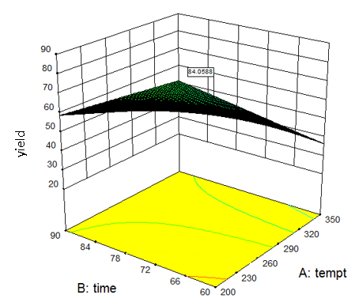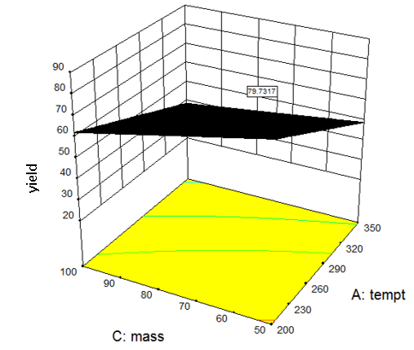
(b)
(a)

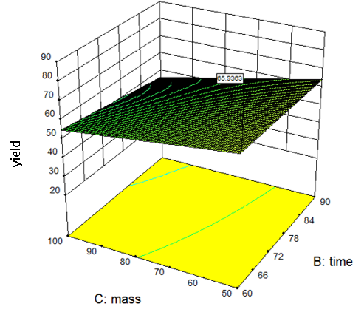
(c)

Figure 2. Model graphs (a) response surface plot of the interaction effect between torrefaction temperature and reaction time, (b) response surface plots of the interaction effect between the torrefaction temperature and biomass loading (c) response surface plots of the interaction effect between the reaction time and biomass loading

The optimization process was used to determine the optimal conditions of the torrefaction process to obtain maximum bio-coal yield. Numerical optimization was used to find the most optimal solution. According to Figure 3, the results show that the optimal condition can be achieved at torrefaction temperature of 200 °C, a reaction time of 60 min, and biomass loading of 100 g with 1.00 desirability and 85.33% bio-coal yield. It shows significant desirability of torrefaction temperature, reaction time, and biomass loading.

Characterization of raw material and bio-coal: FTIR analysis

Figure 4 shows the FTIR analysis performed to determine the chemical changes in the structure of bio-coal via torrefaction at 200 °C. The spectra of raw dry leaves and bio-coal samples show that they contain an O–H bond originating from alcohol and phenols observed in the 3400 cm⁻¹–3600 cm⁻¹ region. Other than that, ketone and aldehyde groups have been observed in the 1680 cm⁻¹–1750 cm⁻¹. Other functional group peaks containing aromatic groups were also observed from 690 cm⁻¹–900 cm⁻¹. The presence of aromatic hydrocarbon indicates significant characteristics of combustible materials [24].

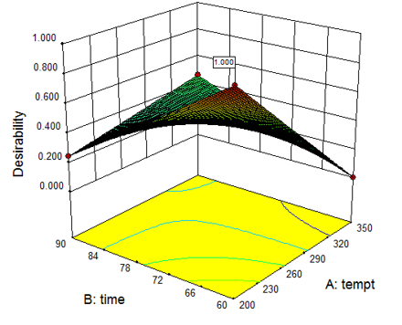

Figure 3. Desirability plot of response surface

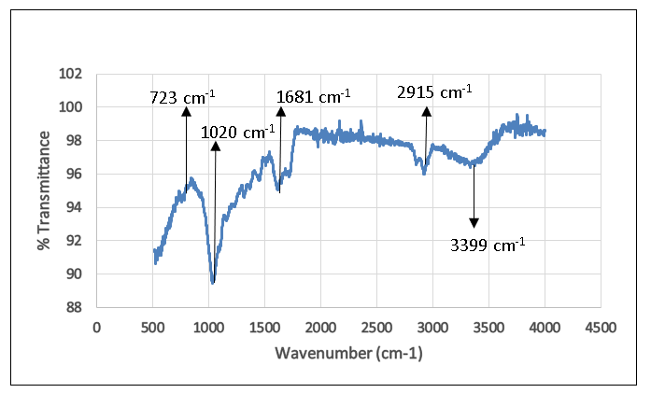

Figure 4. FTIR spectra for bio-coal sample via torrefaction at 200 °C

Characterization of raw material and bio-coal: TGA

The TGA curve in Figure 5 shows that the sample of bio-coal produced at 350 °C exhibits maximum weight loss at 900 °C, which is 11.2 mg of weight loss, or about 56% of the total weight. The bio-coal sample at 200 °C shows 10.84 mg of weight loss, or about 54.2% of the total weight. Raw dry leaves weighed 10.62 mg, which is approximately 53.1% of the total weight. As the torrefaction temperature increases, the weight loss also increases. This is attributable to the moisture release during the thermal events. At some point during the torrefaction, the biomass was dried or dehydrated and the moisture was removed from it as the weight loss can be seen to be significantly high [28,29].

Figure 6 shows the temperature-dependent profile of derivative weight loss, which is highlighted by the sequence of decomposition of hemicellulose, cellulose, and lignin [30]. The first peak at 50 °C and 0.27 mg/min weight loss indicates the decomposition of hemicellulose and the second peak at 300 °C and weight loss of 0.54 mg/min indicates cellulose decomposition. The intensity of the peak for the sample at 350°C was much lower than that at 200 °C. This proved that the torrefaction of dry leaves at higher temperatures can reduce the highly volatile component in the bio-coal [19].

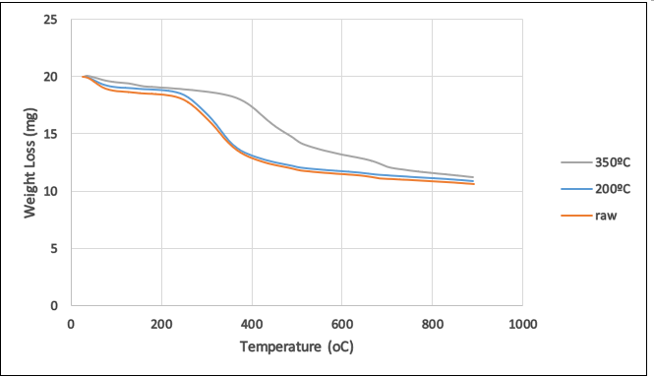

Figure 5. Thermal effect profile of raw dry leaves and bio-coal at different temperatures

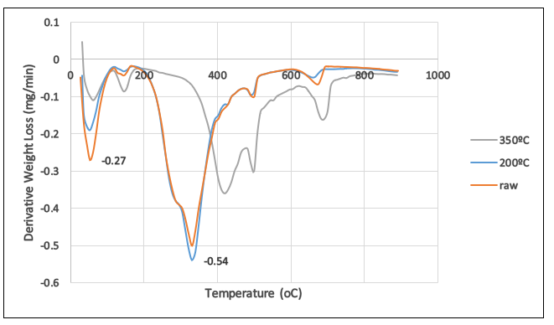

Figure 6. Derivative weight loss of raw dry leaves and bio-coal at different temperatures

Conclusion
In this study, torrefaction of dry leaves was performed using a front-loading furnace under various conditions to determine the optimum conditions for the operating variables. In this study, the Design-Expert software was successfully employed to optimize the production of bio-coal. A high energy-yielding bio-coal was successfully prepared from dry leaves, one of the world’s most abundant forestry wastes. By means of RSM, factors namely torrefaction temperature, reaction time, and biomass loading were screened using factorial design. These factors are the major contributors to the high yield of bio-coal. The optimum bio-coal (85.33% yield) was obtained at a torrefaction temperature of 200 °C, a reaction time of 60 min, and biomass loading of 100 g. ANOVA analysis confirmed that the models used to predict bio-coal yield as a function of torrefaction time, reaction time, and biomass loading were significantly well fitted and sufficiently expressed the experimental results. From FTIR analysis, it was deduced that the functional groups present in the bio-coal are alcohols, phenols, ketones, aldehydes, and aromatic groups. In thermogravimetric analysis, the TGA curve shows that the sample of bio-coal produced at 350 °C exhibited the maximum weight loss or about 56% of the total weight. The differential thermogravimetric analysis profile clearly shows that hemicellulose decomposition started at 50 °C, whereas cellulose decomposition started at 300 °C. This investigation presented a strategy for producing solid bio-coal from dry leaves for effective utilization of biomass efficiency, as well as a suggestion for integrating them for sustainable production of renewable energy.

Acknowledgment

The authors would like to thank the School of Chemical Engineering, College of Engineering, Universiti Technology MARA (UiTM) Shah Alam for the facilities used in this study.

References
- Medic, D. (2012). Investigation of torrefaction process parameters and characterization of torrefied biomass. PhD Dissertation, Iowa State University.
- Demirel, Y. (2012). Energy: Production, conversion, storage, conservation, and coupling. In Energy: Production, Conversion, Storage, Conservation, and Coupling (Green Energy and Technology). Springer Verlag, London: pp. 35.
- Chew, J. J. and Doshi, V. (2011). Recent advances in biomass pretreatment - torrefaction fundamentals and technology. Renewable Sustainable and Energy Reviews, 15(8): 4212-4222.
- Asadullah, M. (2014). Barriers of commercial power generation using biomass gasification gas: A review. Renewable Sustainable and Energy Reviews, 29: 201-215.
- Isa, K. M., Kasim, F. H., Ali, U. F. M. and Rashid, R. A. (2017). Characterization, calculation of calorific values, and bio-oil production via thermochemical processes of municipal solid waste in Perlis, Malaysia. Malaysian Journal of Analytical Sciences, 21(4): 801-809.
- Bergman, P. C., Boersma, R., Zwart, R. W. R. and Kiel, J. H. (2005). Torrefaction for biomass co-firing in existing coal-fired power stations. Energy Research Centre of Netherlands.
- Van der Stelt, M. J. C., Gerhauser, H., Kiel, J. H. A. and Ptasinski, K. J. (2011) Biomass upgrading by torrefaction for the production of biofuels: A review. Biomass and Bioenergy, 35(9): 3748-3762.
- Eseyin, A. E., Steele, P. H. and Pittman, C. U. (2015). Current trends in the production and applications of torrefied wood/biomass - A review. BioResources, 10(4): 8812-8858.
- Chouchene, A., Jeguirim, M., Khiari, B., Trouvé, G. and Zagrouba, F. (2010). Study on the energy mechanism during devolatilization/char oxidation and direct oxidation of olive solid waste in a fixed bed reactor. Journal of Analytical and Applied Pyrolysis, 87(1): 168-174.
- Stelte, W., Nielsen, N. P. K., Hansen, H. O., Dahl, J., Shang, L. and Sanadi, A. R. (2013). Reprint of: Pelletizing properties of torrefied wheat straw. Biomass and Bioenergy, 53: 105-112.
- Azócara, L., Hermosillab, N., Gayb, A., Rochac, S., J. and Jarae, P. (2019). Brown pellet production using wheat straw from southern cities in Chile. Fuel, 237: 823-832.
- Phuang, Y. W., Ng, W. Z., Khaw, S. S., Yap, Y. Y., Gan, S., Lee, L. Y. and Thangalazhy-Gopakumar, S. (2021). Wet torrefaction pre-treatment of yard waste to improve the fuel properties. Materials Science for Energy Technologies, 4: 211-223.
- Singh, S., Chakraborty, J. P. and Monoj Kumar Mondal, M. K. (2019). Optimization of process parameters for torrefaction of Acacia nilotica using response surface methodology and characteristics of torrefied biomass as upgraded fuel. Energy, 186: 1-14.
- Lin, Y., Zheng, N. and Lin, C. (2021). Repurposing Washingtonia filifera petiole and Sterculia foetida follicle waste biomass for renewable energy through torrefaction. Energy, 223: 1-10.
- Sarker, T. R., Azargohar, R., Dalai, A. K. and Meda, V. (2021). Enhancement of fuel and physicochemical properties of canola residues via microwave torrefaction. Energy Reports, 7: 6338-6353.
- Angelique, T. C., Villahermosa, J. E. R., Cabatingan, L. K. and Alchris, W. G. (2018). Energy densification of sugarcane leaves through torrefaction under minimized oxidative atmosphere. Energy for Sustainable Development, 42: 160-169.
- Thani, N. S. M., Ghazi, R. M. and Ismail, N. (2017). Response surface methodology optimization of oil removal using banana peel as biosorbent. Malaysian Journal of Analytical Sciences, 21(5): 1101-1110.
- Fisher, R. A. (1936). The Design of Experiments. Macmillan Publishing, London: pp. 180.
- Asadullah, M., Adi, A. M., Suhada, N., Malek, N. H., Saringat, M. I., and Azdarpour, A. (2014). Optimization of palm kernel shell torrefaction to produce energy densified bio-coal. Energy Conversion and Management, 88: 1086-1093.
- Naijia H., Bezerra, T. L., Wu, Q., Ben, H., Sun, Q., Adhikari, S. and Ragauskas, A. J. (2017). Effect of autohydrolysis pretreatment on biomass structure and the resulting bio-oil from a pyrolysis process. Fuel, 206: 494-503.
- Zhang, C. Y., Yang, L. J., Rong, F., Fu, D. G. and Gu, Z. Z. (2012). Boron-doped diamond anodic oxidation of ethidium bromide: Process optimization by response surface methodology, Electrochimica Acta, 64: 100-109.
- Mark J. A. and Patrick J. W. (2007). DOE simplified: Practical tools for effective experimentation, second edition. Productivity Press, London: pp. 3-6.
- Ayeni, A. O., Banerjee, S., Omeleye, J. A., Hymore, F. K., Giri, B. S., Deshmukh, S. C., Pandey, R. A. and Mudliar, S. N. (2013). Optimization of pretreatment conditions using full factorial design and enzymatic convertibility of shea tree sawdust, Biomass and Bioenergy, 48: 130-138.
- Isa, K. M., Daud, S., Hamidin, N., Ismail, K., Saad, S. A. and Kasim, F. H. (2011). Thermogravimetric analysis and the optimisation of bio-oil yield from fixed-bed pyrolysis of rice husk using response surface methodology (RSM). Industrial Crops and Products, 33(2): 481-487.
- Zhu, T., Heo, H. J. and Row, K. H. (2010). Optimization of crude polysaccharides extraction from Hizikia fusiformis using response surface methodology. Carbohydrate Polymers, 82(1): 106-110.
- Zhu, M., Wang, C., Wang, X., Chen, S., Zhu, H. and Zhu, H. (2011). Extraction of polysaccharides from Morinda officinalis by response surface methodology and effect of the polysaccharides on bone-related genes, Carbohydrate Polymers, 85(1): 23-28.
- Al-wabel, M. I., Al-omran, A. and El-naggar, A. H. (2012). Pyrolysis temperature induced changes in characteristics and chemical, Bioresource Technology, 131: 374-379.
- Barzegar, R., Yozgatligil, A., Olgun, H. and Atimtay, A. T. (2020). TGA and kinetic study of different torrefaction conditions of wood biomass under air and oxy-fuel combustion atmospheres. Journal of the Energy Institute, 93(3): 889-898.
- Jaramillo, F. E. and Alvarado, P. N. (2020). Thermogravimetric evaluation of torrefaction parameters on thermal properties of a colombian woody biomass. Chemical Engineering Transactions, 80: 133-138.
- Ververis, C., Georghiou, K., Christodoulakis, N., Santas, P. and Santas, R. (2004). Fiber dimensions, lignin and cellulose content of various plant materials and their suitability for paper production, Industrial Crops and Products, 19(3): 245-254.

