ANALYSIS OF SUGAR CONTENT IN SELECTED CHILDREN’S HEALTH SUPPLEMENTS IN MALAYSIA

(Analisa Kandungan Gula dalam Suplemen Kesihatan Kanak-Kanak Terpilih

yang Biasa didapati di Malaysia)

Siok-Yee Chan¹, Mazidatulakmam Miskam², Shangeetha Ganesan^{2*}

¹School of Pharmaceutical Sciences,

²School of Chemical Sciences

Universiti Sains Malaysia, 11800 USM, Penang, Malaysia

*Corresponding author: shangeetha@usm.my

Abstract

The aim of this study is to investigate the prevalence of the various types of sugars in over-the-counter children’s health supplements that are commonly available in Malaysia. In this study, a total of 13 children’s health supplement samples of four different brands (tablets, pastilles, gummies) of various flavors (orange, blackcurrant, strawberry, mixed berries, mango and peach) were sent to an independent laboratory and analyzed for the presence of fructose, glucose, galactose, sucrose, maltose, lactose and total sugar content. The sugar profiling was carried out using HPLC with refractive index (RI) detector. The results showed that all brands contain a considerable amount of sugar as compared to the label claimed active content. Although this is expected, as it is important for addition of sugars in supplements targeting children especially for ease of consumption. Peach flavored pastilles were found to contain the most amount of sucrose per piece followed by strawberry flavored gummies. Through this study we found that certain flavoring calls for more sugar content as compared to others. The findings further provide support for the need of more comprehensive sugar content and active ingredients labelling in health supplements.

Keywords: health supplement, sugar, children, Malaysia, flavor

Abstrak

Tujuan kajian ini adalah untuk menyelidik kelaziman pelbagai jenis gula dalam suplemen kesihatan kanak-kanak yang biasanya terdapat di kaunter di Malaysia. Dalam kajian ini, sebanyak 13 sampel suplemen kesihatan kanak-kanak dari empat jenama yang berbeza (tablet, pastil, gummies) dengan pelbagai rasa (oren, anggur hitam, strawberi, campuran beri, mangga dan pic) telah dihantar ke makmal bebas dan dianalisis untuk menentukan kehadiran fruktosa, glukosa, galaktosa, sukrosa, maltosa, laktosa dan jumlah kandungan gula. Profil gula dilakukan menggunakan HPLC dengan detektor indeks biasan (RI). Hasil kajian menunjukkan bahawa semua jenama mengandungi kandungan gula yang agak tinggi berbanding dengan label yang menyatakan kandungan aktifnya. Keputusan ini telah dijangkakan kerana penambahan gula dalam makanan tambahan untuk kanak-kanak memudahkan pengambilan. Pastil berperisa pic didapati mengandungi jumlah sukrosa paling banyak per pastil diikuti dengan gummies berperisa strawberi. Melalui kajian ini, kami mendapati bahawa perasa tertentu memerlukan lebih banyak kandungan gula berbanding yang lain. Penemuan ini memberikan maklumat tentang perlabelan keperluan kandungan gula yang lebih komprehensif dan bahan aktif dalam suplemen kesihatan.

Kata kunci: suplemen kesihatan; gula; kanak-kanak, Malaysia, perisa

Introduction

Pharmaceutical active ingredients are rarely administered in their pure forms. Frequently, the actives are admixed with various adjuncts resulting in the transformation into the so called “dosage forms” or “delivery systems” [1]. Hence, ultimately producing a dosage form, which is a combination of the active components and assortment of different kind of additives to a final design that is elegant and stable with purpose. A successful formulation should reflect on the appreciation of various perspectives that the dosage form should accommodate, i.e., consumer acceptance, health benefits as well as shelf-life stability [2]. This is more challenging when the target consumer is of a specific age group, such as pediatric [3,4]. Pediatric dosage form should be palatable to the pediatrics’ senses or in other words organoleptic amicable [2]. Taste, aroma, flavor and mouthfeel are some of the concerns that a formulator would take into consideration in the development phase [3,5]. However, the selection of the organoleptic additive calls for immense skill, knowledge, and even human psychology. From a patient-centered point of view, the effect of the additive to the pediatric are often time, which is the overlooked “incident”. In order to increase pediatric acceptance, many over the counter supplements are added with sugar, which is a substance that has shown to cause dental caries and chronic health concerns amongst children [6,7].

According to the Department of Food Safety Malaysia, any sugar intake outside the essential food, such as rice, bread, or dairy milk are defined as “sugar added” [6]. Sugar in the form of monosaccharides and disaccharides, glucose, fructose and sucrose are naturally present in vegetables and fruits as a normal dietary intake for humans. Simple sugar, like glucose and fructose, are one that pose health concerns, such as diabetes, and dental caries amongst children [8]. These sugar type gives rise to calories that could also lead to obesity, increase the risk of heart disease (AHA) and issue of hyperactivity amongst children [9]. Fructose, on the other hand, is a sugar type that undergo different metabolism pathway, which involved liver and associated with dyslipidemia [10]. It is a common simple sugar that can be found as the major component in most sweeteners, table sugars and high-fructose corn syrup (HFCS) [9]. Furthermore, sugar alcohols, or also known as polyols are carbohydrate structure that resembled both sugar and alcohol. This sugar type has been cited to be sugar substitute for glucose and fructose in many “sugar free” products. It is not without calories, but it possesses one third or less than half of the calories constituted in sucrose. Examples of sugar alcohols include sorbitol, mannitol, xylitol, lactitol, etc. [11].

Children’s health supplements usually appear in the form of chewable tablets, pastilles, lozenges, and many others [3, 5]. Each of the ingredients used in these dosage form varies according to acceptance and stability point of view. Pastilles and lozenges are prepared with caramel based ingredient, which contained high percentage of sugar [12]. For instance, corn syrup with high fructose content or maltose syrup. While chewable tablet may contain bulking agent, which may or may not contain sugar such as lactose to hold its shape or dosage form in physical stability point of view [3]. Sugar consumption from this aspect is all regarded as “sugar added”. This sugar is often time overlooked as detrimental and pose a risk of health concerns.

Studies on the prevalence of dietary supplements among children and adolescence are not widely reported by many countries. Some of the studies shows that there is a great need to conduct in-depth analysis on the types of preferred supplements, ingredients and most importantly the nutritional impacts these supplements has on children. Australia reported the 24% usage of dietary supplements in children and 20% in adolescence with the supplements ranging from vitamins to mineral [13]. Two different studies in US reported about 32-37% children were found to consume dietary supplements [14, 15]. Meanwhile in Italy, 35% adolescence were found to be regular consumers [16]. Germany [17] and Finland [18] both reported 26% and 37-50%, respectively. Closer to home, such data was also found to be scarce in the ASEAN countries with only a handful of reports were found from Japan with 16-20% [19,20], South Korea 34% [21] and Malaysia [22] with an astonishing 54% prevalence of consumption of dietary supplements among children.

This study is initiated to investigate the sugar content in a few commonly available products that are claimed as “children’s health supplements”. Besides, only a few works were reported on the prevalence of the various types of sugar in over-the-counter health supplements in Malaysia. The examined sugars were frequently used as excipient in formulation development for taste masking purposes. Other sugar types that were not associated with health risk, such as polyols, was excluded.

Materials and Methods

Samples

A total of 13 samples from various brands of single vitamin supplements and multi-vitamin supplements, in tablets, gummies and pastilles were analyzed. Products A-J were chosen randomly and bought from the children’s health supplement section of various pharmacies around Selangor. Product K to M of Champs Vitamin C variants were generous contribution from Duopharma Biotech Bhd. Table 1 shows the descriptions and illustrations of supplements form for the analysis. Samples were stored at room temperature (18–30°C) to simulate household consumption, and all analyses were performed within the expiration date of the samples. For tablet supplements, the samples were grinded to obtained homogenous samples. Pastilles and gummies were used without any pre-treatment.

Table 1. Description and illustrations of supplement forms

Sample | Dosage Form indicated on the label | Illustration of the dosage forms | Description
Product A | Pastille | 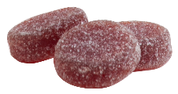 | Orange flavor
Product B | Pastille | 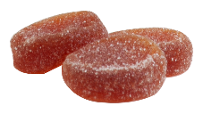 | Mango flavor
Product C | Pastille | 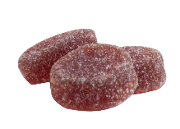 | Mixed berries flavor
Product D | Pastille | 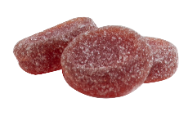 | Peach flavor
Product E | Gummies | 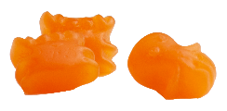 | Orange flavor
Product F | Gummies | 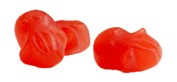 | Strawberry flavor
Product G | Gummies | 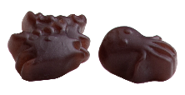 | Blackcurrant flavor
Product H | Chewable Tablet | 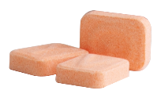 | Orange flavor
Product I | Chewable Tablet | 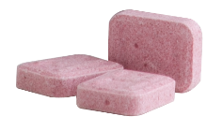 | Blackcurrant flavor
Product J | Chewable Tablet | 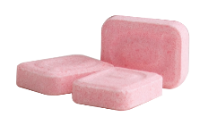 | Strawberry flavor
Product K | Chewable Tablet | 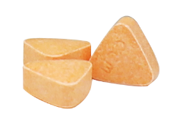 | Orange flavor
Product L | Chewable Tablet | 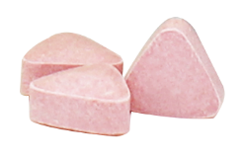 | Blackcurrant flavor
Product M | Chewable Tablet | 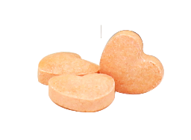 | Orange flavor

Standards and reagents

L-ascorbic acid (≥ 99.9%), fructose, glucose, sucrose, maltose and lactose were purchased from Sigma-Aldrich (St Louis, MO, USA). Analytical-grade reagents phosphate buffer (pH 3), metaphosphoric acid, glacial acetic acid was obtained from Merck (Darmstadt, Germany). HPLC-grade reagents acetonitrile and methanol were obtained from Fisher Scientific (Pittsburgh, USA).

Determination of total sugar content

The pre-treatment for the supplements were carried out according to the previously reported method by Vennard et al. [23]. About 0.5 to 10 g of the samples were weighed and place in Erlenmeyer flask. Then, distilled water was added. The solution was sonicated for 5 min to ensure all samples were dissolved. The mixture was filtered through a 0.22-μm filter membrane before undergoing a quantitative analysis. All samples were diluted to be within the detection limits.

The chromatographic separation was carried out based on the developed method by Tihomirova et al. [24] with minor modification on the flow rate. The samples were analyzed for sugar content (sucrose, fructose, glucose and maltose, galactose and lactose) by using Agilent 1100 high-performance liquid chromatography using coupled with a refractive index detector from Agilent (Agilent Technology, Waldbroon, Germany). Separation of compounds was performed using a Zorbax NH2 (4.6 × 250 mm, 5 μm) from Agilent (Agilent Technology, Waldbroon, Germany). The mobile phase consisted of acetonitrile: water (75: 25 v/v) in isocratic mode at a flow rate of 1.5 mL/min and injection volume of 10 μL.

Results and Discussion

Figure 1 presents the breakdown of the sugar content that contributes to daily calorie intake of consumers (in this case, children), which include sucrose, fructose, glucose and maltose. Galactose and lactose were both absent in all the tested products herein. Products H, I, J, K, L and M were identified to have only sucrose, as this is the main ingredient used for chewable tablet in creating good taste and “mouth feel” compared to other range of pharmaceutical diluents, such as lactose or dextrose [25]. The usage of sucrose ensures the batch-to-batch consistency in terms of quality and hardness of the tablets formulated through wet impregnation for regulatory approval [26].

Product A to G which consists of pastilles and gummies were analyzed to contain fructose, sucrose, maltose and glucose since these products were formulated by using caramel base, such as maltose syrup or corn syrup, which constituted of sucrose [27]. In terms of the ratio of sugar to active ingredient, products A-D and H-M had same active but apparent differences in terms of sugar to active ratio. The lowest ratio was seen in products K and L, while the highest ratio was seen for products A-D.

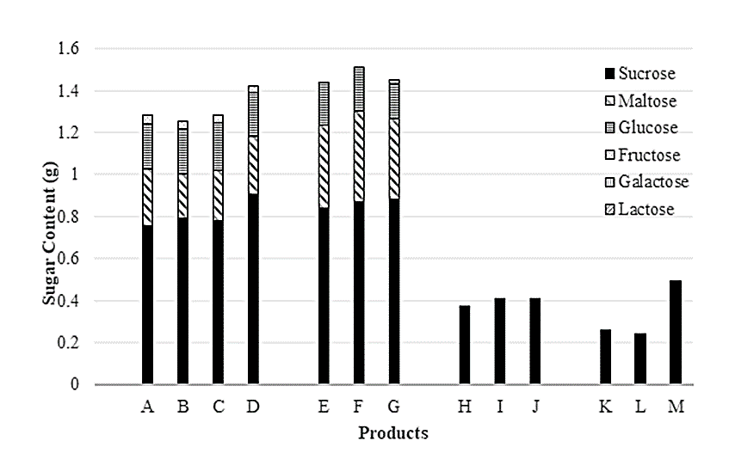

Figure 1. Breakdown of sugar content of selected product from the market

The apparent discrepancy in sugar content could be explained by different physical dosage forms of the analyzed products. Corn syrup is a functional ingredient in gummy formulation due to its ability in preventing sucrose crystallization. However, it possesses lower “reducing sugar”, as a result, formulators usually add simple reducing sugars, such as glucose or fructose to ensure product quality. Sugar is added in the gummies to impart sweetness, tenderness and moisture retention [28]. The formulation of this type of supplements often contains high sugar content, >50%, which results in little nutritional value and may lead to health issues. The benefit to harm ratio of this formulation can cause children to be at high risk of undesired problems, especially children with attention deficit/hyperactivity disorder. Apart from providing sweetness, the high molecular weight carbohydrate acts as gelling agent in gummy formulation [28]. These include starch, pectin, as well as the well-known gummy ingredient – gelatin, a polysaccharide [29].

Table 2. Content of sugar and claimed active from the selected products obtained from the market
Brand | Total Sugar† (g/tablet) | Claimed Active* (mg) | Unit Weight† (g) | Dosing Instructions* | Hypothetical Sugar Intake Based on Label Instructions*  (g per day)
 |  |  |  |  | Lower  Limit | Upper Limit
Product A | 1.284 | 21 | 2.359 | 3-4 pastilles a day | 3.9 | 5.1
Product B | 1.254 | 21 | 2.273 | 3-4 pastilles a day | 3.8 | 5.0
Product C | 1.282 | 21 | 2.175 | 3-4 pastilles a day | 3.8 | 5.1
Product D | 1.422 | 21 | 2.312 | 3-4 pastilles a day | 4.3 | 5.7
Product E | 1.441 | 13.3 | 3.176 | 3 gummies a day | 4.3 | 4.3
Product F | 1.510 | 13.3 | 3.173 | 3 gummies a day | 4.5 | 4.5
Product G | 1.451 | 13.3 | 3.115 | 3 gummies a day | 4.4 | 4.4
Product H | 0.373 | 30 | 0.451 | Children 2-6 years old: 2-6 tabs twice daily | 1.5 | 9.0
Product I | 0.410 | 30 | 0.453 | Children 2-6 years old: 2-6 tabs twice daily | 1.6 | 9.9
Product J | 0.408 | 30 | 0.453 | Children 2-6 years old: 2-6 tabs twice daily | 1.6 | 9.8
Product K | 0.261 | 30 | 0.300 | (Age 1-3) 1-2 tab  (Age 4-6) 1-3 tab | 0.3 | 0.8
Product L | 0.242 | 30 | 0.300 | (Age 1-3) 1-2 tab  (Age 4-6) 1-3 tab | 0.2 | 0.7
Product M | 0.493 | 100 | 0.673 | Children 4-8 years old: 1-3 tabs twice daily | 1.0 | 3.0
*Estimated values based on dosage recommendation from stated instruction and sugar content
†Total sugar and unit weight are values obtained from this study

Per tablet or per 100g?

A rather astonishing fact found was the total sugar content of health supplements targeting children ranges from as low as 0.3 g to exceeding 1 g per unit of supplement (Table 2). In practice, on the consumer’s end, an obedient consumer will follow the instructions stated on the product label. It is worth highlighting that a product that show relatively lower sugar “per 100 g” is not a product of “lowest sugar content” when a consumer consumes according to the daily instructions. It is cynical for one to choose product A for its relatively low sugar content at 100 g. However, his/her child will hypothetically take 4.5 g of sugar (highest amongst the tested products from Table 2), while a product with a much lower sugar content is available on the next shelf.

According to the Recommendation Nutrition Index published by the Ministry of Health (MOH), added sugar for children between 2 – 6 years old was < 15 g per day [7]. A published report on children’s added sugar intake per day recorded approximately 94.7 ± 65.1 g for children between 3 – 6 years old [6]. This figure exceeded the recommendation of the World Health Organization (WHO), as well as MOH in preventing dental caries and diet related chronic diseases in later life [30,31]. Sweetened food and canned beverages are frequently consumed source of sugar [6]. On top of added sugar from common food in-take, children who consumed a single piece/tablet of supplement from brand A would give rise to around 1.3 g of sugar. Since the product is recommended to be consumed 3-4 times a day, a toddler would at least get 5.1 g of added sugar from this single supplement; not to forget about other possible additional supplements such as vit D, DHA, etc., or even from other snacks, such as biscuits, and juices.

Concerns over regulatory control

In Malaysia, health supplements are regulated under the National Pharmaceutical Regulatory Agency (NPRA). Due to the advancement of futuristic formulation, such as or dispersible dosage form and vague of food-drug interphase, any product to be sold in Malaysia would need to be categorized before it can be registered [3]. The above tested brands were checked by using product search in the NPRA website. Further scrutinizing into the information of these products, i.e., products B-G (pastilles and gummy) are not regulated under NPRA [32]. Specifically, gummy is not categorized as pharmaceutical dosage form, and hence are regulated under the Food Safety and Quality Division (FSQD), instead of NPRA. Physical product check reconfirmed the absence of hologram (an indication of NPRA registered product) on these products. While some products from the same companies were registered and some were not, it has high potential that the non-pharmaceutical registered supplement was misinterpreted as pharmaceutical registered. Worse still, in many local pharmacy chains, these products are placed together under the section of supplements, which potentially mislead the consumers who take food registered “candies” falsely as supplementation of vitamins.

Health professionals often recommend or prescribe dietary supplements to clients, which also contributes to the increase in the consumption of these supplements [33]. Apart from that, the mass media also plays a crucial role in advertising the benefits of supplements, such as vitamin C to the general public [34]. Furthermore, sometimes consumers can be lured by the creative advertising gimmicks and be influenced to consume certain supplements without prescription. Therefore, the supplement labelling plays an utmost important role in providing accurate information for the consumers [35].

Conclusion

From this study it was found that products K, L and M contains the least amount of sugar per tablet and the least contribution to daily sugar intake based on the dosage recommendations. Meanwhile, pastilles and gummies were found to contain higher sugar content per piece. The WHO recommended to reduce free sugar intake throughout the life course. It is essential to be aware of the nutritional facts of the available products in the market, especially when the parent is planning for a healthy diet for the child. This study highlighted that the added sugar from supplement products could be substantial and overlooked. There is a potential misunderstanding that might occur at the consumer’s end based on the information stated on the label sheet. It is important to check the presence of the product registration hologram, and to understand the information of total intake and the allowed sugar content per day. While the total sugar intake is not directly reflected on the label, but some calculation and quick interpretation is needed to make a judicial choice of supplement for the children. Therefore, a systematic effort at the regulatory level or consumer awareness needs to be undertaken.

Acknowledgement

The authors would like to acknowledge Universiti Sains Malaysia for providing the support in the writing of this manuscript. This research was funded Duopharma Innovations Sdn Bhd for an independent analysis of the data generated in a third-party laboratory.

References
- Almoazen H. Chapter 4: Dosage forms and drug delivery systems. In the APhA complete review for pharmacy, 12th edition; The American Pharmacists Association, 2017.
- Moreira, M., and Sarraguça, M. (2017). How can oral paediatric formulations be improved? A challenge for the XXI Century. International Journal of Pharmaceutics, 590:119905.
- Batchelor, H. K., Marriott, J. F. (2015). Formulations for children: Problems and solutions. Brazilian Journal of Clinical Pharmacology, 79:405-418.
- Walsh, J., Ranmal, S. R, Ernes, T. B. and Liu, F. (2018). Patient acceptability, safety and access: A balancing act for selecting age-appropriate oral dosage forms for paediatric and geriatric populations. International Journal of Pharmaceutics, 536:547-562.
- Piccone, P., Rastelli, S. L., Pitti, P. (2011). Aroma release and sensory perception of fruit candies model systems. Procedia Food Sciences, 1:1509-1515.
- Amarra, M. S., Khor, G. L., Chan, P. (2016). Intake of added sugar in Malaysia: A review. Asia Pacific Journal Clinical Nutrition, 25:227-240.
- Kamaruddin F. (2021). Sugar intake and oral health - PORTAL MyHEALTH Available online: http://www.myhealth.gov.my/en/sugar-intake-and-oral-health/ [accessed on 10 February 2021].
- Campbell, E., Schlappal, A., Geller, E. and Castonguay, T. W. (2014). Chapter 19- fructose-induced hypertriglyceridemia: A review. In nutrition in the prevention and treatment of abdominal obesity. Academic Press: San Diego. 2014: pp. 197-205.
- Rippe, J. M. and Angelopoulos, T. J. (2015). Sugars and health controversies: What does the science say? Advances Nutrition, 6: 493S-503S.
- Johnson, R. K. and Yon, B. A. (2010). Weighing in on added sugars and health. Journal American Diet Association, 110:1296-1299.
- Clemens, R. A, Jones, J. M, Kern, M, Lee, S. Y., Mayhew, E. J., Slavin, J. L. and Zivanovic, S. (2016). Functionality of sugars in foods and health. Comprehensive Review Food Science and Food Safety, 15: 433-470.
- Chandrawanshi, M. J, Sakhare R. S, Nagoba S. N. and Bhalekar R. V. (2018). A review on medicated lozenges. World Journal Pharmaceutical Research, 8: 396-412.
- O’Brien, S. K, Malacova, E., Sherriff J. and Black, L. J. (2017). The prevalence and predictors of dietary supplement use in the Australian population. Nutrients, 9: 1154.
- Dwyer, J., Nahin, R. L., Rogers, G.T, Barnes, P. M., Jacques, P. M., Sempos, C. T. and Bailey, R. (2013). Prevalence and predictors of children's dietary supplement use: The 2007 national health interview survey. American Journal Clinical Nutrition, 97:1331-1337.
- Qato, D. M., Alexander, G. C, Guadamuz, J. S. and Lindau, S. T. (2018). Prevalence of dietary supplement use in US children and adolescents, 2003-2014. JAMA Pediatrics, 172:780.
- Del Balzo V, Vitiello V. and Germani A. (2014). A cross-sectional survey on dietary supplements consumption among Italian Teen-Agers. PLoS ONE, 9: e100508.
- Sichert-Hellert, W. and Kersting M. (2004). Vitamin and mineral supplement use in German children and adolescents between 1986 and 2003: Results of the DONALD study. Annual Nutritional Metabolism, 48: 414-419.
- Marjamaki, L., Rasanen, M., Uusitalo, L., Anohen, S., Veijola, R., Knip, M. and Virtanen, S. M. (2004). Use of vitamin D and other dietary supplements by Finnish children at the age of 2 and 3 years. International Journal of Vitamin Nutritional Research, 74:27-34.
- Kobayashi, E., Nishijima, C., Sato, Y., Umegaki, K. and Chiba, T. (2018). The prevalence of dietary supplement use among elementary, junior high, and high school students: A nationwide survey in Japan. Nutrients, 10:1176.
- Mori, N., Kubota, M., Hamada, S. and Nagai A. (2011). Prevalence and characterization of supplement use among healthy children and adolescents in an urban Japanese city. Health, 3:135-140.
- Yoon, J. Y., Park, H. A., Kang, J. H., Kim, K. W., Hur, Y. I., Park, J. J., Lee, R. and Lee, H. H. (2012). Prevalence of dietary supplement use in korean children and adolescents: Insights from Korea national health and nutrition examination survey 2007-2009. Journal Korean Medicine Sciences, 27:512-517.
- Sien, Y. P., Sahril, N., Mutalip, M. H. A., Zaki, N. A. M. and Ghaffar, S. A. (2014). Determinants of dietary supplements use among adolescents in Malaysia. Asia Pacific Journal Public Health, 26(5S): 36S-43S.
- Vennard, T. R., Ruosch, A. J., Wejrowski, S. M. and Ellingson, D. J. (2020). Sugar profile method by high-performance anion-exchange chromatography with pulsed amperometric detection in food, dietary supplements, pet food, and animal feeds: First action 2018.16. Journal AOAC International, 103(1):89-102.
- Tihomirova, K, Dalecka B. and Mezule L. (2016). Application of conventional HPLC RI technique for sugar analysis in hydrolysed hay. Agronomy Research, 14(5):1713-1719.
- Potter, N. N. and Hotchkiss, J. H. (1995). Confectionery and chocolate products. Food Science Text Series, 464-477.
- Soukoulis, C. and Tzia, C. (2018). Grape, raisin and sugarcane molasses as potential partial sucrose substitutes in chocolate ice cream: A feasibility study. International Dairy Journal, 76:18-29.
- Onwulata, C. I. and Holsinger, V. H. (1996). Rheology and thermal properties of syrupy composites of saccharides and milk fat. Journal of Food Lipids, 3(1): 43-57.
- Tagami, T., Ito, E., Kida, R., Hirose, K., Noda, T. and Ozeki, T. (2021). 3D printing of gummy drug formulations composed of gelatin and an HPMC-based hydrogel for pediatric use. International Journal of Pharmaceutics, 594: 120118.
- Wood, H. W. (1958). The identification of the sugar in gelatin. Journal Photographic Sciences, 6:170-175.
- Evans, E. W., Hayes, C., Palmer, C. A., Bermudez, O. I., Cohen, S. A. and Must, A. (2013). Dietary intake and severe early childhood caries in low-income, young children. Journal of the Academy of Nutrition and Dietetics, 113(8): 1057-1061.
- Folayan, M. O., Arije, O., El Tantawi, M., Kolawole, K. A., Obiyan, M., Arowolo, O. and Oziegbe, E. O. (2019). Association between early childhood caries and malnutrition in a sub-urban population in Nigeria. BMC Pediatrics, 19(1): 1-8.
- National Pharmaceutical Regulatory Agency (NPRA) Product Classification Guideline - Drugs or Food Products (2021). Available online: https://npra.gov.my/index.php/en/classification-guideline/product-classification-guideline.html?highlight=WyJjbGFzc2lmaWNhdGlvbiIsIidjbGFzc2lmaWNhdGlvbiJd [accessed on 26 May 2021].
- Dickinson, A., Bonci, L., Boyon, N. and Franco, J. C. (2012). Dietitians use and recommend dietary supplements: Report of A survey. Nutrition Journal, 11:14.
- Goston, J. L. and Correia, M. I. T. D. (2010). Intake of nutritional supplements among people exercising in gyms and influencing factors. Nutrition, 26(6): 604-611.
- Abe-Matsumoto, L. T., Sampaio, G. R. and Bastos, D. H. M. (2018). Do the labels of Vitamin A, C, and E supplements reflect actual vitamin content in commercial supplements? Journal Food Composition Analysis, 72: 141-149.

