CATALYTIC ACTIVITY STUDY OF SYNTHESISED POLYSTYRENE-SUPPORTED PALLADIUM(II)-HYDRAZONE (CH₃) AS CATALYST

IN HECK REACTION

(Kajian Aktiviti Pemangkinan Paladium(II)-Hidrazon (CH₃) dengan Sokongan Polistirena Sebagai Pemangkin dalam Tindak Balas Heck)

Najwa Asilah M. Shamsuddin¹, Norul Azilah Abdul Rahman^{1,2}, Kumuthini Chandrasekaram³,

Yatimah Alias³, Nur Rahimah Said^{1*}

¹School of Chemistry and Environment,

Faculty of Applied Sciences Universiti Teknologi MARA,

Cawangan Negeri Sembilan, Kampus Kuala Pilah,

72000 Kuala Pilah, Negeri Sembilan, Malaysia

²School of Chemistry and Environment,

Faculty of Applied Sciences Universiti Teknologi MARA,

40450 Shah Alam, Selangor, Malaysia

³University of Malaya, Centre for Ionic Liquids (UMCiL),

Department of Chemistry,

Faculty of Science,

University of Malaya, 50603 Kuala Lumpur, Malaysia

*Corresponding author: nurra1435@uitm.edu.my

Abstract

Polystyrene as polymer support has various requirements of catalysts for different chemical reactions due to its accessibility, mechanical robustness, product selectivity, chemical inertness, and facile functionalization. This study focuses on the synthesis of polystyrene-supported palladium(II)-hydrazone complex where the hydrazone ligand with an electron donating group (-CH₃) acting as the catalyst in Heck reaction. The first step began with aldehyde functionalization of chloromethylated polystyrene to form PS-CHO. This was then followed by the reaction of PS-CHO with p-toluic hydrazide to form a polystyrene-supported hydrazone ligand (PS-H(CH₃)), which was then reacted with palladium(II) chloride to form polystyrene-supported palladium(II) hydrazone catalyst, PS-Pd(CH₃). The successfully synthesized PS-Pd(CH₃) catalyst was characterized using FTIR, PXRD, FESEM-EDX and AAS. The catalytic performance of PS-Pd(CH3) was tested using Heck reaction between 1-bromo-4-nitrobenzene and methyl acrylate. The percent conversion of reactant to product was determined using GC-FID, where the optimum conversion rate was 99.84 % with 1.0 mmol% catalyst loading, K₂CO₃ as base and DMA as solvent at 165 °C within a 60-minute reaction time.

Keywords: Heck reaction, hydrazone ligand, polystyrene, polymer support, palladium(II)-hydrazone complex

Abstrak

Polistirena sebagai sokongan polimer mempunyai pelbagai kegunaan sebagai pemangkin tindak balas kimia kerana kebolehdapatan, ketahanan mekanik, daya pemilihan produk, lengai secara kimia dan pengfungsian mudah. Kajian ini memberi tumpuan kepada sintesis kompleks paladium(II)-hidrazon dengan sokongan polistirena dengan ligan hidrazon yang mengandungi kumpulan elektron penderma (-CH₃) sebagai pemangkin dalam tindak balas Heck. Sintesis dimulakan dengan pengubahsuaian polistirena klorometil dengan fungsian aldehid untuk membentuk PS-CHO. Kajian dilanjutkan dengan tindak balas PS-CHO dengan p-toluik hidrazida untuk membentuk ligan hidrazon dengan sokongan polistirena (PS-H(CH₃)). Kemudian, PS-H(CH₃) bertindak balas dengan paladium(II) klorida untuk membentuk pemangkin hidrazon paladium(II) dengan sokongan polistirena iaitu PS-Pd(CH₃). Kejayaan sintesis pemangkin disahkan dengan menggunakan FTIR, PXRD, FESEM-EDX dan AAS. Keberkesanan pemangkinan PS-Pd(CH₃) diuji dalam reaksi Heck antara 1-bromo-4-nitrobenzena dan metil akrilat. Peratus penukaran bahan tindak balas kepada produk ditentukan dengan menggunakan GC-FID, dimana penukaran optimum ialah 99.84% dengan pemangkin 1.0 mmol%, K₂CO₃ sebagai bes dan DMA sebagai pelarut pada suhu 165 ° C dalam masa tindak balas 60 min.

Kata kunci: tindak balas Heck, ligan hidrazon, polistirena, sokongan polimer, komplek paladium (II) - hidrazon

Introduction

Immobilisation of catalysts on insoluble supports has increased their potential for industrial uses due to their enhanced thermal and chemical stabilities and ease of separation from product mixtures [1]. The use of polymer-supported catalysts in organic reactions has been approached extensively in many technological, fundamental, and other applications. It is used in many different forms such as polymer anchored metal complexes that coordinate with reactants, colloidal catalyst dispersed in a swollen polymer network and prearrangement of polymer to complexing metal ions [2]. The polymer support also helps in minimising the contamination of reaction products from toxic transition metal complexes. As such insoluble polymer supports are expected to substitute soluble polymer supports for catalyst immobilisation as they are suitable for both catalyst recovery and recycling [3].

Chloromethylated polystyrene or Merrifield resin (Figure 1) is one of the polymers supports commonly used for catalyst immobilisation due to its inert, non-toxic and non-volatile characteristics [4]. The insolubility of chloromethylated polystyrene polymer simplifies catalyst separation from reaction media without any loss to their properties as well as providing a high turnover number and frequency for catalytic activity [5].

Figure 1. Structure of chloromethylated polystyrene

The immobilisation of Pd(II) on chloromethylated polystyrene has been used in the C-C coupling reactions as it improves stability in terms of high temperature resistance, hardness and strength of impact [6, 7]. Heck reaction involves C-C coupling reactions where the coupling occurs between aryl halides and alkenes using palladium as the catalyst. Heck reaction has been utilised in the various synthesis of natural products and pharmaceuticals as it has broad functional group tolerance and requires mild reaction conditions [8].

Normally, the reaction is carried out with the presence of palladium metal on supported polymer and phosphine ligands. The presence of suitable ligands in the structure of designated catalysts is crucial for higher reaction rates, improved life span, and stability. The phosphine ligand, however, has many disadvantages which include high toxicity, high cost, and are also environmentally unfavourable due to residues formed from the metal species [9, 10]. Therefore, the replacement of phosphine ligand with less toxic ligand such as hydrazone ligand will help reduce the toxicity contributed from the ligand and be more environmentally friendly. This is due to the chelating ability of the hydrazone ligand where it can act as a neutral or a mono-negative ligand [11]. The hydrazone ligand contains R₁R₂=NNH₂: two connected nitrogen atom that binds the carbon with a double bond at the terminal nitrogen atom with R₁ and R₂ alkyl groups [12]. Hence, it can easily form stable coordination complexes with most transition metal ions [13]. Apart from that, hydrazone ligand has also been reported to be more selective and has reproducible qualities that will lead to high conversion rate and turnover number, for example, the reaction of 5 mol % of Pd(OAc)₂ as catalyst and bishydrazone as a ligand with Ca(OH)₂ as a base in DMA/H₂O (9:1) as a solvent [14].

The Pd-supported polymer catalyst of different hydrazone ligand derivatives reports variations in C-C coupling product yield even when reaction conditions are similar. The presence of an electron donating group in the structure of the hydrazone will improve the catalytic performance [14]. This is because hydrazone, such as OH group, NH₂ group and methyl group, acts as an activating group that donates some of its electron density into a conjugated π system via resonance or inductive effects where the directing effects are ortho and para [15]. Palladium(II) hydrazone complex with electron-donating ligands seem more prone to aryl exchange than those with electron-withdrawing ligands due to the variety of binding modes and the lone pair of electrons of the imine nitrogen [16].

The presence of methyl as an electron-donating group is crucial in determining the electron density of the imine nitrogen as the methyl group is driven by the electronic properties of the chelating ligand and also because the methyl group has steric bulk [17]. Moreover, the methyl group offers versatility in chelation with transition metal as it is capable to coordinate with metals to form complexes [18]. In a previous study on the ligand effect on migratory insertion by Heck reaction, it was found that among the electron-donating group (methyl, tert-butyl and phenyl), the ligand with methyl group had lower insertion barrier as it increases π-coordination ability of metal with C=C of the starting material. Thus, methyl is reported to have higher tendency to form complexes and increase the catalytic performance [19].

The exploration on the capability of hydrazone ligand especially with electron-donating group functionalities as a ligand with polymer-supported catalyst is still scarce. This study aims in developing new polymer-supported palladium(II)-hydrazone complexes where the hydrazone ligand functionalise with the methyl (-CH₃) group as catalysts for Heck reaction. The optimum reaction condition of newly synthesised catalyst in different parameters were studied and determined.

.

Materials and Methods

Chemicals and instruments

All the chemicals and solvents obtained from commercial suppliers were used as received. The chemicals used were chloromethylated polystyrene-co-divinylbenzene beads with 2% crosslink (Merck), dimethyl sulfoxide (DMSO) (Merck), 1-bromo-4-nitrobenzene (Merck), methyl acrylate (Merck), sodium hydrogen carbonate (NaHCO₃)(Merck), sodium carbonate (Na₂CO₃)(Sigma), potassium carbonate (K₂CO₃)(Merck), triethylamine (Et₃N) (Merck), p-toluic hydrazide (QReC), palladium(II) chloride (Alfa Aesar), ethanol (Merck), methanol (Merck) and nitrogen gas. All solid products produced at the end of every synthesis were collected by high vacuum filtration or slow evaporation technique at room temperature. The product was characterised using Fourier transform infrared (FTIR) spectroscopy, field emission scanning electron microscope/energy dispersive X-ray (FESEM/EDX), atomic absorption spectroscopy (AAS) and powder X-ray diffraction (PXRD).

For the FTIR, spectra were recorded between 4000-400 cm⁻¹ with potassium bromide (KBr) discs on Fourier transform infrared spectrophotometer 8300. For field emission scanning electron microscope, Jeol JSM-6701f equipped with energy dispersive X-ray facility (FESEM-EDX) was used to determine morphology of each sample and to confirm the presence of elements C, N and Pd. For atomic absorption spectrometer (Perkin Elmer-Analyst 400) using flame approach, 1g of catalyst was digested in 5 ml of HNO₃ and heated to 95 °C and refluxed for 10 minutes. The powder X-ray diffraction (PANalytical X-Pert PRO) was used to measure the diffraction pattern of crystalline compounds. The catalytic performance was determined by using gas chromatography (GC-Hewlett Packard-5890 series II). The instrument was equipped with HP-5 capillary column (15m×0.25mm×0.25µm) with flame ionization detector (GC-FID). The microliter samples will be injected at 50 °C (held for 1 minute) and final temperature at 250 °C (held for 30 seconds). Temperature increment will be at 15 °C per minute. The flow rate used was 1.9162 mL/min.

Synthesis of compounds

The outline for the preparation of polymer-supported palladium(II)-hydrazone complex is given in Scheme 1.

Scheme 1. Synthesis of polystyrene-supported palladium(II)-hydrazone complexes

Synthesis of polystyrene with aldehyde functionality (PS-CHO)

Chloromethylated polystyrene beads (1 g; 1.5 mmol of Cl per g of resin and 2% crosslinked with divinylbenzene) were swelled in 15 mL of DMSO in a 3-neck round bottom flask for 1 hour. Sodium hydrogen carbonate (0.3 g; 3.6 mmol) was added into the 3-neck round bottom flask containing the polymer beads solution. The mixture was stirred and refluxed under nitrogen for 6 hours. The aldehyde functionalized polymer was obtained then separated by vacuum filtration, washed with cold ethanol, and dried in a vacuum desiccator at 25 °C.

Synthesis of polystyrene-supported hydrazone ligands (PS-H(CH₃)

PS-CHO (1 g) was swelled with 20 mL of methanol in a 3-neck round bottom flask for 1 hour. Then p-toluic hydrazide ligand (3 g; 0.022 mmol) was added into polymer solution. The reaction mixture was stirred and refluxed at 65 °C under nitrogen for 48 hours and subsequently cooled to room temperature. The polymer anchored hydrazone (p-toluic hydrazide) (PS-H(CH₃)) complex was separated by vacuum filtration, washed with methanol followed by ether, and dried in a vacuum desiccator at 25 °C.

Synthesis of polystyrene-supported palladium(II)-hydrazone complex (PS-Pd(CH₃))

PS-H(CH₃) (0.5 g) was swelled with 15 mL of methanol in a 3-neck round bottom flask for 1 hour. Then palladium(II) chloride (0.22 g; 1.26 mmol) was added into the polymer solution. The mixture was stirred and refluxed at 65 °C under nitrogen gas for 72 hours. The polymer-supported palladium complex was then cooled to room temperature and separated using vacuum filtration. The solid product, polystyrene-anchored palladium(II)-hydrazone complex (PS-Pd(CH₃)), was washed several times with methanol to remove unreacted palladium(II) chloride and dried overnight in a vacuum desiccator at 25 °C.

Catalytic testing

The catalytic performance of PS-Pd(CH₃) (1.0 mmol %) was tested in a Heck reaction between 1-bromo-4-nitrobenzene and methyl acrylate to produce 3-(4-nitrophenyl)-arylic acid methyl ester (Scheme 2). The mixture of 1-bromo-4-nitrobenzene (0.203 g; 1 mmol), methyl acrylate (0.17 g; 2 mmol), sodium carbonate, Na₂CO₃ (0.25 g, 2.4 mmol), polystyrene anchored palladium(II)-hydrazone complex PS-Pd(CH₃) (1.0 mmol %; 0.01 mmol) and the solvent N,N-dimethylacetamide, DMA (5 mL) was refluxed under nitrogen gas. The reaction was monitored under different temperatures at 25, 50, 75, 100, 165 °C. The procedure was repeated with different type of bases namely NaHCO₃, K₂CO₃ and Et₃N. The crude product was analysed by GC-FID to determine the percentage conversion rate of the product. The catalyst was separated from the mixture by vacuum filtration, washed with acetonitrile and methanol, and dried under vacuum while the filtrate was poured into 2 % hydrochloric acid (HCI) solution. Via cooling to 0 °C, a white precipitate was formed which was filtered, washed with distilled water and dried to obtain a white solid.

Scheme 2. Catalytic reaction of 1-bromo-4-nitrobenzene with methyl acrylate

Results and Discussion

Characterization of synthesized compounds

The catalyst PS-Pd(CH₃) was successfully synthesised using a three step synthesis. A change in the compound colour has been noted in each stage of complex preparation. The colour changed from white to pale yellow in the formation of PS-H(CH₃) while the presence of palladium(II) in the preparation of catalyst (PS-Pd(CH₃) gave a brownish colour due to the Pd binding. The amount of palladium in PS-Pd(CH₃) was determined using AAS analysis and was confirmed to be at 21.31% (2.002 mmol g ⁻¹). Table 1 summarises the data.

Table 1. Physical properties of synthesized compounds

Sample | Colour | Pd(%)
PS-CHO | White, powder | -
PS-H(CH₃) | Pale yellow, powder | -
PS-Pd(CH₃) | Brownish, powder | 21.31

The structure of the synthesised compound was confirmed using FTIR analysis. The FTIR spectra are illustrated in Figure 4. The presence of corresponding functional groups at each reaction step in the synthesised complexes recorded in Table 2. PS-CHO shows a new peak at 1741.20 cm⁻¹ assigned to the C=O stretching vibration of aromatic aldehyde [20].

The conversion of PS-CHO to PS-H(CH₃) was confirmed by the appearance of C=O amide (PS-H(CH₃) =1600.91 cm⁻¹), C=N imine (PS-H(CH₃) =1581.36 cm⁻¹) and N-H (PS-H(CH₃) =3461.36 cm⁻¹). The PS-H(CH₃) of C=N peaks appeared at a lower frequency when compared to the normal range absorption peaks of C=N which is 1650 cm⁻¹. The presence of resonance effect in the structure between H-C=N leads to the absorption band of C=N observed at a lower frequency.

The complexation reaction of PS-H(CH₃) with PdCl₂ changed the absorption frequency and peaks intensity of C=O (1618.63 cm⁻¹), and C=N amide (1590.75 cm⁻¹) proved that complexation occurs via the carbonyl oxygen and nitrogen of hydrazone as illustrated in Figure 2 [21,22,23]. The adsorption frequency could increase or decrease upon complexation due to the increase or decrease in the stretching constant of C=O and C=N during the complexation [23,24,25]. This results also confirms the structure and composition of hydrazone in the cross-linked beads was not destroyed after attachment of Pd(II) [26].

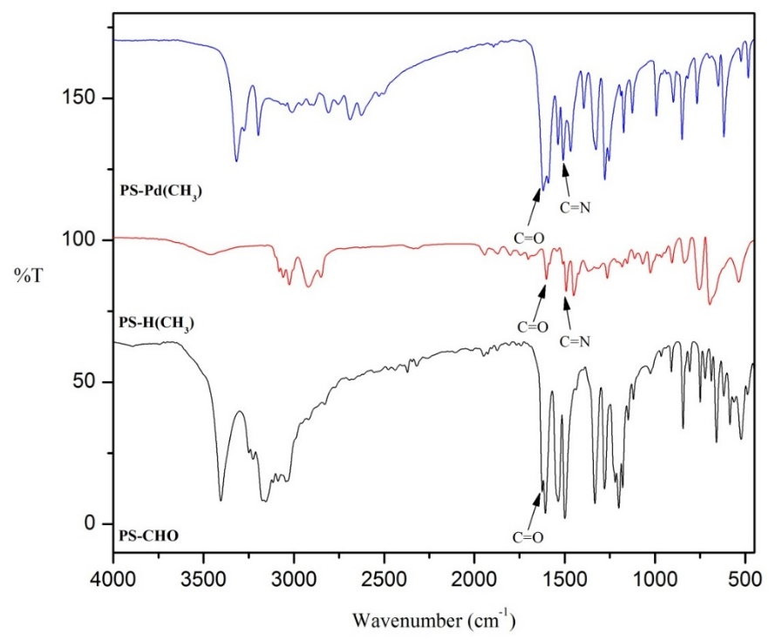

Figure 2. FTIR spectra of synthesized compounds

Table 2. Significant FTIR absorption bands of synthesized compounds
Assignment | PS-CHO | PS-H(CH₃) | PS-Pd(CH₃)
C=O aldehyde | 1741.20 | - | -
C=O amide | - | 1600.91 | 1618.63
C=N imine | - | 1581.36 | 1590.75

Powder X-ray diffraction (PXRD) is a powerful tool for characterising solid state samples. Each crystalline species has a unique X-ray diffraction pattern. Powder X-ray diffraction patterns of PS-CHO, PS-H(CH₃) and PS-Pd(CH₃) are shown in Figure 3. The most prominent peak for PS-CHO shows 2 diffraction patterns between 15° to 22° indicating that the polystyrene is amorphous [20]. For PS-H(CH₃), the presence of the peaks at 2Ɵ are an indication of the presence of amorphous material in the polymer samples. The PS-Pd(CH₃) complex shows three peaks at 35° to 50° of 2Ɵ indicating the existence of Pd [27, 28].

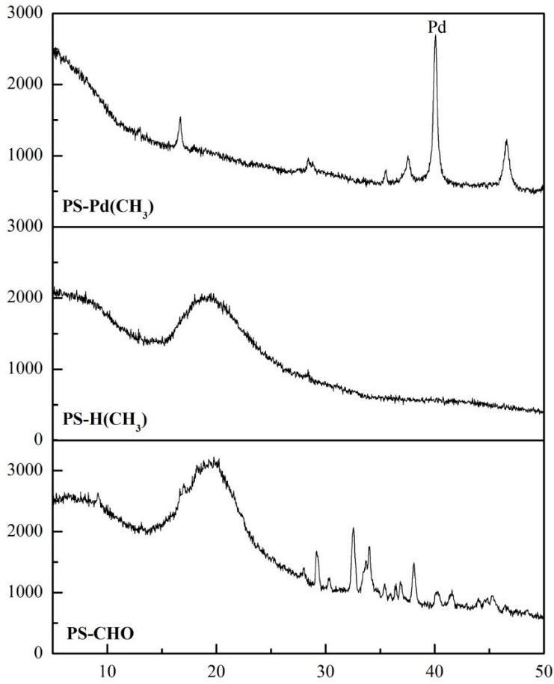

Figure 3. PXRD spectra of synthesized compounds

FESEM analysis on the aldehyde functionalised polymer (PS-CHO), polymer-supported hydrazone ligand (PS-H(CH₃)), and polymer-supported palladium(II) hydrazone complex (PS-Pd(CH₃) at various stages of preparation of the catalysts were recorded to understand morphological changes occurring on the surface of the polymeric matrix. Scanning was done at 50 µm as shown in Figure 6. The polymer beads PS-CHO recorded a smooth and clear surface. Functionalised PS-H(CH₃), however, records scattered deposits on the surface which intensifies the presence of PS-Pd(CH₃) due to palladium metal loading [29].

The FESEM micrographs are supported with EDX spectra presented in Figure 4. The EDX analysis were carried out on the single bead of PS-CHO, PS-H(CH₃), and PS-Pd(CH₃). The spectra shows the synthesis of PS-Pd(CH₃) was successful via the presence of palladium metal element peaks. In summary, based on the results of FTIR, FESEM-EDX, PXRD and AAS, the molecular structure of the polymer-supported palladium(II)-hydrazone complex (PS-Pd(CH₃)) are proposed as depicted in Scheme 1.

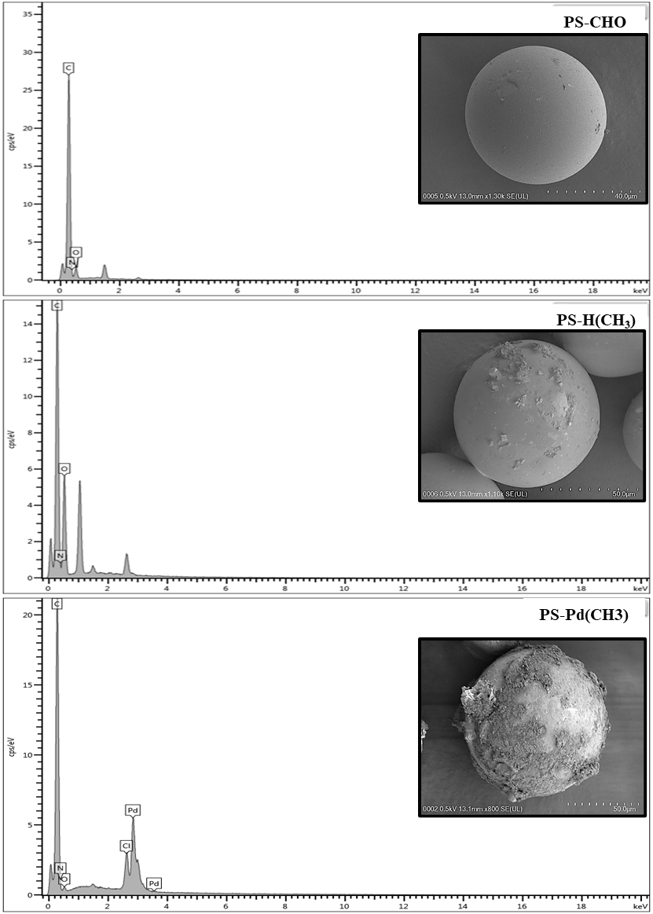

Figure 4. FESEM micrographs and EDX spectra of synthesized compounds

Catalytic testing

The PS-Pd(CH₃) catalyst were tested in the Heck reaction between 1-bromo-4-nitrobenzene and methyl acrylate with different bases and reaction temperatures as shown in Scheme 3. The catalytic performance was determined from GC-FID and the result is summarised in Table 4.

Scheme 3. Heck reaction route

Bases are known to play significant roles in the Heck C-C coupling reaction. The presence of a base helps to improve the catalytic activity of the catalyst [30]. The reaction efficiency depends on the type of base used. Regeneration of the active Pd(0)L₂ complex is affected by the addition of base to remove hydrogen halide from the inactive complex which is an essential role of a base [31,32]. Inorganic bases such as sodium carbonate (Na₂CO₃), sodium hydrogen carbonate (NaHCO₃) and potassium carbonate (K₂CO₃) and organic bases such as triethylamine (Et₃N) are used as a hydrogen halide neutraliser and remover in this study.

Table 3 shows the effect of bases on the reaction of 1-bromo-4-nitrobenzene with methyl acrylate in the presence of catalyst PS-Pd(CH₃) 1.0 mmol % amount of catalyst loading within 60 minutes. At the highest temperature (165 °C), the reactions with inorganic base of Na₂CO₃ and NaHCO₃ recorded acceptable conversion rates of 49.15% (Entry 1) and 40.45% (Entry 2), respectively. Additionally, inorganic base K₂CO₃ and organic base Et₃N recorded excellent conversion rates of 99.84% (Entry 3) and 98.97% (Entry 4), respectively. The catalytic performance at 100 °C (Entry 5-8) and 75 °C (Entry 9-12) for all types of bases shows lower conversion rate and turnover number (TON). Meanwhile, at the lowest temperature, no conversion rate and TON were observed (Entry 13-20). The results show that the best catalytic performance of PS-Pd(CH₃) in K₂CO₃ at 165 °C is at 99.84% (Entry 3). The inorganic base K₂CO₃ was the best base in this catalytic condition as the inorganic base is capable of neutralising protons generated in the oxidative addition mechanism. The reaction also needs high temperature to aid in the activation of aryl bromides [33,34].

A plausible mechanism of Heck reaction in the presence of PS-Pd(CH₃) is illustrated in Scheme 4. The mechanism in the Heck reaction involves: (1) oxidative addition of 1-bromo-4-nitrobenzene to generate Pd(II) species; (2) Methyl acrylate insertion to form π-alkene complex; (3) Migratory insertion to form σ-alkyl palladium complex; (4) Rearrangement of complex by internal rotation; (5) β-hydride elimination releasing targeted product; and (6) The addition of base to regenerate the catalyst by removing hydrogen halide (HX) from the inactive complex [22,35].

Scheme 4. The proposed mechanism of the Heck reaction in the presence of a PS-Pd(CH₃) as a catalyst

Table 3. The catalytic performance of PS-Pd(CH₃) catalyst in Heck reaction

Entry | Temperature | Base | Conversion Rate (%) | TON
1 | 165°C | Na₂CO₃ | 49.15 | 49.15
2 |  | NaHCO₃ | 40.45 | 40.45
3 |  | K₂CO₃ | 99.84 | 99.84
4 |  | Et₃N | 98.97 | 98.97
5 | 100°C | Na₂CO₃ | 34.10 | 34.10
6 |  | NaHCO₃ | 22.14 | 22.14
7 |  | K₂CO₃ | 26.50 | 26.50
8 |  | Et₃N | 31.84 | 31.84
9 | 75°C | Na₂CO₃ | 30.97 | 30.97
10 |  | NaHCO₃ | 22.01 | 22.01
11 |  | K₂CO₃ | 23.97 | 23.97
12 |  | Et₃N | 29.58 | 29.58
13 | 50°C | Na₂CO₃ | - | -
14 |  | NaHCO₃ | - | -
15 |  | K₂CO₃ | - | -
16 |  | Et₃N | - | -
17 | 25°C | Na₂CO₃ | - | -
18 |  | NaHCO₃ | - | -
19 |  | K₂CO₃ | - | -
20 |  | Et₃N | - | -

Reaction condition: [substrate] = 1 mmol; catalyst loading = 1 mmol %; [base] = 2.4 mmol; DMA = 5 mL; time = 60 minute

Conclusion

The synthesis of polymer-supported palladium(II) hydrazone (PS-Pd(CH₃)) has been successfully achieved using chloromethylated polystyrene beads with 2% crosslinking as a polymer support. The results show that the catalyst with the presence of electron-donating group (methyl), PS-Pd(CH₃) (1 mmol%) records an excellent catalytic performance in Heck reaction between 1-bromo-4-nitrobenzene and methyl acrylate with a 99.84% conversion rate. The most suitable condition was achieved using K₂CO₃ as a base at 165 °C in a 60-minute reaction time and using DMA as a solvent. For future work, the optimisation of palladium loading, and recyclability of catalyst will be determined.

Acknowledgement

This research was supported by FRGS/1/2019/STG01/UITM/02/6 from Ministry of Higher Education (MOHE). The authors are grateful to the Universiti Teknologi MARA(UiTM), Cawangan Negeri Sembilan, Kampus Kuala Pilah and Department of Chemistry, University of Malaya for generously providing the research material, equipment, and instrument.

References
- Ali, M., Rahman, M., Sarkar, S. M. and Hamid, S. B. A. (2014). Heterogeneous metal catalysts for oxidation reactions. Journal of Nanomaterials, 1: 209.
- Czulak, J., Jakubiak-Marcinkowska, A. and Trochimczuk, A. (2013). Polymer catalysts imprinted with metal ions as biomimics of metalloenzymes. Advances in Materials Science and Engineering, 9: 464265.
- Miceli, M., Frontera, P., Macario, A. and Malara, A. (2021). Recovery/reuse of heterogeneous supported spent catalysts. Catalysts, 11(5): 591.
- Erkenez, T. and Tümer, M. (2019). Polymer-anchoring Schiff base ligands and their metal complexes: Investigation of their electrochemical, photoluminescence, thermal and catalytic properties. Arabian Journal of Chemistry, 12(8): 2618-2631.
- Itsuno, S. (2013). Polymer catalysts. Encyclopedia of Polymeric Nanomaterials, 2013: 1-9.
- Kann, N. (2010). Recent applications of polymer supported organometallic catalysts in organic synthesis. Molecules, 15(9): 6306-6331.
- Kamilah, S. C., Jusoh, S. A. and Shamsuddin, M. (2014). Synthesis and physicochemical analysis of Polystyrene-anchored Pd(II) metal complex. Scientific Research Journal, 11(2): 45-56.
- Kantam, M. L., Reddy, P. V., Srinivas, P. and Bhargava, S. (2011). Ligand and base-free Heck reaction with heteroaryl halides. Tetrahedron Letters, 34: 4490-4493.
- Said, N. R., Mustakim, M. A., Sani, N. M. and Baharin, S. N. A. (2018). Heck reaction using palladium-benzimidazole catalyst: Synthesis, characterisation and catalytic activity. IOP Conference Series: Materials Science and Engineering, 458: 12-19.
- Sherwood, J., Clark, J. H., Fairlamb, I. J. and Slattery, J. M. (2019). Solvent effects in palladium catalysed cross-coupling reactions. Green Chemistry, 21(9): 2164-2213.
- Umar, H. F. (2008). Synthesis and characterization of transition metal with hydrazoneicarbohydrazone ligand. Doctoral dissertation, Universiti Malaysia Sarawak.
- Gomez, I. J., Arnaiz, B., Cacioppo, M., Arcudi, F. and Prato, M. (2018). Nitrogen-doped carbon nanodots for bioimaging and delivery of paclitaxel. Journal of Materials Chemistry, 6(35): 5540-5548.
- Mandewale, M. C., Patil, U. C., Shedge, S. V., Dappadwad, U. R. and Yamgar, R. S. (2017). A review on quinoline hydrazone derivatives as a new class of potent antitubercular and anticancer agents. Beni-Suef University Journal of Basic and Applied Sciences, 6(4), 354-361.
- Watanabe, K., Mino, T., Abe, T., Kogure, T. and Sakamoto, M. (2014). Hydrazone–palladium-catalyzed allylic arylation of cinnamyloxyphenylboronic acid pinacol esters. The Journal of Organic Chemistry, 79: 6695-6702.
- Aly, S. A. and Fathalla, S. K. (2020). Preparation, characterization of some transition metal complexes of hydrazone derivatives and their antibacterial and antioxidant activities. Arabian Journal of Chemistry, 13(2): 3735-3750.
- Roy, S., Mondal, K. C. and Roesky, H. W. (2016). Cyclic alkyl (amino) carbene stabilized complexes with low coordinate metals of enduring nature. Accounts of Chemical Research, 49(3): 357-369.
- Rosar, V., Dedeic, D., Nobile, T., Fini, F., Balducci, G., Alessio, E. and Milani, B. (2016). Palladium complexes with simple iminopyridines as catalysts for polyketone synthesis. Dalton Transactions, 45(37): 14609-14619.
- Anitha, C., Sumathi, S., Tharmaraj, P. and Sheela, C. D. (2012). Synthesis, characterization, and biological activity of some transition metal complexes derived from novel hydrazone azo schiff base ligand. International Journal of Inorganic Chemistry, 8: 493942.
- Chen, Q., Lin, B. L., Fu, Y., Liu, L. and Guo, Q. X. (2005). Ligand effects on migratory insertion by the Heck reaction. Research on Chemical Intermediates, 31(9): 759-767.
- Xuemei, H. and Hao, Y. (2013). Fabrication of polystyrene/detonation nanographite composite microspheres with the core/shell structure via pickering emulsion polymerization. Journal of Nanomaterials, 8: 751497.
- Muthumari, S. and Ramesh, R. (2016). Highly efficient palladium (II) hydrazone based catalysts for the Suzuki coupling reaction in aqueous medium. RSC Advances, 6(57): 52101-52112.
- Jagtap, S. (2017). Heck reaction—State of the art. Catalysts, 7(9): 267.
- Alhazmi, H. A. (2019). FT-IR spectroscopy for the identification of binding sites and measurements of the binding interactions of important metal ions with bovine serum albumin. Scientia Pharmaceutica, 87(1): 5.
- Ain, Q. U., Ashiq, U., Jamal, R. A. and Mahrooof-Tahir, M. (2013). Synthesis, spectroscopic and radical scavenging studies of palladium (II)-hydrazide complexes. Spectrochimica Acta Part A: Molecular and Biomolecular Spectroscopy, 115: 683-689.
- El-Tabl, A. S., Mohamed Abd El-Waheed, M., Wahba, M. A. and Abou El-Fadl, A. E. H. (2015). Synthesis, characterization, and anticancer activity of new metal complexes derived from 2-hydroxy-3-(hydroxyimino)-4-oxopentan-2-ylidene) benzohydrazide. Bioinorganic Chemistry and Applications, 14: 126023.
- Xie, J., Feng, N., Wang, R., Guo, Z., Dong, H., Cui, H. and Liu, X. (2020). A reusable biosorbent using Ca-alginate immobilized providencia vermicola for Pd (II) recovery from acidic solution. Water, Air and Soil Pollution, 231(2): 1-12.
- Mondal, J., Gomes, R., Modak, A. and Bhaumik, A. (2013). Pd-anchored functionalized mesoporous materials as robust and recyclable heterogeneous catalysts for a series of C=C bond forming reactions. Recyclable Catalysis, 1: 10-33.
- Walbrück, K., Kuellmer, F., Witzleben, S. and Guenther, K. (2019). Synthesis and characterization of PVP-stabilized palladium nanoparticles by XRD, SAXS, SP-ICP-MS, and SEM. Journal of Nanomaterials, 1: 4758108.
- Veisi, H., Mirshokraie, S. A. and Ahmadian, H. (2018). Synthesis of biaryls using palladium nanoparticles immobilized on metformine-functionalized polystyrene resin as a reusable and efficient nanocatalyst. International Journal of Biological Macromolecules, 108: 419-425.
- Pérez-Zúñiga, C., Negrete-Vergara, C., Guerchais, V., Le Bozec, H., Moya, S. A. and Aguirre, P. (2019). Hydrogenation of N-benzylideneaniline by palladium (II) catalysts with phosphorus-nitrogen ligands using formic acid as a renewable hydrogen source. Molecular Catalysis, 462: 126-131.
- Kamilah, S.C., Jusoh, S. A., Sukeri, M., Yusof, M., Khairul, W. M. and Shamsuddin, M. (2018). The effect of bases, catalyst loading and reaction temperature on the the effect of bases, catalyst loading and reaction temperature on the catalytic evaluation of supported palladium (II) catalyst in the Mizoroki-Heck. International Journal of Engineering and Technology, 7(3): 467-469.
- Riapanitra, A. (2010). Catalytic studies of low valent palladium (N)-heterocyclic carbene complexes Doctoral dissertation, University of Tasmania.
- Said, N. R., Adib, N. N. M., Roszaidi, R. M., Shamsuddin, N. A. M. and Badri, N. N. H. S. (2019). Catalytic activity study of synthesized palladium (ii)-hydrazone complexes in the Heck reaction: Optimization of the amount of catalyst loading and reaction time. International Conference in Organic Synthesis, 9: pp. 10.
- Shamsuddin, N. A. M., Badri, N. N. H. S., Rahman, N. A. A. and Said, N. R. (2021). Examining the effect of base, solvent and temperature in Heck reaction with the presence of palladium (II)-hydrazone complexes. AIP Conference Proceedings, 2332: pp. 1.
- Yaşar, S., Özcan, E. Ö., Gürbüz, N., Çetinkaya, B. and Özdemir, İ. (2010). Palladium-catalyzed Heck coupling reaction of aryl bromides in aqueous media using tetrahydropyrimidinium salts as carbene ligands. Molecules, 15(2): 649-659.

