CONCENTRATION OF Heavy Metals in Perna veridis Collected from Straits of Johor, Malaysia

(Kepekatan Logam Berat di dalam Perna veridis yang Dikumpulkan dari Selat Johor, Malaysia)

Tee Lian Sheng¹, Poong Jun Han¹, Evonne Tan¹, Yip Tiam Hing¹, Muhammad Hasbi Ramli¹,

Zaleha Kassim², Ong Meng Chuan^{1,3,4}*,

¹Faculty of Science and Marine Environment,

Universiti Malaysia Terengganu, 21030 Kuala Nerus, Terengganu

²International Institute for Halal Research and Training (INHART),

International Islamic University Malaysia, 25200 Kuantan, Pahang

³Institute of Oceanography and Environment,

Universiti Malaysia Terengganu, 21030 Kuala Nerus, Terengganu

⁴Ocean Pollution and Ecotoxicology (OPEC) Research Group,

Universiti Malaysia Terengganu, 21030 Kuala Nerus, Terengganu

*Corresponding author: ong@umt.edu.my

Abstract

Perna viridis or green mussel is commercially valuable seafood rich in protein and mainly cultured in the Straits of Johor. Over the years, industrial activities and urban development around the Straits of Johor keep increasing, which may cause heavy metal pollution issues in the aquatic environment. Therefore, this study evaluated the concentration of heavy metals in the green mussel Perna viridis collected from the river mouth of Sungai Masai at the Straits of Johor for assessing the level of pollution level with this species as a bio-indicator. The concentration of Cd, Cu, Pb, and Zn of 45 green mussel samples was detected using the inductively coupled plasma mass spectrometry (ICP-MS). The samples were digested using the Teflon Bomb method with HNOз. In general, the concentration of heavy metals in Perna viridis followed the descending order from Zn > Cu > Pb > Cd. The heavy metal content of the green mussel in this study complied with the permissible safety limit stipulated by the 1985 Malaysia Food Regulation. Meanwhile, unlike the findings of other studies, the accumulation of heavy metal in the green mussels in this study might not be related to its size. No significant correlation was detected among these heavy metals, suggesting that they might not come from the same source. The average pollution load index was 3.3, i.e., substantially than the critical level of 50, suggesting that the pollution of heavy metals in the study area was under control.

Keywords: green mussel, heavy metals, inductively coupled plasma mass spectrometry, Perna viridis, Straits of Johor

Abstrak

Perna viridis atau kupang hijau adalah salah satu makanan laut komersial yang kaya dengan protein dan kebanyakannya diternak di Selat Johor. Selama bertahun-tahun, aktiviti perindustrian dan pembangunan bandar di sekitar Selat Johor terus meningkat dan ini boleh menyebabkan isu pencemaran logam berat di dalam persekitaran akuatik. Oleh itu, kajian ini telah dijalankan untuk menentukan kepekatan logam berat di dalam Perna viridis yang dikumpulkan dari Sungai Masai di Selat Johor dan menganggarkan tahap pencemaran dengan menggunakan Perna viridis sebagai penanda biologi. Kepekatan Cd, Cu, Pb dan Zn dalam 45 Perna veridis dianalisis dengan menggunakan spektrometri jisim-plasma gandingan aruhan (ICP-MS). Kaedah pencernaan Teflon Bomb dengan asid HNOз telah digunakan untuk menghadam sampel. Secara umumnya, susunan kepekatan logam berat dalam Perna viridis adalah Zn> Cu> Pb> Cd. Kepekatan logam berat dalam Perna veridis juga mematuhi piawaian dengan had keselamatan yang dibenarkan oleh Peraturan Makanan Malaysia, 1985. Sementara itu, tidak seperti penemuan kajian lain, pengumpulan logam berat pada Perna veridis dalam kajian ini mungkin tidak berkaitan dengan saiznya. Tidak ada korelasi yang signifikan dikesan di antara logam berat ini, menunjukkan bahawa logam ini mungkin tidak berasal dari sumber yang sama. Indeks beban pencemaran purata (PLI) adalah 3.3, iaitu jauh dari tahap kritikal 50, menunjukkan bahawa pencemaran logam berat di kawasan kajian masih terkawal.

Kata kunci: kupang hijau, logam berat, spektrometri jisim-plasma gandingan aruhan, Perna viridis, Selat Johor

Introduction

Straits of Johor, located between the southern part of Peninsular Malaysia and Singapore, is a narrow and shallow waterway with a width of less than 6 km and a depth of 25 m [1]. Most of the lands near the Straits of Johor have been developed into industrial, aquaculture, urbanisation, and agriculture area. The Straits of Johor is an important place for commercial shipping due to the presence of major ports like Johor, Tanjung Langsat and Tanjung Pelepas ports. It is also an essential area for sustaining the corals, mangroves, mudflats and seagrass ecosystems [2]. Many marine life species such as fishes and shellfishes can be found in the Straits of Johor. These organisms are valuable resources for consumption by residents of both Malaysia and Singapore [3]. Over the past few decades, the Straits of Johor has become severely contaminated by heavy metals due to rapid development [2].

Metals polluting the coastal environment are primarily due to anthropogenic inputs such as mining, fossil fuel combustion, municipal wastewater, and the metal industry. However, freshwater inputs are also another indirect source of many chemical pollutants into the marine environment [4]. Among these pollutants, heavy metals are the most harmful ones with high toxicity to human health and aquatic organisms [5]. Since heavy metals do not degrade [6], their concentrations tend to substantially increase when they enter the human body and organisms due to bioaccumulation and bio-magnification [7]. Although heavy metals are toxic to human health, small amounts of essential elements such as Ca, Fe, Ni, Zn, Mg, Mn, and Cu are required for all living organisms for biological purposes. However, non-essential elements such as Cr, Pb, and Cd are harmful to live organisms even in low concentrations [8]. As long as these elements do not exceed the standard limits, their toxicity would be under control [9].

In this respect, the green mussel Perna virdis is susceptible to bio-accumulation of heavy metals in the waterways. This seafood, owing to its high protein content [11] is commonly consumed by Asians. It is widely in the Asian region, Malaysia included [10]. It filters suspended substances and plankton in the water column for food. Along with the suspended particles, pollutants such as heavy metals could accumulate in its body rapidly [12]. When exceeding the safety level, the consumption of this polluted seafood would harm human health.

This study evaluated the concentration of heavy metals in Perna viridis collected from the river mouth of Sungai Masai at the Straits of Johor. With the rapid development in the last few decades, this strait has become a hotspot for heavy metal contamination [2]. Wastewaters containing heavy metals were indiscriminately discharged into this marine environment. Incidentally, the farming of Perna viridis has also become one of the primary aquaculture activities in the Straits of Johor [13]. Thus, it was essential to assess the food safety of Perna viridis and the level of pollution at the Straits of Johor or its surrounding rivers.

Materials and Methods

Study area

The Straits of Johor, approximately 30mi (50km) long, is one of the major maritime routes in Southeast Asia and the busiest shipping activities and few major ports in the area, such as Pasir Gudang and Tanjung Pelepas Ports, Malaysia. In this study, farm-raised green mussels were sampled from the aquaculture site at the river mouth of Sungai Masai (Figure 1) in the eastern part of the Straits of Johor near the Pasir Gudang Port and other areas of heavy industries.

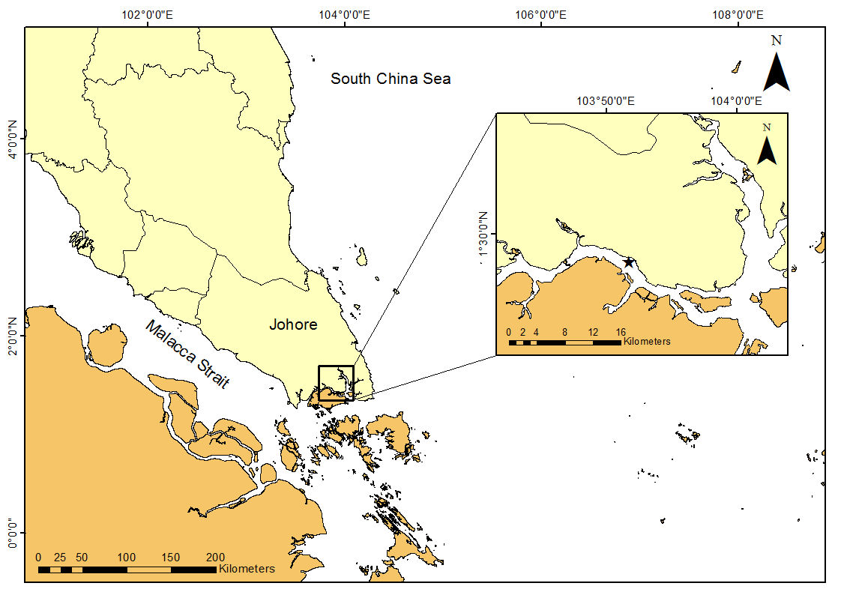

Figure 1. The sampling site (★)at the Straits of Johor, Malaysia

Sample collection and preparation

A total of 45 Perna veridis were collected from the aquaculture racks at the river mouth of Sungai Masai. These mussels were at marketable size, ranging from 48.6 to 80.4 mm in carapace width with an average of 61.2 mm. They weighed 5.8 to 23.3 g with an average of 11.2 g. The collected mussels were kept at low temperature in an ice chest and then transported to the laboratory for analysis.

Each sample was rinsed with distilled water before removing this total tissue (in-toto) with a ceramic knife. The in-toto was weighed and dried in an oven at 60 °C to obtain a constant weight. Each in-toto was then ground into powder using a mortar and pestle. The pestle, mortar, and spatula used were cleaned with 95% ethanol before grinding another mussel [14, 15].

Analytical procedures

Contamination of metallic elements in biota was generally analysed using the Teflon Bomb nitric acid digesting method. The digestion method used in this study was adopted from other studies [16, 17] with slight modifications. Specifically, 1.5 mL of 65% HNO₃ (Suprapur®) was added to 0.05 g dried powder sample placed in a Teflon beaker. The Teflon beaker was then closed tightly in the Teflon jacket and heated in the oven at 100 °C for 8 hours. Upon cooling, the digested sample was then transferred into a centrifuge tube and topped up with deionised water to 10 mL. The samples were then analysed using Inductively Coupled Plasma Mass Spectrometry (ICP-MS).

Results and Discussion

The standard 1946 dogfish liver certified reference material (DOLT-4) was used to determine the accuracy of the analytical methodology of this study. Table 1 shows the recovery percentage for various heavy metals, namely Cd, Cu, Pb, and Zn, with accuracy ranging between 80% and 115% [18]. The individual recovery of Cd, Cu, Pb, and Zn was 87.2, 92.3, 112.5, and 94.8%, respectively.

Table 1. Recovery percentage for heavy metals concentration (µg/g dw*) based on the standard 1946 dogfish liver certified reference material (DOLT-4)
Metals | Measured Values  (µg/g dw) | Certified Values  (µg/g dw) | Recovery Percentage  (%)
Cadmium (Cd) | 21.2 ± 1.2 | 24.3 ± 0.8 | 87.2
Copper (Cu) | 28.8 ± 1.5 | 31.2 ± 1.1 | 92.3
Lead (Pb) | 0.18 ± 0.07 | 0.16 ± 0.04 | 112.5
Zinc (Zn) | 110 ± 8.0 | 116 ± 6.0 | 94.8

*dw = dry weight

Figure 1 shows the average concentration of various heavy metals in Perna viridis in a decreasing order, i.e., Zn (38.9 µg/g dw) > Cu (7.8 µg/g dw) > Pb (0.41 µg/g dw) > Cd (0.14 µg/g dw). This finding is consistent with the results reported in other studies [19, 20]. Zinc accumulated the fastest in the body of the green mussel, while Cd the longest time to build up its concentration [21]. Zinc is an essential precursor for enzymatic activities [19] and is generally abundant in seafood [22]. The Zn concentration of this study (38.9 µg/g dw) was higher than that (28.8 µg/g dw) of another study with samples from the east coast of Peninsular Malaysia [23] Nevertheless, it still complied with the permissible safety level (50 µg/g dw) stipulated by the Malaysia Food Regulation (1985). In other words, the green mussels of Sungai Masai were still safe for human consumption.

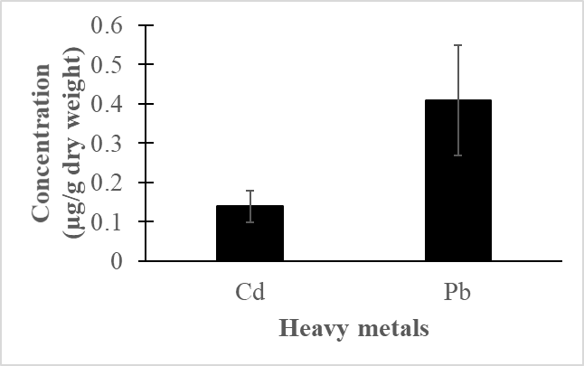
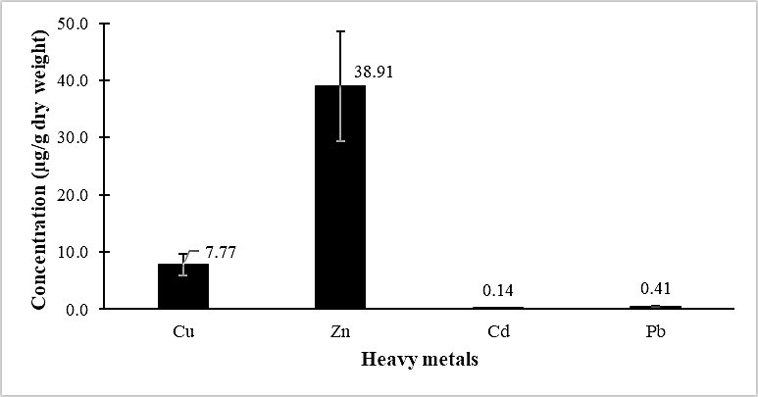

Figure 1. The average concentration of heavy metals in Perna viridis

Similar to Zn, Cu is also an essential element for living organisms [24]. Cu is usually stored in soft tissues for body functions and transportation of oxygen to tissues is through hemocyanin that contains Cu [25]. The Cu concentration (7.8µg/g dw) in the green mussel of this study also complied with the safety limit of the 1985 Malaysia Food Regulation (30 µg/g dw).Cu in waterways usually comes from metal industries and the use of fossil fuels [26]. In another study that used Perna viridis as a bioindicator for water pollution, the eastern part of the Straits of Johor was found to be more polluted than its western side [27]. Thus, the Cu metal detected in this study might have come from other sources such as river runoff and housing activities rather than industrial activity located along the straits.

Meanwhile, both Pb and Cd are non-essential and toxic metals [28]. These elements could accumulate in the body of an organism because they are structurally analogous to essential elements [29]. These toxic metals may be assimilated into tissues and incorporated into intercellular areas and cell components. A high concentration of Cd will cause kidney dysfunction, reproductive deficiencies, and skeletal damage in the human body [30]. They generally occur in trace amounts in our environment. Indeed, the concentration Pb (0.41µg/g dw) and Cd (0.14 µg/g dw) detected in the soft tissue of P. was substantially lower than the permissible level of the Malaysia Food Regulation (1985), i.e., 2 µg/g dw for Pb and 1 µg/g dw for Cd.

Table 2 compares the average concentration of heavy metals in the present study with various other studies within and without Malaysia. The ranking of locations in the Malaysia region for all heavy metals measured generally followed the descending trend of Kg. Pasir Puteh > Pantai Lido > Sungai Masai (present study). These differences might be attributable to the levels and types of industrialisation of the area, and the population density [31]. Industrial production, urbanisation, agricultural activities, and excessive chemicals discharged excess heavy metals into the waterways. In this study, Sungai Masai was just located adjacent to urban areas with comparatively fewer nearby industrial activities nearby. In comparison, both Kg. Pasir Puteh and Pantai Lido were located near industrial, agricultural, and urban areas [32], presumably discharging more heavy metals into their waterways.

Table 2. Comparison of heavy metals in Perna viridis with other studies
Location | Cd | Cu | Pb | Zn | Reference
Hong Kong, Tsim Sha Tsui | 0.31 | 11.50 | 1.20 | 69.50 | [33]
Singapore, Punggol | BDL | 27.00 | BDL | 343.00 | [27]
Singapore, Sembawang | BDL | 35.00 | 3.40 | 446.00 | [27]
Malaysia, Pantai Lido | 0.68 | 9.39 | 4.03 | 116.9 | [32]
Malaysia, Kg. Pasir Puteh | 0.82 | 20.10 | 8.76 | 128.9 | [32]
Malaysia, Sungai Masai | 0.14 | 7.77 | 0.41 | 38.9 | Present study

(BDL: Below detection limit)

Also, the average concentrations of Zn and Cu in this study were lower than that of the Singapore waters, probably because Punggol and Sembawang were located near a recreational port and maintenance shipyards, respectively. Besides, the results of the present study were also lower than that of Hong Kong Tsim Sha Tsui, which was located near the Victoria Harbour with intensive human activities, such as shipping and industries. The sewages were also discharged into the marine environment from the densely populated surrounding area [34], contributing to high levels of heavy metal pollution.

However, the body size of the green mussel could affect the accumulation of metal [35]. Smaller and younger mussels tended to accumulate more Cd, Pb, and Zn than larger and older ones [36]. As the mussels grow, the kinetic steady-states will change, causing differential uptake of heavy metal uptakes [37]. Individuals of Perna viridis in this study were larger (5 – 8 cm) than those in Hong Kong (3.0 - 3.5 cm). Thus, the lower concentrations of heavy metals in this study might partly be due to the larger size of the green mussels.

Figure 2 shows the relationship between the weight of Perna viridis and the concentrations of heavy metals in their soft tissues. The weight showed a weak positive correlation with Cu and Cd but a weak negative relationship with Pb. However, these correlations were not significant (r ranged from -0.058 to 0.301), and the accumulation of heavy metals in the green mussels of this study might not be related to body size. Meanwhile, freshwater inputs from river upstream were another indirect source of chemical elements in the marine environment [38]. Presumably, these freshwater inputs might also affect the uptake of heavy metals in Perna viridis.

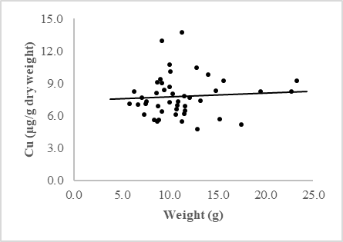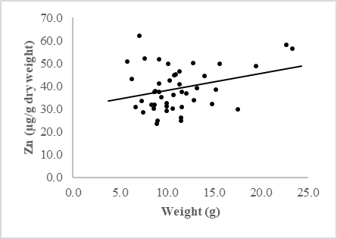
r = 0.301
r = 0.077

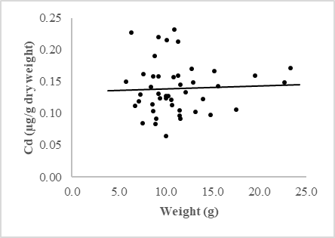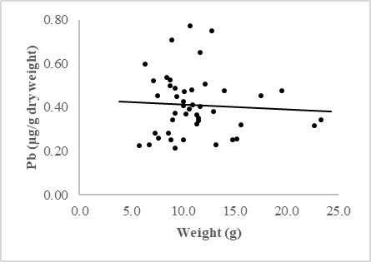
r = 0.044
r = -0.058

Figure 2. Concentrations of heavy metals concentration (Cu, Zn, Cd, and Pb) against the body weight of Perna viridis

Table 3 shows the pairwise correlation between the selected heavy metals in Perna viridis. In general, all metals show a positive correlation with each other, indicating that the metals were affected by similar conditions from natural and anthropogenic sources [39]. These findings suggested that the metals might come from the same sources, such as shipping, industrial and urban activities.

Table 3. Correlation in concentrations between heavy metals found in Perna viridis.
 | Cu | Zn | Cd
Zn | 0.478
Cd | 0.283 | 0.647
Pb | 0.230 | 0.379 | 0.387

The PLI was used to compare the extent of heavy metal pollution at the river mouth of Sungai Masai. The PLI was calculated using Equation 1 below with baseline data from another study [32].

$Pollution Load Index \left(PLI\right)= \sqrt[n]{{CF}_{1}x {CF}_{2}x {CF}_{3}x……x {CF}_{n}}$ (1)

Where,

$Contamination Factor \left(CF\right)= \frac{Concentration of metals in this study}{Concentration of baseline data}$

Table 4 shows the PLI values of .Perna viridis ranged from 1.5 to 6.7 with an average of 3.3. In general, periodic monitoring of the water quality would be essential if the PLI value is larger than 50 [40]. In other words, the pollution at the river mouth of Sungai Masai was still under control.

Table 4. The calculated PLI value in Perna viridis
Metal | Baseline Concentration of Metal  (µg/g) | PLI value
Cd  Cu  Pb  Zn | 0.25  6.31  1.27  53.82 | 3.27  (1.49 - 6.74)

Conclusion

The green mussel Perna viridis collected from the Straits of Johor showed a level of heavy metal concentration for heavy metals. In general, essential elements, such as Zn and Cu accumulated a higher concentration in the soft tissue of the green mussel than the non-essential elements (Pb and Cd) in a descending order Zn (w µg/g dw) > Cu (x µg/g dw) > Pb (y µg/g dw) > Cd (z µg/g dw). Overall, the heavy metal content of the green mussel in this study complied with the permissible safety limit stipulated by the 1985 Malaysia Food Regulation. Contradictory to the findings of other studies, the results of this study indicated that the accumulation of heavy metal in the green mussels might not be related to its size. Low heavy metals concentration in Perna viridis and PLI (average: 3.3) indicated the pollution of heavy metals in the study area was under control.

Acknowledgement

This research was funded by the Malaysian Ministry of Higher Education under the Fundamental Research Grant Scheme FRGS/1/2020/WAB05/UMT/02/5. The authors wish to thank the anonymous reviewers for their constructive recommendations to improve this manuscript. Thanks also go to the Oceanography Laboratory, Faculty of Science and Marine Environment staff for their invaluable assistance and the facilities to carry out the research. The authors also would like to thank Dr. Asnor Azrin Sabuti from International Islamic University Malaysia Kuantan Campus for the sample detection using ICP-MS.

References
- Wood, A. K., Ahmad, Z., Shazili, N. A. M., Yaakob, R. and Carpenter, R. (1997). Geochemistry of sediments in Johor Strait between Malaysia and Singapore. Continental Shelf Research, 17: 1207-1228.
- Zulkifli, S. Z., Ismail, A., Mohamat-Yusuff, F., Arai, T. and Miyazaki, N. (2010). Johor Strait as a hotspot for trace elements contamination in Peninsular Malaysia. Bulletin of Environmental Contamination and Toxicology, 84: 568-573.
- Zulkifli, S. Z., Mohamat-Yusuff, F., Ismail, A., Aris, A. Z., Aziz, A., Sabuti, A. A. and Mohamed, C. A. R. (2015). Status of heavy metals on surface sediments of the western part of the Johor Straits using a sediment quality guideline. World Journal of Fish and Marine Sciences, 7(3): 214-220.
- Sin, T. M., Ang, H. P., Buurman, J., Lee, A. C., Leong, Y. L., Ooi, S. K., Steinberg, P. and Teo, S. L. M. (2016). The urban marine environment of Singapore. Regional Studies in Marine Science, 8: 331-339.
- Ali, H., Khan, E. and Ilahi, I. (2019). Environmental chemistry and ecotoxicology of hazardous heavy metals: Environmental persistence, toxicity, and bioaccumulation. Journal of Chemistry, 2019: 6730305.
- Zhang, Z. Y., Juying, L., Mamat, Z. and QingFu, Y. (2016). Sources identification and pollution evaluation of heavy metals in the surface sediments of Bortala River, Northwest China. Ecotoxicology and Environmental Safety, 126: 94-101.
- Kalantzi, I., Shimmield, T. M., Pergantis, S. A., Papageorgiou, N., Black, K. D. and Karakassis, I. (2013). Heavy metals, trace elements and sediment geochemistry at four Mediterranean fish farms. Science of the Total Environment, 444: 128-137.
- Ong, M. C., Yong, J. C., Khoo, X. Y., Tan, Y. F. and Joseph, B. (2014). Selected heavy metals and polycyclic aromatic hydrocarbon in commercial fishes caught from UMT enclosed lagoon, Terengganu, Malaysia. Advances in Environmental Biology, 8(14): 91-98.
- Beldi, H., Gimbert, F., Maas, S., Scheifler, R. and Soltani, N. (2006). Seasonal variations of Cd, Cu, Pb and Zn in the edible mollusc Donax trunculus (Mollusca, Bivalvia) from the Gulf of Annaba, Algeria. African Journal of Agricultural Research, 1(4): 85-90.
- Tan, K. S. and Julian, R. (2014). A review of feeding behavior, growth, reproduction and aquaculture site selection for green-lipped mussel, Perna viridis. Advances in Bioscience and Biotechnology, 5: 462-469.
- Zhang, X., Huang, H., He, Y., Ruan, Z., You, X., Li, W., Lu, Z., Liu, B, Deng X and Shi Q. (2019). High-throughput identification of heavy metal binding proteins from the byssus of Chinese green mussel (Perna viridis) by combination of transcriptome and proteome sequencing. PLoS ONE, 14 (5): e216605.
- Riani, E., Cordova, M. R. and Arifin, Z. (2018). Heavy metal pollution and its relation to the malformation of green mussels cultured in Muara Kamal Waters, Jakarta Bay, Indonesia. Marine Pollution Bulletin, 133: 664-670.
- Hadibarata, T., Abdullah, F., Mohd Yusoff, A. R., Ismail, R., Azman, S. and Adnan, N. (2012). Correlation study between land use, water quality, and heavy metals (Cd, Pb, and Zn) content in water and green lipped mussels Perna viridis (Linnaeus.) at the Johor Strait. Water, Air, & Soil Pollution, 223: 3125-3136.
- Kamaruzzaman, B. Y., Ong, M. C., Zaleha, K. and Shahbudin, S. (2008). Levels of heavy metals in green-lipped mussel Perna veridis (Linnaeus) from Muar Estuary, Johore, Malaysia. Pakistan Journal of Biological Sciences, 11 (18): 2249-2253.
- Ong, M. C., Kamaruzaman, M. I., Yong, J. C., Kamaruzzaman, B. Y. and Joseph, B. (2017). Metals contamination using Polymesoda expansa (marsh clam) as bio-indicator in Kelantan river, Malaysia. Malaysian Journal of Analytical Sciences, 21(3): 597-604.
- Ong, M. C., Shazili, N. A. M., Menier, D. and Effendy, A. W. M. (2013). Levels of trace elements in tissue of Ostrea edulis and Crassostrea gigas from Quiberon Bay, Brittany, France. Journal of Fisheries and Aquatic Science, 8(2): 378-387.
- Ong, M. C. and Gan, S. L. (2017). Assessment of metallic trace elements in the muscles and fins of four landed elasmobranchs from Kuala Terengganu Waters, Malaysia. Marine Pollution Bulletin, 124(2): 1001-1005.
- Yohannes, Y. B., Ikenaka, Y., Nakayama, S. M. M., Saengtienchai, A., Watanabe, K. and Ishizuka, M. (2013). Organoclorine pesticides and heavy metals in fish from Lake Awassa, Ethiopia: Insights from stable isotope analysis. Chemosphere, 91: 857-863.
- Kamaruzzaman, B. Y., Rina, Z., John, B. A. and Jalal, K. C. A. (2011). Heavy metal accumulation in commercially important fishes of south west Malaysian coast. Research Journal of Environmental Sciences, 5(6): 595.
- Ong, M. C., Tan, Y. F., Khoo, X. Y. and Yong, J. C. (2015). Heavy metals and polycyclic aromatic hydrocarbons (PAHs) concentration in mud crab (Scylla serrata) from UMT mangrove, Terengganu, Malaysia. Advances in Environmental Biology, 9(21): 66-74.
- Eugene Ng, Y. J., Yap, C. K., Zakaria, M. P. and Tan, S. G. (2013). Assessment of heavy metal pollution in the straits of Johore by using transplanted caged mussel, Perna viridis. Pertanika Journal of Science & Technology, 21(1):75-96.
- Stankovic, S. and Jovic, M. (2012). Health risks of heavy metals in the Mediterranean mussels as seafood. Environmental Chemistry Letters, 10(2): 119-130.
- Yap, C. K., Ismail, A., Tan, S. G. and Omar, H. (2002). Correlations between speciation of Cd, Cu, Pb and Zn in sediment and their concentrations in total soft tissue of green-lipped mussel Perna viridis from the east coast of Peninsular Malaysia. Environment International, 28(1-2): 117-126.
- Ragi, A. S., Leena, P. P., Cheriyan, E. and Nair, S. M. (2017). Heavy metal concentrations in some gastropods and bivalves collected from the fishing zone of South India. Marine Pollution Bulletin, 118: 452-458.
- Thanh-Nho, N., Marchand, C., Strady, E. Huu-Phat, N. and Nhu-Trang, T. T. (2019). Bioaccumulation of some trace elements in tropical mangrove plants and snails (Can Gio, Vietnam). Environmental Pollution, 248: 635-645.
- Rehman, M., Liu, L., Wang, Q., Saleem, M. H., Bashir, S., Ullah, S. and Peng, D. (2019). Copper Environmental toxicology, recent advances, and future outlook: A review. Environment Science and Pollution Research, 26: 18003-18016.
- Bayen, S., Thomas, G. O., Lee, H. K. and Obbard, J. (2004). Organochlorine pesticides and heavy metals in green mussel, Perna viridis, in Singapore. Water, Air, & Soil Pollution, 155: 103-116.
- Hossen, M. F., Hamdan, S. and Rahman, M. R. (2015). Review on the risk assessment of heavy metals in Malaysian clams. Scientific World Journal, 2015: 1-7.
- Lehtonen, K. K., d’Errico, G., Korpinen, S., Regoli, F., Ahkola, H., Kinnunen, T. and Lastumäki, A. (2019). Mussel caging and the weight of evidence approach in the assessment of chemical contamination in coastal waters of Finland (Baltic Sea). Frontiers in Marine Science, 6: 688.
- European communities. (2001). Commission regulation no 466/2001 of 8 March 2001 setting maximum levels for certain contaminants in foodstuffs. OJEC L77.
- Blackmore, G. (1998). An overview of trace metal pollution in the coastal waters of Hong Kong. Science of the Total Environment, 214: 21-48.
- Yap, C. K., Ismail, A. and Tan, S. G. (2003). Background concentrations of Cd, Cu, Pb and Zn in the green-lipped mussel Perna viridis (Linnaeus) from Peninsular Malaysia. Marine Pollution Bulletin, 46: 1035- 1048.
- Blackmore, G. and Wang, W. X. (2003). Comparison of metal accumulation in mussels at different local and global scales. Environmental Toxicology and Chemistry, 22: 388-395.
- Richardson, B. J. and Zheng, J. S. (1999). Chlorinated hydrocarbon contaminants in Hong Kong surficial sediments. Chemosphere, 39: 61-71.
- Cai, C. and Wang, W. W. (2019). Inter-species difference of copper accumulation in three species of marine mussels: Implication for biomonitoring. Science of The Total Environment, 692: 1029-1036.
- Yap, C. K., Ismail, A. and Tan, S. G. (2009). Effect of body size on heavy metal contents and concentrations in green-lipped mussel Perna viridis (Linnaeus) from Malaysian coastal waters. Pertanika Journal of Science & Technology, 17(1): 61-68.
- Tang, W. L., Evans, D., Kraemer, L. and Zhong, H. (2017). Body size-dependent Cd accumulation in the zebra mussel Dreissena polymorpha from different routes. Chemosphere, 168: 825-831.
- Blair, R. M., Waldrin, S., Phoenix, V. R. and Gauchotte-Lindsay, C. (2019). Microscopy and elemental analysis characterisation of microplastics in sediment of a freshwater urban river in Scotland, UK. Environmental Science and Pollution Research, 26: 12491-12504.
- Amin, B., Ismail, A., Arshad, A., Yap, C. K. and Kamarudin, M. S. (2009). Anthropogenic impacts on heavy metal concentrations in the coastal sediments of Dumai, Indonesia. Environmental Monitoring and Assessment, 148: 291-305.
- Angulo, E. (1996). The Tomlinson Pollution Load Index applied to heavy metal, ‘Mussel-Watch’ data: A useful index to assess coastal pollution. The Science of the Total Environment, 187: 19-56.

