

ADSORPTION OF ACID ORANGE 7 BY CETYLTRIMETHYL AMMONIUM BROMIDE MODIFIED OIL PALM LEAF POWDER

(Penjerapan Asid Oren 7 oleh Setiltrimetil Ammonium Bromida Ubahsuai Serbuk Daun Kelapa Sawit)

Nik Ahmad Nizam Nik Malek^{1,2}*, Nurul Ain Sallehhuddin¹, Auni Afiqah Kamaru³

¹Department of Biosciences, Faculty of Science

²Centre for Sustainable Nanomaterials (CSNano), Ibnu Sina Institute for Scientific and Industrial Research (ISI-ISIR)

Universiti Teknologi Malaysia, 81310 JohorBharu, Johor, Malaysia

³Geomatika University College,

Prima Peninsula, Jalan Setiawangsa 11, 54200 Kuala Lumpur

*Corresponding author: niknizam@utm.my

Received: 29 August 2021; Accepted: 28 October 2021; Published: xx December 2021

Abstract

The capability of oil palm leaf (OPL) and surfactant modified oil palm leaf (SMOPL) to remove acid orange 7 (AO7) anionic dye in an aqueous solution was studied. The SMOPL was prepared by treating the OPL with different concentrations of cetyltrimethyl ammonium bromide (CTAB) solutions (1.0, 2.5, and 4.0 mM). The samples were characterized using Fourier-transform infrared (FTIR) spectroscopy and dispersion behaviour test. The FTIR results showed the modification of OPL with CTAB surfactant did not change the chemical structure of the OPL, except for an increase in the intensity of the C-H bond, which occurred due to the hydrocarbon group in CTAB. In addition, the effects of initial AO7 concentrations on the adsorption capacity of SMOPL were studied, and the highest AO7 adsorption capacity was found for the SMOPL4.0 with the initial CTAB concentration being 4.0 mM. Comparatively, the raw OPL demonstrated the lowest adsorption capability. The presence of the CTAB surfactant molecules on the samples increased the adsorption site of the adsorbent, allowing more attachments of dye molecules onto the OPL adsorbent. The Langmuir and Freundlich isotherm models were used to describe the adsorption isotherm. The equilibrium data were better fitted by Langmuir isotherm with a maximum AO7 adsorption capacity of 138.89 mg/g. Thus, it is suggested that the adsorption of AO7 takes place as a single monolayer on a homogeneous OPL surface. From this study, it can be concluded that the modification of OPL with cationic surfactant can enhance its adsorption process of anionic dye from an aqueous solution.

Keywords: adsorption, oil palm leaf, cetyltrimethyl ammonium bromide, acid orange 7, surfactant

Abstrak

Keupayaan daun kelapa sawit (OPL) dan daun kelapa sawit yang diubah suai surfaktan (SMOPL) untuk menyingkirkan pewarna anionik asid oren 7 (AO7) dalam larutan akues telah dikaji. SMOPL disediakan dengan merawat OPL dengan kepekatan larutan setiltrimetilammonium bromida (CTAB) yang berbeza (1.0, 2.5, dan 4.0 mM). Sampel dicirikan dengan menggunakan spektroskopi inframerah transformasi Fourier (FTIR) dan ujian tingkah laku penyebaran. Hasil FTIR menunjukkan pengubahsuaian OPL dengan surfaktan CTAB tidak mengubah struktur kimia OPL, kecuali beberapa peningkatan keamatan untuk ikatan C-H yang berlaku disebabkan oleh kumpulan hidrokarbon yang terdapat pada CTAB. Kesan kepekatan AO7 awal pada kapasiti penjerapan SMOPL dikaji, dan kapasiti penjerapan tertinggi AO7 dijalankan untuk SMOPL4.0 di mana kepekatan CTAB awal adalah 4.0 mM. Secara perbandingan, OPL menunjukkan kemampuan penjerapan yang terendah. Kehadiran molekul surfaktan CTAB pada sampel meningkatkan tapak penjerapan, yang memungkinkan lebih banyak interaksi molekul pewarna ke OPL. Model isoterma Langmuir dan Freundlich digunakan untuk menggambarkan isoterma penjerapan. Data keseimbangan lebih baik dipadankan oleh isoterma Langmuir dengan kapasiti penjerapan maksimum AO7 adalah 138.89 mg/g. Jadi, penjerapan AO7 terhasil sebagai satu lapisan tunggal pada permukaan OPL yang homogen. Dari kajian ini, dapat disimpulkan bahawa modifikasi OPL dengan surfaktan kationik dapat meningkatkan proses penjerapannya untuk pewarna anionik dari larutan berair.

Kata kunci: penjerapan, daun kelapa sawit, setiltrimetilammonium bromida, asid oren 7, surfaktan

Introduction

As a colouring agent, anionic dyes have been widely used in many industries, including textile, clothes, food, and polymers. After several steps of the dyeing process, the inappropriate treatment of hazardous effluents that have toxic complex will be discharged as wastewater [1]. Dyes cause toxicity to the water body from their degradation products, and affect living organisms. Therefore, the removal of dyes from an aqueous solution is essential. Some removal methods have been studied recently, such as adsorption using biodegradable polymeric natural adsorbent [2] and modified coconut shell [3], adsorption-photocatalytic degradation [4] and many more. Acid Orange 7 (AO7) is an example of anionic dyes (Figure 1), and it is an acid dye that can be applied on textiles. The AO7 is also known as an azo dye that has a non-biodegradable property, and is mostly used in the dyeing industry [5]. One of the suitable techniques for the removal of AO7 is using the adsorption technique.

Biosorption is a method to remove pollutants from aqueous solutions by using bio-resource materials such as plant wastes, fungi and bacteria. This method is preferable for its low-cost and straightforward process [6]. Plant biomass is abundant in nature, easy to obtain and renewable. This treatment method is also eco-friendly by using adsorbent material from biomass product. Oil palm leaf (OPL) is one of the agricultural wastes easily found in Malaysia and able to be used as a low-cost adsorbent [7].

Elaeis guineensis is the scientific name of the oil palm plant. Besides producing palm oil, it also contains valuable biomass products useful for many applications, including adsorbent. The OPL is part of the oil palm plant converted into biomass product apart from the empty fruit bunch, bark, trunk and shells [8]. Like other agricultural wastes, OPL is composed of hemicellulose, cellulose and lignin. Cellulose and lignin contain hydroxyl group that causes the negatively-charged surface of the OPL. Thus, this material can become a suitable adsorbent for cationic compounds.

Therefore, OPL can be modified with a cationic surfactant such as cetyltrimethyl ammonium bromide (CTAB) (Figure 1) to enhance its adsorption capacity against anionic dyes. CTAB increases the binding affinity towards anionic dyes by changing the property of the adsorbent from negatively-charged to positively-charged adsorbent [9]. Many surfactant-modified biomasses have been developed to remove various pollutants [10-13]. However, there is no report on using surfactant modified OPL as an adsorbent for anionic AO7 dye.

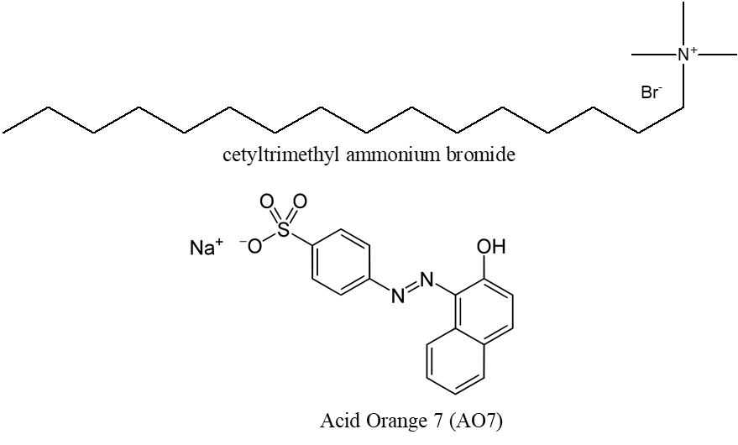

Figure 1. Structural formula of CTAB and AO7

Materials and Methods

Materials preparation

The OPLs from the E. guineensis species were obtained from an oil palm plantation located at the Universiti Teknologi Malaysia (UTM), Johor, Malaysia. The preparation of the OPL powder was performed following the previous report by Kamaru et al. [9, 13]. First, the leaves were initially washed with water several times to remove all the impurities and dust before being dried under the sunlight for one week. Then, it was cut into smaller pieces and subsequently dried in a universal oven at 90 °C for 24 hours. Next, the dried leaves were ground into a powder form using the stainless-steel blade blender, and the powder sample was abbreviated as OPLP.

Then, a pre-treatment method was carried out on the OPLP to remove any colouring component from the sample. The OPLP was suspended in a boiled distilled water, stirred for 30 minutes and filtered to remove the water filtrate. This procedure was repeated several times until a clear filtrate was observed. The pre-treated OPL powder was later dried in a universal oven for 24 hours at 90 °C.

In this study, the OPL adsorbent was modified with a CTAB surfactant. The prepared OPL powder was treated with three different concentrations of CTAB: 1.0, 2.5, and 4.0 mM. First, the CTAB solutions with the desired concentration were prepared by dissolving 0.3644 g, 0.9110 g, and 1.4576 g of CTAB powder in 1000 mL of distilled water. The mixture was then stirred until the CTAB powder was completely dissolved in the solutions. Next, 10.0 g of OPL powder was added into each 1000 mL CTAB solutions, and it was stirred for another 15 minutes. The solutions were then filtered using Whatman filter paper, and the OPL powder residue was dried in a universal oven at 90 °C for 24 hours. After these steps, the samples were known as CTAB-modified OPL powder and abbreviated as SMOPL1.0, SMOPL2.5 and SMOPL4.0 for OPL treated with 1.0, 2.5 and 4.0 mM CTAB, respectively. Finally, the dried modified OPL powder was ground using mortar and pestle into a fine structure and sieved. The resulting powder was kept in airtight plastic containers for further characterization and adsorption study.

Materials characterization

The functional groups in both raw and surfactant modified OPL powder were analysed by using Fourier-transform infrared (FTIR) spectrophotometer (model Thermo Scientific Nicolet IS10-IR) using potassium bromide (KBr) method. The FTIR spectra were recorded using OMNIC software in the range of 4000 to 500 cm⁻¹.

The samples were also analysed for their dispersion behaviour in a hexane-water mixture. The purpose of the dispersion test was to study the relative position of the samples in the mixture of oil and water. This test was carried out by adding 3 mL of distilled water and n-hexane in four universal bottles. Then, 0.06 g of raw and SMOPL were added to the oil-water mixture. The images of the bottles were captured after four different conditions: (1) immediately after the samples were added, (2) after shaking for a while and (3) for 30 minutes, and lastly (4) after being left untouched for one day at room temperature (24 °C).

Adsorption Study

The adsorption study of raw and surfactant modified OPL were performed using AO7 as the adsorbate. To begin with, a stock solution of 1000 mg/L AO7 was prepared by diluting 1.0 g of AO7 powder in 1000 mL of distilled water. Then, this stock solution was used to prepare the working solutions for the adsorption study.

The adsorption test was performed by mixing the AO7 solution with the OPL adsorbent. The AO7 working solutions were first prepared for a wide range of concentrations from 10 to 1000 mg/L, and their absorbance reading was measured to obtain the initial dye concentration. Next, 25 mL of the solutions were added into a 50 mL falcon tube containing 200 mg of raw and CTAB-modified OPL powder. Then, the tubes were left shaken in a rotary shaker for 1 h at room temperature. After 1 h, the solutions were filtered by using Whatman filter paper. The absorbance reading of the filtrates was measured under UV-Vis spectrophotometer at λ_{484 nm} to determine the final concentration. Finally, by comparing the results with the prepared standard curve, the concentration of AO7 before and after the adsorption were determined. All the experiments were done in triplicate.

The adsorption capacity of OPL against AO7 was analysed by using Equation 1:

$q_{t} \left(\frac{mg}{g}\right)= \frac{C_{0}-C_{t}}{m} . V$ (1)

where C₀ is the initial dye concentration (mg/L), C_{t} is the final dye concentration (mg/L) after adsorption, m is the dose of OPL adsorbent (g), and V is the volume of dye adsorbate (L).

Results and Discussion

The prepared samples were characterized for the functional groups using FTIR. After being attached to the surfactant, the changes that happened on the samples were observed in the dispersion behaviour test. Figure 2 shows the FTIR spectra of the samples, and Table 1 gives FTIR peaks assignment for their possible functional groups.

From Figure 2 and Table 1, several vibration bands were shown by the OPL and other samples. Strong, broad bands around 3444 to 3446 cm⁻¹ represented the hydroxyl (O-H) group, indicating that the surface of the OPL had a high amount of hydroxyl group due to the cellulose and lignin structure of the OPL. There were also bands shown in the range of 2921 to 2924 cm⁻¹, representing C-H stretches. Furthermore, the bands observed around 2852 to 2854 cm⁻¹ indicated the existence of C-H asymmetric stretching from methylene (CH₂) and methyl (CH₃) groups [7]. Meanwhile, the bands at around 1746 and 1633 cm⁻¹ were attributed by C=O stretching from carbonyl and C=C stretching of aromatic OPL, respectively [14]. The peaks at about 1647 to 1650 cm⁻¹ indicated carbon-oxygen bonding (C-O-O) due to the presence of aromatic lignin [15]. Additionally, the bands at 1454 to 1456 cm-¹ showed the presence of C=C stretching for the aromatic compound, and the presence of CH₃ bending was detected at 1384 and 1385 cm⁻¹ [16]. The peaks that appeared around 1270 to 1271 cm⁻¹ may be referred to as the C-O stretching of carboxylic acids. Lastly, small peaks were observed at 1030, 1541. 1455, 1385, and 1271 cm⁻¹, possibly indicating the aromatic stretching, C-O bonds, and N-H bonds, respectively [17]. In summary, the FTIR spectrum of the OPL showed many important functional groups (C=O, C=C, O-H) in the sample, which contributed to the ability of OPL in adsorbing other adsorbates.

After surfactant modification of the OPL, the FTIR spectra showed that the addition of CTAB molecules on the OPL did not change its chemical structure as there were no significant differences among their peaks. However, the increased intensity of bands of C-H and C-C bonds were demonstrated at 2921, 2852 and 1455 cm⁻¹ because the number of hydrocarbons on the OPL surface increased by the presence of the surfactant [10]. The binding of CTAB molecules on the OPL was proven by increasing C-H functional group since the CTAB had a long aliphatic hydrocarbon compound [9]. From the analysis, most of the functional groups presented by the FTIR spectra were contributed by the hemicellulose, cellulose and lignin of OPL samples. Except for the peak increase that corresponded to the C-H stretch, no noticeable change of band was shown by other functional groups to compare both unmodified and modified OPL. The result indicated that the modification of OPL with CTAB surfactant would not promote drastic changes in the chemical structure of OPL [9].

The dispersion behaviour method was carried out to determine the relative position of OPL and surfactant-modified OPL in an oil-water mixture to determine the changes in the physical properties of the OPL after being modified with the CTAB. Figure 3 shows the images of the condition and position of oil palm leaf samples in the mixture of water-hexane starting from the beginning of the samples added, after shaking for thirty minutes and lastly after being left for 24 hours at room temperature.

When the samples were added to the water-hexane mixture at the beginning of the process, all the samples were positioned between the distilled water and n-hexane solution. The solutions were then shaken for a while and 30 minutes in the shaker. After shaking, all the samples exhibited different behaviours in the solution. Some of the raw OPL dispersed in the distilled water, and a small portion of OPL dispersed in the n-hexane solution. Meanwhile, all the SMOPL were seen to avoid the n-hexane solution and spread the distilled water solution. Moreover, at the highest concentration of surfactant (SMOPL4.0), a higher amount of the sample dispersed in distilled water. After being left for one day, the images were captured and re-recorded. The photos indicated that the position of OPL and SMOPL in the water-hexane mixture were different. The raw OPL mainly stayed at the middle position of the water-hexane mixture, while the SMOPL remained at the bottom of the bottle. Some SMOPL1.0 and SMOPL2.5 samples were still positioned between the distilled water and n-hexane solution, and a few were dispersed in the distilled water. Meanwhile, most of the SMOPL4.0 samples were located and dispersed in water. From Figure 3, an increasing capability of the SMOPL to disperse in water followed the trend of SMOPL4.0 > SMOPL2.5 > SMOPL1.0 > OPL.

The inability of raw OPL to disperse in water solution could be due to the lignin in the OPL structure with hydrophobic characteristics that tend to repel water molecules [19]. It is also revealed that the modification of CTAB increased the interaction of OPL samples with water molecules because the result showed better dispersion of the SMOPL in water as the CTAB concentration increased. This phenomenon may occur due to the structure of the CTAB that was comprised of hydrophilic ammonium group, resulting in the polar characteristics of SMOPL. A high concentration of surfactant attached to the sample leads to the increasing hydrophilic force. At the same time, the hydrophobic force increased as the surfactant attachment decreased. Therefore, the hydrophilicity of SMOPL increased as the CTAB concentration increased and its interaction with water increased. This dispersion behaviour test proves the successful modification of OPL with CTAB surfactant, and the CTAB molecules affect the physical characteristics of the raw OPL.

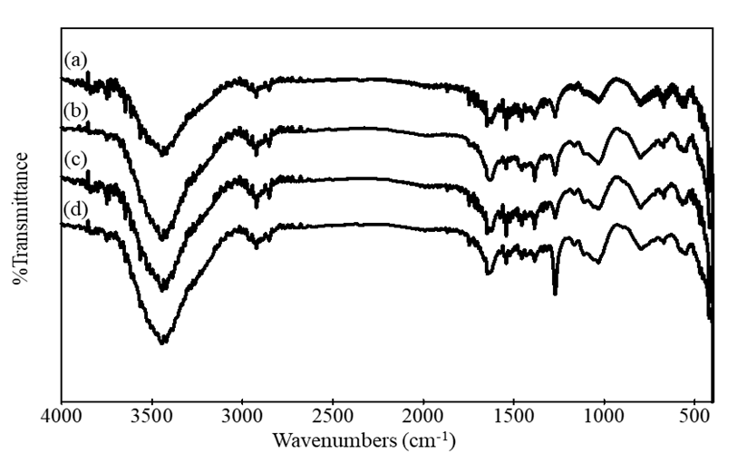

Figure 2. FTIR spectra of raw OPL (a), SMOPL1.0 (b), SMOPL2.5 (c) and SMOPL4.0 (d)

Table 1. FTIR peak assignments of OPL and SMOPL
Wavelength (cm⁻¹) |  |  |  | Functional  Group | References
OPL | SMOPL1.0 | SMOPL2.5 | SMOPL4.0 | Functional  Group | References
3444 | 3444 | 3445 | 3446 | OH | [14]
2921 | 2923 | 2921 | 2924 | C–H | [7]
2852 | 2852 | 2853 | 2854 | C–H | [7]
1749 | 1744 | 1746 | 1746 | C=O | [16]
1633 | 1630 | 1630 | 1633 | C=O | [17]
1455 | 1454 | 1455 | 1456 | C-C | [16]
1384 | 1385 | 1385 | 1384 | C-H | [13]
1270 | 1270 | 1271 | 1271 | C-O | [18]
1031 | 1033 | 1034 | 1033 | C=O | [17]

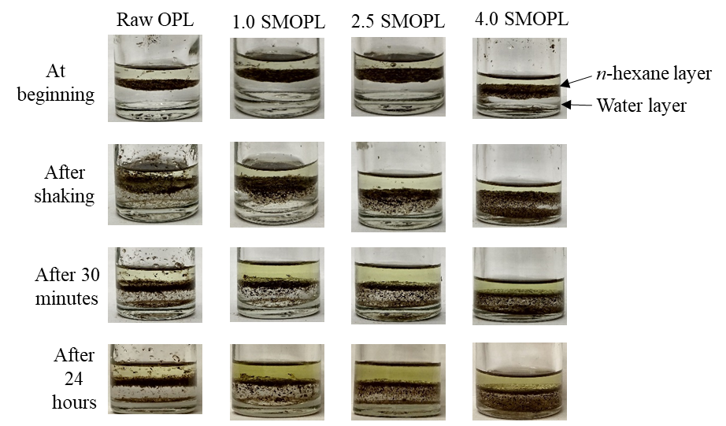

Figure 3. Dispersion behaviour of samples in water-hexane mixture

The adsorption study of OPL and SMOPL was performed by varying the initial concentrations of AO7, ranging from 10 to 1000 mg/L. The effect of the initial concentration of AO7 on its adsorption onto oil palm leaf is presented in Figure 4.

From Figure 4, the adsorption capacity (Q_{e}) of all samples demonstrated a similar pattern towards the anionic dye AO7. The graph shows that the amount of AO7 adsorbed onto the OPL increases as the initial concentration of AO7 increases. However, it is observed that the raw OPL had the lowest adsorption capacity towards AO7 compared to the CTAB modified OPL (SMOPL). Meanwhile, the highest adsorption capacity towards AO7 was exhibited by SMOPL4.0 (Figure 4). As the CTAB concentrations treated on the SMOPL increased, the adsorption capacity towards AO7 was also increased. The removal of AO7 from aqueous solutions by OPL presented by the graph followed the trend of SMOPL4.0 > SMOPL2.5 > SMOPL1.0 > OPL. In addition, the steepness of the slope that increased after CTAB modification and with SMOPL4.0 displaying the steepest slope also had verified that the adsorption capacity of OPL increased as more treatment of CTAB was introduced to the OPL adsorbate [9].

The result showed that the surface modification of the OPL adsorbent and the initial concentrations of dye adsorbate influenced the adsorption capacity and the affinity of the OPL towards AO7. This happens due to the composition of OPL surface that is composed of hemicellulose, cellulose and lignin. The porous structure of cellulose provides a large surface area for the attachment of AO7. That is why all samples showed a positive adsorption behaviour towards AO7. Moreover, when OPL is in an aqueous solution, the hydroxyl group in cellulose and lignin releases the hydrogen ions, leading to the formation of negative charge on the surface of OPL [12]. However, when OPL is modified by CTAB surfactant, the negative charge surface of OPL is inverted into positive charge because of the bilayer formation of CTAB on the surface of OPL. As a result, SMOPL attracts more anionic dye that is negatively charged as the opposite charge between OPL and AO7 will increase the electrostatic interaction between each other, and hence, increase the adsorption capacity of the SMOPL. Therefore, different concentrations of CTAB applied to the OPL will result in the different adsorption behaviour of the OPL towards anionic dyes.

The adsorption behaviour of OPL and SMOPL towards anionic dye AO7 was further analyzed through isotherm studies. Using Langmuir and Freundlich isotherm models, the adsorption capacity of OPL and SMOPL to remove AO7 from an aqueous solution was quantified. The purpose of using the Langmuir and Freundlich isotherm model was to predict the adsorption equilibrium of AO7 adsorbate onto both OPL and SMOPL [12].

Langmuir isotherm model is based on the assumption of the single monolayer adsorption of adsorbate onto the homogenous surface of adsorbent with a structurally similar binding site [20]. The non-linear Langmuir isotherm equation is shown below:

$\frac{x}{m}=q_{e}= \frac{bQ_{o}C_{e}}{1+bC_{e}}$ (2)

where x is defined as mass of adsorbate adsorbed (mg or mmol), m is mass of adsorbent (g), C_{e} is equilibrium concentration (mg/L), b is Langmuir constant related to the affinity of binding site; and Q_{o} is maximum adsorption at monolayer coverage (mg/g).

The non-linear equation can be linearized into:

$\frac{m}{x}=\frac{1}{q_{e}}= \frac{1}{Q_{0}}+\frac{1}{bQ_{0}C_{e}}$ (3)

The plot of 1/q_{e} against 1/C_{e} will give the straight-line graph with 1/Q_{0,} and 1/(bQ₀) being the y-intercept and the slope, respectively.

Freundlich adsorption isotherm is an empirical equation that describes the multilayer adsorption of adsorbate onto the heterogeneous surface of the adsorbent. The non-linear Freundlich isotherm equation is shown as below:

$\frac{x}{m}=q_{e}=K_{f}C_{e}^{\frac{1}{n}}$ (4)

where K_{f} is defined as maximum adsorption at multilayer coverage (mg/g); and n is favourability of the adsorption process.

The non-linear equation can be linearized into:

$log\frac{x}{m}=logq_{e}=logK_{f}+\frac{1}{n}logC_{e}$ (5)

The log q_{e} against log C_{e} will give a straight-line graph with log K_{f} and 1/n as the y-intercept and the slope, respectively. The values of parameters for both adsorption isotherm models are shown in Table 2.

From the isotherm results, it can be summarized that the adsorption behaviour of AO7 by OPL is very different from that of the SMOPL. The adsorption of AO7 by raw OPL neither followed the Langmuir nor the Freundlich isotherm models because the R² of the Langmuir isotherm model was below 0.9, and most data were not distributed well on the linear graph, showing that it could not fit the model. Similarly, the R² value of the adsorption in the Freundlich isotherm was too low, signifying that it did not fit the model. This result showed that the adsorption of dye by raw OPL almost did not happen.

From Table 2, the correlation coefficient (R²) of the Langmuir isotherm model exhibited higher values than the Freundlich isotherm model. Hence, the Langmuir adsorption isotherm fitted all the experimental data better than the Freundlich model. The fitting of the adsorption data into the Langmuir isotherm model recommended that the external surface of the SMOPL was homogenous, and distributed with a high amount of active carboxylic and hydroxyl groups [21]. The adsorption of AO7 onto OPL and SMOPL were expected to form a monolayer coverage, and the AO7 attached to specific binding sites on the surface of SMOPL. Furthermore, once the specific site interacted with dye adsorbate, more adsorption activity could not occur at the adsorbent site. The positive relationship shown in the linear graph of SMOPL indicated that the adsorption was very successful and well-fitted in the Langmuir isotherm model. The Langmuir isotherm model also indicated that SMOPL4.0 exhibited the maximum adsorption capacity of AO7 with 138.89 mg/g.

Throughout this experiment, it was found that the adsorption capacity of OPL towards AO7 increased by the increase of the surfactant concentrations attached to the modified OPL. The trend of the AO7 adsorption by OPL and SMOPL was: SMOPL4.0 > SMOPL2.5 > 1.0SMOPL > OPL. This condition can be referred to the properties of dye and the formation of the surfactant molecules on the OPL. AO7 is characterized as an anionic dye as it carries a negative charge at its negative site. Due to this property, AO7 can be effectively bound to the positive charge of CTAB surfactant through electrostatic interaction [9]. The adsorption trend is also supported by FTIR results, whereby there are many functional groups in the sample responsible for the adsorption to occur. Additionally, the dispersion behaviour of the SMOPL in water-hexane also supported this trend since the SMOPL exhibited different behaviour compared to OPL, which was resulted in the alteration of OPL surfaces. The changes in the surface properties have proven the attachment of a higher amount of CTAB molecules on OPL, contributing to a higher adsorption capacity towards AO7 anionic dye. It is expected that the higher CTAB concentration of more than 4.0 mM will increase the adsorption capacity. However, there will be more CTAB released into the filtrate since the bonding among the CTAB molecules on OPL surfaces is a weak physical bonding at higher concentration than the critical micelle concentration (CMC) of the CTAB (~1.0 mM) [22]. Hence, the releases of excess CTAB molecules are not economical and it can give negative impact to the environment.

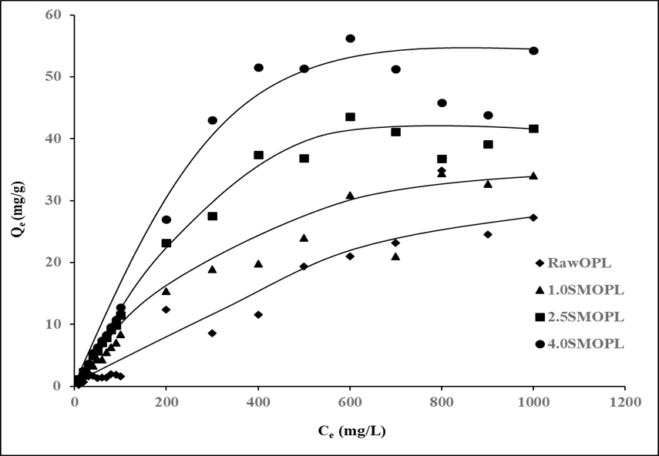

Figure 4. Effect of AO7 dye initial concentration on the adsorption capacity of raw OPL and SMOPL samples

Table 2. Fitted Langmuir and Freundlich parameters for the adsorption of AO7 onto OPL and SMOPL
Samples | Langmuir Isotherm Model |  |  | Freundlich Isotherm Model
Samples | Q_{o} (mg/g) | b (1/g) | R² | K_{f} (mg/g) | n (1/g) | R²
OPL | 40 | 0.0007 | 0.8328 | 25.82 | 36.1011 | 0.0211
SMOPL1.0 | 68.49 | 0.0012 | 0.9900 | 5.58 | 1.2724 | 0.9764
SMOPL2.5 | 81.30 | 0.0016 | 0.9947 | 3.76 | 1.2824 | 0.9668
SMOPL4.0 | 138.889 | 0.0010 | 0.9911 | 4.3 | 1.1923 | 0.9593

Conclusion

The potential of SMOPL to remove anionic dye from an aqueous solution was studied. The characterization of the SMOPL using the FTIR technique showed that the modification with the cationic surfactant CTAB did not change the main structure of the OPL. Through the dispersion behaviour study, the modification of OPL with CTAB molecules enhanced the hydrophilicity of OPL and caused it to interact more with the water molecules. The adsorption experiment was done to analyse the adsorption behaviour of both OPL and SMOPL towards the AO7 anionic dye. The effect of initial concentrations of the dye on the adsorption process was studied. The result showed that as the dye concentration increased, the adsorption capacity also increased. The analysis showed that the adsorption capacity of the OPL towards AO7 was enhanced by the modification of the OPL with more cationic surfactants. Therefore, the surfactant-modified oil palm leaf has the potential as a low-cost adsorbent for anionic dye removal from an aqueous solution.

Acknowledgement

The authors thank the Ministry of Higher Education Malaysia and Universiti Teknologi Malaysia for financially supporting this project under the IIIG research grant (Vot 02M61) and UTM-RUG (Vot 08H01).

References
- Hynes, N. R. J., Kumar, J. S., Kamyab, H., Sujana, J. A. J., Al-Khashman, O. A., Kuslu, Y., Ene. A. and Suresh, B. (2020). Modern enabling techniques and adsorbents-based dye removal with sustainability concerns in textile industrial sector-a comprehensive review. Journal of Cleaner Production, 272: 122636.
- Kubra, K. T., Salman, M. S. and Hasan, M. N. (2021). Enhanced toxic dye removal from wastewater using biodegradable polymeric natural adsorbent. Journal of Molecular Liquids, 328: 115468.
- Jawad, A. H., Abdulhameed, A. S. and Mastuli, M. S. (2020). Acid-factionalized biomass material for methylene blue dye removal: A comprehensive adsorption and mechanism study. Journal of Taibah University for Science, 14(1): 305-313.
- Wang, S., Gao, H., Fang, L., Hu, Q., Sun, G., Chen, X., Yu, X., Zhao, X. and Sun, G. (2021). Synthesis of novel CQDs/CeO₂/SrFe₁₂O₁₉ magnetic separation photocatalysts and synergic adsorption-photocatalytic degradation effect for methylene blue dye removal. Chemical Engineering Journal Advances, 6: 100089.
- Hamidian, K., Najafidoust, A., Miri, A. and Sarani, M. (2021). Photocatalytic performance on degradation of acid orange 7 dye using biosynthesized un-doped and co doped CeO₂ nanoparticles. Materials Research Bulletin, 138: 111206.
- Akpomie, K. G. and Conradie, J. (2020). Banana peel as a biosorbent for the decontamination of water pollutants. a review. Environmental Chemistry Letters, 18(4): 1085-1112.
- Setiabudi, H. D., Jusoh, R., Suhaimi, S. F. R. M. and Masrur, S. F. (2016). Adsorption of methylene blue onto oil palm (Elaeis guineensis) leaves: Process optimization, isotherm, kinetics and thermodynamic studies. Journal of the Taiwan Institute of Chemical Engineers, 63: 363-370.
- Ahmad, T., Rafatullah, M., Ghazali, A., Sulaiman, O. and Hashim, R. (2011). Oil palm biomass–based adsorbents for the removal of water pollutants—a review. Journal of Environmental Science and Health, Part C, 29(3): 177-222.
- Kamaru, A. A., Jani, N. S. A., Malek, N. A. N. N. and Sani, N. S. (2016). Adsorptive removal of methylene blue and acid orange 7 by hexadecyltrimethylammonium bromide modified rice husk. Jurnal Teknologi, 78(3-2): 113-119.
- Khalifa, M. A., Malek, N. A. N. N., Farimani, A. Y., Sani, N. S. and Kamaru, A. A. (2021). Cetylpyridinium bromide (CPB)-treated sugarcane bagasse for the removal of chromate in aqueous solution. Materials Today: Proceedings, 47(6): 1252-1257.
- Malek, N. A. N. N., Yusof, M. H. and Kamaru, A. A. (2019). Simultaneous action of surfactant modified sugarcane bagasse: Adsorbent and antibacterial agent. Malaysian Journal of Fundamental and Applied Science, 15: 32-37.
- Malek, N. A. N. N., Sihat, N. M., Khalifa, M. A., Kamaru, A. A. and Sani, N. S. (2016). Adsorption of acid orange 7 by cetylpyridinium bromide modified sugarcane bagasse. Jurnal Teknologi, 78(1-2): 97-103.
- Kamaru, A. A., Sani, N. S. and Malek, N. A. N. N. (2016). Raw and surfactant-modified pineapple leaf as adsorbent for removal of methylene blue and methyl orange from aqueous solution. Desalination and Water Treatment, 57(40): 18836-18850.
- Sidik, S. M., Jalil, A. A., Triwahyono, S., Adam, S. H., Satar, M. A. H. and Hameed, B. H. (2012). Modified oil palm leaves adsorbent with enhanced hydrophobicity for crude oil removal. Chemical Engineering Journal, 203: 9-18.
- Weng, C. H. and Wu, Y. C. (2011). Potential low-cost biosorbent for copper removal: pineapple leaf powder. Journal of Environmental Engineering, 138(3): 286-292.
- Sulaiman, O., Amini, M. H. M., Rafatullah, M., Hashim, R. and Ahmad, A. (2010). Adsorption equilibrium and thermodynamic studies of copper (II) ions from aqueous solutions by oil palm leaves. International Journal of Chemical Reactor Engineering, 8(1): 108.

- Ahmad, T., Irfan, M. and Bhattacharjee, S. (2016). Parametric study on gold nanoparticle synthesis using aqueous Elaise Guineensis (oil palm) leaf extract: Effect of precursor concentration. Procedia Engineering, 148: 1396-1401.
- Araujo, L. A., Bezerra, C. O., Cusioli, L. F., Silva, M. F., Nishi, L., Gomes, R. G. and Bergamasco, R. (2018). Moringa oleifera biomass residue for the removal of pharmaceuticals from water. Journal of Environmental Chemical Engineering, 6(6): 7192-7199.
- Nakagame, S., Chandra, R. P. and Saddler, J. N. (2010). The effect of isolated lignin’s, obtained from a range of pre-treated lignocellulosic substrates, on enzymatic hydrolysis. Biotechnology and Bioengineering, 105(5): 871-879.
- Tahir, N., Bhatti, H. N., Iqbal, M. and Noreen, S. (2017). Biopolymers composites with peanut hull waste biomass and application for crystal violet adsorption. International Journal of Biological Macromolecules, 94: 210-220.
- Neupane, S., Ramesh, S. T., Gandhimathi, R. and Nidheesh, P. V. (2015). Pineapple leaf (Ananas comosus) powder as a biosorbent for the removal of crystal violet from aqueous solution. Desalination and Water Treatment, 54(7): 2041-2054.
- Neugebauer, J. M. (1990). Detergents: An overview. Methods in Enzymology, 182: 239-253.

