

MODELLING AND OPTIMIZATION OF MICROWAVE ASSISTED EXTRACTION OF TOTAL PHENOLICS IN KAKAWATE (Gliricidia sepium) AS PESTICIDE AGAINST BLACK BEAN APHIDS (Aphis fabae)

(Pemodelan dan Pengoptimuman Pengekstrakan Berbantu Gelombang Mikro bagi Jumlah Fenolik dalam Kakawate (Gliricidia sepium) sebagai Racun Makhluk Perosak Afid Kacang Hitam (Aphis fabae))

Rhonalyn V. Maulion*, John Marco I. Matira, Kristine May M. Fanoga, Maricar C. Marasigan
Melissa Marie C. Dimaculangan⁵

Department of Chemical Engineering, College of Engineering Architecture and Fine Arts,
Batangas State University, Batangas City, Philippines

*Corresponding author: rhonalyn.maulion@g.batstate-u.edu.ph

Received: 15 July 2021; Accepted: 28 October 2021; Published: xx December 2021

Abstract

Pest infestation is one of the serious problems of the agricultural sector in crop production and may even pose health hazards to humans. Aphis fabae, normally known as black bean aphid, is one of the main culprits that predominantly damage growing crops particularly beans, celery, and peas and may carry diseases as they multiply. Kakawate (Gliricidia sepium) leaves extracts was prepared using microwave assisted extraction and used as pesticide against black bean aphids in string beans (Phaseolus vulgaris). Microwave assisted extraction (MAE) is a rapid method of extraction of active components of plants which employ microwave energy to heat sample-solvent mixture at a short period of time. A central composite design (CCD) was employed to evaluate the effect of irradiation time (1.5 minutes) and microwave power (210W, 350W) on the phenolic content of the extract. Response surface methodology (RSM) determined the optimized conditions of MAE of total phenolics in dried G. sepium leaves. The optimized conditions were obtained at irradiation time of 2.44 minutes and microwave power of 275W with total phenolic content of 9.022 mg-GAE/g-dry sample. The presence of bioactive compounds of alkaloids, flavonoids, tannins and phenols were confirmed in the extract. The mortality or average life span of A. fabae upon application of G. sepium pesticide and commercially available pesticide are 5.17 seconds and 4.73 seconds, of which the difference is insignificant with the p-value one tail (0.002) and two tail (0.005) effect. No significant effect on the height of plant and number of P. vulgaris leaves at 10 days after the application of G. sepium pesticide (p = 0.022) and commercially available pesticide (p = 0.026) which make it a great potential biopesticide.

Keywords: black bean aphids, botanical pesticides, Gliricidia sepium, microwave assisted extraction, total phenolic content

Abstrak

Serangan makhluk perosak ialah satu masalah serius bagi sektor pertanian terutama hasil tuaian dan mungkin memberi kesan kesihatan terhadap manusia. Aphis fabae, juga dikenali sebagai afid kacang hitam, merupakan satu dari pemangsa utama yang merosakkan tanaman seperti kacang, seleri, kacang pea dan membawa penyakit. Ekstrak daun Kakawate (Gliricidia sepium) telah disediakan melalui pengekstrakan berbantu gelombang mikro dan digunakan sebagai racun mahkluk perosak bagi melawan afid kacang hitam dalam untaian kacang (Phaseolus vulgaris). Pengekstrakan berbantu gelombang mikro (MAE) ialah satu kaedah pantas bagi pengekstrakan sebatian aktif dari tumbuhan di mana tenaga gelombang mikro digunakan memanaskan sampel campuran pelarut dalam tempoh masa yang singkat. Reka bentuk komposit berpusat (CCD) telah dibangunkan bagi penilaian kesan masa penyinaran (1.5 minit) dan kuasa gelombang mikro (210W, 350W) terhadap kandungan fenolik bagi hasil ekstrak. Keadaan optimum MAE bagi jumlah fenolik daun kering G. sepium ditentukan melalui kaedah gerak balas permukaan (RSM). Keadaan optimum telah diperolehi pada masa penyinaran 2.44 minit dan kuasa gelombang mikro ialah 275 W bersamaan jumlah kandungan fenolik 9.022 mg-GAE/g-sampel kering. Kehadiran sebatian bioaktif seperti alkaloid, flavonoid, tannin dan fenol telah disahkan melalui hasil ekstrak. Kadar kematian atau purata jangka hayat bagi A. fabae berdasarkan pengunaan racun makhluk perosak G. sepium dan perbandingan racun komersial ialah 5.17 saat dan 4.74 saat, di mana perbezaannya tidak signifikan dengan nilai p kesan satu arah (0.002) dan dua arah (0.005). Tiada kesan signifikan terhadap ketinggian pokok dan bilangan P. vulgaris selepas 10 hari racun G.sepium digunapakai (p = 0.022) dan racun komersial (p = 0.026) di mana ia menunjukkan potensi yang baik sebagai racun mahkluk perosak bio.

Kata kunci: afid kacang hitam, racun botani, Gliricidia sepium, pengekstrakan berbantu gelombang mikro, jumlah kandungan fenolik

Introduction
Food security is threatened by the occurrence of insect pest outbreak which estimated to have caused a loss of 20-40% of global crop production due to infestation [1, 2]. Insect pests are considered destructive to the natural environment, adversely impact human health and activities, and damage agricultural production. The quality of crops of a farmer are affected by the pest that thrive on the plants as they grow hence affecting market and reduced crops production to as much as 50% [3, 4]. One of the most serious pests encountered by farmers on their crops is black bean aphids (Aphis fabae). It is a small black insect with a soft body with piercing and sucking mouthparts that transmit harmful viruses to plants and grow in large numbers in agricultural, wild, horticultural, and ornamental plants [5]. It is an identified severe pest of economically important crops which are distributed worldwide, feeding about 200 hosts in various botanical families [6]. Devastating populations of black bean aphids reproduce on the plant hosts under otherwise good developmental conditions, which result to leaf curling, distortion and yellowing through virus transmission to the plant host [7]. The sucking of plant sap from stems and leaves and the transmission of its viruses to plants diminishes the vigor of the plant and hinder its growth [8], hence reducing production yield. P. vulgaris is one of the plants that are commonly infested by black aphids. It is a green color crop with high nutritional value hence proper care must be provided to prevent pest infestation.

Pesticides are used to kill or control pests that invade plants to protect it against the damage from infestation. Synthetic pesticides have proven toxic to pests, reduce crop damages and improve crop production. However, its use has some negative impact on human health and detrimental consequences to the environment such as water pollution, the necessity for excessive use of water, and the growth of weeds [9]. The use of botanical pesticides from plant material is considered a viable alternative to synthetic chemical pesticides because it is environmentally safe, naturally available, and low-cost. Many plants are capable in controlling pest and is being used in traditional agriculture application in most developing countries, particularly the tropical areas [10]. It contains active metabolites which are responsible for pesticidal and fungicidal activity. Phenolic compounds include simple phenols, flavonoids, flavonols, tannins, coumarins, quinnones, and flavons are phytochemicals, which are the major bioactive compounds which have a linear relation to antioxidant activity and toxicity to fungi and pest [9, 11]. Kakawate (Gliricidia sepium) contains coumarins which are potent neutralizers of bed bugs and termites because it possesses a variety of biological properties like antimicrobial, anti-inflammatory, antiviral, antioxidant, and others [12]. Moreover, the leaf extract was proven effective for removal of animal lice and ticks, nematocidal activity against Meloidogyne and has antibacterial properties for a wide classification of bacteria, as well as fungicidal properties [13]. The phytochemicals present in leaf extract exhibit antioxidant properties which is an active component of biological pesticides, however possible degradation during the extraction process may occur which affect the yield and quality of phenolic compounds. Hence, choosing the suitable method of extraction of phenolic compounds from plant source must take into consideration.

Several techniques used for the extraction of phenolic compounds from plant include solvent extraction [14,15,16], Soxhlet extraction [17], supercritical fluid extraction (SFE) [18, 19, 20] and microwave assisted extraction (MAE) [21-25]. These methods require solvent penetration in the plant matrix to separate the phenolic compounds in the plant source. Conventional extraction method such as solvent and Soxhlet extraction has the advantage of lower equipment cost, however it requires extensive use of organic solvent and long extraction time which may cause possible degradation of bioactive compounds and lower extraction efficiency [26]. Advanced method like SFE minimize degradation of phenolic compounds [19], achieved faster extraction time and higher extraction yield due to high degree of selectivity to the compound [27] but a fluid’s supercritical state should have maintained which requires high operating and capital cost. These shortcomings can be partially or completely overcome using MAE which operates at low extraction time, low energy requirement, less consumption of solvent and has improved yield [28]. In MAE, the extraction of bioactive compounds was due to the penetration of the solvent to the plants cell wall and heating with electromagnetic waves. It is important to understand the interaction between the microwave power and irradiation time during MAE to optimize the extraction conditions [29]. The increase in extraction yield was attained by increasing the temperature under microwave heating at short exposure time [30] but may not be generalized due to diverse nature of the phytochemicals present in plant. In view of these, it is important to optimized the MAE parameters such as microwave power and irradiation time and generate a mathematical model that describes the yield of phenolic compounds from G. sepium leaves. Generation of mathematical model provides useful information in control of extraction process, design and scale up of equipment [31] for practical application. It is also important to determine the effectiveness of the produced extract as botanical pesticide by measuring the mortality of black bean aphids upon application.

Materials and Methods
Folin Ciocalteu phenol reagent purchased from Merck and ACS reagent grade sodium carbonate, Na₂CO₃ at >99.5% purity and gallic acid was used for spectrophotometric quantification of TPC. Analytical grade potassium mercuric iodide (K₂HgI₄), sodium hydroxide (NaOH), sodium chloride (NaCl) and anhydrous ferric chloride (FeCl3) was used for qualitative determination of phytochemicals. Laboratory grade ethanol, 95% (C₂H₅OH) was used for microwave assisted extraction of TPC from G. sepium. A batch of G. sepium leaves obtained from Alitagtag, Batangas was used as a precursor of TPC. The schematic of the study was shown in Figure 1.

Sample preparation
The G. sepium leaves was freshly harvested from a farm in Alitagtag, Batangas. The sample were carefully cleaned and washed several times with de-ionized water to remove dirt, drained, placed in zip lock plastic bags and frozen overnight at -4 ºC before drying. The frozen samples were freeze dried in the Instrumentation Laboratory of the Science and Technology Research Center, De La Salle University, Manila using a vacuum freeze dryer at -40ºC. The moisture content of the G. sepium was determined (1) by getting the difference of the weight of the sample before (W_{i}) and after ((W_{i}) drying. The weight of the sample was obtained using a laboratory analytical balance.
$\text{moisture content} \left(\text{\%}\right)\text{=} \frac{{\text{W}}_{\text{i}}\text{-} {\text{W}}_{\text{f}}}{{\text{W}}_{\text{i}}}\text{ x 100}$ (1)
The freeze-dried samples were milled using a blender to obtain fine powder and passed through a 35-tyler mesh sieve to collect sizes less than 500 microns. The G. sepium fine powder was placed in a sealed glass container to avoid adsorption of moisture which may affect the analysis of phenolic compounds and its optimization.

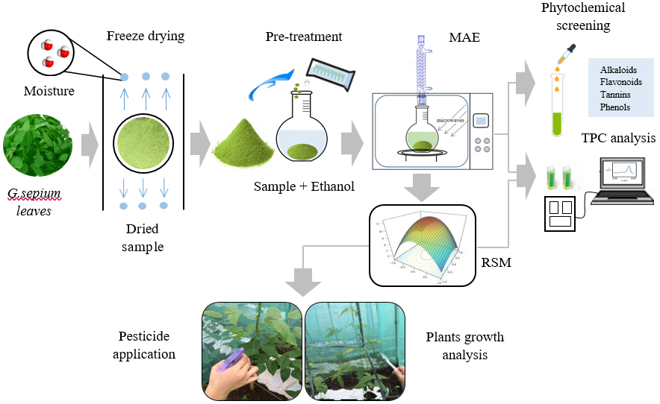
Figure 1. Scheme for extraction of G. sepium leaves using MAE method

Microwave assisted extraction
A Face Centered Central Composite Design is the design of experiment used in the extraction of total phenolics in the G. sepium leaves with two independent numeric variables such as irradiation time and microwave power. The coded value of the independent variable was shown (Table 1) to clearly see the minimum and maximum operation conditions of MAE and the Design of Experiment (Table 2) to describe each set-up.

A full level factorial scheme was used in the analysis have a total of 13 runs with the following characteristics: face centered with α = 1, 8 factorial points, 5 center points at confidence level of 95% (p=0.05) was used in the analysis. To lessen the effect of natural variability on the response, sampling was done randomly. The optimized condition was determined using Response surface methodology (RSM) while the determination of the significance of primary variable effects, variable interaction, and the model will be evaluated using Analysis of variance (ANOVA).

The freeze-dried sample was pretreated with ethanol to soften the cell wall and initiate the release of soluble phytochemicals. The 1-gram sample of G. sepium leaves powder was pre-leached by soaking in 200mL of 95% ethanol for 2 hours. The pre-leached samples were transferred in a microwave oven for extraction of TPC following the design of experiment in Table 2. After each extraction set-up, the liquid was separated from the solid residue using centrifuge at 4000rpm. The crude liquid extract was kept at 4ºC to preserve the bioactive components.

Table 1. Coded values of independent variables
Independent Variables |  | ( -1 ) | ( 0 ) | (+1)
Irradiation time (minutes) |  | 1 | 3 | 5
Microwave power (Watts) |  | 210 | 280 | 350

Table 2. Design of Experiment using Central Composite Design
Standard | Run | Factor 1  A: Irradiation Time  (Minutes) | Factor 2  B: Microwave Power  (Watts) | Response  TPC  (mg-GAE/g-sample)
13 | 1 | 3 | 280 | R₁
12 | 2 | 3 | 280 | R₂
5 | 3 | 1 | 280 | R₃
8 | 4 | 3 | 350 | R₄
11 | 5 | 3 | 280 | R₅
1 | 6 | 1 | 210 | R₆
6 | 7 | 5 | 280 | R₇
7 | 8 | 3 | 210 | R₈
10 | 9 | 3 | 280 | R₉
9 | 10 | 3 | 280 | R₁₀
4 | 11 | 5 | 350 | R₁₁
3 | 12 | 1 | 350 | R₁₂
2 | 13 | 3 | 210 | R₁₃

Determination of phytochemicals of G. sepium leaves extract
The crude extracts from G. sepium obtained at optimized condition were examined qualitatively for presence of phytochemicals such as alkaloids, flavonoids, tannins, and simple phenols. A 5mL crude extract was used in the analysis and the reaction occurred after addition of reagents will determine the presence of each phytochemical. The presence of alkaloids was determined by acidifying 5mL crude extract with hydrochloric acid and addition of 3 drops of Mayer’s reagent (K₂HgI₄). Flavonoids were identified using alkaline reagent analysis wherein the crude extracts were treated with a small amount of NaOH solution dilute hydrochloric acid. Presence of tannins was determined upon addition of NaCl to the crude extract. Finally, the presence of simple phenols was analyzed by adding few drops of FeCl₃ solution to the crude extract.

Determination of total phenolic content
TPC of the extract was quantified using modified Folin Ciocalteu method [32]. A 0.5 mL crude extract was mixed with 0.5 mL of 10% Folin Ciocalteu reagent solution. After 5 minutes, 1-mL of 15% w/w Na₂CO₃ was added to the mixture to catalyze the reaction. The samples were left standing in the dark for 1 hour to achieve complete reaction. A sample prepared (5%v/v) was quantified using spectrophotometer (Shimadzu UV-1800 spectrophotometer) at λ_{max} = 765nm and the result was compared to the standard curve and expressed as gallic acid equivalents (GAE) per gram sample.

Pest and plant isolation
The infested P. vulgaris beans with black bean aphids were sequestered from the other plants by means of housing it into a cage made of nets and fences having a dimension of 34x72x59”. Six (6) cages were prepared which corresponds to the triplicated plots for each kind of pesticide which are the G. sepium extract based pesticide and the commercially available one. A larger cage was made in order to house the three (3) smaller cages with nine (9) string beans plants. A total of six (6) huge cages were made. This is to ensure that the pest will not escape when the researchers apply the pesticide in every plot. Each plot was planted with the same number of string beans.

Pesticide preparation and application
The crude extract produced at optimized condition was purified using rotary evaporator to remove excess ethanol leaving only the crude extract of G. sepium. A 20mL dosing amount of extract were placed in sterilized and clean spray bottles. The P. vulgaris beans plant was sprayed with formulated pesticide. The effect of pesticide on the plant’s height and leaf color and number were examined for 10 consecutive days. The experiments were done in triplicates and were calculated for statistical comparison of the effectiveness and performance of botanical pesticide with commercially available pesticides.

Results and Discussion
The dry weight of the G. sepium leaves obtained after freeze drying was 32.34%. The average dry matter in G. sepium leaves was 25.3% ranging from 19.6 to 37% [33]. The use of the vacuum freeze drying is advantageous from other dehydration methods since the constituents of the dried material remain homogenously dispersed, has less damage on the volatile substances compared to other dehydration methods operated at higher temperatures, hence preserving the phytochemicals of the G. sepium samples. Moreover, no shrinkage or toughening of the material after drying can be observed and can be protected against spoilage for a longer period of time.

Phytochemical screening of G. sepium leaves extract
The presence of phytochemicals or phenolic compounds such as alkaloids, flavonoids, tannins and simple phenols play an important role in pesticide production due to its antibacterial, antimicrobial and insecticidal properties. These are the major bioactive compounds which have a linear relation to antioxidant activity and toxicity to fungi and pest [9,11]. Table 3 shows the result of phytochemical screening of crude ethanolic G. sepium leaves. The color change of the crude extract indicates the presence of phytochemicals.

Qualitative phytochemical screening of crude G. sepium leaves confirmed the presence of alkaloids, flavonoids, tannins, and phenols. These phytochemicals in crude extracts of G sepium leaves indicates the presence of appreciable amounts of bioactive compounds [34, 35] in the extract which exist linearly to TPC and antioxidant activity. Phenolic compounds are the major bioactive compounds found in dried herbs and a linear relationship exists between the total phenolic content and the antioxidant activity of herbs [36, 37]. The presence of alkaloids indicates the appearance of yellow colored residue after acidification and addition of Mayer’s reagent. On the other hand, after treatment with alkaline reagent, an intense yellow color solution was formed and become colorless upon acidification which indicates the presence of flavonoids. Moreover, the presence of tannins was identified after the formation of white precipitates upon addition of salt to the crude extract. Finally, simple phenols were identified for the appearance of bluish black color after addition of ferric chloride. All the phytochemicals tested were found to be present in the extracts of G. sepium, hence it can be assumed that this extract exhibit good antioxidant activities that can be an active component of effective biopesticide.

Microwave assisted extraction of TPC in G. sepium leaves extract
To optimize the extraction of TPC in crude extract of G. sepium, two parameters were varied in the studies such as irradiation time (1.5 minutes) and microwave power (210-350W). The design has 13 runs comprising of 8 non-center points and 5 center points. To lessen the effect of natural variability on the response, sampling was done randomly. Among the varying condition of MAE, the highest TPC obtained in ethanolic extract of G. sepium leaves is 9.04 mg GAE/g dry sample extracted at 3 minutes irradiation time and 280W microwave power while the lowest amount of 2.30 mg-GAE/g-dry sample was obtained at 5 minutes irradiation time and 350W. The TPC values in the present study is higher compared with [38, 39] having 7.57 mg-GAE/g-dry sample where the extraction was done by soaking in ethanol for 3 days and 1.7 mg/ml respectively. Preservation of the bioactive components are achieved using MAE compared to conventional soaking with solvents which improved the antimicrobial and antioxidant activity of the extract.

MAE is effective in extraction of TPC, however proper control of irradiation time and microwave power must be considered to improve extraction yield and reduce processing cost. Phenolic content degrades with longer extraction time and high temperature [40]. Likewise, with higher power settings, too much penetration of the electromagnetic waves was encountered and resulted in the breakdown of phenolic compounds. Increasing irradiation time and microwave power increased the amount of analyte being extracted, although there is the risk of extracted compound degradation [41]. However, at too short extraction time, less amount of total phenolic content can be extracted, thus its effect on extraction of TPC must be determined. The effect of irradiation time and microwave power and their interaction in extraction of TPC in ethanolic G. sepium leaves (Figure 2) is important to study to see its trend.

It is evident from the graph that at increasing irradiation time from 1 to 3 minutes, there is an increase in the extracted TPC at microwave power of 210W signifying the continuous extraction of TPC. As the microwave power increased to 350W, less time is needed to obtain the highest TPC because more electromagnetic waves have been absorbed at a given time. As the extraction process continued longer, a decreasing trend in the phenolic content was observed in both microwave power condition which may be due to degradation of the bioactive components and its evaporation. A drastic decrease in TPC was observed with a longer extraction time at a higher microwave power. An intersection of the curves indicates that the interaction of the process condition was found to affect the extraction of TPC. It revealed that increasing irradiation time and microwave power resulted to an increase in TPC, however were nullified as further increases in both factors were made. This is due to the reason that longer time or exposure and too much microwave power causes a rapid rupture of cell wall that resulted to degradation, hence a lower TPC was obtained. To determine the effect of the primary variables and their interaction, ANOVA was used. Coded equation (2) is useful in identifying the relative impact of irradiation time and microwave power on TPC based on their coefficients.

In comparing the level of their coefficients, irradiation time has greater impact compared to microwave power on the extraction of TPC. The actual equation can be used to predict the TPC at a given condition. The coded equation (2) is very useful to predict the impact of each factors on TPC of G. sepium within the design space. Likewise, actual equation (3) can be used to make predictions on the amount of TPC extracted from G. sepium at a given level of each factors within the design space.

The ANOVA (Table 4) for the model is important to see the significance of the equation to the response within the design space.

The interaction of irradiation with time and power were found to be highly significant with p-value of 0.0078 at α=0.05. The model was generated to relate the specific variable to TPC of G. sepium leaves extract. The devised equation was based on quadratic model with F-value of 50.15 and p-value of <0.0001 at 0.05 level of significance which implies that the model is significant with R² = 0.97. Moreover, the adequate precision is 21.16 which indicates an adequate signal to noise ratio and is desirable, thus the model can be used to navigate the design space at irradiation time of 1 to 5 minutes and microwave power of 210-350 watts. The residual plot of the model (Figure 3) generated is relatively normal distribution which indicates that model chosen representing the data adequate. This was also supported by the plot of predicted versus actual values.

Table 3. Qualitative phytochemical screening of the crude ethanolic extract of G-sepium leaves
 | Alkaloids | Flavonoids | Tannins | Phenols
Appearance  Presence of Phytochemicals | Green to yellow extract  + | Green to intense yellow extract  + | Formation of white precipitate  + | Green to bluish black extract  +

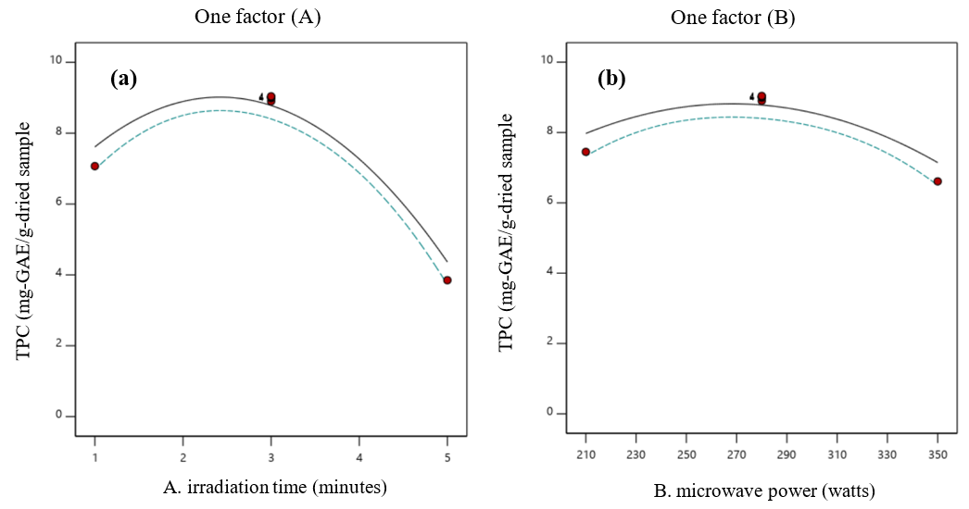

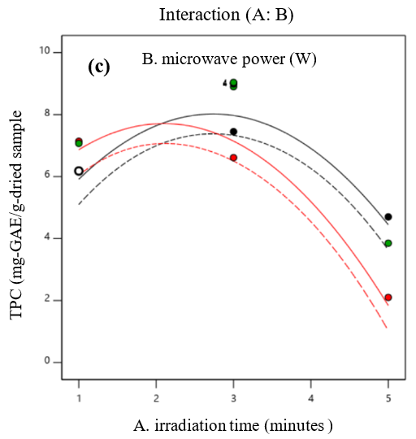
Figure 2. Effect of irradiation time (a) and microwave power (b) and their interaction (c) on TPC of G. sepium leaves extract: Design points: (-) 210W, (--) 210W at 95% CF, (-) 210W, (--) 210W at 95% CF, (•) design points

$TPC= +8.78-1.62A-0.4133B-0.8900AB-{2.79A}^{2}-{1.22B}^{2}$ (2)

$TPC= -18.31+5.16A+0.153B-0.006AB-{0.698A}^{2}-{{2.49x10}^{-4}B}^{2}$ (3)

Table 4. ANOVA for Quadratic model
Source | Sum of squares | F-value | P-value | Effect
Model | 58.43 | 50.15 | <0.0001 | Significant
A: Irradiation time | 15.81 | 67.85 | <0.0001 | Significant
B: Microwave power | 1.03 | 4.40 | 0.0742 | not-significant
AB | 3.17 | 13.60 | 0.0078 | Significant
A² | 21.54 | 92.4 | <0.0001 | Significant
B² | 4.13 | 17.71 | 0.0040 | Significant

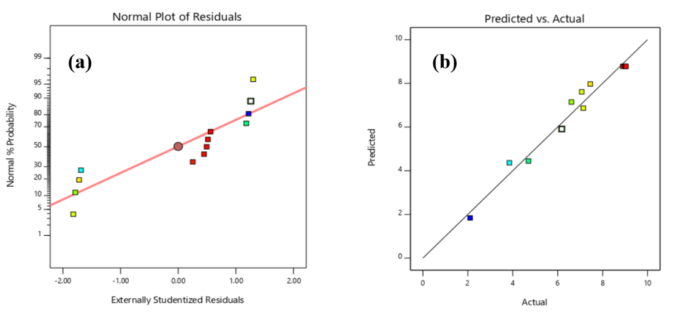

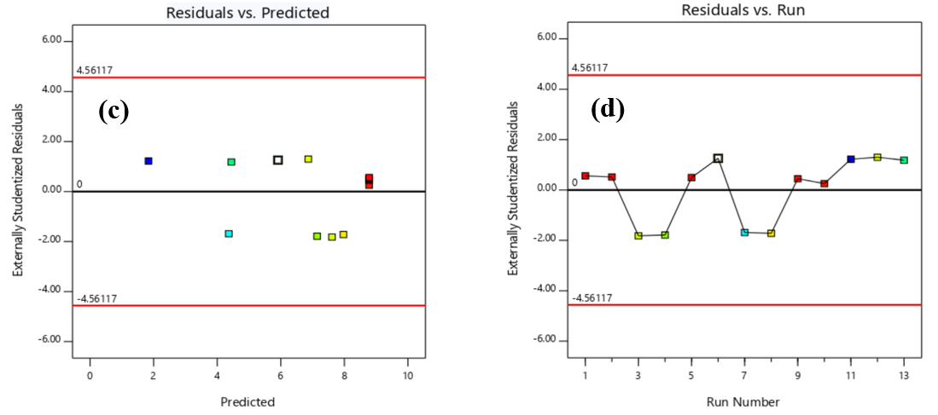

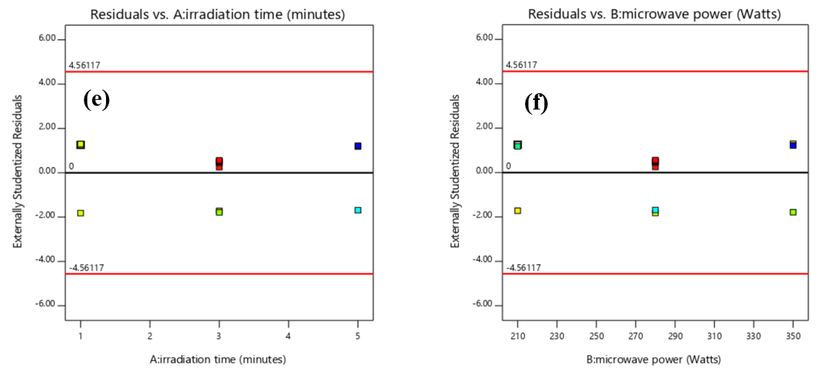

Figure 3. Diagnostics: Normal plot of residuals (a), Predicted vs. actual (b), Residual vs. predicted (c), Residuals vs. run (d), Residuals vs irradiation time (e), Residuals vs. microwave power (f)

Optimization of TPC extraction in G. sepium leaves
Response surface methodology was used to determine the optimum condition for the extraction of TPC in G. sepium at a given design space. Determination of optimum irradiation time and microwave power is necessary to achieve higher yield and low processing cost. Irradiation time and microwave power are essential parameters in MAE extraction and inadequate selection of either less and enormous time and power of extraction can alter the phenolic compounds in plant material [41]. The model plot of MAE of TPC from G-sepium leaves was shown in Figure 4.

The red portion of the plots in both 3D model (Figure 4.a) and contour plot model (Figure 4.b) represents the good condition which yield a high TPC result in which the irradiation time of about 3 minutes and microwave power of 280 watts showed a favorable performance of TPC extraction. The light green up to dark blue represents less to least TPC value. Increasing yield of TPC was observed as the irradiation time increased from 1 minute to less than 3 minutes and microwave power of 210 watts to 280 watts. There is a decline in TPC as irradiation time and microwave power exceeded 3 minutes and 280 watts, respectively. This indicated that upon reaching equilibrium, the interaction of the parameters with extracting solvent and G. sepium occurs until it reached the highest TPC at 3 minutes and 280 watts. Once the highest yield was achieved and the extraction continued, the dissolution of the phenolic compound into the solvent began and this was due to the prolonged exposure to irradiation [42,43]. Decline in TPC (2.1 mg-GAE/g-dry sample) beyond 280 watts can be associated with the overexposure to electromagnetic radiation that activated the diffusion coefficient between solvent and plants resulting from the increased power. This implies that the limited exposure and prolonged exposure of plant matrix to electromagnetic radiation belittle the TPC yield. The highest yield of TPC (9.04 mg-GAE/g-dray sample) was observed at 3 minutes of irradiation time and 280 watts of microwave power which should be considered as the maximum setting MAE. The optimized condition (TPC= 9.022 mg-GAE.g-dry sample) was attained at an irradiation time of 2.44 minutes and microwave power of 275 W at the desirability of 0.997. The generated model was validated by performing extraction of phenolics at 2.44 minutes and 280W power which attained actual TPC of 9.01 mg-GAE/g-dry sample against the predicted value of 9.02 ± 0.48 mg-GAE/g-dry sample. The actual obtained is within the predicted range at 95% confidence level which validated the model.
Effect of G. sepium pesticide upon application
It is important to determine the effect of the application of pesticide on the target pest and the growth of plant. The TPC of G. sepium extract is the active component of the pesticide that enhances its antimicrobial and antioxidant property [23]. Upon application of G. sepium pesticide and the commercially available pesticide, the mortality or average life span of A. fabae are found to be 5.17 seconds and 4.73 seconds respectively. The difference of the result is insignificant in one tail (p-value = 0.002) and two tail (p-value = 0.005). In case of the control (without pesticide application), there is no pest mortality observed. The effect of G. sepium pesticide on the growth of P. vulgaris plants in terms of height and leaves were also studied. A total of 90 P. vulgaris plants were harvested and measured for its height and all the leaves of the P. vulgaris plants were counted. The p-value obtained after 10 days monitoring on the height and number of leaves of P. vulgaris plant compared to the control are 0.025 and 0.0266 respectively at a=0.05 which indicates no significant differences. This implies that the G. sepium pesticide effectiveness against A. fabae is comparable to the commercially available pesticides on the market. Thus, the use of biological pesticides is advantageous in terms of its safe use which caused no hazards to human health and environment.

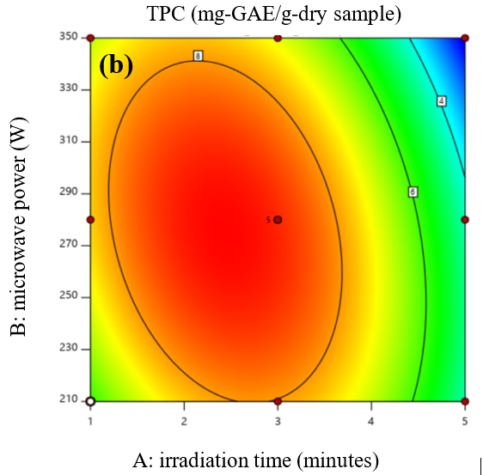

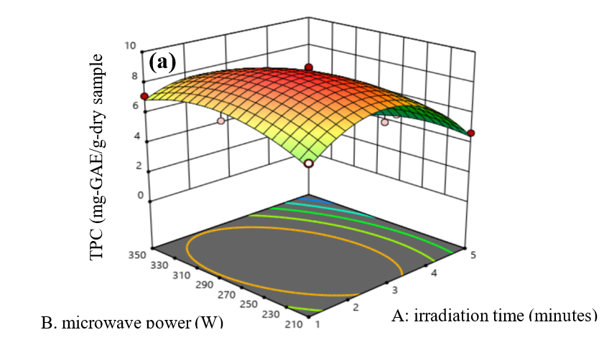
Figure 4. Model Plot of MAE of TPC from G. sepium extract (3-D surface plot (a) and contour plot (b)

Conclusion

The presence of phytochemicals such as alkaloids, flavonoids, tannins, and phenols are present in G. sepium extract which are the active components of its antimicrobial, antioxidant, anti-fungicidal and even the anti-insecticidal activity. Careful control of irradiation time and microwave power in MAE is required to attain high TPC yield. The interaction of the two parameters can give the optimum yield TPC from G. sepium. Prolonged irradiation time and increasing microwave power affect TPC of the plant due to degradation and evaporation. The effectiveness of G. sepium on A. fabae mortality and growth of P. vulgaris plant was comparable to the commercially available pesticide in the market but is advantageous in terms of use because it is safe for humans and posed no hazards to the environment.

Acknowledgement

The authors acknowledge the assistance from the Department of Agriculture, Batangas, Philippines for the acquisition of aphids and application of pesticide. Sincerest thanks are also offered to Dr. Reymark D. Maalihan of Material Testing and Calibration Center, Batangas State University Alangilan, Philippines for sharing valuable inputs.

References
- Food and Agriculture Organization (2017). The future of food and agriculture: Trends and challenges. http://www.fao.org/. [Access online 15 March 2021].
- Food and Agriculture Organization (2019). New standard to curb the global spread of plant pest and diseases. http://www.fao.org/. [Access online 15 March 2021].
- Goodhue, R. E., Bolda, M., Farnsworth, D., Williams, J. C. and Zalom, F. G. (2011). Spotted wing drosophila infestation of California strawberries and raspberries: economic analysis of potential revenue losses and control costs. Pest Management Science, 67(11): 1396-1402.
- Rodriguez, T. (2018). Managing insect pest on organic vegetable production. https://www. agriculture.com.ph/. [Access online 28 February 2020].
- University of Idaho (2021). Integrated pest management: Black bean aphids. https://www.uidaho.edu/. [Access online 15 March 2021].
- Shannag H. K. (2007). Effect of black bean aphids, Aphis fabae, on transpiration stomatal conductance and crude protein content of faba bean. Annals of Applied Biology, 151: 183-187.
- Razmjou, J. and Fallahi, A. (2009). Effects of sugar beet cultivar on development and reproductive capacity of Aphis fabae. Bulletin of Insectology. 62(2): 196-201.
- Kankolongo A. M. (2018). Leguminous crops. Food crop production of smallholder farmers in southern Africa: pp. 173-203
- Boulogne, I., Petit, P., Ozier-lafontaine, H., Loranger-Merciris, G., Boulogne, I. and Petit, P. (2012). Insecticidal and antifungal chemicals produced by plants: A review. Environmental Chemistry Letters, 10(4): 325-347.
- Okwute, S. K. (2012). Plants as potential sources of pesticidal agents: A review. Pesticides – Advances in Chemical and Botanical Pesticides: pp. 207-232.
- Saeed, N., Khan, M. R., & Shabbir, M. (2012). Antioxidant activity, total phenolic and total flavonoid contents of whole plant extracts Torilis leptophylla L. BMC Complementary and Alternative Medicine, 12: 221.
- Rabena, A. R. (1996). Isolation, characterization and identification of the active component of Kakawate (Gliricidia sepium) (Jacq.) Kunth ex Walp. Leaves against termites (Microcerotermes losbanosensis). Thesis of Master Degree, Philippines University Los Banos College, Laguna, Philippines
- Torres, L. M. (2018). Madre de cacao (Gliricidia sepium) and sinta (Andrographis paniculata) leaves extract as botanical animal lice and ticks remover. Journal of Fundamental and Applied Sciences, 10(3S): 650-664.

- Do, Q. D., Angkawijaya, A. E., Tran-Nguyen, P. L., Huynh, L. H., Soetaredjo, F. E., Ismadji, S. and Ju, Y. H. (2014). Effect of extraction solvent on total phenol content, total flavonoid content, and antioxidant activity of Limnophila aromatica. Journal of Food and Drug Analysis, 22(3): 296-302.
- Altemimi, A., Lakhssassi, N., Baharlouei, A., Watson, D. G. and Lightfoot, D. A. (2017). Phytochemicals: Extraction, isolation, and identification of bioactive compounds from plant extracts. Plants, 6(4): 42.
- Zhong, L., Yuan, Z., Rong, L., Zhang, Y., Xiong, G., Liu, Y. and Li, C. (2019). An optimized method for extraction and characterization of phenolic compounds in Dendranthema indicum var. aromaticum flower. Scientific Reports, 9(1): 1-12.
- Alara, O. R., Abdurahman, N. H., and Ukaegbu, C. I. (2018). Soxhlet extraction of phenolic compounds from Vernonia cinerea leaves and its antioxidant activity. Journal of Applied Research on Medicinal and Aromatic Plants, 11(6): 12-17.
- Ghafoor, K., AL-Juhaimi, F. Y. and Choi, Y. H. (2012). Supercritical fluid extraction of phenolic compounds and antioxidants from grape (Vitis labrusca B.) seeds. Plant Foods for Human Nutrition, 67(4): 407-414.
- Farías-Campomanes, A. M., Rostagno, M. A., Coaquira-Quispe, J. J. and Meireles, M. A. A. (2015). Supercritical fluid extraction of polyphenols from lees: Overall extraction curve, kinetic data and composition of the extracts. Bioresources and Bioprocessing, 2(1): 45.
- Phan, L. T. M., Nguyen, K. T. P., Vuong, H. T., Tran, D. D., Nguyen, T. X. P., Hoang, M. N. and Nguyen, H. H. (2020). Supercritical fluid extraction of polyphenols from Vietnamese Callisia fragrans leaves and antioxidant activity of the extract. Journal of Chemistry, 2020: 9548401.
- Gallo, M., Ferracane, R., Graziani, G., Ritieni, A. and Fogliano, V. (2010). Microwave assisted extraction of phenolic compounds from four different spices. Molecules, 15(9): 6365-6374.
- Kaur, P., Chaudhary, A., Singh, B. and Gopichand. (2012). An efficient microwave assisted extraction of phenolic compounds and antioxidant potential of Ginkgo biloba. Natural Product Communications, 7(2): 203-206.
- Wong-Paz, J. E., Contreras-Esquivel, J. C., Muñiz-Marquez, D., Belmares, R., Rodriguez, R., Flores, P., and Aguilar, C. N. (2014). Microwave-assisted extraction of phenolic antioxidants from semiarid plants. American Journal of Agricultural and Biological Science, 9(3): 299-310.
- Li, Y., Li, S., Lin, S. J., Zhang, J. J., Zhao, C. N. and Li, H. Bin. (2017). Microwave-assisted extraction of natural antioxidants from the exotic Gordonia axillaris fruit: Optimization and identification of phenolic compounds. Molecules, 22(9): 1481.
- Akhtar, I., Javad, S., Yousaf, Z., Iqbal, S. and Jabeen, K. (2019). Microwave assisted extraction of phytochemicals an efficient and modern approach for botanicals and pharmaceuticals. Pakistan Journal of Pharmaceutical Sciences, 32(1): 223-230.
- Durmaz, E., Sumnu, G. and Sahin, S. (2015). Microwave-assisted extraction of phenolic compounds from caper. Separation Science and Technology (Philadelphia), 50(13): 1986-1992.
- Mendiola, J. A., Herrero, M., Castro-Puyana, M. and Ibáñez, E. (2013). Supercritical fluid extraction. RSC Green Chemistry, 1: 196-230.
- Lovrić, V., Putnik, P., Kovačević, D. B., Jukić, M., & Dragović-Uzelac, V. (2017). Effect of microwave-assisted extraction on the phenolic compounds and antioxidant capacity of blackthorn flowers. Food Technology and Biotechnology. 55(2): 243-250.
- Kaderides, K., Papaoikonomou, L., Serafim, M. and Goula, A. M. (2019). Microwave-assisted extraction of phenolics from pomegranate peels: Optimization, kinetics, and comparison with ultrasounds extraction. Chemical Engineering and Processing - Process Intensification, 137: 1-11.
- Zheng, X., Xu, X., Liu, C., Sun, Y., Lin, Z. and Liu, H. (2013). Extraction characteristics and optimal parameters of anthocyanin from blueberry powder under microwave-assisted extraction conditions. Separation and Purification Technology, 104: 17-25.

- Shirsath, S. R., Sable, S. S., Gaikwad, S. G., Sonawane, S. H., Saini, D. R. and Gogate, P. R. (2017). Intensification of extraction of curcumin from Curcuma amada using ultrasound assisted approach: Effect of different operating parameters. Ultrasonics Sonochemistry, 38: 437-445.
- Balanquit, B. J. and Fuentes, R. (2015). Preliminary phycochemical screening and antioxidant activity of some brown algae sargassum species from Lawaan, Eastern Samar. Journal of Nature Studies, 14(1): 12-21.
- Tree, D. (2016). Forage fact sheet gliricidia, Inter-American Institute for Cooperation in Agriculture, pp. 5-6.
- Farag, R. S., Abdel-Latif, M. S., Abd El Baky, H. H. and Tawfeek, L. S. (2020). Phytochemical screening and antioxidant activity of some medicinal plants’ crude juices. Biotechnology Reports, 28: e00536.
- Sreesha, K. S. and Danya, U. (2021). Evaluation of preliminary phytochemical, antioxidant and in vitro cytotoxic studies of an ethno therapeutically important tree, Gliricidia sepium (jacq.) Steud. International Journal of Creative Research Thoughts, 9(3): 5515–5521.
- Yashin A., Yahin Y., Xia X. and Nemzer B. (2017). Antioxidant activity of spices and their impact to human health: A review. Antioxidants, 6(3): 70.
- Peter K. V. and Babu K. N. (2012). Introduction to herbs and spices: medicinal uses and sustainable production. Handbook of Herbs and Spices: pp.1-16.
- Kolawole, O. M., Joseph, A. K. and George, O. A. (2018). Antibacterial and phytochemical activity of Gliricidia sepium against poultry pathogens. Microbiology Research Journal International, 24(4): 1-10.
- Akharaiyi, F. C., Boboye, B. and Adetuyi, F. C. (2012). Antibacterial, phytochemical and antioxidant activities of the leaf extracts of Gliricidia sepium and Spathodea campanulata. World Applied Sciences Journal, 16(4): 523-530.
- Maulion R.V. and Madrazo C. (2019). Synthesis of Fe₃O₄ nanoparticle via reduction of Fe⁺³ using S. polycystum for methylene blue dye removal in aqueous solution. Thesis of Master’s Degree, De La Salle University, Manila, Philippines.
- Dahmoune, F., Nayak, B., Moussi, K., Remini, H. and Madani, K. (2014). Optimization of microwave-assisted extraction of polyphenols from Myrtus communis L. leaves. Food Chemistry, 166: 585-595.
- Alara, O. R., Abdurahman, N. H., Ali, H. A. and Zain, N. M. (2021). Microwave-assisted extraction of phenolic compounds from Carica papaya leaves: An optimization study and LC-QTOF-MS analysis. Future Foods, 3: 100035.
- Dahmoune, F., Spigno, G., Moussi, K., Remini, H., Cherbal, A. and Madani, K. (2014). Pistacia lentiscus leaves as a source of phenolic compounds: Microwave-assisted extraction optimized and compared with ultrasound-assisted and conventional solvent extraction. Industrial Crops and Products. 71: 31-40.

