

CHALLENGES OF ALUM RECOVERY FROM DRINKING WATER TREATMENT SLUDGE USING ELECTROLYSIS METHOD

(Cabaran untuk Pemulihan Alum daripada Enapcemar Rawatan Air Minuman Melalui Kaedah Elektrolisis)

Rizkiy Amaliyah Barakwan and Yulinah Trihadiningrum*

Department of Environmental Engineering, Faculty of Civil, Planning, and Geo Engineering,

Institut Teknologi Sepuluh Nopember, Kampus ITS Sukolilo, Surabaya, 60111, Indonesia

*Corresponding author: trihadiningrum@gmail.com

Received: 4 July 2021; Accepted: 17 October 2021; Published: xx December 2021

Abstract
Aluminum sulfate was used as coagulant in the coagulation process in drinking water treatment plant (DWTP) to remove various types of contaminants from the raw water. Acidification was applied for alum recovery from sludge, but it was a nonselective process. It was followed by an electrolysis to separate the aluminum from impurities. This study aims to evaluate the efficiency and challenges of the electrolysis in the alum coagulant recovery from drinking water treatment sludge (DWTS). The dried DWTS was acidified using sulfuric acid at pH 3 and then separated in centrifugation to get the acidified alum sludge solution. The electrolysis was conducted using carbon (C)/silver (Ag), platinum (Pt)/platinum (Pt), and platinum (Pt)/stainless stell (SS A304) electrodes with current density of 25, 29.17, and 12.5 mA/cm², respectively. The electrolysis was performed in a batch recirculation reactor without membrane, using cation exchange membrane (CEM), and anion exchange membrane (AEM). Chemical oxygen demand (COD) value was measured using titrimetric method. The metals (Al, Fe, Mn, Zn, Pb, Cu, and Cr) in the deposited matter at the cathode were weighed and analyzed by Inductively Coupled Plasma (ICP). The results showed that the use of CEM in the electrolysis with Pt/SS A304 electrodes increased the alum recovery up to 67.56% that was pure of organic contaminants. The challenges in alum coagulant recovery from DWTS using electrolysis method were the differences of the raw water quality during wet and dry seasons, the appropriate electrical current density, the electrode materials, the potential value at the anode and cathode, and the use of the ion exchange membrane in the electrolysis.

Keywords: alum recovery, cation exchange membrane, drinking water treatment sludge, electrolysis.

Abstrak
Aluminium sulfat digunakan sebagai penggumpal dalam proses penggumpalan-pengentalan di loji rawatan air minuman untuk menghilangkan pelbagai jenis bahan cemar yang terdapat dalam kandungan air mentah. Pengasidan telah dipilih untuk proses pemulihan penggumpal dari enapcemar alum, tetapi proses ini bersifat tidak selektif. Oleh itu, proses pemulihan ini kemudiannya diikuti dengan proses elektrolisis untuk memisahkan aluminium daripada kekotoran. Kajian ini bertujuan untuk menilai kecekapan dan cabaran kaedah elektrolisis dalam proses pemulihan alum daripada enapcemar rawatan air minuman. Untuk mendapatkan larutan lumpur tepu yang berasid, enap cemar telah ditambah dengan asid sulfurik pada pH 3 dan seterusnya dipisahkan dengan kaedah pengemparan. Elektrolisis dilakukan menggunakan elektrod karbon (C) / perak (Ag), platinum (Pt) / platinum (Pt), dan platinum (Pt) / keluli tahan karat (SS A304) dengan kepadatan arus 25; 29.17; dan 12.5 mA /cm². Elektrolisis dilakukan dalam reaktor sesekumpul dengan sistem kitaran semula tanpa membran, membran pertukaran kation (CEM), dan juga membran pertukaran anion (AEM). Kepekatan permintaan oksigen kimia (COD) diukur dengan kaedah titrimetrik. Kepekatan logam (Al, Fe, Mn, Zn, Pb, Cu, dan Cr) dalam enapan pulih guna yang menumpuk pada katod ditimbang dan dianalisis menggunakan plasma gandingan aruhan. Hasil kajian ini menunjukkan bahawa penggunaan CEM dalam elektrolisis menggunakan elektrod Pt / SS A304 dapat meningkatkan kecekapan pemulihan alum yang bersih dari bahan cemar organik sehingga 67.56%. Cabaran dalam memulihkan penggumpal alum dari enap cemar rawatan air minuman menggunakan kaedah elektrolisis ini terletak pada perbezaan kualiti air mentah pada musim hujan dan kering, ketumpatan arus elektrik yang sesuai, pemilihan bahan elektrod, nilai potensi pada anod dan katod, serta penggunaan membran pertukaran ion semasa elektrolisis dijalankan.

Kata kunci: pemulihan alum, membran pertukaran kation, enap cemar rawatan air minuman, elektrolisis

Introduction
Municipal drinking water companies (PDAMs) in Indonesia generally use river water as raw water in drinking water treatment plants (DWTPs) [1]. River water contains various types of contaminants, such as organic and inorganic substances, bacteria, viruses, and other parasites [2]. These contaminants are in river water in the form of suspended particles, colloids, and deposits [2]. The coagulation-flocculation processes in the DWTP aims to remove suspended solids and colloids in the raw water [3]. Aluminum sulfate (Al₂(SO₄)₃) or alum is the most widely used coagulant in the DWTP process [3]. According to Yonge [4], alum is effective in reducing turbidity, color, and dissolved organics in small doses, low costs, not corrosive, and there is no slag formation in pipes compared to the use of iron salt as a coagulant. The use of alum in the DWTP causes the resulting sludge to contain a high concentration of aluminum of 105 g/kg [5]. The drinking water treatment sludge (DWTS) is generally referred as alum sludge [5].

Alum sludge contains various forms of compounds such as metals (aluminum and iron), organic substances, nitrogen, phosphorus, potassium, and pathogenic bacteria [5]. Barakwan et al. [6] stated that alum sludge from Surabaya DWTP contained aluminum of 1194 mg/L, iron of 515 mg/L, chromium of 0.217 mg/L, copper of 0.559 mg/L, Biological Oxygen Demand (BOD) of 1,082.47 mg/L, and Chemical Oxygen Demand (COD) of 9,666.7 mg/L. The high concentration of aluminum highly exceeded the effluent standards of 10 mg/L according to the National Pollutant Discharge Elimination System (NPDES) [7]. Other characteristics also exceeded the effluent standards according to The State Ministry for The Environment Decree No. 5/2014 concerning Quality Standards of Wastewater [8]. In addition, the amount of aluminum reached 671,316 kg/year with Toxic Weighting Factor (TWFs) values ​​of 40,188 kg/year [7].

Acidification of the alum sludge is commonly applied for alum recovery but it is a nonselective process [9]. This is due to the acidification becoming a chemical dissolution of other heavy metals and organic matter which then act as impurities to the recovered alum coagulant [10]. This process can be followed by an electrolysis method to separate the aluminum from impurities [11]. According to Widodo et al. [12], electrolysis is a mechanism for metal ions separation that are applied because the result has a higher purity without the addition of chemicals. Organic contaminants could decrease mobility of ions and conductivity in electrolyte, so it decreased the effectiveness of alum recovery with electrolysis [13]. In addition, heavy metal impurities might impact the effectiveness of the recovered alum coagulant [14]. Electrodeposition, electrooxidation, and electrolysis with membrane separation can be applied to achieve alum recovery with less impurities [14]. The potential values that are given to the electrodes also affects the purity of the deposited at the cathode [15]. This study aims to evaluate the efficiency and challenges of the electrolysis in the alum coagulant recovery from DWTS.

Materials and Methods

Sludge collection and preparation
Fresh alum sludge samples were collected from Surabaya DWTP during wet and dry seasons in 2019. The sludge sample was dried in a laboratory oven at 105 °C for 24 hours. The dried sludge sample was grinded and passed through 2 mm sieve, then it was mixed to homogenize it before being used in the next process.

Acidification process and characterization of acidified alum sludge solutions
An amount of 200 g sludge sample was mixed with 1 L of aquadest using magnetic stirrer at 700 rpm. 1 N sulfuric acid was added to the sludge solution until it reached pH 3 and acidified for 2 hours. Then, the adjusted acidified sludge solution was centrifuged at 4000 rpm for 10 minutes and filtered using 0.45 µm Whatman filter paper. The acidified alum sludge solution was characterized before being used for electrolytes in the electrolysis process. The metals (aluminum, iron, manganese, zinc, lead, copper, and chromium) were analyzed using inductively coupled plasma (ICP) type Agilent Technologies series 700 ICP-OES. The COD was analyzed using titrimetric method [16, 17].

Electrolysis process
The electrolysis process was performed using a batch recirculation reactor in a laboratory scale. The reactor was made from acrylic in a dimension of 5 cm х 20 cm with 2 cm thickness. In the electrolysis without membrane, the electrolysis cell consisted of one compartment (Figure 1). Whereas in the electrolysis with membrane, the electrolysis cell consisted of two compartments (Figure 2ab).

The semipermeable ion exchange membrane which was used were AEM type AMI-7001S or CEM type CMI-7000S, purchased from Membrane International, Inc. In the electrolysis using CEM, the acidified alum sludge solution at pH 3 was pumped into the anode compartment and the sulfuric acid at pH 3 was pumped into the cathode compartment. While, in the AEM configuration, the acidified alum sludge solution at pH 3 was pumped into the cathode compartment and the sulfuric acid at pH 3 was pumped into the anode compartment. An amount of 1 L feed tank of acidified alum sludge solution and sulfuric acid at pH 3 were continuously recirculated into the reactor using peristaltic pump with a flow rate of 0.5 mL/s. The distance between the electrodes was 1 cm. Electrical current density was determined from the results of the polarization test with each type of electrode in the previous studies [6, 18, 19]. Table 1 shows the conditions in the electrolysis processes.

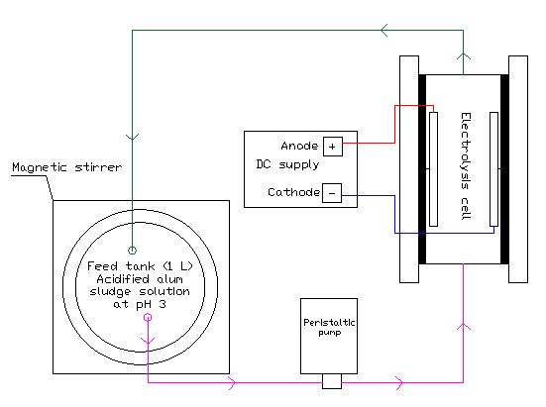
Figure 1. Electrolysis reactor design without membrane
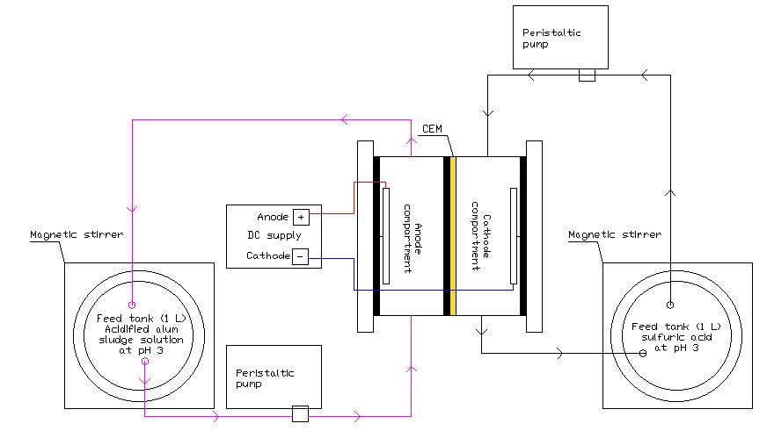
(a)
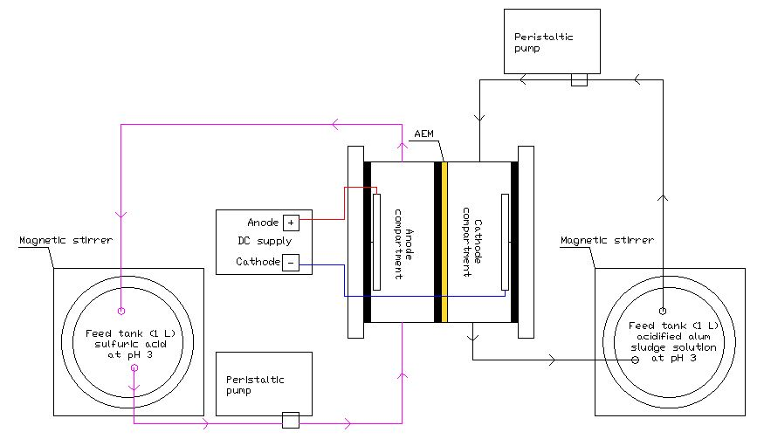
(b)
Figure 2. Electrolysis reactor design using: (a) cation exchange membrane (CEM), (b) anion exchange membrane (AEM)

Table 1. Electrolysis conditions
No | Electrolysis Processes | Conditions
1 | Electrolysis using carbon (C) (+)/ silver (Ag) (-) electrodes | At initial pH 3, electrical current density of 25 mA/cm²,  and voltage of 5.3 V for 10 hours operation time.
2 | Electrolysis using platinum Pt (+)/ Pt (-) electrodes | At initial pH 3, electrical current density of 29.17 mA/cm², and voltage of 5.2 V for 8 hours operation time.
3 | Electrolysis using Pt (+)/ stainless steel (SS A304) (-) electrodes | At initial pH 3, electrical current density of 12.5 mA/cm², and voltage of 4.9 V for 6 hours operation time.
Table 1 (cont’d). Electrolysis conditions
No | Electrolysis Processes | Conditions
4 | Electrolysis using C (+)/Ag (-) electrodes using CEM | At initial pH 3, electrical current density of 25 mA/cm²,  and voltage of 17.3 V for 10 hours operation time.
5 | Electrolysis using C (+)/Ag (-) electrodes using AEM | At initial pH 3, electrical current density of 25 mA/cm²,  and voltage of 14.3 V for 10 hours operation time.
6 | Electrolysis using Pt (+)/ SS A304 (-) electrodes using CEM | At initial pH 3, electrical current density of 12.5 mA/cm², and voltage of 23.8 V for 10 hours operation time.

Analytical measurement

The pH value was measured every hour during electrolysis. The deposited matter at the cathode was dried at 105°C, weighed, and then soaked in nitric acid [20]. Aluminum and other metal impurities (Fe, Mn, Zn, Pb, Cr, Cu) were analyzed using ICP type Agilent Technologies series 700 ICP-OES [16]. The COD was measured by titrimetric method using closed reflux digestion [17]. The electrodes were cleaned using 1 N sulfuric acid solution. Alum recovery efficiency, the SEC value, COD value, and metal composition in deposit were calculated according to Eqs. 1-4.

Alum recovery (%) = $\frac{mass alum in cathode at t6 h}{mass alum at t0 h}$ $×100\%$ (1)

W = $\frac{I×V×t}{\frac{mass alum at t0 h-mass alum at t6 h}{Vf}}$ (2)

COD removal (%) = $\frac{\left[COD at t0 h\right]-[COD at t6 h) }{[COD at t0 h)}×100\%$ (3)

Metal composition (%) = $\frac{metal mass at cathode}{total metal mass at cathode}×100\%$ (4)

where: W = specific energy consumption (kWh/m³); I = electrical current (A); V = potential value (V); t = operation time; Vf = feed tank volume (L); mass alum at t0 h = initial alum weight; mass alum in cathode at t6 h = alum weight t6 h at cathode.

Results and Discussion

Acidified alum sludge solutions characteristics
The aluminum concentrations in the acidified alum sludge solution reached 3,762 mg/L in the wet season 2019 (Table 2). While, in the dry season 2019, the aluminum concentration reached 1,548.57 mg/L (Table 2). High concentration of aluminum was influenced by the high doses of alum coagulants in coagulation-flocculation process [21, 22, 23]. It was caused by the worse river water quality in the wet season than in the dry season, so that the required dose of coagulant was high in DWTP [21, 22, 24]. It was due to the total suspended solids (TSS) concentrations in the wet season at Karangpilang sampling point in the Surabaya river were higher (20 mg/L) than those in the dry season (14.7 mg/L) [25, 26].

The second highest metal concentration in the samples was iron, which was 215.7 mg/L in the wet season and 72.43 mg/L in the dry season (Table 2). The high result of iron concentrations was from the addition of FeCl₃ as a mixture of alum coagulant when the raw water had a low water quality in the wet season [27]. The third highest metal concentration in the acidified alum sludge solutions were manganese which was 119.5 mg/L (Table 1). The high result manganese concentration was from the natural content of these elements in sediments, rocks, and soil in the rivers, the use of low purity coagulants, and the discharge of industrial wastewater along the Surabaya River [25, 28, 29, 30]. The concentrations of zinc, lead, copper, and chromium in the acidified alum sludge solutions were caused by the content of these metals in the raw water from Surabaya River exceeded Class 1 water quality standards according to Government Regulation No. 82/2001 concerning The Management of Water Quality and The Control of Water Pollution [31]. This was due to the fact that there were 42 discharge points for domestic wastewater and 9 out of 18 industries in the Karangpilang area that discharged their wastewater treatment into the Surabaya river [25].

The COD concentration of the solutions during the wet season was 2,060 mg/L (in 2019), whereas it was 1,997.3 mg/L during the dry season (Table 2). These results indicated that the COD concentrations of the solutions exceeded the effluent standard of 100 mg/L according to The State Ministry for the Environment Decree No. 5/2014 concerning Quality Standards of Wastewater [8]. The high COD concentrations was influenced by the discharge of the domestic and industrial wastewater along the Surabaya River [30]. The COD concentrations in the Surabaya River reached 80 mg/L in the wet season and 8.19 mg/L in the dry season [25, 26]. The COD concentrations in the wet season exceeded the quality standard for class 1 water which was 10 mg/L according to Government Regulation No. 82/2001 [31].
The acidified alum sludge solution at pH 3 was an electrolyte that was used in the electrolysis for alum recovery. Therefore, its characteristics affected the electrolysis process. The acidification process was carried out at pH 3 to reduce the dissolution of other metals and organic substances in alum sludge [10, 33, 34, 35, 36, 37]. The lower the pH value of the solution, the higher the solubility of the aluminum with the optimum pH of 1-3 [33]. When the pH was <5, the dominant aluminum speciation was in the form of Al³⁺ [38]. Dissolution of other metals and organic compounds in the acidic conditions caused the recovered alum to have a low purity and some problems in the next processes. The electrolysis method could be applied for separating the acidified alum sludge from its impurities.

Electrolysis for alum recovery
The electrolysis method in alum recovery aims to separate aluminum from metal impurities and dissolved organics. Alum is expected to be deposited at the cathode surface (electrodeposition) and dissolved organics will be oxidized at the anode (electrooxidation). Table 3 presents the results of several electrolysis processes in different conditions for alum recovery based on the calculations in Equations 1-3. The efficiency of electrodeposition and electrooxidation in alum recovery (Table 3) is influenced by various factors as described in Table 1.

Table 2. Characteristics of the acidified alum sludge solutions
No | Acidified alum sludge  solution samples | Parameters
No | Acidified alum sludge  solution samples | Metals (mg/L) |  |  |  |  |  |  | COD  (mg/L)
No | Acidified alum sludge  solution samples | Al | Fe | Mn | Zn | Pb | Cu | Cr | COD  (mg/L)
1 | Wet season 2019 | 3,762.00 | 215.70 | - | 2.81 | - | 1.54 | 0.31 | 2,060.00
2 | Dry season 2019 | 1,548.57 | 72.43 | 119.50 | 1.40 | 0.00 | 0.21 | 0.09 | 1,997.33

Table 3. Electrolysis process for alum recovery
No | Electrolysis processes | Results
1 | Using C (+)/ Ag (-)  electrodes^{(*)} |  | % Al recovery= 26.20% as Al(OH)₃ ; % COD removal = 11.11%; Al recovery SEC of 4.66 kWh/kg
1 | Using C (+)/ Ag (-)  electrodes^{(*)} |  | Deposit composition: Al (96.86%); Fe (0.80%); Pb (0.86%); Cr (0.59%); Cu (0.90%)
2 | Using Pt (+)/ Pt (-)  electrodes |  | % Al recovery= 9.63% as Al(OH)₃ ; % COD removal = 26.39%; Al recovery SEC of 8.34 kWh/kg
2 | Using Pt (+)/ Pt (-)  electrodes |  | Deposit composition: Al (90.39%); Fe (5.80%); Zn (3.11%); Pb (0.18%); Cr (0.01%); Cu (0.51%)
3 | Using Pt (+)/SS A304 (-) electrodes^{[37]} |  | % Al recovery= 52.10% as Al(OH)₃ ; % COD removal = 24%; Al recovery SEC of 2.81 kWh/kg
3 | Using Pt (+)/SS A304 (-) electrodes^{[37]} |  | Deposit composition: Al (82.28%); Mn (11.88%); Fe (5.18%); Zn (0.51%); Cr (0.02%); Cu (0.12%)
4 | Using C (+)/ Ag (-)  electrodes using CEM |  | % Al recovery = 66.74% as soluble Al(OH₄)⁻ ; The use of CEM could purify the recovered alum from organic compounds in recovery compartment; Al recovery SEC of 14.78 kWh/kg
4 | Using C (+)/ Ag (-)  electrodes using CEM |  | Deposit composition: Al (84.52%); Fe (13.30%); Pb (0.49%); Cr (0.85%); Cu (0.83%)
5 | Using C (+)/ Ag (-)  electrodes using AEM |  | % Al recovery= 38.45% as Al(OH)₃; The use of AEM could purify the recovered alum from organic compounds in recovery compartment; Al recovery SEC of 11.32 kWh/kg
5 | Using C (+)/ Ag (-)  electrodes using AEM |  | Deposit composition: Al (79.45%); Fe (19.20%); Pb (0.40%); Cr (0.61%); Cu (0.52%)
6 | Using Pt (+)/ SS A304 (-) electrodes using CEM | - | % Al recovery= 67.56% as soluble Al(OH₄)⁻; The use of CEM could purify the recovered alum from organic compounds in recovery compartment; Al recovery SEC of 9.72 kWh/kg
6 | Using Pt (+)/ SS A304 (-) electrodes using CEM | - | Deposit composition: Al (90.94%); Mn (5.78%); Fe (3.10%); Zn (0.17%); Cu (0.0087%)
^{(*)} SEC (Specific energy consumption)

Electrical current density during electrolysis
In the electrolysis using C/Ag, Pt/Pt, and Pt/SS electrodes, all three processes used the same size of the electrolysis cell, but the current density was different (Table 1). The differences of the current density were influenced by the differences in electrode area and the electrical current. In the electrolysis without membrane, the highest alum recovery efficiency was 52.10% at the electrolysis using Pt/SS A304 electrodes with a current density of 12.5 mA/cm² (Tables 1 and 2). While, the efficiencies of alum recovery in the electrolysis using Pt/Pt and C/Ag electrodes were 9.63% and 26.2% with the current densities of 25 mA/cm² and 29.17 mA/cm², respectively (Tables 1 and 2). It showed that at the current density of 12.5 mA/cm² could recover alum with higher efficieny than at 29.17 mA/cm². Therefore, the optimum, or the limiting, current density was 12.5 mA/cm². The current density that exceeds the limiting value can cause unwanted reactions on the electrode surface, so that it inhibited the deposition of aluminum hydroxide at the cathode and reduce cations mass transfer to the cathode [39]. The decrease of the cations mass transfer to the cathode was caused by the excess of hydrogen gas formation due to overpotential at the cathode [40. In addition to the excess of hydrogen gas formation, the large current densities could also shorten the life time of the electrodes [40]. However, the lowest aluminum composition in the deposited matter at the cathode was 82.28% at the lowest current density in the electrolysis using Pt/SS A304 electrodes. It showed that the low current densities resulted deposited matter with high impurities of other metals (Fe, Mn, Zn, Pb, Cr, and Cu in Table 3).

Optimum current density was affected by the electrolyte characteristics, the type of deposition sought, the operation conditions, electrical current, electrode area, and the ratio of electrode area to volume of the electrolysis cells [41, 42]. The current density could be reduced without expanding the area of the electrode by stirring or recirculating the batch electrolysis reactor [40]. Stirring could also prevent adsorption from hydrogen gas formation which inhibited ions reduction. In this study, a batch recirculation reactor system was used to increase the ions mass transfer to the cathode and accelerate the ion deposition at the cathode with a small current density.

Electrode material in electrolysis
Type of electrodes which was used in the electrolysis for alum recovery from DWTS was influenced by the characteristics of acidified alum sludge solution with the acidic condition (pH = 3) and the high organic content. The use of carbon as anode resulted in an electrosorption process [43]. According to Barakwan et al. [40], the use of carbon for anode could remove COD concentration up to 11.11% in the electrolyte solution (Table 3). The low COD removal was caused by the lack of absorption ability of the carbon surface area, which was compared to the high organic concentrations in the electrolyte. In addition, carbon could decay in a low pH electrolyte, so that it had a short life time. The short life time of the carbon electrode became an economic consideration factor in the cost of electrode maintenance in this electrolysis process. The efficiency of alum recovery reached 26.20% using silver as a cathode (Table 3). It was caused by the decay of the silver cathode in the acid electrolytes and the redeposition of silver as Ag₂O₃ due to the current density in this process was more than 15 µA/cm² [44, 45].

Because of the low efficiency of alum recovery and organic removal in the electrolysis using C/Ag electrodes, platinum could be used as the anode to remove toxic organic contaminants from wastewater at room temperature [42]. Electrochemical mineralization for organic pollutants can be carried out using platinum electrodes with a higher potential than the thermodynamic potential of the oxygen evolution, which is more than 1.23 V / SHE at standard conditions [42]. Platinum electrode was chosen because it was a strong inert metal (does not react with electrolyte solutions), corrosion resistant, good conductors, has a long lifetime, had an electrooxidation ability, and increases mass transfer [46, 47]. These platinum characteristics could accelerate the metal deposition process at the cathode surface. The use of platinum electrodes could remove 24-26.33% of organic contaminants as COD through the electrolysis process (Table 3). However, the use of platinum as anode and cathode resulted in a low alum recovery efficiency of 9.63% (Table 3). This was due to too high electric current (700 mA) was generated at a low potential value, so that it had a high current density. It caused the reduction reaction at the platinum cathode not optimum, and there was blackish brown layer at the cathode. In addition, the use of platinum electrode as cathode also required a high cost, so that the other types of electrodes that could be an alternative as a cathode was stainless steel (SS) alloy [48, 49]. SS electrode was used because of its low cost, easy to obtain, corrosion resistance, low current density, and electrocatalysts with a high specific surface area [50, 51]. It was indicated by an increase in alum recovery reaching 52.10% (Table 3).

Potential value during electrolysis
In the electrolysis for alum recovery from DWTS, there was no measurement for the anode and the cathode potential values. The potential values of the two electrodes were measured as a whole as the voltage value (Table 1). The anode and cathode potential values were important measurements to get the deposition material with a low impurity [15, 52]. For example in the electrolysis with Pt/SS electrodes, the recovery efficiency of alum reached 52.10% (Table 2). This result indicated that the energy used for alum deposition was 52.10% and the remaining (47.90%) was used for the formation of hydrogen gas [15]. The formation of the high hydrogen gas at the cathode surface could prevent the deposition of the metals at the cathode [15]. Therefore, the effectiveness of aluminum hydroxide deposition at the cathode could be increased by decreasing the potential value at the cathode [52]. The potential value that was given to the electrodes also affects the purity of the deposited metal at the cathode [15]. The purity of the aluminum hydroxide could be increased by adjusting the potential value of the cathode according to the standard reduction potential of aluminum. According to Zoski [53], the standard reduction potential for aluminum was -1.66 V and the formation of hydroxide ions was -0.83 V.

The voltage in the electrolysis with CEM and AEM were increased to reach (14.3-23.8) V until the end of the electrolysis (Table 1). While in the electrolysis without membrane, the voltage values tended to remain until the end of the electrolysis (Table 1). This is because the energy was used to encourage ion transfer across the membranes. The increasing voltage was due to the resistance at the membrane [54].

Electrolysis cell configuration
The alum recovery in the electrolysis without membrane using C/Ag, Pt/Pt, and Pt/SS A304 electrodes reached 26.20%, 9.63%, and 52.10%, respectively (Table 3). The electrolysis in one compartment reactor cells resulted in the low alum removal due to the oxidation and the reduction reactions were not selective [55]. In the electrolysis without membrane, there were also the fluctuation values of total dissolved solids (TDS) and pH during the electrolysis due to the redeposition of the ions at the cathode, so that it was measured as TDS value in the electrolyte solutions [39]. This reaction was also called the Electrical Double Layer (EDL) reaction which was caused by the increasing of electrolysis operation time [56]. The EDL could increase the resistance process because of the anode was covered by ions, so that the electrolysis efficiency decreased.

In the electrolysis using AEM, the recovered material was 38.45% in the form of aluminum hydroxide (Al(OH)₃) precipitate at the cathode (Table 3, Figure 3). It was indicated by its form of powder in white colour [57]. The pH value also decreases in the anode compartment due to H₂O oxidation which produced H⁺. Otherwise, the pH value was increased slightly in the cathode compartment due to the reduction of H₂O to OH⁻, while the decrease of pH value was caused by the formation of Al(OH)₃ precipitate [58].

In the electrolysis using CEM, the recovered material was 66.74% and 67.56% at the electrolysis using C/Ag and Pt/SS A304, respectively. These results were almost the same as previous studies, the alum recovery using CEM reached the efficiencies of 60-76% [9, 34]. The recovered material was in the form of soluble Al(OH)₄⁻ (Table 3). The pH value was increased in the cathode compartment due to the use of CEM, which caused the formation of OH⁻ ions and the proton transported from the cathode to the anode [59]. Otherwise, the pH value was decreased in the anode compartment at the end of the process due to the oxidation process that produced H⁺. In the electrolysis with CEM, no precipitate was formed in the cathode compartment, so coagulant recovery was obtained in the form of concentrates. Aluminum hydrolysis caused the breakdown of the aluminum ions when reacting with H₂O so that it produced Al(OH)₄⁻ at alkaline pH. The formation of Al(OH)₃ was a reaction that caused an increase in pH value. The increase in pH value caused Al(OH)₃ to react with OH⁻ to form Al(OH)₄⁻ . Al(OH)₄⁻ could not be a precipitate and became aluminum soluble [60].

Electrolysis using CEM and AEM could purify alum in the recovery compartment from dissolved organic impurities (Table 2). However, the use of CEM and AEM could not purify the alum recovered from metals impurities (Table 2). Therefore, the alum recovery must be carried out by the electrolysis in the next stage using trivalent membrane to obtain pure aluminum coagulant recovery [61, 62].

In this study, the electrolysis using CEM is recommended for alum recovery because the recovered material was formed in soluble, so that it was ready to be applied as coagulant. The electrolysis using membrane required a higher energy, so that the voltage demand was highly. Reduction in energy requirements during electrolysis could be done by shortening the distance between the electrodes. The closer the distance between the electrodes, the smaller the voltage needed and the faster the ions were reduced.

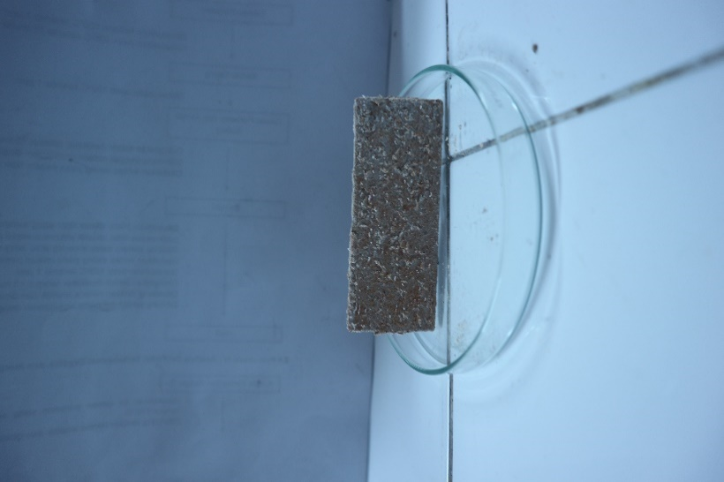
Figure 3. Deposited matter at cathode

Conclusion
The optimum electrolysis process in alum recovery from DWTS was the electrolysis using Pt/SS A304 electrodes with CEM. The efficiency of alum recovery was 67.56% and the recovered alum was in the form of pure soluble Al(OH) ₄⁻ from dissolved organic contaminants. The combination of electrolysis process using a CEM could be an alternative in the removal of dissolved organics impurities in the acidified alum sludge solution. The challenges in alum coagulant recovery from DWTS using electrolysis method were the differences of the raw water quality during wet and dry seasons that affected the characteristics of the DWTS, determination of the appropriate electrical current density, selection of the electrode materials, determination of the potential value at the anode and cathode, and the use of the ion exchange membrane to increase the purity of the recovered coagulant.

Acknowledgement

The authors would like to thank for the financial support from the Ministry of Research and Higher Education of the Republic Indonesia with Master leading to PhD scholarship (PMDSU) No. contract 1287/PKS/ITS/2020, which made this study to work out.

References
- Bhaskoro and Ramadhan. (2018). Evaluation of Karangpilang 1 drinking water treatment plant quantitative performance in Surabaya water treatment supply. Journal of Precipitation: Media and Environmental Engineering Development, 15(2): 62-68.
- Saukkoriipi, J. (2010). Theoritical study of the hydrolysis of aluminum complexes. Thesis of Doctoral Degree, Linnanmaa, Faculty of Science, Department of Chemistry, University of Oulu.
- Ahmad, T., Ahmad, K. and Alam, M. (2016). Characterization of water treatment plant’s sludge and its safe disposal options. Procedia Environmental Sciences, 35: 950-955.
- Yonge, D. T. (2011). A comparison of aluminum and iron-based coagulants for treatment of surface water in Sarasota County. Florida. Florida, University of Central Florida.
- Cherifi, M., Boutemine, N., Laefer, D. F. and Hazourli, S. (2016). Effect of sludge pH and treatment time on the electrokinetic removal of aluminum from water potabilization treatment sludge. CR Chim, 19: 511-516.
- Barakwan, R. A., Hardina, T. T., Trihadiningrum, Y. and Bagastyo, A. Y. (2019). Recovery of alum from Surabaya water treatment sludge using electrolysis with carbon-silver electrodes. Journal of Ecological Engineering, 20(7): 126-133.
- US EPA (2011). Drinking water treatment plant residuals management technical report: pp. 192.
- Ministry for the Environment of Republic Indonesia (2014). State Ministry for the Environment Decree of Republic Indonesia No. 5/2014 concerning Quality Standard of Wastewater, Jakarta, Indonesia, Ministry for the Environment of Republic Indonesia, 2014.
- Evuti, A. M. and Lawal, M. (2011). Recovery of coagulants from water works sludge: A review. Pelagia Research Library, 2(6): 410-417.
- Xu, G. R., Yan, Z. C., Wang, Y. C. and Wang, N. (2009). Recycle of alum recovered from water treatment sludge in chemically enhanced primary treatment. Journal of Hazardous Materials, 161: 663-669.
- Elicker, C., Filho, P. J. S. and Castagno, K. R. L. (2014). Electroremediation of heavy metals in sewage sludge. Brazilian Journal of Chemical Engineering, 31(2): 365-371.
- Widodo, G., Sigit, R. L., and Torowati, N. Y. (2010). Effect of potential, time, and acidification to the electrodialysis of uranil nitrate solution. Jurnal Teknologi Bahan Bakar Nuklir (Batan), 6(1): 1-69.
- Huitle, C. A. M., Rodrigo, M. A. and Scialdone, O. (2018). Electrochemical water and wastewater treatment. United States, Elsevier.
- Zou, L., Morris, G. and Qi, D. (2008). Using activated carbon electrode in electrosorptive deionisation of brackish water. Desalination, 225: 329-340.
- Song, K. D., Kim, K. B., Han, S. H. and Lee, H. K. (2003). A study on effect of hydrogen reduction reaction on the initial stage of Ni electrodeposition using EQCM. Electrochemistry Communications, 5: 460-466.
- Dahhou M. (2017). Drinking water sludge of the Moroccan capital: Statistical analysis of its environmental aspects. Journal of Taibah University for Science: 749–758.
- APHA (2012). Standard methods for examination of water and wastewater 22nd edition, Washington DC.
- Bagastyo, A.Y., Ayu, A. P., Barakwan, R. A. and Trihadiningrum, Y. (2020). Recovery of alum sludge by using membrane-based electrochemical process. Journal Ecology Engineering, 21(6): 237-247.
- Barakwan, R. A., Pratiwi, W. B., Trihadiningrum, Y. and Bagastyo, A.Y. (2020). Electrolysis using Pt/SS electrodes for aluminum recovery from drinking water treatment sludge. Journal Materials Cycles Waste Management, 22: 2130-2139.
- Connor, M. P., Coulthard, R. M. and Plata, D. L. (2017). Electrochemical deposition for the separation and recovery of metals using carbon nanotube-enabled filters. The Royal Society of Chemistry: 1-10.
- Kan, C., Huang, C. and Pan, J. R. (2002). Coagulation of high turbidity water: The effects of rapid mixing. Journal of Water Supply: Research and Technology-AQUA, 51(2): 77-85.
- BaiChuan, C., BaoYu, G., ChunHua, X., Ying, F. and Xin, L. (2010). Effects of pH on coagulation behavior and floc properties in Yellow River water treatment using ferric based coagulants. Chinese Science Bulletin, 55(14): 1382-1387.
- Ernest, E., Onyeka, O., David, N. and Blessing, O. (2017). Effects of pH, dosage, temperature and mixing speed on the efficiency of water melon seed in removing the turbidity and colour of Atabong River, Awka-Ibom State, Nigeria. International Journal of Advanced Engineering, Management and Science, 3(5): 427-434.
- Keeley, J., Jarvis, P. and Judd, S. J. (2014). Coagulant recovery from water treatment residuals: A review of applicable technologies. Environmental Science Technology, 44: 2675-2719.
- Novitasari, A. K. (2015). Analysis of identification and inventaritation of pollution source in Surabaya River. Thesis of Master Degree, Department of Environmental Engineering, Institut Teknologi Sepuluh Nopember.
- Yudo, S. and Said, N. I. (2019). Water quality condition of Surabaya River case study: Improved raw water of PDAM Surabaya. Jurnal Teknologi Lingkungan, 20(1): 19-28.

- Personal commend, Mr. Adi, Operational Staff of Surabaya Drinking Water Treatment Plant. (2019). Surabaya.
- Fazeli, M., Soltani, and Sarvestani, M. R. (2006). Feasibility of reuse of residuals from water treatment plants in landscapes irrigation and agricultural (Case atudy in 3 and 4 water treatment, Tehran). Second Conference on Water Resources Management: pp. 1-10.
- Gibbons, M. K. and Gagnon, G. A. (2011). Understanding removal of phosphate or arsenate onto water treatment residual solids. Journal Hazardous Materials, 186: 1916-1923.
- Trollip, D. L., Hughes, J. C. and Titshall, L. W. (2013). Sources of manganese in the residue from a water treatment plant. Water SA, 39(2): 265-270.
- Goverment Republic of Indonesia (2001). Decree of the Goverment Regulation of Republic Indonesia No. 82/2001 concerning the management of water quality and the control of water pollution, Jakarta, Indonesia: Goverment Republic of Indonesia.
- Razif, M. and Persada, S. F. (2015). The fluctuation impacts of BOD, COD, and TSS in Surabaya Rivers to environmental impact assessment (EIA) sustainability on drinking water treatment plant in Surabaya City. International Journal of Chemtech Research, 8(8): 143-151.
- Cheng, W. P., Fu, C. H., Chen, P. H., and Yu, R. F. (2012). Dynamics of aluminum leaching from water purification sludge. Journal of Hazardous Materials, 217 (218): 149-155.
- Prakash, P., Hoskins, D. and SenGupta, A. K. (2004). Application of homogeneous and heterogeneous cation-exchange membranes in coagulant recovery from water treatment plant residuals using donnan membrane process. Journal of Membrane Science, 237: 131-144.
- Mulchandani, A. and Westerhoff, P. (2016). Recovery opportunities for metals and energy from sewage sludges. Bioresource Technology, 215: 215-226.
- Boaventura, R. A. R., Duarte, A. A. S. and Almeida, M. F. (2000). Aluminum recovery from water treatment sludges. IV International Conference Water Supply and Water Quality” Kraków – Poland, September, 11-13.
- Li, C. W., Lin, J. L., Kang, S. F. and Liang, C. L. (2005). Acidification and alkalinization of textile chemical sludge: Volume/solid reduction, dewaterability, and Al(III) recovery. Separation and Purification Technology, 42: 31-37.
- Xu, H., Ding, M., Shen, K., Cui, J. and Chen, W. (2017). Removal of aluminum from drinking water treatment sludge using vacuum electrokinetic technology. Chemosphere, 173: 45-60.
- Walsh, F. C., and de Leon, C. P. (2018). Progress in electrochemical flow reactors for laboratory and pilot scale processing. Electrochimica Acta, 280: 121-148.
- Barakwan, R. A., Trihadiningrum, Y. and Bagastyo, A. Y. (2019). Characterization of alum sludge from Surabaya water treatment plant, Indonesia. Journal of Ecological Engineering, 20(5): 7-13.
- Rajkumar, S. R., Alagar, M., Somasekaran, S. and Ravisankar, S. R. (2015). Significance of limiting current density by influence of the process parameter for the electrodeposition system. International Journal of Information Science and Computing, 2(1): 1-11.
- Kumar, S., Pande, S. and Verma, P. (2015). Factor effecting electro-deposition process. International Journal of Current Engineering and Technology, 5(2): 700-703.
- Chen, G. and Comninellis, C. (2010). Electrochemistry for the environment, Springer, New York.
- Zhou, G., Li, W., and Wang, Z. (2015). Electrosorption for organic pollutants removal and desalination by graphite and activated carbon fiber composite electrodes. International journal of Environmental Science and Technology, 12(12): 1-20.
- Molleman, B. and Hiemstra, T. (2017). The pH, time, and size dependency of silver nanoparticle dissolution: the road to equilibrium. The Royal Society of Chemistry: 1-18.
- Casey, E. J. and Moroz, W. J. (1964). On the formation of Ag₂O₃ on silver electrodes. Canadian Journal of Chemistry, 43: 1199-1214.

- Ciblak, A., Mao, X., Padilla, I., Vesper, D., Alshawabkeh, I. and Alshawabkeh, I. A. (2012). Electrode effects on temporal changes in electrolyte pH and redox potential for water treatment. Journal of Environmental Science and Health, 47(5): 718-726.
- Chen, G. (2004). Electrochemical technologies in wastewater treatment. Journal of Separation and Purification Technology, 38(1): 11-41.
- Iken, H., Basseguy, R., Guenbour, A. and Bachir, A. B. (2007). Classic and local analysis of corrosion behaviour of graphite and stainless steels in polluted phosphoric acid. Journal of Electrochimica Acta, 52(7): 2580-2587.
- Supratno (2011). Separation of silver from waste fixer by electrolysis. Thesis of Master Degree, Institut Pertanian Bogor.
- Munoz, L.D., Bergel, A., Feron, D., and Basseguy, R. (2010). Hydrogen production by electrolysis of a phosphate solution on a stainless steel cathode. International Journal of Hydrogen Energy: 8561-8568.
- Guler, E. S., Konca, E. and Karakaya, I. (2013). Effect of electrodeposition parameters on the current density of hydrogen evolution reaction in Ni and Ni-MoS₂ composite coatings. International Journal Electrochemical Sciences, 8: 5496-5505.
- Zoski, C. G. (2007). Handbook of electrochemistry, Chapter 18: Potential Electrode. New York, Elsevier.
- Feng, Y., Yang, L., and Logan, B. E. (2016). Electrochemical technologies for wastewater treatment and resource reclamation. Environmental Science Water Research & Technology, 2: 800-831.
- Barazes, J. M., Prasse, C. and Sedlak, D. L. (2016). Electrochemical transformation of trace organic contaminants in the presence of halide and carbonate ions. Environmental Science & Technology, 50(18): 10143-10152.
- Santos, D. M. F. and Sequeira, C. A. C. (2013). Hydrogen production by alkaline water electrolysis. Quimica Nova, 36(8): 1176-1193.
- Haynes, W.M. (2011) CRC handbook of chemistry and physics. 91st edition. Boca Raton, FL: CRC Press Inc.
- Varcoe, J. R., Atanassov, P., Dekel, D. R., Herring, A. M., Nijmeijer, K., Scott, K., Xu, T. and Zhuang, L. (2014). Anion-exchange membranes in electrochemical energy sytems. Energy Environment Science, 7 (10): 3135-3191.
- Rozendal, R. A., Sleutels, T. H. J. A., Hamelers, H. V. M. and Buisman, C. J. N. (2008). Effect of ion exchange membrane on biocatalyzed electrolysis of wastewater. Water Science Technologies, 57: 1757-1762.
- Liu, H., Qu, J., and Zhao, X. (2010). Electrocoagulation in water treatment. Electrochemical Environmental, 1: 245-262.
- Basumataray, A. K., Kumar, R. V., Pakshirajan, K. and Pugazhenty, G. (2017). Removal of trivalent metal ions from aqueous solution via cross-ﬂow ultraﬁltration system using zeolite membranes. Journal of Water Reuse and Desalination, 7(1): 66-76.
- Nurajijah, L., Harjunowibowo, D. and Radiyono, Y. (2014). The effect of voltage variations on laundry wastewater treatment using electrolysis. Jurnal Materi dan Pembelajaran Fisika, 4: 31-38.

