

DETERMINATION OF SODIUM HYDROXIDE CONCENTRATION UNDER HETEROGENEOUS CONDITIONS FOR THE PREPARATION OF

N-CARBOXYMETHYL CHITOSAN

(Penentuan Kepekatan Natrium Hidroksida dalam Keadaan Heterogen bagi Penghasilan

N-Karboksimetil Kitosan)

Nurul Adilah Rodzali and Nadhratun Naiim Mobarak*

Department of Chemical Sciences, Faculty of Science and Technology

Universiti Kebangsaan Malaysia, 43600 UKM Bangi, Selangor, Malaysia

*Corresponding author: nadhratunnaiim@ukm.edu.my

Received: 3 September 2021; Accepted: ; 27 October 2021Published: xx December 2021

Abstract
N-carboxymethyl chitosan (N-CMC) is one of the promising chitosan derivatives which has been used to improve the limitation of chitosan and can be synthesized via direct alkylation in the presence of base. In this work, the effect of sodium hydroxide concentration under heterogeneous conditions has been investigated to obtained N-CMC. The concentration of sodium hydroxide (NaOH) was varied from 1.5 M to 7.5 M. This research showed that the substitution site of chitosan is affected by the concentration of NaOH. The results revealed that N-CMC was successfully synthesized at higher NaOH concentration, 6.0 M, and 7.5 M under heterogeneous conditions. The presence of peak at 1321 cm⁻¹ and 3.2 ppm from Fourier transform infrared (FTIR) and ¹H nuclear magnetic resonance (NMR) spectroscopy, respectively, proving the carboxymethyl group substitution occurred at amino (NH₂) site. X-ray diffraction (XRD) analysis showed insignificant differences in degree of crystallinity of N-CMC at both NaOH concentrations. However, Thermogravimetry analysis (TGA) and differential scanning calorimetry (DSC) revealed that obtained N-CMC possessed distinct thermal properties as the glass transition temperature of 6.0 M was lower than 7.5 M NaOH. Therefore, the selection of NaOH concentration in N-CMC production must be determined according to the intended functional application.

Keywords: N-carboxymethyl chitosan, N-substitution, heterogeneous conditions, NaOH concentration

Abstrak
N-karboksimetil kitosan (N-CMC) merupakan salah satu terbitan kitosan yang telah digunakan bagi menambahbaik kekurangan kitosan dan boleh disintesis melalui pengakilan secara terus dengan kehadiran bes. Dalam kajian ini, kesan kepekatan natrium hidroksida (NaOH) dalam keadaan heterogen telah dikaji untuk menghasilkan N-CMC. Kepekatan natrium hidroksida (NaOH) dibezakan daripada 1.5 M hingga 7.5 M. Kajian ini menunjukkan tapak penggantian pada kitosan dipengaruhi oleh kepekatan NaOH. Hasil kajian menunjukkan N-CMC telah berjaya disintesis pada kepekatan yang lebih tinggi, 6.0 M and 7.5 M dalam keadaan heterogen. Kehadiran puncak pada 1321 cm⁻¹ dan 3.2 ppm masing-masing pada spektroskopi inframerah transformasi Fourier (FTIR) dan resonans magnet nukleus ¹H (NMR), membuktikan penukargantian kumpulan karboksimetil berlaku pada tapak amina (NH₂). Analisis pembelauan sinar-X (XRD) menunjukkan perubahan yang tidak ketara bagi darjah kehabluran N-CMC pada kedua-dua kepekatan NaOH. Walau bagaimanapun, analisis termogravimetri (TGA) dan kalorimetri pengimbasan pembezaan (DSC) menunjukkan N-CMC yang dihasilkan mempunyai sifat terma yang berbeza dimana suhu peralihan kaca bagi 6.0 M lebih rendah berbanding 7.5 M NaOH. Oleh itu, pemilihan kepekatan NaOH dalam penghasilan N-CMC ditentukan berdasarkan aplikasi yang akan digunakan.

Kata kunci: N-karboksimetil kitosan, penggantian-N, keadaan heterogen, kepekatan NaOH

Introduction
Carboxymethyl chitosan (CMC) is the chitosan derivative which has attracted much attention as it enhances the solubility of chitosan. CMC can be obtained by chemically modified the chitosan structure, making the CMC soluble in both acidic and alkaline solution without affecting its cationic characteristics [1]. The reactive sites for the carboxymethylation of chitosan are the amino and hydroxyl groups present in chitosan chains. The choice of an appropriate reaction conditions and reagents can influence the substitution sites of carboxymethyl group [2]. The most widely used method for the chemical modification of chitosan is N-substitution, in which the amino group (-NH₂) in chitosan structure is the functional group which reacts [3]. N-carboxymethyl chitosan (N-CMC) is a CMC generated by reaction of free amino group of chitosan with monochloroacetic acid reagent. N-CMC is a material that can be used in food and cosmetic products due to its unique physical and biocompatibility properties. Aside from being soluble in wider pH, it also has high viscosity and low toxicity [4]. In addition to N-CMC, other N-substitutions such as the potential quaternary chitosan derivatives also gives rise to an important derivative of chitosan and its bioactivity such as antimicrobial, anticoagulant, antioxidant and mucoadhesive properties have been extensively reported [5].

The preparation of N-substitution of chitosan, including N-CMC through direct alkylation, was mostly conducted under homogeneous conditions [6]. An et al. [7] prepared the N-CMC by swollen the chitosan in water and adding monochloroacetic acid for carboxymethyl substitution. The mixture was then strongly stirred until completely dissolved to produce a homogeneous solution. Subsequently, the pH was adjusted to 8 by adding sodium bicarbonate, NaHCO₃, solution. The mixture was then heated to 90 °C, as shown in Figure 1a. The same method also being used by Skorik et al. [8] to synthesize N-carboxyethyl chitosan under homogeneous conditions. In addition to the homogeneous method, selective substitution to produce N-derivatives of chitosan can also be carried out by protection of OH groups in C3 and C6 [9]. Sahariah et al. developed N,N,N-trimethyl chitosan by protecting the -OH groups in the chitosan structure using di-tert-butyldimethylsilyl (di-TBDMS), which is easily removed under strongly basic or moderate acidic conditions without affecting the functional group, as depicted in Figure 1b [9]. However, the reaction times for homogeneous condition were longer than 24 hours and the protection of OH group procedure implies multiple reaction steps [5]. Nevertheless, the preparation of N-substitution, especially N-CMC, using the heterogeneous method is scarcely reported, since homogeneous conditions and reductive alkylation method are preferred.

Our previous research successfully prepared N-CMC through heterogeneous conditions at pH 14 with shorter reaction time which is 4 hours [10]. Based on the literature, the pH of alkaline solution needs to be strictly controlled to succeed in producing N-CMC. However, particularly at an industrial scale, such as in the production of carboxymethyl cellulose, the use of concentration parameters is more feasible [11, 12]. Based on our current reading, alkali concentration to produce N-CMC has not yet been described. Therefore, this research was conducted to investigate the effects of NaOH concentration under heterogeneous conditions in obtaining N-CMC.

Materials and Methods

Materials
Chitosan was commercially acquired from Chito-Chem Sdn. Bhd., Malaysia. Degree of deacetylation and molecular weight of chitosan were 89.25% and 6.12×10⁷ g/mole, respectively. The solvents used, such as isopropanol (99.7%) and ethanol (95%), were supplied by Systerm, Malaysia. Besides, the monochloroacetic acid (99%) from Sigma-Aldrich, Co. St Louis, USA and sodium hydroxide pellets (97%) were obtained from Merck, German. All materials were used without further purification.

Preparation of carboxymethyl chitosan
CMC was prepared according to the heterogeneous method proposed by Chen and Park [13] with minor modifications. Chitosan (10 g) was dispersed in isopropanol (50 mL) and NaOH solutions were prepared in concentrations of 1.5 M, 3.0 M, 4.5 M, 6.0 M, and 7.5 M. The NaOH solution was added dropwise into the flask to swell and provide the alkaline condition at 50 °C for one hour. The monochloroacetic acid (15 g) was dissolved in isopropanol (20 mL) and added into the mixture dropwise for 30 minutes and reacted for 4 hours at the same temperature. The reaction was terminated with 90% ethanol. The precipitate was filtered, rinsed with 90% ethanol and vacuum dried at room temperature. The product was kept in a desiccator for continuous drying prior to characterization.

Figure 1. Synthesis of chitosan derivatives by a) homogeneous method [6] and b) protection of OH groups procedure [8]

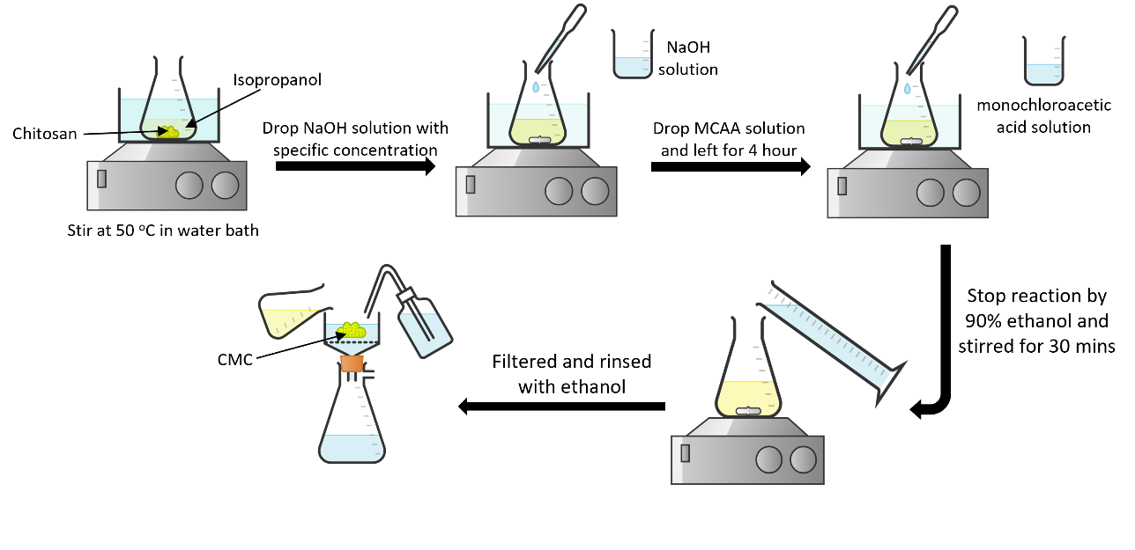

Figure 2. Schematic diagram of synthesis of CMC

Fourier transform infrared spectroscopy
Infrared spectra were recorded by using Agilent Cary 630 Technologies with attenuated total reflectance (ATR) techniques. The range of analysis was 4000-650 cm⁻¹ with a scanning resolution of 2 cm⁻¹. Analysis was conducted to observe the changes in the functional groups of the chitosan derivatives.

¹H NMR spectroscopy
NMR analysis was performed to determine the substitution site of carboxymethyl chitosan by using Bruker AVANCE III HD 400 MHz. Chitosan and all CMC were dissolved in the solvent mixture of 1% of CD₃COOD/D₂O at room temperature.

Degree of substitution
The degree of substitution (DS) values for all synthesized CMC were calculated by acid base titration method from Elomaa et al. [14] and Pushpamalar et al. [15] with some modification. Firstly, the final product, Na-salt of CMC needed to undergo acidic treatment to change into H-form of CMC. The Na-salt CMC was suspended in 80% ethanol and 37% hydrochloric acid was added and stirred for 30 min. The precipitate (H-CMC) was ﬁltered and rinsed in 70–90% ethanol. The products were vacuum dried and stored in a desiccator for 2 to 3 days.
The DS values of CMC were determined using the standard ASTM D1439 method [16]. The dried H-form of CMC were dispersed in the distilled water in flask. Subsequently, 0.3 M of NaOH solution was added into the suspension and stirred at 50 ℃ for 15 min and the flask must be corked to prevent evaporation from the reactions occurred. Three drops of phenolphthalein were added into the mixture as an indicator to retain the pink colour. Finally, the mixture was titrated with 0.3 M HCl solution until the indicator became colourless. A blank test was also carried out using the same procedure as a reference.

The percentage of carboxymethyl groups (%CM) and DS were calculated using Equations (1) and (2), respectively.

$$\%CM=\frac{\left[\left(V_{o}-V_{n}\right)M × 0.059 × 100\right]}{m} (1)$$

$$DS=\frac{162 × \%CM}{\left[5900-\left(58 × \%CM\right)\right]} (2)$$

where V_{o} and V_{n} are the volume of HCl used for blank test (mL) and sample titration (mL), respectively.

Meanwhile, M is the molar concentration of HCl (M), m is the amount of sample used (g), 162 is the molar mass of the anhydrous glucose unit, and 58 is the molar mass of a CM group (–CH₂COOH).

The differences between means were analysed for statistical significance using Student’s t-test. A value of p < 0.05 was considered significant [17].

Thermogravimetry analysis
The thermal stability of the samples was determined using TGA measurements carried out with TG 209 F3 NETZSCH Tarsus equipment. The amount of sample used for each measurement was approximately 2.0 – 3.5 mg in an aluminium pan. All samples were run under nitrogen atmosphere and heating from 25 ℃ to 800 ℃ at a heating rate of 10 ℃/min.

Differential scanning calorimetry
This analysis was carried out using DSC 3 Mettler Toledo with specifications equipment. The amount of samples approximately 2.0 – 3.5 mg was placed into aluminium pan. The samples underwent two heating cycles. The first heating cycle was from 25 ℃ – 120 ℃ to remove the moisture content in the sample, and the second heating cycle was from 25 ℃ – 450 ℃ to determine the polymer properties. All samples were analysed under continuous flow of nitrogen gas at a heating rate of 10 ℃/min.

X-ray diffraction
The crystallinity of the samples was obtained using Bruker D8 Advance X-ray diffractometer (Cu Kα; α = 1.5418 Å). The relative intensity was recorded in the scattering range, 2Ө = 2° – 80° with scanning rate 10°/min. The degree of crystallinity (%) was determined via Bruker DIFFRAC.EVA software by using Equations (3) and (4).

$Amorphous \left(\%\right)=\left[ \frac{all area-adjusted area}{all area} \right]x100 (3)$

$$Degree of Crystallinity \left(\%\right)$$
$=100-Amorphous \left(\%\right)$ (4)

Results and Discussion

Characterization by FTIR spectroscopy
The FTIR spectra for chitosan and all CMC that had been synthesized in different NaOH concentrations are depicted in Figure 3. The common characteristics for chitosan could be observed around 3378 cm⁻¹ (O-H overlapping with N-H stretch), 2871 cm⁻¹ (C-H stretch), 1637 cm⁻¹ (C=O stretch of amide group), 1578 cm⁻¹ (N-H bending of amino group), 1151 cm⁻¹ (asymmetric bridge-O-stretch) and 1071 cm⁻¹ (C-O stretch). The positions of these peaks are in line with findings reported by Mobarak et al. [18] and Chen and Park [13]. The introduction of carboxymethyl group into chitosan structure was confirmed by the appearance of new peaks around 2921-2945 cm⁻¹ and 1389-1413 cm⁻¹, which represent methylene and carboxylate group, respectively [19]. The absorption peaks at around 1637-1651 cm⁻¹, 1578-1590 cm⁻¹, 1151 cm⁻¹ and 1071 cm⁻¹ which represents the C=O of amide group, N-H bend, bridge-O-stretch, and C-O stretch group could be observed at all concentrations.

Besides that, there are peaks appeared around 1535 cm⁻¹ and 1255 cm⁻¹ for CMC at 1.5 M, 3.0 M, and 4.5 M NaOH that attributed to amide II group [13, 20] and C-O-C group, respectively. The presence of C-O-C peak indicated that the carboxymethyl group was substituted at the OH site as supported by Doshi et al. [20]. However, an intense peak around 1316-1321 cm⁻¹, which corresponds to the C-N stretch, was also observed for CMC synthesized using 3.0 M and 4.5 M NaOH. The existence of this peak shows that carboxymethylation also occurred at the NH₂ site for 3.0 M and 4.5 M. On the other hand, only a peak representing C-N stretch at 1323 cm⁻¹ was observed for CMC prepared at 6.0 M and 7.5 M NaOH.

Therefore, FTIR spectra revealed that carboxymethyl group is substituted on the active sites of OH, and NH₂ sites in the chitosan structure, depending on NaOH concentration. This suggests that at low concentration, 1.5 M NaOH, the carboxymethyl group substituted at OH position whereas at 3.0 M and 4.5 M NaOH, NH₂ site began to deprotonate, resulting in carboxymethylation takes place at both sites. However, the carboxymethyl group was fully substituted in the amine groups only at higher concentrations of 6.0 M and 7.0 M NaOH.

Characterization by ¹H NMR spectroscopy
The chemical structure of chitosan and all CMC prepared at different NaOH concentrations shown in Figure 4. All proton signals in the structure are labelled with H1, H2, H3, H4, H5, H6, and H7. The ¹H-NMR spectra for chitosan and all CMC at various concentrations are shown in Figure 5. The basic proton signals assignment of chitosan was as followed δ (ppm): 2.17 (H7), 3.11 (H2), 3.66-3.84 (H3-H6) and 4.81 (H1). Although, the ¹H-NMR spectra of CMC exhibit similar proton signal characteristics to the chitosan, yet new signals can be found in the CMC spectra. The new proton signals, which indicate the carboxymethyl group that substituted in chitosan structure, were denoted as H8a for substitution at the OH position and H8b for carboxymethylation occurred at the NH₂ position.

Based on Figure 4, the resonance signal H8a, which corresponds to carboxymethyl substitution on the OH group, could be observed at 4.21-4.25 ppm, which is consistent with Bukzem et al. [21]. This peak only appeared in CMC at concentrations of 1.5 M, 3.0 M, and 4.5 M NaOH. According to previous reports [20, 22], the signals observed between 4.05-4.55 ppm correspond to hydrogen of carboxymethyl group substituted at C6 and C3 in the chitosan structure. Meanwhile, the signals in the range of 3.25-3.45 ppm indicated the occurrence of carboxymethylation on the NH₂ group [21-26]. This signal was discernible in all CMC except for CMC at 1.5 M NaOH. These results confirmed that O-CMC can be attained at 1.5 M NaOH, while 3.0 M and 4.5 M were identified as N,O-CMC, and N-CMC can be obtained successfully at 6.0 M and 7.5 M NaOH under heterogeneous condition. Furthermore, the pKa value of protonated OH (-2 to -3) is lower than primary amine (6.3 to 6.5) [27]. Thus, the carboxymethyl group more favored to substitute on the OH site than NH₂ site at lower concentrations.

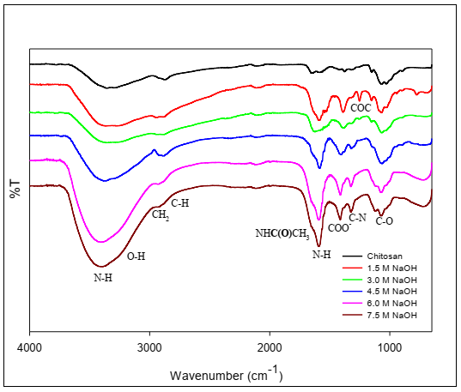

Figure 3. The FTIR spectra of chitosan and all CMC at different concentration of NaOH

Figure 4. The chemical structure of a) chitosan b) O-CMC, c) N,O-CMC and d) N-CMC

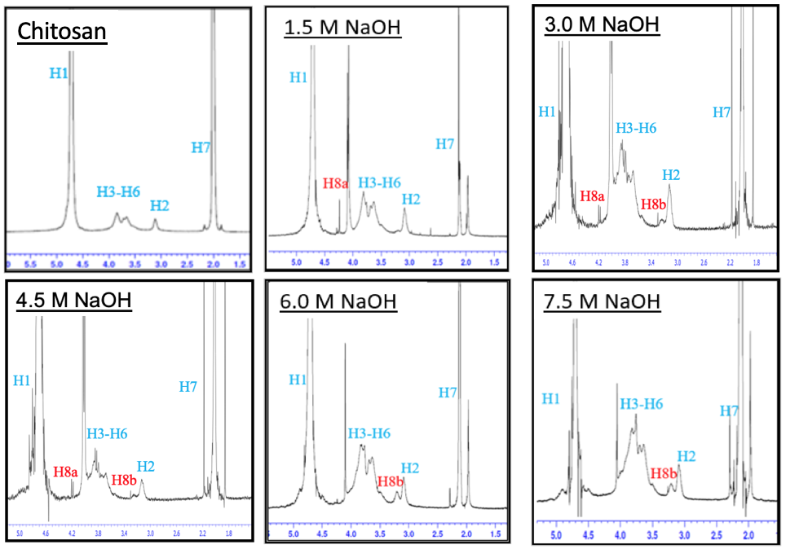

Figure 5. ¹H NMR spectra of chitosan and CMC at different NaOH concentrations

Table 1. Chemical structure of CMC at different NaOH concentrations
Conc. of NaOH (M) | Chemical Shifts, δ (ppm)
Conc. of NaOH (M) | H1 | H2 | H3-H6 | H7 | H8a | H8b
1.5 | 4.70 | 3.12 | 3.67-4.10 | 2.10 | 4.24 | -
3.0 | 4.70 | 3.15 | 3.68-4.05 | 2.12 | 4.21 | 3.25
4.5 | 4.70 | 3.15 | 3.68-4.07 | 2.11 | 4.25 | 3.25
6.0 | 4.70 | 3.13 | 3.68-4.12 | 2.12 | - | 3.23
7.5 | 4.70 | 3.14 | 3.68-4.10 | 2.15 | - | 3.25

Degree of substitutions
The DS represent the average number of carboxymethyl group substituted into OH and NH₂ sites in the chitosan structure. According to Jaidee et al. [28] and Zong et al. [29], there are three possible active sites for carboxymethyl substitution on chitosan structure which are OH-6, OH-3 and NH₂. The DS values for CMC at various NaOH concentrations have been tabulated in Table 2.

Based on Table 2, all DS values for CMC at different NaOH concentrations are close to 1, indicating that at least one active site on chitosan chain has been successfully substituted [14, 16, 30]. According to FTIR and ¹H-NMR spectra, the carboxymethyl group was only substituted at OH site at 1.5 M NaOH, producing O-CMC. The increased in NaOH concentration resulted in increasing DS value, as shown for CMC at 3.0 M and 4.5 M NaOH, which are 0.83 and 1.00, respectively. These values demonstrated that NH₂ sites started to deprotonate and undergo carboxymethyl substitution at both active sites as described by NMR spectra. Despite the introduction of carboxymethyl groups at two active sites, OH and NH₂, the DS value for both concentrations did not approach 2. This could be because not all active sites in the chitosan chain were completely substituted with carboxymethyl groups.

Besides, the DS values of CMC prepared at 6.0 M and 7.5 M were approximately the same at 0.93 and 0.94, respectively. This indicated that the carboxymethyl group substitution occurred under optimal condition at both concentrations, 6.0 M and 7.5 M NaOH. We also conducted the Student’s t-test to determine the selection of NaOH concentration has directly affected the DS for producing N,O-CMC, and N-CMC. Based on the results, there are no statistically significant differences between the means of DS values produced at 3.0 M and 4.5 M NaOH, since p > 0.05. The same observation has been reached for 6.0 M and 7.5 M. Therefore, both concentration either 3.0 M and 4.5 M NaOH can be used to produce N,O-CMC while 6.0 M and 7.5 M to obtain N-CMC.

Thermogravimetry analysis
The TGA and derivative thermogravimetry (DTG) curves of chitosan and CMC for all NaOH concentrations shown in Figure 6. Based on Figure 6, chitosan exhibited two thermal degradation behaviors. The thermal degradation (T_{H2O}) observed at 68.71 °C was associated to the loss of capillary bonded water [2]. Meanwhile, the thermal degradation (T_{d1}) stage started about 296.25 °C and reached maximum mass loss at 43.7% due to thermal and oxidative decomposition of the chitosan chain [31]. The thermal degradation temperature and weight loss of chitosan and CMC at different NaOH concentrations were listed in Table 3.

For all CMCs, degradation at temperatures of 60 °C to 75 °C occurred due to the evaporation of adsorbed and bound water in the polymer structure. Kurniasih et al. [32] reported that carboxymethyl chitosan is more hygroscopic and has a greater ability to bind with water than chitosan due to capability of carboxylic groups forming hydrogen bond with water molecules [22, 33]. The first thermal degradation (T_{d1}) at 207 °C attributed to decomposition of polymer chain can be observed for O-CMC produced at 1.5 M NaOH.
Meanwhile, N,O-CMC prepared at 3.0 M NaOH had only one polymer decomposition at 230 °C (T_{d1}), compared to N,O-CMC produced at 4.5 M NaOH, which had two stages of polymer decomposition at 270 °C (T_{d1}) and 372 °C (T_{d2}). According to Miranda et al. [4], the second stage of thermal degradation (T_{d2}) is assigned to the polymer decomposition of carboxymethyl groups that substituted at NH₂ sites. This shows that a greater amount of carboxymethyl group substituted on NH₂ sites for 4.5 M NaOH compared to 3.0 M NaOH. This also can be supported by FTIR analysis where the C-N peak at 4.5 M NaOH was more intense than 3.0 M NaOH. Similar observations could be made for N-CMC obtained at 6.0 M and 7.5 M NaOH. There are two stages of polymer decomposition at 260 – 270 °C (T_{d1}) and 374 – 383 °C (T_{d2}) since carboxymethyl substitution occurred at NH₂ sites.

Table 2. The DS values for CMC at various concentrations of NaOH
NaOH Concentration  (M) | Degree of Substitution  (DS)
1.5 | 0.74 ± 0.02
3.0 | 0.83 ± 0.06
4.5 | 1.00 ± 0.06
6.0 | 0.93 ± 0.01
7.5 | 0.94 ± 0.03

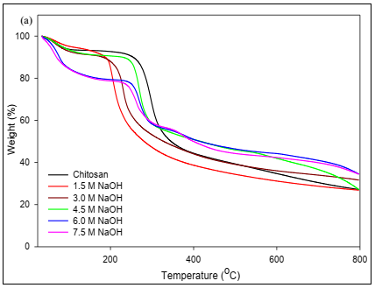

(b)

Figure 6. The a) TGA and b) DTG curves of chitosan and CMC for all NaOH concentrations

Table 3. Thermal degradation temperature and weight loss of chitosan and all CMC at different concentrations
Samples | T _{H2O} (°C) | % Loss | T_{d1} (°C) | % Loss | T_{d2} (°C) | % Loss | % Residue
Chitosan | 68.71 | 6.35 | 296.25 | 41.76 | - | - | 26.69
1.5 M NaOH | 67.01 | 4.27 | 207.75 | 40.71 | - | - | 26.99
3.0 M NaOH | 67.71 | 6.95 | 230.07 | 33.56 | - | - | 31.62
4.5 M NaOH | 60.50 | 7.31 | 270.52 | 31.24 | 372.64 | 8.56 | 26.77
6.0 M NaOH | 75.07 | 15.2 | 270.52 | 20.0 | 383.70 | 9.99 | 34.77
7.5 M NaOH | 67.01 | 16.9 | 260.76 | 18.5 | 374.96 | 10.24 | 34.53

Differential scanning calorimetry
The DSC curves for second heating cycle are shown in Figure 7 to illustrate the thermal behaviour of the polymers. Based on Figure 6, chitosan exhibited two thermal events, first-endothermic and second-exothermic peaks. The first endothermic peak observed at 114 °C could be considered as glass transition temperature (T_{g}) [2], as moisture was evaporated in the first heating cycle. Moreover, the TGA curves revealed that the water evaporating temperature was about 60 – 75 °C. The exothermic peak (T_{d1}) appeared at 307.21 °C, corresponding to thermal decomposition of polymer chain [34-35]. Acosta-Ferreira [36] reported that decomposition of polymer including depolymerization, saccharide ring dehydration, decomposition of deacetylated and acetylated chitosan units. However, the decomposition temperature determined by DSC analysis was greater than TGA results, owing to the enhanced polymer strength caused by the removal of moisture during the first cycle of heating. Table 4 shows the glass transition and polymer decomposition temperatures for chitosan and all CMCs at different NaOH concentrations.

Furthermore, the DSC curves for all synthesized CMC had an endothermic peak centered between 80 °C until 113 °C, which may be ascribed as the glass transition temperature (T_{g}) of all CMC. The T_{g} of all CMC were lower than chitosan indicated that chitosan was more crystalline than CMC as less heat needed to transform CMC polymer chain from glassy to rubbery phase. It can be observed that O-CMC produced at 1.5 M NaOH had an endotherm peak at 207 °C, corresponding to the melting temperature which is consistent with the previous literature [37]. According to Liang et al. [19], the higher melting temperature of polysaccharides is attributed to the higher crystallinity of the polymer. However, a broad and amorphous peak that observed in XRD analysis contributed to low crystallinity of O-CMC, resulting a low glass transition temperature of O-CMC. Further explanation is discussed in XRD analysis.

Besides, an exothermic peak for N,O-CMC produced at 3.0 M NaOH can be seen at 234 °C. Contrary to N,O-CMC prepared at 4.5 M NaOH, there are two exothermic peaks observed at 278 °C and 380 °C. The appearance of these two peaks also could be observed for N-CMC synthesized at higher concentration, 6.0 M, and 7.5 M NaOH. As referred to the literature [38], the first exothermic peak represents the decomposition of polysaccharide chain, while the second exothermic peak was due to the decomposition of carboxymethyl group substituted at NH₂ sites. The second exothermic peak only presence when higher substitution occurred at NH₂ sites. These could support the TGA analysis. as the same occurrence happened in both analysis and confirmed the decomposition of carboxymethyl group at NH₂ sites. However, the glass transition temperature of N-CMC differs significantly, as the 6.0 M was lower than 7.5 M NaOH, indicating that it had dissimilar behaviors in thermal properties. Therefore, further research is needed to reach a better understanding of the internal structure of polymer.

X-ray diffraction analysis
The XRD analysis was conducted to compare the crystallinity of chitosan and all CMC in different NaOH concentrations, as shown in Figure 8. It is observed that the diffractogram of chitosan has a wide and broad peak at 2θ = 10.05° and 2θ = 20.16° that reflected from (0 2 0) plane and (2 0 0) plane [39]. Based on Franca et al. [40], inter- and intra-molecular hydrogen bond play important part in the stabilization of the chitosan structure. An intramolecular hydrogen bond is formed between atoms OH at C3 and O5 of consecutive linked glucosamine units which responsible to keep the polymer chain in 2-fold helical pattern. Meanwhile, the intermolecular hydrogen bond formed between two amide group and amide group with hydroxymethyl group. In addition, intermolecular hydrogen bonds also formed between water molecules in polymer chains [41]. However, the substitution of carboxymethyl loosened their characteristics and led to a less ordered arrangement compared to the chitosan structure [42].
The O-CMC prepared in 1.5 M NaOH showed the three obvious peaks. Besides the existence of peak at 2θ = 11.50°, which contributed to crystallinity of polymers, the new and small pointed peak at 2θ = 8.28° also could be observed at a lower angle of diffractogram. This leads to the appearance of endothermic peak in DSC curve for 1.5 M NaOH. However, the amorphous peak at 2θ = 17.28° was lower and broader than chitosan which helps in reducing the crystallinity of O-CMC even though it has the endothermic peak in DSC. Additionally, N,O-CMC synthesized using 3.0 M NaOH showed broad and amorphous peaks at 2θ = 11.50° and 2θ = 21.60° that might be due to less ordered of polymer chain structure. Compared to N,O-CMC produced at 4.5 M NaOH, the low reflective peak could be observed at 2θ = 9.73° but a strong and sharp peak also could be seen at 2θ = 19.83°. This was due to the greater amount of carboxymethyl substitution occurred at 4.5 M than 3.0 M NaOH, which also could be supported by DS analysis as the DS value of 4.5 M NaOH is higher than other CMC.

Furthermore, N-CMC prepared at 6.0 M and 7.5 M NaOH showed approximately the same characteristics. Only one small peak appeared at 2θ = 20.33° and 2θ = 20.00°, respectively even though it had different thermal behaviour. These might be due to the arrangement of N-CMC chain that still maintains the flexibility of polymer. In addition, Samuel [43] stated that the presence of carboxymethyl group in the N-CMC chain could disrupt the intermolecular hydrogen bonding of chitosan and increase the amorphous state in the polymer chains.

Figure 7. The DSC thermogram for chitosan and CMC at various NaOH concentrations

Table 4. The glass transition and polymer decomposition temperature of chitosan and all CMC

at different NaOH concentrations
Samples | T_{g} (°C) | T_{m} (°C) | T_{d1} (°C) | T_{d2} (°C)
Chitosan | 114.17 | - | 307.21 | -
1.5 M NaOH | 89.77 | 206.78 | - | -
3.0 M NaOH | 101.16 | - | 234.04 | -
4.5 M NaOH | 101.16 | - | 278.94 | 380.01
6.0 M NaOH | 80.08 | - | 271.88 | 383.13
7.5 M NaOH | 113.06 | - | 268.96 | 384.30

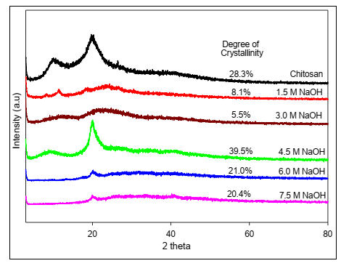

Figure 8. The XRD diffractogram for chitosan and CMC prepared at different NaOH concentrations

Conclusion
In conclusion, N-carboxymethyl chitosan was successfully synthesized under heterogenous conditions at higher NaOH concentration which are 6.0 M and 7.5 M NaOH as confirmed by FTIR spectroscopy, ¹H-NMR spectroscopy, and DS calculation. However, the glass transition temperatures of N-CMC at both NaOH concentrations showed significant differences, indicating dissimilar behavior in thermal properties. Despite this, N-CMC still retains its flexibility, as shown in XRD analysis. Therefore, the choice of N-CMC at selective concentration may be determined by specific applications.

Acknowledgement
The authors would like to thank Fakulti Sains dan Teknologi and Centre for Research and Instrumentation Management (i-CRIM), UKM for providing the facilities and research grant GGPM-2017-093 for funded this work.

References
- Alves, N. M. and Mano, J. F. (2008). Chitosan derivatives obtained by chemical modifications for biomedical and environmental applications. International Journal of Biological Macromolecules, 43(5): 401-414.
- Tzaneva, D., Simitchiev, A., Petkova, N., Nenov, V., Stoyanova, A. and Denev, P. (2017). Synthesis of carboxymethyl chitosan and its rheological behaviour in pharmaceutical and cosmetic emulsions. Journal Applied Pharmaceutical Science, 7(10): 70-78.
- Madera-Santana, T. J., Herrera-Méndez, C. H. and Rodríguez-Núñez, J. R. (2018). An overview of the chemical modifications of chitosan and their advantages. Green Materials, 6(4): 131-142.

- Miranda, M. E. S., Marcolla, C., Rodrígues, C. A., Wilhelm, H. M., Sierakowski, M. R., Bresolin, T. M. B. and de Freitas, R. A. (2006). Chitosan and N‐carboxymethyl chitosan: I. The role of N‐carboxymethylation of chitosan in the thermal stability and dynamic mechanical properties of its films. Polymer international, 55(8): 961-969.
- Andreica, B. I., Cheng, X. and Marin, L. (2020). Quaternary ammonium salts of chitosan. A critical overview on the synthesis and properties generated by quaternization. European Polymer Journal, 2020: 110016.
- Klinkesorn, U. (2013). The role of chitosan in emulsion formation and stabilization. Food Reviews International, 29(4): 371-393.
- An, N. T., Dong, N. T. and Le Dung, P. (2009). Water-soluble N-carboxymethylchitosan derivatives: Preparation, characteristics, and its application. Carbohydrate Polymers, 75(3): 489-497.
- Skorik, Y. A., Gomes, C. A., Vasconcelos, M. T. S. and Yatluk, Y. G. (2003). N-(2-Carboxyethyl) chitosans: regioselective synthesis, characterisation and protolytic equilibria. Carbohydrate research, 338(3): 271- 276.
- Sahariah, P., Árnadóttir, B. and Másson, M. (2016). Synthetic strategy for selective N-modified and O-modified PEGylated chitosan derivatives. European Polymer Journal, 81: 53-63.
- Salehuddin, N. E. A., Rodzali, N. A., Ku Bulat, K. H. and Mobarak, N. N. (2021). Site-selective carboxymethylation of chitosan under heterogeneous conditions. Malaysian Journal of Analytical Sciences, 25(3): 376-387.
- Rahman, M., Hasan, M., Nitai, A. S., Nam, S., Karmakar, A. K., Ahsan, Shiddiky, M. J. A. and Ahmed, M. B. (2021). Recent developments of carboxymethyl cellulose. Polymers, 13(8): 1345.
- Heinze, T. and Pfeiffer, K. (1999). Studies on the synthesis and characterization of carboxymethylcellulose. Die Angewandte Makromolekulare Chemie, 266(1): 37-45.
- Chen, X. G. and Park, H. J. (2003). Chemical characteristics of O-carboxymethyl chitosan related to the preparation conditions. Carbohydrate Polymers, 53(4): 355-359.
- Elomaa, M., Asplund, T., Soininen, P., Laatikainen, R., Peltonen, S., Hyvärinen, S. and Urtti, A. (2004). Determination of the degree of substitution of acetylated starch by hydrolysis, ¹H NMR and TGA/IR. Carbohydrate Polymers, 57(3): 261-267.
- Pushpamalar, V., Langford, S. J., Ahmad, M. and Lim, Y. Y. (2006). Optimization of reaction conditions for preparing carboxymethyl cellulose from sago waste. Carbohydrate Polymers 64(2): 312-318.
- Aggeryd, I. and Olin, Å. (1985). Determination of the degree of substitution of sodium carboxymethylcellulose by potentiometric titration and use of the extended henderson-hasselbalch equation and the simplex method for the evaluation. Talanta, 32(8): 645-649.
- Liu, J., Zhang, X., Kennedy, J. F., Jiang, M., Cai, Q. and Wu, X. (2019). Chitosan induces resistance to tuber rot in stored potato caused by Alternaria tenuissima. International Journal of Biological Macromolecules, 140: 851-857.
- Mobarak, N. N., Ahmad, A., Abdullah, M. P., Ramli, N. and Rahman, M. Y. A. (2013). Conductivity enhancement via chemical modification of chitosan based green polymer electrolyte. Electrochimica Acta, 92:161-167.
- Liang, X., Wang, H., Tian, H., Luo, H. and Chang, J. (2008). Synthesis, structure and properties of novel quaternized carboxymethyl chitosan with drug loading capacity. Acta Physico-Chimica Sinica, 24(2): 223-229.
- Doshi, B., Repo, E., Heiskanen, J. P., Sirviö, J. A. and Sillanpää, M. (2017). Effectiveness of N, O-carboxymethyl chitosan on destabilization of marine diesel, diesel and marine-2t oil for oil spill treatment. Carbohydrate Polymers, 167: 326-336.
- Bukzem, A. L., Signini, R., Dos Santos, D. M., Lião, L. M. and Ascheri, D. P. R. (2016). Optimization of carboxymethyl chitosan synthesis using response surface methodology and desirability function. International Journal of Biological Macromolecules, 85: 615-624.
- Mourya, V. K., Inamdar, N. N. and Tiwari, A. (2010). Carboxymethyl chitosan and its applications. Advanced Materials Letters, 1 (1): 11 – 33.
- Jimtaisong, A. and Saewan, N. (2014). Utilization of carboxymethyl chitosan in cosmetics. International Journal of Cosmetic Science, 36(1): 12-21.
- Abreu, F. R. D. and Campana-Filho, S. P. (2005). Preparation and characterization of carboxymethylchitosan. Polímeros, 15(2): 79-83.
- Hjerde, R. J. N., Vårum, K. M., Grasdalen, H., Tokura, S. and Smidsrød, O. (1997). Chemical composition of O-(carboxymethyl)-chitins in relation to lysozyme degradation rates. Carbohydrate Polymers, 34 (3):131-139.
- Muzzarelli, R. A., Ilari, P. and Petrarulo, M. (1994). Solubility and structure of N-carboxymethylchitosan. International Journal of Biological Macromolecules, 16(4): 177-180.
- Klinkesorn, U. (2013). The role of chitosan in emulsion formation and stabilization. Food Reviews International, 29(4): 371-393.
- Jaidee, A., Rachtanapun, P. and Luangkamin, S. (2012). ¹H-NMR analysis of degree of substitution in N, O-carboxymethyl chitosan from various chitosan sources and types. Advanced Materials Research, 506: 158 – 161.
- Zong, Z., Kimura, Y., Takahashi, M. and Yamane, H. (2000). Characterization of chemical and solid-state structures of acylated chitosans. Polymer, 41(3): 899-906.
- Bono, A., Ying, P. H., Yan, F. Y., Muei, C. L., Sarbatly, R. and Krishnaiah, D. (2009). Synthesis and characterization of carboxymethyl cellulose from palm kernel cake. Advances in Natural and Applied Sciences, 3(1): 5-12.
- Jiang, M., Wang, K., Kennedy, J. F., Nie, J., Yu, Q. and Ma, G. (2010). Preparation and characterization of water-soluble chitosan derivative by Michael addition reaction. International Journal of Biological Macromolecules, 47(5): 696-699.
- Kurniasih, M., Purwati, P., Hermawan, D. and Zaki, M. (2014). Optimum conditions for the synthesis of high solubility carboxymethyl chitosan. Malaysian Journal of Fundamental and Applied Sciences, 10(4): 189-194.
- Pang, H. T., Chen, X. G., Park, H. J., Cha, D. S. and Kennedy, J. F. (2007). Preparation and rheological properties of deoxycholate-chitosan and carboxymethyl-chitosan in aqueous systems. Carbohydrate Polymers, 69(3): 419-425.
- Kittur, F. S., Prashanth, K. H., Sankar, K. U. and Tharanathan, R. N. (2002). Characterization of chitin, chitosan and their carboxymethyl derivatives by differential scanning calorimetry. Carbohydrate polymers, 49(2): 185-193.
- Shinde, U., Ahmed, M. H. and Singh, K. (2013). Development of dorzolamide loaded 6-o-carboxymethyl chitosan nanoparticles for open angle glaucoma. Journal of Drug Delivery, 2013: 562727.
- Acosta-Ferreira, S., Castillo, O. S., Madera-Santana, J. T., Mendoza-García, D. A., Núñez-Colín, C. A., Grijalva-Verdugo, C., Villa-Lerma. A. G., Morales-Vargas. A. T. and Rodríguez-Núñez, J. R. (2020). Production and physicochemical characterization of chitosan for the harvesting of wild microalgae consortia. Biotechnology Reports, 28: e00554.
- Kamari, A. and Yusoff, S. N. M. (2019). N-octyl chitosan derivatives as amphiphilic carrier agents for herbicide formulations. Open Chemistry, 17(1): 365-380.
- Kasaai, M. R., Arul, J. and Charlet, G. (2013). Fragmentation of chitosan by acids. The Scientific World Journal, 2013: 508540.
- Osorio-Madrazo, A., David, L., Trombotto, S., Lucas, J. M., Peniche-Covas, C. and Domard, A. (2010). Kinetics study of the solid-state acid hydrolysis of chitosan: Evolution of the crystallinity and macromolecular structure. Biomacromolecules, 11(5): 1376-1386.
- Franca, E. F., Lins, R. D., Freitas, L. C. and Straatsma, T. P. (2008). Characterization of chitin and chitosan molecular structure in aqueous solution. Journal of Chemical Theory and Computation 4(12): 2141-2149.
- Brza, M. A., Aziz, S. B., Nofal, M. M., Saeed, S. R., Al-Zangana, S., Karim, W. O., Hussen, S. A., Abdulwahid, R.T. and Kadir, M. F. Z. (2020). Drawbacks of low lattice energy ammonium salts for ion-conducting polymer electrolyte preparation: structural, morphological, and electrical characteristics of CS:PEO:NH₄BF₄-based polymer blend electrolytes. Polymers 12(9): 1885-1906.
- Katugampola, P., Winstead, C. and Adeleke, A. (2014). Thermal stability of carboxymethyl chitosan varying the degree of substitution. International Journal of Pharmaceutical Science Invention, 3(5): 42- 48.

- Samuels, R. J. (1981). Solid state characterization of the structure of chitosan films. Journal of Polymer Science: Polymer Physics Edition 19(7): 1081-1105.

