APPLICATION OF ZINC OXIDE NANOPARTICLES AND NANOCHITOSAN TO ENHANCE THE LIGHT FASTNESS OF COTTON DYED WITH NATURAL INDIGO

(Aplikasi Zink Oksida Nanopartikel dan Nano Kitosan untuk

Meningkatkan Ketahanan Pudar Kain yang Diwarnai Indigo Asli)

Renung Reningtyas^{1,2}, Edia Rahayuningsih^{1,3*}, Yuni Kusumastuti¹, Indriana Kartini^{3,4}

¹Department of Chemical Engineering,

Faculty of Engineering,

Universitas Gadjah Mada, 55281 Yogyakarta, Indonesia

² Department of Chemical Engineering,

Faculty of Industrial Engineering

Universitas Pembangunan Nasional “Veteran” Yogyakarta, 55283 Yogyakarta, Indonesia

³Indonesia Natural Dye Institute,

Integrated Research and Testing Laboratory,

⁴Department of Chemistry, Faculty of Mathematics and Natural Sciences,

Universitas Gadjah Mada, 55281 Yogyakarta, Indonesia

*Corresponding author: edia_rahayu@ugm.ac.id

Abstract

The use of eco-friendly natural dyes with lower environment impact is getting more interest. Indigo dye is one of the most popular natural dyes and has been used for textile dyeing since ages. The lower light fastness of natural indigo dye compared with blue synthetic dye has been a major disadvantage of its use in the textile industry. In this study, zinc oxide nanoparticles (ZnONPs) synthesized using simple precipitation method were applied as an anti-UV agent to protect the color of natural indigo dyed cotton. To increase the adsorption of ZnONPs in cotton, nanochitosan coating was applied before ZnONPs coating. X-ray diffraction (XRD) and transmission electron microscopy (TEM) were conducted to characterize the crystallinity, shape and size of the produced ZnO. The particle size distribution of ZnONPs and nanochitosan was measured using the dynamic light scattering technique. The amount of ZnO adsorbed in cotton, coated with and without nanochitosan were measured using energy-dispersive X-ray spectroscopy (EDS) and X-ray fluorescence (XRF). Applying nanochitosan coating before ZnONPs coating could increase the amount of ZnO adsorbed in cotton up to fourfold. The ability of ZnONPs as anti-UV agent to protect color of dyed cotton was measured by the photofading test. The photofading test was performed under UV-A light exposure and the color difference of cotton samples before and after 144 h irradiation was measured based on CIELAB value. Cotton dyed with natural indigo and coated with nanochitosan and ZnONP has a lowest color difference, indicating the increasing of light fastness provided by ZnONPs.

Keywords: zinc oxide nanoparticles, nanochitosan, natural indigo dye, adsorption, fading

Abstrak

Penggunaan pewarna asli dengan kesan yang lebih rendah terhadap alam sekitar semakin menarik dikembangkan. Pewarna indigo adalah salah satu pewarna asli yang popular dan telah digunakan untuk pewarnaan tekstil sejak zaman dahulu. Ketahanan cahaya pewarna indigo yang lebih rendah berbanding dengan pewarna sintetik telah menjadi kelemahan utama penggunaannya dalam industri tekstil. Dalam kajian ini, Zink oksida nanopartikel (ZnONPs) yang disintesis dengan kaedah pemendakan sederhana digunakan sebagai agen anti-UV untuk melindungi warna indigo pada kain kapas. Untuk meningkatkan penjerapan ZnONP, lapisan nano kitosan digunakan sebelum lapisan ZnONPs. Pembelauan sinar-X (XRD) dan mikroskop elektron transmisi (TEM) digunakan untuk mencirikan penghabluran, bentuk dan ukuran ZnO yang dihasilkan. Taburan ukuran zarah ZnONP dan nano kitosan diukur dengan teknik penyebaran cahaya dinamik (DLS). Jumlah ZnO yang diserap dalam kapas, dilapisi dengan dan tanpa nano-kitosan diukur menggunakan sinar-X pendafluoran (XRF). Salutan nano kitosan sebelum pelapisan ZnONP dapat meningkatkan jumlah ZnO yang diserap dalam kain kapas hingga empat kali. Ujian pudar dilakukan di bawah cahaya UV-A dan hasil sebelum dan setelah penyinaran selama 144 jam diukur dengan nilai CIELAB. Kain kapas yang diwarnai dengan indigo asli dan telah dilapisi nano-kitosan dan ZnONP mempunyai perbezaan warna yang paling rendah. Hal ini menunjukkan peningkatan daya tahan cahaya dapat disediakan oleh ZnONPs.

Kata kunci: zink oksida nanopartikel, nano-kitosan, indigo asli, jerapan, pudar

Introduction

Eco-friendly natural dye is re-emergencing in the textile industries. This tendency grows with the soaring popularity of the back-to-nature lifestyle [1]. Currently, numerous small enterprise textile industry in Indonesia, especially the Batik industry have moved to the use of natural dye in textile coloring. Natural indigo dye is a popular dye used in different parts of the world, especially in Europe, Japan, India and Indonesia. The unique blue color of indigo mainly comes from indigotin pigment, which can be extracted through fermentation, reduction and oxidation process from indigoid plant leaves such as Indigofera tinctoria, Indigofera sumatrana, Indigofera. arecta, Indigofera galegoides, Indigofera enncaphylla, Strobilanthes flaccidifollus, Marsdenia tinctoria, Isatis tinctoria, and Polygonum tinctorium, and etc. [2]. Indigofera tinctoria leaves and the chemical structure of indigotin are shown in Figure 1.

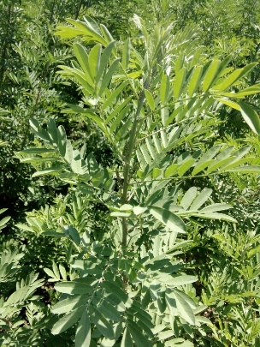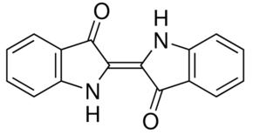
(b)
(a)

Figure 1. Indigofera tinctoria leaves (a) and chemical structure of indigotin (b)

The application of natural indigo dye in textile fabrics has its limitations such as low to moderate light fastness properties [3]. Indigo is prone to fading because of exposure to light. Fading occurs when the energy of light breaks the double bond in the dye structure; hence, dye molecules cannot reflect the original color. A shorter wavelength of light has higher energy; therefore, UV light with higher energy than visible light can cause undesired degradation [4].

Recently, inorganic nanomaterial has received more attention in the textile research industry; to provide multifunctional textile like textiles with anti-UV, anti-microorganism, self-cleaning and anti-odor properties. Particle with a diameter below 20 nm cannot scatter light in the visible range and therefore are not opaque when applied in fiber [5]. Zinc oxide (ZnO), titanium oxide (TiO₂) and silicon oxide (SiO₂) are among the good inorganic UV protection agents [6]. Zinc oxide nanoparticles are metal oxide semiconductors that have a large energy band gap, biocompatibility and relatively low cost. The photocatalytic activity of ZnONPs is also less than that of TiO₂, making it suitable for application in textile. Zinc oxide in nanosize has received considerable attention in numerous studies as an anti UV finishes in textiles [7-9]. However, research on the anti-UV properties in textile was mainly focused on its effect on skin protection. Moreover, ZnONPs were applied in undyed fabric or fabric dyed with synthetic dye. Unlike previous work, our present study is focused on the application of ZnONPs as an anti UV finish on cotton fabrics dyed with natural indigo to protect color from photofading.

The main barrier to nanoparticle application in the textile surface is their low adsorption and durability. To increase nanoparticle adsorption and to maintain nanoparticle durability, the addition of a binder agent is usually employed. Chitosan is a great candidate for an ecofriendly textile finishing material because of its biodegradability, biocompatibility and nontoxic properties. Chitosan is a functional biopolymer that can be obtained by partial de-N-acetylation of chitin. Chitosan also possesses antimicrobial properties that can be beneficial to protect fabrics as well as the wearer [10]. To create the homogenous coating on the cotton surface, chitosan can be produced in nanosize. To enhanced cellulose and chitosan bonding, the addition of a crosslinking agent like butane tetracarboxylic acid (BTCA), Arcofix NEC [11] and citric acid [12] has been reported. Citric acid is food grade material, has high availability and low cost, and therefore it is suitable to be applied in textile industries.

Several studies combined nanochitosan and ZnO to enhance anti-UV properties of textiles. However, the chitosan and ZnONPs was produced as nanocomposites. Moreover, the study of anti-UV properties in fabrics were focused on skin protection, as measured by the UV protection factor (UPF) [13-16]. Tangkawanit applied nanochitosan and ZnONPs in cotton prior indigo dyeing and the result showed the improvement in color fastness and anti-UV properties [17]. There are few publications in the literature regarding the application of nanochitosan-ZnONPs in dyed fabrics that focused on the color protection.

This research aims to protect color of cotton fabrics dyed with natural indigo from photofading by the application of ZnONPs as an anti-UV finish. Nanochitosan was used to enhance ZnONPs adsorption and durability in cotton fabrics. Impregnation of chitosan and ZnONPs was done in a series process after dyeing the cotton with natural indigo. Nanochitosan was produced by an ionic gelation method using sodium trypolyphosphate. Citric acid was used as a crosslinking agent to provide chemical linking between cellulose and chitosan. A characterization of ZnONP and nanochitosan was conducted and the amount of ZnONP adsorbed in treated cotton was analyzed. The effect of nanochitosan and ZnONP coating on light fastness of cotton dyed with natural indigo was also investigated by the photofading test.

Materials and Methods

Chemicals and materials

Chitosan powder with a 90% degree of deacetylation was purchased from PT. Biotech Surindo, West Java, Indonesia. Zinc nitrate tetrahydrate (Zn(NO₃)₂.4H₂O) and sodium hydroxide (NaOH), were purchased from Merck. Natural indigo dye powder, sodium dithionite and sodium carbonate as reduction agent in indigo dyeing were obtained from Gama Indigo (Indonesia). Cotton fabric (mercerized sanforized with warp 106 and weft 92, Ne1 50) was purchased from PT. Primatexo. The cotton fabric was soaked with 2% non-ionic detergent, washed several times and air dried before further treatment.

Methods: Cotton dyeing

Indigo powder (50 g), sodium carbonate (14 g), and sodium dithionite (18 g) were dissolved in 1 L of water at 70 °C. The solution was allowed to stand for 15 minutes under closed conditions to prevent oxidation. After 15 minutes the solution was mixed with a 9 L solution containing sodium carbonate (3.5 g) and sodium dithionite (4.5 g). The mixture was allowed to stand for 1 hour under closed conditions. The coating of fabrics was performed in a 1:20 mass-to-liquid ratio. Cotton fabric was dipped for 5 minutes in dyebath and air dried for 5 minutes to obtain contact with oxygen. The dipping process was repeated seven times to maximize dye uptake. Dyed cotton was washed with tap water to remove the unreacted dye in fabric surface and air dried.

Synthesis of ZnONPs

Zinc oxide nanoparticles were synthesized using precipitation method reported by Talam et al. with some modifications [18]. An aqueous solution of zinc nitrate at a concentration of 0.05 M (500 mL) was placed in beaker glass under continuous stirring. Sodium hydroxide solution (0.1 M, 500 mL) was added dropwise. The reaction occurred in room temperature (±1 30°C) for 2.5 hours and left under constant stirring for 30 minutes to reach completion. The particles were separated from supernatant by sedimentation. The supernatant solution was discharged carefully and the white precipitate remaining were washed 3 times with 100 mL of deionized water, dried in an oven at 100 °C for 3 hours, and ground to a fine powder. ZnONPs powder was kept in air-tight storage for further use.

Synthesis of nanochitosan

Nanochitosan was prepared by the ionic gelation method. Briefly, 0.2% (w/v) chitosan was made by dissolving 1 g of chitosan powder in 500 mL of 1% (v/v) acetic acid solution under constant stirring for 2 hours. After this solution had completely dissolved, 0.84% (w/v) sodium tripolyphosphate (STPP) solution was added dropwise under constant stirring. The volume ratio of chitosan and STPP solution was 5:2 and therefore the chitosan concentration in the dispersion was reduced to 0.14% (w/v). The dispersion of nanochitosan was kept air tight in glass bottle until further use.

Coating of cotton with nanochitosan

Cotton samples of 10 cm × 10 cm (±1 gr) were dip-coated for 5 minutes in a mixture of 100 mL nanochitosan dispersion with the combination of citric acid (0.8 g) as a crosslinking agent and sodium dihydrogen phosphate (0.6 g) as a catalyst. The coated cotton was then dried in oven with the temperature of 80°C for 5 minutes, followed by curing at 150°C for 3 minutes (Figure 2).

Coating of Cotton with ZnONPs

ZnONPs (1 g/L) were dispersed in water using probe sonicator (Vibracell, 750 W). The 100 mL dispersion was irradiated for 5 minutes. The dispersion temperature was raised from room temperature up to 40°C due to sonication process. Cotton samples of 10cm x 10cm (±1 g) were dip-coated for 5 min in the dispersion right after sonication and air dried (Figure 2).

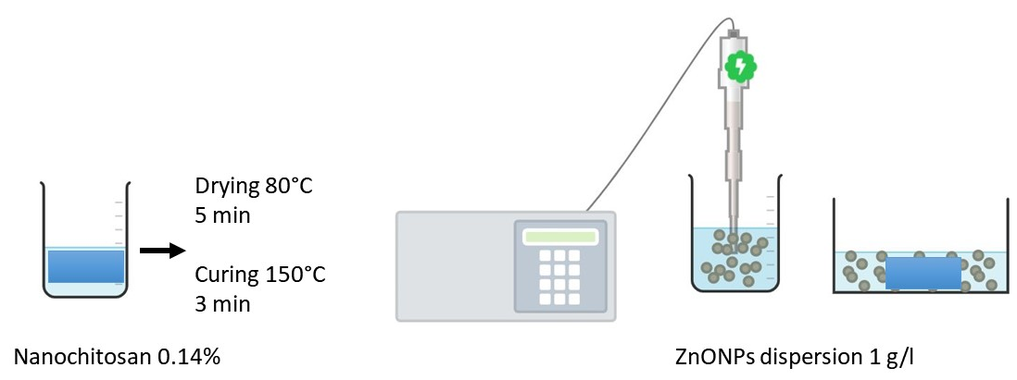

Figure 2. Coating process

Durability test

The coated samples were washed with demineralized water under constant stirring for 5 minutes and air dried. The mass to liquid ratio of washing was 1: 200. All samples were kept in dark chamber before further analysis.

Photofading test

Fading of natural indigo dye in cotton samples was tested using UV-A irradiation (Sankyo Denki, 20 W) for 144 hours. A photoreactor chamber with the dimensions of 60 cm × 50 cm × 30 cm was equipped with a fan to make the temperature inside the chamber uniform. A cotton sample were placed 25 cm below the lamp. The radiant flux was measured at 0.206 mW/cm² using a Lutron UV light meter YK-35UV.

Analysis

The shape and size of synthesized ZnONPs were determined by TEM (JEOL JEM 1400). The sample was previously dispersed in ethanol medium.

The X-ray diffraction (XRD) patterns of the ZnO powder were determined using Rigaku Smartlab with Cu Kα radiation of 40 kV, 30 mA, a scan speed 3 deg/min, a step width of 0.01° and a scan range of 3-90°. An estimation of the crystal size was calculated using Scherrer’s formula, equation 1, where D is the crystalline size, K is a dimensionless shape factor (0.89), λ is the wavelength of the X-ray (0.154 nm) and β is the full width at half maximum, while θ is the half diffraction angle.

$$D=\frac{kλ}{β cosθ}$$ | (1)

The size distribution of the ZnONPs dispersion was determined using the dynamic light scattering technique (Zetasizer Nano ZS, Malvern Instrument Ltd). The 12 mm cell was used and the parameters chosen for ZnO and dispersant (water) were as follows: (refractive index: 1.99 and 1.333, respectively). All measurements were taken at 25°C.

The surface morphology of cotton samples was observed with scanning electron microscope (Quanta Chrome) equipped with energy-dispersive X-ray spectroscopy (EDS). The zinc content within the cotton samples was estimated using X-ray fluorescence (XRF) PANalytical Epsilon1.

The change in color of the samples in CIELAB was evaluated using a UV-Vis spectrophotometer (Shimadzu, PC 2401). L represents the brightness where a* measures the perceived change from green (-a*) to red (+a*) and b* measures the perceived change from blue (-b*) to yellow (+b*). The color difference ($dE$) and the change in color ($ΔE$) were calculated using equation 2 and equation 3
$$dE= {\left[{\left({L*}^{'}-L*\right)}^{2}+{\left({a*}^{'}-a*\right)}^{2}+{\left({b*}^{'}-b*\right)}^{2}\right]}^{\frac{1}{2}}$$  $$ΔE={dE}_{before irradiation}-{dE}_{after irradiation}$$ | (2)  (3)

Results and Discussion

Characterization of ZnONPs and nanochitosan

The primary particle size and morphologies of ZnONPs prepared by the precipitation method were examined by TEM. Figure 3a shows that most of the particles are at the nanometer scale with a spherical shape like grain. It can be seen that the primary particle formed an agglomerate with the size of approximately 300˗400 nm. Figure 3b shows a histogram of the diameter of ZnONPs, with the calculated average size of primary nanoparticles is 22.51 nm.

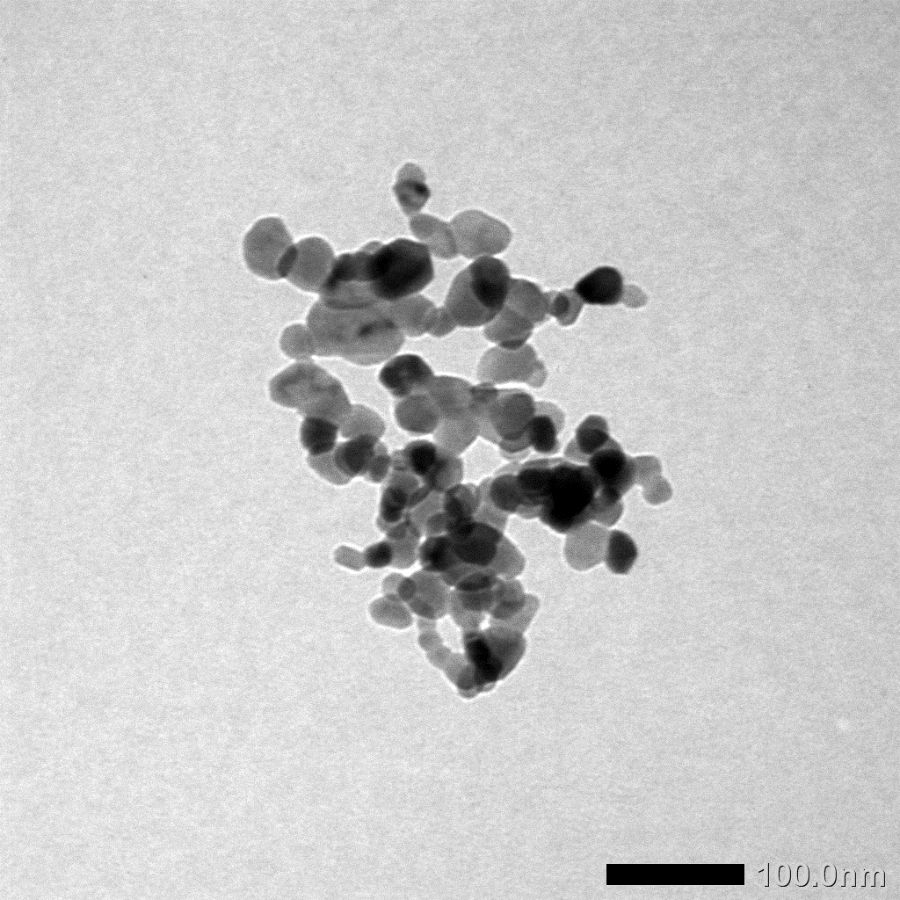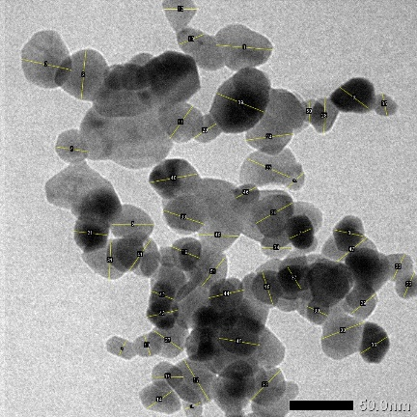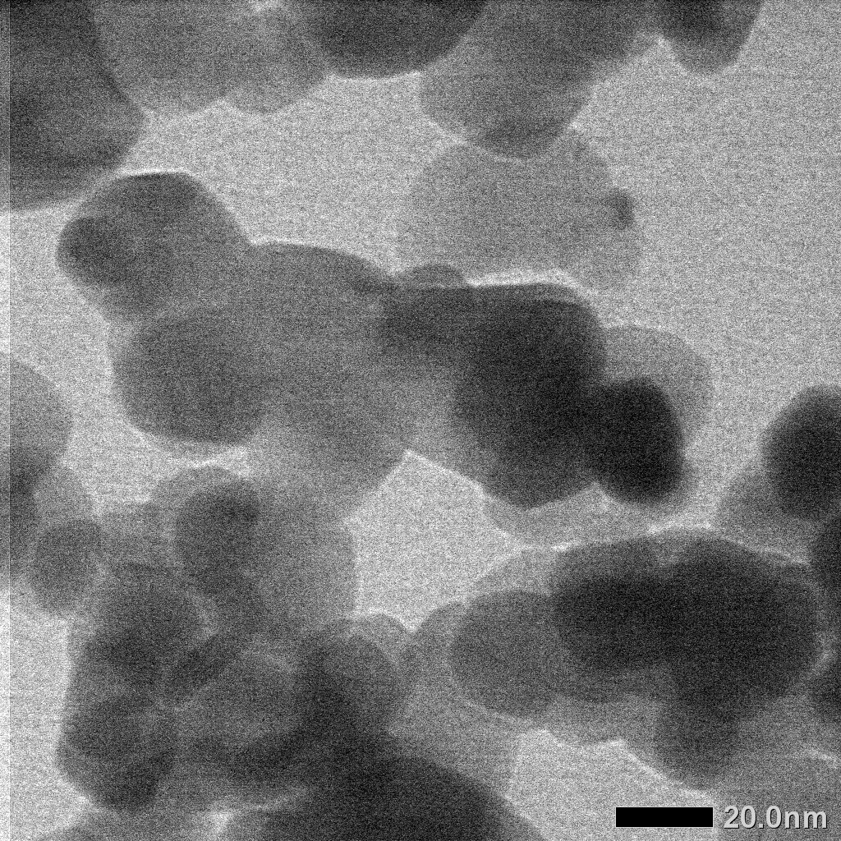
a
20 nm
50 nm
100 nm

b

Figure 3. (a) Transmission electron micrographs and (b) a histogram profile of ZnONPs prepared using the precipitation method and dried at 100°C

The XRD spectrum of the synthesized zinc oxide in Fig. 4 shows peaks at 2θ of 31.73°, 34.43°, 36.24°, 56.54°, 62.89° and 68.02°, which can be assigned to the (100), (002), (101), (102), (110), (103), and (112) crystal planes of the ZnO structure, respectively. The sharp peaks confirm the good crystalline nature of deposited ZnONPs. All peaks show the formation of a hexagonal wurtzite structure, which is in accordance with the JCPDS card 36-1451 [19]. Diffraction peaks related to impurities are not observed, indicating that pure ZnONPs were successfully synthesized using the precipitation method. The average particle size was determined to be 19.75 nm using Scherrer’s equation.

Figure 4. XRD spectrum of zinc oxide prepared using the precipitation method

ZnONPs with a concentration of 1 g/L were dispersed in pure water using ultrasound energy. The particle size distribution curve of the ZnONPs dispersion in water medium after sonication for 5 minutes is shown in Figure 5. The diameter of ZnONPs in aqueous solution is in the range of 400-800 nm, which is much larger than the diameter of primary particle. The z-average hydrodynamics diameter of the ZnONPs dispersion is 2310 nm, indicating the formation of aggregate or agglomerate in aqueous medium. This result is in accordance with the result of Jo et al. [20]. A large surface area and high surface energy of nanoparticles promote fast aggregation and agglomeration. Rapid particle collisions, van der Waals attraction, water bridging and a high surface energy of nanoparticles in water were responsible for their size increase [21].

The polydispersity index (PDI) is related to the size distribution of a nanoparticle dispersion. The PDI ranges from 0-1, where a PDI close to 0 indicates a homogenous dispersion and a PDI above 0.5 indicates heterogeneous dispersion [22]. From the particle size analyzer, the PDI of the ZnONPs dispersion is measured as 0.876. A heterogeneous distribution in the dispersion is likely caused by the agglomeration of ZnONPs in the water medium. Therefore, immediately after sonication, cotton was dip coated for not more than 5 minutes. A longer coating time resulted in the attachment of agglomerate ZnONPs, which are expected to fall under washing.

Figure 5. Particle size distribution of (1g/L) ZnONPs dispersion

Figure 6 shows the size distribution of chitosan solution 0.14% w/v. Nanochitosan with a smaller size distribution was successfully produced by an ionic gelation method using sodium tripolyphospate as crosslinking agent. PDI of nanochitosan dispersion was 0.409, indicating that a stable dispersion was successfully made.

Figure 6. Particle size distribution of the 0.14% (w/v) chitosan dispersion

Application of ZnONP and nanochitosan in cotton dyed with natural indigo dye

Figure 7 depicts the FTIR spectrum of chitosan and treated cottons. The absorption band at around 3300-3500 cm^{–1} for chitosan and cotton is corresponding to the stretching vibration of –NH₂ and –OH groups. The bands at 2896 cm^{–1} reflects the characteristic peak for asymmetric stretching of –CH₃ and –CH₂. The peaks at 1638 cm⁻¹ were assigned to –NH₂ groups. The vibration at 1388 cm^{–1} was assigned to the CH₃ symmetrical deformation and the vibration at 1024 cm^{–1} was assigned to C–O stretching vibrations. The band at below 500 cm^{–1} is corresponding to ZnO [23-24]. Compared with undyed cotton, the broader peak in the range of 3300-3500 cm^{–1} and the sharper peaks at 1630 cm^{–1} is shown in all cotton dyed with natural indigo, indicating the presence of more amine and hydroxyl groups as a contribution of the natural indigo compound. The peak of cotton-indigo coated with chitosan shifted to higher wavenumber (3414 cm^{–1}) compared with that of cotton-indigo without chitosan (3404 cm^{–1}). This indicates the chitosan attached to cotton surface, since the peak of chitosan alone shows at higher wavenumber (3448.5 cm^{–1}).

Figure 7. FTIR spectra of chitosan and cotton samples

Figure 8a shows the SEM micrograph and EDS spectrum of cotton-indigo coated with ZnONPs and washed for 5 minutes with deionized water under vigorous stirring. Figure 8b shows the SEM micrograph and EDS spectrum of cotton-indigo treated with nanochitosan and coated with ZnONPs. The inset shows the wt.% of the elements in the cotton samples. Carbon (C) and oxygen (O) are from cellulose and chitosan structures. EDS analysis shows that a coating of cotton-indigo with 0.14% wt. could increase the nitrogen content (N) from 0.3% to 0.6% wt. A nitrogen compound detected in the untreated cotton-indigo sample was probably due to nitrogen from the indigo structure (Figure 1b). The addition of nitrogen in cotton-indigo treated with nanochitosan was from amine groups in the chitosan structure (Figure 9). This increase in N content demonstrated the successful preparation of cotton-nanochitosan using the dip-cure method. Similar findings were documented by Preethi et al. who have reported the presence of N in a nanocomposite of chitosan/ZnO [15].

The presence of Zn indicates the ZnONPs attached in cotton. ZnONPs are well dispersed on both cotton surfaces. The deposition of ZnONPs in the cotton treated with nanochitosan was significantly higher compared to untreated cotton. Based on the EDS analysis, the amount of Zn was only 0.3% wt. in untreated cotton and 4.5% wt. in cotton treated with nanochitosan. This result shows that applying a nanochitosan coating before the ZnONPs coating can increase the adsorption and durability of ZnONPs in cotton substrate. To confirm the EDS result, an analysis of the Zn component using XRF was conducted. From the XRF analysis (Table 1), the detected Zn content was 4-fold higher in cotton treated with nanochitosan than in untreated cotton.

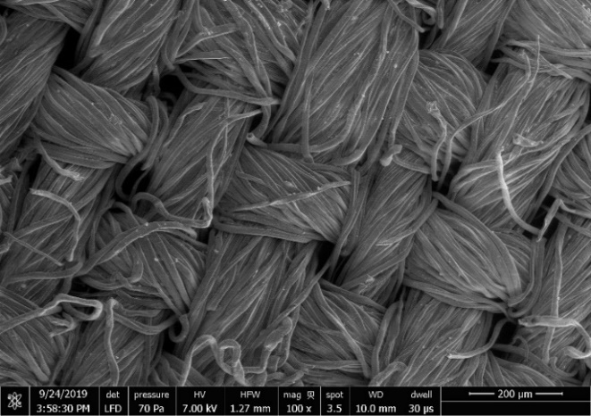  200 µm | 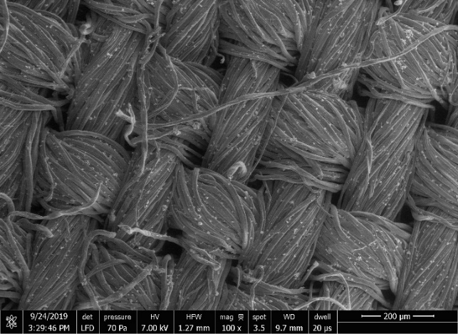  200 µm
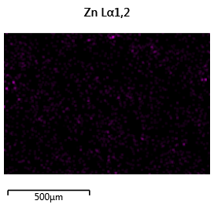 | 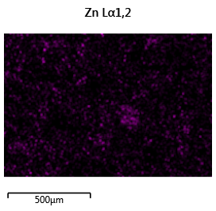
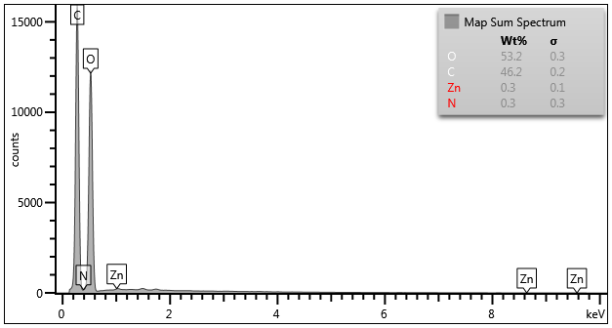 | 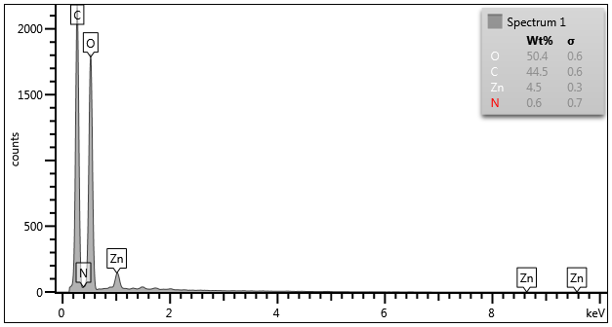
a | b

Figure 8. SEM-EDS of (a) Cotton-indigo-ZnONPs and (b) cotton-indigo-chitosan-ZnONPs after washing treatment

Table 1. Zinc content in the cotton sample

Treatment | N %  EDS | Zn %  EDS | Zn %  XRF
Cotton-Indigo | - | - | 0.001
Cotton-Indigo-ZnONPs | 0.3 | 0.3 | 0.177
Cotton-Indigo-Nanochitosan-ZnONPs | 0.6 | 4.5 | 0.723

The increasing amount of adsorbed Zn could be due to the rich hydroxyl groups in the nanochitosan structure. The addition of OH groups from chitosan provides more active sites to attract ZnONPs via hydrogen bonding. The rougher surface of cotton treated with nanochitosan could trap ZnONPs and hence, ZnONPs would not easily fall during washing. Chitosan in nano size also promoted higher adsorption of ZnONPs on the cotton surface due to its large surface area. Figure 8 shows the proposed interaction of cellulose-indigo-chitosan-ZnO.

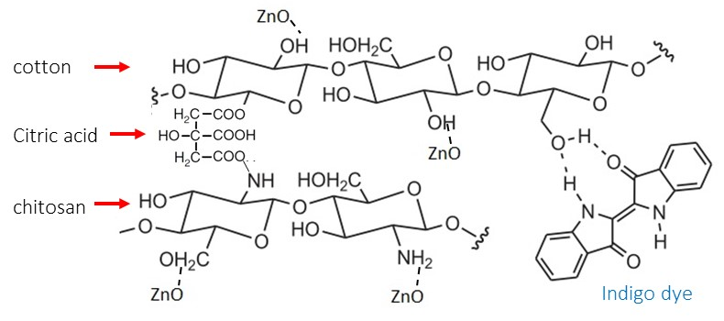

Figure 8. Schematic of interaction of cellulose-indigo-chitosan-ZnO, adapted from Tangkawanit [17]

The effect of ZnONP coating on the light fastness of cotton dyed with natural indigo was investigated by a photofading study using UV-A irradiation. The color difference (dE), which is a comparison of color coordinates of samples and the plain cotton (standard), was measured using CIELAB standard and was calculated according to equation 1. The color coordinates, L*, a*, and b* of the samples were illustrated in Table 2. The color change before and after irradiation is calculated using equation 3.

Table 2. Color difference of cotton sample before and after UV-A irradiation

Treatment | Before Irradiation |  |  |  | After 144 h UV-A Irradiation |  |  |  | ΔE
Treatment | L | a* | b* | dE | L | a* | b* | dE | ΔE
Cotton (standard) | 101.33 | −0.07 | 0.03 | 0 | 101.31 | −0.29 | 0.09 | 0 | 0
Cotton-Indigo | 48.35 | −5.22 | −16.23 | 55.58 | 58.03 | −6.73 | −23.81 | 49.77 | 5.81
Cotton-Indigo-ZnONPs | 44.46 | −2.59 | −21.73 | 60.94 | 48.93 | −2.79 | −19.8 | 56.09 | 4.85
Cotton-Indigo-Nanochitosan-ZnONPs | 34.38 | −1.47 | −18.41 | 69.46 | 38.43 | −3.1 | −18.94 | 65.77 | 3.69

After irradiation, the brightness (L) in all samples was increased and the color became greener and yellower. The change in color (ΔE) was lower in the treated samples than in the untreated sample. Cotton-indigo treated with nanochitosan and ZnONPs has the smallest color changes, indicating that chitosan works well as a binder of ZnONPs and ZnONPs work well as an anti-UV finish. Light impinging on the surface of the material can be absorbed, reflected, scattered and transmitted. ZnONPs has the ability to absorb UV light and the absorption peak is approximately 380 nm [25]. The energy absorbed could promote electron excitation on the ZnONP surface. The excited electron jumps from the valence band to the conduction band and creates a hole with a positive charge. Approximately 90% of the hole-electron pairs could recombine followed by a release of energy [26]. The photo-generated holes and electrons can also induce oxidation-reduction reaction with water and oxygen on the ZnONP surface, forming hydroxyl radicals and reactive oxygen species (ROS) [27]. These radicals and can to react with organic material causing degradation. However, based on the result in Table 2, the anti-UV effect of ZnONPs was more dominant than its photocatalytic action, as indicated by lower the color change in the cotton coated with ZnONPs. Applying nanochitosan coating before ZnONP coating could increase the adsorption and durability of ZnONPs. The combination of nanochitosan and ZnONP coating on cotton dyed with natural indigo has the potential for use in the production of durable multifunctional textile.

Conclusion

We have demonstrated a simple production of ZnONPs via the precipitation method and nanochitosan via ionic gelation. The synthesis of zinc oxide from zinc nitrate and sodium hydroxide results in the formation of hexagonal wurtzite nanoparticles with a size of ±20 nm. The characterization using a particle size analyzer confirms that ZnONPs and the chitosan dispersion were of nanometer size, which makes them suitable for textile functionalization. The application of nanochitosan coating before ZnONP coating on cotton increased the amount of absorbed ZnONPs up to fourfold and thus enhanced more light fastness properties compared with untreated cotton. The dip-cure method applied in this study could be useful for the preparation of multifunctional textile.

Acknowledgment

The authors gratefully acknowledge the Indonesia Endowment Fund for Education (Lembaga Pengelola Dana Pendidikan Kementerian Keuangan Republik Indonesia) for providing financial support via Beasiswa Unggulan Dosen Indonesia-Dalam Negeri.

References
- Widiawati, D. (2009). The revival of the usage of natural fibers and natural dyes in Indonesian textile. ITB Journal of Visual Art and Design, 3(2): 115-128.
- Papanastasiou, M., Allen, N. S., McMahon, A., Naegel, L. C. A., Edge, M. and Protopappas, S. (2012). Analysis of indigo-type compounds in natural dyes by negative ion atmospheric pressure photoionization mass spectrometry. Dyes and Pigments, 92(3): 1192-1198.
- Padfield, T. and Landi, S. (1966). The light fastness of the natural dyes, Studies in Conservation, 11: 181-196.
- Saravanan, D. (2007). UV protection textile materials. Autex Research Journal, 7(1): 11-18.
- Fajzulin, I., Zhu, X. and Möller, M. (2015). Nanoparticulate inorganic UV absorbers: A review. Journal of Coatings Technology and Research, 12(4): 617-632.
- Schneider, S. L. and Lim, H. W. (2019). A review of inorganic UV filters zinc oxide and titanium dioxide. Photodermatology, Photoimmunology and Photomedicine, 35(6): 442-446.
- Becheri, A., Dürr, M., Lo Nostro, P. and Baglioni, P. (2008). Synthesis and characterization of zinc oxide nanoparticles: Application to textiles as UV-absorbers. Journal of Nanoparticle Research, 10(4): 679-689.
- Pulit-Prociak, J., Chwastowski, J., Kucharski, A. and Banach, M. (2016). functionalization of textiles with silver and zinc oxide nanoparticles. Applied Surface Science, 385: 543-553.
- Kathirvelu, S., D’Souza, L. and Dhurai, B. (2009). UV protection finishing of textiles using ZnO nanoparticles. Indian Journal of Fibre and Textile Research, 34(3): 267-273.
- Ibrahim, N. A., Eid, B. M., El-Aziz, E. A., Elmaaty, T. M. A. and Ramadan, S. M. (2017). Loading of chitosan–nano metal oxide hybrids onto cotton/polyester fabrics to impart permanent and effective multifunctions. International Journal of Biological Macromolecules, 105: 769-776.
- El-tahlawy, K. F., El-bendary, M. A., Elhendawy, A. G. and Hudson, S. M. (2005). The antimicrobial activity of cotton fabrics treated with different crosslinking agents and chitosan. Carbohydrate Polymers, 60: 421-430.
- Alonso, D., Gimeno, M., Olayo, R., Vázquez-Torres, H., Sepúlveda-Sánchez, J. D. and Shirai, K. (2009). Cross-linking chitosan into UV-irradiated cellulose fibers for the preparation of antimicrobial-finished textiles. Carbohydrate Polymers, 77(3): 536-543.
- Farouk, A., Moussa, S., Ulbricht, M. and Textor, T. (2012). ZnO nanoparticles-chitosan composite as antibacterial finish for textiles. International Journal of Carbohydrate Chemistry, 2012 (693629): 1-8.
- Raza, Z. A. and Anwar, F. (2016). Impregnation of zinc oxide mediated chitosan nano-composites on polyester fabric for performance characteristics. Fibers and Polymers, 17(9): 1378-1383.
- Preethi, S., Abarna, K., Nithyasri, M., Kishore, P., Deepika, K., Ranjithkumar, R., Bhuvaneshwari, V. and Bharathi, D. (2020). Synthesis and characterization of chitosan/zinc oxide nanocomposite for antibacterial activity onto cotton fabrics and dye degradation applications. International Journal of Biological Macromolecules, 164: 2779-2787.
- Abd Elhady, M.M. (2012). Preparation and characterization of chitosan/zinc oxide nanoparticles for imparting antimicrobial and UV protection to cotton fabric. International Journal of Carbohydrate Chemistry, 2012 (840591): 1-6.
- Tangkawanit, S. (2020). Color fastness and UV protection improvement of indigo dyed cotton fabrics coated with nano chitosan and zinc oxide. The Journal of King Mongkut’s University of Technology North Bangkok, 30(3): 1-13.
- Talam, S., Karumuri, S. R. and Gunnam, N. (2012). Synthesis, characterization, and spectroscopic properties of ZnO nanoparticles, ISRN Nanotechnology, 2012 (372505): 1-6.
- Liu, Z. R, Hou, J., Duan, L. M. and Xu, L. (2011). Study on the synthesis and properties of nano-ZnO, Materials Science Forum, 694: 324-327.
- Jo, M., Chung, H., Kim, H., Bae, S., Go, M., Yu, J. and Choi, S. (2016). Effects of zinc oxide nanoparticle dispersants on cytotoxicity and cellular uptake. Molecular and Cellular Toxicology, 12(3): 281-288.
- Tso, C. P, Zhung, C. M, Shih, Y.H, Tseng, Y., Wu, S.C. and Doong, R. A. (2010). Stability of metal oxide nanoparticles in aqueous solutions. Water Science and Technology, 61(1): 127-133.
- Rosyada, A., Sunarharum, W. B. and Waziiroh, A. (2019). Characterization of chitosan nanoparticles as an edible coating material. IOP Conference Series: Earth and Environmental Science, 230 (012043): 1-5.
- Turemen, M., Demir, A. and Gokce, Y. (2021). The synthesis and application of chitosan coated ZnO nanorods for multifunctional cotton fabrics. Materials Chemistry and Physics, 268(124736): 1-6.
- El.Shafei, A. and Abou-Okeil, A. (2011). ZnO/carboxymethyl chitosan bionano-composite to impart antibacterial and UV protection for cotton fabric. Carbohydrate Polymers, 83: 920-925.
- Ahmed, M. T., Sarhan, A. and Hassan, A. (2016). Preparation and characterization of ZnO nanoparticles by simple precipitation method. International Journal of Science, Engineering Technology, 4(3): 507-512.
- Wang, C., Lv, J., Ren, Y., Zhou, Q., Chen, J., Zhi, T., Lu, Z., Gao, D., Ma, Z. and Jin, L. (2016). Cotton fabric with plasma pretreatment and ZnO/carboxymethyl chitosan composite finishing for durable UV resistance and antibacterial property. Carbohydrate Polymers, 138: 106-113.
- Das, A., Sk., N. and Nair, R. G. (2019). Influence of surface morphology on photocatalytic performance of zinc oxide: A review, Nano-Structures and Nano-Objects, 19(100353): 1-18.

