PHYSICOCHEMICAL AND DYEING CHARACTERISTICS OF COTTON FABRIC DYEING FROM THE EXTRACT OF ANGSANA

(Pterocarpus indicus) BARK

(Fiziko Kimia dan Ciri Pencelupan Pewarnaan Kain Kapas dengan Menggunakan Ekstrak dari Kulit Kayu Angsana (Pterocarpus indicus))

Mukmin Sapto Pamungkas^{1,2}, Edia Rahyuningsih^{1,2*}, Taranipa Marfitania², Wachid Siti Fatimah²

¹Department of Chemical Engineering,
Faculty of Engineering

Universitas Gadjah Mada, Sleman 565223, Daerah Istimewa Yogyakarta, Indonesia

²Indonesia Natural Dye Institute,

Integrated Research and Testing Laboratory

Universitas Gadjah Mada, Sleman 565223, Daerah Istimewa Yogyakarta, Indonesia

*Corresponding author: edia_rahayu@ugm.ac.id

Abstract

Herein, the Angsana bark (Pterocarpus indicus) extract was studied for its potential as a natural dye for cotton fabrics. Angsana bark was extracted using water solvent at 70 °C with a ratio of solid-water of 70 g/L, for 1 hour, with a yield of 20.08% (w/w). The Angsana bark extract has acidic pH, a tannin content of 11.90%, and a density of 1.015 g/mL. Visible spectrophotometry results showed the highest peak of 395 nm, which indicated a high tannin content. FTIR revealed the presence of hydroxyl (-OH) (indicating an auxochrome group), aromatic (C-H) (indicating an aromatic group), carbonyl (C=O), and ether (C-O-C) groups. Cotton fabrics were premordanted using alum and soda ash prior to dyeing. Dyeing of the cotton fabrics was done by immersion for 15 minutes in the Angsana extract repeatedly and postmordanted using alum, lime, and iron sulfate. The colors produced by the alum and lime fixatives were different variations of brown, whereas that for the iron sulfate fixative was dark green. The highest K/S value of 8.554 was found for the iron sulfate fixative. Overall wash and light fastness scores were presented on the scale of 4 (good) and 4/5 (excellent). Thus, Angsana bark in water can be used as a source of natural dye for cotton fabrics, showing potential as a new material for application in cotton fabrics.

Keywords: Angsana extract, cotton fabrics, natural dye, Pterocarpus indicus

Abstrak
Di sini, potensi ekstrak kulit kayu Angsana (Pterocarpus indicus) sebagai pewarna semula jadi untuk kain kapas dikaji. Kulit kayu Angsana diekstrak menggunakan pelarut air pada suhu 70 °C dengan nisbah air pepejal sebanyak 70 g/L, selama 1 jam, dengan hasil sebanyak 20.08% (b/b). Ekstrak kulit kayu Angsana mempunyai pH berasid, kandungan tanin sebanyak 11.90%, dan ketumpatan 1.015 g/mL. Penelitian menggunakan spektrofotometri menunjukkan puncak tertinggi dicapai pada 395 nm, iaitu menunjukkan kandungan tanin yang tinggi. FTIR mendedahkan kehadiran hidroksil (-OH) (menunjukkan kumpulan auxochrome), aromatik (C-H) (menunjukkan kumpulan aromatik), karbonil (C=O), dan kumpulan eter (C-O-C). Sebelum pencelupan, kain kapas akan di pra-mordant menggunakan alum dan abu soda. Pencelupan kain kapas dilakukan dengan merendamkannya ke dalam ekstrak Angsana secara berulang kali dan di post-mordant menggunakan alum, kapur dan besi sulfat. Warna yang dihasilkan oleh fiksasi alum dan kapur adalah variasi warna coklat yang berbeza, manakala warna untuk fiksasi besi sulfat adalah hijau tua. Didapati fiksasi besi sulfat mempunyai nilai K/S tertinggi iaitu 8.554. Keseluruhan skor pencucian dan ketahanan cahaya ditunjukkan pada skala 4 (baik) dan 4-5 (cemerlang). Demikian, kulit kayu Angsana dapat digunakan sebagai sumber pewarna semula jadi untuk kain kapas, yang menunjukkan potensi sebagai bahan baru untuk aplikasi kain kapas.

Kata kunci: ekstrak Angsana, kain kapas, pewarna semula jadi, Pterocarpus indicus

Introduction

Dyes can be classified based on their origin: synthetic dyes are obtained from chemical reactions [1], while natural dyes are produced through solvent extraction of natural sources [2], including various parts of plant, such as roots, stems, bark, leaves, fruit, seeds, and flowers [3]. Synthetic dyes are often chosen for their low cost, sharper color, good fastness properties, and wide range of colors. However, azo dyes, a class of synthetic dye containing stable and difficult-to-degrade R-N=N-R’ functional groups, are carcinogenic [4]. Thus, the exploration and use of natural dyes can help in the conservation of environment to achieve the 2030 Sustainable Development Goals.

Angsana, which belongs to the Fabaceae family, is a wood-producing tree species that can grow up to 30–40 m in various tropical regions, with a trunk width of 4 m [5]. Its bark contains tannins that can be used as a source of natural dye, as shown in Figure 1. Tannins are polyphenol compounds with high molecular weight that are soluble in water and organic solvents [6], have diverse chemical structures, and consist of hydroxyl and carboxyl groups [7]. Studies on the utilization of barks from different tree species, such as mahogany, soga tingi, mango, Rhizophora mucronata, and Angsana, as a source of natural textile dyes have been carried out previously [8-11]. However, a prior study on the use of Angsana bark as natural dye was limited solely to its application to silk fiber [12], thus opening opportunities to explore other applications of the natural dye produced from Angsana bark extract.

Cotton fabrics are derived from cotton fibers formed by cellulose polymer [13]. Due to the high degree of polymerization of cellulose polymers, cotton fibers have excellent properties such as strength, air permeability, and absorbency [14]. These properties of cotton fiber make it more widely used as a textile material, compared to the other natural fibers (e.g., silk, wool, etc.) [15]. In this study, Angsana bark extract was analyzed for its potential as natural dye for cotton fabrics with the use of different mordants, namely alum, lime, and iron sulfate. For that purpose, the color strength test (K/S value), L*a*b* value test, and color fastness test were performed.

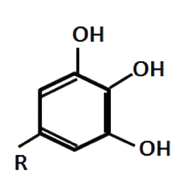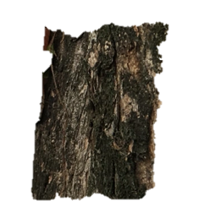

Figure 1. Angsana bark (left) and the main structure of tannin (right)

Materials and Methods

Materials

The Angsana bark analyzed in this study was from Angsana tree that grows in the vicinity of the Faculty of Engineering, Universitas Gadjah Mada, Yogyakarta. Cotton fabrics (100% cotton) used for the dyeing were obtained from PT Primissima Yogyakarta, with the thickness of 0.35 mm and a weight per area of 192 g/m². Aquadest was chosen as a solvent for extracting natural dyes. Potassium permanganate, oxalic acid, and indigo carmine were utilized as reagents in volumetric analysis. Alum, limestone, and iron sulfate were employed as fixating agents or also known as mordant.

Extraction of the Angsana bark

First of all, Angsana bark was weighed to obtain 140 g of bark. Then, 2 l of water was heated in a pot to reach a temperature of 70 °C. The Angsana bark was put into heated water afterwards and stirred every 10 minutes for 1 hour. The addition of solids and extraction were carried out until the sample measured by a hydrometer showed the optimum Baume value. After 1 hour, the solids and extracts were separated; the extract was taken as a dye product.

Evaluation of the Angsana bark extract
The pH value of Angsana bark extract was determined using a pH meter, while a pycnometer was utilized to find out the density of the extract. The yield of the dye was determined by drying 5 mL of the sample in an oven at 65 °C until a constant weight was achieved. The total tannin content was measured by the AOAC method. An amount 10 mL of Angsana bark extract and the solution indicator of indigo carmine were added to the volumetric flask and diluted up to the limit mark with aquadest. After that, 50 mL of the solution was titrated with KMnO₄ solution, standardized with oxalic acid (H₂C₂O₄·2H₂O) until the color changed from blue to golden yellow. The titration was carried out in triplicate. In addition, a blank titration was conducted to determine how much KMnO₄ reacted to indigo carmine. One milliliter of 0.1125 N KMnO₄ is equivalent to 0.0415 g of tannin.

The visible spectra were recorded using a Logger-lite spectro-visible portable. The Angsana bark extract was characterized by tannic acid, which was also used as a control sample. The concentration of the tannic acid solution was 10 ppm. The color coordinate test was performed using a Konica Minolta Color CR-400. The Fourier transform infrared (FTIR) spectrum of Angsana bark extract powder was recorded from 4000 to 400 cm⁻¹ using a Shimadzu Prestige 21 FTIR spectrometer. The Angsana bark extract was transformed into powder by drying it in an oven at a temperature of 65 °C.

Dyeing of cotton fabric
The pre-mordant stage was carried out by soaking the cotton fabric in alum solution and hanging it to dry. Afterward, the dried fabric weighing 1 g in an unfolded state was immersed in 10 ml of the extract solution heated at 60 °C for 20 minutes in a shaker bath and then dried at room temperature. Finally, fixation was performed by heating the cotton fabric to reach a temperature of 60 °C at a ratio of 1:10 (w/v) for 10 minutes using alum, lime, and iron sulfate fixative solutions prepared by dissolving the solids at a ratio of 1:10 (w/w), heating and allowing them to settle overnight, and then filtering them using filter paper. The obtained fabric was then rinsed in running water and dried at room temperature.

Color strength (K/S) value

The color strength value test was carried out at a wavelength range of 350–750 nm using a Shimadzu UV-2401PC spectrophotometer, and the results are expressed in reflectance (%R). The maximum wavelength can be determined with the lowest % R-value. The reflectance value was then converted to a K/S value based on the Kubelka–Munk equation, as follows:

$\frac{K}{S}=\frac{{\left(1-R\right)}^{2}}{2R}$ (1)

where K is the light absorption coefficient, S is the light scattering coefficient, and R is the percentage of reflectance. After determining the K/S value of the dyed material, the K/S value was corrected with the K/S value of the white cotton fabric before the dyeing process.

Color fastness
The color fastness to washing was determined according to ISO 105-C06:2010. The cotton fabric (5x10 cm) was placed between the upholsteries, namely a 100% white fabric and a 100% white polyester fabric. The three fabrics were sewn on one of their shortest sides and placed in 150 mL of the washing solution prepared by dissolving 4 g/L of AATCC soap and 1 g/L of sodium perborate and then heating it at 40 ºC. The washing process was done in Launder O Meter machine run for 30 minutes. The fabric was then rinsed with 0.2 g/L of glacial acetic acid solution, wrung out, dried at room temperature, and checked for color changes using grayscale and staining scales. The rating scale was expressed in 0 (poor) to 5 (excellent).

The light fastness test was carried out by irradiating Xenon Arc lamp (48 W/m²) under certain conditions and spaces. After exposure, the color differences between the exposed and protected parts of the fabric were compared to the AATCC grayscale. The rating scale was stated in 0 (poor) to 5 (excellent).

Results and Discussion

Evaluation of the Angsana bark extract

The physicochemical results revealed that an aqueous extract of Angsana bark was dark brown in color and had an acidic pH, 1.015 g/mL density, 11.90% of total tannin, and 20.08% of yield of dyestuff (Table 1). These properties showed the potential of Angsana bark extract as dyeing agent due to its high natural tannin content.

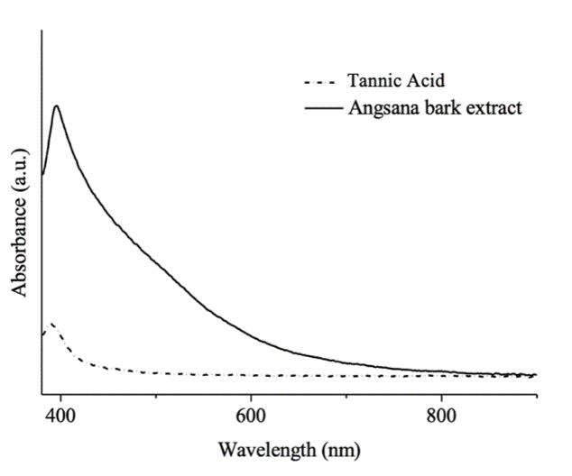

Figure 2. Visible spectra of Angsana bark extract and tannic acid

The visible spectrum of the tannic acid solution reached a peak at 391 nm. As for the Angsana bark extract, it showed a sharp increase at 395 nm, indicating high tannin content (Figure 2). Figure 3 displays the FTIR spectrum of the Angsana bark extract, presenting a broad peak at 3425.58 cm⁻¹. In addition, other increases were seen at 1635.64 cm⁻¹ and 1064.71 cm⁻¹, caused by the presence of hydroxyl (-OH) stretching vibration of flavonoids [16], C=O stretching of hydrolysable tannin esters [17], and etheric groups of tannins (C-O-C) [18]. Therefore, it can be inferred from the FTIR results (Figure 3) that Angsana bark extract contains flavonoids, polyphenols, and tannins.

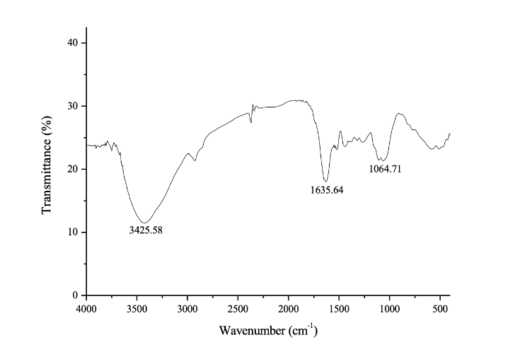

Figure 3. Fourier transform infrared spectrum of Angsana bark extract

Table 1. Physical characteristics of Angsana bark extract

Data | Average | Standard deviation
pH | 6.5 | 0.041
Density (g/mL) | 1.015 | 0.002
Tannin contents (%) | 11.90 | 0.248
The yield of extract (% w/w) | 20.08 | 0.724
CIE L* value | 20.73 | 0.000
CIE a* value | 0.85 | 0.006
CIE b* value | 2.25 | 0.006

Dyeing cotton fabric

The dyeing process of cotton fabric was done after the pre-mordant process. A pre-mordant agent was applied to open the hydroxyl bonds in the cotton fabric to bind to the mordant ions. Dry cotton fabric was dipped in Angsana bark extract with various extract concentrations of 70 and 140 g/l. The mordant ions, namely Al³⁺, Ca²⁺, and Fe³⁺ with a coordination number of +6, increased the color intensity of the fabric. The mordant ions can be considered as a bridge between the dye and the cotton fabric. Principally, mordant ions are required for cotton fabrics that will be dyed in natural dyes; otherwise, the color intensity will be low. In the absence of a mordant, hydrogen bonds will be formed between the cellulose fibers and the hydroxyl groups in the auxochromes of the tannin molecule. Hydrogen bonds are relatively weak and produce low fastness. To overcome this problem, mordant ions are needed. Mordant ions will form ionic and coordination bonds between dye-mordant and the mordant-cellulose of the cotton fabrics, as illustrated in Figure 4 below.

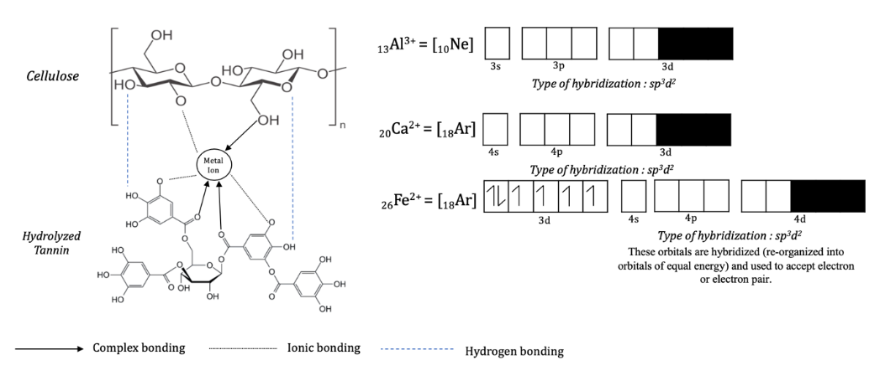

Figure 4. Possible structure of hydrolyzed tannin in Angsana bark extract with the mordant ions on cotton fabrics

Negatively charged electrons can fill the empty orbitals in metal ions. The bonding complex that occurs in the d orbitals gives a distinct color. The number of orbitals that can be filled indicates the value of the coordination number. Al³⁺ ion hybridization occurs in a 3s orbital, three 3p orbitals, and two 3d orbitals. This arrangement forms stability with the same energy value, taking into account the steric resistance that may arise. Similarly, for mordant ions Ca²⁺ and Fe²⁺, the orbitals were stable at the same energy value.

The color strength (K/S) value identifies the quality of the dyeing parameters. The higher the K/S value, the more the tannin dyes are absorbed by the cotton fabric. Conversely, the lower the K/S value, the lighter the color. Based on the experimental results, the concentration of Angsana bark extract significantly affected the K/S value. The increase in K/S by 6 to 13 means that the concentrated extract of Angsana bark could provide better color strength. The type of mordant was also proven to affect color strength, with the order of alum<lime<iron sulfate. The highest K/S value of 8.554 was obtained for iron sulfate mordant with an extract concentration of 140 g/l. The exact test values are shown in Table 2.

The identification of color types was modeled with the CIELAB color space. The L* value indicates the lightness of the color, which is 0 for black and 100 for white. The a* value describes a green-red color type, where a positive value means red and a negative value means green. The b* value represents the color yellow (+) and blue (-). Overall, the L* value decreased along with the increase in extract concentration. The lowest L* value of 28.91 implies that the fabric was dyed more. It can be seen that iron sulfate mordant gave a darker color orientation, while alum mordant contributed to a lighter color orientation. The colors produced were in the brown area, namely the burlywood color for Al³⁺ mordant, saddle brown color for Ca²⁺ mordant, and dark olive-green color for Fe²⁺ mordant. The resulting color character was unique under the peculiarities of natural dyes, in which the post-mordant process played a significant role. The Fe²⁺ ion had an empty orbital in the d subshell, creating a specific characteristic of color.

Table 2. Results of fabric dyeing test with Angsana bark extract

Fixative | Concentration (g/L) | Color |  | K/S Value |  | L*a*b* Value
Alum | 70  140 |    | 0.358 ± 0.049  4.017 ± 0.154 |  | L* 76.63 ± 5.309  a* 10.62 ± 1.084  b* 25.54 ± 1.067  L*49.51 ± 1.103  a* 13.62 ± 0.307  b*19.42 ± 0.525
Lime | 70  140 |    |  | 0.823 ± 0.112  5.840 ± 0.285 |  | L* 67.29 ± 1.236  a* 15.08 ± 0.233  b* 23.23 ± 0.874  L*41.33 ± 0.577  a*16.74 ± 0.419  b*21.05 ± 0.750
Iron sulfate | 70  140 |    |  | 1.428 ± 0.215  8.554 ± 0.377 |  | L* 54.00 ± 0.603  a* 4.543 ± 0.613  b* 15.70 ± 1.306  L*28.91 ± 0.485  a*2.277 ± 0.106  b*9.817 ± 1.218

Color fastness properties

Fastness to washing and light is vital in dye applications to fabrics. The washing fastness test was carried out by washing a sample of fabric with certain detergents and sewing it on two white cloths based on ISO 105-C06:2010. Meanwhile, the light fastness test was conducted according to American Association of Textile Chemists and Colorists (AATCC) 16.

The fastness value can be increased by using a mordant in the pre-mordant and post-mordant processes. The illustration in Figure 4 shows that a mordant with metal ions can provide a bridge to bind the dye to the cellulose fibers of the fabric. These bonds can increase the size of the dye molecules so that they can be well-absorbed and it will be difficult for them to get out of the pores of the cotton fibers. At the end of the dyeing process, the fixation process can make the bonds stronger to increase the fastness value. The results of the fastness evaluation are presented in Table 3.

Table 3. Fastness quality testing of cotton fabrics

Fixative | Concentration (g/L) | Washing Fastness | Light fastness
Alum | 70  140 | 3–4  4 | 4–5  4–5
Lime | 70  140 | 4  4 | 4–5  4
Iron Sulfate | 70  140 | 3–4  3–4 | 4–5  4–5
The value of washing fastness was obtained on scales of 3–4 (fairly good) and 4 (good). This value has met the minimum requirements (3–4 scale) for textile fabric products based on SNI 0051:2008. The highest value of washing fastness was in alum mordant at an extract concentration of 140 g/l as well as in lime mordant at 70 g/L and 140 g/L of extract concentrations. This was because Ca²⁺ ions can firmly bind tannin molecules; calcium ions can increase the affinity of tannins for cellulose in cotton fabrics and lock the dye into the fiber molecules [19]. This is in contrast to Fe²⁺ ion, where coordination complex bonds occur to reduce the solubility of the dye, thus reducing the color fastness [20].

The light fastness test obtained an overall score on a scale of 4–5 (excellent). This was due to the complex bond between the dye and the metal ion of the mordant. As seen in Figure 4, the empty orbital diagram in the s, p, and d subshells can be filled by free electrons in the tannin molecules. The subshells protect the chromophore groups from photolytic degradation. The d orbitals can form ligand complexes with the chromophore groups of the dye. The d orbital can be a resonance site on the tannin chromophore, thereby stabilizing the absorbed photon energy irradiated with UV light.

Conclusion

Exploration of potential alternative sources of natural dyes from Angsana bark waste has yielded significant results. This is in line with the mission of environment conservation to reduce the use of synthetic dyes that are not environmentally friendly. From the results of this study, it can be seen that Angsana bark extract produced brown dye. The dyeing results for cotton fabric with extract solutions in low concentration (70 g/L) and high concentration (140 g/L) gave different color changes in the post-mordant solution. The types of color generated by alum and lime mordants were in the variations of brown color, while iron sulfate mordant produced dark green color. The highest K/S value was found in the use of iron sulfate mordant. Overall, the washing fastness scores were on the scale of 4 (good) and the light fastness scores were on the scale of 4-5 (excellent). Thus, Angsana bark extract can be used as a source of natural dye for cotton fabrics.

Acknowledgement

The author would like to express the deepest gratitude to LPDP (Indonesian Endowment Fund for Education) for the funds provided in the RISPRO Commercial Funding scheme and to Chemical Engineering Department, Universitas Gadjah Mada for the supporting facilities made available for this study.

References
- Booth, G. (2000). Dyes, general survey in Ullmann’s encyclopedia of industrial chemistry. Wiley-VCH Verlag GmbH & Co. KGaA, Weinheim: pp. 676-678.
- Gulrajani, M. L. and Gupta, D. (1992). Natural dyes and their application to textiles. Department of Textile Technology, New Delhi: pp. 38–42.
- Krizova, H. (2013). Textile dyeing theory and application -chapter 2. Natural Dyes. Liberec TUL. Czechia: pp. 15-25.
- Bruna, C. V. and Maria, A. M. M. (2013). Azo dyes: Characterization and toxicity – A review. Textiles and Light Industrial Science and Technology, 2(2): 85-103.
- Thomson, L. A. J. (2006). Specifies profiles for Pacific Island agroforestry: Pterocarpus indicus (Narra). Permanent Agriculture Resources, Hawaii: pp. 1-5.
- Smith, B. and Swain (1962). Flavonoid compounds: Comparative biochemistry. III. Academic Press, New York: pp. 75-809.
- Sieniawska, E. and Baj, T. (2017). Pharmacognosy. Tannins. Elsevier, Amsterdam: pp. 199-232.
- Prayanto, Nur, A. and Nurcahyanti, D (2018). Produksi dan aplikasi zat warna alami dari kulit kayu mahoni dan kulit kayu tingi untuk batik di desa Kuwiran, Kecematan Banyudono, Kabupaten Boyolali. Jurnal Ilmiah Momentum, 14(2): 1-7.
- Handayani, P. A. and Maulana, I. (2013). Pewarna alami batik dari kulit soga tingi (Ceriops tagal) dengan metode ekstraksi. Jurnal Bahan Alam Terbarukan, 2(2): 1-6.
- Win, Z. M. and Swe, M. M. (2008). purification of natural dyestuff extracted from mango bark for the application on protein fibres. World Academy of Science, Engineering and Technology, 46: 536-540.
- Dewi, L. F., Pringgenies, D., and Ridlo, A. (2018). Pemanfaatan mangrove Rhizophora mucronata sebagai pewarna alami katun. Journal of Marine Research, 7(2): 79-98.
- Lestari, D. W. and Satria, Y. (2017). Pemanfaatan kulit kayu Angsana (Pterocarpus indicus) sebagai sumber zat warna alami pada pewarnaan kain batik sutera. Dinamika Kerajinan Dan Batik, 34(1): 35-42.
- Dochia, M., Sirghie, C., Kozłowski, R.M. and Roskwitalski, Z. (2012). Handbook of natural fibres: cotton fibres. Woodhead Publishing, Cambridge: pp. 11-23.
- Ismail, S. and Azha, S. F. (2018). Cotton cloth: Diversified applications beyond fashion and wearable cloth. Current Trend in Fashion Technology & Textile Engineering, 2(3): 39-45.
- IHS Markit (2019). Natural and man-made fibers overview. https://ihsmarkit.com/products/fibers-chemical-economics-handbook.html. [Access online 4 September 2021].
- Oliveira, R. N., Mancini, M. C., Oliveira, F. C. Sd, Passos, T. M., Quilty, B., Thiré, R. MdS. M., and McGuinness, G. B. (2016). FTIR analysis and quantification of phenols and flavonoids of five commercially available plants extracts used in wound healing. Matéria (Rio de Janeiro), 21(3): 767–779.
- Okonkwo, S. N., Ohanuzua, C. B. C., Onuegbu, G. C., Obasi, H. C. and Nnorom, O. O. (2019). Extraction of natural dyes from Whitfieldia lateritia plant and its application on cotton fabric. International Journal of Textile Science and Engineering, 9(1): 1-4.
- Anburaj, R. and Jothiprakasam, V. (2017). Bioassay of tannin rich fraction and identification of compounds using UV–Vis, FTIR, and RP-HPLC. Research Journal of Pharmaceutical, Biological and Chemical Sciences, 8(1): 432-445.
- Pujilestari, T. (2014). Pengaruh ekstraksi zat warna alam dan fiskasi terhadap ketahanan luntur warna pada kain batik katun. Dinamika Kerajinan Dan Batik, 31(1): 31-40.
- Uddin, M. G. (2015). Extraction of eco-friendly natural dyes from mango leaves and their application on silk fabric. Textiles and Clothing Sustainability, 1(1): 1-7.

