CHROMATOGRAPHIC PROFILING OF Syzygium cumini LEAVES USING HIGH-PERFORMANCE THIN LAYER CHROMATOGRAPHY
AND GAS CHROMATOGRAPHY-MASS
SPECTROMETRY TECHNIQUES

(Profil Kromatografi bagi daun Syzygium cumini mengunakan Teknik Kromatografi Lapisan Nipis Prestasi Tinggi dan
Kromatografi Gas-Spektrometri Jisim)

Joshi Vivek^{1*}, MerSagar¹, BhagatKeyuri¹, SavaliaVaibhavi¹, Dhalani Jayesh²,
Pandya Mayank², Pandya Devang¹

¹School of Pharmacy
²Department of Chemistry, School of Science
RK University, Rajkot - 360020, Gujarat, India

*Corresponding author: vjoshi850@rku.ac.in

Abstract
Global use of traditional medicinal plants has increased logarithmically in the past few decades. Leaves of Syzygium cumini (S. cumini) contain important classes of pharmacologically active phytoconstituents like alkaloids, flavonoids, saponins, tannins, glycosides, phenols, fixed oils, monoterpenoids, steroids, and triterpenoids. Since community health is at risk due to improper knowledge and unenforced standardization parameters for herbal formulations, the focus of the study was to develop high-performance thin layer chromatography (HPTLC) fingerprinting and to identify phytoconstituents through gas chromatography and mass spectrometry (GC-MS). HPTLC fingerprinting of the methanolic extract of the leaves of S. cumini was performed using the mobile phase chloroform: methanol: ethyl acetate (6:4:6) after several pilot thin layer chromatography (TLC) analyses, which revealed 14 peaks at 254 nm and 10 peaks at 366 nm. Also, qualitative analysis of the same was performed using GC-MS, which revealed 9 phytoconstituents, some of them possessing known pharmacological activity. Such fingerprint analysis using sophisticated chromatographic and spectral techniques can contribute to the quality control in herbal industries; help in assuring purity, efficacy, and safety of the formulations by detection of adulteration; as well as broaden the horizon of phytochemical research, including the isolation of a marker therefrom.

Keywords: Syzygium cumini, adulteration, fingerprinting, gas chromatography mass spectrometry, high-performance thin layer chromatography, standardization

Abstrak
Pengunaan tumbuhan bagi perubatan traditional secara global telah meningkat bagi tempoh beberapa dekad yang lepas. Daun Syzygium cumini (S. cumini) mengandungi jujukan fito aktif secara farmakologi merupakan kelas utama seperti alkaloid, flavonoid, saponin, tannin, glikosida, fenol, minyak, monoterpenoids, steroids, dan triterpenoids. Semenjak kesihatan komuniti berada pada keadaan berisiko disebabkan oleh maklumat yang kurang tepat dan tidak peguatkuasaan piawaian parameter bagi formulasi herbal, maka fokus kajian ini untuk membangunkan pencapjarian kromatografi lapisan nipis prestasi tinggi (HPTLC) dan mengenalpasti jujukan fito melalui kromatografi gas dan spektrometri jisim (GC-MS). Pencapjarian HPTLC terhadap ekstrak metanol bagi daun S. cumini telah dijalankan mengunakan fasa bergerak klorofom: metanol: etil asetat (6:4:6) selepas beberapa analisis pilot kromatografi lapisan nipis (TLC), ia menjelaskan terdapat 14 puncak pada 254 nm dan 10 puncak pada 366 nm. Juga, analisis kualitatif telah dijalankan mengunakan GC-MS, dimana ia menjelaskan 9 jujukan fito, sebahagian dikenalpasti mempunyai aktiviti farmakologi. Analisis capjari mengunakan teknik kromatografi dan spekta boleh menyumbang kepada kawalan kualiti dalam industri herba; membantu dalam jaminan ketulenan, kejituan dan keselamatan dalam formulasi dengan cara mengenal pemalsuan; juga pengembangan bidang kajian fitokimia, termasuklah pemencilan penanda kimia.

Kata kunci: Syzygium cumini, pemalsuan, pencapjarian, kromatografi gas dan spektrometri jisim, kromatografi lapisan nipis prestasi tinggi, pemiawaian

Introduction
Syzygium cumini also known as Eugenia cumini, Eugenia jambolana, Myrtus cumini, Syzygium jambolana, Syzygium jambolanum, and Eugenia caryophyllifolia, is a tree belonging to the Myrtle family, Myrtaceae. It is found in India, Bangladesh, Nepal, Sri Lanka, and Myanmar and throughout south-east Asia and the Pacific Islands while it is also grown in Indonesia, Thailand, Australia, Malaysia, Kenya, Zimbabwe, Madagascar, Colombia, Zambia, Cuba, Mexico, Brazil, and some parts of the USA particularly Florida and Hawaii. It is commonly known as Indian blackberry, Java Plum, Jambolan while Surabhipatra (in Ayurveda); Jamun (in Hindi); Jambudo (in Gujarati); Brahaspati, Mahajambu, and Ksudrajambu (in Sanskrit)[1, 2, 3].S. cumini leaves, shown in Figure 1, contain various classes of secondary metabolites: glycosides, alkaloids, triterpenoids, flavonoids, saponins, tannins, phenols, proteins, steroids, and fixed oils and fats. Major phytoconstituents of the leaves include sitosterols, crategolic (maslinic) acid, myricetin, quercetin, ellagic acid, and betulinic acid. Essential oils from leaves are rich in pinocarveol, cineole, α-terpeneol, ellagic acids, myrtenol, eucarvone, α-myrtenal, geranyl acetone, α-cadinol, kaempferol, pinocarvone, quercetin, isoquercetin [4, 5, 6].

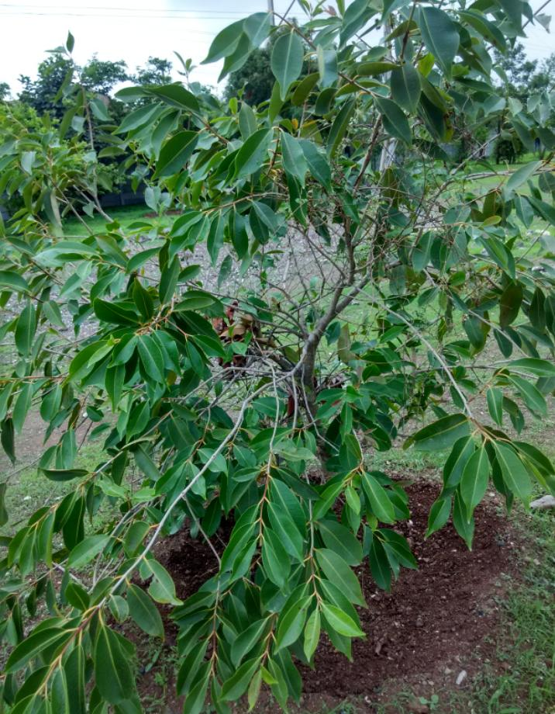
Figure 1. Leaves of Syzygium cumini

Its leaves are found to be useful in diabetes, hepatitis, and dental disorders as well to be an anticancer, anti-diarrheal, cardioprotective, diuretic, gastroprotective, and hepatoprotective agent. The leaves possess anti-allergic, antipyretic, antibacterial, anti-inflammatory, antimicrobial, and antioxidant properties. The leaves are also used to treat stomachache, dermopathy, leucorrhoea, constipation, fever, reduce DNA damage induced by radiation, and in inhibition of blood discharges in the feces [7-11].

S. cumini leaves are pharmacologically useful. However, the standardization of herbal formulations is always an issue. Additionally, government bodies have also levied certain regulations for the quality control and standardization of herbal products. However, chromatographic analysis of Indian medicinal plants using globally accepted sophisticated techniques is scarcely available.

This research may provide the HPTLC and GC-MS fingerprints of S. cumini leaves to herbal industries and society. It may facilitate standardization and quality control for the prevention of adulteration in S. cumini leaves formulations, thereby benefitting the end-user. It shall give an insight into the phytochemical composition of the leaves, which can be further worked upon.

Materials and Methods
Collection and sampling
Leaves of S. cumini were obtained from the Medicinal Garden of RK University in February (Figure 1). The sample was then authenticated by comparing it with standard literature. Its herbarium SOP/COG/91/2013 was prepared and submitted at the School of Pharmacy, RK University, and certified by the botanist of School of Science, RK University.

Extraction of S. cumini leaves
Leaves of S. cumini were dried in a hot air oven at 50 ºC and powdered using a mixer grinder. Maceration of 50.0 g dry powder of the leaves with 100 mL methanol was carried out at room temperature for 24 hours. After filtration, on evaporating the excess solvent from the filtrate at room temperature, 7.2 g sticky, dry and solid extract was obtained.

Pilot TLC studies and HPTLC fingerprinting
Several pilot TLCs were developed for methanolic extract using various proportions of chloroform, methanol, and ethyl acetate. Highly non-polar petroleum ether extract and highly polar water extract were not used, as we had expected to obtain chemical constituents of medium polarity. After observing the results, many TLCs of methanolic extract was developed by adding ethyl acetate and formic acid for removal of tailing. The mobile phase Chloroform: Methanol: Ethyl acetate (6: 4: 6) showed the best resolution in TLC studies. Hence, it was further used for HPTLC fingerprinting.

Methanolic extract of S. cumini leaves was analyzed to obtain HPTLC fingerprinting using Chloroform: Methanol: Ethyl acetate (6: 4: 6) at the Department of Pharmaceutical Sciences, Saurashtra University, Rajkot, Gujarat, India. The HPTLC fingerprinting was obtained on HPTLC plates containing silica gel C₆₀ F₂₅₄ as stationary phase, manufactured by E.MERCK KgaA. CAMAG Linomat 5 “Linomat5_171010” S/N 171010 (2.01.02) was used for a sample application. Peak height and area were selected for evaluation, while the measurement was done using the principle of absorption. The sample was dissolved in Methanol. CAMAG TLC Scanner 3 “Scnner_171010” S/N 171010 (2.01.02) was used for scanning the plates in daylight as well as at 254 nm and 366 nm.

GC-MS analysis
The sample containing methanolic extract of S. cumini leaves was named Jambudo (local name of S. cumini). Qualitative GC-MS analysis of the sample was performed at the Department of Chemistry, School of Science, RK University, Rajkot, Gujarat, India. Agilent GC-7820A/MS-5977 with HP-5ms column containing (5%-phenyl)-methylpolysiloxane as stationary phase and helium as carrier gas was used for this purpose following the GC-MS protocol from authentic standard works of literature [12,13,14,15,16]. National Institute of Standards and Technology (NIST) library was used for the precise identification of phytoconstituents.

Results and Discussion
Pilot TLC studies and HPTLC fingerprinting
After several pilots, TLC analyses, an HPTLC fingerprinting of the methanolic extract of the leaves of S. cumini was performed using the mobile phase Chloroform: Methanol: Ethyl Acetate (6: 4: 6). The HPTLC plates were scanned at 254 nm (Figure 2), 366 nm (Figure 3), and daylight (Figure 4) that revealed 14 spots (Figure 5) at 254 nm and 10 spots (Figure 6) at 366 nm. The distinct R_{f} values of the spots at 254 nm and 366 nm are as provided in Table 1 and Table 2 respectively.

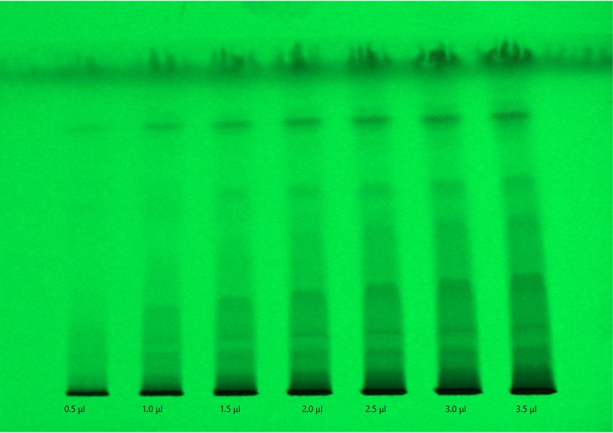
Figure 2. HPTLC plate at 254 nm

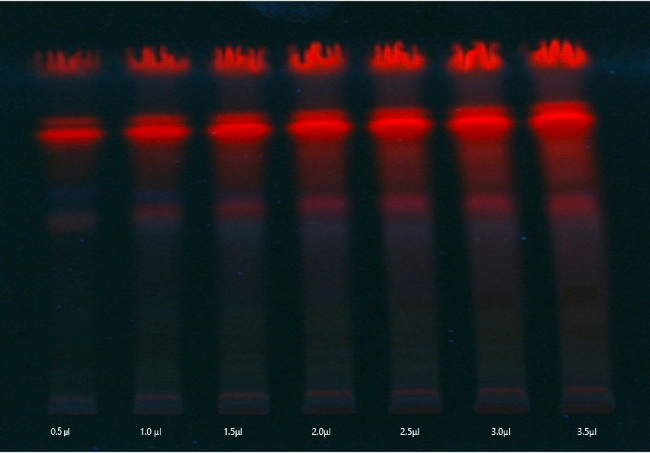

Figure 3. HPTLC plate at 366 nm

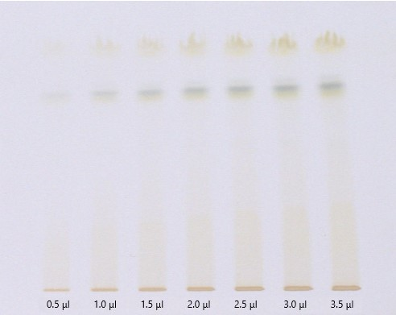
Figure 4. HPTLC plate at daylight

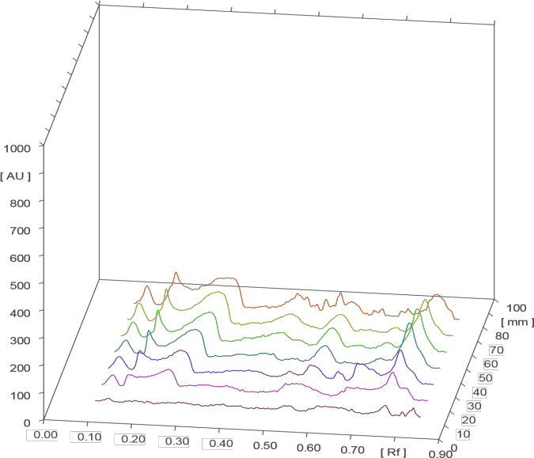
Figure 5. Densitometric chromatogram of methanolic extract of S. cumini leaves at 254 nm

Table 1. Maximum R_{f} and Area under curve at 254 nm
Peak | Max R_{f} | AUC (ng µL⁻¹)
1 | 0.13 | 1071.2
2 | 0.19 | 3841.1
3 | 0.31 | 6786.7
4 | 0.47 | 1727.1
5 | 0.49 | 548.9
6 | 0.52 | 367.7
7 | 0.54 | 535.1
8 | 0.57 | 1254.4
9 | 0.60 | 1081.0
10 | 0.65 | 167.0
11 | 0.67 | 218.9
12 | 0.71 | 188.0
13 | 0.72 | 314.9
14 | 0.79 | 3410.2

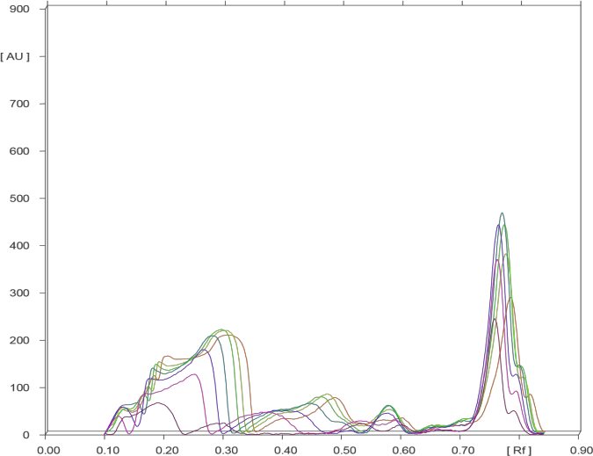
Figure 6. Densitometric chromatogram of methanolic extract of S. cumini leaves at 366 nm

Table 2. Maximum R_{f} and Area under curve at 366 nm
Peak | Max R_{f} | AUC (ng µL⁻¹)
1 | 0.13 | 1304.5
2 | 0.18 | 2726.1
3 | 0.20 | 3751.8
4 | 0.30 | 15174.9
5 | 0.40 | 981.2
6 | 0.49 | 3995.0
7 | 0.60 | 735.7
8 | 0.67 | 298.7
9 | 0.78 | 9574.9
10 | 0.81 | 1127.4

GC - MS analysis
The GC-MS spectrum of methanolic extract of S. cumini leaves (Figure 7) revealed a confirmatory structure match of the nine chemical compounds when compared with the NIST database. The following compounds (as shown in Table 3) were identified from the analysis.

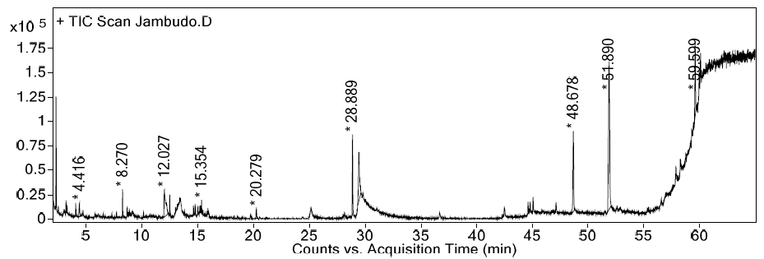

Figure 7.Gas chromatogram of methanolic extract of S. cumini leaves

Table 3. Phytoconstituents identified from methanolic extract of S. cumini leaves
Peak | RT | Name of Compound | Molecular Formula | Molecular Weight (gm/mol) | Peak Area %
1 | 2.31 | (1R)-2,6,6-trimethylbicyclo[3.1.1]hept-2-ene | C₁₀H₁₆ | 136.2340 | 7.54
2 | 4.416 | 2,5,5-trimethyl-cyclopentadiene | C₈H₁₂ | 108.18 | 1.87
3 | 8.27 | α-terpineol | C₁₀H₁₈O | 154.25 | 1.95
4 | 12.027 | 1,2,3-benzenetriol | C₆H₆O₃ | 126.11 | 9.24
5 | 12.499 | 1,4-methanocycloocta[d]pyridazine,1,4,4a,5,6,9,10,10a-octa hydro-11,11-dimethyl-(1.alpha,4.alpha,4a.alpha,10a.alpha) | C₁₃H₂₀N₂ | 204.15 | 1.2
6 | 28.889 | 3,7,11,15-tetramethyl-2-hexadecen-1-ol | C₂₀H₄₀O | 296.5310 | 7.28
7 | 29.451 | 9,12,15-octadecatrienoic acid, methyl ester (Z, Z, Z) | C₁₉H₃₂O₂ | 292.4562 | 10.45
8 | 48.678 | Vitamin E | C₂₉H₅₀O₂ | 430.7061 | 13.23
9 | 51.89 | γ-sitosterol | C₂₉H₅₀O | 414.7067 | 34.01

Compound 1:(1R)-2,6,6-trimethylbicyclo [3.1.1]hept-2-ene, Mol. formula - C₁₀H₁₆, Mol. wt. - 136.2340, RT - 2.31. GC-MS fragment: The peak at 2.31 minutes had a mass [M⁺] 136.2340. The daughter ion spectra of compound 1 revealed the characteristic fragments m/z (as shown in Figure 8) 53, 55, 77.1, 78.1, 79.1, 80.1, 91.1, 92.1, 93.1, 105.1.

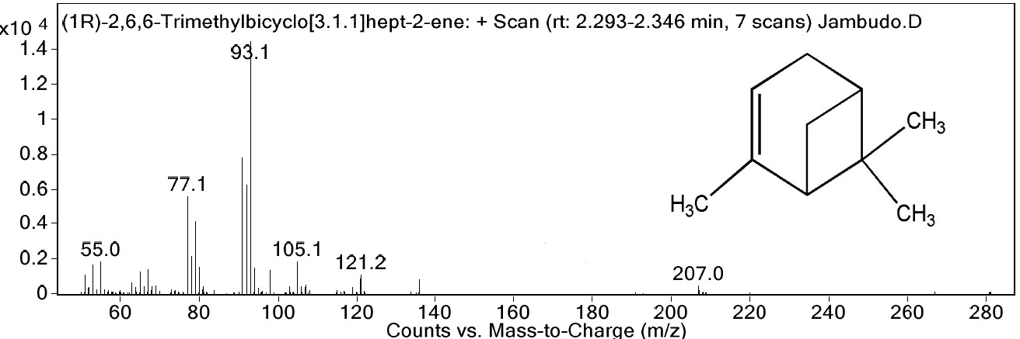

Figure 8. Mass spectrogram of Compound 1

Compound 2: 2,5,5-trimethyl-cyclopentadiene; Mol. formula - C₈H₁₂; Mol. wt. - 108.18, RT - 4.416. GC-MS fragment: The peak at 4.416 minutes had a mass [M⁺] 108.18. The daughter ion spectra of compound 2 revealed the characteristic fragments m/z (as shown in Figure 9) 51, 77, 78, 79, 91, 92, 93.1, 105, 107, 108.

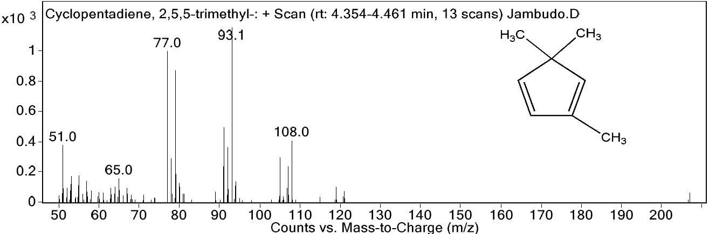

Figure 9. Mass spectrogram of Compound 2

Compound 3:α-terpineol; Mol. formula - C₁₀H₁₈O; Mol. wt. - 154.25; RT - 8.27. GC-MS fragment: The peak at 8.27 minutes had a mass [M⁺] 154.25. The daughter ion spectra of compound 3 revealed the characteristic fragments m/z (as shown in Figure 10) 59.1, 77.1, 79, 81.1, 91.1, 92.1, 93.1, 94, 121.1, 136.1.

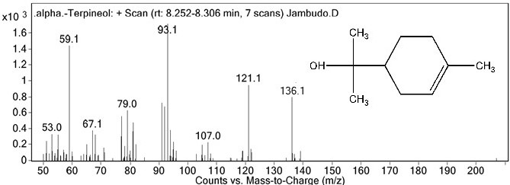

Figure 10. Mass spectrogram of Compound 3

Compound 4:1,2,3-benzenetriol; Mol. formula - C₆H₆O₃; Mol. wt. - 126.11; RT - 12.027. GC-MS fragment: The peak at 12.027 minutes had a mass [M⁺] 126.11. The daughter ion spectra of compound 4 revealed the characteristic fragments m/z (as shown in Figure 11) 51, 52, 52.1, 52.9, 53.1, 79, 80, 97, 108, 126.

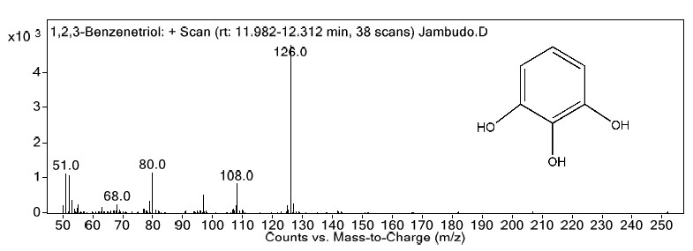

Figure 11. Mass spectrogram of Compound 4

Compound 5:1,4-methanocycloocta[d]pyridazine,1,4,4a, 5,6,9,10,10a-octahydro-11,11dimethyl(1.alpha,4.alpha, 4a.alpha,10a.alpha); Mol. formula - C₁₃H₂₀N₂; Mol. wt. - 204.15; RT - 12.499. GC-MS fragment: The peak at 12.499 minutes had a mass [M⁺] 204.15. The daughter ion spectra of compound 5 revealed the characteristic fragments m/z (as shown in Figure 12) 55.1, 67, 69.1, 77.1, 79.1, 91, 93.1, 105.1, 119.1, 133.
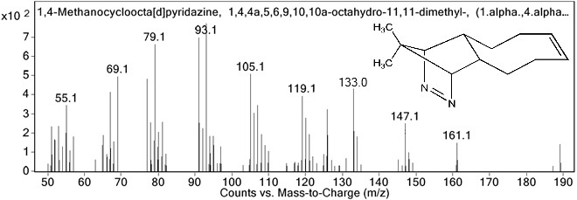

Figure 12. Mass spectrogram of Compound 5

Compound 6:3,7,11,15-tetramethyl-2-hexadecen-1-ol; Mol. formula - C₂₀H₄₀O; Mol. wt. - 296.5310; RT - 28.889. GC-MS fragment: The peak at 28.889 minutes had a mass [M⁺] 296.5310. The daughter ion spectra of compound 6 revealed the characteristic fragments m/z (as shown in Figure 13) 55.1, 57.1, 68.1, 69.1, 71.1, 79.1, 81.1, 82.1, 95.1, 123.1.

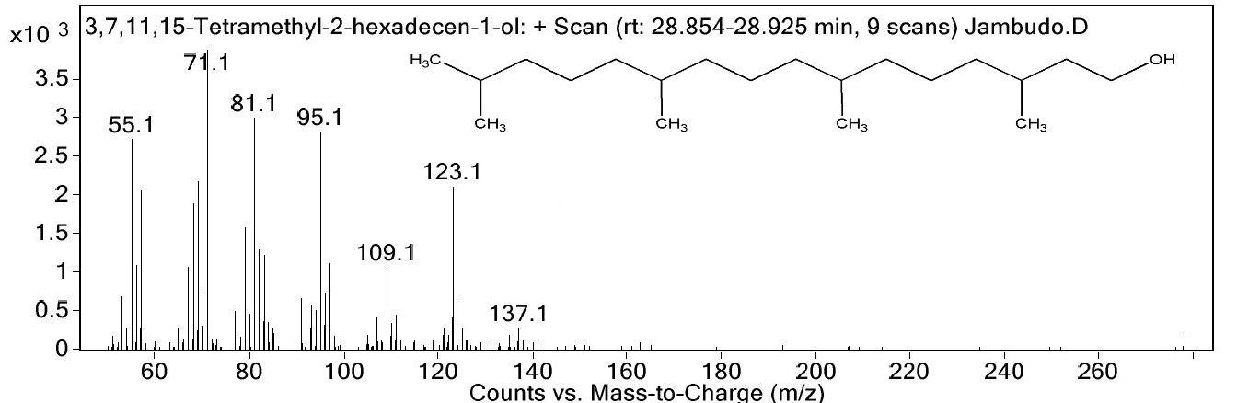

Figure 13. Mass spectrogram of Compound 6

Compound 7:9,12,15-octadecatrienoic acid, methyl ester (Z, Z, Z); Mol. formula - C₁₉H₃₂O₂; Mol. wt. - 292.4562; RT - 29.451. GC-MS fragment: The peak at 29.451 minutes had a mass [M⁺] 292.4562. The daughter ion spectra of compound 7 revealed the characteristic fragments m/z (as shown in Figure 14) 55.1, 60, 67.1, 77.1, 79.1, 80.1, 81.1, 91.1, 93.1, 95.1.

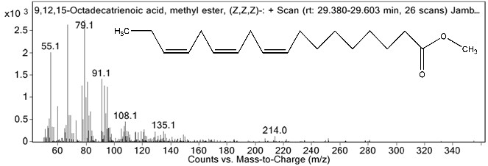

Figure 14. Mass spectrogram of Compound 7

Compound 8:Vitamin E; Mol. formula - C₂₉H₅₀O₂; Mol. wt. - 430.7061; RT - 48.678. GC-MS fragment: The peak at 48.678 minutes had a mass [M⁺] 430.7061. The daughter ion spectra of compound 8 revealed the characteristic fragments m/z (as shown in Figure 15) 73, 121, 164, 164.1, 165.1, 166.1, 205.1, 430.4, 431.3, 431.4.

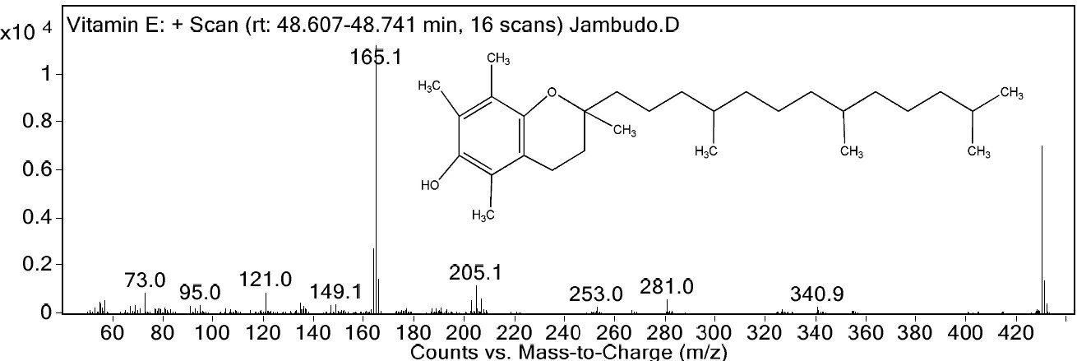

Figure 15. Mass spectrogram of Compound 8

Compound 9: γ-sitosterol; Mol. formula - C₂₉H₅₀O; Mol. wt. - 414.7067; RT - 51.89. GC-MS fragment: The peak at 51.89 minutes had a mass [M⁺] 414.7067. The daughter ion spectra of compound 9 revealed the characteristic fragments m/z (as shown in Figure 16) 55.1, 57.1, 79, 81.1, 91.1, 95.1, 105.1, 145.1, 207, 396.3.

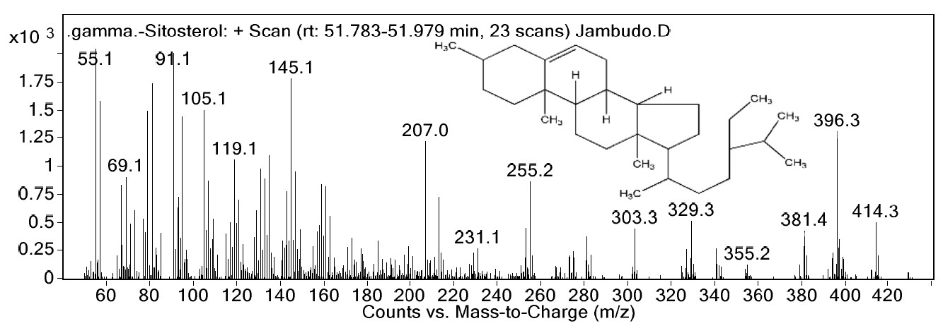

Figure 16. Mass spectrogram of Compound 9

The following phytochemicals detected from the GC-MS analysis of a methanolic extract of S. cumini leaves (Table 4) were reported with significant biological activities:

Table 4. Compounds detected from GC-MS of S. cumini leaves and their biological activities
Name of Compound | Reported Biological Activities
(1R)-2,6,6-trimethylbicyclo[3.1.1]hept-2-ene  (commonly known as α-pinene) | - Anti-inflammatory[17]  - Antinociceptive[18]  - Inhibits hepatoma carcinoma cell proliferation[19]
α-terpineol | - Anticancer agent[20]  - Inhibits IL-1β, IL-6 & IL-10 production[21]  - Antimicrobial in dental problems[22]
3,7,11,15-tetramethyl-2-hexadecen-1-ol  (commonly known as Phytol) | - Anticonvulsant[23]  - Antinociceptive and antioxidant[24]
9,12,15-octadecatrienoic acid, methyl ester, (Z, Z, Z)  (commonly known as α-methyl linolenate) | - Antimicrobial and antibacterial[25]  - Downregulate melanogenesis[26]
Vitamin E  (commonly known as α-tocopherol) | - Prevents loss of spermatogenesis and lipid peroxidation, antioxidant, inhibits smooth muscle proliferation, decreases protein kinase C activity, enhances prostacyclin release, upregulates cytosolic phospholipase A2 and cyclooxygenase activities, and facilitates natriuresis.[27]
γ-sitosterol | - Antidiabetic[28]

It was found that many of the compounds detected in the GC-MS analysis possessed significant pharmacological activity. Few of them were antimicrobial and specifically antibacterial as well. The presence of Vitamin E explains a lot of health benefits as given in the table. Some of them were found anticancer, anticonvulsant, antinociceptive, antioxidant as well as anti-inflammatory, while one of them was detected possessing antidiabetic activity.

It is noteworthy that Jaleel et al. (2019) have reported 10 different compounds through GC-MS analysis of S. cumini seeds extract in hexane [29]. In addition to that, Sharma et al. (2015) had identified and quantified 8 monoterpenoids by GC-MS in volatile oil of unripe fruit pulp of S. cumini[30]. Chitnis et al. (2012) reported HPTLC analysis of available formulations containing S. cumini seeds using Toluene: Ethyl acetate: Formic acid (2: 7: 1) [31]. However, general HPTLC analysis by Kharat et al. revealed 12 peaks in ethanolic, 15 in methanolic, 14 in ethyl acetate, 11 in chloroform, and 3 in aqueous extract of S. cumini leaves using Toluene: Methanol: Diethylamine (30: 4: 4) solvent system using sonication method [32].

This exclusive method for HPTLC fingerprint and GC-MS analysis of S. cumini leaves may help to determine the quality of formulations as well as to detect adulteration by other materials in those formulations, thereby helping in standardization. It paves way for the isolation of the detected compounds. It also opens options for exploring other pharmacological uses of S. cumini leaves based on the reported biological properties of the detected compounds.

Conclusion
This preliminary fingerprint analysis of S. cumini leaves using sophisticated techniques may provide a starting point for quality control of its formulations; assuring purity, efficacy, and safety of the formulations; detecting adulteration; in standardization and ensuring isolation of a marker compound, thereby helping government regulatory agencies, herbal industries, and consumers. It may also broaden the horizon for further phytochemical and pharmacological research, and the development of more sophisticated methods for standardization purposes.

Acknowledgments
The authors especially thank Mr. Rahim Dhanani for providing his expert skills in English editing and Proofreading of this research manuscript, also to Ms. Anjali Patadiya for assistance in linguistics as well as RK University for providing the required facilities and technical support.

References
- Khare, C. P. (2007). Indian medicinal plants. Springer, Berlin: pp. 637.
- Kirtikar, K. R. and Basu, B. D. (1935). Indian medicinal plants (2nd Edition). Lalit Mohan Basu, Allahabad, 2: pp. 1052-1054.
- Bandiola, T. M. B., Ignacio, G. B., Yunson, E. G. A. and Bandiola, P. D. B. (2017).Syzygium cumini (L.) Skeels: a review of its phytochemical constituents, toxicity studies, and traditional and pharmacological uses.International Journal of Applied Pharmaceutical and Biological Research, 2(6): 15-23.
- Ayyanar, M. and Subash-Babu, P. (2012). Syzygium cumini (L.) Skeels: A review of its phytochemical constituents and traditional uses.Asian Pacific Journal of Tropical Biomedicine, 2(9): 240-246.
- Ramos, I. L. and Bandiola, T. M. B. (2017). Phytochemical screening of Syzygium cumini (Myrtaceae) leaf extracts using different solvents of extraction.Der Pharmacia Lettre, 9(2): 74-78.
- Ramya, S., Neethirajan, K. and Jayakumararaj, R. (2012). Profile of bioactive compounds in Syzygium cumini - a review.Journal of Pharmacy Research, 5(8): 4548-4553.
- Kumar, A., Ilavarasan, R., Jayachandran, T., Deecaraman, M., Aravindan, P., Padmanabhan, N. and Krishan, M. R. V. (2013).Anti-diabetic activity of Syzygium cumini and its isolated compound against streptozotocin-induced diabetic rats.Journal of Medicinal Plants Research, 2(9): 246-249.
- Veeram, A., Sindhu, G. and Girish, C. (2017). A review on pharmacology and phytochemistry of Syzygium cumini. Indian Journal of Pharmaceutical and Biological Research, 5(4): 24-28.
- Katiyar, D., Singh, V. and Ali, M. (2016). Recent advances in the pharmacological potential of Syzygium cumini: A review. Advances in Applied Science Research, 7(3): 1-12.
- Brito, F. A., Lima, L. A., Ramos, M. F. S., Nakamura, M. J., Cavalher-Machado, S. C., Siani, A. C., Henriques, M. G. M. O. and Sampio, A. L. F. (2007). Pharmacological study of the anti-allergic activity of Syzygium cumini (L.) Skeels. Brazilian Journal of Medical and Biological Research, 40(1): 105-115.
- Gowri, S. S. and Vasantha, K. (2010). Phytochemical screening and antibacterial activity of Syzygium cumini (L.) (Myrtaceae) leaves extracts. International Journal of PharmTech Research, 2(2): 1569- 1573.
- Dhalani, J., Dubal, G., Rathod, C. and Nariya, P. (2020). Evaluation of non-polar composition in Plumbago zeylanica leaves by gas chromatography and mass spectrometry.Folia Medica, 62(2): 308-313.
- Dhalani, J., Kapadiya, K., Pandya, M., Dubal, G., Imbraj, P. and Nariya, P. (2018). An approach to identify sterol entities from Abrus Pretorius's seeds by GC-MS.Journal of Scientific and Industrial Research, 77: 297-300.
- Dhalani, J., Parmar, R., Rajpara, R. and Nariya, P. (2020). Rapid identification of fatty acids from Leptadenia reticulata areal parts by GC-MS.Journal of Scientific and Industrial Research, 79(8): 709- 711.
- Dhalani, J., Chandegara, B. and Pathak, V. (2019). Rapid investigation of sterols from Plumbago zeylanica stem. International Research Conference and summit on Innovations, Startups& Investments: 69-72.
- Dhalani, J., Dubal, G., Patel, A. and Nariya, P. (2019). Isolation and identification of non-polar chemical entity from Leptadenia reticulata aerial parts.Asian Journal of Pharmaceutical and Clinical Research, 12(2): 226-229.
- Kim, D. S., Lee, H. J., Jeon, Y. D., Han, Y. H., Kee, J. Y., Kim, H. J., Shin, H. J., Kang, J. W., Lee, B. S., Kim, S. H., Kim., S. J., Park, S. H., Choi, B. M., Park, S. J., Um, J. Y. and Hong, S. H. (2015). Alpha pinene exhibits anti-inflammatory activity through the suppression of MAPKs and the NF-κB pathway in mouse peritoneal macrophages.American Journal of Chinese Medicines, 43(4): 731-742.
- Him, A., Ozbek, H., Turel, I. and Oner, A. C. (2008). Antinociceptive activity of alpha-pinene and fenchone. Pharmacologyonline 3: 363-369.
- Chen, W. Q., Xu, B., Mao, J. W., Wei., F. X., Li, M., Liu, T., Jin, X. B. and Zhang, L. R. (2014). Inhibitory effects of α-pinene on hepatoma carcinoma cell proliferation.Asian Pacific Journal of Cancer Prevention, 15(7): 3293-9297.
- Hassan, S. B., Hala, G. M., Goransson, H. and Larsson, R. (2010). Alpha terpineol: a potent anticancer agent which acts through suppressing NF-κB signaling.Anticancer Research,30(6): 1911 – 1919.
- Noguiera, M. N. M., Aquino, S. G., Rossa Junior, C. and Spolidorio, D. M. P. (2014). Terpinen-4-ol and alpha-terpineol (tea tree oil components) inhibit the production of IL-1β, IL-6, and IL-10 on human macrophages.Inflammation Research, 63(9): 769-778.
- Park, S. N., Lim, Y. K., Freire, M. O., Cho, E., Jin, D. and Kook, J. K. (2012). Antimicrobial effect of linalool and α-terpineol against periodontopathic and cariogenic bacteria. Anaerobe,18(3): 369-372.
- Costa, J. P., Ferreira, P. B., De Sousa, D. P., Jordan, J. and Freitas, R. M. (2012). Anticonvulsant effect of phytol in a pilocarpine model in mice.Neuroscience Letters, 523(2): 115-118.
- Santos, C. C. D. M. P., Salvadori, M. S., Mota, V. G., Costa, L. M., De Almeida, A. A. C., De Oliveira, G. A. L., Costa, J. P., De Sousa, D. P., De Freitas, R. M. and De Almeida, R. N. (2013). Antinociceptive and Antioxidant activities of Phytol In vivo and In vitro models.Neuroscience Journal, 2013: 1-9.
- Singab, A. N. B., Mostafa, N. M., Eldahshan, O. A., Ashour, M. L. and Wink, M. (2014). Profile of volatile components of Hydrodistilled and extracted leaves of Jacaranda acutifolia and their antimicrobial activity against foodborne pathogens. Natural Product Communications, 9(7): 1007-1010.
- Ko, G. A., Shrestha, S. and Kim Cho, S. (2018). Sageretia thea fruit extracts rich in methyl linoleate and methyl linolenate downregulate melanogenesis via the Akt/GSK3β signaling pathway. Nutrition research and practice, 12(1): 3-12.
- Brigelius-Flohe, R. and Traber, M. G. (1999). Vitamin E: function and metabolism. FASEB Journal, 13(10): 1145-1155.
- Balamurugan, R., Duraipandiyan, V. and Ignacimuthu, S. (2011). Antidiabetic activity of γ-sitosterol isolated from Lippia nodiflora L. in streptozocin induced diabetic rats. European Journal of Pharmacology, 667(1‒3): 410-418.
- Jaleel, A. A. H., Mahdi, J. F., Farooqui, M. and Shaikh, Y. H. (2019). Gas chromatography-mass spectroscopic analysis of black plum seed (Syzygium cumini) extract in hexane. Asian Journal of Pharmaceutical and Clinical Research, 12(2): 219-222.
- Sharma, R. J., Gupta, R. C., Bansal, A. K. and Singh, I. P. (2015). Metabolite fingerprinting of Eugenia jambolana fruit pulp extracts using NMR, HPLC-PDA-MS, GC-MS, MALDI-TOF-MS and ESI-MS/MS spectrometry. Natural Product Communications, 10(6): 969-976.
- Chitnis, K. S., Palekar, S. B., Koppar, D. R. and Mestry, D. Y. (2012). Evaluation of Syzygium cumini Linn. seed formulations available in the market using spectrophotometric and chromatographic techniques. International Journal of Pharmaceutical Sciences and Research, 3(2): 556-560.
- Kharat, S. N., Ansari, N. and Mendhulkar, V. D. (2020). HPTLC screening for flavonoids content in leaf extracts of Syzygium cumini (Linn.) and its antimicrobial activity. Research Journal of Pharmacy and Technology, 13(6): 2720-2726.

