SPECTROPHOTOMETRIC DETERMINATION OF TOTAL FLAVONOID CONTENTS IN TEA PRODUCTS AND THEIR LIQUORS UNDER VARIOUS BREWING CONDITIONS

(Tajuk Artikel dalam Bahasa Malaysia)

Nguyen Cong-Hau¹, Le-Thi Anh-Dao¹, Le Nhon-Duc², Nguyen Thanh-Nho^{1*}

¹Nguyen Tat Thanh University, Faculty of Environmental and Food Engineering, Ho Chi Minh City

²Warrantek Joint Stock Company-Testing Center, Can Tho City

*Corresponding author: ntnho@ntt.edu.vn

Abstract

Tea (Camellia sinensis L.) has been considered among the most common beverages consumed worldwide, primarily due to its medical properties and sensory attributes. Flavonoids are the most abundant type of phenolic compounds found in tea leaves, and the flavonoid contents vary according to tea variety and processing method. In this study, we proposed and validated a spectrophotometric method for determining the total flavonoid contents (TFCs) in tea products and their liquors. Quercetin was used as the standard to build the calibration curve with AlCl₃ as the color reagent, to measure the absorbance of the formed complex at 510 nm for quantification purposes. The reaction time in the colorimetric assay was investigated, and immediate spectrophotometric measurement after adding enough reagent was applied. The linear range was from 50 to 700 milligrams of quercetin equivalents per liter (mg QE L^{–1}), and the regression equation was y = 0.0013x + 0.0872 (R² = 0.9981). Repeatability and reproducibility (RSD_{r} = 1.1 and RSD_{R} = 1.2%) were favorable regarding Appendix F. AOAC (2016). Trueness was assessed through the spiked samples, and recoveries ranged from 98 to 102%. The analytical method was applied to determine the TFCs in several tea products collected from tea plantation regions in the North and South of Vietnam. The TFCs in tea products followed the descending order of green (140.1-155.3 mg QE g^{–1}) > Pu’erh (108.5-141.8 mg QE g^{–1}) > white (95.3-99.0 mg QE g^{–1}) > black (60.8-89.7 mg QE g^{–1}) > oolong (42.0 to 59.8 mg QE g^{–1}). Moreover, the effect of brewing conditions on the release of TFCs into tea liquors was assessed. The results indicate that the highest extraction percentage of flavonoid for most tea products was recorded at 90 °C within the infusion time of 40 minutes.

Keywords: Camellia sinensis L., flavonoids, quercetin, tea products, tea liquors

Abstrak

Kata kunci: Camellia sinensis L., flavonoids, quercetin, produk teh, ekstrak teh

Introduction
Tea plants have a long history of cultivation and utilization worldwide, and tea is considered among the most popular beverages, besides water, coffee, and cocoa. According to Chinese mythology, tea plants were discovered thousands of years ago in South-East Asia, and mankind has been drinking tea for more than 5 000 years for its health and medicinal benefits to prevent and treat diseases, especially cancer (respiratory, digestive, and urinary) and cardiovascular disorder [1]. Tea leaves are used to produce tea infusions, and there are many types of tea products depending on the degree of oxidation, such as white tea (young tea leaves or new growth buds, withered, uncured, baked dry), green tea (not oxidized), oolong tea (partially oxidized), black tea (fully oxidized), and many other commercial products made from tea leaves [2, 3]. Green or raw Pu-erh, processed similarly to green tea: picked, quickly roasted, but then sun-dried under uncontrolled temperature and humidity and allowed to ripen for several weeks or months (not drying with hot air as green tea in order to deactivate oxidases). The enzyme deactivation is not complete for Pu'erh, therefore, the oxidation could still occur during its long storage, which makes for a smooth-tasting tea [4].
Flavonoids are the most abundant component of phenolic compounds in tea and considered the most important constituent because they act as bioactive ingredients to enhance tea's therapeutic properties. Flavonoids are in the primary group of polyphenols and can be divided into six main groups, including flavones (apigenin, luteolin, baicalein, chrysin), flavanones (eriodictyol, hesperetin, naringenin), isoflavones (daidzein, genistein, glycitein, biochanin A, formononetin), flavonols (isorhamnetin, kaempferol, myricetin, quercetin), anthocyanidins (cyanidin, delphinidin, malvidin, pelargonidin, peonidin, petunidin) and flavan-3-ols (monomers, dimers or oligomers). The flavonoid contents in tea products vary regarding the differences in many criteria, including geographical origins, cultivation, and processing methods. White, green, or oolong teas contain mono-catechins such as (+)-catechin, (-)-epicatechin, (-)-epigallocatechin, (+)-gallocatechin, and gallate derivatives. For black tea, catechins are oxidized by the enzyme polyphenol oxidase to form dimer compounds such as theaflavin and thearubigin. Besides the compounds in the flavan-3-ol group mentioned above, tea also contains compounds belonging to the flavonol group. Tea has relatively high flavan-3-ol content, making up the characteristics of tea [5-7]. There have been increasing interest in the positive health effects of tea, which are believed to be related to tea flavonoids, particularly their antioxidant capacities, anticancer, and anti-inflammatory [8-11].
There have been various studies related to the procedures for the determination of flavonoids in many sample matrices. In particular, the analysis of total flavonoid contents (TFCs) based on the principle of molecular absorption spectrophotometry (UV-Vis) is one of the simplest analytical methods to evaluate variations in the TFCs. However, the selection of the colorimetric assay and the standard substances depends on the compositional nature of the significant existing flavonoids in the sample. For tea, quercetin has been used as the standard for the quantification of TFCs, expressed in milligrams of quercetin equivalents per gram of dry weight (mg QE g^{–1} DW). Although there are many methods used to determine the TFCs, all are based on the ability to form chelate complexes with aluminum ions with the addition of several other reagents such as NaNO₂, CH₃COOH, CH₃COONa. The complexes formed with NaNO₂ in an alkaline medium for rutin, luteolin, and catechin have significant absorbance at 510 nm. Thus, the procedure using NaNO₂ would be suitable for the tea sample in the presence of substantial concentrations of catechin compounds [12]. The study of Qhairul et al. (2013) [13] analyzed the TFCs in green and black teas, and the results showed that green tea had higher TFCs, especially green tea produced from tea buds (from 20.90 to 35.17 mg QE g^{–1} DW and from 19.07 to 33.70 mg QE g^{–1} DW for green and black tea samples, respectively). In 2012, Bansal et al. conducted a study on the TFCs in green tea [14] and reported the TFCs in green tea as 130.5 mg 100 g^{–1}. Another study by Putri et al. (2015) showed that for the extraction condition of 100 °C within 45 minutes, the extraction of flavonoid content from tea samples into the liquid reached the highest (41.68 ± 1.25 mg L^{–1}) [15]. The publication of Kılıç et al. (2017) investigated the infusion temperature values of 60 °C, 80 °C, and 100 °C in 10 minutes, indicating that at 100 °C, the release of flavonoids into tea liquors was the highest [16].
To our knowledge, despite the high production and exportation of tea products in Vietnam, the publications related to chemical profiles for Vietnamese tea products are limited. For most of previous studies, authors mainly focused on determining total polyphenol contents and DPPH radical scavenging as antioxidant activity in tea products among different regions when applying spectrophotometric methods. Meanwhile, flavonoid contents reflect and contribute to the antioxidant capacities of tea products. In the present study, we proposed and validated a spectrophotometric method for determining the total flavonoid contents in various tea products and their liquors. The tea products were of different processing methods, including green, white, black, Pu'erh, and oolong. The effects of temperature and infusion time on the extraction of flavonoid in tea liquors were evaluated to discover the most favorable brewing condition (temperature and infusion time) to achieve the highest total flavonoid content. This study will enrich the scientific data for chemical profiles of Vietnamese tea products.

Materials and Methods

Chemicals and reagents
A stock standard solution of 1000 mg L^{–1} quercetin was prepared by dissolving 10.00 mg of quercetin (Sigma, Germany) in 10.00 mL of methanol (Merck, Germany). Working quercetin standard solutions of 50, 100, 200, 300, 400, 500, 600, and 700 mg L^{–1} were prepared by appropriate dilution of the stock standard solution by deionized (DI) water (Millipore, USA). Other chemicals and reagents were of analytical grade (Merck, Germany) and were used to prepared 10% w/v aluminium chloride, 5% w/v sodium nitrite, and 1 mol L^{–1} sodium hydroxide.

Sample collection, flavonoid extraction, and coloring procedure
This study was conducted in two tea growing regions in Vietnam. The first region was Ha Giang Province located in the high mountainous area in North Vietnam, where 12 old, wild tea products of the green, white, black, and Pu'erh types were collected. The second region was Lam Dong Province in the South Central Highland of Vietnam, where 6 green and oolong tea products were collected. The green tea plants were believed to be from the old, wild tea in the North of Vietnam which were grown in Lam Dong Province since 1927 (almost 100 years prior). The oolong tea belonged to young tea plants (10-year-old tea). The specific sampling information is presented in Table 1.
Table 1. Sampling information
Tea types | Quantities | Sample code | Sampling location
Green | 3 | Green-1, Green-2, Green-3 | Ha Giang Province, mountainous regions in the North (Vietnam)
White | 3 | White-1, White-2, White-3
Pu’erh | 3 | Pu’erh-1, Pu’erh-2, Pu’erh-3
Black | 3 | Black-1, Black-2, Black-3
Green | 3 | Green-4, Green-5, Green-6 | Lam Dong Province, Central Highland in the South (Vietnam)
Oolong | 3 | Oolong-1, Oolong-2, Oolong-3 | Lam Dong Province, Central Highland in the South (Vietnam)
Before analysis, tea samples underwent a pre-treatment procedure following ISO 1572:1980 for homogenization purposes [17]. Samples were stored at 25 °C, 70% humidity, and in a shaded space away from direct sunlight.
The well-homogenized tea products were subjected to the extraction procedure referenced from ISO 14502-1:2005 with some modifications [18]. Briefly, a quantity of 0.200 g ± 0.001 g of dried tea sample was weighed into a reaction tube. Then, 10.00 mL of MeOH 70% (v/v) in DI water was added to this tube. The mixture was vortexed for 1 minute and transferred to a 70 °C water bath where the extraction may proceed for 30 minutes. After that, the tube was centrifuged at 4000 rpm for 10 minutes. The supernatant was transferred to another tube and diluted for 5-10 times prior to the colorimetric assay (Figure 1). The calibration curves were established by plotting the milligrams quercetin mass equivalents (mg QE) at various concentrations from 50 to 700 mg QE L^{–1} versus their UV-Vis absorbance values measured at 510 nm in the format of the linear calibration curve (y = ax + b) as referenced from Kim et al. (2003) [19].
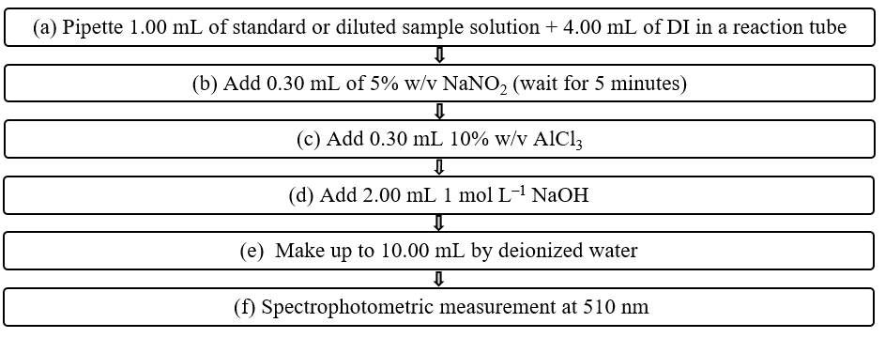
Figure 1. Coloring procedure for determining the total flavonoid content

Determination of total flavonoid content in tea products and their liquor
The analytical method for determining total flavonoid contents in tea products (expressed in mg QE g^{–1} dry weight) was validated, following the requirements in Appendix F of AOAC (2016) [20]. The evaluated performance characteristics included the calibration curve, limit of detection and quantification (LOD and LOQ) estimation, repeatability/intra-day and reproducibility/inter-day (% RSD_{r} and % RSD_{R}), and recovery testing for trueness evaluation. The method limits of detection and quantification (LOD and LOQ) were determined by simultaneous analysis of 11 blank samples. The estimated average concentration value ($\overline{x})$ and standard deviation (SD) were calculated to apply in the following relationships: LOD = $\overline{x}$ + 3SD and LOQ = 3LOD [21]. The method accuracy and precision were evaluated from the recovery study conducted by green tea samples spiked at levels of 40, 80, and 160 mg QE g^{–1}.
The proposed analytical method was applied in determining the TFCs of various tea products and their liquors, with the aim of evaluating the effects of brewing conditions (temperature and infusion time) on the release of flavonoids from tea products into the water. For the preparation of tea liquors, 0.200 g ± 0.001 g of dried tea sample and 10.00 mL of DI water were used for each brewing condition. The surveyed temperature and infusion time varied from 10 °C to 90 °C and 3 minutes to 60 minutes, respectively. The infusion time was kept at 60 minutes to assess the effects of temperature and 90 °C was used as the temperature for evaluating the influences of infusion time. The releasing percentage of TFCs was calculated as the ratio of TFCs between the tea liquors and products at different brewing conditions.
All the analytical data were carried out in three replicates (n = 3) to ensure the repeatability and analyzed by Microsoft Office Excel 2016, then expressed as mean value $±$ standard deviation (SD).

Result and Discussion

Effect of reaction time on the determination of TFCs
The coloring procedure for TFCs (Figure 1) employed the basic principle of aluminium chloride colorimetric method, in which aluminium chloride formed acid-stable complexes with the C-4 keto group and either the C-3 or C-5 hydroxyl group of flavones and flavonols. Moreover, aluminium chloride also formed acid-labile complicated compounds with the ortho-dihydroxyl group in the A- or B- rings of flavonoids. For tea samples, quercetin has been reported to be a suitable standard for determining TFCs [19, 22, 23]. Therefore, the conditions for chemical reactions to form certain complexes during the coloring procedure were remarkably important for quantification purposes to guarantee the accuracy of the analytical results. After adding 1 mol L^{–1} NaOH and volumetric calibration (step (d) and (e) in Figure 1), the pH of the reaction solution would change to be favorable for complex formation, affecting the measured absorption signals. Therefore, the reaction duration before the spectrophotometric measurement was investigated to obtain the optimized coloring procedure. The absorbance was recorded at each reaction duration for 300 mg L^{–1} quercetin standard solution (Figure 2).
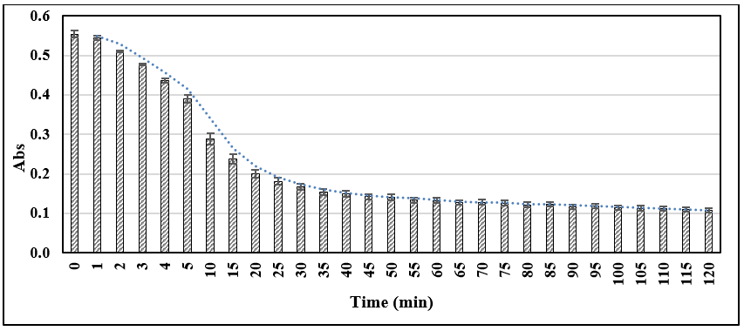
Figure 2. Investigation of reaction durations before spectrophotometric measurement
As can be seen in Figure 2, the measured absorbance values remained unchanged in the first minute (0-1 minute) and showed a descending trend from 1 to 120 minutes. However, the absorbance declined faster in the first 20 minutes (from 0.5434 to 0.2005). The absorbance continued to decrease in the next 40 minutes (from 0.1811 to 0.1325), but not as much as in the first 20 minutes. From the 60th minute onward, the signals still showed a descending trend but at a very slow rate (from 0.1327 to 0.1075). Therefore, to ensure the highest sensitivity and save analysis time, the spectrophotometric measurement should be carried out right after the addition of NaOH and volumetric calibration or in the first 60 seconds. Moreover, in this study, we employed the manual measurement; therefore, we could follow the procedure separately for each sample solution. However, in the case of simultaneous measurement of various cells simultaneously (e.g., ELISA method), we could choose the reaction time above 60 minutes with smaller dilution factors.

Analytical method performance for determining TFCs in tea products and their liquors
The proposed analytical method was validated before application on real samples. The results for method performance are shown in Table 2.
Table 2. Analytical method performance for the determination of TFCs
Parameter | LOD  (mg QE g^{–1}) | LOQ  (mg QE g^{–1}) | Linear range  (mg L^{–1}) | RSD_{r}  (%) | RSD_{R}  (%) | Recoveries  (%)
Values | 1.4 | 4.1 | 50-700 | 1.1 | 1.2 | 98-102
LOD and LOQ values were estimated as 1.4 and 4.1 mg QE g^{–1}, respectively, which were low compared to the TFCs in tea products.
The calibration curve for determining the TFCs in various tea samples and their liquors was established from 50 to 700 mg L^{–1} and is shown in Figure 3.

Figure 3. Calibration curve of TFCs
The regression equation was y = 0.0013x + 0.0872 and R² = 0.9981, exhibiting goodness of linearity. The %RSD_{r} and RSD_{R} were used to evaluate the repeatability (within one day) and reproducibility (for three separate days) of the analytical method. These values were favorable according to Appendix F. AOAC (2016) for the concentrations from 10 to 100% (RSD_{r} less than 1.3% and RSD_{R} less than 2 %) [20]. Besides, the recoveries varied from 98 to 102%, assuring the method’s accuracy. Therefore, the validated analytical method could be applied for determining TFCs in tea products and their liquors during routine daily analysis and further research.

Variations of TFCs in different tea products
For plants in general and tea specifically, flavonoids have been known as the most popular, important, and mostly distributed single group of phenols with strong antioxidant properties [24, 25]. Flavonoids could inhibit metal-initiated lipid oxidation through the formation of complexes with metal ions. The TFC in dried tea products were determined, and their values are presented in Figure 4.

Figure 4. Flavonoid contents in tea samples
Among the available tea products, green-3 and oolong-2 had the highest (155.3 ± 1.3 mg QE g^{–1}) and lowest (42 ± 0.7 mg QE g^{–1}) TFCs, respectively. For the samples collected from the mountainous regions in North Vietnam, the TFCs were found in the descending order of green tea (140.1 ± 1.0 to 155.3 ± 1.3 mg QE g^{–1}) > Pu'erh tea (108.5 ± 0.8 to 141.8 ± 1.5 mg QE g^{–1}) > white tea (95.3 ± 1 to 99.0 ± 1.0 mg QE g^{–1}) > black tea (60.8 ± 1.1 to 89.7 ± 1.1 mg QE g^{–1}). The same order was reported by Peterson et al. (2005) [26] and Unachukwu et al. (2010) [27].
The differences in TFCs among various tea products could be explained by their oxidation levels. Non-fermented tea and very lightly fermented tea (green, white, and Pu'erh) contained simple flavonoids (catechins). During fermentation, the polyphenol oxidase enzyme oxidized simple catechins to form low molecular weight dimers (theaflavins) or high-molecular-weight polymers (thearubigins), leading to lower measured TFCs [13, 28]. The oxidation of catechins to theaflavins during the fermentation contributed to the dark color and distinctive flavor of the tea [29, 30]. In this study, the Pu'erh tea products possessed relatively high TFCs, not much different from those of green tea (the most extensive variation of 24 mg QE g^{–1}). It might be due to the similarity in the processing of green tea and Pu'erh tea products. However, oxidation is known to continue during storage for Pu'erh tea products due to the incomplete deactivation of enzymes in its processing, unlike green tea which undergoes heat treatment to remove bitterness and stop fermentation. Therefore, the TFCs for the three Pu'erh tea samples fluctuated in a wider range than other tea types, even though they originated from the same cultivar and variety. Moreover, the TFCs could change during storage, as reported by Chen et al. (2016) [31] and Zhou et al. (2020) [32].
For green and oolong tea products collected in the Central Highland (the southern Vietnam), they also exhibited a similar trend for non-fermented and fermented tea, in which green tea exhibited higher TFCs than oolong tea (85.2 ± 1.3 to 96.2 ± 1.8 mg QE g^{–1} vs. 42 ± 0.7 to 59.8 ± 0.4 mg QE g^{–1}). However, the difference in TFCs between green tea products of the North and South might be due to the difference in tea cultivar, soil types, altitude of cultivation, planting conditions, post-harvest storage, leaf quality, processing conditions, and ontogenetic effects [22, 33-36]. For fermented teas in this study, the black tea products showed higher TFCs than oolong tea (60.8 ± 1.1 mg QE g^{–1} to 89.7 ± 1.1 mg QE g^{–1} vs. 42 ± 0.7 mg QE g^{–1} to 59.8 ± 0.4 mg QE g^{–1}), which was also reported by Hertog et al. (1993) [37] and Zayadi et al. (2016) [38] for most oolong and black tea samples.

Effects of temperature and infusion time on TFCs in tea liquors
The effects of brewing conditions, including temperature and infusion duration, on TFCs in several tea liquors were evaluated. A quantity of 12 investigated samples belonging to four tea types of white, green, black, and Pu'erh from the same tea plantation area in Ha Giang Province were evaluated for their average extraction percentage for each brewing condition, as presented in Figure 5. There were no results for green and oolong tea samples in Lam Dong Province here due to the limitation of sample availability and experiment time.

- Infusion temperature
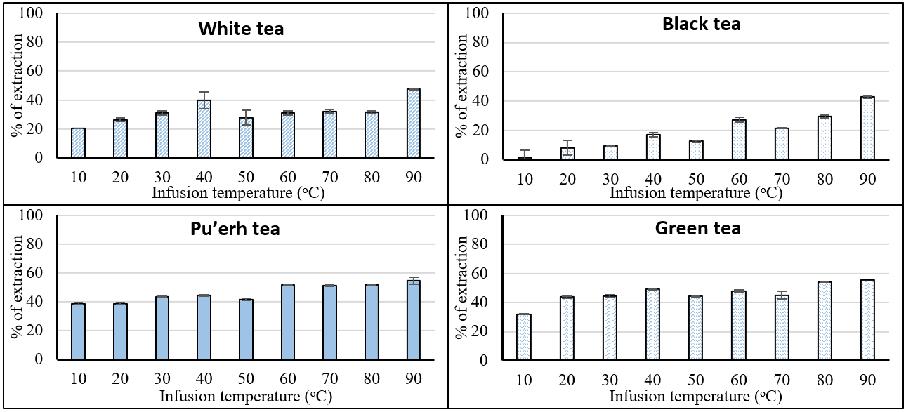

- Infusion time
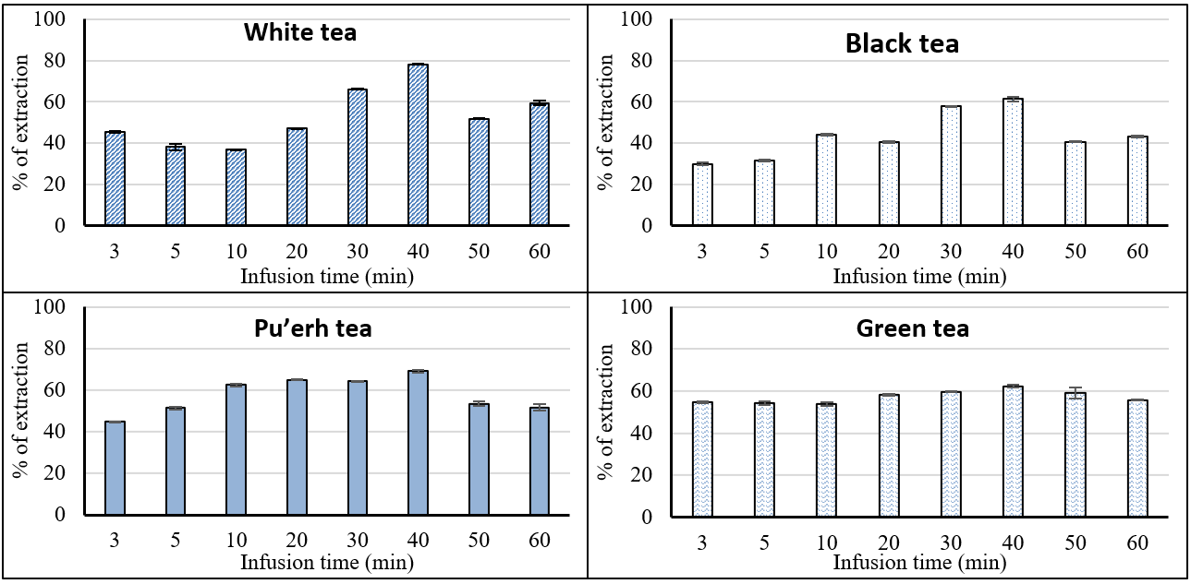
Figure 5. Effect of (a) temperature and (b) infusion time on TFCs in tea liquors
As can be seen from Figure 5, higher brewing temperature led to the higher extraction percentage of TFCs for the four tea types and reached the highest at 90 °C. Black tea showed the most apparent increasing trend (1.02% to 42.8% from 10 °C to 90 °C) and required higher temperature to release the flavonoids from the tea leaves to the water. The temperature accelerated the extraction of internal compounds, especially the easily soluble substances such as flavonoids, catechins, and metal(loid)s from the tea products into their liquors, as reported in several publications [7, 39-42].
For infusion time effects, the extraction percentage of TFCs in tea liquors reached the highest at the infusion time of 40 minutes, then decreased in the next 20 minutes (from 40 to 60 minutes). The longer infusion time could have caused the thermal oxidation or decomposition of flavonoid compounds, leading to lower TFCs recorded in tea liquors [43, 44]. As in the situation of brewing time experiment, black tea exhibited the largest variation in the extraction percentage within the investigated infusion time from 3 to 60 minutes (29.93% - 43.23%). Meanwhile, the recorded fluctuation was smaller for white, green, and Pu'erh tea types with higher extraction percentages (59.49%, 55.49%, and 51.74%). Besides the TFCs, a longer infusion time at high temperatures might draw out more undesirable compounds, especially potentially toxic metal(loid)s, into the tea liquors. Therefore, tea drinkers could choose a shorter infusion time without much effect on the TFCs released into tea liquors. For example, green tea had the TFC extraction percentage of 54.31% ± 0.74%, only 8% lower than the most favorable condition (62.29 ± 0.59%).

Conclusion
The analytical method for determining the total flavonoid content in different tea products and their liquors, based on the principle of spectrophotometric assay after forming complexes with AlCl₃ in alkaline medium, was validated according to the requirements in Appendix F. AOAC (2016). The estimated limit of detection and quantification values were low compared to the TFCs present in tea samples. The calibration curve was built from 50 to 700 mg QE L^{–1} with R² = 0.9981, exhibiting goodness of linearity. Non-fermented and lightly-fermented tea products exhibited higher TFCs than fermented ones, whereby TFCs followed the descending order of green (140.1-155.3 mg QE g^{–1}) > Pu’erh (108.5-141.8 mg QE g^{–1}) > white (95.3-99.0 mg QE g^{–1}) > black (60.8-89.7 mg QE g^{–1}) > oolong (85.2-96.2 mg QE g^{–1}). The temperature and infusion time affected the TFCs in tea liquors. The highest TFCs in tea liquor were recorded at 90 °C within the infusion time of 40 minutes for most tea products. However, for a better assessment, more samples belonging to different tea types should be collected, and we could carry out further investigation for catechins, antioxidant capacities, and elemental analysis to discover the most favorable brewing condition for each tea type.

Acknowledgment

The authors would like to express our thanks and appreciation to Nguyen Tat Thanh University for the assistance and support during this study. This research is funded by Nguyen Tat Thanh University, Ho Chi Minh city, Vietnam, under grant number 2021.01.21/HĐ-KHCN.

References
- Yan, Z., Zhong, Y., Duan, Y., Chen, Q. and Li, F. (2020). Antioxidant mechanism of tea polyphenols and its impact on health benefits. Animal Nutrition, 6 (2): 115 – 123.
- Zhang, L., Li, N., Ma, Z.-Z. and Tu, P.-F. (2011). Comparison of the chemical constituents of aged pu-erh tea, ripened pu-erh tea, and other teas using HPLC-DAD-ESI-MS. Journal of Agricultural and Food Chemistry, 59 (16): 8754 – 8760.
- Kosińska, A. and Andlauer, W. (2014). Antioxidant capacity of tea: Effect of processing and storage. Processing and impact on antioxidants in beverages: 109-120): Elsevier.
- Ahmed, S., Unachukwu, U., Stepp, J. R., Peters, C. M., Long, C. and Kennelly, E. (2010). Pu-erh tea tasting in Yunnan, China: correlation of drinkers' perceptions to phytochemistry. Journal of Ethnopharmacology, 132 (1): 176 – 185.
- Chen, S., Li, M., Zheng, G., Wang, T., Lin, J., Wang, S., Wang, X., Chao, Q., Cao, S. and Yang, Z. (2018). Metabolite profiling of 14 Wuyi Rock tea cultivars using UPLC-QTOF MS and UPLC-QqQ MS combined with chemometrics. Molecules, 23 (2): 104.
- Kodama, D. H., Gonçalves, A. E. d. S. S., Lajolo, F. M. and Genovese, M. I. (2010). Flavonoids, total phenolics and antioxidant capacity: comparison between commercial green tea preparations. Food Science and Technology, 30: 1077 – 1082.
- Tao, W., Zhou, Z., Zhao, B. and Wei, T. (2016). Simultaneous determination of eight catechins and four theaflavins in green, black and oolong tea using new HPLC–MS–MS method. Journal of Pharmaceutical and Biomedical Analysis, 131: 140 – 145.
- Higdon, J. V. and Frei, B. (2003). Tea catechins and polyphenols: health effects, metabolism, and antioxidant functions. Critical Reviews in Food Science and Nutrition, 43 (1): 89 – 143.
- Yokozawa, T., Dong, E., Nakagawa, T., Kashiwagi, H., Nakagawa, H., Takeuchi, S. and Chung, H. Y. (1998). In vitro and in vivo studies on the radical-scavenging activity of tea. Journal of Agricultural and Food Chemistry, 46 (6): 2143 – 2150.
- Ahmad, N., Cheng, P. and Mukhtar, H. (2000). Cell cycle dysregulation by green tea polyphenol epigallocatechin-3-gallate. Biochemical and biophysical research communications, 275 (2): 328 – 334.
- Kundu, J. K., Na, H.-K., Chun, K.-S., Kim, Y.-K., Lee, S. J., Lee, S. S., Lee, O. -S., Sim, Y.-C. and Surh, Y.-J. (2003). Inhibition of Phorbol Ester–Induced COX-2 Expression by Epigallocatechin Gallate in Mouse Skin and Cultured Human Mammary Epithelial Cells. The Journal of nutrition, 133 (11): 3805S – 3810S.
- Pękal, A. and Pyrzynska, K. (2014). Evaluation of aluminium complexation reaction for flavonoid content assay. Food Analytical Methods, 7 (9): 1776 – 1782.
- Izzreen, N. Q. and Mohd Fadzelly, A. (2013). Phytochemicals and antioxidant properties of different parts of Camellia sinensis leaves from Sabah Tea Plantation in Sabah, Malaysia. International Food Research Journal, 20 (1): 307 – 312.
- Bansal, S., Syan, N., Mathur, P. and Choudhary, S. (2012). Pharmacological profile of green tea and its polyphenols: A review. Medicinal Chemistry Research, 21 (11): 3347 – 3360.
- Putri, T. (2015). In vitro anti-gout activity and phenolic content of "black tea" soursop (Annona muricata L.) leaves brew. Journal of chemical and pharmaceutical research, 7 (11): 735 – 743.
- Kılıç, C., Can, Z., Yılmaz, A., Yıldız, S. and Turna, H. (2017). Antioxidant properties of some herbal teas (green tea, senna, corn silk, rosemary) brewed at different temperatures. International Journal of Secondary Metabolite, 4 (3, Special Issue 1): 142 – 148.
- ISO 1572 (1980). Tea-Preparation of ground sample of known dry matter content.
- ISO 14502-1 (2005). Determination of substances characteristic of green and black tea-Part 1: Content of total polyphenols in tea-Colorimetric method using Folin-Ciocalteu reagent.
- Kim, D.-O., Jeong, S. W. and Lee, C. Y. (2003). Antioxidant capacity of phenolic phytochemicals from various cultivars of plums. Food Chemistry, 81(3), 321 – 326.
- Appendix F. AOAC (2016). Guidelines for Standard Method Performance Requirements.
- Konieczka, P. and Namiesnik, J. (2016). Quality assurance and quality control in the analytical chemical laboratory: A practical approach, CRC Press.
- Shannon, E., Jaiswal, A. K. and Abu-Ghannam, N. (2018). Polyphenolic content and antioxidant capacity of white, green, black, and herbal teas: a kinetic study. Food Research, 2 (1): 1 – 11.
- Akbay, P., Basaran, A. A., Undeger, U. and Basaran, N. (2003). In vitro immunomodulatory activity of flavonoid glycosides from Urtica dioica L. Phytotherapy Research: An International Journal Devoted to Pharmacological and Toxicological Evaluation of Natural Product Derivatives, 17 (1): 34 – 37.
- Pokorny, J., Yanishlieva, N. and Gordon, M. H. (2001). Antioxidants in food: Practical applications: CRC press.
- Abdeltaif, S. A., SirElkhatim, K. A. and Hassan, A. B. (2018). Estimation of phenolic and flavonoid compounds and antioxidant activity of spent coffee and black tea (processing) waste for potential recovery and reuse in Sudan. Recycling, 3 (2): 27.
- Peterson, J., Dwyer, J., Bhagwat, S., Haytowitz, D., Holden, J., Eldridge, A., Beecher, G. and Aladesanmi, J. (2005). Major flavonoids in dry tea. Journal of Food Composition and Analysis, 18 (6): 487 – 501.
- Unachukwu, U. J., Ahmed, S., Kavalier, A., Lyles, J. T. and Kennelly, E. J. (2010). White and green teas (Camellia sinensis var. sinensis): variation in phenolic, methylxanthine, and antioxidant profiles. Journal of Food Science, 75 (6): C541 – C548.
- Rusak, G., Komes, D., Likić, S., Horžić, D. and Kovač, M. (2008). Phenolic content and antioxidative capacity of green and white tea extracts depending on extraction conditions and the solvent used. Food Chemistry, 110 (4): 852 – 858.
- Harbowy, M. E., Balentine, D. A., Davies, A. P. and Cai, Y. (1997). Tea chemistry. Critical Reviews in Plant Sciences, 16 (5): 415 – 480.
- Graham, H. N. (1992). Green tea composition, consumption, and polyphenol chemistry. Preventive Medicine, 21 (3): 334 – 350.
- Chen, M., Zhu, Y., Zhang, H., Wang, J., Liu, X., Chen, Z., Zheng, M. and Liu, B. (2017). Phenolic compounds and the biological effects of Pu-erh teas with long-term storage. International Journal of Food Properties, 20 (8): 1715 – 1728.
- Zhou, B., Ma, C., Wu, T., Xu, C., Wang, J. and Xia, T. (2020). Classification of raw Pu-erh teas with different storage time based on characteristic compounds and effect of storage environment. LWT Food Science and Technology, 133: 109914.
- Imran, A., Butt, M. S., Sharif, M. K. and Sultan, J. I. (2013). Chemical profiling of black tea polyphenols. Pakistan Journal of Nutrition, 12 (3): 261.
- Lee, J.-E., Lee, B.-J., Chung, J.-O., Kim, H.-N., Kim, E.-H., Jung, S., Lee, H., Lee, S.-J and Hong, Y.-S. (2015). Metabolomic unveiling of a diverse range of green tea (Camellia sinensis) metabolites dependent on geography. Food Chemistry, 174: 452 – 459.
- Yang, J. and Liu, R. H. (2013). The phenolic profiles and antioxidant activity in different types of tea. International journal of food science & technology, 48 (1): 163 – 171.
- Pacheco-Coello, F., Peraza-Marrero, M., Orosco-Vargas, C., Ramirez-Azuaje, D. and Pinto-Catari, I. (2020). Determination of total phenolic compounds and evaluation of the antioxidant activity of commercial and artisanal green tea traded in Maracay, Venezuela. Revista Boliviana de Química, 37 (1): 28 – 33.
- Hertog, M. G., Hollman, P. C. and Van de Putte, B. (1993). Content of potentially anticarcinogenic flavonoids of tea infusions, wines, and fruit juices. Journal of Agricultural and Food Chemistry, 41 (8): 1242 – 1246.
- Zayadi, R. A., Rahim, N. A. and Bakar, F. A. (2016). Determination of flavonoid and caffeine content in black and oolong teas. Journal of Science and Technology, 8 (2): 18 – 24.
- Chang, M.-Y., Lin, Y.-Y., Chang, Y.-C., Huang, W.-Y., Lin, W.-S., Chen, C.-Y., Huang, S.-L. and Lin, Y.-S. (2020). Effects of infusion and storage on antioxidant activity and total phenolic content of black tea. Applied Sciences, 10 (8): 2685.
- Kelebek, H. (2016). LC-DAD–ESI-MS/MS characterization of phenolic constituents in Turkish black tea: Effect of infusion time and temperature. Food Chemistry, 204: 227 – 238.
- Jamshidpour, S., Faramarzi, E., Mahmoudi, M. and Varmira, K. (2016). The Effect of the Duration and Temperature of Infusion on the Heavy Metal Content of Green Tea. European Online Journal of Natural and Social Sciences, 5 (4): 980 – 987.
- Asil, M. H., Rabiei, B. and Ansari, R. H. (2012). Optimal fermentation time and temperature to improve biochemical composition and sensory characteristics of black tea. Australian Journal of Crop Science, 6 (3): 550 – 558.
- Ioannou, I., Chekir, L. and Ghoul, M. (2020). Effect of Heat Treatment and Light Exposure on the Antioxidant Activity of Flavonoids. Processes, 8 (9): 1078.
- Buchner, N., Krumbein, A., Rohn, S. and Kroh, L. (2006). Effect of thermal processing on the flavonols rutin and quercetin. Rapid communications in mass spectrometry: RCM, 20: 3229 – 3235.

